Invertebrate Bioregions in Tasmania

Preface
Executive Summary and Summary of Recommendations
General Introduction
Methods
Results and Discussion
References
Appendix A: Project Brief
Appendix B: Tables
Appendix C: Maps

Preface
A draft proposal for the Invertebrate Bioregions in Tasmania project was floated on 23 November 1995. The proposal was accepted for consideration by the Environment and Heritage Project Team, modified on 13 March 1996 by the Fauna Reference Group assisting the CRA, and approved for CRA funding by the Joint Commonwealth and Tasmania RFA Steering Committee on 2 May 1996. The project steering committee initially consisted of Dr Sally Bryant (Environment and Heritage Project Team), David Peters (Department of Environment and Land Management, Tasmania), Dr Alastair Richardson (Zoology Department, University of Tasmania) and Jasmine Lynch (Australian Nature Conservation Agency). Ms Lynch was later replaced by Geoff Larmour (ANCA).
The Invertebrate Bioregions in Tasmania project was wholly funded by the Commonwealth of Australia and the State of Tasmania as part of the Comprehensive Regional Assessment of Tasmania’s forests. Work on the project was divided into three subprojects. The principal subproject was the gathering and analysing of invertebrate locality data and the production of this report. I carried out this task at my home in Burnie over six months between May and December 1996, with faxing and photocopying provided by Forestry Tasmania, Burnie.
In the second subproject Alastair Hunt, a graduate entomologist, was employed for five months (to September 1996) to sort, identify and database a collection of freshwater insect specimens which was being deposited at the Queen Victoria Museum and Art Gallery (QVMAG) by the Inland Fisheries Commission (IFC). Forestry Tasmania provided Hunt with facilities at its Surrey House headquarters in Hobart. Specimen vials and alcohol were purchased with CRA funds through QVMAG. Working within a narrow time frame, Hunt became an accomplished identifier of caddisflies, dragonflies and stoneflies, and successfully curated much of the massive IFC collection in preparation for further sorting and cataloguing at QVMAG. He was generously assisted by Stuart Chilcott, the IFC collection manager, and Dr Jean Jackson, a caddisfly specialist.
In the third subproject, Dr Rob Blakemore was funded for five months (to October 1996) to sort, identify and database the large collection of earthworm specimens at QVMAG. Dr Blakemore, who is based at QVMAG in Launceston, has made a major contribution to Tasmanian zoology by ‘re-organising’ the classification of our earthworm fauna, and is now continuing this work with Plomley Foundation support.
As can be seen, Invertebrate Bioregions in Tasmania was a three-city project, and as principal project officer I was fortunate to have subcontractors who could work capably and independently at a considerable distance from their nominal supervisor. I am very grateful to Rob and Alastair for their efforts, and to Dr Tim Kingston of QVMAG for managing the IFC-Forestry Tasmania-QVMAG connection.
I am also very grateful to the invertebrate specialists named in section 2.1 of this report for their generous contributions of locality records and taxonomic advice.
Finally, I thank Andrew Blakesley, Sally Bryant and Alastair Richardson for constructive comments on a draft of this report.

Executive Summary and Summary of Recommendations
Locality records for selected groups of Tasmanian invertebrates were analysed in a search for invertebrate bioregions, faunal boundaries, ‘hot spots’ and data gaps. Most of the records used are contained in a database compiled for this project and held at the Queen Victoria Museum and Art Gallery, with restricted access. With redundant data removed, the project database contains 10 871 one-kilometre-square occurrences for 792 terrestrial and freshwater invertebrate species.
Twelve invertebrate bioregions were tentatively identified on mainland Tasmania. Most of these bioregions overlap fairly broadly with neighbouring bioregions. The most discrete and well-defined bioregion is Plomley’s Island in the Northeast.
There are at least three well-documented, four poorly documented and five suspected faunal breaks (narrow transition zones between invertebrate bioregions). Several of the uncertain breaks run through largely cleared land and may no longer be demonstrable.
‘Hot spots’ with unusually high species diversity (or high numbers of rare or unusual species) could not be located at a spatial scale of use to conservation planners. The main obstacle is the recorder effect: invertebrate sampling in Tasmania has been highly biased (towards particular areas) at both coarse and fine spatial scales.
Data gaps were prioritised with a nearest-neighbour analysis of 10 km grid squares. The most significant gap is a 30-40 km-wide corridor running northwest from Sorell to Lake Echo in Derwent Forest District.
Recommendations:
1. No new reserves or modifications to existing reserves are proposed.
2. Funding should continue for studies of the distribution and conservation of geographically restricted, forest-dwelling invertebrates. The results of such research, supported in the recent past principally by Forestry Tasmania, have been of great value in the understanding of invertebrate biogeography. Priority groups for study include caddisflies, carabid and lucanid beetles, earthworms, land snails, landhoppers, millipedes, parastacid crustaceans and stoneflies.
3. The least-disturbed sections of faunal breaks should be managed appropriately as field laboratories for the study of invertebrate ecology, invertebrate evolution and landscape history.
4. Field work is recommended to better locate and document the poorly known and suspected faunal breaks, and to ‘salvage sample’ invertebrates in the more disturbed sections of the better known faunal breaks (Tyler’s Line, East Tamar and Goulds Country Breaks).
5. No further conversion of native forest to plantation should take place in remnant blocks of forest surrounded by cleared land, or in larger forest blocks which have already been largely converted to plantations. These forest remnants are biodiversity ‘hot spots’ of great importance for conservation on a bioregional scale.
6. Biogeographical information can be irretrievably lost through clearing without affecting the conservation status of the invertebrate species concerned. For this reason, no further clearing of bush remnants should take place on any land tenure in Tasmania without an invertebrate survey to salvage specimens and distribution data. The need for surveys is particularly urgent in relatively isolated bush remnants and in areas close to faunal breaks.
7. Sampling of terrestrial and freshwater invertebrates is urgently required in both Crown and private forest in portions of Derwent Forest District. The forest blocks in question (see section 3.4.5) represent the largest data gaps for invertebrates in Tasmania.

General Introduction

1.1 What this report is about
1.2 Where are the primary data?
1.3 How believable are the results?

1.1 What this report is about
Invertebrate Bioregions in Tasmania was designed to be a summary of biogeographical information about freshwater and terrestrial invertebrates, with a focus on forest-dwelling species (see Appendix A for a project brief.)
The first section of this report (section 3.1) covers the ‘invertebrate bioregions’ of the title and explains that there are distinctive invertebrate faunas in geographical clusters around the State. This clustering does not correspond in a simple way with forest vegetation type and is probably best explained as arising from a series of earth-history events. During some of these events, such as the coldest parts of the ice ages, most of Tasmania’s freshwater and terrestrial invertebrates lived in small, scattered refuges. When conditions improved and the invertebrates dispersed, the size and location of their new ranges may have been determined partly by chance and partly by competition on the ‘I was here first!’ principle. Sea-level changes probably allowed Victorian species to invade, while volcanic eruptions and faulting may have created dispersal barriers and led to local extinctions in an otherwise friendly Tasmanian landscape.
Regardless of its origins, the regionalisation of invertebrates is a ‘handle’ for dealing with the conservation of Tasmania’s enormous diversity of freshwater and terrestrial invertebrates. It is not the only such handle (invertebrates can also be grouped ecologically, as communities or role-players), and many invertebrates pay no attention whatsoever to any bioregional schemes. Nevertheless, invertebrate regionalisation is an important part of the faunal background against which forest operations are carried out, and forest managers need to be aware, like politicians, of the special character of the residents in their particular ‘electorate’ (bioregion) in Tasmania.
Faunal breaks are particularly important aspects of invertebrate regionalisation. For the most part, faunal regions meet in broad, fuzzy transition zones which are tens of kilometres wide. In a few places, however, the regional boundaries are marked by abrupt changes in the local invertebrate fauna. These faunal breaks are discussed in section 3.2; they are of great current and future importance in studies of invertebrate ecology, invertebrate evolution and landscape history.
This report also deals with invertebrate ‘hot spots’ (section 3.3). ‘Hot spots’ are sometimes thought of as places with a high diversity of rare or unusual invertebrates, or of invertebrates generally. On a global scale, Tasmania is a ‘hot spot’ of this sort, since the vast majority of its invertebrate species are found nowhere else. On a within-Tasmania scale, each distinctive invertebrate region could also be regarded as a ‘hot spot’. At the scale at which forest operations are planned - the coupe or block - it is very hard to identify ‘hot spots’ with any confidence, because the apparently special nature of a local species list might turn out to be un-special if the surrounding areas were to be sampled more thoroughly. One kind of ‘hot spot’, however, stands out unambiguously at this fine geographic scale, namely the remnant of native forest or woodland in a surround of farms or forest plantations. The significance of such remnants for biodiversity conservation is very great, and increases with the degree of isolation of the remnant.
Finally, this report highlights data gaps (section 3.4). These are areas where very little is known about the invertebrate fauna, and where it is essential that invertebrate data be gathered before rare species or unusual biogeographic features are threatened by forest operations.

1.2 Where are the primary data?
A peculiarity of this report is that it contains very little information on where, exactly, various invertebrate animals have been found. These omissions are deliberate. As will be explained in section 2, the great majority of the locality >records on which this report is based were provided to me in confidence, and it has therefore been necessary to generalise and otherwise obscure the relevant localities. I have also disguised a number of not-yet-published scientific names. Specific findings, such as the nature and location of faunal breaks, will be published elsewhere and will be backed up by locality data released for that purpose by data-providers, who may also be co-authors. The skeptical reader is advised that the unpublished locality data used in this project are held in electronic form, with restricted access, at the Queen Victoria Museum and Art Gallery (QVMAG). The records can be examined there, but they cannot be copied or quoted without the written permission of the data-providers. For more detail on these arrangements, see section 2.3.

1.3 How believable are the results?
Non-zoological readers need to be warned about the reliability and usefulness of invertebrate locality data. Presences can be believed, but absences often mean very little. A botanist can lay out a 10 x 10 m quadrat and quickly catalogue every tree, shrub, herb and fern, and, with a bit more effort, most of the mosses, liverworts and lichens. After an hour on the quadrat, the botanist is unlikely to have missed any significant plant presences. An invertebrate zoologist who visits the same quadrat for an hour will be lucky to find and identify more than 10% of the resident invertebrates larger than 3 mm, which is a respectable size for some of our flies and land snails. Determining the range limits for conservation-worthy but secretive invertebrates, such as earthworms and velvet worms, takes hundreds of hours of field time, and there will still be uncertainty at the edges of the range. There will also be uncertainty about abundance patterns within the range, about habitat preferences and about the apparent effects of logging and other disturbance; reliable data on these items may be unobtainable without a massive (and probably unjustifiable) field effort.
This report should be read with the caution on ‘absences’ clearly in mind. I have based my results mainly on well-sampled distributions, but fewer than 50 of Tasmania’s 20 000+ invertebrate species have had their distributions intensively mapped. It needs to be appreciated, as well, that very widespread species are useless in a study of within-Tasmania biogeography, even though widespread species are typically well-represented in collections. Ubiquitous distributions tell us nothing about bioregions or faunal breaks, which are features of more restricted distributions. At the other end of the scale of range size, species with very restricted distributions are of biogeographical interest (as opposed to conservation interest) only if those distributions more or less coincide, thus locating a ‘hot spot’. When we discount very widespread species, very restricted species and species known only from one or two scattered localities, we are left with biogeographically informative invertebrates. Although these species contribute only a small proportion of the available locality records for Tasmania, they are the focus of this project.

Methods

2.1 Sources of locality records
2.2 Databasing and editing
2.3 Data management and security
2.4 Comments on targeted invertebrate groups
2.5 Other groups

2.1 Sources of locality records
Fourteen forest-associated invertebrate groups were targeted for databasing in this project: butterflies, caddisflies, carabid beetles, chrysomelid beetles, dragonflies, earthworms, geometrid moths, land snails, landhoppers, lucanid beetles, millipedes, parastacid crustaceans, stoneflies and velvet worms. These were selected because their component species were known to be distributed around Tasmania, sometimes in mosaic patterns; because numerous specimen records for those species had been databased or catalogued; and because taxonomic sorting to species was relatively recent and believed to be reasonably stable. Within each group only native species were considered, and obligate cave-dwelling and littoral forms were excluded.
The primary source for locality records was the database compiled by the author in 1994-95 for a National Estate study of Tasmanian invertebrate recording. Earthworm records in the NEGP database were replaced with those supplied by Dr Rob Blakemore, one of the sub-contractors for this project. The other sub-contractor, Alastair Hunt, provided new caddisfly, dragonfly and stonefly records from his sorting of Inland Fisheries Commission samples. Additional records came from the ‘discard pile’ of the NEGP project, namely records outside that project’s time frame (1970-1994) and records not sufficiently well-located for that project’s purposes. Many new records were found in the QVMAG collection database. New or previously unavailable locality records, together with taxonomic advice, were generously provided by local specialists who had supplied records for the NEGP project and who were approached again for data: Dick Bashford (Forestry Tasmania), Kevin Bonham, Karyl Michaels (Department of Geography and Environmental Studies, University of Tasmania) and Dr Alastair Richardson (Zoology Department, University of Tasmania).
Table 1 (Appendix B) lists records by source for the 14 groups of terrestrial and freshwater invertebrates targeted in this project. Also in Table 1 are ‘embargo’ entries; embargoing of records is discussed in section 2.3.
A large number of invertebrate localities have been published in the form of distribution maps with no explicit cross-referencing to database records or catalogues. For this project I consulted the maps in Allbrook (1979) for dragonflies, Collier et al. (1994) for butterflies, Neboiss (1981) for caddisflies and Smith and Kershaw (1981) for land snails. I also consulted a number of literature sources on distributions of both targeted and non-targeted invertebrates; these are referenced below where appropriate. Information from all these sources has been included in the results on bioregions and faunal breaks. Only project database information was used in the analysis of data gaps.

2.2 Databasing and editing
The project database actually consists of a set of 14 group databases, one for each of the targeted invertebrate groups. Fields in each group database are: genus, species, locality name, 100 km grid square, easting, northing, 100 m or 1 km grid reference (‘yes’ or ‘no’, respectively), elevation, date of collection (or last date in a collection series), name(s) of collector(s), embargo (‘yes’ or ‘no’) and source of record.
For this project it was important to ensure that records had been correctly assigned to species. Ideally, every record would have been checked, if not supplied, by a specialist currently working with the species in question. This was only the case for earthworms (R. Blakemore), millipedes (D. Black and the author), velvet worms (the author) and Parastacoides crayfish (A. Richardson and B. Hansen). For all other invertebrates, records derive from identifications by specialists and/or by local zoologists who either collaborated with specialists or identified specimens by reference to voucher specimens or the appropriate taxonomic literature. Taxonomically doubtful records were excluded from the project database. Land snail synonymies were corrected on the advice of Dr B.J. Smith (QVMAG).
Localities for all records were sourced as, or converted to, 100 m or 1 km grid square references. Some records were provisionally assigned to 1 km grid squares on the basis of a locality description (e.g., ‘200 m downstream from the bridge over X Creek on Y Road’). A few such assignments were approximations which were re-checked if they appeared in areas shown by analysis to be significant. Uncertain localities were excluded from the database.
The final result was a database of 13 929 locality records for 792 species (Table 2, Appendix B). About one-quarter of the species are represented in the database by only a single record, and about half the species by four or fewer records. Seven species are represented by 200 or more records: the landhopper Keratroides vulgaris (507 records); the land snails Caryodes dufresnii (371), Cystopelta petterdi (237), Helicarion cuvieri (415) and Stenacapha hamiltoni (244); and the millipedes Lissodesmus perporosus (246) and Lissodesmus n.sp. E1 (213).
For the purposes of this project, all localities were defined as one kilometre grid squares. This definition makes the database spatially redundant, since many species were recorded at more than one locality within the same one kilometre square. The database is also temporally redundant, as some species were recorded at the same locality on more than one date. Eliminating these redundancies results in a list of 10 871 OKSOs (‘One Kilometre Square Occurrences’) of particular species in particular one kilometre grid squares (Table 2).

2.3 Data management and security
By promising confidentiality I was able to obtain a large number of records from lists which are currently the intellectual property of specialists, or of agencies or institutions which restrict access to their locality data. These embargoed records and their sources are indicated in Table 1. Among these records are many unpublished scientific names and grid references for places where threatened species have been collected; embargoing of such information is accepted practice. Since nearly 80% of the project database is confidential, the whole of the database is being treated as a confidential document, with access available only with the written approval of the data-providers and the database custodian, QVMAG. One electronic copy is held at QVMAG, and one electronic and one hard copy is held by the author. It is intended that the project database will be a source of information for scientific studies of faunal breaks, species distributions, invertebrate conservation and other matters. Interested investigators are invited to contact the author or Dr Tim Kingston at QVMAG.
A full list of one kilometre squares from the project database (i.e., squares with records) has been provided to ANCA for validation purposes, and OKSOs for a number of groups (with species names disguised) are being used for species modelling by the Tasmanian Parks and Wildlife Service.

2.4 Comments on targeted invertebrate groups
Butterflies. Despite the high conservation profile of these insects, the documentation of butterfly localities in Tasmania is widely scattered and uneven in quality. Collier et al. (1994) listed seven institutions and five entomologists as sources for butterfly records. The majority of those records were not, at the time, in electronic form, and evidently could not all be mapped as 10 km square occurrences (e.g. Neolucia mathewi on King Island; compare text and distribution map in Collier et al., p. 92). For this project I independently compiled 372 records for 28 of the 32 native, non-immigrant species. A conservation study of Oreixenica ptunarra (Neyland 1992 and M. Neyland, unpublished data) accounts for 40% of these records and 50% of the 289 butterfly OKSOs. The project database and the maps in Collier et al. complement each other to some extent. For example, CRA records for Argynnina hobartia in the Northeast and for Candalides acastus at Zeehan significantly extend the mapped ranges of these two species. The combined results suggest that several butterflies are more or less ubiquitous in Tasmania. Most of the remaining species have distributions which are (or probably were, in pre-European times) more or less the same as those of their respective foodplants. Three species may be geographically restricted within the ranges of available foodplants: Antipodia chaostola in the Southeast, Oreixenica orichora in the Central Highlands and Oreisplanus munionga in the far Northwest. For the purposes of this project, butterfly coverage is poor (Map 1; Appendix C). However, apart from looking more closely at the three species just mentioned, further collecting is unlikely to be of use in faunal regionalisation studies.
Carabid beetles. An atlas of Tasmanian carabids is being prepared by Karyl Michaels, a PhD student in the Department of Geography and Environmental Studies at the University of Tasmania. Ms Michaels has surveyed carabids at a number of well-defined localities around the State, and her records make up half the total of 621 in the project database. Coverage overall is poor (Map 2). Additional records from collections held on the mainland will be included in the carabid atlas but are unlikely to improve coverage greatly. Many of the 200+ native species are known only from a handful of localities; 22 of the 86 species in the CRA database are represented by only a single OKSO. Much additional collecting will be needed before regional or ‘hot spot’ patterns become clear in this group, which is highly likely to display mosaic distribution patterns.
Chrysomelid beetles. Not surprisingly, most of the CRA records are for a few species of economic importance: leaf-eaters that attack eucalypt forests and plantations. Statewide coverage is broad but sparse (Map 3). The vast majority of chrysomelids feed on living plants, and it is likely that further mapping of non-economic species will show their distributions to be predictable from vegetation and climate regionalisations.
Earthworms. All CRA records were provided by Dr Rob Blakemore, QVMAG, who is currently sorting and describing a Tasmanian fauna of 200+ native species. Coverage is broad (Map 4) but inadequate for faunal mapping, since the majority of species (55 of the 85 in the project database) are so far known from only a single locality. More intensive mapping of forest earthworms in the future is likely to contribute greatly to our understanding of faunal regionalisation in Tasmania, and to show also that a number of species are highly restricted and of conservation importance.
Geometrid moths. Localities for species in this very diverse group are being privately documented by Dr Peter McQuillan of the Department of Geography and Environmental Studies at the University of Tasmania. Only a few localities, mainly in the Tasmanian Wilderness World Heritage Area, were databased for this project (Map 5). It is likely, however, that most Tasmanian geometrids, like butterflies, have distributions which are more or less the same as those of their obligate or preferred food plants, with further ‘containment’ by preferred-climate envelopes.
Landhoppers. The distributions of all but a few, recently discovered native landhoppers on the Tasmanian mainland were well documented in the PhD work of J.A. Friend (published as Friend 1987). Many more records have come from later surveys by Dr Alastair Richardson and colleagues (Zoology Department, University of Tasmania), Dr Robert Taylor and colleagues (Forestry Tasmania), and the author. The resulting coverage (Map 6) is good and has proved useful in this project. The CRA data set (1474 records, 1081 OKSOs) is believed to include all but a few of the existing specimen records, although the Furneaux Group fauna remains to be documented (Friend 1987). Future taxonomic study may result in a splitting of the ubiquitous Keratroides vulgaris (A. Richardson, pers. comm.); the new species ‘fragments’ will contribute significantly to regionalisation studies.
Land snails. Land snails are the best-recorded terrestrial invertebrates in Tasmania. The 3407 records used in this project include all those from well-defined localities databased by QVMAG (keeper of the largest collection) and almost all the records compiled by the state’s most active collector, Kevin Bonham of Hobart. Coverage is excellent (Map 7). Future biogeographic work with this group will be founded largely on an increase in taxonomic resolution of selected ‘difficult’ forms, especially in the Charopidae (B.J. Smith, pers. comm., and K. Bonham, pers. comm.), and may not require extensive additional collecting. The existing species list includes many biogeographically informative species.
Lucanid beetles. Locality documentation for this group, like that for butterflies, is scattered and uneven in quality. Karyl Michaels (see Carabid beetles, above) has begun to compile records, and fine-scale mapping of Hoplogonus spp. and Lissotes menalcas has recently been carried out by Forestry Tasmania. Unknown numbers of records are held by Drs George Bornemissza and Barry Moore (both of CSIRO Division of Entomology, retired). The available coverage (Map 8) is sparse and only 154 lucanid OKSOs were databased in this project. Future fine-scale mapping of the speciose, log-dwelling genus Lissotes is likely to be very useful in regionalisation studies.
Millipedes. Coverage of this group is much better for the north of the state than the south (Map 9), but distributions in all areas appear to be highly mosaicised. Sorting of species in the ubiquitous spirostreptidan families Iulomorphidae and Cambalidae has recently been started by the author and is likely to ‘solidify’ the mosaic patterns already seen in the orders Polydesmida, Polyzoniida and Chordeumatida. After land snails, millipedes are the second best-recorded group of terrestrial invertebrates in Tasmania, and are the second best-documented group in this project (2842 records, 2266 OKSOs).
Velvet worms. Only three well-mapped species (Ooperipatellus cryptus, Tasmanipatus anophthalmus and T. barretti) have been included in the project database (Map 10), although use is made in later sections of records for a locally endemic, live-bearing genus in southwest Tasmania. Egg-laying species are nearly ubiquitous as a group (Ruhberg & Mesibov 1996) but their taxonomy, currently under study by Dr Hilke Ruhberg of Hamburg University, is unresolved, and it may be some years before this group proves biogeographically useful.
Caddisflies. Coverage of this diverse group of freshwater insects is very broad (Map 11) and will improve as sorting continues of existing collections made by personnel of the Inland Fisheries Commission and the Monitoring River Health Initiative. Many caddisfly species are known to have limited distributions. The great majority of the 1597 OKSOs in the CRA database have been documented as 100 m grid squares, making Trichoptera a potentially important group in fine-scale regionalisation studies.
Dragonflies. As with butterflies, the project database for dragonflies and published maps (Allbrook 1979) complement each other and show that most of the Tasmanian species are widespread. CRA coverage is poor (Map 12) but the biogeographical usefulness of this group is unlikely to be improved by extensive further collecting. Future conservation studies of Hemiphlebia mirabilis may provide additional records for this rare and restricted dragonfly in northeast Tasmania.
Parastacid crustaceans. CRA coverage (Map 13) would be better if I had included all Astacopsis records, but the recent review of the genus by Hamr (1992) has created some uncertainty about the identity of specimens previously referred either to A. franklinii or A. tricornis. A. gouldi records are also being reviewed in another CRA project. More than 400 Parastacoides records were provided by Dr Alastair Richardson and his student Brita Hansen; these are believed to be a reasonably complete data set for this endemic Tasmanian taxon. Engaeus is a well-studied and highly mosaicised genus (Horwitz 1990, 1995, in press) but no complete catalogue of records was made available for this project; records for several restricted species are being reported in a separate CRA project by Niall Doran and Karen Richards. More records for the remaining genus, Geocharax, in northwest Tasmania would be biogeographically useful.
Stoneflies. Much of the remarkably good coverage for this group (Map 14; 1064 records, 937 OKSOs) derives from a statewide survey in the late 1970s by H.B.N. Hynes. Subsequent records have mainly come from the Tasmanian Wilderness World Heritage Area. As with caddisflies, sorting of existing collections by the Inland Fisheries Commission and the Monitoring River Health Initiative will fill in many of the gaps in the coverage map. While some stoneflies are nearly ubiquitous, others apparently have restricted distributions, and species-targeted surveys on a fine scale will be useful in future regionalisation studies.

2.5 Other groups
As noted in section 2.1, the 14 invertebrate groups targeted in this project were selected because they were well-represented in collections, had relatively well-understood and stable taxonomies, and were distributed statewide in possibly mosaic patterns. At least eight other groups of native invertebrates could meet these criteria and could be used in future regionalisation studies. These groups are listed below; selected taxa are mentioned in later sections of this report.
Ants. Well-represented in collections but incompletely sorted to species by specialists. Most collections are from dry forest and woodland. A problem with ants in biogeographic studies is that a number of species have spread beyond their pre-European ranges as a result of clearing of forest for agriculture (Lowery 1994).
Beetles. Tasmanian Buprestidae and Cerambycidae have been relatively well-sampled by specialist collectors. It is not yet clear whether the locality documentation of these and other private and public beetle collections is adequate for fine-scale biogeographic studies.
Centipedes. Numerous specimens from all over Tasmania are in TMAG and QVMAG collections, but only a few genera appear to have mosaicised species distributions (Mesibov 1986). The taxonomy of the most speciose genera, in the Geophilomorpha, is incompletely resolved.
Freshwater snails. Well-sampled and well-understood taxonomically as a result of the continuing efforts of Dr Winston Ponder and colleagues at the Australian Museum (Ponder et al. 1993; Ponder, in press). Hydrobiid snails are highly speciose in Tasmania with small species ranges. Hydrobiids are sensitive to habitat degradation, and there is a case to be made for urgent ‘salvage’ sampling of streams in many areas. Species-level identifications are technically difficult.
Orthoptera. The studies of Dr K.H.L. Key (1990, 1991) have demonstrated that Tasmania’s endemic grasshopper fauna is regionalised at specific and sub-specific levels, and the same is likely to be true for crickets. The latter have not been adequately sampled around the State.
Slaters. Well-represented in Tasmanian collections and known to be mosaicised in distribution, but a number of new species have not yet been sorted (Alison Green, pers. comm.). Dr Glen Ingram (Queensland Museum) has recently begun a study of the Tasmanian fauna as part of an Australia-wide review.
Terrestrial flatworms. Surveyed in Tasmania and sorted by Leigh Winsor, James Cook University of North Queensland. Most records are from the west, but it is already clear that a number of species have restricted distributions. Special preservation techniques are needed and species identification is difficult with preserved material.
Water mites. The pioneering round-Tasmania survey of Cook (1986) showed that water mites can be useful in biogeographic studies. Collection and preservation are unproblematic but identifications are technically difficult. The Australian fauna is currently under study by Dr Mark Harvey (Western Australian Museum).

Results and Discussion

3.1 Invertebrate bioregions
- 3.1.1 Introduction
- 3.1.2 Notes on the provisional map of bioregions
- 3.1.3 Comparison with other regionalisations
- 3.1.4 Significance for forest management
- 3.1.5 Recommendation

3.2 Faunal breaks
- 3.2.1 Introduction
- 3.2.2 Known faunal breaks
- 3.2.3 Poorly documented faunal breaks
- 3.2.4 Suspected faunal breaks
- 3.2.5 Significance for forest management
- 3.2.6 Recommendations

3.3 ‘Hot spots’
- 3.3.1 Introduction
- 3.3.2 The recorder effect
- 3.3.3 How big is a ‘spot’?
- 3.3.4 Bush remnants
- 3.3.5 Significance for forest management
- 3.3.6 Recommendations

3.4 Data gaps
- 3.4.1 Introduction
- 3.4.2 Best-recorded areas
- 3.4.3 Least-recorded areas
- 3.4.4 Significance for forest management
- 3.4.5 Recommendations

3.1 Invertebrate bioregions

3.1.1 Introduction
It would be useful for conservation purposes if the map of Tasmania was a neat biogeographical mosaic. Each tile of the mosaic would have a fauna recognisably different from that in neighbouring tiles, and each of the characteristic faunas would be uniformly distributed across its home tile. The reality is very different. It is, of course, possible to find groups of species which all have more or less the same range within Tasmania. When we pencil in these consensus bioregions on the map, we find that they overlap very broadly. Another problem is that ‘more or less the same range’ usually means ‘less’. The species which might be used to characterise a bioregion only rarely fill the whole of that area, and they usually ‘leak’ into adjoining bioregions. Only at faunal breaks (section 3.2) is it clear that one bioregional assemblage is spatially distinct from another.
Perhaps the closest we come to a mosaic-tile bioregion in Tasmania is Plomley’s Island (Mesibov 1994b) in the Northeast (Map 15). Here most of the characteristic species appear to fill the bioregion, at least two of the edges are faunal breaks and there are a number of widespread invertebrates which are found close to Plomley’s Island but not within it.
The next most obvious bioregional features are the areas labelled ‘Wotlia’ (West-of-Tyler’s-Line-ia) and ‘Eotlia’ (East-of-Tyler’s-Line-ia) in Map 15 (for more on Tyler’s Line, see section 3.2.2). There are numerous invertebrates endemic to Wotlia, and many more Wotlian species range into the Wotlia/Eotlia transition zone but no further east. There are also many invertebrates which range throughout Eotlia; a substantial proportion of these also occur in the transition zone but have never been found in Wotlia. The main difficulty with calling Wotlia (or Eotlia) a bioregion is that the majority of the species endemic to this area only occupy a small portion of it. Saying that these species ‘occur in Wotlia’ is a bit more geographically precise than saying ‘occur in Tasmania’, but not much. A second difficulty is that the faunal transition zone between Wotlia and Eotlia is itself large enough to be considered a bioregion (Interotlia?), yet we have defined it with a mix of two other faunas, not with a characteristic fauna of its own.
In addition to these geometric obstacles to mapping invertebrate bioregions, there is a serious practical one: most invertebrate ranges are poorly known (see section 1.3). Of the 792 species in the CRA project database, only 234 have been recorded from 10 or more one kilometre squares, and almost two-thirds of these better-mapped species are very widespread and therefore of little value for regionalisation studies.
Problems of this kind are not peculiar to Tasmania, and it is not even clear that areas of endemism within land masses are demonstrable realities at a range of spatial scales, and not just biogeographers’ daydreams (Henderson 1991). Future work in this field is likely to proceed along two separate tracks. The taxon-based approach will look for geographical clustering of species and genera within a particular invertebrate group, e.g. caddisflies. The caddisfly clusters might then be compared with those for stoneflies. Clusters in common, which might be called general areas of endemism, will require explaining by ecological or evolutionary hypotheses. The more groups there are with particular clusters in common, the more biogeographically important those clusters will be. It is unlikely, however, that the general areas of endemism will fill the map of Tasmania with invertebrate bioregions. A second approach, under consideration by the author and Dr Alastair Richardson, is a statistical one which uses a map grid and presence/absence data as its starting point; the resulting areas of endemism are objectively defined and testable against null hypotheses (Morrone 1994). This statistical procedure, like the taxon-based one, is not expected to produce a map-filling mosaic of invertebrate bioregions.
I used a more subjective approach to draw a provisional map of invertebrate bioregions for this project. I compared the ranges of the better-mapped species and looked for ‘more-or-less-the-same-ness’. Consensus bioregions were roughly sketched, then refined by marking in edges that seemed to be common to many ranges, even the less well-mapped ones. (Many of these edges are known or suspected faunal breaks (section 3.2)). Tentative bioregions are shown in Map 16 and discussed below. They are partly characterised by what I believe to be genuinely local endemics, not just poorly recorded species whose few known localities happen to be in the area in question (e.g. the lucanid Lissotes latidens in the Buckland area and the spider Migas plomleyi in Cataract Gorge). The bioregions are perhaps more clearly characterised by their edges.
3.1.2 Notes on the provisional map of bioregions
(Bioregion names are as shown in Map 16.)
Plomley’s Island. The land snail Anoglypta launcestonensis, the earthworms ‘Animon’ and ‘Perker’, the centipede Tasmanophilus sp. NE45 and the millipedes Gasterogramma sp. 5 and Lissodesmus sp. NE4 are endemic to Plomley’s Island and range widely within it. The rare lucanid beetle Hoplogonus simsoni is restricted to the northeast corner of this bioregion. Plomley’s Island is also defined by the absence of well-mapped species which range up to the bioregional boundary, among them the velvet worm Tasmanipatus barretti, species in the land snail genus Tasmaphena and the millipedes Lissodesmus alisonae, Lissodesmus sp. E1 and paradoxosomatid n.sp. The eastern and western boundaries of Plomley’s Island include the East Tamar and Goulds Country Breaks, respectively (see section 3.2.2).
Bioregion A. The far northeast coast is home to the dragonfly Hemiphlebia mirabilis and the paradoxosomatid millipedes Dicranogonus sp. and Pogonosternum sp., all of which also occur on Flinders Island and in Victoria. The ‘toehold’ these Victorian species have in the far Northeast gives Bioregion A a special biogeographical significance. The western boundary of Bioregion A is the Bridport Gap (see section 3.2.3). The boundary with Bioregion B runs just north of St Helens and is supported by the northern range boundary of the widespread coastal land snail Bothriembryon tasmanicus and by a parapatric boundary between short- and long-tegmen races of the widespread grasshopper Tasmaniacris tasmaniensis (Key 1991).
Bioregion B. Endemic to Bioregion B, which is centered on the St Marys area, are the velvet worms Tasmanipatus anophthalmus and T. barretti, the centipede Cryptops sp. SS and a charopid land snail tentatively assigned to the genus Flammulops. Three well-mapped ‘neighbouring’ millipede species appear to be excluded: Lissodesmus sp. NE1, ‘Rankodesmus’ sp. 2 and Tasmanodesmus hardyi. The southern boundary is very approximately drawn but is probably near and north of Bicheno.
Bioregion C. This weakly supported bioregion is home to the locally endemic millipedes Lissodesmus sp. NE3 and ‘Rankodesmus’ sp. 2. It includes the mountains of the southern half of the Northeast from Ben Lomond to Tower Hill. The southern boundary contains the Fingal Valley and the northern range boundary of the millipede Lissodesmus margaretae.
Bioregion D. The Bioregion D forests have been poorly sampled for invertebrates. The only locally endemic species so far known for this bioregion are the millipedes Lissodesmus sp. E2, which ranges from Campbell Town east to Lake Leake, and Lissodesmus margaretae, which ranges through a band of country from the East Coast to the Central Plateau at Lake Augusta. Two suspected faunal breaks (see section 3.2.4) bound this bioregion to the north and south in the Eastern Tiers.
Bioregion E. This is another weakly supported bioregion, with only the presence of the locally endemic millipede ‘Rankodesmus’ sp. 1 and the absence of the land snail Cystopelta petterdi as defining features. A 1991 survey comparing litter invertebrates on Maria Island with those of the adjoining mainland from Triabunna to Orford found no species-level differences (unpublished results of the author). A suspected faunal break (see section 3.2.4) bounds this region to the north.
Bioregion F. This bioregion comprises the Forestier and Tasman Peninsulas, two surprisingly little-surveyed areas which are home to at least two local endemics: the land snail Helicarion rubicundus and the millipede Lissodesmus sp. P1. The Peninsulas may be bounded by a faunal break (see section 3.2.4).
Bioregion G. Southeast Tasmania around the lower Derwent area is a well-supported bioregion, but not precisely mapped. The western boundary is particularly hard to place due to lack of sampling. Local endemics include the lucanid beetle Lissotes menalcas and the millipedes Lissodesmus cf. margaretae form B, Lissodesmus modestus and Lissodesmus sp. SE1.
Bioregion H. This bioregion could be described as Southwest Tasmania plus the Wellington Range. Local endemics include species in the live-bearing velvet worm genus D, millipede species in the burrowing dalodesmid genus A, Parastacoides sp. ‘is’, the landhopper Austrotroides leptomerus and the caddisfly Smicrophylax creektona. A number of Bioregion H species have range boundaries at or near the southern boundary of the overlapping Bioregion I, suggesting that Bioregion H could be subdivided into northwest and southeast bioregions, roughly by line ‘i’ in Map 16. H-NW endemics include the millipedes Lissodesmus sp. SW1 and dalodesmid A1, the velvet worm D1, the centipede Cryptops C-new and Parastacoides sp. ‘wci’. H-SE endemics include the velvet worm D2 and the millipedes dalodesmid A2 and Gasterogramma sp. 6. The northern boundary of this bioregion includes the Tyler’s Line Break (section 3.2.2) and the Macquarie Harbour Break (section 3.2.4).
Bioregion I. This large bioregion includes much of the far Northwest, the West Coast and the Cradle Mountain area, but its northeastern corner is part of the problematic ‘Northwest series’ discussed below. There are many local endemics, notably the landhoppers Keratroides albidus and Orchestiella neambulans, the land snail Victaphanta milligani and the millipedes Lissodesmus sp. NW1 and Reginaterreuma tarkinensis. If Bioregion I is cut off on boundary ‘ns1’ (Map 16) and added to Bioregion H, the resulting bioregion neatly covers the ranges of the grasshopper Truganinia bauerae (Key 1991) and the freshwater snail genus Phrantela (Ponder et al. 1993).
The Northwest series. Bioregions in northwest Tasmania can be drawn as a ‘nested’ or concentric series of invertebrate distributions with an origin west of Smithton (Map 16). The area enclosed by ‘ns2’ and ‘ns3’ is home to the land snails Tasmaphena lamproides and Miselaoma weldii, the butterfly Oreisplanus munionga, the millipede Pogonosternum sp. and the grasshopper Schayera baiulus (Key 1990). M. weldii, O. munionga and Pogonosternum sp. extend to Victoria, as do the landhopper Arcitalitrus bassianus and burrowing crayfish in the genus Geocharax, found between ‘ns1’ and ‘ns3’. The far Northwest is thus a ‘toehold’ area, like Bioregion A, of special importance in biogeography. (Curiously, both Pogonosternum sp. and S. baiulus also occur in Bioregion A, but have not been found between the far Northwest and the far Northeast.) The area between ‘ns1’ and ‘ns3’ is also characterised by the apparent absence of the widespread caddisfly Alloecella longispina. A number of species found between ‘ns2’ and ‘ns3’ extend further east along the north coast. Those reaching to ‘ns4’ include the velvet worm Ooperipatellus cryptus; and to ‘ns5’ the land snail Oreomava johnstoni. The lines ‘ns3’, ‘ns4’ and ‘ns5’ are the Wynyard, Leven and Don Breaks, respectively (section 3.2.3).
Bioregion J. The Tamar region is characterised by the presence of the land snail Pernagera tamarensis and the millipede Lissodesmus alisonae, and by the gap in the north coastal distribution of the freshwater lobster Astacopsis gouldi. Boundaries are marked by the Bridport Gap and the East Tamar and Don Breaks (section 3.2).
Bioregion K. The eastern half of the Central Plateau is a weakly supported bioregion, its only known local endemic being the locally abundant millipede ‘Rankodesmus’ sp. 3.

3.1.3 Comparison with other regionalisations
Map 16 has few features in common with the most recent map of the Interim Bioregions for Tasmania (Thackway & Cresswell 1995). The intricacies of invertebrate regionalisation in the Northeast are lost in the ‘Ben Lomond’ IBRA bioregion, and geographically restricted east Tasmanian invertebrates range freely across the boundaries between IBRA’s ‘Freycinet’, Midlands’ and ‘Central Highlands’ bioregions. The closest match betwen the IBRA map and Map 16 is the ‘Woolnorth’ bioregion along the north coast, which includes most of the Northwest series (section 3.1.2). Unfortunately, ‘Woolnorth’ meets ‘Ben Lomond’ without recognising the faunally distinctive Tamar area or the Don and East Tamar Breaks (see section 3.2).
I have not yet found a geological, geomorphological, vegetation or vertebrate-faunal map of Tasmania which is clearly congruent with Map 16, although particular invertebrate distribution patterns often reflect particular environmental features. Two examples would be the faithfulness of the parapatric boundary between the grasshoppers Russalpia albertisi and R. longifurca (Key 1991) to the mid-southern geological divide between igneous and metamorphosed sedimentary bedrocks, and the general agreement in distribution of west Tasmanian rainforest and many ‘Wotlian’ endemics (3.1.1). What is remarkable is that certain very obvious environmental boundaries, like the Mt Arthur/Mt Barrow line of foothills, act as faunal divides, while others equally obvious, like the Midlands face of the Great Western Tiers, do not. Conversely, faunal transition zones like the Leven Break (section 3.2.3) can occur in the landscape with no environmental correlates to satisfactorily ‘explain’ them. (The Dial Range might have acted as an invertebrate dispersal barrier in colder, drier periods in the past, but the Leven Break lies east of the Dial Range, not along it. If the Leven River has been a barrier, on the other hand, why is there no obvious faunal divide near the Cam, Emu or Blythe Rivers to the west?)
In another CRA study, David Peters of the Department of Environment and Land Management has compared frog species assemblages and physical environments in Tasmania and found remarkably little agreement. The RFA Environment and Heritage Technical Committee reports that ‘the frogs are responding to biological imperatives in relation to the physical environment which are not known, discriminating among apparently uniform environments in some cases and ignoring apparently major environmental variation in others’ (Background Report C, volume 1, p. 52). Change ‘the frogs’ to ‘many invertebrates’ and ‘physical’ to ‘historical’ in the quote to hear again the results of the present study.
There are, of course, a very large number of terrestrial invertebrate species which are ecologically tied in one way or another to particular vegetation types, and their distributions can, in principle, be predicted by vegetation mapping. The same predictability might be found for many freshwater invertebrates and a combined climatic/geological mapping. It cannot be claimed that these habitat-tied invertebrates are more or less important in forest conservation than millipedes, which are apparently happy wherever leaf litter can accumulate, or earthworms, whose statewide distribution patterns are mysteriously fragmented (R. Blakemore, pers. comm.). What does seem clear is that an explanation of Map 16 will need to be based on a landscape history of Tasmania (see section 1.1). Until an historical map is available, no non-faunal mappings are likely to adequately match the regionalisation seen in Map 16.

3.1.4 Significance for forest management
The pattern of invertebrate regionalisation in Tasmania is complex, uncertain and not simply predictable from other regionalisations. It has only limited value in the design of a CAR forest reserve system, although Map 16, rough as it is, could be included as a data layer in a test of reservation adequacy. The significance of regionalisation for conservation planners lies in the principle that geographically restricted, forest-dwelling invertebrates are not scattered randomly around the map of Tasmania, but tend to cluster together, like the species found only in the St Marys area (Bioregion B). As these rarer species are found and recognised, they should, of course, be protected. Forest managers who conserve such locally endemic invertebrates will also be helping to conserve the larger bioregional pattern.

3.1.5 Recommendation
Forestry Tasmania and other funding agencies should continue to support research on the distribution and conservation of geographically restricted, forest-dwelling invertebrates. Prior to the CRA, Forestry Tasmania assisted distribution and conservation studies of the land snails Anoglypta launcestonensis, Helicarion rubicundus and Tasmaphena lamproides; and the velvet worms Ooperipatellus cryptus, Tasmanipatus anophthalmus and T. barretti. CRA-related projects focussed on the lucanid beetles Hoplogonus simsoni and Lissotes menalcas, several burrowing crayfish (Engaeus spp.) and a range of cave invertebrates. These are excellent examples of species-focussed studies with results of great value for biogeographers. Priority groups for future studies should be those which have already proved to be particularly useful: caddisflies, carabid and lucanid beetles, earthworms, land snails, landhoppers, millipedes, parastacid crustaceans and stoneflies.

3.2 Faunal breaks

3.2.1 Introduction
Faunal breaks are places in the landscape where species assemblages change over relatively short distances (Mesibov 1994b). Breaks may occur at ecotones, but not all ecotones are faunal breaks. The faunal change seen at a forest/moorland boundary may be reversed a few metres or hundreds of metres further on, with no ‘net’ change in fauna over the length of the transect. At a faunal break, a set of reasonably widespread species in a range of animal groups gives way to a different set of reasonably widespread species. Faunal breaks are thus the narrowest portions of transition zones between bioregions. In Tasmania, faunal breaks can be as narrow as 5 km (Mesibov, in press).
Faunal breaks in Tasmania have only recently been recognised, but it is already clear that these landscape zones are important for understanding the evolution and ecology of a wide range of invertebrate taxa. They are important even when all the species with range boundaries at a break are widespread, common and well-conserved.
It is not easy to decide whether a particular faunal boundary involves a large enough number of species to deserve being called a faunal break. I have suggested elsewhere (Mesibov 1994b) that the percentage differences in invertebrate species lists across a break may well be at the level expected from the random sampling of a uniformly distributed fauna. Individual cases have to be carefully investigated. For example, the parapatric boundary between the ranges of the velvet worm Tasmanipatus barretti and its congener T. anophthalmus in northeast Tasmania is not known to be respected by any other invertebrates (Mesibov & Ruhberg 1991), and thus appears to be a special case. The northwest range boundary for T. barretti, on the other hand, has been shown to lie along the Goulds Country Break (Mesibov 1994b and below).
Another difficulty is that the sharpness or otherwise of a faunal divide only becomes clear when the areas on either side have been sampled intensively. To date only the southern portion of the East Tamar Break (Mesibov, in press, and below) has been mapped at a fine scale: more than 150 sites were visited within a 30 x 30 km square. Other known and suspected faunal breaks have not yet been investigated so closely, and should be regarded at this stage as biogeographical hypotheses.

3.2.2 Known faunal breaks
Tyler’s Line Break. Shiel et al. (1989) described a limnological boundary, which they named Tyler’s Line in recognition of the limnologist Peter Tyler, between characteristically eastern and western rotifer assemblages. Tyler himself took a broader view and noted that the landscape zone in question is ‘a congruence of climatic, geologic, edaphic and vegetational change’ (Tyler 1992, p. 358). I have previously shown that the Tyler’s Line zone contains range boundaries for frogs, grasshoppers and landhoppers (Mesibov 1994b). The narrowest portion of Tyler’s Line is apparently a faunal break, here called the Tyler’s Line Break, running north-northwest and crossing the Lyell Highway just east of Derwent Bridge (Map 17). The break runs at right angles to a very steep rainfall gradient in this part of central Tasmania and is thus congruent with a climatic ecotone. The Tyler’s Line Break appears to contain eastern range boundaries for many widespread ‘west of Tyler’s Line’ invertebrates, among them the grasshoppers Russalpia longifurca and Truganinia bauerae; the landhoppers Keratroides albidus, Neorchestia plicibrancha and Orchestiella neambulans; the land snails Cystopelta bicolor and Victaphanta milligani; the millipedes Lissodesmus cf. margaretae form B, Lissodesmus sp. NW1 and Reginaterreuma tarkinensis; velvet worms currently referred to Euperipatoides cf. leuckarti; the caddisfly Conoesucus nepotulus; the stoneflies Tasmanoperla thalia and Trinotoperla zwicki; and the crustacean genus Parastacoides. The break also appears to contain western range boundaries for widespread east Tasmanian invertebrates, notably the grasshopper Russalpia albertisi; the millipedes Australeuma jeekeli, Lissodesmus cf. margaretae form C and Tasmanodesmus hardyi; and the centipede Cryptops sp. A. To date, the only invertebrate survey designed to transect the Tyler’s Line Break covered only three sites near the zone marked in Map 17 and involved a total of only four hours sampling (Mesibov 1994a). East of Lake St Clair the northern portion of the break runs into the Tasmanian Wilderness World Heritage Area, while to the south the break runs through State, private and HEC-managed forest.
East Tamar Break. This 40 km long biogeographical feature (Map 18) runs parallel to the Tamar Valley ca. 20 km east of Launceston. The southern portion of the East Tamar Break has now been intensively sampled for millipedes and centipedes (Mesibov, in press) and has been shown to be only 5 km wide in the Weavers Creek area. Several widespread, ecologically tolerant millipedes (Lissodesmus alisonae, Tasmanodesmus hardyi, paradoxosomatid n.sp.) appear to be ‘excluded’ from the Northeast by competition at the break with related or ecologically convergent forms. The break contains western range boundaries for millipedes confined to northeast Tasmania (Lissodesmus adrianae, Lissodesmus sp. NE1) and the northern range boundary for a very widespread eastern species (Lissodesmus sp. E1) which is parapatric at the break with ecologically convergent forms (Lissodesmus adrianae and L. alisonae). The Weavers Creek section of the East Tamar Break runs through State forest and crosses a steep elevation and rainfall gradient.
Goulds Country Break. Like the East Tamar Break, the Goulds Country Break (Map 18) was first recognised in distribution maps for invertebrates endemic to northeast Tasmania (Mesibov 1994b). It contains eastern range boundaries for the carabid beetle Hoplogonus simsoni, the land snail Anoglypta launcestonensis and the millipedes Gasterogramma sp. 5 and Lissodesmus adrianae. The break also contains western range boundaries for the geographically restricted velvet worm Tasmanipatus barretti and the very widespread millipede Lissodesmus sp. E1. A recent, casual sampling on a transect across the Goulds Country Break indicated that on Rayners Hill the break is less than 3 km wide (K. Bonham and the author, personal observations). The mapped section of the break is ca. 30 km long, crosses a rainfall gradient and lies largely within State forest.

3.2.3 Poorly documented faunal breaks
The following four zones have only begun to be tested as faunal breaks (by fine-scale distribution mapping) in the past two years. All four occur in areas which were forest or woodland in pre-European times. Clearing for agriculture and plantation forestry has reduced the forest to a scattering of remnants, many of which are badly degraded as invertebrate habitat. It may no longer be possible to gather enough distributional evidence to locate these breaks precisely, or even to demonstrate their existence unequivocally. Apparent locations for the four breaks are shown in Map 19. Unlike the better-known breaks, which cross steep environmental gradients, these four traverse the narrow coastal strip adjoining Bass Strait and run along, rather than across, the coastal-inland gradient of elevation and climate.
Wynyard Break. The Wynyard Break begins in the Table Cape area and runs generally south for ca. 25 km. Western species with eastern range boundaries at this break apparently include the snails Cystopelta bicolor and Tasmaphena lamproides (pre-clearance record) and the rare millipede Gasterogramma sp. 7. Eastern species respecting the break include the snail Cystopelta petterdi and the millipede Tasmanodesmus hardyi.
Leven Break. The second northwest break is in the Leven River area, north of the mountains of the Black Bluff group. The break contains the eastern range boundaries for the landhopper Keratroides albidus and the velvet worm Ooperipatellus cryptus, and possibly the landhoppers Neorchestia plicibrancha and Tasmanorchestia annulata. The western range boundaries of the millipede Australeuma jeekeli and the centipede Cormocephalus westwoodi also lie along this break. It is interesting that the rare burrowing crayfish Engaeus yabbimunna has its entire known distribution between the proposed Wynyard and Leven Breaks (Horwitz 1995 and report to this CRA project by Niall Doran and Karen Richards).
Don Break. The third Northwest break is well-supported by distribution data. It consists of two faunal divides: two arms of a V with the angle near the mouth of the Don River. The southwest-running arm of the V, a minor break, appears to contain the western range boundaries of Lissodesmus alisonae and Gasterogramma sp. 3 (and possibly also the snail Victaphanta lampra) and may also contain the eastern range boundary of the crustacean Parastacoides sp. ‘lept’. The southeast-running arm of the V seems to be a major faunal break. It contains the eastern range boundaries for the millipedes Tasmaniosoma sp. 2, dalodesmid spp. A1, C1 and D2, and Siphonotus sp. ‘insu’; the western edge of the ‘Tamar Gap’ in the distribution of the giant freshwater lobster Astacopsis gouldi; the western range boundary for the burrowing crayfish Engaeus nulloporius; and the western range boundaries for the millipedes paradoxosomatid n.sp., Siphonotus sp. ‘sexi’ and dalodesmid spp. A4 and D1. Each of the nine millipede species meeting along the southeast-running arm of the break is widespread in east or west Tasmania. What is more remarkable is that two other widespread millipedes have localised distributions in the open, southern portion of the V, namely dalodesmid sp. A2 (extension of the distribution in west, central and south Tasmania) and Lissodesmus sp. NW2 (disjunct population separated from widespread northeast distribution).
Bridport Gap. Running south from the town of Bridport, this ca. 20 km wide landscape zone separates the millipede Lissodesmus alisonae (to the west) from Lissodesmus spp. E1 and NE5 (to the east) (Mesibov 1994b). All three species are common on either side of the Gap but absent within it, yet the Gap is home to three other Lissodesmus species which are also common on either side: Lissodesmus adrianae and Lissodesmus spp. NE1 and NE2. This peculiar situation may be an artefact of human activity. A sharp faunal break may formerly have existed in the Gap, and Aboriginal burning, European agricultural development or both may have selectively eliminated the ‘missing’ Lissodesmus species. Engaeus mairener, a burrowing crayfish which is widespread along the Bass Strait coast of the Northeast, has an unexplained disjunction in the Bridport Gap, and the very restricted Engaeus spinicaudatus is found only on the Gap’s eastern edge (Horwitz, in press).

3.2.4 Suspected faunal breaks
For each of the cases listed below, the evidence in favour of a break consists of intriguing but limited data in the areas where two invertebrate bioregions appear to meet. Much additional field work will be required at the indicated places before the width and generality of the faunal transition zone can be assessed.
Macquarie Harbour Break. A number of invertebrates occur south of the King River (and are widespread in southwest Tasmania) but have not been found in suitable habitats between Queenstown and Zeehan (or elsewhere in mid-west and northwest Tasmania). These include the landhopper Mysticotalitrus cryptus and species in at least two millipede genera and one velvet worm genus. The same suspected break divides the widespread Parastacoides species ‘lept’ and ‘in-st’ and the long- and short-tegmen races of the grasshopper Tasmaniacris tasmaniensis (Key 1991), and may be the southern boundary for burrowing crayfish in the genus Engaeus.
Dunalley Break. Forestier and Tasman Peninsulas are home to the locally endemic snail Helicarion rubicundus, the locally endemic millipede Lissodesmus sp. P1 and the Southeast endemic lucanid beetle Lissotes menalcas. All three are reasonably common on Forestier Peninsula but have not been found in suitable habitats in the Dunalley area, just over the Denison Canal. Conversely, the very widespread east Tasmanian millipede Lissodesmus sp. E1 is common in the Dunalley area but has not been found on Forestier Peninsula. The forest blocks between Green Point and Cape Paul Lamanon on Forestier Peninsula may contain a faunal break or lie just north of one.
Fingal Valley Break? In a paper soon to be published, Prof. J.B. Kirkpatrick (Department of Geography and Environmental Studies, University of Tasmania) notes that the Fingal Valley is a biogeographic divide for plants ‘as strong as the line that separates the quartzite high rainfall country of the Southwest from the more argillaceous and less perhumid east’ (Kirkpatrick, in press). Only two widespread millipede species are so far believed to be narrowly separated by the Fingal Valley: Lissodesmus margaretae (south) and ‘Rankodesmus’ sp. 2 (north). No land snails or landhoppers appear to respect the divide. The Fingal Valley may act as a broad faunal divide between the Northeast and East Coast but neither it nor its immediate surrounds have so far been shown to contain a faunal transition zone, narrow or otherwise.
East Coast Breaks. A line running roughly west from Swansea is the northern limit for landhoppers of the genus Mysticotalitrus and the locally endemic millipede Lissodesmus sp. E3. A line running roughly west-southwest from Little Swanport is the northern limit for the millipede ‘Rankodesmus’ sp. 1 and is the parapatric boundary between Lissodesmus margaretae and Lissodesmus cf. margaretae form E. There is also a curious absence of records on the East Coast for the relatively large, common and widespread snails Cytopelta petterdi, Stenacapha hamiltoni and Thryasona diemenensis. The gap for Stenacapha and Thryasona runs roughly from Bicheno to Orford, and for Cystopelta from Bicheno to the Derwent at Hobart. The cut-off lines for the three species, if they exist, have not been located.
Mt Horror Break. This faunal divide is discussed in section 3.3.4 and illustrated in Map 21. It is a well-defined feature but it is not known whether it is respected by more than a pair of millipede species and a pair of burrowing crayfish species.
Upper Derwent Breaks. The upper Derwent River system areas identified in section 3.4.3 as major data gaps are also, on the evidence of distribution maps, the sites of faunal transition zones between Central Plateau and Southeast forms and between Southeast and East Coast forms. Within the area are range boundaries for a substantial number of otherwise well-mapped millipede species and presumably for a wide range of invertebrates which respect Tyler’s Line. The absence of distribution data makes it impossible to predict the number or orientation of possible faunal breaks in these areas, but nearby Lissodesmus records suggest that at least two breaks may be present.

3.2.5 Significance for forest management
Faunal breaks are fragile biogeographic features. The ecological interactions which maintain them can be lost through habitat destruction without significant overall reductions in the ranges of any of the species meeting at the break, or significant changes in the conservation status of those species. The scientific value of faunal breaks lies in the information they contain on species-species interactions and evolutionary and landscape history. For ecological studies, a faunal break is a field laboratory and its least-disturbed sections need to be protected from habitat modification. For evolutionary and biogeographic studies, it is important that all sections of the break be intensively sampled, regardless of their condition.

3.2.6 Recommendations
Field work should be carried out to complete the documentation of the poorly known and suspected faunal breaks listed in sections 3.2.3 and 3.2.4. To be efficient, this work should focus on species likely to define the breaks, and should aim to locate the least-disturbed sections of each break as quickly as possible.
State and private forest blocks covering the Tyler’s Line, East Tamar and Goulds Country Breaks should be managed so as to preserve the least-disturbed sections as field laboratories for ecological investigation. It should not be necessary to formally reserve these sections, but it will be important to locate them as accurately as possible. A location study on the East Tamar Break has recently been completed (Mesibov, in press) and has indicated that patch logging and occasional burning have had no significant impact on the centipede and millipede distributions which define the break in the Weavers Creek area. Closer studies of logged and unlogged forest on the Tyler’s Line and Goulds Country Breaks will suggest what forms of management would be appropriate in those places.
Field work should also be carried out to extend the list of break-respecting species and to intensify the sampling along the more disturbed sections of the Tyler’s Line, East Tamar and Goulds Country Breaks. This is ‘salvage sampling’ for evolutionary and biogeographic studies and needs to be carried out prior to logging or clearing in these areas.

3.3 ‘Hot spots’

3.3.1 Introduction
Invertebrate ‘hot spots’ are places of special interest to invertebrate zoologists and conservation planners. As noted in the General Introduction (section 1.1), ‘hot spots’ can be places with an unusually high species diversity or an unusually high number of rare or unusual invertebrates. ‘Hot spots’ of this kind are difficult to recognise in a non-uniformly sampled landscape; this methodological problem is discussed below (section 3.3.2). Another methodological difficulty concerns spatial scale in ‘hot spot’ location (section 3.2.3). No such problems affect the definition of a ‘hot spot’ as a ‘remnant of native forest or woodland in a surround of farms or forest plantations’, and section 3.3.4 focusses on these ‘Noah’s Arks’ for native invertebrates.

3.3.2 The recorder effect
Tasmania has a species-diverse and very well-distributed fauna of native invertebrates. Away from cities, towns and intensively farmed rural areas, almost anywhere in the State will yield to the collector a rich bag of specimens, at least some of which will be rare or unusual. The time it takes to accumulate, say, 40 species of spiders or flying insects at a collecting site is (generally speaking) more dependent on the time of year, the weather and the skill of the collector than on where, exactly, the site lies on the map. Other things being equal, however, are there places which are more likely to yield 100 than 40 species?
The search for ‘hot spots’ of this kind is complicated by the recorder effect: distribution data tends to be ‘heavily biased in favour of recorder, rather than species, distributions’ (Prendergast et al. 1993, p. 39). A particularly fine example of the recorder effect is shown in Map 20, which shows one kilometre grid squares and walking tracks in a portion of Cradle Mountain - Lake St Clair National Park. According to the database compiled for this CRA project, the central one kilometre square is the most species-rich in Tasmania for the 14 targeted invertebrate groups - if we assume that the effort put into searching for those invertebrates has been the same for every one kilometre square in the State. The square just to the east of the central square has no invertebrate species recorded, and is therefore among the most species-poor in Tasmania - if we assume that the effort put into searching for invertebrates has been the same for every one kilometre square in the State. This assumption, of course, is nonsense. The central square is ‘species-rich’ because it has been repeatedly visited by specialists working on an invertebrate inventory of the Tasmanian Wilderness World Heritage Area. It is a recording ‘hot spot’, not a species ‘hot spot’.
Because most of Tasmania has been relatively poorly sampled, it is possible to create an invertebrate ‘hot spot’ with a burst of localised sampling. I call this the ‘magic coupe effect’. If a forest coupe is very intensively surveyed for invertebrates prior to logging, it is not unlikely that the survey will turn up new species, rare species and new records for species previously thought to live somewhere else, i.e., possible disjunctions in distributions (an important result for the conservation of genetic diversity across the range of a species). The survey would make the coupe a faunal ‘hot spot’, and responsible forest managers would delay logging until further surveys, in surrounding forest areas and in nearby forest reserves, had shown whether the coupe was genuinely ‘magic’ or merely typical for its neighbourhood.
The recorder effect is pervasive in Tasmania. It is theoretically possible to correct for search effort in biological recording, but only if that search effort is quantitatively known or can be estimated. For example, area distributions for bird species density can be corrected using the numbers of person-hours spent at the sites in question by experienced birdwatchers. No such correction is possible for the vast majority of invertebrate locality records, which are simply species/locality/date/collector data with no associated information on search effort. For this reason, invertebrate ‘hot spots’ cannot yet be located in Tasmania on a finer scale (a few square kilometres per spot).

3.3.3 How big is a ‘spot’?
Spatial scale also has an important effect on the location of ‘hot spots’, however defined. In an earlier study (Mesibov 1995) I mapped the ‘top 22%’ of grid squares for invertebrate species density in central Tasmania at a range of grid scales. The spatial distribution of these squares changed significantly as grid square size was increased in stages from 1 x 1 km to 10 x 10 km. The changes resulted from loss of information from well-filled squares as repeat collections of the same species were tallied together. This loss increased the importance of less well-filled squares: a particular 1 km square which was not among the ‘top 22%’ on the 1 x 1 km grid ‘single-handedly’ created a ‘top 22%’ 10 km square on the 10 x 10 km grid!
Another effect of spatial scale can be understood in a non-mathematical way by considering the statement, ‘The Amazon Basin is a "hot spot" of biological diversity’, which is certainly true in a global context. Within Amazonia, however, there are high-diversity rainforest areas and species-poor areas cleared for agriculture. The latter are ‘cool spots’ and not worth conserving as attachments to undisturbed forest (except, perhaps, as buffer zones). In Tasmania, the whole of Wotlia and the adjoining transition zone (Map 15 and section 3.1.1) could be regarded as a faunal ‘hot spot’ by virtue of its relatively high proportion of primitive, relictual and Gondwanan invertebrates. One set of such species is concentrated in forests, another in alpine areas and a third in the vast buttongrass moorlands of the region. There are therefore three ‘hot spots’ in Wotlia+’Interotlia’, well-dispersed and finely mingled on the map. Can any one of them be called a ‘spot’?
By virtue of faunal distinctiveness and more or less sharp edges, any of the invertebrate bioregions described in section 3.1 could be called a ‘hot spot’, but the bioregions are far too large to be conserved as ‘hot spots’ in toto. At smaller scales the scale-size effect (above) joins the recorder effect (section 3.3.2) in preventing us from objectively justifying the selection of particular parts of Tasmania as invertebrate ‘hot spots’. It remains to be seen whether the results of future, more extensive sampling will make the job any easier.

3.3.4 Bush remnants
No methodological obstacles stop us from recognising small bush remnants as local faunal ‘hot spots’, since the boundaries of isolated patches of native vegetation are almost always clearly defined on maps and aerial photographs. There are thousands of such remnants in Tasmania. It would be possible, if tedious, to list all of them in a database and assign to each a potential significance for fauna conservation based on degree of isolation, degree of disturbance within the remnant and degree of conversion of the surround. The remnants most worthy of preservation might be thought to be those currently in the best condition and most at risk of future loss ‘if threatening processes continue’. What is not always appreciated is that the potential biogeographical value of a remnant is unrelated to its condition or degree of isolation. What is important for biogeographical studies is simply the remnant’s map location. If the remnant lies on a faunal break, for example, it deserves to be conserved, whether or not the species resident in the remnant are well-conserved elsewhere in the area. Remnants containing outlier populations of widespread invertebrates also deserve conservation, partly as ‘specimen areas’ of genetic diversity within the species as it exists today, and partly to serve as genetic reservoirs for future conservation and evolution of the species.
A good example of the biogeographical value of remnants is shown in Map 21, which covers the Mt Horror area in Bass Forest District. Sampling by Dr Pierre Horwitz for burrowing crayfish and by the author for millipedes revealed the existence of a narrow faunal divide just west of Mt Horror. The area had already lost much of its native forest cover by the time sampling began. If no remnants had been left, the divide would not have been discovered. The extent of past and ongoing clearing is such that it is unlikely the mapped species (and other, unmapped species which may also respect the divide) will continue to maintain this unusual biogeographic feature.

3.3.5 Significance for forest management
Bush remnants continue to be threatened in Tasmania by clearing for agriculture, plantation forestry and suburban development. They are generally seen by conservation planners as forest or woodland patches whose loss can be tolerated if larger, ‘equally representative’ patches can be saved. However, every bush remnant has conservation value in a landscape known to be rich in geographically restricted invertebrates, and at a time when very few invertebrates, narrowly endemic or not, have been carefully mapped.
The National Forest Policy Statement (Anonymous 1992) asks for ‘the maintenance of the existing private forest cover’ (p. 26) and affirms that all States ‘share the policy, consistent with ecologically sustainable management, of not clearing public land for plantation establishment where this would compromise regional conservation and catchment management objectives’ (p. 29). Where cleared land is available for plantation establishment, as it is near virtually all bush remnants in Tasmania, it is inconsistent with biodiversity conservation on a bioregional scale to clear such remnants for plantation forestry.

3.3.6 Recommendations
No further conversion of native forest to plantation should take place in remnant blocks of forest surrounded by cleared land, or in larger forest blocks which have already been largely converted to plantations.
No further clearing of bush remnants should take place on any land tenure in Tasmania without an invertebrate survey to salvage specimens and distribution data. The need for surveys is particularly urgent in relatively isolated bush remnants and in areas close to faunal breaks.

3.4 Data gaps

3.4.1 Introduction
Invertebrate sampling and recording have been far from uniform across Tasmania. In this section I identify the best and least-recorded 10 km squares. The significance of data gaps for forest management is discussed, and recommendations are made for filling high-priority gaps in invertebrate records.

3.4.2 Best-recorded areas
A convenient way to look at the spatial distribution of Tasmanian invertebrate data is to compare recording intensity in 10 km grid squares. In an earlier analysis (Mesibov 1995) I explored three ways to carry out this comparison: by number of species, number of orders and number of 1 km squares recorded. For this project a simple comparison of number of OKSOs (One Kilometre Square Occurrences) is sufficient. Map 22 shows the distribution of OKSO density (in three density classes) for CRA freshwater groups among the 670 ten kilometre squares which are at least half land. A very strong bias in favour of west Tasmania, especially the Tasmanian Wilderness World Heritage Area, is immediately obvious. The bias for terrestrial groups, on the other hand, favours the north of the State (Map 23).

3.4.3 Least-recorded areas
To the extent that the targeted invertebrate groups are representative of invertebrates generally, we can use the CRA data to define the highest priority areas for future recording, i.e. the deepest ‘holes’ in the recording map. The analysis done here is a simplification of the one devised by Mesibov (1995). For each of the 10 km squares containing at least 50% land which have no OKSOs, one OKSO or two OKSOs, I calculated a simple average of the number of OKSOs in the immediately adjacent, land-containing squares. (There are eight such neighbours for each inland square, fewer for coastal squares; neighbours with less than half land were included in the average.) The aim was to distinguish poorly known squares in a poorly known neighbourhood from poorly known squares in a relatively well-known neighbourhood. ‘Worst of the worst’ squares, with low nearest-neighbour averages, are shown in Map 24 for freshwater groups and in Map 25 for terrestrial groups. The two results are combined in Map 26. The highest priority areas for future recording are clustered in the Bass Strait islands, the far Northwest, the northern Midlands and Tamar valley, and a very large block running northwest from the Sorell area to the vicinity of Lake Echo.

3.4.4 Significance for forest management
Not all the high-priority areas in Maps 24, 25 and 26 are of concern to forest managers. The relative shortage of invertebrate data for northern King Island, for example, is a problem for biogeographers interested in faunal connections between Victoria and northwest Tasmania, but there is virtually no forest left on northern King Island to be surveyed for invertebrates. The forested areas near the Mainwaring River on the southwest Tasmanian coast have also been highlighted, but the likelihood of logging in that remote part of the Southwest Conservation Area is vanishingly small.
Other data gaps are of concern, particularly those for public and private forests in parts of Derwent Forest District. It has been suggested in section 3.2.4 that faunal breaks occur in those forests, and the general lack of invertebrate data for the area means that Derwent forest managers are working with far less information on rare (or any) invertebrate species than their counterparts in Circular Head, Bass, Eastern Tiers and Huon districts.
In the following section I recommend that invertebrate sampling be carried out in particular forest areas which are currently available for wood production and which have been identified in section 3.4.3 as representing important data gaps in invertebrate recording in Tasmania. For biogeographic studies the key invertebrate groups to be sampled are those identified above as being particularly useful: caddisflies, carabid beetles, earthworms, land snails, landhoppers, lucanid beetles, millipedes, parastacids, and stoneflies. However, since so little is known about the invertebrate fauna of the recommended areas, sampling should include as many groups as time and field resources allow.

3.4.5 Recommendations
To fill major gaps in distribution data for forest-dwelling invertebrates, sampling should be carried out as soon as possible in the following 12 areas:
(1:25000 ‘Echo’ sheet) State forest and private forest blocks southeast of Lake Echo, in the Kenmere Creek and Boggy Marsh Rivulet catchments.
(1:25000 ‘Dee’ sheet) State forest northeast and southwest of Victoria Valley, on Native Tier and in the Kenmere and Simpsons Creek catchments.
(1:25000 ‘Hermitage’ sheet) Private forest blocks southeast of Bashan Plains, in the catchments of creeks running southeast into the River Ouse.
(1:25000 ‘Cluny’ sheet) State forest and private forest blocks in the forested hills east of the River Ouse, e.g. Sibbels, Cellars, Little Blue, Madmans and Blue Hills and Devils Back.
(1:25000 ‘Dennistoun’ sheet) Large private forest remnants between the River Clyde and Jordan River.
(1:25000 ‘Bothwell’ sheet) State forest and private forest blocks southeast of Bothwell in the Den Hill area.
(1:25000 ‘Kempton’ sheet) Private forest blocks west of Melton Mowbray on Wetheron and Black Tiers.
(1:25000 ‘Elderslie’ sheet) Large private forest remnants and timber reserves between Elderslie and Dysart.
(1:25000 ‘Bains’ sheet) State forest and private forest blocks southwest of Levendale and east of Mt Bains.
(1:25000 ‘Cressy’ and ‘Nile’ sheets) Private forest blocks on either side of Powranna Road.
(1:25000 ‘Cranbrook’ sheet) Private forest blocks in the Grange Hills southeast of Cranbrook.
(1:25000 ‘Communication’ sheet) Private forest blocks west of Saltwater River, especially in the range of hills which includes Mts Wilmot and Communication.

References
Allbrook, P. 1979. Tasmanian Odonata. Fauna of Tasmania Handbook No. 1. Hobart: Fauna of Tasmania Committee, University of Tasmania. 84 pp.
Anonymous. 1992. National Forest Policy Statement: A New Focus for Australia’s Forests. Canberra: Commonwealth of Australia.
Collier, P. (ed.), McQuillan, P. and Virtue, J. 1994. Butterflies of Tasmania. Hobart: Tasmanian Field Naturalists Club Inc. 104 pp.
Cook, D.R. 1986. Water mites from Australia. Memoirs of the American Entomological Institute 40: 1-568.
Friend, J.A. 1987. The terrestrial amphipods (Amphipoda: Talitridae) of Tasmania: systematics and zoogeography. Records of the Australian Museum Supplement 7: 1-85.
Hamr, P. 1992. A revision of the Tasmanian freshwater crayfish genus Astacopsis Huxley (Decapoda: Parastacidae). Papers and Proceedings of the Royal Society of Tasmania 126: 91-94.
Henderson, I.M. 1991. Biogeography without area? Australian Systematic Botany 4: 59-72.
Horwitz, P. 1990. A taxonomic revision of species in the freshwater crayfish genus Engaeus Erichson (Decapoda: Parastacidae). Invertebrate Taxonomy 4: 427-614.
Horwitz, P. 1995. A new species of freshwater crayfish belonging to the genus Engaeus Erichson (Decapoda: Parastacidae) from northwestern Tasmania. Memoirs of the Museum of Victoria 54: 439-445.
Horwitz, P. (in press) Biogeographical affinities of macrocrustacean groups in northeast Tasmania. Records of the Queen Victoria Museum.
Key, K.H.L. 1990. On the identity of Erichson’s species Calliptamus baiulus (Orthoptera: Acrididae). Invertebrate Taxonomy 3: 519-522.
Key, K.H.L. 1991. On four endemic genera of Tasmanian Acrididae (Orthoptera). Invertebrate Taxonomy 5: 241-288.
Kirkpatrick, J.B. (in press) The Northeast in its context. Records of the Queen Victoria Museum.
Lowery, B. 1994. The Myrmecia of Tasmania. Invertebrata No. 2: 7-8. [Invertebrata is a newsletter produced by the Zoology section of the Queen Victoria Museum and Art Gallery.]
Mesibov, R. 1986. A Guide to Tasmanian Centipedes. Hobart: published by the author. 64 pp.
Mesibov, R. 1994a. Biodiversity Assessment: 1994 Tyler’s Line Project. Unpublished report for Parks and Wildlife Service, Tasmania. 11 pp.
Mesibov, R. 1994b. Faunal breaks in Tasmania and their significance for invertebrate conservation. Memoirs of the Queensland Museum 36(1): 133-136.
Mesibov, R. 1995. An Analysis of Locality Records for Tasmanian Non-Marine Invertebrates, 1970-1994. Unpublished report to the Australian Heritage Commission. 47 pp.
Mesibov, R. (in press) A zoogeographical singularity at Weavers Creek, Tasmania. Memoirs of the Museum of Victoria.
Mesibov, R. and Ruhberg, H. 1991. Ecology and conservation of Tasmanipatus barretti and T. anophthalmus, parapatric onychophorans (Onychophora: Peripatopsidae) from northeastern Tasmania. Papers and Proceedings of the Royal Society of Tasmania 125: 11-16.
Morrone, J.J. 1994. On the identification of areas of endemism. Systematic Biology 43: 438-441.
Neboiss, A. 1981. Tasmanian Caddis-flies. Fauna of Tasmania Handbook No. 4. Hobart: Fauna of Tasmania Committee, University of Tasmania. 180 pp.
Neyland, M.G. 1992. The Ptunarra Brown Butterfly Oreixenica ptunarra. Conservation Research Statement. Department of Parks, Wildlife and Heritage, Tasmania, Scientific Report 92/2. Hobart: Department of Parks, Wildlife and Heritage, Tasmania. 101 pp.
Ponder, W. (in press) Freshwater molluscs of northeast Tasmania. Records of the Queen Victoria Museum.
Ponder, W.F., Clark, G.A., Miller, A.C. and Toluzzi, A. 1993. On a major radiation of freshwater snails in Tasmania and eastern Victoria: a preliminary overview of the Beddomeia group (Mollusca: Gastropoda: Hydrobiidae). Invertebrate Taxonomy 7: 501-750.
Prendergast, J.R., Wood, S.N., Lawton, J.H. and Eversham, B.C. 1993. Correcting for variation in recording effort in analyses of diversity ‘hot spot’s. Biodiversity Letters 1: 39-53.
Ruhberg, H. and Mesibov, R. 1996. Some observations on the onychophoran fauna of Tasmania. In Geoffroy, J.-J., Mauries, J.-P. and Nguyen Duy-Jacquemin, M. (eds.), Acta Myriapodologica. Mémoires du Muséum national d’Histoire naturelle 169: 139-150.
Shiel, R.J., Koste, W. and Tan, L.W. 1989. Tasmania revisited: rotifer communities and habitat heterogeneity. Hydrobiologia 186/187: 239-245.
Smith, B.J. and Kershaw, R.C. Tasmanian Land and Freshwater Molluscs. Fauna of Tasmania Handbook No. 5. Hobart: Fauna of Tasmania Committee, University of Tasmania. 148 pp.
Thackway, R. and Cresswell, I.D. 1995. An Interim Biogeographic Regionalisation for Australia: A Framework for Setting Priorities in the National Reserves System Cooperative Program, Version 4.0. Canberra: Australian Nature Conservation Agency.
Tyler, P.A. 1992. A lakeland from the dreamtime. The second Founder’s Lecture. British Phycological Journal 27: 353-368.

Appendix A: Project Brief
Title Invertebrate Bioregions in Tasmania
Number FT-13(b)
Organisation Department of Premier and Cabinet, Tasmania
Investigator Dr Bob Mesibov
ANCA liaison officer Geoff Larmour
Objectives
To produce provisional maps of Tasmanian faunal boundaries and investigate large-scale correlations between faunal boundaries and environmental domains. Faunal bioregions, faunal breaks and ‘hot spots’ will be identified as well as an important upgrading of existing invertebrate databases.
Tasks and output
1. Construct a database of selected invertebrate groups.
2. Sort and identify existing specimens (earthworms and aquatic insects).
3. Produce a provisional map at 1 : 500 000 of invertebrate bioregions.
4. Identify gaps in knowledge (for Phase 2).
5. Compare provisional map with TASPAWS modelling of vertebrate groups.
Timeframe
Task Duration Finish by
Phase 1a. Data and modelling
1. Construct a database 2 months June
2. Sorting and identification of specimens 5 September
3. Mapping and testing of bioregions 1 September
Phase 1b. Validation
4. Identify gaps in data 1.5 October
5. Assessment with vertebrate modelling 1.5 December
Variations from brief (December 1996)
1. Tasks were run concurrently rather than sequentially.
2. Ants were one of the original target groups, but were dropped when necessary taxonomic advice became unavailable.
3. Project time was insufficient for databasing of Department of Primary Industry collections (New Town and Devonport) and upgrading of locality data from certain sources (e.g., McQuillan geometrid records).
4. Separate maps were drawn (see body of report) for bioregions, faunal breaks and data gaps. ‘hot spots’ other than forest remnants were not defined for methodological reasons, and remnant mapping and classification would require a separate CRA project. Boundaries on the bioregions map were not precise enough, for methodological reasons, to justify enlargement to 1 : 500 000 scale.
5. Due to funding uncertainty, a Phase 2 plan (follow-up field work) was not produced.

Appendix B: Tables

Table 1: Locality records by group and source.

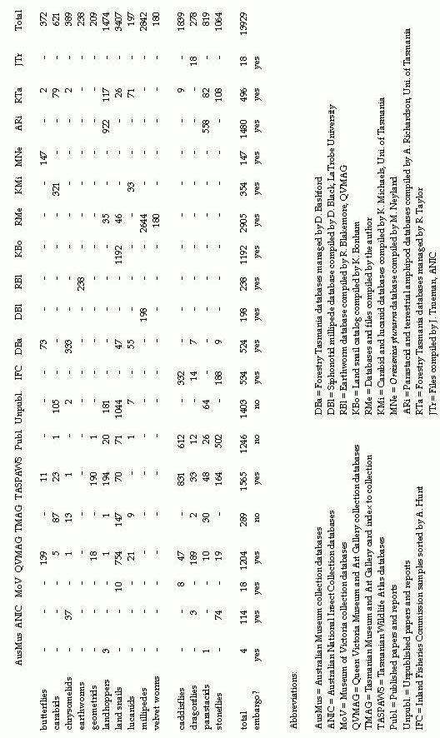
Table 2: Summary by group of the project database and the reduced database of OKSOs (one kilometre square occurances).
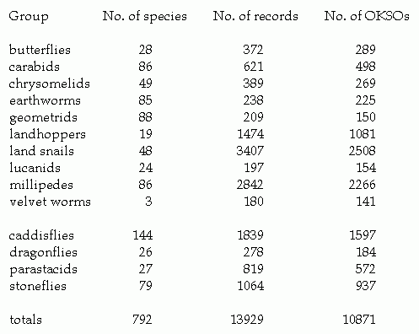

Appendix C: Maps
Map 1. Geographical coverage of CRA butterfly records. Black dots are one kilometre squares containing at least one OKSO. Coverage is 203 one kilometre squares.
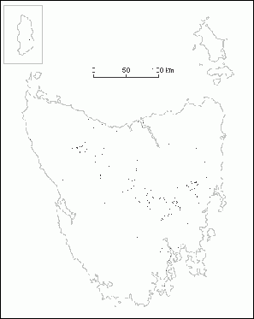

Map 2. Geographical coverage of CRA carabid beetle records. Black dots are one kilometre squares containing at least one OKSO. Coverage is 150 one kilometre squares.
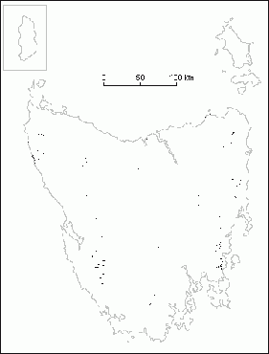
Map 3. Geographical coverage of CRA chrysomelid beetle records. Black dots are one kilometre squares containing at least one OKSO. Coverage is 91 one kilometre squares.
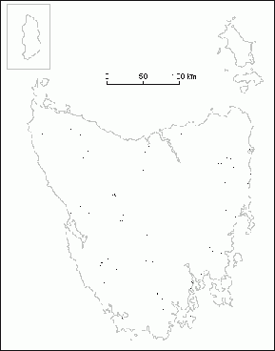
Map 4. Geographical coverage of CRA earthworm records. Black dots are one kilometre squares containing at least one OKSO. Coverage is 133 one kilometre squares.
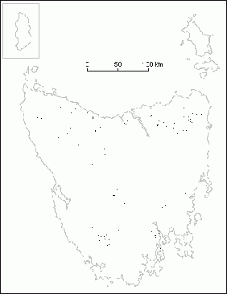
Map 5. Geographical coverage of CRA geometrid moth records. Black dots are one kilometre squares containing at least one OKSO. Coverage is 20 one kilometre squares.
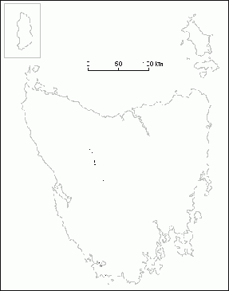
Map 6. Geographical coverage of CRA landhopper records. Black dots are one kilometre squares containing at least one OKSO. Coverage is 508 one kilometre squares.
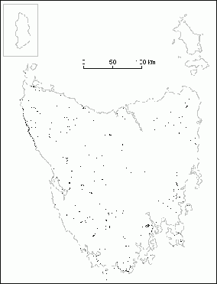
Map 7. Geographical coverage of CRA land snail records. Black dots are one kilometre squares containing at least one OKSO. Coverage is 858 one kilometre squares.
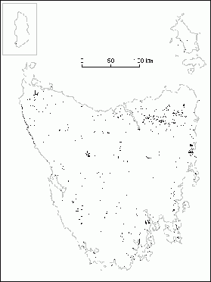
Map 8. Geographical coverage of CRA lucanid beetle records. Black dots are one kilometre squares containing at least one OKSO. Coverage is 120 one kilometre squares.
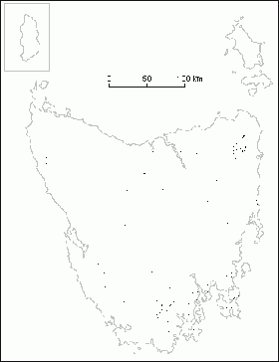
Map 9. Geographical coverage of CRA millipede records. Black dots are one kilometre squares containing at least one OKSO. Coverage is 1033 one kilometre squares.
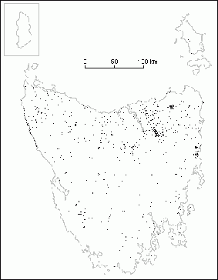
Map 10. Geographical coverage of CRA velvet worm records (three species only). Black dots are one kilometre squares containing at least one OKSO. Coverage is 137 one kilometre squares.
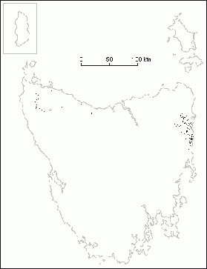
Map 11. Geographical coverage of CRA caddisfly records. Black dots are one kilometre squares containing at least one OKSO. Coverage is 394 one kilometre squares.
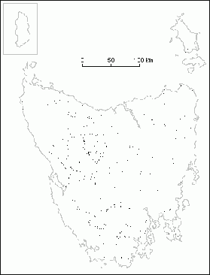
Map 12. Geographical coverage of CRA dragonfly records. Black dots are one kilometre squares containing at least one OKSO. Coverage is 83 one kilometre squares.
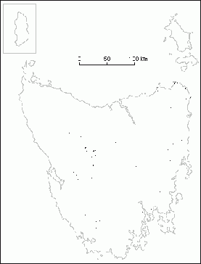
Map 13. Geographical coverage of CRA parastacid crustacean records. Black dots are one kilometre squares containing at least one OKSO. Coverage is 497 one kilometre squares.
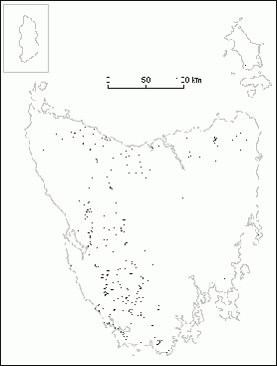
Map 14. Geographical coverage of CRA stonefly records. Black dots are one kilometre squares containing at least one OKSO. Coverage is 381 one kilometre squares.
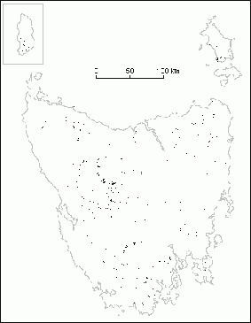
Map 15. Some biogeographical features (see section 3.1.1 for explanation).
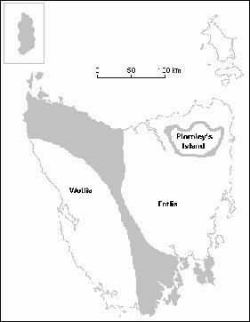

Map 16. A provisional map of invertebrate bioregions (see section 3.1.2 for explanation).
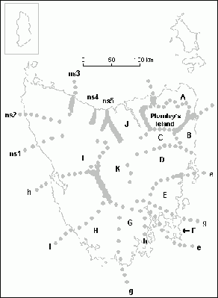

Map 17. Approximate location of the Tyler’s Line Break. Grid squares are 10 x 10 km.
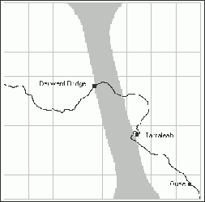

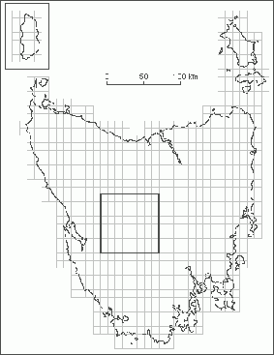

Map 18. Approximate locations of the East Tamar Break (left) and the Goulds Country Break (right). Grid squares are 10 x 10 km. For a detailed mapping of the southern portion of the East Tamar Break, see Mesibov, R., ‘A zoogeographical singularity at Weavers Creek, Tasmania’, Memoirs of the Museum of Victoria (in press).
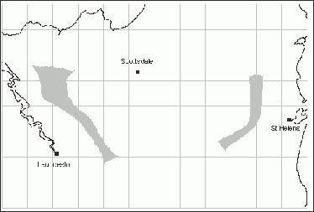
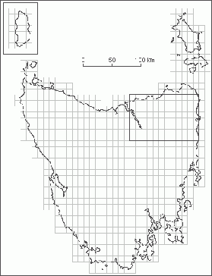
Map 19. Approximate location of north coast faunal breaks. W = Wynyard Break, L = Leven Break, D= Don Break, B = Bridport Gap. Grid squares are 10 x 10 km.

Map 20. The recorder effect in the Cradle Mountain area (see section 3.3.2). Grid squares are 1 x 1 km, black figures are numbers of species. The central one kilometre square has 68 species in the project database, the highest figure for any one kilometre square in Tasmania. At the centre of the map are the junctions of the Overland Track (to the west and south), the track from Patons Road (to the northwest), the Mt Oakleigh track (to the north), Innes Track (to the east) and the Mt Thetis/Mt Ossa track (to the southwest). The central square is the site of Pelion Hut and huts used by visiting investigators when sampling the invertebrate fauna of the Tasmanian Wilderness World Heritage Area.
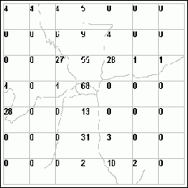

Map 21. Importance of remnants in biogeographical studies (see section 3.3.4). The map shows an area near Mt Horror in northeast Tasmania (summit of Mt Horror marked by asterisk at right centre) . Black lines are major streams, grid squares are 1 x 1 km and north is at the top. The row of black dots is the approximate location of the parapatric boundary between the burrowing crayfish Engaeus leptorhynchus (to the southeast) and E. mairener (to the northwest) (data from Horwitz, in press). The paired rows of gray dots enclose the parapatric zone between the millipedes Lissodesmus adrianae (to the southeast) and Lissodesmus sp. E1 (to the northwest) (unpublished results of the author). All four species are widespread in the Northeast. The faunal divide, which cuts across several major streams, is not obviously correlated with environmental features. Shaded areas on the map show approximate locations in 1994 of pasture, recently clearfelled native forest and Pinus radiata and eucalypt plantations. Unshaded areas are native forest.
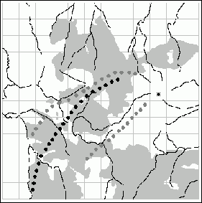

Map 22. Distribution of OKSOs for caddisflies, dragonflies, parastacid crustaceans and stoneflies among 10 km grid squares which are at least half land. The OKSO distribution has been divided into three more or less equally populated classes and shaded accordingly: light shading = 126 squares with 1 or 2 OKSOs, medium shading = 114 squares with 3 - 6 OKSOs, dark shading = 114 squares with 7 - 163 OKSOs. Blank squares either have no freshwater-group OKSOs in the project database or are less than half land.
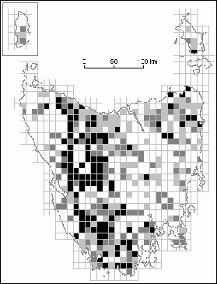

Map 23. Distribution of OKSOs for butterflies, carabid and chrysomelid beetles, earthworms, geometrid moths, land snails, landhoppers, lucanid beetles, millipedes and selected velvet worms among 10 km grid squares which are at least half land. The OKSO distribution has been divided into three more or less equally populated classes and shaded accordingly: light shading = 154 squares with 1 - 3 OKSOs, medium shading = 166 squares with 4 - 12 OKSOs, dark shading = 168 squares with 13 - 149 OKSOs. Blank squares either have no terrestrial-group OKSOs in the project database or are less than half land.
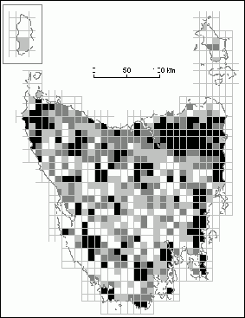

Map 24. ‘Worst of the worst’ 10 km squares for caddisfly, dragonfly, parastacid crustacean and stonefly records (see text for explanation). The distribution of nearest-neighbour OKSO averages has been divided into three more or less equally populated classes and shaded accordingly: dark shading = 139 squares with average 0 - 0.86, medium shading = 156 squares with average 0.88 - 2.50, light shading = 145 squares with average 2.57 - 30.38. Blank squares either have more than two freshwater-group OKSOs in the project database or are less than half land.
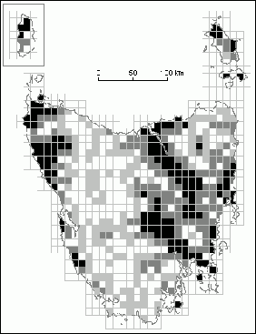

Map 25. ‘Worst of the worst’ 10 km squares for butterfly, carabid and chrysomelid beetle, earthworm, geometrid moth, land snail, landhopper, lucanid beetle, millipede and selected velvet worm records (see text for explanation). The distribution of nearest-neighbour OKSO averages has been divided into three more or less equally populated classes and shaded accordingly: dark shading = 98 squares with average 0 - 3.13, medium shading = 96 squares with average 3.25 - 6.25, light shading = 99 squares with average 6.38 - 41.13. Blank squares either have more than two terrestrial-group OKSOs in the project database or are less than half land.
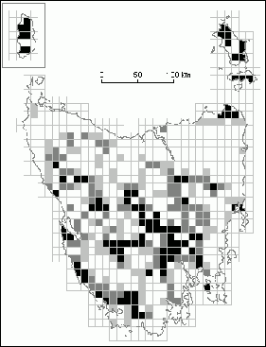

Map 26. High-priority squares for new recording of freshwater and terrestrial invertebrates. The squares with the darkest shading in Maps 24 and 25 (lowest nearest-neighbour OKSO averages) are marked again here, with medium shading for squares on one map only, and dark shading for squares on both maps.
