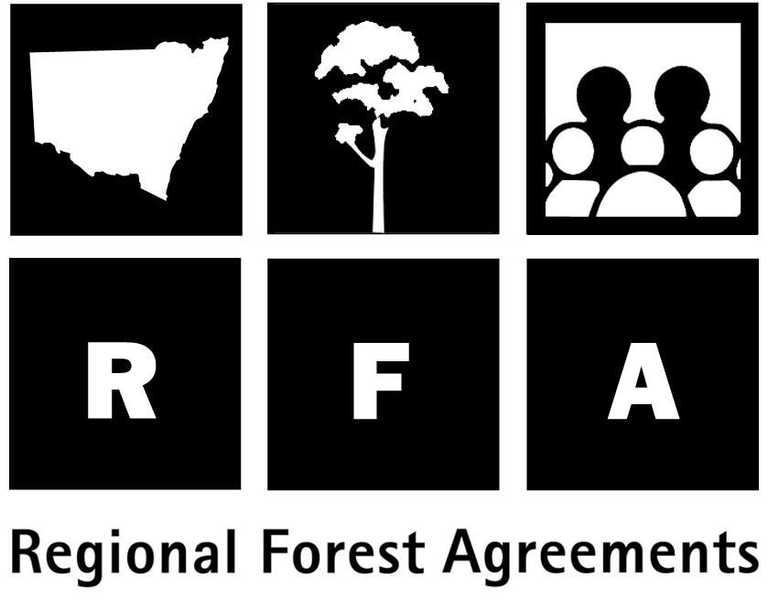 Options for a Southern RFA

Background

The Regional Forest Agreement (RFA) for the Southern region of New South Wales is one of a series of agreements being developed between the Commonwealth and New South Wales governments on the future use and management of the State’s native forests.

The RFA will be a framework for managing the forests for 20 years. It aims for both a world-class reserve system and an internationally competitive, ecologically sustainable forest industry. It will be finalised by 31 March 2000.

Public consultation

The Commonwealth and NSW governments undertook a first round of public consultation in October and November 1999 with the release of background information and an invitation to comment on issues relating to the development of an RFA for the Southern Region. Information sessions were conducted with the Southern Regional Forest Forum and the broader regional community.

Options

Governments took public submissions and stakeholder views into account in developing options for a comprehensive, adequate and representative (CAR) reserve system in the Southern RFA region. There are five options for the South Coast sub-region and one for the Tumut sub-region. They provide for large, high quality sawlog supply from State Forests ranging from 32,000 cubic metres to 65,000 cubic metres per year in the South Coast sub-region and 48,000 cubic metres in the Tumut sub-region.

None of the options necessarily represents the preferred position of either government. Fact sheets outlining each option describe and compare their environment and heritage, economic and social implications.

The CAR reserve system

The RFA will establish a Comprehensive, Adequate and Representative (CAR) reserve system based on nationally agreed “JANIS” criteria for the protection of forest biodiversity, old-growth and wilderness values.
The criteria aim to reserve, where practicable:

- 15 per cent of the estimated extent of each forest ecosystem prior to European arrival;
- at least 60 per cent of old-growth forest; and
- 90 per cent or more of high quality wilderness.

Other criteria deal with representativeness, rare species, geographic variation and other factors important for long term conservation. The CAR reserve system will include:

- Dedicated reserves (national parks, nature reserves, flora reserves);
- Informal reserves on State forests (such as forest management zones) and crown lands (Crown Reserves); and
- Forest management prescriptions under NSW Integrated Forestry Operations Approvals.

All the proposed reserve designs, except that delivering 32,000 cubic metres per annum, could be readily implemented as they take account of such considerations as leasehold lands, areas under Aboriginal land claims in relation to the NSW Native Title Act 1994 and areas of high mineral potential.

What happens now?

Your views are invited on the options presented here and on any other issues you consider should be addressed in the Southern RFA. Both governments will take into account submissions received during this consultation phase before making a final decision for the Southern Regional Forest Agreement.

You can send submissions to: Resource and Conservation Division
Dept of Urban Affairs and Planning
GPO Box 3927, SYDNEY NSW 2001

Submissions close on 25 February 2000.

Where can I find more information?

Reports and data prepared for the Southern RFA can be viewed on the Internet with other RFA background material at www.rfa.gov.au

Further information sessions in the region during February will be advertised in the local media. If you have any further queries please contact:

Forests Taskforce
Department of the Prime Minister and Cabinet
Phone: 1800 650 983
Fax: 02 6271 5511

Resource and Conservation Division
Department of Urban Affairs and Planning
Phone: 02 9228 3166
Fax: 02 9228 4967

The Southern Region

An area of about six million hectares from the edge of the Sydney basin to the Victorian border and west almost to Albury has been studied for the scientific comprehensive regional assessment (CRA). This Southern CRA Region includes three sub-regions – South Coast, Tumut and Northern. (It excludes the Eden region, which is covered by its own Regional Forest Agreement).

As illustrated in the accompanying map, the Southern RFA will cover the 4,513,000 hectares in the lower part of this region – that is, the South Coast and Tumut sub-regions. Following completion of the Southern RFA, the assessments undertaken for the northern area will be used in a process designed to achieve similar levels of certainty for industry and the environment.

About 45 per cent of the RFA region is public land, of which about 80 per cent is forested. The remaining 55 per cent is private land, about 30 per cent of which is forested. Overall, about 53 per cent of the region is forested.

National parks (1,032,500 hectares, or 25 per cent of public land), State forest (643,200 hectares) and Crown reserves (including leasehold) managed by the Department of Land and Water Conservation (361,500 hectares) currently total 2,037,200 hectares.

The comprehensive regional assessment of the social, economic, environmental and cultural heritage values of the region’s native forests included more than 50 technical projects undertaken over three years with the participation of key forest stakeholders and the regional community, including through the Southern Regional Forest Forum.

Findings are summarised below. These, along with feedback from public submissions, provided the basis for the options now circulating for consultation.

The timber industry

The Southern RFA region produces about 28 per cent of the State’s hardwood sawlogs and 17 per cent of pulp logs.

Twenty-two hardwood mills source logs from the region, 10 of which processed public hardwood timber purchased from State Forests of NSW in 1998/99.

Fifteen hardwood mills sourced timber from the South Coast sub-region in 1998/99. Seven of these mills processed 41,776 cubic metres of large high quality hardwood sawlogs. Those seven mills, together with two other mills located outside the South Coast sub-region, processed a total of 136,155 cubic metres of hardwood across all product classes sourced from public forests in 1998/99. Six other mills that source timber exclusively from private land processed 42 per cent of the estimated 25,600 cubic metres of sawlogs sourced from private property in 1998/99.

The value of production across all 15 mills in 1998/99 was approximately $18 million, with mills sourcing from public lands accounting for approximately $15.7 million of this figure. Direct employment in the hardwood industry in the sub-region (including employment associated with fall, snig and load operations) was estimated to be 206 people across all mills, with public timber mills accounting for employment of 177 people.

In 1998/99, three mills in the Tumut sub-region processed public hardwood timber purchased from State Forests. State Forests of New South Wales’ supply commitments to these mills that year included 38,702 cubic metres of large high quality hardwood sawlogs as part of a total supply of 48,667 cubic metres of hardwood across all product classes. Using this resource, the three mills generated a gross value of output of approximately $5.4 million and employed 64 people (including employment associated with fall, snig and load operations). One other mill in the sub-region processed timber exclusively from private property.

The certainty provided by the RFA will encourage investment in new technologies and promote value-adding initiatives to make better and more efficient use of the timber resource.

Economic Models

Economic analysis was undertaken using three economic models capable of predicting changes in employment and economic activity at different wood supply levels. It should be noted that these models will only provide an indication of the possible effects of changes to wood supply. Actual outcomes may differ, as decisions will reflect the full range of factors on which commercial decisions are based.

Wood Volumes

In the South Coast sub-region, the existing State forest tenure could provide a deliverable volume of 70,000 cubic metres of large high quality sawlogs annually for the first 20 years, and then between 42,500 cubic metres and 65,500 cubic metres (averaging 56,000 cubic metres) of large high quality sawlogs annually from 20 to 200 years.

In the Tumut sub-region, the existing State Forest tenure could provide 49,500 cubic metres of large high quality sawlogs annually for 200 years.

Hardwood and softwood plantations

There are approximately 180,000 hectares of exotic softwood plantations in the Southern CRA region, of which 48,000 hectares are privately owned. The balance is State-owned and managed by State Forests of New South Wales. Pinus radiata accounts for over 98 per cent of the plantation area. There are only about 40 hectares of hardwood plantation on State forest in the region, and no private hardwood plantations greater than 10 hectares. A CRA study of plantation potential of cleared private land in the Southern region found there are approximately 431,000 hectares capable of growing Pinus radiata, rated at medium or high productivity. Economic analysis indicated 163,000 hectares would also be economically suitable (as compared to current land use) for softwood plantation establishment. While approximately 100,000 hectares were identified as of medium or high productivity for hardwood plantation establishment, only 1,300 hectares were assessed as being economically suitable under the most optimistic scenario.

Thirty thousand hectares of softwood plantations are expected to be established in the Tumut area over the next 10 years to support a major new pulpwood industry.

Other forest industries

Apiary
The forests of the CRA region as a whole produce approximately 2,400 tonnes of honey with a wholesale value of $3.9 million per annum. Wax and other products directly related to this production are worth another $200,000 per annum.

Mining
Construction material extraction is a significant mining activity in the Southern RFA region, worth approximately $97 million in 1997/98. About 260 quarries operate in the region, mostly in unforested land. The largest operations are at Marulan (limestone) and Berrima (coal).

Minor forest products
Timber and other minor products from the region’s forests, mostly from coastal management areas, include fencing timber, mining props, landscape timbers, craftwood supply, firewood, seed, bark and leaves for oil extraction.

Tourism
Tourism and recreation are important industries, with visitors spending approximately $1 billion in the region in 1996/97 on both nature-based and other tourism and recreation activities.

In 1998/99, about 420,000 visits to State forests and approximately 2.34 million to national parks in the South Coast sub-region were estimated to be worth between $48 million and $69.2 million.

In the Tumut sub-region in1998/99, including during the Kosciusko National Park winter season, there were approximately 1.06 million visitors to national parks and 70,000 visitors to State forests. Visits to national parks generated approximately $25 million and visits to State forests generated approximately $1.7 million.

People and communities

Approximately 258,000 people live in the Southern CRA region. The main employers for the 118,000 people in the workforce in 1996 were retailing, manufacturing, and health and community services. In 1998/99, almost 300 people were employed in the harvesting, hauling and milling of hardwood in the Tumut and South Coast sub-regions. While employment in the harvesting and milling of timber in the hardwood and softwood industries together decreased by 11 per cent in the South Coast sub-region between 1991 and 1996, activity in these industries in the Tumut sub-region increased by 35 per cent over the same period. This increase was largely due to an increase in softwood industry activities.

The Southern Social Assessment found that the region has an ageing population with high levels of unemployment, generally lower than average median income and, in the coastal areas, high numbers of retirees. These factors, coupled with recent decline in the provision of services and infrastructure, a low level of industry diversity and a decline in community unity have affected the communities’ ability to adapt to change. Of the six communities studied in detail, Wandandian, Tumbarumba, Narooma, and Ulladulla were found to be particularly vulnerable to change.

Community members interviewed as part of the social assessment believed further development is necessary to sustain their service and infrastructure base. The communities of Tumut, Tumbarumba, Wandandian and Ulladulla have lobbied for retention of vital services and facilities. Interviewees reported that the softwood industry in the Tumut sub-region and seasonal tourism across the region have contributed positively to their communities. The development of the Visy Pulpwood Mill is also likely to be beneficial to Tumut's economic development.

Environment values

The tables included in this information kit provide detailed information on levels of protection for environment and heritage values.

Forest Ecosystems
Assessments in the Southern RFA region have identified 159 forest ecosystems in the RFA region, including 107 represented in the South Coast sub-region and 75 represented in the Tumut sub-region.

All of the 107 forest ecosystems represented in South Coast sub-region were assigned JANIS targets. Nine of these features had a zero achievable target (that is, they are not represented on public lands available for reservation). In the Tumut sub-region, 74 forest ecosystems were assigned JANIS targets, five of which had a zero achievable target. The remaining one forest ecosystem, having no extant distribution (that is, it no longer occurs), was not assigned a JANIS target. Features having an achievable target of zero were excluded from the summary reporting.

Of the forest ecosystems with achievable targets, 39 represented in the South Coast sub-region, and 33 represented in the Tumut sub-region, had targets that could not be achieved on public land alone.

Old Growth

Assessments in the Southern RFA region have identified 101 old growth forest ecosystems, including 62 represented in the South Coast sub-region and 58 represented in the Tumut sub-region. The most extensive tracts of old growth forest are in existing reserves on the escarpment (Deua and Morton National Parks). Old growth forest in the coastal environments is less extensive and more fragmented.

Fifty-six old growth forest ecosystems represented in the South Coast sub-region were assigned JANIS targets: the remaining six being non-eucalypt forest features or having no actual extant distribution. In the Tumut sub-region, 50 old growth forest ecosystems were assigned JANIS targets, two of which had a zero achievable target. The remaining eight old growth forest ecosystems, being non-eucalypt forest features or having no extant distribution, were not assigned JANIS targets. Features having an achievable target of zero were excluded from the summary reporting.

Of the old growth forest ecosystems with achievable targets, 22 represented in the South Coast sub-region and 19 represented in the Tumut sub-region had targets that could not be achieved on public land alone.

Threatened species

More than 130 priority plant species and 180 animal species were assessed in the Southern RFA region.

Animals include the tiger quoll, the powerful owl, the eastern false pipistrelle bat and the Booroolong frog. Plants include the Pimelia humilis which was found in the Southern CRA survey for the first time since its only previous documented record early in the 20th Century.

Wilderness
Both the State and Commonwealth Governments have requirements to assess wilderness.
Wilderness assessments in the region under the NSW Wilderness Act are now complete with 16 study areas totalling 316,400 hectares found to meet the wilderness criteria. These areas are termed provisionally identified wilderness and are in addition to the 481,650 hectares of declared wilderness in the region. Provisionally identified wilderness areas were considered in developing the options. NSW Government decisions on wilderness declaration will follow public exhibition of the assessment results including wilderness declaration options. Provisionally identified wilderness will also be considered in finalising the RFA.

Wilderness has also been measured according to the ‘JANIS’ criteria based on the National Wilderness Inventory (NWI). The criterion is to reserve 90 per cent or more of the region’s high quality wilderness, defined as NWI wilderness with a minimum rating of 12 and minimum area requirements. There are 860,500 hectares of this wilderness in the RFA region, of which 358,750 hectares is in the South-Coast sub-region and 501,750 is in the Tumut sub-region. Eighty-seven per cent of wilderness occurs in existing reserves across the RFA region, including 77 per cent in the South Coast sub-region and 94 per cent in the Tumut sub-region.

Indigenous interests

Forested landscapes contain much evidence of Aboriginal use of and spiritual link to the land, which can be protected through:
- the protection of Aboriginal sites and artefacts; and
- the maintenance of natural forest values.

The RFA will address current forest management practices in relation to Indigenous interests. The NSW National Parks and Wildlife Service and State Forests of NSW are reviewing Indigenous cultural heritage management in consultation with Aboriginal communities, aiming to develop systems that better consider the landscape context of sites and that provide for efficient protection and greater involvement of Aboriginal communities in decision making.

Due to a number of factors, including the opening of a new mill during 1998/99, actual wood volumes processed for 1998/99 were below committed levels. It is estimated that, had the committed timber been fully utilised, as would be expected in a normal year, the gross value of output for the public crown hardwood timber industry would be approximately $7.3 million with direct total employment of 83 people.

