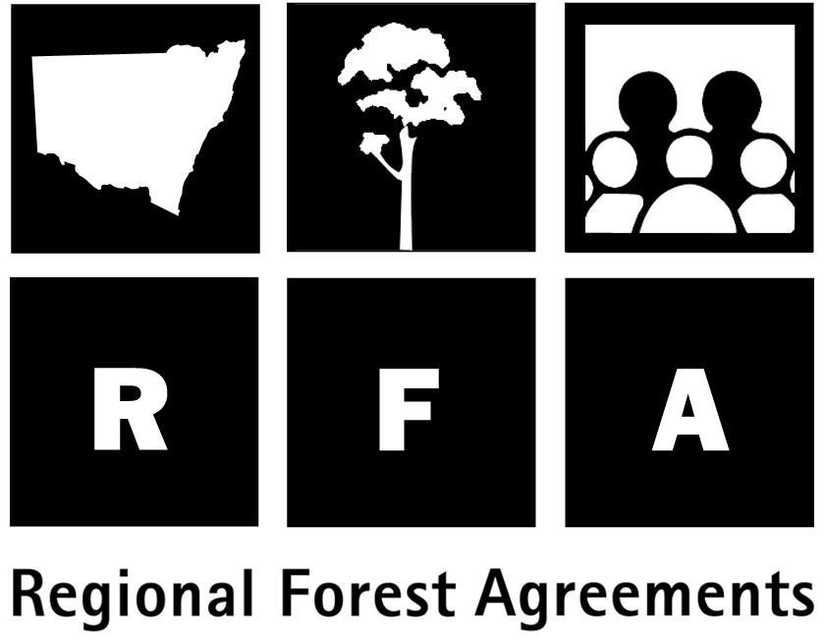 Future forest management

Ecologically Sustainable Forest Management

The Eden RFA will be in place for 20 years, with provision for five-yearly reviews. Ecologically Sustainable Forest Management (ESFM) of both reserves and production forests is a key objective of the agreement.

The RFA recognises that many of the existing NSW processes and regulations for the Eden region are designed to ensure the region’s forests are managed sustainably, and that these systems and processes provide a sound basis for further development of integrated, complementary and strategic systems capable of responding to new information.

The NSW Forestry and National Park Estate Act 1998 forms the principal framework for managing NSW forests. The Act enables NSW Ministers to make Forest Agreements for each CRA/RFA region and to grant Integrated Forestry Operations Approvals (IFOAs) for the operational aspects of timber harvesting.

Under the RFA, NSW will undertake a number of forest management improvements, including:

- The development of regional ESFM Plans.
- The development by the National Parks and Wildlife Service (NPWS) of an Environmental Management System (EMS) for lands dedicated under the National Parks and Wildlife Act 1974.
- The development by State Forests of NSW of an EMS (called the Native Forest Management System) for its lands.
- The cooperation of NPWS and State Forests in the development of feral and introduced predator control programs and noxious weed control programs. They will also prepare joint arrangements for bushfire prevention, detection and suppression. State Forests will prepare a grazing management plan.
- The preparation by State Forests of management plans for large areas of rainforest, high conservation value old growth and other areas of State forest excluded from production by forest management prescription and informal reserves.
- The preparation by NPWS of plans of management for dedicated reserves under the National Parks and Wildlife Act and Crown reserves.
- The implementation by State Forests of a Forest Management Zoning system.
- The monitoring of and reporting on a number of ESFM criteria and indicators.
- The development of a framework for evaluating forest conservation and management systems, including auditing of compliance with IFOAs and codes of practice.
- The adoption of the NSW Biodiversity Strategy.
- The establishment of regional Vegetation Management Plans and Codes of Practice for timber harvesting for private land.
- The documentation of the basis for silvicultural practices and the publication (by 31 March 2000) of silvicultural guidelines for commercial forest types.

- The development of cultural heritage management guidelines which will include protection for the National Estate and Indigenous heritage.

- The adoption of five yearly reviews of sustainable yield.

- The development of an information management system as well as other coordinating mechanisms to improve sharing of data and integration of management between all levels of government.

