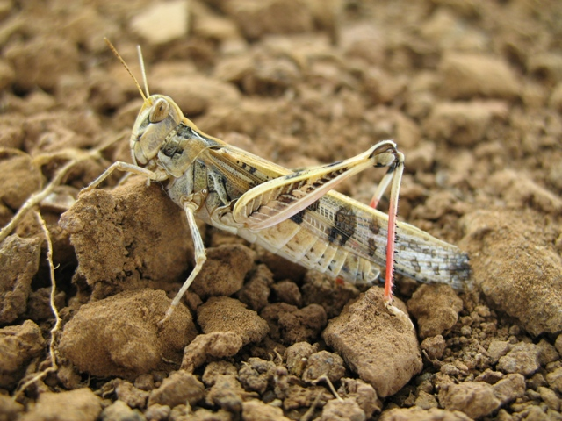

AUSTRALIAN PLAGUE

LOCUST COMMISSION

ANNUAL

REPORT

2016–17

**J:\APLC\APLC-Common\Logos\black\APLC_Logo.tif**

A joint venture of the Australian Government and the Member States of New South Wales, Victoria, South Australia and Queensland.

Contents

[Introduction 1](#_Toc503422963)

[APLC Charter 1](#_Toc503422964)

[Director’s Report: 2016–17 2](#_Toc503422965)

[Overview of 2016–17 locust situation 4](#_Toc503422966)

[Australian plague locust 4](#_Toc503422967)

[Spur-throated locust 8](#_Toc503422968)

[Migratory locust 8](#_Toc503422969)

[Achievement of Key Performance Indicators 10](#_Toc503422970)

[Operations 13](#_Toc503422971)

[Survey and Monitoring 13](#_Toc503422972)

[Forecasting and information 13](#_Toc503422973)

[Control operations and pesticide use 15](#_Toc503422974)

[Organisational Management 16](#_Toc503422975)

[Staffing 16](#_Toc503422976)

[Workplace Health & Safety 16](#_Toc503422977)

[Competency based training and assessment 16](#_Toc503422978)

[Environmental Management System 17](#_Toc503422979)

[International linkages 19](#_Toc503422980)

[Administration 20](#_Toc503422981)

[Governance 20](#_Toc503422982)

[Financial Management 21](#_Toc503422983)

[Research 24](#_Toc503422984)

[Purpose and research areas 24](#_Toc503422985)

[Research and Development Collaborations 24](#_Toc503422986)

[Summaries of research in progress 26](#_Toc503422987)

[Publications 30](#_Toc503422988)

[Appendix 1: APLC Commissioners 2016–17 31](#_Toc503422989)

[Appendix 2: 2016–17 Australian plague locust situation report for each Member State 32](#_Toc503422990)

**Figures**

[Figure 1: Australian plague locust distribution October 2016 5](#_Toc503355254)

[Figure 2: Australian plague locust distribution December 2016 6](#_Toc503355255)

[Figure 3: Australian plague locust distribution February 2017 7](#_Toc503355256)

[Figure 4: Spur-throated locust distribution February – March 2017 9](#_Toc503355257)

[Figure 5: APLC 2016-17 ground survey coverage and intensity 14](#_Toc503355258)

[Figure 6 : Colony growth of Metarhizium acridum (Greenguard) on agar plates with various carbohydrate, protein and fat profiles. 28](#_Toc503355259)

**Tables**

[Table 1 : APLC performance against KPI measures 10](#_Toc503355303)

[Table 2 : Locust control agent stocks 2016-17 15](#_Toc503355304)

[Table 3 : APLC Environmental Management System conformance 17](#_Toc503355305)

[Table 4 : APLC 2016-17 financial performance report 22](#_Toc503355306)

[Table 5 : Cost Sharing of Approved 2016-17 Budget 22](#_Toc503355307)

[Table 6 : APLC Reserve Fund Reconciliation 23](#_Toc503355308)

# Introduction

The Australian Plague Locust Commission was established in 1974 and began operations in late 1976. The Commission is financed by the Member States of New South Wales, Victoria, South Australia and Queensland, with a matching contribution from the Australian Government. Funding allocations from the Member States are in proportion to the agreed benefit delivered to that state by APLC operations, while the Australian Government contribution reflects the broader national benefit derived from APLC activities. These five governments constitute the Member Parties of the Commission.

## APLC Charter

A Memorandum of Understanding (MOU) was signed between the Member Parties in 2002, and incorporates a Charter that replaced the original terms of reference under which the APLC had operated since its establishment.

The purpose of the APLC, as defined in that Charter, is “to control locust populations in those situations where they have the potential to inflict significant damage to agricultural industries in more than one Member State.” In fulfilling its charter the APLC is required to:

* implement a preventive control strategy to minimise economic loss to agricultural industries caused by the Australian plague locust, spur-throated locust and migratory locust, with priority given to Australian plague locust
* minimise risk of locust control to the natural environment, human health and markets for Australian produce
* develop improved locust management practices through a targeted research program
* provide a monitoring and forecasting system for operations conducted by APLC and Member States
* promote and facilitate adoption of best practice in locust control by Member States
* participate in cooperative national and international programs for development of APLC expertise
* continually review APLC operations to ensure they keep pace with the expectations of industry, community and government.

# 

# Director’s Report: 2016–17

The 2016-17 locust season commenced with some isolated areas of over-wintering locusts but, despite some favourable rainfall and habitat conditions early in the season, no significant locust population materialised during the season. As a consequence, APLC operations were again limited to a somewhat reduced survey effort, with no prospect of any control activity required. This represents the fifth consecutive season with a limited widespread locust population in the Commission’s area of operations.

The protracted sequence of limited locust populations and absence of control activities presents an ongoing challenge to skills development and retention within APLC, particularly for field staff. The opportunity to develop and demonstrate competency in various aspects of field survey (such as delimitation of high density infestations) has been absent for several years. Similarly, the lack of locust control activities has meant that field officers cannot gain the experience of being part of a control campaign, while field base officers-in-charge cannot develop or refresh their experiences in managing a control campaign. Should no reasonable opportunity present itself in the following 2017-18 season, alternative training approaches such as simulation will need to be considered to ensure that APLC officers at all levels develop and retain some levels of the skills which are essential to the Commission’s role as an experienced rapid response group.

After a lengthy process to identify and address the risks associated with APLC’s low level helicopter operations, and the development of new protocols and measures to implement risk treatments, all APLC Member Parties formally agreed to accept the residual risk levels associated with these operations. While there has been no need to undertake low level helicopter operations (principally used for adult locust swarm survey and control) for some years, the return of this option to the Commission’s operational capacity will ensure that the most flexible and effective approach can be taken in managing locust infestations.

The aerial services tendering process commenced in 2015 was brought to its conclusion, with contracts negotiated and completed for all 16 operators identified as suitable through the tendering process.

The vacancies which existed in two senior science positions (Applications Officer and Research Entomologist) have been addressed through some strategic redirection of both roles. The enduring role of Applications Officer has been segmented into an initial role focussed solely on identifying and developing alternative control agents, to be undertaken over the next five years and to be followed by an expected return to the broader, more traditional Applications Officer role. In view of the medium and longer-term needs of APLC, and the likelihood of some structural and staffing changes over that timeframe, the role of Research Entomologist has been refocussed as a Research Ecologist position. Recruitment actions for both of these redefined positions has commenced, with new appointees likely to take effect early in 2017-18.

**Focus and Challenges for 2017–18**

Should the 2017-18 season not result in a more substantial locust population, and particularly if there is no opportunity to implement even a limited control campaign aimed primarily at training, a very different approach will need to be developed to meet the training needs of APLC field and operations staff. In addition to meeting ongoing training needs, it will be necessary to adopt approaches which ensure continued engagement of staff in the operations of the Commission.



Chris Adriaansen

Director APLC

# Overview of 2016–17 locust situation

## Australian plague locust

The season commenced with an unusual winter population in Southwest Queensland. Localised high density nymphs and adults persisted in part of Southwest Queensland and the Far North region of South Australia during April and May 2016. Breeding by that population produced a widespread low and medium density nymphal population in mid-August. Surveys identified nymphs at all development stages, indicating both direct developing and diapause eggs were laid in those regions. Widespread heavy rainfall during winter and early spring throughout inland eastern Australia produced unseasonal vegetation growth in arid and summer rainfall areas and dense ephemeral pasture growth in southern New South Wales, South Australia and Victoria. Despite further heavy rainfall during summer in inland regions, this early breeding population did not result in large increases or swarm migrations to agricultural regions.

Two distinct cohorts of nymphs developed during October (Figure 1). Localised high density nymphs developed from autumn-laid eggs in small areas of Far Southwest NSW and the Flinders Ranges of South Australia. Breeding in August in Southwest and Northwest Queensland gave rise to a widespread low density nymph population in those regions and adjacent parts of northern South Australia in October. Fledging of those nymphs in late October produced widespread medium density adults, with localised higher densities and small swarms in the Arrabury area. Adult numbers were generally low in other regions. Occasional low density nymphs were recorded in other regions of Queensland and in Far West NSW.

Locust population levels remained generally low during November, despite the fledging of spring nymphs. However, migration resulted in increased adult numbers and sporadic high density egg laying in Central West NSW in mid-November. Localised hatchings occurred in December and several small bands developed in the Trangie–Dubbo area, but no swarm formation resulted (Figure 2).

There were population increases in several regions during December and January. Widespread rainfall produced favourable habitat conditions for locust breeding. A large increase in adult numbers occurred in the Far North and Northwest regions of South Australia in late January, after breeding in December (Figure 3). Low density nymphs were identified at several locations in Far West NSW. However, no significant increase in locust numbers was detected in Southwest or Central West Queensland.

Locust populations remained at low densities in most regions during March. However, medium density adult populations were maintained in the Far North region of South Australia and in parts of Southwest Queensland, as a result of further breeding in late January. Several small swarms were recorded around the North Flinders Ranges area in late March. Few nymphs were recorded during March, indicating only limited egg laying during February and populations declined to low levels by late autumn.

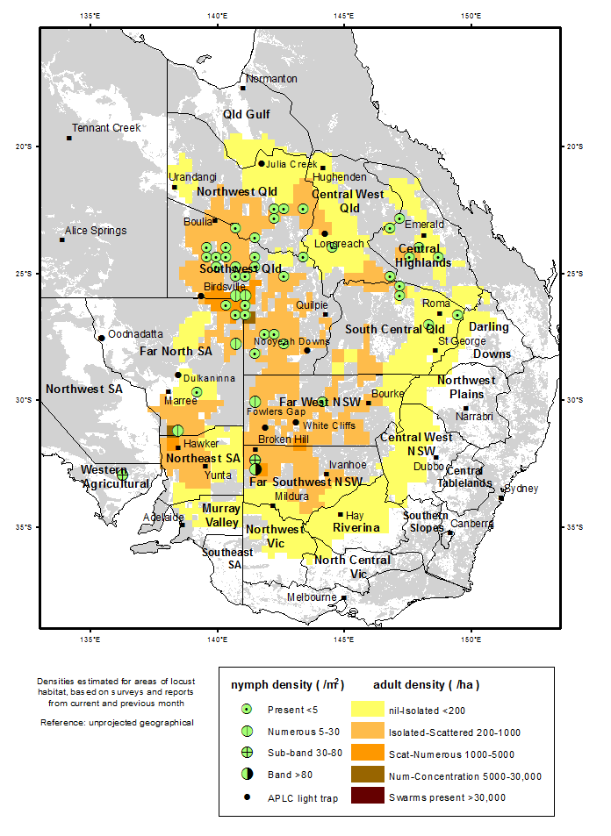

Figure 1: Australian plague locust distribution October 2016

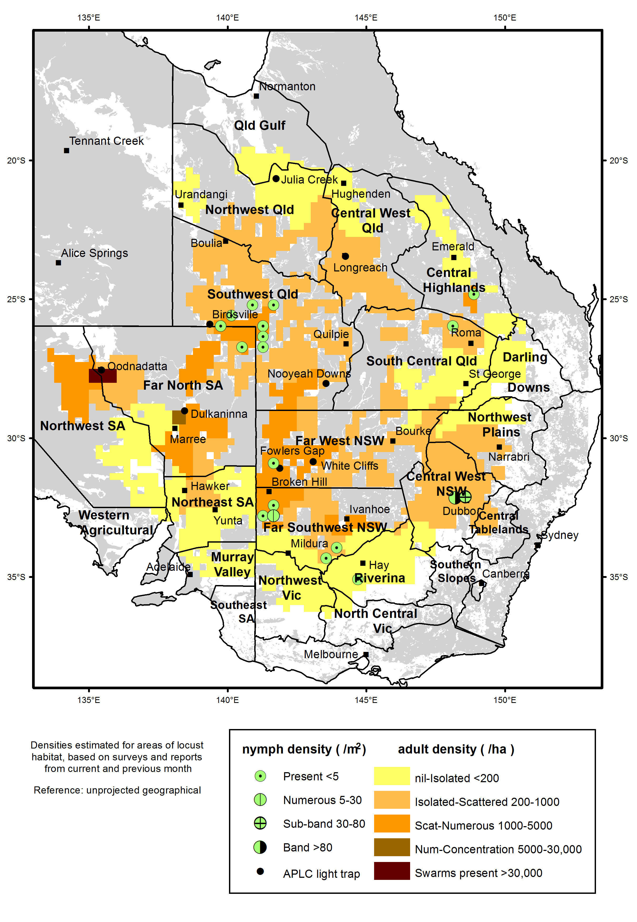

Figure 2: Australian plague locust distribution December 2016

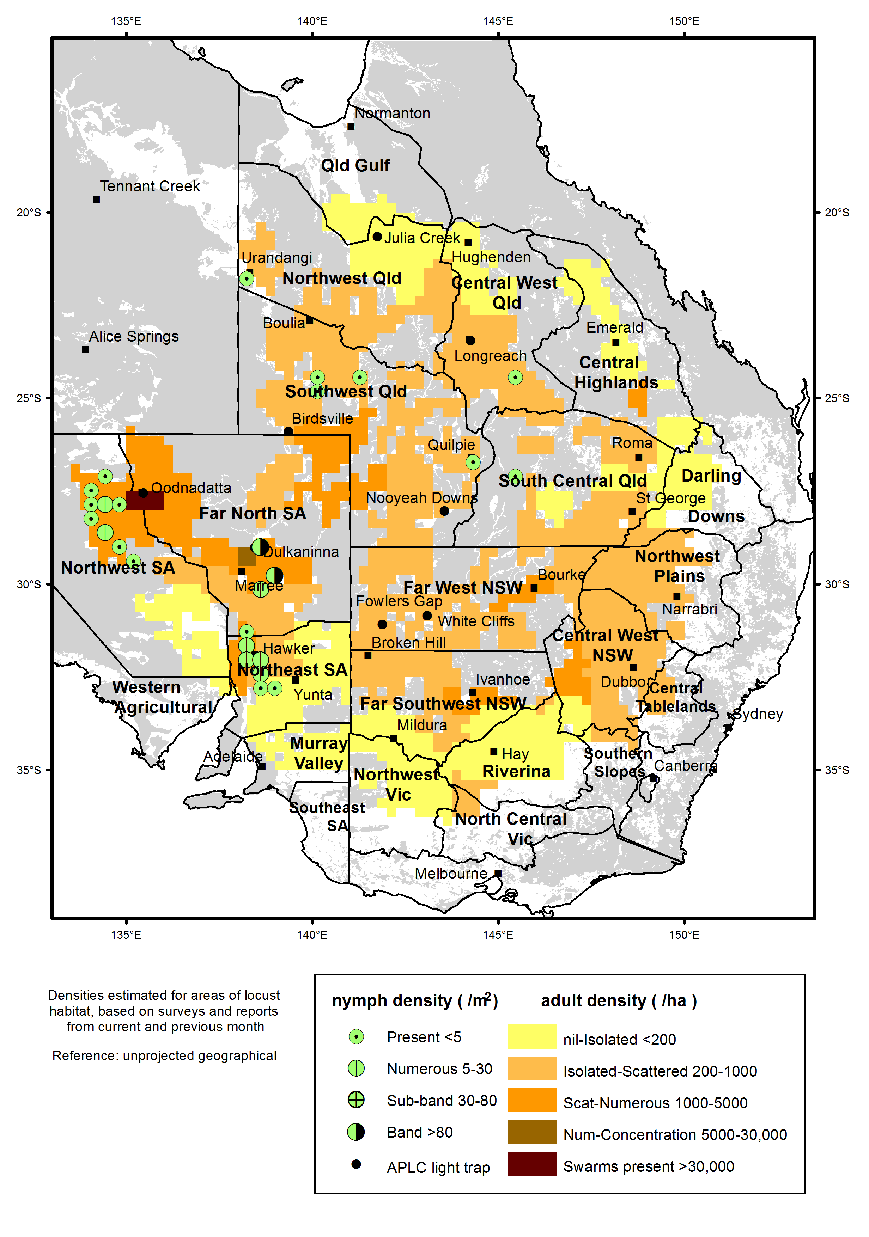

Figure 3: Australian plague locust distribution February 2017

## Spur-throated locust

Adult population levels increased markedly in Northwest, Southwest and Central West Queensland during late autumn 2016. Young adults of this species spend winter in a non-reproductive state, often forming swarms that occupy woodlands and riparian tree lines. Migrations often occur during spring and early summer and breeding usually commences after the onset of the wet season. There were several reports of swarms from the Winton–Cloncurry area during August and APLC surveys in early September identified medium and some swarm density adults in Richmond, McKinlay and Cloncurry Shires. The unseasonal winter and September rainfall in Queensland and green habitat conditions throughout inland regions appears have initiated early breeding in some locations.

Habitat conditions were favourable for early breeding in Queensland during September and October, but became relatively dry during November in areas north of 23°S. Nymphs were recorded in a few locations during October, but later surveys indicated that breeding was not widespread.

During October and November, there was a widespread medium density adult population throughout the Central West, Northwest, Central Highlands and Queensland Gulf regions. Low densities were recorded in Southwest and South Central and Central Queensland, the Far North and Northeast regions of South Australia and in Far West New South Wales. There was a population increase to medium densities in Quilpie, Paroo and Murweh Shires in November. These were likely to have redistributed from populations further north. The majority of nymphs recorded in November and December were in Southwest Queensland.

Heavy storm rainfall in most regions of Queensland during December and January allowed breeding to continue. Medium density adults and low density nymphs were identified at numerous locations in the Central West, Northwest and northern parts of the South Central region during January and February. In March, low and medium density nymphs were detected at many locations in Central West and Northwest Queensland, with low density nymphs in the Southwest, South Central and Central Highlands regions (Figure 4). However, the overall recorded autumn population level was lower than in the previous two years.

## Migratory locust

Population densities of this species remained low throughout the 2016–17 season, but a small increase in numbers was detected in Queensland during autumn. This species is persistent in the in the Central Highlands, eastern Central West and South Central regions of Queensland and produce irregular outbreaks. These regions received above average rainfall in winter and September 2016, which produced favourable habitat conditions for low density breeding. Surveys in October identified only occasional low density adults in the Buckland Plains area, Southwest of Springsure in the southern Central Highlands and in the Injune area. Occasional adults were also recorded near Alpha and Longreach in Central West Queensland.

In early December, low numbers of adults were recorded in the Emerald–Springsure, Arcadia Valley and Injune areas of the southern Central Highlands. No nymphs were detected during survey. Rainfall during December produced favourable habitat conditions for continued breeding during summer.

Low density adults were again recorded in the Springsure–Injune, Buckland Plains and Arcadia Valley districts in March. Low densities were also recorded in the Taroom area of Banana Shire and in the Roma–Mitchell area of Maranoa Regional Council area. Medium density adults were recorded at one location between Roma and Taroom. Patchy storm rainfall during each week of March, and heavy rainfall at the end of the month maintained favourable habitat conditions for continued breeding during autumn.

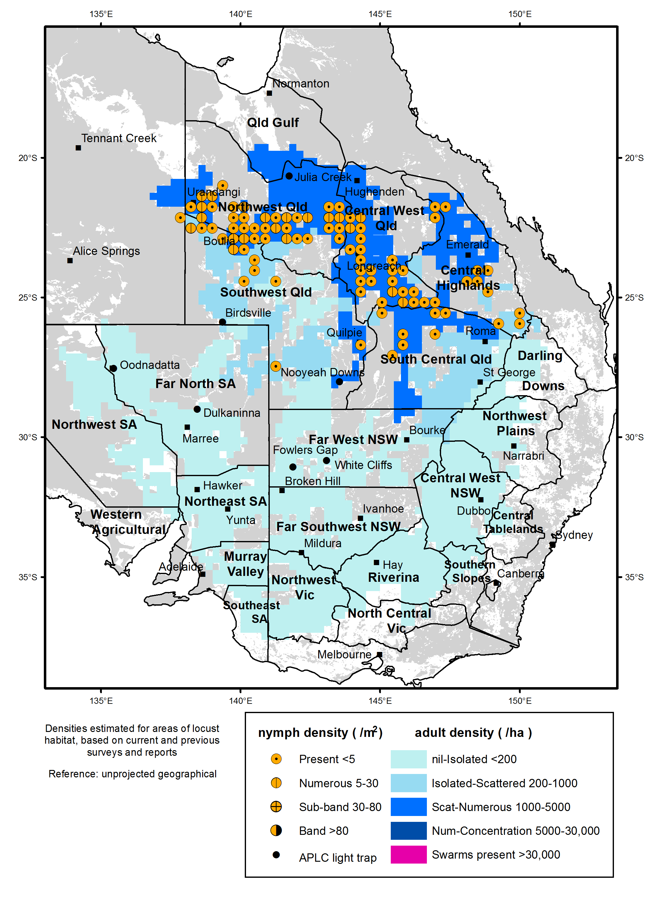

Figure 4: Spur-throated locust distribution February – March 2017

# Achievement of Key Performance Indicators

The 2005 external review of the APLC suggested a number of Key Performance Indicators (KPIs) against which the future performance of the APLC could be measured. These KPIs have been adopted with some modifications to provide additional measures for reporting on an annual basis. Details of the KPIs and performance measures, together with an assessment of the APLC’s performance in 2016­‑17 against each, are summarised in Table 1.

Table 1 : APLC performance against KPI measures

| **Key Performance Indicator** | **KPI Measures** | **Assessment/comments (2016-17)** |
| --- | --- | --- |
| Effectiveness of monitoring, prediction and control of locust populations | Significant populations detected at early-mid instar stage  Accuracy of forecasts of population scale, timing and location  Majority of control measures against nymphal stage  No adverse aerial spraying incidents | Limited populations were detected in 2016-17 , either through APLC survey or through reports received which were confirmed through subsequent survey.  Forecasts accurately indicated consistent low levels with only short-duration and localised higher density infestations.  No control activity undertaken during 2016-17  Not applicable, as no control activity. |
| Availability and effectiveness of control agents | Availability of existing agents  Replacement agents identified and application rates/techniques verified | No change to availability of current control agents.  Control agent development plan prepared, identifying several candidate agents. Full program for evaluation and verification in preparation, to be implemented from 2017. |
| Environmental impact of control | No reported/observed significant adverse impacts | No observed or reported adverse impacts due to an absence of control operations in 2016-17.  Collaborative research project with University of Wollongong and Macquarie University, funded by the Australian Research Council’s Linkage Program (LP 160100686) commenced at Fowlers Gap Research Station (NSW). Further collaborative research with CSIRO Canberra has quantified the sensitivity of the Australian native marsupial, *Sminthopsis macroura* (Gould 1845) to the phenyl pyrazole insecticide, fipronil. The publication of legacy research projects within the APLC continues. |
| Trade risks minimised | No adverse trade (residue) impacts | Not applicable, as no control activity undertaken in 2016-17. |
| Cooperation with environmental, OH&S and other relevant agencies in developing and implementing plans for control programs | Plans developed and agreed and reviewed on regular basis. | Review of various WHS documents undertaken, primarily as part of preparing new specifications and standards for aerial services tender process.  Various aerial operations risks addressed through new task protocols and operational requirements, reviewed and approved by relevant external authorities.  Several current environmental policies reviewed as part of preparing responses to national plans dealing with rare & threatened species. |
| Ensuring OH&S of APLC staff, including aerial safety | No significant OH&S incidents | No OH&S incidents were recorded. This can be attributed to sound practices and procedures as well as a very strong safety culture among all personnel. |
| Improved management practices developed through a targeted research program | Research findings incorporated into APLC control strategy and operations | Research activities (detailed in Research section of this report) are linked to key strategic issues of APLC operations, including environmental impact and locust control options.  After completion of major longitudinal ecological study, no alterations to APLC pesticide application technology are considered to be warranted.  Emphasis on analysis and publication of legacy environmental research project to facilitate incorporation into risk assessments for pesticide impacts. |
| APLC staff participation in national and international programs/scientific conferences | APLC staff invited to participate in appropriate programs and conferences | National and international scientific and technical conferences and meetings were attended and addressed. Continuing environmental research with international collaborators to enable comparison of APLC practices with international environmental benchmarks. |
| Training of member state staff | APLC training course developed and core of trained member state staff available | No training requested for Member State agency staff during 2016-17. |

# Operations

## Survey and Monitoring

Field survey for the presence and abundance of pest locust species continued throughout the 2016–17 season across the APLC area of operations and in adjacent areas of suitable habitat. Staff from APLC’s three field bases at Narromine, Broken Hill and Longreach undertook regular targeted ground surveys during the season. All field survey information was recorded and stored in a database as part of the APLC Geographic Information System (GIS).

Ground survey operations by 8 APLC field staff covered a total distance of 94,185 kilometres over the period 4 Aug 2016 to 7 Apr 2017. Field surveys focussed on the areas where locust presence was known or anticipated from previous surveys and reports, overlaid by rainfall and habitat condition information. A further level of information regarding the timing of hatching and development for the range of geographical areas was also considered in deciding the timing and location of ground surveys. Figure 5 shows the location and intensity of APLC ground surveillance was conducted during the 2016–17 season. The total effort (approximately 317 person-days) and the distance covered by survey operations in 2016-17 was lower than that recorded for 2015-16, reflecting the reduced levels of locust population across APLC’s area of operations and the generally poor habitat conditions which were present during the season.

No aerial surveillance was undertaken in 2016-17 due to the absence of any significant locust infestations.

The UNSW insect monitoring radar (IMR) at Bourke airport, NSW was in operation during the whole season, though the detection numbers of flying insects at night were very low, reflecting the very low general locust population levels throughout the season. The IMR antenna and cabin from Thargomindah in Qld, were relocated to Hay in NSW in late November 2016, with upgraded hardware and software developed in collaboration with UNSW-ADFA installed in late April 2017. This is a major upgrade following some 20 years of field operation of the previous system. The upgraded unit will run 24 hours a day, 7 days a week at the time rate of 80% observation and 20% self-check, while the previous version ran only at night and collected observations for only 50% of its running time. The new system also samples the whole radar detection range instead of the previous segmented range which covered only one third of the total range height interspersed with two thirds of unobserved gaps. Initial field trials have been promising, but the quantity of data increased significantly in comparison with the previous system due to the day length and coverage provided by the new system. Fine tuning of data processing continues, with the objective of enabling parallel of radar operation and data analysis, allowing for real-time graphic display of observations on a remote desktop screen.

## Forecasting and information

During 2016-17, eight Locust Bulletins reporting on current locust population levels and forecasting population development were prepared and released covering the period from October 2016 to May 2017. Each of these Bulletins was released within the first week of the month, which meets the information delivery target proposed by APLC. As previously agreed with APLC Commissioners, no hard copies of the Locust Bulletin were produced or distributed. All Bulletins were posted on APLC web pages, with automatic release alerts emailed to all APLC Bulletin subscribers.



Figure 5: APLC 2016-17 ground survey coverage and intensity

## Control operations and pesticide use

No control activity was undertaken in 2016–17 due to the absence of any significant locust populations.

Significant quantities of all control agents are currently on hand, as detailed in Table 2.

Table 2 : Locust control agent stocks 2016-17

|  | ***Fenitrothion***  ***[Sumithion® ]***  ***(litres)*** | ***Fipronil***  ***[Adonis 3®]***  ***(litres)*** | ***Metarhizium***  ***[Green Guard®]***  ***(≡ 14 lt ULV pails)*** | ***Summer Spray Oil***  ***(litres )*** | ***Malathion***  ***[Fyfanon®]***  ***(litres)*** |
| --- | --- | --- | --- | --- | --- |
| On Hand @ 1 July 2016 | **73,856** | **34,400** | **67.25** | **15,990** | **800** |
| Purchased 2015-2016 | **0** | **0** | **0** | **0** | **0** |
| Used 2015-2016 | **0** | **0** | **0** | **0** | **0** |
| Disposed 2016 - 2017 |  |  |  |  |  |
| Inventory @ 30 June 2017 | **73,856** | **34,400** | **67.25** | **15,990** | **800** |
| Approx. equivalent area (hectares) | **351,696** | **312,727** | **8,070** | **N/A** | **1,143** |
| Inventory Value @ 30 June 2017 | **$1,682,640** | **$409,676** | **$141,398** | **$10,147** | **$6,400** |

The total inventory value of the APLC pesticide stocks held on 30 June 2017 was revised down to approximately $2.25 million (based on cost at purchase) following disposal of some aged material that failed to meet specifications after testing. The above figures do not include the 5 tonnes of fenitrothion still held by APLC on behalf of Queensland or the value of material donated to APLC by the Victorian Government in 2014. The exclusion of the value of this material is to ensure correlation between the inventory value recorded by APLC and that recognised on the asset listing of the Australian Government Department of Agriculture & Water Resources.

Small quantities of pesticide can also be held at APLC field bases for immediate use during a control operation. The remainder (with the exception of the Green Guard stocks) is held at commercial storage premises in NSW.

The majority of Green Guard material is held as dry spores with only a very small quantity routinely held as formulated product. The quantity of Green Guard stock listed above is expressed as 14 litre container equivalents. Green Guard stocks are held by the manufacturer in controlled storage facilities, and were last tested for viability in June 2017. (Viability testing of spores in May 2016 identified four batches of spores totalling 21.24 kg that fell below the minimum viability specification and were appropriately disposed in 2016 - 2017.) The shelf-life of Green Guard stored by the manufacturer [at 4oC] is guaranteed for 2 years but is only guaranteed for approximately 6 months in the field [at 25oC]. Stored inventory is turned over and replaced when practicable.

# Organisational Management

## Staffing

A number of changes to the staffing of APLC occurred during 2016-17.

Dr James Woodman commenced in the role of APLC Entomologist in February 2009, with his work subsequently focussed on addressing outstanding questions regarding the physiology and ecology of locusts. During his time with APLC, James published numerous scientific papers reporting his research outcomes, and provided a high level of professional assistance and guidance to other APLC officers and to scientists from other entities with whom he collaborated. In October 2016, James commenced a secondment as Scientific Advisor in the officer of the Australian Chief Plant Protection Officer. In January 2017, James was able to secure that position on an ongoing basis. We thanks James for his high-level professional input to APLC, and for the scientific rigour which he applied to both his own work and any activities of other APLC staff with whom he collaborated.

Narromine field officer Genevieve Buckton commenced a period of leave without pay in early September 2016, and has since resigned from her employment with APLC.

Longreach field officer Sarah Hickman commenced a secondment with DAWR Biosecurity in Brisbane in February 2017, and was subsequently successful in her application for permanent appointment to that position.

Thanks to both Genevieve and Sarah for the diligence and expertise they demonstrated while with APLC. Replacement of these two vacant field officer positions has be deferred due to the very limited locust population present, which would limit the initial training that could be undertaken by new field officers.

## Workplace Health & Safety

During the 2016-17 period there was one defined “near miss” incident, which involved a vehicle sliding backwards into a creek bed. No officer injury resulted from this incident, although the vehicle sustained minor damage to a front panel.

All operations personnel satisfactorily completed the annual pre-season fitness for duty medical evaluation.

## Competency based training and assessment

Relevant APLC personnel satisfactorily completed or renewed qualifications in Dangerous Goods Transport, Heavy Vehicle Licencing, First Aid and Driver Safety in addition to completing training required to address any outstanding elements of field operations.

Staff recruited during the previous year have progressed their Competency based training while continuing staff have maintained currency of completed training. Components for all staff for certain elements have not progressed as they are dependent on controllable locust populations. Should no locust control operations occur during the 2017-18 season, a simulated control campaign will likely be scheduled to coincide with the 2018 APLC pre-season gathering of staff.

Additional external training has been scheduled to coincide with the APLC pre-season meeting early in 2017-18, as all APLC staff will be gathered in Canberra for that meeting.

# Environmental Management System

As there were no gregarious populations of locusts within the Commission’s area of operations, no control campaign-related environmental assessment or work was undertaken.

A summary of APLC’s standing in relation to the performance indicators of our Environmental Management System (EMS) is provided in Table 3 below.

Table 3 : APLC Environmental Management System conformance

| **Program** | **Sub-project** | **Progress (2016–17)** |
| --- | --- | --- |
| 1. Excellence in all operational areas | Staff trained to full field competence | Recently-appointed staff continued to progress through competency training in all areas of field operations, other than control operations training which has not been possible due to the absence of a significant locust population. |
| DGPS used in all aircraft | DGPS remains a standard requirement for all aircraft engaged by APLC for application of locust control agents, and is stipulated for all control aircraft in the new aerial services contract specifications. |
| Improved control efficiency | Absence of control operations has not allowed for improvements in control operations to be identified and/or implemented. |
| 2. All waste managed appropriately | Waste management contract | Empty locust control pesticide containers and associated waste collected and disposed of by approved waste management contractor.  Laboratory waste was disposed of through an accredited contractor. |
|
| 3. Minimise the intensity, extent and duration of disturbance to native flora and fauna | Incidents effectively managed | Not applicable, as no control activity undertaken |
|
| Reduce the proportional use of fenitrothion in control ops | Not applicable, as no control activity undertaken |
|
| Increased successful use of fipronil and larger track spacing | Not applicable, as no control activity undertaken |
|
| 4. Contribute to our understanding of natural and managed ecosystems | Develop risk assessment process for APLC pesticides, based on outcomes of environmental research. | Ongoing environmental research continues to focus on the response of arid ecological systems to pesticide exposure. Additionally, laboratory-based research is quantifying the sensitivity and metabolic fate of locusticides on key representative marsupial species.  Continued support from the Australian Research Council’s Linkage Program has been received (LP 160100686) to investigate the comparative ecotoxicological impacts of fenitrothion and fipronil on to key species, S. macroura and Pogona vitticeps, in an arid landscape. This research will further our understanding of pesticide residues and their impacts on vertebrates (refer to Research Collaborations section of this report for further details). |
|
| Develop field protocols based on research | Aquatic sampling systems for pesticide residue are now fully developed for operational deployment. Development of passive air samplers for pesticide detection during locust control operations continues. Incorporation of passive sampling into the APLC’s EMS is planned as an environmental monitoring tool to be deployed during future control campaigns. |
|
| 5. Avoid disturbance to protected sites/areas | Development of the GIS, OpsManager® and PDA handhelds sensitive area maps and database | As reported elsewhere in this report, a new platform for survey and other operations has been developed and implemented as part of APLC control operations. The migration of all map layers, including sensitive and restricted sites, is part of this continued development. |
| Procedures and buffers developed to avoid disturbance | No change necessary – current agreed protocols remain appropriate and have been recognised in the APVMA review of locust control agents. The potential for locust spray operations to overlap with areas sensitive to chemical pesticide application are reviewed continuously as needed in collaboration with the relevant environmental authority. |
| 6. Ensure stakeholders are aware of all environmental obligations and they assist APLC achieve these. | Develop environmental aspect into APLC stakeholder training course. | No external stakeholder training requested or undertaken |
| Landholder consultation prior to and after pesticide application | Not applicable, as no control activity undertaken |

# International linkages

Dr Haikou Wang attended the 25th International Congress of Entomology in September 2016, Orlando, Florida, USA. Haikou organised a symposium of “Monitoring and Forecasting of Migratory Insect Movements” and delivered an oral presentation of “Do spur-throated locusts, *Austracris guttulosa* (Walker), return to the tropics for winter?” within the session.

APLC Director Chris Adriaansen attended the 12th International Congress of Orthopterology in Ilheus, Brazil, in November 2016. In addition to establishing potential linkages with international agencies on aspects of locust monitoring and control, Mr Adriaansen delivered a presentation on the economics, effectiveness and environmental impacts (“the three E’s”) of locust management in Australia. This presentation brought together a range of APLC’s internal and external research and development work over the past five years to demonstrate how it was possible to achieve locust population management within the confines of the three E’s.

As follow up to the contacts made at this Congress, there has been further exchange of information with a counterpart agency in Mexico who are currently investigating the use of drone-mounted imagery for delimiting high-density locust infestations prior to undertaking control operations.

# Administration

## Governance

The Commission is governed by six Commissioners: one from each of the four Member States, one from the Australian Government Department of Agriculture and Water Resources and one from the Australian Government Department of Environment. Functional and operational management of the Commission is undertaken by a Director assisted by staff based in Canberra HQ and at three field bases in NSW and Qld. The Commission is accountable to the Ministers of Agriculture representing the five governments which finance APLC. Details of the 2016–17 APLC Commissioners and Director are provided in **Appendix 1.**

There were two teleconference meetings of APLC Commissioners in 2016-17. No face-to-face meetings were held by agreement between all parties, as the minimal preceding and current locust situation raised no policy or strategic operations issues requiring discussions. The proposed 2016-17 APLC budget was discussed during a teleconference in August 2016, while the teleconference held in June 2017 reviewed the likely budget outcome as 2016-17 drew to a close and discussed the funding of a proposed 2017-18 budget.

Two APLC Commissioners retired from their representation of their Member Party during 2016-17. Mr Gordon Berg retired as the Victorian Commissioner in September 2016, while Mr Mark Ramsay retired as the South Australian Commissioner in June 2017. The input of both Gordon and Mark to the strategic direction and governance of APLC during their time as Commissioners has been gratefully received.

# Financial Management

The 2016-17 APLC Expenditure Budget approved by Commissioners totalled $4.517 million. Of that amount, $0.993 million was to be drawn from accumulated Reserve Funds with the balance contributed by the Australian Government and Member States in agreed proportions.

Total revenue received from all Member Parties during 2016-17 was $3,551,737. Revenue received from Member States totalled $1,764,339. Revenue received from the Commonwealth totalled $1,787,398. This Commonwealth revenue recognises an allocation of $80,411 for the Commonwealth’s share of unfunded depreciation.

Total expenditure for APLC to the end of June 2017 was $3,536,654. When balanced against actual revenue received (not including the nominal $0.993 million Reserve Fund draw-down), actual revenue received exceeded expenditure by $15,084. The net effect of this is evident in the reconciliation of the APLC Reserve Fund included in the attached table, which shows a total balance at 30 June 2016 of $4,008,557.

Direct expenses for 2016-17 were below budgeted amounts in all three areas : employee expenses, control operations and supplier expenses. Reduced employee expenses reflected periods of vacancies in APLC positions, both in the field and at HQ. The minimal locust population during the year meant that no control operations were required. Reduced spending in supplier expenses resulted from delays in undertaking several areas of planned research activities, changes to commercial arrangements for storage of the APLC locust control agent inventory, and a reduction in travel costs for field staff due to reduced locust survey operations (reflecting the low population levels). The level of Indirect expenses recorded against APLC, reflecting the administrative and other overheads charged to APLC by the Department of Agriculture and Water Resources, remains a significant concern for APLC management and the Member Parties. Indirect expenses were 13% above the level budgeted in 2016-17, and amounted to some 38% of the total expenditure recorded by APLC in the year.

In accordance with APLC budgeting policy established at the 69th Commissioners Meeting in May 2012, the value of the Reserve Fund will be held at (or close to) $3 million, with accumulated reserve in excess of that amount to be applied as a reduction in funding contributions requested from Member Parties for the following financial year. As a consequence, Member Party contributions requested for the 2017-18 APLC budget will reflect the application of $1.008 million of reserve funds.

Table 4 : APLC 2016-17 financial performance report

| **Expense** | Approved Budget 2016-17 | Actual Expenditure 2016-17 | Expenditure Variance 2016-17 |  |
| --- | --- | --- | --- | --- |
| Leave and other Entitlements | **172,000** | **110,000** | **62,000** |  |
| Other benefits-allowances | **92,000** | **52,000** | **340000** |  |
| Employee benefits-superannuation | **296,000** | **224,000** | **72,000** |  |
| Wages and salaries | **1,368,000** | **1,142,000** | **226,000** |  |
| Staff development and recruitment | **30,000** | **22,000** | **8,000** |  |
| **Total Employee Expenses** | **1,958,000** | **1,550,000** | **408,000** |  |
| Aerial Services - Helicopter | **30,000** | **0** | **0** |  |
| Aerial Services - Survey Aircraft | **110,000** | **0** | **110,000** |  |
| Aerial Services - Spray Aircraft | **80,000** | **0** | **80,000** |  |
| Aerial Services - Aviation Fuel | **10,000** | **0** | **10,000** |  |
| Insecticide - expensed | **75,000** | **0** | **75,000** |  |
| Bio-Insecticide - expensed | **75,000** | **0** | **75,000** |  |
| Control Ops: Equipment & freight | **20,000** | **0** | **20,000** |  |
| Control Ops: Travel/accommodation | **25,000** | **0** | **25,000** |  |
| **Control Operations** | **425,000** | **0** | **425,000** |  |
| Contractors, consultants & research | **220,000** | **16,000** | **60,000** |  |
| IT & telecommunications | **23,000** | **25,000** | **- 2,000** |  |
| Office equipment, consumables | **12,000** | **3,000** | **9,000** |  |
| Other technical & field expenses | **28,000** | **12,000** | **16,000** |  |
| Vehicle leasing and other charges | **258,000** | **251,000** | **7,000** |  |
| Legal Services AGS | **10,000** | **0** | **10,000** |  |
| Other administrative expenses | **10,000** | **3,000** | **7,000** |  |
| Conferences, memberships, fees | **3,000** | **3,000** | **0** |  |
| Subscriptions, publications, data | **10,000** | **12,000** | **- 2,000** |  |
| Communications, media, advertising | **2,000** | **0** | **2,000** |  |
| Light trap operations | **15,000** | **14,000** | **1,000** |  |
| Rent, offsite storage & property | **88,000** | **37,000** | **51,000** |  |
| Travel | **275,000** | **131,000** | **144,000** |  |
| **Total Supplier Expenses** | **954,000** | **651,000** | **303,000** |  |
| Corporate - Business overheads | **992,000** | **1,070,000** | **– 78,000** |  |
| DAWR Divisional support costs | **38,000** | **54,000** | **- 16,000** |  |
| Program overheads | **33,000** | **50,000** | **- 17,000** |  |
| Depreciation & amortisation | **7117000** | **161,000** | **- 44,000** |  |
| **Total Overhead Expenses** | **1,180,000** | **1,335,000** | **- 155,000** |  |
| **TOTAL** | **4,517,000** | **3,536,000** | **981,000** |  |
|  |  |  |  |  |

Table 5 : Cost Sharing of Approved 2016-17 Budget

|  |  |  |  |  |
| --- | --- | --- | --- | --- |
| **Member Jurisdiction** | **% Share** | **Direct Expense Contribution** | **Indirect Expense Contribution** | **Total** |
| **Total Contributions** |  | $2,343,526 | $1,127,800 | **$3,471,326** |
| **Commonwealth** | 50 | $1,149,290 | $557,697 | **$1,706,987** |
| **New South Wales** | 32.5 | $776,253 | $370,567 | **$1,146,820** |
| **Victoria** | 10 | $238,847 | $114,021 | **$352,868** |
| **South Australia** | 5 | $119,424 | $57,010 | **$176,434** |
| **Queensland** | 2.5 | $59,712 | $28,505 | **$88,217** |

Table 6 : APLC Reserve Fund Reconciliation

|  |  |
| --- | --- |
| Opening balance 01 July 2016 | $3,993,474 |
| Total revenue received 2016-17 | $3,471,326 |
| **Total funds available 2016-17** | **$7,746,800** |
| Total reported expenditure | $3,536,654 |
| Less Commonwealth share of Unfunded Depreciation absorbed | $80,411 |
| Total actual expenditure 2016-17 | $3,456,243 |
| **Closing balance 30 June 2017** | **$4,008,557** |

# Research

## Purpose and research areas

In carrying out its charter, the APLC identifies and undertakes research to plan for, and be responsive to, issues relating to its activities. These include, but are not limited to, the efficient monitoring and accurate forecasting of locust populations, the potential environmental and trade impacts of its control programs, the cost and efficacy of control agents, and the decision-making associated with locust control. An ongoing research program is essential to addressing these issues now and into the future. The three research areas targeted are:

* Improvement in efficacy and reduction of risks associated with **control agents and application technology** addressing both immediate and future issues
* Identification and measurement of **environmental** and trade (residue) risks potentially resulting from the APLC’s operations and integration of research results into the core business of APLC and Member State agencies
* Improved understanding of the **population ecology** of locusts to improve the effectiveness of existing surveillance and forecasting systems as well as improving planning, preparedness and early intervention strategies.

## Research and Development Collaborations

During 2016-17, APLC continued our engagement with external research collaborations through a series of well-established established relationships with external entities, and expanded the scope of these engagements through the development of a new collaborative relationship.

From 2011 to 2015, APLC provided significant partnership investment (both cash and in-kind) to an Australian Research Council (ARC) Linkage Program project led by the University of Wollongong, which also involved specialist researchers from Macquarie University and Flinders University. APLC’s cash contribution to this project of some $395,000 generated a total project investment from all parties of just under $1.6 million over the life of the project, and secured $575,000 of funding from ARC. In addition to the financial leverage gained by APLC from this research project, significant scientific expertise was accessed from the three collaborating universities to achieve robust outcomes across a wider range of technical areas than could have been covered by APLC alone.

A further short-term project investment was made in 2015-16 with these research partners while a new four year ARC project was developed for funding submission. This short-term project also generated base data to be incorporated into the longer-term ARC Linkage Project, which was successful in its bid for ARC funding support. The new ARC Linkage Project with these partners commenced in July 2016 and will continue this collaborative relationship through until December 2019. This project once again demonstrates the leverage which APLC is able to gain from such collaborative partnerships, in terms of both funding and technical capacity. APLC’s cash investment of $330,000 over the life of the project has resulted in a project with a total value of $1.677 million (cash and in-kind).

Collaboration with long-standing research partners University of Sydney also continues through the ARC Linkage Project LP150100479, as reported in the 2015-16 APLC Annual Report. Progress in this work is reported below, although some elements of this project have bene hampered by the lack of an appreciable field locust population over the past few years.

The APLC has continued the productive relationship with CSIRO (Black Mountain Laboratories, Canberra) to further our understanding of the sensitivity of an Australian endemic marsupial (*Sminthopsis macroura* Gould 1845) to the locusticide, fipronil, and further research into its metabolic fate in this species.

Engagement with specialists from the University of NSW – Australian Defence Force Academy (ADFA) also continues to further develop and refine the insect monitoring radar capacity operated by APLC and ADFA. This has resulted in the construction and installation of a new insect monitoring radar in the Hay area of the NSW Southern Riverina. This radar incorporates new operating software which allows for constant data capture (in both time and across the full height range) and for real-time remote viewing of information gathered.

Development of a new collaborative research relationship with the University of Canberra has progressed well, and it is envisaged that a formal research partnership will be established early in 2017-18. This is based on a proposed post-graduate research project to study in detail the metabolic fate and effects on feeding behaviour of the insecticide fipronil in central bearded dragons (*Pogina vitticeps*), a reptile which is very common across the locust habitat of inland eastern Australia.

In all instances, the collaboration between APLC and these institutions and agencies has added significant value to the APLC research portfolio. APLC officers are able to gain access to facilities and equipment which are not available to them within the APLC laboratory areas, primarily because their frequency of use does not justify the investment required. More importantly, however, APLC and its researchers build intellectual capital and expertise which not only expands the APLC knowledge base, but also provides a professional point of reference for APLC researchers operating in relatively narrow technical areas.

## Summaries of research in progress

*The following research summaries provide an overview of current research activities being undertaken by the Australian Plague Locust Commission. The research summaries are not considered to constitute publication as the investigations are often incomplete and any results presented tentative.*

### Entomology Program

**Understanding adaptations and limitations in locust eggs oviposited in dry substrates**

This project aimed to better understand the effects of embryonic quiescence and diapause on locust population dynamics. The first phase of this work focussed on how long eggs remain viable in quiescence and diapause in dry substrate in the laboratory. The extent to which hatchling body condition (and subsequent vitality/survival) is dependent on water availability and temperature before, during and after different quiescent periods is also being investigated. Results to date indicate survival beyond 14 weeks in quiescence in dry substrate at 30°C. To this point, there appears to be little effect on hatchling nymph body condition and only a slight decrease in survival to second instar.

This work was suspended in October 2016 following the departure of Dr James Woodman from APLC. An analysis of work completed and results to date will be undertaken to determine further work in this area, either to complete the original scope of this work or to investigate one or more elements in greater detail.

**Physiological regulation of feeding and responses to starvation in Orthoptera**

An Honours student at the Australian National University, Canberra, under the supervision of Dr James Woodman has characterised the structure and physiology of the foregut in different locust species to begin to understand its role in digestion. Results have revealed intricate patterns of arranged spines on the interior surface that may shred ingested food and then pass it into the mid-gut with the assistance of contractions from a network of associated musculature. This work indicates a previously undescribed role of the fore-gut in processing food before passage to the mid-gut. The next phase of this work is now analysing this morphological data for species and sex differences. Experiments are also underway to understand the initiation and termination of the muscle contractions. Preliminary results are showing clear patterns of muscular contraction associated with digestion and that these patterns can be stimulated or inhibited by different amines (neurohormones). This project is part of a broader research direction to understand the regulation of feeding behaviour and digestion for locust species with different feeding ecologies. There is also the potential for discovering specific biochemical targets for disrupting the capacity to process ingested food.

This work has been undertaken in collaboration with Dr Paul Cooper at the Australian National University, Canberra.

This work was suspended in October 2016 following the departure of Dr James Woodman from APLC. However, two manuscripts are still being prepared for publication.

**A review of the population ecology of the Australian plague locust**

This project has been restructured and is on-going as a collaborative initiative with Dr Fiona Clissold (University of Sydney) and Dr Jerome Buhl (University of Adelaide). The work will acquire and synthesise all relevant information on the key factors that influence locust population size. The planned publication will improve APLC’s knowledge base and identify important knowledge gaps and priorities for future research.

This work was delayed from October 2016 following the departure of Dr James Woodman from APLC, but remains active as part of the current ARC linkage project *Locust immunity and native disease organisms as possible new control agent candidates* (refer below for further details)

**Physiological aspects of locust survival: effects of soil salinity on locust oviposition behaviour and embryonic development**

This project is part of a long-term ongoing research program to quantify physiological tolerance to different environmental conditions that may be encountered in the field and impact on locust population dynamics. Specifically, this work has recently quantified the effects of different substrate salinity levels (control, 4, 8, 12, 16, 20, 24, 28 ppt NaCl) on female oviposition behaviour (e.g. test drilling propensity), embryonic development (i.e. potential for quiescence) and survival to hatching. Results indicate embryonic developmental arrest by quiescence at ≥16 ppt NaCl due to altered osmotic gradients. The work has now been published.

**Dynamic energy budget modelling for *Chortoicetes terminifera***

**(with the University of Melbourne)**

This work is a collaborative initiative with Dr Michael Kearney and Dr James Maino at the University of Melbourne and has progressed to having a parameterised dynamic energy budget model for predicting *C. terminifera* phenology. This type of model makes use of life history, eco-physiological and environmental data to predict phenology in a more sophisticated way than previously available. The model now requires validation testing.

### Control Agents and Application Technology Program

**Locust immunity and native disease organisms as possible new control agent candidates**

***[University of Sydney Australian Research Council Linkage Project LP150100479]***

Considerable data has been collected since the commencement of this project in 2015. Analysis will be completed once the entire data set has been assembled. The mortality rate experiments under choice and no-choice conditions are almost complete. Image analysis of insect behaviour and fungal growth rates will be carried out by faculty students from March 2018 onwards. The chemical analysis for the host-plant quality will be undertaken when all samples are collected.

***Objective 1: To use next-generation sequencing and other molecular techniques to identify candidate microbes or combinations of microbes that can be added to* Green Guard(R)** ***to enhance APL susceptibility*.**

1. *Field collections*
2. *Quantification of nutritional state, thermoregulatory behaviour and disease resistance of APL populations.*
3. *Determination of gut and body microbiota and other pathogens.*
4. *To compare immune function in APL populations.*

Due to the extremely low locust populations across eastern Australia, no further samples have been collected in the past 12 months.

***Objective 2:* *To quantify the interactive impact of temperature and nutrition on immune function, disease resistance and host-plant quality of APL.***

1. *Bioassays of promising microorganisms identified from field collected samples.*
2. *Quantifying host plant ‘quality’*.
3. *Quantifying immunity and disease resistance across nutritional and temperature landscapes.*

1. Microorganism assay requires isolations from field-collected locusts. Due to the extremely low locust populations across eastern Australia during the 2016-17 season, no collections were possible.

1. Samples have been collected for seven common locust habitat grass species across a temperature gradient from 26-44oC. Five more grass species are currently being cultivated, with plans to source a further four grass species from field collections. Grass species have been chosen that occur in areas of locust infestations either as native grasses or grasses that have been commonly introduced for improved pasture.

1. Disease resistance across temperature and nutritional gradients under choice and no-choice dietary exposures will be completed after the final experimental cohort of locusts reach the end of their cycle. To further the investigation of nutrition and temperature of the growth of the Greenguard fungus *Metarhizium acridum*, agar plates containing different nutrient profiles (protein, carbohydrate and fat) and concentrations have been used. While not yet statistically analysed, initial observations of agar plates held at 26oC indicate that nutrient concentration has the most significant impact of growth rates of *M. acridum*, while Figure 6 below appears to indicate that the relative protein : carbohydrate ratio has a more significant impact that the level of fat available.

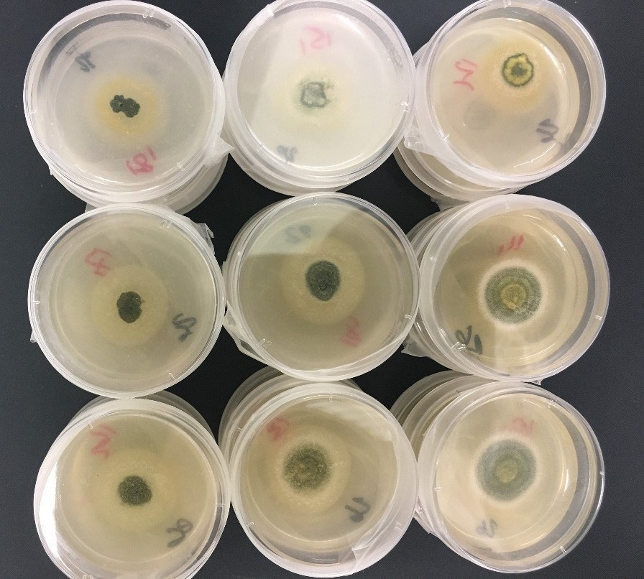

High carbohydrate

50:50 Protein : Carbohydrate

High protein

High fat Mid fat No fat

Figure 6 : Colony growth of Metarhizium acridum (Greenguard) on agar plates with various carbohydrate, protein and fat profiles.

Other investigations of the temperature impacts upon survival and growth of *M. acridum* revealed that, on inoculated agar plates held at either 12oC or 4oC for one month and then incubated at 32oC, colony growth rate appeared to be the same as for freshly-inoculated plates incubated at 32oC. However, colony growth rates were substantially reduced where inoculated agar plates were stored at 38oC prior to incubation. Further investigation will determine if this translates into similar *M. acridum* effects when locusts are inoculated and reared at temperatures of 38oC or above.

### Environmental Program

**The comparative metabolic fate of the phenyl pyrazole insecticide, fipronil, and it’s metabolites in a representative eutherian (*Mus musculus domesticus* L. 1758) and metatherian (*Sminthopsis macroura* Gould 1845)**

A collaborative study with CSIRO Canberra (Black Mountain Laboratories, Acton ACT) during 2016-2017 investigated the metabolic fate of fipronil and its metabolites in a representative eutherian mammal (*Mus musculus domesticus* L. 1758) and a representative metatherian mammal (the marsupial, *Sminthopsis macroura* Gould 1845). Previous APLC research has shown that these two mammalian classes differ significantly in their sensitivity to the two chemical insecticides currently used by APLC, and that differing avian sensitivities to fipronil can, in part, be attributed to the metabolic fate of both the parent chemical and metabolites in conjunction with their ability to cross the blood-brain barrier. This project traced fiprole residues in mammalian tissues over time after exposure to ecologically realistic doses of this pesticide. The results will help to determine if the current risk assessment for this chemical in Australia adequately protects our native marsupial fauna. The dosing phase of this project has only recently concluded and no tissue residue data is available as yet. The functional response of thyroid glands from each species will also be determined histologically and coupled with thyroid hormone (T3 and T4) analysis from blood samples taken at specific post-dose time points.

**Impacts of locust control pesticides on arid-zone fauna**

***[Australian Research Council Linkage Project LP160100686]***

Further ARC Linkage funding has been received for a project aimed at improving our understanding of how different organisms encounter pesticide in the landscape through quantifying residue deposition in arid grasslands and investigating how pesticides used to control locust plagues impact on the behaviour and physiology of key target fauna. This research collaboration between the APLC, University of Wollongong and Macquarie University will investigate the two pesticides currently used for aerial control of locusts; the organophosphate pesticide, fenitrothion, and the phenyl pyrazole pesticide, fipronil. Specifically, this project will;

* develop a spray deposition model of aerial ultra-low volume (ULV) applications of fipronil and fenitrothion, incorporating residue depletion profiles over time within different ecosystem compartments in arid-zone native vegetation communities
* determine the short-term impact of aerially sprayed fipronil and fenitrothion on the behavior and condition of free-ranging target fauna that use the environment differently, including a small marsupial mammal, lizards of different sizes, small birds and an ant species
* quantify the relative importance of dietary and non-dietary pesticide exposure routes in vertebrates to gauge the importance to behaviour on pesticide exposure for key target animals.

Through the development of a spray deposition model, the short-term impact of pesticides on the behaviour and condition of free-ranging target fauna that use the different compartments of arid landscapes will be quantified, as will the relative importance of dietary and non-dietary exposure routes. The results will contribute to biologically relevant risk assessments for pesticides and improve existing knowledge of the deposition behaviour of ULV fipronil and fenitrothion applications.

# Publications

**Deveson, E** & Martinez, A. 2017, ‘Locusts in Southern Settler Societies: Argentine and Australian Experience and Responses, 1880–1940’, in:  E Vaz, C Joanoz de Melo, C Pinto and M Ligia (eds.) Environmental History in the Making. Vol 1. Explaining, Springer, Switzerland, pp. 259-286.

Maute K, French K, **Story PG**, Bull M and Hose GC. 2017.  Short and long-term impacts of ultra-low-volume pesticide and biopesticide applications for locust control on non-target arid zone arthropods.  Agriculture, Ecosystems and Environment 240:233-243

Maute K, **Story PG**, Hose GC, Bull CM, French K. 2017.  Applications of fipronil (Adonis 3UL) and Metarhizium acridum for use against locusts have minimal effect on litter decomposition and microbial function diversity in Australian arid grassland.  Soil Research 55:172-181.

**Story PG** and Walker B. 2016.  A low-cost, do-it-yourself data logging system using passive infrared detectors and an Arduino microcontroller circuit board to monitor and record animal activity in laboratory and small enclosure experiments.  Australian Mammalogy   39(2):152-160.

Walker PW, **Story PG** and Hose GC. 2016.  Comparative effects of pesticides, fenitrothion and fipronil, applied as ultra-low volume formulations for locust control, on non-target invertebrate assemblages in Mitchell grass plains of south-west Queensland, Australia.  Crop Protection 89:38-46

**Woodman, J.D.** 2017. Effects of substrate salinity on oviposition and embryonic development in the Australian plague locust, Chortoicetes terminifera (Walker). Journal of Insect Physiology 96, 9-13.

# Appendix 1: APLC Commissioners 2016–17

Dr Sally Troy (Chair)

Assistant Secretary, Plant Health Policy

Department of Agriculture, Fisheries and Forestry - Australia

GPO Box 858 Canberra ACT 2601

Mr Andrew McNee

Assistant Secretary - Chemicals and Waste Branch

Environment Standards Division

Department of the Environment

GPO Box 787 Canberra ACT 2601

Mr Barry Kay

Director - Emergency Operations, Intelligence and Programs

Department of Primary Industries

Locked Bag 21 Orange NSW 2800

Mr Gordon Berg

Principal Officer – Entomology

Biosecurity Division

Department of Economic Development

Private Bag 15, Ferntree Gully Delivery Centre VIC 3156

(Mr Berg retired in September 2016, and has been replaced by:)

Dr Amanda Kobelt

Principal Officer - Entomology   
Biosecurity, Agriculture, Food and Fibre  
Department of Economic Development, Jobs, Transport and Resources     
475-485 Mickleham Rd. Attwood Victoria 3049

Mr Mark Ramsey

Principal Policy Officer – Biosecurity SA

Primary Industries and Regions SA

GPO Box 1671 Adelaide SA 5001

(Mr Ramsey retired in June 2017)

Mr Kevin Strong

Manager Operations - Invasive Plants and Animals   
Biosecurity Queensland   
Department of Agriculture and Fisheries

GPO Box 46, Brisbane. Qld. 4001.

**Director**

Mr Chris Adriaansen

Australian Plague Locust Commission

50 Collie Street, Fyshwick ACT 2609

# Appendix 2: 2016–17 Australian plague locust situation report for each Member State

### Specific details regarding locust population densities and locations are provided in the monthly Locust Bulletins, available from the APLC web pages at the following site www.agriculture.gov.au/pests‑diseases‑weeds/locusts/bulletins.

### New South Wales

There was a residual autumn population in parts of Far West and Far Southwest NSW in autumn. Consistent low density adults were recorded in these regions during October, but localised high density nymphs and medium density fledgling adults developed in a small area south of Broken Hill Figure 1). Only occasional low density adults were recorded in the Central West and Northwest regions.

Adult numbers increased in part of Central West NSW, following the passage of a low pressure system during 10–12 November. High density adults were subsequently recorded near Tottenham and a small swarm between Collie and Narromine, but numbers declined during the month. Adults were recorded a low densities in the Northwest Plains and Riverina. Fledging of nymphs continued throughout November in the area south of Broken Hill, but adult numbers remained at medium density.

Landholders in the Central West reported hatchings in mid-December and nymphs reached late instar stages at the end of the month. Hatchings were limited to the Trangie–Narromine–Collie–Eumungerie–Albert area. Reports and surveys identified mostly medium density nymphs, along with several small bands (Figure 2). Low density nymphs were identified in the Trangie–Albert area in early January and a small swarm of fledgling adults was recorded near Narromine. Adult numbers subsequently increased to medium densities in other parts of the region. Surveys identified medium density adults throughout the Far West and the Menindee–Ivanhoe area of the Far Southwest region. Locusts were recorded at the Fowlers Gap and White Cliffs light traps during the second half of December, with higher numbers associated with low pressure weather systems. Only low numbers of adults were identified in the Riverina.

During January, medium density adults and low–medium density nymphs were recorded at numerous locations in the Central West and in the Broken Hill–Tibooburra area of the Far West region. Adult numbers increased to medium densities in the Bourke–Brewarrina area in the second half of January, and a single swarm was identified near Bourke. February was dry throughout NSW and there was little rainfall in western regions during March. The population level declined to low densities in all regions no nymphs were detected by autumn surveys.

### Queensland

Localised high density nymphs and adults persisted in part Southwest Queensland during April and May 2016. Breeding by that population produced a widespread low and medium density nymphal population in mid-August. Surveys of the Southwest and Northwest regions in early August identified only low density adults, but detected low density nymphs at most stops in the Birdsville–Betoota–Bedourie area in Diamantina Shire and the Windorah–Arrabury area in Barcoo Shire. Occasional nymphs were also recorded in Boulia Shire.

In October, further widespread low density nymphs developed in the Diamantina, Barcoo and Winton Shires (Figure 1). These are likely to have been the result of breeding by the early spring adult population following heavy rainfall throughout inland Queensland during September. Fledging of those nymphs in late October produced medium density adults in Southwest Queensland, with localised higher density adults and small swarms in the Arrabury area. Medium density adults and occasional nymphs persisted in the Southwest region during November and December. Only occasional low density adults and nymphs were recorded in the Central West, South Central and Central Highlands regions during November and December, but medium density adults developed in the Arcadia Valley of the southern Central Highlands in January.

Rainfall during December and January maintained suitable habitats for locust breeding in several regions, but only low density adults and occasional late instar nymphs were recorded in the Central West, South Central, Northwest regions during February. Medium density adults were identified in parts of the Southwest and the southern Central Highlands during February and March. Autumn population declined to low levels during autumn and habitats became dry in April.

### Victoria

There were several reports of adult locusts in parts of North Central and Northwest Victoria during April 2016, but there were no nymphs detected when hatchings would have commenced during October or November. The locust population level remained very low into summer, but in early February noticeable numbers of adults were reported in the Echuca–Mitiamo area and persisted in northern Victoria throughout the month. The increase is likely to have been the result of immigration from the NSW Riverina. APLC surveys in early March identified only occasional adults in the Northwest and North Central regions. The locust population declined to very low levels during autumn and no significant breeding was likely.

### South Australia

An extension of the winter population in Southwest Queensland persisted in the Cordillo Downs and Clifton Hills areas of the Far North region, where in early August there were widespread low density late instar nymphs. Band density hatching nymphs were recorded at one location. In October, medium density adults, associated with low density late instar nymphs were recorded in the Innamincka–Cordillo Downs area (Figure 1).

A separate nymph cohort developed during October around the Flinders Ranges from autumn laid eggs. Medium density adults were recorded from Hawker to Parachilna and high density fledgling adults and late instar nymphs were identified in the Parachilna–Commodore area. Only occasional adults were identified in other areas of the Far North and Northeast regions, but medium density adults were recorded in the Murnpeowie–Dulkaninna area in early November. Nymph hatchings were reported from the Ceduna area in the Western Agricultural region.

In November, medium density adults were recorded in the Oodnadatta–Marla and Coober Pedy–Arkaringa areas of the Northwest region. This population is likely to have resulted from breeding following heavy rainfall in September. Several rainfall events during December, in particular the widespread heavy falls at the end of the month, established favourable habitat conditions for further breeding. High numbers of locusts were caught in the Dulkaninna light trap at that time, indicating a significant breeding population in the Far North region.

Heavy rainfall in northern South Australia during January maintained green habitat conditions and limited APLC surveys of those regions. In late January, flying locusts were reported from the Coober Pedy–Oodnadatta area. Surveys identified a widespread population of medium density adults and mostly mid-instar nymphs in the Oodnadatta–Mt Barry–Coober Pedy–Marla area in early February (Figure 3). A number of swarms were recorded in the Oodnadatta area, containing both immature and gravid females. Adult densities were low in most of the Far North region, but localised bands of late instar nymphs were recorded near Dulkaninna and Murnpeowie. More widespread low and medium density late instar nymphs were recorded from Hawker to Peterborough in the Northeast region. High density nymphs were also reported from the Ceduna area in mid-February.

Medium density adults persisted in Far North region during March, extending from Frome Downs to Murnpeowie in the North Flinders Ranges, and from Hawker north to Maree and Oodnadatta. Localised swarm activity was recorded in the Arkaroola area on the eastern side of the Flinders Ranges.