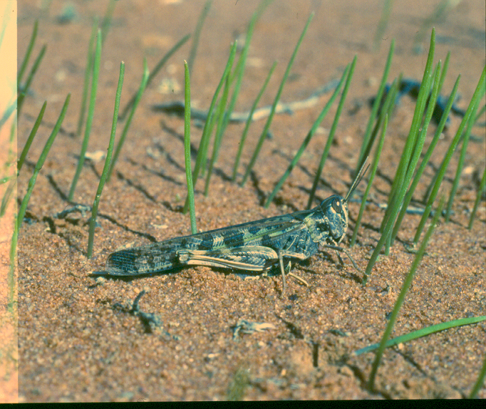

AUSTRALIAN PLAGUE

LOCUST COMMISSION

ANNUAL

REPORT

2014–15

**J:\APLC\APLC-Common\Logos\black\APLC_Logo.tif**

A joint venture of the Australian Government and the Member States of New South Wales, Victoria, South Australia and Queensland.

Contents

[Introduction 1](#_Toc445371137)

[APLC Charter 1](#_Toc445371138)

[Director’s Report : 2014–15 2](#_Toc445371139)

[Overview of 2014–15 locust situation 4](#_Toc445371140)

[Australian plague locust 4](#_Toc445371141)

[Spur-throated locust 8](#_Toc445371142)

[Migratory locust 8](#_Toc445371143)

[Achievement of Key Performance Indicators 10](#_Toc445371144)

[Operations 13](#_Toc445371145)

[Survey 13](#_Toc445371146)

[Forecasting and information 13](#_Toc445371147)

[Control operations and pesticide use 15](#_Toc445371148)

[Organisational Management 16](#_Toc445371149)

[Staffing 16](#_Toc445371150)

[Workplace Health & Safety 16](#_Toc445371151)

[Competency based training and assessment 17](#_Toc445371152)

[Environmental Management System 18](#_Toc445371153)

[National and International linkages 20](#_Toc445371154)

[Administration 21](#_Toc445371155)

[Governance 21](#_Toc445371156)

[Financial Management 22](#_Toc445371157)

[Research 24](#_Toc445371158)

[Purpose and research areas 24](#_Toc445371159)

[Research and Development Collaborations 24](#_Toc445371160)

[Summaries of research in progress 25](#_Toc445371161)

[Publications 27](#_Toc445371162)

[Appendix 1: APLC Commissioners 2014–15 28](#_Toc445371163)

[Appendix 2: Detailed 2014–15 locust situation for each Member State 29](#_Toc445371164)

**Figures**

Figure 1: Australian plague locust distribution in October 2014 .. ................................................... 5

Figure 2: Australian plague locust distribution in January 2015 .................................................... 6

Figure 3: Australian plague locust distribution in March 2015 ........................................................... 7

Figure 4: Spur-throated locust distribution in February – March 2015 ...............................................9

Figure 5: APLC ground survey coverage 2014–15 …………………………………….. ..................... 14

**Tables**

[Table 1 : 2014–15 APLC Performance against KPI measures 15](#_Toc209581995)0

[Table 2 : 2014–15 Locust control agent stocks](#_Toc209581996) 15

[Table 3 : APLC Environmental Management System conformance](#_Toc209581997) 18

**Appendices**

Appendix 1: APLC Commissioners 2014–15 ...................................................................................... 28

Appendix 2: Detailed 2014–15 locust situation for each Member State…..…....…………….......….… 29

# 

# Introduction

The Australian Plague Locust Commission was established in 1974 and began operations in late 1976. The Commission is financed by the States of New South Wales, Victoria, South Australia and Queensland, with a matching contribution from the Australian Government. Funding allocations from the member states are in proportion to the agreed benefit delivered to that state by APLC operations, while the Australian Government contribution reflects that national benefit derived from APLC activities. These five governments constitute the Member Parties of the Commission.

## APLC Charter

A Memorandum of Understanding (MOU) was signed between the Member Parties in 2002, and incorporates a Charter that replaced the original terms of reference under which the APLC had operated since its establishment.

The purpose of the APLC, as defined in the Charter, is “to control locust populations in those situations where they have the potential to inflict significant damage to agricultural industries in more than one member state.” In fulfilling its charter the APLC is required to:

* Implement a preventive control strategy to minimise economic loss to agricultural industries caused by the Australian plague locust, spur-throated locust and migratory locust, with priority given to Australian plague locust.
* Minimise risk of locust control to the natural environment, human health and markets for Australian produce.
* Develop improved locust management practices through a targeted research program.
* Provide a monitoring and forecasting system for operations conducted by APLC and member states.
* Promote and facilitate adoption of best practice in locust control by member states.
* Participate in cooperative national and international programs for development of APLC expertise.
* Continually review APLC operations to ensure they keep pace with the expectations of industry, community and government.

# Director’s Report : 2014–15

The 2014–15 locust season saw a continuation of both the habitat and populations situation which existed in the previous season. Limited areas of suitable habitat limited the extent and density of locust populations generally, with isolated areas supporting short-lived population increases in different regions. In those areas where summer rainfall was sufficient to generate a vegetation response, the lack of a preceding population to take advantage of these conditions, followed by a significant drying off in autumn, provided no real opportunity for significant population build-up in inland areas during the 2014–15 season. However, infestations in South Central Queensland in spring and in Central West NSW during summer and autumn required localised control by state agencies and landholders.

Survey activity continued throughout the season to detect any potential population build-up at the earliest opportunity. The detection of some pockets of higher density locust nymphs in both south-central Queensland and north-western New South Wales in January and February provided an opportunity to train several new field staff in aerial survey techniques. No significant infestation was detected in either area from this aerial surveillance.

Whilst seasons such as 2014–15 result in minimal operational demands due to the low locust population levels, particularly when several such seasons occur in succession, it does present the opportunity for both field and headquarters staff to become engaged in more strategic and diverse activities. Staff from APLC’s three field bases continued their extensive involvement in the Commission’s research activities, especially the work conducted at Fowlers Gap, NSW, under the ARC Linkage collaboration with the University of Wollongong, Macquarie University and Flinders University. APLC headquarters staff were also able to engage further in more strategic activities, including the revision and development of various information technology support systems, and the planning of further research activities to improve our understanding of locust physiology and population dynamics, and the potential off-target impact of APLC’s activities.

Preliminary forecasts for the 2015-16 locust season indicate both the unfavourable habitat conditions and the generally low locust population levels will persist through the coming year. Pockets of higher density or persistent population may be present at some time during the coming season, which may present further training opportunities in both aerial survey and control practices.

**Focus and Challenges for 2015–16**

A significant effort will be required during 2015–16 to complete the tendering process so that a new pre-approved panel of aerial services providers can be established. Prior to advertising the actual tender, a major review of minimum specifications for operators, aircraft and pilots will be completed, with much of this revision being driven by contemporary safety standards and current WHS obligations. Engagement of a suitable aerial safety expert to assist with this revision will ensure that the standards set in the new tender documentation will effectively manage the risks posed by APLC’s aerial operations. Once tenders are received, a further concerted effort will be required to evaluate these bids and ensure that businesses listed on the supplier panel are of a standard which supports APLC’s efforts in managing the safety of its aerial operations.

A new Research and Development Strategic Plan will be required to set the agency’s R&D direction for 2016–2020. The current plan covers APLC’s R&D focus through until 2015, so the preparation of this new plan provides an opportunity to ensure that the strategic direction and focus of our R&D addresses the needs of APLC, the Commission’s investors and other stakeholders. A key thrust in this new strategy will be that APLC will not only continue to implement best practice across relevant sectors, but will emphasise its efforts in developing new best practice.



Chris Adriaansen

Director APLC

September 2015

# Overview of 2014–15 locust situation

## Australian plague locust

After several years of low population densities, the increase in locust population in autumn 2014 resulted in egg laying in several regions of New South Wales and in South Central Queensland. Maturation of most adults did not occur until April 2014 and high density egg laying was only reported in a few locations. The distribution of nymphs during spring 2014 reflected this widespread, extended laying by the autumn adult generation (Figure 1). Low and medium density nymphs were recorded across NSW, Queensland and northern South Australia, but high densities and some bands developed in Central West and Far West NSW, and in South Central Queensland. Fledging in late October and November produced small swarms in those regions and an increase in adult numbers in Central West and Southwest Queensland.

Heavy rainfall in regions on inland Queensland in late December and early January, followed by heavy rainfall in Far West NSW and Far North South Australia in mid-January, initiated breeding and a widespread second generation of nymphs developed in Queensland. Bands were identified in parts of the South Central, Darling Downs, Central West, and Central Highlands regions in January (Figure 2). A second generation of high density nymphs also developed in parts of Central West and Far West New South Wales during February and March. Immigration into the Far North of South Australia in January also resulted in a nymphal generation with high densities in some places during February (Figure 3). Fledging of nymphs produced high density adults and some swarms in Central West, Northwest and South Central Queensland during February and in localised areas of Central West and Far West New South Wales in March. Populations gradually declined in these regions during March and April as vegetation became dry in the absence of further heavy rainfall. Further migrations are likely to have contributed to the decrease, and southward movement from Far West NSW is likely to have brought locusts to the southern Riverina and northern Victoria in mid-March, In Central West NSW, however, swarm populations persisted in March and April, laying eggs in many locations east of Dubbo, which could result in a nymph infestation in spring 2015.

Migrations appear to have played a role in population dispersal of the spring, summer and autumn adult generations during 2014–15. Late November migrations into Central West and Southwest Qld, mid-January migration into Far West NSW and Far North South Australia and Northwest Qld, and migrations into the southern Riverina and Northwest NSW, northern South Australia and northern Victoria in autumn all contributed to redistributions from high density population areas in eastern Australia throughout the 2014–15 season.

Further detail of the Australian plague locust situation in each APLC Member jurisdiction is provided at Appendix 2.

Map of Australian plague locust distribution in October 2014.


Figure 1. Australian plague locust distribution in October 2014

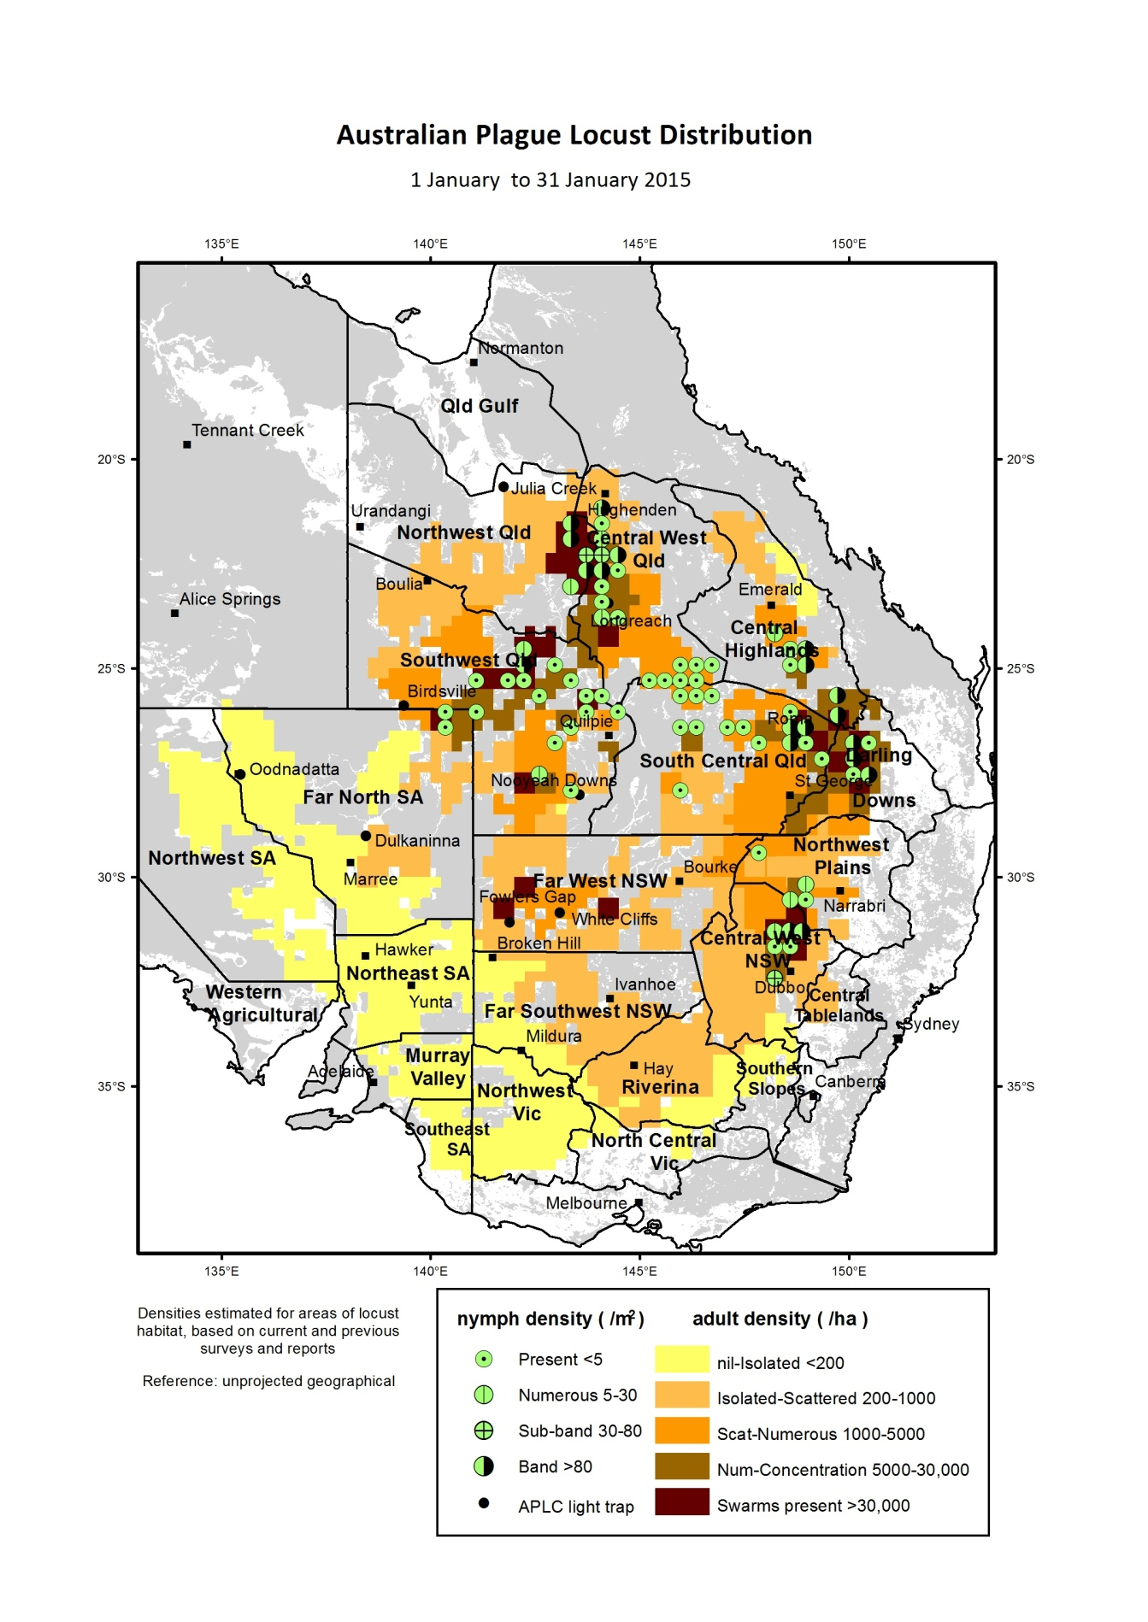

Figure 2. Australian plague locust distribution in January 2015

**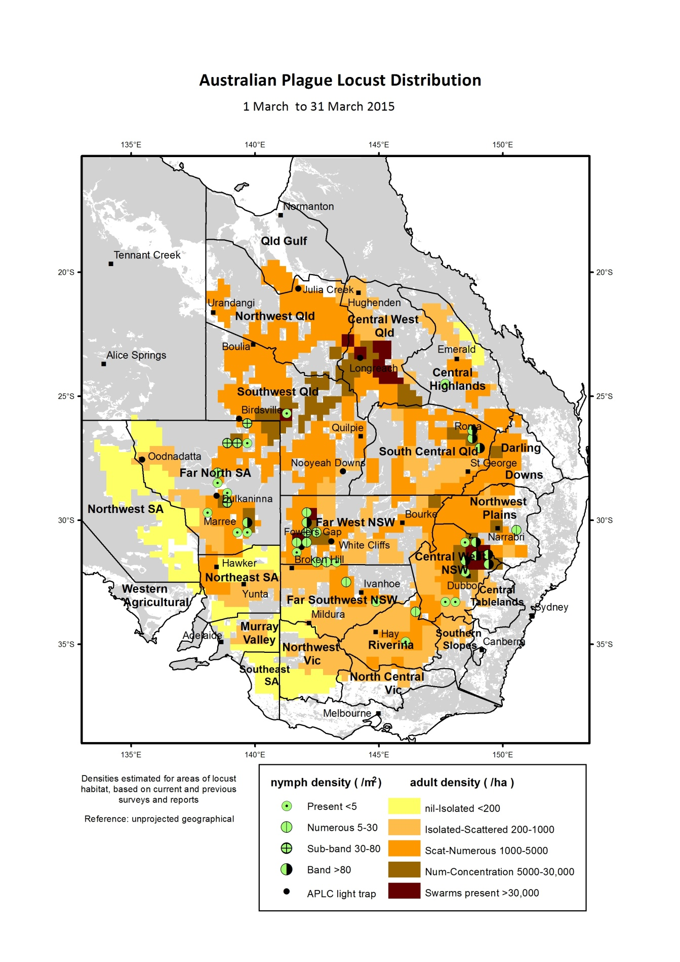**

Figure 3. Australian plague locust distribution in March 2015

## Spur-throated locust

There was a significant population increase in the northern half of Queensland during 2014–15, from the generally low levels of recent years. Widespread breeding occurred during December–February, following repeated widespread heavy rainfall. Low density adults were recorded consistently in the Central West, South Central and Central Highlands regions of Queensland during spring. Only occasional adults were detected in New South Wales and South Australia in spring and summer. Breeding commenced in late November and the widespread heavy rainfall in December and January in Queensland resulted in repeated egg laying in the Central West, Northwest, Queensland Gulf and Central Highlands regions.

Nymphs at early and mid-instar stages were recorded in January in parts of the Queensland Central Highlands and Central West. During February and March, low–medium density nymphs were identified in many locations throughout the Northwest, Central West and Central Highlands regions. Fledging of nymphs during late summer and autumn produced a consistent medium density population of immature adults in these regions, with high densities recorded in localised areas. Low density nymphs also developed in the northern parts of Southwest and South Central Queensland during summer, but resultant adult population densities remained low in autumn. Adults remain in largely sedentary groups in wooded areas during winter, but there were no reports of swarms.

## Migratory locust

An infestation of this species developed in the Central Highlands region of Queensland during summer and autumn. Swarms were reported in the Buckland Plains area, southwest of Springsure in late December, after some nymphs had been noticed in sorghum in spring. Gregarious egg laying was observed by on several properties, and swarms laid in other locations in the southern Central Highlands after heavy rainfall in December. Bands of early instar nymph were reported in the Buckland Plains area at the start of January and surveys identified bands on several other properties. Heavy rainfall in the second half of January provided suitable habitat conditions for developing nymphs. Landholders carried out ground control of hopper bands and Biosecurity Queensland conducted aerial control in the Buckland Plains area on 17 January. Surveys identified low density adults in the Roma–Morven and Augathella–Tambo areas in mid-January. Adults were reported from the Clermont area and nymphs from the Condamine area in South Central Queensland.

The population in the Central Highlands continued to increase during February after fledged nymphs formed swarms in the Emerald and Springsure–Buckland Plains areas. Biosecurity Queensland carried out aerial control of 2 000 ha of swarm infestation and landholders continued to undertake control. Adults migrated to other areas during February. Biosecurity Qld identified a swarm north of Morven in mid-February and medium density adults were recorded in the Roma–Mitchell and Tambo areas in late February. Occasional adults were also identified in the Longreach and Barcaldine Regional Council (RC) areas and in Winton Shire.

The swarm infested areas expanded north into the Isaac Regional Council (RC) area and east into Barcaldine RC area during March, and further localised breeding occurred. Biosecurity Queensland continued to receive reports of high density adults and nymphs from several areas of the Central Highlands, including the Emerald, Clermont–Moranbah–Mt Coolon areas, and near Wandoan in Banana Shire. Biosecurity Queensland conducted aerial control of swarms covering a total area of 20 000 ha in the Emerald and Clermont areas in early April. Several swarms were identified in the Blackall–Yalleroi area of Central West Queensland in late March. Landholder control continued in April and May in the Clermont area, but most reports were of yellow-winged and spur-throated locusts.

**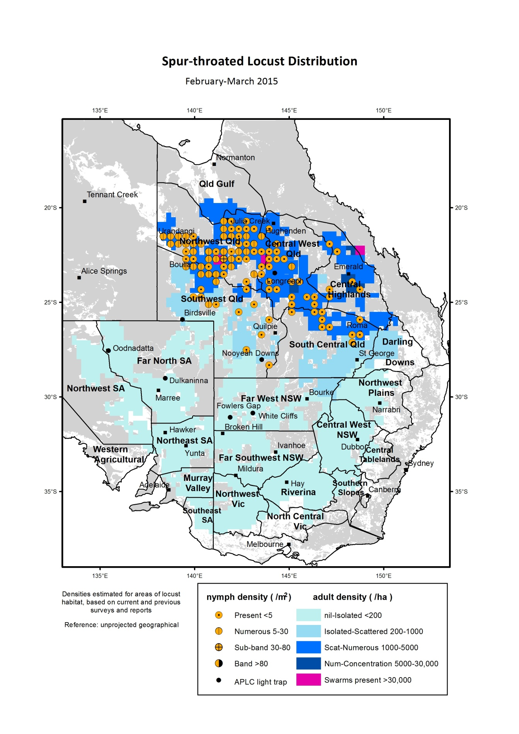**

Figure 4. Spur-throated locust distribution during February–March 2015

# Achievement of Key Performance Indicators

The 2005 external review of the APLC suggested a number of Key Performance Indicators (KPIs) against which the future performance of the APLC could be measured. These KPIs have been adopted with some modifications to provide additional semi quantitative measures for reporting on an annual basis. Details of the KPIs and performance measures together with an assessment of the APLC’s performance in 2014–15 against these are summarised in Table 1.

Table 1. APLC 2014–15 Performance against KPI measures

| **Key Performance Indicator** | **KPI Measures** | **Assessment/comments (2014-15)** |
| --- | --- | --- |
| Effectiveness of monitoring, prediction and control of locust populations | - Significant populations detected at early-mid instar stage  - Accuracy of forecasts of population scale, timing and location  - Majority of control measures against nymphal stage  - No adverse aerial spraying incidents | Limited populations were detected in 2014-15, either through APLC survey or through reports received which were confirmed through subsequent survey. Isolated swarms detected in southern Qld and north-western NSW were derived from previously identified nymphal infestations.  Forecasts accurately indicated consistent low levels with only short-duration and localised higher density infestations.  No control activity undertaken during 2014-15  Not applicable, as no control activity. |
| Availability and effectiveness of control agents | - Availability of existing agents  - Replacement agents identified and application rates/techniques verified | No change to availability of current control agents.  Issues raised in APVMA fenitrothion review have been further discussed with APVMA, and recognise drift research completed by APLC.  Control agent development plan prepared by new Application & Control Officer as priority. Full program for evaluation and verification to be prepared. |
| Environmental impact of control | - No reported/observed significant adverse impacts | No observed or reported adverse impacts due to an absence of control operations in 2014-15. The APLC’s environmental research program continues. Data collation and publication of results of collaborative longitudinal environmental study in western NSW are nearing completion. Publication of legacy research projects also nearing completion. APLC research program into effects of pesticides on dasyurids has commenced. |
| Trade risks minimised | - No adverse trade (residue) impacts | Not applicable, as no control activity. |
| Cooperation with environmental, OH&S and other relevant agencies in developing and implementing plans for control programs | - Plans developed and agreed and reviewed on regular basis. | Review of various WHS documents undertaken, primarily as part of preparing new specifications and standards for aerial services tender process.  Various aerial operations risks addressed through new task protocols and operational requirements, reviewed and approved by relevant external authorities.  Several current environmental policies reviewed as part of preparing responses to national plans dealing with rare & threatened species. |
| Ensuring OH&S of APLC staff, including aerial safety | - No significant OH&S incidents | No OH&S incidents were recorded – this can be attributed to sound practices and procedures as well as a very strong safety culture. |
| Improved management practices developed through a targeted research program | - Research findings incorporated into APLC control strategy and operations | Research activities (detailed in Research section of this report) linked to key strategic issues of APLC operations, including environmental impact and pesticide application technology.  Major longitudinal study of environmental impact nearing completion, which will identify where current practices could be modified to further reduce off-target impact if appropriate. Species specific research into pesticide impacts has commenced. Emphasis on analysis and publication of legacy environmental research project to facilitate incorporation into risk assessments for pesticide impacts.  The intent and construct of a new 2016-2020 APLC Research Strategy has been developed and discussed with Commissioners. |
| APLC staff participation in national and international programs/scientific conferences | - APLC staff invited to participate in appropriate programs and conferences | National and international scientific and technical conferences and meetings were attended and addressed. Environmental research with international collaborators continues enabling comparison of APLC practices with international environmental benchmarks. |
| Training of member state staff | - APLC training course developed and core of trained member state staff available | No training requested for Member State agency staff. |

# Operations

## Survey

Field survey for the presence and abundance of pest locust species continued throughout the 2014–15 season across the APLC area of operations. Staff from APLC’s three field bases at Narromine, Broken Hill and Longreach undertook regular targeted ground surveys and several aerial surveys during the season. All field survey information was recorded and stored as part of the APLC Geographic Information System.

Ground surveys covered a total distance of over 260 000 kilometres during the season, and focussed on the areas where locust presence was known or anticipated from previous surveys and reports, overlaid by rainfall and habitat condition information. A further level of information regarding the timing of hatching and development for the range of geographical areas was also considered when determining the timing and location of ground surveys. Figure 5 maps the areas where APLC ground surveillance was conducted during the 2014–15 season, and the frequency of this surveillance.

Limited fixed-wing aerial surveillance was undertaken in mid-January in the Tambo–Charleville–Roma area (25 hours in air) and late February in the White Cliffs–Tibooburra area (13 hours in air) in response to the identification of areas of higher density infestation through ground survey. While no significant high-density populations were located through this aerial survey, it provided an opportunity for training of newer field staff in the techniques of aerial survey and associated ground verification of detected populations.

## Forecasting and information

Seven Locust Bulletins were released during the period October 2014 to April 2015. Bulletins were simultaneously released via the APLC website and through direct delivery to stakeholders. Due to the low population levels which existed throughout the season, no interim Situation Updates were required.

The insect monitoring radar (IMR) at Bourke airport had been in operation during the whole season of 2014–15, while the IMR at Thargomindah airport was decommissioned in September 2014 for repair and upgrade. No significant event of locust migration was detected by the Bourke IMR during the season.

A feasibility study on the migration of the APLC file-based Decision-Support System (DSS) to a database-centric system has been completed. Following evaluation of a standalone system for APLC, it was decided to stand-up the APLC elements within the Department of Agriculture’s Enterprise Solution for spatial data processing. Existing ArcGIS licenses were upgraded, with two additional extensions for spatial statistics and database interface secured. Archived data along with current online data and newly-acquired APLC survey/control data are to be downloaded into this database.

A GIS-based locust surveillance system was designed and implemented for ground survey utilising iPads to replace the ageing PDA equipment. The new system will capture all information previously gathered during survey, with improved data transmission from the field due to the use of national 3G data networks.

Map of APLC ground survey coverage during 2014-2015.


Figure 5. APLC ground survey coverage 2014–2015

## Control operations and pesticide use

No control activity was warranted in 2014–15 due to the absence of any significant locust populations.

Significant quantities of all control agents are currently on hand, as detailed in Table 1.

Table 2. Locust control agent stocks

|  | ***Fenitrothion***  ***[Sumithion® ]***  ***(litres)*** | ***Fipronil***  ***[Adonis 3®]***  ***(litres)*** | ***Metarhizium***  ***[Green Guard®]***  ***(≡ 14 lt ULV pails)*** | ***Summer Spray Oil***  ***(litres )*** | ***Malathion***  ***[Fyfanon®]***  ***(litres)*** |
| --- | --- | --- | --- | --- | --- |
| On Hand @ 1 July 2014 | **73,856** | **34,400** | **67.43** | **15,990** | **800** |
| Purchased 2014-2015 | **0** | **0** | **0** | **0** | **0** |
| Used 2014-2015 | **0** | **0** | **0** | **0** | **0** |
| Inventory @ 30 June 2015 | **73,856** | **34,400** | **67.25** | **15,990** | **800** |
| Approx. equivalent area (hectares) | **351,696** | **312,727** | **8,070** | **N/A** | **1,143** |
| Inventory Value @ 30 June 2015 | **$1,682,640** | **$409,676** | **$141,398** | **$10,147** | **$6,400** |

The total inventory value of the APLC pesticide stocks held as at 30 June 2015 is approximately $2.25 million. The above figures do not include the 5 tonnes of fenitrothion held by APLC on behalf of Queensland or the value of material donated to APLC by the Victorian Government in 2014. The exclusion of the value of this material is to ensure correlation between the inventory value recorded by APLC and that recognised on the asset listing of the Australian Government Department of Agriculture.

Small quantities of pesticide are held at APLC field bases for immediate use during a control operation. The remainder (with the exception of the Green Guard stocks, and the Summer Spray Oil donated to APLC by Victoria) is held at commercial storage premises in NSW.

Stocks of Green Guard include both formulated product and dry spore material. The quantities of Green Guard stock listed above are expressed in 14 litre container equivalents. Green Guard stocks are held by the manufacturer in controlled storage facilities, and were last tested for viability in March 2015. The shelf-life of Green Guard stored by the manufacturer [at 4oC] is guaranteed for 2 years but is only guaranteed for approximately 6 months in the field [at 25oC]. Stored inventory is turned over and replaced when practicable.

# Organisational Management

## Staffing

There were limited changes during 2014–15 to the staffing of APLC, although two key positions within the headquarters group remained vacant for most of the period.

Mr Peter Spurgin, who had worked with APLC in several different roles and locations over a period of 30years, retired from the position of Application and Control Officer at the end of July 2014. Peter has left a very significant legacy from his time with APLC, having been an integral member of the team which developed and secured registration of the Green Guard biopesticide (*Metarhizium acridum*). Peter also developed and refined the use of the fipronil barrier spraying treatments which have significantly reduced the environmental footprint of APLC’s control operations whilst still delivering effective locust control. Both of these developments have been adopted internationally, with *Metarhizium* use now widespread in Africa and Asia, while the United States have employed the barrier spraying techniques under the banner of their Reduced Area Treatment Systems. These developments, along with Peter’s willingness to share his knowledge by participating in numerous overseas locust control campaigns organised by the United Nations Food and Agriculture Organisation, were justly recognised in Peter being awarded the 2010 Sir Boris Uvarov award at the 10th International Congress of Orthopterology for his contribution to applied science.

As all APLC staff are employed as Australian Public Servants, recruitment actions for the two key HQ positions (Control & Application Officer, vacant since the end of July 2014 with the retirement of Peter Spurgin; and Training & Safety Officer, vacant since April 2014 with the resignation of Heath McRae) was subject to the restrictions put in place by the Australian Public Service Commission. Consequently, these positions were not able to be filled during 2014–15 although recruitment actions for both were commenced during the year. A highly suitable applicant has been recruited to fill the Application & Control Officer position, and subsequently commenced in this role in late July 2015. Interviews to select a candidate for the Safety & Training Officer position have been scheduled for late August 2015.

Longreach-based Field Assistant Ryan Knapp resigned from APLC in March 2015, having joined the Commission in that role in September 2011, and we thank him for his service during his time with us. Recruitment to fill this position will be undertaken during 2015–16.

Ms Sarah Hickman commenced in the role of Field Assistant at Longreach in September 2014 to fill the vacancy left with the departure of Danielle McKay in May 2014.

A number of APLC field staff have not participated in any significant locust control work since commencing their employment with the Commission. While effort was made to identify any opportunity to conduct a small-scale training control program in 2014–15, unfortunately no suitable opportunity arose. This limited experience will be addressed at the first available opportunity. This limited depth of experience among field staff will also necessitate the participation of a number of experienced HQ officers in any control operations which may occur in 2015–16.

## Workplace Health & Safety

There were no reportable Workplace Health & Safety incidents during the 2014–15 operating period, a reflection of the sound practices and procedures developed and applied to all aspects of APLC operations and the very strong safety culture maintained within the Commission.

All operations personnel satisfactorily completed the annual pre-season fitness for duty medical evaluation.

## Competency based training and assessment

Relevant APLC personnel satisfactorily completed or renewed qualifications in: Dangerous Goods Transport, Chemical Handling, First Aid and Driver Safety in addition to additional necessary experience of any outstanding elements of field operations as part of routine duties or as specific opportunities became available (i.e. experience of aerial survey and spotting of migratory locust bands in Queensland during the 2014–15 season).

All operations personnel have progressed their Competency-Based Training Program elements to the stage that only remains reliant on the existence of control-worthy locust populations for the opportunity to gain this key competence component.

# Environmental Management System

As there were no gregarious populations of locusts within the Commissions area of operations, no control campaign-related environmental assessment or work was undertaken.

A summary of APLC’s standing in relation to the performance indicators of our Environmental Management System (EMS) is provided in Table 3 below.

Table 3. APLC Environmental Management System conformance

| **Program** | **Sub-project** | **Progress (2014–15)** |
| --- | --- | --- |
| 1. Excellence in all operational areas | Staff trained to full field competence | Recently-appointed staff continued to progress through competency training in all areas of field operations as possible, with no control operations training possible due to absence of locust population. |
| DGPS used in all aircraft | DGPS remains a standard requirement for all aircraft engaged by APLC for application of locust control agents, and will be stipulated for all control aircraft in the next aerial services tender specifications. |
| Improved control efficiency | Absence of control operations has not allowed for operational improvements to be identified and/or implemented. |
| 2. All waste managed appropriately | Waste management contract | Empty locust control pesticide containers and associated waste collected and disposed of by approved waste management contractor.  Laboratory waste was similarly disposed of through an accredited contractor. |
|
| 3. Minimise the intensity, extent and duration of disturbance to native flora and fauna | Incidents effectively managed | Not applicable, as no control activity undertaken |
|
| Reduce the proportional use of fenitrothion in control ops | Not applicable, as no control activity undertaken |
|
| Increased successful use of fipronil and larger track spacing | Not applicable, as no control activity undertaken |
|
| 4. Contribute to our understanding of natural and managed ecosystems | Develop risk assessment process for APLC pesticides, based on outcomes of environmental research. | Research enabling more relevant pesticide risk assessments for locust control is the primary focus of the APLC Environmental Research Program. The Australian Research Council’s Linkage-funded project to quantify the comparative effects on ecological processes of two locust control agents used by APLC (the chemical pesticide fipronil (Adonis 3UL) and the biopesticide *Metarhizium* *acridum*) was finalised and data analysis and preparation of publications continued throughout 2014-15. The development of a subsequent ARC Linkage2014-15 proposal continued during 2014-15 for submission in late 2015. . |
|
| Develop field protocols based on research | Sampling aquatic systems for the pesticide residue is now operational. Development of passive air samplers for pesticide detection during locust control operations is underway. Incorporation of passive sampling into the APLC’s EMS is planned as an environmental monitoring tool. |
|

| **Program** | **Sub-project** | **Progress (2014–15)** |
| --- | --- | --- |
| 5. Avoid disturbance to protected sites/areas | Development of the GIS, OpsManager® and PDA handhelds sensitive area maps and database | Options to upgrade OpsManager and surveillance software identified, with improved integration with mapping layers and enhanced display through new field devices. Operating systems for new device platforms under development to implement these improvements. |
| Procedures and buffers developed to avoid disturbance | No change necessary – current agreed protocols remain appropriate. The potential for locust spray operations to overlap with areas sensitive to chemical pesticide application are reviewed continuously during the locust season and reviewed as needed in collaboration with the relevant environmental authority. |
| 6. Ensure stakeholders are aware of all environmental obligations and they assist APLC achieve these. | Develop environmental aspect into APLC stakeholder training course. | No external stakeholder training requested or undertaken |
| Landholder consultation prior to and after pesticide application | Not applicable, as no control activity undertaken |

# National and International linkages

Dr Haikou Wang attended the SPIE 2014 Remote-Sensing conference in Amsterdam, the Netherlands during September 2014. Dr Wang delivered a paper and oral presentation ‘Quantitative assessment of locust habitats in inland eastern Australia using remote-sensing and GIS technologies’ under the theme Remote Sensing for Agriculture, Ecosystems, and Hydrology. On the trip, Dr Wang visited the Laboratory of Geo-information Science and Remote Sensing at the Wageningen University.

Dr Wang joined in the international workshop of Locust Management in Central Asia, Urumqi, China, also in September 2014, visiting the locust group at the Institute of Zoology in the Chinese Academy of Sciences in Beijing, the insect monitoring radar group at the Institute of Plant Protection in the Chinese Academy of Agricultural Sciences in Zhengzhou and the locust group at the College of Life Sciences in the Xinjiang Normal University in Urumqi.

Dr Wang attended the forum Monitoring, Forecasting and Ecological Management of Migratory Insect Pests: Chinese Pathways in the International Perspectives, in Nanjing, China, in June 2015, delivering an oral presentation, Migration: Do Migratory Insects Know their Way? Whilst in China, Dr Wang also attended the International Symposium on Collaborative Management of Cross-border Pests in Central Asia. He also took the opportunity to visit the relevant Chinese research groups to discuss latest research findings and technology development on insect migration, and to discuss the latest developments in entomological radars with a view to further collaborative interaction.

# Administration

## Governance

The Commission is governed by six Commissioners: one from each of the four Member States, one from the Australian Government Department of Agriculture and one from the Australian Government Department of Environment. Functional and operational management of the Commission is undertaken by a Director assisted by staff based in Canberra HQ and at three field bases in NSW and Qld. The Commission is accountable to the Ministers of Agriculture representing the five governments which finance APLC. Details of the Commissioners and Director during 2014–15 are provided in **Appendix 1.**

The 73rd APLC Commissioners Meeting was convened by teleconference on 28 August 2014 to receive the 2013-14 APLC Financial Performance Report and to consider a draft 2014–15 APLC Budget. A final budget for 2014–15 was not able to be presented at that time due to delays in provision of final overhead charges to be applied by the Department of Agriculture to APLC. Following ratification of these overhead charges by the Department of Agriculture, Commissioners were presented with and approved the 2014–15 budget in mid-December 2014.

The 74th APLC Commissioners Meeting was held on 4 June 2015. At this meeting, Commissioners considered the year-to-date financial performance of the Commission, along with a preliminary budget for 2015–16. Issues related to risk management within the Commission, particularly in relation to the use of helicopters for locust swarm survey, were also considered and actions to progress these issues were agreed. Discussion was also held on the development of the 2016–2020 APLC Research Strategy, including additional areas which should be included as priorities for future investigation and development.

Full records of the Commissioners Meeting and all decisions taken are archived with APLC and held by all Member jurisdictions.

# Financial Management

Total revenue in 2014–15 from all Member Parties amounted to $4.366 million. While the 2014–15 budget approved by Commissioners included a planned ‘draw down’ of $1.326 million from the APLC Reserve Fund, this was not enacted as part of the Department of Agriculture’s financial recording system. Instead, an additional $1.2 million appropriation was made by the Australian Government (through the Department of Agriculture), thus leaving the Reserve Fund unaffected by any recorded draw-down. However, this additional appropriation may alter perceptions regarding relative contribution levels to the value of the accumulated Reserve Fund by the various Member Parties. Further consideration of this by APLC management and Department of Agriculture finance section will be required, with all aspects to be fully reported to Commissioners regarding any material or perceived issues regarding the APLC Reserve Fund.

Expenses recorded in the 2014–15 period amounted to $3.585 million, resulting in a net operating surplus of $0.781 million. This surplus was carried over to the 2014–15 financial year as part of the accumulated Reserve Fund, as shown in the 2014–15 financial performance report below. The balance of the APLC Reserve Fund at the start of the 2015–16 financial year consequently stood at approximately $4.1 million. This accumulation of surplus into the reserve fund is in accordance with the Memorandum of Understanding, a position that was reconfirmed by decision of the 62nd Commissioners Meeting in April 2008.

The surplus of income over expenditure was delivered principally as a consequence of no control operations or expenditure occurring during the year. Staff vacancies at various times during the year also contributed to this result. A further saving resulted from renegotiation of lease arrangements for several APLC vehicles, and the return of funds where the sale price of replaced APLC vehicles exceeded the lease residual value.

In accordance with APLC budgeting policy at the 69th Commissioners Meeting in May 2012, the value of the Reserve Fund will be held at (or close to) $3 million, with accumulated reserve in excess of that amount to be applied to a reduction in funding contributions requested of investing jurisdictions for the following financial year. As a consequence, Member Party contributions requested for the 2015–16 APLC budget will reflect the application of $1.1 million of reserve funds.

Table 4. APLC 2014-15 financial performance report

| **Expenses** | 2014-15 APLC Approved Budget | | Revised Budget | Total Expenditure 2014-15 | Expenditure Variance 2014-15 |  |
| --- | --- | --- | --- | --- | --- | --- |
| Leave and other Entitlements | **170,000** | | **151,895** | **151,895** | **0** |  |
| Other benefits-allowances | **88,000** | | **77,601** | **77,601** | **0** |  |
| Employee benefits-superannuation | **270,000** | | **226,193** | **226,193** | **0** |  |
| Wages and salaries | **1,247,000** | | **1,247,000** | **1,140,868** | **106,132** |  |
| Staff development and recruitment | **21,000** | | **21,000** | **8,738** | **12,262** |  |
| **Total Employee Expenses** | **1,796,000** | | **1,723,689** | **1,605,295** | **118,394** |  |
| Aerial Services - Helicopter | **-** | | **-** | **0** | **0** |  |
| Aerial Services - Survey Aircraft | **140,000** | | **140,000** | **0** | **140,000** |  |
| Aerial Services - Spray Aircraft | **80,000** | | **80,000** | **0** | **80,000** |  |
| Aerial Services - Aviation Fuel | **10,000** | | **10,000** | **0** | **10,000** |  |
| Insecticide - expensed | **100,000** | | **100,000** | **0** | **100,000** |  |
| Bio-Insecticide - expensed | **100,000** | | **100,000** | **0** | **100,000** |  |
| Control Ops: Equipment & freight | **20,000** | | **20,000** | **0** | **20,000** |  |
| Control Ops: Travel/accommodation | **25,000** | | **25,000** | **0** | **25,000** |  |
| **Sub-Total:Control Operations** | **475,000** | | **475,000** | **-** | **475,000** |  |
| Contractors, consultants & research | **122,000** | | **122,000** | **55,730** | **66,270** |  |
| IT & telecommunications | **190,000** | | **190,000** | **140,909** | **49,091** |  |
| Office equipment, consumables | **6,000** | | **6,000** | **9,000** | **-3,000** |  |
| Other technical & field expenses | **16,000** | | **16,000** | **26,736** | **-10,736** |  |
| Vehicle leasing and other charges | **322,000** | | **321,147** | **257,452** | **63,695** |  |
| Legal Services AGS | **4,000** | | **4,000** | **-** | **4,000** |  |
| Other administrative expenses | **21,000** | | **21,000** | **5,000** | **16,000** |  |
| Conferences, memberships, fees | **3,000** | | **3,000** | **4,000** | **-1,000** |  |
| Subscriptions, publications, data | **6,000** | | **6,000** | **9,000** | **-3,000** |  |
| Comms, media, advertising | **-** | | **-** | **-** | **-** |  |
| Light trap operations | **15,000** | | **15,000** | **18,000** | **3,000** |  |
| Rent, offsite storage & property | **132,000** | | **132,000** | **81,000** | **51,000** |  |
| Travel | **185,000** | | **158,881** | **161,326** | **-2,445** |  |
| **Total Supplier Expenses** | **1,022,000** | | **995,028** | **768,153** | **226,875** |  |
| Sub -Total: Salaries + Control Ops + Supplier Expenses | **3,293,000** | | **3,193,717** | **2,373,448** | **820,269**  **820,269** |  |
| Corporate - Government process | **144,000** | | **144,000** | **142,000** | **2,000** |  |
| Corporate - Business overheads | **756,000** | | **728,696** | **766,000** | **-37,304** |  |
| DA Divisional support costs | **147,000** | | **147,000** | **146,000** | **1,000** |  |
| Program overheads | **42,000** | | **42,000** | **38,000** | **4,000** |  |
| Depreciation & amortisation | **111,000** | | **111,000** | **119,500** | **-8,500** |  |
| **Total Other Expenses** | **1,200,000** | | **1,172,696** | **1,211,500** | **-38,804** |  |
|  |  | |  |  |  |  |
| **TOTAL** | **4,493,000** | | **4,366,413** | **3,584,948 3,584,948** | **781,465** |  |
|  |  | |  |  |  |  |
| **Cost Sharing of Endorsed 2014-15 Budget** | | | | | |  |
| **Member Jurisdiction** | | **% Share** | **Core Contribution** | **Govt. Process Overheads** | **Overheads Contribution** | **Budgeted revenue** |
| Reserve Draw-down | |  |  |  |  | **$1,326,808** |
| Commonwealth | | 50.0% | 983,096 | 145,000  145,000 | 527,500 | **$1,655,596** |
| New South Wales | | 32.5% | 639,012 |  | 342,875 | **$981,887** |
| Victoria | | 10.0% | 196,619 |  | 105,500 | **$302,119** |
| South Australia | | 5.0% | 98,310 |  | 52,750 | **$151,060** |
| Queensland | | 2.5% | 49,155 |  | 26,375 | **$75,530** |
|  | |  |  |  |  | **$4,493,000** |
| **Reserves At Start Of 2014-15 Financial Year** | | **3,324,000** |  |  |  |  |
| **Reported 2014-15 Surplus** | | **781,000** |  |  |  |  |
| **Reserves At Start Of 2015-16 Financial Year** | | **4,105,000** |  |  |  |  |

# Research

## Purpose and research areas

In carrying out its charter, the APLC identifies and undertakes research to plan for, and be responsive to, issues relating to its activities. These include, but are not limited to, the efficient monitoring and accurate forecasting of locust populations, the potential environmental and trade impacts of its control programs, the cost and efficacy of control agents, and the decision-making of locust control. An ongoing research program is essential to addressing these issues now and into the future. The three research areas are:

* Improvement in efficacy and reduction of risks associated with **control agents and application technology** addressing both immediate and future issues
* Identification and measurement of **environmental** and trade (residue) risks potentially resulting from the APLC’s operations and integration of research results into the core business of APLC and Member State agencies’
* Improved understanding of the **population ecology** of locusts to improve the performance and effectiveness of existing surveillance and forecasting systems as well as improving planning, preparedness and early intervention strategies.

## Research and Development Collaborations

Several important research and development collaborations between APLC and other institutions continued throughout 2014–15, either to advance previous work or to develop new proposals for future work. These collaborations provide significant benefits to APLC, through the leverage of additional resources and funds provided by or available through the collaborating institution and the access to significant additional intellectual capacity.

The ongoing relationship with the University of Wollongong, Macquarie University and Flinders University, established through the ARC Linkage project investigating long-term impacts of locust control agents, has continued with the development of a one-year field and laboratory investigation of further aspects of the issues covered in the ARC Linkage project. This new project has been developed to act as a bridging activity between the completed work and the work planned to be undertaken under a new ARC Linkage project, which has been submitted for funding consideration in early 2016. The activities in this one-year project will effectively provide precursor results to be fully developed in the new ARC project, should its funding application be successful. If, however, further ARC funding is not forthcoming, the one-year project will still produce valid self-contained results.

Continued work with the University of New South Wales – Australian Defence Force Academy has seen further development of APLC’s insect monitoring radar (IMR) capacity and capability. New controller hardware and software has been developed, and will be installed in the IMR facility which is planned to be relocated from southern Queensland to the NSW Riverina region during 2016.

The relationships established with the University of Sydney through a previous ARC Linkage project have formed the basis of a new ARC project to further investigate the factors affecting locust population persistence. In particular, the observations of high levels of rapid nymphal mortality observed in certain areas in autumn 2010 will be investigated in detail to determine if the causal agents of this mortality could supplement existing population management practices. This new ARC project also engages several overseas institutions and researchers, further expanding the research capacity and capability applied to this work. ARC funding for this project has been granted, with the project to commence during 2015–16.

## Summaries of research in progress

*The following research summaries provide an overview of current research activities being undertaken by the Australian Plague Locust Commission. The research summaries are not considered to constitute publication as the investigations are often incomplete and any results presented tentative.*

### Entomology Program

**Effects of inundation on Australian plague locust egg development and viability**

This study has quantified the effects of different inundation durations at different temperatures on locust egg development and viability. Development rates, egg survival, hatchling condition and nymph survival to 2nd instar have been quantified to estimate the impacts of flooding on population dynamics in the field. Results show that most eggs can survive >14 days, unless soil temperature is ≥25°C. Additionally, the embryonic development stage at the time of flooding is important, with higher mortality in eggs inundated at later stages. This work has been accepted for publication and is in press.

**Physiological regulation of feeding and responses to starvation in Orthoptera**

An Honours student at ANU under the supervision of Dr James Woodman and Associate Professor Paul Cooper (ANU) is characterising the structure and physiology of the foregut in different locust species to begin to understand its role in digestion. Results so far have revealed intricate patterns of spines on the interior foregut surface that may be involved in shredding ingested food and passing it into the mid-gut with the assistance of contractions from a network of associated musculature. The next phase of this work will be to analyse this morphological data for species and sex differences as well as the commencement of experiments to understand the initiation and termination of the muscle contractions. This project is part of a broader research direction to understand the regulation of feeding behaviour and digestion for locust species with different feeding ecologies. There is also the potential for discovering specific biochemical targets for disrupting the capacity to process ingested food.

**A review of the population ecology of the Australian plague locust**

This project has been restructured as a collaborative initiative with Dr Fiona Clissold (University of Sydney) and Dr Jerome Buhl (University of Adelaide). The work will acquire and synthesise all relevant information on the key factors that influence locust population size. The planned publication will improve APLC’s knowledge base and identify important knowledge gaps and priorities for future research.

**Locust immunity and native disease organisms as possible new control agent candidates**

This work is a collaborative initiative with the University of Sydney that is pending a funding application as part of the ARC Linkage projects program. Stemming from the mass epizootic near Hillston in November 2010, this project aims to (i) identify and quantify the microbiota occurring in *C. terminifera* populations across seasons and regions, (ii) compare immune function and disease resistance in locust populations from different regions, (iii) quantify the effects of temperature and locust nutritional state on immune function and disease resistance, (iv) study the pathogenicity of *Pseudomonas* sp. collected in 2010 as well as any other identified candidate disease organisms, and (v) explore the effects of pathogens on locust ecology and behaviour.

**Physiological aspects of locust survival: effects of soil salinity on locust oviposition behaviour and embryonic development**

This project is part of a long-term ongoing research program to quantify physiological tolerance to different environmental conditions that may be encountered in the field and impact on locust population dynamics. Specifically, this work has recently quantified the effects of different substrate salinity levels (control, 4, 8, 12, 16, 20, 24, 28 ppt) on female oviposition behaviour (e.g. test drilling propensity), embryonic development (i.e. potential for quiescence) and survival to hatching. Results indicate embryonic developmental arrest by quiescence at ≥16 ppt NaCl due to altered osmotic gradients. The work is now being prepared for publication.

**Dynamic energy budget modelling for *Chortoicetes terminifera* (with the University of Melbourne)**

This work is a collaborative initiative with Dr Michael Kearney and Dr James Maino at the University of Melbourne and has progressed to having a parameterised dynamic energy budget model for predicting *C. terminifera* phenology. This type of model makes use of life history, eco-physiological and environmental data to predict phenology in a more sophisticated way than previously available. The model now requires validation testing.

### Environmental Program

**The effect of aerial spraying of two pesticides on semi-arid grasslands; Australian Research Council Linkage project (LP 110200105)**

Undertaken at the University of New South Wales, Fowlers Gap Arid Zone Research Station, this research project investigated the impacts of operational applications of the chemical pesticide, fipronil and the biological insecticide, *Metarhizium acridum* (Green Guard®) and concluded during the 2014–15. This project investigated how these two pesticides affected a semi-arid ecosystem by examining impacts on invertebrates, their predators, lizards and soil processes. These effects were followed through time in a large-scale field-based experiment to determine recovery and compare each pesticide treatment using a Before-After-Control-Impact (BACI) experimental design.

No effect of either treatment was detected on soil microbial communities or reptile populations. In relation to termite populations, there was no detectable impact of either pesticide on termite activity, bait loss or termite community composition. Non-significant differences in termite survey measures among sites suggested that climate and environmental conditions were stronger drivers of our termite measures than single, localised pesticide applications.

Arthropod community composition was not significantly affected over time by either locust control treatment. However, abundance measures of collembolans, acarians, coleopterans, psocopterans, gryllids, thysanopterans, dipterans and two formicid species were affected within a month after treatment by both fipronil and *Metarhizium*. While the abundance of most taxa subsequently recovered, the slowly reproducing ant, *Rhytidoponera mayri*, retained depressed abundance relative to the control, one year after fipronil treatment. Only dipteran and blattodean changes in abundance suggested a possible significant impact of *Metarhizium* one year aftertreatment. Arthropod abundance and community composition changed over time, in both control and treatment plots, probably reflecting changes in patterns of local rainfall over the study period. The statistically significant treatment effects recorded in our study were not long lasting. This suggests that single applications of either of the two locust control methods studied represent a relatively insignificant hazard to most arthropod taxa at our site. The pronounced temporal variation in arthropod abundance over all plots indicated that climate and environmental factors are likely to be stronger drivers of arid zone arthropod abundance and community structure than the single application, low-dose aerial pesticide treatments used to control locusts in arid and semi-arid regions of Australia.

A general lack of evidence of for an impact of *M. acridum* or fipronil applications supports their use as low hazard locust control options with minimal large scale and longer term effects on soil microbes, termites, soil arthropods and herpetofauna in Australia arid rangelands. Data analysis is completed, research publications are finalised and are currently being submitted to scientific journals for publication. Applications to the Australian Research Council’s Linkage Program are now being prepared for research to take a closer look at the effects of chemical pesticides on in conjunction with the development of spray residue and deposition models for fenitrothion and fipronil.

**Sensitivity of *Sminthopsis macroura* (Gould 1845) to the phenyl pyrazole insecticide, fipronil.**

Research is underway to quantify the sensitivity of the stripe-face dunnart to the phenyl pyrazole insecticide, fipronil. Determining the acute oral toxicity of test species to this pesticide is a critical first step in research aimed at quantifying the toxicological effects of fipronil on Australian native vertebrates through further laboratory and field experimentation. This research project uses the Up-And-Down (UDP, OECD Guideline 425) protocol for resolving median lethal doses and was suspended early in 2014 after anomalies were identified with reference grade fipronil obtained for dosing. This project will resume in April 2015.

# Publications

Deveson, E.D. and Woodman J.D. (2014) Embryonic diapause in the Australian plague locust relative to parental experience of cumulative photophase decline. *Journal of Insect Physiology*, 70, 1-7.

Maute, K., French, K., Bull, M. C., Story, P. G. and Hose, G. (2015). Current insecticide treatments used in locust control have less of a short term impact on Australian zone reptile communities than does temporal variation. *Wildlife Research* 42, 50-59

Story, P. G. (2015). Sensitivity of the dasyurids*, Sminthopsis crassicaudata* (Gould 1844) and *S. macroura* (Gould 1845) to the organophosphorus insecticide fenitrothion and its impact on locomotory and thermogenic performance in *S. macroura*. Master of Science (Research) Thesis, University of Wollongong.

Wang, H.K. (2014) Quantitative assessment of Australian plague locust habitats in the inland of eastern Australia using RS and GIS technologies. Proc. SPIE 9239, Remote Sensing for Agriculture, Ecosystems, and Hydrology XVI, 92390D (Amsterdam, November 11, 2014); doi:10.1117/12.2068382

# Appendix 1: APLC Commissioners 2014–15

Dr Sally Troy (Chair)

Assistant Secretary

Biosecurity Plant Division

Department of Agriculture

GPO Box 858 Canberra ACT 2601

(Vacant)

Department of the Environment

GPO Box 787 Canberra ACT 2601

Mr Barry Kay

Director, Biosecurity Operations

NSW Primary Industries

Locked Bag 21 Orange NSW 2800

Mr Gordon Berg

Principal Officer Entomology   
Biosecurity Division, Regulation and Compliance   
Department of Economic Development  
Private Bag 15 Ferntree Gully Delivery Centre VIC 3156

Mr Mark Ramsey

Principal Policy Officer

Biosecurity South Australia

Primary Industries and Resources SA

GPO Box 1671 Adelaide SA 5001

Mr Kevin Strong

Manager Operations

Invasive Plants & Animals

Biosecurity Queensland

GPO Box 4267

Brisbane QLD 4001

**Director**

Mr Chris Adriaansen

Australian Plague Locust Commission

GPO Box 858 Canberra ACT 2601

# Appendix 2: Detailed 2014–15 locust situation for each Member State

### New South Wales

Small areas of high density nymphs developed in late September in the Far West and Central West regions. In mid-October widespread low–medium density nymphs and numerous small bands were recorded in the Broken Hill–White Cliffs–Tibooburra, Wanaaring–Bourke and the Nyngan–Carinda–Coonamble–Dubbo areas. (Figure 1). Medium density nymphs were also recorded in the Wilcannia–Ivanhoe and Wentworth–Broken Hill districts of the Far Southwest, and Hay–Lake Cargelligo district of the Riverina. Extended fledging from late October to mid-November produced widespread medium density adults in all these regions. Several small swarms were recorded in the Nyngan–Carinda, Bourke and Broken Hill and White Cliffs areas.

Redistribution and migration of adults in the Central West during November, resulted in Concentration and swarm density adults spreading eastwards to the Dubbo and Coonamble districts, and swarm egg laying was reported in the Collie–Gulargambone–Gilgandra area late in the month. In response to locally heavy rainfall at the end of November, swarm laying continued in the Gilgandra–Dubbo–Tooraweenah–Baradine area. Migration also resulted in localised swarm egg laying in the Coonamble–Pilliga–Burren Junction area of the southern Walgett district. Adult numbers declined in the Nyngan–Carinda area and densities remained low in the southern Central West.

There was only light rainfall in the Far West during spring and vegetation became dry in November. Adult densities declined throughout the region during November as a result of natural mortality and possible migrations. Light traps at Fowlers Gap and White Cliffs recorded high numbers of locusts during the second half of October, indicating nocturnal activity of young adults. There was no dominant wind direction during that period, which suggests that any migrations would have mostly redistributed locusts within NSW, with possible movements to adjacent regions in other states. By December, only low density adults were recorded in the Far West, Far Southwest and Riverina regions.

Localised storm rainfall in the White Cliffs–Wanaaring–Louth area of the Far West in early December could have initiated some egg laying, but the appearance of several gravid swarms around Fowlers Gap–Milpa and in northern South Australia in mid-January, after widespread heavy storm rainfall, suggests some immigration earlier in January. A subsequent nymph generation developed during February, with medium density nymphs in the Broken Hill, Tibooburra and White Cliffs districts, and bands recorded around White Cliffs, Fowlers Gap and Milpa (Figure 3). APLC aerial survey of the Broken Hill, White Cliffs and Tibooburra districts during 19-22 February did not detect any bands, suggesting that January swarm breeding had been localised. The nymphs fledged in early March and several small swarms were recorded.

A second nymph generation developed in the eastern Central West in late December. Local Land Services received many landholder reports of bands of early instar nymphs from the Dubbo and Coonamble districts during January. By the end of the month LLS had received over 100 reports, with the highest number from the Collie–Gilgandra and Tooraweenah–Baradine–Coonamble areas. Some bands were also identified northeast of Coonamble to Pilliga, and nymphs were reported from other locations in the Northwest Plains (Figure 2). Swarm activity was reported in late January around Gilgandra–Narromine and Coonamble–Baradine. Swarm egg laying commenced in early February and continued throughout the month, extending into the Coonabarabran district. A third generation of nymphs developed from late February in the Coonamble–Baradine and Coonabarabran–Binnaway areas. All locust development stages were present in the eastern Central West during March (Figure 3). High density adults and swarms persisted in the Coonamble–Gilgandra and Coonabarabran–Mendooran–Binnaway area and continued sporadic egg laying area in the same areas that nymph bands were developing. Egg laying continued during April in some locations and a nymph infestation is expected in areas east of Dubbo in spring 2015. Some immigration, possibly from the north, was reported in the Northwest districts of Tamworth, Gunnedah and Narrabri during March and swarm egg laying occurred in a few areas. Adult numbers increased to medium densities in the southern Central West in late March.

Locust numbers had remained generally low in the Riverina during summer and vegetation conditions were unsuitable for widespread breeding, but high densities were recorded in a few locations in the Narrandera and Hillston districts during February. Concentration and swarm density adults appeared in the Deniliquin–Moulamein area in mid-March after immigration from the Far West and Central West. Adult numbers declined in this area in April, but sporadic egg laying is likely to have occurred.

### Queensland

A widespread nymph generation developed in South Central Queensland in spring. Medium density nymphs and some bands were reported in the Maranoa, Western Downs and Dalby Regional Council areas during October (Figure 1). Fledging produced high density adults and a number of swarms in the Roma–Mitchell, Meandarra–Tara and Cunnamulla–Charleville areas in late October and November. Nymphs also developed in the Southwest and Central West regions, and localised high density young adults were recorded in the Tambo–Augathella, Quilpie–Adavale and Noccundra–Kihee areas in late October. There was also an increase in overall adult numbers to medium densities in these regions. Low density adults had been recorded in the Longreach–Barcaldine area in late October, but in mid-November medium–high densities and a few small swarms appeared in that area before there was any significant rainfall. Immigration from the South Central region is likely to have supplemented local population redistribution in the Central West.

Redistribution of adults continued during November, and small swarms formed in the Betoota, Mt Howitt and Nockatunga areas in the Southwest after localised storm rainfall at the end of the month. Swarm egg laying was reported from the Charleville–Augathella and the Injune–Roma–Mitchell areas of the South Central region in mid-December and swarms moved into the Miles–Condamine, St George–Thallon and Goondiwindi–Moonie areas, where egg laying occurred in areas of recent rainfall. Widespread heavy rainfall in December produced favourable habitat conditions for egg laying and nymph survival throughout the South Central, Central West and Central Highlands regions, and in parts of the Southwest and Northwest regions. Bands were reported from numerous locations in South Central Queensland during January, including the Roma–Mitchell–Injune, Wondoan–Taroom, Miles–Condamine–Meandarra, Goondiwindi–Moonie and St George–Thallon areas (Figure 2). APLC aerial survey of the Maranoa and Western Downs Regional Council areas during 8–10 January detected only one of the numerous reported bands. Swarms formed in these areas in late January.

Bands of late-instar nymph and swarms of young adults were also identified in the Longreach–Muttaburra–Winton and Isisford–Yaraka areas of the Central West region in mid-January (Figure 2). In the Southwest region, high density young adults and swarms, along with residual nymphs were identified in the Warbreccan–Lochiel, Windorah–Morney, Retreat–Araluen and Nockatunga areas in late January, indicating that egg laying during the first half of December had been widespread in Barcoo and Bulloo Shires.

The adult population peaked in western Queensland during February, when high densities and some swarms were recorded in many areas of Southwest, Northwest and Central West Queensland. A further generation developed in the South Central and Darling Downs regions in early February, where swarms were reported the Maranoa, Western Downs and Goondiwindi RC areas in early February, but only sporadic egg laying was reported and densities declined in during the second half of the month. February and March were dry in most regions and adult numbers declined to low densities by April.

### Victoria

Locust population levels remained low in Victoria throughout spring and summer, with only low density adults and occasional nymphs reported in the North Central region. An increase in adult numbers was recorded in the Echuca area on 18 March, consistent with immigration detected in the southern Riverina at the same time. Medium density adults were subsequently recorded in areas around Echuca but only a small increase in numbers in other areas. However, a number of reports were received from the Wimmera and Mallee districts in mid-April and Department of Economic Development staff identified medium density gravid adults at several locations. Egg laying by these adults could produce localised low and medium density nymphs in October.

### South Australia

Only very low density locusts were identified in most surveyed areas region during spring, but localised nymphs developed on the eastern side of the North Flinders Ranges and north of Olary near the New South Wales border. Fledging of these nymphs produced limited areas of high density young adults in late October (Figure 1). Population declined to low levels in all surveyed areas in November and December, but there was isolated moderate rainfall in the Far North and Northwest regions in early December.

Surveys of the Far North in late January identified several areas of swarm density young adults and residual late instar nymphs in the Cordillo Downs–Cadelga area. The age of these locusts indicated localised egg laying in mid-December. There was no detected increase in adult densities in other areas, despite the indication of immigration in adjacent areas of Far West NSW in mid-January.

The widespread heavy rainfall in mid-January resulted in migration and breeding of adults from Cordillo Downs area, possibly supplemented by some earlier immigration from Queensland. Light traps at Dulkaninna and the Oodnadatta light trap recorded high numbers of locusts in mid-January. Medium–high density nymphs and a number of bands were recorded in February and early March between North Mulga and Moolawatana on the eastern side of the North Flinders Ranges, and medium density nymphs and fledglings in the Dulkaninna and Mungeranie areas (Figure 3). APLC survey in late February identified several bands of mid-late instar nymphs between North Mulga and Moolawatana on the eastern side of the North Flinders Ranges. In early March, medium density young adults and late instar nymphs were identified in all habitat areas in the Murnpeowie–Dulkaninna, Etadunna–Mungeranie and Clifton Hills–Pandie Pandie areas. Occasional late instar nymphs were recorded as far south as Farina (Figure 3).

Light traps again recorded locusts during 15–23 March, with high numbers recorded at Dulkaninna on 16 and 17 March. The catches indicated nocturnal activity associated with the passage of a low pressure trough system over South Australia. Images from the Bureau of Meteorology weather radar at Woomera detected flying insects on the night of 16 March and wind directions indicated a southward displacement of migrating insects. However, no significant increase in adult numbers was reported in the southern Flinders Ranges.