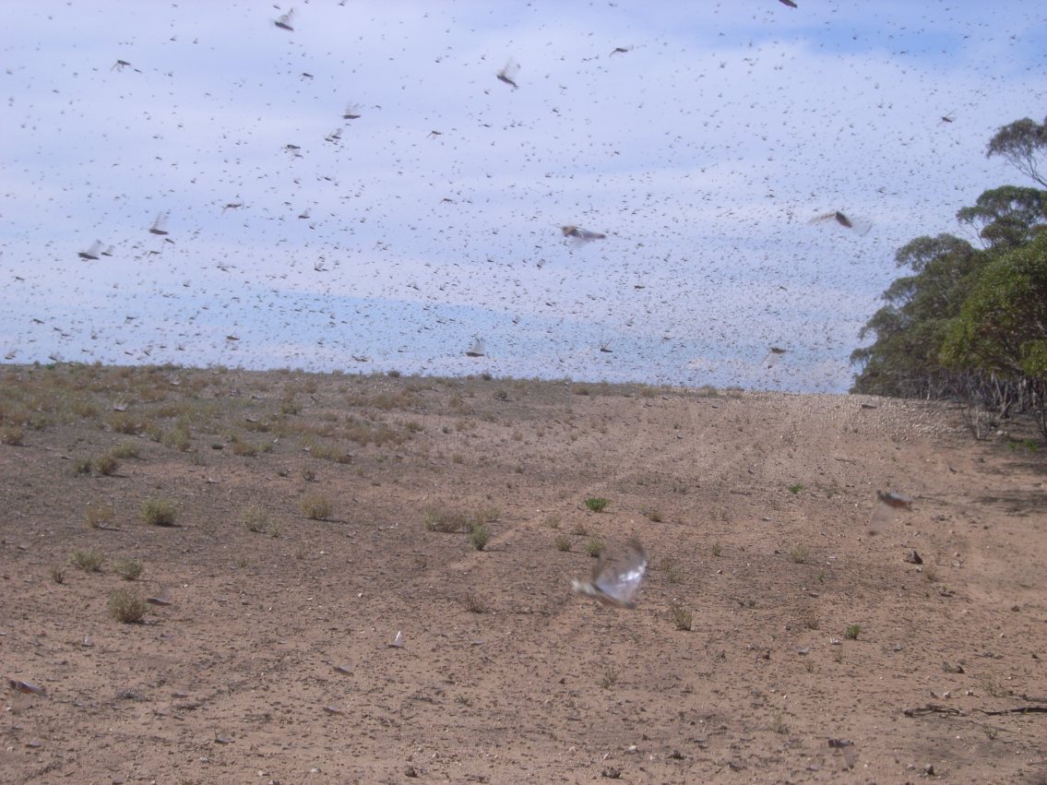

AUSTRALIAN PLAGUE

LOCUST COMMISSION

ANNUAL

REPORT

2010-11

**J:\APLC\APLC-Common\Logos\black\APLC_Logo.tif**

A joint venture of the Australian Government and the Member States of New South Wales, Victoria, South Australia and Queensland.

Contents

[Introduction 1](#_Toc263163105)

[APLC Charter 1](#_Toc263163106)

[Commissioners 2](#_Toc263163107)

[Review of 2010-2011 3](#_Toc263163109)

2010-11 [Locust situation 5](#_Toc263163110)

[Australian plague locust 5](#_Toc263163111)

[Spur-throated locust](#_Toc263163112) 13

[Migratory locust](#_Toc263163113) 13

[Operations 15](#_Toc263163114)

[Forecasting, information and survey 15](#_Toc263163115)

[Pesticide evaluation and application management 16](#_Toc263163116)

[Control operations and pesticide use 16](#_Toc263163117)

[Environmental Management System 19](#_Toc263163118)

[Occupational Health & Safety](#_Toc263163119) 20

[Competency based training and assessment](#_Toc263163120) 21

[International linkages 21](#_Toc263163121)

[Administration 22](#_Toc263163122)

Governance 22

[Staffing 22](#_Toc263163123)

[Finance 24](#_Toc263163124)

[Key Performance Indicators 25](#_Toc263163125)

[Research 27](#_Toc263163126)

Purpose and [Research Areas 27](#_Toc263163127)

[Summaries of research in progress 27](#_Toc263163129)

[Publications 33](#_Toc263163130)

**Figures**

[Figure 1 : Australian plague locust distribution: October 2010](#_Toc263163132) 9

[Figure 2 : Australian plague locust distribution: December 2010](#_Toc263163133) 10

[Figure 3 : Australian plague locust distribution: January 2011](#_Toc263163134) 11

[Figure 4 : Australian plague locust distribution: March 2011](#_Toc263163135) 12

[Figure 5 : Spur-throated locust distribution: January - March 2011](#_Toc263163135) 14

[Figure 6 : Map of locust control operations in south-west NSW and north-west Victoria, October – November 2010](#_Toc263163135) 17

[Figure 7 : Map of locust control operations in NSW southern Riverina, November 2010](#_Toc263163135) 17

[Figure 8 : Estimates of *Chortoicetes terminifera* mortality rates by *Metarhizium* with long term average temperatures](#_Toc263163135) 28

[Figure 9 : Simulation of *Chortoicetes* *terminifera* mortality rates by *Metarhizium* with observed daily temperatures](#_Toc263163135) 28

[Figure 10 : Mean sea level pressure charts for night of 29 October 2010](#_Toc263163135) 32

[Figure 11 : Clear air echoes from BoM weather radars at Warrego and Namoi for the night of 29 October 2010](#_Toc263163135) 33

**Tables**

[Table 1 : Control operations 2010-11](#_Toc209581995) 18

[Table 2 : Area treated by pesticide type 2010-11](#_Toc209581995) 18

[Table 3 : Locust control agent stocks](#_Toc209581995) 19

[Table 4 : Staffing position during 2010-11](#_Toc209581996) 23

[Table 5 : APLC 2010-11 Performance against KPI measures](#_Toc209581997) 25

**Annexes**

Annex 1: Environmental Management System conformance 2010-11…………………………… 34

# 

Annex 2: Financial performance report 2010-11…………………………..……....................…… 36

# Introduction

The Australian Plague Locust Commission was established in 1974 and began operations in late 1976. The Commission is financed by the States of New South Wales, Victoria, South Australia and Queensland, with a matching contribution from the Australian Government. Funding allocations from the member states are in proportion to the agreed benefit delivered to that state by APLC operations, while the Australian Government contribution reflects that national benefit derived from APLC activities. The Commission is governed by six Commissioners: one from each contributing state, one from the Department of Agriculture, Fisheries and Forestry and one from the Department of the Environment, Water, Heritage and the Arts. APLC activities are managed by a Director assisted by staff based in Canberra HQ and at three field bases in NSW and Qld, who are all Commonwealth Public Sector employees. The Commission is accountable to the Australian Government Minister for Agriculture, Fisheries and Forestry and to the relevant Minister for Primary Industries in each member state.

## APLC Charter

In August 2002, a Memorandum of Understanding (MOU) was signed between the Department of Agriculture, Fisheries and Forestry (DAFF) on behalf of the Australian Government and participating member States effectively replacing the original (1974) Exchange of Letters under which the APLC was established. The MOU also incorporated a Charter that replaced the original terms of reference under which the APLC had operated since its establishment.

The purpose of the APLC, as defined in the Charter, is “to control locust populations in those situations where they have the potential to inflict significant damage to agricultural industries in more than one member state.” In fulfilling its charter the APLC is required to:

* Implement a preventive control strategy to minimise economic loss to agricultural industries caused by the Australian plague locust, spur-throated locust and migratory locust, with priority given to Australian plague locust.
* Minimise risk of locust control to the natural environment, human health and markets for Australian produce.
* Develop improved locust management practices through a targeted research program.
* Provide a monitoring and forecasting system for operations conducted by APLC and member states.
* Promote and facilitate adoption of best practice in locust control by member states.
* Participate in cooperative national and international programs for development of APLC expertise.
* Continually review APLC operations to ensure they keep pace with the expectations of industry, community and government.

# Commissioners (as at 01 April 2011)

Dr Colin Grant (Chair)

Executive Manager, Biosecurity Plant Division

Department of Agriculture, Fisheries and Forestry - Australia

GPO Box 858, Canberra. ACT. 2601

Mr Greg Plummer

Director, Risk Assessment Section

Department of Environment, Water, Heritage and the Arts

GPO Box 787, Canberra. ACT. 2601

Mr Ross Burton

Director, Emergencies and Animal Welfare

NSW Primary Industries

Locked Bag 21, Orange. NSW. 2800

Mr Gordon Berg

Principal Scientist, Plant Standards

Department of Primary Industries Victoria

Private Bag 15, Ferntree Gully DC. VIC. 3156

Mr John Badgery

Manager, Emergency Management

Primary Industries and Resources SA

GPO Box 1671, Adelaide. SA. 5001

Mr Andrew Wilke

Operations Manager, Invasive Plants & Animals

Biosecurity Queensland

Department of Employment, Economic Development and Innovation

GPO Box 46, Brisbane. QLD. 4001

**Director**

Mr Chris Adriaansen

Australian Plague Locust Commission

GPO Box 858, Canberra. ACT. 2601

# Review of 2010-2011

The 2010-11 locust season can best be described as one of challenge and achievement for the Australian Plague Locust Commission.

The major locust infestations in autumn of the 2009-10 season set up the potential for the emergence of a widespread, high-density infestation in many parts of New South Wales, South Australia and northern Victoria – what would be considered a “true plague”. Over-wintering eggs laid by adults in the preceding autumn were anticipated to emerge into very favourable habitat conditions given the extensive autumn and winter rainfall received across virtually the whole of inland eastern Australia.

The one clear positive emanating from such a situation was the time available in the lead up to the anticipated widespread spring hatchings. This time was put to good use by all parties in planning and coordination between APLC and the affected states, and to ensuring that landholders were very well informed of the impending plague. Numerous collective planning events were held, operational plans developed and shared between all agencies, and agreed communications strategies developed. Consequently, all agencies working in the affected states started the 2010-11 season with a very clear understanding of the roles, responsibilities and operational areas for each. The communications strategy employed also ensured that the expectations and understanding of landholders and the community at large were effectively managed.

In addition to implementing its own planned control activities, APLC also provided significant training and operational support to state agencies and others during their own response activities. Collaboration with national industry groups (such as GRDC and Dairy Australia) and a coordinated effort with ABC Rural ensured that critical information was delivered to landholders in an efficient and timely manner.

All of these coordinated planning and operational efforts reduced the potential for a large scale spring emergence to become an out-of-hand emergency, and tribute must be paid to the efforts and willingness of all parties involved.

The weather conditions which had created the population build-up in late 2009-10 and provided for successful emergence of the spring 2010 plague eventually helped to significantly tame the situation. Continued rainfall during spring and summer resulted in very dense pasture and crop cover, and for high humidity within that canopy. The southward migration of swarms arising from the first generation of 2010-11 placed the subsequent nymphs into areas where cool and humid conditions maximised the impact of bacterial infections and parasites upon emerging nymphs. The consequent collapse of the widespread high-density population was almost as spectacular (if not nearly as evident) as the plague which had preceded it, and resulted in very few areas of noticeable locust population remaining by the end of the 2010-11 season.

The planning, coordination, information and technical support provided by APLC in the lead up to and during the 2010-11 season serves to underscore the fact that APLC is much more than a pest control operation. As previously stated, an analysis of long-term expenditure trends for APLC shows that on average less than 20% of the Commission’s funds have been applied to locust control. The roles which APLC play in gathering and analysing intelligence, providing key information for decision support, delivering technical advice and support, and assisting other agencies and individuals to maximise the efficiency and effectiveness of their actions are critical functions of the Commission. These were paramount in the coordinated response to the 2010-11 locust plague across three states, and underscored the value of the multi-jurisdictional position occupied by APLC.



Chris Adriaansen

Director APLC

# 2010-11 Locust situation

## Australian plague locust

### Overview

The plague cycle of *Chortoicetes terminifera* (Walker) that was established in inland eastern Australia during autumn 2010 when swarm migrations spread to agricultural areas of northern Victoria, New South Wales and South Australia, produced a major widespread nymphal infestation during spring. Bands developed in Far West and Central West NSW, the Northeast and Murray Valley regions of South Australia during September. During October the Riverina and Far Southwest of New South Wales, and North Central and Northwest Victoria were also infested with large numbers of hopper bands (Fig. 1). Nymphs were reported from most areas of suitable grassland habitat in all these regions. Only occasional nymphs and low density adults were identified in Queensland during the spring.

A second high density generation extended through to autumn 2011, occurring in Victoria, southern NSW and South Australia. At this time the population contracted to the southern margins of the species habitat in Victoria and South Australia. No gregarious population development was identified Queensland.

Inter-agency planning for the spring 2010 plague was coordinated by the APLC and commenced during the preceding winter with contingency, communications and logistics discussions and the identification of jurisdictional areas, roles of each party and predicted timing of regional events. Control activities and insecticide supplies were coordinated during the spring campaigns, when the infestation covered its maximum geographic extent across three states. A combined total of over one million hectares of infested land was treated by state agencies, APLC, landholders and local councils. Control effort was concentrated on the nymphal stage ‘hopper bands’, which developed from September 2010 in the Bourke area of NSW through to late November in the Horsham area in western Victoria.

The intense La Niña ocean-atmosphere phase that developed in autumn 2010 continued to produce widespread rainfall throughout 2010-2011. Resultant dense pasture vegetation growth contributed, along with control activities, to the low reported incidence of locust damage to agricultural crops. Swarms of the first generation moved southward and laid eggs in the southern Riverina. Significant egg parasitism and natural bacterial infection of high density early instar nymphs led to a decline in population in the second generation in New South Wales and only a few swarms formed in March. The plague population had largely collapsed by autumn 2011.

### New South Wales

Hatchings commenced in the Brewarrina­–Bourke in early September and a large number of hopper bands had developed by the end of the month. Dense hatchings were reported near Carinda in the Northwest Livestock Health and Pest Authority (LHPA) area and the Nyngan–Hermidale area in the Central West LHPA during the second week of September. Hatchings followed during September in Lachlan, Western, Hume and Riverina LHPA areas and by the end of the month bands of young nymphs were widespread across the southern half of the state.

By mid-October hopper bands developed in many locations across the state and most were at late instar stages by the end of the month, but in the southern Riverina and Hume LHPA many nymphs were still at mid-instar stages (Fig. 1). Reports of mass death of nymphs in dense, moist grass were received from a number of locations in Lachlan and Riverina LHPA areas. Fledging commenced in Bourke–Brewarrina–Carinda area after mid-October and adult numbers increased to swarm density in some locations. Fledging and swarm formation followed in early November in the Central West, and from mid-November in the Riverina and Far Southwest regions.

An indication of the intensity of the nymph infestation in NSW and the engagement of landholders in the control response was shown by the number of reports to LHPAs by late November; over 400 in Central West, 1000 in Lachlan, 1800 in Riverina and 200 reports in Hume. Some swarms developed in early November in Darling, Central West and Northwest LHPA areas, but adult numbers declined at the end of the month, partly as a result of emigrations to the south in early November. In mid-November, fledging occurred in Lachlan, Riverina and Western LHPA areas and swarms formed in many locations by the end of the month.

Swarm activity increased in late November and continued throughout December in the Riverina and Far Southwest of New South Wales. A general southward movement during December resulted in swarms accumulating in the southern and eastern Riverina (Fig. 2). Sporadic egg laying began in these areas in late November and intense swarm egg laying was reported in the southern Riverina from mid-December, where many egg beds were recorded in the Lockhart–Corowa–Jerilderie–Deniliquin area. Relatively few nymphal bands formed in that area during January due to the high rates of egg parasitism (>80% recorded at 5 egg beds) by *Scelio fulgidus*. Adult numbers declined to low–medium levels in the Riverina and Far West regions, with swarms contracting to the eastern and southern margins of the infested area (Fig. 3).

By February adult numbers were at low-medium density, with only occasional nymphs, throughout most regions. Nymphal bands were reported from Jindera, north of Albury, in the southern Hume (LHPA) area in early February. In the Albury–Corowa and Wagga–Cootamundra areas, fledging of second generation nymphs produced a few small swarms at the end of February. The only known swarm density egg laying during autumn occurred in early March in the Corowa–Oaklands area in southeast Riverina LHPA (Fig. 4). These swarms were reported by LHPA staff to have migrated west from Jindera in early March and exhibited high levels of dipteran parasitism that contributed to the limited subsequent oviposition.

### Queensland

There was a low density adult population in Queensland during spring, with only low density nymphs detected in the South Central and Southwest regions. In the Noccundra area of Bulloo Shire, residual low density nymphs developed in September where swarms had formed the previous autumn. There were several periods of unseasonal heavy rainfall in western Queensland during spring and dense vegetation growth occurred in these locust habitat areas. Light traps recorded *Chortoicetes* activity in late October and early November and a local increase in adult numbers was reported at Thargomindah in early November. Heavy rainfall continued in inland Queensland during summer and flooding restricted access for ground surveillance in the Southwest region. Aerial surveillance during January did not identify any nymphal bands.

Surveys were carried out in all inland regions during February and identified very low adult densities in the Northwest, Central West and Central Highlands regions. There were low density adults in localised areas of the Southwest and South Central regions, with medium density adults in the Charleville–Cunnamulla area. By March adult numbers declined to very low densities in all regions (Fig. 4).

### Victoria

There was a widespread nymphal infestation in western and northern Victoria during spring. Hatchings commenced in mid-September near Mildura in the Northwest and increased after early October across North Central Victoria and the Wimmera, with numerous reports from Bendigo, Shepparton, Swan Hill, Kerang, Boort and Horsham.

Intense nymphal band activity occurred in late October in the area bounded by Mildura–Swan Hill–Bendigo–Hopetoun–Murrayville (Fig. 1). Nymphs were at late instar stage around Mildura, but early instar stages were still widespread in areas south of Swan Hill and Echuca. Fledging and swarm formation occurred in Northwest Victoria during the second half of November, while hopper bands continued to develop in areas south of Swan Hill and Echuca. Several periods of migratory activity during November resulted in movement of adults into southern Victoria, notably during 10–12 November when locusts appeared in areas from Benalla to Melbourne.

Many swarms formed in North Central and Northwest Victoria during the first half of December and a general southward movement resulted in reports of swarms as far south as Horsham–Stawell and Hamilton (Fig. 2). Sporadic egg laying began after mid-November and widespread swarm egg laying occurred during December in the area bounded by Wodonga–Echuca–Horsham–Stawell–Heathcote, extending into early January in the Wimmera district and areas around the Grampians.

The majority of hatchings of second generation nymphs occurred in early January in northern Victoria and nymphs were at late instar stages at the end of the month. In south-western Victoria hatchings occurred later and the majority of nymphs were at mid-instar stages in late January (Fig. 3). Fledging followed in early February in North Central Victoria, which produced localised high density adults and a number of swarms. Fledging continued into late February in the Wimmera and Grampians districts in western Victoria. Swarms were reported near Yarrawonga, Bendigo and Kyabram in North Central Victoria after mid-February. Band activity continued in the Grampians and southern Wimmera districts until late February and swarm formation occurred during March, with highest swarm activity in the southern Wimmera and Grampians districts. Numerous swarms formed in the Boort–Charlton, St Arnaud–Horsham and Ararat–Lake Bolac areas in the southern Wimmera and Grampians districts in mid-March (Fig. 4). Sporadic swarm egg laying was reported in a number of locations in North Central and western Victoria but adult numbers declined during April.

### South Australia

High density hatchings commenced in mid-September in the Parachilna–Hawker area of the Northeast region and hopper bands developed in late September. Widespread hatchings followed in late September in the Riverland and Murray Mallee districts of the Murray Valley region. By mid-October fledging had commenced in the Hawker area there were many bands of mid-instar nymphs from Orroroo to Morgan in the Northeast region and in the Riverland and Murray Mallee districts (Fig. 1). Fledging followed in mid-November in these areas and swarm formation occurred in early December. Migrations resulted in small increases in adult numbers around Port Augusta and parts of in the Southeast and Far North regions.

Swarms moved into the western Mt Lofty Ranges in mid-December and egg laying was reported from Peterborough to the Barossa Valley. In the Riverland and Murray Mallee districts, swarm egg laying was reported from Loxton to Mannum in mid-December (Fig. 2). Hatchings and second generation nymphal bands were widespread in the Murray Valley and southern Northeast regions during January, from Jamestown in the north to Murray Bridge in the south. Bands were also reported in parts of the Mt Lofty Ranges, including Clare and the Barossa Valley, where hatchings extended to Gawler north of Adelaide. Nymphs in these areas were at mid-instar stages at the end of January. Bands also developed in the Morgan–Koomooloo area, while in the Riverland and Murray Mallee districts, band development was more localised (Fig. 3).

Fledging of second generation nymphs occurred during February, producing some high density adults in the Burra–Morgan area, the Barossa Valley, Murray Mallee and Lower Murray districts. Swarms were reported in early March from the Burra–Morgan–Clare area, the Barossa Valley, Murray Mallee and from Sedan to Mannum in the Lower Murray district(Fig. 4). Locusts also moved into the Southeast region from Coonalpyn to Naracoorte. The population of second generation adults produced fewer swarms and only sporadic egg laying was reported near Burra in late March, which produced mostly diapause eggs. Localised nymphal bands were reported around Orroroo–Carrieton, indicating that some earlier egg laying occurred during February to produce a partial third generation in this part of the Northeast region.

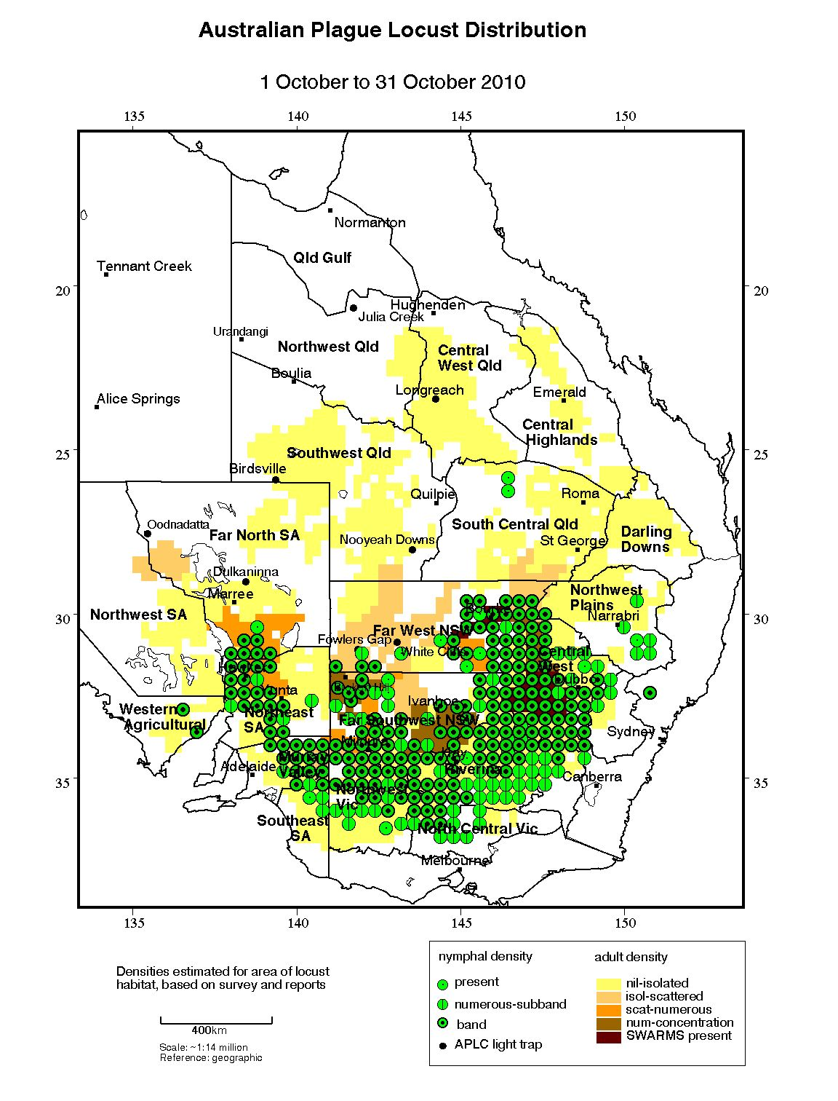

Figure 1 : Australian plague locust distribution: October 2010

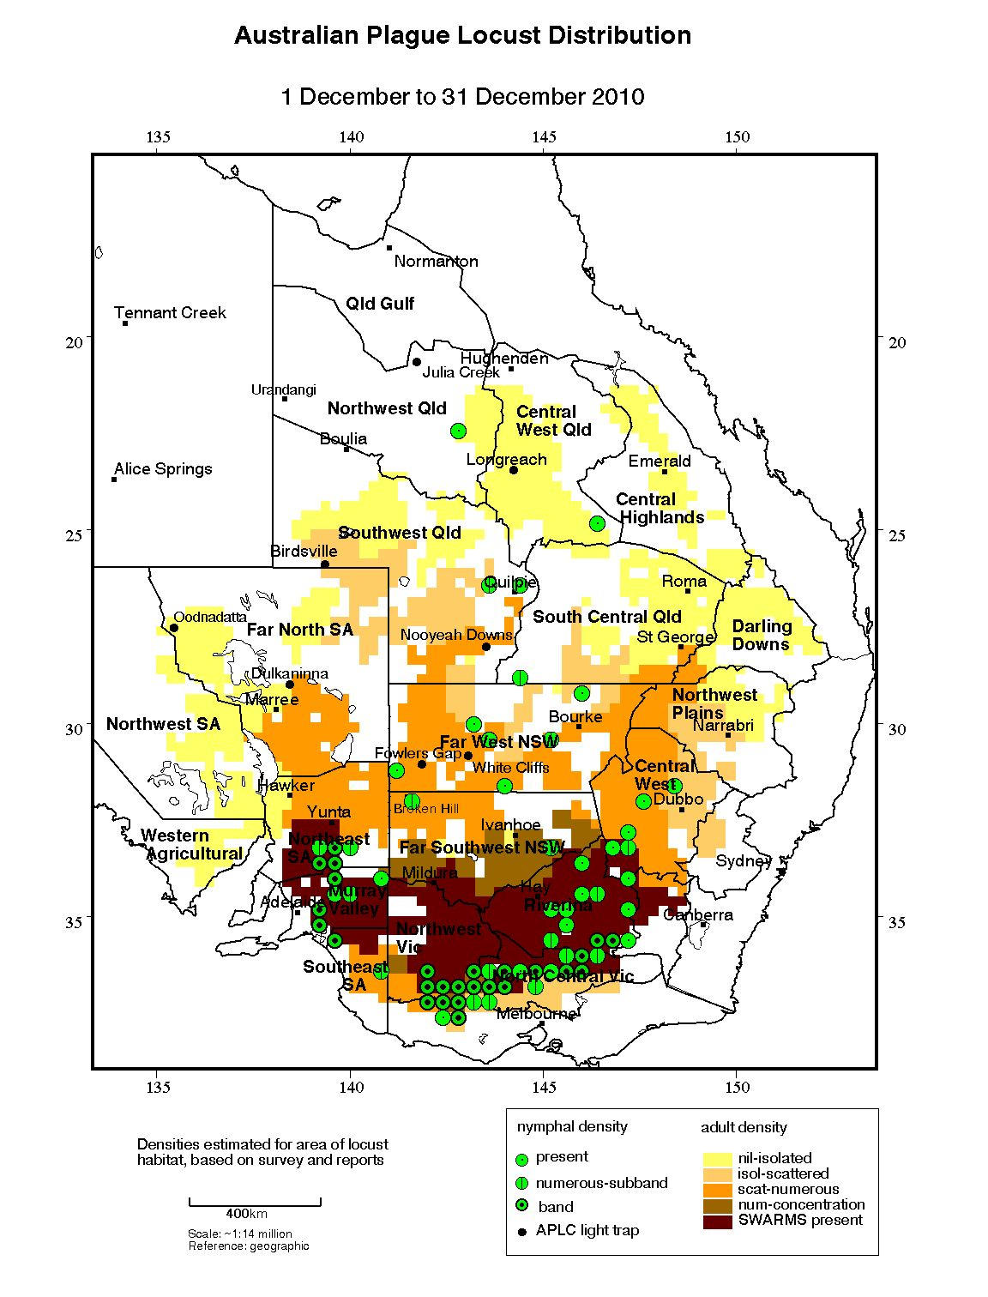

Figure 2 : Australian plague locust distribution: December 2010

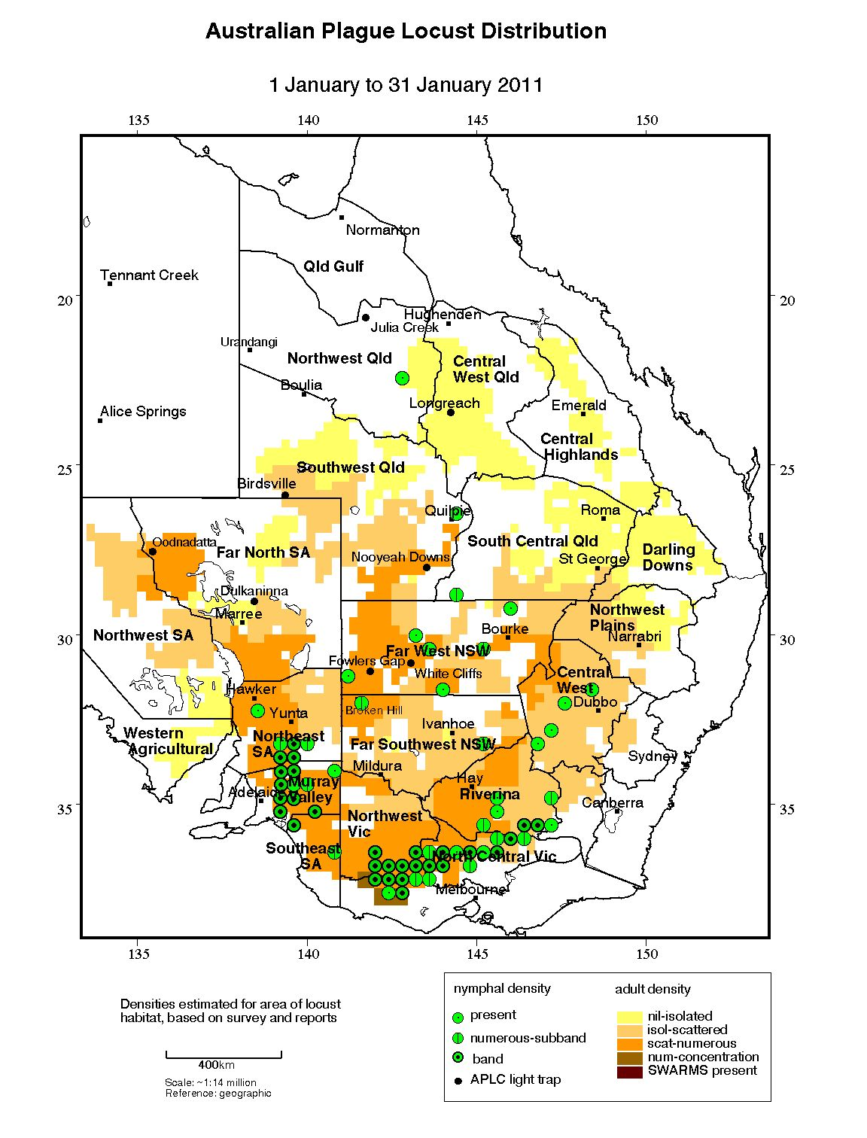

Figure 3 : Australian plague locust distribution: January 2011

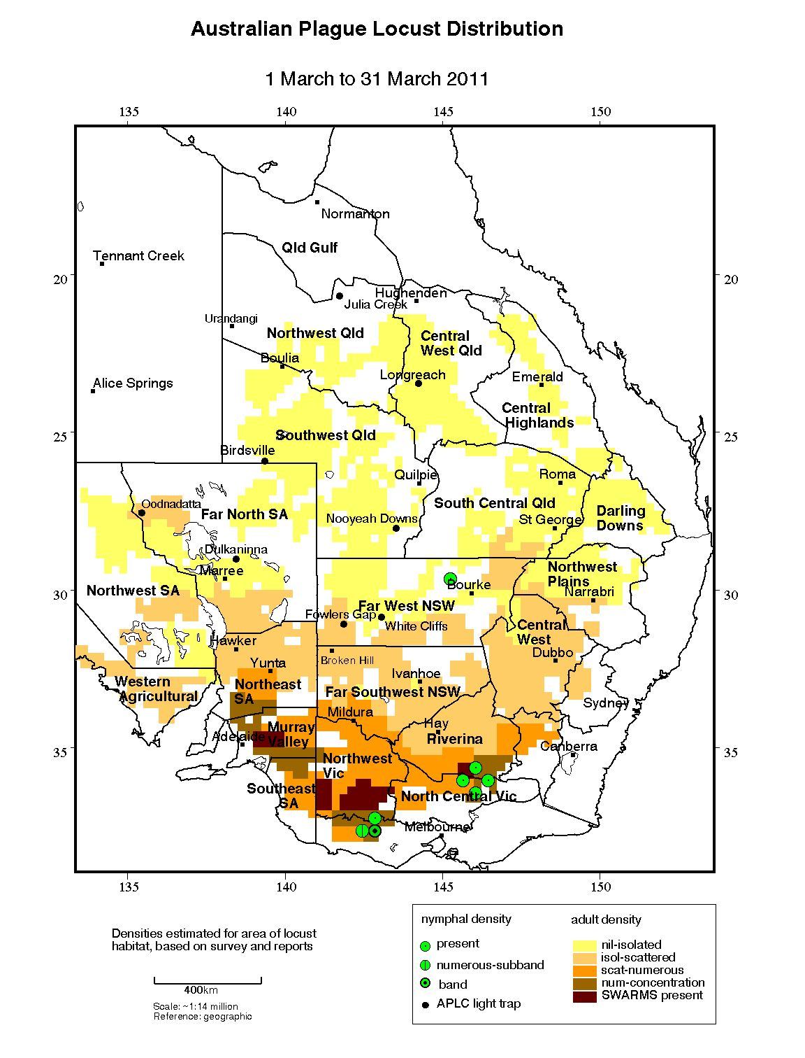

Figure 4 : Australian plague locust distribution: March 2011

## Spur-throated locust

There was a major breeding cycle of the univoltine spur-throated locust (*Austracris guttulosa* Walker) in Queensland and in New South Wales during 2010–2011. There were several southward migrations of adults from Queensland in late October and early November 2010. Migrations were detected by the insect monitoring radar at Bourke at the end of October and in early November, and also by the Bureau of Meteorology weather radars at Warrego on 29 October and at Yarrawonga, on the Murray River, on 11 November. There were hundreds of reports of low numbers of this species from Melbourne residents during the following week.

Widespread egg laying occurred across New South Wales from November 2010 to February 2011 and the subsequent summer nymphal population was consistently identified at low–medium densities in all inland regions of Queensland and New South Wales. Nymphs were reported causing damage in citrus orchards at Griffith, Bourke and as far south as Buronga in NSW, and at Loxton in South Australia. An outbreak also occurred in the Carnarvon area of Western Australia, causing damage to horticulture during February. This largely tropical species normally occurs in high densities in Queensland and this level of immigration, coupled with such successful nymphal recruitment over summer, had not been recorded in New South Wales since 1974.

The heavy rainfall in inland regions throughout summer resulted in repeated egg laying and successful recruitment of nymphs, which were recorded at various development stages from December to March (Fig. 5). Adult numbers increased during late summer and early autumn following the fledging of nymphs. Swarms of young adults were reported in some locations during March and early April, but few overwintering swarms formed subsequently.

## Migratory locust

The population level of this species remained generally low throughout the 2010–2011 season and was largely confined to the Central Highlands and South Central Queensland, and the New South Wales Northwest Plains.

Surveys in early spring identified occasional adults of this species in the Cunnamulla and Roma areas in South Central Queensland and also in the Goodooga–Collarenebri area of the Northwest LHPA in New South Wales. Biosecurity Queensland reported low–medium density adults in an areas east of Clermont in mid-November.

Despite the widespread and repeated rainfall events during summer providing suitable conditions for continuous breeding of the low density population during summer, no gregarious population development was detected. APLC surveys were limited in the regions where this species is more commonly found due to staff commitments to monitoring and control of *Chortoicetes terminifera*. In early February, low density adults were identified in several locations in the Mungindi area of the Northwest LHPA area in NSW and in the Roma–Injune area of South Central Queensland. Occasional adults were detected near Dalby and in the Queensland Central Highlands. Low density adults were again identified in several locations in the Roma–Injune area in early March.

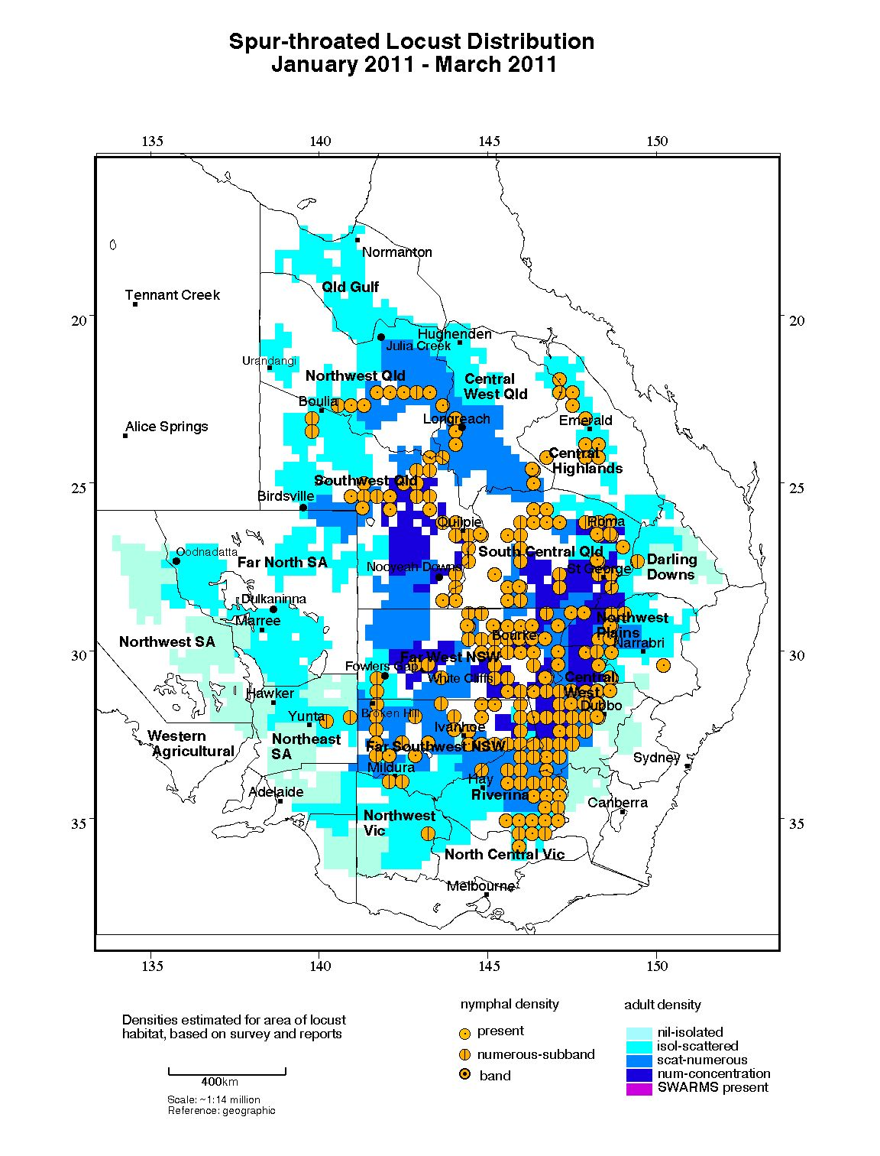

Figure 5: Spur-throated locust distribution: January-March 2011

# Operations

The 2010-11 APLC Operational Plan was prepared as part of the extensive pre-season planning activities conducted with Member state agencies, developed over four months of interagency collaboration between May and September 2010.

This plan identified areas of primary focus for potential APLC locust control for the spring 2010 generation, planned surveillance activities in other areas, coordination with anticipated state agency control activities, and included a communications strategy developed through the specialist Communicators Network established during the pre-season preparations. This plan, the associated strategies and subsequent updates were presented to meetings of department Ministers of the five Member jurisdictions on several occasions throughout the season and to numerous industry groups, landholder meetings and other stakeholder events.

The collaborative planning effort and the national communications strategy meant that any operational support or resource availability issues were quickly resolved between agencies, and ensured the overall national strategy remained on track. It also provided a consistent message to stakeholders and the general public, ensuring cooperation in survey and control activities and securing significant reporting input to supplement agency surveillance activities.

## Forecasting, information and survey

As part of the extensive pre-season planning undertaken, maps and other information were prepared to identify likely hatching and life-stage dates for all areas known to hold over-wintering egg beds. This information allowed all agencies and landholders to target their surveillance and other activities, and to schedule these for the most appropriate timing.

This information was updated regularly as warranted by climatic influences, and was revised as appropriate throughout the season. The information gathered through surveillance was supplemented by reports and insect monitoring radar, light trap and meteorological data to produce forecasts in relation to locust swarm events.

Eight Locust Bulletins were released during the period September 2010 to April 2011. Bulletins were simultaneously released via the APLC website and through direct delivery to stakeholders.

Regular situation updates were prepared and posted in the intervening periods between monthly Bulletins. These updates not only kept stakeholders and the general public informed of developments in the locust situation, but also satisfied a significant amount of the media’s need for timely information.

The UNSW insect monitoring radars (IMR) were in operation to varying extents during the 2010-11 season. The Bourke IMR was active for all but 5 days, while the Thargomindah IMR operated only intermittently during August–September 2010.

A new procedure was developed to generate daily maps of wind trajectories from the Bureau of Meteorology ACCESS weather model using Python scripting. ACCESS data calculates winds and temperatures on geopotential heights, allowing for topographic variations, and the new trajectories are only mapped for air temperatures >16° C to account for the minimum air temperature required to sustain locust take-off and flight.

## Pesticide evaluation and application management

The nature of control operations undertaken by APLC during the 2010-11 season limited opportunities for evaluation of control agents or application techniques. However, APLC officers assisted NSW Primary Industries and Livestock Health and Pest Authority (LHPA) staff in planning and evaluating the application of fipronil barrier spraying in Central West NSW. This involved training staff undertaking aerial target identification and mapping and measuring nymphal band movement for planning barrier strip spray placement.

APLC officers also provided considerable operational and field assistance to state agency responses in South Australia and Victoria in the management and application of control agents. APLC staff worked within the state agency incident management teams for several weeks fulfilling specific designated roles..

APLC staff also participated in incident debrief activities with these state agencies, which included evaluations of the effectiveness of the control agents and application systems employed.

## Control operations and pesticide use

As outlined in the Locust Situation Overview section of this report, a widespread nymph population emerged during spring, requiring coordinated control by the APLC, state agencies and landholders. There was a subsequent overall population decline and control of the second nymph generation was only carried out by landholders.

In line with the coordinated operational plans established prior to spring 2010, APLC carried out aerial control in key areas of southern NSW and northern Victoria. A relatively small total area (less than 800 km2) was sprayed, but covered a large number (over 100) of individually targeted sites with high density locusts.

**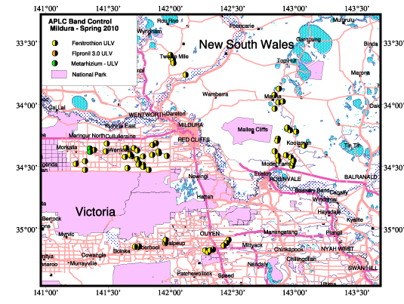**

**Figure 6: Map of APLC locust control in southwest NSW and northwest Victoria during October-November 2010, showing locations of control events by insecticide.**

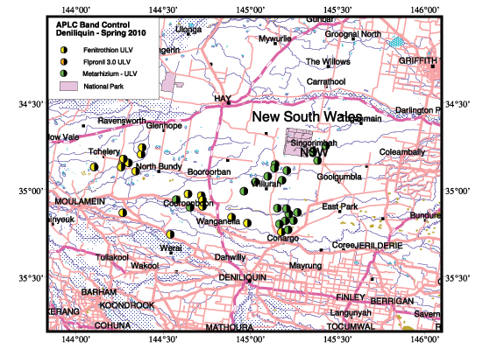

**Figure 7: Map of APLC locust control in the NSW southern Riverina during November 2010, showing locations of control events by insecticide.**

Table 1: Control operations 2010-11

|  |  |  |  |  |
| --- | --- | --- | --- | --- |
| **Control Base** | **Type** | **Period** | **Number**  **of targets** | **Area Treated**  **(km2)** |
| Mildura, VIC | Band | 24/10 – 11/11/2010 | 65 | 417.34 |
| Deniliquin, NSW | Band | 7/11/ - 18/11/2010 | 37 | 378.88 |
| Total 2010-11 |  |  | 102 | 796.22 |

Table 2: Area treated (km2) by pesticide type 2010-11

|  |  |  |
| --- | --- | --- |
| **Fenitrothion** | **Fipronil** | Green Guard |
| 686.95 km2 | 0 km2 | 109.27 km2 |
| (86.3%) | (0 %) | (13.7%) |

**Locust Control Agent Stocks**

As part of its pre-season planning for 2010-11, APLC purchased stocks of the three insecticides currently used for aerial control.. APLC also provided guidance to Member state agencies regarding their own likely pesticide requirements.

Despite the advance notice provided to suppliers regarding the season’s requirements, a shortage occurred in the supply of the biopesticide Green Guard from the single manufacturer in Australia. As manufacture of this biopesticide requires a lengthy spore production period, APLC placed its own order and facilitated the placement of orders by state agencies at least three months prior to it being required to allow for production and supply. However a contamination problem during spore production led to a two month lag in supplies. APLC then acted as supply manager for Green Guard, setting up a supply and distribution schedule for the manufacturer to ensure that no jurisdiction was left without stocks at critical times.

APLC total pesticide use was below the anticipated levels as a result of the coordinated inter-agency control and the decline of the locust population during summer. The stocks of all three control agents at the end of 2010-11 were therefore higher than at the start of 2010-11 due to the quantities purchased in anticipation of extensive control activities, as shown in Table 3.

Table 3: Locust control agent stocks 2010-11

|  |  |  |  |  |
| --- | --- | --- | --- | --- |
|  | ***Fenitrothion***  ***[Sumithion® ]***  ***(tonnes)*** | ***Fipronil***  ***[Adonis 3®]***  ***(litres)*** | ***Metarhizium***  ***[Green Guard®]***  ***(containers)*** | ***Malathion***  ***[Fyfanon®]***  ***(litres)*** |
| On Hand 1 July 2010 | 47.1 | 400 | 43 | 800 |
| Purchased 2010-2011 | 69.9 | 24,000 | 150 | 0 |
| Used 2010-2011 | -18.5 | 0 | -123 | 0 |
| Inventory @ 30 June 2011 | 98.5 | 24,400 | 70 | 800 |
| Approx. equivalent area (hectares) | 351,696 | 221,818 | 8,284 | 1,143 |
| Inventory Value 30 June 2011 | $1,663,665.25 | $409,676 | $148,352.34 | $6,400 |

The total inventory value of the APLC pesticide stocks held at 30 June 2011 is approximately $2.23 million. The above figures do not include the 5 tonnes of fenitrothion held by APLC on behalf of Queensland.

Small quantities of pesticide are held at APLC field bases. The remainder (with the exception of the Green Guard stocks) is held in commercial premises in Dubbo, NSW.

Some 6,560 litres of the carrying agent for Green Guard (Summer Spray Oil) [valued at $10,824.00] held in store are not included in the above figures.

Stocks of Green Guard include both formulated product and dry spore material. The quantities of Green Guard stock listed above are expressed in 14 litre container equivalents.

Green Guard stocks are held by the supplier, Becker Underwood. The shelf-life of Green Guard stored by the manufacturer [@ 4oC] is guaranteed for 2 years but is only guaranteed for 6 months in the field [@ 25oC]. Stored inventory is turned over and replaced when practicable.

## Environmental Management System

A report of the progress made by the APLC in meeting the objectives of its Environmental Management System (EMS) is provided at Annex 1.

Ibis sensitive (nesting) areas in NSW were incorporated in APLC GIS and Pesticide Application Management and Mapping System.

Victorian and SA environmental sensitive areas were provided by VIC DPI and PIRSA and incorporated into the APLC’s GIS system and overlays were created for the OpsManager system to be used during control campaigns.

As part of a worldwide project designed to better inform pesticide risk assessment for gorge-feeding vertebrates, the APLC Environmental Officer (Paul Story) was joined by Pierre Mineau (Environment Canada) and Wim Mullie (Foundation of the First Lady of Senegal) to study the feeding behaviour of birds co-occurring with locust control during spray operations in the Mildura-Robinvale area (northern Victoria and southern NSW) during 2010-2011. This is an ongoing research project quantifying feeding rates and dietary pesticide intake loads for gorge feeding avian species across landscapes subjected to pesticide application for locust and grasshopper control. This data, together with information from locust and grasshopper programs in other countries, will be used to test the sensitivity to and better inform risk assessments for pesticide used in locust and grasshopper control throughout the world.

The APLC treated a total area of 79,622 ha of nymphal bands during 2010-11 with 14% of the area treated with the biopesticide GreenGuard. The majority of biopesticide use was in the Riverina north of Deniliquin over protected Plains Wanderer habitat, which was consistent with the policy established between APLC, NSW Primary Industries and NSW Department of Environment, Climate Change and Water. The continued use of the Personal Digital Assistants to locate sensitive areas prior to treatment ensured no sensitive areas were treated with the organophosphate insecticide fenitrothion.

No environmental issues were reported during the two control campaigns conducted in 2010-11. Of the 65 targets treated during the control campaign based at Mildura, 22 targets had post treatment monitoring and no observable adverse environmental effects were noted.

## Occupational Health & Safety

Two reportable and one non reportable OH&S incidents occurred involving the release of pesticides due to hoses being removed from aircraft filler tanks while still under pressure. This was during the testing and use of a new pumping system using larger diameter hoses and a completely closed pumping system.

There were also OH&S issues raised with the new larger diameter hoses being too heavy to handle, especially when full of chemical. While improved training in the use of the new pumping system may reduce the likelihood of spills, the combined OH&S issues involved are likely to result in the APLC returning to using the more transportable and lighter spear and nozzle, semi-closed loading system.

A non-reportable aircraft operations incident occurred when agreed aircraft operational communications channels were not applied by the fire bombing team of the Victorian Department of Sustainability and Environment working off an airstrip close to APLC aerial spraying areas. This resulted in firebombing aircraft overflying APLC target areas not responding to contact attempts. Before any near misses could occur, APLC aerial operations in the area were called off.

In order to address the potential impacts of the differing approaches to operational helicopter use between APLC and NSW I&I, both parties contracted the helicopter safety consultant YTBN services to conduct a review of APLC low level helicopter operations. One of the key requirements of the review was to determine what, if any, changes to APLC helicopter operations are necessary to deliver a level of risk which is acceptable to all parties.

The preliminary draft review was received by the APLC in May 2011 and a final draft review received for comments in June 2011 by both the APLC and NSW I&I.

## Competency based training and assessment

Skye Irving commenced duties as a Field Officer and was taken through introductory training, including workplace health and safety.

Clare Mulcahy experienced another control campaign and was deemed fully competent in conducting fixed wing aerial survey and control of nymphal bands as well as assisting in the running of a control campaign.

Heather Brooks, Ashley Johnston and Jason Ullrich received further training in fixed wing band survey and directing spray aircraft in the aerial control of bands, and were deemed fully competent by the completion of the Mildura campaign. Skye Irving received training in all ground support aspects of a control campaign and began progressing through her first year of competency training.

## International linkages

APLC GIS officer Dr Haikou Wang was invited by the Grassland Division, National Animal Husbandry Service, Ministry of Agriculture, China to attend the workshop on locust monitoring and forecast, and assessment of environmental impact from locust control activity, in Beijing, China during 27 Nov – 3 Dec 2010, to deliver presentations and join discussions about the monitoring and forecasting of locust population. Chinese scientists on locust/grasshopper researches and insecticide researches/applications were also invited to attend the workshop.

APLC Director Chris Adriaansen Visited UN-FAO headquarters in Rome in March 2011 to investigate the potential use in Australia of the pesticide stock management and tracking system developed by FAO. Given the significant stocks of locust control agents accumulated by various agencies in preparation for the 2010-11 season, the stocks held at the cessation of the plague, and the issues associated with coordinated supply across jurisdictions, Commissioners expressed interest in the possibility of a nationally-coordinated pool of locust control agents, and were interested in whether the FAO pesticide stock management system could be effectively applied in Australia.

Dr Wang was invited by the Asian Food and Agriculture Cooperation Initiative, Rural Development Administration, Korea, to attend the international workshop on the Collaboration Network for Control of Migratory Rice Planthoppers and Associated Virus Diseases of Rice in Asia, Seoul, 26-28 April 2011. The 3-day workshop involved international participants and scientists from more than 10 Asian countries. Dr Wang presented a keynote speech on the surveillance network and management system for the Australian plague locust, which is regarded as an advanced system for monitoring and managing migratory insect pests.

# Administration

## Governance

A single APLC Commissioners’ meeting was held on 7th May 2011 (67th APLC Commissioners meeting). It was agreed that no Commissioners meeting was necessary in the first six months of the 2010-11 year as all parties had been constantly engaged with one another in the extensive pre-season planning activities and in the subsequent first generation control operations.

Full records of the Commissioners meeting and all decisions taken are archived with APLC and held by all Member jurisdictions. An overview of the 2009-10 performance and outcomes of the Commission were contained in the 2009-10 APLC Annual Report.

Key governance issues covered by Commissioners and the APLC Director during 2010-11 included the establishment of new contractual arrangements for the supply of *Metarhizium* biopesticide (with the inclusion of penalty clauses for delays in supply of orders, in recognition of the supply issues faced in preparation for the 2010-11 season), agreement of all parties on proposed resolution of several outstanding risk mitigation measures pertaining to low-level helicopter use, and initial framing of the scope and focus of a planned strategic review of APLC which would take into account a number of the learnings from the 2010-11 season planning and response activities.

## Staffing

APLC Administration Officer Peter Slattery commenced a period of leave without pay in July 2010 to accompany his spouse on her posting to the Solomon Islands.

It was with sadness that we bid farewell to field officer Laurie Sanchez after a number of years with the Commission. Laurie had taken various periods of leave in the preceding year to care for his partner during her illness, and decided to resign following her passing.

Three other field officers (Jason Ullrich, Skye Irving and Ashley Johnson) resigned at the end of the 2010-11 season, with their positions to be filled through a bulk recruitment round in early 2011-12.

Experienced officer-in-charge John Nolan rejoined APLC at Narromine field base in August 2010 after previously departing in April 2010 to take up a position with an aerial agriculture operator based at Narromine. It was good to have John back, with the wealth of expertise he has acquired over his 13 years with APLC.

**Table 4 : APLC Staffing position during 2010-11**

| ***Officer*** | ***Position*** | ***Location*** | ***Period Employed*** |
| --- | --- | --- | --- |
| C. Adriaansen | Director | Canberra HQ | Throughout |
| W. Spratt | Deputy Director | Canberra HQ | Throughout |
| E. Deveson | Forecasting & Information Officer | Canberra HQ | Throughout |
| P. Spurgin | Control Officer | Canberra HQ | Throughout |
| P. Story | Environmental Officer | Canberra HQ | Throughout |
| J. Woodman | Entomologist | Canberra HQ | Throughout |
| H. Wang | GIS Officer | Canberra HQ | Throughout |
| H. McRae | OH&S/Training Officer | Canberra HQ | Throughout |
| P. Slattery | Administration Officer | Canberra HQ | Until 30 July 2010 |
| L. Veness | Administration Officer | Canberra HQ | From 20/08/10 |
| R. Graham | Officer in Charge | Broken Hill | Throughout |
| L. Sanchez | Field Officer | Broken Hill & Narromine | Until 29/04/11 |
| J. Ullrich | Field Officer | Broken Hill | Until 15/04/11 |
| S. Irving | Field Officer | Broken Hill | 04/11/10 - 01/04/11 |
| J. Nolan | Officer in Charge | Narromine | From 16/10/10 |
| H. Brooks | Field Officer | Narromine | Throughout |
| A. Johnson | Field Officer | Narromine | Until 30/06/11 |
| C. Mulcahy | Officer in Charge | Longreach | Throughout |
|  |  |  |  |

\* Note that these figures do not include part-time staff employed to operate the APLC light trap network.

# Finance

Total revenue in 2010-11 amounted to $4.951 million. Expenses recorded in the 2010-11 financial report (Annex 2) amounted to $4.471 million resulting in a net operating surplus of $0.480 million. The surplus was carried over to the 2011-12 financial year as part of the accumulated reserve. This accumulation of surplus into a reserve fund is in accordance with the Memorandum of Understanding, a position that was reconfirmed by decision of the 62nd Commissioners Meeting in April 2008.

The addition of this net operating surplus to that carried forward into 2011-12 raises the level of total accumulated reserve to $2.408 million as at 30 June 2011. This fund would be drawn upon should the cost of control activities in any year exceed the annual allocation for control activities. The 62nd Commissioners Meeting also established a review “cap” for the reserve fund of $3 million, above which the application of accumulated reserves would be decided by Commissioners (either as a reduction in the following year’s contributions or invested for a specific agreed purpose).

The surplus of income over expenditure for 2010-11 was delivered principally as a consequence of limited staff vacancies at various times during the year, while renegotiation of vehicle lease costs and return of vehicle sale proceeds also contributed to this result.

Control operations expenditure for 2010-11 exceeded the budgeted amount by $0.190 million, reflecting control campaign activity in the spring 2010 generation which, due to its location and timing, was far less efficient that the more extensive control operations carried out in autumn 2010.

A marked upsurge in corporate overheads costs was recorded in 2010-11, with actual expenditure exceeding budget allocation by some $260,000. This was primarily as a result of a change to the account capture of this type of expenditure, with property, storage and internal business overheads now being recorded as corporate overheads instead of supplier expenses as had previously been the case. There was no net impact upon APLC finances as a consequence of this expense realignment, as there was an equivalent reduction in these expenses captured elsewhere in APLC\s accounts. The allocation of an additional $134,626 of funds by the Commonwealth also served to reduce the impact of unbudgeted overhead charges which were attributed to APLC as a result of cost realignment by the Department of Agriculture during the 200-11 financial year.

# Key Performance Indicators

The 2005 external review of the APLC suggested a number of Key Performance Indicators (KPIs) against which the future performance of the APLC could be measured. These KPIs have been adopted, with some modifications to provide additional semi quantitative measures, for reporting on an annual basis. Details of the KPIs and performance measures together with an assessment of the APLC’s performance in 2010-11 against these are summarised in Table 5.

Table 5: APLC 2010-11 Performance against KPI measures

| **Key Performance Indicator** | **KPI Measures** | **Assessment/comments (2010-11)** |
| --- | --- | --- |
| Effectiveness of monitoring, prediction and control of locust populations | - Significant populations detected at early-mid instar stage  - Accuracy of forecasts of population scale, timing and location  - Majority of control measures against nymphal stage  - No adverse aerial spraying incidents | Significant plague locust populations in several locations and across three jurisdictions were detected at early life stage through targeted ground and aerial surveillance, which utilised forecasts prepared for each generation.  100% of area subjected to control activities undertaken in 2010-11 was completed during the nymphal stage.  No adverse incidents were reported or were known to have occurred. |
| Availability and effectiveness of control agents | - Availability of existing agents  - Replacement agents identified and application rates/techniques verified | No change to availability of current control agents.  Additional performance and reporting criteria added to revised biopesticide supply contract to redress supply problems experienced at the start of the 2010-11 season.  Following investigations and engagement with USDA programs and specialists, discussions have been held with Australian supplier of major insect growth regulant compound to scope evaluation and development work in future years. |
| Environmental impact of control | - No reported/observed significant adverse impacts | No adverse impacts observed or reported consequent to APLC control activities in 2010-11. |
| Trade risks minimised | - No adverse trade (residue) impacts | No adverse trade impacts resulted from APLC operations. Comprehensive advice was provided to state and local agencies to minimise the residue and trade risk of their locust control activities. |
| Cooperation with environmental, OH&S and other relevant agencies in developing and implementing plans for control programs | - Plans developed and agreed and reviewed on regular basis. | Current policy on locust control in habitat areas of endangered species and in other environmentally restricted areas was applied where appropriate.  Facilitated and collaborated with member state agencies in the preparation of state locust response plans for 2010-11, and the post-season review of their implementation. |
| Ensuring OH&S of APLC staff, including aerial safety | - No significant OH&S incidents | Two reportable incidents occurred in 2010-11, which has resulted in revised application of existing OH&S standards and procedures.  Revised Aerial Operations Safety Manual implemented and reviewed with operational staff as part of post-season review.  Review of OH&S Manual progressed to reflect outcomes of external review.  External consultant engaged to review low-level helicopter risk factors and recommend appropriate and acceptable risk mitigation measures. |
| Improved management practices developed through a targeted research program | - Research findings incorporated into APLC control strategy and operations | Continued application of fipronil barrier spraying techniques as a consequence of previous R&D in both application technology and environmental research sectors. |
| APLC staff participation in national and international programs/scientific conferences | - APLC staff invited to participate in appropriate programs and conferences | National and international scientific and technical conferences and meetings as listed were attended and addressed to ensure APLC profile and contacts remain current. |
| Development of effective strategic, operational and communication plans | - Plans developed, endorsed and implemented  - Plans published | Significant effort applied to pre-season strategic, operational and communications planning across all Member jurisdiction agencies.  Detailed information derived from these plans provided widely through stakeholder meetings, publications and media. |
| Training of member state staff | - APLC training course developed and core of trained member state staff available | Training delivered to state agency and LHPA staff prior to and at the commencement of the 2010-11 season.  In-field training and development provided to NSW department and LHPA staff during response activities. |

# Research

## Purpose and research areas

In carrying out its charter, the APLC identifies and undertakes applied and targeted research to plan for, and be responsive to, issues relating to its activities. These include, but are not limited to, the efficient monitoring and accurate forecasting of locust populations, the potential environmental and trade impacts of its control programs, the cost and efficacy of control agents, and the decision-making of locust control. An ongoing research program is essential to addressing these issues now and into the future. The three research areas are:

* Improvement in efficacy and reduction of risks associated with **control agents and application technology** addressing both immediate and future issues.
* Identification and measurement of **environmental** and trade (residue) risks potentially resulting from the APLC’s operations and integration of research results into the agencies’ core business.
* Improved understanding of the **population ecology** of locusts to improve the performance and effectiveness of existing surveillance and forecasting systems as well as improving early intervention strategies.

## 

## Summaries of research in progress

*The following research summaries provide an overview of current research activities being undertaken by the Australian Plague Locust Commission. The research summaries are not considered to constitute publication as the investigations are often incomplete and any results presented tentative.*

### 1. Control agents and application technology

Technical advice and training relating to use of Fipronil and the biopesticide Green Guard® was provided to state counterpart organisations to assist with their control response.

An estimation of *Metarhizium* infection rate, using long-term average temperatures, for possible application near Deniliquin New South Wales in October 2010, indicated it would take about 18 days for 50% mortality of sprayed *Chortoicetes terminifera* nymphs. (Figure 8). Field observation found that the locust nymphs sprayed on 7 November started to die on 23 Nov from the infection of *Metarhizium*, (Fig. 9). The results suggest that the model parameters for *C. terminifera* response to *Metarhizium* are well fitted.

Figure 8 graphs the estimated mortality rates of Metarhizium-treated plague locusts using long-term average temperatures

Figure 8: Estimates of *Chortoicetes terminifera* mortality rates by *Metarhizium* with long-term average temperatures

Figure 9 graphs the simulated mortality rates of Metarhizium-treated plague locusts using actual observed daily tenperatures

Figure 9: Simulation of *Chortoicetes terminifera* mortality rates by *Metarhizium* with observed daily temperature maxima and minima

### 2. Environmental impact

#### 2.1 Quantifying the effects of pesticides used for locust control on Australian native vertebrates.

With the completion of previous collaborative research between the APLC, University of Wollongong, Texas Tech University and the National Research Centre for Environmental Toxicology, research effort has been focussed on publication of results. Lab-based research outlined in the APLC's previous Annual Activity Statement (2007-2008) will now be developed further to incorporate field-based effects.

#### 2.2 Comparative risk assessments of pesticide used for locust control throughout the world.

Several methods exist for building species sensitivity distributions (SSDs) using data relevant to several toxicity end points allowing the estimation of the probability of lethality as a result of pesticide exposure.  The APLC's Environmental Officer, Mr Paul Story, is currently working with Dr Pierre Mineau (Research Scientist and Program Leader, Pesticides Section, Environment Canada) on the development of comparative risk assessments for pesticides used throughout the world for locust control.  Pesticides registered in Australia, USA, Canada, the European Union as well as those on the World Food and Agriculture Groups (FAO) approved list will be evaluated.

An appeal for new and updated research data, specifically as it relates to pesticide residue values on either insects or vegetation, has been extended to the world-wide scientific community through various key researchers and research agencies.  It is envisaged that the incorporation of this data with new, more probabilistic risk assessment methods, will enable risk assessments for insecticides currently used for locust control to be updated and compared.  Risk assessments derived from this research will potentially be more protective because we will first look for the influence of body-weight scaling on toxicity and use that as covariate before developing pesticide specific species sensitivity distributions.  Benefits to locust control agencies, such as the APLC, will flow from these improved comparative risk assessments, enabling improvements in their environmental performance through the selection of "environmentally softer" pesticides for spray operations.

#### 2.3: The impact of fipronil on ants and termites

This collaborative project was led by former APLC entomologist, Dr Martin Steinbauer. Data collection was concluded in November 2008 by APLC field staff and subsequent analysis and interpretation was led by James Woodman in collaboration with Martin and statisticians at BRS. The work targeted ants and termites due to Fipronil being a marketed termiticide that has previously shown severe, long-lasting impacts on termites from high dosage applications in Madagascar.

The results of this work are currently being evaluated in light of experimental design limitations identified during analysis and interpretation. As such, this work is presently being used to inform the planning of a successive research project. This work will quantify the off-target impacts of fipronil applied using current APLC application rates and barrier intervals (as opposed to blanket applications which have not been used since 2002‑03) for a greater number of invertebrate study species. This new study will also have a greater focus on the functional significance of these species to arid Australian ecology.

### 3. Population Ecology and Dynamics

#### 3.1: High-temperature survival relative to food availability in first-instar Australian plague locust nymphs

Thresholds for high temperatures and limited food availability causing mortality in first instar *C. terminifera* nymphs have been long standing knowledge gaps for locust monitoring and forecasting in Australia. This work attempted to answer this question by evaluating the extent to which hot and dry food limited conditions may contribute to nymphal mortality in the field. The critical upper limit for fed nymphs is very high at 53.3 ± 1.0°C, with death preceded by a progression of changes in behaviour, gas exchange, water loss and excretion. At more ecologically relevant temperatures, mortality from desiccation is dependent on food availability relative to exposure duration and maximum temperature as well as the rate of warming. While very high mortality occurs at temperatures of ≥45°C maintained for 6 h, a highly exposed and very poorly vegetated summer environment would be required for local population failures from current high temperatures and low humidity alone. This work has now been published in the peer-reviewed literature.

**3.2: Overwintering physiology of pre-reproductive adult Spur-throated locusts**

This study aims to describe and quantify the physiological basis to overwintering adult survival in *A. guttulosa* as part of a broader objective to improve our understanding of Australian locust population ecology. Results to date show impressive cold tolerance for a predominantly sub-tropical insect. The body fluids freeze between -6 and -12.8°C depending on body size and the amount of freshly eaten food. Dissections of the digestive tract have also shown an impressive reaction to the absence of food. The direction of food movement through the gut is reversed so that processed food destined to pass out of the locust is moved back up to the front. It can be held there for several days to maximise water and nutrient extraction and delay the effects of starvation. At low temperatures above the freezing point, mortality increases dramatically at -7°C independently of sex, acclimation and the rate of cooling preceding minimum temperature exposure. In contrast to *C. terminifera* nymphs, *A. guttulosa* cannot temporarily enhance cold hardiness in response to declining temperatures. This work is in preparation for publication in the peer-reviewed literature.

#### 3.3: Genetic diversity in the Australian plague locust at the continental scale

The population genetics program at the University of Sydney has finalised the process of identifying genetic markers in *Chortoicetes terminifera* and comparing populations collected from 92 sites across the continent. Statistical analysis indicates that there is no significant genotypic differentiation between the samples from different locations suggesting that the distribution of the *C. terminifera* is panmictic. A panmictic population is one where all individuals are potential partners – i.e. there are no mating restrictions on the population and no localised geographic variation.

While this does not prove that east-west and west-east migration is common, it does suggest that such migration has occurred recently. Continent wide migration may therefore be a contributing factor to the development of outbreaks. This work is now published in the peer-reviewed literature.

**3.4: Parasitism rates, life history and reproductive biology of *Scelio fulgidus***

*Scelio fulgidus* is a widely distributed egg endoparasitoid of the Australian plague locust that can exert considerable influence on locust population dynamics. The only experimental data for *Scelio fulgidus* longevity is from 1935 and suggested total mortality within 15 days. Our preliminary results show longevity to be variable, but adults may survive in excess of 40 days at 20°C, 25 days at 25°C and 15 days at 30°C. Upcoming experiments will more sensitively control temperature and relative humidity to more fully explore implications for parasitism incidence and frequency in late autumn. Reproductive potentials will also be investigated.

**3.5: Effects of inundation on Australian plague locust egg development and viability**

This study aims to quantify the effects of different inundation durations at different temperatures on locust egg development and viability. Development rates, egg survival, hatchling condition and subsequent nymph survival to 2nd instar will be quantified to estimate the likely impacts of flooding on population dynamics in the field. This project is being undertaken with an ANU research student under the supervision of Dr James Woodman.

#### 3.6: Collective movement of the Australian plague locust

An airborne optical locust tracker to monitor the movement of late instar C. terminifera nymphs within bands was successfully tested. The sensor, a powerful strobe light source collocated with a high definition digital camera was carried by a remotely controlled unmanned aerial vehicle (UAV), a one third scale J3 Cub aircraft. The aperture and shutter speed of the camera were matched to the strobe pulse duration and intensity to minimise reflection from the ground and only detect returns from special retro-reflector tags. These tags (a 2.5 mm wide x 3.5 mm long reflective crystal) were attached (heat glued) to the thorax of fifth instar nymphs and were reliably detected from heights of 100-125 m above ground level. In practise, a known number of these tagged nymphs would be released into a marching band of nymphs and repeated passes of the UAV over the band should allow the movement of individual nymphs to be tracked within the band by the positions of their retro-reflectors.

A field trial to test this monitoring tool will occur when suitable populations of banding locusts can be located.

#### This project is an ARC Linkage Project 0989291 funded collaboration between the University of Sydney’s School of Biological Sciences, Australian Centre for Field Robotics and the APLC.

**3.7: Spring migration of spur-throated locust**

A migration event of *A. guttulosa* was detected for the first time by both the UNSW insect monitoring radar at Bourke and the Bureau of Meteorology (BoM) weather radar in Warrego on the night of 29 Oct 2010, and confirmed by APLC staff on the ground next day. A pre-front trough passed through this region on that night (Fig. 10) and induced a large immigration of spur-throated locusts into the Bourke-Nyngan (NSW) region from the Goodooga-Dirranbandi-Bollon Queensland region to the north-east. The BoM weather radar at Warrego (Qld) detected the edge of this migration, which was toward to the southwest, while the radar at Namoi (NSW) did not pick up a significant insect layer (Fig. 11).

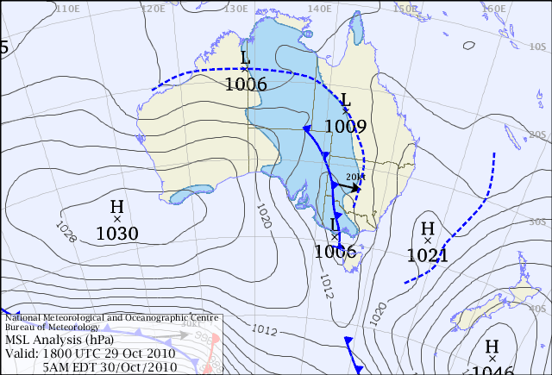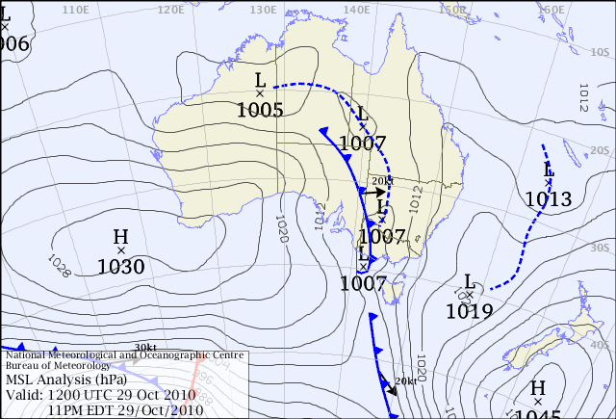

Figure 10: Mean sea level pressure charts for the night of 29 Oct 2010

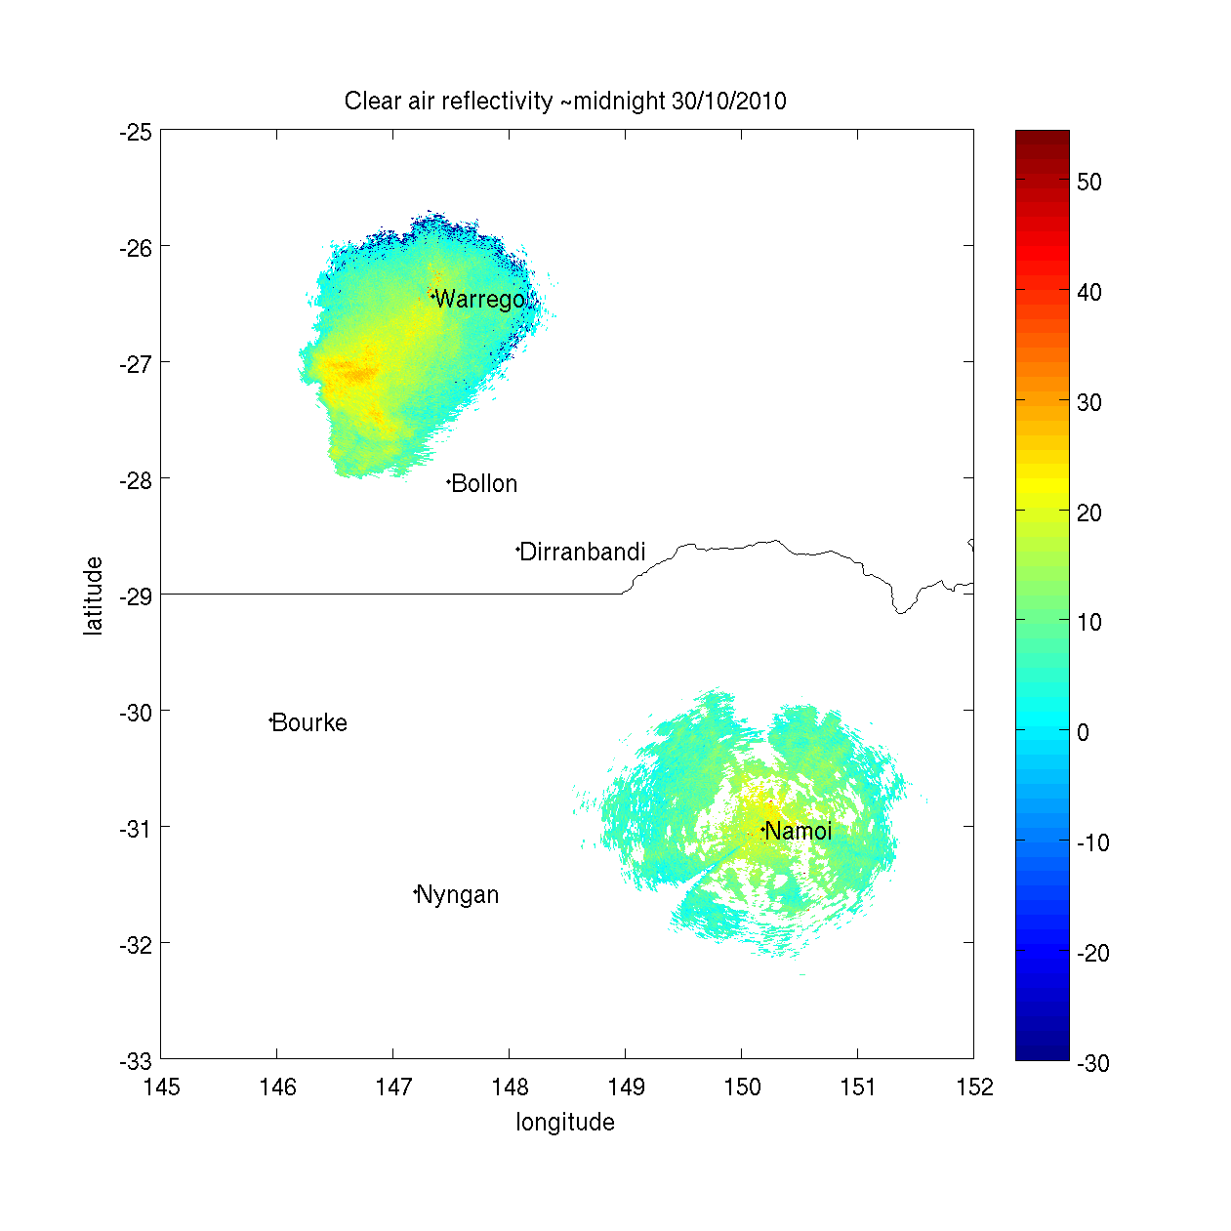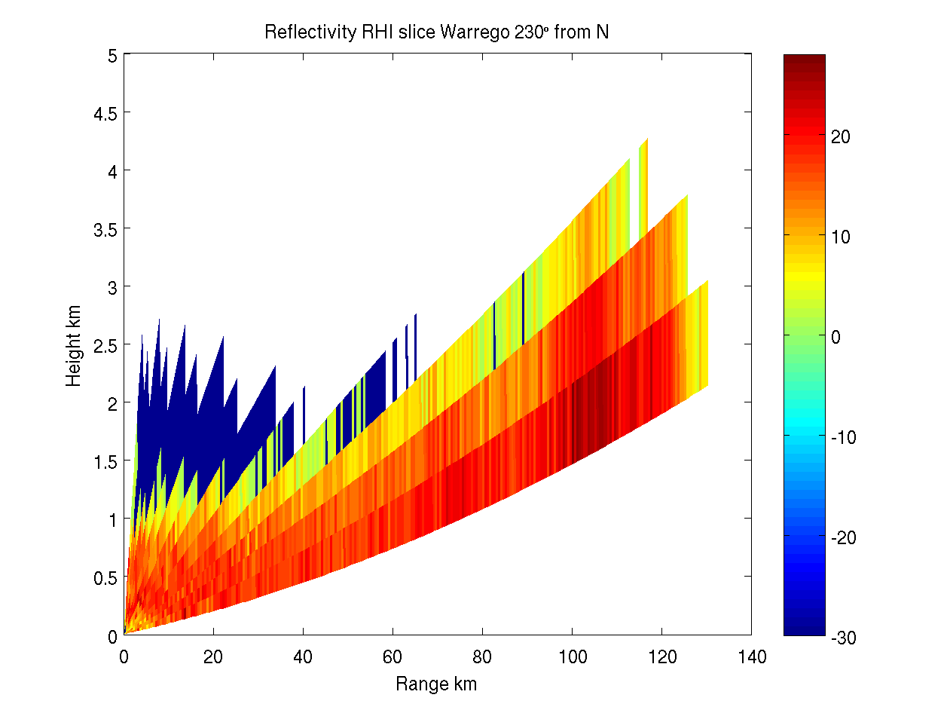

Figure 11: Clear air echoes from BoM weather radars in Warrego and Namoi on the night of 29 Oct 2010

# Publications

Chapuis, M-P., Popple, J-A., Berthier, K., Simpson, S.J, Deveson, E., Spurgin, P., Steinbauer, M.J., and Sword, G.A. 2011. Challenges to assessing connectivity between massive populations of the Australian plague locust. Proceedings of the Royal Society B 278, 3152-3167.

Letnic M, Story PG, Story GL, Field J, Brown, O and Dickman CR (2011). Resource pulses, switching trophic control and the dynamics of desert small-mammal assemblages in arid Australia. Journal of Mammalogy 92(6):1210-1222

Smith PN, Afzal M, Al-Hasan R, Bouwman H, Castillo LE, Depledge MH, Subramanian M, Dhananjayan V, Fossi C, Kitulagodage M, Kylin H, Law R, Marsili L, O’Hara T, Spinola M, Story PG and Goddard-Codding C (2010). Global perspectives on wildlife toxicology: Emerging issues. In: Wildlife Toxicology. Emerging Contaminants and Biodiversity Issues. (Eds: Kendall RJ, Lacher TE, Cobb GP and Cox SB). CRC Press, Taylor-Francis Group, Boca Raton FL USA (Pubs) 321 pp. ISBN 978-1-4398-1794-0

Woodman, J.D. 2010. High temperature tolerance is limited by food availability in first-instar locust nymphs. Australian Journal of Zoology 58, 323-330.

Annex 1: Environmental Management System conformance 2010-11

|  |  |  |
| --- | --- | --- |
| **Program** | **Sub-project** | **Progress (2010-11)** |
| 1. Excellence in all operational areas | Staff trained to full field competence | *All APLC field staff were able to progress fully through their 2nd year competency training and assessment. The two band control campaigns at Deniliquin and Mildura provided good opportunity for field staff to complete their training in APLC band control operations.* |
| DGPS used in all aircraft | *dGPS continued to be used in all spray aircraft to provide detailed record of spraying operations.* |
| Improved control efficiency | *As all APLC control occurred within the intensive agricultural regions of southern NSW and northern Victoria only Fenitrothion and Metarhizium blanket treatments were used. The availability of Metarhizium for use in plains wander habitat ensured the majority of the locust infestation could be treated.* |
| 2. All waste managed appropriately | Waste management contract | *No contract was in use this year and APLC negotiated appropriate disposal of waste through NSW I&I’s waste disposal.* |
|
| 3. Minimise the intensity, extent and duration of disturbance to native flora and fauna | Incidents effectively managed | *No environmental incidents or reports were received or observed during the season. With the availability and use of infield sensitive area mapping, no plains wanderer habitat was accidently treated with fenitrothion. Post spray assessments were undertaken at 34% of treated targets.* |
|
| Reduce the proportional use of fenitrothion in control ops | *While APLC use of fenitrothion remained relatively high (86% of total control undertaken), there was very significant use of fipronil barrier spraying and of* Metarhizium *biopesticide by other agencies as recommended and supported by APLC.* |
|
| Increased successful use of fipronil and larger track spacing | *Due to both APLC control campaigns occurring within the more intensive agricultural regions of southern NSW and northern Victoria the majority of target sizes were too small for the efficient use of wide interval track spacing with fipronil.* |
|
| 4. Contribute to our understanding of natural and managed ecosystems | Develop risk assessment process for APLC pesticides, based on outcomes of environmental research. | *As part of a worldwide project designed to better inform pesticide risk assessment for gorge-feeding vertebrates, Paul Story and international colleagues Pierre Mineau (Environment Canada) and Wim Mullie (Foundation of the First Lady of Senegal) began the bird feeding behaviour of birds co-occurring with locusts during spray operations. This is an ongoing research project quantifying feeding rates and dietary pesticide intake loads for gorge feeding avian species across landscapes subjected to pesticide application for locust and grasshopper control.* |
|
| Develop field protocols based on research | *Relevant research results still pending.* |
|

|  |  |  |
| --- | --- | --- |
| **Program** | **Sub-project** | **Progress (2010-11)** |
| 5. Avoid disturbance to protected sites/areas | Development of the GIS, OpsManager® and PDA handhelds sensitive area maps and database | *Updated Plain-wanderer habitat geo-spatial information provided by NSW DEC and added to the APLC’s sensitive areas database was used extensively during the Deniliquin campaign.*  *The APLC’s sensitive area database was updated with spring ibis nesting areas within NSW, Victorian national and state park boundaries, northern Victorian endangered species sites, and SA environmental sensitive areas.* |
| Procedures and buffers developed to avoid disturbance | *There were no changes to aerial spray buffers during the season.*  *Procedures were established to ensure the use of Metarhizium only in plains-wanderer habitat and to negotiate the use of Metarhizium only in sensitive areas in northern Victoria.* |
| 6. Ensure stakeholders are aware of all environmental obligations and they assist APLC achieve these. | Develop environmental aspect into APLC stakeholder training course. | *Training was conducted with NSW I&I and LHPA staff through September and Vic DPI staff in October.* |
| Landholder consultation prior to and after pesticide application | *Extensive landholder consultation was conducted during the two control campaigns.*  *Pre campaign discussion were conducted with NSW National Park and Victorian DSE staff to ensure potential impacts on sensitive areas within campaign risk zones were assessed.*  *Post control advice was issued within 2 weeks to all property owners.* |

# Annex 2: APLC Financial Performance Report 2010-11

