A Draft Report on Progress with Implementation of the Victorian Regional Forest Agreements (RFAs)
East Gippsland RFA, Central Highlands RFA, North East RFA,
West Victoria RFA and Gippsland RFA
ISBN 978-1-74242-215-2 (online)

This report has been coordinated by the Forests and Parks Division of the Victorian Government Department of Sustainability and Environment.
© Copyright State of Victoria and Commonwealth of Australia 2009
Published by:
Department of Sustainability and Environment on behalf of the State of Victoria and the Commonwealth of Australia.
8 Nicholson Street
PO Box 500
East Melbourne VIC 3002
Phone: 136 186 (DSE Customer Service Centre)
Email: rfa.review@dse.vic.gov.au
Website address: www.dse.vic.gov.au/forests
ISBN 978-1-74242-215-2 (online)
December 2009
Key contributors:
- Victorian Government (Department of Sustainability and Environment)
- Australian Government (Department of Agriculture, Fisheries and Forestry)
- Australian Government (Department of the Environment, Water, Heritage and the Arts)
Disclaimer
This publication may be of assistance to you but the State of Victoria, Commonwealth of Australia, and their employees do not guarantee that the publication is without flaw of any kind or is wholly appropriate for your particular purposes and therefore disclaims all liability for any error, loss or other consequence which may arise from you relying on any information in this publication.
TABLE OF CONTENTS
1. ACRONYMS & ABBREVIATIONS 4
2. TABLES 6
3. EXECUTIVE SUMMARY 8
4. INTRODUCTION 14
5. progress against MILESTONES AND OBLIGATIONS 16
5.1. Relationship to Statutory Obligations 16
5.2. Milestones 20
5.3. Five yearly review 20
5.4. Ecologically Sustainable Forest Management 20
5.5. Monitoring, reporting and consultative mechanisms 22
5.6. Sustainability indicators 27
5.7. Private land 29
5.8. Threatened flora and fauna 30
5.9. Water 36
5.10. The CAR reserve system 36
5.11. Industry Development 42
5.12. Indigenous Heritage 55
5.13. Plantations 56
5.14. Other Forest Uses 56
5.15. Competition Principles 59
5.16. Research 60
5.17. Funding 61
5.18. Data Agreement 62
5.19. Legally Binding Provisions 63
(a) Forest management 63
(b) Compensation 65
(c) Industry development funding 65
6. THE RESULTS OF MONITORING OF SUSTAINABILITY INDICATORS 67
7. DOCUMENTS CITED IN THIS REPORT 68
8. APPENDIX 1 - CAR RESERVE SYSTEM 70
9. APPENDIX 2 – THREATENED SPECIES 121
10. APPENDIX 3 – LISTING, PROTECTION AND MANAGEMENT OF NATIONAL ESTATE VALUES 134
11. APPENDIX 4 - PUBLIC REPORTING AND CONSULTATIVE PROCESSES 137
12. APPENDIX 5 - RESEARCH 140

ACRONYMS & ABBREVIATIONS
ABC | Actions for Biodiversity Conservation
AFCS | Australian Forestry Certification Scheme
AFS | Australian Forestry Standard
AHC Act | Australian Heritage Commission Act 1975 (Cwth)
Allocation Order | Allocation to VicForests Order 2004
CAR reserve system | Comprehensive, Adequate and Representative reserve system
CH | Central Highlands RFA
CMA | Catchment Management Authority
CRA | Comprehensive Regional Assessment
CRC | Cooperative Research Centre
CSIRO | Commonwealth Scientific and Industrial Research Organisation
DAFF | Australian Government (Department of Agriculture, Fisheries and Forestry)
DPI | Victorian Government (Department of Primary Industries)
DSE | Victorian Government (Department of Sustainability and Environment)
Eastern Victoria | Area of Victoria east of the Hume Hwy
ECC | Environment Conservation Council
EG | East Gippsland RFA
EIAP | Expert Independent Advisory Panel
EID Act | Extractive Industries Development Act 1995 (Vic)
EMS | Environmental Management System
EPA Victoria | Environmental Protection Agency Victoria
EPBC Act | Environment Protection and Biodiversity Conservation Act 1999 (Cwth)
ESP Act | Endangered Species Protection Act 1992 (Cwth)
EVC | Ecological Vegetation Class
FFG Act | Flora and Fauna Guarantee Act 1988 (Vic)
FMA | Forest Management Area
G | Gippsland RFA
GMZ | General Management Zone
IFPS | Integrated Forest Planning System
Joint Study | Australian Heritage Commission/NRE study of the National Estate
JoSHL | Joint Sustainable Harvest Level
LCC | Land Conservation Council
MAHP | Monitoring Annual Harvesting Performance
MIG | Montréal Process Implementation Group
MRSD Act | Mineral Resources (Sustainable Development) Act 1990 (Vic)
NE | North East RFA
NRE | Department of Natural Resources and Environment
Period 1 | Period of time on which the first five-yearly review of the Victorian RFAs is based (date RFA signed to 30 June 2004)
Period 2 | Period of time on which the second five-yearly review of the Victorian RFAs is based (1 July 2004 to 30 June 2009)
RFA | Regional Forest Agreement
RFA Act | Regional Forest Agreements Act 2002 (Cwth)
RNE | Register of the National Estate
SFMS | Sustainable Forest Management System
SFRI | Statewide Forest Resource Inventory
SFT Act | Sustainable Forests (Timber) Act 2004 (Vic)
SMZ | Special Management Zone
SPZ | Special Protection Zone
Sustainability Charter | Sustainability Charter for Victoria’s State forests
VEAC | Victorian Environmental Assessment Council
VicFISAP | Victorian Forest Industry Structural Adjustment Program
W | West Victoria RFA

TABLES
Table 1 Summary of performance against RFA milestones and obligations. | 13
Table 2 Species listed under the Environment Protection and Biodiversity Act 1999 (Cwth) and the Flora and Fauna Guarantee Act 1988 (Vic), extending beyond Victoria and found in the East Gippsland RFA region, for which Recovery Plans have been adopted. | 31
Table 3 Threatening processes listed under the Environment Protection and Biodiversity Act 1999 (Cwth) and the Flora and Fauna Guarantee Act 1988 (Vic), extending beyond Victoria relevant to all RFA regions, for which national Threat Abatement Plans have been adopted. | 31
Table 4 Species listed under the Environment Protection and Biodiversity Act 1999 (Cwth) and the Flora and Fauna Guarantee Act 1988 (Vic), extending beyond Victoria and found in the Central Highlands RFA region, for which Recovery Plans have been adopted. | 31
Table 5 Species listed under the Environment Protection and Biodiversity Act 1999 (Cwth) and the Flora and Fauna Guarantee Act 1988 (Vic), found in the North East RFA region and outside Victoria, for which Recovery Plans have been adopted. | 32
Table 6 Species listed under the Environment Protection and Biodiversity Act 1999 (Cwth) and the Flora and Fauna Guarantee Act 1988 (Vic), extending beyond Victoria and found in the West Victoria RFA region, for which Recovery Plans have been adopted. | 32
Table 7 Species listed under the Environment Protection and Biodiversity Act 1999 (Cwth) and the Flora and Fauna Guarantee Act 1988 (Vic), extending beyond Victoria and found in the Gippsland RFA region, for which Recovery Plans have been adopted. | 33
Table 8 Representation of pre-1750 EVC/Bioregions of each RFA region in the CAR reserve system. | 38
Table 9 Representation of Endangered, Rare and Vulnerable EVC/Bioregions of each RFA region in the CAR reserve system. | 39
Table 10 Representation of old-growth in the CAR reserve system for each RFA region. | 40
Table 11 Schedule of tenure changes identified in the RFAs. | 70
Table 12 Current representation of Ecological Vegetation Classes in the East Gippsland RFA region. | 72
Table 13 Current representation of Ecological Vegetation Classes in the Central Highlands RFA region. | 75
Table 14 Current representation of Ecological Vegetation Classes in the North East RFA region. | 79
Table 15 Current representation of Ecological Vegetation Classes in the West Victoria RFA region. | 84
Table 16 Current representation of Ecological Vegetation Classes in the Gippsland RFA region. | 106
Table 17 Current representation of old-growth in the East Gippsland RFA region. | 114
Table 18 Current representation of old-growth in the Central Highlands RFA region. | 115
Table 19 Current representation of old-growth in the North East RFA region. | 116
Table 20 Current representation of old-growth in the West Victoria RFA region. | 117
Table 21 Current representation of old-growth in the Gippsland RFA region. | 119
Table 22 Listing status of prioritised species nominated under the Flora and Fauna Guarantee Act 1988 (Vic). | 122
Table 23 Priority Ecological Vegetation Classes for nomination under the Flora and Fauna Guarantee Act 1988 (Vic). | 123
Table 24 Prioritised flora species in the East Gippsland RFA for nomination and preparation of an Action Statement or Recovery Plan. | 124
Table 25 Prioritised Ecological Vegetation Classes for preparation of an Action Statement. | 125
Table 26 Progress with preparation of Action Statements/Recovery Plans for priority fauna species identified in the East Gippsland RFA. | 127
Table 27 Progress with preparation of Action Statements/Recovery Plans for priority species identified in the Central Highlands RFA. | 128
Table 28 Progress with preparation of Action Statements/Recovery Plans for priority species identified in the North East RFA. | 129
Table 29 Progress with preparation of Action Statements/Recovery Plans for priority species identified in the West Victoria RFA. | 130
Table 30 Progress with preparation of Action Statements/Recovery Plans for priority species identified in the Gippsland RFA. | 131
Table 31 Prioritised potentially threatening processes for preparation of an Action Statement. | 131

EXECUTIVE SUMMARY

Background
The State of Victoria and the Commonwealth of Australia entered into five Regional Forest Agreements (RFAs) between February 1997 and March 2000. These 20-year agreements establish the framework for the conservation and sustainable management of forests within each of the five Victorian RFA regions. The main objectives of the Victorian RFAs are:
- to identify a Comprehensive, Adequate and Representative (CAR) Reserve System and provide for the conservation of those areas
- to provide for the ecologically sustainable management and use of forests in each RFA region, and
- to provide for the long-term stability of forests and forest industries.
To assist in achieving their objectives, each of the Victorian RFAs contains milestones and obligations agreed to by the Parties upon signing of the RFAs. This draft report, jointly prepared by the State of Victoria and Commonwealth of Australia, contributes to the first two five year reviews of the Victorian RFAs. Table 1 lists the Clauses (milestones and obligations) in the Victorian RFAs identified for review in the Scoping Agreement for the review of progress with implementation of the Victorian Regional Forest Agreements (Scoping Agreement).

Progress with implementation of RFA milestones and obligations
Since signing Victoria’s RFAs, the State of Victoria and Commonwealth of Australia have made substantial progress in implementing the milestones and obligations set out in the RFAs.
All tenure and zoning changes required under the Victorian RFAs were implemented during the review period. Implementation of tenure changes saw the addition of significant areas of public land to the national park and conservation reserve system in the RFA regions. It also resulted in the addition of significant areas of endangered, rare and vulnerable Ecological Vegetation Classes (EVCs) and old-growth forest to the CAR reserve system. Victoria now has a world-class forest conservation reserve system which supports the conservation of biodiversity whilst securing access to timber resources and providing certainty for Victoria’s native forest timber industry into the future.
In 2002, the Victorian Government released Our Forests, Our Future which set out directions for forest management reform. In accordance with the National Competition Policy principles, Our Forests, Our Future took into account: ecologically sustainable development; social welfare and equity considerations; economic and regional development; and the efficient allocation of timber resources.
Our Forests, Our Future reformed the process for sustainable timber harvesting in eastern Victoria. Under Our Forests, Our Future the Victorian Government agreed to establish VicForests as a separate, fully commercial entity to manage the commercial interface with the timber industry. VicForests was established in August 2004 (Period 2) under the State Owned Enterprises Act 1992 (Vic) to manage the harvest and commercial sale of timber in the forests of eastern Victoria. VicForests has established market-based approaches for timber sales, enhancing competition and efficiency in the utilisation of forest produce in Victoria. The creation of VicForests achieved a separation of the commercial functions of the government from the regulatory and policy functions.
Our Forests, Our Future recognised the level of timber harvesting in Victoria’s native forests was unsustainable. To ensure Victoria’s forests, the timber industry and regional communities were protected for the long-term, Our Forests, Our Future reduced harvesting in State forests by about a third. Additions to the national park and conservation reserve system resulting from the RFAs, and significant reductions in sustainable harvest levels resulting from Our Forests, Our Future reduced the size of the Victorian timber industry.
Outside of the RFA process, Victoria implemented additions to the ‘Dedicated Reserves’ component of the CAR reserve system in the West Victoria and North East RFA regions following investigations of the Environment Conservation Council (ECC), and Victorian Environmental Assessment Council (VEAC). The Victorian Government also committed to additions to the national park and conservation reserve system in the East Gippsland RFA region through their 2006 Victoria’s National Parks and Biodiversity election policy, though these additions were not implemented during the review period.
The Victorian Government provided $80 million of funding to help forest workers and regional communities adjust to changes in timber availability. During the review period the Victorian and Australian governments also provided a package of $42.6 million under the Commonwealth-Victorian Hardwood Timber Industry Development and Restructuring Program (VicFISAP) to help businesses take advantage of RFA certainty and adjust to changes in timber availability within two years of the RFA signing. Victoria also allocated an additional $20 million dollars to facilitate improvements in the productive capacity of public native forests, establish hardwood plantations, and establish other forest-based initiatives that generate significant employment opportunities in regional Victoria. During the review period, the Commonwealth also removed export controls on hardwood woodchips and unprocessed wood sourced from the RFA regions.
The Code of Practice for Timber Production 2007 is a key regulatory instrument that applies to commercial timber production in both public and private native forests and plantations in Victoria. It is a statutory document prepared under Part 5 of the Conservation, Forests and Lands Act 1987. Compliance is required under the Sustainable Forest (Timber) Act 2004 and via its incorporation into the Victoria Planning Provisions. The purpose of the Code is to ensure that commercial timber growing and timber harvesting operations are carried out on both public land and private land in such a way that:
- permits an economically viable, internationally competitive, sustainable timber industry
- is compatible with the conservation of the wide range of environmental, social and cultural values associated with timber production forests
- provides for the ecologically sustainable management of native forests proposed for continuous timber production
- enhances public confidence in the management of Victoria's forests and plantations for timber production.
Our Forests, Our Future committed to make the application of the Code of Forest Practices for Timber Production (now the Code of Practice for Timber Production 2007) more transparent. To deliver on this commitment, the Minister for Environment asked the Environment Protection Agency Victoria (EPA Victoria) to engage an independent environmental auditor to assess compliance of timber harvesting and related activities on public land with the Code. Audits of compliance with the Code are publicly available on the EPA Victoria website (www.epa.vic.gov.au).
In 2007-08, instead of coordinating the annual audit, EPA Victoria reviewed the forest audit program and determined that responsibility for commissioning future audits should be passed over to the Department of Sustainability and Environment (DSE). In 2009, DSE began
developing an improved auditing program for commercial timber harvesting in Victoria’s State forests. The new audit program is being developed at the request of the Minister for Environment and Climate Change, in response to the independent review administered by EPA Victoria. The new audit program will allow for the examination of a range of activities associated with timber harvesting, including: forestry operational planning; roading; operational practices; and the conduct of timber harvesting organisations. DSE will contract third-party (independent) environmental auditors in 2010 to conduct audits and assess compliance with the Code and other relevant planning and operational guidelines. The auditors will provide independent reports that will be published on the DSE website (www.dse.vic.gov.au).
DSE’s Environmental Management System (EMS) for State forests is being developed as a requirement of Our Forests, Our Future and will require DSE to foster a culture of continual improvement in minimising environmental impacts whilst complying with legal obligations and improving operational efficiency. The EMS will provide a framework for quality assurance in DSE. The supporting framework for the EMS is the Environmental Policy for Victoria's State Forests, while sustainable forest management objectives are set out in the Sustainability Charter for Victoria’s State forests (Sustainability Charter).
The implementation of RFA milestones and obligations, and Our Forests, Our Future reforms undertaken in Victoria during the review period, have significantly enhanced the States capacity to deliver effective conservation, forest management and forest industry outcomes.
Criteria and Indicators for Sustainable Forest Management in Victoria were adopted in 2007 following extensive community consultation. Victoria’s criteria and indicators for sustainable forest management are consistent with the Montréal Process, an internationally agreed framework for measuring sustainable forest management, and complement the Framework of Regional (Sub-National) Level Criteria and Indicators of Sustainable Forest Management in Australia. Performance against each indicator is reported on a five-yearly basis through Victoria's State of the Forest reporting, and informs Victorians about progress towards sustainable forest management. Data gaps have been identified for over two-thirds of the indicators of sustainable forest management in Victoria’s criteria and indicator framework, these gaps are primarily due to measurement difficulties. As part of its continuous improvement process, DSE is currently undertaking a review of the indicators to assess their measurability and determine which, if any, of the reported data gaps can be addressed over time.
During the review period National Estate commitments were overtaken by events (refer Section 5.1 and Appendix 2), and forest management reforms brought about by Our Forests, Our Future negated the value of undertaking Statewide Forest Resource Inventory (SFRI) and Integrated Forest Planning System (IFPS) works in the West Victoria RFA region (refer section 5.5). It is not possible to assess whether changes to that component of the CAR reserve system in State forest lead to a net deterioration in the protection of identified CAR values (EVCs and old-growth) during the review period as improvements in knowledge and technology over the review period mean that the inputs have changed (refer Section 5.10). The tables in Appendix 2 document the current levels of protection of EVCs and old-growth in the CAR reserve system in the RFA regions, and provide a baseline for future comparison.
There are also a number of milestones and obligations that were not achieved during the review period. The commitment to undertake a review of the performance of the Victorian RFAs within 5 years of signing was not met. This report contributes to both the first and second five-yearly reviews of the Victorian RFAs (refer Section 5.3). While the Victorian Government increased its investment in public land weed and pest management over the review period, the development of pest plant and pest animal control programs was not achieved. However, the development of these programs is underway (refer Section 5.8).
Guidelines for the Management of Cultural Heritage Values in Forests, Parks and Reserves in East Gippsland was published in October 1997. These guidelines are applied in the management of public land in the East Gippsland RFA region. Statewide guidelines have not yet been developed (refer Section 5.5).
The Portland and Horsham Forests Proposed Forest Management Plan was released for public comment in December 2005. The plan is being finalised and is expected to be completed in 2009. The review of the Otway Forest Management Plan was deferred while the review of land-use undertaken by VEAC as part of the Angahook-Otway Investigation was underway. VEAC’s recommendations led to the creation of the Great Otway National Park and Otway Forest Park. The draft management plan for the Great Otway National Park and Otway Forest Park was released for public comment in March 2008. The plan is being finalised and is expected to be completed in 2009. Review of the Midlands Forest Management Plan was not undertaken during the review period, as management planning focussed on the preparation of plans for all forests in the State within the RFA regions and the box-ironbark and riverine forests outside of the RFA regions. Review of the Midlands Forest Management Plan is not currently scheduled. DSE has recently commenced a strategic review of forest management planning in Victoria (refer Section 5.10).
The effective regeneration of harvested areas within State forest is required to maintain ecosystem sustainability and future productive capacity of the forest. The Code of Practice for Timber Production 2007 requires all State forest areas in Victoria which have been subjected to timber harvesting to be regenerated to approximate the composition and spatial distribution of canopy species common to the coupe prior to harvesting, where they can be determined. Harvested stands that do not meet the required standards following the first regeneration treatment must be re-treated until that standard is achieved. Monitoring Annual Harvesting Performance in Victoria’s State forests 2006-07 (DSE 2008b) reported that it is estimated over 7 000 hectares of forest in Victoria requires re-treatment to achieve successful post-harvest regeneration, and an additional 19 000 hectares of forest is estimated to be overdue for regeneration surveys, with 63% of this area occurring in East Gippsland. DSE is progressively addressing this issue (refer Section 5.11).
A State-wide data agreement between Victoria and the Commonwealth was signed on 28 March 2000. Data schedules to the State-wide agreement were developed by the Parties, and archival copies of data have been lodged for the East Gippsland RFA region. Data schedules and lodging of archival copies of data was not completed in the other RFA regions (refer Section 5.18).
In the West Victoria RFA region, Victoria expanded the CAR reserve system by converting the Otway State Forest to the Great Otway National Park and Otway Forest Park. This tenure change saw timber harvesting in the Otways phased out by 30 June 2008. The creation of the Great Otway National Park was not in accordance with the West Victoria RFA. This was acknowledged by the Premier of Victoria in the Victorian Parliament on 5 October 2004. Victoria created the Great Otway National Park and Otway Forest Park in recognition of the considerable biodiversity value of these forests, and the substantial area of hardwood plantation that would become available over the next decade and potentially provide a viable long-term alternative supply of timber to the native forest. In considering obligations under Clauses 65 and 69 of the West Victorian RFA, the creation of the Great Otway National Park did not lead to a net deterioration in the protection of identified CAR values, but did lead to a net deterioration in the timber production capacity of the forest in the West Victoria RFA region. The Victorian Government worked closely with the timber industry and local community during the phase-out of timber harvesting in the Otways (refer Section 5.11).
The Cobboboonee State Forest (now the Cobboboonee National Park and Forest Park) was also added to the ‘Dedicated Reserves’ component of the CAR reserve system in the West Victoria RFA region outside of the RFA process.
As stated above, Victoria implemented additions to the ‘Dedicated Reserves’ component of the CAR reserve system in the North East RFA region, and committed to additions to the national park and conservation reserve system in the East Gippsland RFA region. These additions to the CAR reserve system were all outside of the RFA process.
The State of Victoria and Commonwealth of Australia remain committed to ensuring effective conservation, forest management and forest industry outcomes are delivered in the Victorian RFA regions. The review to which this report contributes will not open up the RFAs to re-negotiation, however both Parties may agree to some minor modifications to incorporate the review findings.
Table 1 Index of RFA milestones and obligations reported in this review.
RFA | East Gippsland | Central Highlands | North East | West Victoria | Gippsland | Report Section
Clause number
Relationship to statutory obligations | 12, 15-18, 20-21, 23 | 36 | 21, 25-30, 32-33 | 21, 25-31, 33-34 | 21, 25-31, 33-34 | 5.1
Milestones | 25 | 37-39 | 35 | 36 | 36 | 5.2
Five yearly review | 30-32 |  | 36-38 | 37-39 | 37-39 | 5.3
Ecologically sustainable forest management | 34 | 42-46 | 39-40 |  |  | 5.4
Monitoring, reporting and consultative mechanisms | 26-29 | 49-51 | 41-45 | 42-46 | 42-46 | 5.5
Sustainability indicators | 37-40 | 53 | 48-50 | 49-51 | 49-51 | 5.6
Private land | 42 | 55-60 | 52 | 53 | 53 | 5.7
Threatened flora and fauna | 43-46 | 61 | 55-59 | 55-60 | 55-60 | 5.8
Water |  | 64-67 |  | 61 | 61 | 5.9
The CAR reserve system | 49-51 | 68-77 | 62-65 | 64-67 | 64-67 | 5.10
Industry development | 53 | 78 | 66-72 | 68-77 | 68-77 | 5.11
Indigenous heritage | 54 |  | 73 | 78 | 78 | 5.12
Plantations | 56 | 83-87 |  |  |  | 5.13
Other forest uses | 57, 59, 60 | 88 | 76-79 | 83-87 | 83-87 | 5.14
Competition principles | 61 | 89-91 | 80 | 88 | 88 | 5.15
Research | 62-64 |  | 81-83 | 89-91 | 89-91 | 5.16
Funding | 65, 66 | 92 |  |  |  | 5.17
Data agreement | 67 | 94-95 | 84 | 92 | 92 | 5.18
Forest management |  | 96 | 86-87 | 94-95 | 94-95 | 5.19
Compensation |  | 97 | 88 | 96 | 96 | 5.19
Industry development funding |  | 91 | 89 | 97 | 97 | 5.19
Attachment number
CAR reserve system | 1 | 1 | 1 | 1 | 1 | Appendix 1
Threatened flora, fauna and communities | 4 | 2 | 2 | 2 | 2 | Appendix 1
Listing, protection and management of national estate values in the Gippsland Region | 2 | 3 | 3 | 3 | 3 | Appendix 2
Milestones | 3 | 4 | 4 | 4 | 4 | Refer to relevant clause numbers
Indigenous heritage |  |  |  | 8 | 8 | 5.12
Forest management |  |  |  | 9 | 9 | 5.10
Program for completion of SFRI and sustainable yield forecasts for RFAs in Victoria |  |  |  | 10 | 10 | 5.5
Industry adjustment and development |  |  |  | 11 | 11 | 5.11

INTRODUCTION
RFAs are 20-year agreements between the Commonwealth of Australia and state governments (Western Australia, Tasmania, New South Wales and Victoria) for the conservation and sustainable management of Australia's native forests. The RFAs are given legislative status through the Regional Forest Agreements Act 2002 (Cwth) (RFA Act). The RFAs provide certainty for forest-based industries, forest-dependent communities and conservation. They are the result of years of scientific study, consultation and negotiation covering a diverse range of interests. Of the 10 RFAs in Australia, half apply to Victoria. The State of Victoria and Commonwealth of Australia (the Parties) entered into the RFAs as follows:
RFA Region | Date of agreement
East Gippsland | 3 February 1997
Central Highlands | 27 March 1998
North East | 9 August 1999
West Victoria | 31 March 2000
Gippsland | 31 March 2000
The Victorian and Australian governments committed to ensuring the RFAs are durable and that the obligations and commitments that they contain are delivered to ensure effective conservation, forest management and forest industry outcomes. The Australian Government’s role is to coordinate a national approach to environmental and industry-development issues, while the State Government has constitutional responsibility for forest management in Victoria.
The Victorian RFAs seek to balance and protect the full range of environmental, social, economic and heritage values that forests provide for current and future generations. The RFAs are a key outcome of the 1992 National Forest Policy Statement through which the Australian, state and territory governments committed to the sustainable management of all Australian forests, whether the forest is on public or private land, or reserved or available for production.
Victoria’s RFAs were developed following Comprehensive Regional Assessments (CRAs) which evaluated the economic, social, environmental and heritage values of forest regions and involved the full range of stakeholder and community groups. The CRAs provided governments with the information needed to make long-term decisions about forest use and sustainable development, and provided the framework for the development of the Victorian RFAs. Each RFA involved at least 50 assessment projects in disciplines ranging from biology and zoology to economics and sociology.
The three main objectives of the Victorian RFAs are:
- to identify a Comprehensive, Adequate and Representative (CAR) Reserve System and provide for the conservation of those areas
- to provide for the ecologically sustainable management and use of forests in each RFA region, and
- to provide for the long-term stability of forests and forest industries.
To assist in achieving their objectives, each of the RFAs contains milestones. In addition, the State and the Commonwealth identified other obligations, to ensure the RFAs are implemented effectively.
An important element of each of the Victorian RFAs is the requirement for a five yearly review of the performance of the RFAs. Clauses 30, 31 and 32 of the East Gippsland RFA, Clauses 36, 37 and 38 of the Central Highlands and North East RFAs, and Clauses 37, 38 and 39 of the West Victoria and Gippsland RFAs require the five yearly review to provide an assessment of progress of the RFA against the established milestones, and include:
- the extent to which milestones and obligations have been met, including the management of the National Estate;
- the results of monitoring of sustainability indicators; and
- invited public comment on the performance of the Agreement.
This draft report was jointly prepared by the State of Victoria and Commonwealth of Australia and assesses the performance of each of the Victorian RFAs between the date the RFAs were signed and 30 June 2004 (Period 1), and between 1 July 2004 and 30 June 2009 (Period 2). With the release of this draft report, an 11 week period of public comment commences. Submissions received by DSE will be forwarded to an Independent Reviewer for analysis. A report prepared by the Independent Reviewer will be considered by the State of Victoria and Commonwealth of Australia in preparing a final report.
The review process to which this draft report contributes will satisfy the requirement of each Victorian RFA to undertake a review of the performance of the RFAs for the first two five year periods. While the review process will not open up the RFAs to re-negotiation, both Parties may agree to some minor modifications to incorporate the review findings.
The format of this draft report is consistent throughout. Each Clause of the RFAs identified for review in the Scoping Agreement is stated. A review of progress against each Clause in both Period 1 and Period 2 follows. Where appropriate, progress against milestones and obligations is reported separately for each of the Victorian RFAs.

progress against MILESTONES AND OBLIGATIONS

Relationship to Statutory Obligations
Obligation  Parties will manage their respective responsibilities with regard to the National Estate in accordance with the provisions of this Agreement as detailed in the RFA Attachment. | Clause numbers  EG - 12  CH - 21  NE - 21  W - 21  G - 21
This commitment has been overtaken by events.
In 2003, the Commonwealth repealed the Australian Heritage Commission Act 1975 (Cwth) and amended the Environment Protection and Biodiversity Conservation Act 1999 (Cwth) (EPBC Act) to provide for a National Heritage List to replace the Register of the National Estate (RNE). At the time it was jointly agreed to suspend further work on identifying places to add to the register, pending the outcomes of the legislative amendments. Following amendments in 2006 to the EPBC Act and the Australian Heritage Council Act 2003 (Cwth), the RNE was frozen on 19 February 2007, which means that no new places can be added, or any existing places, or values of places, removed.
The Register will continue as a statutory register until February 2012. A transition period of five years was provided to allow State and Territories to consider whether places on the Register should be protected under other statutory provisions or their own heritage registers. The Commonwealth Minister is required to consider information in the RNE in the course of his decision making under the EPBC Act during this period.
From February 2012, all references to the Register are to be removed from the EPBC Act and AHC Act; however the RNE will be maintained on a non-statutory basis as a publicly available archive. The Australian Government has invited Victoria to consider whether any places listed on the Register should be accorded any ongoing status under State legislation. While Victoria does not have any equivalent register for natural values, the State does have the Victorian Heritage Register. Any consideration of places of heritage significance on the RNE should be undertaken in consultation with relevant stakeholders.
All heritage places on the RNE, National Heritage List and Commonwealth Heritage List can be found by searching the Australian Heritage Database (http://www.environment.gov.au/cgi-bin/ahdb/search.pl).
Obligations in the RFA Attachment referred to in this Clause, and a review of progress against these obligations, is provided in Appendix 3.
Obligation  The Commonwealth notes that its obligations to promote endangered species protection will involve ongoing cooperative work with Victorian agencies concerning the RFA region. | Clause numbers  EG - 15  CH - 25  NE - 25  W - 25  G - 25
This ongoing commitment was met during Periods 1 and 2.
A number of Victorian threatened species are listed under the EPBC Act, including species which occur in RFA regions. The Victorian and Australian governments regularly share information on species as part of the Commonwealth listing processes.
In addition, the Commonwealth has had contracts in place since 2004 to prepare species data sheets on 50 species which are listed under the Flora and Fauna Guarantee Act 1988 (Vic) (FFG Act). The purpose of the Species Information Partnership is to align the listings between the State and Federal legislation. These data sheets are being used as the basis of listing advices for consideration under the EPBC Act.
Milestone  The Commonwealth undertakes to use its best endeavours to secure the enactment of legislation which amends the Environment Protection and Biodiversity Conservation Act 1999 (Cwth) by inserting definitions of ‘Forestry Operations’, ‘RFA Forestry Operations’ and ‘RFA or Regional Forest Agreement’ identical to those contained in the Regional Forest Agreements Bill (Cwth) and introduce such legislation into the Parliament of the Commonwealth by 30 June 2000. The purpose of these amendments is to give effect to the Commonwealth Government’s intention that Forestry Operations in RFA regions may be undertaken without approval under the Environment Protection and Biodiversity Conservation Act 1999 (Cwth). | Clause numbers  W - 26  G - 26
This milestone was achieved in Period 1.
The Australian Government enacted the RFA Act in May 2002. The Act defines “forestry operations”, “RFA forestry operations” and “Regional Forest Agreement”, and amended the relevant Sections (38, 40 and 42) of the EPBC Act to reflect these definitions. Section 6(4) of the RFA Act states that Part 3 of the EPBC Act does not apply to an RFA forestry operation that is undertaken in accordance with an RFA, giving effect to the Australian Government’s intention that Forestry Operations in RFA regions may be undertaken without approval under the EPBC Act.
Obligation  Parties agree to actively investigate, and participate in, World Heritage assessment of the Australia-wide Eucalypt theme, including any potential contribution from the RFA region. | Clause numbers  EG - 16  CH - 26  NE - 26  W - 27  G - 27
Obligation  Parties note that in order to progress work and then proceed to World Heritage nomination, the agreement of all relevant governments will be required. | Clause numbers  EG - 17  CH - 27  NE - 27  W - 28  G - 28
Obligation  Parties agree that any potential nomination for World Heritage involving areas in the RFA region could be achieved from within the CAR reserve system. | Clause numbers  EG - 18  CH - 28  NE - 28  W - 29  G - 29
Obligation  The Commonwealth agrees that it will give full consideration to the potential socio-economic consequences of any World Heritage nomination of places in the RFA region and that any such nomination will only occur after the fullest consultation and with agreement of the State. | Clause numbers  CH - 29  NE - 29  W - 30  G - 30
Obligation  The Parties agree that before any World Heritage nomination is made:  - all necessary management arrangements, including joint policy coordination arrangements will be agreed; and  - all related funding issues will be resolved to the satisfaction of both Parties. | Clause numbers  CH - 30  NE - 30  W - 31  G - 31
These ongoing commitments were met during Periods 1 and 2.
In 1999 Victoria participated in an Expert Workshop on the eucalypt-dominated vegetation. Information on this workshop is provided in Comprehensive Regional Assessment World Heritage Sub-theme: Eucalypt-dominated vegetation, Report of the Expert Workshop, Canberra, 8 & 9 March, 1999 (Commonwealth of Australia 1999).
In 2004, as part of the National Heritage Protocol (relating to the coordination of Australian, State and Territory governments with respect to the protection of heritage), it was agreed that, as a general principle, future nominations for World Heritage listing will be drawn from the National Heritage List.
The national parks of the Australian Alps and some adjoining conservation reserves in NSW and the ACT, including the Baw Baw, Mount Buffalo, Alpine and Snowy River National Parks and Avon Wilderness Park in Victoria, were included on the National Heritage List on 7 November 2008.
In 2007 the Environment Protection and Heritage Council (a Commonwealth, States and Territories Ministerial Council) agreed to the development of a World Heritage Tentative List, which is a prerequisite for a place being nominated for inclusion on the World Heritage List. The Victorian and Australian governments continue to participate in the development of Australia’s World Heritage Tentative List.
The Victorian Government has indicated its support for World Heritage listing for Australia’s alpine national parks, including several parks in Victoria.
No World Heritage nomination involving Victorian RFA regions was made in Period 1 or 2.
Milestone  The Commonwealth will, subject to the passage of amendments to the relevant regulations under the Export Controls Act 1982, ensure that no controls under that Act will apply to the export of hardwood woodchips or unprocessed wood sourced from the East Gippsland region while this Agreement is in place. The Commonwealth will seek passage of the relevant amendments by 30 June 1997. In the interim, licences will be issued to applicants seeking to export hardwood woodchips or unprocessed wood derived from areas within the East Gippsland region. The licences will be valid while this Agreement is in place and will not include an export volume constraint. | Clause number  EG - 20
This milestone was achieved in April 1997.

Obligation  Parties note that no controls under the Export Control Act 1982 will apply to hardwood woodchips or unprocessed wood sourced from the RFA region while this Agreement is in place. | Clause numbers  CH - 32  NE - 32  W - 33  G - 33
This ongoing commitment was met during Periods 1 and 2.
The Export Control (Hardwood Wood Chips) Regulations 1996 made under the Export Control Act 1982 (Cwth) ensure that wood chips derived from native hardwood forests are only permitted to be exported if:
i) they are derived from a region to which a RFA applies; or
ii) they are exported under a restricted shipment licence.
Under the Export Control (Regional Forest Agreements) Regulations 1997, as an RFA came into force all export controls on woodchips and other processed wood from that RFA region (except that sourced from plantations) were lifted.
In relation to plantation-sourced material, under amendments to the Export Control (Unprocessed Wood) Regulations 1986, the requirement for export licences does not apply in Victoria, since the Code of Practice for Timber Production 2007 (DSE 2007b) satisfactorily protects environment and heritage values.
Obligation  The Commonwealth notes Victoria’s intention to separate more clearly its commercial forestry activities within native State forests from the broader policy, strategic planning and regulatory functions associated with the management of those forests. Victoria also confirms its commitment to the ongoing implementation of its plans, codes and prescriptions relevant to the achievement of Ecologically Sustainable Forest Management (ESFM). | Clause numbers  EG - 21  CH - 33  NE - 33  W - 34  G - 34
These ongoing commitments were met during Periods 1 and 2.
Victoria separated the commercial forestry activities within native State forests from the policy and regulatory functions in eastern Victoria in Period 2 (August 2004) with the creation of VicForests. VicForests is accountable to the Treasurer as shareholder and relevant Minister under the State Owned Enterprises Act 1992 (Vic).
DSE is responsible for the management of Victoria’s State forests. In eastern Victoria, DSE allocates timber resources from State forests to VicForests for the purposes of harvesting and commercial sale through the Allocation to VicForests Order 2004 (as amended) (Allocation Order).
In western Victoria, including areas within the West Victoria RFA, commercial forestry activities have not been separated from the policy and regulatory forestry activities. All aspects of forest management in State forests in western Victoria remain the responsibility of DSE due to the relatively small scale of forestry activities in the west.
During Periods 1 and 2, Victoria remained committed to the implementation of its plans, codes and prescriptions relevant to the achievement of ecologically sustainable forest management.

Milestones
Milestone and Obligation  This Agreement establishes milestones and Parties will report annually on their achievement for the first five years, and then as they fall due and as part of the 5 yearly review, using an appropriate public reporting mechanism. | Clause numbers  EG - 25  CH - 35  NE - 35  W - 36  G - 36
Aspects of this milestone and obligation were met during Periods 1 and 2.
Victorian RFA Annual Reports were produced and agreed between the State of Victoria and the Commonwealth of Australia each year from 1998 to 2002, and reported on the achievement of milestones in the RFAs.
These reports were tabled in the Australian Parliament as follows:
Annual Report year | House of Representatives | Senate | RFAs covered in report
1998 | 20 June 2002 | 20 June 2002 | EG, CH
1999 | 7 February 2001 | 7 February 2001 | EG, CH, NE
2000 | 20 June 2002 | 20 June 2002 | EG, CH, NE, W, G
2001 | 5 November 2003 | 25 November 2003 | EG, CH, NE, W, G
2002 | 5 November 2003 | 25 November 2003 | EG, CH, NE, W, G
The Annual Reports are publicly available on the Department of Agriculture, Fisheries and Forestry (DAFF) website (www.daff.gov.au/rfa).
Progress with implementation of the milestone is also provided in this report.

Five yearly review
Obligation  Within each five year period, a review of the performance of the Agreement will be undertaken. The purpose of the five yearly review is to provide an assessment of progress of the Agreement against the established milestones, and will include:  - the extent to which milestones and obligations have been met including management of the National Estate;  - the results of monitoring of sustainability indicators; and  - invited public comment on the performance of the Agreement. | Clause numbers  EG - 30  CH - 36  NE - 36  W - 37  G - 37
Obligation  Each review will be scheduled concurrent with the five yearly reviews required for the East Gippsland RFA. | Clause number  CH - 36
Obligation  While the review process will not open up the Agreement to re-negotiation, both parties may agree to some minor modifications to incorporate the results of the review. | Clause numbers  EG - 31  CH - 37  NE - 37  W - 38  G - 38
Milestone and Obligation  The outcomes of the review will be made public. The mechanism for the review will be determined by both Parties before the end of the five year period and the review will be completed within three months. | Clause numbers  EG - 32  CH - 38  NE - 38  W - 39  G - 39
The commitment to undertake a review of the performance of the Victorian RFAs during the first five year period (Period 1) was not met. The review was delayed as a consequence of reforms in the management of Victoria’s forests associated Our Forests, Our Future.
A Draft Report on Progress with Implementation of the Victorian Regional Forest Agreements (RFAs) contributes to the first (Period 1) and second (Period 2) five-yearly reviews for each of the Victorian RFAs, which are being undertaken simultaneously. The review will assess progress with implementation of the Victorian RFAs between the date the RFAs were signed and 30 June 2009.
The Commonwealth of Australia and State of Victoria have signed a Scoping Agreement for the review of progress with implementation of the Victorian Regional Forest Agreements. The Scoping Agreement sets out the principles, governance and process for the conduct of the review, including RFA requirements relating to purpose, items for review, timelines and public consultation. The Scoping Agreement is available on the DSE website (www.dse.vic.gov.au).
The final review report, which will be publicly released following revision to account for comments of the public and an independent reviewer, will mean that Victoria and the Commonwealth will have met their review commitments until 30 June 2014 when the third five-yearly review is due.

Ecologically Sustainable Forest Management
Obligation  The Parties agree that ESFM is an objective which requires a long term commitment to continuous improvement and that the key elements for achieving it in accordance with clause 7 are:  - the establishment of a CAR reserve system;  - the development of internationally competitive forest products industries; and  - a fully integrated and strategic forest management system capable of responding to new information. | Clause numbers  NE - 39
Obligation  The Parties agree that Victorian processes and systems provide for ecologically sustainable management of forests in the North East region and that these processes and systems are accredited in clause 47 of this Agreement. | Clause numbers  NE - 40
The Parties agree with these clauses.
The Australian and Victorian governments agreed that ecologically sustainable forest management is an objective which requires a long term commitment to continuous improvement and that the key elements for achieving it are the establishment of a CAR reserve system, the development of internationally competitive forest products industries, and the implementation of a fully integrated, strategic, and adaptive forest management system.
It was also agreed that Victorian processes and systems provide for the ecologically sustainable management of forests in the RFA regions, and that the processes and systems in place in Victoria were accredited in the RFAs.

Monitoring, reporting and consultative mechanisms
Obligation  Victoria will report on the results of monitoring of sustainability indicators. | Clause numbers  EG - 26  CH - 41  NE - 41  W - 42  G - 42
This ongoing commitment was met during Periods 1 and 2.
Victoria reports on the results of monitoring of sustainability indicators through five-yearly State of the Forests reporting, at both the state and national level.
Several State of the Forests reports were published during the review period. Australia’s State of the Forests Report was published in 1998 (Period 1), 2003 (Period 1) and 2008 (Period 2). Victoria’s State of the Forests Report 2003 (DSE 2005b) (Period 1) published in 2005 provides baseline information at 2003. Victoria’s State of the Forests Report 2008 (DSE 2009c) (Period 2), published in August 2009, reports on the condition of Victoria’s forests at 30 June 2006 and trends in the forests between the period 1 July 2001 and 30 June 2006 (Periods 1 and 2).
Victoria’s State of the Forests 2008 meets the reporting requirements in the Sustainable Forests (Timber) Act 2004 (Vic) (SFT Act) and supports the Victorian Government’s commitment to improve openness, accountability and community engagement in forest management. The report is structured to provide information in response to the Criteria and Indicators for Sustainable Forest Management in Victoria (DSE 2007a). These criteria and indicators were adopted in 2007 following extensive community consultation, and are consistent with the Montréal Process, an internationally agreed framework for measuring sustainable forest management. Victoria’s criteria and indicators for sustainable forest management also complement the Framework of Regional (Sub-National) Level Criteria and Indicators of Sustainable Forest Management in Australia (Commonwealth of Australia 1998) used in Australia’s State of the Forests reporting.
Data gaps have been identified for over two-thirds of the indicators of sustainable forest management in Victoria’s criteria and indicator framework, these gaps are primarily due to measurement difficulties. DSE is currently undertaking a review of the indicators to assess their measurability and determine which, if any, of the reported data gaps can be addressed over time.
Victoria’s State of the Forests Reports and Criteria and Indicators for Sustainable Forest Management in Victoria are available on the DSE website (www.dse.vic.gov.au).
DSE is also developing a new monitoring program which will provide the information required to evaluate the success of policy and management initiatives in achieving desired forest management outcomes. This new monitoring program will support adaptive management and ensure continual improvement in forest management is achieved.

Obligation  Comprehensive Regional Assessments and the development of this Agreement have provided extensive opportunities for public participation and reporting. Parties recognise that the public reporting activities and on-going opportunities for public participation and consultation associated with existing Victorian and Commonwealth processes and instruments will continue. These processes are listed in the RFA Attachment. | Clause numbers  EG - 27  CH - 42  NE - 42  W - 43  G - 43
This ongoing commitment was met during Period 1 and Period 2.
During the implementation of the RFAs, public reporting activities and on-going opportunities for public participation and consultation associated with the existing Victorian and Commonwealth processes and instruments identified within the RFAs has continued. Further information is provided in Appendix 4.
Obligation  In addition to these activities, Victoria agrees to publish future reports of internal audits of compliance with the Code of Forest Practices for Timber Production. Supporting documents will also be publicly available. | Clause numbers  EG - 28  CH - 43  NE - 43  W - 44  G - 44
This ongoing commitment was met during Periods 1 and 2.
In 2002, the Victorian Government released the Our Forests, Our Future policy with a commitment to make the application of the Code of Forest Practices for Timber Production (now the Code of Practice for Timber Production 2007) more transparent. To deliver on this commitment, the Minister for Environment asked the Environment Protection Agency Victoria (EPA Victoria) to engage an independent environmental auditor to assess compliance of timber harvesting and related activities on public land with the Code. Audits of compliance with the Code are publicly available on the EPA Victoria website (www.epa.vic.gov.au).
In 2007-08, instead of coordinating the annual audit, EPA Victoria reviewed the forest audit program and determined that responsibility for commissioning future audits should be passed over to the Department of Sustainability and Environment (DSE). In 2009, DSE began developing an improved auditing program for commercial timber harvesting in Victoria’s State forests. The new audit program is being developed at the request of the Minister for Environment and Climate Change, in response to the independent review administered by EPA Victoria. The new audit program will allow for the examination of a range of activities associated with timber harvesting, including: forestry operational planning; roading; operational practices; and the conduct of timber harvesting organisations. DSE will contract third-party (independent) environmental auditors in 2010 to conduct audits and assess compliance with the Code and other relevant planning and operational guidelines. The auditors will provide independent reports that will be published on the DSE website (www.dse.vic.gov.au).
Milestone  Victoria will further develop the transparency and accountability of its forest management processes through the implementation of an on-going quality assurance program. The program will be implemented, within three years, utilising expertise external to the forest agency in the Department of Natural Resources and Environment or its equivalent. | Clause numbers  EG - 29  CH - 44  NE - 44
Obligation  Parties note that to develop the transparency and accountability of its forest management processes, Victoria is implementing an on-going quality assurance program utilising, as appropriate, expertise external to the forest agency in the Department of Natural Resources and Environment or its equivalent. | Clause numbers  W - 45  G - 45
This milestone was achieved in Period 1.
To improve the transparency and accountability of forest management processes in Victoria, DSE developed and implemented a variety of quality assurance initiatives during Period 1. DSE does not have a single quality assurance program, instead it developed and implemented a variety of initiatives that ensure that continued development and refinement of business practice processes and procedures is achieved. Details of these initiatives are available in the Victorian RFA Annual Reports which were released from 1998 to 2002 and which reported on the milestones set out in the RFAs. Our Forests, Our Future also outlines many of the forestry reforms that supported improved transparency and accountability in forest management which occurred in Victoria over the reporting period.
The most important of these initiatives is the development and implementation of DSEs EMS for State forests. This EMS is being developed as a requirement of Our Forests, Our Future and requires DSE to foster a culture of continual improvement in minimising environmental impacts whilst complying with legal obligations and improving operational efficiency. The EMS will provide a framework for quality assurance in DSE, and will cover operational activities such as prescribed burning, road building, recreation services and timber harvesting.
Basic components of the EMS will be:
- environmental policy
- identification of environmental risks
- development of objectives and targets for sustainable forest management
- a plan to achieve the objectives and targets
- operational controls – a series of standard operating procedures for DSE's operational activities in State forests
- corrective action and incident reports
- monitoring and reporting on DSE’s operational activities
- internal, external and third party auditing, and
- management review.
The supporting framework for the EMS is the Environmental Policy for Victoria's State Forests (DSE 2007e), while sustainable forest management objectives are set out in the Sustainability Charter for Victoria’s State forests (Sustainability Charter) (DSE 2006).
VicForests also demonstrated commitment to the objectives outlined in the Sustainability Charter through the development of a Sustainable Forest Management System (SFMS), which allows VicForests to measure their operational performance and outcomes. The SFMS was certified under the Australian Forestry Certification Scheme (AFCS) in 2007 and VicForests has maintained that certification. The AFCS is endorsed by the Programme for Endorsement of Forest Certification schemes, which is the largest assessor of sustainable forest management world-wide. Certification under the AFCS involves certification against the Australian Forestry Standard (AFS) (AS 4708) which is an Australian Standard that incorporates the principles of sustainable forest management.
Our Forests, Our Future outlines many of the forestry reforms that support improved transparency and accountability in forest management which occurred in Victoria over the reporting period.
Milestone  Victoria undertakes to:  - complete and publish regional prescriptions for timber production by the end of 1997(EG)/ 1998(CH); | Clause numbers  EG - 34  CH - 45(a)
This milestone was achieved in Period 1.
Regional prescriptions for timber production were first published in 1998 and are periodically updated. The current prescriptions are published in the Management Procedures for Timber Harvesting, Roading and Regeneration in Victoria's State Forests 2009 (DSE 2009d), available on the DSE website (www.dse.vic.gov.au).
Milestone  Victoria undertakes to:  - use its best endeavours to complete and publish management plans for all National and State Parks by the end of 1998; | Clause numbers  EG - 34  CH - 45(b)
This milestone was achieved in Period 1.
Management plans for National and State Parks are available on the Parks Victoria website (www.parkweb.vic.gov.au).
Obligation  Victoria undertakes to:  - continue to manage the Dedicated Reserves within the CAR reserve system in accordance with the relevant government approved recommendations of the Land Conservation Council or Environment Conservation Council; | Clause numbers  EG - 34  CH - 45(c)  NE - 45(a)  W - 46(a)  G - 46(a)
This ongoing commitment was met in Periods 1 and 2.
VEAC replaces the Environment Conservation Council (ECC) which in turn replaced the former Land Conservation Council (LCC).
Victoria continues to manage Dedicated Reserves within the CAR reserve system in accordance with relevant government approved recommendations of VEAC, ECC and LCC.
Obligation  Victoria undertakes to:  - manage cultural values, both Aboriginal and non-Aboriginal, in East Gippsland, based on the Guidelines for the Management of Cultural Heritage Values in Forests, Parks and Reserves in East Gippsland which will be jointly agreed; | Clause number  EG - 34
This ongoing commitment was met in Periods 1 and 2.
Guidelines for the Management of Cultural Heritage Values in Forests, Parks and Reserves in East Gippsland (NRE 1997b) were published in October 1997. These guidelines are applied in the management of public land in the East Gippsland RFA region.

Obligation  Victoria undertakes to:  - manage cultural values, both Aboriginal and non-Aboriginal, in the RFA region, based on Statewide Guidelines for the Management of Cultural Heritage Values in Forests, Parks and Reserves which will be jointly agreed. | Clause numbers  CH - 45(d)  NE - 45(b)  W - 46(b)  G - 46(b)
This commitment was not met during either Period 1 or Period 2.
Statewide guidelines for the management of cultural heritage values in forests, parks and reserves have not yet been developed in Victoria. In the interim Victoria continues to manage cultural heritage values through relevant legislation and management plans. Timber harvesting operations are carried out in accordance with the Management Procedures for Timber Harvesting, Roading and Regeneration in Victoria's State Forests 2009 which outline measures for the protection of Indigenous and non-indigenous cultural heritage values.
Further information on the management of Indigenous cultural heritage in Victoria is provided in Section 5.12 of this report.
Milestone  Victoria undertakes to:  - implement the Integrated Forest Planning System and the Statewide Forest Resource Inventory in East Gippsland in time for the next review of sustainable yield due in 2001. | Clause number  EG - 34
Milestone  Victoria undertakes to:  - implement the Integrated Forest Planning System and the Statewide Forest Resource Inventory (SFRI) in the Central Highlands in time for the next review of sustainable yield due in 2001. | Clause number  CH - 45(e)
Milestone  Victoria undertakes to:  - implement the Integrated Forest Planning System and the Statewide Forest Resource Inventory (SFRI) in the North East region in time for the next review of sustainable yield due in 2001. | Clause number  NE - 45(c)
Milestone  Victoria undertakes to:  - implement the Integrated Forest Planning System and the Statewide Forest Resource Inventory (SFRI) across Victoria in accordance with the schedule set out in the RFA Attachment. | Clause numbers  W - 46(c)  W – Attachment 10  G - 46(c)  G – Attachment 10
Milestones were achieved in all RFA regions except the West Victoria RFA region. Policy changes through Our Forests, Our Future negated the value of undertaking the works in the West Victoria RFA region.
Use of the IFPS, a spatially based modelling tool used to forecast timber resource availability in Victoria, was replaced by Woodstock in 2005. Likewise, DSEs use of SFRI, which includes stand level mapping, estimates of standing volume and growth and yield forecasting, is being replaced by a more strategic forest resource dataset being developed to support the planning and management of all forest values. VicForests also undertakes modelling to estimate the sustainable yield (in volume terms) of timber products that can be derived from the area of forest allocated to it through the Allocation Order.
Implementation of the IFPS and SFRI in the East Gippsland, Central Highlands, North East and Gippsland RFA regions was achieved.
In the West Victoria RFA region, SFRI was achieved in the Midlands Forest Management Area (FMA). The mapping component of SFRI was achieved in the Otway and Portland FMAs however the inventory component was not. Aside from the Wombat State Forest in the Midlands FMA, IFPS was not applied in the West Victoria RFA region.
SFRI and IFPS commitments were not achieved in the West Victoria RFA region due to forest management reforms brought about by Our Forests, Our Future.
Victoria separated the commercial forestry activities within native State forests from the policy and regulatory functions in eastern Victoria in Period 2 (August 2004) with the creation of VicForests. VicForests is accountable to the Treasurer as shareholder and relevant Minister under the State Owned Enterprises Act 1992 (Vic). DSE is responsible for the management of Victoria’s State forests. In eastern Victoria, DSE allocates timber resources from State forests to VicForests for the purposes of harvesting and commercial sale through the Allocation Order.
Since the creation of VicForests the emphasis for timber allocation has been in the eastern half of the state, where VicForests operates. As commercial timber production now predominately occurs in eastern Victoria, resources for estimating the availability of timber resources were redirected away from the West Victoria RFA region.
While IFPS milestones were not achieved in the West Victoria RFA region, a review of timber resource availability in this region was undertaken as part of a statewide review of timber resource availability in 2001. Further information on the review of timber resource availability is provided in Section 5.11.

Sustainability indicators
Milestone and Obligation  Parties agree that the current forest management system could be enhanced by further developing appropriate mechanisms to monitor and review the sustainability of forest management practices. To ensure that this occurs, Parties agree to establish an appropriate set of sustainability indicators to monitor forest changes. Any indicators established will be consistent with the Montréal Process Criteria (as amended from time to time), the current form of which is specified in the RFA Attachment, and will take into account the framework of regional indicators developed by the Montréal Process Implementation Group (MIG). Indicators will be practical, measurable, cost-effective and capable of being implemented at the regional level. | Clause numbers  EG - 37  CH - 48  NE - 48  W - 49  G - 49
Milestone  Parties will assess the outcomes of the Montréal Process Implementation Group (MIG) process by the end of 1997. After considering the extent to which the MIG process provides, or is likely to provide, relevant indicators, the process to be used in developing indicators for application in East Gippsland will be determined. Any process adopted will provide for appropriate public consultation and determine the frequency of reporting. | Clause number  EG - 38
Obligation  In developing effective indicators, Parties agree to take into account the results of the Forest and Wood Products Research and Development Corporation’s pilot studies for the development of effective regional indicators. | Clause numbers  EG - 39  CH - 49  NE - 49  W - 50  G – 50
Milestone  Development of indicators, and collection of results for those indicators which can be readily implemented, will be completed in time to enable assessment during the first review of this Agreement. | Clause numbers  EG - 40  CH - 50  NE - 50  W - 51  G – 51
These milestones were completed during Period 2. These obligations were met during Periods 1 and 2.
These milestones were delivered through the development of a Framework of Regional (Sub-National) Level Criteria and Indicators of Sustainable Forest Management in Australia (the Framework).
Australia used the international Montréal Process criteria and indicators as the basis for the Framework. The Framework provides a guideline for monitoring forest management in all forest areas, including those covered by the RFAs.
The Montréal Process member countries identified the following seven criteria as the essential components of sustainable forest management:
1. conservation of biological diversity
2. maintenance of productive capacity of forest ecosystems
3. maintenance of ecosystem health and vitality
4. conservation of maintenance of soil and water resources
5. maintenance of forest contribution to global carbon cycles
6. maintenance and enhancement of long term multiple socio-economic benefits to meet the needs of societies, and
7. legal, institutional and economic framework for forest conservation and sustainable management.
Indicators provide measures of change in these criteria over time. They are ways to assess or describe criteria and may be quantitative or qualitative. All indicators provide information about forest conditions and management and, over time, identify trends.
The Commonwealth-State Montréal Process Implementation Group for Australia (MIG) developed the Framework with input from a number of stakeholders. The Framework comprises 67 indicators that were considered the most relevant for use at the regional level at that point in time.
In 2005, the MIG reviewed the 67 indicators with the objective of streamlining them, removing areas of duplicity, ambiguity and gaps between indicators to ensure they have national and regional relevance. As a result of this review process, a set of 44 indicators are now used at the regional level.
The Victorian sustainability indicators are described in the Criteria and Indicators for Sustainable Forest Management in Victoria. These criteria and indicators were adopted in 2007 following extensive community consultation. Results of the Forest and Wood Products Research and Development Corporation’s pilot studies for the development of effective regional indicators were taken into account in developing the indicators. The criteria and indicators are consistent with the Montréal Process, an internationally agreed framework for measuring sustainable forest management, and complement the Framework of Regional (Sub-National) Level Criteria and Indicators of Sustainable Forest Management in Australia used in Australia’s State of the Forests reporting.
Performance against each indicator is reported on a five-yearly basis through Victoria's State of the Forests reports. These are five-yearly reports from the Secretary of DSE to the Minister for Environment and Climate Change on the condition of, and trends in, Victoria’s forests. Victoria's State of the Forests Report 2008, was not released until August 2009, a month after the review period, however, it reports on the condition of Victoria’s forests at 30 June 2006, and trends in the forests between the period 1 July 2001 and 30 June 2006 (Periods 1 and 2). Victoria's State of the Forests Report 2008 is the second in this series of reports published in Victoria, but is the first to provide information in response to the Criteria and Indicators for Sustainable Forest Management in Victoria.
Data gaps have been identified for over two-thirds of the indicators of sustainable forest management in Victoria’s criteria and indicator framework, these gaps are primarily due to measurement difficulties. As part of its continuous improvement process, DSE is currently undertaking a review of the indicators to assess their measurability and determine which, if any, of the reported data gaps can be addressed over time.
DSE is also developing a new monitoring program which will provide the information required to evaluate the success of policy and management initiatives in achieving desired forest management outcomes. This new monitoring program will support adaptive management and continual improvement towards sustainable forest management objectives in Victoria.
Criteria and Indicators for Sustainable Forest Management in Victoria and Victoria’s State of the Forests Report 2008 are available on the DSE website (www.dse.vic.gov.au).

Private land
Obligation  Victoria will continue to encourage private forest owners to ensure that their management operations are consistent with the Code of Forest Practices for Timber Production, and to have in place adequate mechanisms to protect nature conservation and catchment values. | Clause numbers  EG - 42  CH - 52  NE - 52  W - 53  G - 53
This ongoing commitment was met during Periods 1 and 2.
Private forest owners continue to be required to comply with the Code of Practice for Timber Production 2007 (formerly the Code of Forest Practices for Timber Production). Under the Planning and Environment Act 1987 (Vic), local government, as the local planning authority, is responsible for ensuring that forestry activities on private land comply with the Code of Practice for Timber Production 2007. This responsibility involves ensuring that forestry activity on private land is appropriately planned, developed, managed, harvested and restored/revegetated.
The requirement for private landholders to comply with the Code is incorporated in all local government planning schemes in Victoria through standard provisions known as the Victorian Planning Provisions. Clause 66 of the Victoria Planning Provisions set out the types of applications which must be referred under Section 55 of the Planning and Environment Act 1987 (Vic). Various Ministers, Departmental Secretaries and government agencies of the State of Victoria are listed as referral authorities under the Provisions. A Forest Practitioner Accreditation Scheme developed by Timber Towns Victoria provided councils and forest owners’ access to Accredited Forest Practitioners to assist them with Code compliance during the review period.

Threatened flora and fauna
Obligation  The Parties agree that the CAR reserve system, actions under the Flora and Fauna Guarantee Act 1988 (Vic) and the Endangered Species Protection Act 1992 (Cwth), and the application of the strategies in the RFA Attachment provide for the protection of rare or threatened flora and fauna species and ecological communities. These will guide the development of the range of management strategies to be included in future Forest Management Plans. | Clause numbers  W - 55  G - 55
Milestone and Obligation  Where threatened species, ecological communities and threatening processes restricted to Victoria are listed under both the Flora and Fauna Guarantee Act 1988 and the Endangered Species Protection Act 1992, any new or revised Action Statements will be jointly prepared to meet the requirements of both acts. Where the Action Statements meet the requirement of the Endangered Species Protection Act 1992, the Commonwealth agrees to adopt Action Statements as Recovery Plans under Section 46 of the Endangered Species Protection Act 1992. | Clause numbers  EG – 43  CH – 55  NE - 55  W - 56  G - 56
These milestones and obligations were met during Periods 1 and 2.
The EPBC Act introduced altered and additional requirements for national Recovery Plans compared to the superseded Endangered Species Protection Act 1992 (Cwth) (ESP Act). As a result the Action Statements prepared under the FFG Act could no longer meet the requirements of the EPBC Act. From 2001 (Period 1), DSE entered into a series of financial agreements to prepare national Recovery Plans for the vast majority of EPBC-listed threatened species and ecological communities (both endemic and non-endemic) that occur in Victoria. DSE also sought to prepare or revise Action Statements for the same species, so they would contain the same actions as the Recovery Plans.
Milestone and Obligation  Recovery Plans for items listed under both Acts and extending beyond Victoria will be prepared jointly with Victoria and other relevant governments, and incorporate the agreed Action Statement as the Victorian component of the National Recovery Plan. | Clause numbers  EG - 44  CH - 56  NE - 56  W - 57  G - 57
This milestone and obligation was met during Periods 1 and 2.
Recovery Plans are prepared jointly between Victoria and other relevant governments. Victoria has taken a lead role or participated in the preparation of Recovery Plans for listed species occurring in each RFA region. Further information relating to each RFA region follows.
East Gippsland
There are 25 species listed under both the EPBC and FFG Acts, which are found in the East Gippsland RFA region and which can also be found outside Victoria. Since the signing of the East Gippsland RFA, eight of these species have had Recovery Plans adopted (Table 2). In addition, the Recovery Plans for 15 species, including the Genoa River Correa and Eastern Bristlebird, are in preparation.
Table 2 Species listed under the Environment Protection and Biodiversity Act 1999 (Cwth) and the Flora and Fauna Guarantee Act 1988 (Vic), extending beyond Victoria and found in the East Gippsland RFA region, for which Recovery Plans have been adopted.
Scientific Name | Common Name | Progress
Thalassarche cauta | Shy Albatross | Adopted 2001
Diomedea exulans | Wandering Albatross | Adopted 2005
Macronectes giganteus | Southern Giant-Petrel | Adopted 2005
Anthochaera phrygia | Regent Honeyeater | Adopted 2000 under review
Potorous longipes | Long-footed Potoroo | Adopted 2001 under review
Lathamus discolor | Swift Parrot | Adopted 2002 under review
Prasophyllum frenchii | Maroon Leek-orchid | Adopted 2004 under review
Pseudomys fumeus | Smoky Mouse | Adopted March 2009
Commonwealth Threat Abatement Plans are under review for Predation by feral cats, Predation by the European red fox, Competition and land degradation by rabbits and Disease caused by the root-rot fungus (Phytophthora cinnamomi) (Table 3). Feral cat and red fox predation on wildlife are FFG Act listed potentially threatening processes with approved Action Statements. The spread of Phytophthora cinnamomi into parks and reserves is also an FFG Act listed potentially threatening process, and an Action Statement is in preparation.
Table 3 Threatening processes listed under the Environment Protection and Biodiversity Act 1999 (Cwth) and the Flora and Fauna Guarantee Act 1988 (Vic), extending beyond Victoria relevant to all RFA regions, for which national Threat Abatement Plans have been adopted.
Threatening process | Progress
Competition and land degradation by rabbits | Revised threat abatement plan published 2008.
Predation by the European red fox | Revised threat abatement plan published 2008.
Predation by feral cats | Revised threat abatement plan published 2008.
Disease caused by the root-rot fungus (Phytophthora cinnamomi) | Revised threat abatement plan (2009) subject to disallowance motion; outcome will be decided by end 2009.
Infection of amphibians with chytrid fungus resulting in chytridiomycosis | Published in 2006.
Central Highlands
There are 23 species listed under both the EPBC and FFG Acts, which are found in the Central Highlands RFA region and which can also be found outside Victoria. Since the signing of the RFA, eight of these species have had Recovery Plans adopted (Table 4). All of these species have approved Action Statements. In addition, Recovery Plans for 15 species are in preparation, including the Spot-tailed Quoll, Curly Sedge and Alpine Tree-frog.
Table 4 Species listed under the Environment Protection and Biodiversity Act 1999 (Cwth) and the Flora and Fauna Guarantee Act 1988 (Vic), extending beyond Victoria and found in the Central Highlands RFA region, for which Recovery Plans have been adopted.
Scientific Name | Common Name | Recovery Plan Status
Lathamus discolor | Swift Parrot | Adopted 2002 under review
Xerochrysum palustre | Swamp Everlasting | Adopted 2004
Xanthomyza phrygia | Regent Honeyeater | Adopted 2000 under review
Caladenia rosella | Little Pink Spider-orchid | Adopted 2001 under review
Litoria spenceri | Spotted Tree Frog | Adopted 2001 under review
Delma impar | Striped Legless Lizard | Adopted 2002 under review
Caladenia concolor | Crimson Spider-orchid | Adopted 2004 under review
Pseudomys fumeus | Smoky Mouse | Adopted March 2009
North East
There are 10 species listed under both the EPBC and FFG Acts, which are found in the North East RFA region and which can also be found outside Victoria, that have had Recovery Plans adopted since the RFA signing (Table 5). All of these species have approved Action Statements.
Table 5 Species listed under the Environment Protection and Biodiversity Act 1999 (Cwth) and the Flora and Fauna Guarantee Act 1988 (Vic), found in the North East RFA region and outside Victoria, for which Recovery Plans have been adopted.
Scientific Name | Common Name | Recovery Plan Progress
Thalassarche cauta | Shy Albatross | Adopted 2001
Kelleria laxa | Kelleria | Adopted 2007
Anthochaera phrygia | Regent Honeyeater | Adopted 2000 under review
Delma impar | Striped Legless Lizard | Adopted 2000 under review
Litoria spenceri | Spotted Tree Frog | Adopted 2001 under review
Potorous longipes | Long-footed Potoroo | Adopted 2001 under review
Lathamus discolor | Swift Parrot | Adopted 2002 under review
Caladenia concolor | Crimson Spider-orchid | Adopted 2004 under review
Diuris ochroma | Pale Golden Moths | Adopted 2004 under review
Pseudomys fumeus | Smoky Mouse | Adopted March 2009
Thirteen dual-listed species which are not endemic to Victoria have Recovery Plans in preparation, including the Mountain Pygmy Possum and Spot-tailed Quoll. Most of these species also have Action Statements in preparation.
West Victoria
There are 22 species listed under both the EPBC and FFG Acts, which are found in the West Victoria RFA region and which can also be found outside Victoria, that have had Recovery Plans adopted since the RFA signing (Table 6). All of these species have approved Action Statements. One additional EPBC Act listed species, the Rigid Spider-orchid, is not currently listed under the FFG Act, but it has an approved Action Statement and Recovery Plan.
Table 6 Species listed under the Environment Protection and Biodiversity Act 1999 (Cwth) and the Flora and Fauna Guarantee Act 1988 (Vic), extending beyond Victoria and found in the West Victoria RFA region, for which Recovery Plans have been adopted.
Scientific Name | Common Name | Recovery Plan Progress
Diomedea epomophora | Royal Albatross | Adopted 2001
Phoebetria fusca | Sooty Albatross | Adopted 2001
Thalassarche bulleri | Buller's Albatross | Adopted 2001
Thalassarche cauta | Shy Albatross | Adopted 2001
Thalassarche chlororhynchos | Yellow-nosed Albatross | Adopted 2001
Thalassarche chrysostoma | Grey-headed Albatross | Adopted 2001
Xerochrysum palustre | Swamp Everlasting | Adopted 2004
Diomedea exulans | Wandering Albatross | Adopted 2005
Macronectes giganteus | Southern Giant-Petrel | Adopted 2005
Macronectes halli | Northern Giant-Petrel | Adopted 2005
Calyptorhynchus banksi | Red-tailed Black-Cockatoo | Adopted 2007
Cassinia rugata | Wrinkled Cassinia | Adopted 2007
Neophema chrysogaster | Orange-bellied Parrot | Adopted 2007
Anthochaera phrygia | Regent Honeyeater | Adopted 2000 under review
Delma impar | Striped Legless Lizard | Adopted 2000 under review
Caladenia formosa | Elegant Spider-orchid | Adopted 2001 under review
Caladenia tensa * | Rigid Spider-orchid * | Adopted 2001 under review
Leipoa ocellata | Malleefowl | Adopted 2001 under review
Perameles gunnii | Eastern Barred Bandicoot | Adopted 2001 under review
Lathamus discolor | Swift Parrot | Adopted 2002 under review
Prasophyllum frenchii | Maroon Leek-orchid | Adopted 2004 under review
Thelymitra epipactoides | Metallic Sun-orchid | Adopted 2004 under review
Pseudomys fumeus | Smoky Mouse | Adopted March 2009
* Despite not being FFG-listed at present, this species is included in the multi-species orchid Action Statement and Recovery Plan currently under review.
Nineteen dual-listed species which are not endemic to Victoria also have Recovery Plans in preparation, including the Western Whipbird and the Spot-tailed Quoll. Most of these species also have Action Statements approved or in preparation.
Gippsland
There are 11 species listed under both the EPBC and FFG Acts, which are found in the Gippsland RFA region and which can also be found outside Victoria, that have had Recovery Plans adopted since the RFA signing (Table 7). All of these species have approved Action Statements.
Table 7 Species listed under the Environment Protection and Biodiversity Act 1999 (Cwth) and the Flora and Fauna Guarantee Act 1988 (Vic), extending beyond Victoria and found in the Gippsland RFA region, for which Recovery Plans have been adopted.
Scientific Name | Common Name | Recovery Plan Status
Thalassarche cauta | Shy Albatross | Adopted 2001
Xerochrysum palustre | Swamp Everlasting | Adopted 2004
Neophema chrysogaster | Orange-bellied Parrot | Adopted 2007
Anthochaera phrygia | Regent Honeyeater | Adopted 2000 under review
Litoria spenceri | Spotted Tree Frog | Adopted 2001 under review
Potorous longipes | Long-footed Potoroo | Adopted 2001 under review
Lathamus discolor | Swift Parrot | Adopted 2002 under review
Diuris ochroma | Pale Golden Moths | Adopted 2004 under review
Prasophyllum frenchii | Maroon Leek-orchid | Adopted 2004 under review
Thelymitra epipactoides | Metallic Sun-orchid | Adopted 2004 under review
Pseudomys fumeus | Smoky Mouse | Adopted March 2009
Nineteen dual-listed species which are not endemic to Victoria also have Recovery Plans in preparation, such as the Long-nosed Potoroo and Superb Parrot. Most of these species also have Action Statements approved or in preparation.
Milestone  Parties will continue to consult on the priorities for listing threatened species, ecological communities and threatening processes, and the preparation of Action Statements and Recovery Plans, recognising that priorities can change in the light of new information. Currently agreed priorities and commitments for the next five years are outlined in the RFA Attachment. | Clause numbers  EG - 45  CH - 57  NE - 57  W - 58  G - 58
This milestone was achieved during the review period.
The EPBC Act no longer requires a recovery plan for each listed threatened species or ecological community. All species and ecological communities that had a recovery plan in preparation prior to the amendments will continue to have the plan finalised unless the relevant Commonwealth Minister decides not to have a recovery plan.
All EPBC Act listed threatened species identified by the RFA are continuing to have recovery plans finalised, with the exception of Littlejohn’s Tree Frog Litoria littlejohni as this species did not have a plan in preparation at the time of the amendments. This species now has an approved conservation advice in place.
Progress on recovery plans being developed by Victoria during the Periods 1 and 2 is discussed below and in Appendix 2. Any delays reported are primarily a consequence of resourcing issues, the time taken for formal endorsement of plans, and in some cases a lack of available expertise or baseline data.
Victoria and the Commonwealth continue to consult on the listing of threatened species on national lists. Information on progress with implementation of each of the priorities identified in the RFA Attachments is provided in Appendix 2.
Obligation  Parties reaffirm their commitment that species in the RFA region for which Recovery Plans or Action Statements have already been prepared will have all recommended actions completed or significantly advanced in accordance with the timelines specified in the Recovery Plans or Action Statements. | Clause numbers  CH - 58  NE - 58  W - 59  G - 59
This ongoing commitment was met during Periods 1 and 2.
The Actions for Biodiversity Conservation (ABC) database follows the progress of intended management actions which are outlined in Action Statements or which are added as priorities change. The following reports represent the current progress of actions that have been recommended for the species or item in each of its prioritised locations in Victoria.
Central Highlands
Twenty-three Action Statements were approved prior to the Central Highlands RFA signing in 1998, for species or potentially threatening processes in the region. Over half the species or threatening processes had an extensive proportion of recommended actions completed or in progress (>75%). A medium level of progress (between 50 & 75%) had been made for six species. Partial progress (between 25 & 50%) had been met for the Grasslands Earless Dragon, and only one species had less than 25% of actions completed.
North East
Twenty-six Action Statements were approved prior to or during the North East RFA signing in 1999, for species or potentially threatening processes in the region. All of the threatened species in the North East RFA region with Action Statements at the time of the signing had at least half of their recommended actions either completed or in progress. Seventeen species or threatening processes had an extensive proportion of recommended actions completed or in progress (>75%). A medium level of progress (between 50 & 75%) had been made for nine species.
West Victoria
Forty-four Action Statements were approved prior to the West Victoria RFA signing in 2000, for species or potentially threatening processes in the region. Twenty-three species or threatening processes in the West Victoria RFA region had an extensive proportion of recommended actions completed or in progress (>75%). A medium level of progress (between 50 & 75%) had been made for 19 species, and only two species had less than 50% of current recommendations completed or in progress.
Gippsland
Twenty-six Action Statements were approved prior to the Gippsland RFA signing in 2000, for species or potentially threatening processes in the region. Over half the species or threatening processes had an extensive proportion of recommended actions completed or in progress (>75%). A medium level of progress (between 50 & 75%) had been made for 11 species. Partial progress (between 25 & 50%) had been made for the Marble Daisy-bush.
Milestone  Parties agree that within five years pest plant and pest animal control programs will be developed in accordance with the relevant Forest Management Plan. | Clause numbers  EG - 46  CH – 59  NE - 59
Milestone  Parties agree that within five years pest plant and pest animal control programs will be developed within the framework established by the relevant Catchment Management Authority. | Clause numbers  W - 60  G - 60
Progress towards these milestones was achieved in Periods 1 and 2.
In June 2002, Victoria released Victorian Pest Management – A Framework for Action (NRE 2002b), which provides strategic direction for the management of declared and potential pests across the state. During the development of the Framework, specific management strategies were developed for weeds, rabbits, wild dogs, foxes, feral pigs, feral goats and public land management.
Victoria also allocated resources for the pest management component of the recovery programs in the Victorian Alps following the 2003 and 2006-07 fires, and continued implementation of the Good Neighbour program in all RFA regions. The Good Neighbour program invests in cooperative pest management programs on the freehold/public land boundary.
In addition, the Victorian Government allocated $14 million to the four-year Weeds and Pests on Public Land Initiative 2003–07 to undertake major weed and pest animal control programs in National parks, State forest and other public land in Victoria. This initiative delivered on many of the objectives of the Framework. On-ground projects included the large scale ‘Ark’ fox control projects in Gippsland and Glenelg, fox and broom control in the Alps, weed management in the Otways, controlling Blackberry in partnership with the community and rabbit control in the Mallee. Guidelines and Procedures for Managing the Environmental Impacts of Weeds on Public Land in Victoria 2007 (DSE 2007c) were also prepared.
The Victorian Government remains committed to protecting Victoria against weeds and pests. In May 2007 the Government announced a $30.1 million, four-year investment that includes a $4 million boost for new programs to prevent new weeds and $26 million to build on its previous initiatives. $9.58 million will be directed towards programs on public land.
Under this initiative, DSE began setting priorities for invasive species management on public land. The strategic approach being developed for pest management on public land seeks to improve coordination and integration of planning and on-ground activities between relevant project partners. Priorities will be based on the biosecurity approach incorporating asset based protection principles. Five regional 'integrated landscape scale projects' were established during 2008-09 to demonstrate this integrated approach to target protection of high value assets. Further information on this initiative is available on the DSE website (www.dse.vic.gov.au).
While the Victorian government increased its investment in public land weed and pest management over Periods 1 and 2, the focus of this new investment was not to develop pest plant and pest animal control programs in accordance with the relevant Forest Management Plan within five years of the signing of each RFA. However, the development of pest plant and pest animal control programs is underway.
In 2000, each of the relevant Catchment Management Authorities (CMAs) developed regional plans for weeds and rabbits, and in 2004 regional plans for wild dogs. The strategic directions articulated in these plans have been mostly implemented. Under the Weeds and Pests Initiative (2007-2011) CMAs were funded to update their weed and rabbit plans into comprehensive Invasive Plants and Animals plans that would cover a wider range of pests and weeds.

Water
Obligation  Parties agree that the provision of adequate flows of high quality surface water and maintenance of groundwater processes is a fundamental goal of forest management and note that a range of measures (in the RFA Attachment) have been implemented through the Victorian Forest Management System to address the issues associated with water supply, water quality and groundwater processes in forests. As part of the Forest Management System, Victoria proposes to conduct hydrological research on the impacts of timber harvesting on water quality and yield. | Clause numbers  W - 61  G - 61
Obligation  Victoria will develop a project brief for this research which will include the Otway Ranges, in consultation with industry and community stakeholders, by 30 June 2000. | Clause number  W - 61
These obligations were met during Period 1.
In December 2000, the findings of research undertaken in the Otway forests investigating the impacts of timber harvesting on water quality and yield was published. The report Otway Forest Hydrology Project: Impact of Logging Practices on Water Yield and Quality in the Otway Forests (NRE 2000), prepared by Sinclair Knight Merz Pty Ltd., is available on the DSE website (www.dse.vic.gov.au).
DSE undertook a Harvesting in Catchments project in the Central Highlands RFA region to implement the commitments set out in Action 2.21 of the Victorian Government White Paper Securing Our Water Future Together (DSE 2004b) during the review period. Hydrological studies were undertaken as part of this project to inform the development of management options and an assessment of the relative impacts of various harvesting options on water yield and timber supply, within Melbourne’s catchments. The studies are available on the Our Water, Our Future website (www.ourwater.vic.gov.au).

The CAR reserve system
Milestone and Obligation  Victoria agrees to implement the CAR reserve system, including the required public land tenure changes, described in the Attachment and identified on the RFA Maps. | Clause numbers  EG - 49  CH - 62  NE - 62  W - 64  G - 64
This milestone and obligation was achieved, with the majority of required changes made in Period 1 and the remainder in Period 2.
All of the public land tenure changes identified in the Victorian RFAs have been implemented. The Informal Reserves identified in the RFAs were effective on signing of the RFAs.

Further information is provided in Appendix 1 of this report.
Obligation  Parties agree that changes to that component of the CAR reserve system in State forest will only occur in accordance with this Agreement, will not lead to a net deterioration in the protection of identified CAR values, and will be publicly available. | Clause numbers  EG - 50  CH - 63  NE - 63  W - 65  G - 65
i) Changes to that component of the CAR reserve system in State forest will only occur in accordance with this Agreement
This ongoing commitment was met during Periods 1 and 2, except in the North East and West Victoria RFA regions where changes to that component of the CAR reserve system in State forest were made which were not in accordance with the RFAs.
In each RFA region, changes to the CAR reserve system in State forest were made throughout the review period in response to new information. Proposed changes were assessed against the management guidelines for amending forest zoning schemes provided in the RFAs.
Victoria also implemented additions to the ‘Dedicated Reserves’ component of the CAR reserve system in the North East and West Victoria RFA regions which were not in accordance with the RFAs. In the North East RFA region, additions of State forest to the national park and conservation reserve system followed the Box-Ironbark Forests and Woodlands Investigation by the ECC, and in the West Victoria RFA region the Angahook-Otway Investigation by VEAC. These additions did not lead to a net deterioration in the protection of identified CAR values.
West Victoria RFA
During Period 2 the Victorian Government passed legislation creating the Great Otway National Park. The creation of the National Park was not in accordance with the West Victoria RFA, this was acknowledged by the Premier of Victoria in the Victorian Parliament on 5 October 2004. This change to that component of the CAR reserve system in State forest was not in accordance with the West Victoria RFA, but did not lead to a net deterioration in the protection of identified CAR values. The Victorian Government also created the Cobboboonee National Park and Forest Park (previously the Cobboboonee State forest) in the West Victoria RFA region during Period 2, again these changes did not lead to a net deterioration in the protection of identified CAR values.
East Gippsland RFA
The Victorian Government also committed to additions to the conservation reserve system in the East Gippsland RFA region during Period 2 through their 2006 Victoria’s National Parks and Biodiversity election policy. The implementation of this policy (which had yet to be finalised in Period 2) will add over 45 000 hectares of State forest to the conservation reserve system in East Gippsland. While this commitment will change the component of the CAR reserve system in State forest in the East Gippsland RFA region, it will not lead to a net deterioration in the protection of identified CAR values, and will be achieved without any net job losses or reduction in available timber resources.
ii) Changes to that component of the CAR reserve system in State forest will not lead to a net deterioration in the protection of identified CAR values, and will be publicly available
It is not possible to assess whether this commitment was met during Periods 1 and 2.
It is not possible to compare the current level of protection of EVC and old-growth values in each RFA region with the level of protection in place when the RFAs were signed, as
improvements in knowledge and technology over the review period mean that the inputs (pre-1750 and current typology and extent of EVCs, and modelled old-growth estimates) have changed. Tables 12-16 and 17-21 in Appendix 1 document the current levels of protection of EVCs and old-growth in the CAR reserve system, respectively. These tables provide a baseline for future comparison.

Conservation of biodiversity in the CAR reserve system
Section 6.1.2(1) of the Nationally Agreed Criteria for the Establishment of a Comprehensive, Adequate and Representative Reserve Systems for Forests in Australia (JANIS 1997) states that as a general criterion, 15% of the pre-1750 distribution of each forest ecosystem (i.e. EVC) should be protected in the CAR reserve system with flexibility considerations applied according to regional circumstances. Reductions in the 15% criterion may also be appropriate on a case by case basis where biodiversity conservation objectives can be demonstrated to be met with a lesser area, or where a forest ecosystem is subject to low intensity resource use and has demonstrated resilience and stability. In each RFA region except East Gippsland, there are EVC/Bioregions which were present pre-1750 and for which the total current extent is less than 15% (Table 8). Even 100% protection of these EVC/Bioregions in the CAR reserve system will not achieve the required protection of 15% of the pre-1750 distribution. Table 8 also illustrates that in each RFA region there are EVC/Bioregions for which the total current extent exceed 15% of the pre-1750 distribution, and for which the level of representation in the CAR reserve system is less than 15%. Detailed information is provided in Tables 12-16.
Table 8 Representation of pre-1750 EVC/Bioregions of each RFA region in the CAR reserve system.
RFA region | Number of pre-1750 EVC/Bioregions currently present in the RFA region | Number of pre-1750 EVC/Bioregions for which total current extent in RFA region is <15% | Number of pre-1750 EVC/Bioregions for which total current extent in RFA region is ≥15% and which have <15% representation in the CAR reserve system
East Gippsland | 126 | 0 | 13
Central Highlands | 144 | 14 | 66
North East | 194 | 13 | 91
Gippsland | 331 | 24 | 87
West Victoria | 808 | 76 | 305
Sections 6.1.2(2) and (3) of the Nationally Agreed Criteria for the Establishment of a Comprehensive, Adequate and Representative Reserve Systems for Forests in Australia state that where forest ecosystems are recognised as vulnerable then at least 60% of their remaining extent should be reserved. All remaining occurrences of rare and endangered forest ecosystems should be reserved or protected by other means as far as is practicable. Table 9 shows the number of EVC/Bioregions in each RFA Region that are Endangered, Rare and Vulnerable, and the number of EVC/Bioregions with each of these statuses for which the level of representation in the CAR reserve system is less than that required under the nationally agreed criteria. Detailed information is provided in Tables 12-16.
Table 9 Representation of Endangered, Rare and Vulnerable EVC/Bioregions of each RFA region in the CAR reserve system.
RFA region | Status | Number of EVC/Bioregions with this status | Level of protection in the CAR reserve system required under the nationally agreed criteria | Number of EVC/Bioregions with this status which have less than the required level of representation in the CAR reserve system
East Gippsland | E - Endangered | 7 | 100% | 1
 | R - Rare | 22 | 100% | 8
 | V - Vulnerable | 15 | 60% | 7
Central Highlands | E - Endangered | 49 | 100% | 49
 | R - Rare | 9 | 100% | 5
 | V - Vulnerable | 27 | 60% | 26
North East | E - Endangered | 70 | 100% | 67
 | R - Rare | 13 | 100% | 8
 | V - Vulnerable | 45 | 60% | 34
Gippsland | E - Endangered | 315 | 100% | 302
 | R - Rare | 10 | 100% | 5
 | V - Vulnerable | 202 | 60% | 146
West Victoria | E - Endangered | 80 | 100% | 71
 | R - Rare | 48 | 100% | 25
 | V - Vulnerable | 55 | 60% | 34
Forest ecosystems occurring on private land can only be included in the CAR reserve system with the consent of the land owner. Where a large proportion of an EVC occurs on private land and consent is not obtained, representation of the EVC in the CAR reserve system will be below that specified in the nationally agreed criteria.
Representation of EVCs in the CAR reserve system will also be below that specified in the nationally agreed criteria where the EVC is relatively dispersed across the RFA region. To protect relatively dispersed EVCs, it would be necessary to include a considerable area of already well-represented EVCs in the CAR reserve system in order to achieve comparatively small gains in protection. This would have resource availability implications. The protection of small isolated areas of EVCs also presents operational and management issues, particularly the delineation of identifiable reserve boundaries in the field.

Conservation of old-growth in the CAR reserve system
Sections 6.2.2(1) of the Nationally Agreed Criteria for the Establishment of a Comprehensive, Adequate and Representative Reserve Systems for Forests in Australia state that where old-growth forest is rare or depleted (generally less than 10% of the extant distribution) within a forest ecosystem, all viable examples should be protected, wherever possible. Sections 6.2.2(2) states that for other forest ecosystems, 60% of the old-growth forest identified at the time of assessment would be protected, consistent with a flexible approach where appropriate, increasing the levels of protection necessary to achieve the following objectives:
- the representation of old-growth forest across the geographic range of the forest ecosystem;
- the protection of high-quality habitat for species identified under the biodiversity criterion;
- appropriate reserve design;
- protection of the largest and least fragmented areas of old-growth;
- specific community needs for recreation and tourism.
Table 10 lists the number of EVCs in each RFA Region in which old-growth is rare or depleted, and the number of these EVCs for which the level of old-growth representation in the CAR reserve system is less than 100%. Table 10 also lists the number of EVCs in each RFA Region in which old-growth is neither rare nor depleted, and the number of these EVCs for which the level of old-growth representation in the CAR reserve system is less than 60%. Detailed information is provided in Tables 17-21.
Table 10 Representation of old-growth in the CAR reserve system for each RFA region.
RFA region | Number of EVCs in which old-growth is rare or depleted (<10% of the current extent) | Number of EVCs in which old-growth is rare or depleted and for which old-growth representation in the CAR reserve system is <100% | Number of EVCs which contain ≥10% old-growth | Number of EVCs which contain ≥10% old-growth and for which old-growth representation in the CAR reserve system is <60%
East Gippsland | 8 | 0 | 11 | 6
Central Highlands | 3 | 0 | 5 | 1
North East | 6 | 1 | 8 | 4
Gippsland | 9 | 0 | 21 | 16
West Victoria | 16 | 0 | 25 | 5
Forest ecosystems occurring on private land can only be included in the CAR reserve system with the consent of the land owner. Where a large proportion of the old-growth component of an EVC occurs on private land and consent is not obtained, representation of the old-growth component of an EVC in the CAR reserve system will be below that specified in the nationally agreed criteria.
Representation of the old-growth component of an EVC in the CAR reserve system will also be below that specified in the nationally agreed criteria where the old-growth is relatively dispersed across the RFA region. To protect relatively dispersed old-growth, it would be necessary to include a considerable area of already well-represented non-old-growth in the CAR reserve system in order to achieve comparatively small gains in protection, which would have resource availability implications. The protection of small isolated areas of old-growth also presents operational and management issues, particularly the identification of old-growth forest and the delineation of identifiable reserve boundaries in the field.
Obligation  Parties agree that best endeavours will be used to maintain the levels of protection of national estate values in a regional context; however, minor changes to the levels of protection of individual values may occur as a result of changes to the CAR reserve system in State forest. | Clause number  CH - 64  NE - 64  W - 66  G - 66
This commitment has been overtaken by events.
The means of protecting National Estate values has changed since the RFAs were signed. Refer to clause numbers EG – 12, CH – 21, NE – 21, W – 21 and G – 21 in Section 5.1. National Estate values identified under the RFA process will be protected under these new arrangements.
Milestone  Victoria agrees to produce and publish by June 1997 an amendment to the East Gippsland Forest Management Area Plan that describes the changes to management zones and protection levels to different values brought about by this Agreement. In addition the amendment will:  - explain the role of the JANIS Reserve Criteria in attaining a CAR reserve system; and  - amend the ‘Guidelines for Reviewing Management Strategies and Zones’ on page 79 of the Forest Management Area Plan as described in Box 1 in Attachment 5. | Clause number  EG - 51
This milestone was achieved during Period 1.
In August 1997, Victoria published the East Gippsland forest management plan amendment: amendments subsequent to the East Gippsland RFA, 1997 (NRE 1997a).
Milestone  Victoria agrees to produce and publish by 30 June 1998 the Central Highlands Forest Management Plan that reflects the outcomes of this Agreement. | Clause number  CH - 65
This milestone was achieved during Period 1.
In May 1998, Victoria published the Forest Management Plan for the Central Highlands (NRE 1998).
Milestone  Victoria agrees to produce and publish by 30 June 2000 the North East Forest Management Plan that reflects the outcomes of this Agreement. | Clause number  NE - 65
This milestone was achieved during Period 1.
Following the release of the proposed forest management plan for public comment in April 1999, the Forest Management Plan for the North East (NRE 2001a) was published in January 2001.
Milestone  Victoria agrees to:  - produce and publish a Forest Management Plan for the Portland and Horsham FMAs by 30 June 2002; and  - review and where appropriate update forest management plans for the Midlands and Otway FMAs by 2005.  to reflect the outcomes of this Agreement. The RFA Attachment provides further details on the Forest Management Plan process and other relevant forest management issues. | Clause number  W – 67  W – Attachment 9
This milestone was not achieved. Work towards achieving this milestone is ongoing.
The Portland and Horsham Forests Proposed Forest Management Plan (DSE 2005a) was released for public comment in December 2005. The plan is being finalised and is expected to be completed in 2009.
The review of the Otway FMA forest management plan was deferred while the review of land-use undertaken by VEAC as part of the Angahook-Otway Investigation was underway.
The Victorian Government adopted the majority of VEAC’s recommendations in the Angahook-Otway Investigation Final Report (VEAC 2004). VEAC’s recommendations led to the creation of the Great Otway National Park and Otway Forest Park, and the preparation of the management plan for these parks being prepared as part of a single coordinated process. The draft management plan for the Great Otway National Park and Otway Forest Park was released for public comment in March 2008. The plan is being finalised and is expected to be completed in 2009.
Review of the Midlands FMA forest management plan was not undertaken during the review period. Management planning has focussed on the preparation of plans for all forests in the State within the RFA regions and the box-ironbark and riverine forests outside of the RFA regions. Review of the Midlands FMA forest management plan is not currently scheduled.
DSE has recently commenced a strategic review of forest management planning in Victoria.
Milestone  Victoria agrees to produce and publish by 31 December 2001 the Gippsland Forest Management Plan that reflects the outcomes of this Agreement. Attachment 9 provides further details on the Forest Management Plan process and other relevant forest management issues. | Clause number  G – 67  G – Attachment 9
This milestone was achieved during Period 1.
Following the release of the proposed forest management plan for public comment in August 2001, the Forest Management Plan for Gippsland (DSE 2004a) was published in June 2004. The Forest Management Plan for Gippsland reflects the outcomes of the Gippsland RFA and the issues identified in Attachment 9 of the RFA were taken into account when developing the plan.

Industry Development
Obligation  The Parties agree that State Forest outside the CAR reserve system is available for timber harvesting in accordance with the Victorian Forest Management System. | Clause numbers  CH - 67  NE - 66  W - 68  G - 68
Obligation  Victoria also confirms that the Sustainable Yield for forests for the RFA region will continue to be based on areas available for timber harvesting outside the CAR reserve system. | Clause numbers  EG - 23  CH - 67  NE - 66  W - 68  G - 68
These ongoing commitments were met during Periods 1 and 2.
As outlined above, since the signing of the RFAs there have been some changes to the CAR reserve system in Victoria. Those areas of State forest which remained outside the CAR reserve system were available for timber production.
Our Forests, Our Future reformed the process for setting sustainable timber harvesting levels in eastern Victoria. Allocation of timber to VicForests has shifted from being volume-based (sustainable yields) to area-based (the area of forest which may be sustainably harvested).
The Victorian Government allocates timber to VicForests for commercial harvest and/or sale through the Allocation Order, which provides a description of the forest stands to which VicForests has access, and the extent and location of these stands. The Allocation Order also describes the area of forest available for VicForests to harvest and/or sell timber products from in each of three, five-year periods. It is VicForests responsibility to determine the volume of timber that can be yielded from allocated stands, and maximise commercial return.
Despite the transition from volume-based to area-based allocation of timber resources, the allocation continues to be based on the areas of forest available for harvesting outside of the CAR reserve system.
Obligation  Parties agree that any changes to the area of State forest will not lead to a net deterioration in the timber production capacity of those areas available for harvesting in terms of volume, species and quality. | Clause numbers  CH - 68  NE - 67  W - 69  G - 69
This ongoing commitment was met in all RFA regions except the North East and West Victoria RFA regions.
Changes have been made to the area of State forest in Victoria since the RFAs were signed. Victoria made additions to the ‘Dedicated Reserves’ component of the CAR reserve system in the North East and West Victoria RFA regions which were not in accordance with the RFAs. In the North East RFA region, additions of State forest to the national park and conservation reserve system followed the Box-Ironbark Forests and Woodlands Investigation by the ECC, and in the West Victoria RFA region the Angahook-Otway Investigation by VEAC. Many of the areas added to the Dedicated Reserves category of the CAR reserve system were existing Informal Reserves (i.e. Special Protection Zones).
West Victoria
In the West Victoria RFA region, Victoria expanded the CAR reserve system by converting the Otway State Forest to the Great Otway National Park and Forest Park. This tenure change resulted in sawlog and pulpwood harvesting in the Otways being phased out by June 2008. Victoria created the Great Otway National Park and Forest Park in recognition of the considerable biodiversity value of these forests, and the substantial area of hardwood plantation that would become available over the next decade and potentially provide a viable long-term alternative supply of timber to the native forest. The Victorian Government worked closely with the timber industry and local community during the phase-out of timber harvesting in the Otways. Further information on this transition is outlined below.
In 2008, the Cobboboonee National Park and Forest Park were established in the West Victoria RFA region, replacing the former Cobboboonee State Forest. Timber harvesting did not occur within the Cobboboonee State Forest after 2002 when the licence for timber harvesting in the forest was voluntarily surrendered under Our Forests, Our Future.
Creation of the Great Otway National Park and Forest Park and Cobboboonee National Park and Forest Park led to a net deterioration in the timber production capacity of those areas available for harvesting in terms of volume, species and quality in the West Victoria RFA region.
East Gippsland
In its 2006 Victoria’s National Parks and Biodiversity election policy, the Victorian Government committed to add at least 41 000 hectares of State forest to the conservation reserve system in East Gippsland without any net job losses or reduction in available timber
resources. On 8 December 2009 the Parks and Crown Land Legislation Amendment (East Gippsland) Bill 2009 was passed by the Victorian Parliament. The Bill amends the National Parks Act 1975 (Vic) and Crown Land (Reserves) Act 1978 (Vic) to add more than 45 000 hectares to the parks and reserves system in East Gippsland by expanding the Croajingolong, Errinundra and Snowy River national parks and creating the Tara Range Park and twelve new or expanded nature conservation reserves.
The new and expanded national park and conservation reserve system in East Gippsland will enhance the protection of biodiversity and old-growth values in the RFA region, whilst ensuring the sustainable development of the timber industry. The Government committed to achieve this addition to the reserve system without any net job losses or reduction in available timber resources. As such, this tenure change will not lead to a net deterioration in the timber production capacity of those areas available for harvesting.
As outlined previously, changes to forest management zoning within Victoria’s State forests have and will continue to be implemented to ensure continual improvement in forest management toward sustainability objectives is achieved in Victoria. Changes to State forest zoning, and therefore the areas of forest available for timber production, will continue to be made in accordance with RFA commitments.
Obligation  Parties will facilitate industry development through enhanced resource certainty, recognising that a purpose of this Agreement is to provide long term stability of forests and forest industries. The Commonwealth will facilitate industry development by not preventing enterprises obtaining, using or exporting timber, woodchips or unprocessed wood products sourced from the East Gippsland region. In addition, parties will encourage:  - introduction of new technology;  - value adding;  - utilisation of regrowth timber for sawn products;  - thinning of regrowth forests; and  - extraction of residual wood. | Clause numbers  EG - 53
Obligation  The Parties acknowledge that the forest-based industries in the RFA region make a significant contribution to both the regional and State economies and are an essential component of many communities in the region. The Parties intend that this Agreement will enhance opportunities for further growth and development of forest-based industries in the RFA region and provide long term stability for these industries. The Parties therefore acknowledge that this Agreement must provide enhanced security of access to resources on forested land for the life of the Agreement. This, in turn will facilitate industry development through:  - new investment, plantation development, reforestation, downstream processing, value-adding and jobs growth in forests-based industries;  - further introduction of new technology, enhanced utilisation of regrowth timber for sawn products, thinning of regrowth forests and more efficient utilisation of residual wood;  - investment in mineral exploration and mining; and  - tourism and recreation investment. | Clause numbers  CH - 69  NE - 68  W - 70  G - 70
These ongoing commitments were met during Periods 1 and 2.
The Parties reaffirm their acknowledgement of the significant contribution of forest-based industries in the RFA regions to both regional and State economies, and that these industries are an essential component of many communities in the RFA regions.
Growth and development of forest-based industries in Victoria occurred during Period 1 and Period 2. Increases in the productivity of Victoria’s timber industry were achieved through increasing levels of investment, the adoption of new technologies, and increases in the capacity and competitiveness of processing and value-adding sectors. To remain competitive the industry has also been pursuing higher value markets by moving away from green timber towards dried and engineered wood products.
Since the mid 1990s there has been significant investment in Victoria’s forestry and forest products industry. An Analysis of the Victorian forestry and forest products industry (URS Forestry 2007) undertaken by URS Forestry for the Victorian Department of Primary Industries (DPI), identified the key factors contributing to the increased level of investment as being: 1) the expansion of the softwood processing sector as the volume of softwood plantation resources available for harvest increased; 2) an expansion of value adding investment and restructuring in the hardwood sawmilling sector; and 3) significant trade in forestry and forest products processing assets.
Major investments in Victoria since the mid-1990s include:
- the upgrade of the Maryvale pulp and paper mill
- a new particleboard line installed in Benalla, and
- new sawmill investments and upgrades in Lara, Colac, Morwell, Dartmoor, Benalla, and Dandenong.
The rapid establishment of hardwood pulpwood plantations has also generated large volumes of new investment, particularly in south west Victoria (URS Forestry 2007).
There was a decline in the availability of timber resources over Periods 1 and 2. This decline resulted from:
- a review of timber resource availability in 2001 which determined that harvesting levels at that time were above that which could be sustained in the long term
- landscape scale fires in 2003, 2006-07 and 2009 which burnt over 2 million hectares of eastern Victoria, significantly impacting the availability of timber resources into the future, and
- the phase out of timber harvesting in the Otway State Forest. Victoria recognised the objectives of the West Victoria RFA could be best met through a transition from the native forest timber industry in the region, to a plantation-based timber industry. The conversion of the Otway State Forest to the Great Otway National Park and Forest Park significantly reduced the availability of native forest timber resources in the West Victoria RFA region. The Victorian Government supported the industry and affected communities during this transition.
Victoria’s native hardwood processing industry has adapted to declining resource availability and increasing competition from softwood plantation products, by pursuing value-adding opportunities and embracing new specialty markets for its products. Between 2001 and 2006 it is estimated that the Victorian native hardwood processing industry invested over $50 million in new processing equipment and technologies, including technologies required for the production of higher-value dried timber products. It is estimated that over 75% all timber produced in Victoria is now (Period 2) dried to produce a high-value product, compared to 25% 10-15 years ago (Period 1) (URS Forestry 2006; 2007).
VicForests was established in August 2004 (Period 2) as a separate, fully commercial entity to manage the harvest and commercial sale of timber in the forests of eastern Victoria. VicForests established market-based approaches for timber sales, to enhance competition and efficiency in the utilisation of forest produce. URS Forestry (2007) noted that rising sawlog prices under the new market-based auction system resulted in structural adjustment within the native hardwood sector, including sawmill consolidation.
During Period 2 VicForests pursued forest certification in order to demonstrate timber harvesting and associated activities in Victoria’s native forests are undertaken sustainably. Forest certification provides buyers with the certainty that the product they are buying comes from a legal and well-managed source, and assists industries to retain and expand on existing international and domestic markets. VicForests Sustainable Forest Management System, which allows VicForests to measure their operational performance and outcomes, was certified under the AFCS in 2007 and VicForests maintained that certification for the remained of Period 2. The AFCS is endorsed by the Programme for Endorsement of Forest Certification schemes, which is the largest assessor of sustainable forest management world-wide. Certification under the AFCS involves certification against the AFS (AS 4708) which is an Australian Standard that incorporates the principles of sustainable forest management. Victoria’s public native forest estate and most of Victoria’s timber plantations are now managed under at least one of the two main third-party forest certification schemes operating within Australia: the AFS and Forest Stewardship Council certification schemes.
Despite declines in the availability of timber resources, adaptation measures of Victoria’s timber industry including investment in value-added technologies, resulted in the value of output from Victoria’s forestry and forest products industry remaining relatively steady at $5-6 billion (in 2004-05 dollars) over Periods 1 and 2. In addition, employment in the forest product industries grew at an average of 2.5% per annum over Periods 1 and 2.
In addition to funding initiatives to support the timber industry, Victoria invested in a variety of tourism and recreation initiatives in each of the RFA regions during Periods 1 and 2. In 2008 (Period 2), Victoria released the Nature-Based Tourism Strategy 2008-2012 (Tourism Victoria 2008) which provides direction to guide the sustainable and prosperous growth of Victoria’s nature-based tourism industry.
Obligation  As part of providing greater security of access to forest resources, the Commonwealth will not prevent enterprises obtaining, using or exporting timber, woodchips or unprocessed wood products sourced from the RFA region in accordance with this Agreement. | Clause numbers  CH - 70  NE - 69  W - 71  G - 71
This ongoing commitment was met during Periods 1 and 2.
The Export Control (Regional Forest Agreement) Regulations 1997 provided that, as the RFAs came into force, all export controls on woodchips and other processed wood from an RFA region (except product sourced from plantations) were lifted, thus removing controls in relation to application of the Export Control Act 1982 (Cwth).
Section 38 of the EPBC Act states that approval under the Act is not required for any RFA forestry operations that are undertaken in accordance with an RFA. In addition, an amending provision to the EPBC Act, which commenced on 19 February 2007, states that in deciding if approval is required for a proposed development the Australian Minister for the Environment must not consider any adverse impacts of any RFA forestry operations in making their decision.

Obligation  The Parties acknowledge that this Agreement is expected to provide as a minimum the current legislated sustainable yield of D+ sawlogs (415 000 m³ per annum) from the Dandenong, Central and Central Gippsland Forest Management Areas (FMAs) for the next twenty years, but recognise that sustainable yield levels in Victoria are subject to periodic review. Economic and social issues have been taken into account in providing a land base that is expected to deliver these yields. Sustainable yield levels in these FMAs will be reviewed when new resource information becomes available from the Statewide Forest Resource Inventory (SFRI) which should be completed by the end of 1999. When the sustainable yield for these FMAs is confirmed following this review, Victoria agrees to supply the revised sustainable yield level from these FMAs to the industry, in accordance with the requirements of the Forests Act. However, the Parties note that Victoria is committed to supply, as a minimum, the current licensed volume of D+ sawlogs (345 000 m³ per annum) for the next twenty years from these FMAs. | Clause number  CH - 71
Obligation  The Parties acknowledge that this Agreement is expected to provide as a minimum the current level of supply of D+ sawlogs (68 000 m³ per annum) from the North East region (comprising the Benalla/Mansfield and Wangaratta FMAs and part of the Wodonga FMA) for the next twenty years, but recognise that timber supply levels in Victoria are subject to change based on periodic review of sustainable yield.  Economic and social issues have been taken into account in providing a land base that is expected to deliver these yields. Sustainable yield levels in this region will be reviewed based on new resource information now available from the Statewide Forest Resource Inventory (SFRI). Victoria will make available to industry any additional timber volumes identified through periodic reviews, in accordance with relevant legislation. | Clause number  NE - 70
Obligation  The Parties:  (a) acknowledge that this Agreement is expected to provide 77 900 m³ per annum of D+ sawlogs from the West Victoria region comprising:  (i) the Midlands FMA (40 000 m³ per annum subject to Clause ),  (ii) the Otway FMA (27 000 m³ per annum),  (iii) the Portland FMA (10 000 m³ per annum) and  (iv) the Horsham FMA (900 m³ per annum)  but recognise that timber supply levels in Victoria are subject to change based on periodic review of Sustainable Yield and that Sustainable Yield estimates are based on the full extent of FMAs;  (b) acknowledge that completion of SFRI will result in updated datasets which will form the basis of Sustainable Yield forecasts for each FMA, and agree that when these datasets become available during the course of this Agreement, Sustainable Yield will be reviewed in consultation with industry and community stakeholders and that, following this, Sustainable Yield rates are likely to change;  (c) agree that, in particular, the Sustainable Yield rate for Midlands FMA will be reviewed by 31 December 2003, in consultation with industry and community stakeholders, following completion of SFRI for this area. It should be noted that SFRI data were not available at the time of the Timber Resource Analyses used to develop the RFA;  (d) recognise that the expected available volume of D+ sawlogs referred to in Clause 72(a) includes a component of forest stands which may be less desirable to harvest under existing market conditions, due to low yields, accessibility and product distribution but not areas which are considered unproductive for sawlogs, for example less than 22 metre stand height. The available volume is dependent on the capacity of the timber industry to harvest all areas contributing to the estimate;  (e) agree that economic and social issues have been taken into account in providing a land base that is expected to deliver the yields in Clause (a). | Clause number  W - 72
Obligation  The Parties:  (a) acknowledge that this Agreement is expected to provide 115 000 m³ per annum of D+ sawlogs from the Gippsland region comprising:  (i) the Tambo FMA (62 000 m³ per annum),  (ii) eleven blocks of the Wodonga FMA (13 000 m³ per annum) and  (iii) the eastern part of the Central Gippsland FMA (40 000 m³ per annum of the expected 175 000 m³ from the whole FMA)  but recognise that timber supply levels in Victoria are subject to change based on periodic review of Sustainable Yield and that Sustainable Yield estimates are based on the full extent of the FMAs;  (b) recognise that the expected available volume of D+ sawlogs referred to in Clause 72 (a) includes forest stands which may be less desirable to harvest under existing market conditions, due to low yields, accessibility and product distribution. The available volume is dependent on the capacity of the timber industry to harvest these areas. Timber Resource Analyses identified that approximately 8 per cent of the total Gippsland resource and 20 per cent of the mixed species resource is sourced from forest stands which fall into this category;  (c) agree that economic and social issues have been taken into account in providing a land base that is expected to deliver the yields in Clause 72 (a). | Clause number  G - 72
Obligation  The Parties agree that Victoria will manage the forest estate in the Central Highlands, North East, Gippsland and West Victoria RFA region to at least maintain its timber production capacity in terms of volume, species and quality. | Clause numbers  CH - 71  NE - 70  G - 75
Obligation  The Parties agree that Victoria will continue to implement silvicultural programs that aim to at least maintain its timber production capacity in terms of volume, species and quality. | Clause number  W - 75
These ongoing commitments were met during Periods 1 and 2 notwithstanding additions to the national parks and conservation reserve system in the West Victoria RFA region (see clause number W- 69 in Section 5.11). Regenerated activities were conducted in those areas, but not for the purpose of future timber production.
In estimating the volume of D+ sawlog expected to be produced in each FMA over the 20 year period of the RFAs, the Parties recognised that timber supply levels were subject to change to account for the findings of periodic reviews of sustainable yield. It was also recognised that some of the estimated available volume would occur in stands which were less desirable to harvest under existing market conditions due to low yield, accessibility and product distribution. The available volume in these areas was dependent on the capacity of the timber industry to harvest in these areas. With this in mind, these ongoing commitments were met during Periods 1 and 2.
Since signing the RFAs, Victoria has periodically reviewed the availability of timber resources to take into account:
- new resource information
- changes in the area of forest available to harvest as a result of code of practice prescriptions, management procedures and forest management plans
- changes in land tenure
- operational and merchantable constraints to harvesting identified by industry
- improvements in modelling techniques to forecast timber resource availability, and
- the impacts of fire, including the 2003 Alpine fires, 2006-07 Great Divide fires, and the 2009 fires in eastern Victoria.
The timber resource review undertaken in 2001 as part of the Licence Renewal Project used new information from the SFRI and took into account a range of operational and merchantable constraints identified by industry and had not previously been factored into resource estimates. As a result of this review, Victoria announced Our Forests, Our Future and reduced timber harvesting in Victoria’s State forests by about a third.
East Gippsland, Central Highlands, North East and Gippsland RFA regions (Eastern Victoria)
Our Forests, Our Future reformed the approach for determining sustainable timber harvesting levels in the State forests of the RFA regions in eastern Victoria (i.e. the East Gippsland, Central Highlands, North East and Gippsland RFA regions). Under the SFT Act volume-based timber allocation has been replaced with area-based allocation, expressed in the Allocation Order. DSE allocates areas of forest (by forest type and FMA) for commercial harvest and/or sale to VicForests in each of three five-year periods through the Allocation Order. It is the responsibility of VicForests to determine the volume of timber that can be sustainably harvested within the allocated area.
The Allocation Order published in the Victorian Government Gazette on 29 July 2004 (Period 2) covers an initial period of 15 years from 1 August 2004 to 31 July 2019. The area of forest allocated to VicForests within the Allocation Order was based on the 2001 Estimates of Sawlog Resources.
Under Section 18(1) of the SFT Act, the Allocation Order must be reviewed every five years. The Allocation Order may also be reviewed at any time (under Section 18(2) of the SFT Act) if there has been a significant variation in available timber resources as a result of fire, disease or other natural causes, significant changes in the land base zoned as available for timber harvesting, or any other event considered to have had a significant impact on the timber resources in State forests which are available for timber harvesting in accordance with sustainable forest management.
In 2007-08 (Period 2), DSE and VicForests undertook the Joint Sustainable Harvest Level (JoSHL) Project in response to industry concerns about impacts of the 2006-07 Great Divide fires on future timber availability. In undertaking the project, DSE and VicForests aimed to explore modelling approaches for predicting sustainable harvest levels that better incorporated the objectives of the Sustainability Charter.
The JoSHL Project evaluated sixty-two different scenarios, with each scenario comprising a different set of model constraints. The preferred scenario was determined via an iterative process that adjusted model constraints until an outcome that balanced the environmental, social and economic objectives of the Charter was achieved. DSE and VicForests then made a joint statement to the timber industry. The DSE and VicForests Joint Sustainable Harvest Level Statement (DSE 2008a) to industry suggested that (based on the best resource information and modelling available at that time) up to 500 000 m³ per annum of D+ sawlog on average could be harvested each year for the next 15 years from eastern Victoria (East Gippsland, Central Highlands, North East and Gippsland RFA regions) without compromising long term sustainability. This estimate was completed prior to the 2009 wildfires.
The Allocation to VicForests Order 2009 Review (DSE 2009a), a review of the allocation of timber resources to VicForests under Section 18(1) of the SFT Act, was completed in August 2009. The review covered Period 2 (June 2004 to June 2009), and gave regard to:
- the principles of ecologically sustainable development
- Victoria’s State of the Forests reporting
- the structure and condition of the forest and its impact on future timber resource availability
- VicForests’ compliance with the Allocation Order, including the conditions specified in the order, during the previous 5 years
- the provisions of any Code of Practice
- VicForests’ compliance with any Code of Practice during the previous 5 years, and
- any existing timber commitments VicForests had under any managed licences and any agreements VicForests had entered into.
The review found that nearly 52 000 hectares of forest available and suitable for timber harvesting in eastern Victoria was burnt in the 2009 fires. Approximately 14 800 hectares (Ash forest: 13 500 hectares; Mixed Species forest: 1 300 hectares) of the forest burnt in these fires was killed, and the condition of these stands can be reasonably predicted as new, regenerating stands. Effects on timber availability are likely to be greatest in Ash forest, of which 11.2% of the available and suitable area was burnt, compared to only 0.4% in the Mixed Species forest. The Allocation Order is currently being amended to account for the effects of these fires, amongst other things. The amended Allocation Order will allocate the area of forest (by forest-type and FMA) from which VicForests can harvest and/or sell timber resources in the next three, five-year periods. VicForests will determine the volume of timber that can be sustainably harvested from the allocated area.
West Victoria RFA region
In the West Victoria RFA region, the 2001 Estimates of Sawlog Resources continue to be the most current estimates of timber availability. As discussed previously, timber harvesting in the Otways was phased out by June 2008.
Each year DSE reconciles the area of forest harvested by forest-type and FMA, and publishes the findings in the Monitoring of Annual Harvesting Performance (MAHP) reports. An Expert Independent Advisory Panel (EIAP) reviews the MAHP process and makes recommendations to the Minister for Environment and Climate Change where improvements are necessary. This annual process of verification provides a mechanism for an independent review of DSEs performance and recommendations for future improvements in the MAHP process. The MAHP and EIAP reports are available on the DSE website (www.dse.vic.gov.au).
Obligation  It will be necessary to provide industry with sufficient time to adjust to the revised timber resource availability resulting from the West Victoria and Gippsland RFA outcomes. The Parties agree that this adjustment will take place within two years of the date of signing this agreement in conjunction with the actions in Clause 77 of the West Victoria and Gippsland RFAs. | Clause numbers  W – 73  W – Attachment 11  G – 73  G – Attachment 11
This obligation was met in Period 1.
The Australian and Victorian governments provided a package of $42.6 million under VicFISAP to help businesses take advantage of RFA certainty and adjust to changes in resource availability within two years of the RFA signing.
Subsequent to industry adjustment resulting from the RFAs a further program of industry adjustment was implemented through Our Forests, Our Future. The Victorian Government allocated $80 million to help forest workers and regional communities adjust to changes in resource availability. Industry adjustment support offered by the Victorian Government included a Voluntary Licence Reduction Program; Workers Assistance Package comprising of an Industry Restructure Package, Training Assistance, Relocation Assistance and Job Placement Assistance; and an Industry Transition Taskforce.
Victoria provided the additional funding identified in Clause 77 of the West Victoria and Gippsland RFAs to facilitate improvements in the productive capacity of public native forests, establish hardwood plantations, and support forest-based initiatives that generate significant employment opportunities in regional Victoria.
Obligation  Victoria agrees that Sustainable Yield levels will be reviewed based on new resource information from the SFRI when available, and the use of IFPS. | Clause numbers  W - 74  G - 74
This obligation was met in the Gippsland RFA region, but not the West Victoria RFA region. Policy changes through Our Forests, Our Future negated the value of undertaking the works in the West Victoria RFA region.
Further information is reported under West Victoria and Gippsland RFA Clause 46(c) above.
Obligation  Wherever possible Victoria will enhance Statewide silvicultural programs and reforestation works to improve the productive capacity of State forests. | Clause numbers  CH - 72  NE - 71  W - 76  G – 76
Aspects of this ongoing commitment were met during Periods 1 and 2.
Following the 2003 Alpine fires and 2006-07 Great Divide fires Victoria implemented a significant silvicultural program to facilitate recovery of forest stands available for timber harvesting. This program included salvage harvesting, and regeneration of forest stands which were immature when burnt and therefore devoid of viable seed. DSE has undertaken assessments of burnt areas, site preparation, seed collection, and establishment using aerial seeding and planting. Recovery work has focussed on forest stands comprising tree species which are sensitive to fire and are of the highest commercial value, such as the Ash species.
Thinning (both commercial and non-commercial) is a silvicultural tool that has been applied in all RFA regions during the review period. The thinning undertaken removed the smaller and poorer quality trees from forest stands, allowing the remaining trees to grow faster. Research has shown that thinning in this manner improves the productive capacity of a stand. The timber removed can be utilised for products such as pulp and firewood.
The effective regeneration of harvested areas within State forest is required to maintain ecosystem sustainability and future productive capacity of the forest. Successful regeneration is required to meet the objectives of the Sustainability Charter, in particular:
- Objective 1: To maintain and conserve biodiversity in State forests, and
- Objective 2: To maintain and improve the capacity of forest ecosystems to produce wood and non-wood products.
The Code of Practice for Timber Production 2007 requires all State forest areas in Victoria which have been subjected to timber harvesting to be regenerated to approximate the composition and spatial distribution of canopy species common to the coupe prior to harvesting, where they can be determined. Compliance with the Code is required under the SFT Act.
Harvested stands that do not meet the required standards following the first regeneration treatment must be re-treated until that standard is achieved. Monitoring Annual Harvesting Performance in Victoria’s State forests 2006-07 (DSE 2008b) reported that:
- 4 690 hectares of forest is known to require re-treatment to achieve successful post-harvest regeneration. A further 2 501 hectares is predicted to require re-treatment to achieve successful regeneration, making a total estimated area requiring re-treatment of 7 191 ha, and
- an additional 19 000 hectares of forest is estimated to be overdue for regeneration surveys, with 63% of this area occurring in the East Gippsland FMA.
The majority of forest areas requiring re-treatment were harvested prior to 1 August 2004, and are therefore DSEs responsibility to regenerate. DSE is progressively addressing this issue. Re-treatment operations are higher risk than standard first-attempt operations due to increased browsing by herbivores. The effects of adverse growing conditions, such as frosts and desiccation, are usually amplified on re-treated coupes due to the lack of shelter from slash and overwood.
During the review period small areas of State forest have been reforested, mainly in the Otways (West Victoria RFA region) and the Central Highlands RFA region.
Obligation  Both Parties are committed to the implementation of a Hardwood Timber Industry Development and Restructuring Program for Victoria. Parties agree to develop a Memorandum of Understanding for a joint Commonwealth-Victorian Hardwood Timber Industry Development and Restructuring Program which will establish the respective roles and responsibilities of the two governments in administering the program. The Parties further agree that a total of $27.6 million is available to implement the program across the five Victorian RFA regions (refer RFA Attachment). | Clause numbers  CH - 73  NE - 72
Obligation  The Parties agree that the funding available through the joint Commonwealth-Victorian Hardwood Timber Industry Development and Restructuring Program (VicFISAP) has been increased to $42.6 million across the five Victorian RFA regions. The Parties agree to review the Memorandum of Understanding for the VicFISAP which establishes the respective roles and responsibilities of the two governments in administering the program to take into account the outcomes of this Agreement. The Parties acknowledge that Victoria will provide an additional $20 million dollars to facilitate improvements in the productive capacity of public native forests, establish hardwood plantations, and other forest-based initiatives that will generate significant employment opportunities in regional Victoria. This brings the total funding package associated with the five Victorian RFAs to $63 million. RFA Attachment provides details. | Clause numbers  W – 77  W – Attachment 11  G – 77  G – Attachment 11
These commitments were met during Period 1.
The Victorian and Australian governments established the VicFISAP in Period 1 to support the development of a competitive, sustainable and value-adding native forest timber industry, and to help businesses and workers in the industry directly and adversely affected by the outcomes of the RFA process. VicFISAP also provides financial assistance to existing and potential participants in the native forest hardwood timber industry. This is to encourage investment in capital equipment that will improve the performance of the harvesting and haulage sector and enhance the ability of the industry to process and add value to native forest timber, and to increase marketing and promotional skills in the industry.
Victorian and Australian government funding initially allocated to the VicFISAP initiative was $27.6 million. Of this amount, $8.8 million was directed towards industry positioning and research and $1.3 million towards restructuring during the Interim Forest Agreement process. The balance of $17.5 million was available to assist businesses, workers and industry organisations whose jobs and businesses had been affected by the RFA process. In 2000, VicFISAP funding was increased to $42.6 million. Of the $42.6 million in funding made available, the Victorian Government provided $23.8 million and the Australian Government $18.8 million.
The four components of the package were:
- Industry Development Assistance
- Rescheduling Assistance
- Business Exit Assistance
- Worker Assistance.
Industry Development Assistance
The Industry Development Assistance component of the package provided financial assistance for initiatives to develop the Victorian native forest timber industry. The objective of development assistance was to support initiatives which:
- maximised market opportunities for businesses
- promoted a responsible, sustainable, efficient and competitive forest industry in Victoria, and
- created employment opportunities.
Industry Development Assistance was approved for 23 applicants, equating to a total amount of $11.4 million. The funding was contingent on recipients meeting the Industry Development Assistance objectives. All assistance was provided during Period 1.
Rescheduling Assistance and Business Exit Assistance
The Rescheduling Assistance component of the package was designed to compensate existing businesses whose operations had been adversely affected by a newly declared Deferred Forest Area. These areas, which restrict access to commercial logging, were established as part of
the Interim Forest Agreements in January 1996 and were a precursor to the CAR reserve system. Applicants requesting Rescheduling Assistance had to prove an ongoing involvement in the native forest industry and that their businesses had suffered financially as a result of changes to either the:
- location of log supplies (increased transport costs)
- type of logs supplied (increased processing and handling costs), or
- site conditions for harvesting timber (increased harvesting costs).
The Business Exit Assistance component of the package was effectively a licence buy-back scheme. Business Exit Assistance was designed to assist businesses in, or dependent on, the native forest timber industry, to completely or partially leave the industry where:
- their access to sawlogs had been affected by decisions made as part of the Deferred Forest Area or RFA processes, and
- restricted access had impacted on the viability of their business.
Rescheduling Assistance remained open in an RFA region for a 12 month period following the signing of the RFA, and Business Exit Assistance for an 18 month period. All assistance was provided during Period 1. A total of $8.3 million was provided in Business Exit and Rescheduling Assistance.
Worker Assistance
The Worker Assistance component of the package was designed to assist employees made redundant when businesses exited the industry. Again, any compensation paid had to be linked to an adverse financial impact resulting from the declaration of a Deferred Forest Area or from the RFA processes. The Worker Assistance provided consisted of five types of support:
- special redundancy payments in addition to any benefits paid by a former employer
- training assistance (financial support for training)
- relocation assistance (financial assistance for relocation to a new job)
- an employment incentive scheme (wage subsidies for employers), and
- a voluntary redundancy payment (paid to an employee who wished to leave the industry, thereby creating a vacant position).
The support offered to individuals employed in the industry was provided for a period of up to two years, following their loss of employment.
Worker Assistance remained open in an RFA region for an 18 month period following the signing of the RFA. All assistance was provided in Period 1, with 117 workers receiving a total of $5.2 million in Worker Assistance.
Other expenditure
Other expenditure included significant in-kind State and Commonwealth contributions, administration of VicFISAP, and independent assessment.
Additional Funding
Victoria allocated an additional $20 million dollars to facilitate improvements in the productive capacity of public native forests, establish hardwood plantations, and establish other forest-based initiatives that generate significant employment opportunities in regional Victoria. The programs carried out supported:
- enhanced resource information through the SFRI program. Refer to Section 5.5 clause numbers EG - 34, CH – 45(e), NE – 45(c), W – 46(c) and G – 46(c) for further information regarding the State’s progress with the SFRI program
- increased forest productivity, including tree spacing operations and stand improvement
- a variety of forest management initiatives, including the completion of Regional Vegetation Plans
- hardwood plantation establishment, and
- the development of forest tourism and recreation opportunities, including the upgrade and completion of tracks and trails.

Indigenous Heritage
Obligation  Victoria will, in accordance with the East Gippsland Forest Management Area Plan, formalise a consultation, participation and negotiation mechanism with the relevant Aboriginal groups in East Gippsland to ensure the appropriate management of Aboriginal heritage, including the maintenance of traditional and historic uses and values, in East Gippsland. | Clause number  EG - 54
Milestone and Obligation  The Parties agree to develop a package of measures that will be implemented by Victoria to ensure the appropriate management of Aboriginal heritage including the maintenance of traditional historic uses and values, in the RFA region. These measures are the development of: Statewide guidelines for the management of cultural heritage values; provision for participation and negotiation through the establishment of formal consultation mechanisms with local Aboriginal communities; modelling to establish priority areas for future surveys of Aboriginal sites; and training of staff. These measures are further outlined in the RFA Attachment. | Clause numbers  CH - 74  NE - 73  W – 78  W – Attachment 8  G – 78  G – Attachment 8
Aspects of these milestones and obligations were achieved in Periods 1 and 2.
Statewide Indigenous partnership frameworks and strategies were developed by Victoria during Period 1 and Period 2. Victoria’s Indigenous Partnership Framework 2007-2010 (DSE 2007d) and Indigenous Partnership Strategy and Action Plan (Parks Victoria 2005) aim to facilitate the participation of Traditional Owners and Indigenous people in all aspects of public land and park management, respectively. The Keerna - Indigenous Partnership Framework (DPI 2006) aims to strengthen opportunities for Indigenous participation in primary industries. Developed in Period 2, these policies have replaced the Indigenous Partnership Strategy (NRE 2001b) of Period 1. Each of the frameworks and strategies identifies initiatives relating to cultural awareness, community partnerships and engagement, Indigenous employment and cultural heritage management.
An important outcome of the development of these frameworks and strategies was the statewide implementation of Indigenous cross-cultural awareness programs, which provide cross-cultural awareness training for all DSE, DPI and Parks Victoria staff. Indigenous facilitators are employed by DSE in all RFA regions to encourage effective engagement with Indigenous communities and identify areas for greater participation.
In addition to the frameworks and strategies above, Indigenous groups continue to have the opportunity to protect Indigenous cultural heritage through their input into Timber Release Plans, Wood Utilisation Plans, forest management plans and fire operations plans. In accordance with the Code of Practice for Timber Production 2007, the statewide Management Procedures for Timber Harvesting, Roading and Regeneration in Victoria's State Forests 2009 outline measures for the protection of Indigenous cultural heritage in areas of forest available for timber harvesting. Statewide fire operations are carried out in accordance with guidelines recently developed for the management of Indigenous cultural heritage values during fire suppression on public land.
The Parties have not yet developed statewide guidelines for the management of cultural heritage values in parks, forests and reserves. However, there have been recent changes in Victorian legislative arrangements relating to Aboriginal heritage. The Aboriginal Heritage Act 2006 (Vic) and Aboriginal Heritage Regulations 2007 (Vic) provide a consistent approach to protecting and managing Aboriginal cultural heritage as well as providing clear guidance about when, and how, Aboriginal cultural heritage management issues must be considered.
Throughout Periods 1 and 2, Victoria undertook activities to increase Indigenous engagement and participation. All RFA regions have provided training in natural resource management to Indigenous students to develop the capacity of Indigenous communities to engage with government into the future. In the East Gippsland, Central Highlands, North East and Gippsland RFA regions, fire recovery projects continue to be carried out following the 2002-03, 2006-07 and 2009 fires. These projects are undertaken in partnership with Indigenous people, who receive accredited training for their participation.
In the North East RFA region, Hughes and Buckley (2000), in consultation with Aboriginal communities, developed a sensitivity zoning plan for the North East region based on a predictive modelling approach to assist in the management of sensitive archaeological areas. Modelling to establish priority areas for future surveys of Aboriginal sites was not undertaken within the other RFA regions during the review period.

Plantations
Milestone  The Commonwealth will seek to remove export controls on unprocessed timber sourced from Victorian plantations before the end of March 1997. | Clause number  EG - 56
This milestone was achieved in Period 1.
In December 1996, the Export Control (Unprocessed Wood) Regulations (Amendment) 1996 No. 338 was made to remove export controls on unprocessed plantation sourced wood from a state, subject to the appropriate Australian Government Minister approving the state’s code of practice. The Minister may only approve a state’s code of practice after finding that the code of practice will satisfactorily or substantially protect environmental and heritage values in the state. The Minister, in approving the state’s code of practice, must consider a scientific assessment of the code of practice by the Commonwealth Scientific and Industrial Research Organisation (CSIRO) that uses as a basis the document Forest Practices Related to Wood Production in Plantations: National Principles.
The CSIRO assessed Victoria’s code of practice in April 1996, and approval was subsequently granted by the Australian Government Minister responsible for forestry at that time.

Other Forest Uses
Obligation  Parties agree that forest uses other than timber production will be determined in accordance with Victorian legislation with due regard for protection of environmental and heritage values. In some limited circumstances that do not relate to the substance of this Agreement (for example foreign investment approval, export controls for non-forest products and major infrastructure developments) Commonwealth legislative provisions may also apply. | Clause numbers  EG - 57  CH - 77  NE - 76  W - 83  G - 83
This ongoing commitment was met in Periods 1 and 2.
Sustainable forest management must achieve a balance between the conservation of biodiversity and heritage values and the socio-economic benefit of forests to the Victorian community. In addition to timber production, Victoria’s forests are utilised for firewood, apiary, grazing, mining, and water supply, as well as a variety of recreation activities including four wheel-driving, trail bike riding, mountain biking, fishing, horse riding, hunting and camping. Forest uses other than timber production continue to be determined in accordance with Victorian legislation with due regard for protection of environmental and heritage values.
Obligation  Parties recognise that under legislative provisions in Victoria, issuing of new exploration licences and subsequent mining is not permitted in National Parks, Wilderness Parks, State Parks and Reference Areas. | Clause numbers  CH - 78  NE - 77  W - 84  G - 84
This ongoing commitment was met in Periods 1 and 2.
Legislative provisions which prohibit the issuing of new exploration licences and subsequent mining in National Parks, Wilderness Parks, State Parks and Reference Areas continue to apply in Victoria.
Obligation  Parties recognise that exploration and mining may be permitted in parts of the CAR reserve system, other than those identified in the previous clause, where the identified conservation values are not incompatible with exploration and mining. To this end, Victoria will ensure that in accordance with relevant Victorian legislation proposed Mining Operations in the CAR reserve system will be subject to an Environmental Effects Statement or planning permission (eg planning permit) as required. In the case of exploration, the provisions of the Mineral Resources Development Act 1990 (Vic) require the application of conditions to protect environmental values, and may in the case of proposed road construction or bulk sampling require an exploration impact statement. Victoria will ensure these provisions apply to proposed exploration activities in the CAR reserve system. The Parties note that, in accordance with the relevant Forest Management Plan, no new activities under the Extractive Industries Development Act 1995 (Vic) will be permitted in the State forest component of the CAR reserve system unless it will make a significant contribution to the regional economy and unless the values within the CAR reserve system can be maintained or provided for elsewhere. | Clause numbers  EG - 59  CH - 79  NE - 78  W - 85  G - 85
This ongoing commitment was met in Periods 1 and 2.
Victoria continues to implement the requirements of the Mineral Resources (Sustainable Development) Act 1990 (Vic) (MRSD Act) and the Extractive Industries Development Act 1995 (Vic) (EID Act).
The MRSD Act was amended in 2006 to: include principles of sustainable development; enable the inclusion of licence conditions for providing and implementing environmental
offsets; require licensees to consult with the community; and to provide for the requirement for rehabilitation of exploration and mining sites to continue after the licence expires if the rehabilitation is not already complete. The amendments do not impact on commitments under the RFAs.
Obligation  Rehabilitation of any mining site will be in accordance with the provisions of the Mineral Resources Development Act 1990 or the Extractive Industries Development Act 1995, and it will aim to achieve world’s best practice. | Clause numbers  EG - 60  CH - 80  NE - 79  W - 86  G - 86
This ongoing commitment was met during Periods 1 and 2.
Rehabilitation of mining sites in Victoria continues to be required under the MRSD Act and the EID Act. Rehabilitation works in Victoria aim to achieve world’s best practice.
Milestone  The Parties recognise that the Central Highlands region is an important source of water, particularly for Melbourne. Victoria will develop a long term timber harvesting and water production strategy for the Thomson Reservoir catchment in accordance with the Central Highlands Forest Management Plan when timber resource data (SFRI) becomes available in 1999. | Clause number  CH - 81
This milestone was achieved during the review period.
The first diversion of the waters of the Thomson River into the Upper Yarra Reservoir commenced in 1974 and in 1984 the Thomson Dam was completed. The land is a ‘special water supply catchment area’ proclaimed under the Catchment and Land Protection Act 1994 (Vic). In addition to the Central Highlands RFA, the land is also subject to the Central Highlands Forest Management Plan and the Forests (Thomson River Forest Reserve) Regulations 2005 (which superseded the Forests (Thomson River Forest Reserve) Regulations 1995). The Thomson Reservoir is the largest of all of Melbourne’s reservoirs with a capacity of 1,068,000 ML it contributes approximately 60% of Melbourne's total reservoir storage capacity.
Commencing July 2004, management procedures for timber harvesting in Victoria’s State forests have required that the area of forest harvested in the Thomson water supply catchment not exceed 150 hectares for Ash forest, and 15 hectares for Mixed Species forest, per annum (measured as a rolling average). The management procedures also contain a list of other requirements for timber harvesting and associated activities in the Thomson Reservoir catchment. Independent auditing of timber harvesting activities in the catchment reported that harvesting operations are in compliance within the average annual limits specified in the management procedures.
In March 2007, DSE and Melbourne Water Corporation (Melbourne Water) signed a Catchment Management Agreement for the Thomson Reservoir catchment. The Agreement establishes the basis for future co-operation by DSE and Melbourne Water, to ensure that appropriate and sufficient measures are taken to protect and manage the catchment area.
In recognition of the importance of continual improvement in forest management activities, Action 2.21 of the Victorian Government White Paper Securing Our Water Future Together (DSE 2004b) states:

      - The Government will:
- Undertake hydrological studies on the impact of logging on water yield of catchments in State forests supplying water to Melbourne;
- Develop options aimed at improving the water yield, including potential changes to management practices and phasing out logging in these areas;
- Assess the feasibility of establishing plantations outside State forests to offset any reductions in timber availability. This will be informed by the results of modelling and mapping work on high, medium and low hydrologic impact zones for plantations; and
- Investigate the economic, social and environmental benefits and costs of these options.
      - Once they have been completed the Government will report on the findings of these studies and begin consultation with the timber industry, the community and other stakeholders to develop a long term plan that will improve water yield outcomes for Melbourne's catchments, while continuing to meet timber supply commitments.
DSE undertook a Harvesting in Catchments project to implement the commitments set out in Action 2.21. Victoria completed the studies required as part of the project in 2008 which included a water quality review, hydrological studies and a timber substitution study. These studies provided the basis for the development of management options and an assessment of the relative impacts of various options on water yield and timber supply, within Melbourne’s catchments. The studies are available on the Our Water, Our Future website (www.ourwater.vic.gov.au).
A sustainability assessment which investigated the economic, social and environmental costs and benefits of the various management options identified was completed in late 2008. The Victorian Government will consider its release once there is a better understanding of the impacts of the February and March 2009 fires which affected about one-third of Melbourne’s water supply catchments.
Milestone  Parties agree that the harvesting of firewood, posts and poles, will be phased out within the CAR reserve system within three years of signing this Agreement. | Clause numbers  W - 87  G - 87
This milestone was achieved in Period 1.
Harvesting of firewood, posts and poles within the CAR reserve system was phased out within three years of signing of the West Victoria and Gippsland RFAs.

Competition Principles
Milestone and Obligation  Parties recognise that under the Competition Principles Agreement, Governments aim to achieve more transparency and greater efficiency in Government owned business enterprises. The Commonwealth agrees that the day to day pricing and allocation arrangements for wood from public forests are matters for Victoria. Victoria confirms its commitment to the pricing and allocation principles set out in the National Forest Policy Statement. Victoria confirms that legislation and policies relevant to the allocation and pricing of hardwood logs from State forests will be reviewed as part of the Competition Principles Agreement before the end of 1999. Competitive neutrality principles will be taken into account in any changes following the review. | Clause numbers  EG - 61  CH - 82  NE - 80  W - 88  G - 88
This milestone and obligation was achieved in Period 1. These ongoing commitments were met during Periods 1 and 2.
A review of legislation and policies relevant to the allocation and pricing of hardwood logs from State forests undertaken as part of the Competition Principles Agreement was completed in May 1999.
Competitive neutrality principles relevant to the allocation and pricing of hardwood logs from State forests were taken into account during forest management reforms which followed the National Competition Policy Review of the Forests Act 1958 (Vic) undertaken in 1998.
In 2002, Victoria released the Our Forests, Our Future which set out directions for forest management reform. In accordance with the National Competition Policy principles, Our Forests, Our Future took into account: ecologically sustainable development; social welfare and equity considerations; economic and regional development; and the efficient allocation of timber resources.

Research
Obligation  The results of the Comprehensive Regional Assessments of the forest values of the RFA region indicated a number of areas requiring further research. The Compendium of Victorian Forest Research (1998) provides a bibliography of research in progress as well as published and unpublished works. Parties have outlined Statewide research priorities in the RFA Attachment. | Clause numbers  EG - 62  CH - 83  NE - 81  W - 89  G - 89
Obligation  Parties agree to consult each other in the development of future research projects that may affect the Agreement and note that the subject areas and priorities may change throughout the duration of the Agreement. | Clause numbers  EG - 63  CH - 84  NE - 82  W - 90  G - 90
Obligation  Parties agree to make publicly available, wherever possible, research reports relevant to this Agreement. | Clause numbers  EG - 64  CH - 85  NE - 83  W - 91  G - 91
Milestone  In addition, Victoria agrees to publish its rainforest research by December 1998. | Clause number  EG - 64
This milestone was achieved in Period 1. These ongoing commitments were met during Periods 1 and 2.
The report Rainforests and Cool Temperate Mixed Forests of Victoria (Peel 1999) was published by the Department of Natural Resources and Environment (NRE) in 1999.
Throughout the review period research has continued on all themes and priorities listed in the RFAs. The importance of ecologically sustainable forest management and the development of appropriate mechanisms to monitor and continually improve management practices has remained central to the research carried out in Victoria. In addition to the themes listed in the RFAs, research during the review period has demonstrated a developing focus on issues relating to climate change and carbon sequestration.
Research relating to forests and forestry which is funded by the Victorian Government is carried out by, and in collaboration with, a number of research agencies, universities, and Cooperative Research Centres (CRCs). These include: the Arthur Rylah Institute for Environmental Research; the CSIRO; The University of Melbourne; The Australian National University, La Trobe University; the University of Ballarat; and various CRCs including the eWater CRC, Bushfire CRC and the CRC for Forestry.
Wherever possible, research reports have been made publicly available. Annual reports of the various research agencies are available online at each research agency’s website; these reports describe the agency’s current research projects and generally include a list of related research publications. Research results may also be reported in articles published in peer-reviewed journals.
Consultation between Victoria and the Commonwealth regarding future research is achieved through Victorian representation on Commonwealth research priorities governance committees. Further information on major research projects carried out in Victoria during Periods 1 and 2 is provided in Appendix 5.

Funding
Obligation  The parties agree that achieving the objectives of this Agreement will require the commitment of financial resources from both Governments. | Clause number  EG - 65
Obligation  The Commonwealth will consider assistance for the development of sustainability indicators and work on endangered species. Under these circumstances where possible and appropriate, Victoria will administer funds provided by, and on behalf of, the Commonwealth for projects agreed within the context of this Agreement. Where this occurs, Victoria will establish appropriate financial review and monitoring arrangements agreed by the Commonwealth. | Clause number  EG - 66
These commitments were met during Periods 1 and 2.
Upon signing of the RFAs, the Victorian and Australian governments agreed to commit financial resources to ensure that milestones and obligations within the RFAs would be achieved. The Parties committed $62.6 million to VicFISAP to help businesses take advantage of RFA certainty and adjust to changes in resource availability (see Section 5.11). A further program of industry adjustment was implemented through Our Forests, Our Future. The Victorian government allocated $80 million to assist forest workers and regional communities.
As part of the implementation of priority actions for recovery of threatened species and ecological communities in Victoria, the Commonwealth provided funding of $300 000 in 2004-05, $267 800 in 2006-07, $120 000 in 2007-08, and $192 000 in 2008-09. The Commonwealth provided this funding for activities across Victoria; it was not specifically targeted at the RFA regions. Commonwealth assistance for the development of Victoria’s sustainability indicators was not required. Victoria developed the Criteria and Indicators for Sustainable Forest Management in Victoria and report against these criteria and indicators on a five-yearly basis through State of the Forests reporting (see Clause EG - 26 reported in Section 5.5.

Data Agreement
Milestone  Parties agree to develop an agreement concerning the management of the data used to develop this Agreement within six months of signing. The data agreement will cover:  - ownership and custodianship;  - archival lodging and location and associated documentation standards; and  - access, use and maintenance of the data.  Parties also agree to lodge archival copies of data within six months of signing this Agreement. | Clause number  EG - 67
Milestone  Parties note the development of a State-wide data agreement. Both Parties agree to develop a schedule to the State-wide agreement concerning the management of the data used to develop this Agreement within six months of signing. The data agreement covers:  - ownership and custodianship;  - archival lodging and location and associated documentation standards; and  - access, use and maintenance of the data.  Parties also agree to lodge archival copies of data within six months of signing this Agreement. | Clause numbers  CH - 86  NE - 84
Milestone  Parties note the signing of a State-wide data agreement on 28 March 2000. Both Parties agree to develop a schedule to the State-wide agreement concerning the management of the data used to develop this Agreement by 30 June 2000. The data agreement covers:  - ownership and custodianship;  - archival lodging and location and associated documentation standards; and  - access, use and maintenance of the data.  Parties also agree to lodge archival copies of data by 31 March 2001. | Clause numbers  W - 92  G - 92
This milestone was achieved in the East Gippsland RFA region in Period 1. The milestone was not achieved in the other RFA regions.
A State-wide data agreement between Victoria and the Commonwealth was signed on 28 March 2000. Data schedules to the State-wide agreement were developed by the Parties, and archival copies of data have been lodged for the East Gippsland RFA region. Data schedules and lodging of archival copies of data was not completed in the other RFA regions.

Legally Binding Provisions

Forest management
Milestone  Victoria will:  - Complete and publish regional prescriptions for timber production by the end of 1998. | Clause number  CH – 88.1
This milestone was achieved in Period 1. See clause number CH - 45(a) reported in Section 5.5.
Milestone  Victoria will:  - Implement the Integrated Forest Planning System and the Statewide Forest Resource Inventory (SFRI) in the Central Highlands in time for the next review of sustainable yield due in 2001. | Clause number  CH – 88.2
This milestone was achieved in Period 1. See clause number CH - 45(e) reported in Section 5.5.
Obligation  Victoria will:  - Publish future reports of audits of compliance with the Code of Forest Practices for Timber Production. | Clause number  CH – 88.3
This ongoing commitment was met during Periods 1 and 2. See clause number CH - 43 reported in Section 5.5.
Milestone  Victoria will:  - Review legislation and policies relevant to the allocation and pricing of hardwood logs from State forest as part of the Competition Principles Agreement before the end of 1999. | Clause number  CH – 88.4
This milestone was achieved in Period 1. See clause number CH - 82 reported in Section 5.15.
Milestone  Victoria will:  - Use its best endeavours to complete and publish management plans for all National and State Parks by the end of 1998. | Clause number  CH - 88.5
This milestone was achieved in Period 1. See clause number CH - 45(b) reported in Section 5.5.
Obligation  Victoria will:  Implement the CAR reserve system, including any required public land tenure changes, described in the RFA Attachment and identified on RFA Maps. | Clause numbers  NE - 86.1  W - 94.1  G - 94.1
This commitment was met during Periods 1 and 2. See clause numbers NE - 62, W - 64 and G - 64 reported in Section 5.10.
Milestone  Victoria will:  - Produce and publish by 30 June 2000 the North East Forest Management Plan that reflects the outcomes of this Agreement. | Clause number  NE - 86.2
Milestone  Victoria will:  - Produce and publish by 30 June 2002 the Portland and Horsham Forest Management Plan that reflects the outcomes of this Agreement. | Clause number  W - 94.2
Milestone  Victoria will:  - Produce and publish by 31 December 2001 the Gippsland Forest Management Plan that reflects the outcomes of this Agreement. | Clause number  G - 94.2
This milestone was achieved in the Gippsland and North East RFA regions. The milestone was not achieved in West Victoria RFA region; work towards achieving this milestone is ongoing. See clause numbers NE – 65, W - 67 and G – 67 reported in Section 5.10.
Milestone  Victoria will:  - Implement the Integrated Forest Planning System and the Statewide Forest Resource Inventory (SFRI) in the North East region in time for the next review of sustainable yield due in 2001. | Clause number  NE - 86.3
Milestone  Victoria will:  - Implement the Integrated Forest Planning System and the Statewide Forest Resource Inventory by 31 December 2003 for the Midland FMA, 30 June 2005 for the Otway FMA and 30 June 2006 for the Portland FMA. | Clause number  W - 94.3
Milestone  Victoria will:  - Implement the Integrated Forest Planning System and the Statewide Forest Resource Inventory (SFRI) in the Gippsland region by 31 December 2002. | Clause number  G - 94.3
This milestone was achieved in the North East and Gippsland RFA regions, but not the West Victoria RFA region. Policy changes through Our Forests, Our Future negated the value of undertaking the works in the West Victoria RFA region. See clause numbers NE - 45(c), W - 46(c) and G - 46(c) reported in Section 5.5.
Obligation  Victoria will:  - Publish future reports of audits of compliance with the Code of Forest Practices for Timber Production. | Clause numbers  NE - 86.4  W - 94.4  G - 94.4
This ongoing commitment was met during Periods 1 and 2. See clause numbers NE - 43, W -44 and G - 44 reported in Section 5.5.

Obligation  Victoria will:  - Take into account competitive neutrality principles in any changes arising from the Forest Act 1958, National Competition Policy Review and Government Response (May 1999). | Clause number  NE – 86.5
This ongoing commitment was met during Periods 1 and 2. See clause number NE - 80 reported in Section 5.15.
Obligation  The Commonwealth will:  - Maintain accreditation of Victoria’s forest management system for the RFA region as amended by this Agreement providing changes to the system are consistent with the provisions of this Agreement. | Clause numbers  CH – 89.1  NE – 87.1  W – 95.1  G – 95.1
This ongoing commitment was met during Periods 1 and 2.
Obligation  The Commonwealth will:  - Not prevent enterprises obtaining, using or exporting timber, woodchips or unprocessed wood products sourced from the RFA region in accordance with this Agreement. | Clause numbers  CH – 89.2  NE – 87.2  W – 95.2  G – 95.2
This ongoing commitment was met during Periods 1 and 2. See clause number CH - 70, NE - 69, W – 71 and G - 71 reported in Section 5.11.

Compensation
The RFAs detail the provisions for compensation. | Clause numbers  CH - 90  NE - 88  W - 96  G - 96
There have been no claims for compensation provisions during the review period.

Industry development funding
Obligation  The Commonwealth will, subject to the terms and conditions under any Commonwealth Act which appropriates money, provide an amount of $13.8 million and Victoria will provide $13.8 million to implement a Hardwood Timber Industry Development and Restructuring Program subject to the development of a Memorandum of Understanding between the two Parties which establishes the respective roles and responsibilities of the two governments in administering the Program. | Clause number  CH - 91
Obligation  As provided for in the Memorandum of Understanding for a Hardwood Timber Industry Development and Restructuring Program for Victoria (refer clause 72) the Commonwealth will, subject to the terms and conditions under any Commonwealth Act which appropriates money, provide an amount of $13.8 million and Victoria will provide $13.8 million to implement a Hardwood Timber Industry Development and Restructuring Program subject to the provisions of the Memorandum of Understanding between the two Parties which established the respective roles and responsibilities of the two governments in administering the Program. | Clause number  NE - 89
Obligation  The Commonwealth will, subject to the terms and conditions under any Commonwealth Act which appropriates money, provide an amount of $18.8 million and Victoria will provide $23.8 million to implement a Hardwood Timber Industry Development and Restructuring Program across the five Victorian RFA regions. A revision of the Memorandum of Understanding between the two Parties which established the respective roles and responsibilities of the two governments in administering VicFISAP will be required to take into account the outcomes of this Agreement. | Clause numbers  W - 97  G - 97
These commitments were met during Period 1. See clause numbers CH – 73, NE – 72, W – 77 and G – 77 reported in Section 5.11.

THE RESULTS OF MONITORING OF SUSTAINABILITY INDICATORS
The Criteria and Indicators for Sustainable Forest Management in Victoria was released in 2007. It contains seven criteria and 45 indicators which were developed with the assistance of key experts, government partners, and in consultation with the Victorian community. This framework fulfils Victoria’s commitment to establish an appropriate set of Sustainability Indicators to monitor forest changes. The Criteria and Indicators for Sustainable Forest Management in Victoria are consistent with the Montréal Process, and complement both regional and national State of the Forest reporting in Australia.
The Montréal Process provides seven broad criteria to describe the forest values that society seeks to maintain. These are:
1. conservation of biological diversity
2. maintenance of productive capacity of forest ecosystems
3. maintenance of ecosystem health and vitality
4. conservation and maintenance of soil and water resources
5. maintenance of forest contribution to global carbon cycles
6. maintenance and enhancement of long term socio-economic benefits, and
7. an effective legal, institutional and economic framework.
Victoria reports on the results of monitoring of Sustainability Indicators through five-yearly State of the Forests reporting, at both the state and national level. State of the Forests reporting is a major component of sustainable forest management in Victoria, providing information on the environmental, economic, and social values associated with forests. This information supports continuous improvement in forest management by enabling the assessment of management performance and the further development of forest policy.
Victoria’s State of the Forests Report 2008 was the first structured around the Criteria and Indicators for Sustainable Forest Management in Victoria. The report assesses Victoria’s forests over the period 2001-02 to 2005-06 using the best available data from both State and Australian government agencies.
The Criteria and Indicators for Sustainable Forest Management in Victoria and Victoria’s State of the Forests Report 2008 are available on the DSE website (www.dse.vic.gov.au). It is highly recommended that the State of the Forests report be read in conjunction with the indicator information which is also provided on the DSE website.

DOCUMENTS CITED IN THIS REPORT
Commonwealth of Australia (1999). Comprehensive Regional Assessment World Heritage Sub-theme: Eucalypt-dominated vegetation. Report of the Expert Workshop, Canberra, 8 & 9 March, 1999.
Commonwealth of Australia (1998). Framework of Regional (Sub-National) Level Criteria and Indicators of Sustainable Forest Management in Australia. Commonwealth of Australia, Canberra.
DPI (2006). Keerna: Indigenous Partnership Framework: Strengthening Indigenous Opportunities in Primary Industries. Department of Primary Industries, Melbourne.
DSE (2009a). Allocation to VicForests Order 2009 Review. Department of Sustainability and Environment, East Melbourne.
DSE (2009b). Scoping agreement for the review of progress with implementation of the Victorian Regional Forest Agreements. An agreement between the Commonwealth of Australia and the State of Victoria, August.
DSE (2009c). Victoria’s State of the Forests Report 2008. Department of Sustainability and Environment, East Melbourne.
DSE (2009d). Management Procedures for timber harvesting, roading and regeneration in Victoria’s State forests. Department of Sustainability and Environment, East Melbourne.
DSE (2008a). Joint Sustainable Harvest Level Statement. Department of Sustainability and Environment, East Melbourne.
DSE (2008b). Monitoring annual harvesting performance in Victoria’s State forests 2006-07. Department of Sustainability and Environment, East Melbourne.
DSE (2007a). Criteria and Indicators for Sustainable Forest Management in Victoria. Department of Sustainability and Environment, East Melbourne.
DSE (2007b). Code of Practice for Timber Production 2007. Department of Sustainability and Environment, East Melbourne.
DSE (2007c). Guidelines and procedures for managing the environmental impacts of weeds on public land in Victoria 2007. Department of Sustainability and Environment, East Melbourne.
DSE (2007d). Indigenous Partnership Framework 2007-2010. Department of Sustainability and Environment, East Melbourne.
DSE (2007e). Environmental Policy for Victoria's State Forests. Department of Sustainability and Environment, East Melbourne.
DSE (2006). Sustainability Charter for Victoria’s State forests. Department of Sustainability and Environment, East Melbourne.
DSE (2005a). Portland-Horsham forests: Proposed Forest Management Plan. Department of Sustainability and Environment, East Melbourne.
DSE (2005b). Victoria’s State of the Forests Report 2003. Department of Sustainability and Environment, East Melbourne.
DSE (2004a). Forest Management Plan for Gippsland. Department of Sustainability and Environment, East Melbourne.
DSE (2004b). Securing Our Water Future Together – Victorian Government White Paper. Department of Sustainability and Environment, East Melbourne.
Hughes and Buckley (2000). Development of an aboriginal heritage management model for the Victorian regional forests, with reference to the north east forest region: a report to Environment Forest Taskforce. Environment Australia, Canberra.
JANIS (1997). Nationally Agreed Criteria for the Establishment of a Comprehensive, Adequate and Representative Reserve System for Forests in Australia. A report by the Joint Australian and New Zealand Environment and Conservation Council (ANZECC) and Ministerial Council on Forestry, Fisheries and Aquaculture (MCFFA) National Forest Policy Statement Implementation Sub-committee. Commonwealth of Australia, Canberra.
NRE (2002a). Our Forests, Our Future: Victorian Government Statement on Forests. Department of Natural Resources and Environment, East Melbourne.
NRE (2002b). Victorian Pest Management – A Framework for Action. Department of Natural Resources and Environment, East Melbourne.
NRE (2001a). Forest Management Plan for the North East. Department of Natural Resources and Environment, East Melbourne.
NRE (2001b). Indigenous Partnership Strategy. Department of Natural Resources and Environment, East Melbourne.
NRE (2000). Otway Forest Hydrology Project, Impact of Logging Practices on Water Yield and Quality in the Otway Forests, Final Report. A report by Sinclair Knight Merz Pty Ltd for the Department of Natural Resources and Environment, East Melbourne.
NRE (1998). Forest Management Plan for the Central Highlands. Department of Natural Resources and Environment, East Melbourne.
NRE (1997a). East Gippsland Forest Management Plan Amendment: amendments subsequent to the East Gippsland RFA, 1997. Department of Natural Resources and Environment, East Melbourne.
NRE (1997b). Guidelines for the management of cultural heritage values: in the forests, parks and reserves of East Gippsland. Department of Natural Resources and Environment, East Melbourne.
NRE (1996). Code of practice: Code of forest practices for timber production. Department of Natural Resources and Environment, East Melbourne.
Parks Victoria (2005). Indigenous Partnership Strategy and Action Plan. Parks Victoria, Melbourne.
Peel (1999). Rainforests and Cool Temperate Mixed Forests of Victoria. Department of Natural Resources and Environment, East Melbourne.
Tourism Victoria (2008). Victoria’s Nature-Based Tourism Strategy 2008-2012. Tourism Victoria, Melbourne.
URS Forestry (2007). Analysis of the Victorian forestry and forest products industry. A report prepared by URS Forestry for the Department of Primary Industries, Melbourne.
URS Forestry (2006). Impacts of log auctions on the Victorian native hardwood sawmilling industry. A report prepared by URS Forestry for the Victorian Association of Forest Industries, Melbourne.
VEAC (2004). Angahook-Otway Investigation Final Report. Victorian Environmental Assessment Council, East Melbourne.

APPENDIX 1 - CAR RESERVE SYSTEM

Public land
All of the public land tenure changes identified in the RFAs have been implemented. The East Gippsland tenure changes were legislated in November 1998 and proclaimed in April 1999. In June 2000 legislation was passed to add the Wongungarra area to the Alpine National Park in the North East and Gippsland RFA regions. Legislation was passed for the remaining tenure changes identified in the West Victoria and Gippsland RFAs in October 2004. Further information is provided in Table 11.
Table 11 Schedule of tenure changes identified in the RFAs.
Locality | New Tenure | Act under which park/  reserve established | Date on which area was included in park or reserve
East Gippsland RFA
Ellery Creek | Addition to Errinundra National Park | National Parks Act 1975 (Vic) | 15 April 1999
Martins Creek | New Flora and Fauna Reserve | Crown Land (Reserves) Act 1978 (Vic) | 15 April 1999
Goolengook | New Flora and Fauna Reserve | Crown Land (Reserves) Act 1978 (Vic) | 15 April 1999
North East RFA
Wongungarra | Addition to the Alpine National Park | National Parks Act 1975 (Vic) | 25 January 2001
West Victoria RFA
Mt Arapiles-Tooan | Additions to Mount Arapiles-Tooan State Park | National Parks Act 1975 (Vic) | 16 November 2004
Langi Ghiran | Addition to Langi Ghiran State Park | National Parks Act 1975 (Vic) | 16 November 2004
Pyrete Range (Wombat State Forest) | Addition to Lerderderg State Park | National Parks Act 1975 (Vic) | 16 November 2004
Dunmore | Addition to Mount Eccles National Park | National Parks Act 1975 (Vic) | 30 June 2005
Tallageira | New Nature Conservation Reserve | Crown Land (Reserves) Act 1978 (Vic) | 13 October 2004
Jilpanger | Additions to Jilpanger Flora and Fauna Reserve | Crown Land (Reserves) Act 1978 (Vic) | 13 October 2004
Gippsland RFA
Wongungarra | Addition to the Alpine National Park | National Parks Act 1975 (Vic) | 25 January 2001
Tarra-Bulga | Addition to Tarra-Bulga National Park | National Parks Act 1975 (Vic) | 16 November 2004
Morwell | Addition to Morwell National Park | National Parks Act 1975 (Vic) | 16 November 2004
Marble Gully - Mount Tambo | New Nature Conservation Reserve | Crown Land (Reserves) Act 1978 (Vic) | 13 October 2004
Mount Elizabeth | New Nature Conservation Reserve | Crown Land (Reserves) Act 1978 (Vic) | 13 October 2004
Glenmaggie | New Nature Conservation Reserve | Crown Land (Reserves) Act 1978 (Vic) | 13 October 2004
The CAR reserve system was also implemented in Victoria’s State forests. The Informal Reserves identified in the RFA Attachments were effective upon signing of the RFAs.
Victoria’s CAR reserve system comprises over 5 million hectares of land across the state. Of this area, around 3 million hectares occurs within Victoria’s RFA regions, equivalent to approximately 70% of public land, or 25% of all land, in the RFA regions.

East Gippsland RFA region
The CAR reserve system covers an area of approximately 606 400 hectares (approximately 57% of the public land in the region or half of the entire region). Levels of protection of EVCs and old-growth forest achieved in the CAR reserve system are shown in Tables 12 and 17.

Central Highlands RFA region
The CAR reserve system covers an area of approximately 319 550 hectares (approximately 53% of the public land in the region or 28% of the entire region). Levels of protection of EVCs and old-growth forest achieved in the CAR reserve system are shown in Tables 13 and 18.

North East RFA region
The CAR reserve system covers an area of approximately 714 730 hectares (approximately 61% of the public land in the region or 30% of the entire region). Levels of protection of EVCs and old-growth forest achieved in the CAR reserve system are shown in Tables 14 and 19.

West Victoria RFA region
The CAR reserve system covers an area of approximately 691 710 hectares (approximately 74% of the public land in the region or 12% of the entire region). Levels of protection of EVCs and old-growth forest achieved in the CAR reserve system are shown in Tables 15 and 20.

Gippsland RFA region
The CAR reserve system covers an area of approximately 895 390 hectares (approximately 65% of the public land in the region or a third of the entire region). Levels of protection of EVCs and old-growth forest achieved in the CAR reserve system are shown in Tables 16 and 21.
Heathy Dry Forest
In Attachment 1 of the North East RFA, Heathy Dry Forest was assessed as vulnerable as a consequence of inappropriate fire regimes. DSE (formerly NRE) committed to analyse the extent and frequency of fuel reduction burning in Heathy Dry Forest across all public land. Where possible, DSE committed to develop and implement fire operations plans by 2004 to facilitate the development and implementation of burning strategies that maintain or promote the ecological characteristics of the Heathy Dry Forest EVC.
This milestone was completed in 2002. Vital attribute and key response species data was gathered for Heathy Dry Forest and ecological burning strategies were completed for a number of areas in eastern Victoria. Several of the ecological burning strategies (now known as fire ecology assessments) were made obsolete by the 2002-03, 2006-07 and 2009 fires which burnt over 2 million hectares of eastern Victoria. Victoria is continuing to update fire ecology assessments (particularly in fire affected areas), and where appropriate, planned burns have been nominated within the North East RFA region. Planned burns are nominated and approved through the annual Three Year Fire Operations Planning process for each DSE district across Victoria.
Table 12 Current representation of Ecological Vegetation Classes in the East Gippsland RFA region.
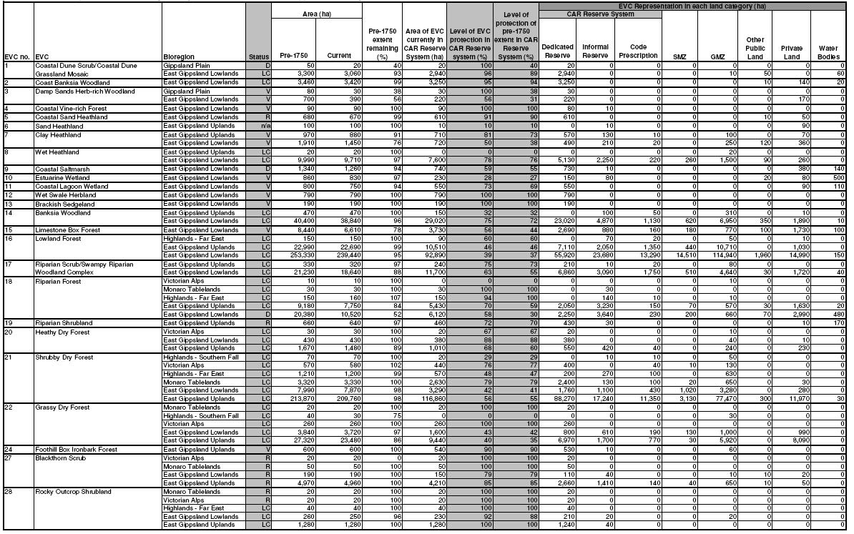

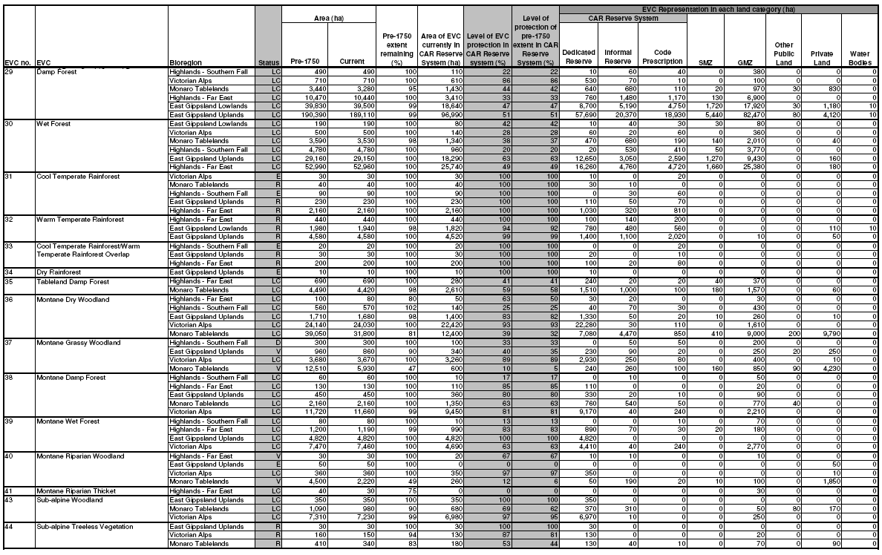
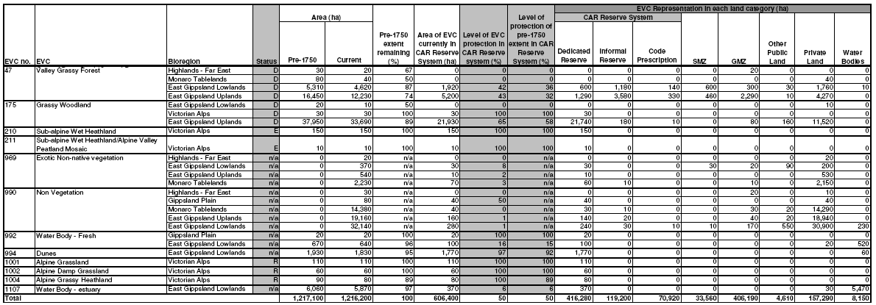
Only EVC/Bioregion combinations currently present in the East Gippsland RFA region are reported in this table. The figures shown in this table are based on modelled information and are therefore only approximate. The analysis used the approved EVC datasets (NV2005_EVCBCS and NV1750_EVCBCS) at 30 June 2009 and the approved FMZ dataset (FMZ100) at 20 August 2009. While changes to forest management zoning have been made since the RFA was signed, no comparison can be made between this table and that created in 1997 following the RFA for the East Gippsland Forest Management Plan Amendment, as they are based on different EVC source datasets.
Since the RFAs were signed, changes have been made to the list and classification of EVCs in Victoria; EVCs have been added, removed and merged. The EVC datasets (current and pre-1750 extent) were updated in 2007 to make required changes, and the old EVC datasets are now obsolete. The FMZ source datasets used to determine the level of protection of EVCs within the CAR Reserve System do not exactly match the RFA region boundaries. This has resulted in a gap around the edge of most RFA regions producing an error of around 1% in the area statements. The analysis was undertaken using ESRI GRID versions of EVCs (25m cells) and forest zoning (12.5m cells). The use of this technique will have modified the area of each attribute compared to the polygon versions of these datasets. Area statements have been rounded to the nearest 10 ha to account for the errors discussed above.
Dedicated Reserves, Informal Reserves and Code Prescription zoning categories comprise the area of each EVC protected within the CAR Reserve System. Code Prescription refers to areas protected by Code of Practice for Timber Production 2007 prescriptions. The remaining zone categories fall outside of the CAR Reserve System. SMZ and GMZ refer to vegetation in Special Management Zone and General Management Zone but which are not protected by Code of Practice for Timber Production 2007 prescriptions. Status refers to Bioregional Conservation Status, where: E – Endangered; V – Vulnerable; D – Depleted; R – Rare; and LC – Least Concern. E, V and R statuses are defined in accordance with the national reserve criteria (JANIS 1997).
Table 13 Current representation of Ecological Vegetation Classes in the Central Highlands RFA region.
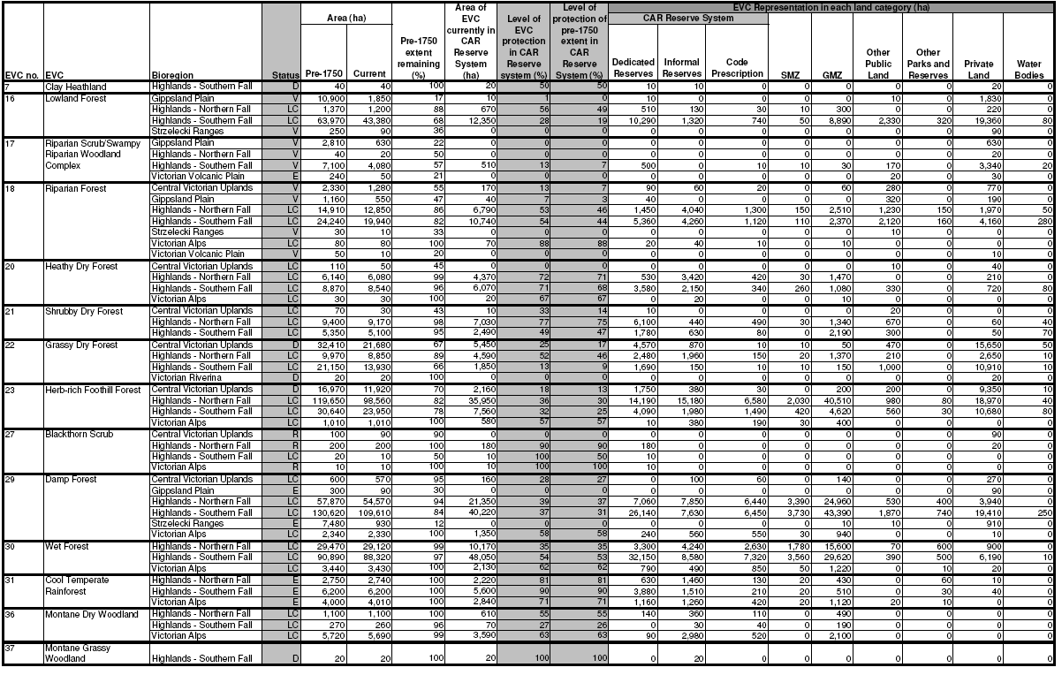
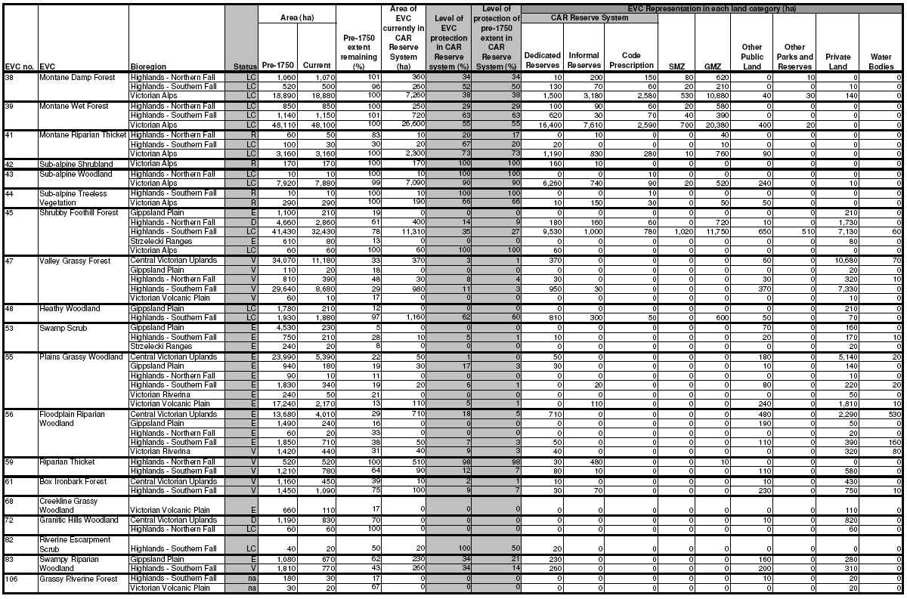

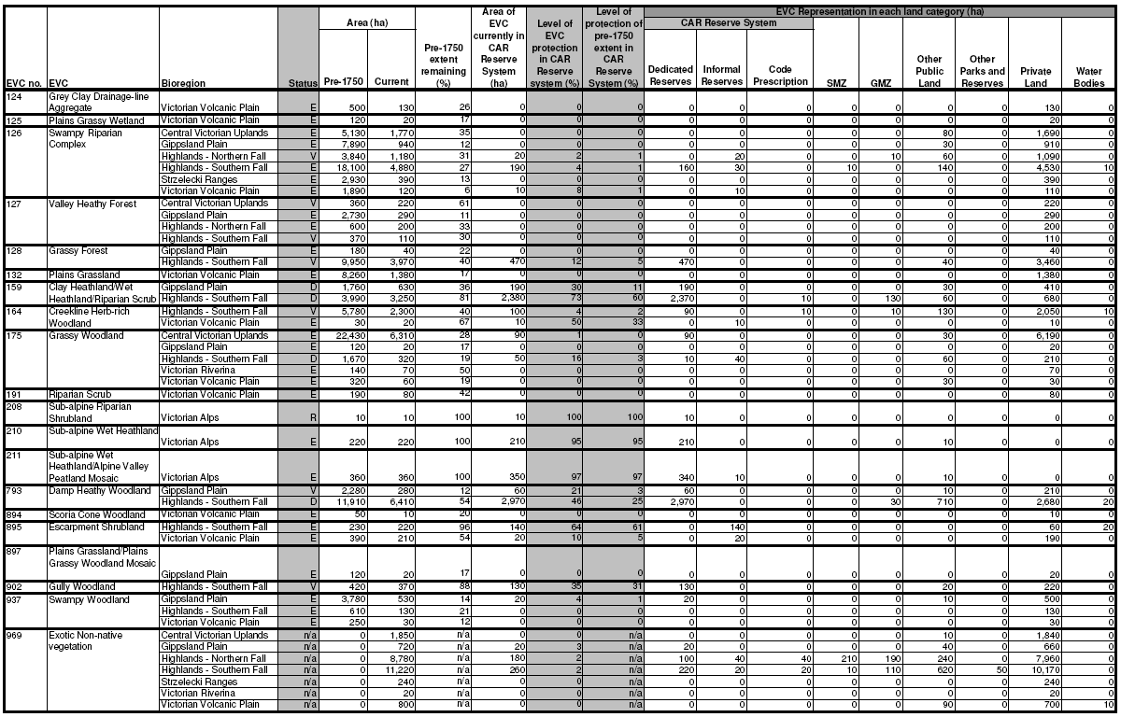
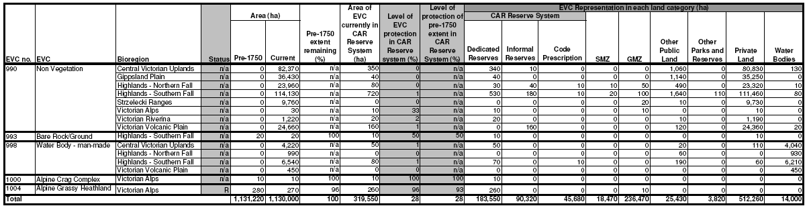
Only EVC/Bioregion combinations currently present in this RFA region are reported in this table. The figures shown in this table are based on modelled information and are therefore only approximate. The analysis used the approved EVC datasets (NV2005_EVCBCS and NV1750_EVCBCS) at 30 June 2009 and the approved FMZ dataset (FMZ100) at 20 August 2009. While changes to forest management zoning have been made since this RFA was signed, no comparison can be made between this table and that in the RFA as they are based on different EVC source datasets.
Since the RFAs were signed, changes have been made to the list and classification of EVCs in Victoria; EVCs have been added, removed and merged. The EVC datasets (current and pre-1750 extent) were updated in 2007 to make required changes, and the old EVC datasets are now obsolete. The FMZ source datasets used to determine the level of protection of EVCs within the CAR Reserve System do not exactly match the RFA region boundaries. This has resulted in a gap around the edge of most RFA regions producing an error of around 1% in the area statements. The analysis was undertaken using ESRI GRID versions of EVCs (25m cells) and forest zoning (12.5m cells). The use of this technique will have modified the area of each attribute compared to the polygon versions of these datasets. Area statements have been rounded to the nearest 10 ha to account for the errors discussed above.
Dedicated Reserves, Informal Reserves and Code Prescription zoning categories comprise the area of each EVC protected within the CAR Reserve System. Code Prescription refers to areas protected by Code of Practice for Timber Production 2007 prescriptions. The remaining zone categories fall outside of the CAR Reserve System. SMZ and GMZ refer to vegetation in Special Management Zone and General Management Zone but which are not protected by Code of Practice for Timber Production 2007 prescriptions. Status refers to Bioregional Conservation Status, where: E – Endangered; V – Vulnerable; D – Depleted; R – Rare; and LC – Least Concern. E, V and R statuses are defined in accordance with the national reserve criteria (JANIS 1997).
Table 14 Current representation of Ecological Vegetation Classes in the North East RFA region
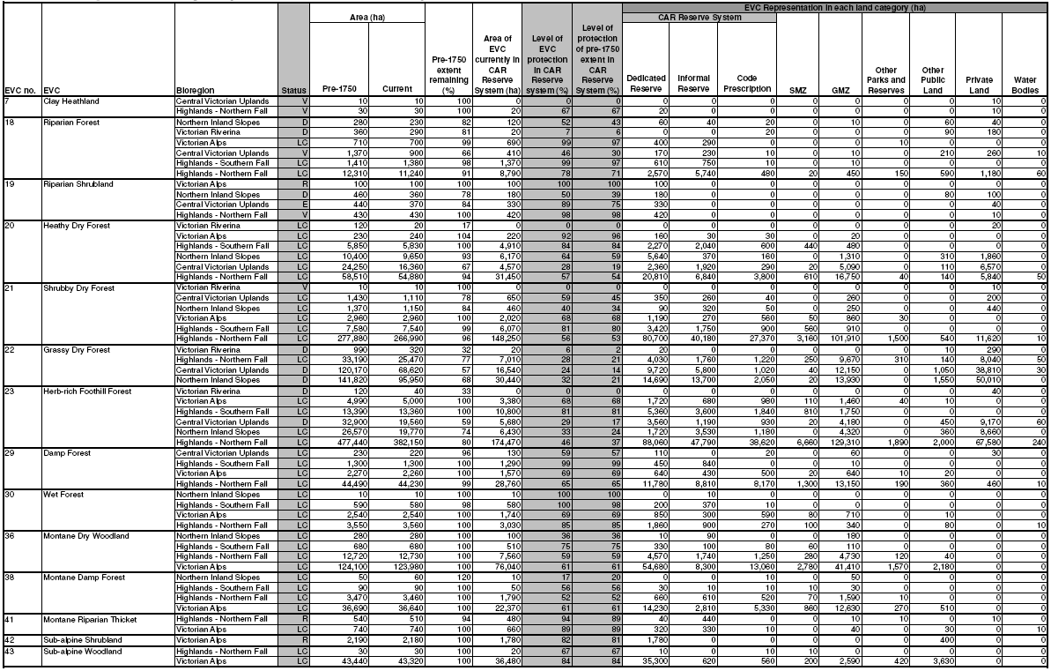
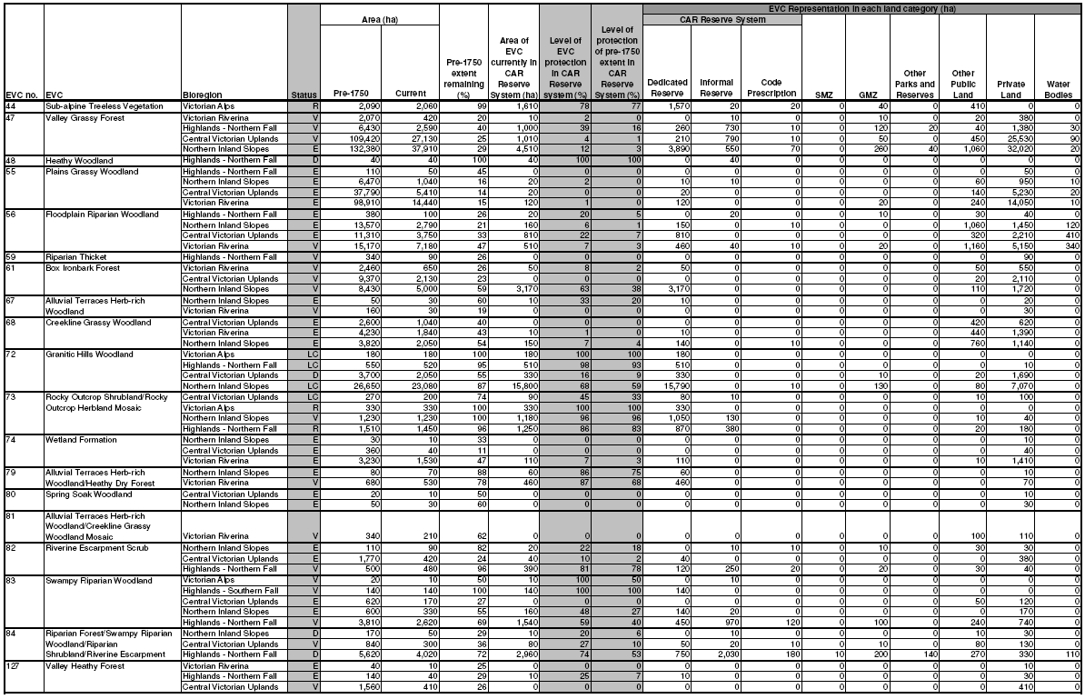

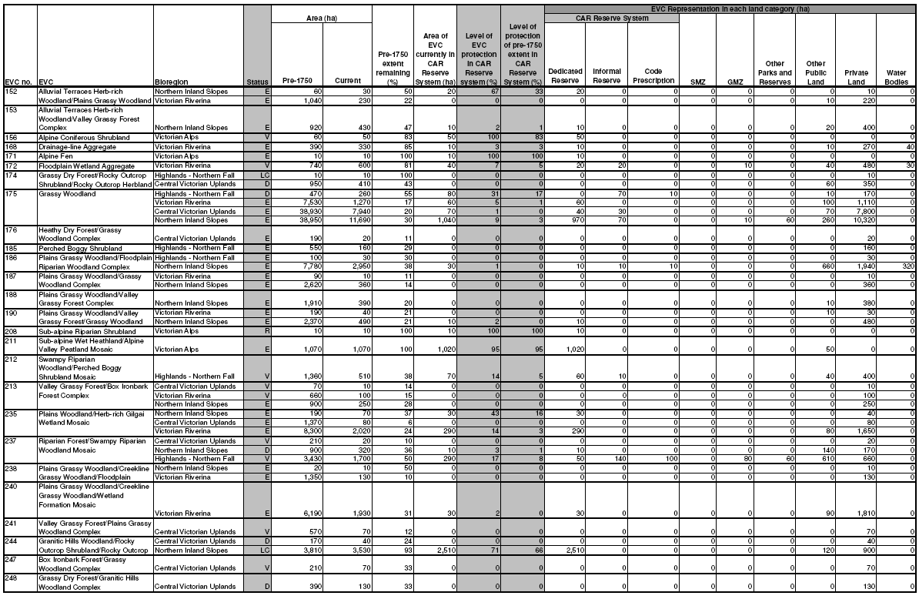
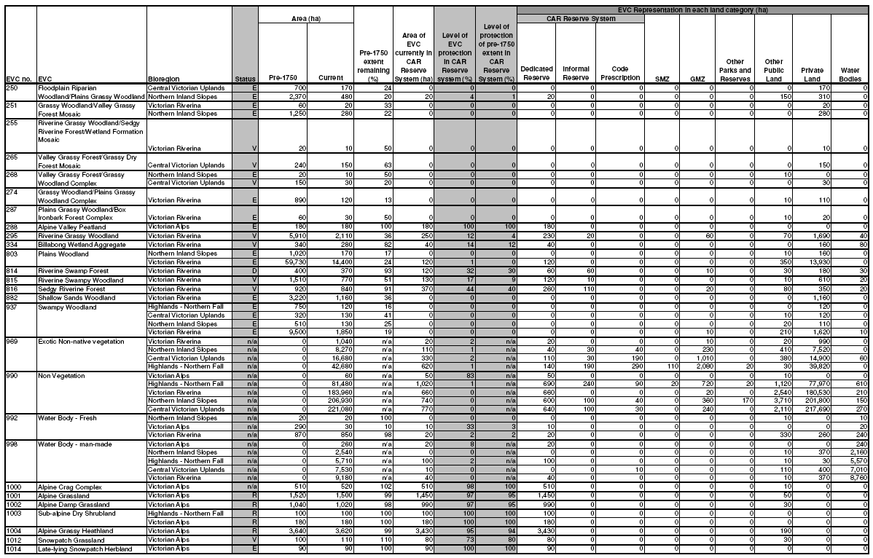
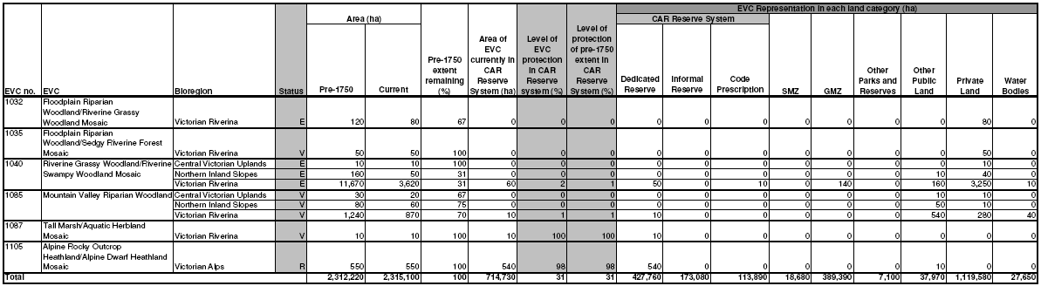
Only EVC/Bioregion combinations currently present in this RFA region are reported in this table. The figures shown in this table are based on modelled information and are therefore only approximate. The analysis used the approved EVC datasets (NV2005_EVCBCS and NV1750_EVCBCS) at 30 June 2009 and the approved FMZ dataset (FMZ100) at 20 August 2009. While changes to forest management zoning have been made since this RFA was signed, no comparison can be made between this table and that in the RFA as they are based on different EVC source datasets. Since the RFAs were signed, changes have been made to the list and classification of EVCs in Victoria; EVCs have been added, removed and merged. The EVC datasets (current and pre-1750 extent) were updated in 2007 to make required changes, and the old EVC datasets are now obsolete. The FMZ source datasets used to determine the level of protection of EVCs within the CAR Reserve System do not exactly match the RFA region boundaries. This has resulted in a gap around the edge of most RFA regions producing an error of around 1% in the area statements. The analysis was undertaken using ESRI GRID versions of EVCs (25m cells) and forest zoning (12.5m cells). The use of this technique will have modified the area of each attribute compared to the polygon versions of these datasets. Area statements have been rounded to the nearest 10 ha to account for the errors discussed above.
Dedicated Reserves, Informal Reserves and Code Prescription zoning categories comprise the area of each EVC protected within the CAR Reserve System. Code Prescription refers to areas protected by Code of Practice for Timber Production 2007 prescriptions. The remaining zone categories fall outside of the CAR Reserve System. SMZ and GMZ refer to vegetation in Special Management Zone and General Management Zone but which are not protected by Code of Practice for Timber Production 2007 prescriptions. Status refers to Bioregional Conservation Status, where: E – Endangered; V – Vulnerable; D – Depleted; R – Rare; and LC – Least Concern. E, V and R statuses are defined in accordance with the national reserve criteria (JANIS 1997).
Table 15 Current representation of Ecological Vegetation Classes in the West Victoria RFA region.
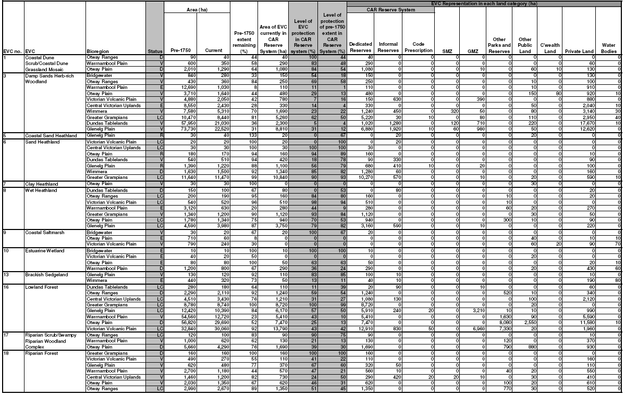
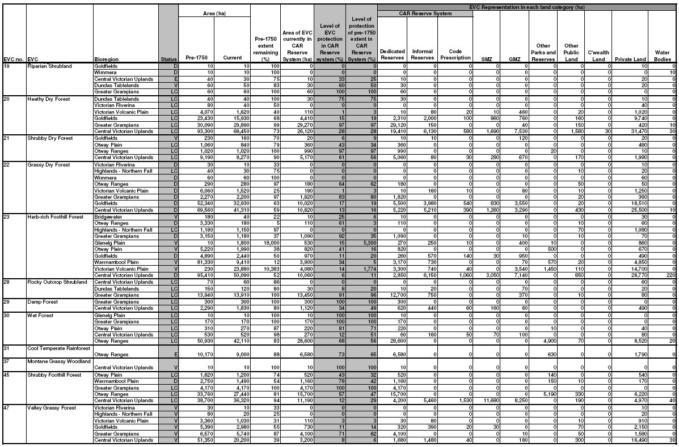

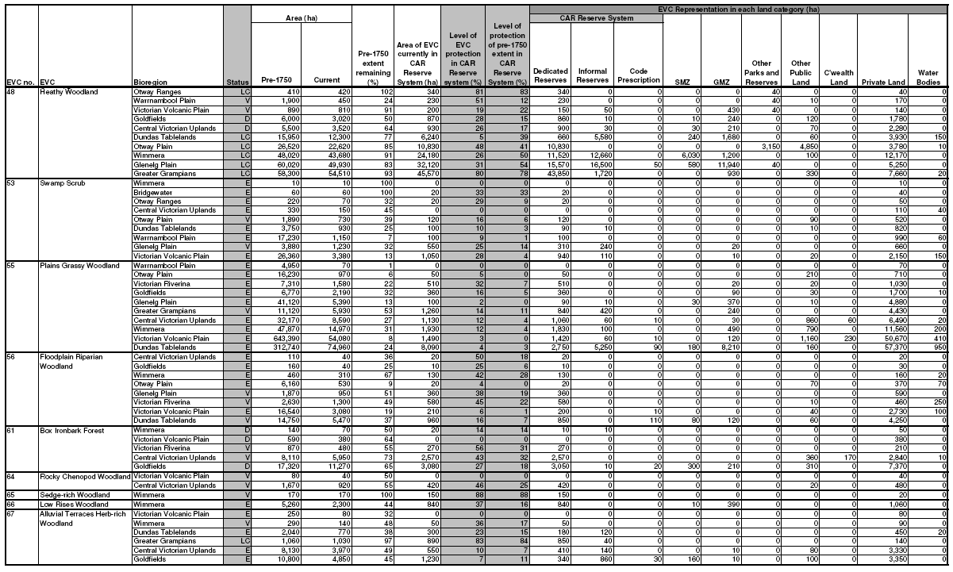

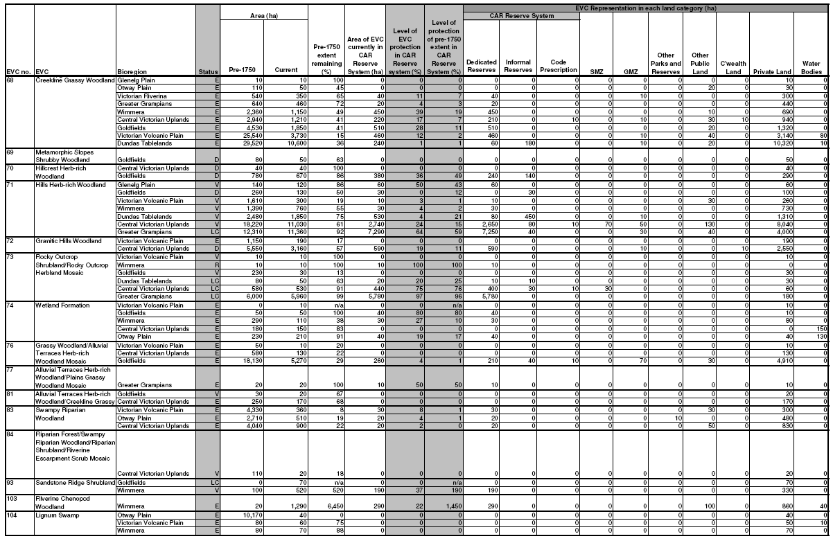
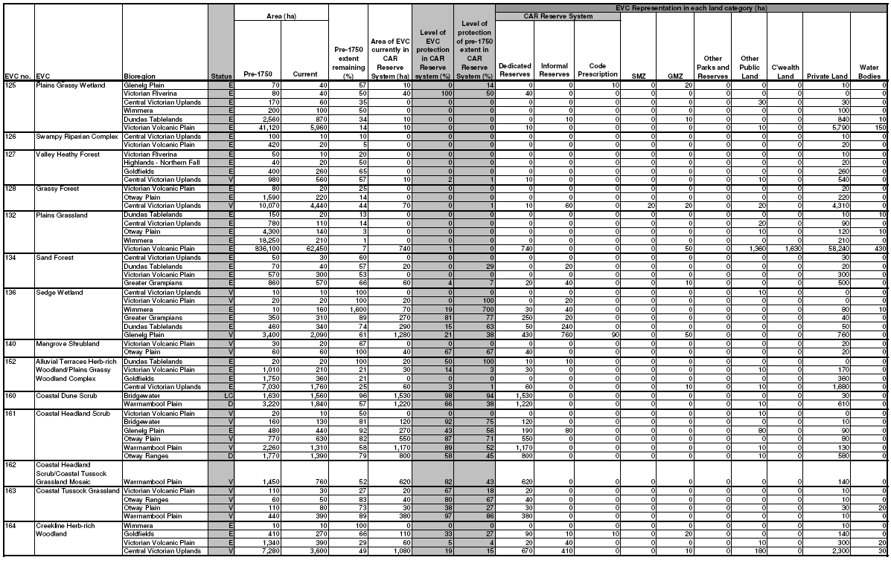
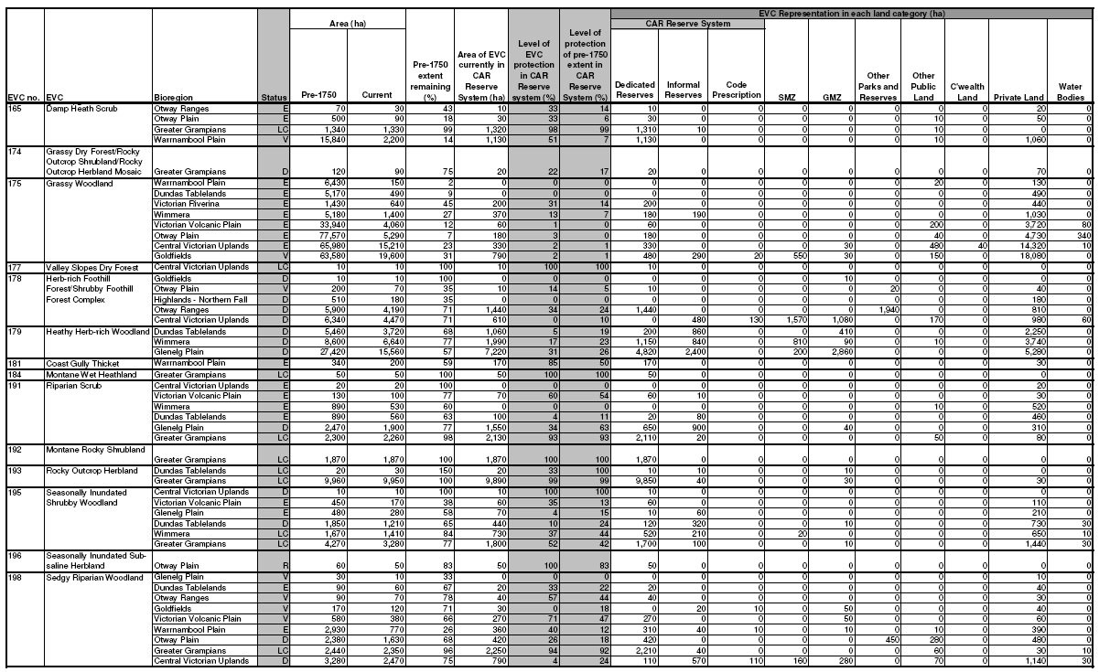
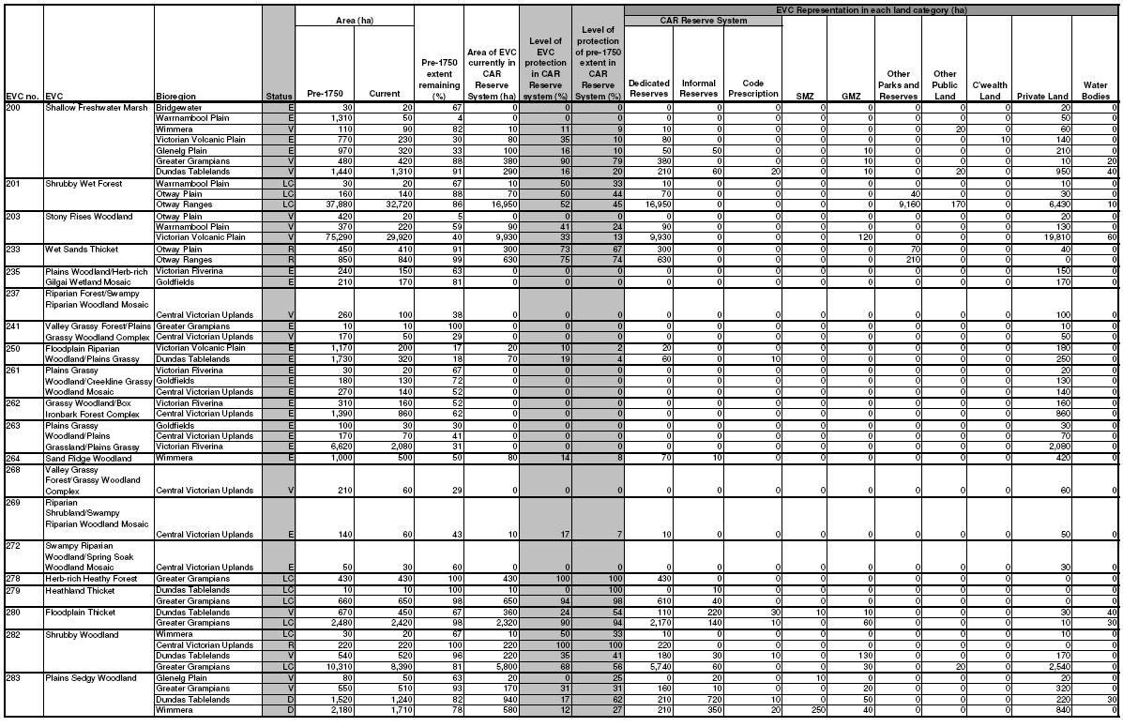
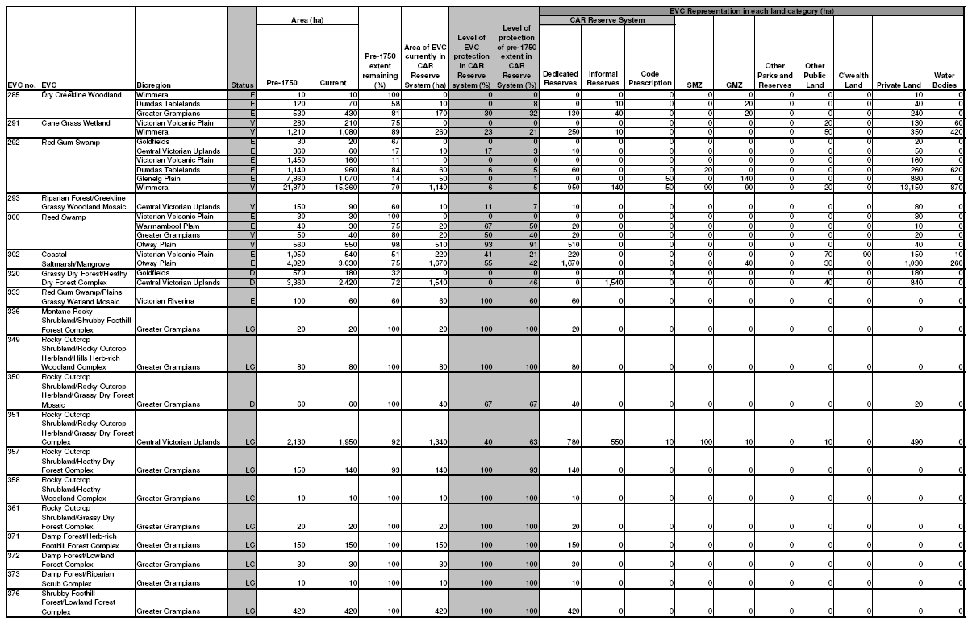
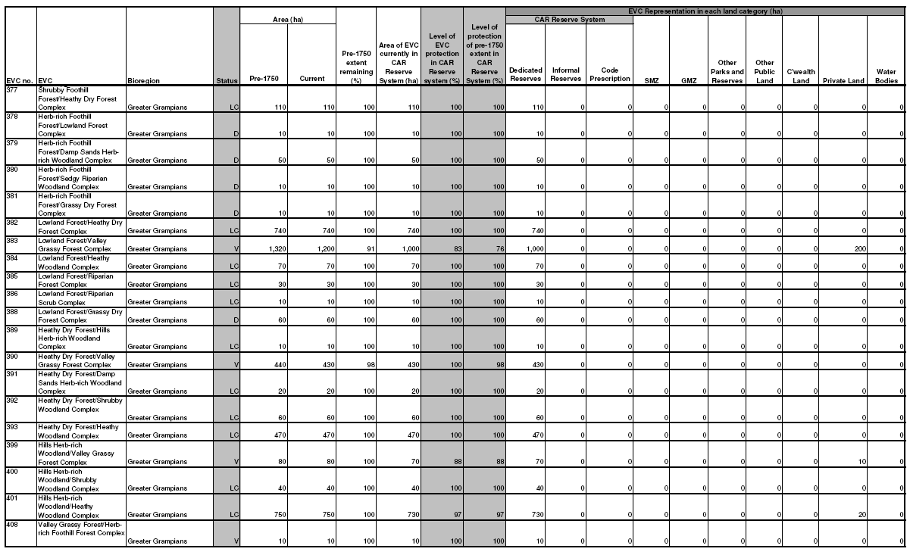

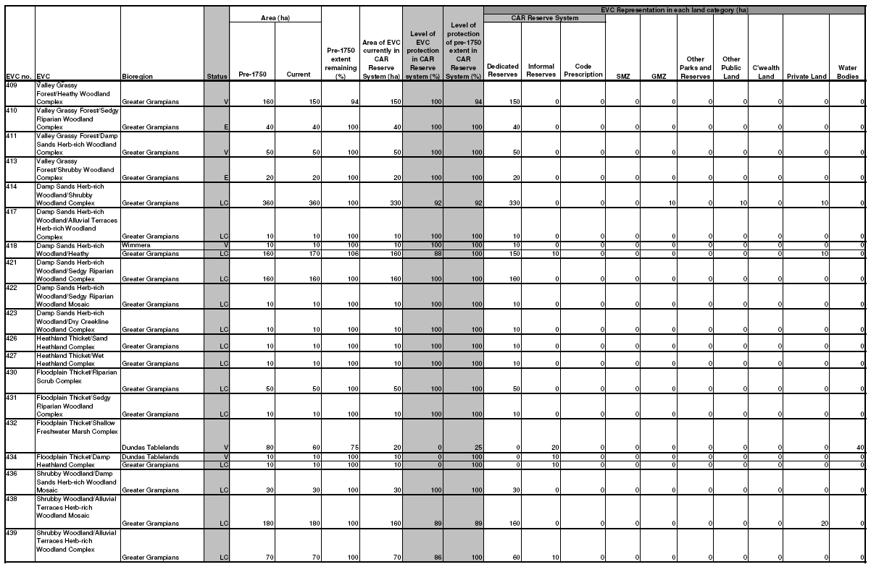
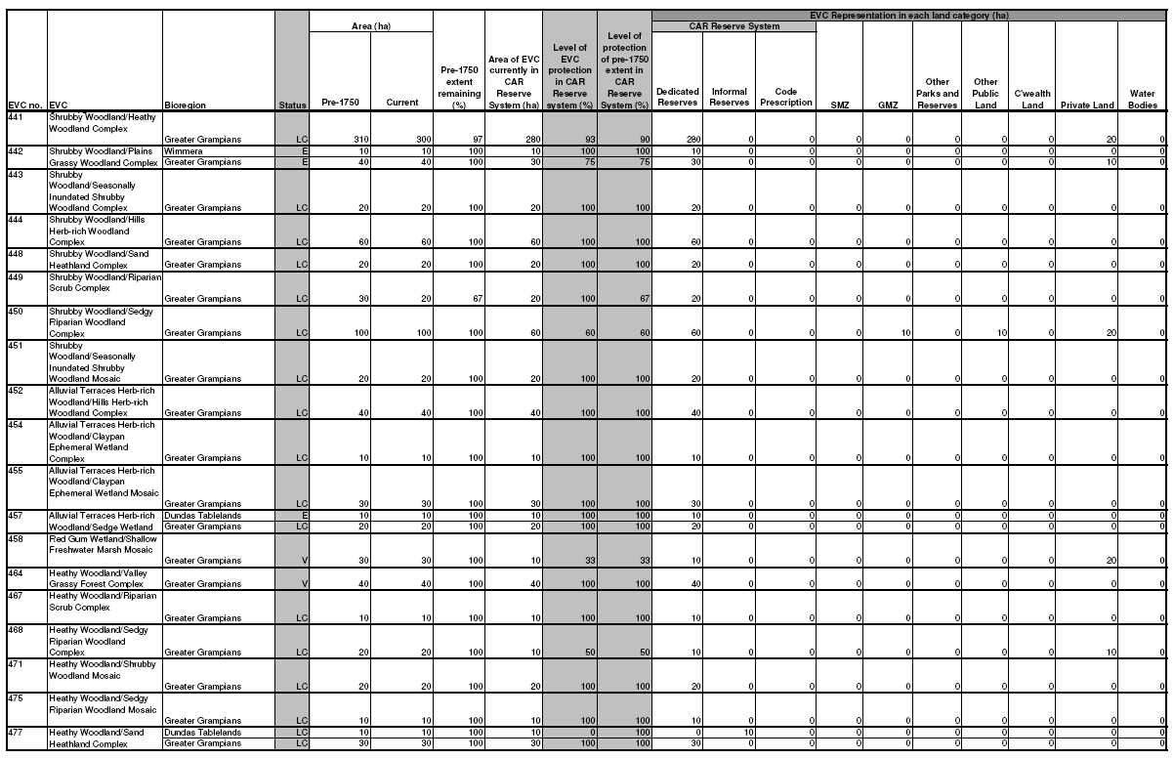
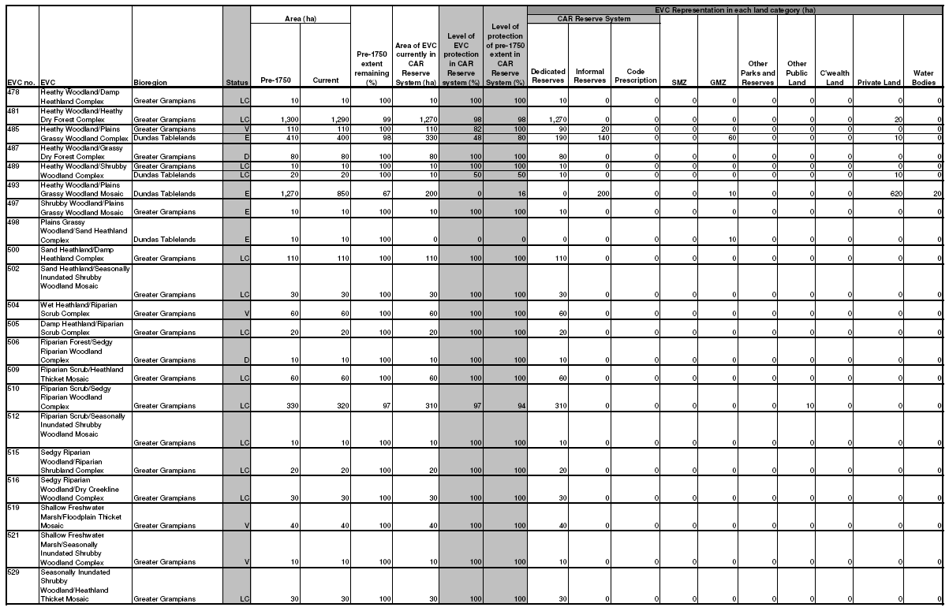
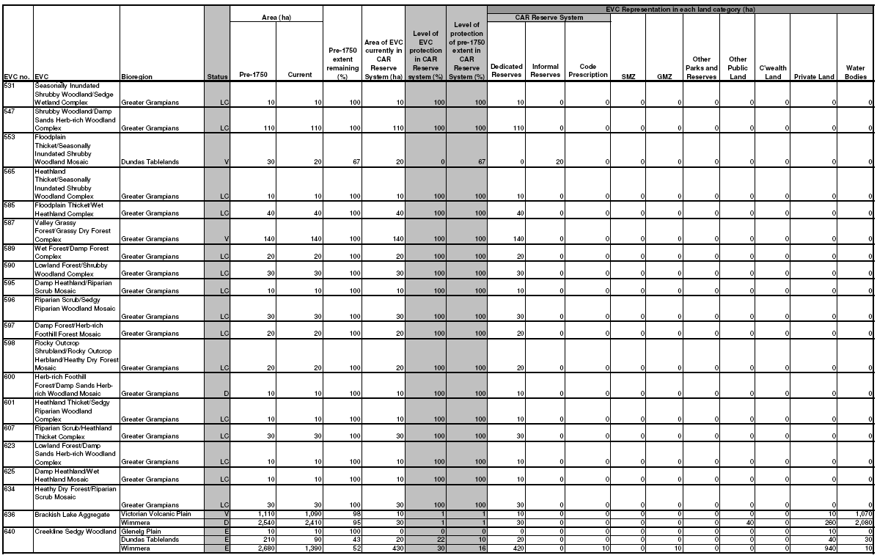
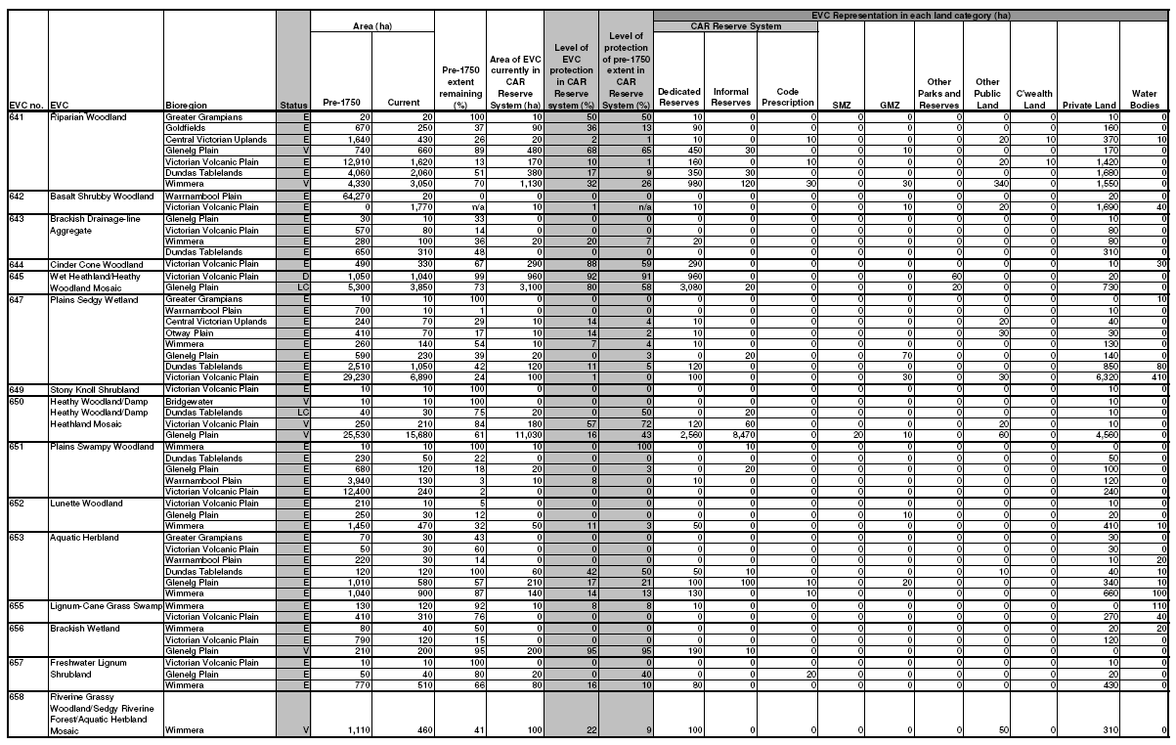
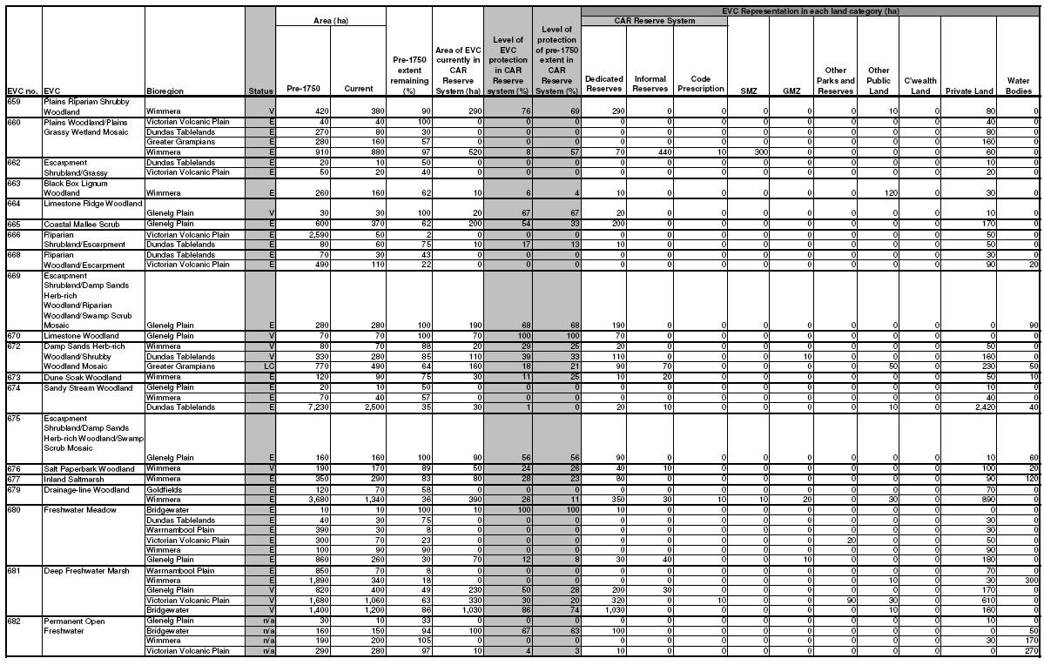
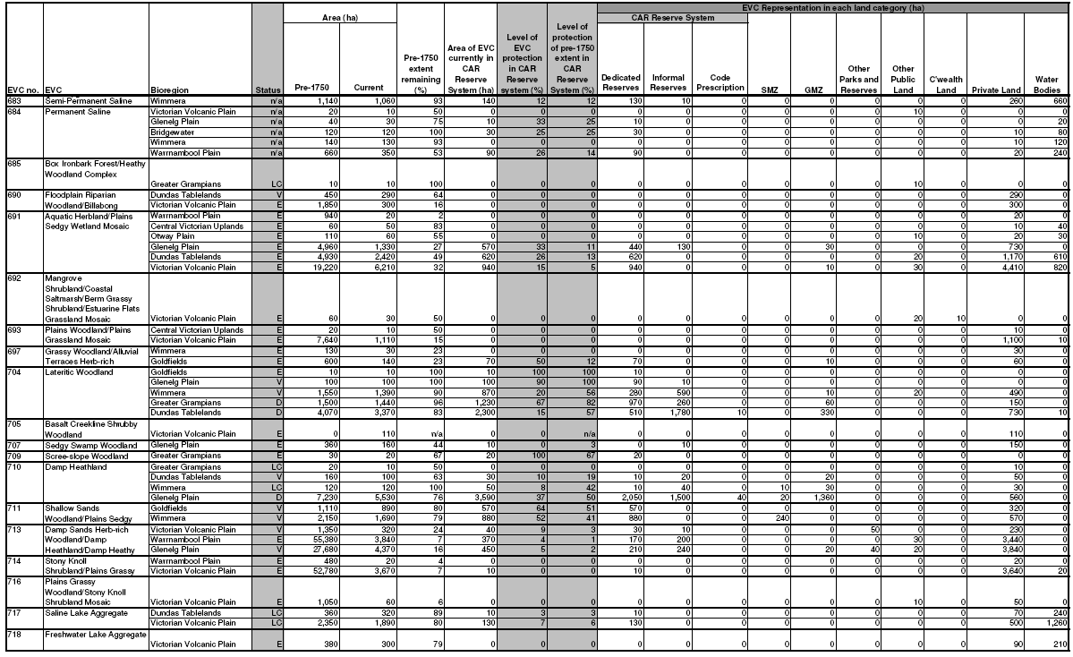
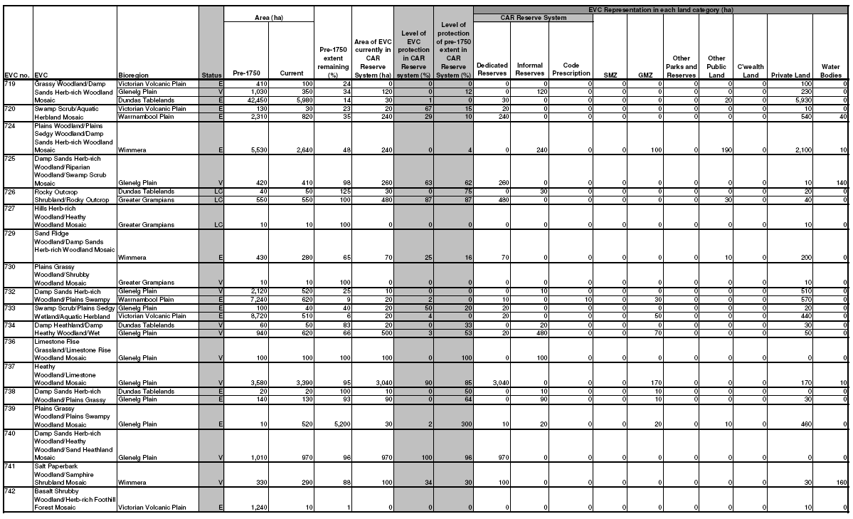
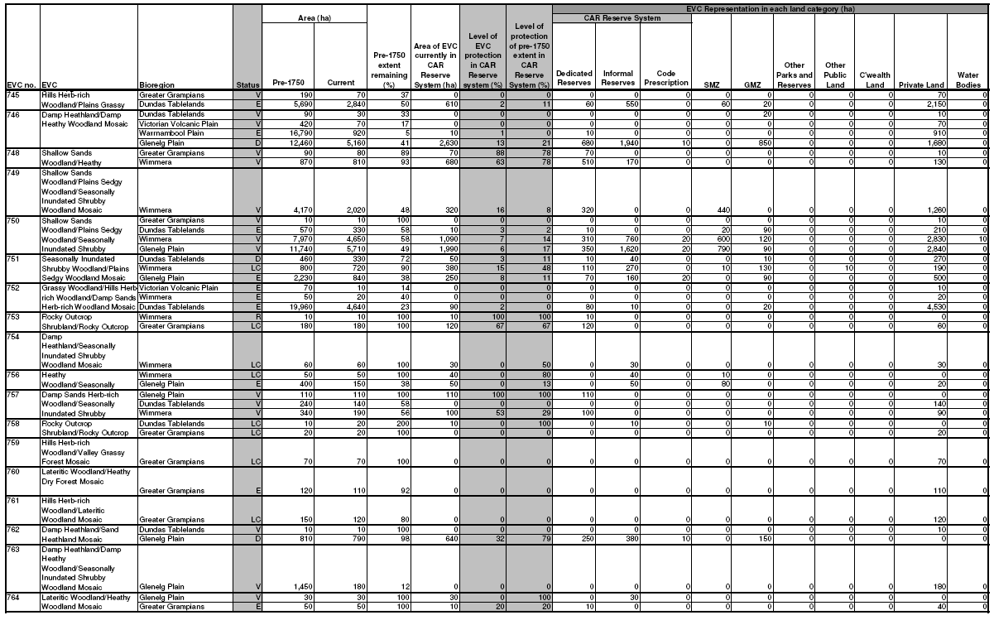
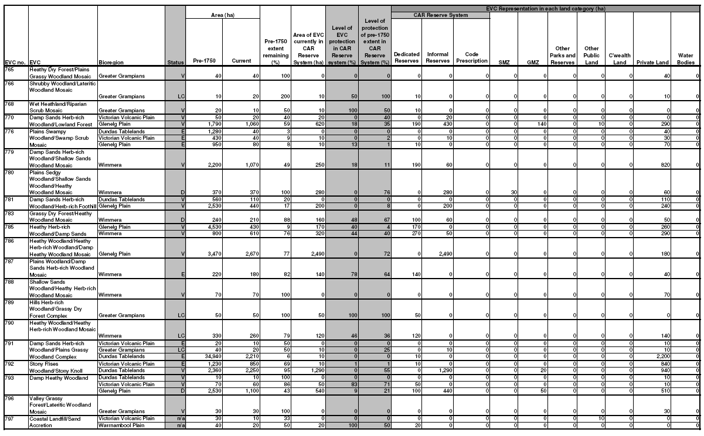
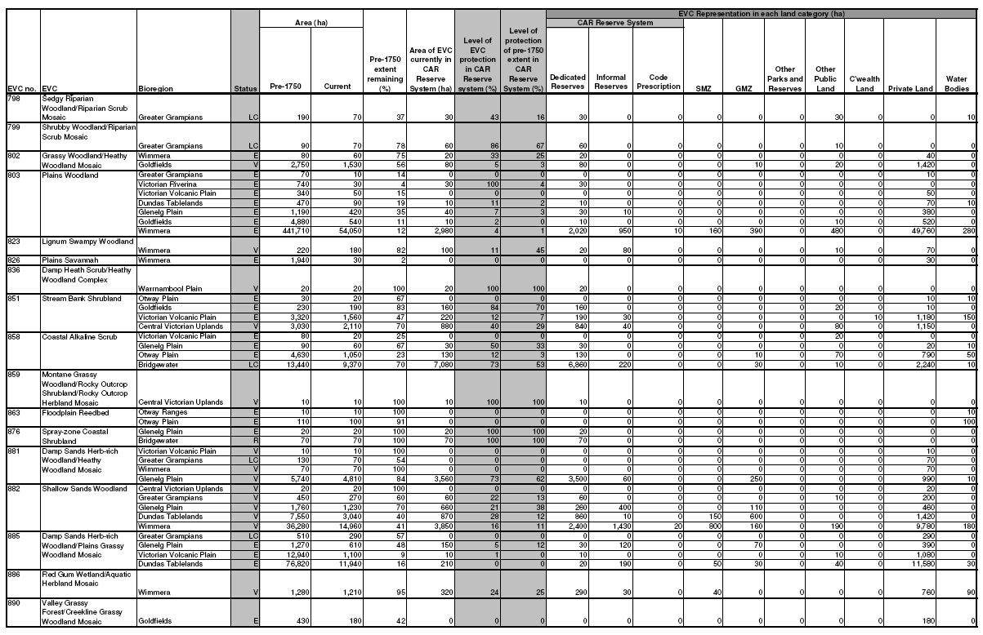
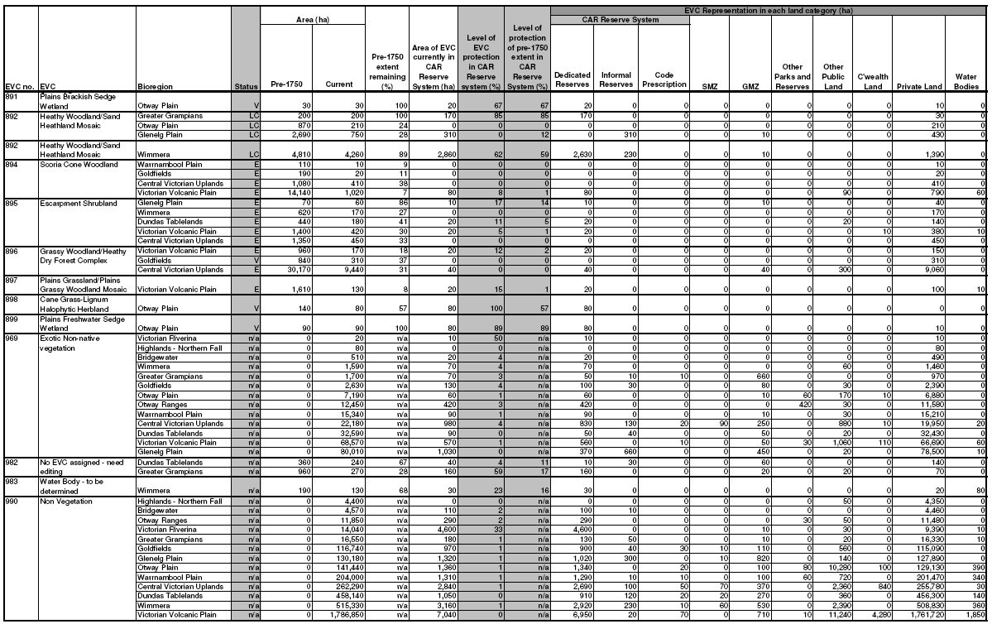
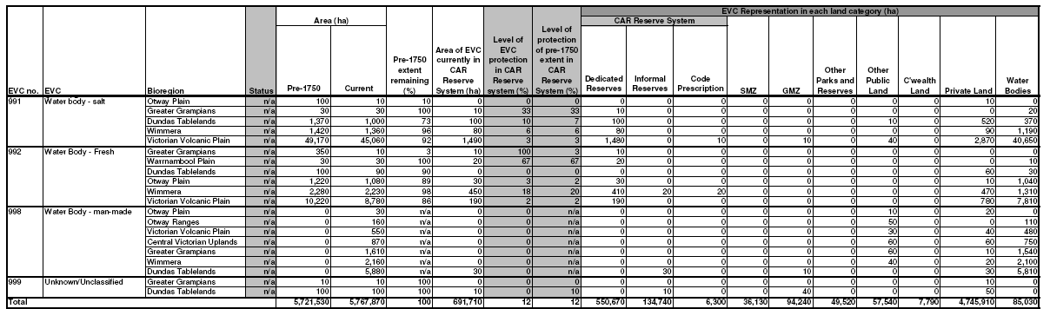
Only EVC/Bioregion combinations currently present in this RFA region are reported in this table. The figures shown in this table are based on modelled information and are therefore only approximate. The analysis used the approved EVC datasets (NV2005_EVCBCS and NV1750_EVCBCS) at 30 June 2009 and the approved FMZ dataset (FMZ100) at 20 August 2009. While changes to forest management zoning have been made since this RFA was signed, no comparison can be made between this table and that in the RFA as they are based on different EVC source datasets. Since the RFAs were signed, changes have been made to the list and classification of EVCs in Victoria; EVCs have been added, removed and merged. The EVC datasets (current and pre-1750 extent) were updated in 2007 to make required changes, and the old EVC datasets are now obsolete. The FMZ source datasets used to determine the level of protection of EVCs within the CAR Reserve System do not exactly match the RFA region boundaries. This has resulted in a gap around the edge of most RFA regions producing an error of around 1% in the area statements. The analysis was undertaken using ESRI GRID versions of EVCs (25m cells) and forest zoning (12.5m cells). The use of this technique will have modified the area of each attribute compared to the polygon versions of these datasets. Area statements have been rounded to the nearest 10 ha to account for the errors discussed above.
Dedicated Reserves, Informal Reserves and Code Prescription zoning categories comprise the area of each EVC protected within the CAR Reserve System. Code Prescription refers to areas protected by Code of Practice for Timber Production 2007 prescriptions. The remaining zone categories fall outside of the CAR Reserve System. SMZ and GMZ refer to vegetation in Special Management Zone and General Management Zone but which are not protected by Code of Practice for Timber Production 2007 prescriptions. Status refers to Bioregional Conservation Status, where: E – Endangered; V – Vulnerable; D – Depleted; R – Rare; and LC – Least Concern. E, V and R statuses are defined in accordance with the national reserve criteria (JANIS 1997).
Table 16 Current representation of Ecological Vegetation Classes in the Gippsland RFA region.
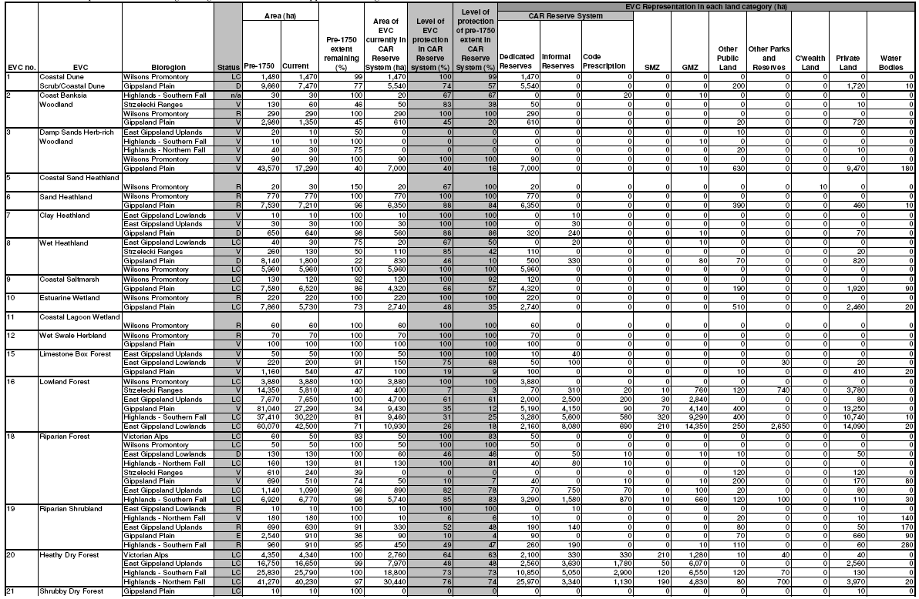

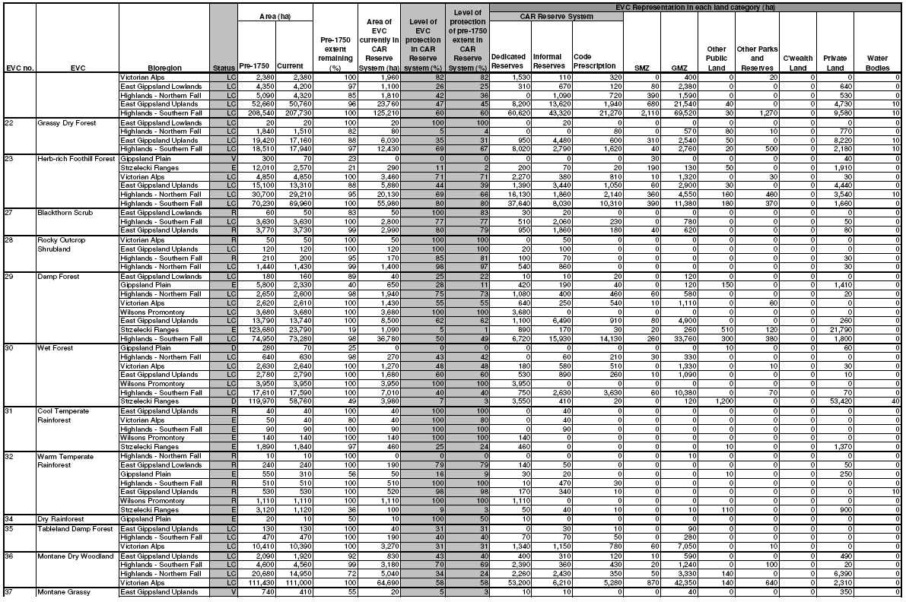
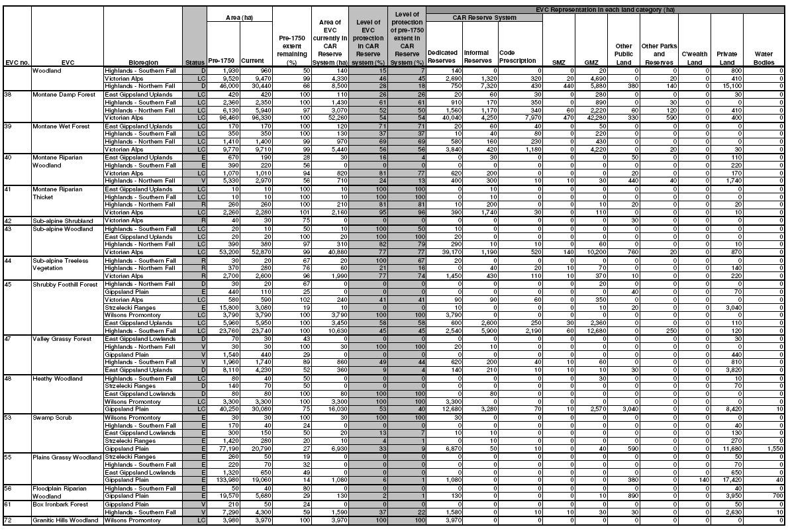
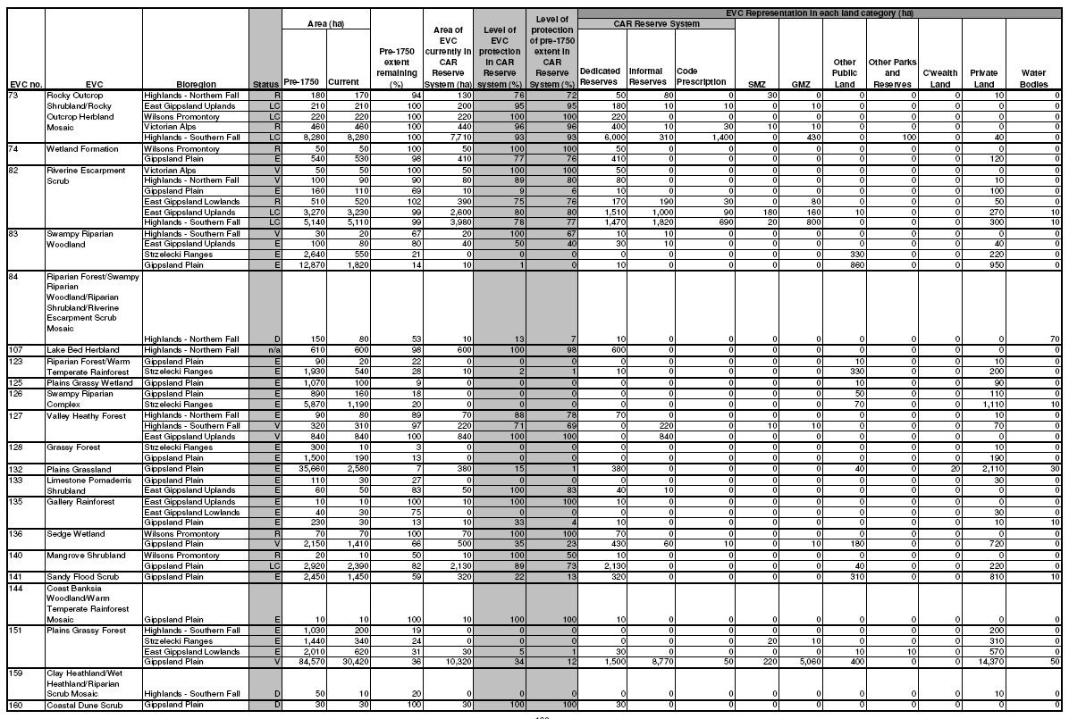
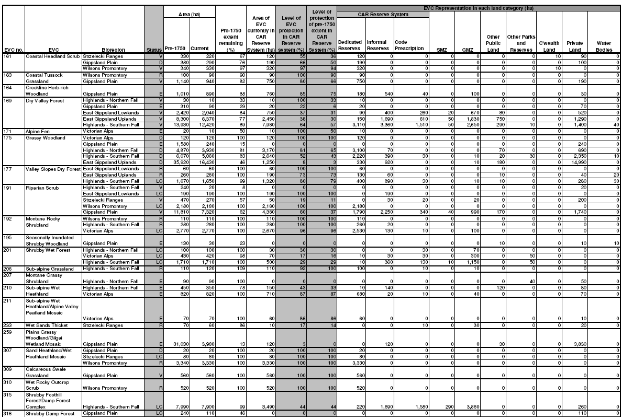
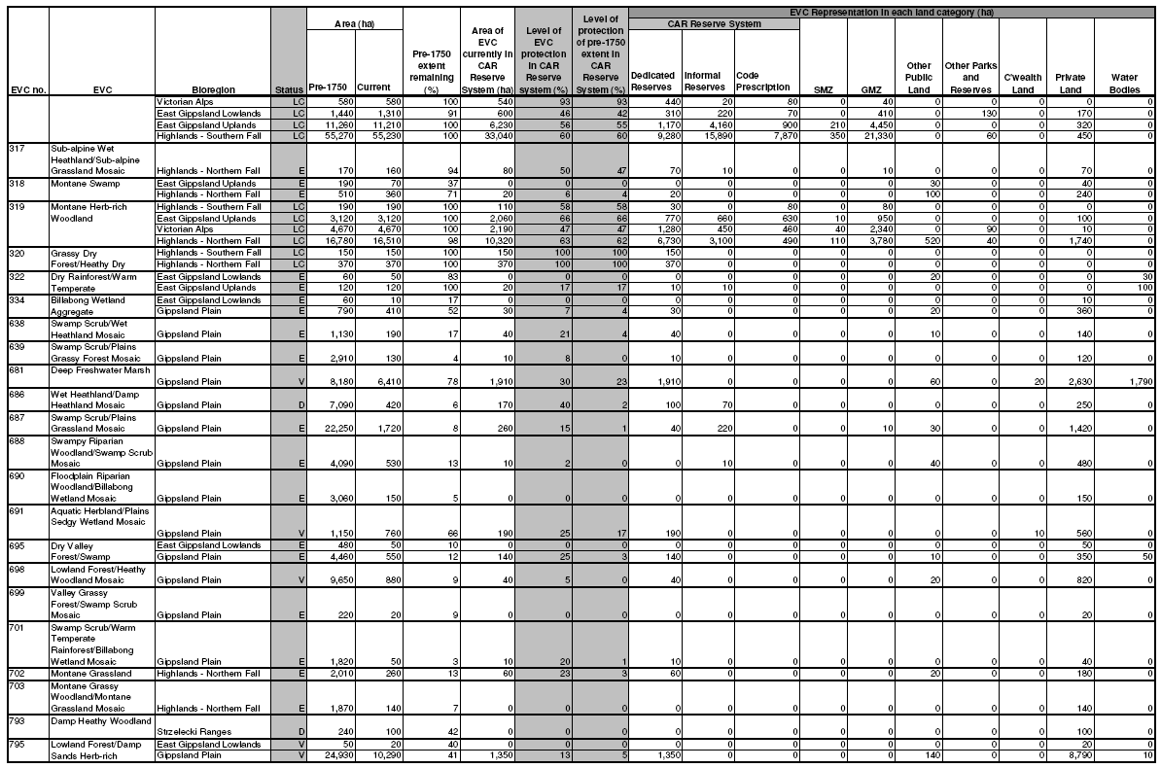
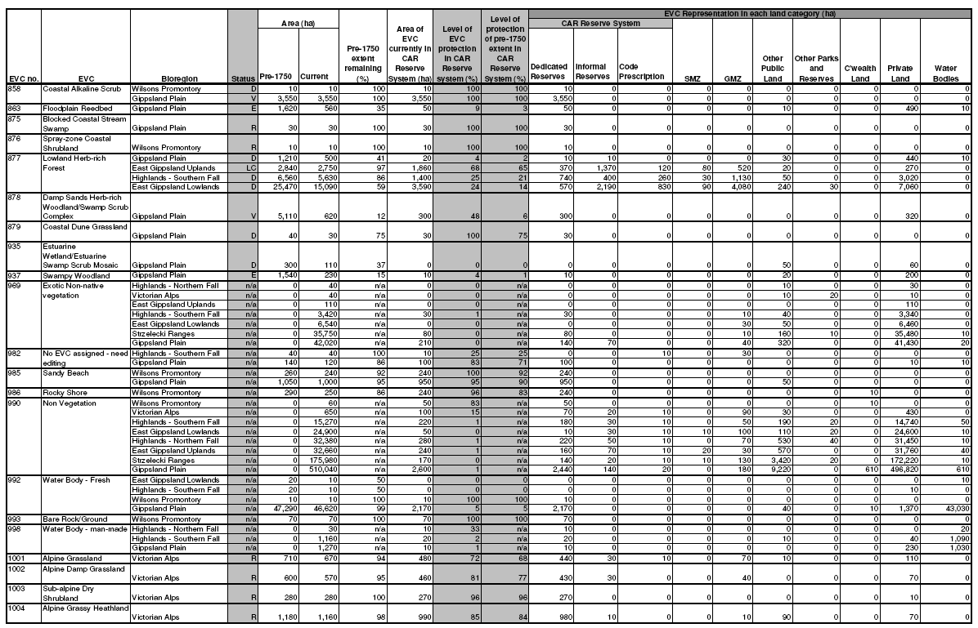
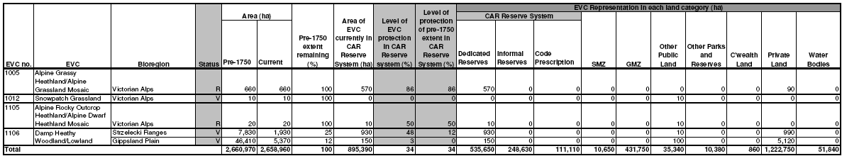
Only EVC/Bioregion combinations currently present in this RFA region are reported in this table. The figures shown in this table are based on modelled information and are therefore only approximate. The analysis used the approved EVC datasets (NV2005_EVCBCS and NV1750_EVCBCS) at 30 June 2009 and the approved FMZ dataset (FMZ100) at 20 August 2009. While changes to forest management zoning have been made since this RFA was signed, no comparison can be made between this table and that in the RFA as they are based on different EVC source datasets. Since the RFAs were signed, changes have been made to the list and classification of EVCs in Victoria; EVCs have been added, removed and merged. The EVC datasets (current and pre-1750 extent) were updated in 2007 to make required changes, and the old EVC datasets are now obsolete. The FMZ source datasets used to determine the level of protection of EVCs within the CAR Reserve System do not exactly match the RFA region boundaries. This has resulted in a gap around the edge of most RFA regions producing an error of around 1% in the area statements. The analysis was undertaken using ESRI GRID versions of EVCs (25m cells) and forest zoning (12.5m cells). The use of this technique will have modified the area of each attribute compared to the polygon versions of these datasets. Area statements have been rounded to the nearest 10 ha to account for the errors discussed above.
Dedicated Reserves, Informal Reserves and Code Prescription zoning categories comprise the area of each EVC protected within the CAR Reserve System. Code Prescription refers to areas protected by Code of Practice for Timber Production 2007 prescriptions. The remaining zone categories fall outside of the CAR Reserve System. SMZ and GMZ refer to vegetation in Special Management Zone and General Management Zone but which are not protected by Code of Practice for Timber Production 2007 prescriptions. Status refers to Bioregional Conservation Status, where: E – Endangered; V – Vulnerable; D – Depleted; – Rare; and LC – Least Concern. E, V and R statuses are defined in accordance with the national reserve criteria (JANIS 1997).
Table 17 Current representation of old-growth in the East Gippsland RFA region.
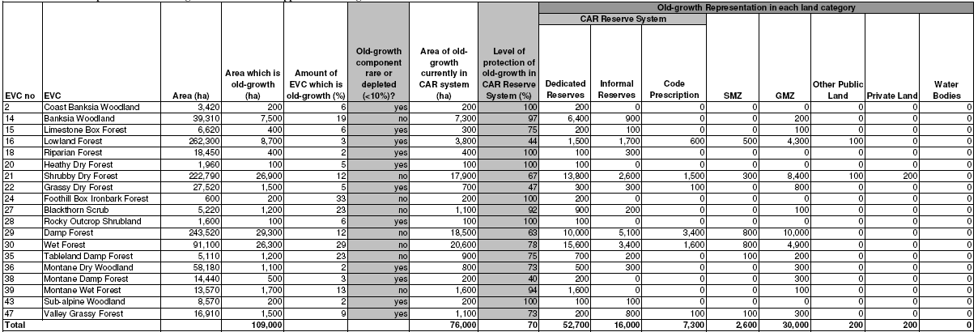
Only EVCs which can usually contain old-growth in this RFA region are reported in this table. The figures shown in this table are based on modelled information and are therefore only approximate. The analysis used the approved EVC datasets (NV2005_EVCBCS and NV1750_EVCBCS) at 30 June 2009 and the approved FMZ dataset (FMZ100) at 20 August 2009. The modelled old-growth layer (MOG_2009) used incorporates fire disturbance to March 2009 and timber harvesting disturbance to June 2008. While changes to forest management zoning have been made since the RFA was signed, no comparison can be made between this table and that created in 1997 following the RFA for the East Gippsland Forest Management Plan Amendment, as they are based on different EVC and old-growth source datasets.
Since the RFAs were signed, changes have been made to the list and classification of EVCs in Victoria; EVCs have been added, removed and merged. The EVC datasets (current and pre-1750 extent) were updated in 2007 to make required changes, and the old EVC datasets are now obsolete. The FMZ source datasets used to determine the level of protection of EVCs within the CAR Reserve System do not exactly match the RFA region boundaries; this resulted in a gap around the edge of most RFA regions producing an error of around 1% in the area statements.
Old-growth modelling in Victoria is limited to vegetation with potential height generally greater than 5 metres and a eucalypt crown cover projection generally greater than 10%. EVCs which do not generally meet this description are not included in this table. The new modelled old-growth dataset used in the analysis does not account for old-growth recovery in the East Gippsland RFA region post June-2007. It is likely that the figures in these tables underestimate the extent of old-growth in this region. The analysis was undertaken using ESRI GRID versions of EVCs (25m cells) and forest zoning (12.5m cells), and modelled old-growth (25m cells). The use of this technique will have modified the area of each attribute compared to the polygon versions of these datasets. Area statements have been rounded to the nearest 100 ha to account for the errors discussed above.
Dedicated Reserves, Informal Reserves and Code Prescription zoning categories comprise the area of each EVC protected within the CAR Reserve System. Code Prescription refers to areas protected by Code of Practice for Timber Production 2007 prescriptions. The remaining zone categories fall outside of the CAR Reserve System. SMZ and GMZ refer to vegetation in Special Management Zone and General Management Zone but which are not protected by Code of Practice for Timber Production 2007 prescriptions.
Table 18 Current representation of old-growth in the Central Highlands RFA region
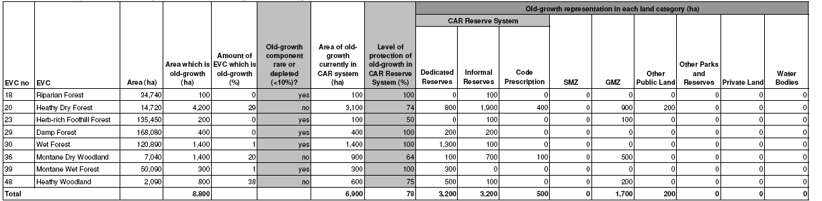
Only EVCs which can usually contain old-growth in this RFA region are reported in this table. The figures shown in this table are based on modelled information and are therefore only approximate. The analysis used the approved EVC datasets (NV2005_EVCBCS and NV1750_EVCBCS) at 30 June 2009 and the approved FMZ dataset (FMZ100) at 20 August 2009. The modelled old-growth layer (MOG_2009) used incorporates fire disturbance to March 2009 and timber harvesting disturbance to June 2008. While changes to forest management zoning have been made since this RFA was signed, no comparison can be made between this table and that in the RFA as they are based on different EVC and old-growth source datasets.
Since the RFAs were signed, changes have been made to the list and classification of EVCs in Victoria; EVCs have been added, removed and merged. The EVC datasets (current and pre-1750 extent) were updated in 2007 to make required changes, and the old EVC datasets are now obsolete. The FMZ source datasets used to determine the level of protection of EVCs within the CAR Reserve System do not exactly match the RFA region boundaries; this resulted in a gap around the edge of most RFA regions producing an error of around 1% in the area statements.
Old-growth modelling in Victoria is limited to vegetation with potential height generally greater than 5 metres and a eucalypt crown cover projection generally greater than 10%. EVCs which do not generally meet this description are not included in this table. The modelled old-growth dataset used in the analysis does not account for old-growth recovery in this RFA region. It is likely that the figures in this table underestimate old-growth extent. The analysis was undertaken using ESRI GRID versions of EVCs (25m cells) and forest zoning (12.5m cells), and modelled old-growth (25m cells). The use of this technique will have modified the area of each attribute compared to the polygon versions of these datasets. Area statements have been rounded to the nearest 100 ha to account for the errors discussed above.
Dedicated Reserves, Informal Reserves and Code Prescription zoning categories comprise the area of each EVC protected within the CAR Reserve System. Code Prescription refers to areas protected by Code of Practice for Timber Production 2007 prescriptions. The remaining zone categories fall outside of the CAR Reserve System. SMZ and GMZ refer to vegetation in Special Management Zone and General Management Zone but which are not protected by Code of Practice for Timber Production 2007 prescriptions.
Table 19 Current representation of old-growth in the North East RFA region
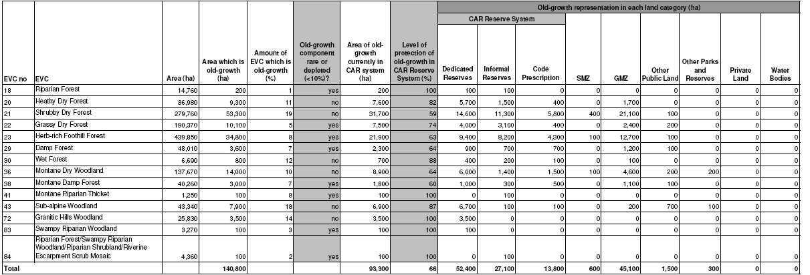
Only EVCs which can usually contain old-growth in this RFA region are reported in this table. The figures shown in this table are based on modelled information and are therefore only approximate. The analysis used the approved EVC datasets (NV2005_EVCBCS and NV1750_EVCBCS) at 30 June 2009 and the approved FMZ dataset (FMZ100) at 20 August 2009. The modelled old-growth layer (MOG_2009) used incorporates fire disturbance to March 2009 and timber harvesting disturbance to June 2008. While changes to forest management zoning have been made since this RFA was signed, no comparison can be made between this table and that in the RFA as they are based on different EVC and old-growth source datasets.
Since the RFAs were signed, changes have been made to the list and classification of EVCs in Victoria; EVCs have been added, removed and merged. The EVC datasets (current and pre-1750 extent) were updated in 2007 to make required changes, and the old EVC datasets are now obsolete. The FMZ source datasets used to determine the level of protection of EVCs within the CAR Reserve System do not exactly match the RFA region boundaries; this resulted in a gap around the edge of most RFA regions producing an error of around 1% in the area statements.
Old-growth modelling in Victoria is limited to vegetation with potential height generally greater than 5 metres and a eucalypt crown cover projection generally greater than 10%. EVCs which do not generally meet this description are not included in this table. The modelled oldgrowth dataset used in the analysis does not account for old-growth recovery in this RFA region. It is likely that the figures in this table underestimate old-growth extent. The analysis was undertaken using ESRI GRID versions of EVCs (25m cells) and forest zoning (12.5m cells), and modelled old-growth (25m cells). The use of this technique will have modified the area of each attribute compared to the polygon versions of these datasets. Area statements have been rounded to the nearest 100 ha to account for the errors discussed above.
Table 20 Current representation of old-growth in the West Victoria RFA region.
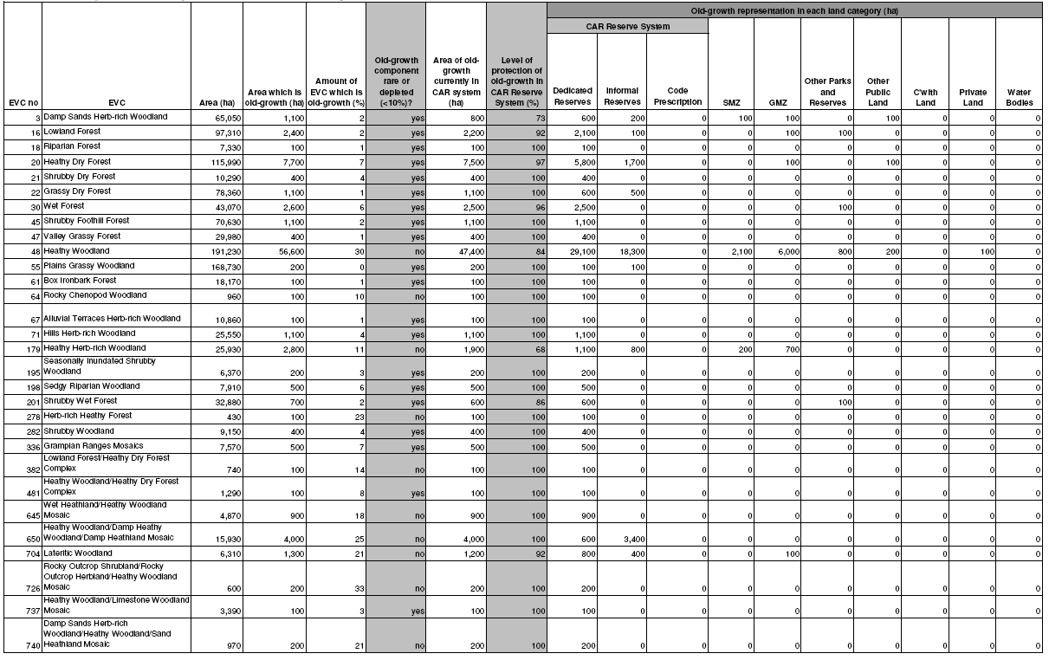
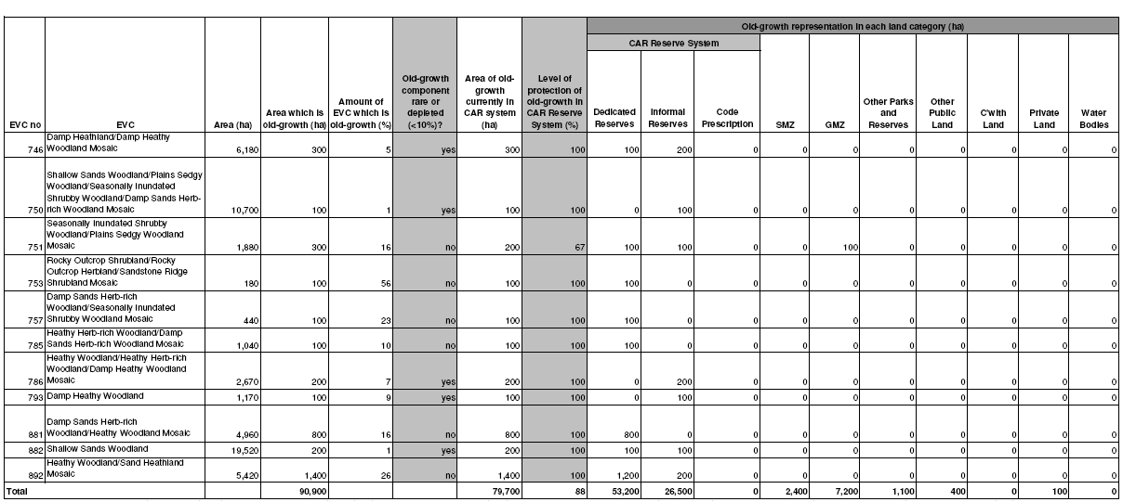
Only EVCs which can usually contain old-growth in this RFA region are reported in this table. The figures shown in this table are based on modelled information and are therefore only approximate. The analysis used the approved EVC datasets (NV2005_EVCBCS and NV1750_EVCBCS) at 30 June 2009 and the approved FMZ dataset (FMZ100) at 20 August 2009. The modelled old-growth layer (MOG_2009) used incorporates fire disturbance to March 2009 and timber harvesting disturbance to June 2008. While changes to forest management zoning have been made since this RFA was signed, no comparison can be made between this table and that in the RFA as they are based on different EVC and old-growth source datasets.
Since the RFAs were signed, changes have been made to the list and classification of EVCs in Victoria; EVCs have been added, removed and merged. The EVC datasets (current and pre-1750 extent) were updated in 2007 to make required changes, and the old EVC datasets are now obsolete. The FMZ source datasets used to determine the level of protection of EVCs within the CAR Reserve System do not exactly match the RFA region boundaries; this resulted in a gap around the edge of most RFA regions producing an error of around 1% in the area statements.
Old-growth modelling in Victoria is limited to vegetation with potential height generally greater than 5 metres and a eucalypt crown cover projection generally greater than 10%. EVCs which do not generally meet this description are not included in this table. The modelled old-growth dataset used in the analysis does not account for old-growth recovery in this RFA region. It is likely that the figures in this table underestimate old-growth extent. The analysis was undertaken using ESRI GRID versions of EVCs (25m cells) and forest zoning (12.5m cells), and modelled old-growth (25m cells). The use of this technique will have modified the area of each attribute compared to the polygon versions of these datasets. Area statements have been rounded to the nearest 100 ha to account for the errors discussed above.
Dedicated Reserves, Informal Reserves and Code Prescription zoning categories comprise the area of each EVC protected within the CAR Reserve System. Code Prescription refers to areas protected by Code of Practice for Timber Production 2007 prescriptions. The remaining zone categories fall outside of the CAR Reserve System. SMZ and GMZ refer to vegetation in Special Management Zone and General Management Zone but which are not protected by Code of Practice for Timber Production 2007 prescriptions.
Table 21 Current representation of old-growth in the Gippsland RFA region.
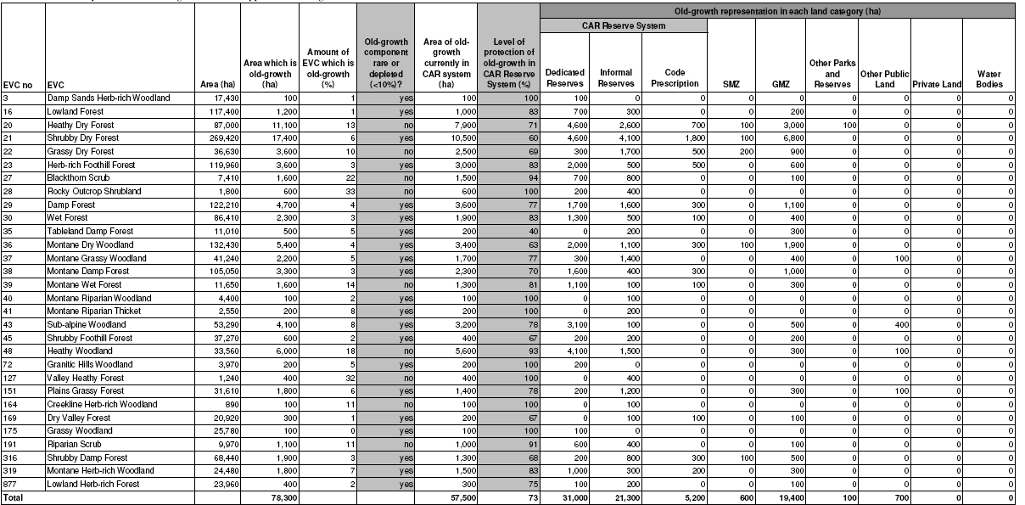
Only EVCs which can usually contain old-growth in this RFA region are reported in this table. The figures shown in this table are based on modelled information and are therefore only approximate. The analysis used the approved EVC datasets (NV2005_EVCBCS and NV1750_EVCBCS) at 30 June 2009 and the approved FMZ dataset (FMZ100) at 20 August 2009. The modelled old-growth layer (MOG_2009) used incorporates fire disturbance to March 2009 and timber harvesting disturbance to June 2008. While changes to forest management zoning have been made since this RFA was signed, no comparison can be made between this table and that in the RFA as they are based on different EVC and old-growth source datasets.
Since the RFAs were signed, changes have been made to the list and classification of EVCs in Victoria; EVCs have been added, removed and merged. The EVC datasets (current and pre-1750 extent) were updated in 2007 to make required changes, and the old EVC datasets are now obsolete. The FMZ source datasets used to determine the level of protection of EVCs within the CAR Reserve System do not exactly match the RFA region boundaries; this resulted in a gap around the edge of most RFA regions producing an error of around 1% in the area statements.
Old-growth modelling in Victoria is limited to vegetation with potential height generally greater than 5 metres and a eucalypt crown cover projection generally greater than 10%. EVCs which do not generally meet this description are not included in this table. The modelled oldgrowth dataset used in the analysis does not account for old-growth recovery in this RFA region. It is likely that the figures in this table underestimate old-growth extent. The analysis was undertaken using ESRI GRID versions of EVCs (25m cells) and forest zoning (12.5m cells), and modelled old-growth (25m cells). The use of this technique will have modified the area of each attribute compared to the polygon versions of these datasets. Area statements have been rounded to the nearest 100 ha to account for the errors discussed above.
Dedicated Reserves, Informal Reserves and Code Prescription zoning categories comprise the area of each EVC protected within the CAR Reserve System. Code Prescription refers to areas protected by Code of Practice for Timber Production 2007 prescriptions. The remaining zone categories fall outside of the CAR Reserve System. SMZ and GMZ refer to vegetation in Special Management Zone and General Management Zone but which are not protected by Code of Practice for Timber Production 2007 prescriptions.

Private land
Victoria continues to use a range of mechanisms to protect biodiversity on private land. Mechanisms which provide for the protection of biodiversity on private land include:
- conservation covenants under the Victorian Conservation Trust Act 1972 (Vic);
- Land Management Cooperative Agreements under the Conservation Forests and Lands Act 1987 (Vic);
- critical habitat provisions under the Flora and Fauna Guarantee Act 1988 (Vic); and
- provisions of the Planning and Environment Act 1987 (Vic).
Private lands across the RFA regions are protected through these mechanisms. Private land protected by these mechanisms can only be included in the CAR reserve system with the consent of the land owner. There were no additions of private land to the CAR reserve system during either Period 1 or Period 2. Although consent has not be provided by any land owners to include their private land within the CAR reserve system, the private lands protected by these mechanisms complement the CAR reserve system.
Regional Native Vegetation Plans completed in 2006 identified assets, areas and sites which are priorities for retention and management over and above the statewide priorities established in Victoria's Native Vegetation Management: A Framework for Action.

Other lands identified for possible future inclusion in the CAR reserve system
The Central Highlands RFA identified lands managed by Melbourne Water that contain EVCs which are priorities for inclusion in the CAR reserve system. An assessment of these areas has not been undertaken during the review period; however, Victoria continues to protect significant biodiversity and old-growth values on these lands subject to the management requirement to maintain and protect water supply values and assets.
The freehold land surrounding the Beaconsfield Reservoir has been transferred to the Crown as public land and is now included within the CAR reserve system.

APPENDIX 2 – THREATENED SPECIES
The RFAs document the range of mechanisms in place to conserve the habitat of rare and threatened flora and fauna. These include protection within the CAR reserve system, protection of rare or threatened EVCs, and the development of Action Statements for species listed under the FFG Act and Recovery Plans for species listed under the former ESP Act (now the EPBC Act).
The RFAs identified priorities for the preparation of Action Statements and Recovery Plans, recognising that priorities can change in light of new information. Information on progress with implementation of each of the priorities identified in the RFAs follows. Some actions have not been completed due to changes to national and state priorities over the review period.

Priority species and EVCs for nomination under the Flora and Fauna Guarantee Act 1988 (Vic)
Central Highlands
Of the species prioritised in the Central Highlands RFA for listing under the FFG Act, four have been nominated to the Scientific Advisory Committee (Table 22). The Smoky Mouse, Grey Goshawk and Strzelecki Gum were approved for listing as threatened species, while the nomination for Tree Geebung was rejected. There is currently insufficient data to nominate the Broad-toothed Rat for listing.
Five EVCs were prioritised in the Central Highlands RFA for nomination under the FFG Act (Table 23). Three of these EVCs have been incorporated in FFG-listed threatened communities.
North East
Five of the species prioritised in the North East RFA for nomination under the FFG Act have been nominated and listed as threatened (Table 22). The Golden Perch nomination was assessed but rejected for listing.
West Victoria
Of the 10 species prioritised in the West Victoria RFA for listing under the FFG Act, five have been nominated to the Scientific Advisory Committee (Table 22). Three of the species were listed under the FFG Act as threatened. Two of the species, the Flat-headed Galaxias and Mt. William (Serra) Grevillea, were rejected for listing.
Gippsland
Of the eight species prioritised in the Gippsland RFA region for nomination under the FFG Act, seven have been the subject of submissions to the Scientific Advisory Committee (Table 22). Six of the species were listed under the FFG Act as threatened, while the Lilly Pilly Burrowing Cray was rejected for listing.
Table 22 Listing status of prioritised species nominated under the Flora and Fauna Guarantee Act 1988 (Vic).
Scientific Name | Common Name | Progress
Central Highlands RFA region
Mastacomys fuscus | Broad-toothed Rat | Data deficient
Myotis macropus | Large footed Myotis | Not nominated
Pseudomys fumeus | Smoky Mouse | Listed
Accipiter novaehollandiae | Grey Goshawk | Listed
Eucalyptus strzeleckii | Strzelecki Gum | Listed
Huperzia varia | Long Clubmoss | Not nominated
Hypsela tridens | Hypsella | Not nominated
Persoonia arborea | Tree Geebung | Rejected
Senecio laticostatus | Ridged Groundsel | Not nominated
Thelymitra circumsepta | Bog Sun-orchid | Not nominated
Tmesipteris elongata ssp. elongata | Slender Fork-fern | Not nominated
Treubia tasmanica | Liverwort | Not nominated
North East RFA region
Acacia dallachiana | Catkin Wattle | Not nominated
Carex echinata | Star Sedge | Not nominated
Colobanthus affinis | Alpine Colobanth | Not nominated
Craspedia alba | White Billy-buttons | Not nominated
Euchiton nitidulus | Shining Cudweed | Not nominated
Euphrasia crassiuscula ssp. eglandulosa | Thick Eyebright | Listed
Hibbertia humifusa ssp. erigens | Euroa Guinea-flower | Listed
Poa hothamensis var. parviflora | Soft Ledge-grass | Not nominated
Struthidea cinerea | Apostlebird | Listed
Lophoictinia isura | Square-tailed Kite | Listed
Vermicella annulata | Bandy Bandy | Listed
Ramphotyphylops proximus | Woodland Blind Snake | Not nominated
Gadopsis marmoratus | River Blackfish | Not nominated
Galaxias olidus | Mountain Galaxias | Not nominated
Macquaria ambigua | Golden Perch | Rejected
Philypnodon grandiceps | Flat-headed Gudgeon | Not nominated
West Victoria RFA region
Aprasia striolata | Striped Worm-lizard | Listed
Bertya findlayi | Mountain Bertya | Not nominated
Caladenia tensa | Rigid Spider-orchid | Not nominated
Diuris behrii | Golden Cowslips | Not nominated
Plectrotarsus gravenhorstii | Caddisfly | Not nominated
Boekella nyoraensis | Calanoid copepod | Not nominated
Taskiria otwayensis | Caddisfly species | Listed
Thelymitra mackibbinii | Brilliant Sun-orchid | Listed
Galaxias rostratus | Flat-headed Galaxias | Rejected
Grevillea williamsonii | Mt. William Grevillea | Rejected
Gippsland RFA region
Epilobium brunnescens ssp. beaugleholei | Bog Willow-herb | Listed
Grevillea celata | Colquhoun Grevillea | Listed
Litoria verreauxii alpina | Alpine Tree Frog | Listed
Litoria littlejohni | (Littlejohn’s) Large Brown Tree-Frog | Listed
Gobiomorphus australis | Striped Gudgeon | Not nominated
Engaeus australis | Lilly Pilly Burrowing Cray | Rejected
Euastacus crassus | Alpine Spiny Cray | Listed
Euastacus neodiversus | South Gippsland Spiny Cray | Listed
This list includes a number of priority species which are listed under the EPBC Act:
Gippsland RFA region
- Epilobium brunnescens ssp beaugleolei (Bog Willow-herb) — Listed as Vulnerable
- Grevillea celata (Colquhoun Grevillia) — Listed as Vulnerable
- Litoria verreauxii alpine (Alpine Tree Frog) — Listed as Vulnerable
- Litoria littlejohnii (Little Brown Tree frog) — Listed as Vulnerable
North East RFA region
- Hibbertia humifusa ssp. Erigens (Euroa Guinea Flower) — Listed as Vulnerable
Central Highlands RFA region
- Pseudomys fumeus (Smokey Mouse) — Listed as Endangered
- Eucalyptus strzeleckii (Strzelecki Gum) — Listed as Vulnerable
- Secio laticostatus (Ridged Groundsel — Listed as Vulnerable
Table 23 Priority Ecological Vegetation Classes for nomination under the Flora and Fauna Guarantee Act 1988 (Vic).
Central Highlands
Plains Grassy Woodland | Forest Red Gum Grassy Woodland Community | FFG-listed
Plains Grassy Wetland | Herb-Rich Plains Grassy Wetland | FFG-listed
Swamp Forest (part of Swampy Riparian Complex) | Sedge-rich Eucalyptus camphora Community | FFG-listed
Valley Grassy Forest | These EVC’s are not yet included in any FFG-listed threatened communities
Grey Clay Drainage Line complex

Priority plant species for nomination under the Flora and Fauna Guarantee Act 1988 (Vic) and subsequent preparation of Action Statements/Recovery Plans (East Gippsland RFA)
Of the priority species in the East Gippsland RFA, two of the Action Statements have been approved and a further three are in preparation (Table 24). Three previously unlisted species have been nominated and listed as threatened under the FFG Act. Two prioritised Recovery Plans have been adopted, and two more are in preparation.
Table 24 Prioritised flora species in the East Gippsland RFA for nomination and preparation of an Action Statement or Recovery Plan.
Scientific Name | Activity | Progress
East Gippsland RFA
Pultenaea parrisiae ssp.  parrisiae | Recovery plan | No progress
Pultenaea parrisiae ssp.  parrisiae | Nominate and proceed toward Action Statement | No progress
Acacia caerulescens | Recovery plan | Adopted 2006
Acacia caerulescens | Nominate and proceed toward Action Statement | Action Statement in preparation
Prasophyllum morganii | Recovery plan | Adopted 2004
Prasophyllum morganii | Nominate and proceed toward Action Statement | Approved 2002
Pomaderris brunnea | Recovery plan | In preparation
Pomaderris brunnea | Nominate and proceed toward Action Statement | No progress
Thelymitra matthewsii | Recovery plan | In preparation
Thelymitra matthewsii | Action Statement | In preparation
Correa lawrenciana var.  genoensis | Nominate and proceed toward Action Statement | Action Statement in preparation
Alectryon subcinereus | Nominate and proceed toward Action Statement | FFG listed
Thelychiton speciosum var. speciosum | Action Statement | No progress
Christella dentata | Action Statement | No progress
Pseudoraphis paradoxa | Action Statement | No progress
Gahnia subaequiglumis | Nominate and proceed toward Action Statement | No progress
Cryptostylis erecta | Nominate and proceed toward Action Statement | FFG listed
Sarcochilus falcatus | Action Statement | No progress
Acacia binervia | Nominate and proceed toward Action Statement | FFG listed
Dipodium hamiltonianum | Action Statement | Approved 2003
Pterostylis oreophila | Nominate and proceed toward Action Statement | No progress
Thelymitra sp. aff. pulchella | Nominate and proceed toward Action Statement | No progress
Poa aff. tenera (Capillary) | Nominate and proceed toward Action Statement | No progress
This list includes a number of priority species which are listed under the EPBC Act:
East Gippsland RFA region
- Pultenaea parrisiae ssp. Parrisiae — Listed as Vulnerable
- Acacia caerulescens — Listed as Vulnerable
- Prasophyllum morganici — Listed as Vulnerable
- Pomaderris brunnea — Listed as Vulnerable
- Thelymitra matthewsii — Listed Vulnerable
- Corea lawrenciana var. Genoensis — Listed as Endangered

Priority Ecological Vegetation Classes for preparation of Action Statements
The East Gippsland RFA identified that priority will be given to the preparation of Action Statements for floristic communities that are listed under the FFG Act and which fall within the following EVCs identified in Table 25. Warm Temperate Rainforest has been listed as four separate threatened communities, all of which have Action Statements in preparation.
The Action Statement for the Silurian Limestone Pomaderris Shrubland Community was approved in 1999 and is currently under review.
Table 25 Prioritised Ecological Vegetation Classes for preparation of an Action Statement.
Ecological Vegetation Class | Listed Community | Progress
Limestone Grassy Woodland | Limestone Grassy Woodland Community | FFG-listed
Limestone Pomaderris Shrubland | Silurian Limestone Pomaderris Shrubland Community | FFG-listed  Action Statement approved 1999 under review
Warm Temperate Rainforest | Warm Temperate Rainforest (East Gippsland Alluvial Terraces) Community | FFG-listed  Action Statement in preparation
Warm Temperate Rainforest | Warm Temperate Rainforest (Coastal East Gippsland) Community | FFG-listed  Action Statement in preparation
Warm Temperate Rainforest | Warm Temperate Rainforest (Cool Temperate Rainforest Overlap Howe Range) Community | FFG-listed  Action Statement in preparation
Warm Temperate Rainforest | Warm Temperate Rainforest (Far East Gippsland) Community | FFG-listed  Action Statement in preparation
Dry Rainforest | Dry Rainforest (Limestone) Community | FFG-listed  Action Statement in preparation
Coastal Grassy Forest  Montane Riparian Woodland | These EVC’s are not yet included in any FFG-listed threatened communities
A number of EVCs referred to within the Victorian RFAs correspond with, or overlap with, ecological communities which are listed or being listed under the EPBC Act. Ecological communities which are listed/being listed under the EPBC Act which correspond with, or overlap with, EVCs referred to in the RFAs are:
East Gippsland RFA region
- Silurian Limestone Pomaderris Shrubland of the South East Corner & Australian Alps Bioregions
- Alpine Sphagnum Bogs and Associated Fens
- Littoral Rainforest and Coastal Vine Thickets of Eastern Australia
- Gippsland Red Gum (Eucalyptus tereticornis subsp. mediana) Grassy Woodland and Associated Native Grassland
Gippsland RFA region
- Alpine Sphagnum Bogs and Associated Fens
- Gippsland Red Gum (Eucalyptus tereticornis subsp. mediana) Grassy Woodland and Associated Native Grassland
Central Highlands RFA region
- White Box – Yellow Box – Blakely’s Red Gum Grassy Woodland & Derived Native Grassland
- Alpine Sphagnum Bogs and Associated Fens
- Natural Temperate Grassland of the Victorian Volcanic Plain
- Grassy Eucalypt Woodland of the Victorian Volcanic Plain
North East RFA region
- White Box – Yellow Box – Blakely’s Red Gum Grassy Woodland & Derived Native Grassland
- Alpine Sphagnum Bogs and Associated Fens
West Victoria RFA region
- Buloke Woodlands of the Riverina and Murray Darling Depression Bioregions
- White Box – Yellow Box – Blakely’s Red Gum Grassy Woodland & Derived Native Grassland
- Natural Temperate Grassland of the Victorian Volcanic Plain
- Grassy Eucalypt Woodland of the Victorian Volcanic Plain

Priority species for preparation of an Action Statement / Recovery Plan
Of the 88 species identified as being priority species for Action Statement / Recovery Plan preparation, more than 80% were addressed during Periods 1 and 2. In most cases, new or revised Action Statements and/or Recovery Plans were prepared. In some cases, plans are currently in preparation. In a few cases, such as the Narrow Goodenia, preparation of an Action Statement or Recovery Plan was not required. The Narrow Goodenia was identified for Recovery Plan preparation in the North East RFA. However, a subsequent multi-State review of its distribution and abundance led to its delisting from the EPBC Act and hence no further action was required.
East Gippsland
Eleven of the prioritised Action Statements for fauna species have been approved since the RFA signing, including the Brush-tailed Phascogale Action Statement that is now under review (Table 26). Action Statements for the Brush-tailed Rock Wallaby and Long-footed Potoroo are currently under review, while the revised Spot-tailed Quoll Action Statement has been approved. Two prioritised Recovery Plans for the Swift Parrot and Long-footed Potoroo have been adopted and are now under review. Recovery Plans are in preparation for a further three species.
Table 26 Progress with preparation of Action Statements/Recovery Plans for priority fauna species identified in the East Gippsland RFA.
Species Name | Common Name | Activity | Progress
Mammals
Petrogale penicillata | Brush-tailed Rock-wallaby | Recovery Plan | In preparation
Petrogale penicillata | Brush-tailed Rock-wallaby | Review Action Statement | Currently under review
Dasyurus maculatus | Spot-tailed Quoll | Recovery Plan | In preparation
Dasyurus maculatus | Spot-tailed Quoll | Review Action Statement | Approved 2003
Potorous longipes | Long-footed Potoroo | Recovery Plan | Adopted 2001 under review
Potorous longipes | Long-footed Potoroo | Review Action Statement | Currently under review
Pseudomys fumeus | Smoky Mouse | Action Statement | Approved 2003
Miniopterus schreibersii | Common Bent-wing Bat | Action Statement | No progress
Phascogale tapoatafa | Brush-tailed Phascogale | Action Statement | Approved 1997 under review
Birds
Ninox strenua | Powerful Owl | Action Statement | Approved 1999
Tyto novaehollandiae | Masked Owl | Action Statement | Approved 2001
Tyto tenebricosa | Sooty Owl | Action Statement | Approved 2001
Calyptorhynchus lathami | Glossy Black-Cockatoo | Action Statement | No progress
Dasyornis brachypterus | Eastern Bristlebird | Recovery Plan | In preparation
Dasyornis brachypterus | Eastern Bristlebird | Action Statement | Approved 1999
Lathamus discolor | Swift Parrot | Recovery Plan | Adopted 2002 under review
Lathamus discolor | Swift Parrot | Action Statement | Approved 2002
Pezoporus wallicus | Ground Parrot | Recovery Plan # | No progress
Pezoporus wallicus | Ground Parrot | Action Statement | No progress
Reptiles
Morelia spilota | Diamond Python | Action Statement | Approved 2000
Cyclodomorphus michaeli | Eastern She-oak Skink | Action Statement | No progress
Eulamprus kosciuskoi | Alpine Water Skink | Action Statement | Approved 2001
Amphibians
Mixophyes balbus | Southern Barred Frog | Action Statement | No progress
Fish
Pototroctes maraena | Australian Grayling | Action Statement | In preparation
Gobiomorphus australis | Cox’s Gudgeon | Action Statement | No progress
Hypseleotris compressa | Empire Gudgeon | Action Statement | Approved 2005
Crustaceans
Euastacus diversus | Orbost Spiny Crayfish | Action Statement | Approved 2001
# Subspecies found in East Gippsland is not listed under the EPBC Act, unlike Western Ground Parrot Pezoporus wallicus flaviventris
Central Highlands
Of the 14 Action Statements prioritised for preparation, 12 have been approved since the signing of the Central Highlands RFA (Table 27). Two of these Action Statements are now under review. The Baw Baw Frog Action Statement was also revised in 2004. A further three Action Statements are in preparation.
Recovery Plans have been adopted for five prioritised species of the Central Highlands RFA region, and three are now under review. In addition, five Recovery Plans are currently in preparation.
Table 27 Progress with preparation of Action Statements/Recovery Plans for priority species identified in the Central Highlands RFA.
Scientific name | Common Name | Action | Progress
Eucalyptus crenulata | Buxton Gum | Recovery Plan | Adopted 2006
Astelia australiana | Tall Astelia | Recovery Plan | In preparation
Nematolepis wilsonii | Shiny Nematolepis | Action Statement | Approved 2009
Thismia rodwayi | Fairy Lanterns | Action Statement | No progress
Caladenia concolor | Crimson Spider-orchid | Action Statement | Approved 2002
Caladenia concolor | Crimson Spider-orchid | Recovery Plan | Adopted 2004 under review
Caladenia rosella | Little Pink Spider-orchid | Action Statement | Approved 2000 under review
Lepidium hyssopifolium | Small Pepper-cress | Action Statement | In preparation
Lepidium hyssopifolium | Small Pepper-cress | Recovery Plan | In preparation
Amphibromus pithogastrus | Plump Swamp Wallaby-grass | Action Statement | Approved 2000
Bracteantha sp. aff. subundulata | Swamp Everlasting | Action Statement | Approved 2009
Carex tasmanica | Curly Sedge | Action Statement | Approved 1999 under review
Carex tasmanica | Curly Sedge | Recovery Plan | In preparation
Cyathea cunninghamii | Slender Tree-fern | Action Statement | In preparation
Grevillea barklyana ssp. barklyana | Gully Grevillea | Action Statement | Approved 2004
Eucalyptus strzeleckii | Strzelecki Gum | Recovery Plan | Adopted 2007
Senecio macrocarpus | Large-headed Fireweed | Recovery Plan | In preparation
Senecio laticostatus | Ridged Groundsel | Recovery Plan | No progress
Reiekoperla darlingtoni | Mt Donna Buang Wingless Stonefly | Action Statement | Approved 2001
Austrogammarus haasei | Amphipod | Action Statement | Approved 2000
Engaeus phyllocerus | Narracan Burrowing Crayfish | Action Statement | Approved 2001
Engaeus sternalis | Warragul Burrowing Crayfish | Action Statement | Approved 1999
Litoria spenceri | Spotted Tree Frog | Recovery Plan | Adopted 2001 under review
Philoria frosti | Baw Baw Frog | Revise Action Statement | Approved 2004
Philoria frosti | Baw Baw Frog | Recovery Plan | Adopted 2001 under review
Prototroctes maraena | Australian Grayling | Recovery Plan | Adopted 2008
Galaxiella pusilla | Dwarf Galaxias | Recovery Plan | In preparation
North East
Of the Action Statements prioritised for preparation, three have been approved (Barking Owl, Squirrel Glider and Purple Eyebright) (Table 28). Eight prioritised Recovery Plans have been adopted, the multi-species Recovery Plan including the Maroon Leek-orchid is under review, and a further four Recovery Plans are in preparation.
Table 28 Progress with preparation of Action Statements/Recovery Plans for priority species identified in the North East RFA.
Species Name | Common Name | Action | Progress
Flora
Acacia deanei ssp. deanei | Deane's Wattle | Action Statement | No progress
Acacia phasmoides | Phantom Wattle | Recovery Plan | In preparation
Babingtonia crenulata | Fern-leaf Baeckea | Recovery Plan | Adopted 2007
Carex cephalotes | Wire-head Sedge | Action Statement | No progress
Eucalyptus alligatrix ssp. limaensis | Lima Stringybark | Recovery Plan | Adopted 2007
Eucalyptus cadens | Warby Swamp Gum | Recovery Plan | Adopted 2007
Euchiton nitidulus | Shining Cudweed | Recovery Plan | No progress
Euphrasia collina ssp. muelleri | Purple Eyebright | Action Statement | Approved 2009
Euphrasia collina ssp. muelleri | Purple Eyebright | Recovery Plan | Adopted 2007
Euphrasia eichleri | Bogong Eyebright | Recovery Plan | Adopted 2007
Glycine latrobeana | Clover Glycine | Recovery Plan | In preparation
Goodenia macbarronii | Narrow Goodenia | Recovery Plan | Nominated for delisting
Kelleria laxa | Kelleria | Recovery Plan | Adopted 2007
Pomaderris subplicata | Concave Pomaderris | Recovery Plan | Adopted 2007
Prasophyllum frenchii | Maroon Leek-orchid | Recovery Plan | Adopted 2004 under review
Pterostylis cucullata | Leafy Greenhood | Recovery Plan | In preparation
Thelypteris confluens | Swamp Fern | Action Statement | No progress
Fauna
Petaurus norfolcensis | Squirrel Glider | Action Statement | Approved 2002
Rhinolophus megaphyllus | Eastern Horseshoe-bat | Action Statement | No progress
Ninox connivens | Barking Owl | Action Statement | Approved 2001
Galaxias fuscus | Barred Galaxias | Recovery Plan | In preparation
Macquaria australasica | Macquarie Perch | Action Statement | In preparation
Archeophylax canarus | Caddisfly | Action Statement | No progress
Thaumatoperla alpina | Stonefly | Action Statement | No progress
West Victoria
Of the 11 Action Statements prioritised for preparation, all have been prepared and approved, except for Mt. William Grevillea which was rejected for listing (Table 29). Action Statements are now under review for four of these species. The Spot-tailed Quoll Action Statement has also been revised.
Recovery Plans have been adopted for eight priority species and two Recovery Plans are in preparation. All of the adopted Recovery Plans are now under review.
Table 29 Progress with preparation of Action Statements/Recovery Plans for priority species identified in the West Victoria RFA.
Scientific Name | Common Name | Action | Progress
Flora
Caladenia fulva | Tawny Spider-orchid | Action Statement | Approved 2002
Caladenia fulva | Tawny Spider-orchid | Recovery Plan | Adopted 2004 under review
Caladenia hastata | Mellblom’s Spider-orchid | Action Statement | Adopted 2000 under review
Caladenia hastata | Mellblom’s Spider-orchid | Recovery Plan | Adopted 2001 under review
Caladenia tensa | Rigid Spider-orchid | Recovery Plan | Adopted 2001 under review
Caladenia xanthochila | Yellow-lip Spider-orchid | Action Statement | Adopted 2000 under review
Caladenia xanthochila | Yellow-lip Spider-orchid | Recovery Plan | Adopted 2001 under review
Caladenia formosa | Elegant Spider-orchid | Action Statement | Adopted 2000 under review
Caladenia formosa | Elegant Spider-orchid | Recovery Plan | Adopted 2001 under review
Grevillea williamsonii | Mt. William Grevillea | Action Statement | Rejected for listing
Grevillea williamsonii | Mt. William Grevillea | Recovery Plan | Rejected for listing
Olearia pannosa ssp. cardiophylla | Velvet Daisy-bush | Action Statement | Approved 2003
Prasophyllum diversiflorum | Gorae Leek-orchid | Action Statement | Approved 2003
Prasophyllum diversiflorum | Gorae Leek-orchid | Recovery Plan | Approved 2001 under review
Prasophyllum subbisectum | Pomonal Leek-orchid | Recovery Plan | Approved 2004 under review
Thelymitra epipactoides | Metallic Sun-orchid | Recovery Plan | Adopted 2004 under review
Thelymitra merraniae | Merran's Sun-orchid | Action Statement | Approved 2003
Rutidosis leptorynchoides | Button Wrinklewort | Recovery Plan | In preparation
Fauna
Dasyurus maculatus | Spot-tailed Quoll | Revise Action Statement | Approved 2003
Pseudomys shortridgei | Heath Mouse | Action Statement | Approved 2003
Pseudomys shortridgei | Heath Mouse | Recovery Plan | In preparation
Grantiella picta | Painted Honeyeater | Action Statement | Approved 2003
Edelia obscura | Yarra Pygmy Perch | Action Statement | Approved 2001 under review
Neochanna cleaveri | Australian Mudfish | Action Statement | Approved 2003
Gippsland
Of the four species prioritised for the preparation of Action Statements in the Gippsland RFA, all have had Action Statements approved, except for the Prostrate Cone-bush (Table 30). The Action Statement is now under review for Spiny Pepper-cress.
A Recovery Plan has been adopted for the Eastern Spider-orchid and is currently under review, and two Recovery Plans are in preparation.
Table 30 Progress with preparation of Action Statements/Recovery Plans for priority species identified in the Gippsland RFA.
Scientific Name | Common Name | Action | Progress
Caladenia orientalis | Eastern Spider-orchid | Recovery Plan | Adopted 2004 under review
Isopogon prostratus | Prostrate Cone-bush | Action Statement | No progress
Lepidium aschersonii | Spiny Pepper-cress | Action Statement | Approved 2000 under review
Prasophyllum correctum | Gaping Leek-orchid | Recovery Plan | In preparation
Rulingia prostrata | Dwarf Kerrawang | Action Statement | Approved 2003
Rulingia prostrata | Dwarf Kerrawang | Recovery Plan | In preparation
Engaeus rostrogaleatus | Strzelecki Burrowing Crayfish | Action Statement | Approved 2003

Potentially threatening processes under the FFG Act prioritised for preparation of Action Statements
Of the five potentially threatening processes in the Central Highlands RFA prioritised for preparation of Action Statements, two have had Action Statements approved (Table 31). A third Action Statement is also in preparation.
Table 31 Prioritised potentially threatening processes for preparation of an Action Statement.
Potentially threatening process | Progress
Loss of hollow-bearing trees from Victorian native forests. | Approved 2003
Increase in sediment input into Victorian rivers and streams due to human activities. | Approved 2003
Use of Phytophthora-infected gravel in construction of roads, bridges and reservoirs. | In preparation
Invasion of native vegetation by environmental weeds (including “Spread of Pittosporum undulatum in areas outside its natural range”). | -
Collection of native orchids. | -
One potentially threatening process was prioritised in the North East RFA for preparation of an Action Statement Degradation of native riparian vegetation along Victorian rivers and streams. An Action Statement for this process was approved in 2003.
One potentially threatening process was prioritised in the Gippsland RFA, Soil erosion and vegetation damage and disturbance in the alpine regions of Victoria caused by cattle grazing. This potentially threatening process has been listed, and the Action Statement is being prepared.

Priority for preparation of a Threat Abatement Plan under the Endangered Species Protection Act 1992 (Cwth)
In accordance with the Central Highlands RFA, the Threat Abatement Plan for the prioritised key threatening process Phytophthora spp. was approved in 2003, titled Dieback caused by the root-rot fungus (Phytophthora cinnamomi).
Other priorities identified in the RFAs
Baw Baw Frog
Priorities set out in the Central Highlands RFA to protect Baw Baw Frog populations have been implemented. Research and surveys were prioritised to further understand the breeding requirements of the species, allowing more effective protection of important habitat. Until the research results were available, the RFA provided for Victoria to adopt a precautionary strategy surrounding the Baw Baw plateau, to protect and preserve habitat and minimise the effects of forestry. Victoria also revised the Action Statement.
The revised Action Statement was approved in 2004, and updated the intended management actions, including: measuring and analysing population and habitat trends; determining and reducing the impact of processes that threaten the Baw Baw Frog; and increasing knowledge on biology and ecology of the species. The 2004 Action Statement included an interim management guideline to prevent habitat loss which prohibited timber harvesting within 200m of known habitat.
Research and surveying priorities for the Baw Baw Frog have been addressed or are underway and have improved current knowledge of the species’ distribution. As a result, critical habitat largely on the south face of the Baw Baw Plateau and around the South Cascade Creek will be protected in the CAR reserve system including the national park and State forest. The Baw Baw Frog Action Statement will be revised again in the latter part of 2009 to reflect these changes to habitat protection and management. The Baw Baw Frog has been listed as Endangered under the EPBC Act.
Long-footed Potoroo
In the North East RFA, Victoria and the Commonwealth agreed to give priority to implementing the Long-footed Potoroo national Recovery Plan. The Plan was adopted in 2001 and is currently being revised. The Action Statement, published in 1994, is also under review.
The habitat protection measures identified within the North East RFA have been implemented. Through implementation of the Action Statement and the availability of new information, Victoria has identified a new approach to Long-footed Potoroo protection. The revised Action Statement provides for a Core Protected Area of habitat, including habitat within conservation reserves, supplemented by harvesting prescriptions around records in State forest outside the Core Protected Area. This approach offers greater certainty for industry and more strategic long term protection for the Long-footed Potoroo. The Long-footed Potoroo has been listed as Endangered under the EPBC Act.
Spot-tailed Quoll
The Spot-tailed Quoll is listed as threatened under the FFG Act and endangered under the EPBC Act. Commitments to protect the species within the West Victoria and Gippsland RFAs have been implemented.
The Spot-tailed Quoll Action Statement, originally approved in 1992, has been reviewed since the signing of the West Victoria and Gippsland RFAs, with the revised publication approved in 2003. At present, the Commonwealth Recovery Plan for the Spot-tailed Quoll is in the drafting stages, being jointly prepared by a number of states.
Grassy woodland EVCs
Plains Grassy Woodland and a range of similar EVCs, characterised by River Red Gum (Eucalyptus camaldulensis) and Yellow Gum (E. leucoxylon var leucoxylon) were prioritised in the West Victoria RFA. A substantial proportion of these endangered EVCs have been protected in the CAR reserve system but, consistent with the flexibility provisions of the JANIS criteria, other areas have been retained for low intensity utilisation of timber and other forest products.
The management objective for these EVCs both within and outside the CAR reserve system is to maintain the biodiversity and structure of the grassy woodland communities.
The West Victoria RFA sought the review of grazing licences in areas of rare or endangered EVCs on a case-by-case basis, in conjunction with the licensee, to determine grazing regimes which conform with the management objectives of the EVC. Grazing licences have continued to be reviewed, resulting in a phase out and voluntary relinquishment of grazing licences within this area.
In addition, timber harvesting in these EVCs continues to use low-intensity selection systems as required by the RFA. It has not been possible to review the methods used to obtain regeneration due to the lack of seed forming on River Red Gum trees.

APPENDIX 3 – LISTING, PROTECTION AND MANAGEMENT OF NATIONAL ESTATE VALUES
Protection and management of National Estate values
1. Both Parties endorse the findings of the Australian Heritage Commission/Department of Natural Resources and Environment (AHC/NRE) study of National Estate in the RFA regions (the Joint Study) and agree that national estate values exist as documented in publicly available plots of GIS coverages and published documents as listed in the RFA.
No update necessary.
2. Both Parties recognise that the extensive and systematic information and regional framework provided by the Joint Study and this Agreement provide a unique regional context for national estate values in the RFA Region.
No update necessary.
3. Both Parties agree that many of the national estate values are well reserved in the CAR reserve system and that the relevant forest management plan (and other mechanisms) provide for the conservation of many other national estate values within the RFA region.
No update necessary.
4. Both Parties agree that all national estate values in the RFA Region will be conserved through the application of the principles for managing national estate values as detailed in the relevant forest management plan.
This commitment has been overtaken by events, including the introduction of the National Heritage List and the agreement between the Parties to transfer places to appropriate heritage registers. From February 2012 all references to the RNE will be removed from the EPBC Act and the AHC Act. The RNE will be maintained after this time on a non-statutory basis as a publicly available archive.
5. Both Parties endorse the joint preparation of a set of Statewide Guidelines for the Management of Cultural Heritage Values in the Forests, Parks and Reserves of Victoria. When completed Victoria agrees to manage in accordance with these guidelines.
NRE published Guidelines for the Management of Cultural Heritage Values: in the Forests, Parks and Reserves of East Gippsland in 1997 in accordance with the East Gippsland RFA. Subsequent Victorian RFAs called for the joint preparation of a set of statewide guidelines for the management of cultural heritage values in the forests, parks and reserves of Victoria, based on those prepared for East Gippsland. This commitment is yet to be implemented. However, forest management plans relevant to the Victorian RFA regions contain conservation measures for natural values identified as being sensitive to disturbance, and forest management zoning, conservation and management guidelines and actions for the conservation of other natural and cultural national estate values.
6. Both Parties agree to maintain the databases of the values identified in the Joint Study and cooperate in relation to access to the data.
As previously discussed, this commitment has been overtaken by events. However, all databases of values will be maintained in a reasonably accessible format.
Listings in the Register of the National Estate
Existing Listings
7. Parties note that the Australian Heritage Commission (the Commission) has agreed to update the Statements of Significance and condition and description statements for all existing listings to incorporate the results of the Commission/Department of Natural Resources and Environment study of the National Estate (Joint Study).
Parties note that existing national estate places will remain in the Register of the National Estate where the results of the Joint Study confirm the presence of national estate values.
In 2003, the Commonwealth repealed the Australian Heritage Commission Act 1975 (Cwth) and amended the Environment Protection and Biodiversity Conservation Act 1999 (Cwth) (EPBC Act) to provide for a National Heritage List to replace the RNE.
Following amendments in 2006 to the EPBC Act and the Australian Heritage Council Act 2003 (Cwth), the RNE was frozen on 19 February 2007, which means that no new places can be added, or any existing places, or values of places, removed. The Register will continue as a statutory register until February 2012. A transition period of five years was provided to allow State and Territories to consider whether places on the Register should be protected under other statutory provisions or their own heritage registers. The Commonwealth Minister is required to consider information in the RNE in the course of his decision making under the EPBC Act during this period.
From February 2012, all references to the Register are to be removed from the EPBC Act and AHC Act; however the RNE will be maintained on a non-statutory basis as a publicly available archive. The Australian Government has invited the State to consider whether any places listed on the Register should be accorded any ongoing status under State legislation. While Victoria does not have any equivalent register for natural values, the State does have the Victorian Heritage Register.
Listings Arising from the Joint Study
8. The Parties note that new listings recommended to the Commission will include national estate values protected by reservation, by reserve management prescription, by site exclusion, by consultation processes or other measures appropriate to the value, or which are robust and not affected by harvesting or other off-reserve management regimes or activity.
No update necessary.
9. Parties note that the Commission will work in cooperation with Victoria in delineating places for National Estate listing. The identification of these areas will be based on the following principles:
- New listings in Dedicated and Informal Reserves, the boundaries of which are unlikely to change, should be distinct places and may be based on any national estate values.
- Listing of other National Estate places outside the CAR reserve system will be based on robust values and those values that are protected by forest management prescription. Areas of contiguous values will be listed as a single National Estate place.
- Boundaries for listing National Estate places outside the CAR reserve system will be based on identified values and will follow natural topographic features and/or roads as appropriate. In areas where a national estate value overlaps an Informal Reserve, but also continues outside that reserve, the full coverage of the value will be listed and it will be recognised that a portion of this value is protected.
- For places arising from the Joint Study, only places identified by the above principles will be listed in the Register of the National Estate.
As previously discussed, this commitment has been overtaken by events.
10. Both Parties note that the identification and assessment of national estate values for the CRA has been completed with the only exception being Indigenous heritage. Parties note that the Commission will continue to consult with Victoria and Indigenous communities in an effort to finalise this work.
No update necessary.
Future Listings
11. Parties note that future nominations will be referred to them by the Commission. The Parties agree to work cooperatively and in a timely fashion in considering whether such nominations will be recommended to the Commission for listing. The Parties are to compare the nominations with the existing agreed national estate database, and to consider any new research or information provided. Parties will also jointly agree on any future recommendations to the Commission for listing. The Parties note that the Commission will work cooperatively with Victoria on the detail of any consequent listings that may arise.
As previously discussed, this commitment has been overtaken by events.
12. The Parties note that the Commission has agreed not to undertake any further regional studies of forests in Victorian RFA regions.
No update necessary.
13. Parties note that the Commission confirms that, based on the National Estate Assessment, there is no evidence to identify additional large areas with national estate values in the forested areas of the RFA regions and that it therefore does not anticipate listing additional large places in the regions.
No update necessary.
Statutory Advice
14. The Parties agree that the advice of the Australian Heritage Commission has already been provided in relation to the protection of national estate values and the impact of forestry activities within the RFA regions in developing this Agreement. The Commission is also satisfied regarding the range of mechanisms and levels of protection afforded to national estate values.
No update necessary.
15. The Parties note that the advice of the Commission will be sought in relation to proposed actions by the Commonwealth which are outside the scope of this Agreement, and which might adversely affect national estate values in RFA regions including proposed actions that may affect national estate values in areas outside the CAR reserve system and which have not been listed in the Register of the National Estate. The Parties note that the Commission has agreed to take into account the undertakings in this Agreement in providing its advice and will provide such advice in a regional context.
No update necessary.
16. The Parties note that the Commission may delegate the Section 30 function for the RFA area/s to an appropriate official in a Victorian Agency. This delegation would be limited to the RFA area/s, and those operations which affect those aspects of the forest estate documented in the CRA.
No update necessary.

APPENDIX 4 - PUBLIC REPORTING AND CONSULTATIVE PROCESSES
During the implementation of the RFAs, public reporting activities and on-going opportunities for public participation and consultation associated with the existing Victorian and Commonwealth processes and instruments identified within the RFAs has continued. Examples of these process and instruments with public reporting and community engagement opportunities during the review period follow.
- Land Conservation Council and Environment Conservation Council studies
The ECC Box-Ironbark Forests and Woodlands Investigation and VEAC Angahook-Otway Investigation each included public participation and consultation.
- Preparation and amendment of forest management plans, National and State Park management plans, and regional fire protection plans
Preparation and amendment of management plans in each RFA region including park management plans, the forest management plans referred to in Section 5.10 of this report, and fire protection plans provided opportunities for public participation and consultation.
Public participation and consultation programs continue to be provided in the implementation of forest management plans.
- Activities associated with implementation of the FFG Act
Nominations and listing of items in the FFG Act are advertised and draft Action Statements available for public comment on the DSE website (www.dse.vic.gov.au).
- Preparation and review of Codes of Practice
The review of the Code of Practice for Fire Management on Public Land in 2006 and the review of the Code of Practice for Timber Production 2007 provided opportunities for public participation and consultation.
- Publication of audits of compliance with the Code of Forest Practices for Timber Production
In 2002, the Victorian Government released the Our Forests, Our Future policy with a commitment to make the application of the Code of Forest Practice for Timber Production (now the Code of Practice for Timber Production 2007) more transparent. To deliver on this commitment, the Minister for the Environment asked EPA Victoria to engage an independent environmental auditor to assess compliance on public land with the Code. DSE ensured that timber harvesting operations in the latter part of Period 1, and throughout Period 2, were regularly audited for compliance with the regulatory framework. The annual audits of compliance with the Code are available on the EPA website (www.epa.vic.gov.au). A consultative process in place during the review period ensured the community, conservation groups, industry and other interested organisations at the State, regional and local level were engaged in the audit program.
- Preparation of Wood Utilisation Plans and Fuel Reduction Burning Plans
The preparation of Wood Utilisation Plans and Fire Operations Plans in Victoria continues to include opportunities for public comment.
- Technical, research and other reports on such topics as sustainable yield reviews, regeneration performance, old-growth surveys and updates of the schedules of the FFG Act
Victoria continued to publish technical, research and other reports relating to Victoria’s forests during the review period. These reports include: sustainable yield reviews; old-growth forest studies; reports on regeneration success following timber harvesting operations; Victoria’s State of the Forests reporting; Monitoring of Annual Harvesting Performance reports; and new and revised Action Statements prepared under the FFG Act. Many of these reports are available on the DSE website (www.dse.vic.gov.au).
As outlined in this report, the Victorian Government released Our Forests, Our Future in February 2002. With this policy statement, Victoria published reports which included estimates of sawlog resources for each FMA, and the independent Expert Data Reference Group’s report on the quality of data and processes used to derive the estimates of sawlog availability.
Public consultation and reporting opportunities were also associated with a range of other projects, including the Criteria and Indicators for Sustainable Forest Management in Victoria, the Statewide Forest Resource Inventory and the Wood and Water Project, an investigation of the impact of timber harvesting on water yield within Melbourne’s catchments.
- Nomination, preparation and possible contraventions of recovery plans and threat abatement plans prepared under the EPBC Act and former Endangered Species Protection Act 1992 (Cwth)
Under Section 275 of the EPBC Act the Minister for the Environment, Heritage and the Arts must consult on recovery plans and threat abatement plans. Plans are developed in consultation with, for example, state agencies, local councils, individuals or groups that may be affected by a proposed plan and people with expertise in the species. Once a Draft Plan has been prepared, it is released for public comment for a minimum period of three months (the former ESP Act also required a minimum of three months public consultation). At the end of this period the plans are revised to take into consideration any public comments received. The Minister will consider the revised plans as well as the comments received when deciding on adoption of the plans. The Minister must also publicise the adoption of a plan and where it can be obtained.
Further information about recovery plans and threat abatement plans can be found on the Department of Environment, Water, Heritage and the Arts website (www.environment.gov.au).
- Listing of places in the Register of the National Estate under the former Australian Heritage Commission Act 1975 (Cwth)
Interim listings on the RNE were subject to a public consultation process prior to formal inclusion on the list. The RNE has now been replaced by the National and Commonwealth Heritage Lists; however, the RNE will remain as a publicly available archive.
Valid nominations for the National Heritage List and the Commonwealth Heritage List, which are accepted from members of the public, are provided to the Australian Heritage Council. The Council is the principal adviser to the Australian Government on heritage matters. The Council assesses nominations for the heritage lists, and maintains the RNE.
Once a year, the Council prepares a priority assessment list for consideration by the Minister. This list, when approved by the Minister, sets the work program for the Council for the next 12 months. The list is published on the internet, and the Council must invite public comment on whether the places under assessment contain the heritage values for which they were nominated. The Council must also consult owners and occupiers of any place that it finds, during assessment, to have heritage value.
The Council then gives the Minister an assessment report on each place on the priority assessment list, together with copies of all comments it has received from its statutory consultations. The Minister must consider the assessment report and comments and decide whether or not to add each place to the heritage lists.
All heritage places on the RNE, National Heritage List and Commonwealth Heritage List can be found by searching the Australian Heritage Database (http://www.environment.gov.au/cgi-bin/ahdb/search.pl).

APPENDIX 5 - RESEARCH
The RFA identified the following state wide research priorities noting that the subject areas and priorities may change throughout the duration of the RFAs.
- Forest research in Victoria is aimed at ensuring the management policies and practices for Victoria’s native forests are scientifically based, efficient and sustainable for all forest values.
- The major priority of future research in Victoria will be the development of appropriate mechanisms to monitor and continually improve the sustainability of forest management practices. Accordingly, statewide research will continue on the following major themes:
- silviculture
- flora and fauna conservation
- soil and water conservation
- fire ecology
- wood quality in regrowth forests.
- Parties also recognise the importance of continuing research to address:
- control of feral pests
- environmental weed control in priority areas
- population monitoring of high priority threatened flora and fauna species
- the effectiveness of Ecological Vegetation Classes as surrogates of biodiversity
- the effects of differing buffer and filter strip widths on water quality and stream biota
- the development of ecologically based fire management regimes
- the effect of regrowth forests on water yields and their impacts on stream biota
- the effect of introduced fish species on aquatic fauna
- growth responses and ecological impacts of intensive silviculture in regrowth forests
- stem defect and wood quality in regrowth forest
- technologies and processes associated with the development of high value wood products.
- Research on the above themes will vary from region to region.
Throughout the review period research has continued on each of these themes and priorities listed in the RFAs. The importance of ecologically sustainable forest management and the development of appropriate mechanisms to monitor and continually improve management practices has remained central to the research carried out in Victoria. In addition to the themes listed in the RFAs, research during the review period has demonstrated a developing focus on issues relating to climate change and carbon sequestration.
Three case studies of major research projects carried out in Victoria during the review period are discussed below, as examples of the extensive and varied research work that has been undertaken to support sustainable forest management in Victoria. Major research work has also been carried out in the following areas:
- Population monitoring of high priority threatened flora and fauna species including Powerful Owl, Spot-tailed Quoll, Long-footed Potoroo, Black-footed Rock Wallaby, Baw Baw Frog and Mountain Pygmy-possum.
- Wood quality in regrowth forests.
- Variable retention harvesting.
- Fire ecology, fire effects and post fire recovery.
- Control of feral predators.
- Environmental weed control.
- Water yield and quality responses to timber harvesting, fire and climate.
Case study one: Long term monitoring and research program in the Central Highlands ash forests.
Since 1983 the Victorian Government has supported a long term monitoring and allied research program in the ash-type eucalypt forests of the Central Highlands RFA region. To date, over 50 major projects have been completed. The primary focus of the program is the long term monitoring of arboreal marsupials, such as Leadbeater’s Possum (Gymnobelideus leadbeateri) and the Mountain Brushtail Possum (Trichosurus cunninghami).
The monitoring program currently comprises:
- Long term ecological monitoring of landscape cover and composition (logged/unlogged mosaic) effects on arboreal marsupials, forest owls and diurnal birds.
- Monitoring falls of large hollow trees.
- Nest-box use and occupancy patterns of hollow-dependent fauna.
- Fauna surveys (mammals, birds and reptiles) of dry and mixed-species forest patches in the Upper Yarra catchment (32 sites in the Yarra Ranges National Park).
- A variable retention harvest system experiment.
- Small-mammal population dynamics – relationships between forest floor architecture (logs, ground cover, etc.) and populations of three species of small mammals.
- Long term population dynamics of the Mountain Brushtail Possum.
A significant silvicultural-related component of this work is the set up of a major variable retention harvesting system experiment in the Mountain Ash forests of the Central Highlands in 2003. This experiment is ongoing and involves intensive data gathering for vertebrates and recording the structure composition and condition of the vegetation in the survey plots. This research forms part of the Value-adding and Silvicultural Systems Project, which was established to test the hypothesis that a better balance between economic and environmental concerns can be achieved with silvicultural systems other than clearfelling.
Case study two: Wombat fire effects study.
In 1984, a multidisciplinary study was established in the Wombat State Forest with the support of the Victorian government, to investigate the effects of repeated low-intensity prescribed burning in mixed eucalypt foothill forest. The study—the Wombat Fire Effects Study—is quantitative and statistically based and includes various aspects of fauna, flora, soils, tree growth, fuel management and fire behaviour.
On the same permanent plots, various methodologies were used to investigate the ecological impacts of fire on understorey flora, invertebrates, birds, bats, reptiles, terrestrial mammals, soil chemistry and the growth, bark thickness and defect development in trees. Local climate and weather, fuel dynamics and fire behaviour were also studied, along with their interactions.
Numerous published papers and reports have been produced as a result of this work, including a series of research reports published by DSE in 2003.
Case study three: Monitoring the response of medium sized mammals to effective fox control.
In June 1998 Project Deliverance, a large-scale field-based research project investigating the response of medium sized mammals, such as potoroos, bandicoots and possums, to effective fox control, was carried out in East Gippsland. This project concluded in 2003 and led to the establishment of the Southern Ark Project, a major conservation initiative that aims to help the recovery of a suite of native mammals, birds and reptiles by significantly reducing the fox population in far East Gippsland.
The Victorian Government, in partnership with the Invasive Animals CRC, has supported further research projects adding to the knowledge gathered from Project Deliverance and Southern Ark. The Glenelg Ark project, in the West Victoria RFA region, complements the Southern Ark project and builds on many years of research that has shown the positive impacts that fox control has on native mammal populations.

