

State Specific Guideline
for Tasmania

This Guideline has been prepared by the Australian Government and the Tasmanian Government. It is intended to assist processors from Tasmania, who process raw logs into another form, in understanding the regulatory framework in Tasmania in order for them to carry out their due diligence obligations under the Illegal Logging Prohibition Amendment Regulation 2013, which supports the Illegal Logging Prohibition Act 2012.

This Guideline was co-endorsed by the Australian and
Tasmanian Governments on 1 October 2014.

Contents
What is required under the new law? 3
How is timber harvesting regulated in Tasmania? 4
Preamble 4
Tasmanian legislative framework 4
Additional information 5
Identifying legal product from Tasmania 6
Who should I contact for further information? 9
Attachment A – Example Forest Practices Plan cover page 10
Attachment B – Example Delivery Arrangement – Forestry Tasmania sales procedure 11

What is required under the new law?
Australia’s Illegal Logging Prohibition Act 2012 (the Act) restricts the movement of illegally logged timber into Australia at the border, for imported timber and timber products; and at timber processing mills, for domestically grown raw logs.
The Act seeks to address the harmful environmental, social and economic impacts of illegal logging, including forest degradation, habitat loss and threats to sustainable livelihoods.
The Act defines illegally logged as:
‘…in relation to timber, means harvested in contravention of laws in force in the place (whether or not in Australia) where the timber was harvested’.
The Illegal Logging Prohibition Amendment Regulation 2013 (the Regulation) prescribes due diligence for the regulated community, that is, Australian importers of regulated timber products (for these purposes a regulated timber product is a product listed in Schedule 1 to the Regulation) and Australian processors of domestic raw logs. Under the Regulation the regulated community have to undertake a due diligence process to minimise the risk of sourcing illegally logged timber.

Due diligence requirements for processors include the following steps:
Step 1: Information gathering
Step 2: Assessing and identifying risk against a prescribed timber legality framework (optional) or a state specific guideline (optional)
Step 3: Risk assessment (if required)
Step 4: Risk mitigation (if required)

Further information about the Act and the Regulation is available at www.agriculture.gov.au/illegallogging.
This guideline is intended to assist a processor of Australian raw logs from Tasmania to comply with the due diligence requirements of the Regulation.
Information or evidence listed in this guideline is not an exhaustive list of evidence or documentation required to satisfy due diligence requirements under the Regulation. The Regulation should be referred to for a complete list of the information required to be gathered to satisfy due diligence requirements.
Information gathered by applying this guideline, along with any other information gathered in accordance with the Regulation, needs to be assessed in accordance with the processes outlined in the Regulation to identify the risk that a regulated timber product is, is made from, or contains illegally logged timber.

How is timber harvesting regulated in Tasmania?

Preamble
Tasmania has a long history of timber harvesting for the production of sawn timber, wood chips for domestic use and export sales, round wood and rough sawn wood for post poles and a range of timbers for what are classified as speciality purposes, including boat building, furniture, artistic and decorative functions.
The forest resource is usually described as falling into three broad categories:
- native forest
- softwood plantation
- hardwood plantation.
Additionally, these forest resources are held by a diverse group of owners.
The Tasmanian Government, through Forestry Tasmania, manages resources of native forest and eucalypt plantation. Forestry Tasmania harvests timber from land legally described as the Permanent Timber Production Zone, previously defined as State Forest.
Tasmania has significant forest resources held privately by individuals or businesses engaged in and/or vertically integrated in the forest industry. Other individuals may hold forests as part of a larger agricultural enterprise or as a small plot or holding. Consequentially, a processor may find that wood may be for sale from a wide range of legal sources.

Tasmanian legislative framework
Tasmania has a complex legislative environment, with statutes on environmental, cultural, planning and resource use that are material in determining the legality of a forest harvesting operation, and hence the legality of timber that is being sold to processers.
Processors need to be aware that there are a variety of circumstances that may impact on the legality of timber purchases. However, in most cases, this is relatively straightforward because the approvals to meet legislative requirements for timber harvesting have been centralised under the forest practices system. The Forest Practices Authority (FPA) administers the forest practices system, set up under the Forest Practices Act 1985. Most forest practices require a Forest Practices Plan (FPP) which must be prepared in accordance with the Forest Practices Code. There are some exemptions for small scale operations and these are specified in the Forest Practices Regulations 2007. It must be stressed that these exemptions are limited in their application.
For guidance, the relevant wording of the Forest Practices Regulation exempting small scale operations is displayed in quotes below:
“For the purpose of section 17(6) of the Forest Practices Act, the following circumstances are prescribed:
- the harvesting of timber or the clearing of trees with the consent of the owner of the land, if the land is not vulnerable land* and –
  - the volume** of timber harvested or trees cleared is less than 100 tonnes for each area of applicable land for each year; or
  - the total area of land on which the harvesting or clearing occurs is less than one hectare for each area of applicable land for each year – whichever is the lesser.”
*Note; Vulnerable land is defined in the Forest Practices Regulations 2007
**Note: This is the total volume of the trees cleared or harvested, NOT the volume of merchantable products contained within them.
Beside the Forest Practices Regulation, additional exemptions from the requirement to prepare a FPP are found under other planning and approval processes. An example is a dam permit authorised under the Water Management Act 1999. These additional exemptions are outlined later in this document.
Authorised Forest Practices Officers (FPOs) prepare FPPs and supervise the implementation of these plans. They submit certificates detailing the compliance of forest practices with the FPP to the FPA at the end of each stage of the FPP. An example FPP cover page is included at Attachment A.
FPOs are employed directly by the forest industry or engaged as consultants either by forest owners or the forest industry to prepare and supervise FPPs. They are trained, authorised, directed and monitored by the FPA. Selected FPOs are authorised by the FPA to certify FPPs. The FPA can provide information on accredited FPOs.
If the land from which timber is sourced under the Forest Practices Act is either classified as Permanent Timber Production Zone, or is a Private Timber Reserve (PTR), the key document processors can utilise in undertaking due diligence is a certified FPP. If the land is held privately but is not registered as a PTR, local government planning laws may apply and in addition to a certified FPP, a Development Permit from the local government authority may be required to meet compliance with these laws.
For further information on local government planning schemes, including Development Permit applications, see the Tasmanian Planning Commission website at – www.planning.tas.gov.au.

Additional information
This Guideline outlines the regulatory framework in Tasmania in order to assist timber processors in identifying compliance with the Regulation. Processors should refer to the Regulation for further information.
The Regulation alerts processors of the need to check different aspects of legality. For example, purchasers of raw logs may make payment and quantity checks and, if necessary, validate information from invoicing systems or billing for products. Log processors should also be aware that these systems may contain information to undertake further checks.
It is not within the scope of this Guideline to explain or accredit every relevant system in Tasmania. However, other systems may also be of assistance. For example, under Forestry Tasmania’s sales system:
- Documentation received by a processor may provide relevant advice, such as regulatory information (e.g. FPP number) and information on compliance with forest certification(s) held by Forestry Tasmania;
- All log deliveries and their invoices are supported by a Delivery Arrangement (see Attachment B), issued to all processors prior to deliveries being made.
Processors may find these, or similar systems, useful. However, it is the processor’s responsibility to make documented decisions on their timber legality assessments.

Identifying legal product from Tasmania
To assist in identifying legal product from Tasmania, the following flowcharts are provided explaining the key regulatory mechanisms. Supporting example material is located at Attachments A and B.
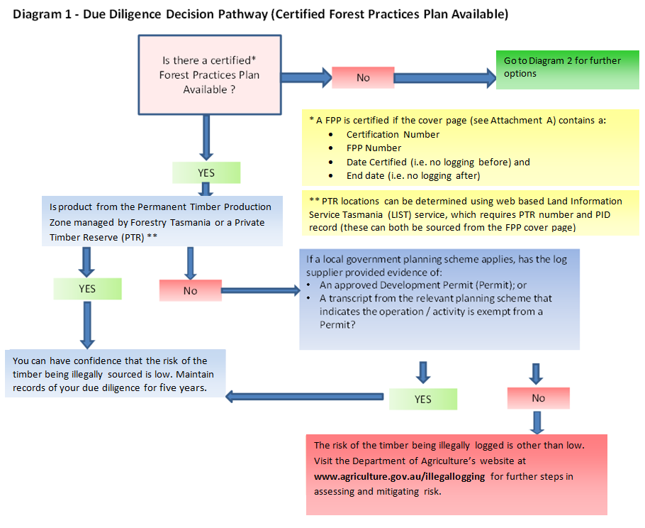
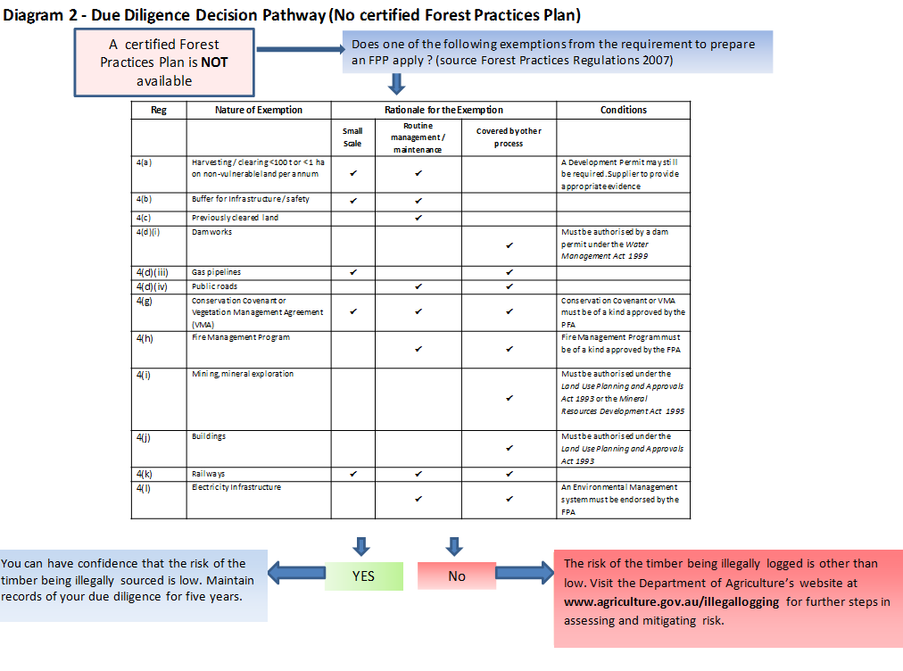

Who should I contact for further information?
Australian Government  Department of Agriculture  GPO Box 858  Canberra City ACT 2601  Phone: 02 6272 3933  Email: illegallogging@agriculture.gov.au  Web: www.agriculture.gov.au/illegallogging |  | rms  Tasmania Government  Forest Practices Authority  30 Patrick Street  Hobart Tasmania 7000  Phone: 03 6165 4090  Email: info@fpa.tas.gov.au  Web: www.fpa.tas.gov.au

Disclaimer
While reasonable efforts have been made to ensure that the contents of this Guideline and the associated Quick Reference Guide are factually correct, the Commonwealth does not accept responsibility for the accuracy or completeness of the contents and expressly disclaims liability for any loss or damage, however caused, that may be occasioned directly or indirectly through the use of, or reliance on, the contents of this Guideline or associated Quick Reference Guide.
This Guideline and its associated Quick Reference Guide is made available on the understanding that the Commonwealth is not providing professional advice. Before relying on this Guideline or its associated Quick Reference Guide, readers should obtain appropriate professional advice suitable to their particular circumstances.
Readers should also confirm that this is the most up-to-date available Guideline by referring to the Department of Agriculture website.

Attachment A – Example Forest Practices Plan cover page
Valid entries in fields marked in red are ‘mandatory’ in determining the authenticity and currency of a Forest Practices Plan
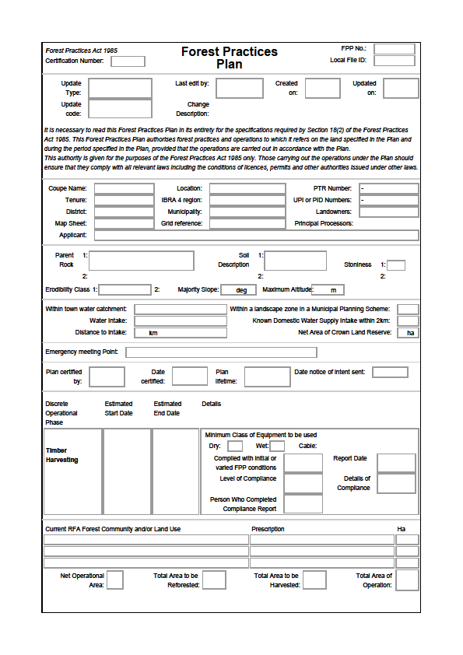
Example Only

Fields marked in yellow may provide data for determining the need to check for a Local Council permit.

Attachment B – Example Delivery Arrangement – Forestry Tasmania sales procedure

Example Only
Notes to the Delivery Arrangement Example above
(1) Where a field is shaded or marked XX… there will need to be information entered pertinent to the specific operation
(2) This information may be useful in assisting in the check of the actual FPP if required
(3) This paragraph alerts the purchaser to other means of meeting due diligence obligations under the provisions of schedule 2 of the Regulation

