State Specific Guideline
for South Australia
This guideline has been prepared by the Australian Government and the South Australian Government. It is intended to assist processors who process raw logs from South Australia into another form, in understanding the regulatory framework in South Australia in order for them to carry out their due diligence obligations under the Illegal Logging Prohibition Amendment Regulation 2013, which supports the Illegal Logging Prohibition Act 2012.
This guideline was co-endorsed by the Australian and South Australian Governments on 23 October 2014.

Contents

What is required under the new law? 4
Background information 5
Identifying legal product from South Australia 7
How is timber harvesting regulated in South Australia? 9
Other relevant laws that relate to legal timber 12
References 12
Who should I contact for further information? 13
Attachment A – Due Diligence Template for Domestic Processors (example) 14
Attachment B – Commercial Forest Plantation Licence (example) 15
Attachment C – Approval documentation from the Native Vegetation Council (example) 16

What is required under the new law?
Australia’s Illegal Logging Prohibition Act 2012 (the Act) restricts the movement of illegally logged timber into Australia at the border, for imported timber and timber products; and at timber processing mills, for domestically grown raw logs.
The Act seeks to address the harmful environmental, social and economic impacts of illegal logging, including forest degradation, habitat loss and threats to sustainable livelihoods.
The Act defines illegally logged as:
‘in relation to timber, means harvested in contravention of laws in force in the place (whether or not in Australia) where the timber was harvested.’
The Illegal Logging Prohibition Amendment Regulation 2013 (the Regulation) prescribes due diligence for the regulated community, that is, Australian importers of regulated timber products (for the purposes of the Act a regulated timber product is a product listed in Schedule 1 to the Regulation) and Australian processors of domestic raw logs. Under the Regulation the regulated community have to undertake a due diligence process to minimise the risk of sourcing illegally logged timber.
Due diligence requirements for processors include the following steps:
Step 1: Information gathering
Step 2: Assessing and identifying risk against a timber legality framework (optional) or a state specific guideline (optional)
Step 3: Risk assessment (if required)
Step 4: Risk mitigation (if required)
Further information about the Act and the Regulation is available at the Australian Government Department of Agriculture’s website (agriculture gov.au/illegallogging).
This guideline is intended to assist a processor of Australian raw logs from South Australia to comply with the due diligence requirements of the Regulation.
Information or evidence listed in this guideline is not an exhaustive list of evidence or documentation required to satisfy due diligence requirements under the Regulation. The Regulation should be referred to for a complete list of the information required to be gathered to satisfy due diligence requirements.
All information needs to be assessed in accordance with the processes outlined in the Regulation to identify the risk that a regulated timber product is, or is made from, or contains illegally logged timber.

Background information
Timber harvested in South Australia (SA) is generally sourced from plantations. Currently most are covered by certification, and as such constitute a low risk for processors of non-compliance under the Regulation. Nevertheless all processors are required to comply with their regulatory due diligence requirements.

Resources
Approximately 189,000 hectares of plantation resources exist in SA, including 129,000 hectares of softwood and 60,000 hectares of hardwood. SA’s largest plantation area is located in the Green Triangle region, in the state’s South East. Other major regions for commercial plantations are Kangaroo Island, Mount Lofty Ranges and the Mid-North.
Figure 1 shows the locations and extent of these plantation areas.
In 2014, the large majority of plantation material harvested in SA is certified under one of two schemes – Forest Stewardship Council (FSC) or Programme for the Endorsement of Forest Certification (PEFC) (discussed below).
SA also has about 4.4 million hectares of naturally occurring native forest protected under the Native Vegetation Act 1991 (NV Act) and the Native Vegetation Regulations 2003 (NV Regulations) (see Figure 1 for location and extent). Of this, about 2.2 million hectares is also protected for biodiversity conservation including those proclaimed under the National Parks and Wildlife Act 1972, the Wilderness Protection Act 1992 and the conservation reserves dedicated under the Crown Land Management Act 2009.
Major processing centres in SA’s share of the Green Triangle region are located in Mount Gambier and the surrounding areas of Millicent, Nangwarry, Tarpeena and Kalangadoo. Other processors exist in the Mount Lofty Ranges, Mid North, Adelaide and on Kangaroo Island.
Given the proximity of the South-Eastern region of SA to South-West Victoria, the State Specific Guideline for South Australia should be read in conjunction with the State Specific Guideline for Victoria for timber and timber products sourced from this region.
The State Specific Guideline for Victoria is available on the Australian Department of Agriculture website at agriculture.gov.au/illegallogging .

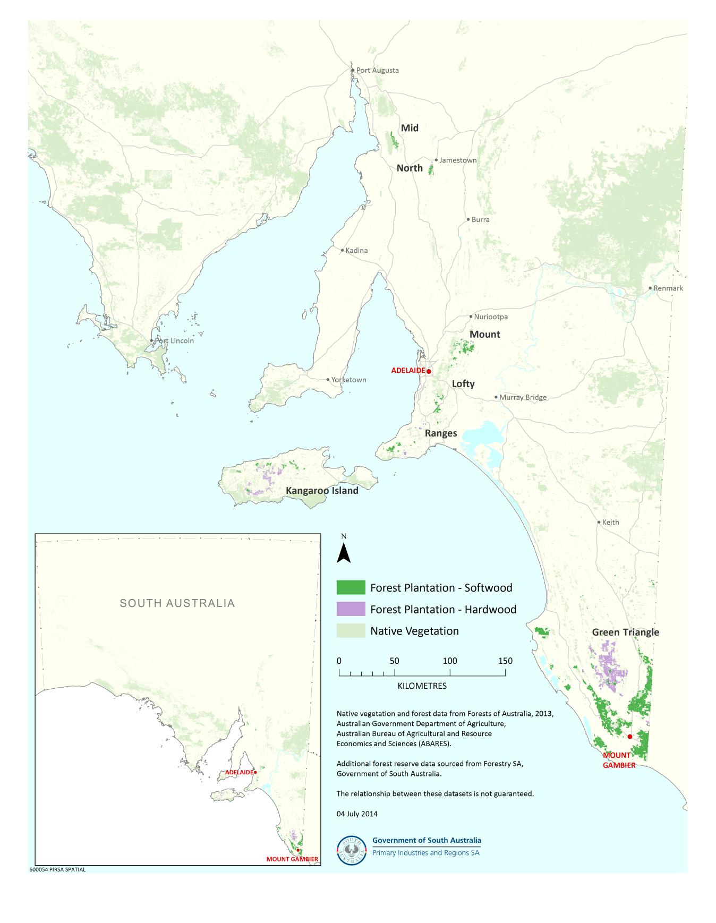

Figure 1: Plantation (softwood and hardwood) and native vegetation areas within SA.

Identifying legal product from South Australia
This section provides information on possible methods to enable a processor to identify if logs harvested in SA have been done so legally.
A flow chart is included in Figure 2, and a template to assist with the collection of due diligence information is provided in the Due Diligence Template for Domestic Processors (example) – see Attachment A.

Plantations

With certification
Currently, two certification schemes listed in the Regulation are relevant in SA. Specifically, the majority of the wood harvested in SA is currently certified under the Forest Stewardship Council (FSC) or Programme for the Endorsement of Forest Certification (PEFC) scheme. Certification documents from any of these frameworks may suggest there is a low risk that the timber is from an illegal source. For more information on these timber legality frameworks see info.fsc.org (for FSC) and pefcregs.info (for PEFC).

Without certification
A smaller proportion of SA logs provided to a processor may be from privately owned small growers or plantations. In this instance the private grower may have a right to harvest through a Commercial Forest Plantation Licence issued under the Forest Property Act 2000, (see an example at Attachment B). However, this is not a mandatory process for private landowners who wish to harvest.
If SA plantation logs are provided to a processor from either:
- a private grower without a commercial forest plantation licence; or
- a non-certified company (or from a non-certified location within a certified company),
then the processor should undertake their own risk assessment, as per the Regulation.

Native Vegetation (non-plantation)
If logs are sourced from native vegetation (non-plantation), then a harvester is required to possess:
- clearance approval from the Native Vegetation Council (NVC) (and in some circumstances the Minister for Sustainability, Environment and Conservation) under the Native Vegetation Act 1991 (NV Act) to harvest the logs, or

- an exemption under one of the regrowth regulations (described in more detail below under ‘How timber harvesting is regulated in South Australia’) to harvest/clear the native vegetation.
In the case of the clearance approval, it may be a requirement of the NVC under Section 30A of the NV Act that the native vegetation removed is marked or tagged. In this case, the processor may check that the marking or tagging is authorised and any tags are issued by the NVC.

Alternatively a harvester may have written documents or a letter from the NVC approving the native vegetation clearance. An Approval documentation from the Native Vegetation Council (example) is at Attachment C.

Are the logs approved under a Right to Harvest?
No
Will have a right to harvest approval documentation

Yes

Will have certification documentation
Are the logs certified?
No
Plantation

If the appropriate documentation cannot be confirmed, a processor should undertake a risk assessment to be assured that the logs are from a legal source.
Yes

Exotic Species Logs*
Are the logs compliant with exemptions under the Native Vegetation Regulations 2003?
Depending on the specifications in the Native Vegetation Regulations 2003, documentation from the Native Vegetation Council may or may not be required

No
Native regrowth within a plantation

Yes

Are the logs approved by Local Council?
No
Native Species Logs*
**Regulated or Significant tree

Will have approval documentation from the local Council
Yes

Are the logs approved or exempted under the Native Vegetation Act 1991?
No
Native Forest
Will have appropriate documentation from the Native Vegetation Council and/or NVC tagged logs

Yes

Figure 2: Process of identifying if SA logs have been legally harvested

* A log may fit into more than one category.

** For requirements of the Regulated or Significant trees refer to the Development Act 1993.

How is timber harvesting regulated in South Australia?
This section includes existing SA legislation relating to timber harvesting in SA. Laws relating to the growing and establishment of a plantation are outlined in the ‘Guidelines for Plantation Forestry in South Australia 2009’ which is available on the Department of Primary Industries and Regions website at pir.sa.gov.au/forestry .

Plantations
The Forest Property Act 2000 (SA) facilitates commercial forestry development on private land through the provision of:

- Two types of Forest Property Agreements:
  - A Forest Property (Vegetation) Agreement, which separates the ownership of trees from the ownership of the land.
  - A Forest Property (Carbon Rights) Agreement, which separates the ownership of carbon rights from ownership of the trees.
- Commercial Forest Plantation Licences, which may secure a tree owner’s ‘right to harvest’ a forest plantation, subject to conditions (S 6).
A Forest Property (Vegetation) Agreement transfers the ownership of forest vegetation from the owner of the land to another person without severance of the vegetation from the land. It may also specify actions relating to the establishment, management and harvesting of trees, and provide the tree owner with the right to enter the land for these purposes.

A Forest Property (Carbon Rights) Agreement transfers the ownership of carbon rights from the owner of the vegetation to another person. It may also specify actions relating to the establishment, management and harvesting of trees, and provide the tree owner with the right to enter the land for these purposes.

A Commercial Forest Plantation Licence is not compulsory. A licence authorises operations, including harvesting, in relation to a commercial forest plantation. A licence may be subject to conditions. The licence does not authorise the establishment of plantations contrary to State and Local Government planning legislation and requirements.

The Forest Property Act 2000 only applies to plantations and not native forest or vegetation. See the example Commercial Forest Plantation Licence at Attachment B.

The Local Government (Forestry Reserves) Act 1944 provides for the establishment and management of forests by municipal and district Councils. It permits Councils to sell or otherwise dispose of any timber or other products derived from forests established by them.

The Forestry Act 1950 provides for the creation and management of State forest reserves. The South Australian Forestry Corporation may sell any trees or timber produced in forests under the control and management of the Corporation. Section 15 of the Forestry Regulations 2013 states that a person must not, without lawful authority, remove a tree or wood from a forest reserve (including plantations).

Native Vegetation
In SA, native vegetation is protected under the Native Vegetation Act 1991 (NV Act) and the associated Native Vegetation Regulations 2003 (NV Regulations). Under this legislation, any clearance of or disturbance to native vegetation on public or private land (including harvesting) is prohibited. However, under section 28 of the NV Act applications may be made to clear native vegetation. Therefore any harvest of individuals of a native species or on a broader scale within forest or woodland, requires approval from the Native Vegetation Council (NVC) through this formal application process.

See the Approval documentation from the Native Vegetation Council (example) at Attachment C.

The NV Regulations include exemptions to the general prohibition on clearing native vegetation. If certain criteria are met there are mechanisms to clear native vegetation without applying for a formal clearance. Currently two specifically apply to forestry:

- Regulation 5(1)(zf): Clearance to maintain land for cultivation, pasture or forestry. Allows for the clearance of regrowth native vegetation less than 5 years old on land used for forestry, in order to maintain that land use. Applies only to plants with a diameter of 150mm or less at the lowest point of the stem above ground level. Although no formal approval is required, it is recommended that the exemption be confirmed with a NVC Assessment Officer prior to undertaking any clearance.
- Regulation 5(1)(zfa): Clearance of regrowth greater than 5 years old for agriculture. Allows for the clearance of regrowth native vegetation greater than 5 years old from land that has been used for forestry, as part of a commercial enterprise since the land was lawfully cleared. The clearance must be undertaken in accordance with a Management Plan approved by the NVC.
Forestry Act 1950 –section 9A establishes that it is the responsibility of the South Australian Forestry Corporation to ensure that no operations are undertaken on a native forest reserve that are inconsistent with the stated purpose of a native forest reserve. Section 15 of the Forestry Regulations 2013 states that a person must not, without lawful authority, remove a tree or wood from a forest reserve (including native forest reserves).

Regulated or Significant Trees
Development Act 1993 – the following trees are protected unless they are of a species specified in the Development Regulations 2008 and must not be damaged unless development approval has been granted by the relevant council:
- Regulated trees (any tree in metropolitan Adelaide, Adelaide Hills Council townships and parts of Mount Barker Council with a trunk circumference of two metres or more measured at a point one metre above natural ground level - in the case of multiple trunks, a regulated tree has a total circumference of 2 metres or more and an average circumference of 625 millimetres or more); and
- Significant trees (a regulated tree with a trunk circumference of three metres or more measured at a point one metre above natural ground level - in the case of multiple trunks, a significant tree has a total circumference of 3 metres or more and an average circumference of 625 millimetres or more).

During harvesting
Aboriginal Heritage Act 1988 and Heritage Places Act 1993 – the objective is to protect heritage values during harvesting operations.

Native Vegetation Act 1991 and Native Vegetation Regulations 2003 – the objective is to protect native vegetation adjacent to a plantation from damage during the felling of plantation trees.

National Parks and Wildlife Act 1972 – the objective is to protect endangered and vulnerable plants and animals in areas adjacent to plantations during harvesting (plant and animal species are listed in Schedules 7, 8 and 9). Note there is a Koala Management Policy for Plantation Harvest Operations, the objective of which is to maintain koala welfare and minimise the risk of injury to koalas from forestry operations, mainly in Eucalyptus globulus (Tasmanian Blue Gum) plantations.

This list excludes SA legislation that is more general in nature and applies to all sectors, not just to log harvesting (e.g. Road Traffic Act 1961).

Voluntary Codes of Conduct/ Codes of Practice
The Commonwealth approved (June 2013) Plantation Forestry Code of Practice in South Australia refers to the Primary Industries and Regions SA (PIRSA) document ‘Guidelines for Plantation Forestry in South Australia’ (PIRSA, 2009).

Other relevant laws that relate to legal timber
Below is an additional SA law relating to legal timber (except the growing/establishment of plantations).

Indigenous
SA’s Native Title Act 1993 provides a mechanism to determine Native Title.

References
Legislation: legislation.sa.gov.au
Koala policy and guidelines: gtplantations.org/environment/environment-publications
FSC certification: info.fsc.org/
PEFC certification: pefcregs.info/
Primary Industries and Regions SA (2009) Guidelines for Plantation Forestry in South Australia 2009.

Who should I contact for further information?

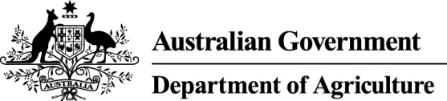  Australian Government  Department of Agriculture  GPO Box 858  Canberra City ACT 2601  Phone: 02 6272 3933  agriculture.gov.au/illegallogging  illegallogging@agriculture.gov.au |  |   South Australian Government  Primary Industries and Regions SA (PIRSA)  GPO Box 1671  Adelaide SA 5001  Phone: 08 8226 0900  pir.sa.gov.au  pirsaforestry@sa.gov.au

Disclaimer
While reasonable efforts have been made to ensure that the contents of this guideline and the associated quick reference guide are factually correct, the Commonwealth of Australia and the State Government of South Australia do not accept responsibility for the accuracy or completeness of the contents and expressly disclaims liability for any loss or damage, however caused, that may be occasioned directly or indirectly through the use of, or reliance on, the contents of this guideline or associated quick reference guide.
This guideline and its associated quick reference guide is made available on the understanding that the State Government of South Australia and the Commonwealth of Australia is not providing professional advice. Before relying on this guideline or its associated quick reference guide, readers should obtain appropriate professional advice suitable to their particular circumstances.
Readers should also confirm that this is the most up-to-date available guideline by referring to the Australian Government’s Department of Agriculture website.
PIRSA and its employees do not warrant or make any representation regarding the use, or results of the use, of the information contained herein as regards to its correctness, accuracy, reliability and currency or otherwise. PIRSA and its employees expressly disclaim all liability or responsibility to any person using the information or advice.

Attachment A – Due Diligence Template for Domestic Processors (example)

Domestic Processor Details
Business name ________________________________________ ABN or ACN___________________
Street address ______________________________________________________________________
Postal address ______________________________________________________________________
Person responsible for maintaining the system
Name _______________________________________ Position_______________________________
Telephone number _______________________________ Email______________________________

Supplier of raw logs
Public/Crown Land
- Business name _____________________________________ ABN/ACN _____________________
Address ______________________________________________Phone_____________________
Species purchased______________________ Quantity purchased (m³/tonnes)__________________
Source (Please circle) Plantation/ Native regrowth/ Native forest/ Regulated or significant tree
Forest name (if applicable)___________________Forest certification number (if applicable)___________
Native Vegetation Council decision notification reference (if applicable)________________________
Local Council regulated or significant tree approval reference (if applicable)_____________________

Private Land
- Business name _____________________________________ ABN/ACN _____________________
Address ______________________________________________Phone_____________________
Species purchased______________________ Quantity purchased (m³/tonnes)__________________
Source (Please circle) Plantation/ Native regrowth/ Native forest/ Regulated or significant tree
Forest name (if applicable)___________________Forest Certification number (if applicable)___________
Native Vegetation Council decision notification reference (if applicable)________________________
Local Council regulated or significant tree approval reference (if applicable)_____________________
Commercial Forest Plantation Licence number (if applicable)_________________________________

Delivery dockets supporting this information are maintained on site (please circle) Yes/ No

This information is in accordance with the State Specific Guidance for South Australia.

Signed ________________________________ Date ________________________________

Attachment B – Commercial Forest Plantation Licence (example)


FOREST PROPERTY ACT 2000
SECTION 16

COMMERCIAL FOREST PLANTATION LICENCE

LICENCE NO. [ ]

I, XXXXXXXXX Minister for Forests, hereby pursuant to section 16 of the Forest Property Act 2000 grant this Licence to the Licensee in respect of the Commercial Forest Plantation for the Term subject to the Conditions listed below.

Licensee

Name:
Address:

ABN:

Commercial Forest Plantation

[details of land on which commercial forest plantation established]

Term

[specify term]

Conditions

- …

[Execution clause] by Minister for Forests
Dated:

Attachment C – Approval documentation from the Native Vegetation Council (example)

