12 April 2016



ABN: 25 107 507 559

ACN: 107 507 559

PO Box 138

Camberwell VIC 3124

Level 2, 273 Camberwell Road

Camberwell VIC 3124

T (03) 9882 0277

F (03) 9882 6722

E info@ausveg.com.au

www.ausveg.com.au

Ms Lyn O’Connell

Deputy Secretary

Department of Agriculture and Water Resources

18 Marcus Clarke Street

ACT 2601

**Re: Proposed conditions for the import of poppy straw and pellets from Turkey, Hungary and Portugal for processing**

Dear Ms O’Connell

AUSVEG welcomes the opportunity to comment on the Biosecurity Advice 2016/18 – *Proposed conditions for the import of poppy straw and pellets from Turkey, Hungary and Portugal for processing*.

We have looked at the documents provided by the Department of Agriculture through its website at the following address:

<http://www.agriculture.gov.au/biosecurity/risk-analysis/memos/ba2016-08>

and the associated PDF found at:

<http://www.agriculture.gov.au/SiteCollectionDocuments/ba/memos/2016/ba2016-08.pdf>

We note that the Department has invited comment on this advice up until 30 April 2016.

Unfortunately, subsequent searching of the Department’s website failed to find any further detail relating to this advice.

Based upon the information on the web pages as noted above, we found it extremely difficult to make an informed comment due to the lack of information provided. For example, it would have been useful to provide stakeholders with background information on the form of the imports and what treatments are applied to the straw.

Presumably the pellets have had some form of treatment, which may or may not involve some form of kill step, although again this is conjecture. Unfortunately, no information is provided on treatment of waste or transport of material to processing plants in Australia.

We found it difficult to provide informed comments given this information was lacking.

Noting that four insects have been identified as potential pests it is assumed that the straw has not undergone any process which would involve sterilisation. Consequently some serious questions need to be answered as to what other pests/pathogens may be present. There is no mention of other potential pests/pathogens that may be transmitted by straw, including potential weeds.

Was this investigation performed? If so, what was found and if not, why not? Are we to believe that there are no other pests, pathogens or weed species found in these countries that are exotic to Australia and that may be of concern to the vegetable industry? There is nothing in the advice to suggest that anything other than insects have been considered.

AUSVEG feels that the information provided by the Department in relation to this Advice is inadequate. We would like to request a more detailed explanation around the issues mentioned above. If more detailed information is provided, we would be interested in providing a more comprehensive response.

Thank you for the opportunity to provide our feedback in relation to this Advice.

Yours sincerely

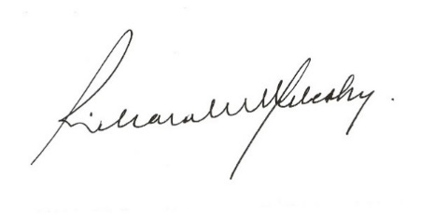

Richard J Mulcahy  
Chief Executive Officer