# Importing timber and timber products What’s inside?

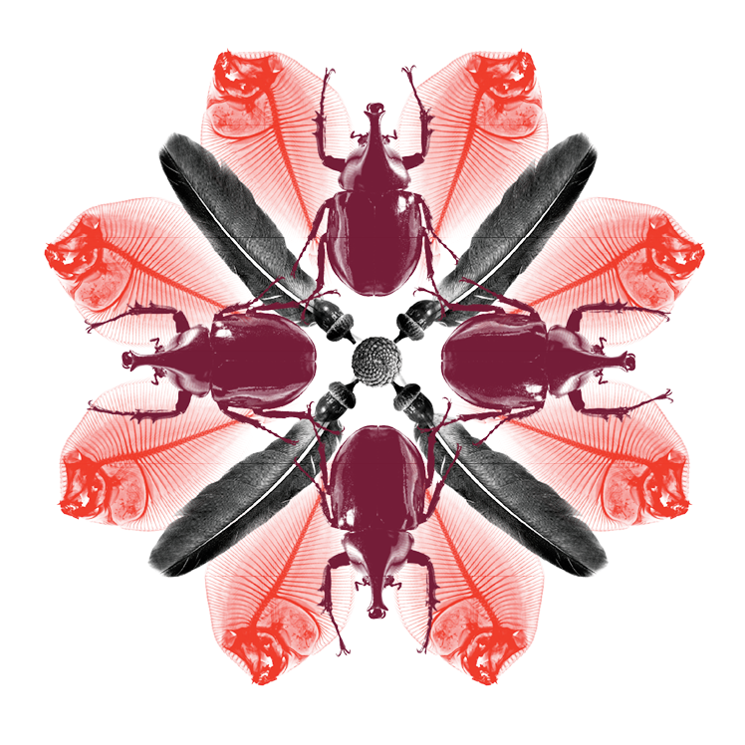

© Commonwealth of Australia 2016

All material in this publication is licensed under a Creative Commons Attribution 3.0 Australia Licence, except for content supplied by third parties, logos and the Commonwealth Coat of Arms.

Creative Commons Attribution. 

The Creative Commons Attribution 3.0 Australia Licence is a standard form licence agreement that allows you to copy, distribute, transmit and adapt this publication provided you attribute the work. A summary of the licence terms is available from [creativecommons.org/licenses/by/3.0/au/deed.en](http://creativecommons.org/licenses/by/3.0/au/deed.en). The full licence terms are available from [creativecommons.org/licenses/by/3.0/au/legalcode](https://creativecommons.org/licenses/by/3.0/au/legalcode). Inquiries about the licence and any use of this document should be sent to [copyright@agriculture.gov.au](mailto:copyright@agriculture.gov.au).

This publication should be attributed as Department of Agriculture and Water Resources 2016, *Importing timber and timber products – What’s inside?*, Department of Agriculture and Water Resources, Canberra.

The Australian Government, acting through the Department of Agriculture and Water Resources, has exercised due care and skill in preparing and compiling the information and data in this publication. Notwithstanding, the department, its employees and its advisers disclaim all liability, including for negligence and for any loss, damage, injury, expense or cost incurred by any person as a result of accessing, using or relying on information or data in this publication, to the maximum extent permitted by law.

## Importing timber and timber products

### **Biosecurity benefits all Australians**

Australia enjoys freedom from many of the world’s most damaging pests and diseases. There are many exotic pests and insects that could hitch a ride to Australia in timber, timber products, packaging and on cargo containers. If these pests establish in Australia they could have a detrimental impact on our agricultural and forestry industries, natural environment, food security and economy.

Protecting Australia’s biosecurity is a shared responsibility between governments, industry and the community. As a buyer and importer you are responsible for making sure that all imported goods meet Australia’s import conditions, including being free of exotic insects and pests.

Everyone in the supply and retail chain has a role in recognising and reporting any signs of pest activity in imported timber and timber products, including furniture.

To avoid delays and additional costs to your business make sure your overseas buyers, suppliers and manufacturers know what the import and biosecurity requirements are before you purchase and import your products.

Timber pest activity is not always obvious and may not be seen until long after an item is imported. Any signs of pest activity in imported timber products must be reported to the Department of Agriculture and Water Resources as soon as possible.

### Be aware of exotic timber pests

Some of the more damaging pests that threaten our biosecurity include Asian longhorn beetle, burnt pine longicorn beetle, Japanese pine sawyer beetle, termites, Asian gypsy moth, auger beetles, powderpost beetles and wood wasps.

Many of these exotic pests arrive in timber and timber products in the egg or larvae stage and their presence may not be obvious. Pests sometimes go unnoticed for many years, until frass (sawdust-like substance) and holes appear or chewing sounds are heard.

Timber and plant pests often create a biosecurity risk by attaching themselves to cargo containers. Product fillings and packaging such as straw, rice, sand, soil and wheat can also carry pests and diseases. These products may also require an import permit.

During the hotter months there is an increased risk of exotic pests and insects hitching a ride on vessels and cargo.

To avoid additional costs and delays to your business, check timber import conditions before purchasing timber products from overseas at [agriculture.gov.au/timber](http://www.agriculture.gov.au/timber).

Timber products are all items made of timber, bamboo or cane including sawn timber, packaging, pallets, dunnage (e.g. crates, pallets, gluts and skids), toys, statues, ornaments etc. It also includes furniture that is made of timber or furniture that has a timber/wooden attachment.

Termites with alates and frass pellets.

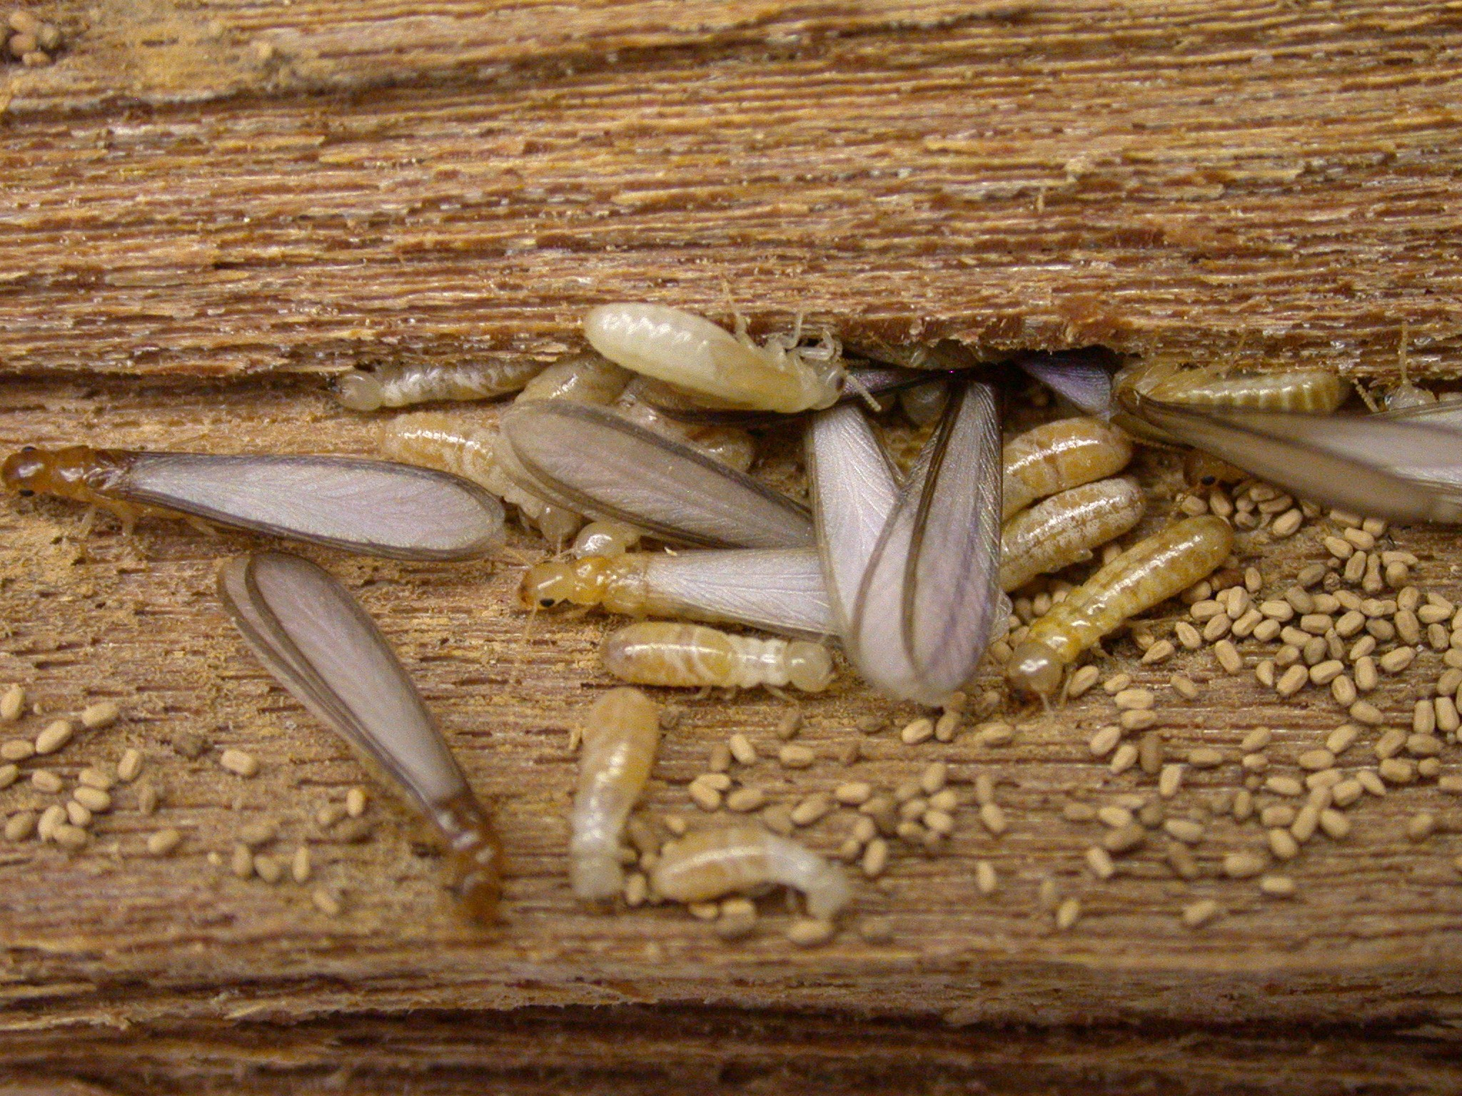

### Keep watch for Australia’s most unwanted

Information on Australia’s most unwanted timber pests is provided in this booklet, including:

* what they look like
* the time of year when they are most active
* their favourite conditions (temperature, light etc.)
* the impact they would have if established in Australia.

Keep this booklet handy when working around imported timber and timber products – whether they are being unloaded or while they are in storage.

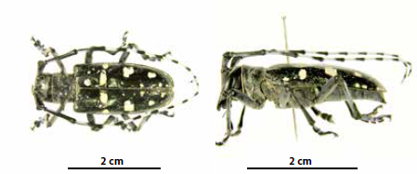

## Asian longhorn beetle

Anoplophora glabripennis

**Adult** beetles are 20-35 mm long, shiny black with about 20 irregular white dots on their wing-covers. Antennae are black with white rings, and are much longer than the body.

**Larvae** are pale white in colour, elongated and cylindrical, with a reduced head and legs, and are 50-70 mm long at maturity.

**Distribution:** China, Korea, Japan, Taiwan, Austria, France, Germany, Italy, UK, Canada and USA.

### When to look for it

All year but most likely to be seen in winter.

### Preferred conditions or environment

**Eggs** are laid under tree bark in oval to round darkened wounds.

**Larvae** tunnel into the heartwood of the trees.

**Adults** emerge in summer from trees or timber from circular holes 9-11 mm in diameter and often leave piles of sawdust at the base of trees or in branch crevices. They typically live up to 66 days and are strong fliers. They are most likely to arrive in Australia in imported timber and wood used for packing materials from Asia. Hosts include standing trees and timber of many species including elm, willow, poplar, apple, plum and maple.

The beetle occurs in agricultural and disturbed areas, natural forests, planted forests, scrub/shrublands, and urban areas.

### Impact

These beetles are very destructive and could potentially devastate Australia’s hardwood forests, apple and pear plantations and parkland trees. A single larva can consume up to 1 000 cubic cm of wood in its lifetime. It has the potential to damage timber, nursery, and tourism industries.

Asian longhorn beetle outbreaks began in China in the 1980s following major reforestation programs. Nowak et al. (2001) investigated the potential maximum impact of Asian longhorn beetle on urban trees in the United States. They predicted that this beetle could cause a loss of about a third of urban trees in the United States—more than a billion trees—with a compensatory value of nearly three quarters of a trillion dollars.

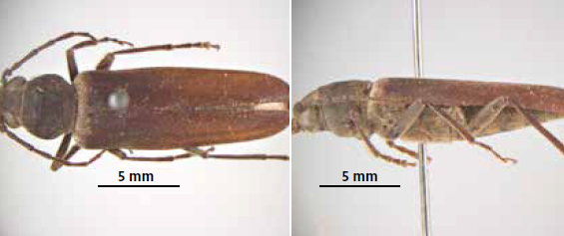

## Burnt pine longicorn beetle

Arhopalus ferus

**Adult** beetles range from 10-30 mm in length and are reddish-brown to black in colour. The female’s antennae are approximately half the length of their body, with male antennae being three quarters the length. Male beetles are smaller than females and are a lighter shade of brown.

**Larvae** are elongated and cylindrical with reduced heads and legs. They are 25 mm long at maturity.

**Distribution:** Europe, Northern Asia, Northern Africa, South and South-East Asia and New Zealand.

### When to look for it

Beetles fly during the summer months (November‒March in New Zealand).

### Preferred conditions or environment

**Eggs** are laid in groups of 5-50 in bark crevices on freshly burned or felled timber. Each female can lay up to 1 000 eggs in its lifetime.

**Larvae** feed in cambium; tunnels are oval in cross-section, up to 12 mm wide, loosely packed with frass and coarse wood particles.

**Adult** emergence holes are oval and average 6 mm in diameter. Adults live for several weeks and can appear in large numbers. They are active dusk to dawn, attracted to light, and shelter in crevices during the day. The beetles make a characteristic squeaking noise when held.

Burnt pine longicorn beetles attack logs, stumps and standing, dead or damaged pine trees, and less commonly, Norway spruce. It is best known for its spectacular attacks of scorched trees following forest fires.

### Impact

If introduced to Australia, the burnt pine longicorn beetle would have devastating effects on our forest and construction industries. Its larvae cause damage to pine tree timber used for construction by tunnelling in the wood, which significantly reduces the quality of the timber.

The Biosecurity Act 2015 requires persons in charge of goods that are subject to biosecurity control to notify the department of reportable biosecurity incidents such as live pests. Read more about reportable biosecurity incidents on our website at [agriculture.gov.au/reportable-incident](http://www.agriculture.gov.au/reportable-incident).

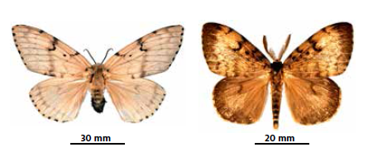

## Asian gypsy moths

Lymantria species, including L. dispar and its subspecies, L. mathura and L. umbrosa

**Eggs** are laid in a flat mass of up to 600 eggs, covered with a dense coat of tan hairs. Egg masses are about the same size as an Australian 20 cent coin.

**Adult** female moths have tan wings with dark markings with a wingspan of up to 90 mm; L. mathura has pink markings. Males are dark tan with black markings and have a wingspan of up to 60 mm.

**Larvae** are dark mottled brown and have two rows of blue and red spots along their body. They are covered in stinging hairs and may cause skin irritation if handled.

**Distribution:** Temperate Asia, including China, Taiwan, Korea, Far Eastern Russia and Japan.

### When to look for it

Eggs are the most likely form in which this pest is detected. Female moths, attracted to lights at night, will contaminate goods with their eggs during most months of the year, which can then be carried internationally as freight on ships, shipping containers and road vehicles, but may also be found on timber items.

### Preferred conditions or environment

**Eggs** hatch, from up to a nine month dormancy, after being exposed to three months or more of cold temperatures, allowing larvae (caterpillars) to hatch at the beginning of spring.

**Larvae** disperse on strands of silk via light breezes, allowing them to be carried up to 1 km. Landing on a suitable host, the caterpillars can feed for 8-12 weeks, causing considerable defoliation. Once fully grown, the caterpillars will spin a cocoon in a sheltered place.

**Adult** moths hatch during the spring and early summer. They do not feed and are short lived. Females release a pheromone to attract males. Both sexes are attracted to lights at night and will settle on virtually any illuminated item. Females will contaminate items they have landed on with their eggs.

### Impact

Gypsy moths have the potential to devastate all forests in Australia. Known hosts include gum trees (Eucalypts) and pine trees. A colony of fully grown larvae can defoliate an entire tree overnight. Outbreaks in Asia have been reported to cause the defoliation of entire forests. Damage caused can result in reduced tree growth, dieback and even death of large trees.

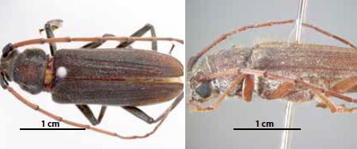

## Drywood longicorn beetle (teak trunk borer)

Stromatium barbatum

**Adult** beetles reach between 12-28 mm long. They are reddish-brown to almost black in colour, and covered with fine hairs. Their antennae are close to the body length of females, and about 1.5 times the body length of males.

**Larvae** are a creamy white colour and up to 38 mm long and 9.5 mm wide. They are elongated and cylindrical with a reduced head and legs.

**Eggs** are laid singly or in batches, in cracks and crevices of wood and timber products such as plywood. The eggs are white, oval and about 2 mm long.

**Distribution:** Thailand, Myanmar, Bangladesh, Nepal, India, Pakistan, Ceylon, Andaman, Nicobar, Tanzania, Bourbon, Seychelles, Mauritius and Madagascar.

### When to look for it

Adults emerge in late spring to early summer.

### Preferred conditions or environment

**Larvae** form irregular tunnels tightly packed with very fine powdery frass (sawdust-like substance). In heavy infestations tunnels can interlace so the interior of the wood is reduced to powder but exterior surfaces are left intact. It can take up to 10 years to emerge. The larvae scraping on the wood makes a characteristic “kit kit” sound which can be easily heard.

They are most often detected in packing material, dunnage, furniture and sporting goods such as cricket bats and stumps.

### Impact

This beetle poses a significant economic threat to Australia. It has a host range of over 350 species of seasoned hardwood and softwood timber and plywood including eucalyptus, pine, elm and oak. Unlike Australian longicorns, drywood longicorn can attack seasoned timber.

Report suspect insects or pest activity to the Department of Agriculture and Water Resources by completing the online form at [agriculture.gov.au/report](http://www.agriculture.gov.au/report) or calling the See.Secure.Report. Hotline 1800 798 636, as soon as possible.

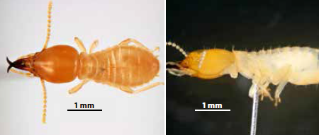

## Formosan subterranean termite

Coptotermes formosanus

These termites live in colonies, with soldiers being 12-15 mm long. The soldiers have hardened, scissor-like extensions on the front of their heads that they use to defend the colony from invaders. They are pale yellow and exude drops of milky fluid from the head when disturbed. Yellowish-brown winged forms are produced in early spring to midsummer.

**Distribution:** China, Taiwan, Japan, Sri Lanka, South Africa, Central America and USA including Hawaii.

### When to look for it

Winged reproductive termites swarm in summer.

### Preferred conditions or environment

Nests are built from a substance resembling paper; made in soil, wood, hollows or spaces between walls and floors, and can be in places not in contact with the ground. They are most likely to enter Australia in nests in shipping containers or in timber.

There are more than 50 species of timber that are hosts to the termite, including oak, citrus, and cypress. They are known to chew through foam insulation boards, thin lead and copper sheeting, plaster, asphalt and some plastics.

### Impact

Formosan subterranean termites are one of the world’s most destructive termites. They cause severe damage to buildings and other timber in-service.

The Pest and Disease Image Library (PaDIL) [padil.gov.au](http://www.padil.gov.au) is a good source of technical information on pests and diseases, and has detailed photos of the pests shown in this booklet.

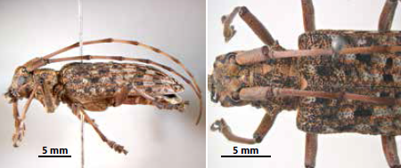

## Japanese pine sawyer beetle

Monochamus alternatus

**Adults** range between 15-28 mm in length and 4.5-9.5 mm in width (females are larger than males). Their antennae are longer than their body [1.3x (male); 2x (female)]. Their body colour is a distinctive brown with grey and orange markings. The thorax has a pair of distinct lateral spines. The adults can carry plant pathogens.

**Larvae** are white, opaque, legless grubs, averaging 43 mm in length, and are wood boring.

**Eggs** are about 4 mm long, milky white in colour and sickle-shaped.

**Distribution:** China, Japan, Korea, Laos, Taiwan and Vietnam.

### When to look for it

Adult beetles usually emerge in early summer.

### Preferred conditions or environment

**Eggs** are laid singly in weak or newly felled trees.

**Larvae** hatch and burrow into the timber causing significant damage. Pupation occurs within the timber.

**Adult** beetles emerge from the timber in summer.

The major hosts of this beetle are *Pinus* species. Other host species are fir, cedar, birch, larch, ginkgo, spruce, liquidamber, juniper and apple.

### Impact

This species can cause significant damage to forests. It can also carry the exotic Pine wilt nematode—a devastating microscopic worm-like pest known to kill pine trees.

Biosecurity is a shared responsibility between governments, industries and the community.

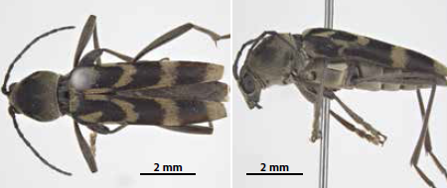

## Kokeshi longicorn beetle

Chlorophorus diadema

**Adult** beetles are 6-12 mm long and 2-4 mm wide. The body is dark brown/black, with yellow/grey hairs on most of the body. It has a distinctive pattern of curved lines across each wing cover. Antennae are about half the length of the body.

**Larvae** are milky white or pale yellow, elongated and cylindrical, with a reduced head and legs. They grow up to 20 mm long.

**Eggs** are oval and white and approximately 1.5 mm long.

**Distribution:** China, Japan, Korea, Mongolia, Russia and Taiwan.

### When to look for it

Adults emerge from mid-June to early August.

### Preferred conditions or environment

**Eggs** are laid in the bark of branches.

**Larvae** typically live for one to two years boring inside host timber.

**Adults** survive for about one month, and may be attracted to lights. Hosts include black locust, birch, sour cherry, grapevine, poplar and willow.

The likely mode of entry is inside timber products imported from China, including furniture, ornaments, household effects and doors.

### Impact

Larvae tunnel inside timber and can weaken live plants and timber in-service. If introduced to Australia, the Kokeshi longicorn beetle would have a serious impact on our viticulture industries and affect amenity trees.

The Biosecurity Act 2015 requires persons in charge of goods that are subject to biosecurity control to notify the department of reportable biosecurity incidents such as live pests. Read more about reportable biosecurity incidents on our website at [agriculture.gov.au/reportable-incident](http://www.agriculture.gov.au/reportable-incident).

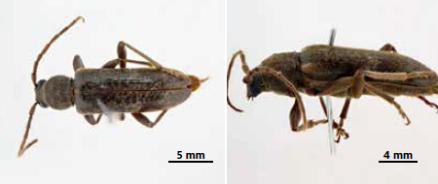

## Velvet longhorned beetle

Trichoferus campestris

**Adult** beetles range in size from 11-20 mm long. They are dark brown to brownish orange with fine hairs and have long antennae. The antennae are about 70-90 per cent of their body length dependent on whether the insect is male or female, and covered with long fine hairs.

**Larvae** are usually a yellowish-white colour and grow between 15-30 mm long. Larger larvae can weigh around 170 mg. The head can be up to 3 mm wide and is slightly flattened.

**Eggs** are laid on the bark of trunks or large branches of healthy, dying or cut trees. The larvae then enter the bark before moving into the wood.

**Distribution:** China, Japan, Korea, Mongolia and the Russian Far East. It has been introduced to North America (USA and Canada) and Europe.

### When to look for it

Adults emerge in large numbers from the end of June to August, are active at night and are attracted to bright lights.

### Preferred conditions or environment

**Larvae** enter the bark of a tree and feed on the wood near the cambium (layer of tissue between the bark and the wood), destroying most of the bark as they bore further into the tree. The galleries can be 5-15 cm large and the larvae can overwinter under the bark or as pupae. It can take over two years for the life cycle to complete, and this is dependent on the presence of bark that is necessary for the larvae to complete development.

With this insect having a wide host range of plants, it is often detected in timber dunnage, furniture and a variety of timber products. Larvae are highly resistant to dry timber.

### Impact

This beetle poses a significant economic and environmental threat to Australia with its ability to devastate orchards, forests and dry woods. It can attack healthy or stressed trees.

The Pest and Disease Image Library (PaDIL) [padil.gov.au](http://www.padil.gov.au) is a good source of technical information on pests and diseases, and has detailed photos of the pests shown in this booklet.

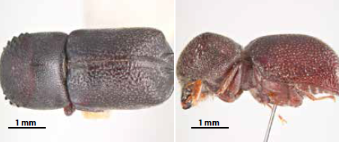

## Conifer auger beetle

Sinoxylon conigerum

**Adult** beetles are small and range in size from 3.5-6 mm long, and 2-2.5 mm wide. They are dark reddish brown to black in colour and the head is not visible from above.

**Larvae** are C-shaped grubs that are white with brown heads and can grow to 7 mm long.

**Eggs** are translucent white and approximately 1 mm long.

**Distribution:** An Oriental species which is now almost cosmopolitan throughout the tropics, occurring in South and South-East Asia, Africa, the Americas and parts of Europe.

### When to look for it

As with closely related species, the conifer auger beetle can emerge from timber throughout the year with no regular correlation to seasons.

### Preferred conditions of environment

**Eggs** are not usually visible as they are deposited in cracks and crevices in timber or the adult female may actively bore into timber to lay the eggs.

**Larvae** feed along the grain of timber and produce fine frass that is usually visible only when the adult beetle emerges.

**Adults** are nocturnal and attracted to lights. They may live for up to 75 days. Depending on conditions, it may take from between a few months to several years to complete a generation.

The likely mode of entry is in imported timber furniture, artefacts, and timber dunnage.

### Impact

Conifer auger beetles attack the sapwood of hardwoods, green or seasoned timber and freshly cut trees. They can attack almost any woody plant in suitable condition, and can cause significant damage to timber items that are ineffectively treated for timber pests.

Timber pest activity is not always obvious and may not be seen until long after an item is imported. Any signs of pest activity in imported timber products must be reported to the Department of Agriculture and Water Resources as soon as possible.

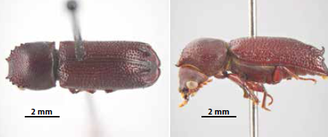

## Lesser auger beetle

Heterobostrychus aequalis

**Adults** are 6-13 mm long with spines on the back of their wing covers. Their body is cylindrical, dark brown to black in colour. Their head is not visible when viewed from above.

**Larvae** are C-shaped, white with brown heads, and reach up to 15 mm long. Eggs are translucent white and approximately 1 mm in length. Length of development from egg to adult is variable from 1-6 years.

**Distribution:** Asia, and parts of Africa, Europe, the Americas, and Oceania.

### When to look for it

Throughout the year, but the warmer months are when most beetles emerge.

### Preferred conditions or environment

**Eggs** are deposited within cracks/pores in timber or the female may bore actively into timber to lay the eggs. Likely mode of entry into Australia is through imported timber, dunnage, furniture, artefacts and souvenirs.

### Impact

Lesser auger beetles attack the sapwood component of many species of green or seasoned hardwood timber. This can result in significant damage to timber in-service, such as furniture, dunnage, artefacts etc. It is a threat to nearly all wood products and has even been known to bore through the lead linings of boxes. In hardwoods, the damage is usually confined to the sapwood, but may extend deeper in soft woods.

Biosecurity is a shared responsibility between governments, industries and the community.

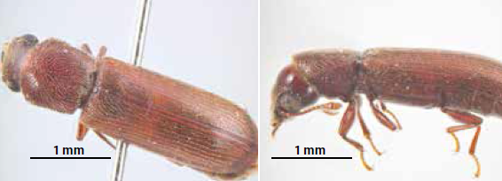

Reference photo is of African Powderpost Beetle (Lyctus africanus)

## Powderpost beetle

**Adults** are 6-13 mm long, are cylindrical and dark brown to black in colour. Their head is visible from above.

**Larvae** are 15 mm long, C-shaped white with brown heads. There are 26 known species of Powderpost beetles. The life cycle depends on the moisture and can be from one to three years but will often reinfest the same item for many years.

**Distribution:** Africa, Asia, Europe and North America.

### When to look for it

Throughout the year, but the warmer months are when most beetles emerge.

### Preferred conditions or environment

The beetle’s hosts include hardwood, freshly felled trees and green or seasoned timber. To develop it prefers wood with a moisture content of 8-32 per cent. Its greatest activity will occur with 10-20 per cent moisture. It would most likely come to Australia in wood that has been stored in timber yards or through manufactured goods, such as furniture.

### Impact

Powderpost beetles can cause damage to exposed wood in houses, furniture and panelling. This insect attacks the sapwood of wide-pored hardwoods that are usually less than 10 years old. They attack both raw timber and manufactured products, which can result in significant damage to in-service timber, such as furniture, dunnage, artefacts etc. Powderpost beetles are regarded as one of the most destructive pests of timber and timber products, including plywood. It can also infest dried roots and tubers.

The Biosecurity Act 2015 requires persons in charge of goods that are subject to biosecurity control to notify the department of reportable biosecurity incidents such as live pests. Read more about reportable biosecurity incidents on our website at [agriculture.gov.au/reportable-incident](http://www.agriculture.gov.au/reportable-incident).

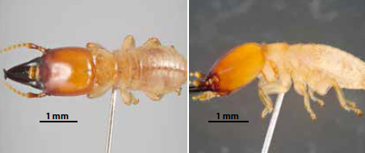

## Western drywood termite

Incisitermes minor

**Adults** live in colonies and different specialised castes (forms) are present. Pale nymphs/immatures are most numerous and do the work. Soldiers have black, hardened, scissor-like extensions on the front of their reddish-brown heads that they use to defend the colony from invaders. They range from 8 to over 12 mm long.

Winged reproductive forms (called ‘alates’) are produced in early spring to midsummer. They are 11-12.5 mm long with an orange-brown head, brown body and smoky-tinted wings. These termites reproduce very slowly and it may take as long as five to seven years before a colony causes enough damage for the infestation to be noticed.

**Distribution:** USA including Hawaii, Mexico, Canada, China and Japan.

### When to look for it

Swarm in large numbers at dusk from early spring to midsummer.

### Preferred conditions or environment

Nests are built from a substance resembling paper. Nests are not made in the soil but are located inside the wood, which is the food source. Frass (sawdust-like substance) is sometimes visible outside the nests and are usually hard, hexagonal pellets less than 1 mm in diameter. They like dry wood (with moisture content <12 per cent), and timber that is in-service.

Alates swarm in large numbers at dusk, fly and disperse in order to start new colonies. They are most likely to come to Australia as nests built in timber (e.g. furniture, artefacts), dunnage (e.g. pallets, creates) or in yachts/boats.

### Impact

The western drywood termite is a serious timber pest that can severely damage in-service timber, such as dunnage, artefacts, boats, furniture, houses etc.

Report suspect insects or pest activity to the Department of Agriculture and Water Resources by completing the online form at [agriculture.gov.au/report](http://www.agriculture.gov.au/report) or calling the See. Secure. Report. Hotline on 1800 798 636, as soon as possible.

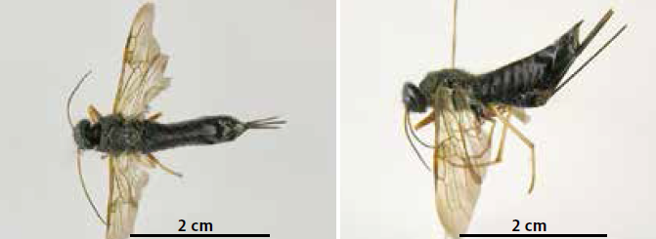

Reference photo is of Sirex wasp

## Wood wasps (Horntails)

**Adults** grow up to 35 mm long with two pairs of transparent amber coloured wings which are usually metallic. They often have a metallic body, although some have distinctive yellow/brown markings as well. Females have a long ovipositor (leading to the name “horntail”) up to 20 mm in length to facilitate egg-laying into wood. Adults can be confused with other large native Australian wasps and the introduced species *Sirex noctilio*.

**Pupae** are creamy-white and gradually assume the colour of the adults.

**Larvae** are 30 mm long, S-shaped, creamy white, legless, with a dark brown spine at the posterior end. They feed on fungus growing within timber.

**Eggs** are 1.55 mm long, white, soft, smooth and elongate and are laid deep inside the wood.

**Distribution:** Asia, Russia, Europe, Chile, USA and Canada.

### When to look for it

Most adults emerge in summer.

### Preferred conditions or environment

**Larvae** feed on wood decayed by a fungus growing within the timber. They make longitudinal tunnels 15-75 cm long (usually tightly packaged with frass) from sapwood to heartwood and back. Wood decay (white rot) may be visible.

**Adults** emerge in summer from circular exit holes up to 8 mm in diameter (this size may vary). They have pale yellowish halos, often visible around holes, and fly for considerable distances. Females usually lay eggs in weakened trees, often on freshly burned or cut logs. Adults occasionally emerge from timber used in houses or furniture. They are most likely to enter Australia in pine logs, packing material and unseasoned dunnage (e.g. gluts, crates and pallets).

### Impact

There are a number of exotic species of wood wasps in five main genera (*Sirex*, *Urocerus*, *Tremex* *Eriotremex* and *Xeris*). *Sirex noctilio* is the only significant wood wasp pest species currently found in Australia. Wood wasps can attack and kill healthy trees and/or degrade wood leading to structural damage.

## Australia’s import requirements



All importers need to be aware of, and comply with Australia’s import conditions. Import conditions are determined by scientific evidence, rigorous analysis and intelligence, and are vital for keeping unwanted pests and diseases out of Australia.

There are two steps to the biosecurity process for importing timber and timber products.

1. Check the Biosecurity Import Conditions system (BICON) [agriculture.gov.au/bicon](http://www.agriculture.gov.au/bicon). BICON will list the import conditions your product needs to meet, based on the category of your product.
2. Complete and submit the import permit application if BICON states that an import permit is required.

### Entry requirements

It is more cost effective to have your timber and timber products, containers and packaging treated before they enter Australia.

Treatments for timber and timber products can include fumigation, gamma irradiation and heat. Treatments carried out overseas must be done by an approved treatment provider to clear biosecurity controls on arrival in Australia. A list of approved treatment providers can be found on the department’s website at [agriculture.gov.au/treatmentproviders](http://www.agriculture.gov.au/treatmentproviders).

Timber and bamboo packaging used to support and protect your goods can also carry exotic pests and diseases. There are a number of options to ensure packaging meets import requirements:

* choose good quality timber packaging and check that there are no signs of insects or insect damage and no bark
* keep the timber packaging dry
* select only ISPM 15 compliant timber (it will be stamped), or
* have the timber treated using either fumigation, kiln drying, heat treatment, gamma irradiation, or by permanent preservatives. Valid documentation, showing that this treatment has occurred, must be presented to the department.

### Declaring

When lodging the details about your imported timber or timber products in the Integrated Cargo System (ICS), make sure that the details you enter are accurate. Incorrect details could see your goods held up unnecessarily for inspection, and you could incur additional costs. Incorrect details could also introduce an exotic pests or disease into Australia.

### Failing to meet entry requirements

If goods do not meet Australia’s entry requirements they will be stopped at the border and may be treated, exported or destroyed at the importer’s expense – this can happen even if similar goods were imported previously. If your goods have not been pre-treated before they are exported to Australia, they may be subject to onshore treatment using fumigation, gamma or heat methods. This occurs at the importer’s expense.

Partnering with industry to build a better biosecurity system.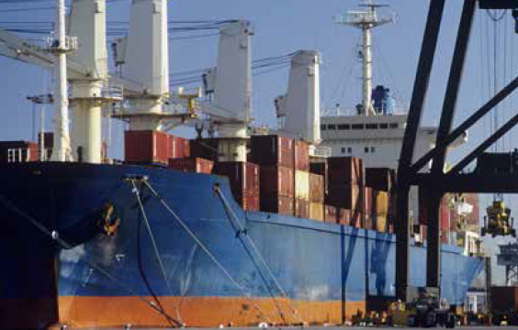

### Report biosecurity concerns

It is important that you do regular checks for insect or pest activity while your goods are in storage, even if your goods are cleared through Australia’s biosecurity controls. Things to look for include:

* insect or larvae activity
* the sudden appearance of holes
* a lot of fine dust or sawdust (frass) which keeps returning
* strange noises coming from the furniture.

If you suspect anything unusual in timber or timber products, contact the department by calling the See.Secure.Report. Hotline **1800 798 636** or completing the online form available at [agriculture.gov.au/report](http://www.agriculture.gov.au/report), as soon as possible.

Frass is usually the first sign of timber pests.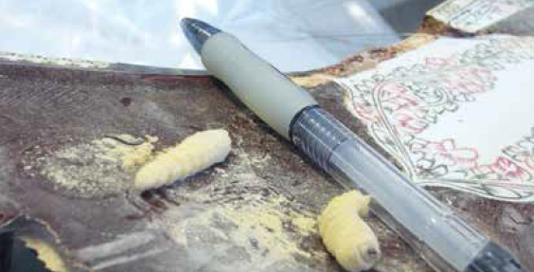

### Post-sale responsibility

If exotic insects are found in goods after sale, the department will attempt to trace these back to the importer for appropriate treatment. Future imports may also be subject to increased levels of inspection to ensure that they do not pose a biosecurity risk.

### Illegal logging

If you are a business importing timber or timber products into Australia or processing domestically grown raw logs you need to be aware of your responsibilities. Further information is available at [agriculture.gov.au/illegal-logging](http://www.agriculture.gov.au/illegal-logging).

Timber pests could cause severe and widespread damage if they establish in Australia.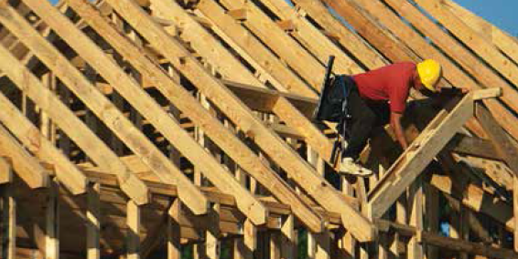

## For further information on Australia’s import conditions contact the Department of Agriculture and Water Resources

### General importing inquiries

**Phone:** 1800 900 090  
**Email:** [imports@agriculture.gov.au](mailto:imports@agriculture.gov.au)  
**Web:** [agriculture.gov.au/timber](http://www.agriculture.gov.au/timber)

### Stay updated

Subscribe to the department’s Import Industry Advice Notices:   
**Web:** [agriculture.gov.au/iian](http://www.agriculture.gov.au/iian)

### Report a biosecurity concern (including suspect insects and pest activity)

**Phone:** See.Secure.Report Hotline 1800 798 636  
**Email:** [biosecurity.reports@agriculture.gov.au](mailto:biosecurity.reports@agriculture.gov.au)  
**Web:** [agriculture.gov.au/report](http://www.agriculture.gov.au/report)

### Report illegal importing activity

Redline 1800 803 006 (free call in Australia)

Borer larvae damage.

