**Imported food inspection data**

July to December 2016

Imported Food Inspection Scheme



© Commonwealth of Australia 2017

**Ownership of intellectual property rights**

Unless otherwise noted, copyright (and any other intellectual property rights, if any) in this publication is owned by the Commonwealth of Australia (referred to as the Commonwealth).

**Creative Commons licence**

All material in this publication is licensed under a Creative Commons Attribution 3.0 Australia Licence, save for content supplied by third parties, logos and the Commonwealth Coat of Arms.



Creative Commons Attribution 3.0 Australia Licence is a standard form licence agreement that allows you to copy, distribute, transmit and adapt this publication provided you attribute the work. A summary of the licence terms is available from [creativecommons.org/licenses/by/3.0/au/deed.en](http://creativecommons.org/licenses/by/3.0/au/deed.en). The full licence terms are available from [creativecommons.org/licenses/by/3.0/au/legalcode](http://creativecommons.org/licenses/by/3.0/au/legalcode).

Inquiries about the licence and any use of this document should be sent to [copyright@agriculture.gov.au](mailto:copyright@agriculture.gov.au).

**Cataloguing data**

This publication (and any material sourced from it) should be attributed as: Imported Food Inspection Scheme 2016, *Imported food inspection data report for July to December 2016*, Department of Agriculture and Water Resources, Canberra, December. CC BY 3.0.

This publication is available at [agriculture.gov.au/food/inspection-data](http://www.agriculture.gov.au/import/goods/food/inspection-compliance/inspection-data).

Department of Agriculture and Water Resources

Postal address GPO Box 858 Canberra ACT 2601

Telephone 1800 900 090

Web [agriculture.gov.au](http://agriculture.gov.au/)

The Australian Government acting through the Department of Agriculture and Water Resources has exercised due care and skill in preparing and compiling the information and data in this publication. Notwithstanding, the Department of Agriculture and Water Resources, its employees and advisers disclaim all liability, including liability for negligence and for any loss, damage, injury, expense or cost incurred by any person as a result of accessing, using or relying upon any of the information or data in this publication to the maximum extent permitted by law.

**Table of Contents**

Introduction 1

Background 2

Imported Food Inspection Scheme 3

Review of risk classified foods 3

Australian food trade 4

Summary of results 7

Results of inspection and testing 8

Compliance rates against all tests conducted 8

Labelling compliance 9

Analytical testing data 10

Other test data 15

Results by commodity groups 16

Results by country of origin 17

Food Import Compliance Agreement notifications 18

Comparing five years of inspection data reports 18

Appendixes 20

Appendix 1: Analytical tests applied to food 21

Appendix 2: Tariff codes included in each food commodity group 23

Appendix 3: Number of lines inspected per country 24

Glossary 27

**Tables**

Table 1 Compliance for all tests 8

Table 2 Compliance for analytical testing 10

Table 3 Compliance for chemical tests 10

Table 4 Compliance for contaminant tests 11

Table 5 Compliance for microbiological tests 11

Table 6 Compliance for composition analytical tests 12

Table 7 Compliance for chemical tests, China 12

Table 8 Compliance for contaminant tests, China 12

Table 9 Compliance for microbiological testing, China 13

Table 10 Compliance for composition analytical testing, China 13

Table 11 Compliance for chemical tests, Thailand 13

Table 12 Compliance for contaminant tests, Thailand 14

Table 13 Compliance for microbiological tests, Thailand 14

Table 14 Compliance for chemical tests, Italy 14

Table 15 Compliance for contaminant tests, Italy 14

Table 16 Compliance for microbiological tests, Italy 15

Table 17 Compliance for composition analytical tests, Italy 15

Table 18 Compliance for BSE certificate checks 16

Table 19 Compliance for visual assessments 16

Table 20 Inspection and test data, by commodity group 17

Table 21 Number of inspections, by country of origin 17

**Figures**

Figure 1 Trends in Australian food trade 4

Figure 2 Composition of Australian food imports 5

Figure 3 Value shares of Australian food imports 6

Figure 4 Non-compliant test results 8

Figure 5 Non-compliant labelling 9

Figure 6 Percentage of tests applied to each commodity group 16

Figure 7 Percentage of inspections, by country of origin 18

Figure 8 Inspection activity, January 2011 to December 2016 19

Figure 9 Tests conducted, January 2011 to December 2016 19

## Introduction

The Department of Agriculture and Water Resources is responsible for managing Australia’s biosecurity system. Every year the department helps millions of people, goods, vessels and aircraft move into and out of Australia while minimising harm to environmental, animal, plant and human health.

The department is also responsible for monitoring the safety of imported food at the border. Food entering Australia is subject to the *Imported Food Control Act 1992*, which provides for the inspection and control of imported food using a risk-based border inspection program, the [Imported Food Inspection Scheme (IFIS)](http://www.agriculture.gov.au/import/goods/food/inspection-compliance/inspection-scheme). Food Standards Australia New Zealand (FSANZ) advises the department on food that poses a medium or high risk to human health and safety, with the department classifying this food as risk for inspection under the IFIS.

In addition to the inspection activity undertaken at the border, state and territory authorities in Australia have responsibility for monitoring all food, including imported food, that is available for sale.

This report provides summary data from imported food inspections conducted under the IFIS during 1 July to 31 December 2016. The department has published these reports every six months since July 2006; previous reports are available from the department’s website. The department also publishes a [monthly report](http://www.agriculture.gov.au/import/goods/food/inspection-compliance/failing-food-reports) on foods that have failed an inspection or analysis.

## Background

The department is one of many government agencies responsible for regulating food in Australia. The department administers two sets of requirements with which imported food must comply. Food imported into Australia must meet biosecurity requirements under the *Biosecurity Act 2015* (Cwlth). Imported food is also subject to the *Imported Food Control Act 1992* (Cwlth) and must meet requirements for food safety and compliance with Australia’s food standards.

The *Imported Food Control Act 1992* requires all imported food to meet the requirements in the [Australia New Zealand Food Standards Code](http://www.foodstandards.gov.au/code/Pages/default.aspx) and not pose a risk to human health. It is the responsibility of the importer to ensure imported food complies with the Act and Australian food safety requirements.

To monitor importers’ compliance with sourcing food that meets Australia’s food standards, the department operates a risk-based border inspection scheme—the Imported Food Inspection Scheme (IFIS).

Food Standards Australia New Zealand (FSANZ), an independent statutory authority, develops and maintains the Australia New Zealand Food Standards Code (the Code). The Code lists Australia’s food standards requirements including for contaminants (such as microbiological and chemical), additives, labelling and genetically modified food, as well as production and processing standards.

FSANZ provides advice to the department on foods that have the potential to pose a medium or high risk to public health. The Minister for Agriculture and Water Resources may then classify these foods as risk food under the IFIS. All other food is classified as surveillance food.

Risk food is initially referred for inspection and analysis at a rate of 100 per cent of consignments. Surveillance food is referred for inspection and analysis at a rate of five per cent of consignments.

Once food is referred, the department’s systems apply relevant tests and inspection based on the risk the food may pose and for some food, the compliance history of the food producer.

When imported food fails inspection, follow-up action such as treatment of the food to bring it into compliance, destruction or export is undertaken. Additionally, subsequent imports of the same food are subject to inspection at the rate of 100 per cent of consignments until a history of compliance is demonstrated.

In addition to the department's imported food testing, the state and territory governments and local governments have responsibility for ensuring that all food, including imported food, meets the requirements of food legislation (include the Code) at the point of sale.

### Imported Food Inspection Scheme

The department operates a risk-based border inspection scheme—the [Imported Food Inspection Scheme (IFIS)](http://www.agriculture.gov.au/import/goods/food/inspection-compliance/inspection-scheme). Under this scheme, the department monitors importers’ compliance with sourcing food that meets Australia’s food standards and does not pose a risk to human health.

FSANZ provides advice to the department on foods that have the potential to pose a medium or high risk to public health. Regulation 9 of the Imported Food Control Regulations 1993 provides that food may be classified as risk food if FSANZ has advised the Minister for Agriculture and Water Resources that the food has the potential to pose a medium or high risk to public health. In accordance with regulation 9 and the advice from FSANZ, the Minister may classify foods as ‘risk food’ in the Imported Food Control Order 2001. All other food is classified as surveillance food.

Risk food is referred to the department by the Department of Immigration and Border Protection. Risk food is initially inspected and tested at a rate of 100 per cent of consignments against a published list of potential hazards, including microorganisms and contaminants. Once five consecutive consignments have passed inspection, the inspection rate may be reduced to 25 per cent; after a further 20 consecutive passes, the inspection rate may be reduced to 5 per cent.

Risk foods are subject to 'test and hold' direction and not released for sale until test results are known. Consignments of risk food that fail inspection cannot be imported. These foods must be brought into compliance otherwise the food will be re-exported or destroyed.

Any consignments that fail will result in a return to 100 per cent testing of that product until a history of compliance is re-established for the producer of the food.

To identify risk food and the rate at which they should be referred (that is, whether at 100 per cent or five per cent of consignments), the department applies electronic profiles in the Department of Immigration and Border Protection Integrated Cargo System (ICS).

Once risk food is referred, the department’s systems apply relevant inspection and analysis rates based on the risk the food may pose and for some food, the compliance history of the food producer.

### Review of risk classified foods

FSANZ has completed its review of foods classified as risk food (previously reviewed in 2007). FSANZ has published risk statements for each food/hazard combination on their web site. The FSANZ website provides more information on [imported food risk statements](http://www.foodstandards.gov.au/consumer/importedfoods/Pages/FSANZ-advice-on-imported-food.aspx.).

During the July to December 2016 period, the department implemented revised border inspection and compliance requirements in response to the FSANZ imported food risk statements for cheese. These changes included changes to the inspection and analysis of ready-to-eat finfish, peanut and satay sauce, as well cooked and processed meat. Following legislative changes, the department also implemented changes to the inspection and analysis of fish for histamine and uncooked ready-to-eat meat.

### Australian food trade

The department monitors trends in the food that Australian food businesses import into Australia. This information is used by the department to inform inspection and analysis activities and to continue to improve the efficiency of these inspection and analysis activities.

The value of Australian food exports increased by 2.1 per cent to $39.3 billion in 2015-16, the highest ever recorded (Figure 1). The value of food imported by Australian food businesses was $16.3 billion in 2015-16, an 11 per cent increase on the previous year. As a result, Australia's net exports of food, the difference between the value of food exports and food imports, decreased by 4.6 per cent to $23 billion in 2015-16.

In value terms, the proportion of imports as a proportion of exports increased to 41.5 per cent in 2015-2016. This is the highest proportion ever recorded and represents twice the proportion recorded in 1992-1993 (25 years ago).

Figure 1 Trends in Australian food trade

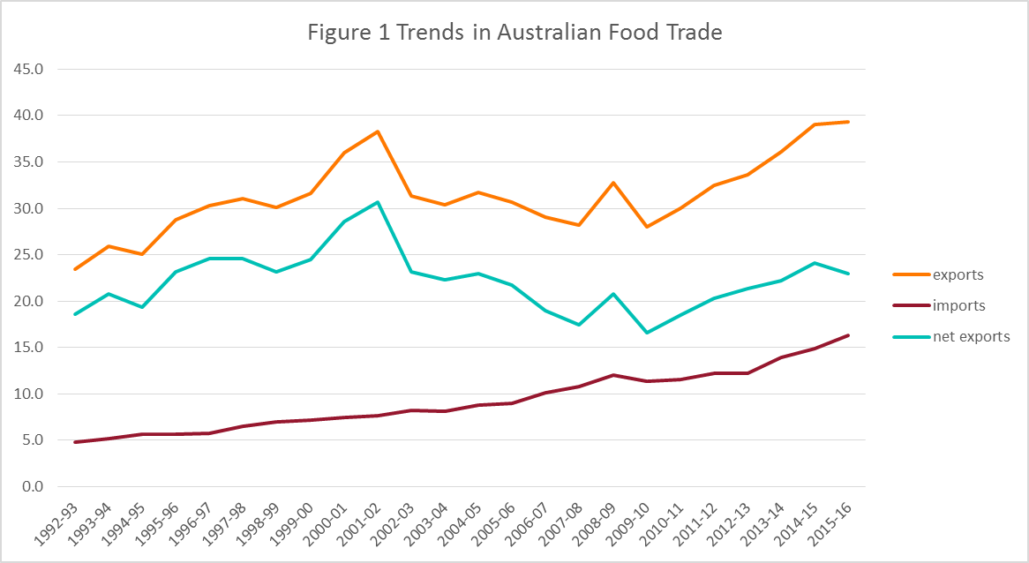

#### Australian food imports

The value of food imported by Australian food businesses increased to $16.3 billion in 2015-16. The main contributors to the increase were cereal foods, fruits and vegetables, fats and oils and dairy products (Figure 2). Partially offsetting this increase were lower imports of meat, sugar and soft drinks.

Over the past 20 years the value of foods imported by Australian food businesses has increased. The kinds of foods imported by Australian food businesses are generally processed products with major contributors being seafood and fruits and vegetables.

Figure 2 Composition of Australian food imports

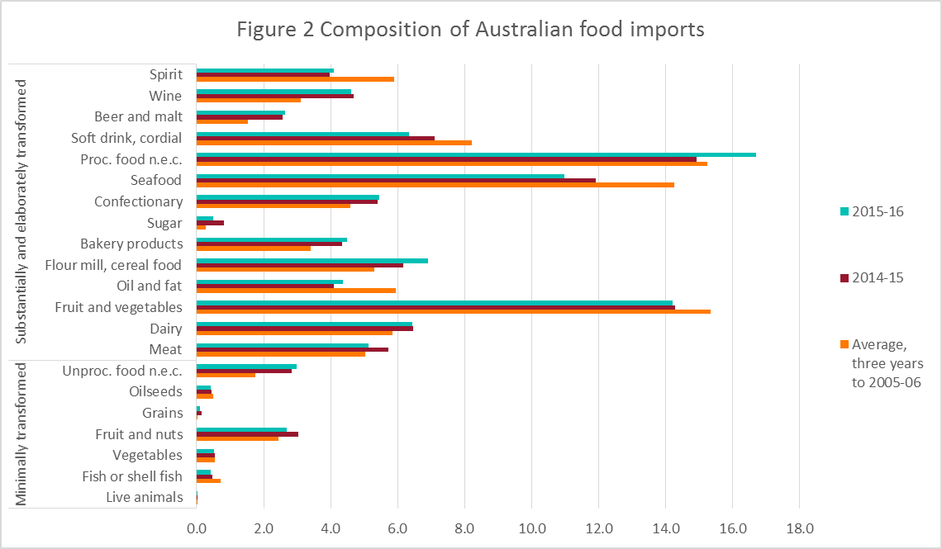

#### Source of Australian food imports

New Zealand remains the major source of food imported by Australian food businesses, accounting for $2.8 billion or 17.3 per cent of the total value of food imported in 2015-16 (Figure 3). Other major sources of food imports in 2015-2016 were the United States of America (10.2 per cent), China (7.4 per cent) and Thailand (6.1 per cent).

The composition of Australian food imports have been stable over the last ten years with only minor fluctuations in the proportions of foods imported from particular countries by Australian food businesses (Figure 3).

Figure 3 Value shares of Australian food imports

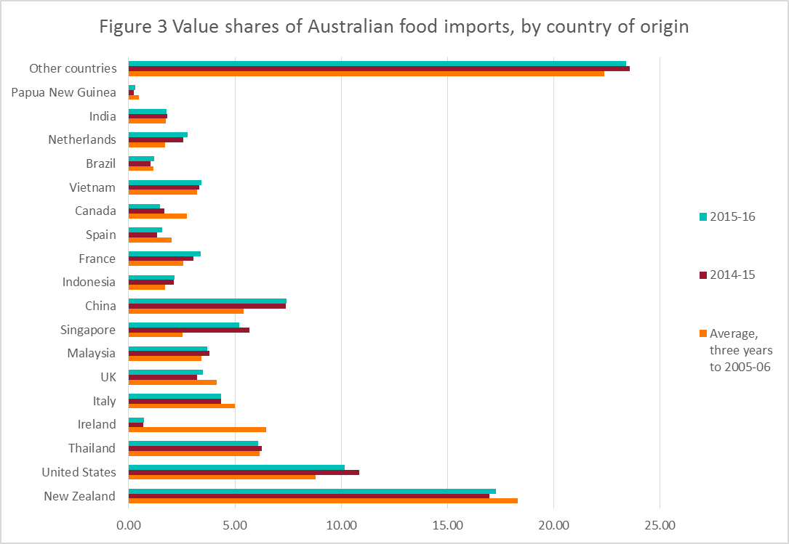

## Summary of results

The data contained in this report was obtained from imported food inspection data for the period 1 July to 31 December 2016.

During this reporting period, the compliance rate for all foods inspected was 99 per cent.

In summary:

* 10,024 entries of imported food were referred for inspection or analysis
* 16,799 lines of imported food were inspected. Of these lines:
  + 29.8 per cent were risk food
  + 67.8 per cent were surveillance food
  + 2.5 per cent were surveillance food subject to a Holding Order
* 63.2 per cent of food inspections were on food from 10 countries, with food from China, Thailand and Italy subject to the most inspections
* In total, 51,119 tests (including label and visual checks), comprising
  + 20,428 label and composition assessments
  + 10,316 analytical tests
  + 20,375 other tests.

More detailed analysis of data is provided based on:

* commodity groups
* country of origin
* inspection data tests applied and compliance rates.

See Glossary for explanation of terms used in this document.

## Results of inspection and testing

Following are the results of inspections and tests undertaken from July to December 2016. This section includes:

* summary of all tests undertaken
* breakdown of results for the three countries subject to the highest number of inspection during the reporting period – China, Thailand and Italy, reflecting the countries from which importers most frequently source food
* summary of inspection results for the main commodity group imported
* summary of inspection results from country of origin.

### Compliance rates against all tests conducted

* 99 per cent of all tests applied to imported food under the IFIS complied with Australian standards for these tests.
* Non-compliant labelling accounted for most non-compliance (73.3 per cent of failures).
* When labelling non-compliances are removed from testing data, the compliance rate for imported food rises to 99.6 per cent.

Table 1 Compliance for all tests

| Test group | No. of tests applied | No. compliant | No. non-compliant | Compliance rate (%) |
| --- | --- | --- | --- | --- |
| Analytical | 10,316 | 10,188 | 128 | 98.8 |
| Labelling | 20,428 | 20,050 | 378 | 98.1 |
| Other | 20,375 | 20,365 | 10 | 99.9 |
| **Total** | 51,119 | 50,603 | 516 | 99.0 |

Figure 1 provides a summary of the 516 non-compliant tests from the 51,119 tests applied, with details of each specific test and the proportion each test contributed to the total.

Figure 4 Non-compliant test results

### Labelling compliance

Figure 2 provides a detailed summary of labelling non-compliances against Australian food standards. Absent, incomplete or incorrect nutrition information details on labelling is the largest contributor to non-compliant labelling, accounting for 33.7 per cent of non-compliances. Absent or incomplete importer details, lot code and country of origin labelling account for a further 40.6 per cent of label non-compliances.

Figure 5 Non-compliant labelling

### Analytical testing data

Within the analytical test category, tests are grouped according to four main types: chemical, contaminant, composition (analytical assessment) and microbiological (Table 2). Each category consists of several tests which are reported in detail in Tables 3, 4, 5 and 6.

Analytical test results show a 98.8 per cent compliance rate with the tests applied under the IFIS.

Of the 10,316 analytical tests applied, 128 (1.2 per cent) of the products being tested failed against the standards.

The number of lines of food referred for inspection under the Scheme and the number of analyses of food may differ. This is because food subject to inspection is sampled and analysed based on the number of:

* batches and lots within each batch of food on the line referred for inspection
* analyses for each sample of that food taken during inspection.

For example, one line of a cooked and processed meat product may be referred for inspection under the Scheme. The line contains two batches of the product, each with one lot. An officer will take one sample from each batch and apply the analyses relevant to this food. The analyses for cooked and processed meat products are *Listeria monocytogenes* and *Salmonella*. As a result, two samples have been taken from this one line of imported food with two microbiological analyses for each sample.

This will be reported as one line, with four analyses.

Table 2 Compliance for analytical testing

| Type of test | No. of tests applied | No. compliant | No. non-compliant | Compliance rate (%) |
| --- | --- | --- | --- | --- |
| Chemicals | 1,651 | 1,623 | 28 | 98.3 |
| Contaminants | 3,828 | 3,781 | 47 | 98.8 |
| Microbiological | 4,809 | 4,756 | 53 | 98.9 |
| Composition | 28 | 28 | 0 | 100.0 |
| **Total** | 10,316 | 10,188 | 128 | 98.8 |

Table 3 Compliance for chemical tests

| Chemical | No. of tests applied | No. compliant | No. non-compliant | Compliance rate (%) | Types of food |
| --- | --- | --- | --- | --- | --- |
| Ethylene Chlorohydrin | 2 | 1 | 1 | 50.0 | Spices |
| Fluoroquinolones | 195 | 194 | 1 | 99.5 | Farmed fish and prawns |
| Fruit and veg residue screen | 867 | 842 | 25 | 97.1 | Fruit and vegetables |
| Malachite Green | 171 | 171 | 0 | 100.0 | Farmed fish |
| Nitrofurans | 26 | 26 | 0 | 100.0 | Farmed prawns, honey |
| Pesticides | 390 | 389 | 1 | 99.7 | Meat |
| **Total** | 1,651 | 1,623 | 28 | 98.3 | – |

Table 4 Compliance for contaminant tests

| Contaminant | No. of tests applied | No. compliant | No. non-compliant | Compliance rate (%) | Types of food |
| --- | --- | --- | --- | --- | --- |
| Aflatoxins | 590 | 574 | 16 | 97.3 | Nuts |
| Arsenic total | 396 | 396 | 0 | 100.0 | Cereal grains, cereal flours and processed cereals |
| Domoic acid | 265 | 265 | 0 | 100.0 | Bivalve molluscs |
| Erucic acid | 183 | 183 | 0 | 100.0 | Edible plant oils |
| Histamine | 1,312 | 1,296 | 16 | 98.8 | Fish |
| Hydrocyanic acid | 29 | 24 | 5 | 82.8 | Cassava chips |
| Inorganic arsenic | 3 | 3 | 0 | 100.0 | Seaweed |
| Iodine | 55 | 52 | 3 | 94.5 | Seaweed (brown algae) |
| Lead | 608 | 601 | 7 | 98.8 | Cereal grains, ready-to-eat cereal flours and processed cereals, canned and preserved fruit |
| PSP Toxin | 263 | 263 | 0 | 100.0 | Bivalve molluscs |
| Tin | 124 | 124 | 0 | 100.0 | Canned fruit |
| **Total** | 3,828 | 3,781 | 47 | 98.8 | – |

Table 5 Compliance for microbiological tests

| Microbial agent | No. of tests applied | No. compliant | No. non-compliant | Compliance rate (%) | Types of food |
| --- | --- | --- | --- | --- | --- |
| *Bacillus cereus* | 23 | 22 | 1 | 95.7 | Bean curd, tofu |
| Coagulase positive Staphylococcus | 398 | 398 | 0 | 100.0 | Processed meats and cooked prawns |
| *Escherichia coli* | 395 | 382 | 13 | 96.7 | Processed meats, water, seafood, and cheese |
| *Listeria* *monocytogenes* | 1,779 | 1,756 | 23 | 98.7 | Cheese, ready-to-eat seafood, processed meats |
| *Q-listeria monocytogenes-*enumerated | 116 | 116 | 0 | 100.0 | Spices |
| *Salmonella* | 1,599 | 1,588 | 11 | 99.3 | Processed meats, seafood, dried coconut, dried chilli and pepper, sesame seeds, cheese |
| Standard plate count | 330 | 325 | 5 | 98.5 | Cooked prawns |
| *Vibrio cholerae* | 169 | 169 | 0 | 100.0 | Cooked prawns |
| **Total** | 4,809 | 4,756 | 53 | 98.9 | – |

Table 6 Compliance for composition analytical tests

| Microbial agent | No. of tests applied | No. compliant | No. non-compliant | Compliance rate (%) | Types of food |
| --- | --- | --- | --- | --- | --- |
| Allergen - Dairy | 1 | 1 | 0 | 100.0 | Coconut drinks and coconut powders |
| C4 adulteration | 9 | 9 | 0 | 100.0 | Honey |
| Moisture content | 9 | 9 | 0 | 100.0 | Honey |
| Reducing sugar content | 9 | 9 | 0 | 100.0 | Honey |
| **Total** | 28 | 28 | 0 | 100.0 | - |

#### Analytical testing data, China

In the period July to December 2016, food from China was subject to the highest number of inspections in comparison with other countries inspected under the IFIS, representing 10.1 per cent of all food lines inspected.

Of the 1 136 analytical tests applied to imported food from China, 30 were found to be non-compliant, giving a 97.4 per cent compliance rate for tests applied.

Microbiological tests were the most frequently applied followed by tests for contaminants, chemical content and non-permitted compositional content.

Table 7 Compliance for chemical tests, China

| Chemical | No. of tests applied | No. compliant | No non-compliant | Compliance rate (%) |
| --- | --- | --- | --- | --- |
| Fluoroquinolones | 10 | 10 | 0 | 100.0 |
| Fruit and veg residue screen | 148 | 138 | 10 | 93.2 |
| Malachite Green | 5 | 5 | 0 | 100.0 |
| Nitrofurans | 5 | 5 | 0 | 100.0 |
| Pesticides | 3 | 2 | 1 | 66.7 |
| **Total** | 171 | 160 | 11 | 93.6 |

Table 8 Compliance for contaminant tests, China

| Contaminant | No. of tests applied | No. compliant | No. non-compliant | Compliance rate (%) |
| --- | --- | --- | --- | --- |
| Aflatoxins | 118 | 110 | 8 | 93.2 |
| Arsenic total | 13 | 13 | 0 | 100.0 |
| Domoic acid | 87 | 87 | 0 | 100.0 |
| Histamine | 47 | 47 | 0 | 100.0 |
| Iodine | 7 | 5 | 2 | 71.4 |
| Lead | 69 | 64 | 5 | 92.8 |
| PSP toxin | 87 | 87 | 0 | 100.0 |
| Tin | 22 | 22 | 0 | 100.0 |
| Total | 450 | 435 | 15 | 96.7 |

Table 9 Compliance for microbiological testing, China

| Microbial agent | No. of tests applied | No. compliant | No. non-compliant | Compliance rate (%) |
| --- | --- | --- | --- | --- |
| *Bacillus cereus* | 2 | 1 | 1 | 50.0 |
| Coagulase positive Staphylococcus | 50 | 50 | 0 | 100.0 |
| *Escherichia coli* | 52 | 52 | 0 | 100.0 |
| *Listeria* *monocytogenes* | 43 | 43 | 0 | 100.0 |
| *Q-listeria monocytogenes-*enumerated | 1 | 1 | 0 | 100.0 |
| *Salmonella* | 270 | 270 | 0 | 100.0 |
| Standard plate count | 51 | 48 | 3 | 94.1 |
| *Vibrio cholerae* | 31 | 31 | 0 | 100.0 |
| **Total** | 500 | 496 | 4 | 99.2 |

Table 10 Compliance for composition analytical testing, China

| Microbial agent | No. of tests applied | No. compliant | No. non-compliant | Compliance rate (%) |
| --- | --- | --- | --- | --- |
| C4 adulteration | 5 | 5 | 0 | 100.0 |
| Moisture content | 5 | 5 | 0 | 100.0 |
| Reducing sugar content | 5 | 5 | 0 | 100.0 |
| **Total** | 15 | 15 | 0 | 100.0 |

#### Analytical testing data, Thailand

In the period July to December 2016, food from Thailand was subject to the second highest number of inspections in comparison with other countries inspected under the IFIS; representing 8.4 per cent of all food lines inspected.

Of the 1,058 analytical tests applied to imported food from Thailand, seven were found to be non-compliant, giving a 99.3 per cent compliance rate for tests applied.

Contaminant tests were the most frequently applied followed by tests for microbiological and chemical content.

Table 11 Compliance for chemical tests, Thailand

| Chemical | No. of tests applied | No. compliant | No. non-compliant | Compliance rate (%) |
| --- | --- | --- | --- | --- |
| Fluoroquinolones | 8 | 8 | 0 | 100.0 |
| Fruit and veg residue screen | 83 | 79 | 4 | 95.2 |
| Malachite Green | 8 | 8 | 0 | 100.0 |
| Nitrofurans | 1 | 1 | 0 | 100.0 |
| **Total** | 100 | 96 | 4 | 96.0 |

Table 12 Compliance for contaminant tests, Thailand

| Contaminant | No. of tests applied | No. compliant | No. non-compliant | Compliance rate (%) |
| --- | --- | --- | --- | --- |
| Aflatoxins | 12 | 12 | 0 | 100.0 |
| Arsenic total | 69 | 69 | 0 | 100.0 |
| Domoic acid | 11 | 11 | 0 | 100.0 |
| Histamine | 419 | 418 | 1 | 99.8 |
| Hydrocyanic acid | 1 | 1 | 0 | 100.0 |
| Lead | 110 | 109 | 1 | 99.1 |
| PSP toxin | 10 | 10 | 0 | 100.0 |
| Tin | 31 | 31 | 0 | 100.0 |
| **Total** | 663 | 661 | 2 | 99.7 |

Table 13 Compliance for microbiological tests, Thailand

| Microbial agent | No. of tests applied | No. compliant | No. non-compliant | Compliance rate (%) |
| --- | --- | --- | --- | --- |
| Coagulase positive staphylococcus | 55 | 55 | 0 | 100.0 |
| *Escherichia coli* | 3 | 3 | 0 | 100.0 |
| *Listeria monocytogenes* | 17 | 17 | 0 | 100.0 |
| *Salmonella* | 111 | 111 | 0 | 100.0 |
| Standard plate count | 53 | 52 | 1 | 98.1 |
| *Vibrio cholerae* | 56 | 56 | 0 | 100.0 |
| **Total** | 295 | 294 | 1 | 99.7 |

#### Analytical testing data, Italy

In the period July to December 2016, food from Italy was subject to the third highest number of inspections in comparison with other countries inspected under the IFIS; representing 8.1 per cent of all food lines inspected.

Of the 626 analytical tests applied to imported food from Italy, 13 were found to be non-compliant, giving a 97.9 per cent compliance rate for tests applied.

Microbiological tests were the most frequently applied followed by tests for contaminants, non-permitted compositional and chemical content.

Table 14 Compliance for chemical tests, Italy

|  |  |  |  |  |
| --- | --- | --- | --- | --- |
| Chemical | No. of tests applied | No. compliant / | No. non-compliant | Compliance rate (%) |
| Fruit and veg residue screen | 3 | 3 | 0 | 100.0 |
| **Total** | 3 | 3 | 0 | 100.0 |

Table 15 Compliance for contaminant tests, Italy

| Contaminant | No. of tests applied | No. compliant | No. non-compliant | Compliance rate (%) |
| --- | --- | --- | --- | --- |
| Aflatoxins | 34 | 34 | 0 | 100.0 |
| Arsenic total | 21 | 21 | 0 | 100.0 |
| Domoic acid | 1 | 1 | 0 | 100.0 |
| Erucic acid | 24 | 24 | 0 | 100.0 |
| Histamine | 20 | 20 | 0 | 100.0 |
| Lead | 29 | 29 | 0 | 100.0 |
| PSP toxin | 1 | 1 | 0 | 100.0 |
| Tin | 4 | 4 | 0 | 100.0 |
| **Total** | 134 | 134 | 0 | 100.0 |

Table 16 Compliance for microbiological tests, Italy

| Microbial agent | No. of tests applied | No. compliant | No. non-compliant | Compliance rate (%) |
| --- | --- | --- | --- | --- |
| Coagulase positive staphylococcus | 15 | 15 | 0 | 100.0 |
| *Escherichia coli* | 50 | 50 | 0 | 100.0 |
| *Listeria monocytogenes* | 362 | 349 | 13 | 96.4 |
| *Q-listeria monocytogenes-*enumerated | 11 | 11 | 0 | 100.0 |
| *Salmonella* | 45 | 45 | 0 | 100.0 |
| **Total** | 483 | 470 | 13 | 97.3 |

Table 17 Compliance for composition analytical tests, Italy

| Microbial agent | No. of tests applied | No. compliant | No. non-compliant | Compliance rate (%) |
| --- | --- | --- | --- | --- |
| C4 adulteration | 2 | 2 | 0 | 100.0 |
| Moisture content | 2 | 2 | 0 | 100.0 |
| Reducing sugar content | 2 | 2 | 0 | 100.0 |
| Total | 6 | 6 | 0 | 100.0 |

### Other test data

Other than labelling and analytical testing, other testing applied during the period July to December 2016 included composition assessments, Bovine Spongiform Encephalopathy (BSE) checks and visual assessments.

#### Composition assessments

Additives or ingredients that are not permitted, or are in excess of permitted levels, may be identified during a label assessment. Of the 20,428 label assessments conducted, 32 labels were found to be non-compliant with these requirements.

#### Bovine Spongiform Encephalopathy certificate checks

Food containing beef is inspected to ensure it is covered by the appropriate government certification, consistent with Australia’s BSE policy. A fail is recorded when the food containing beef is not covered by the appropriate government certificate.

Table 18 Compliance for BSE certificate checks

| Type of test | No. of tests applied | No. compliant | No. non-compliant | Compliance rate (%) |
| --- | --- | --- | --- | --- |
| BSE Certificate | 508 | 507 | 1 | 99.8 |

#### Visual assessments

At every inspection the food is visually assessed for signs of unsafe or unsuitable condition such as foreign objects or deterioration.

Table 19 Compliance for visual assessments

| Type of test | No. of tests applied | No. compliant | No. non-compliant | Compliance rate (%) |
| --- | --- | --- | --- | --- |
| Visual | 19,867 | 19,858 | 9 | 99.9 |

### Results by commodity groups

Figure 3 and Table 20 below provide an overview of tests applied to food commodity groups. This data does not indicate the volume of trade in particular commodities, but the commodities most often tested. This will be influenced by the following factors:

* commodity groups that contain more risk food or are imported more frequently will have a higher representation under the inspection activity
* the rate of inspection and analysis of foods identified as failing foods is increased to 100 per cent until compliance has again been demonstrated.

#### Test data by commodity groups

During the reporting period seafood was the single commodity subject to most testing. Testing of seafood accounted for 17.5 per cent of tests applied (Figure 3) under the IFIS. This commodity includes fresh, chilled, frozen and processed seafood products.

Horticulture (including fresh and processed fruit and vegetables) was the next highest single commodity inspected and was subject to 13.5 per cent of all tests applied to imported food under the IFIS.

Figure 6 Percentage of tests applied to each commodity group

Data source: AIMS database

Appendix 1 provides an overview of the analytical tests applied to the commodity groups and Appendix 2 provides a list of the tariff codes associated with each commodity grouping used for this report.

Table 20 Inspection and test data, by commodity group

| Commodity group | No. of tests applied | No. compliant | No. non‑compliant | Compliance rate (%) |
| --- | --- | --- | --- | --- |
| Beverages | 4,508 | 4,461 | 47 | 99.0 |
| Cereals, flours and milled products | 1,937 | 1,917 | 20 | 99.0 |
| Dairy | 4,474 | 4,439 | 35 | 99.2 |
| Eggs | 10 | 10 | 0 | 100.0 |
| Honey | 47 | 46 | 1 | 97.9 |
| Horticulture | 6,878 | 6,794 | 84 | 98.8 |
| Meat | 2,084 | 2,079 | 5 | 99.8 |
| Other (incl. processed food) | 22,229 | 21,974 | 255 | 98.9 |
| Seafood | 8,952 | 8,883 | 69 | 99.2 |
| **Total** | 51,119 | 50,603 | 516 | 99.0 |

Source: AIMS database

### Results by country of origin

Under the IFIS, food is inspected based on whether it is classified as a risk food or not, irrespective of the country from which the food was exported. The exception to this is where a food has previously failed inspection. In these circumstances, future consignments of that food from the producer in the particular country are inspected and analysed at a 100 per cent rate of inspection and analysis, until a history of compliance is re-established for the producer of the food.

The countries from which importers more frequently source food will have a higher representation in the inspection data.

For the period 1 July to 31 December 2016:

* China, Thailand and Italy were the countries whose food was subject to most inspections
* 63.2 per cent of food inspections were on food from 10 countries; the remaining 36.8 per cent were on food from 108 countries.

A significant proportion of food imports are from New Zealand. Most food from New Zealand is not subject to the *Imported Food Control Act 1992*, as Australia and New Zealand, under the Trans-Tasman Mutual Recognition Arrangement have agreed that food produced or imported into one country that meets that country’s food standards, may be legally sold in the other country. Therefore, food produced or imported into New Zealand that meets New Zealand’s food legislation can be legally sold in Australia.

Table 21 Number of inspections, by country of origin

| Country of origin | No. of lines inspected | Percentage of total lines inspected |
| --- | --- | --- |
| China | 1,705 | 10.1% |
| Thailand | 1,410 | 8.4% |
| Italy | 1,360 | 8.1% |
| United States | 1,189 | 7.1% |
| Japan | 1,109 | 6.6% |
| India | 1,015 | 6.0% |
| Korea Republic Of | 849 | 5.1% |
| France | 688 | 4.1% |
| Malaysia | 667 | 4.0% |
| United Kingdom | 625 | 3.7% |
| Other | 6,182 | 36.8% |
| **Total** | 16,799 | 100.0% |

Note: For details of all countries of origin see Appendix 3.

Source: AIMS database

Figure 7 Percentage of inspections, by country of origin

More detailed information about China, Thailand and Italy is provided in the analytical testing data section.

### Food Import Compliance Agreement notifications

Food Import Compliance Agreements offer food importers an alternative regulatory arrangement to the border inspection and testing of their products under the IFIS. Compliance agreements are an assurance-based arrangement undertaken through formal recognition and audit of an importer’s documented food safety management system by the department.

Importers under a compliance agreement must report non-compliant analytical test results to the department. The department can then consider what further action is needed.

During the reporting period, three non-compliant food notifications were reported. These results are not included in the summary of inspection and testing results undertaken under the IFIS.

### Comparing five years of inspection data reports

The department has been publishing twice yearly Imported Food Inspection Data reports on activities dating back to July 2006.

Figure 5 summarises the number of food entries and lines inspected for each six month reporting period. The table shows a regular pattern where the period January to June each year has lower activity than the period July to December.

Figure 8 Inspection activity, January 2011 to December 2016

Figure 6 summarises the number of tests applied at inspections for each six month reporting period. This table reflects a similar pattern to Figure 5. Figure 6 also shows a reduction in the number of tests in 2013, reflecting changes made after a review of surveillance testing.

Figure 9 Tests conducted, January 2011 to December 2016

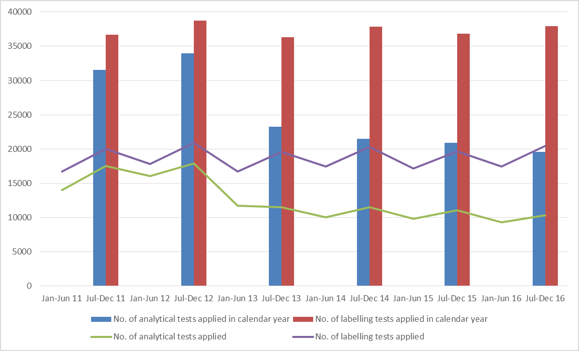

## Appendixes

1. Analytical tests applied to food.
2. Tariff codes included in each food commodity group
3. Number of lines inspected per country

## Appendix 1: Analytical tests applied to food

| Food group | Risk / Surveillance test | Analytical test |
| --- | --- | --- |
| Dairy products | Risk | *Listeria* *monocytogenes* |
| Surveillance | *Salmonella*  *E. coli* |
| Edible plant oils | Surveillance | Erucic acid |
| Fruit | Surveillance | Fruit & veg residue screen  *E. coli* (ready-to-eat frozen berries only)  Hepatitis A (ready-to-eat frozen berries only) |
| Fruit – canned and preserved | Surveillance | Lead  Tin (canned only) |
| Fruit juices | Surveillance | Fruit & veg residue screen |
| Herbs and spices | Risk | *Salmonella* |
| Honey | Surveillance | C4 Adulteration  Moisture content  Reducing sugar content |
| Meat | Risk | BSE government certification  Coagulase positive Staph  *E. coli*  *Listeria* *monocytogenes*  *Salmonella* |
| Surveillance | Pesticide screen |
| Nuts and nut products | Risk | *Salmonella*  Aflatoxin |
| Seafood | Risk | Histamine  *Listeria* *monocytogenes*  Coagulase positive Staph  *E. coli*  *Salmonella*  Standard plate count  Paralytic shellfish poison (PSP)  Domoic acid  *Vibrio cholerae* |
| Surveillance | Histamine  Malachite green  Nitrofurans  Fluoroquinolones |
| Vegetables | Risk | *Salmonella* (Sesame seeds, dried coconut)  Inorganic arsenic (Hijiki seaweed)  Iodine (Seaweed (brown algae))  Hydrocyanic acid (Cassava chips) |
| Surveillance | Fruit & veg residue screen  *Bacillus cereus* (tofu, soy bean / milk curd)  Arsenic total (Cereal grains, ready-to-eat cereal flours and processed cereals) |
| Coconut drinks and coconut powders | Risk | Dairy allergen (betalactoglobulin, casein, and total milk) **a** |

**a** Introduced in September 2015 at the risk rate. Testing was removed in March 2016 due to good compliance.

## Appendix 2: Tariff codes included in each food commodity group

| Commodity group | Tariff code |
| --- | --- |
| Beverages | 2009  2201 – 2208 |
| Cereals | 1001 – 1008  1101 – 1109 |
| Dairy | 0401 – 0406 |
| Eggs | 0407 – 0408 |
| Honey | 0409 |
| Horticulture | 0701 – 0714  0801 – 0814  0904 – 0910  1201 – 1208  1210 – 1212  1801 – 1802 |
| Meat | 0201 – 0212  0504  1601 – 1602 |
| Seafood | 0302 – 0307  1603 – 1605 |
| Other (including processed food) | 0410  0901 – 0903  1301 – 1302  1501 – 1504  1506 – 1517  1520 – 1521  1701 – 1704  1803 – 1806  1901 – 1905  2001 – 2008  2101 – 2106  2209  2501  3501 – 3503  3505  3507 |

## Appendix 3: Number of lines inspected per country

| Country | Lines inspected |
| --- | --- |
| Algeria | 1 |
| Argentina | 46 |
| Australia | 11 |
| Austria | 46 |
| Bangladesh | 20 |
| Belgium | 174 |
| Bolivia | 4 |
| Bosnia and Herzegowina | 17 |
| Brazil | 63 |
| Bulgaria | 17 |
| Canada | 123 |
| Chile | 85 |
| China | 1,705 |
| Colombia | 27 |
| Costa Rica | 4 |
| Cote Divoire | 1 |
| Croatia | 61 |
| Cuba | 1 |
| Cyprus | 18 |
| Czech Republic | 7 |
| Denmark | 185 |
| Dominican Republic | 3 |
| Ecuador | 4 |
| Egypt | 28 |
| El Salvador | 4 |
| Estonia | 2 |
| Ethiopia | 13 |
| Fiji | 39 |
| Finland | 16 |
| France | 688 |
| Georgia | 4 |
| Germany | 394 |
| Ghana | 5 |
| Greece | 125 |
| Guatemala | 3 |
| Honduras | 5 |
| Hong Kong | 94 |
| Hungary | 18 |
| India | 1,015 |
| Indonesia | 387 |
| Iran | 88 |
| Ireland | 86 |
| Israel | 60 |
| Italy | 1,360 |
| Jamaica | 3 |
| Japan | 1,109 |
| Jordan | 15 |
| Kenya | 3 |
| Korea republic Of | 849 |
| Latvia | 3 |
| Lebanon | 95 |
| Liberia | 1 |
| Lithuania | 1 |
| Luxembourg | 1 |
| Macedonia | 39 |
| Madagascar | 2 |
| Malaysia | 667 |
| Maldives | 13 |
| Malta | 6 |
| Mauritius | 7 |
| Mexico | 88 |
| Moldova | 2 |
| Montenegro | 1 |
| Morocco | 9 |
| Myanmar | 32 |
| Namibia | 2 |
| Nepal | 21 |
| Netherlands | 374 |
| New Caledonia | 1 |
| New Zealand | 163 |
| Nicaragua | 8 |
| Nigeria | 2 |
| Norway | 92 |
| Pakistan | 61 |
| Panama | 2 |
| Papua New Guinea | 15 |
| Paraguay | 2 |
| Peru | 30 |
| Philippines | 257 |
| Poland | 66 |
| Portugal | 51 |
| Puerto Rico | 5 |
| Romania | 11 |
| Russian Federation | 19 |
| Rwanda | 1 |
| Saudi Arabia | 9 |
| Serbia | 39 |
| Seychelles | 2 |
| Sierra Leone | 1 |
| Singapore | 182 |
| Slovakia Slovak Republic | 2 |
| Slovenia | 7 |
| Solomon Islands | 10 |
| South Africa | 249 |
| Spain | 302 |
| Sri Lanka | 275 |
| St Helena | 1 |
| Sudan | 1 |
| Swaziland | 3 |
| Sweden | 40 |
| Switzerland | 113 |
| Syrian Arab Republic | 2 |
| Taiwan | 559 |
| Tanzania United Republic Of | 3 |
| Thailand | 1,410 |
| Timor-Leste | 1 |
| Tonga | 5 |
| Tunisia | 2 |
| Turkey | 118 |
| Uganda | 3 |
| Ukraine | 6 |
| United Arab Emirates | 31 |
| United Kingdom | 625 |
| United States | 1,189 |
| Uruguay | 5 |
| Vanuatu | 1 |
| Vietnam | 414 |
| Zimbabwe | 3 |
| **Grand total** | **16,799** |

## Glossary

**AIMS**

The computer system that receives data on imported goods from the Integrated Cargo System (ICS) and processes entries for both imported food and quarantine purposes.

**Australia New Zealand Food Standards Code**

The Code details food standards applicable to food for human consumption in Australia and is available from the FSANZ website.

**Batch**

Food of a particular kind made or packed in a distinct manner which may include one or more lots.

**Entry**

A Customs and Border Protection Services electronic document generated using the ICS. An entry may contain one or more lines or food.

**Food**

Section 3 of the *Imported Food Control Act 1992* describes food as:

(a) Any substance or thing of a kind used or capable of being used as food or drink by human beings; or

(b) any substance or thing of a kind used or capable of being used as an ingredient or additive in, or substance used in the preparation of, a substance or thing referred to in paragraph (a); or

(c) any other substance or thing that is prescribed; whether or not it is in a condition fit for human consumption, but does not include a therapeutic good within the meaning of the *Therapeutic Goods Act 1989.*

**FSANZ**

Food Standards Australia New Zealand is a bi-national government agency responsible for developing food standards and administering the Australia New Zealand Food Standards Code. FSANZ conducts the food risk assessment and advises the Department of Agriculture and Water Resources about food that poses a medium or high risk to public health.

**Holding Order**

An order made under section 15 of the *Imported Food Control Act 1992* increasing the rate of inspection of a surveillance food that has failed an imported food inspection. This targets the specific food from the specific producer in a specific country at a rate of 100 per cent of consignments.

**Imported Food Inspection Scheme**

The inspection scheme, established under the Imported Food Control Regulations 1993, provides for inspection of food at the border to assess importer compliance with sourcing food that does not pose a risk to human health and meets Australian food standards.

**Inspection**

Includes inspection (visual and label assessment), or inspection and analysis (samples taken and sent for analysis), as the case requires.

**Line**

Items of food being imported are recorded within the ICS as lines within the import entry. An import entry may consist of one line or many lines of products.

**Lot**

A quantity of a food prepared or packed under essentially the same conditions (ordinarily from a particular preparation or packing unit and during a particular time ordinarily not exceeding 24 hours).

**Lot Code**

A unique code that identifies a lot and can be used for recall purposes if necessary.

**Risk food**

Food that is classified as risk food in the Imported Food Control Order 2001. This kind of food is referred to AIMS by the ICS for inspection at the rate of 100 per cent of imports, reducing with a history of compliance.

**Surveillance food**

All other food not classified as risk. Referred to AIMS by the ICS for inspection at the rate of 5 per cent of consignments.