**EXDOC**

Exporter Interface System

Specification

Errata Set 45

Version 8.9

Issue date: 9 April 2017

# Introduction

This document lists amendments that have been identified for Version 8.9 of the Exporter Interface System Specification issued April 2017. It follows Errata Set 44. Please update your copy of the specification as appropriate.

Within the following document where there are changes to segment or data rules the entire segment has been reproduced with the changes to the rules underlined. Where text has been deleted the text is displayed in the sections below with lines through the text. Where text has been added the text is underlined in the sections below.

5.2.3.17 Reason 13 (Lodge): GR0 FTX (Role – Notify Party Text)

Segment Rule: Optional. May be supplied if Commodity Type is set to ‘D’ (Dairy), ~~‘G’ (Grain),~~ ‘M’ (Meat), ‘I’ (Inedible Meat), ‘W’ (Wool) or ‘S’ (Skins and Hides), otherwise not allowed.

Segment Rule: Maximum of 99 repeats allowed.

Data Item: *Name:* Text Subject Qualifier, *Element:* FTX 4451

Data Rule: Must equal AAG (Notify Party).

Data Item: *Name:* Notify Party Text, *Element:* FTX C108/4440

Data Rule: Minimum 1 and maximum 5 repeats.

Data Rule: Free format text.

Data Rule: Any spaces will be stored and printed.

Data Rule: Each element repeat will be treated as a separate line when printing the data on certificates.

Data Rule: Content is validated manually by departmental staff.

5.2.3.18 Reason 13 (Lodge): GR0 FTX (Role – Letter of Credit Text)

Segment Rule: Optional. May be supplied if Commodity Type is set to ~~‘G’ (Grains), ‘H’ (Horticulture),~~ ‘W’ (Wool) or ‘S’ (Skins and Hides), otherwise not allowed.

Segment Rule: Repeats allowed.

Data Item: *Name:* Text Subject Qualifier, *Element:* FTX 4451

Data Rule: Must equal AAW (Letter of Credit).

Data Item: *Name:* Letter of Credit Text, *Element:* FTX C108/4440

Data Rule: Minimum 1 and maximum 5 repeats.

Data Rule: Free format text.

Data Rule: Each repeat must be non-blank.

Data Rule: Each element repeat will be treated as a separate line when printing the data on certificates.

Data Rule: Content is validated manually by departmental staff.

~~5.15.3.7 Reason 9 (Cert Request): GR0 FTX (Role – Notify Party Text)~~

~~Segment Rule: Optional. May only be supplied if Commodity Type is set to ‘G’ (Grain).~~

~~Segment Rule: Repeats allowed.~~

~~Data Item:~~ *~~Name:~~* ~~Text Subject Qualifier,~~ *~~Element:~~* ~~FTX 4451~~

~~Data Rule: Must equal AAG (Notify Party).~~

~~Data Item:~~ *~~Name:~~* ~~Notify Party Text,~~ *~~Element:~~* ~~FTX C108/4440~~

~~Data Rule: Minimum 1 and maximum 5 repeats.~~

~~Data Rule: Free format text.~~

~~Data Rule: Any spaces will be stored and printed.~~

~~Data Rule: Each element repeat will be treated as a separate line when printing the data on certificates.~~

~~Data Rule: Content is validated manually by departmental staff.~~

~~5.15.3.8 Reason 9 (Cert Request): GR0 FTX (Role – Letter of Credit Text)~~

~~Segment Rule: Optional.~~

~~Segment Rule: Repeats allowed.~~

~~Data Item:~~ *~~Name:~~* ~~Text Subject Qualifier,~~ *~~Element:~~* ~~FTX 4451~~

~~Data Rule: Must equal AAW (Letter of Credit).~~

~~Data Item:~~ *~~Name:~~* ~~Letter of Credit Text,~~ *~~Element:~~* ~~FTX C108/4440~~

~~Data Rule: Minimum 1 and maximum 5 repeats.~~

~~Data Rule: Free format text.~~

~~Data Rule: Each repeat must be non-blank.~~

~~Data Rule: Each element repeat will be treated as a separate line when printing the data on certificates.~~

~~Data Rule: Content is validated manually by departmental staff.~~

Exdoc (Certificate Request) Adaptation of SANCRT

Letter of Credit removed from FTX

: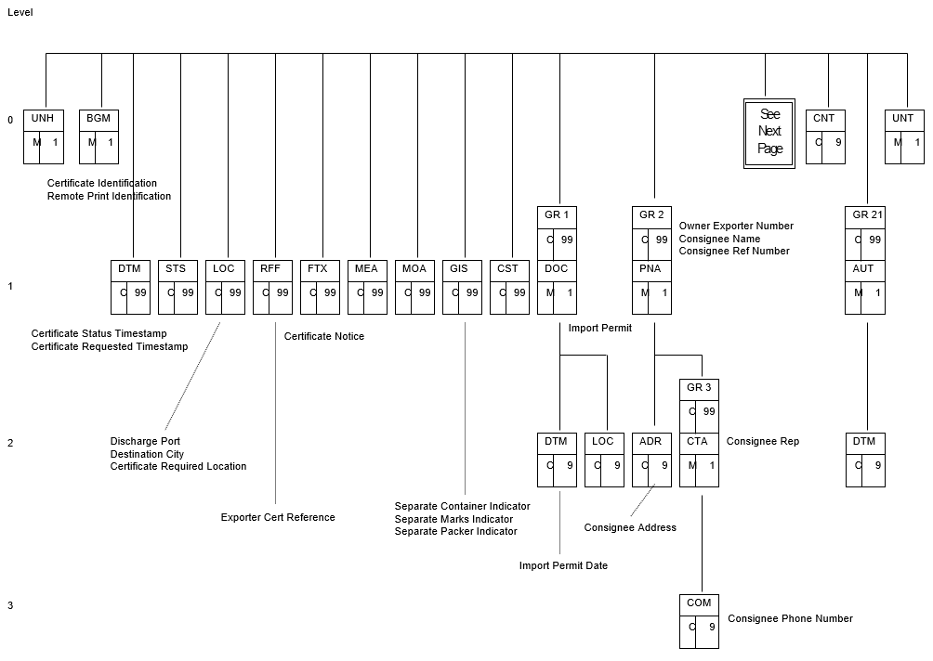

Figure 1 - EXDOC (Certificate Request) Adaptation of SANCRT Part 1

**Certificate Request Data Item Mapping**

|  |  |  |  |  |  |
| --- | --- | --- | --- | --- | --- |
| ~~Notify Party~~ | ~~HDR GR0~~ | ~~FTX~~ | ~~4451~~ | ~~Text subject qualifier~~ | ~~AAG (Notify Party)~~ |
|  |  |  | ~~4453~~ | ~~Text Function, Coded~~ | ~~Filler (must be blank)~~ |
|  |  |  | ~~C107~~ | ~~Text Reference~~ | ~~Filler (must be blank)~~ |
|  |  |  | ~~C108/4440~~ | ~~Notify Party Text~~ | ~~Free format text value (1-8 repeats)~~ |
|  |  |  |  |  |  |
| ~~Letter of Credit~~ | ~~HDR GR0~~ | ~~FTX~~ | ~~4451~~ | ~~Text subject qualifier~~ | ~~AAW (Letter of Credit)~~ |
|  |  |  | ~~4453~~ | ~~Text Function, Coded~~ | ~~Filler (must be blank)~~ |
|  |  |  | ~~C107~~ | ~~Text Reference~~ | ~~Filler (must be blank)~~ |
|  |  |  | ~~C108/4440~~ | ~~Letter of Credit Text~~ | ~~Free format text value (1-5 repeats)~~ |

Certificate Message/Segment Summary

| **Grp** | **Tag** | **Role** | 9  Certificate Request | 98  Certificate Ack | 99  Remote Print Ack |
| --- | --- | --- | --- | --- | --- |
| ~~GR0~~ | ~~FTX~~ | ~~Notify Party~~ | ~~O~~ |  |  |
| ~~GR0~~ | ~~FTX~~ | ~~Letter of Credit~~ | ~~O~~ |  |  |

# Appendix C: Change Permissions Matrix

|  |  |  |  |  |  |  |
| --- | --- | --- | --- | --- | --- | --- |
| Letter of Credit Text | ~~GH~~SW | ~~GH~~SW | ~~GH~~SW | ~~GH~~SW | ~~GH~~SW |  |
| Notify Party Text | D~~G~~IMSW | D~~G~~IMSW | D~~G~~IMSW | D~~G~~IMSW | D~~G~~IMSW |  |

|  |  |  |  |  |  |  |
| --- | --- | --- | --- | --- | --- | --- |
| Letter of Credit Text | ~~GH~~SW | ~~GH~~SW | ~~GH~~SW | ~~GH~~SW | ~~GH~~SW |  |
| Notify Party Text | D~~G~~IMSW | D~~G~~IMSW | D~~G~~IMSW | D~~G~~IMSW | D~~G~~IMSW |  |

# endix C: Change Permissions Matrix

|  |  |  |  |  |  |  |
| --- | --- | --- | --- | --- | --- | --- |
| Letter of Credit Text | ~~GH~~SW | ~~GH~~SW | ~~GH~~SW | ~~GH~~SW | ~~GH~~SW |  |
| Notify Party Text | D~~G~~IMSW | D~~G~~IMSW | D~~G~~IMSW | D~~G~~IMSW | D~~G~~IMSW |  |

Sample Grains Messages

Lodge RFP

This lodgement contains the following features:

* ~~Letter of Credit information for the RFP~~
* Treatment information for the line

1. Interchange Header UNB+UNOB:2+8+7+990608:0922+3++EXDOC|
2. Message Header UNH+6+SANCRT:D:97B:UN:RF0801|
3. Message Ident BGM+G::AQ:9++13|
4. Loading Port LOC+9+SYD|
5. Discharge Port LOC+12+NZWLG|
6. Destination City LOC+8+WELLINGTON|
7. Destination Country LOC+36+NZ|
8. Prod Source Country LOC+30+AU|
9. Cert. Req. Location LOC+91+BNE|
10. Print Region LOC+48+BNE|
11. Exporter Reference RFF+ABE:GJR999|
12. ~~Letter of Credit info FTX+AAW++ATTN – MR BANKER, BANK OF NEW ZEALAND|~~
13. FOB Currency Unit MOA+63::AUD|
14. Certificate Print Ind GIS+A::AQ:PHC|
15. Customs Agent Ind GIS+Y::AQ:ACS|
16. Decl Estimate Ind GIS+C::AQ:DCT|
17. Owner Exporter Nbr PNA+EX+99999|
18. Consignee Name PNA+CN+++++10:CONSIGNEE JOE|
19. Consignee Address ADR++5:1600 PENSYLLVANIA AVE+WASHINGTON++US|
20. Transport Details TDT+12+68+1++:::BLUEBOTTLE INDUSTRIES+++:::ECCLES THE BOAT|
21. Departure Date DTM+136:20040412:102|
22. Inspection Process PRC+IN:PP:AQ|
23. Insp Requested Date DTM+318:20040328103000:204|
24. Inspect Estab Nbr PNA+FO+604|
25. Line Identifier LIN+1|
26. Line Net Quantity MEA+AAA+SQ+TNE:100|
27. Line Met Gr Weight MEA+AAI+AAE+TNE:120|
28. Product Code PIA+5+XWHTVRGC:CC|
29. AHECC Code PIA+5+02012020:HS|
30. Durability Start Date DTM+194:20020519:102|
31. Durability End Date DTM+206:20060519:102|
32. FOB Amount MOA+63:1000|
33. Packaging Details PAC+0+3+VR::AQ|
34. Shipping Marks PCI++MARKS1|
35. Treatment PRC+TR:PP:AQ|
36. Treatment Information IMD++25+M HEAT:::90-95 DEGREES CELSIUS AT 40% RELATI:VE HUMIDITY FOR AT LEAST 15 CONTINU:OUS HOURS|
37. Treatment Date DTM+194:20040315:102|
38. Message Trailer UNT+37+6|
39. Interchange Trailer UNZ+1+3|

Sample Wool Messages

Lodge RFP

This lodgement contains the following features:

* Letter of Credit information for the RFP

1. Interchange Header UNB+UNOB:2+8+7+010822:1145+369++EXDOC+++EXL|
2. Message Header UNH+222+SANCRT:D:97B:UN:CR0801|
3. Message Identifier BGM+W::AQ++13
4. Message Ident BGM+W::AQ:9++13|
5. Loading Port LOC+9+ADL|
6. Discharge Port LOC+12+NZAKA|
7. Destination City LOC+8+AUCKLAND|
8. Destination Country LOC+36+NZ|
9. Prod Source Country LOC+30+AU|
10. Cert Req Location LOC+91+MEL|
11. Print Region LOC+48+MEL|
12. Exporter Reference RFF+ABE:REFW123|
13. Letter of Credit info FTX+AAW+++ATTN – MR BANKER, BANK OF NEW ZEALAND|
14. Cert Print Ind GIS+M::AQ:PHC|
15. Ship Stores GIS+N::AQ:SST|
16. Customs Agent Ind GIS+N::AQ:ACS|
17. Exporter Number PNA+EX+99999|
18. Consignee Name PNA+CN+++++10:WOOL IMPORTS|
19. Consignee Address ADR++5:ROOM 123 RAFFLES HOTEL+AUCKLAND+555+NZ+:::NEARCHANGI|
20. Consignee TRACES ID FTX+ZZZ+4+TRACESCONSIGNEEID:160:AQ+12AB34CD+|
21. Consignee Rep Name CTA+AG+:AKIRA KURUSAWA|
22. Transport Details TDT+12+123+1++:::GOLDEN FLEECE SHIPPING+++:::MV ARGO|
23. Departure Date DTM+136:20040406:102|
24. Line item LIN+1|
25. Net Quantity MEA+AAA+SQ+KGM:1|
26. Metric Gross Wt MEA+AAI+AAE+KGM:1|
27. Product Code PIA+5+UOW BA:CC|
28. Cut type PIA+5+W00400:BP|
29. AHECC PIA+5+51011110:HS|
30. Packaging details PAC+1+3+CT::AQ|
31. Shipping marks PCI++MARKS1|
32. Package measurement MEA+AAU+AAL:4+KGM:1|
33. Container Number EQD+CN+ABCD1234567|
34. Container Seal SEL+JH12345|
35. Message Trailer UNT+31+222|
36. Interchange Trailer UNZ+1+369|