# Biosecurity Emergency Management

Evaluation and Lessons Management Guide

V 1.0 – 4 April 2017

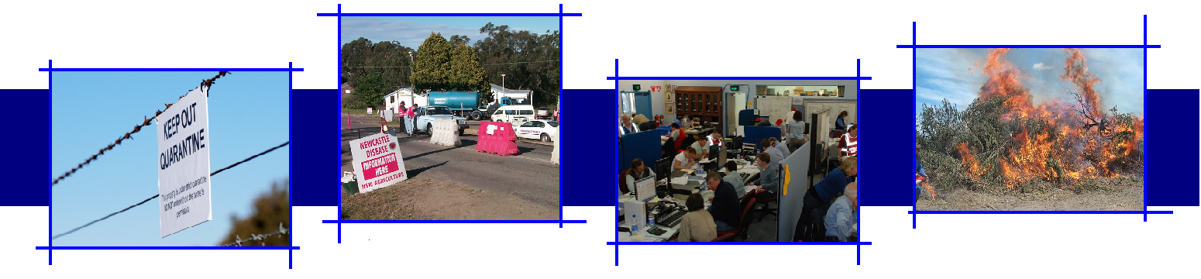

Version Control

| Version | Date of issue | Author | Comments |
| --- | --- | --- | --- |
| V1.0 | 04/04/17 | Evaluation and Lessons Management Specialist Task Group (ELMSTG) | National Biosecurity Committee endorsed version |

National Group Biosecurity Emergency Preparedness Expert Group

Evaluation and Lessons Management Specialist Task Group

[NBEPEG@agriculture.gov.au](mailto:NBEPEG@agriculture.gov.au)

C/- Australian Government Department of Agriculture and Water Resources

PO Box 858, Canberra ACT 2600

Cover: photographs courtesy of New South Wales Department of Primary Industries and Australian Government Department of Agriculture and Water Resources.

## Acknowledgements

The National Biosecurity Emergency Preparedness Expert Group and Evaluation and Lessons Management Specialist Task Group would like to acknowledge the significant contributions made by the following stakeholders:

* Australian Government Department of Agriculture and Water Resources
* Department of Agriculture and Food Western Australia
* Department of Primary Industries, Parks, Water and Environment Tasmania
* Department of Primary Industries, New South Wales
* Department of Primary Industry and Resources, Northern Territory
* Department of Agriculture and Fisheries, Queensland
* Territory and Municipal Services, Australian Capital Territory
* Department of Economic Development, Jobs, Transport and Resources, Victoria
* Primary Industries and regions, South Australia
* Animal Health Australia
* Plant Health Australia

**Contents**

1. Introduction 1

1.1 Authority 1

1.2 Purpose 1

1.3 Current evaluation and lessons management approaches 1

1.4 Scope and Application 3

1.5 Review 3

2. Managing evaluation 5

2.1 Evaluation principles 5

2.2 Evaluation process 5

3. Evaluation planning 8

3.1 Evaluation planning 8

4. Conducting evaluation 10

4.1 Conducting an evaluation 10

5. Evaluation reporting 13

5.1 Evaluation outcomes 13

5.2 Evaluation reporting 13

6. Lessons management 14

6.1 Lessons management process 14

6.2 Collection 14

6.3 Analysis 15

6.4 Implementation 17

6.5 Monitoring and review 17

7. Glossary 20

8. Checklists, forms and templates 21

9. References 51

## Introduction

### Authority

This document has been prepared by the Evaluation and Lessons Management Specialist Task Group, established by the National Biosecurity Emergency Preparedness Expert Group and endorsed by the National Biosecurity Committee on 4 April 2017.

Membership of the Evaluation and Lessons Management Specialist Task Group includes representatives from the Australian Government, state and territory governments, Animal Health Australia and Plant Health Australia.

### Purpose

The purpose of this document is to provide guidance on contemporary-practices for evaluation and lessons management in the context of Australia’s biosecurity emergency preparedness, response and initial recovery activities.

### Current evaluation and lessons management approaches

Evaluation and lessons management is applied by a range of emergency management organisations to inform a cycle of continuous improvement. It is a tool widely used by management to find out how organisations are performing, whether objectives are being met, what areas need improvement and how this might be achieved.

The evaluation and lessons management principles and approaches outlined in this guide are designed to be consistent with those applied by other emergency management sectors.

#### What is evaluation?

Evaluation is an integral component of a lessons management framework. It is a process where data about one or more activities is collected and analysed to identify themes or insights that feed into further learning.

In the context of biosecurity preparedness, response and initial recovery, evaluation is a management tool that can assist biosecurity organisations to:

* facilitate evidence-based decisions about preparedness, response and initial recovery activities
* improve preparedness, response and initial recovery capabilities
* reduce or mitigate risks associated with response
* improve the performance of responders
* maximise the return on investment in biosecurity emergency preparedness activities.

Evaluation uses a range of collection tools and is most effective when undertaken in real time through direct observations. Evaluation can also be used following an activity in the form of debriefs and reviewing reports or other evidence collected during an activity.

To be effective, evaluation needs to be planned, use trained personnel to conduct the evaluation and be managed by experienced personnel.

In a biosecurity context, evaluation can be used to assess the effectiveness of preparedness activities (such as exercises) and the response to incidents, in order to identify practices that should be retained or those that need to be addressed or improved.

The outcomes from the evaluation of biosecurity preparedness and response activities, in turn contribute towards lessons management and the maintenance of good practices or implementation of improvements to address shortfalls in preparedness and response activities.

#### What is lessons management

Lessons management is a holistic approach that builds on the outputs from the evaluation of activities. Lessons management involves a detailed analysis of the outcomes from the evaluation of preparedness, response and initial recovery activities in order to identify and address themes that may be evident or have developed over a period of time.

Effective lessons management relies on a structured approach to the collection, collation, and analysis of data together with agreed programs to reinforce good practice or implement improvements.

Lessons management includes the implementation of actions to reinforce or sustain certain behaviours or to address and improve where this is warranted.

Lessons management takes place over a period of time, and may rely on addressing trends (rather than one observation or occurrence) and contributes towards organisational learning and continuous improvement.

In a biosecurity context, lessons management takes the outcomes from a number of evaluation activities in order to identify recurring themes, assess these and consider an appropriate course of action to address the cause.

Figure 1 Lessons management process

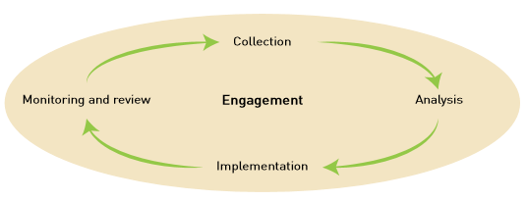

### Scope and Application

The guide lays out the principles and best practice approaches for evaluation and lessons management for biosecurity emergency preparedness, response and initial recovery activities.

Figure 2 Biosecurity Emergency Management illustrates the relationship between the various elements of prevention, preparedness, response and recovery. It shows how evaluation provides a vital link between preparedness, response and recovery activities functioning as the agent for continuous improvement.

For the purpose of evaluation and lessons management:

* **Preparedness** includes activities associated with the development and implementation of policy/planning, resourcing, training and education and exercising.
* **Response** and **initial recovery** includes activities which are undertaken to mitigate the impact of the incident on agricultural assets, the environment, property, people and/or infrastructure.

There are a number of checklists, forms and templates at the end of this guide that have been designed to assist in the management and conduct of evaluations and lessons management in a biosecurity context.

### Review

This guide will be reviewed every two years and/or as necessary to capture contemporary evaluation and lessons management practices as they emerge.

Figure 2 Biosecurity Emergency Management

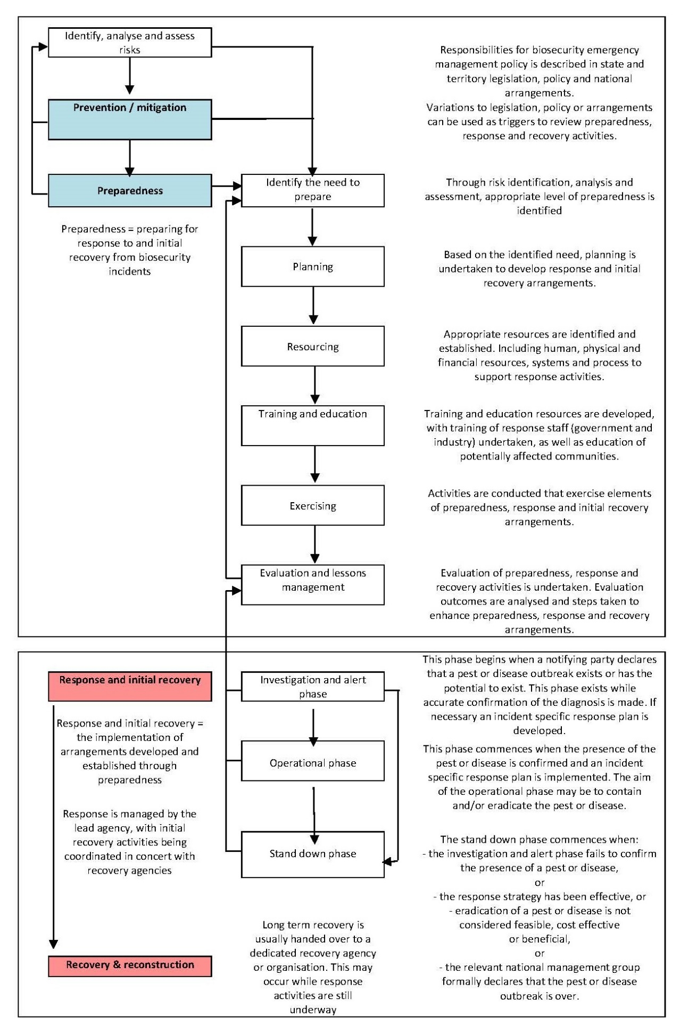

## Managing evaluation

### Evaluation principles

The principles outlined below underpin evaluation.

* **Timeliness** means that evaluation should be undertaken as close to the event as practical, i.e. while an activity (response/exercise) is being conducted. In the context of exercising, evaluation should be considered in the initial planning stages of the exercise.
* **Evidence based** evaluation is about making observations which are supported by the collection of multiple forms of data.
* **Flexible** approaches means the evaluation methodology suits the needs of the activity being evaluated.
* **Scalable** recognises that the evaluation aligns with the scale of an event - it may involve just one person or a team of people to conduct the evaluation.
* **Confidentiality** means that information is used for the purpose for which it is collected and provided to those that are authorised to receive it.

### Evaluation process

Managing an evaluation can be broken into four distinct phases of initiate, plan, conduct and report. It is essential that staff are identified and appointed to manage the evaluation through these four stages (this is different to actually conducting the evaluation, which is outlined later). Staff appointed to manage the evaluation should have a good understanding of the evaluation process and do not necessarily need to be subject matter experts, however some knowledge of the evaluation subject would be helpful.

#### Initiate the evaluation

In order to initiate an evaluation, a critical analysis of the need for an evaluation is undertaken. This analysis could include a scan of the internal and external environment, political imperatives, related activities and previous evaluations.

Following this initial analysis, the scope of the evaluation and terms of reference are determined which will include determining the rationale for the evaluation, purpose, outcomes and evaluation criteria. Other actions that may need to be taken include:

* identifying key roles and responsibilities for the evaluation
* identifying and canvassing stakeholders to ensure that their requirements are addressed in the planning stage of the evaluation, i.e. establish what they will use the evaluation outputs for, e.g.:
* to inform decision-making, identify causes and/or contributing factors to problems
* to conduct a ‘spot-check’ on an aspect of capability to identify possible gaps.
* securing ownership of the evaluation data/outcomes and right of access
* determining reporting lines and governance arrangements
* undertaking a risk assessment to develop a risk management strategy that ensures the objectives of the evaluation can be met.

The output from the initiate stage should be a set of initiating instructions, which will inform the evaluation planning stage.

#### Plan the evaluation

In planning the evaluation, an evaluation strategy is approved and a work plan for checking progress, reading reports and providing feedback and interim approvals is developed. At this point the infrastructure, logistics and staff required to conduct the evaluation are identified and approved/appointed.

Staff appointed to manage the evaluation will also need to consider:

* processes for monitoring, collecting and collating data
* processes for reporting progress of the evaluation against objectives
* establish timelines for reporting
* manage the political context and stakeholder expectations, in order to overcome barriers and ensure ongoing commitment/input to the evaluation.

The output from the planning stage should be the evaluation plan and other documentation that is required to support and conduct the evaluation.

#### Conduct the evaluation

During the conduct stage of the evaluation, staff appointed to manage the evaluation may take a management role (in a large scale evaluation) or actually undertake the evaluation activity (in the case of a small scale evaluation). While this is described in detail in the next section, activities undertaken in conducting an evaluation are consistent and include:

* briefing staff that are conducting the evaluation, on their roles and responsibilities, the evaluation process and expectations of them as evaluators
* briefing the subjects of the evaluation, on the evaluation process and how they may be expected to interact with the evaluator/s
* monitoring progress of the evaluation, negotiate changes to timeframes, methodology or tools as required
* concluding evaluation activities, debrief evaluators and collect evaluation data.

The output from the conduct stage should be a set of data and observations that can be analysed and contribute to reporting on the evaluation.

#### Report on the evaluation

Following the conduct of the evaluation, staff appointed to manage the evaluation will normally be responsible for reporting on the evaluation outcome. Activities that may be undertaken in order to report on the evaluation include:

* collate the evaluation data collected during the conduct of the evaluation, which may be included in:
* evaluator observations
* debrief outcomes
* feedback provided in questionnaires
* records of interviews.
* analyse the evaluation data and compare to the evaluation criteria, in order to identify any themes that may emerge, in order to identify findings that can be reported on
* prepare an evaluation report and provide to relevant parties identified in initiating and planning the evaluation.

The output from the report stage should be an evaluation report that is provided to the initiating body.

## Evaluation planning

### Evaluation planning

Evaluation planning is the responsibility of the Evaluation Manager and should commence at the earliest opportunity. Considerations for evaluation planning are outlined below.

#### **Evaluation plans and documentation**

During the planning stage, the Evaluation Manager should develop an evaluation plan which is approved by the initiating body. The evaluation plan should provide sufficient information to guide the conduct of and reporting on the evaluation and should include information on the:

* activity background, aims, objectives and scope
* evaluation aim
* evaluation objectives
* scope of the evaluation, including what and/or who will be evaluated
* type and/or method of evaluation. The more complex an activity is, the more consideration will need to be given to planning the evaluation. In addition, the need for subject matter experts needs to be considered
* who will conduct the evaluation, including roles and responsibilities
* where and when the evaluation will be conducted including timelines/schedules before, during and after the activity
* the data collection plan which summarises which collection tools and methods will be used for each activity objective. A template is provided at the end of this document
* reporting arrangements including consultation and overall custodian of the evaluation report
* administration and logistics requirements, including evaluation budget and budget management
* communication requirements
* risk management which may include:
* ineffective methodology
* insufficient evaluators
* ineffective evaluation tools
* inadequate standards for objective and consistent evaluation
* work, health and safety considerations impacting on the evaluation, e.g. no safety officers, no identification, fatigue management, inadequate briefings.

An evaluation plan template is provided at the end of this document.

Further, the Evaluation Manager should develop the documentation required to undertake the evaluation. These documents may include:

* evaluator briefing pack
* data collection tools
* questionnaires.

Templates for these documents are included at the end of this document.

#### Workplace health and safety

During the evaluation planning stage, the Evaluation Manager should consider workplace health and safety issues that may be faced by the evaluators and need to be addressed, to ensure a safe work environment for the evaluators.

#### Evaluation staff

During the evaluation planning stage, the Evaluation Manager should identify and appoint evaluator/s.

Where possible, evaluators should have sufficient subject matter knowledge and understand the evaluation process being applied during the particular evaluation.

#### Evaluation logistics

During the evaluation planning stage, the Evaluation Manager will need to consider the logistical requirements for the evaluation, which may include:

* travel and accommodation arrangements for evaluator/s to and from the activity as well as during the activity
* evaluation facilities and supporting logistics
* physical location of evaluators.

## Conducting evaluation

### Conducting an evaluation

In conducting the evaluation, the Evaluation Manager takes a lead role in ensuring the evaluation is conducted in accordance with the evaluation plan and that documentation prepared in the planning stage is used and applied during the evaluation.

#### Evaluation briefings

When conducting an evaluation, the Evaluation Manager will be responsible for briefing the evaluators and evaluation subjects (i.e. those participating in the activity/incident being evaluated).

The evaluation briefing should provide sufficient information and direction to allow evaluators to undertake their assigned tasks, in accordance with the evaluation plan. As a minimum, the evaluation briefing should include information on the evaluation’s purpose, methodology, tools to be used, how the evaluation will be reported and how the outcomes will be used.

An evaluator briefing template is included at the end of this document.

#### Collecting evaluation data

During the evaluation, the evaluator/s will collect and record evaluation data in accordance with the evaluation plan, utilising the documents developed during the evaluation planning stage. At this point, evaluators should be recording observations (i.e. what was actually observed).

Opportunities for collecting data include:

* observing response operations, training activities or exercises
* planning sessions or conferences
* reviewing reports, articles and documents
* observing or participating in debriefs or post incident reviews.

These collection opportunities can be classified as either ‘active’ (where evaluators interact with participants to gather data/observations) or passive (where data/observations are collected from documentation or other media).

#### Collection tools and techniques:

There are many ways of collecting data, some ways are active, while others are passive. Active evaluation usually occurs while an event is underway (or in real-time) and may include collecting data via:

* observations made by evaluators during an activity
* interviews, surveys or questionnaires
* debriefs.

Passive evaluation may occur after an event or through analysis of outputs from an event and may include collecting data via:

* facilitated discussions
* audio/visual recordings
* review of logs and documentation produced during an event
* media reviews
* reports written as the result of an event.

Evaluation tools may include:

* data collection form
* questionnaires
* issues log.

Templates for these documents are included at the end of this document.

#### Data analysis

During this stage of the evaluation, it is normal for the evaluator to undertake an initial analysis of the data. This analysis is intended to contextualise the recorded data and should assist with identifying factors that contribute towards the observation.

In concluding the evaluation, evaluators should summarise their observations and initial analysis and provide this to the Evaluation Manager in accordance with the evaluation plan.

It is the responsibility of the Evaluation Manager to undertake a detailed analysis of the evaluation data. The steps that would normally take place include:

* collate observations
* assess whether the observation is something that should be addressed or reflects good practice and should be retained and encouraged
* group or theme the observation
* develop a statement that summarises the theme. This statement should be in the form of a finding which provides direction on action that could be taken to address the theme.

Table 1 Collation and analysis of observations is an example of how observations could be collated and analysed, in order to develop a finding.

Table 1 Collation and analysis of observations

|  |  |  |  |
| --- | --- | --- | --- |
| Observation | Retain, address or neutral | Theme 1 | Theme 2 |
| the positive diagnosis of the Khapra Beetle was based upon an international standard (ISPM 27) | Neutral | Diagnosis | Application |
| There was a lack of clarity around who the ultimate decision maker was | Address | Decision making | Application |
| Establishment of an IMT brought the right areas of the organisation together | Retain | Incident Management | Coordination |

In Table 1:

* Retain – refers to an observation that represents good practice and should be retained
* Address – refers to an observation that should be addressed in order to enhance or improve performance
* Neutral – represents an observation that does not require action, however adds to the contextualisation of the evaluation

In using this approach, observations can be quickly themed in order to develop one or more findings about related groups of observations.

Further explanation and an example of an evaluation collation tool are provided at the end of this document.

## Evaluation reporting

### Evaluation outcomes

Effective evaluation will generate one or many ‘findings’. These findings will be based on the analysis of multiple recurring observations. These findings will lead to activities that can either sustain a positive action or address an area for improvement.

|  |
| --- |
| Example finding:  Information provided to staff prior to deployment should be clear about:   * travel and accommodation arrangements * agreed costs and reimbursement thereof * points of contact upon arrival * the incident that is being responded to. |

### Evaluation reporting

The owners of the activity being evaluated or those responsible for initiating the evaluation will expect to receive a report on the evaluation outcomes. It should be noted that the evaluation report may not necessarily be a final report but will inform the final report. As a minimum, the evaluation report should include information on the:

* background of the activity to provide a context in which the evaluation was conducted
* evaluation methodology
* evaluation outcomes, including a summary of observations, themes and findings.

The evaluation report is prepared so that the evaluation outcomes can be compared to the evaluation criteria established at the outset.

Unbiased and objective evaluation outcomes are reported in a form and language to suit the intended audience of the report.

Any findings identified in the evaluation report should be supported by the evaluation data.

An evaluation report template is provided at the end of this document.

## Lessons management

### Lessons management process

Lessons management is an overarching term that refers to the collecting, analysing and disseminating experiences from operations, exercises and reviews. The lessons management model described in the Emergency Management Australia – Lessons Management Handbook consists of four steps:

* collection
* analysis
* implementation
* monitoring and review.

These steps are underpinned by continuous stakeholder engagement.

Figure 3 Lessons management process



### Collection

The first step in the lessons management process is the collection and collation of observations.

Observations can be collected through formal evaluation process (as described earlier in this document) and other opportunities, which include:

* observing actual events, training activities or exercises
* planning sessions and conferences
* submissions by individuals or groups
* post-event reviews and debriefs.

In order to obtain the most benefit from a lessons management system, it is important that the collection of data is planned. Noting that some opportunities are unpredictable (such as responding to an actual incident), the lessons management process needs to be flexible enough to capture the unexpected.

In planned events, where evaluation is considered in the early stages of planning, the evaluation plan and documentation should provide clear guidance on how data is collected and collated. Data collected can be qualitative or quantitative in nature, and will be more objectively and consistently collected when evaluation personnel use templates designed for the activity.

Where events are unplanned, experience from previous evaluations will be invaluable in quickly implementing a collection process that suits the particular event.

It should be remembered that there are multiple ways of collecting data, many of which are outlined in the section ‘Conducting evaluations’.

### Analysis

Analysis processes are complex and involve a range of different theories and applications to derive findings. The analysis step involves the review of the collected data to identify trends or themes that may be used to define learning opportunities. This in turn informs possible solutions and implementation options.

It should be noted that the observations recorded in the collection step may reflect the evaluators’ perceptions. As such, the analysis process needs to identify the factual evidence underlying these perceptions and identify the root cause of the situation.

Analysing data should include the following steps:

* data coding (collation of observations)
* grouping of similar themed observation
* analysis of themed observations to develop an insight or finding
* identify possible treatment options.

These steps are illustrated in Figure 4 Approach to analysis.

Figure 4 Approach to analysis

The approach to analysing data should include the following steps: record, collate and code observations; group similar themed observations together; analyse themed observations to develop an insight or finding; and identify possible treatment options.


#### Data coding

Observations should undergo some form of coding so that trends or themes and can be identified. The identified themes will then inform the evaluation findings based on the analysis of multiple recurring observations or insights. This also allows information to be extracted at any time. Using a common coding system can facilitate the exchange of information and lessons across agencies and jurisdictions.

In coding observations, at least two levels of classifications should be considered. The first level should be of a higher order than the second. While it would seem efficient to have a nationally agreed set of classifications, experience has shown that this could be restrictive, with the urge to code within a defined set of criteria, rather than develop criteria that are appropriate to the activity being evaluated. Examples of data classifications are shown in Table 2 Example of criteria used in analyzing Exercise Odysseys observations.

Table 2 Example of criteria used in analysing Exercise Odysseus observations

|  |  |
| --- | --- |
| Theme – Level 1 | Theme – Level 2 |
| Arrangements (for response) | Existence |
| Decision making | Availability |
| Coordination | Knowledge |
| Communication | Application |
| Resources | Capability |

#### Grouping similar themed observations

Once coded, similar observations can be grouped to form patterns that can be further investigated.

Not all observations from an activity will immediately lead to an action. However, if the same or similar observation is repeated or recorded on several occasions, this may translate into a trend or theme that may need to be addressed.

#### Analysing observations

Once themed, observations can be further analysed in order to identify causal factors (rather than simply addressing their symptoms). This can be undertake using root-cause analysis tools such as the ‘5 whys technique’.

This step will lead to identifying insights or findings. It should be noted that insights or findings can relate to good practices that should be encouraged and retained or actions that need to be addressed are improved.

#### Identify treatment options

Following the analysis and identification of root-cause, options for addressing the situation should be developed. These may include ways to address gaps in performance or ensure that high performance is retained.

### Implementation

The outcome from the analysis should identify a number of findings that either represent good practice and should be sustained (or encouraged) or need to be addressed to enhance future preparedness and response activities.

It should be acknowledged that not all findings can be implemented, nor are all findings applicable to all aspects of biosecurity emergency preparedness and response. Therefore, findings (evaluation outcomes) should be referred to the appropriate body for consideration and appropriate implementation, rather than expecting that all recommendations will be actioned by all parties involved in biosecurity emergency preparedness and response.

Table 3 Responsibilities for implementing evaluation outcomes provides guidance on the body that may be responsible for considering and implementing evaluation outcomes.

Table 3 Responsibilities for implementing evaluation outcomes

|  |  |  |  |
| --- | --- | --- | --- |
| Lesson type | Responsible body | Implementation | Recommended to be shared with |
| Findings specific to an agency / organisation | Relevant agency / organisation | Findings considered and actioned by the relevant agency / organisation | Other jurisdictional partners, national committees (functional/sectoral) |
| Findings specific to a jurisdiction | Relevant jurisdiction | Findings considered and actioned by the relevant jurisdiction | National expert group |
| Findings that have application across a specific sector | Relevant sectoral committee | Findings considered and actioned by the relevant sectoral committee | National expert group |
| Findings that are specific to an element of preparedness and/or response and have application across one or more sectors | National expert group | Findings considered and actioned by the relevant expert group | Relevant sectoral committees and task groups |
| Findings that have national ramifications and may be across several elements of preparedness and response and/or one or more sectors | National Biosecurity Committee | Findings considered and actioned by the National Biosecurity Committee | Relevant sectoral committees and task groups |

### Monitoring and review

Monitoring and review links directly to ‘capability development’ and jurisdiction’s or agency’s organisational and resource priorities. The purpose of lessons management is to efficiently learn and continually improve biosecurity emergency preparedness and response activities. Findings need to be evidence based and meaningful to the appropriate person or people authorised to resource and implement the lessons, recommendations or findings.

The purpose of lessons management is to learn efficiently from experience and to provide validated justification for amending the existing way of undertaking business in order to improve performance, both during and post the course of an activity.

Monitoring and reviewing also requires the ‘user’ to own and implement the lessons management processes within their jurisdiction or area of responsibility. Jurisdictions implement the lessons management approach as a means of reducing risk and improving the effectiveness and efficiency of biosecurity emergency preparedness and response.

Figure 5 Evaluation and Lessons Management cycle

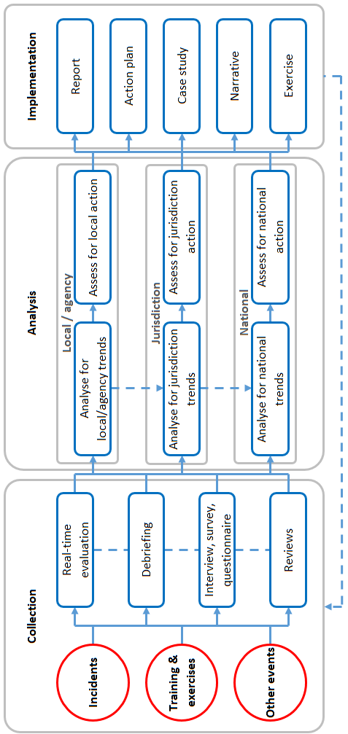

## Glossary

The following terms have been used within this document and their definitions provided for ready reference.

|  |  |
| --- | --- |
| Term - Acronym | Meaning |
| Evaluator | Individual/s appointed by the Evaluation Manager to undertake evaluation activities, including the collection of data and initial analysis. |
| Evaluation Manager | Individual/s appointed to manage all aspects of planning, conducting and reporting on an evaluation. They are responsible for appointing evaluator/s. |
| Finding | In some models, this is a conclusion reached after analysis to identify the root cause. It is a clear, succinct statement that needs to be agreed to or accepted before considering solutions or recommendations. A finding defines the issue, not the solution. |
| Insight | A deduction drawn from the evidence collected (observations), which needs to be further considered. Insights provide guidance for future analysis and potential action. Insights can be positive or negative, and can contribute to reinforcing positive behaviour or changing practices. Insights may be developed when a single observation poses a high risk to the organisation or when a number of similarly themed observations have been collected. |
| Lesson identified | A viable course of action based on the analysis of one or more insights or observations that can either sustain a positive action or address an area for improvement. |
| Lesson learned | A lesson is only learned once the approved recommendation is implemented and embedded in the organisation. Depending on the changes required, it may take several years for the change to be institutionalised across the organisation. A full iteration of a lessons learned cycle would involve the identification of a lesson, an action proposed and agreed, and the solution implemented and tested/validated to ensure the desired behaviour is sustained across the organisation. |
| Observation | A record of a noteworthy fact or occurrence as seen during an activity or operation; it is the evidence or data collected – that is, what is seen or discovered (observed). Observations can be positive or negative. |
| Recommendation | A feasible course of action that addresses an insight or finding. It can either reinforce positive behaviour or address an area for improvement. A recommendation needs to be considered by a relevant authority to determine if it is accepted or rejected. |

## Checklists, forms and templates

##### Evaluation specific

BELM 300: Evaluation Initiating Instructions

BELM 301: Evaluation Plan

BELM 302: Data Collection Plan

BELM 303: Evaluator Briefing

BELM 304: Date Collection Form

BELM 305: Evaluator Summary

BELM306: Exercise Questionnaire

BELM 307: Exercise Management Questionnaire

BELM 308: Maturity Matrix for Preparedness

BELM 309: Maturity Matrix for Response

BELM 310: Evaluation Report

BELM 311: Evaluation Collation Tool

BELM 312: Evaluation Checklist

BELM 320: Evaluation Manager Checklist

BELM 321: Evaluation Checklist

##### Non-evaluation specific

Template: Issues Log

Template: Debrief Agenda

Template: Meeting Summary

Template: Implementation Plan

### Template BELM 300: Evaluation initiating instructions

This template should be completed by the evaluation manager and is intended to provide guidance on the evaluation aims, objectives, scope, team, reporting arrangements and relevant references.

**Evaluation initiating instructions**

|  |  |
| --- | --- |
| ****Activity:**** | **<insert title of activity being evaluated>** |
| ****Location:**** | **<insert location of the evaluation>** |
| ****Date/time:**** | **<insert exercise/activity date/s>** |

**Prepared by:** <insert name/s>

**Date:** <insert date prepared>

**Contents**

**<insert table of contents>**

**1. Background and context**

**<insert text>**

**2. Evaluation aim**

**<insert text>**

**3. Evaluation objectives**

**<insert text>**

**4. Evaluation scope**

**<insert text>**

**5. Outcomes**

**<insert text>**

**6. Evaluation method**

**<insert text>**

**7. Evaluation team**

**<insert text>**

**8. Reporting**

**<insert text>**

**9. Evaluation Activity References: Key documents and contacts**

**<insert text>**

### Template BELM 301: Evaluation plan

This template should be completed by the evaluation manager and is intended to provide guidance to the way in which the evaluation will be planned, conducted and reported.

The evaluation plan will be a central document to the evaluation process. It can be used to gain agreement on the evaluation process as well as providing a useful resources for the development of all other evaluation documentation.

The headings included in this template are a guide only and should be amended to suit the situation.

**Evaluation plan**

|  |  |
| --- | --- |
| ****Activity:**** | **<insert title of activity being evaluated>** |
| ****Location:**** | **<insert location of the evaluation>** |
| ****Date/time:**** | **<insert exercise/activity date/s>** |

**Prepared by:** <insert name/s>

**Date:** <insert date prepared>

**Contents**

**<insert table of contents>**

**Introduction**

**1. Background**

<Background information will set the scene for the evaluation and could include commentary on:

* general overview of the exercise/activity being evaluated, including its aim and objectives (if known)
* key focus areas for the evaluation
* if the activity is part of a larger program identify how it fits into the overall program
* who is participating in the exercise/activity>

**2. Aim (of the activity being evaluated)**

**<insert text>**

**3. Objectives (of the activity being evaluated)**

**<insert text>**

**4. Scope (of the activity being evaluated)**

**<insert text>**

**Evaluation**

**5. Evaluation aim**

**<insert text>**

**6. Evaluation Objectives / outputs / outcomes**

**<insert text>**

**7. Evaluation scope**

**<insert text>**

**8. Evaluation method**

**<insert text>**

**9. Governance, roles and responsibilities**

**<insert text>**

**10. Evaluation timings and locations**

**<insert text>**

**11. Reporting**

**<insert text>**

**12. Communication**

**<insert text>**

**13. Risk management**

**<insert text>**

### Template BELM 302: Data collection plan

This template should be used to map the data to be collected during the evaluation, the method of collection and the activity objectives they relate to.

**Data collection plan**

|  |  |
| --- | --- |
| ****Activity:**** | **<insert title of activity being evaluated>** |
| ****Location:**** | **<insert location of the evaluation>** |
| ****Date/time:**** | **<insert exercise/activity date/s>** |

**Prepared by:** <insert name/s>

**Date:** <insert date prepared>

|  |  |  |  |  |  |
| --- | --- | --- | --- | --- | --- |
| Row | Activity objective | Measure or standard | Collection tool | Collection method/strategy | Notes |
| 1 | - | - | - | - | - |
| 2 | - | - | - | - | - |
| 2 | - | - | - | - | - |
| 4 | - | - | - | - | - |
| 5 | - | - | - | - | - |
| 6 | - | - | - | - | - |
| 7 | - | - | - | - | - |
| 8 | - | - | - | - | - |
| 9 | - | - | - | - | - |
| 10 | - | - | - | - | - |

### Template BELM 303: Evaluator briefing

**Template instructions**

This template should be used to brief exercise evaluators, who are engaged for the purpose of evaluating all or part of an exercise or response activity. The majority of the information should be available in the evaluation plan.

**Evaluator briefing**

|  |  |
| --- | --- |
| ****Activity:**** | **<insert title of activity being evaluated>** |
| ****Location:**** | **<insert location of the evaluation>** |
| ****Date/time:**** | **<insert exercise/activity date/s>** |

**Prepared by:** <insert name/s>

**Date:** <insert date prepared>

**1. Background**

<Background information should be taken from the exercise/activity plan and could include commentary on:

* general overview of the exercise/activity being evaluated, including its aim and objectives (if known)
* key focus areas for the evaluation
* how the activity being evaluated fits within the overall program of exercises/activities
* who is participating in the exercise/activity
* how the evaluation outcomes will be used.>

**2. Evaluation aim**

<Insert the aim of the evaluation. This is a general statement outlining what is intended to be achieved by conducting the evaluation.>

**3. Evaluation objectives**

<insert specific objectives for the evaluation>

**4. Evaluation scope**

<describe the scope of the evaluation, i.e. what is being evaluated and what is not>

**5. Instructions for evaluator/s**

* general administration
* responsibilities and reporting
* where evaluator/s should be located
* timing of activities, including briefings and debriefings
* who evaluators should liaise with
* what forms they need to fill out for evaluation
* date evaluator summary should be provided and who it should be provided to
* evaluator risks and treatment strategies (per evaluation risk register)
* WH&S consideration for the exercise/activity
* issues about the evaluation (using the issues log)
* advice on appropriate conduct during the exercise/activity.

**6. Related documents**

<Information should include reference to other documentation evaluators should be familiar with, e.g. exercise plan/response plan/incident action plan, legislation, policies, manuals, standard operating procedures, work instructions etc.>

### Template BELM 304: Data collection form

This template is just one that could be used by evaluators to record their observation and their initial analysis of the observations.

**Data collection form**

|  |  |
| --- | --- |
| ****Activity:**** | **<insert title of activity being evaluated>** |
| ****Location:**** | **<insert location of the evaluation>** |
| ****Date/time:**** | **<insert exercise/activity date/s>** |

**Prepared by:** <insert name/s>

**Date:** <insert date prepared>

|  |  |
| --- | --- |
| ****Objective 1:**** | **<insert from exercise/response plan>** |
| ****Performance measure 1.1:**** | **<insert performance measure>** |
| **Observations** | **Analysis** |
| < Observations should be evidence based – i.e. they have been observed by the evaluator and/or can be supported with documented evidence> | <Analysis should include the evaluator’s comments on what was observed and perhaps ‘why’ this may have occurred.> |

Repeat this table for each ‘performance measure’

**Observation summary**

Use this space to summarise observation or record additional information

|  |
| --- |
| <insert observations and initial analysis of the observations> |

**Evaluator:** <insert name>

**Signed:** <insert signature>

**Prepared by:** <insert name>

### Template BELM 305: Evaluator summary

This template should be completed by the evaluation manager and is intended to provide a summary of observations and initial analysis of the data collected and collated by the evaluators. This template would be used where there are multiple evaluators and there is a need to aggregate the data collected to assist with further analysis and reporting.

This information is intended to be presented against each element of the exercise/activity being evaluated and may form part of the evaluation report.

**Evaluator summary**

|  |  |
| --- | --- |
| ****Activity:**** | **<insert title of activity being evaluated>** |
| ****Location:**** | **<insert location of the evaluation>** |
| ****Date/time:**** | **<insert exercise/activity date/s>** |

**Prepared by:** <insert name/s>

**Date:** <insert date prepared>

**Contents**

**<insert table of contents>**

**1. Evaluation observations**

**1.1 Exercise/activity objective**

**Summarise the evaluator’s observations and initial analysis, which may include:**

* **observations recorded in data collection forms**
* **observations recorded at debriefings**
* **feedback from interviews and/or questionnaires.**

**This summary should assist in further analysis and theming of observations in order to identify what needs to be addressed or sustained.**

**1.2 Exercise/activity objective**

**<follow 1.1 Exercise/activity objective – repeat as necessary>**

**2. Evaluation summary**

**<provide a high level summary of the evaluator’s observations>**

**3. Attachments**

**<List attachments to this summary. This should include the documentation completed or collected as part of the evaluation, which may include data collection forms and other documented or photographic evidence.>**

### Template BELM 306: Exercise questionnaire

This template has been designed to be completed by exercise participants and people appointed to control staff functions in an exercise. The first part of the questionnaire is focused on the objectives of the exercise, while the second part focuses on the management of the exercise. Additional elements can be included for evaluation if required.

**Evaluator questionnaire**

|  |  |
| --- | --- |
| ****Activity:**** | **<insert title of activity being evaluated>** |
| ****Location:**** | **<insert location of the evaluation>** |
| ****Date/time:**** | **<insert exercise/activity date/s>** |

|  |  |
| --- | --- |
| **Name (optional):** | **<enter name (optional)>** |
| **Exercise role:** | **<enter exercise role>** |

**The aim of this exercise is to <insert exercise aim>.**

**The objectives of this exercise are to:**

**1. <insert exercise objective>**

**2. <insert exercise objective>**

**3. <insert exercise objective>**

In completing this questionnaire, please circle the appropriate response to each question, where 0 = not at all – 3 = completely. If not observed leave blank.

**Exercise objective 1**

1. <insert exercise objective>

|  |  |  |  |  |
| --- | --- | --- | --- | --- |
| Has this exercise achieved this objective? | **0** | **1** | **2** | **3** |
| <insert additional questions that link specifically to each of the performance measures for objective 1> | **0** | **1** | **2** | **3** |

**Comments about objective 1**

|  |
| --- |
| <insert comments about objective 1> |

**Exercise objective 2**

1. <insert exercise objective>

|  |  |  |  |  |
| --- | --- | --- | --- | --- |
| Has this exercise achieved this objective? | **0** | **1** | **2** | **3** |
| <insert additional questions that link specifically to each of the performance measures for objective 2> | **0** | **1** | **2** | **3** |

**Comments about objective 2**

|  |
| --- |
| <insert comments about objective 2> |

**Exercise objective 3**

1. <insert exercise objective>

|  |  |  |  |  |
| --- | --- | --- | --- | --- |
| Has this exercise achieved this objective? | **0** | **1** | **2** | **3** |
| <insert additional questions that link specifically to each of the performance measures for objective 3> | **0** | **1** | **2** | **3** |

**Comments about objective 3**

|  |
| --- |
| <insert comments about objective 3> |

**Exercise management**

These questions relate to the design and conduct of the exercise:

|  |  |  |  |  |
| --- | --- | --- | --- | --- |
| I received adequate information about the arrangements in preparation for the exercise? | **0** | **1** | **2** | **3** |
| The exercise resources and logistics were appropriate for this exercise? | **0** | **1** | **2** | **3** |
| I understood my role in the Exercise Control Team? | **0** | **1** | **2** | **3** |
| The exercise control ran smoothly in a coordinated and structured manner? | **0** | **1** | **2** | **3** |
| The exercise provided an opportunity for the participants to <insert activity>? | **0** | **1** | **2** | **3** |
| Participants were appropriately and fully engaged during the day? | **0** | **1** | **2** | **3** |

**What worked well (about exercise management)?**

|  |
| --- |
| <insert comments> |

**What suggestions do you have for improving the way future activities are conducted?**

|  |
| --- |
| <insert comments> |

**General comments**

**Do you have any other comments about the exercise?**

|  |
| --- |
| <insert comments> |

### Template BELM 307: Exercise management questionnaire

This template has been designed to be used by people appointed to evaluate the management of an exercise. It includes all stages of exercise management, including design, conduct and evaluation.

If required, this approach can be adopted and the questionnaire adapted to other biosecurity preparedness activities, such as training, if required.

**Exercise management – questionnaire**

|  |  |
| --- | --- |
| ****Activity:**** | **<insert title of activity being evaluated>** |
| ****Location:**** | **<insert location of the evaluation>** |
| ****Date/time:**** | **<insert exercise/activity date/s>** |

**Exercise management – evaluation objective 1:**

**Evaluation of the methods, process and approach used to design the exercise.**

**For each of the following elements, please indicate if it was achieved or not. Please provide comments that support your response.**

In completing this questionnaire, please circle the appropriate response to each question, where 0 = not at all – 3 = completely. If not observed, leave blank.

|  |  |  |  |  |
| --- | --- | --- | --- | --- |
| 1. Determine exercise purpose | | | | |
| 1.1 Exercise stakeholders are identified and engaged | **0** | **1** | **2** | **3** |
| 1.2 Exercise governance arrangements are confirmed | **0** | **1** | **2** | **3** |
| 1.3 Exercise aim is identified in consultation with stakeholders | **0** | **1** | **2** | **3** |
| 1.4 Exercise objectives that meet the identified aim are determined | **0** | **1** | **2** | **3** |
| 1.5 Exercise focus is determined, based on operational outcomes, results of training needs analysis, previous exercises and evaluation reports | **0** | **1** | **2** | **3** |

**Comments**

|  |
| --- |
| <insert comments> |

|  |  |  |  |  |
| --- | --- | --- | --- | --- |
| 2. Design and plan exercise activities | | | | |
| 2.1 Planning team is established where required. | **0** | **1** | **2** | **3** |
| 2.2 Governance and planning meetings are held, agreements and decisions are made, and outcomes are communicated to stakeholders. | **0** | **1** | **2** | **3** |
| 2.3 Components of the exercise program are identified, developed and documented in the exercise plan. | **0** | **1** | **2** | **3** |
| 2.4 Exercise style and activities consistent with exercise objectives are selected in consultation with stakeholders. | **0** | **1** | **2** | **3** |
| 2.5 Design planning processes are undertaken with stakeholders to meet exercise objectives and components. | **0** | **1** | **2** | **3** |
| 2.6 Exercise documentation is prepared. | **0** | **1** | **2** | **3** |

**Comments**

|  |
| --- |
| <insert comments> |

|  |  |  |  |  |
| --- | --- | --- | --- | --- |
| 3. Assess exercise risk | | | | |
| 3.1 Risk and safety considerations are included in planning process. | **0** | **1** | **2** | **3** |
| 3.2 Activities which mitigate/reduce risks associated with conducting exercise activities are designed and included. | **0** | **1** | **2** | **3** |
| 3.3 Exercise risk and safety management plan is prepared. | **0** | **1** | **2** | **3** |

**Comments**

|  |
| --- |
| <insert comments> |

|  |  |  |  |  |
| --- | --- | --- | --- | --- |
| 4. Plan resource allocation | | | | |
| 4.1 Resources to support the exercise are identified and secured. | **0** | **1** | **2** | **3** |
| 4.2 Exercise host is identified and commitment to achieving exercise objectives is secured. | **0** | **1** | **2** | **3** |
| 4.3 Appropriate authorisation(s) to use resources are obtained and documented. | **0** | **1** | **2** | **3** |
| 4.4 Availability and timeframes for use of resources is agreed by appropriate authorities. | **0** | **1** | **2** | **3** |

**Comments**

|  |
| --- |
| <insert comments> |

**Exercise management – evaluation objective 2:**

**Evaluation of the methods, process and approach used to conduct the exercise.**

**For each of the following elements, please indicate if it was achieved or not. Please provide comments that support your response.**

|  |  |  |  |  |
| --- | --- | --- | --- | --- |
| 1. Prepare to manage the exercise | | | | |
| 1.1 Exercise documentation reviewed to confirm governance and stakeholder requirements. | **0** | **1** | **2** | **3** |
| 1.2 Exercise aim, objectives, activities and evaluation plan are confirmed. | **0** | **1** | **2** | **3** |
| 1.3 Relevant permissions, authorities, clearances and approvals are identified and confirmed. | **0** | **1** | **2** | **3** |
| 1.4 Logistic requirements are identified and organised. | **0** | **1** | **2** | **3** |
| 1.5 Communication plan is designed and implemented in consultation with stakeholders. | **0** | **1** | **2** | **3** |

**Comments**

|  |
| --- |
| <insert comments> |

|  |  |  |  |  |
| --- | --- | --- | --- | --- |
| 2. Manage exercise activities | | | | |
| 2.1 Exercise management team is formed where required. | **0** | **1** | **2** | **3** |
| 2.2 Communication and consultation is established with activity personnel and maintained throughout the conduct of the exercise. | **0** | **1** | **2** | **3** |
| 2.3 Exercise site preparation and familiarisation are ensured in accordance with the exercise plan. | **0** | **1** | **2** | **3** |
| 2.4 Briefings are prepared and delivered to stakeholders reflecting exercise objectives and activities. | **0** | **1** | **2** | **3** |
| 2.5 Confirmation and management of logistic requirements required to conduct exercise activities is ensured. | **0** | **1** | **2** | **3** |
| 2.6 The exercise plan is used to initiate and facilitate the conduct and direction of the exercise. | **0** | **1** | **2** | **3** |
| 2.7 Risk is managed throughout the exercise. | **0** | **1** | **2** | **3** |

**Comments**

|  |
| --- |
| <insert comments> |

|  |  |  |  |  |
| --- | --- | --- | --- | --- |
| 3. Evaluate outcomes against exercise objectives | | | | |
| 3.1 Post-exercise debriefings are conducted and feedback is gathered. | **0** | **1** | **2** | **3** |
| 3.2 Exercise feedback is collated, recorded, analysed and issues identified. | **0** | **1** | **2** | **3** |
| 3.3 An exercise report, including recommendations, is prepared to organisational standards and distributed to stakeholders. | **0** | **1** | **2** | **3** |

**Comments**

|  |
| --- |
| <insert comments> |

### Template BELM 308: Maturity matrix for preparedness

This matrix has been developed to assess the level of maturity in relation to preparing for biosecurity incidents.

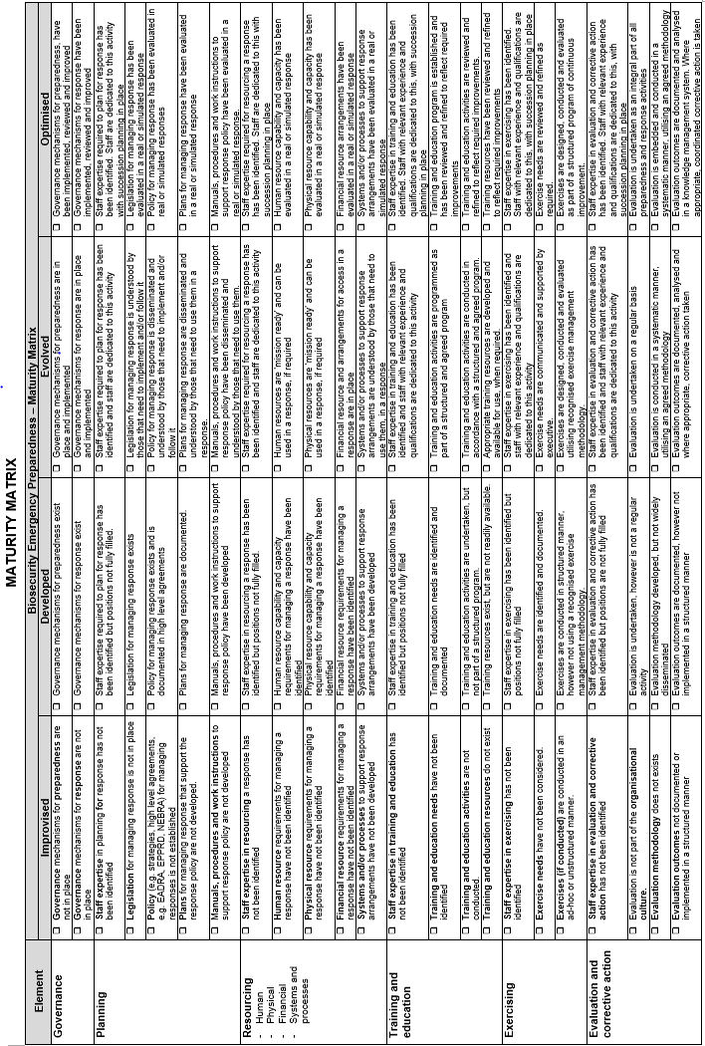

### Template BELM 309: Maturity matrix for response

This matrix has been developed to assist when evaluating response activities. The elements can be modified, or added to, to reflect the specific needs of the evaluation/response.

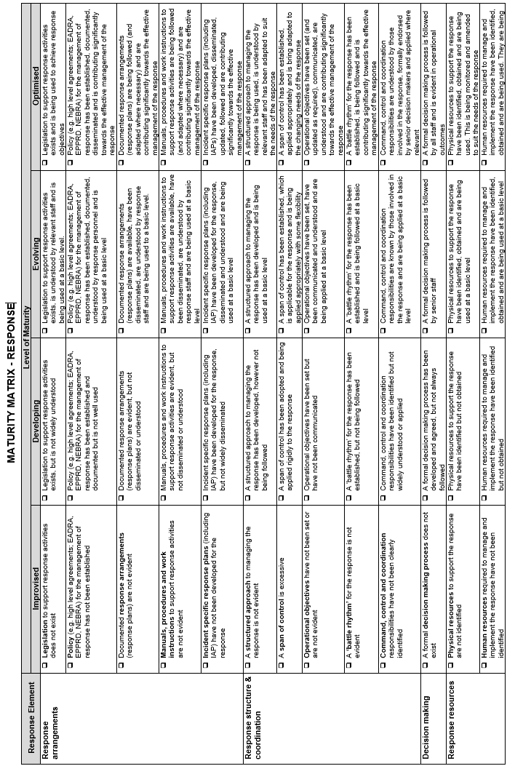

### Template BELM 310: Evaluation report

This template should be completed by the evaluation manager and is intended to provide a summary and initial analysis of the evaluation data.

**Evaluation report**

|  |  |
| --- | --- |
| ****Activity:**** | **<insert title of activity being evaluated>** |
| ****Location:**** | **<insert location of the evaluation>** |
| ****Date/time:**** | **<insert exercise/activity date/s>** |

**Prepared by:** <insert name/s>

**Date:** <insert date prepared>

**Contents**

**<insert table of contents>**

**Executive summary**

**<** **Introduce the exercise/activity and summarise key findings in the form of an executive summary>**

**1. Background**

<Background information should be taken from the exercise/activity plan and could include commentary on:

1. general overview of the exercise/activity being evaluated, including its aim and objectives (if known)
2. key focus areas for the evaluation
3. how the activity being evaluated fits within the overall program of exercises/activities
4. who is participating in the exercise/activity
5. how the evaluation was undertaken.>

**2. Evaluation methodology**

**<Insert the aim of the evaluation. This is a general statement outlining what is intended to be achieved by conducting the evaluation.>**

**3. Evaluation outcomes**

**The following provides a summary and analysis of observation recorded throughout the evaluation of <insert exercise/activity details>.**

**A total of <<insert number>> observations were identified, collated and themed. In doing this an assessment was made as to whether the observation related to:**

* **something that could be addressed to improve effectiveness or efficiency – ADDRESS**
* **something that represented good practice and should be retained and/or encouraged – SUSTAIN**
* **a general noteworthy comment – NEUTRAL.**

**Of the <insert number> observations, <insert number> themes were identified and are represented in the following graph.**

**<insert graphic that illustrates the breakdown of observations, by theme>**

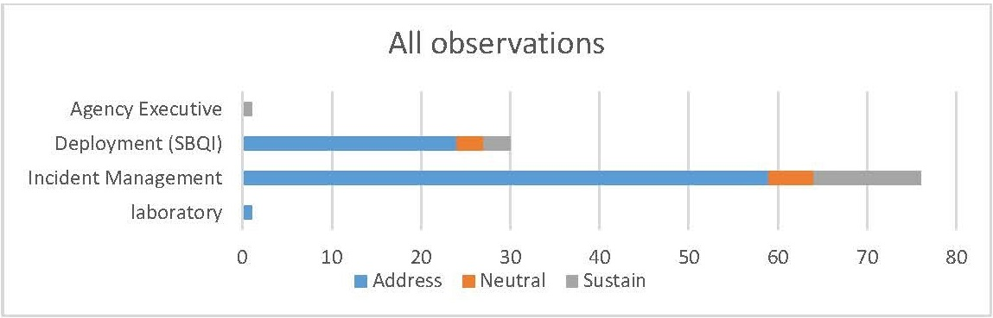

**(Example only)**

**Figure 1. Graph depicting all observations by function**

Definition of these themes are:

* **Agency Executive** – relates to …

**3.1 <insert theme>**

Provide dialogue about this theme that summarises the observations and provides a logical link to finding/s.

**Finding:** example

The duration of the deployment for interstate personnel needs to be revisited, in order to:

• reduce staff churn

• increase skills and knowledge in the affected jurisdiction

• provide continuity and efficiency in the management of the response.

### Template BELM 311: Observation collation tool

The template for the observation collation tool is in an excel format. It is often printed in A3 landscape and is not easily reproducible in an A4 word format. The following graphic shows the observation collection tool’s layout. Its application is described below.

**Excel observation collation tool**

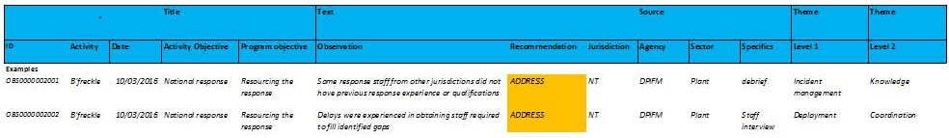

Using the observation collation tool, observations are recorded under the following headings:

* Title (of the activity, which has the following sub categories)
* ID (unique numerical identification allocated to each observation)
* Activity (title or name of the activity being evaluated)
* Date (the observation was made or recorded)
* Activity Objective (i.e. the broader focus of the activity)
* Program objective (i.e. more specific description of the planned evaluation )
* Observation (a description of what was ‘observed’)
* Recommendation (an initial assessment as to whether the observation relates to something that needs to be addressed, sustained or is neutral)
* Source (of the observation)
* Jurisdiction
* Agency
* Sector
* Specifics (I.e. additional context of the observation – e.g. debrief, staff interview)

Once recorded in this format, each observation can be themed in order to identify groupings of observations that collectively can contribute towards the development of one or more findings. This includes identifying two levels of themes. The first theme should be such that it can be further broken down into sub themes. Common groupings for:

* **Level 1** themes may include ‘arrangements - legislation’, ‘arrangements – policy’, ‘decision making’, ‘Incident management’
* **Level 2** themes may include ‘knowledge’, ‘application’ etc

Using this approach in a spreadsheet means that observations can be sorted by the first or second theme, in order to assist in developing one or more findings. Under the headings used above:

* all observations about ‘incident management systems’ could be groups to identify findings about this subject, then sorted under the second theme, or
* all observations about ‘knowledge’ could be grouped to identify specifically what may need to be addressed or sustained (i.e. the first theme).

### Template BELM 312: Evaluation checklist

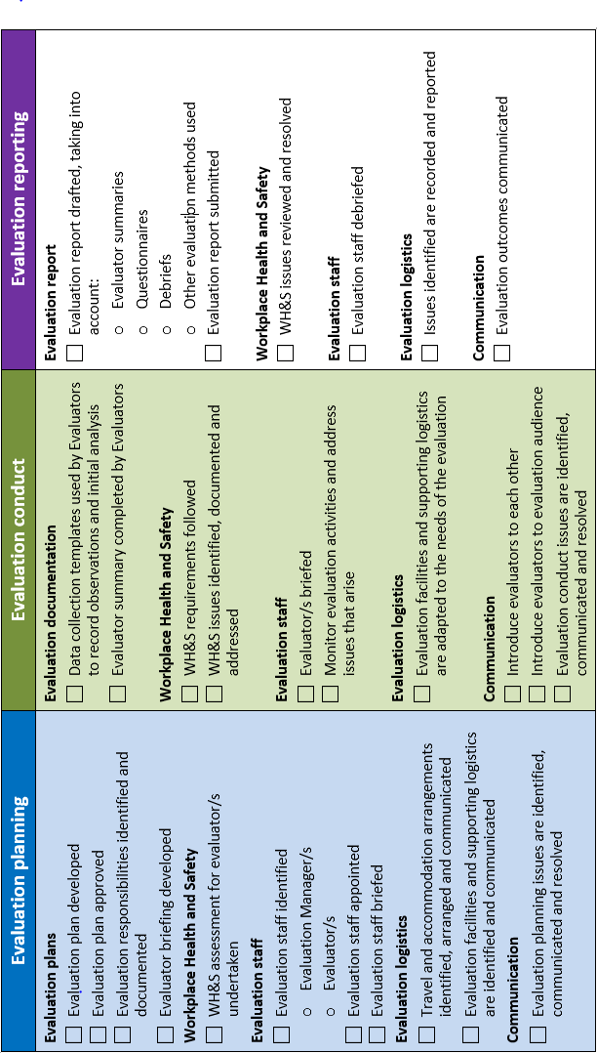

### Template BELM 320: Evaluation Manager

The following checklist shows the main factors taken into consideration by the evaluation manager during the planning, conduct and reporting phases of the evaluation process.

Staff appointed to manage the evaluation should have a good understanding of the evaluation process and do not necessarily need to be subject matter experts, however some knowledge of the evaluation subject would be helpful.

**Plan the evaluation**

Staff appointed to manage the evaluation will need to consider:

* processes for monitoring, collecting and collating data
* processes for reporting progress of the evaluation against objectives
* establish timelines for reporting
* manage the political context and stakeholder expectations, in order to overcome barriers and ensure ongoing commitment/input to the evaluation.

**Conduct the evaluation**

* brief staff that are conducting the evaluation, on their roles and responsibilities, the evaluation process and expectations of them as evaluators
* brief the subjects of the evaluation, on the evaluation process and how they may be expected to interact with the evaluator/s
* monitor progress of the evaluation, negotiate changes to timeframes, methodology or tools as required
* conclude evaluation activities, debrief evaluators and collect evaluation data.

**Report on the evaluation**

* collate the evaluation data collected during the conduct of the evaluation, which may be included in:
* evaluator observations
* debrief outcomes
* feedback provided in questionnaires
* records of interview.
* analyse the evaluation data and compare to the evaluation criteria, in order to identify any themes that may emerge, in order to identify findings that can be reported on
* prepare an evaluation report and provide to relevant parties identified in initiating and planning the evaluation.

### Template BELM 321: Evaluator

The following checklist shows the main activities that need to be undertaken by the evaluators before, during and after the evaluation process.

Staff appointed as evaluators should have a good understanding of the subject matter.

**Pre evaluation activities**

Staff appointed to conduct evaluations will need to consider:

* familiarisation with the activity aims/objectives and key documentation
* reviewing relevant Standard Operating Procedures
* reviewing the data collection plan and tools
* clarifying their role and responsibilities as part of the evaluation team.

**During the evaluation**

* participate in the evaluation briefing and any other scheduled meetings of the evaluation team
* gather evidence using the provided data collection tools
* implement the agreed protocols for contact/interaction with the subjects of the evaluation
* support the timely implementation of the evaluation plan.

**Post evaluation activities**

* submit evaluation data collected
* participate in preliminary review of the data, and/or more extensive contribution toward development of themes, insights and/or findings
* assist with developing the evaluation report, as needed.

### Template BELM 322: Issues Log

|  |  |  |
| --- | --- | --- |
| Issues Log | 1. <insert Incident Name> | 2. <insert Position> |
| Date/Time | Issue | Action |
| - | - | - |
| - | - | - |
| - | - | - |
| - | - | - |
| - | - | - |
| - | - | - |
| - | - | - |
| - | - | - |
| - | - | - |
| - | - | - |
| - | - | - |
| - | - | - |
| - | - | - |
| - | - | - |
| - | - | - |
| - | - | - |
| - | - | - |
| - | - | - |
| - | - | - |
| - | - | - |
| - | - | - |
| - | - | - |
| - | - | - |
| - | - | - |
| - | - | - |
| - | - | - |
| - | - | - |
| - | - | - |
| - | - | - |
| BIMS 230  20100302 | 3. Prepared by (insert Name and Position) | |

### Template: Debriefing Agenda

**Template Instructions**

This template represents a sample agenda for debriefings. It may by amended as required to suit the needs of the particular activity.

**Debriefing Agenda**

**<Insert type or name of incident/activity>**

**Location: <insert meeting location>**

**Date: <insert date to be conducted>**

**Time: <insert start and finish time (if known)>**

**Welcome**

**<insert text>**

**Present/Apologies:**

**<insert text>**

**Agenda items**

**1. Aim of the debriefing**

**<insert text>**

**2. Chronology of events**

**<insert text>**

**3. Participants’ reports**

* **<list the organisation, agency, group or functions that are expected to provide a report at the debriefing>**
* <insert text>

**4. Additional items (General discussion)**

* **<list issues or items that have been specifically identified for discussion>**
* **<insert text>**

**5. Summary of recommendations and actions**

**<insert text>**

**6. Next steps**

**<insert text>**

### Template: Meeting summary

|  |  |  |  |  |  |
| --- | --- | --- | --- | --- | --- |
| Meeting Summary | 1. Incident name  <insert incident name> | | 2. Meeting date  <insert meeting date> | | 3. Meeting time  <insert meeting time> |
| 4. Meeting name: <insert meeting name> | | | | | |
| 5. Meeting location: <insert meeting location> | | | | | |
| 6. Chair/Facilitator: <insert name of chair/facilitator> | | | | | |
| 7. Attendees: <insert attendee name> | | | | | |
| <insert attendee name> | | | | | |
| <insert attendee name> | | | | | |
| <insert attendee name> | | | | | |
| 8. Notes (with summary of decisions and action items) | | | | | |
| - | | | | | |
| - | | | | | |
| - | | | | | |
| - | | | | | |
| - | | | | | |
| - | | | | | |
| - | | | | | |
| - | | | | | |
| - | | | | | |
| - | | | | | |
| - | | | | | |
| - | | | | | |
| - | | | | | |
| - | | | | | |
| - | | | | | |
| - | | | | | |
| - | | | | | |
| - | | | | | |
| - | | | | | |
| BIMS 230  20100302 | | 9. Prepared by (insert Name and Positon) | | 10. Approved by: (insert Name and Positon) | |

### Template: Implementation Plan

**Implementation plan for**

**Recommendations from**

**<insert type or name of incident/activity>**

**1. Background**

**<insert background information about the activity>**

**A full list of recommendations that have been forthcoming from this activity/incident are included in Appendix A.**

**2. Expected outcomes**

**The expected outcomes from implementing the arrangements described in the Corrective Action Plan are:**

**1. <insert details about what is expected to be achieved by implementing this plan, this may be enhanced response arrangements for emergency animal disease… etc>**

**3. Managing the process**

**Authority: This Corrective Action Plan has been developed by <insert details of project team and the authority they have to implement this plan>**

**Governance and membership: <describe governance arrangements and membership of the group/team responsible for implementing the Corrective Action Plan>**

**Reporting: The responsibility for monitoring and reporting on the activities in the Corrective Action Plan rests with <insert details>. <insert details about reporting schedule>.**

**4. Implementing corrective action**

**A full analysis of the corrective action required is included in Appendix B. This analysis identifies, for each recommendation:**

* **Appropriate action required,**
* **Body responsible for this action,**
* **Anticipated budget (if known) for implementing this action, and**
* **Anticipated timeframe for completion of this action.**

**The <insert details> will have oversight responsibility for the implementation of this Corrective Action Plan and will:**

* **Consult with relevant parties in the analysis of recommendations,**
* **Inform and seek approval from relevant parties on the process and activities identified in this Corrective Action Plan,**
* **Assign responsibilities to relevant parties,**
* **Monitor and review the implementation of appropriate actions, and**
* **Report as required to <insert details>.**

**5. Resources and budget**

**<identify major resource requirements and budget associated with implementing the Corrective Action Plan>**

**Appendix A – Recommendations**

**<List the recommendations that have been received from the review of the activity/incident. In some cases it may be beneficial for analysis to group the recommendations under themes. It may also be beneficial to identify recommendations that do not require further action or have not been supported.>**

**Appendix B – Analysis of Recommendations**

**<For each recommendation or group of recommendations complete the following template to record any analysis of the recommendation/s, appropriate actions, responsible parties, resource requirements and timeframes for implementation.>**

|  |  |  |  |
| --- | --- | --- | --- |
| ****Recommendation**** | **<insert recommendation>** | | |
| ****Analysis**** | **<insert details of analysis. This should inform the action or activities required for the appropriate implementation of the recommendation>** | | |
| ****Individual Activities**** | ****Responsible (Person/Organisation)**** | ****Resources/Costs/Inputs**** | ****Time Frame**** |
| **<list sequentially the activities required to implant the recommendation>** | **<identify the parties responsible for each activity>** | **<identify the resource requirements for each activity>** | **<identify timeframes for commencement and completion of each activity>** |
| - | - | - | - |
| - | - | - | - |
| **Comments:**  **<insert any other information that will assist with the appropriate implementation of the recommendation>** | | | |

## References

Emergency Management Australia 2013, Australian Emergency Management Handbook Series - Lessons Management Handbook 8, Australian Emergency Management Institute, Australian Attorney General’s Department, Canberra

Emergency Management Victoria 2014-15, EM-LEARN Framework Emergency Management - Lessons, Evaluation and Review Network, Melbourne