3 March 2009

BIOSECURITY AUSTRALIA ADVICE 2009/03

BIOSECURITY POLICY DETERMINATION –
IMPORTATION OF BANANAS FROM THE PHILIPPINES

This Biosecurity Australia Advice informs stakeholders that Australia’s Director of Animal and Plant Quarantine has determined a quarantine policy for the importation of bananas from the Philippines. Importation of bananas may be permitted subject to the Quarantine Act 1908, and the application of phytosanitary measures as specified in the Final import risk analysis report for the importation of Cavendish bananas from the Philippines, November 2008. The policy will now be taken into account by decision makers when considering import applications for bananas from the Philippines in accordance with the Quarantine Act 1908 and Quarantine Proclamation 1998 as amended.

In response to an application from the Philippines Government, Biosecurity Australia has completed an import risk analysis (IRA) in accordance with the provisions of the Import Risk Analysis Handbook, 2003. This IRA was subject to extensive consultation with stakeholders and public submissions, review by the independent Eminent Scientist Group and an appeal process. The independent Import Risk Analysis Appeal Panel was unanimous in its decision not to allow any of the appeals. Information on the appeals is available from www.daff.gov.au/biosecuritycoordination. At the completion of the IRA process, Biosecurity Australia recommended that Australia’s Director of Animal and Plant Quarantine make a policy determination that bananas from the Philippines could be permitted entry into Australia under specific quarantine conditions.

The Director of Animal and Plant Quarantine has now determined the quarantine policy to permit the entry of bananas from the Philippines to Australia. Importation of bananas may be permitted subject to the Quarantine Act 1908, and the application of phytosanitary measures as specified in the Final import risk analysis report for the importation of Cavendish bananas from the Philippines, November 2008. These measures are designed to limit quarantine risk to a level that is acceptably low in order to achieve Australia’s appropriate level of protection. The policy will now be taken into account by decision makers when considering import applications for bananas from the Philippines in accordance with the Quarantine Act 1908 and Quarantine Proclamation 1998 as amended.

A detailed operational work plan between Australia and the Philippines will now be developed. This will need to be approved by the Australian Quarantine and Inspection Service before any import permits for bananas from the Philippines into Australia will be considered. In accordance with the IRA Handbook, Biosecurity Australia will liaise with AQIS on implementation.

The final report is available via the Biosecurity Australia website www.biosecurityaustralia.gov.au.
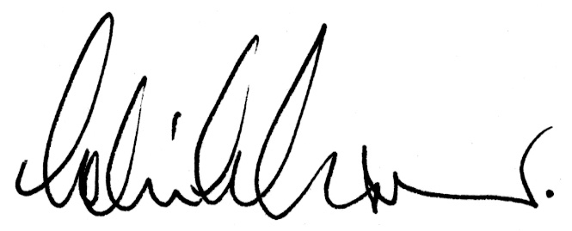
DR COLIN J GRANT
Chief Executive

