21 September 2009

BIOSECURITY AUSTRALIA ADVICE 2009/23

IMPORT RISK ANALYSIS FOR APPLES FROM THE PEOPLE’S REPUBLIC OF CHINA
STATUS REPORT

This Biosecurity Australia Advice (BAA) informs stakeholders that the Draft import risk analysis report for fresh apple fruit from the People’s Republic of China (revised after consideration of stakeholders’ comments) has been formally referred to the independent Eminent Scientists Group (ESG) for review.

Biosecurity Australia, with the advice of an external expert panel, has completed its consideration of all stakeholders’ comments submitted in response to the Draft import risk analysis report for fresh apple fruit from the People’s Republic of China. The draft report was issued on 21 January 2009 (BAA 2009/01) with the comment period closing on 23 March 2009. Biosecurity Australia received 10 submissions from stakeholders. All non-confidential submissions (nine) were placed on the Biosecurity Australia website.
The draft import risk analysis (IRA) report (revised) has now been referred to the independent ESG for review. The role of the ESG is to ensure that: all technical submissions received from stakeholders in response to the draft IRA report have been properly considered; the conclusions of the report are scientifically reasonable based on the material presented; and that all relevant matters relating to the likely economic consequences of a pest or disease incursion have been comprehensively considered.
The ESG has a maximum of 60 days to undertake its review and report to the Director of Animal and Plant Quarantine on its findings. The ESG report will be provided to the Chief Executive of Biosecurity Australia and will subsequently be publicly released.
Biosecurity Australia will take the recommendations of the ESG into account in producing a provisional final IRA report, which will be open to formal appeal.
The Import Risk Analysis Handbook 2007 (updated 2009) and information on all IRAs and policy reviews being conducted by Biosecurity Australia are available on the Biosecurity Australia website at www.biosecurityaustralia.gov.au.
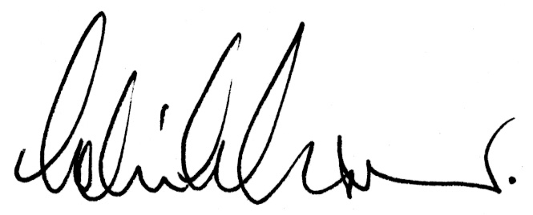
Dr Colin J Grant
Chief Executive

