# Imported Cut Flower Treatment Guide

May 2018—Version 2.2

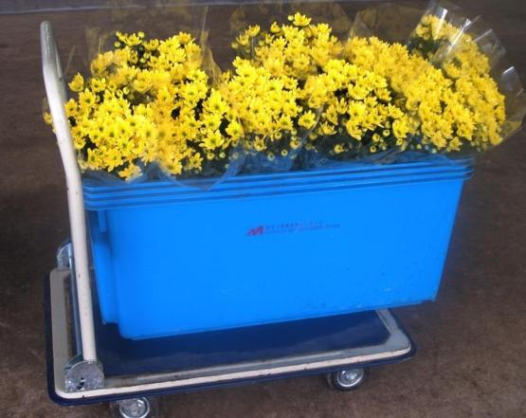

© Commonwealth of Australia

**Ownership of intellectual property rights**

Unless otherwise noted, copyright (and any other intellectual property rights, if any) in this publication is owned by the Commonwealth of Australia (referred to as the Commonwealth).

**Creative Commons Licence**

All material in this publication is licensed under a Creative Commons Attribution 3.0 Australia Licence, save for content supplied by third parties, logos and the Commonwealth Coat of Arms.

Creative Commons Attribution 3.0 Australia Licence is a standard form licence agreement that allows you to copy, distribute, transmit and adapt this publication provided you attribute the work. A summary of the licence terms is available from creativecommons.org/licenses/by/3.0/au/deed.en. The full licence terms are available from creativecommons.org/licenses/by/3.0/au/legalcode.

This publication (and any material sourced from it) should be attributed as: Imported Cut Flower Treatment Guide—Version 2.1 prepared for the Department of Agriculture and Water Resources, Canberra.

**Department of Agriculture and Water Resources**

Postal address GPO Box 858

Canberra ACT 2601

Switchboard +61 2 6272 3933

Web [agriculture.gov.au](http://www.agriculture.gov.au/)

Inquiries regarding the licence and any use of this document should be sent to: [copyright@agriculture.gov.au](mailto:copyright@agriculture.gov.au).

The Australian Government acting through the Department of Agriculture and Water Resources has exercised due care and skill in the preparation and compilation of the information and data in this publication. Notwithstanding, the department, its employees and advisers disclaim all liability, including liability for negligence, for any loss, damage, injury, expense or cost incurred by any person as a result of accessing, using or relying upon any of the information or data in this publication to the maximum extent permitted by law.

**Version history**

|  |  |  |
| --- | --- | --- |
| Date Published | Version | Detail reason for issue or amendments |
| October 2012 | 1.0 | Devitalisation treatment guide |
| October 2015 | 2.0 | Updates to links, contact details and department name |
| June 2016 | 2.1 | Updates to terminology for *Biosecurity Act 2015* |
| May 2018 | 2.2 | Updates to Glyphosate treatment and dosage |

Contents

Introduction 4

Further information 4

Cut flower devitalisation treatments 5

Glyphosate treatment and dosage 5

Cut flower devitalisation treatment procedure 7

Work health and safety 7

Preparation of devitalisation vessels 7

Mixing the dipping solution 8

Preparation of flowers 9

Devitalising the flowers 9

Powdery mildew treatment 10

Phytosanitary requirements for treated flowers and foliage 11

## Introduction

Some flower and foliage species may be propagated from stem material. The current policy of the Department of Agriculture and Water Resources is that all propagable cut flowers and foliage imported into Australia must be devitalised using the procedure described in this document before they are released from biosecurity control. Devitalisation may be performed by an approved treatment provider overseas or when the flowers arrive in Australia.

This guide provides information about the department’s cut flower devitalisation requirements for devitalisation treatment providers and National Plant Protection Organisations (NPPO). It also outlines how to treat roses with symptoms of powdery mildew.

Treatments are subject to change and should always be verified be searching the department’s [biosecurity import condition database (BICON).](http://www.agriculture.gov.au/import/bicon)

### Further information

If you require further information about this process please contact:

Cut Flower Imports

Department of Agriculture and Water Resources

GPO Box 858

Canberra ACT 2601

Phone: 1800 900 090

Email: imports@agriculture.gov.au

## Cut flower devitalisation treatments

The following chemical dips have been approved for use in devitalising propagable cut flowers. In addition, rose buds can be physically devitalised by cutting, burning or pricking the auxiliary buds, mainly for the purpose of flowers imported by passengers through airports.

### Glyphosate treatment and dosage

Glyphosate is the only herbicide approved as a dip treatment for the devitalisation of cut flowers and foliage for import to Australia. Any glyphosate product can be used; the dosage is calculated based on the amount of active ingredient (glyphosate) in the product.

Table 1—Glyphosate dosage and dipping requirements for cut flowers

|  |  |  |
| --- | --- | --- |
| Flower species | Required Glyphosate  Active ingredient g/L  (% glyphosate) | Dipping method |
| *Brunia* spp.  *Calathea* *lancifolia* | 0.9 (0.25% glyphosate) | 20 minute immersion of stems to at least **35 cm** from the cut end (**OR** to within **5 cm** of the flower head) |
| *Callistephus chinensis*  *Callistemon* spp. (Bottlebrush)  *Chrysanthemum* spp.  *Dianthus* spp. (Carnation)  *Oxypetalum* spp. (syn. *Tweedia* spp.) (Baby Blue) | 1.8 (0.5% glyphosate) | 20 minute immersion of stems to at least **35 cm** from the cut end (**OR** to within **5 cm** of the flower head) |
| *Hypericum* spp.  *Rhapis* spp. (basal stems only, not required for leaves and fronds)  *Rosa* spp. (Rose)  *Viburnum* spp.  *Viola* spp. | 5.4 (1.5% glyphosate) | 20 minute immersion of stems to at least **35 cm** from the cut end (**OR** to within **5 cm** of the flower head) |
| *Codiaeum  variegatum* (syn. *Croton  variegates*), (flowers and foliage with stems , not required for leaves and fronds only), *Dracaena* spp. (stems with leaves, not required for leaves and fronds only) | 5.4 (1.5% glyphosate) | 20 minute immersion of stems to within to **15cm of apex** |

#### Example glyphosate dosage calculations

The treatment dosage depends on the amount of active ingredient in the glyphosate concentrate. The general formula for working out the amount of glyphosate concentrate to use is:

Volume of concentrate required (ml) = ( glyphosate dosage (g/L) x Volume of solution required in ml)

(grams of active ingredient/L)

#### A. *Brunia*, *Calathea* *lancifolia* leaves with stem only - 0.25% Glyphosate solution

0.9 grams per litre is the amount of glyphosate active ingredient that is required to make a 0.25% solution of glyphosate for devitalisation of the species listed above.

A one litre treatment solution of 0.25% glyphosate can be prepared by mixing

* 1.76 ml glyphosate concentrate (active ingredient 510g/L) in 998.24 ml of water
* 1.87 ml glyphosate concentrate (active ingredient 480g/L) in998.13 ml of water
* 2.5 ml glyphosate concentrate (active ingredient at 360g/L) in 997.5 ml of water
* 5.3 ml glyphosate concentrate (active ingredient 170g/L) in 994.7 ml of water

#### B. *Carnations,* *Chrysanthemums*, *Callistemon*, *Callistephus chinensis*, and *Oxypetalum* (syn. *Tweedia*) - 0.5% Glyphosate solution.

1.8 grams per litre is the amount of glyphosate active ingredient that is required to make a 0.5% solution of glyphosate for devitalisation of the species listed above.

A one litre treatment solution of 0.5% glyphosate can be prepared by mixing

* 3.53 ml glyphosate concentrate (active ingredient 510 g/L) in996.47 ml of water
* 3.75 ml glyphosate concentrate (active ingredient 480 g/L) in 996.25 ml of water
* 5 ml glyphosate concentrate (active ingredient 360g/L) in 995 ml of water
* 10.6 ml glyphosate concentrate (active ingredient 170g/L) in 989.4ml of water

#### C. Roses, *Codiaeum variegatum*, *Dracaena* spp, *Hypericum* spp, *Viola* spp, *Viburnum* spp, and *Rhapis* palm foliage cluster.

5.4 grams per litre is the amount of glyphosate active ingredient that is required to make a 1.5% solution of glyphosate for devitalisation of the species listed above.

A one litre treatment solution of 1.5% glyphosate can be prepared by mixing

* 10.56 ml glyphosate concentrate (active ingredient 510g/L) in 989.44 ml of water
* 11.25 ml glyphosate concentrate (active ingredient 480g/L) in 988.75 ml of water
* 15 ml glyphosate concentrate (active ingredient 360g/L) in 985 ml of water
* 31.8 ml glyphosate concentrate (active ingredient 170g/L) in 968.2ml of water

## Cut flower devitalisation treatment procedure

The devitalisation procedure involves dipping flower and foliage stems in a glyphosate solution. During the treatment the glyphosate is taken up in to the stems of the plant by a process called transpiration. To achieve an effective treatment, the glyphosate dosage, the dipping depth and the duration of the treatment must meet the requirements specified in the following procedure.

The treatment provider should also implement procedures to avoid mixing treated and untreated flowers. These should incorporate

* how to separate treated and untreated flowers
* how to keep flowers for export to Australian flowers segregated from flowers for other markets
* labelling the flowers for Australian markets

### Work health and safety

Glyphosate may cause irritation if it comes in contact with eyes or skin. Always use personal protective equipment such as safety glasses and gloves and wash your hands thoroughly after use.

You must consult the Materials Data Safety Sheet for the glyphosate product you are using for local regulatory, safety, storage and disposal considerations.

### Preparation of devitalisation vessels

1. Measure the amount of water required to fill the devitalisation vessel to a depth of 35 cm or, for flowers with shorter stems, there must be enough water to reach 5 cm below the flower head. Any type of vessel may be used as long as it is deep enough to accommodate the flowers being treated.
2. A permanent mark should be put inside the vessel so that the level of the solution can be checked and maintained during the devitalisation process.

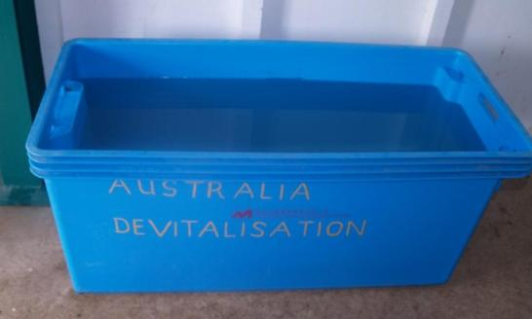

### Mixing the dipping solution

1. The glyphosate concentrate used for the treatment must be within the ‘use by date’ on the label. Concentrate should be stored as specified by the manufacturer on the container and not in direct sunlight.
2. To determine the amount of glyphosate concentrate needed to make the dipping solution check
   1. the type of flower or foliage being treated
   2. the amount of water needed to fill the devitalisation vessel to the required depth
   3. the amount of active ingredient in the glyphosate concentrate.

Calculate the amount of glyphosate concentrate needed using this information and the example calculations provided in this document.

1. Add the water to the devitalisation vessel and then measure and add the glyphosate concentrate to the water and mix thoroughly.
2. When making the dipping solution you must prepare additional dipping solution at the correct concentration for topping up the vessel during treatment.
3. Dipping solution should not be kept for more than seven days. This should be monitored by using labelling and record keeping (for example, the date and time solution was mixed, concentrate used).

### Preparation of flowers

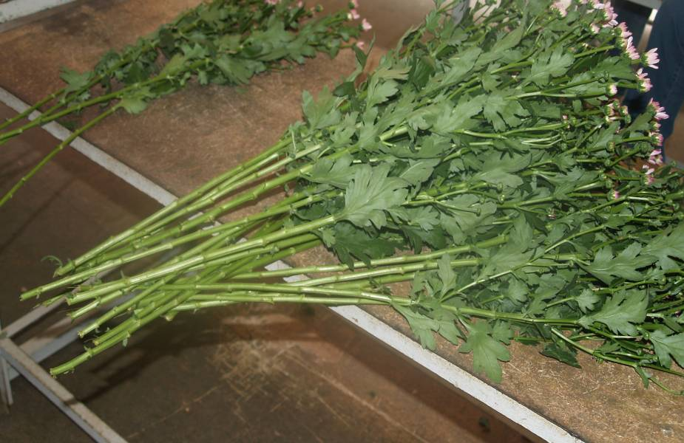

1. Flower stems should be cut within two hours of treatment to ensure that:

* the mixture can be readily absorbed up the flower stems
* all the stems are immersed to the correct depth

1. Flowers that have been stored in cool rooms should be brought to room temperature before the treatment.

### Devitalising the flowers

1. Set up the devitalisation vessel in a room with adequate air flow and ambient temperatures close to 18° to 21°C. High humidity in the room will also improve uptake of the glyphosate. Fans may be used to circulate the air.
2. Before placing the flowers in the dipping solution remove or fold down any plastic sleeves or other coverings to ensure effective transpiration.
3. The stems must be immersed in the dipping solution for at least 20 minutes. Timing should commence when the last bunch has been immersed.
4. Remove any leaves from the dipping solution after each treatment. If there is a significant amount of organic material in the treatment solution, then it should be discarded and fresh solution made up for use.
5. Top up the vessel with additional dipping solution as required to ensure correct dipping depth is being maintained.

## Powdery mildew treatment

Some flowers species that require devitalisation may show symptoms of powdery mildew, especially roses. Devitalisation treatment providers can also treat the flowers for powdery mildew.

Fungicide treatment is only expected to be applied if there are any visible symptoms of powdery mildew infection on the produce. Roses from Kenya are not required to undergo any treatment for powdery mildew.

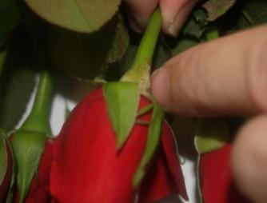

1. Stems and flower heads should be treated if there is any mildew symptoms on them.
2. The fungicide used must be appropriately registered for treatment of powdery mildew on roses and prepared and used according to label instructions provided by the manufacturer.
3. The fungicide treatment must be the last treatment performed on the roses prior to export, i.e. fungicide dipping to be performed after the devitalisation treatment.
4. Consignments of roses that have undergone fungicide treatment for powdery mildew must arrive in Australia and be inspected within ten days, otherwise they may require re-treatment if fungal symptoms are detected.

## Phytosanitary requirements for treated flowers and foliage

Each consignment of flowers that have been devitalised overseas must be accompanied by an original Phytosanitary certificate that describes how the flowers have been treated. If roses have been treated with fungicide for powdery mildew this also needs to be recorded on the Phytosanitary certificate. The required additional declarations are explained in the biosecurity import conditions database (BICON).

Phytosanitary certificates must meet the minimum documentary requirements policy.

Consignments arriving without the correct documentation and endorsements (including original documents appropriate concentration of glyphosate, duration of treatment, dipping method) will require treatment in Australia, export or destruction.