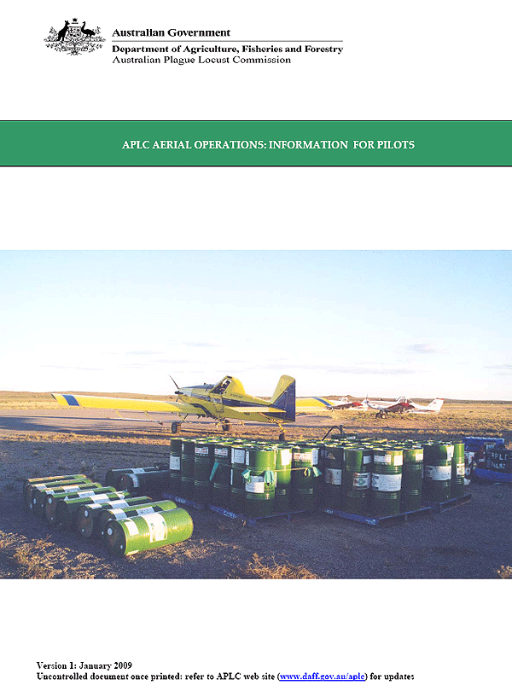

Contents
Section 1: General (All aircraft/pilots) 3
1.1 APLC Aviation Quality and Safety Policy 3
1.2 APLC Standard Operating Procedures 3
1.3 Overview: APLC Aerial operations and aerial safety 4
1.4 Daily Operational Briefing Checklist 8
Section 2: Information for Spray Pilots 9
2.1 Acceptance Checklist: Fixed Wing Spray Aircraft 9
2.2 Locust Control: Instructions to Spray Pilots 11
2.3 Tasking and Safety Direction No. 2: Spray Operations 14
2.4 Aerial spraying checklist 16
2.5 Fenitrothion: Guideline for control of Australian Plague locust 17
2.6 Fipronil: Guideline for control of Australian Plague locust nymphs 18
2.7 Green Guard: Guideline for control of Australian Plague locust nymphs 20
2.8 Malathion: Draft Guideline for control of Australian Plague locust 22
Section 3: Information for Fixed-wing spotter pilots 23
3.1 Acceptance Checklist: Fixed-wing Spotter Aircraft 23
3.2 Tasking and Safety Direction No. 3: Fixed Wing Survey 25
3.3 Pre Flight checklist for aerial survey 27
Section 4: Information for Helicopter Survey Pilots 28
4.1 Survey Helicopter Acceptance Checklist 28
4.2 Tasking and Safety Directions No. 1: Helicopter Survey 30
4.3 Pre flight checklist for aerial survey 33
Annex 1: APLC Standard Operating Procedures 34

Section 1: General (All aircraft/pilots)

1.1 APLC Aviation Quality and Safety Policy
The Australian Plague Locust Commission acknowledges that aviation safety is an essential and integral factor in satisfying the objectives and requirements of the Commission’s mandate in control and management of Plague Locust activities.
It is the policy of the Australian Plague Locust Commission to prevent accidents and minimise injury by placing safety of aviation activities above all considerations.
To accomplish this APLC will:
- Promote a culture encouraging the development, implementation and continuous improvement of operating systems which protect personnel involved in aviation operations.
- Establish principles and standards regarding safety, health and environmental protection, and in doing so, develop and maintain measurable objectives to focus APLC on continuously improving aviation safety performance.
- Empower all staff, sub‐contractors and air operators involved in APLC aviation activities to initiate immediate Stop Work procedures in the event of unsafe acts being observed.
- Identify, evaluate and control safety, health and environmental hazards through risk analysis.
- Provide necessary and adequate training and resources to APLC personnel for fulfillment of aviation activities in accordance with objectives and standards.
- Communicate safety, health and environmental responsibilities to every individual within the APLC, and hold personnel accountable.
- Monitor and audit ongoing operations to assure conformance to safety, health and environmental standards.
- Identify non‐compliance with safety, health and environmental requirements, promote a ‘Just Culture’ where all incidents and near misses are openly reported and investigated, take corrective action and verify the effectiveness of those actions.
- Ensure only approved air operating companies, personnel and equipment, meeting APLC minimum requirements, are contracted for APLC aviation operations.
- Require contractors to manage Health, Safety and Environment (HSE) in line with this policy.

1.2 APLC Standard Operating Procedures
The APLC has developed a set of Standard Operating Procedures (SOP’s) to assist Aircraft Operators and APLC personnel in the safe and efficient management and use of aircraft involved in the provision of locust management aerial operations.
The conduct of aerial operations within APLC must satisfy two main quality requirements – the APLC Quality and Safety Policy [section 1.1 above] and the requirements of the Civil Aviation Safety Authority for aerial activities.
The purpose of the Standard Operating Procedures and associated guidance material is to provide confidence that all operations are conducted in accordance with the applicable requirements, standards and operational procedures in order to ensure safe operations and efficient service.
For APLC aerial activities to function safely and efficiently, it must identify and manage numerous linked activities. Each activity has a process for completion and often the output from one process directly forms the input to the next. It is essential therefore, that each objective and process be identified, monitored and measured against requirements and policies, results reported and continual improvements planned and actioned. A poorly monitored task at the lower level of Operations may result in an unsatisfactory input into a higher Operational level, thereby resulting in a compromised flight safety issue or poor level of overall service.
All pilots working with the APLC are required to read and comply with the SOPs (refer Annex 1) as appropriate to the aerial tasking undertaken.

Disclaimer
Aircraft Operators are responsible for determining whether they should seek specialist advice and assistance in managing their air operations, based upon individual circumstances. To the extent of any inconsistency, the following take precedence over these SOP’s insofar as they relate to the management and use of aircraft and the provision of related services:
- Any statutory requirements or other requirements under the laws of Australia (including without limitation, Civil Aviation and OH&S legislation);
- Any Codes of Practice or related industry standards or guidelines, or guidelines or policies issued by Government or Regulatory Authorities;
- Aircraft Operators Operations Manuals;
- Any manufacturers’ recommendations.
Aircraft Operators are responsible for notifying APLC immediately of any inconsistencies they become aware of between these SOP’s and the above requirements, codes, regulations, guidelines and recommendations.

1.3 Overview: APLC Aerial operations and aerial safety

Purpose of the Information Pack
The purpose of this document is to provide relevant background information on APLC operations and procedures and the APLC’s approach to aviation safety to pilots working for the APLC.
The document contains essential information describing the protocols used by the APLC to mitigate the risks involved in aerial operations.
All pilots should carefully read the relevant parts of the document to familiarise themselves with APLC procedures and protocols.

APLC aerial safety
The Australian Plague Locust Commission regards aviation safety as an essential and integral factor in satisfying the objectives and requirements of the Commission’s mandate in control and management of Plague Locust activities.
It is the policy of the Australian Plague Locust Commission to prevent accidents and minimise injury by placing safety of aviation activities above all considerations.
The APLC commissioned an independent review of aerial safety in 2006‐2007. Following this review the APLC implemented a number of recommendations arising from the review to further mitigate risks. A copy of the review report is available from the APLC web site (www.daff.gov.au/aplc).
Documentation that is both essential and critical for the safety of aircraft operations is contained in:
- The APLC Aviation Procedures Manual;
- APLC Standing Orders; and
- Aircraft Tasking and Safety Directions.
Copies of the APLC Aviation Procedures manual can be downloaded from the APLC web site (www.daff.gov.au/aplc).
Some of the information contained in this manual has been reproduced directly from the Aviation Procedures Manual.

Fixed wing survey (Hopper bands)
Aerial search using a fixed wing aircraft is the standard method for the detection of hopper bands enabling the APLC to quickly establish the extent of an infestation and to identify specific blocks of hopper bands suitable for aerial control.
If bands are not visible from the air it is unlikely the APLC will mount a nymphal control campaign. Unfortunately, bands are not always visible from the air so aerial search can sometimes be misleading as to the size of the infestation. Even when all bands visible from the air have been successfully controlled, significant swarm campaigns have followed. The aim of band control is to limit the size of the swarm infestation, and the size of the population that can migrate or lay eggs to produce another generation.
Before the sortie begins the boundaries of the area to be surveyed will be discussed/agreed with the APLC OIC. Generally the boundaries will be delimited by lines of latitude and longitude and/or by an easily identifiable geographic feature such as a range of hills, major creek line, road or river. The original boundaries of the survey area can be extended if bands are found at the edges of the search area but other APLC staff at the control base (or Canberra) need to be informed of any changes to the original flight plan and the SAR time amended if necessary.
The spotter aircraft should initially fly tracks at intervals of approximately 2 nautical miles and at a height of 700 m above ground level over the area to be searched. The interval should be reduced to 1 nautical mile if bands are observed.
Bands show up most clearly when the sun is behind you, so if you are not certain that what you are seeing is a band, circle round it a few times to check and try a change in altitude. Blocks of country (target areas) containing bands should be delimited from the air and the coordinates of the target areas locked in by the aircraft GPS (in case conditions are unsuitable for spraying and there will be a need to subsequently relocate the area). If a spray aircraft is called up the APLC observer will provide a lat/long coordinate for the block to the spray pilot. Once the spray aircraft arrives the APLC observer will describe the location of the spray block to the spray pilot and provide directions for the spraying operations by radio (normally UHF).

Helicopter Survey (Swarms)
Helicopters, though costly, are invaluable for locating locust swarms. They should be used mainly when the weather conditions are suitable for locust to undertake spontaneous flight: careful consideration needs to be given to using a helicopter when few adults are flying because of cool and/or windy conditions. Helicopters are also used to delimit the boundaries of a swarm for the spray aircraft pilot.
The search area and approximate route should be planned in advance and drawn on a map for both the pilot and the observer. Flight details must be left with somebody who is not flying, even if the pilot is following standard SAR (Search & Rescue) procedures.
There must be ʺintercomʺ between the pilot and the APLC observer(s). When a suspect area is spotted, a high level reconnaissance must be undertaken to identify any aviation hazards before a decision is made for the helicopter to descend to undertake low level survey. If the weather conditions are good and locusts flying it is possible the target area can be demarcated without a low level survey. Record the position of the target on the relevant property map or on the aircraft GPS.
The APLC observer will call up the spray aircraft if conditions are suitable for control. The location and boundaries of the target block will be described to the spray pilot by the APLC observer by radio (normally UHF). Often the helicopter will fly the boundaries of the target block to assist the spray pilot in demarcating the area.

Aerial spraying of locusts
There are three aerial spraying techniques used by the APLC:
- Blanket spraying (crosswind); and
- Wide interval track spacing using either:
  - Wide interval (cross wind); or
  - Wide interval (into and down wind alternate runs)
Both the wide interval spraying techniques are only used for the application of fipronil. The persistence of fipronil enables effective control of hopper bands by application as either a more irregular pattern (cross wind application) or by applying fipronil as narrow discrete barriers of pesticide.
The cross wind wide interval application technique results in a very irregular coverage of fipronil across the target areas whilst the “Into and downwind” technique restricts the fipronil coverage to narrow discrete strips or “barriers” approximately 80 to 100 meters wide with virtually no fipronil between the barriers.
Applying fipronil as a wide interval spray is highly cost effective in terms of the amount of insecticide applied and also in terms of the aircraft time to undertake the application when compared to a blanket treatment.
APLC staff will provide instructions to the spray pilot on which aerial spraying technique and track spacing is to be used on a specific target.

APLC Control Agents
The APLC utilises 3 products for the aerial control of locusts:
- Fenitrothion (Sumithion ulv)
- Fipronil (Adonis 3UL); and
- Metarhizium (Green Guard ulv)
The APLC is also currently evaluating Malathion ulv (Fyfanon) for locust control.
All the above products are applied as a ulv formulation using a ulv rotary atomiser (Micronair or similar) or through a Jarba Boom.
Mixing is only required for Green Guard: fenitrothion and fipronil are applied as a concentrated (ulv) product.
For Green Guard the product needs to be mixed with summer oil. The relative proportions of the mixture of Summer oil and Green Guard active ingredient are provided on the Green Guard Information Sheet. The APLC will normally provide specialised mixing equipment for the task.
Information sheets on each of the above products are included, for information, in this document. The information sheets provide the necessary information on the aircraft settings (blade angle, track spacing, application rate) for each product together with additional information.
A summary of the application methods, targets and registered use of the various control agents is presented in Table 1 (below).
Notwithstanding the information presented in the attached sheets and Table 1, spray pilots should also read the registered label and, if necessary, seek clarification from the APLC officer on site.
Table 1: Summary of APLC control agents characteristics and use
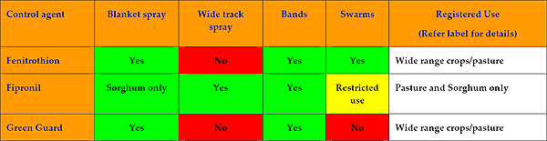

Aircraft Hire arrangements
The APLC has a “Standing Offer” (contract) arrangement with a range of aerial operators including aerial spraying firms and aerial survey operators (fixed wing and helicopter).
Nearly all the aircraft engaged under the standing offer arrangement have a Daily Minimum Flying Charge which usually varies between 1 and 3 hours flying charge/per day (Dry rate). It is expected that the aircraft pilot will be aware of the Daily Minimum Flying Charge.
Under the Standing Offer arrangement all pilots and, if used, other aerial operator staff such as a loader/driver or mobile refueller are entitled to accommodation, meal and incidental costs at the same rates as APLC staff.

Acceptance of aircraft by APLC
Contracted aircraft are initially engaged by APLC Headquarters in Canberra. APLC Canberra initiates the aircraft engagement by exchanging an aircraft acceptance form with the contractor. The form is a checklist to ensure that the aircraft is in accord with specification and the pilot has the necessary experience and qualifications (endorsements) to undertake the task.
Once the acceptance form has been completed the aircraft is deployed to the APLC Locust Control Base. APLC Headquarters faxes a copy of the acceptance form to the OIC at the Locust Control Base and once the aircraft arrives it is cross checked against the acceptance form.
Aircraft which are not in accordance with specification or that are not fit for purpose may be returned to the contractor.

Aircraft Flying Log
The aircraft pilot should ensure that the APLC Flying Log is completed daily by the APLC OIC.
An entry should be made for any days during which the aircraft was available for operational flying but no flying was undertaken (due to, for example, poor weather conditions) and the Minimum Daily Flying Charge recorded.
If an aircraft was unavailable for operational flying (for example, due to unserviceability of the aircraft or pilot illness) the period of the day during which the aircraft was unavailable is to be entered in the Aircraft Flying Log (e.g. Aircraft unavailable due to unserviceability from 8am to 4pm).

Aircraft Fuel
The APLC Standing Offer arrangement has a provision for the aircraft contractor to purchase fuel which is subsequently reimbursed by the APLC at cost and the dry flying rate is charged. This approach is probably most convenient when survey and control operations are based in a location where aviation fuel is available at a bowser. Under some circumstances, usually where major survey and control operations are being conducted from a remote location, the APLC will provide drum fuel for aircraft operations.

1.4 Daily Operational Briefing Checklist
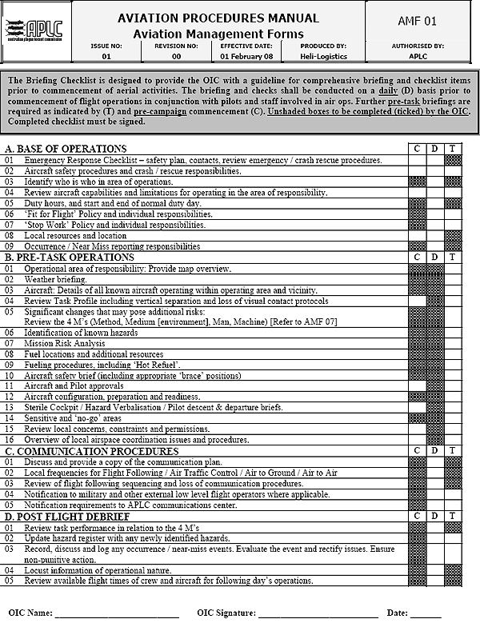

Section 2: Information for Spray Pilots

2.1 Acceptance Checklist: Fixed Wing Spray Aircraft
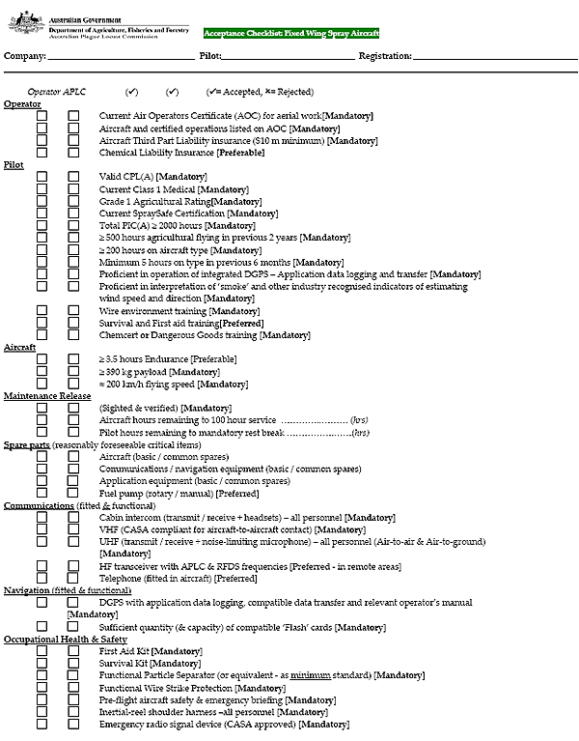
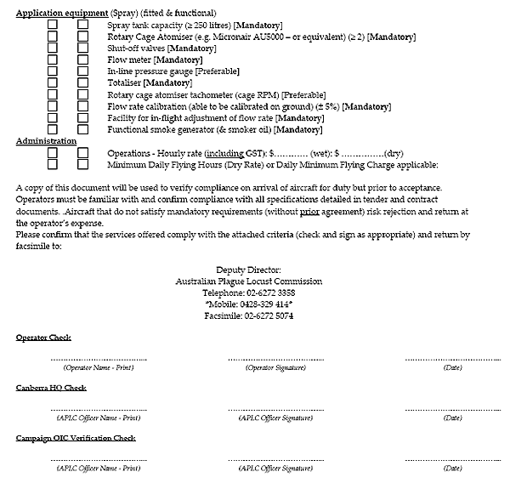

2.2 Locust Control: Instructions to Spray Pilots

General
Spray operations will not begin until the aircraft has been formally accepted and declared ready for operations by an APLC officer. This must include confirmation of a functioning ‘smoker’, DGPS and calibration of the flow rate. The method of calibration shall be agreed between the Campaign OIC and applicator [Refer to APLC Application Manual]. A DGPS must be used for track guidance during application and accurate recording of the position of all spray runs.

Spray Application Records (DGPS)
At the end of each day, you are required to download from the aircraft DGPS and provide the following information to the APLC OIC for each target sprayed:
- target boundary coordinates (logfile);
- number of litres applied;
- flying speed; and
- flow rate
A separate DGPS logfile must be generated for each APLC target. Where aircraft DGPS software can output logfiles directly in GIS format (e.g. ArcView shapefiles), such a format is preferred. Included in the logfile must be a unique number to indicate the pilot’s consecutive target number for each target treated on a single day. When application on an individual target is interrupted (e.g. by the need to refuel or reload additional insecticide), the current logfile should be continued when application is resumed on the relevant target. The APLC will normally provide information on meteorological parameters (e.g wind speed, temperature) which will be amalgamated with the logfile data.

Failure of aircraft equipment
In the event of a failure in the aircraft systems (DGPS or ‘smoker’ or communications or spray system), application is to cease immediately and not resume until acceptable [Refer to APLC Application Manual] interim measures are adopted or equipment is again operational.

Permissions and precautions
It is the joint responsibility of the relevant landholder, the attending APLC officer and the pilot performing the application to ensure that sensitive areas are not treated or directly affected by off-target drift.
- Areas that MUST NOT BE TREATED UNDER ANY CIRCUMSTANCES: any body of water, beehives, property homesteads / public buildings, bus stops or any property that has not granted permission for application;
- Areas MUST ONLY BE TREATED WITH PRIOR CONSENT OF THE LANDHOLDER / MANAGER Obtained by APLC: preferably in writing): National Parks, heritage listed areas and protected sites, livestock, certain crops, neighbouring properties or organic production properties.
When applying fipronil or fenitrothion the APLC requires a minimum 1500 metre buffer zone down wind from the boundary of a target area (e.g. the first spray run).
When applying Green Guard the minimum required downwind buffer zone is 100 metres.

Over flying of water bodies
Pilots must turn off application equipment when over‐flying an area that could result in contamination of recognised hazards that may exist within a treatment area (e.g. farm dams and bodies of surface water).

Communications
The spray pilot must be contactable by radio or mobile phone whilst on standby at the APLC control base.
Once a locust target has been identified by APLC ground or aerial survey the spray pilot will be contacted by radio or phone and provided with the coordinates of the target location, instructions regarding the type and quantity of control agent to be loaded, and any other relevant information.
The spray pilot should confirm the target location and the details of the control agent and provide an ETA for reaching the target location.
The spray pilot should be aware that other APLC survey aircraft (fixed wing spotter or helicopter) may be in the vicinity of the target area. There is also the possibility that other non-APLC aircraft, for example, media aircraft may occasionally be present in the target vicinity.
The spray pilot should notify the approach of the spray aircraft to APLC staff and/or survey aircraft when within 5 nautical miles of the notified target area, establish visual contact with any survey aircraft and maintain safe vertical separation with aircraft in the vicinity of the target area using pre-arranged protocols (refer AMF 01 – Operational Briefing Checklist).
The spray pilot must be contactable by radio [UHF] throughout the spraying operation.
Instructions given by APLC Officers must be followed unless the pilot considers these unsafe. In the event of unresolved disagreement between the APLC Officer and pilot, either the Campaign OIC, Operations Manager or Director must be consulted immediately.

Control Agent Application Parameters
APLC may employ any of a range of control agents and application techniques depending on the prevailing circumstances. You will be informed of the material to be used and provided with the relevant material safety data sheet (MSDS) for your information. The application techniques to be used will be explained at
The desired area dose will vary depending on the agent and method of application employed. Current recommended control parameters to achieve a successful outcome are:
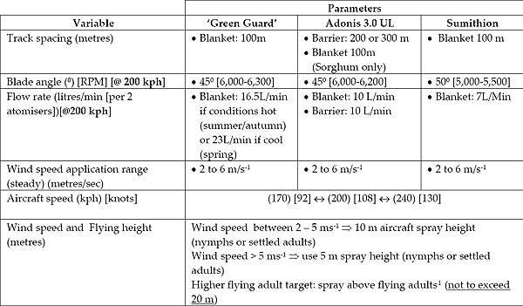
Either the APLC officer in charge of the campaign operation, or the APLC officer at the target site, will advise the desired parameters to be used.
If recommended aircraft speed [200 kph] cannot be achieved, then the flow rate must be varied as indicated below to achieve the desired area dose:
Flow rate = (actual speed/desired speed) x desired flow rate

Target Boundaries
Normally a locust target for aerial spraying will be identified by the APLC through aerial survey using either a fixed wing spotter aircraft (bands) or a helicopter (swarms).
Safe aircraft separation must be maintained between the spray aircraft and other aircraft especially APLC survey aircraft in the vicinity of the target area.
The boundaries of a target area together with any other relevant information on potential aviation and environmental hazards will normally be communicated to the spray pilot by the APLC observer in the survey aircraft.
The survey aircraft will normally fly the boundaries of the target area to assist the pilot of the spray aircraft in locating and demarcating the target boundaries on the spray aircraft GPS.
The APLC officer will normally also indicate the A-B spray line for the first spray application to the spray pilot and request that a first run be made along the A-B line using smoke to recheck wind direction prior to actual release of insecticide.

2.3 Tasking and Safety Direction No. 2: Spray Operations
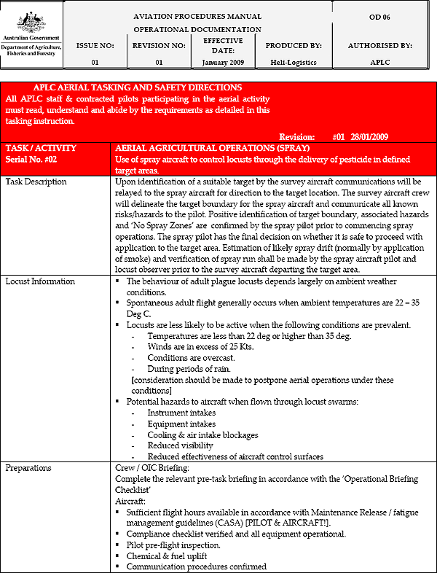
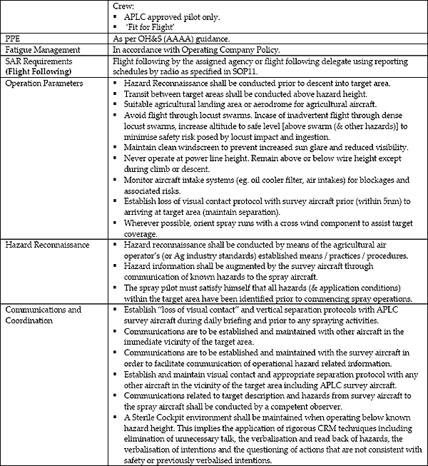

2.4 Aerial spraying checklist
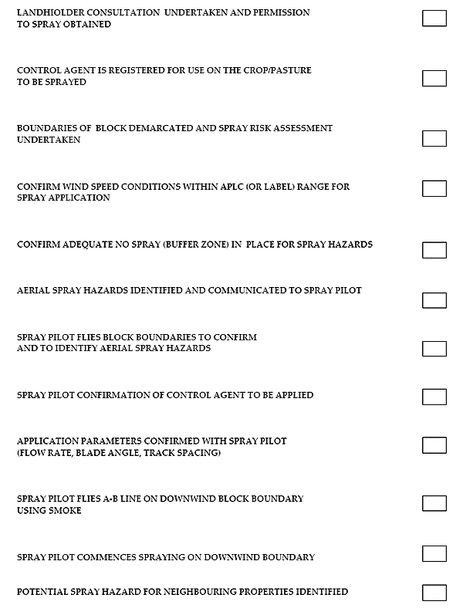

2.5 Fenitrothion: Guideline for control of Australian Plague locust
Fenitrothion (Sumithion ULV) is an organophosphorous insecticide, of moderate mammalian toxicity and acts on the nervous system of the insect. Fenitrothion is registered within Australia for use against locusts on a broad range of crops including cereals, vegetable crops (cabbage, lettuce, tomatoes), fruit crops (cherries, grapes and apples) and pasture and some forage crops. The APLC uses technical fenitrothion (1.23 grams a.i./litre) applied by aircraft as a blanket spray, for the control of both locust bands and swarms. Fenitrothion is highly toxic to aquatic invertebrates and bees and a 1500m buffer is a mandatory (label) requirement for water bodies.

Application technique and parameters
- The APLC uses fenitrothion against both bands and swarms using the same blanket spraying technique
- The standard application parameters are 50 0 blade angle, 7 L/min flow rate with a 100 m track spacing assuming an aircraft speed of 200 km/hr, resulting in a dose of 260g a.i./ha (210ml/ha).
- Wind speeds for application should be within the range of >2m/sec to <6m/sec.

Buffer Zones
- A label requirement is that Fenitrothion is not to be sprayed within 1500m upwind of sensitive areas including wetlands, watercourses or water bodies and human dwellings or within 5km of bee hives.

Withholding periods
- Crops for human consumption: do not harvest for 14 days after application.
- Crops for animal consumption/stockfeed:
  - Pasture/lucerne where stock have not been oversprayed: do not graze for 7 days after application or withhold stock from slaughter for 14 days;
  - Pasture/lucerne where stock have been oversprayed: withhold stock from slaughter for 14 days;
  - Cereal straw and fodder, pasture seed crops, forage crops: Do not graze or cut for stock feed for 14 days after application.

Phytotoxicity
- Fenitrothion is likely to cause phytotoxicity in a number of varieties of sorghum and it is APLC policy NOT to apply fenitrothion to sorghum crops.

Dangerous Good
Fenitrothion is classified as a Dangerous Good: Class 6.1 Toxic

2.6 Fipronil: Guideline for control of Australian Plague locust nymphs
Fipronil (Adonis 3UL) has proven to be highly effective for treating Australian plague locust nymph (band) targets using barrier treatments. The barrier treatment is most efficient against locust bands occurring in pasture in medium to large area blocks (ca 5 to 50km2). It use on small blocks (ca <2km2) is not recommended except in cases where the infestation occurs in a sorghum crop .Fipronil is only registered for application against locusts in pasture and sorghum crops.

DO NOT apply Fipronil:
- against locusts in any crop other than sorghum;
- on any pasture which is used for organic production;
- in designated plains wanderer habitat areas;
- as a blanket treatment (unless the band infestation is located in a sorghum crop)
- In areas where termite mounds are present.

ONLY apply Fipronil with:
- aircraft equipped with Micronair AU5000 rotary atomisers using a 450 blade angle as the standard setting* (with aircraft speed 170‐200 km/h);
- in wind speed between >2 m/s but less than <6m/s;
- a spray buffer zone of 1.5 km;
- the aircraft smoker is to be used to monitor conditions prior to and during application; and
- only as a blanket treatment against bands within a sorghum crop.

Barrier Techniques
- Two techniques can be used:
- Wide interval track spacing (300meters) sprayed conventionally in a crosswind
- Wide interval track spacing (300 metres) with the aircraft spraying “into and down wind”
- Barrier treatments on large (>5 km²) rectangular blocks may be carried out into wind and with a tail wind (using a 300 m spacing) rather than the normal crosswind procedure if this allows the pilot to fly the longest runs. This particular technique is still under evaluation so reports on efficacy would be appreciated. Note that this upwind/downwind technique still requires an environmental assessment of drift risk identical to the assessment used for normal crosswind applications.

Wide interval treatments with Adonis 3UL
Small blocks 0.5-2 km². The use of fipronil for small block treatment is not recommended. If control of a small block comprising a sorghum crop is necessary (due to potential phytotoxicity of fenitrothion) then a fipronil blanket treatment may be undertaken using a 100 m spacing between spray runs, 10 m flying height and total flow rate of 10 L/min, VAR ‐ 110 mL/ha equivalent to an area dose of 1.0 g ai/ha.
Medium sized blocks 2-5 km² in open grassland/pasture. If no scrub/trees present use 300 m spacing, 10 m height & flow rate of 10 L/min. This will result in a mean area dose of 0.33 g ai/ha.
If scrub/trees present use a 200 m spacing, 10 L/min flow rate, mean area dose - 0.5 g ai/ha.
Large blocks > 5 km², open rangeland. Use 300 m spacing, 10 m height & flow rate of 10 L/min, for a mean area dose of 0.33 g ai/ha.
Note: when calibrating for Barrier or Wide Interval treatments calculate the required flow rate using the aircraft speed, a 100 m spacing & a VAR of 0.33 L/ha.

Buffer Zones
- APLC policy is not to apply Fipronil within 1500m upwind of sensitive areas including wetlands, watercourses or water bodies and human dwellings or within 5km of bee hives

Withholding
- Do not graze or cut for stock food for 14 days after application or withhold stock for 21 days after application whichever is appropriate
- Sorghum: do not graze of cut for stock food for 14 days after application.

2.7 Green Guard: Guideline for control of Australian Plague locust nymphs
Green Guard® ULV is a bio-insecticide containing a naturally occurring Australian fungus, Metarhizium anisopliae var. acridum. The product is registered for use against locusts in most, if not all, crop situations and pastures although its primary use by the APLC is the control of nymphs in environmentally sensitive areas, organic farms and against targets where the presence of buffer zones precludes treatment by pesticides or where, for example, the 14 day withholding period would cause severe inconvenience to a landholder.

Pre application measures
- It is essential that the aircraft tank be thoroughly cleaned, preferably by the aircraft company before arrival, before any Green Guard is loaded into the aircraft to avoid the risk of any pesticide residue in the tank resulting in mortality of the Metarhizium (Green Guard) spores.
- If you need to switch from using chemical to Green Guard, you need to wash tank and pump lines thoroughly with two washes of strong detergent (eg truckwash). The wash must be disposed of in the same manner as chemical waste.

Mixing
- The Green Guard concentrate needs to be mixed with summer oil before aerial application is undertaken. Mixing is normally undertaken using a specialised mixing equipment (trailer mounted).
- The procedure is to pump one drum (205 litres) of Summer Spray Oil (Caltex) into the specialised mixing tank then to thoroughly decant 3 pails (3 x 14 litres) of the Green Guard concentrate into the mixing unit. The mixture is thoroughly agitated for at least 10 minutes and then pumped into the (clean) aircraft tank.
- Each batch should only be mixed where it is certain that it can be used within a few hours.
- Each batch of 247 litres (Green Guard plus summer oil) should be sufficient to treat around 490 ha at a dose rate of around 25 grams of spores/ha using the standard application parameters (refer below).

Application
- The standard application parameters are 45° blade angle, 16.6 L/min flow rate with a 100 m track spacing assuming an aircraft speed of 200 km/hr, resulting in a dose of 25 g/ha of spores in 0.5 L oil/ha.
- Wind speeds for application should be within the range of >2m/sec to 6 m/sec.
- The formula for flow rate is:
  - Flow rate (L/min) = Aircraft speed (km/hr) X track spacing (m) X Dose (L/ha)/600
  - Flow rate for slower (170kph) aircraft = 170 km/hr X 100 m X 0.5 L/ha/600= 8500/600= 14.2 L/min
- If using Green Guard in the spring in southern NSW it is recommended the dose rate is increased to around 35g spores in 0.7 L oil/ha.
- The increased dose rate is achieved by using a ratio of 3 pails of Green Guard to one drum of summer oil at the mixing stage and increasing the dose to 0.7 L/ha (flow rate increased to 20-23 L/min, depending on aircraft speed).

Buffer Zones
- A label requirement is that Green Guard is not to be sprayed within 100m upwind of wetlands, watercourses or water bodies. In addition, the APLC does not spray Green Guard within 5 kilometres of bee hives.

Withholding period
- There is no withholding period for crops or stock.

Main APLC uses
- The broad spectrum of crops on which Green Guard can be used, the 100m buffer zone, the absence of any withholding period and the fact it is a bio‐pesticide make Green Guard a very versatile control agent that can be used in situations where other conventional pesticides cannot.
- The APLC mainly uses Green Guard on organic properties (crops and rangelands) and Plains wanderer habitat areas. However, its versatility means that it can be used in situations where, for example, a long withholding period is not acceptable or where the presence of water bodies precludes the use of conventional pesticides

2.8 Malathion: Draft Guideline for control of Australian Plague locust
Malathion (Fyfanon ULV) is an organophosphorus insecticide, of moderatemammalian toxicity and acts on the nervous system of the insect. Malathion is registered for use against Australian plague locust bands on Maize, Sorghum, Pasture seed crops and Pasture. The ULV formulation contains 1,169 g a.i./L.
Currently the APLC is evaluating Malathion for its effectiveness and, hence, this Guideline is a draft only. At present Malathion is only registered for use against Australian plague locust nymphs.
As with fenitrothion, Malathion is highly toxic to aquatic invertebrates, fish and bees. One significant potential benefit of malathion is the very short withholding period (1day) when compared to other locust control agents.

Application technique and parameters
The APLC will undertake trials to evaluate Malathion and to develop appropriate aerial spraying parameters. At present the recommended (label) application rate for Australian plague locust is 700ml/ha. Initially the APLC will apply Malathion as a blanket spray using parameters similar to those used for the application of fenitrothion, that is:
- The standard application parameters are 50° blade angle, 23L/min flow rate with a 100 m track spacing assuming an aircraft speed of 200 km/hr, resulting in a dose of 818 g a.i./ha (700ml/ha).
- Wind speeds for application should be within the range of >2m/sec to <6m/sec.

Buffer Zones
- Whilst there is no mandatory (label) buffer zone specified, the APLC will voluntarily adopt a 1500m buffer upwind of water bodies and 5 km for bee hives.

Withholding periods
- Maize Sorghum, Pastures, Pasture Seed crops: do not graze or cut for stock food for 1 (one) day after application.

Phytotoxicity
- Malathion is registered for use on sorghum.

Dangerous Goods
- Malathion is classified as a Dangerous Goods: Class 9 Miscellaneous (Environmentally Hazardous Substance, Liquid).

Section 3: Information for Fixed-wing spotter pilots

3.1 Acceptance Checklist: Fixed-wing Spotter Aircraft
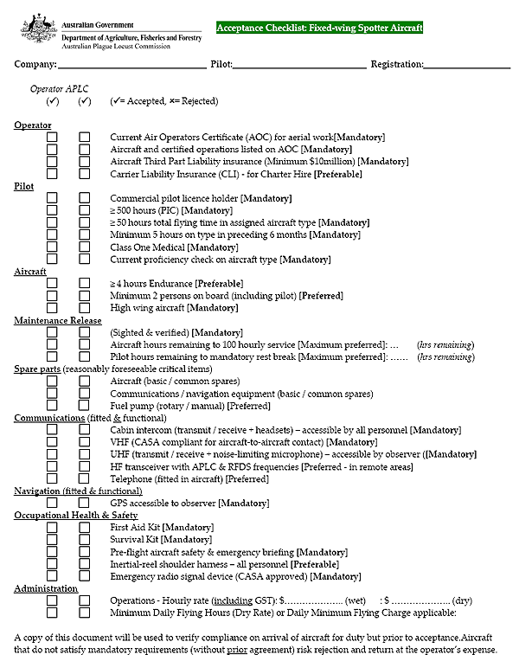
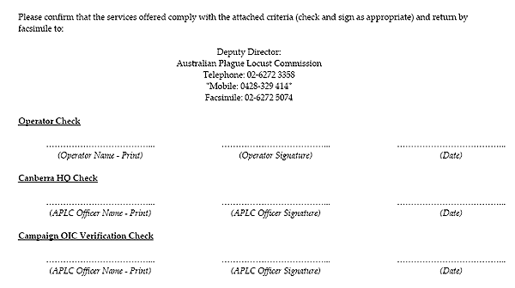

3.2 Tasking and Safety Direction No. 3: Fixed Wing Survey
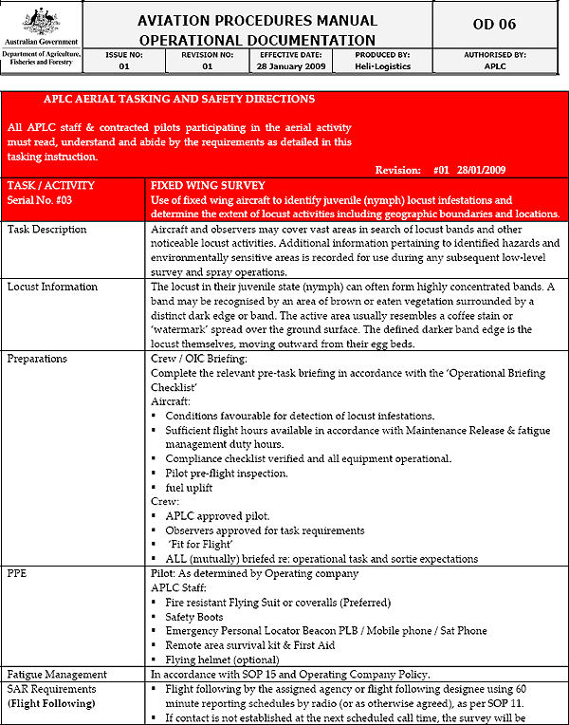
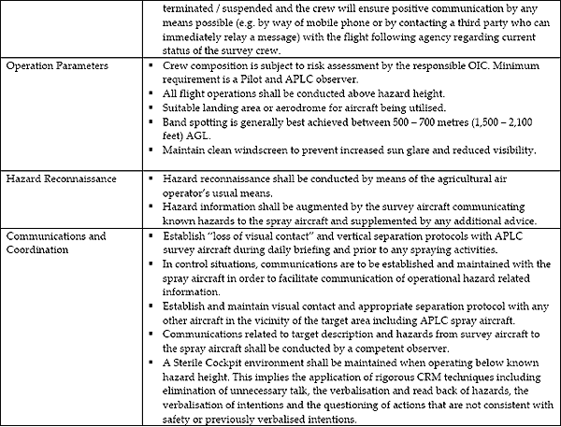

3.3 Pre Flight checklist for aerial survey
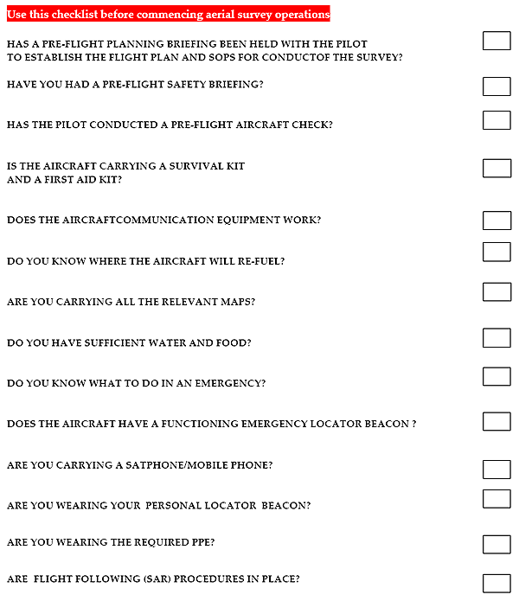

Section 4: Information for Helicopter Survey Pilots

4.1 Survey Helicopter Acceptance Checklist
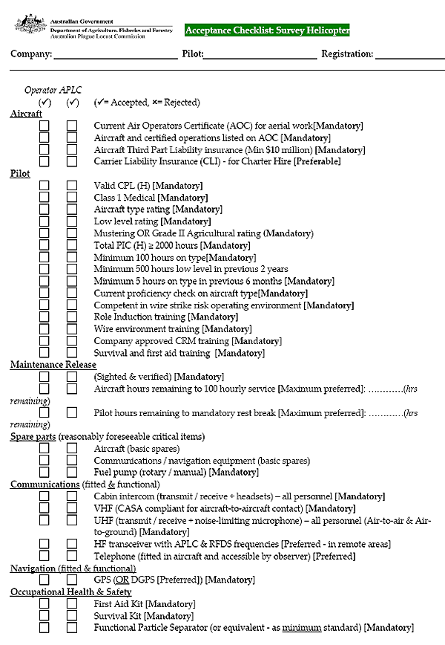
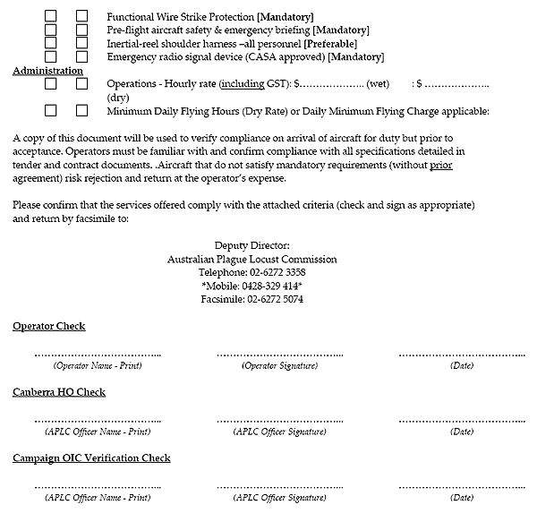

4.2 Tasking and Safety Directions No. 1: Helicopter Survey
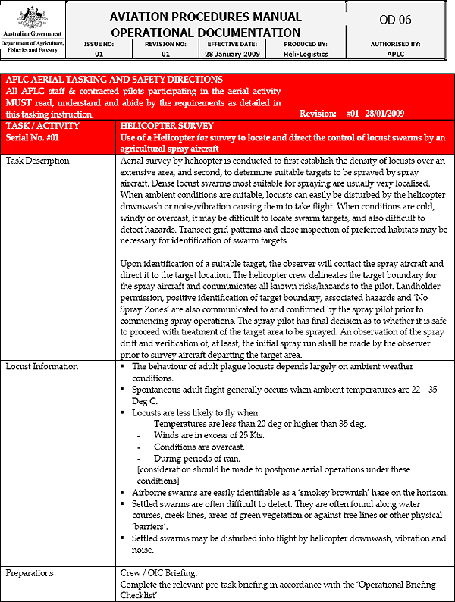
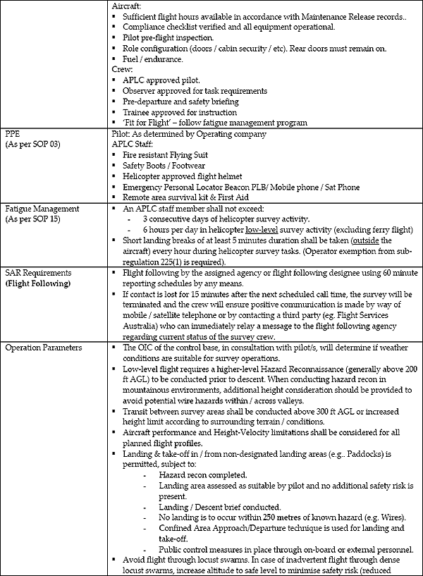
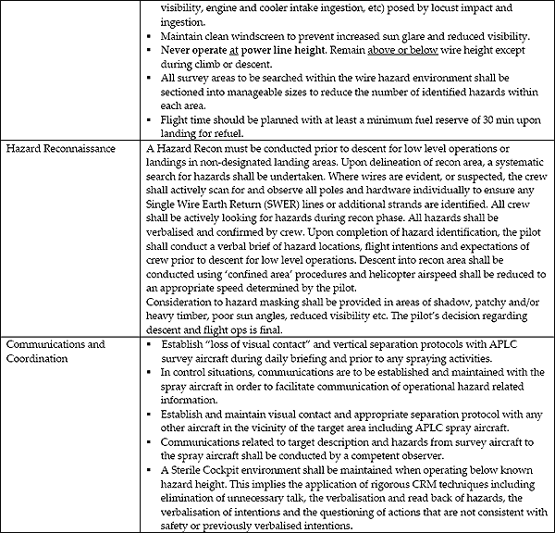

4.3 Pre flight checklist for aerial survey
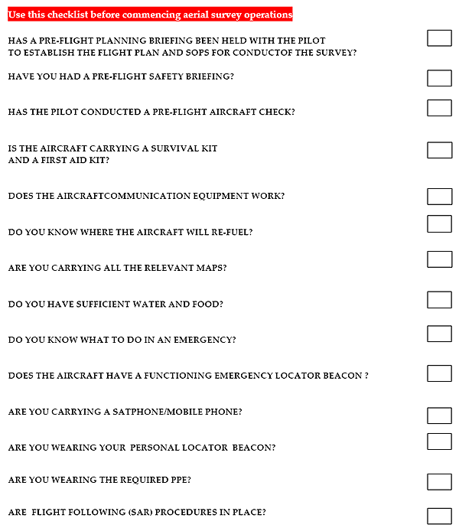

Annex 1: APLC Standard Operating Procedures
