Tuesday, January 5, 2016
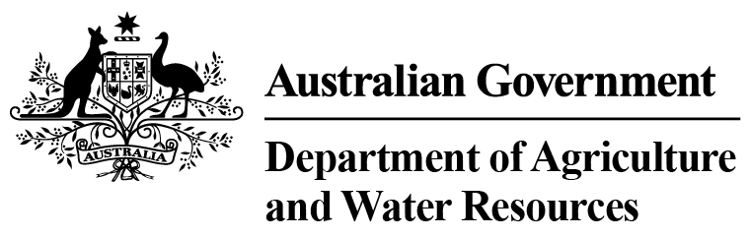 Total Chilled & Frozen Meat Exports by Load Port -- December 2015 -- Tonnes Shipped Weight
EU
Western
Europe
Eastern
Europe
USA
East
USA
West
Canada
East
Canada
West
Japan
Taiwan
Korea
Other
Asia
Middle
East
Other
Dest
State &
Load Port

Total
NSW
NEWCASTLE
0
0
0
0
0
0
0
0
0
0
0
0
0
0
PORT BOTANY
0
0
0
0
0
0
0
0
0
0
0
0
0
0
SYDNEY
638
5
25
3041
2724
487
154
1299
1626
383
4138
1497
923
16940
638
State Total
5
25
3041
154
2724
487
1299
1626
383
4138
1497
923
16940
VIC
PORTLAND
0
0
0
0
0
0
0
0
0
0
0
0
0
0
GEELONG
0
0
0
0
0
0
0
0
0
0
0
0
0
0
MELBOURNE
1030
65
80
12569
5218
797
264
6333
4650
1030
13731
8385
3902
58054
1030
State Total
65
80
12569
264
5218
797
6333
4650
1030
13731
8385
3902
58054
QLD
CAIRNS
0
0
0
0
0
0
0
0
0
0
40
0
0
40
TOWNSVILLE
0
0
0
76
0
0
0
0
0
0
0
0
14
90
BOWEN
0
0
0
0
0
0
0
0
0
0
0
0
0
0
MACKAY
0
0
0
0
0
0
0
0
0
0
0
0
0
0
PORT ALMA
0
0
0
0
0
0
0
0
0
0
0
0
0
0
GLADSTONE
0
0
0
0
0
0
0
0
0
0
0
0
0
0
BRISBANE
1041
77
103
14035
5800
1044
158
17766
12432
2873
14108
2636
1679
73752
1041
State Total
77
103
14111
158
5800
1044
17766
12432
2873
14148
2636
1693
73882
SA
PORT LINCOLN
0
0
0
0
0
0
0
0
0
0
0
0
0
0
ADELAIDE
317
31
0
1388
480
19
14
533
315
259
2666
1295
641
7958
317
State Total
31
0
1388
14
480
19
533
315
259
2666
1295
641
7958
1
Note: Components May Not Add to Totals Due to Rounding

EU
Western
Europe
Eastern
Europe
USA
East
USA
West
Canada
East
Canada
West
Japan
Taiwan
Korea
Other
Asia
Middle
East
Other
Dest
State &
Load Port

Total
WA
GERALDTON
0
0
0
0
0
0
0
0
0
0
0
0
0
0
PORT HEDLAND
0
0
0
0
0
0
0
0
0
0
0
0
0
0
NORTHERN WA
0
0
0
0
0
0
0
0
0
0
0
0
0
0
BUNBURY
0
0
0
0
0
0
0
0
0
0
0
0
0
0
ALBANY
0
0
0
0
0
0
0
0
0
0
0
0
0
0
FREMANTLE/PERTH
98
26
24
648
301
93
153
646
496
175
3221
2488
303
8672
98
State Total
26
24
648
153
301
93
646
496
175
3221
2488
303
8672
TAS
BURNIE
0
0
0
0
0
0
0
0
0
0
0
0
0
0
DEVONPORT
0
0
0
0
0
0
0
0
0
0
0
0
0
0
LAUNCESTON
0
0
0
0
0
0
0
0
0
0
0
0
0
0
HOBART
0
0
0
0
0
0
0
0
0
0
0
0
0
0
BELL BAY
0
0
0
95
19
0
0
0
183
0
52
103
0
452
0
State Total
0
0
95
0
19
0
0
183
0
52
103
0
452
NT
DARWIN
0
0
0
1409
976
0
133
31
165
62
0
0
16
2792
ALICE SPRINGS
0
0
0
0
0
0
0
0
0
0
0
0
0
0
0
State Total
0
0
1409
133
976
0
31
165
62
0
0
16
2792
3124
Australia
204
232
33261
15518
2440
876
26608
19867
4782
37956
16404
7478
168750
2
Note: Components May Not Add to Totals Due to Rounding

