Friday, October 2, 2015
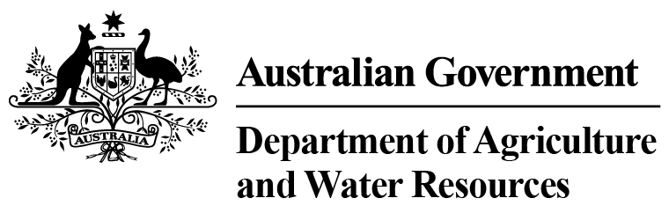
Total Chilled & Frozen Meat Exports by Load Port -- September 2015 -- Tonnes Shipped Weight
EU
Western
Europe
Eastern
Europe
USA
East
USA
West
Canada
East
Canada
West
Japan
Taiwan
Korea
Other
Asia
Middle
East
Other
Dest
State &
Load Port

Total
NSW
NEWCASTLE
0
0
0
0
0
0
0
0
0
0
0
0
0
0
PORT BOTANY
0
0
0
0
0
0
0
0
0
0
0
0
0
0
SYDNEY
420
5
74
2299
1387
160
83
1872
1388
234
3727
1755
882
14286
420
State Total
5
74
2299
83
1387
160
1872
1388
234
3727
1755
882
14286
VIC
PORTLAND
0
0
0
0
0
0
0
0
0
0
0
0
0
0
GEELONG
0
0
0
0
0
0
0
0
0
0
0
0
0
0
MELBOURNE
885
62
145
8488
4703
962
120
5513
2773
815
12351
9327
3831
49975
885
State Total
62
145
8488
120
4703
962
5513
2773
815
12351
9327
3831
49975
QLD
CAIRNS
0
0
0
0
0
0
0
0
0
0
45
0
0
45
TOWNSVILLE
0
0
0
0
0
0
0
0
0
0
0
0
13
13
BOWEN
0
0
0
0
0
0
0
0
0
0
0
0
0
0
MACKAY
0
0
0
0
0
0
0
0
0
0
0
0
0
0
PORT ALMA
0
0
0
0
0
0
0
0
0
0
0
0
0
0
GLADSTONE
0
0
0
0
0
0
0
0
0
0
0
0
0
0
BRISBANE
1244
67
-1
13617
5359
1874
332
19701
10739
2340
16409
3275
1830
76786
1244
State Total
67
-1
13617
332
5359
1874
19701
10739
2340
16454
3275
1843
76844
SA
PORT LINCOLN
0
0
0
0
0
0
0
0
0
0
0
0
0
0
ADELAIDE
602
9
25
476
369
0
57
730
449
131
2062
823
613
6346
602
State Total
9
25
476
57
369
0
730
449
131
2062
823
613
6346
1
Note: Components May Not Add to Totals Due to Rounding

EU
Western
Europe
Eastern
Europe
USA
East
USA
West
Canada
East
Canada
West
Japan
Taiwan
Korea
Other
Asia
Middle
East
Other
Dest
State &
Load Port

Total
WA
GERALDTON
0
0
0
0
0
0
0
0
0
0
0
0
0
0
PORT HEDLAND
0
0
0
0
0
0
0
0
0
0
0
0
0
0
NORTHERN WA
0
0
0
0
0
0
0
0
0
0
0
0
0
0
BUNBURY
0
0
0
0
0
0
0
0
0
0
0
0
0
0
ALBANY
0
0
0
0
0
0
0
0
0
0
0
0
0
0
FREMANTLE/PERTH
109
14
24
110
168
61
80
447
317
158
2786
2308
514
7096
109
State Total
14
24
110
80
168
61
447
317
158
2786
2308
514
7096
TAS
BURNIE
0
0
0
0
0
0
0
0
0
0
0
0
0
0
DEVONPORT
0
0
0
0
0
0
0
0
0
0
0
0
0
0
LAUNCESTON
0
0
0
0
0
0
0
0
0
0
0
0
0
0
HOBART
0
0
0
0
0
0
0
0
0
0
0
0
0
0
BELL BAY
0
0
0
133
19
0
0
0
37
0
40
76
0
305
0
State Total
0
0
133
0
19
0
0
37
0
40
76
0
305
NT
DARWIN
0
0
0
184
57
14
0
81
147
40
41
0
19
583
ALICE SPRINGS
0
0
0
0
0
0
0
0
0
0
0
0
0
0
0
State Total
0
0
184
0
57
14
81
147
40
41
0
19
583
3260
Australia
157
267
25307
12062
3071
672
28344
15850
3718
37461
17564
7702
155435
2
Note: Components May Not Add to Totals Due to Rounding

