Drought Pilot Review Panel: a review of the pilot of drought reform measures in Western Australia

2011
Contents
Terms of reference 1
Scope of the review 1
Drought Pilot Review Panel 1
Executive Summary 2
Recommendations 4
Section 1 Introduction 6
1.1 Background 6
1.2 Drought and risk in Australian agriculture 9
1.3 The pilot of drought reform measures 11
1.4 The pilot region (2010–11) 12
1.5 The pilot programs (2010–11) 16
Section 2 Farm Planning 19
Key points 19
2.1 Rationale and objectives 19
2.2 Program description 20
2.3 Participant snapshot 20
2.4 Targeting 23
2.5 Preliminary outcomes 24
2.6 Motivation to participate 28
2.7 Maintaining momentum 30
2.8 Delivery 31
2.9 Costs 37
2.10 Conclusions and recommendations 38
Section 3 Building Farm Businesses 40
Key points 40
3.1 Rationale and objectives 40
3.2 Program description 40
3.3 Participant snapshot 41
3.4 Targeting 42
3.5 Preliminary outcomes 43
3.6 Delivery 47
3.7 Conclusions and recommendations 47
Section 4 Farm Family Support 50
Key points 50
4.1 Rationale and objectives 50
4.2 Program description 51
4.3 Participant snapshot 52
4.4 Targeting 55
4.5 Preliminary outcomes 56
4.6 Delivery 57
4.7 Application process 58
4.8 Payments and eligibility criteria 60
4.9 Reconciliation payments 65
4.10 Mutual responsibility 65
4.11 Training and advice component 70
4.12 Ancillary benefits 71
4.13 Time-limited support 71
4.14 Costs 72
4.15 Conclusions and recommendations 72
Section 5 Farm Social Support 74
Key points 74
5.1 Rationale and objectives 75
5.2 Rural Support Initiative 76
5.2.1 Objectives 76
5.2.2 Program description 76
5.2.3 Participant snapshot 76
5.2.4 Preliminary outcomes 79
5.2.5 Delivery 79
5.2.6 Costs 81
5.2.7 Conclusions 81
5.3 Online Counselling for Rural Young Australians Initiative 82
5.3.1 Objectives 82
5.3.2 Program description 82
5.3.3 Participant snapshot 82
5.3.4 Preliminary outcomes 82
5.3.5 Delivery 83
5.3.6 Costs 84
5.3.7 Conclusions 84
5.4 Rural and Regional Family Support Service 84
5.4.1 Objectives 84
5.4.2 Program description 84
5.4.3 Participant snapshot 85
5.4.4 Preliminary outcomes 86
5.4.5 Delivery 87
5.4.6 Costs 89
5.4.7 Conclusions 89
5.5 Overall conclusions and recommendations for Farm Social Support 90
Section 6 Stronger Rural Communities 91
Key points 91
6.1 Rationale and objectives 91
6.2 Program description 92
6.3 Participant snapshot 92
6.4 Delivery 94
6.5 Costs 96
6.6 Preliminary outcomes 96
6.7 Other government support to increase community resilience 98
6.8 Conclusions 98
Section 7 Farm Exit Support and Beyond Farming 98
Key points 98
7.1 Rationale and objectives 99
7.2 Farm Exit Support 99
7.2.1 Program description 99
7.2.2 Participant snapshot 100
7.2.3 Targeting 100
7.2.4 Preliminary outcomes 100
7.2.5 Eligibility criteria 101
7.2.6 Delivery 102
7.2.7 Costs 102
7.2.8 Links to other programs 102
7.2.9 Conclusions 103
7.3 Beyond Farming 103
7.3.1 Program description 103
7.3.2 Participant snapshot 103
7.3.3 Targeting 103
7.3.4 Preliminary outcomes 104
7.3.5 Delivery 104
7.3.6 Costs 105
7.3.7 Links to other programs 105
7.3.8 Conclusions 105
Section 8 Other measures 105
Key points 105
8.1 Introduction 106
8.2 Tax provisions 106
8.2.1 Farm Management Deposits 106
8.2.2 Other tax provisions 109
8.3 Research and development 110
8.4 Seasonal forecasting 111
8.5 Payments for ecosystem services 111
8.6 Multi-peril crop insurance 112
8.7 Government-supported loan arrangements 113
Appendix A: Abbreviations 114
Appendix B: Biographies of panel members 115
Appendix C: Consultations with pilot participants and other stakeholders 115
Appendix D: Submissions received by the Drought Pilot Review Panel 117
Appendix E: Tax provisions for primary producers 119
Provisions directly supporting the drought pilot objectives 119
General tax provisions available to primary producers 123
References 130

List of Figures
Figure 1.1: Industry volatility, 1974–75 to 2003–04 10
Figure 1.2: Comparison of price and yield variability of wheat 11
Figure 1.3: The pilot region (2010–11) 13
Figure 1.4: Local government areas in the pilot region 14
Figure 1.5: Number of farm businesses by local government area 15
Figure 1.6: Pilot region rainfall 16
Figure 2.1: Number of Farm Planning participants by local government area 21
Figure 2.2: Use of strategic business plans by participants before and after program 26
Figure 2.3: Confidence in future viability of farm business 26
Figure 2.4: Main motivation to participate in the Farm Planning program 28
Figure 2.5: Confidence in developing or updating a succession plan 35
Figure 3.1: Building Farm Businesses grant recipients by local government area 42
Figure 4.1: Farm Family Support recipients by local government area 53
Figure 4.2: Payment rates for Farm Family Support recipients to 31 May 2011 60
Figure 4.3: Net assets of Farm Family Support recipients to 31 May 2011 62
Figure 5.1: Number of Rural Support Initiative contacts with clients by local government area and locations visited by Australian Government Mobile Office 78
Figure 5.2: Number of clients registered with the Rural and Regional Family Support Service by local government area 86
Figure 6.1: Stronger Rural Communities applications and grants by local government area 93
Figure 8.1: Number of FMD accounts by deposit value 108

List of Tables
Table 2.1: Age of Farm Planning participants compared to pilot region and Australia 22
Table 2.2: Gender of Farm Planning participants compared to pilot region and Australia 23
Table 3.1: Building Farm Businesses funding ($ millions) 41
Table 3.2: Building Farm Businesses grants—funded activities 43
Table 4.1: Farm industries of Farm Family Support recipients compared with other regions 54
Table 4.2: Age of Farm Family Support recipients compared with other regions 54
Table 4.3: Gender of Farm Family Support recipients compared with other regions 55
Table 4.4: Action Plans—preferred methods to improve financial position to 31 May 2011 68
Table 4.5: Action Plans—specific objectives to improve circumstances to 31 May 2011 69
Table 4.6: Action Plans—advice and training options identified to 31 May 2011 70
Table 6.1: Stronger Rural Communities grant recipients 94
Consultations with pilot participants, 18–21 April 2011 115
Consultations with delivery organisations and other stakeholders, 2–18 May 2011 116

Terms of reference

Scope of the review
The review of the pilot of drought reform measures in Western Australia will focus on the efficiency, effectiveness and appropriateness, and preliminary outcomes of the pilot measures.
It will consider the capacity of the pilot measures, over the long-term, to:
- improve farmers’ ability to adapt and to manage farm risks
- support farmers’ sustainable management of natural resources
- deliver more effective and equitable social support for farming families and rural communities.
Acknowledging the short timeframe of the pilot and the review, the review will:
- examine the efficiency, effectiveness and appropriateness, and preliminary outcomes of each measure of the pilot against its objective
- consider the preliminary outcomes of each measure and the overall pilot in terms of making progress towards long-term reform outcomes
- examine the effectiveness of the delivery model of each measure
- make recommendations about how individual measures could be designed and delivered more efficiently and effectively.

Drought Pilot Review Panel
The Drought Pilot Review Panel, comprising Mr Mick Keogh (Chair), Ms Sue Middleton and Mr Robert Granger, was established in February 2011 to undertake a review of the pilot. The panel’s task was defined by its terms of reference, which were agreed by the Australian and Western Australian governments. A short biography of each panel member is at Appendix B.
The review panel consulted widely during the review. During April 2011, the panel travelled to the pilot region to talk directly to pilot participants about their experiences with the programs at a series of forums. During May 2011, the panel returned to Western Australia and also travelled to Canberra to meet with delivery organisations, industry groups, banks, and Australian and state government agencies. Details of the panel’s consultation meetings are at Appendix C.
The panel also released an issues paper calling for written submissions from individuals, groups and organisations that had participated or were interested in the pilot. In response, the panel received 55 submissions, listed at Appendix D.
The panel was supported in its work by a small secretariat from the Australian Government Department of Agriculture, Fisheries and Forestry.

Executive Summary
In response to the national review of drought policy, the Australian and Western Australian governments announced in May 2010 a pilot of drought reform measures in part of Western Australia. The budget for the one-year pilot was $23 million, with $18 million contributed by the Australian Government and $5 million by the Western Australian Government.
Other drought support measures provide crisis support to farm businesses experiencing drought, rather than assisting farm business managers to better prepare for drought. The pilot was to test measures designed to better support farmers, their families and rural communities in preparing for future challenges. It also trialled services for farming families and rural communities that were designed to provide more effective social support.
In February 2011, the Australian and Western Australian governments announced arrangements for an independent review of the drought pilot, and appointed the Drought Pilot Review Panel. In conducting the review, the panel visited a number of communities across the pilot region to talk with pilot participants. The panel also met with program delivery partners, industry organisations, banks, Australian and state government agencies and other interested parties in Perth and Canberra. The panel received more than 50 written submissions from stakeholders.
The panel was satisfied that the pilot was implemented as intended and noted the strong demand for many of the pilot programs. Almost 400 farm businesses developed or updated strategic farm plans as part of the Farm Planning program, over 120 farm businesses received Building Farm Businesses grants of up to $60 000, and over 400 farm families experiencing financial hardship received Farm Family Support (income support). Social support services were also provided to those in need across the pilot region.
The panel believes that an income support safety net for farm families in hardship that is available based on demonstrated individual need, rather than a climatic trigger, should be the foundation of any future national drought policy. The panel considers the Farm Family Support program to be an appropriate means of providing this safety net. The emphasis on mutual responsibility to help farm families to realistically assess their financial position and take steps to become more self reliant is a critical element of the safety net.
This safety net should also be complemented by adequately funded social and mental health support programs that are available at all times, not just during drought or other crises. The panel noted the strong demand for the social support services available during the pilot and believes this reflected an underlying demand for mental health services, counselling and other social support services that had not been previously met. Providing outreach services is an integral part of tailoring social support services to farm families and rural communities and should continue.
Furthermore, the panel considers that social support services should be embedded in rural communities—making them available alongside existing community services and at community events—to increase people’s confidence in accessing them.
The panel recognises the importance of farm businesses maintaining adequate financial resources to manage risk. To this end, farmers should continue to be encouraged to utilise the Farm Management Deposits (FMD) scheme, which provides tax incentives for farmers to put money aside in good times to draw on during the tough times. The FMD scheme in its current form is appropriate in the panel’s view.
The panel concluded that the Farm Planning program dealt with appropriate and important aspects of running a farm business and believes its implementation and delivery was carried out professionally. The panel also considered that the Farm Planning program provided a good starting point for farm businesses looking to improve their practices, but that pathways and incentives to encourage ongoing training and farm plan implementation are needed.
The panel is mindful that other states and territories are watching the pilot’s progress with interest, given the backdrop of ongoing consideration of national drought policy reform. The panel notes that other jurisdictions may favour different approaches to deliver strategic planning programs for farm businesses. The panel believes it would be appropriate for other jurisdictions to build on their existing approaches to achieve cost effectiveness in any national roll-out of a government-supported strategic farm business planning program.
While the grants available under the Building Farm Businesses program were a strong incentive for farmers to participate in the Farm Planning program, the panel sees little merit in continuing the Building Farm Businesses program in the context of any future national drought policy. The panel considers that most of the activities funded with Business Adaptation Grants are unlikely to help farm businesses better prepare for future challenges such as drought, climate variability and reduced water availability.
Some activities funded by Landcare Adaptation Grants will have lasting public benefits, such as the establishment and protection of native vegetation, and the repair of degraded land. However, many of the activities funded by these grants appear to have predominantly private benefits. Better alignment with existing natural resource management priorities and programs is needed to ensure that funded activities deliver clear and lasting benefits for the community.
The Stronger Rural Communities program provided grants to rural communities to build social capital. The panel considers that the sorts of activities funded would more appropriately be pursued under a regional development platform rather than through drought programs. The panel noted that this program was to be replaced by other measures under the extension to the pilot into 2011–12.
The Farm Exit Support program received a degree of interest but, as for previous exit programs, the panel noted that exit packages alone are not an inducement to leave farming for most farmers because they do not address the non-monetary reasons why farmers prefer to remain on their farms. The Beyond Farming program sought to address the non-monetary reasons for staying on-farm but the panel felt the program needed more time to become integrated into the community.
The panel received a number of submissions that argued for ongoing business support, enhanced taxation measures, and government supported loans. The panel recognises these calls but also notes that taxation measures that help farm businesses to account for seasonal and other variations in their income are already in place. The panel further notes that there has been interest expressed in multi-peril crop insurance and other risk management approaches and that commercial companies are looking to establish more risk products for farm businesses.
The panel heard from many program participants, service delivery agencies and interested observers that badging the pilot as ‘drought’ support hindered uptake and interest. The panel’s recommendations on income and social support measures reflect its view that these programs should be available irrespective of seasonal conditions.
The panel concludes that the following measures would represent a robust future policy platform:
- an income support safety net for farm families in hardship that is available based on demonstrated individual need
- the permanent presence of social support services delivered via outreach to people in rural communities
- continuing opportunities to engage in and implement strategic farm business planning
- ongoing access to the FMD scheme and existing tax incentives for primary producers.

Recommendations
Recommendation 2.1: Governments should support strategic farm business planning as a means of improving resilience and adaptability in the farm sector.
Recommendation 2.2: Strategic farm business planning programs supported by government should integrate all critical elements of operating a farm business, including financial planning, natural resource management, managing the impact of a changing climate, work-life balance, farm family wellbeing and succession planning.
Recommendation 2.3: Before any national roll-out of a strategic farm business planning program, an audit of similar programs Australia-wide should be undertaken to clearly identify current resourcing to avoid duplication and to coordinate delivery for any future initiatives.
Recommendation 2.4: Government-supported training in strategic farm business planning should be continuously available to enable farm businesses to undertake such training when it best suits their circumstances.
Recommendation 2.5: Any future government platform for the delivery of training in strategic farm business planning should encourage participation by women, recognising their role in facilitating important farm business changes.
Recommendation 2.6: Any future strategic farm business planning program should include follow up incentives to encourage participants to update and implement their strategic plan over the longer term and to foster a culture of continuous learning.
Recommendation 2.7: Any incentives to encourage participation in strategic farm business planning courses should reinforce participant commitment to outcomes from the planning process.
Recommendation 2.8: Training in strategic farm business planning should be offered in a way that takes account of the variation in participant skills and knowledge, with different streams for participants with entry level and more advanced skills.
Recommendation 3.1: The Building Farm Businesses grants program should not form part of future drought policy.
Recommendation 3.2: Any future investment to assist farm businesses to become more resilient should be better targeted at activities that deliver lasting benefits that help farmers to better manage and prepare for future challenges like drought, climate variability and reduced water availability. Such activities may include:
- further training, especially in managing the risks posed by drought, climate variability and reduced water availability
- trialling innovations that draw on research and development relevant to the program’s objectives
- activities that help farmers to access alternative income streams, such as payments for ecosystem services
- natural resource management activities that are closely aligned with state and national priorities and programs, and deliver clear and lasting public benefits.
Recommendation 4.1: Temporary income support for farm families experiencing hardship that is available based on demonstrated individual need should be the foundation of any reform of national drought policy.
Recommendation 4.2: Any future income support program for farm families should be underpinned by adequately resourced Centrelink outreach services that provide assistance to clients in the home, at local venues and via the Australian Government Mobile Office.
Recommendation 4.3: In any future income support program for farm families, more complete guidance on the application process, such as an online tool, should be developed to better inform applicants about the information needed to support their application.
Recommendation 4.4: The hardship provisions that are applied by Centrelink in some circumstances for other government support programs should also be considered for application in the case of longstanding beneficiary loans associated with family trust structures.
Recommendation 4.5: The merits of establishing a reconciliation payment process should be considered for any future income support program for farm families.
Recommendation 4.6: An assessment of the Farm Financial Assessment and Action Plan processes should be undertaken during the extended pilot in Western Australia to determine their effectiveness.
Recommendation 5.1: Social support services, including counselling, information and referral, should be available and accessible to those in need at all times and not just during crisis events.
Recommendation 5.2: The outreach model of providing direct services to farming families and rural communities, in the home, workplace or another local venue, should be part of any rural and remote social support service and must be appropriately resourced.
Recommendation 5.3: Social support services should be promoted through local and regional networks and established alongside existing community services.
Recommendation 5.4: Delivery agencies should continue to improve communication and coordination across the range of social support services provided.

Introduction

Background
Drought policy in Australia can be traced back to the early 1900s, with the focus of support changing over time, from ‘drought proofing’ through irrigation to direct financial assistance to help primary producers through hard times. Australian Government drought support is currently delivered through the Exceptional Circumstances (EC) system, which relies on the declaration of a drought or other adverse event in a specific region before farmers in that region can access support. A brief history of drought policy in Australia is set out in Box 1.1.
Box 1.1: History of drought policy in Australia
Drought policy in the middle of the 20th century focused on attempts to ‘drought proof’ agriculture through the expansion of irrigation. In 1971, government policy shifted to recognise drought as a natural disaster, enabling support for those affected to be provided under the joint Commonwealth-state Natural Disaster Relief and Recovery Arrangements.
In 1989, drought was removed from these arrangements and a review undertaken, which determined that previous drought policy was poorly targeted, distorted farm input prices and worked as a disincentive for farmers to prepare for drought. The response to this review was the National Drought Policy, announced in 1992. The objectives of this policy were to:
- encourage primary producers and other sections of rural Australia to adopt self-reliant approaches to managing for climate variability
- facilitate the maintenance and protection of Australia’s agricultural and environmental resources base during periods of climatic stress
- facilitate the early recovery of agricultural and rural industries, consistent with long-term sustainable levels.
Under the National Drought Policy, a number of assistance programs were introduced, including the Rural Adjustment Scheme, which offered grants and interest rate subsidies and the Drought Relief Payment, which provided income support for farmers within declared EC areas. In 1997 these programs were replaced by EC Interest Rate Subsidies and the EC Relief Payment.
The current definition of ‘exceptional circumstances’ was developed in 1997. For an event to be declared an exceptional circumstance, it must:
- be rare and severe, that is it must not have occurred more than once on average in every 20 to 25 years and must be of a significant scale
- result in a rare and severe downturn in farm income over a prolonged period of time (that is, greater than 12 months)
- not be predictable or part of a process of structural adjustment.
Eligibility criteria and various other provisions of EC programs have been adjusted from time to time since 1997, but EC arrangements have remained largely unchanged.
Other programs were also established under the National Drought Policy between 1996 and 2000, including the Farm Management Deposits scheme, the Rural Financial Counselling Service, FarmBis and FarmHelp. FarmBis and FarmHelp were discontinued in 2008 and FarmReady was introduced in their place. Programs under the National Drought Policy provide household assistance to farm families and support for training and financial counselling.
A range of other support programs, not directly associated with the National Drought Policy, are also available to farmers through the Australian and state and territory governments.
In 2008, the Primary Industries Ministerial Council agreed that the current EC arrangements are no longer appropriate in the context of a changing climate and that an improved drought policy is needed to ensure farmers place a greater emphasis on preparation for seasonal and climatic variability. The council’s principles for drought policy reform, which it reconfirmed in 2011, are set out in Box 1.2.
Box 1.2: Primary Industries Ministerial Council principles for drought policy reform
In April 2011, the Primary Industries Ministerial Council reconfirmed its principles for drought policy reform. The principles are:
- there should no longer be Exceptional Circumstances declarations or ‘lines on maps’. Instead, governments should focus on addressing the specific needs of farming families, farming businesses and farming communities
- acknowledgement that drought is just one of a number of hardships that can adversely impact farmers
- recognition of the important role of farmers as the nation’s food producers
- future farm family welfare assistance should require a level of mutual responsibility
- for access to the income support system, farming families should have a temporary period of exemption from the normal assets tests for farm assets, but otherwise receive the same access rights as the wider community
- government farm business support should assist farming businesses plan and prepare for the future. Farm business support will be based on a willingness by those businesses to prepare for the impacts of drought and climate change
- the role of farmers in natural resource management and their role in maintaining vibrant rural communities
- the importance of maintaining and supporting the natural resource base during drought and climate change
- government policies and programs should support farming communities to prepare for drought and enhance their long-term sustainability and resilience.
In response to the widely accepted need for reform, the Australian Government commissioned a national review of drought policy, which was conducted during 2008–09. The review found that drought conditions in Australia were projected to occur more often and be more severe in key agricultural production areas and that drought policy should be restructured to better help farmers and farm families plan and prepare for drought (see Box 1.3).
Box 1.3: Summary of findings from the national review of drought policy
The national review of drought policy included a climatic assessment by the Bureau of Meteorology and CSIRO, a social assessment by an expert social panel and an economic assessment by the Productivity Commission.

Climatic assessment
The Bureau of Meteorology and CSIRO climatic assessment found that:
- there is an increased risk of severe drought projected over the next 20–30 years
- the current definition of ‘exceptional circumstances’ based on the historical climate record is out of date
- farmers need access to better information about climate change preparedness.

Social assessment
The expert social panel’s assessment of the social impacts of drought found that:
- improved drought policy must focus on preparing for drought and planning for personal and family wellbeing
- crisis-framed assistance in times of difficulty should be replaced with early intervention to counteract the worst effects of drought.

Economic assessment
The Productivity Commission’s inquiry into the economic aspects of government drought support found that:
- the current policy of EC declarations and related drought assistance programs does not help farmers improve their self-reliance or climate change management
- EC Interest Rate Subsidies and state transaction-based subsidies (such as for fodder and transport) are ineffective, perversely encourage poor management practices, and should be terminated
- EC Relief Payments are inequitable as they are limited to those in drought-declared areas, ignore hardship elsewhere or for other reasons, and should therefore be replaced.
In response to the findings of the national drought policy review the Australian and Western Australian governments agreed to conduct a pilot of drought reform measures in part of Western Australia. The Drought Pilot Review Panel was asked to review the pilot to inform further government consideration of reforms to drought policy.

Drought and risk in Australian agriculture
As the history of drought policy in Australia highlights, over an extended period of time governments and those involved in agriculture have grappled with how best to manage the risks associated with drought in Australian agriculture. Part of the reason for the continuing focus on these issues is the degree of income volatility faced by businesses operating in the agriculture sector in Australia. This volatility is not solely due to drought, although drought is a significant factor, especially for broadacre farm businesses.
Analysis by the Productivity Commission highlights the degree of volatility in agriculture relative to other sectors of the Australian economy (see Figure 1.1).
Figure 1.1: Industry volatility, 1974–75 to 2003–04
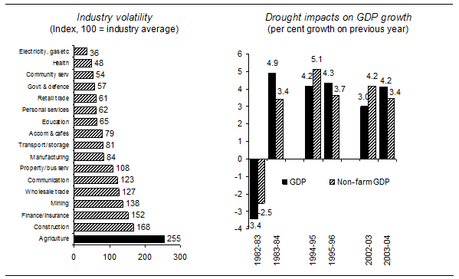
Industry volatility is calculated by taking the standard deviation of the percentage difference between actual and trend annual output (chain-volume index, 2002-03 prices) for every year from 1974-75 to 2003-04 for all 17 ANZSIC industry divisions. Data are indexed to the industry average and ranked. Trend data are estimated using a Hodrick-Prescott smoothing filter.
Data source: ABS (Cat. no. 5204.0).
Recent reports published by the Organisation for Economic Co-operation and Development (OECD) highlight, through the example of wheat, that Australian farmers face both yield and price volatility greater than that faced by farmers in many overseas locations (see Figure 1.2).
Figure 1.2: Comparison of price and yield variability of wheat
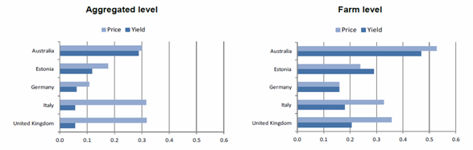
The data confirms that Australian farmers operate businesses in a more volatile environment than most other businesses in Australia, and also experience more yield and price volatility than most other farmers do internationally. The OECD data also shows that in Australia a larger proportion of farmers are often exposed to the same risk.
Despite this volatile environment, Australian farmers are very adept at managing these risks without the levels of government assistance provided to farmers in other nations. Australian farmers receive lower levels of government funded support than farmers in any other OECD nation, except for New Zealand, and have developed a range of different ways to successfully manage the risks faced by their businesses. As the Productivity Commission recently highlighted, more than 70 per cent of Australian broadacre and dairy farmers received no government drought support over the period from 2002–03 to 2007–08, despite this period being considered by many to be the worst period of extended drought in southern Australia for over 100 years.
Against this background, the pilot of drought reform measures in Western Australia needs to be considered in the context of a desire by governments to develop an improved policy framework to enable Australian farmers to better manage risk, rather than as an attempt to simply reduce government expenditure in this area.

The pilot of drought reform measures
The pilot of drought reform measures in Western Australia was established to test programs designed to better support farmers, their families and rural communities in preparing for future challenges, rather than waiting until they are in crisis to provide assistance. The drought pilot also involved a trial of alternative means of delivering social services for farm families and rural communities. The measures included in the pilot aimed to achieve the following outcomes:
- farmers and farm families can better adapt and adjust to the impacts of drought, increased climate variability and reduced water availability
- a more effective social support system for farming families and communities
- farmers are encouraged to adopt self-reliant approaches to managing farm risks
- farmers are encouraged to more sustainably and efficiently use Australia’s natural resource base and water resources.
In line with these outcomes, much of the focus of the pilot has been on helping farm businesses to prepare for and manage risk.
The pilot began on 1 July 2010 and was originally scheduled to run until 30 June 2011. The budget for the one-year pilot was $23 million, with $18 million contributed by the Australian Government and $5 million by the Western Australian Government. The pilot has since been extended to 30 June 2012 and expanded to cover more of Western Australia. Given the extension of the pilot for a second year and the timing of this review, the focus has necessarily been limited to reviewing the preliminary outcomes of the first year of the pilot.

The pilot region (2010–11)
The 2010–11 pilot region (see Figure 1.3) incorporated the wheatbelt area in south-western Western Australia, the rangelands area and the irrigated farming district around Carnarvon. The main farming activities undertaken in these areas include cropping (particularly grains, oilseeds and pulses), livestock (mainly beef cattle and/or sheep) and horticulture. These activities are typical of those undertaken by approximately 85 per cent of farm businesses in Australia. None of the pilot region was EC declared, but it did include areas that had been EC declared in the past as well as areas that had not. The pilot region covered 53 per cent of Western Australia’s land mass and 69 per cent of all agricultural land in the state.
Figure 1.3: The pilot region (2010–11)
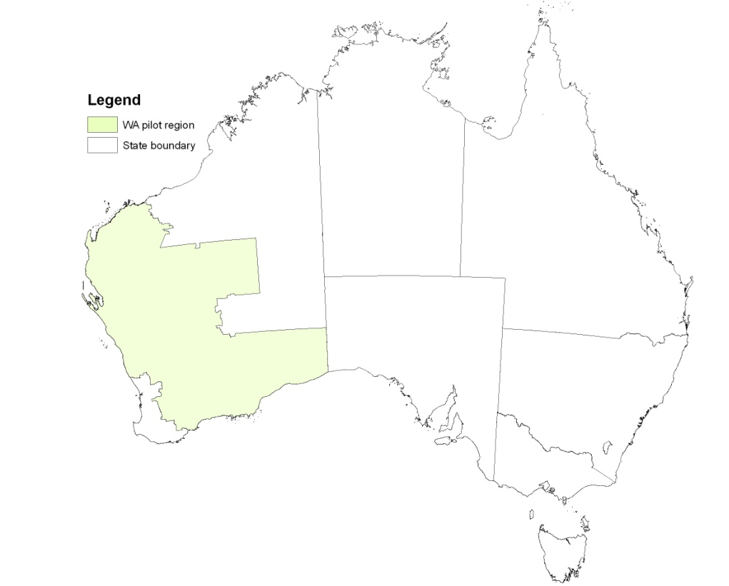
The pilot region comprised 67 local government areas (see Figure 1.4) and included approximately 6000 farm businesses (43 per cent of farm businesses in Western Australia).
Figure 1.4: Local government areas in the pilot region
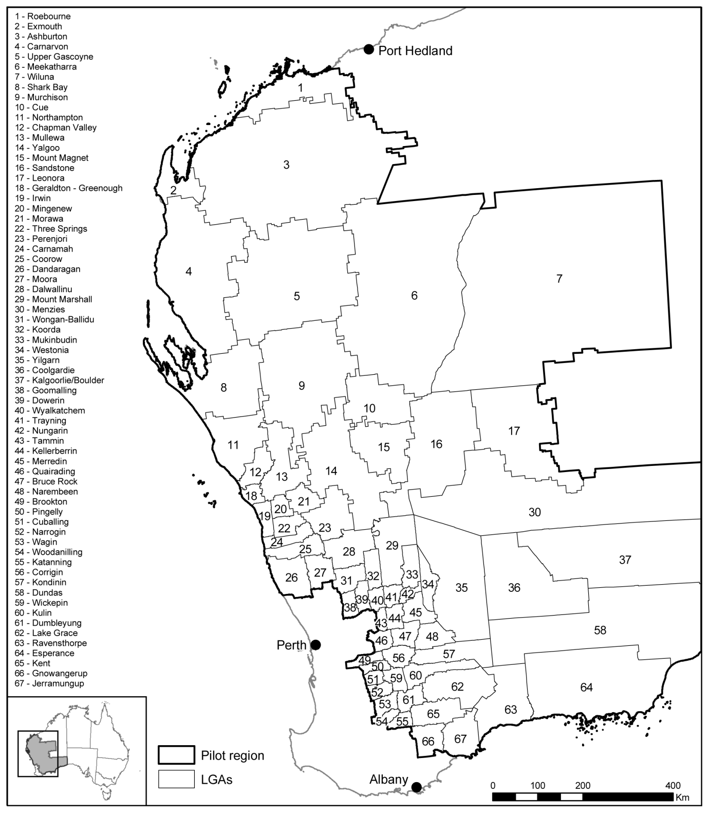Source: ABARES.
Farm businesses within the pilot region are concentrated in the wheatbelt area, with much lower numbers of farm businesses in the rangelands (see Figure 1.5).
Figure 1.5: Number of farm businesses by local government area
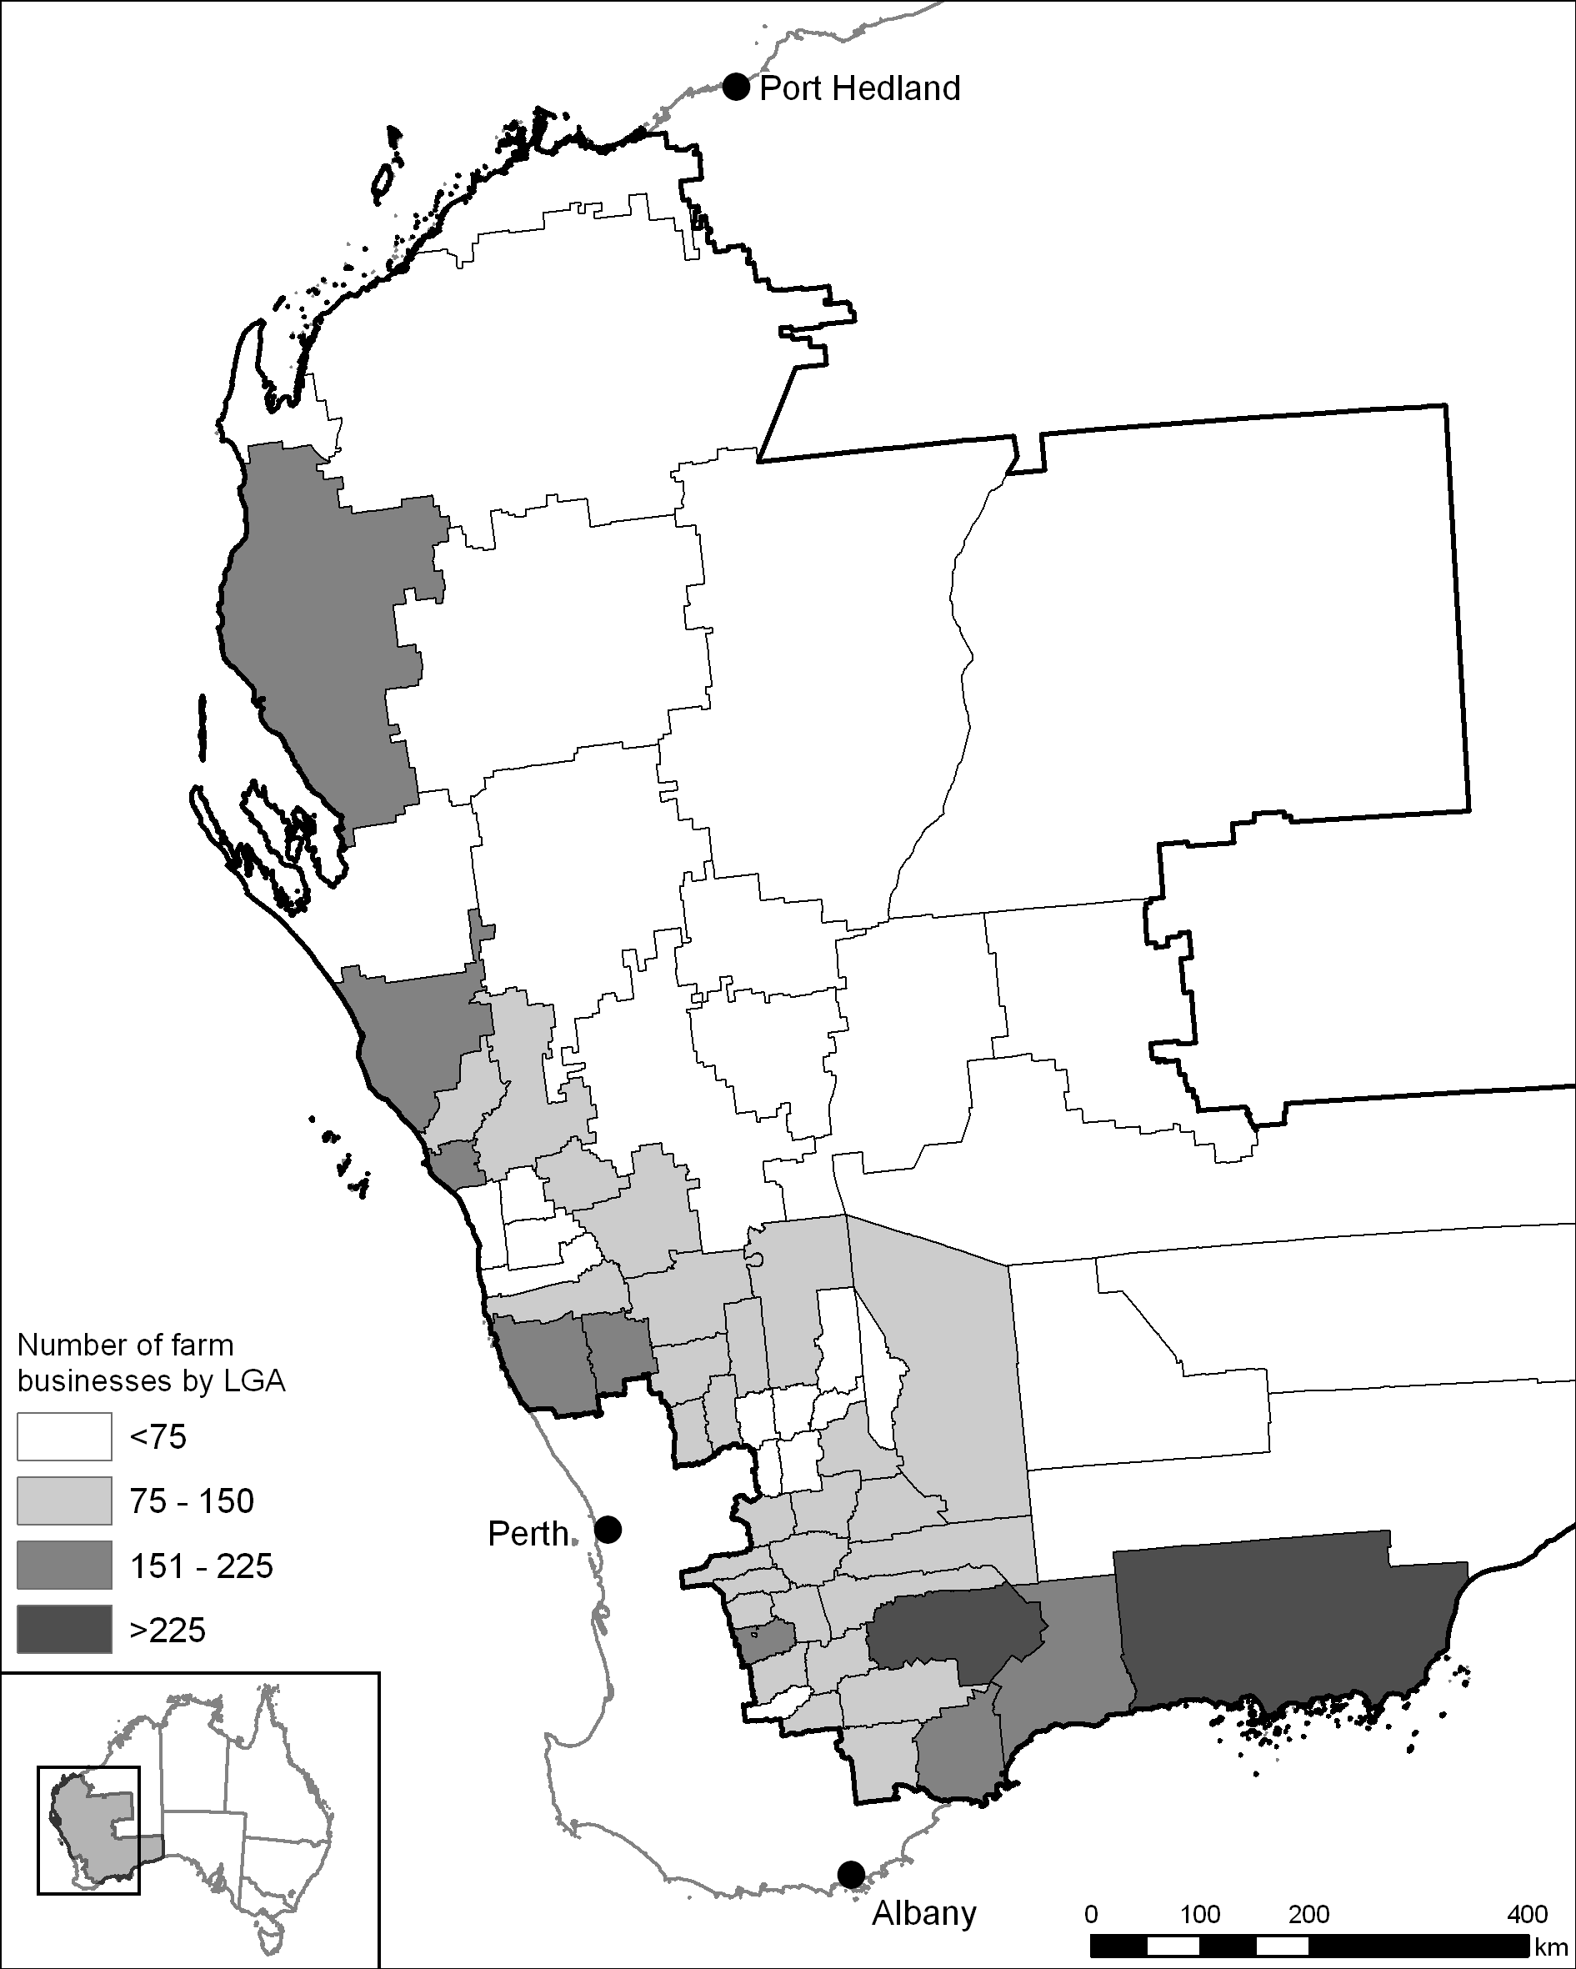
Sources: Australian Bureau of Statistics 2006 (data); ABARES (map).
Rainfall in parts of the pilot region was well below average during the pilot period (see Figure 1.6). It is likely that the poor seasonal conditions increased demand for many of the pilot programs.
Figure 1.6: Pilot region rainfall
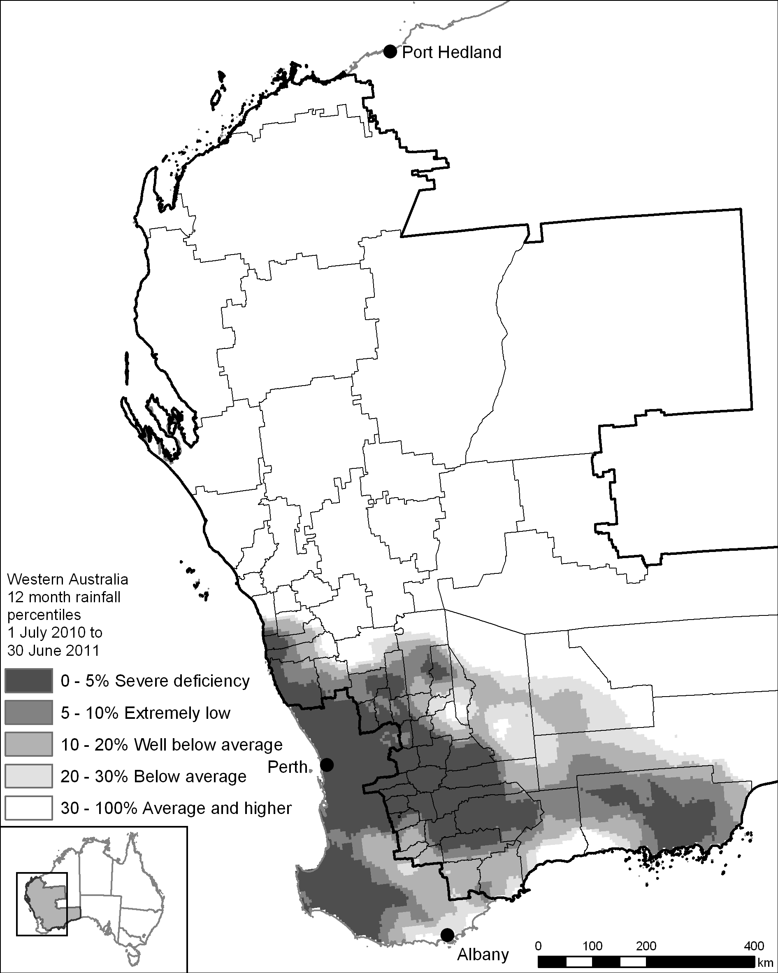
Sources: Bureau of Meteorology (data); ABARES (map).

The pilot programs (2010–11)
There were seven programs in the pilot.

1. Farm Planning
The Farm Planning program aimed to enhance farmers’ skills in business, natural resource management and personal planning and increase the number of farm businesses with comprehensive written strategic farm plans.
Farm businesses undertook training to develop or update a strategic plan for the business. Participants identified priority activities to help improve the management and preparedness of the farm business to respond to future challenges, including drought and a changing climate.
The Farm Planning program was funded by the Western Australian Government and delivered by Curtin University.

2. Building Farm Businesses
The Building Farm Businesses program aimed to assist farmers to improve the viability of their farm businesses by providing financial support for activities that:
- will better equip them to manage and prepare for the impacts of drought, reduced water availability and a changing climate
- improve on-farm resilience
- reduce the environmental impact of agricultural activity in times of extreme climatic conditions.
Grants of up to $60 000 were provided in two components:
- Business Adaptation Grants—up to $40 000 for eligible activities identified in the strategic plan that help farm businesses prepare for the impacts of drought, reduced water availability and a changing climate
- Landcare Adaptation Grants—up to $20 000 for eligible activities identified in the strategic plan with a natural resource management focus and having a broader public benefit.
The Building Farm Businesses program was jointly funded by the Australian and Western Australian governments and delivered by the Department of Agriculture and Food Western Australia.

3. Farm Family Support
The Farm Family Support program provided eligible farm families with income support equivalent to the Newstart Allowance while they initiated planning and action to address their long-term business viability, diversify into new careers or re-establish themselves outside farming. As part of the program’s emphasis on mutual responsibility, Centrelink officers helped recipients to develop a plan to identify actions that may improve their financial position on-farm or off-farm.
The Farm Family Support program was funded by the Australian Government and delivered by Centrelink.

4. Farm Social Support
The Farm Social Support program aimed to provide social support services that were more accessible, coordinated, integrated and efficient in meeting the counselling and mental health needs of those living in rural and remote areas. Assistance included the:
- Rural Support Initiative—Centrelink professionals delivered improved outreach and social support to rural communities. Rural services officers assisted people to access a range of payments and services and referred them to other government and non-government agencies for further assistance. Social workers provided short-term personal support and counselling for those in need of such support.
- Online Counselling for Rural Young Australians Initiative—confidential and free professional online counselling for young people in rural areas. The program was delivered by headspace, Australia’s National Youth Mental Health Foundation.
- Rural and Regional Family Support Service—free professional help to families who were experiencing relationship difficulties or other stress. The program was delivered by Centacare Family Services Geraldton, Centrecare Inc. and Relationships Australia, Western Australia.
Farm Social Support was funded by the Australian Government.

5. Stronger Rural Communities
The Stronger Rural Communities program aimed to increase the capacity of rural communities experiencing significant hardship to build social capital, develop new and existing community networks and increase community resilience to the impacts of agricultural downturns. Grants of up to $300 000 were provided to local government authorities and community organisations to help them achieve these objectives.
The Stronger Rural Communities program was funded by the Australian Government and delivered by the Department of Agriculture, Fisheries and Forestry.

6. Farm Exit Support
Farm Exit Support aimed to help farmers in significant financial difficulty who decided to sell their farm to re-establish themselves outside farming. Grants of up to $170 000, including for retraining and relocation expenses, were available to support eligible farmers.
Farm Exit Support was funded by the Australian Government and delivered by Centrelink.

7. Beyond Farming
The Beyond Farming program aimed to help farmers make a decision about whether or not to leave farming. The program put current farmers in touch with former farmers to talk about opportunities outside farming.
Beyond Farming was funded by the Australian Government and delivered by the Western Australian Council of Social Service.

Farm Planning

Key points
- Governments have a role in providing support for strategic farm business planning because enhancing education and skill levels in the national economy is an important driver of national productivity growth and, in the case of the farm sector, also provides broad public benefits.
- The Farm Planning program appeared to enhance farmer skills in strategic farm business planning.
- The program covered appropriate content that will help participating farm businesses to better prepare for and manage future challenges.
- The $60 000 Building Farm Businesses grants acted as a strong incentive for farm businesses to participate in the Farm Planning program but there were concerns raised about farm plans being tailored towards eligible grant activities, rather than the individual needs of the farm business.
- Delivery costs were higher than expected due to short lead times between announcement and delivery of the program. To make the Farm Planning program cost effective in an ongoing context, delivery costs would need to be reduced.
- Pathways and incentives for ongoing training and farm plan implementation are needed.

Rationale and objectives
The national review of drought policy recommended that significant public funding be directed to a continuous learning program for farmers that encompasses advice and training in managing climate variability and improving farm business management. The review also noted that policy needs to encourage a comprehensive approach to farm planning that includes planning for personal and family wellbeing as well as farm business and natural resource management.
The Australian and Western Australian governments developed the Farm Planning program with specific objectives to:
- enhance farmers’ skills in business, natural resource management and personal planning with particular focus on managing drought and climate variability; and
- increase the number of farm enterprises with comprehensive written strategic business plans.

Program description
The Farm Planning program aimed to encourage farmers to place more value on strategic business planning and improve their business planning skills. Groups of approximately ten farm businesses attended a five-module course over five days (generally spread over five to eight weeks) to develop or update a written strategic plan for their farm business. Some participants also completed an optional sixth module to review their plan. The strategic plans identified priority activities to help improve the management and preparedness of the farm business to respond to future challenges, including drought and a changing climate.
The program modules were professionally facilitated and covered financial planning, natural resource management, managing the impact of a changing climate, work–life balance, and succession planning. Participants were able to have their strategic plan assessed by an independent advisory panel, which advised whether the implementation of the plan would lead to a more viable farm business.
The Department of Agriculture and Food Western Australia (DAFWA) required Farm Planning participants to fill out a questionnaire before starting the program and another questionnaire after completing it. These questionnaires asked a range of questions about participants’ experience with the program and responses were an important source of information for the review panel.
The Farm Planning program was fully funded by the Western Australian Government and was allocated administered funds of $3.2 million and departmental funds of $0.4 million. Funding was intended to cater for approximately 400 participants.

Participant snapshot
DAFWA approved applications from 422 farm businesses to participate in the Farm Planning program. Of these, 374 (89 per cent) completed it. Participants were encouraged to bring multiple members of the farm business to the course, which resulted in 813 people participating in the program. Participation was broadly spread across the pilot region, with farm businesses from 54 of the 67 local government areas (shires) involved (see Figure 2.1). Participation was greatest in the shires of Carnarvon, Esperance, Corrigin, Ravensthorpe and Lake Grace. More than 40 per cent of participating farm businesses were from these five shires.
Figure 2.1: Number of Farm Planning participants by local government area
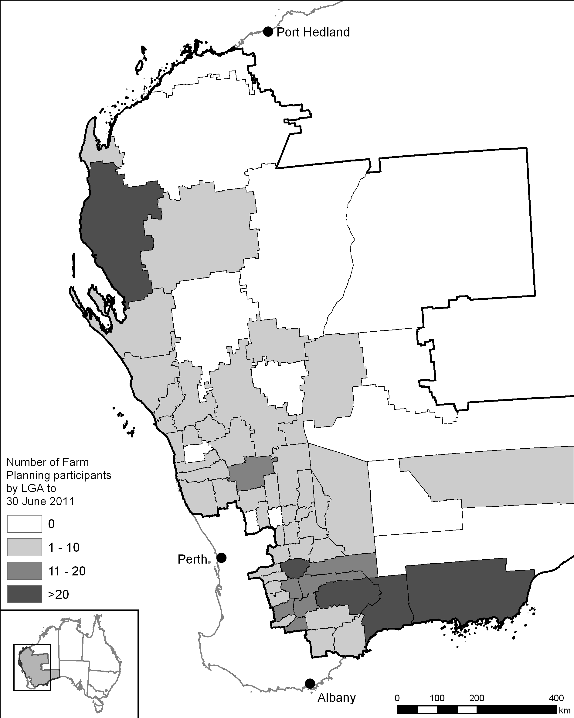
Sources: DAFWA (data supplied 15 July 2011); Australian Bureau of Agricultural and Resource Economics and Sciences (ABARES) (map).
The program included an opportunity for participants to have their strategic plan assessed by an independent advisory panel. This assessment was a compulsory requirement for those participants wishing to apply for Building Farm Businesses grants. Despite this opportunity being available to all Farm Planning participants, only those farm businesses that went on to apply for grants took up the opportunity to have their plan assessed. At 30 June 2011, the independent advisory panel had assessed 119 plans.
Farm industry representation in the Farm Planning program courses reflected the distribution of industry types across the pilot region. The vast majority of Farm Planning participant businesses (99.6 per cent) were broadacre, livestock or horticulture businesses, as are the majority of farm businesses in Western Australia (98 per cent) and across the country (89.6 per cent).
Farm Planning program participants were comparatively younger than Australian farmers in general. Less than 20 per cent of participants were aged 55 years or over, while more than 40 per cent of farmers in the pilot region and nationally fall into this age bracket (see Table 2.1). The panel was encouraged that younger farmers, at an early stage in their farming career responded to the opportunity to engage in strategic farm business planning.
Table 2.1: Age of Farm Planning participants compared to pilot region and Australia
Age  (years) | Farm Planning participants  (per cent)  n = 355* | Pilot region farmers (per cent)  n = 9375† | Australian farmers (per cent)  n = 151 292†
24 and under | 2 | 5 | 5
25–34 | 18 | 12 | 9
35–44 | 30 | 16 | 14
45–54 | 33 | 22 | 24
55–64 | 14 | 24 | 26
65 and over | 3 | 21 | 22
* Source: DAFWA questionnaires (data supplied 15 July 2011).
† Source: ABARES (data supplied 6 April 2011). Data compiled from farm surveys, which include responses from all individuals owning part of the farm business or receiving a share of the farm business income, plus salaried farm managers in the case of corporate farms of agricultural establishments that have an estimated value of agricultural operations exceeding $40 000 in the wheat and other crops, mixed livestock–crops, sheep, beef, sheep–beef or dairy industries.
Gender representation at the course was relatively similar to gender representation of farmers across the pilot region, as estimated by ABARES (see Table 2.2).
Table 2.2: Gender of Farm Planning participants compared to pilot region and Australia
Gender | Farm Planning participants  (per cent)  n = 351* | Pilot region farmers (per cent)  n = 9372† | Australian farmers (per cent)  n = 151 109†
Male | 64 | 59 | 56
Female | 36 | 41 | 44
* Source: DAFWA questionnaires (data supplied 15 July 2011).
† Source: ABARES (data supplied 6 April 2011). Data compiled from farm surveys, which include responses from all individuals owning part of the farm business or receiving a share of the farm business income, plus salaried farm managers in the case of corporate farms of agricultural establishments that have an estimated value of agricultural operations exceeding $40 000 in the wheat and other crops, mixed livestock–crops, sheep, beef, sheep–beef or dairy industries.
Prior to commencing the course, 97 per cent of participants indicated that strategic planning was useful to their farm business, yet only 40 per cent reported actually having a strategic plan. The reasons participants most frequently cited for not having a plan were that it was in their head, that they hadn’t got around to it, or that their bank manager, accountant or consultant did it for them.

Targeting
The Farm Planning program was available to all farm businesses in the pilot region. The panel heard that networks such as grower groups were the most effective in encouraging farm businesses to participate.
There was a concern expressed by some participants that growers outside these networks may not have been effectively reached. However, the panel heard that information about the program’s availability was well distributed and accessible through a range of different avenues. The most frequently reported means by which participants heard about the pilot were word of mouth and DAFWA. Other means included the newspaper, farm business advisers, consultants or accountants, the radio, and the internet.

Engaging women
The panel found that women in the farm business played a pivotal role in ensuring the engagement of multiple members of the business in the program.
The panel heard from some participants and other stakeholders, including the Rural, Remote and Regional Women’s Network, that those farm businesses that sent more than one member of the business to the course benefited the most.
All business partners should have to be there; you have to commit to the process.
Participation levels fluctuated across the modules … Often this left only one business member attending the modules, which is possibly not conducive to collaborative planning.
The panel also observed that women appeared to bring a broader perspective to the planning process. It concluded that any program that aims to engage farmers in a planning process needs to understand the role that women play within farm businesses and encourage their development, input and participation. The panel saw merit in targeting women’s participation to improve whole-of-farm engagement.

Preliminary outcomes
The panel recognised that, given the short timeframes associated with the pilot and its review, its evaluation of the Farm Planning program would necessarily be of a preliminary nature. Any consideration of whether longer-term outcomes had been achieved through the Farm Planning program would be a matter for consideration in a future review process. In this context, the panel noted that there was an opportunity to monitor the medium-term progress of Farm Planning participants who went on to receive a grant under the Building Farm Businesses program. These farm businesses could usefully be monitored over the four-year period of the grant payments to help evaluate the longer-term effectiveness of the Farm Planning program.

Value of the course to participants
Most Farm Planning participants that the panel met during its consultations gave positive feedback about the program, indicating that it had been valuable for them.
[Farm Planning has] been a great strategic lift for the business and identified lots of things we can tackle and improve.
We’ve seen that we can turn our business around. Putting it down on paper has helped us heaps.
Even those with specific criticisms of the program were often also able to identify elements of the program they found valuable.
The panel heard particularly positive feedback about the Managing Finances module.
The best module by far was the financial management [module].
The financial module was particularly useful.
The Farm Planning lead facilitators noted that some farmers appeared to have lost touch with the financial workings of their business and that the Farm Planning program had enabled them to re-engage with this. Some participants informed the panel that the Managing Finances module had improved their understanding of their business and enabled them to seek better advice from business support professionals such as their agricultural consultant; this feedback underlines the importance of financial literacy to the modern farm business manager.
While many participants said that their main motivation to undertake the Farm Planning program had been the possibility of obtaining grants under the Building Farm Businesses program (see 2.6), other participants indicated it was worth more to them to have undertaken the course than to receive a grant.

The ‘whole-of-farm business’ approach
Farm Planning was a ‘whole-of-farm business’ strategic planning course that addressed all major aspects of a farm business—financial planning, natural resource management, managing the impact of a changing climate, work–life balance and succession planning—as part of the same course.
This represented a different approach to that of many previous planning courses and courses offered in other states, which have tended to focus purely on either the financial, production or environmental aspects of farm businesses. It responds to the national review of drought policy recommendation that an “improved policy for dryness must focus on … planning for personal and family wellbeing”. Broadening the scope to whole-of-farm business strategic planning encouraged farm businesses to consider what was important to the individuals and families involved in the business, not just what would improve the bottom line. As one participant said of the program:
it fills out the whole picture.
Curtin University, the Farm Planning lead facilitators, and the independent advisory panel were supportive of the whole-of-farm business approach and reported that the Farm Planning program increased participant understanding of all aspects of farming, including often neglected social aspects of farming such as work–life balance.
The plans showed that many business owners are not getting the work–life balance right and the plans had specific strategies to address this issue.

Attitudinal change
The Farm planning program attracted farmers who did not have written plans or plan effectively. Sixty-three per cent of Farm Planning participants did not have a strategic plan before undertaking the program and 19 per cent of those who did never referred to their plan. On completion of the program, 98 per cent of participants intended to refer to their strategic plan at least annually (see Figure 2.2).
Figure 2.2: Use of strategic business plans by participants before and after program
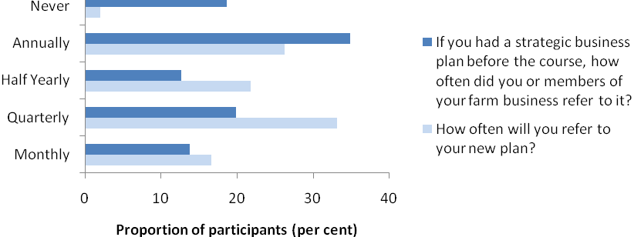
Source: DAFWA questionnaires (data supplied 15 June 2011).
Participants reported that their confidence and skill in strategic planning improved over the course of the program. For example, the number who said they were either confident or very confident in implementing a strategic plan for their business increased from 52 per cent to 89 per cent.
Participant confidence in the future viability of their farm business increased as a consequence of undertaking the program, with the proportion of participants reporting they were confident to very confident in the future viability of their business increasing from 64 per cent to 84 per cent (see Figure 2.3).
Figure 2.3: Confidence in future viability of farm business
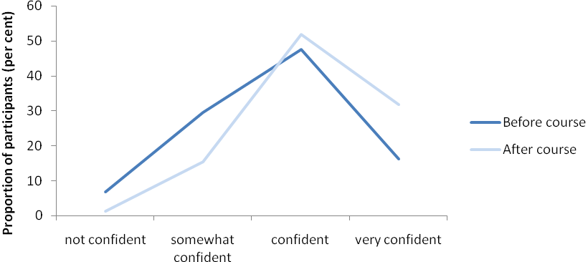
Source: DAFWA questionnaires (data supplied 15 June 2011).

Assessment of plans
As part of the Farm Planning program, an independent advisory panel (IAP) was set up to assess strategic plans and provide advice to those farm businesses about whether implementation of their plan would lead to the business becoming more viable. The IAP found that all of the 119 plans it had assessed to 30 June 2011 would, if implemented, lead to the business becoming more viable.
The panel heard from an IAP member that participants’ plans were “principally focused on the big picture and making a difference to their business risk profile”. The panel also heard that the planning process appeared to have improved the understanding farm businesses have of their finances and highlighted the need for them to improve the work–life balance of members of the business.
The review panel was encouraged by the IAP’s finding that all of the plans it assessed, if implemented, could lead to more viable farm businesses. However, the panel also noted that, despite the IAP assessment being available to all Farm Planning participants, only those farm businesses that went on to apply for Building Farm Businesses grants took up the opportunity to have their plan assessed.

Readiness for change
The panel observed that participants who were ‘ready for change’ were generally more willing to engage with strategic planning as a business tool. Readiness for change appeared to be more common among participants who understood the strengths and weaknesses of their business. Those who were experiencing specific personal or business circumstances—for example, those who were new to farming, restructuring their farming operation or actively considering their future—seemed to more readily recognise the risks facing their businesses. The panel felt that participants in these circumstances were focused on managing risk and would be more likely to make changes to increase their capacity to adapt to future challenges as a result of undertaking the Farm Planning program.
While Farm Planning appeared to inspire changes geared towards increasing resilience and better risk management for many businesses, the panel heard from some participants that they felt they were already as resilient as they could be—demonstrated by the fact that they were still farming in the face of recent and continuing adversity.
Farmers around here have had to farm smarter over the years … so they’re already doing a good job or they wouldn’t still be here.
The panel noted that these participants may not be ready for change, but also noted that many found aspects of the program useful. The panel felt that, despite the initial views of these participants, the Farm Planning program may have highlighted further actions they could take to make their farm business more resilient.
The panel felt that farm businesses that recognise their strengths and weaknesses and are ready for change may be keener to undertake strategic planning and as such, may benefit more from the program than others. Specifically targeting these farm businesses could improve program outcomes. However, it is also important to attract those farm businesses that feel they are already as resilient as they can be, because the course may raise their awareness of strengths and weaknesses they had not previously considered.

Motivation to participate
Specific financial incentives were provided to encourage participation in the Farm Planning program. Course costs were covered up front and participants were able to claim reimbursement for their travel costs. Little feedback was received by the panel about the effect of these incentives on farmer willingness to undertake the Farm Planning program.
The financial incentive of the Building Farm Businesses grants was a strong motivator. It was the most commonly cited motivation for participating in the Farm Planning program, followed by others such as the opportunity to engage in strategic planning, to seek ideas on how to improve business profitability, and to update their goals (see Figure 2.4). These were not the only motivations however.
Business planning is important to us and we have two generations farming so planning day to day, seasonally and into the future along with succession planning is vital … this course offered a well structured format with very good facilitators.
We chose to participate in the program due to the drought conditions.

Grants
Feedback received by the panel from all sources strongly indicated that the opportunity to access the $60 000 Building Farm Businesses grants was the main motivation for participating in the Farm Planning program (see Figure 2.4).
Figure 2.4: Main motivation to participate in the Farm Planning program
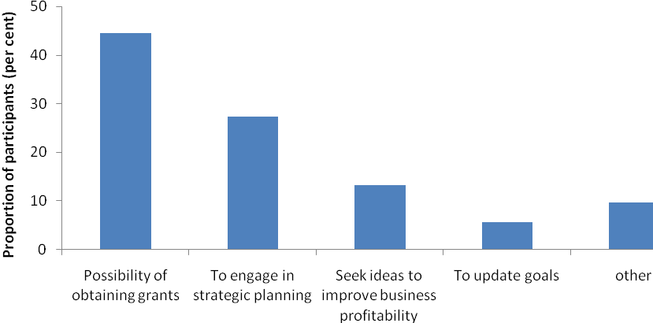
Source: DAFWA questionnaires (data supplied 15 June 2011).
A comparison of uptake rates with a similar program, stage 2 of the National Property Management Planning Campaign (PMP), points to the impact of the grant incentive in attracting farmers to Farm Planning. PMP, which did not offer grants or other cash incentives, attracted only 1.5 per cent of WA farm businesses per year over four years, while the Farm Planning program under the pilot attracted 7 per cent of farm businesses in the pilot region within 12 months.
The Building Farm Businesses grant encouraged participation in the Farm Planning program, but it also had wider impacts. The panel heard from some participants that they tailored priority activities in their strategic plan to those they perceived would be most likely to attract a grant (this issue is discussed further in Chapter 3). The panel noted that not all participants tailored their plans towards the grants and that the primary motivation of some who initially participated because of the grant became the planning process itself.
The financial reward of the planning will be so much more than $60 000 in the long run.
I’m glad they made us do the planning thing, because if we’d just put the application in for the grant we’d have missed the whole point.
The panel considered that participants who committed to the planning process and who tailored their strategic plan to their individual circumstances, rather than towards the list of eligible grant activities, will be better placed in the long-term.

Incentives to undertake strategic planning
While farm businesses should be encouraged to undertake strategic farm business planning, incentives that distort course outcomes should be avoided. The panel noted that incentives such as cash grants are likely to encourage some farm businesses to design their plan to meet the requirements of the incentive rather than the individual needs of their business. The panel believes that other types of incentives could be used to reinforce participant commitment to the outcomes of the planning process. For example, a contribution to the cost of the course by government could encourage participation and requiring a co-contribution from participants to meet the remaining costs could increase their personal commitment to achieving course outcomes. Promoting the value of strategic farm business planning in its own right could also help to encourage participation.

Maintaining momentum
As noted earlier, participant confidence in developing and implementing a strategic plan increased as a consequence of undertaking the Farm Planning program and many indicated their intent to refer to their plans more often. These early indicators about the effectiveness of the course are promising, but they also highlight that Farm Planning is the first step in a longer-term process, and the path forward is not necessarily clear for all participants. As stated by the Rural Financial Counselling Service Western Australia (RFCS WA):
[The Farm Planning] workshops may leave a number of participants wondering ‘where next’. This is both useful and an opportunity for further work. It may also be a weakness if no further assistance is accessed and the progress made is lost.
Some participants and stakeholders, including the Farm Planning lead facilitators, the Australian Association of Agricultural Consultants Western Australia, RFCS WA and a member of the IAP called for additional measures aimed at building on the momentum for planning and business change created by the Farm Planning program.
A 12 month review with a facilitator would be beneficial as follow up.
follow up workshops around 12 months after the initial process could be a great way to keep the momentum going.
The panel agreed that strategic planning was an important first step in what should be an ongoing professional development process. As such, the panel believes any strategic plan developed through the Farm Planning program or other similar courses should provide pathways for participants to further their professional development.
Professional development could be encouraged by governments by:
- linking any follow-on grant programs like Building Farm Businesses, to the ongoing implementation of the strategic farm plan, rather than to a set of agreed activities up front (see Box 2.1 for an example of how this might work)
- requiring the development of a strategic plan through Farm Planning or a similar course, as a threshold step to access other government programs for farmers
- linking the planning course to training pathways that offer professional recognition, or
- linking the program with other avenues to generate income, such as payments for the provision of ecosystem services (payments for ecosystem services are discussed in Chapter 8).
Box 2.1: Example of a proposal for ongoing strategic plan implementation and professional development
In its submission to the panel, Primary Industries and Resources SA outlined a proposal to support farm businesses in continuing their professional development after undertaking a comprehensive strategic farm business planning course. The support (a series of small grants linked to needs identified during the strategic planning) would be available over a period of three to four years. Grants to farm businesses would comprise:
- up to $2500 for further training and upskilling or a grant to access specialised expertise in formalising exit from the industry
- up to $5000, with a matching co-contribution from the farm business, for business management infrastructure that will improve business decision making, such as new technology or software
- up to $5000 for individual business coaching over one to two years to assist with plan implementation and developing business management skills
- up to $2500 per business for groups of neighbouring farm businesses to work collaboratively on projects such as improving business efficiencies or natural resource management on a landscape scale
- up to $4000 to undertake a comprehensive review of their strategic plan to set directions for the future, incorporating economic, production, human and natural resource management, business marketing and family issues.

Delivery
Many questionnaire respondents reported that the Farm Planning program was delivered well.
I was very happy with the presenters and general delivery.
It was all done very well.
Participants also noted a broad range of factors that affected the quality of the delivery of the Farm Planning program. Those factors that the panel identified as common themes across different course groups are discussed below.

Facilitators
Participants who felt their facilitators possessed relevant local, agricultural and/or natural resource management expertise were highly valued, while participants who perceived that facilitators lacked this expertise felt it was detrimental to their learning. The Western Australian Farmers Federation also identified the variability of facilitator skill levels as an issue.
Course content was of a high standard however it appears that there was variability in the delivery of this information, between facilitators.
The Farm Planning program lead facilitators acknowledged this view, but felt it was more a reflection of variable facilitation skills among facilitators rather than variability in specific topic knowledge.
The panel observed that there was a need to ensure that courses had the right mix of:
- skilled facilitators to improve learning outcomes for participants
- experts with appropriate knowledge to answer questions about specific issues.

Tailoring to participant skill level
It was evident to the panel that not all participants held the same level of knowledge and skill when they entered the program. Some reported the content was too basic, while others said that more time should be allocated to help them understand the concepts presented.
I found the financial module a waste of time as I [already] … do all the ratios mentioned in our annual review with our farm consultant.
Expand on the financial side—some people had never seen the profit and loss or balance sheets so that could have been explained at bit more.
Participants who felt they had previously covered material to be delivered under the Farm Planning modules were able to seek recognition of their previous learning in lieu of completing one or more program modules. It appears, however, that this opportunity was not well understood by participants and/or not easily implemented. The Pastoralists and Graziers Association of Western Australia, the Rural, Remote and Regional Women’s Network of Western Australia and others noted this in their submissions. Participants also commonly felt their prior learning was not recognised.
the planning courses, although planned to acknowledge prior learning, found it difficult to accommodate prior learning. It appeared difficult to break the courses down into smaller modules and consequently some attendees reported a half day of wasted time.
There was no recognition of prior work people had done on business plans or similar training.
The panel recognises that it can be difficult to formally recognise the prior learning of participants in the context of a short training course. Despite the availability of formal recognition of prior learning under the Farm Planning program, no participants actually sought this recognition. Rather than offer formal recognition of prior learning, there may be scope to better gauge the skill level of participants at the beginning of each module and tailor content accordingly.
To further help overcome issues with different skill levels among participants it may also be beneficial to offer the Farm Planning program in two tiers: entry-level and advanced. Participants could graduate from the shorter entry-level program to the longer and more in-depth advanced program. Those in the advanced program could graduate to a higher learning pathway identified in their strategic plan. Such an arrangement may also be more compatible with progression to a formal qualification.

Managing Finances module
The Managing Finances module was designed to assist participants to develop a robust financial plan for their farm business by improving their ability to:
- undertake profit and loss analysis
- understand assets and liabilities
- forecast cash flow
- calculate ratios to understand the financial performance of the business over time
- undertake cost comparative analysis of farm enterprises
- manage relationships with their bank
- understand business cost structures to enable better cost control.
With their improved understanding, participants were encouraged to identify actions that would improve the financial management of their farm business.
As noted earlier, the panel heard that the Managing Finances module of the Farm Planning program was the most highly valued among participants. This may go some way to explaining why participants frequently commented that the financial module should be more in-depth, farm business-specific and/or allocated more time.
The Farm Planning lead facilitators and some participants felt it could be helpful to bring the financial management module forward in the program to better set the scene for the individual farm businesses attending. One Farm Planning lead facilitator, who took a group through the financial module as the second module rather than the fourth, indicated that this had worked very well for that group. The panel felt this suggestion had merit and also felt that an extended and more in-depth financial module should be available in the context of a two-tiered delivery model.

Managing Environments module
The Managing Environments module (commonly referred to as the NRM or climate change module) was designed to assist participants to identify on-farm practices that would improve the sustainability of their farm’s natural resource base and lead to:
- the identification of practical improvements to better manage resources
- improved ability to adapt to climatic variability
- improved viability.
The panel heard positive feedback about the Managing Environments module from participants who attended courses where the presenters used detailed local climatic information. Where participants felt that information was not specific to their local area, feedback was less positive.
The NRM/Weather module was a bit hopeless … greater use of a recognised expert from weather bureau may be an idea.
The panel also heard from some participants that they felt the focus of this module was on convincing them that climate change was occurring, rather than the practical steps that farm businesses can take to improve environmental outcomes on-farm. This approach was not well received, with one group of participants commenting that this module was the worst they had done because the presenter perceived that they were all climate change deniers. Another participant commented that:
the NRM module should have been more about building a knowledge base—the emotional/political side should be totally taken out of it.
The Farm Planning lead facilitators acknowledged the variable quality of delivery of the Managing Environments module and agreed that it needs to be improved. The panel agreed and noted that to improve the module, detailed local and regional climatic information should be provided to attendees at all courses and the climate change focus should be on developing strategies for future climate change adaptation.

Balancing Life module
The Balancing Life module (commonly referred to as the Work–life Balance module) was designed to help participants improve the family and personal side of their lives through:
- improving understanding of how they interact with others, and how others interact with them
- building individual resilience and managing stress
- planning to stay fit and healthy
- clarifying the future roles of family members in the farm business and planning to undertake a comprehensive succession planning process.
The Balancing Life module received mixed reports. Some felt it was valuable.
I think the reflection on our work–life balance was a very important process to go through.
We’d been saying for 10 years that we needed to do a succession plan. Even if we don’t get the [Building Farm Businesses] funding, this will get us moving on the succession plan.
I enjoyed it. It was good to bring the succession side into it … good to bring it together and do it together [with my husband].
The value of the succession planning element of the module was apparent, with the proportion of participants who were either confident or very confident in developing or updating a succession plan increasing from 50 per cent to 77 per cent (see Figure 2.5).
Figure 2.5: Confidence in developing or updating a succession plan
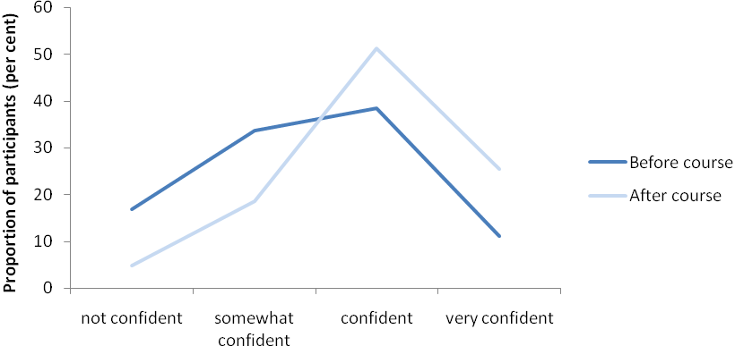
Source: DAFWA questionnaires (data supplied 15 June 2011).
Some participants did not find the Balancing Life module useful and reported that work–life balance can only be achieved if the financial situation of the farm business is sound.
[the] balancing life module was the least benefit as most stress is caused by financial insecurity.
These views seemed to reflect an observation of the national review of drought policy that farm business concerns tend to take precedence over family concerns, particularly in times of drought, to the detriment of the family. The panel held the view that farm businesses should be encouraged to adequately account for the wellbeing of the farm family independently of the needs of the business. So while the Balancing Life module did not appear to be universally accepted as necessary or useful by all participants, the panel felt that it should be a part of any future strategic farm business planning course. As the national review of drought policy noted, “people should be the priority … not the farm property”.

‘Kitchen Table’ module
An optional sixth module (commonly referred to as the ‘Kitchen Table’ module) was available to Farm Planning participants. Participants were able to spend time one-on-one or in a small group with a facilitator to finalise elements of their strategic plan. Approximately 70 per cent of participants who completed Farm Planning also completed the Kitchen Table module. Most of those who undertook this module found it useful, with some indicating that it was particularly helpful in enabling them to complete their strategic plan.

Communication
As noted earlier, the initial promotion of Farm Planning seemed comprehensive. The panel heard, however, that ongoing communication with program applicants was lacking in some instances. The Farm Planning lead facilitators reported that, in some cases, there was a significant time lag between application submission and approval. The panel heard that some applicants were notified of their successful application only a week before the course commenced. The panel felt that these communication issues were a result of the short timeframes associated with the roll-out of the pilot and would be resolved if a longer lead time was available.

Structure of course
A number of participants reported that program delivery could be improved by condensing the program to fewer days and/or providing more one-on-one time with facilitators. A common suggestion was to reduce the group component to two or three days and have participants spend the remaining time on-farm with a facilitator or consultant. This suggestion was often attributed to a recognition among participants and stakeholder groups that farmers are less likely to be forthright about their personal and business circumstances in a group setting.
A key question … is whether this is the right forum for detailed family discussions to resolve difficult issues … There should be a clear separation of what can be achieved with training and what then needs to be worked on further with some individual advice and support.
2 days is enough to be with other farm businesses, the forum is not open enough to share any longer. Farmers don't discuss the nuts and bolts of their financial situations with other farmers!
To overcome this, the panel felt that issues such as personal health, family wellbeing, and succession planning, and ‘tough decisions’ about finances, could be considered in an extended Kitchen Table module. The panel recognised that increasing one-on-one time with experts could increase program costs, but considers that such an increase could be warranted where it was likely to improve outcomes.
The panel also heard that there were benefits in the group setting of the Farm Planning program. One participant reported that gaining an understanding of other farmers’ situations helped them better understand their own. Other benefits of the group setting were also apparent to the panel. Gathering individuals together from diverse geographical locations and age groups encouraged the sharing of ideas and experiences and the establishment of new networks. In communities where declining social capital was commonly reported, these benefits were viewed by some as strong positives from the program.
There were benefits of coming together; having conversations together that you wouldn’t have at sport.

Group size
Participants from larger course groups reported that delivery was hampered by the size of their group. Participants from smaller groups (approximately seven to ten farm businesses or fewer) reported a more positive experience with the delivery of their program. DAFWA intended to have a minimum of 10 farm businesses participating per group. There may be a case to make this a maximum, rather than a minimum, noting that such a change would increase the cost of delivering the program.

Costs
The panel felt that the $6000 budgeted cost of the Farm Planning program per farm business represented reasonable value for money. However, the panel was advised that actual costs were in the order of $11 000 per farm business. The panel questioned whether this cost would represent value for money in the context of an ongoing program.
The panel observed that the roll-out of the Farm Planning program was resource intensive. Delivery organisations reported that very short lead times from announcement to implementation significantly increased the cost of delivery. For example, it was reported that short lead times did not allow for sufficient planning to ensure the location and timing of separate Farm Planning course days were aligned. As a consequence, course deliverers were frequently required to travel from Perth to an area of the pilot region for only one or two days of course delivery. As such, travel costs associated with the delivery of the Farm Planning program were higher than expected. Curtin University and the Farm Planning lead facilitators indicated that significant efficiencies could be achieved through longer lead times and through the ongoing delivery of the program.

Conclusions and recommendations
The panel concluded that the Farm Planning program dealt with appropriate and important aspects of running a farm business and that its implementation and delivery was carried out professionally.
The Farm Planning program was well received across the pilot region as indicated by demand, course completion rates, and feedback about the content and delivery of the program.
Participants and other stakeholders indicated that participation in the Farm Planning program is likely to have enhanced farmer skills in business, natural resource management and personal planning and increased the number of farm businesses with comprehensive written strategic plans. While noting these positive preliminary outcomes, the panel was also aware that Farm Planning participants were only in the initial stages of implementing their plans, and in some cases plans were still being developed. Any consideration of the program’s effectiveness in the long term would need more time than was available in the review period.
Consistent with recommendations from earlier reviews of drought policy, the panel believes governments have a role in providing support for strategic farm business planning because enhancing education and skills levels in the national economy is an important driver of national productivity growth and, in the case of the farm sector, also provides broad public benefits. It is also widely understood that farmers who become better long-term risk managers will become more self-reliant.
The whole-of-farm business approach to strategic planning trialled through the pilot also has potential to deliver wider public benefits not achieved under previous programs that focused narrowly on farm financial or production planning. Importantly, any improved natural resource management outcomes achieved as a consequence of the course are likely to contribute to the public good.
Recommendation 2.1: Governments should support strategic farm business planning as a means of improving resilience and adaptability in the farm sector.
Recommendation 2.2: Strategic farm business planning programs supported by government should integrate all critical elements of operating a farm business, including financial planning, natural resource management, managing the impact of a changing climate, work–life balance, farm family wellbeing and succession planning.
Farm Planning appeared to be a valuable program in the Western Australian context. If there is a view among governments that strategic farm business planning should form part of drought policy reforms under discussion at the national level, other states could utilise or further develop platforms they already have in place to deliver strategic planning courses.
Recommendation 2.3: Before any national roll-out of a strategic farm business planning program, an audit of similar programs Australia-wide should be undertaken to clearly identify current resourcing to avoid duplication and to coordinate delivery for any future initiatives.
The panel noted that participants who were experiencing specific personal or business circumstances, for example those who were new to farming, restructuring their farming operation or actively considering their future, seemed more willing to engage with strategic planning as a business tool to help resolve those circumstances.
Recommendation 2.4: Government-supported training in strategic farm business planning should be continuously available to enable farm businesses to undertake such training when it best suits their circumstances.
The panel found that women members of the farm business played a pivotal role in engaging multiple members of the business in the program and bringing broader perspectives to the planning process.
Recommendation 2.5: Any future government platform for the delivery of training in strategic farm business planning should encourage participation by women, recognising their role in facilitating important farm business changes.
The panel found that there is a need to ensure that participants in strategic planning courses are encouraged to implement their plan over the longer-term and also to take up opportunities for further professional development.
Recommendation 2.6: Any future strategic farm business planning program should include follow up incentives to encourage participants to update and implement their strategic plan over the longer term and to foster a culture of continuous learning.
The main reason many farm businesses were initially attracted to the Farm Planning program was the opportunity to access Building Farm Businesses grants. The panel found, however, that the Building Farm Businesses grant incentive also encouraged some participants to frame their strategic plans around the eligible activities listed in the Building Farm Businesses guidelines.
While farm businesses should be encouraged to undertake strategic planning, incentives that will potentially distort course outcomes should be avoided. The panel believes that a partial contribution to the cost of the course by government could encourage participation. Requiring participants to meet the remaining course costs could assist in reinforcing participant commitment to real outcomes.
Recommendation 2.7: Any incentives to encourage participation in strategic farm business planning courses should reinforce participant commitment to outcomes from the planning process.
The panel found that the knowledge and skills of Farm Planning program participants varied, and that some were frustrated with what they considered to be ‘basic’ content. Rather than encourage participants to gain recognition for prior learning in lieu of completing parts of the course, the panel believes a better approach would be to provide programs that cater for different knowledge and skill levels.
Recommendation 2.8: Training in strategic farm business planning should be offered in a way that takes account of the variation in participant skills and knowledge, with different streams for participants with entry level and more advanced skills.

Building Farm Businesses

Key points
- The Building Farm Businesses program is unlikely to improve the capacity of farm businesses to prepare for and manage future challenges such as drought, climate variability and reduced water availability. Grants appear to have been used to meet typical input and operating costs.
- The $60 000 Building Farm Businesses grants were a strong incentive for farmers to participate in the Farm Planning program.
- The Business Adaptation Grant component did not effectively target activities that could improve long-term resilience.
- The Landcare Adaptation Grant component would benefit from stronger linkages with existing state and national natural resource management priorities and programs.

Rationale and objectives
As part of the national review of drought policy, the expert social panel recommended that future drought programs should focus on preparedness and planning. They considered that rather than focusing on providing assistance during a crisis, government should “invest in providing incentives during better times to encourage commercially and environmentally responsible management under variable seasonal conditions”. They also found that the most commonly reported barriers to farmers improving natural resource management are lack of financial resources, lack of time and lack of government incentives.
The Building Farm Businesses program aimed to assist farmers to undertake activities to improve the viability of their farm businesses. The objectives were to:
- assist eligible farm enterprises to adjust, improve risk management and improve their capacity to prepare for drought, reduced water availability and the impacts of climate variability
- increase natural resource management efforts to improve on-farm resilience and reduce the environmental impact of agricultural activity in times of extreme climatic conditions, such as drought
- reduce human stress associated with drought and reduce reliance on in-drought assistance.

Program description
Grants of up to $60 000 were provided in two components:
- Business Adaptation Grants—up to $40 000 was provided for eligible activities identified in strategic farm plans that would assist farm businesses prepare for the impacts of drought, reduced water availability and climate variability
- Landcare Adaptation Grants—up to $20 000 was provided for eligible activities identified in strategic farm plans with a natural resource management focus and having a broader public benefit.
Payments were to be made in instalments over four years, from 1 July 2010 to 30 June 2014.
The Building Farm Businesses program was delivered by the Department of Agriculture and Food Western Australia. The program was funded for approximately 140 farm businesses to access the Business Adaptation Grant and 130 farm businesses to access the Landcare Adaptation Grant. A total budget of $8.4 million over four years was allocated to the program, comprising $1.4 million from the Western Australian Government and $7.0 million from the Australian Government (see Table 3.1).
Table 3.1: Building Farm Businesses funding ($ millions)
Building Farm Businesses funding | Australian Government | Western Australian Government | TOTAL
Departmental | 0.3 | 0.6 | 0.9
Administered | 6.7 | 0.8 | 7.5
TOTAL | 7.0 | 1.4 | 8.4

Participant snapshot
The Department of Agriculture and Food Western Australia advised the panel that to 30 June 2011, 263 Building Farm Businesses grant applications had been submitted and 119 had been approved. All approved applications included both grant components and nearly all were for the maximum grant ($60 000). All approved grants provided funding for eligible activities (see Box 3.1).
Grant recipients were located in 33 (49 per cent) of the 67 local government areas in the pilot region (see Figure 3.1). Almost half of the grant recipients were from five shires: Corrigin (13 per cent of total), Lake Grace (8 per cent), Kulin (8 per cent) Ravensthorpe (8 per cent) and Wagin (8 per cent) shires. The value of grants received by farm businesses involved in different farming industries was consistent with the relative scale of those sectors within the pilot region.
Figure 3.1: Building Farm Businesses grant recipients by local government area
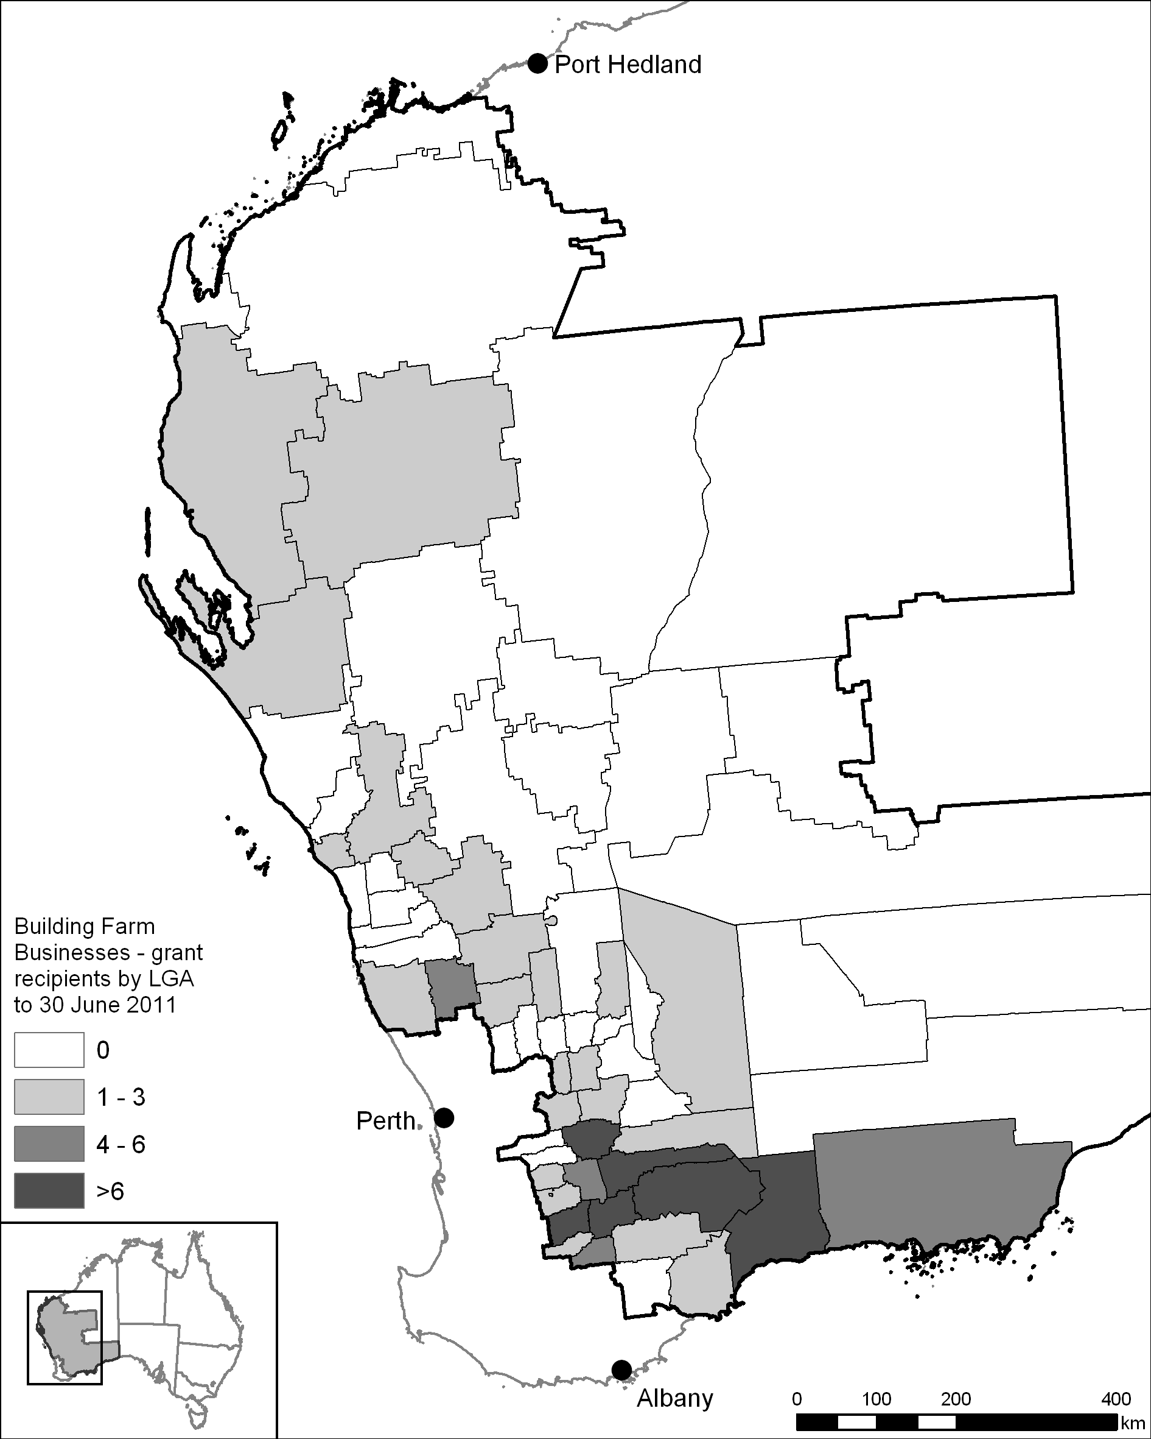
Sources: Department of Agriculture and Food Western Australia (data supplied 15 July 2011); Australian Bureau of Agricultural and Resource Economics and Sciences (map).

Targeting
To be eligible, farm businesses must have completed the Farm Planning program and had an independent advisory panel determine that implementation of their strategic farm plan would lead to a more viable farm business. Eligibility was also subject to a net off-farm assets test of $750 000.
The off-farm assets test was applied in an attempt to ensure that those businesses receiving grants were those most in need of financial assistance to implement actions that would make their farm businesses more viable over the longer-term. There was not sufficient evidence to determine if the eligibility criteria helped to target those farm businesses.
The panel heard from some stakeholders, including the Western Australian Farmers Federation, that the assets test was too restrictive and not suitable in the Western Australian context, where off-farm asset levels are generally higher than in other states. Some saw the assets test as a penalty against those who had already made positive changes, such as diversifying off-farm. The panel noted that only four applications were rejected based on the off-farm assets test.
The panel considered that there was not a strong case for increasing the $750 000 net off-farm assets test.

Preliminary outcomes
The Building Farm Businesses program provided grants in two components—Business Adaptation Grants and Landcare Adaptation Grants. Given the short timeframes for the review, it was difficult for the panel to assess the long-term benefits of the activities funded by these grants.

Business Adaptation Grants
Business Adaptation Grants provided up to $40 000 for eligible activities—identified in the strategic farm plan developed in the Farm Planning program—that will help farm businesses prepare for the impacts of drought, reduced water availability and climate variability. More than 60 per cent of funding was used on the adoption of precision farming techniques, fodder conservation and the costs associated with soil conditioning (see Table 3.2).
Table 3.2: Building Farm Businesses grants—funded activities
Business Adaptation Grant | Total funds committed ($) | Proportion of total funds committed (per cent)
Precision farming equipment (e.g. autosteer, GPS) | 947 267 | 24
Fodder conservation (e.g. silos, lick feeders) | 880 683 | 22
Soil conditioning (e.g. lime/gypsum) | 700 746 | 18
Equipment purchase/modification (e.g. boom sprays) | 476 155 | 12
Confinement areas for drought feeding | 304 373 | 8
Water management (e.g. solar water pumps) | 170 553 | 4
Laneway fencing | 141 476 | 4
Training/succession planning | 72 200 | 2
Pasture improvement | 67 503 | 2
Land monitoring and evaluation | 45 170 | 1
Other | 113 182 | 3
TOTAL | 3 919 308 | 100
Landcare Adaptation Grant
Soil conditioning (e.g. lime/gypsum) | 1 094 631 | 56
Fencing (e.g. to protect native vegetation) | 328 503 | 17
Establishing vegetation | 165 398 | 8
Managing soil acidity/salinity | 138 910 | 7
Other | 221 000 | 12
TOTAL | 1 948 442 | 100
Source: Department of Agriculture and Food Western Australia (data supplied 3 June 2011).
Funded activities reflect those listed in the program guidelines (see Box 3.1). While the list of eligible activities was intended to act only as a guide to the sorts of activities that could be eligible for funding, it seems to have been used prescriptively, with little evidence of innovative approaches being funded to improve the future resilience of farm businesses.
This result highlights the risks associated with governments providing prescriptive guidance and associated funding for these types of activities. As the Productivity Commission inquiry into drought support found:
The record of governments picking winning technologies in agriculture is mixed. Where governments are required to arbitrate on what qualifies as appropriate preparedness investments there is a risk that preparedness could be over promoted or inconsistently promoted (with some types of investments receiving support and others not).
Furthermore, some of the activities deemed ineligible for funding under the program could, in the panel’s view, be considered as measures that would improve long-term viability, such as water interception projects and activities to improve water availability. The panel noted that certain water-related activities were excluded from funding to minimise the risk of duplicating or running counter to other government initiatives such as the Australian Government’s Water for the Future program.
The panel considered that activities like fodder conservation, confinement areas for drought feeding, further training and land monitoring and evaluation might deliver lasting benefits that meet the objectives of the program. However, more than half of the grant funds were used to purchase precision farming equipment, seeders, boom-sprays and soil conditioners. While these activities were likely to deliver efficiency gains and short-term productivity benefits, the panel was less convinced about their long-term benefits with respect to improving preparedness for the future impacts of drought, climate variability and reduced water availability.
Consequently, the panel was not convinced that the activities funded by the Business Adaptation Grants would make those farm businesses more resilient over the longer-term or help to reduce reliance on in-drought assistance. Some grant applicants came to the same conclusion.
Within our group the emphasis of the grant application was on operational expenses—lick feeders and lime. The long-term value of these would be questionable.
The poor 2010 season may partly explain the tendency for grant applicants to favour activities with more immediate benefits. This highlights the difficulty of piloting measures aimed at improving drought preparedness during one of the driest seasons on record for much of the pilot region.
Arguably the grants were useful in reducing the stress associated with drought by meeting the costs of activities that might not otherwise have been undertaken because of reduced cash-flows resulting from the poor seasonal conditions. However, one of the program’s objectives was to reduce reliance on in-drought assistance, not to provide it by default.

Landcare Adaptation Grants
Landcare Adaptation Grants provided up to $20 000 for eligible activities identified in the strategic farm plan with a natural resource management focus and having a broader public benefit. Most of the funding was used on soil conditioners, fencing to protect vegetation and establishing vegetation, including repairing degraded land (see Table 3.2). The panel considered that some of the funded activities might improve natural resource management outcomes and have lasting public benefits, such as the establishment and protection of native vegetation, and managing salinity.
Some stakeholders felt that greater investment in natural resource management was needed.
It was the view of some members that directing all money into natural resource management projects would be better use of money than random so called productivity related measures.
Industry stakeholders, including the Western Australian Farmers Federation and the Pastoralists and Graziers Association of Western Australia, did not support the Landcare Adaptation Grant, and expressed a preference for all the funds to be directed to farm business activities.
Over half of the Landcare Adaptation Grants were used on soil conditioning—mostly the application of lime. The panel noted that while managing soil acidification is a national natural resource management priority, it needs to be underpinned by soil testing and ongoing monitoring to deliver lasting benefits on a landscape scale. The merits of the broad-scale application of lime with respect to the objectives of the Landcare Adaptation Grant were questionable, given that this activity delivers largely private benefits to farmers. It seemed more likely that being able to purchase lime, which primarily delivers productivity gains, provided an opportunity to subsidise typical farm input costs. This example highlighted inconsistencies between the program’s higher-level stated objectives and the operating guidelines under which specific grant decisions were made.
Any future investment to assist farm businesses to become more resilient should not allow typical farm input and operating costs to be funded. The panel also believes there is merit in having any natural resource management grant programs more closely linked to existing state and national natural resource management priorities and programs.

Unintended impacts on the Farm Planning program
To be eligible for Building Farm Businesses grants, farm businesses were required to have first completed the Farm Planning program and then had an independent advisory panel determine that implementation of their strategic farm plan would lead to a more viable farm business.
The availability of grants acted as a strong driver for participation in the Farm Planning program. However, the panel heard that the grants caused a tension for participants between the aim of the Farm Planning program—to facilitate the development of strategic farm plans best suited to individual circumstances—and the desire to tailor strategic farm plans towards eligible Building Farm Businesses grant activities to ensure the farm business was eligible for the grants.
As observed by several stakeholders, the link between the planning and the grants risks reducing the value of the strategic farm plan developed in the Farm Planning program.
[the link] relegates the document to the same pile as budgets that are done to get finance [from the bank]. Strategic Plans are a high level planning tool that should focus the business on overall policy within the business—not how to get a free lick feeder or lime.

Delivery
The grants were to be paid over four years ($10 000; $30 000; $10 000; $10 000), with the initial payment provided up front and the remaining payments made by reimbursement. Some stakeholders, including the National Farmers’ Federation, felt that paying the grant over four years, rather than the whole amount up front, limited the types of activities that could be funded, especially in what turned out to be such a poor season, where the ability of farmers to fund larger projects up front may have been limited.
While the panel noted this argument, it recognised that making payments over four years will provide the opportunity to monitor the implementation of the funded activities and evaluate their longer-term value. In the panel’s view, the payment of smaller grants over longer periods could be usefully taken further by linking grant payments to the ongoing implementation of the strategic farm plan more broadly, not just to specific grant activities. This would help to reinforce the importance and long-term relevance of strategic farm planning.
The Building Farm Businesses grants were offered on a first-come first-served basis. This meant that farm businesses completing the Farm Planning program earlier in the pilot period had a better chance of successfully applying for a grant. Some stakeholders felt this wasn’t fair.
I was disappointed especially when told it was a first in first serve basis. I think that is a little unfair. Once again are these grants truly going to the worst hit areas?
The panel agreed with the Rural, Remote and Regional Women’s Network, the representatives of which noted that a merit-based funding round (or rounds) would have been more equitable. The panel recognised that this would have presented challenges in the context of the pilot, given the short timeframes involved.
Some industry stakeholders also felt that a $60 000 grant was insufficient for modern farm businesses to implement significant change. The panel noted that the grants were provided to assist farm businesses with the costs of preparedness activities and not necessarily to meet the full costs.

Conclusions and recommendations
The panel noted that the Building Farm Businesses grants provided a strong motivation for farm business managers to participate in the Farm Planning program. This created tension for participants between developing strategic farm plans that best meet the needs of individual farm businesses and a desire to tailor plans to ensure the farm business was eligible for Building Farm Businesses grants.
The panel found that grants were used to fund a variety of activities that reflected the list of eligible activities in the program guidelines. Some of those activities represented typical farm input and operating costs, highlighting inconsistencies between the program’s higher-level stated objectives and the operating guidelines under which specific grant decisions were made. While some of these activities were likely to deliver efficiency gains and short-term productivity benefits, the panel was less convinced about their long-term benefits with respect to improving preparedness for the future impacts of drought, climate variability and reduced water availability.
Recommendation 3.1: The Building Farm Businesses grants program should not form part of future drought policy.
The panel considered that a significant number of the activities funded under the Building Farm Businesses grants program will not result in those farm businesses becoming more resilient and better prepared for future challenges.
The panel considered that some activities funded by Landcare Adaptation Grants might have lasting public benefits, such as the establishment and protection of native vegetation, and the repair of degraded land. However, many of the funded activities appear likely to generate what are predominantly private benefits. Better alignment with existing natural resource management priorities is needed to ensure that funded activities deliver clear and lasting benefits for the community.
Recommendation 3.2: Any future investment to assist farm businesses to become more resilient should be better targeted at activities that deliver lasting benefits that help farmers to better manage and prepare for future challenges like drought, climate variability and reduced water availability. Such activities may include:
- further training, especially in managing the risks posed by drought, climate variability and reduced water availability
- trialling innovations that draw on research and development relevant to the program’s objectives
- activities that help farmers to access alternative income streams, such as payments for ecosystem services
- natural resource management activities that are closely aligned with state and national priorities and programs, and deliver clear and lasting public benefits.
Box 3.1 Building Farm Businesses eligible activities
Activities for both grants had to be identified as priority activities in the strategic farm plan developed under the Farm Planning program. Eligible activities included but were not limited to:
Farm Business Adaptation Grants
General
- Business diagnostics (e.g. benchmarking)
- Training in management skills, capacity and systems (e.g. succession planning)
- Information/knowledge systems
- Identification and development of enterprise diversification opportunities
- Development or revision of an on-farm water management plan
- Costs associated with improving soil quality—including before and after soil testing.
Livestock
- Laneway fencing, livestock watering points, or subdivisional fencing to control the movement and feeding patterns of animals
- Construction of confinement areas for drought feeding
- Purchase/modification of equipment to conserve fodder (e.g. silos and silage pits)
- Pasture improvements and renovation.
Horticulture
- Change to enterprise mix (not including irrigation infrastructure)
- Purchase and upgrades to on-farm processing and packaging systems
- Adoption of on-farm value add techniques
- Waste management systems.
Cropping
- Land monitoring and evaluation (e.g. soil fertility testing)
- Adoption of precision farming techniques (e.g. autosteer tramlining, yield mapping and weedseeker technology)
- Costs associated with applying soil conditioners, such as clay and lime, including modification of equipment for this purpose
- Planning and implementation of cropping to better match types, varieties, enterprise mix or cropping rotations to environmental conditions
- Equipment purchase or modification to help improve sustainability of production (e.g. modification of seeding equipment to reduce tillage).
Landcare Adaptation Grants
Natural Resource Management
- Training in environmental or climate management
- Managing soil salinity through, for example, engineering works or vegetation, and/or managing acidity
- Costs associated with improving soil quality—including before and after soil testing
- Establishment of locally appropriate native species to revegetate degraded farm land
- Native vegetation planting, including tubestock or direct seeding
- Re-fencing to better match property layout with land capability
- Activities associated with revegetation to improve natural resource management outcomes
- Improving floodplain/stream bank/wetland riparian zone management
- Assessment of farm biodiversity, including the identification of species and communities and on-farm conservation values
- Development or revision of an on-farm biodiversity management plan.

Farm Family Support

Key points
- The Farm Family Support program provided important income support to farmers facing financial hardship.
- Providing income support for farmers based on demonstrated individual need, rather than a climatic trigger, is appropriate and should be the foundation of any future drought policy.
- The measure is strongly supported by farmers and other stakeholders.
- The outreach model used in the pilot—raising awareness, assisting with the application process and providing case management to farmers in their home, workplace or via the Australian Government Mobile Office or other local venue—is integral to the successful delivery of Farm Family Support.
- The emphasis on mutual responsibility to help farm families to improve their financial position and become more self-reliant is a critical element of the program.
- The total net assets test associated with Farm Family Support required detailed assessment and the processing of applications took Centrelink longer than expected.
- Application processing times would be expected to improve as applicants and Centrelink become more accustomed to the information needed to support an application.

Rationale and objectives
The national review of drought policy noted that, as a general rule, eligibility requirements for social security payments should require that where an individual has significant assets, they liquidate or borrow against those assets to support themselves rather than call on the community for assistance. Income support programs specific to farm households generally have higher asset thresholds than programs offered to the general community, in recognition of farmers’ unique asset position—they are generally ‘asset rich and income-poor’, and are not easily or quickly able to liquidate their assets. Farm assets can also include the family home, which is excluded from assets tests applied to other social security measures.
The national review of drought policy found there is a need to strike a balance between targeting those most in need and ensuring that farmers are not required to run their equity down to irrecoverable levels in the face of short-term reductions in income associated with drought. The review found that there is a case for a targeted income support scheme for farm households that:
- is equitable
- recognises issues of farm viability (providing support before farm assets are run down)
- avoids welfare dependence by limiting the duration of support
- is provided in conjunction with training, professional financial advice and counselling to assist farmers to improve their viability or to evaluate their options outside farming.

Program description
The Farm Family Support program was delivered by Centrelink. It aimed to assist individual farmers suffering financial hardship by providing them with temporary income support while they took action to address their long-term business viability, or to re-establish themselves in occupations other than farming. Those farm families in the pilot region who met the eligibility requirements received fortnightly income support equivalent to the Newstart Allowance. Case management support was also provided to assist these farmers to develop a plan to identify actions that may improve their financial position on-farm or off-farm. This was part of the program’s emphasis on mutual responsibility.
The Farm Family Support program comprised three key elements:
- income support, paid at a fortnightly rate based on the Newstart Allowance basic rate, or the Youth Allowance rate for those under 21, to help farmers and their families to pay for basic household needs
- case management to assist farmers to develop an Action Plan to identify actions that may improve their financial position on-farm or off-farm as part of the emphasis on mutual responsibility
- a grant of up to $2500 to fund professional financial advice to assess the farmer’s long-term financial position and a grant of $5000 to fund professional advice and/or training.
The Farm Family Support program was funded to enable approximately 190 farmers to receive payments and access the associated grants. A total budget of $4.9 million was allocated to the program by the Australian Government.

Participant snapshot
Centrelink received 845 applications for Farm Family Support. Of those:
- 450 were approved
- 181 lapsed as a result of documents not being supplied by the applicant
- 106 were rejected due to income rendering the applicant ineligible
- 4 were rejected due net assets rendering the applicant ineligible
- 22 were rejected because the applicants did not meet the definition ‘farmer’
- 2 were rejected because the applicants were not willing to meet mutual obligations
- 2 were rejected because the applicants were already receiving some form of government income support
- 12 were withdrawn
Among the 450 recipients, 22 payments were subsequently cancelled because they no longer met eligibility requirements.
Recipients were located in 50 (75 per cent) of the 67 shires in the pilot region. The highest numbers of recipients were located in the shires of Lake Grace, Kulin and Kondinin (see Figure 4.1).
Figure 4.1: Farm Family Support recipients by local government area
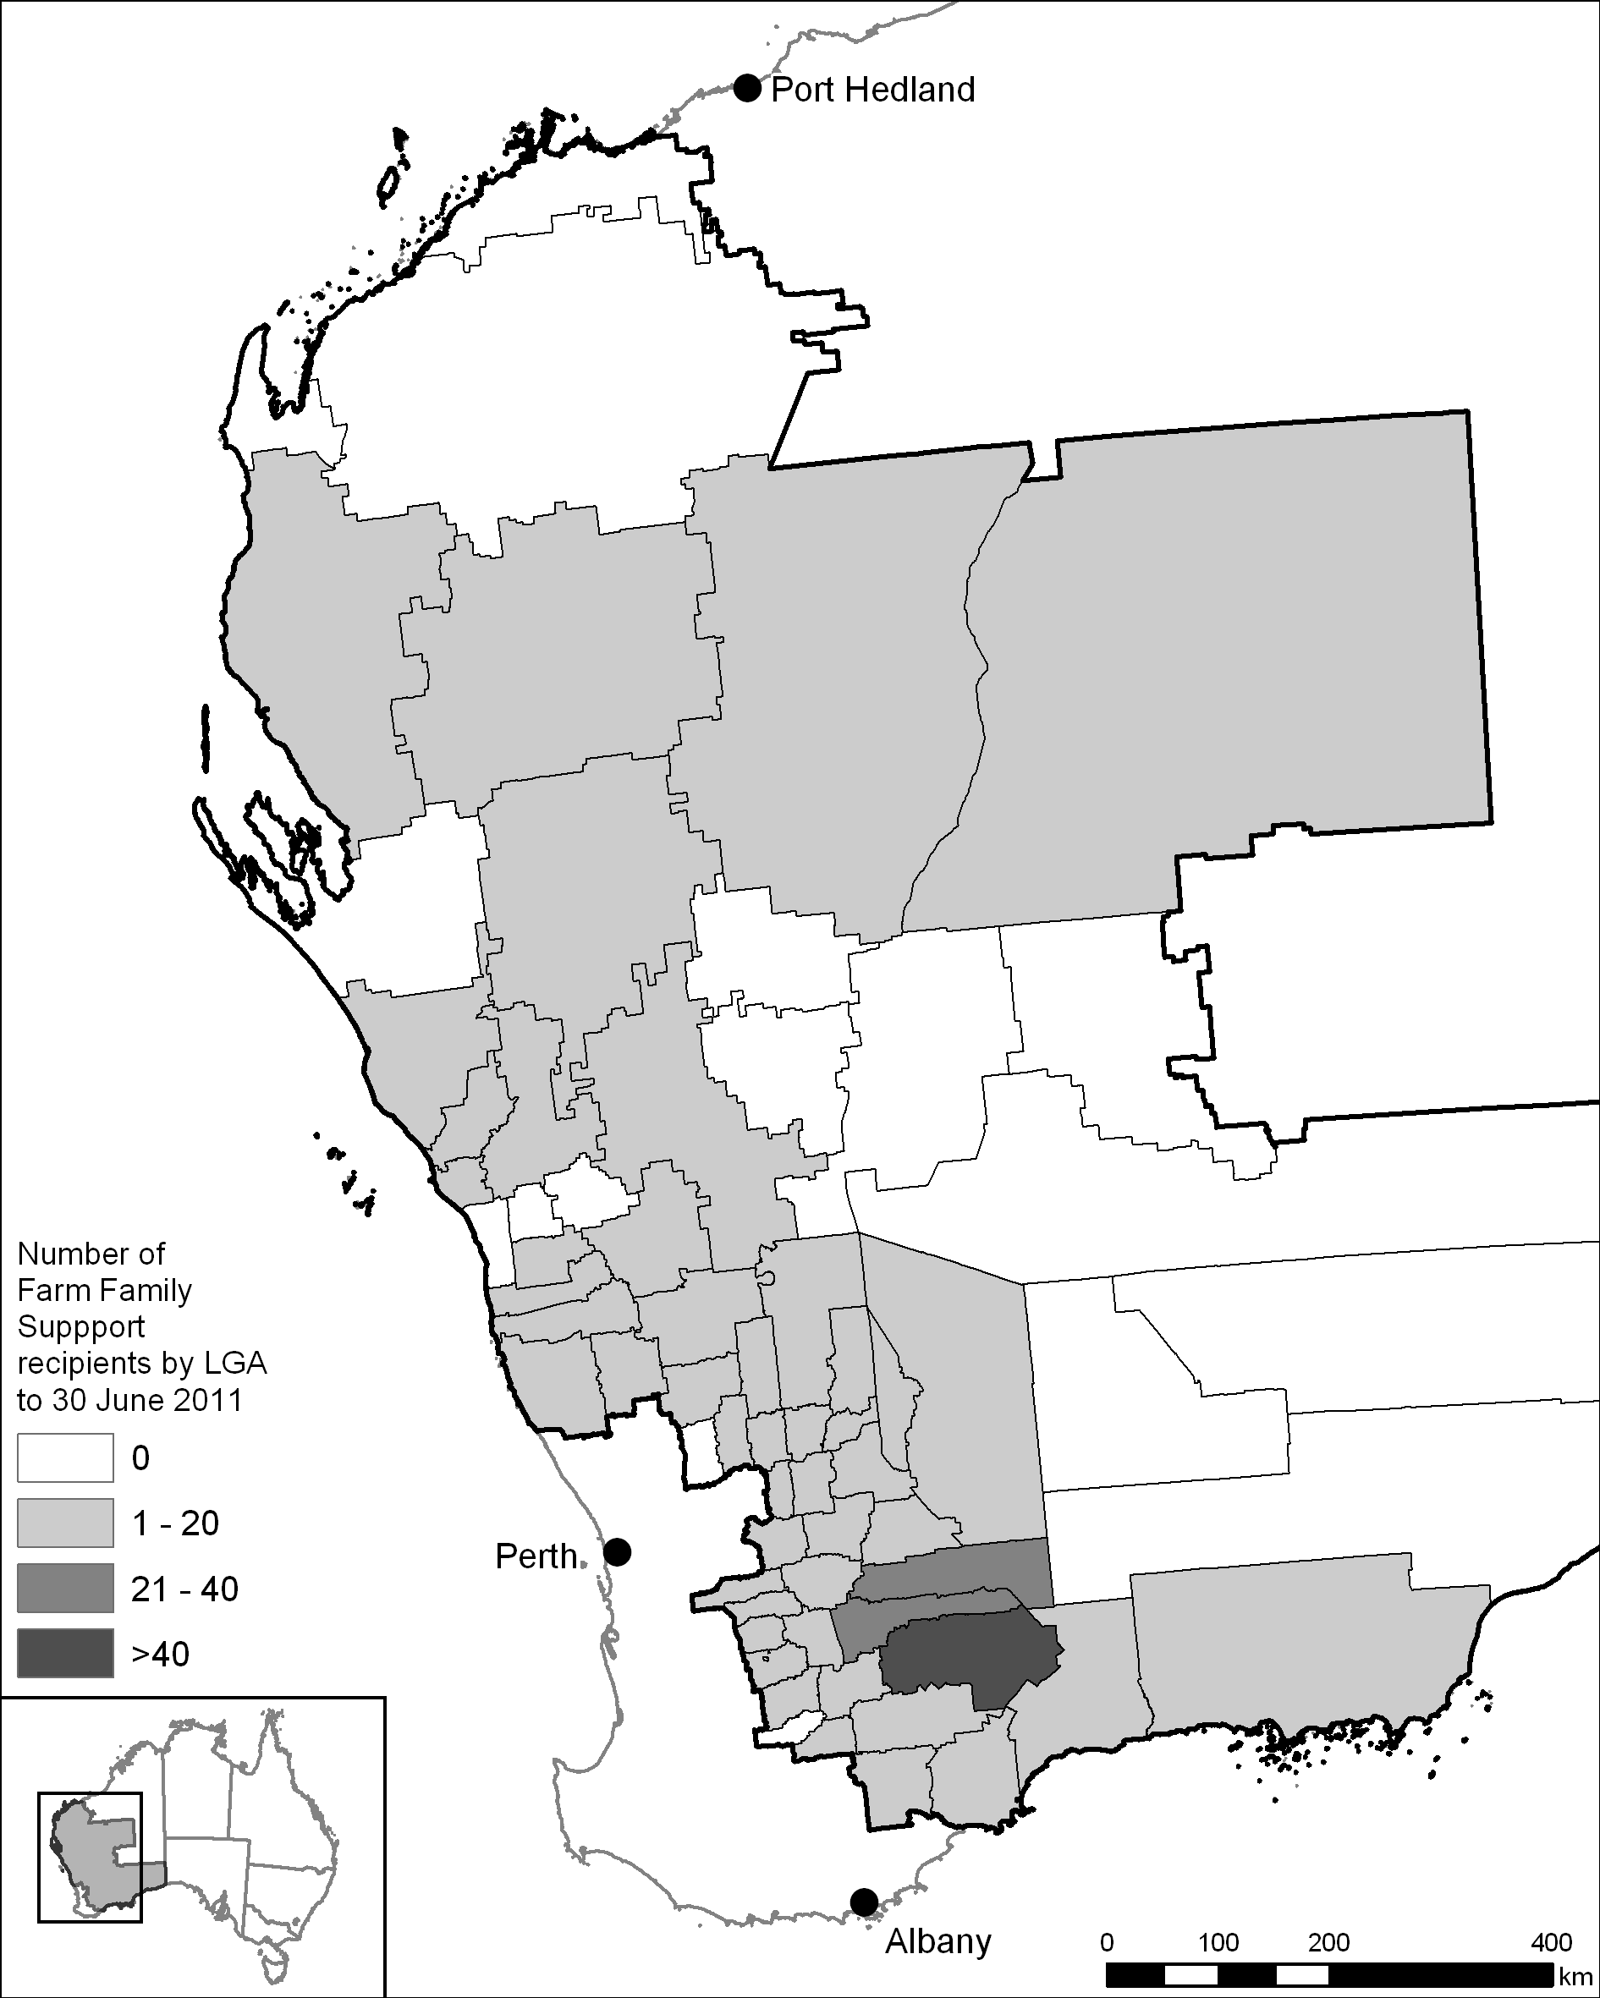 Sources: Centrelink (data supplied 15 July 2011); Australian Bureau of Agricultural and Resource Economics and Sciences (map).
The majority of recipients were farmers from wheatbelt areas, with recipients from livestock and horticultural industries under-represented in comparison with the numbers of these farms in the pilot region (see Table 4.1).
Table 4.1: Farm industries of Farm Family Support recipients compared with other regions
Industry | Farm Family Support recipients (per cent)  n=424* | Pilot region farmers (per cent)  n=9372† | Australian farmers (per cent)  n=151 109†
Cropping only | 14 | 39 | 16
Livestock only | 5 | 27 | 58
Cropping and livestock | 76 | 28 | 11
Other | 5 | 0 | 0
Horticulture | 0 | 6 | 15
*Source: Centrelink (data supplied 15 June 2011).
†Source: Australian Bureau of Agricultural and Resource Economics and Sciences (ABARES) (data supplied 6 April 2011). Data compiled from ABARES farm survey which includes responses from all individuals owning part of the farm business or receiving a share of the farm business income plus salaried farm managers in the case of corporate farms of agricultural establishments that have an estimated value of agricultural operations exceeding $40 000 in the wheat and other crops, mixed livestock–crops, sheep, beef, sheep–beef or dairy industries.
Proportionally more of the recipients of support were younger farmers. Farmers under 45 years of age represented 43 per cent of recipients despite only making up 19 per cent of farmers in the pilot region and 14 per cent of farmers nationally (see Table 4.2).
Table 4.2: Age of Farm Family Support recipients compared with other regions
Age (years) | Farm Family Support recipients (per cent)  n=424* | Pilot region farmers  (per cent)  n=9372† | Australian farmers  (per cent)  n=151 109†
24 and under | 3 | 0 | 0
25 to 34 | 15 | 5 | 3
35 to 44 | 26 | 14 | 11
45 to 54 | 24 | 30 | 25
55 to 64 | 21 | 27 | 33
65 and over | 11 | 24 | 28
*Source: Centrelink (data supplied 15 June 2011).
†Source: ABARES (data supplied 6 April 2011). Data compiled from ABARES farm survey which includes responses from all individuals owning part of the farm business or receiving a share of the farm business income plus salaried farm managers in the case of corporate farms of agricultural establishments that have an estimated value of agricultural operations exceeding $40 000 in the wheat and other crops, mixed livestock–crops, sheep, beef, sheep–beef or dairy industries.
While the proportion of female farmers that received Farm Family Support appeared to be lower than the proportion of female farmers in the pilot region (see Table 4.3), this was more likely a reflection of the fact that payments were only made to one member of a farming couple—more often the male farmer.
Table 4.3: Gender of Farm Family Support recipients compared with other regions
Gender | Farm Family Support recipients (per cent)  n=424* |  | Pilot region farmers  (per cent)  n=9372† | Australian farmers (per cent)  n=151 109†
Male (partnered) | 60 | 73 | 59 | 56
Male (single) | 13 | 73 | 59 | 56
Female (partnered) | 25 | 27 | 41 | 44
Female (single) | 2 | 27 | 41 | 44
* Source: Centrelink (data supplied 15 June 2011).
† Source: ABARES (data supplied 6 April 2011). Data compiled from ABARES farm survey which includes responses from all individuals owning part of the farm business or receiving a share of the farm business income plus salaried farm managers in the case of corporate farms of agricultural establishments that have an estimated value of agricultural operations exceeding $40 000 in the wheat and other crops, mixed livestock–crops, sheep, beef, sheep–beef or dairy industries.
Some 24 per cent of recipients indicated that they had previously received Exceptional Circumstances (EC) Relief Payments and 17 per cent said they had previously received EC Interest Rate Subsidies.

Targeting
Access to Farm Family Support was available on the basis of demonstrated individual need. It was available irrespective of climatic conditions. Farmers in financial hardship were able to access assistance, irrespective of the cause of that hardship, subject to certain assets and income tests.
In contrast, access to EC assistance for a region is dependent on the declaration of an administratively determined exceptional circumstances event, such as a one in 20 to 25-year drought. The national review of drought policy found that the EC trigger, which relies on historical rainfall records, is no longer appropriate in the context of a changing climate.
The national review of drought policy found that the EC declaration process also causes great stress, with some people receiving support and others missing out according to the judgement of officials, and based on ‘lines on maps’.

Preliminary outcomes
Throughout the review of the pilot, the panel heard almost universal support for an income support program provided to farming families based on individual need. Comments from the Australian Association of Agricultural Consultants WA typify the views expressed to the panel by stakeholders.
This type of funding has been welcomed by those farmers who are unable to provide the most basic of needs for their families. This should continue irrespective of the outcome of the drought pilot review to provide a safety net for those people in significant financial difficulty.
The panel found that Farm Family Support, as an income safety net for farmers, is appropriate, worthwhile and working. The provision of support without a climatic trigger is very important, as it provides support to those in hardship, irrespective of the cause of that hardship. The criteria effectively address the concerns expressed about ‘lines on maps’ under the EC arrangements.
During the panel’s consultations with Farm Family Support recipients and delivery agencies, it was reported that Farm Family Support payments were being used to meet basic household needs, rather than farm business expenses. As well as assisting farm families this brings benefits to regional communities because, as identified in the national review of drought policy, expenditure by farmers in smaller towns is an important source of income for many small businesses. The panel heard that Farm Family Support payments flow through to regional small businesses and service providers through local expenditure by farm families on goods and services.
The panel heard that the poor seasonal conditions during the pilot drove stronger demand for Farm Family Support than would be the case in better seasonal conditions. However, the extent of this seasonal influence is not easily determined. As reported by the Productivity Commission inquiry into government drought support, underlying financial hardship is not easily distinguished from the financial effects of drought.
A number of studies have revealed a complex picture of entrenched and chronic problems that go well beyond drought and point to chronic rural disadvantage. Nevertheless, poor seasonal conditions are known to reduce farm incomes. In the panel’s view, it would be reasonable to expect that demand for Farm Family Support would reflect seasonal conditions, but with an underlying number of farm businesses needing assistance irrespective of seasonal conditions. This points to the need for interventions that improve the long-term financial position of those recipients, including identifying alternative career pathways and retirement options as appropriate.

Delivery
Centrelink delivered Farm Family Support through its offices and using enhanced outreach services. Outreach involved Centrelink staff visiting and providing services to clients in remote and regional areas, including raising awareness and providing services via the Australian Government Mobile Office (also known as the ‘drought bus’).
Extra resources for outreach services allowed Centrelink staff to travel to rural and remote locations not in close proximity to a Centrelink office, so that the people in those locations had the opportunity to access assistance from Centrelink staff that would not have been available otherwise. Centrelink rural services officers (RSOs) helped farmers and their families access a range of payments and services. They also referred them to a range of government and non-government agencies for further assistance. Centrelink social workers provided short-term personal support and counselling.
The panel found that RSOs were instrumental in helping farmers to access Farm Family Support—they raised awareness, encouraged farmers not to ‘self-assess’ and helped them through the detailed application process.
The panel met a number of recipients who expressed great appreciation for the help provided by RSOs. Those who had initial one-on-one assistance, particularly a farm visit from a RSO, generally reported a smoother and less stressful experience with the Farm Family Support application process.
I’ve felt well supported through the whole process.
Rural services officers provided support to recipients who had no access to a Centrelink office due to their remoteness. For example, in late 2010 RSOs travelled approximately 2000 kilometres on a round trip to Carnarvon shire and the Upper Gascoyne region to collect new claims from clients and gather paperwork for claims in progress. Centrelink staff reported that, without such a service, many people in hardship would not receive the financial and other support they need. Side benefits from outreach activities include social interaction with clients located in remote areas and the opportunity to identify other client needs, such as mental health counselling.
Mobile office staff reported being approached by a number of people, particularly at field days, who had heard something about the pilot, but had not taken action to access any of the programs. Centrelink staff were able to assist these people to access the available support. Rural services officers also collaborated with local community agencies to use their premises as a hub to conduct appointments with local clients. This helped to reduce the travel distances for clients, and improved the efficiency of RSOs by enabling them to help more clients in less time with less reliance on farm visits.
The panel found that the outreach model was very well received by clients. It helped Centrelink identify and respond to previously unmet demand for support services. The panel considered that these outreach services were crucial to the success of the Farm Family Support program and would need to be appropriately resourced in any national roll-out of such a program.
The panel consistently heard from both recipients and delivery agencies that the stigma usually associated with income support was not experienced by Farm Family Support recipients.
10 years ago there was a stigma associated with Exceptional Circumstances. That’s disappeared with this program.
This appeared to be the combined result of upfront communication about the program, mobile office visits, positive experiences with Centrelink staff and the sense among recipients and Centrelink staff that ‘we are all in this together’. The panel heard that this was helped by the fact that Centrelink provides access to a range of services, not just income support.

Application process
The national review of drought policy recommended that access to government assistance and services should be improved by making applications and referral pathways simpler. While RSOs were instrumental in helping farmers to access assistance, the panel heard complaints from applicants that there was too much paperwork and claims took too long to process.
Some applicants felt that to make a successful claim they had to be very persistent. Some claimants said they found the application process daunting, in part because of the stress brought on by the poor seasonal conditions.
I know many people in Koorda (which is one of the worst hit areas from the drought because it never hardly rains here!!!) who are struggling and never got the farm family help and who really needed it. I know some mentioned to me how hard the paperwork was to fill out and some believed they wouldn’t get it anyway, as they never get ‘help like that’.
Concerns were raised across a number of communities that families were electing to go without financial assistance, rather than experiencing the stress and at times added costs associated with their accountant and lawyer preparing the required information.
According to the Rural Financial Counselling Service WA “those farmers who access the income support successfully often refer to the paper work as horrendous”. The panel noted that, while perceived by some applicants as onerous, the accountability and documentation requirements for assessment were consistent with the broader framework within which Centrelink operates. In the panel’s view, these issues reinforced the importance of the outreach model and the role of the RSOs in assisting clients with their applications.
Claim assessment times are calculated by Centrelink from the date the claim is physically lodged to when Centrelink advises the applicant, based on the information supplied, of the outcome of the claim. Centrelink contacts farmers to advise of any material that has not yet been supplied. Performance data from Centrelink indicated that there were delays in processing applications. For granted claims, the average assessment period was 58 days and for rejected claims it was 53 days. The main contributing factors were:
- the prevalence of complex business structures among applicants which meant that all of the necessary documentation was not initially supplied by most applicants
- the fact that farm assets are not exempt (unlike EC Relief Payments) and need to be ‘unpacked’ and assessed
- the lack of sophisticated information technology infrastructure to record and process claims.
Almost 50 per cent of Farm Family Support claims were from farmers who identified that they have complex business structures such as trusts. In many other cases trusts or companies existed that were not originally identified by the farmer. In all trust and company cases, the application was referred to a complex assessment officer for further assessment. This usually required seeking further documentation and clarification from applicants and their accountants, which took extra time.
Delays were compounded by the new total net assets test being trialled under this program. For other income support programs, such as EC Relief Payments, farm assets essential to the day-to-day running of the farm business are disregarded in assessing eligibility. The need to assess the value of all farm assets in this program added to the complexity of the assessment process. The panel considered that processing times for applications would improve as applicants and Centrelink staff become more accustomed to the information needed to support an application. There may also be a case to employ additional complex assessment officers under any future program. A reconciliation system for payments, which could further reduce claims processing times, is discussed below (see 4.9).
Many recipients felt that a list of the supporting documentation required by Centrelink should be provided up front to streamline the process and reduce the number of follow-up requests for further information. The panel saw merit in this idea, noting Centrelink’s advice that for complex assessments, this is not straightforward because the required documentation varies from case to case.
Centrelink officials advised the panel that the development of information technology infrastructure to support the applications and payments process requires lead times of at least 12 months. In the context of the short-term nature of the pilot it was not feasible to develop such systems. As a result, the assessment of claims against the new suite of assets and income criteria relied on manual processing. This resulted in unavoidable delays—especially in the assessment of applicants with complex farm business structures.

Payments and eligibility criteria
Income support was paid at a fortnightly rate based on the Newstart Allowance basic benefit rate, or the Youth Allowance rate for those under 21 years of age. The rate of the payment takes into account the age and partner status of the applicant, and an income and total net asset test also apply. The basic Newstart Allowance fortnightly benefit rate as at July 2011 ranged from $474.90 (for a single person with no dependent children) to $857.40 in total (for a partnered person). Adult payment rates are adjusted for inflation each March and September.
In setting a recipient’s payment rate for Farm Family Support, Centrelink assessed income received and asset values, including details of income and assets earned by trusts and companies that the farmer and partner are involved in. A separate income and assets test is applied to determine a recipient’s payment rate. The applicable payment rate is determined from whichever test returns the rate of lower payment. Farm Family Support recipient payment rates were set based on their income in 93 per cent of cases, with the remaining 7 per cent calculated based on their assets. Income for the farming business may be either ‘actual’ income from the most recent available financial year’s taxation return projected into the current year—as applies for all mainstream social security payments—or an estimate of the current year’s income. Centrelink advised that most farmers prefer their payment rate to be based on their estimate of farming income rather than on an earlier year’s actual income.
Most single recipients and a large proportion of partnered recipients received a fortnightly rate of payment at or close to the maximum amount available (see Figure 4.2). A large proportion of partnered recipients were subject to a variable payment rate, which was recalculated each fortnight to account for their, and/or their partner’s, variable income from employment.
Figure 4.2: Payment rates for Farm Family Support recipients to 31 May 2011
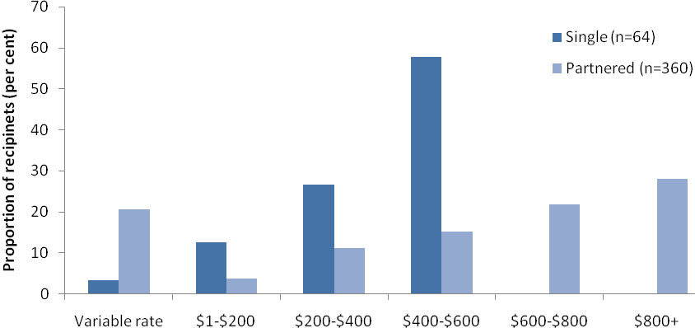
Source: Centrelink (data supplied 15 June 2011, n=424).

Assets limits
The panel noted that income support programs for farmers have typically been established in recognition that some farmers are asset rich and cash poor, and their high asset levels generally exclude them from accessing mainstream welfare.
The Farm Family Support program had a tapering total net assets test that started at $2 million, including the farm. The only exempt assets were superannuation and life insurance funds. Farms held in self-managed superannuation funds are included in the net asset test as they are considered to be a farm asset. The fortnightly rate of Farm Family Support was reduced by $0.40 for every $1000 in assets over $2 million.
Unlike EC Relief Payments, the Farm Family Support eligibility test includes assets essential to the running of the farm business in the calculation of total net assets. This approach reflected the national review of drought policy proposal, which aimed to target those farmers most in need of assistance.
The National Farmers’ Federation commented to the panel that its members were concerned about the Farm Family Support measure’s $2 million net assets limit. The Western Australian Farmers Federation also argued that:
the eligibility criteria need reviewing in terms of the farm business asset value and the farm family trust structures, and the need for financial support, which are not directly linked.
The Pastoralists and Graziers Association of Western Australia was also concerned that the assets test was too low. It argued that some assets classes should not be included in the test.
While acknowledging these concerns, the panel recognised that funds could be readily transferred between different asset classes, and that more flexible eligibility criteria might result in farmers who are not in hardship accessing the program. The panel supported the principle of the total net assets test as it was more likely to result in assistance being provided to those in real need.
The panel was not presented with compelling evidence to suggest that the $2 million total net assets threshold should be adjusted. In fact, most Farm Family Support recipients had net assets below $750 000 (see Figure 4.3) and only four claims were rejected on the basis of net assets being too high.
Figure 4.3: Net assets of Farm Family Support recipients to 31 May 2011
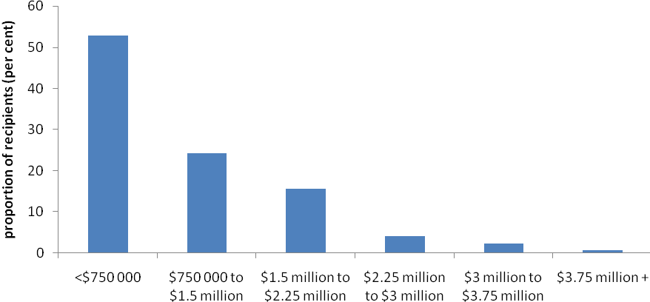
Source: Centrelink (data supplied 15 June 2011, n=415).

Liquid assets
The liquid assets waiting period was designed to encourage potential recipients with liquid assets in excess of $20 000 to draw those down before accessing public assistance. This $20 000 threshold is higher than that applied for the Newstart Allowance, in recognition that farm businesses require more working capital than ordinary households. For each $1000 in liquid assets held in excess of $20 000, applicants incurred a waiting period of one week, up to a maximum of 13 weeks. The maximum waiting period applies for those applicants with liquid assets in excess of $33 000.
More than half of all Farm Family Support recipients incurred the liquid assets waiting period before receiving support payments. The maximum waiting period was imposed on 50 per cent of recipients and a waiting period of one to 12 weeks was imposed on 7 per cent of applicants. The remaining 43 per cent of applicants did not incur the liquid assets waiting period.
The panel considered that applying a waiting period based on the level of the applicant’s liquid assets was appropriate, being consistent with the expectation that individuals should call on their own resources before accessing income support.

Income test
An income test was part of the Farm Family Support eligibility requirements. Under the income test, an applicant could earn before-tax income of up to $62 per fortnight before the level of Farm Family Support payment was affected. An applicant with fortnightly income of between $62 and $250 had fortnightly payments reduced by 50 cents for each dollar earned over $62. An applicant with fortnightly income above $250 also had fortnightly payments reduced by 60 cents for each dollar earned over $250.
Over 75 per cent of the Farm Family Support claims that were rejected were because the applicant’s income was too high.

Deeming
Some concerns were raised with the panel about the income deeming provisions of the eligibility rules for Farm Family Support.
Under the Social Security Act 1991, certain classes of financial assets are subject to deeming provisions—that is, they are ‘deemed’ to be generating income at a defined rate irrespective of the actual income being generated by those assets.
Farm [financial] assets impacted on the eligibility of some potential participants and the impact of deeming provisions and trusts need further consideration.
Concerns were raised in particular about deeming applied to longstanding beneficiary loans associated with family trusts. Some applicants were found to be ineligible because of deemed income in respect of their beneficiary loans exceeding the income threshold, despite those loans not generating any actual income for the farm business in some cases. For other farmer-specific income support programs this issue has not arisen because assets essential to the running of the farm business, including beneficiary loans, are disregarded for the purposes of assessing eligibility.
There were 15 applicants found ineligible for Farm Family Support because the amount of deemed income calculated for loan assets (mostly beneficiary loans associated with family trusts) was too high. In these cases the amount of money the farmer would need to have on loan would exceed $525 000 for a single person and $1 million for a couple. Under social security guidelines, if substantial assets are held, but they produce little or no income, a customer is expected to rearrange their financial affairs before calling on the community for income support through the social security system.
The panel considered there may be instances where the deeming rules that are applied in the case of long-established beneficiary loans associated with family trusts may render individuals ineligible for income support, even where it is not possible to quickly rearrange business structures or to change the nature of the loan so that it generates actual income. This is likely to be particularly relevant where the farm business is not generating income due to drought or other circumstances.
There are circumstances with respect to mainstream income support, where ‘hardship provisions’ apply, in recognition that some assets are not readily realisable and that assistance should be provided where applicants are otherwise eligible. The panel believes that such measures may be appropriate in some circumstances where the deeming provisions make an applicant ineligible to receive Farm Family Support.

Off-farm salary and wages offset
The off-farm salary and wages offset allows Farm Family Support recipients to earn up to $20 000 per annum from certain off-farm employment before the income test takes effect. This test mirrors arrangements for EC Relief Payments, conceived at the height of the last drought in an effort not to ‘penalise’ those diversifying into off-farm employment. The Productivity Commission argued that such an offset is not necessary because the income test does not penalise recipients to such an extent as to deter them from earning income. No equivalent offsets apply to mainstream income support measures, such as Newstart and Youth Allowance.
The application of the offset is problematic. As a consequence of the way it is calculated, its value effectively becomes larger as the year progresses. More importantly, it treats different forms of off-farm employment and on-farm improvements inequitably (see Box 4.1). Data supplied by Centrelink indicates that almost 22 per cent of Farm Family Support recipients earned off-farm wages or salary, at an average of $789 per fortnight ($20 514 per annum) (including partner).
Box 4.1: Case study of the off-farm wages and salary offset
Barry, John and Steve are single farmers whose previous income from farming was $12 000 annually and who expect the same on-farm income this year. Each has net assets of less than $2 million. Each is eligible for Farm Family Support at a rate of $253.98 per fortnight.
Barry finds ways to improve his on-farm productivity, which improves his farm income. He notifies Centrelink he expects to earn an extra $8000 in the year. As a result, his Farm Family Support payment is reduced to $69.36 per fortnight. Barry’s total income from all sources is $21 808.31 in the year.
John decides to supplement his farm income by using his farm equipment to do some contract harvesting. He earns an extra $8000 in the year. This form of employment does not attract the off-farm salary and wages offset so his Farm Family Support payment is reduced to $69.36 per fortnight. John’s total income from all sources is $21 808.31 in the year.
Steve decides to supplement his farm income by working part time at the local co-op. He earns an extra $8000 in the year. This form of employment attracts the off-farm salary and wages offset so his Farm Family Support payment is not affected. Steve will continue to be eligible for Farm Family Support at a rate of $253.98 per fortnight. Steve’s total income from all sources is $26 621.62 in the year.
Despite Barry, John and Steve each earning the same income through their own personal effort, Steve receives $4813.31 more in Farm Family Support payments in the year because of the off-farm salary and wages offset.
Note: Based on rates applicable at 1 July 2011. Calculations verified by Centrelink, 7 July 2011.

Reconciliation payments
Centrelink advised the panel that eligibility for Farm Family Support is more often based on a farmer’s estimated income, unlike mainstream income support where people are usually assessed based on their actual income. Relying on estimated income limits the scope for retrospective payment adjustment where actual income differs from estimated income. This arrangement essentially rewards those who underestimate their likely income, and penalises those who are more realistic in assessing their likely income. It also creates a requirement for all relevant income and asset information to be available and fully assessed before an applicant receives any income support.
The Productivity Commission envisaged that Farm Family Support would be made available utilising a reconciliation system. Under such a system, an applicant’s actual income in a given taxation year is periodically reconciled against the estimated income used to initially calculate payments for the same taxation year. Such systems are used for a range of other family payments such as the Family Tax Benefit.
Under a reconciliation system, successful applicants receive an adjustment to their payment that retrospectively reflects their exact support entitlement. This is because a reconciliation system enables payments in arrears to be made to those applicants whose actual income is less than originally estimated, and overpayments to be recovered from those recipients who underestimated their actual income. Such a system would also allow Centrelink to adopt a more risk-based assessment, with some farmers being able to make a quicker estimate of income and speeding up some applications.
The only form of adjustment for Farm Family Support is to raise a debt where the estimated income proves to be too low and there is no scope to pay arrears where the estimated income later proves to be too high. The panel sees merit in the use of a reconciliation system to streamline application processes and to encourage more responsible reporting of income while enabling the delivery of more equitable outcomes for successful applicants.
The panel noted that the benefits of more timely access to payments need to be balanced against the risk of farmers accruing debts that would later need to be recovered by Centrelink, sometimes many years into the future. Careful design of this system would be required, including legislative changes. A reconciliation system would also need to be supported by a fully computerised system, rather than the manual processing system that was in place for the pilot program.

Mutual responsibility
The mutual responsibility element of the Farm Family Support program was conceived to reinforce self-reliance, discourage long-term welfare dependency and to assist farmers to determine their own futures. Recipients were required to have an independent assessment undertaken of their farm business’ financial position. This then provided context for the actions that were identified to help the farm business become more viable, to help the recipient diversify or help them re-establish outside farming.
Farmers the panel met during consultation processes were supportive of the mutual responsibility requirements of Farm Family Support. The mutual responsibility requirements comprise:
- case management by a rural services officer
- a Farm Financial Assessment carried out be an independent qualified person
- the development of an Action Plan.
Farm Family Support recipients were required to:
- organise an appointment with a prescribed adviser to complete a Farm Financial Assessment to determine the financial health of the farm business (see Box 4.2), returning it to Centrelink within 28 days from the date the form was issued to the farmer
- meet with a RSO to develop an initial Action Plan (see Box 4.3) within 28 days of obtaining a Farm Financial Assessment. The Action Plan was required to outline the steps to be undertaken to improve the long-term financial situation, through either on- or off-farm actions, taking into account the farm’s financial position
- attend appointments or arranged telephone contacts with their RSO
- undertake the actions set out in their Action Plan.

Case management
Case management involved RSOs working closely with support recipients to help them improve their financial position and ensure that they met their mutual obligations. It was developed to ensure that clients were “in a well informed position to make difficult decisions about their business and their future in agriculture”. Case management represented an important and resource-intensive departure from other farmer-specific income support programs such as EC Relief Payments.

Farm Financial Assessments
The Farm Financial Assessment provided recipients and case managers with a snapshot of the financial health of the farm business (see Box 4.2). Farm Family Support applicants were provided with a $2500 grant to pay the cost of a Farm Financial Assessment undertaken by a qualified professional, regardless of whether their application was ultimately successful. This helped to ensure the early commencement of the mutual responsibility component of the program. Rural services officers in particular noted the benefits of this approach. The panel was not made aware of any evidence to indicate that spurious Farm Family Support claims were made in order to access the Farm Financial Assessment grant.
Box 4.2: Farm Financial Assessments
The Farm Financial Assessment provided a snapshot of the financial health of the recipient’s farm business. It comprised a farm business analysis section, which was completed by the farmer, and a financial assessment, which was completed by a prescribed adviser with relevant financial qualifications and professional membership.
The farm business analysis covered farm location, size, industry type, stocking rates, crop area, condition of infrastructure, water storage and access, number of farm employees, any leasing or share farming arrangements, agistment arrangements, retirement plans and factors affecting farm profitability.
The financial assessment detailed the gross value of the farmer’s assets, the farmer’s outstanding debt, equity level, historical income/expenditure/debt, cash flow projections, analysis of farm business strengths/weaknesses/opportunities/threats, management plans (if any) and actions needed to improve profitability in the short- and long-term.
The Farm Financial Assessment underpinned the Action Plan. It was therefore crucial that it provided a frank assessment of the applicant’s position. As identified by Australian Association of Agricultural Consultants Western Australia:
It is important that a critical review of the farming business be undertaken with at least one independent review of where the business is at. One of our members suggested that one short half day visit was often enough to provide some significant input into the business and give the owners some clear direction.
The panel sees merit in involving the professional who developed the Farm Financial Assessment in an early meeting between the farmer and the case manager to ensure they each have a good understanding of the farm’s financial position and the possible actions that could be taken to improve it. Centrelink advised that in some cases, as the pilot progressed, RSOs and financial professionals successfully conducted joint meetings to ensure a good understanding of both the farm’s health and the paperwork required to ensure a timely outcome for the payment decision.
The panel acknowledged it would be preferable for the Farm Financial Assessment to be undertaken by a qualified professional who had not previously been involved with the farm business. It also noted the limits that exist to achieving this in rural Western Australia, where access to professionals may be limited.
The panel also believed that the Farm Financial Assessment process could be used to link recipients with other government programs. For example, farm business managers with good prospects on-farm could be linked into a strategic farm business planning program. Those with poorer prospects on-farm could be helped to prepare for and find off-farm employment, either as a means of supplementing their farm income or as an alternative career path.

Action Plans
Action Plans were developed by Farm Family Support recipients to identify ways to improve their financial position (see Box 4.3). There was general support from farmers for the concept of mutual responsibility and the Action Plan process. However, the panel heard conflicting views regarding the effectiveness of Action Plans. Some recipients reported that they tended to treat it as a ‘tick-the-box’ exercise, whereas others felt the exercise helped to highlight important changes they could make to improve their circumstances.
Box 4.3: Action Plans
Action Plans were developed by recipients to identify ways to improve their financial position. The Action Plan had three parts. Part A was completed by the farmer and Parts B and C were completed by the farmer in consultation with a RSO (case manager).
Part A covered farmer details, skills/experience and formal education (including partner) and opportunities for recognition of prior learning.
Part B contained a summary of the Farm Financial Assessment, preferred ways to improve the farm financial position, long-term planning and preparation already undertaken, personal and financial goals, farm assets and needs, personal assets/liabilities and needs, objectives to improve the financial situation and advice/training options to help meet identified objectives.
Each objective identified the action to be undertaken, by whom and by when. It also identified how completing this action would improve the farmer’s financial situation.
Part C was a review of progress against the agreed objectives over the life of the program including any new or changed actions. It also identified the date of the next review.
Recipients indicated a strong preference to stay on-farm to improve their financial position (see Table 4.4).
Table 4.4: Action Plans—preferred methods to improve financial position to 31 May 2011
Preferred method to improve financial position | Proportion of recipients (per cent)  n=263
Remain on-farm and improve farm performance | 79
Remain on-farm and improve off farm income | 8
Re-establish outside farming | 7
Remain on farm and diversify | 4
Undecided | 2
Source: Centrelink (data supplied 15 June 2011).
Review consultations revealed that accessing off-farm income in their local area was not a readily available option for farmers in many areas of Western Australia, because of the lack of larger regional population centres. The types of activities identified in Action Plans early in the program included seeking farm technical advice, seeking business or financial planning advice and undertaking farm and non-farm related training (see Table 4.5).
Table 4.5: Action Plans—specific objectives to improve circumstances to 31 May 2011
Objectives identified in Action Plans | Proportion of recipients  (per cent)
Objective 1 (n=260)
Farm technical advice | 24
Training—farm-related | 13
Business planning/advice | 12
Training—non-farm | 12
Financial planning/advice | 12
Other | 27
Objective 2 (n=203)
Farm technical advice | 19
Training—farm-related | 15
Financial planning/advice | 14
Training—non-farm | 13
Business planning/advice | 13
Other | 26
Objective 3 (n=95)
Training—farm-related | 20
Farm technical advice | 18
Training—non-farm | 12
Succession planning | 12
Business planning/advice | 9
Other | 29
Source: Centrelink (data supplied 15 June 2011).
One recipient drew a direct comparison between the Action Plan and the strategic plans developed under the Farm Planning program.
The action plan was partly useful in instigating the thought process for better management. The five modules of the strategic plan were far more useful.
Centrelink advised that RSOs were keen to refer farmers to the Farm Planning course, but regrettably, once this program was filled, there was no scope to get farmers to such courses.
There was not sufficient time to determine the long-term benefits of the Action Plans. The panel was not aware of any recipients leaving the program due to improvements in their circumstances that were the direct result of implementing their Action Plan.
The panel believes there is more scope for Action Plans to consider personal and family wellbeing. Centrelink recommended better connections with the Rural Financial Counselling Service model or a rationalisation of roles as there is some duplication. The panel agreed that there might be better opportunities to meet recipients’ needs, for example Centrelink staff may be more proficient in assisting with applications and rural financial counsellors are more proficient in facilitating succession planning. Other social service providers could also be utilised.
The panel believes that for recipients in serious financial difficulty the Action Plan process could be used to support farmers in their consideration of retirement or an alternative career. More rigorous Farm Financial Assessments and access to targeted professional advice could help facilitate this process.

Training and advice component
Grants of up to $5000 were available for professional advice and training to support the implementation of the Action Plan.
Some recipients the panel met appeared to be confused about the training and advice component of this program, including how it links to the Action Plan, and what it can be used for. The panel heard that some recipients used the grant to pay accountant or consultant bills that would have been incurred anyway, rather than to undertake training or seek advice to help implement their Action Plan. Some also reported having difficulty finding appropriately registered local providers of training or advice to utilise the grant.
The types of training and advice options identified by recipients included financial advice, farm technical advice, agricultural related training and skills for off-farm employment (see Table 4.6).
Table 4.6: Action Plans—advice and training options identified to 31 May 2011
Advice and training | Proportion of recipients  (per cent)
Advice options (n=171)
Financial planning and business management | 66
Farm technical advice (agronomic etc.) | 56
Legal advice (succession planning etc.) | 37
Personal advice | 3
Other | 4
Training options (n=111)
Agricultural-related training | 56
Skills for off-farm employment | 48
Recognition of prior learning | 28
Other | 11
Source: Centrelink (data supplied 15 June 2011).
Note: proportions add to more than 100 per cent due to multiple responses from participants.
Where recipients are looking to improve their circumstances through on-farm changes, the panel believes that further consideration needs to be given to linkages with existing training courses, such as the Farm Planning program. In the case of those looking to improve their employment prospects off-farm, the panel sees merit in using the grant for recognition of prior learning to a greater extent. For those considering exiting farming, the grant could be used to develop a succession plan or prepare for alternative employment.

Ancillary benefits
Recipients of Farm Family Support also received ancillary benefits, such as access to Youth Allowance for dependent children, and the Health Care Card, which provides access to low cost pharmaceuticals under the Pharmaceutical Benefits Scheme. These ancillary benefits were reported to be highly valued by recipients.
As reported by the expert social panel, lack of access to Youth Allowance is a barrier to further education for dependent children in farming families. According to Centrelink data, almost 12 per cent of Farm Family Support recipients had Youth Allowance dependent children.
The panel considered that the provision of ancillary benefits in association with Farm Family Support was appropriate.

Time-limited support
The objective of Farm Family Support was to provide farmers in hardship with temporary income support while they take action to improve their long-term financial position. The measure is not intended to provide a long-term minimum income for farmers. The panel believes that these messages should be constantly reinforced.
It was originally conceived that Farm Family Support would provide not more than three years of income support in any seven years, in recognition that a farm business should be prepared for at least one and probably two years of drought and that farm cash incomes tend to recover quickly after a drought event. Although the duration of the pilot was too short to trial time-limited income support, the panel agreed that such support should be time-limited to encourage farmers to take action to improve their circumstances, to avoid entrenching dependence on income support, and to reduce the risk of the support measure impeding structural adjustment.

Costs
As noted earlier, this support measure was delivered using a case management system where applicants were directly assisted by a RSO, which is not the approach adopted for mainstream social welfare programs.
Case management represents a significant investment. The panel believed this is justified where it is shown to help farming families into a better long-term financial position. The panel believed that the early indications of the effectiveness of case management were very positive.
The panel noted that allowing all applicants to receive the $2500 Farm Financial Assessment grant up front, irrespective of eligibility for Farm Family Support, substantially added to the cost of this component of the program.

Conclusions and recommendations
The panel strongly supports the Farm Family Support component of the pilot, which provided temporary income support for farm families based on demonstrated individual need. The panel believes this is a more timely and equitable way of assisting farmers in hardship because it is not contingent on an EC declaration.
Recommendation 4.1: Temporary income support for farm families experiencing hardship that is available based on demonstrated individual need should be the foundation of any reform of national drought policy.
The panel noted that the provision of income support to farm families resulted in revenue flows to regional small businesses and service providers through expenditure by farm families on goods and services. The panel acknowledged the benefits this brought to regional communities.
The panel heard that the adverse seasonal conditions during the course of the pilot contributed to stronger uptake of Farm Family Support than expected. The panel recognises that there are many causes of hardship and, as a result, there may be a number of farm families that will require support irrespective of seasonal conditions.
The panel agrees that income support should be time-limited to encourage farmers to take action to improve their circumstances, avoid entrenching dependence on income support and to reduce the risk of impeding structural adjustment. The panel noted that the income support model recommended by the national review of drought policy included a proposal that such support be provided for a maximum of three years in any seven years.
Effective delivery of the Farm Family Support program was underpinned by Centrelink’s outreach services. Centrelink RSOs and social workers visited applicants in their homes, at local venues and via the Australian Government Mobile Office to assist with applications and provide ongoing support, including case management and counselling. These outreach services helped Centrelink staff to identify and respond to previously unmet demand. Outreach services need to be properly resourced to be effective in any national roll-out of a similar program (see also Chapter 5).
Recommendation 4.2: Any future income support program for farm families should be underpinned by adequately resourced Centrelink outreach services that provide assistance to clients in the home, at local venues and via the Australian Government Mobile Office.
The total net assets eligibility test trialled as part of the Farm Family Support program created challenges for applicants and Centrelink alike. On balance, the panel believes that the test is reasonable and expects that application processing times will improve as applicants and staff become more accustomed to the information needed to support an application. The panel believes there is scope to better communicate the types of information needed to potential applicants in order to make the application process simpler and faster.
Recommendation 4.3: In any future income support program for farm families, more complete guidance on the application process, such as an online tool, should be developed to better inform applicants about the information needed to support their application.
The panel understands that application processing times would be further improved by the delivery of Farm Family Support through Centrelink’s mainstream service delivery platform, rather than via a stand-alone pilot program. The panel acknowledged that investment by Centrelink in a more comprehensive administration system for this program was not possible in the context of the pilot.
The panel considers that applying a waiting period based on the applicant’s liquid assets in any future income support program for farm families would be appropriate—consistent with the expectation that individuals should call on their own resources before accessing government income support.
The panel noted that income deemed as a consequence of applicants having longstanding beneficiary loans associated with family trust structures resulted in a number of applicants being found ineligible for Farm Family Support. In circumstances where such arrangements are longstanding, the panel believes the deeming provisions might have the unintended consequence of depriving families in hardship of government income support. A degree of flexibility is required in dealing with such applicants.
Recommendation 4.4: The hardship provisions that are applied by Centrelink in some circumstances for other government support programs should also be considered for application in the case of longstanding beneficiary loans associated with family trust structures.
The panel noted that the off-farm salary and wages offset allowed recipients to earn up to $20 000 from off-farm salaries and wages without any reduction in their Farm Family Support payments. However, equivalent income derived from certain other sources, such as contract work, resulted in a reduction in Farm Family Support payments (see Box 4.1). The panel noted that the off-farm salary and wages offset might result in inequitable outcomes for Farm Family Support recipients.
There was limited opportunity for Farm Family Support payment adjustment where actual income differed from estimated income—such adjustments only allowed for debts to be raised and no arrears paid. Some other government support programs include a reconciliation mechanism to enable payments to be adjusted in a later tax year based on actual income. The panel sees merit in establishing a reconciliation payment process as a means of providing more accurate and timely payments or adjustments to recipients based on actual income. The possible need to recover overpayments from recipients would need to be considered.
Recommendation 4.5: The merits of establishing a reconciliation payment process should be considered for any future income support program for farm families.
The pilot program included ‘mutual responsibility’ elements associated with income support, including a Farm Financial Assessment, and the development and implementation of an Action Plan, supervised by Centrelink case managers. The panel agreed with the emphasis on mutual responsibility and heard expressions of support for it from stakeholders. The panel noted that case management was a significant investment of resources and would need to demonstrate over time that it delivers better outcomes for income support recipients.
The panel noted that ideally the Farm Financial Assessment (see Box 4.2) should be undertaken by a professional adviser who has had no prior involvement with the recipient. There would also be merit in having the professional adviser attend an early case management meeting to help set the context and identify actions that would improve the financial position of the recipient.
The panel sees Action Plans (see Box 4.3) as an important vehicle for establishing stronger links across the full range of government programs and services available for farm families. For example, Action Plans could be used to direct Farm Family Support recipients to strategic farm planning programs, social support services or exit support. Clearer and more timely pathways for accessing these should be identified through the Action Plan process.
The panel found that the Farm Financial Assessment and Action Plan processes have merit, but the short timeframes of the pilot did not allow their long-term effectiveness to be tested. The panel sees merit in further examining these processes during the extended pilot, to ensure they are helping to improve the financial position of recipients and making them more self-reliant.
Recommendation 4.6: An assessment of the Farm Financial Assessment and Action Plan processes should be undertaken during the extended pilot in Western Australia to determine their effectiveness.

Farm Social Support

Key points
- The Farm Social Support program delivered enhanced and better coordinated social support services. It identified and responded to previously unmet demand for these services.
- Social support services should be available to rural communities at all times, not just in times of crisis.
- Embedding mental health, counselling and referral services with other community services and at community events should increase people’s confidence in accessing them.
- The outreach model used in the pilot—providing services to farmers in their home, workplace or other local venue—is integral to the successful delivery of social support services in rural communities.
- Delivery agencies should continue to improve communication and coordination across the range of social support services provided.

Rationale and objectives
The Farm Social Support program was developed in response to the national review of drought policy, which found that droughts have a significant negative impact on the mental wellbeing of farm families and the social fabric of rural communities, and that these issues need to be addressed as part of a comprehensive national drought policy.
The national review of drought policy also identified that the ad hoc and expensive approach of bringing in additional mental health resources during drought periods was not as successful as intended, and concluded that governments and non-government organisations must move away from crisis-framed responses and adopt more long-term, sustainable approaches to the delivery of human support services in rural Australia.
The national review of drought policy recommended that, in planning for drought:
improved human support services must be available and responsive to the needs of farm families and rural people, and
the outreach mobility of human services to respond to rural people in times of stress, such as future periods of dryness, needs to be improved, with one option being an expansion of the Centrelink Rural Services Officer program.
Social support can be more difficult to access in rural areas because of greater travelling distances for both service providers and clients and a lack of service points compared to metropolitan areas. A range of factors specific to the farming community―crop harvesting and seeding for example, which limit the ability of farm family members to leave the property―can also impact the ability of farmers to access traditional services. Therefore, more specific efforts, such as outreach services, are needed to meet the mental health, counselling and social wellbeing needs of farm families and rural communities. Outreach services are not centre based but are instead provided in the home, workplace or at another local venue.
The aim of the Farm Social Support program was to build stronger social support networks to meet the mental health, counselling and other social needs of farming families and rural communities.
There were three components to the program:
- the Rural Support Initiative, delivered by Centrelink
- the Online Counselling for Rural Young Australians Initiative, delivered by the Department of Health and Ageing
- the Rural and Regional Family Support Service, delivered by the Department of Families, Housing, Community Services and Indigenous Affairs.
The services were available to anyone in the pilot region―not farmer-specific like most other pilot programs. An important part of the approach was to improve the outreach of services to rural areas. Increasing the resources available to existing service providers meant that staff could spend more time interacting with people face-to-face. This included providing direct services and contact through community events, forums and home visits.
The Farm Social Support program, with a budget of $3.3 million, was fully funded by the Australian Government.

Rural Support Initiative

Objectives
The Rural Support Initiative aimed to provide support services that are more accessible, coordinated, integrated and efficient in meeting the mental health, counselling and other social needs of farming families and rural communities.

Program description
Centrelink delivered the initiative, which largely focused on expanding its existing services to support better integration and outreach to rural communities. The $1.5 million budget for the initiative funded:
- Centrelink rural services officers (RSOs) to help individuals and families access a range of payments and services and referred them to other government and non-government agencies for further assistance where appropriate
- Centrelink social workers to provide short-term personal support and counselling, and support for community capacity building
- a rural support coordinator to oversee the coordination of government and non-government services, engage with stakeholders, and support and develop networks
- two Australian Government Mobile Office visits to the pilot region to provide local access to a broad range of Centrelink and other government services for rural and remote communities.

Participant snapshot
People in the pilot region made contact with RSOs 8269 times during the pilot. Of these contacts, 927 (11 per cent) took place at the farm or in the home of the person or family in need of support. People in the pilot region made contact with social workers 1404 times, with 233 (17 per cent) of these contacts taking place at the farm or in the home. Between them, RSOs and social workers attended 199 community outreach events and made 112 presentations at community forums or events, providing a further opportunity for pilot region residents to obtain information and interact with them in a familiar setting.
People in the pilot region were referred by RSOs and social workers to financial services providers, rural financial counsellors, educational providers, industry bodies, local, state and Australian government agencies, and the Rural and Regional Family Support Service.
More than 2000 people in the pilot region accessed the Australian Government Mobile Office while it was there. The mobile office visited 26 communities in the pilot region during August and September 2010 and 12 towns during a second visit in December 2010 and January 2011 (see Figure 5.1).
Figure 5.1: Number of Rural Support Initiative contacts with clients by local government area and locations visited by Australian Government Mobile Office
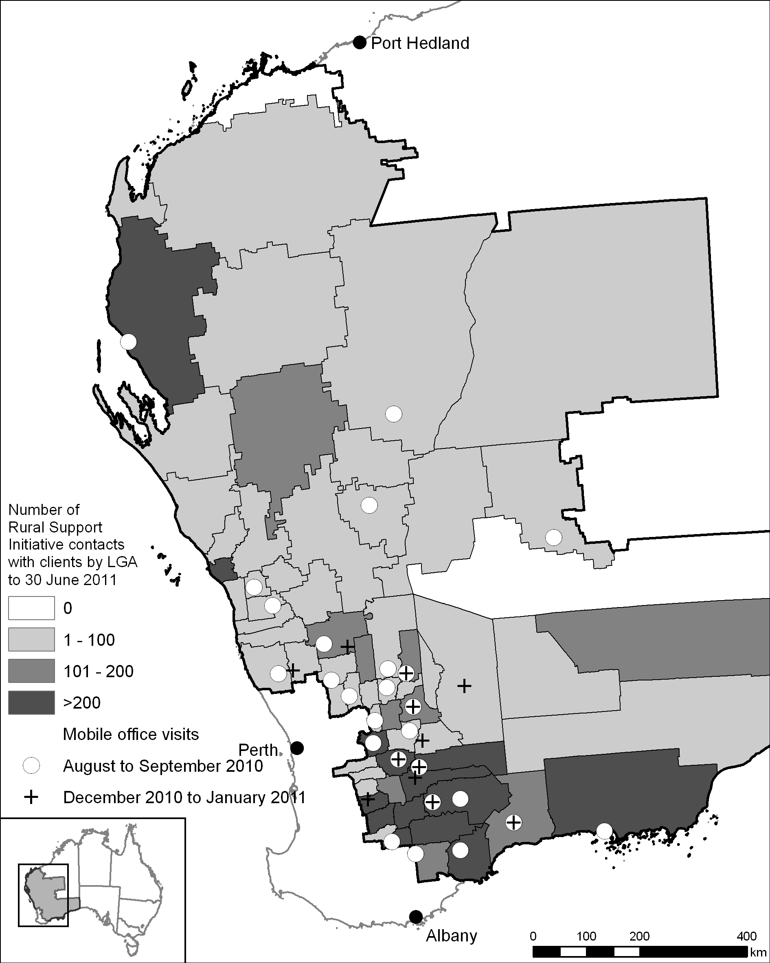
Sources: Centrelink (data supplied 15 July 2011); Australian Bureau of Agricultural and Resource Economics and Sciences (ABARES) (map).

Preliminary outcomes
The pilot review panel heard that the outreach model of taking services to farmers was effective and well received and both RSOs and social workers were helpful, professional and well respected.
Centrelink advised the panel that the generally poor seasonal conditions in the pilot region meant that counselling services were more in demand than they might otherwise have been. The panel noted that this higher than expected demand may have impacted on the capacity of Centrelink staff to undertake case management of Farm Family Support recipients and the overall provision of services under Farm Family Support.

Delivery

Rural services officers
The panel heard almost universally positive comments from Farm Family Support recipients about their experience with RSOs and many of them, as well as a range of other stakeholders, commented that RSOs were instrumental in helping farmers to access Farm Family Support.
Rural services officers were useful in assisting farmers applying for benefits and … seeking solution[s] to problem cases.
[Our RSO] was fantastic. She helped us get everything in quickly,
The panel heard that home visits from RSOs were particularly valued by clients. RSOs and their clients reported to the panel that the RSO would often spend several hours at the client’s farm to help them with the process of applying for Farm Family Support. Centrelink and the RSOs themselves noted how resource intensive this support mechanism was.
Centrelink originally employed five RSOs in Western Australia for the pilot but, as demand for Farm Family Support increased beyond original estimates, it brought more RSOs into the region. At one stage there were nine RSOs employed in the pilot region. RSOs noted that, even with extra resourcing, they were required to prioritise their clients.
While the increased level of RSO support was recognised and welcomed by most Farm Family Support recipients the panel met, the panel noted that the high demand and limited resources impacted on some applicants. One Farm Family Support recipient, for example, said they did not receive a farm visit and were only able to speak to an RSO over the phone because it seemed that they were ‘totally flat out’. Some recipients said they would have preferred to retain their RSO as their only point of contact with Centrelink, but eventually they were directed to the broader Centrelink system.
The panel noted that the level of resourcing required for a truly effective outreach model may be substantial.

Social workers
The panel also heard from Farm Family Support recipients and Centrelink that farmers have been supported to access health and wellbeing agencies and services.
The panel noted that social workers were clearly valued―they made presentations at 50 community events, made 233 farm or home visits and made contact with 280 people at field days―but because of the sensitive nature of their role, direct feedback to the panel during consultations was limited.
The case study in Box 5.1 provides an example of how the Rural Support Initiative assisted farm families in the pilot region.
Box 5.1: Social worker case study
A farming couple were experiencing a combination of physical and mental health issues, as well as financial difficulty. They received a joint farm visit from a Centrelink social worker and an RSO, following a referral requesting financial assistance and social and emotional support.
The social worker provided a professional social casework assessment to the couple. The social worker also helped them apply for financial and educational assistance from a philanthropic trust to help with medical costs and connected them to several support services. The RSO supported the family though the claim process for Farm Family Support.
The couple reported that one family member’s mental health had improved as a result of talking with a professional. The knowledge that their Farm Family Support application was successfully lodged also helped ease the couple’s stress.
Source: Centrelink.

Rural support coordinator
A rural support coordinator was appointed for the duration of the pilot to enhance coordination between government and non-government services. They engaged with stakeholders and supported the development of linkages and networks. Their efforts were critical in managing the local relationships between the pilot partners and coordinating services with delivery agencies. The panel recognised that coordination was a huge task, given number and variety of agencies and organisations involved in delivering the pilot and the short lead times associated with its implementation.
The rural support coordinator promoted Farm Family Support and Farm Social Support at information sessions when the pilot commenced. They helped plan the Australian Government Mobile Office’s visits to the pilot region. They also coordinated Centrelink’s and other Farm Social Support providers’ attendance at community events, helping to present a united operation to the community.
Delivery agencies advised the panel that the level of integration achieved by Centrelink with other services available in the pilot region was significant. Referral statistics also indicated significant integration, with RSOs and social workers referring more than 2000 people to other services.
One service provider suggested to the panel that more clarity is needed about the roles of Centrelink social workers in relation to other service providers. There was reportedly some confusion initially among farmers over the roles of the different service providers under the Farm Social Support measure. The panel heard during consultations that, at the local level, RSOs, social workers, and other counsellors ensured that clients had access to the services they needed. In what was a learning process for providers as the pilot progressed, collaboration increased, including joint visits to areas where appropriate.

Australian Government Mobile Office
Centrelink advised the panel that the reaction of communities to the Australian Government Mobile Office’s visits to the pilot region was ‘overwhelmingly positive’ and that the number of people accessing the mobile office was much higher than for previous visits to Western Australia.

Costs
The budget for the Rural Support Initiative was $1.5 million. However, Centrelink advised that the program actually cost more than this because demand increased as a result of the poor seasonal conditions and extra RSOs were employed.
While outreach services are more costly than centre-based services, the panel considered that the benefits of providing additional funds for outreach were significant.

Conclusions
Centrelink RSOs were instrumental in helping farmers to access Farm Family Support—they raised awareness, encouraged farmers not to ‘self-assess’ and frequently helped farmers through the application process. Social workers were effective at providing counselling and access to other services, and in some cases assisted clients to access Farm Family Support. The panel considered that the Rural Support Initiative was effective in linking to existing support networks and to other social support programs.
The panel noted that, although adverse seasonal conditions were likely to have increased demand for services, the strength of that demand indicated an underlying need for these services in rural communities.
The panel considered that the outreach model of taking services directly to farmers was effective for promoting and delivering services and was well received by farm families and rural communities. The panel considers that outreach services should be part of any future social support services in rural Australia. The panel did, however, note that the model requires substantial resourcing and consideration would need to be given to this in any broader roll-out of the Rural Support Initiative.
The panel noted that the roles of the different service providers could be better clarified in any broader roll-out of the Rural Support Initiative and considers improvements could be made with a more coordinated communications strategy. The panel noted that integration between providers could be improved over a longer timeframe, including over the 2011–12 pilot extension.

Online Counselling for Rural Young Australians Initiative

Objectives
The Online Counselling for Rural Young Australians initiative provided free, professional and confidential online mental health counselling to young Australians, including those in rural and remote areas. The initiative aimed to be more accessible, coordinated, integrated and efficient in meeting mental health needs.
The program was overseen by the Department of Health and Ageing, and was delivered by headspace, Australia’s National Youth Mental Health Foundation. The online counselling initiative allowed young people an opportunity to access mental health support at a time and place that suited them and in a way that could be easier for them to engage with than through more traditional face-to-face service delivery.

Program description
A comprehensive online counselling service―eheadspace―was launched by headspace. Although the service was actively promoted and targeted at people aged 12 to 25 years living in the pilot region, the service was available nationally and was not restricted to those within the pilot region, nor to a particular age group.
Young people and others using the service were able to email or chat online with experienced youth mental health professionals, including psychologists, mental health social workers, nurses and occupational therapists. They could also be referred to other services if required, and when appropriate, online counsellors encouraged people to access face-to-face services. In cases where clients were identified as at immediate risk, they were generally willing to provide sufficient information to facilitate a response appropriate to the circumstances.
The initiative was delivered at no cost to eheadspace users and there were no restrictions on the number of times they could use it.

Participant snapshot
The eheadspace service was used by 1141 people nationally. In the pilot region, 37 people from 18 local government areas used the service, just under 3 per cent of the national total.
RSOs referred 67 people to eheadspace and social workers referred 26 people.

Preliminary outcomes
The panel heard from headspace that a typical counselling interaction between a young person and a counsellor would be an initial conversation about an issue of concern, for example trouble with parents. Over time, the counsellor might identify other more serious issues. headspace focused on ensuring contact was maintained with the client until the issues identified were resolved or the young person was referred to another service, more appropriate for their circumstances. For a client story see Box 5.2. headspace informed the panel that, even for young people in remote locations, eheadspace was able to refer them to an appropriate service if required.
The Department of Health and Ageing indicated that some young people prefer to engage with counselling online as it allows for anonymity and there is no need to present to a local service or general practitioner to seek help. Although uptake from within the pilot region was low, substantial uptake across Australia indicates that the program is meeting previously unmet demand for this type of service.
headspace also advised that the online counselling measure was effective in identifying mental health issues early on and was able to provide appropriate counselling or referral to services. Early intervention is important in improving mental health outcomes for young people and can help prevent the development of serious mental health problems.
Box 5.2: eheadspace client story
Things were really tough and I found it really hard to cope. So I started to use a suicide help line one night, which was the night I was given the website for eheadspace.
When I first came online I found it really easy to be able to talk to someone. I felt welcome and felt like I could talk about anything. I have been talking to a counsellor on eheadspace now for six or seven months. During this time I have made quite a bit of progress with a lot of things. I have learnt how to communicate better with people that I don't know and how to get my point across better than what I used to be able to do.
I would like to share how grateful I am to be able to use this service and how much it has meant for me to be able to use it without having many problems. It is a great big team of wonderful, helpful, supporting, willing-to-help, caring, kind and friendly staff. They listen to what I need to say, listen to what I feel I need to talk about for the session and also help me to work out what I need to do.
Towards the end of these sessions the counsellor makes sure that I am OK and am ready to finish for the week. This has been a really big help for me and [I] am looking forward to my future with my life. In the past, before I started coming in online, I wasn't able to look for the future, I was always looking backwards and going backwards.
Source: Department of Health and Ageing

Delivery
When compared to uptake nationally, engagement by people in the pilot region with eheadspace was low. The panel heard from both headspace and the Department of Health and Ageing that this may have resulted from a combination of factors:
- the short timeframe to set up the service, including developing new software, leading to delays in early promotional activities
- the mix and focus of promotional activities undertaken may need reviewing to ensure appropriate targeting includes the involvement of established regional networks for the promotion of an online counselling service
- the service was not represented at the Australian Government Mobile Office visits to the pilot region
- the service may have been hampered by being branded as ‘drought’ support
- it is not known how many young people in the pilot region have internet access
- engaging and building trust with young people who could benefit from and wish to access online counselling may take longer than a few months. It would be expected that the numbers of young people accessing the service would grow over a longer period.
headspace recommended that this program also needs to target GPs, schools, community groups and other mental health service providers to increase awareness in rural and regional areas. headspace also recommended that young people should be involved when developing a communications strategy for future initiatives to ensure accurate targeting. The panel felt these suggestions had merit.

Costs
The budget for this initiative was $855 000. Nationally, 1141 young people used the service, highlighting its value. However, given only 37 people accessed eheadspace in the pilot region, better promotion is needed to maximise its value there.

Conclusions
The panel supports the online counselling initiative and considers that it is appropriate for any national online counselling program to continue to have a focus on rural and regional Australia. The panel noted that actions to address low uptake in the pilot region should be pursued through the extension of the pilot into 2011–12. It is noted that eheadspace will be delivered through an expanded national model from 2011–12, with a continued focus on the pilot region, but also actively targeting youth across Australia. This will provide the opportunity for national promotion and a broader campaign, which may result in a greater impact in the pilot region.
The panel noted that a range of factors, such as established rural and regional networks not being effectively utilised in program promotion, may have influenced the low access rates in the pilot region. The panel noted, however, that usage rates should not be the only factor used to assess the success of the measure. It was likely that the outcomes of the services provided would not be realised in the immediate term and, indeed, were difficult to measure.

Rural and Regional Family Support Service

Objectives
The Rural and Regional Family Support Service aimed to build stronger social support networks to meet the counselling and other social needs of farming families and rural communities.

Program description
The Rural and Regional Family Support Service provided free professional help to families experiencing relationship difficulties and other social issues. Activities included community work, education and training, and counselling and referrals to other support services. The Department of Families, Housing, Community Services and Indigenous Affairs administered the program, which extended existing services provided by non-government organisations to improve access to counselling and relationship support in the pilot region. The program was delivered by:
- Centacare Family Services in the Geraldton and Midwest Gascoyne area
- Centrecare Inc. in the Esperance and Eastern Goldfields area
- Relationships Australia Western Australia, in the Wheatbelt, Esperance and Goldfields area.
Each of the three organisations received Australian Government funding of $315 000 ($945 000 in total) to deliver the Rural and Regional Family Support Services program.

Participant snapshot
Professional staff from the three service providers interacted with 2293 people in the pilot region to 30 June 2011. The service providers delivered 1218 ‘sessions’―where a professional met with an individual or group. Of the 2293 people who utilised the service, 529 people registered their personal details. 142 people indicated that they were referred to the service by community organisations and 169 indicated that they self-referred. Registered service users came from 45 different local government areas (LGAs); 67 per cent of LGAs in the pilot region (see Figure 5.2).
Figure 5.2: Number of clients registered with the Rural and Regional Family Support Service by local government area
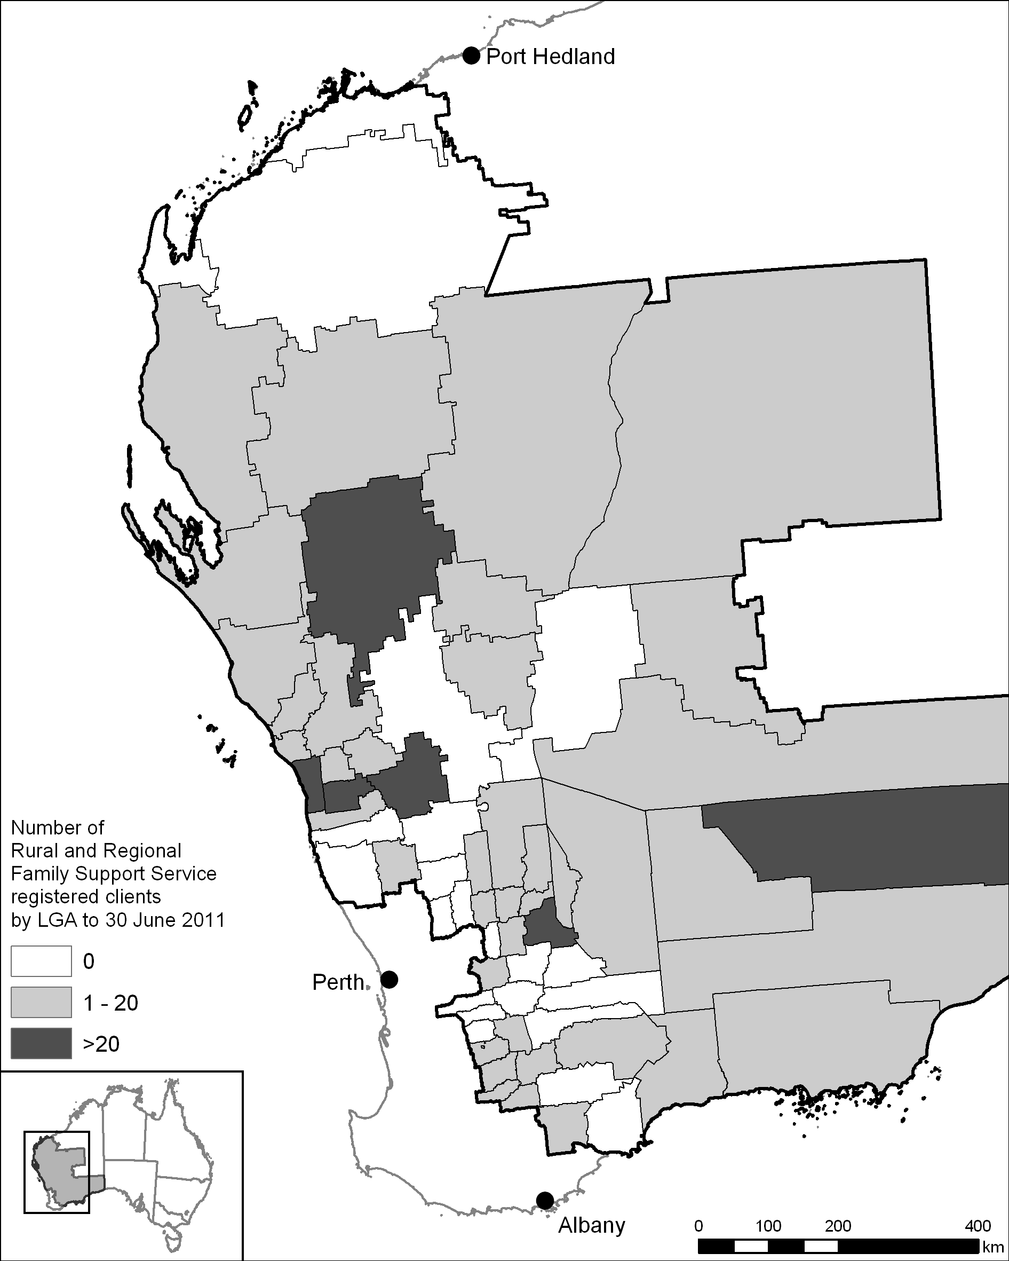
Sources: Department of Families, Housing, Community Services and Indigenous Affairs (data supplied 1 August 2011); ABARES (map).

Preliminary outcomes
The panel heard positive feedback about the Rural and Regional Family Support Service through its meetings with delivery organisations and through submissions to the review. The panel heard that it has helped to meet previously unrealised demand as well as meet demand arising from the poor seasonal conditions in the pilot region.
This is an excellent initiative and should form a part of the health service provided to the community. Further resources should be allocated to this type of program irrespective of the outcome of the drought review.

Delivery
The panel noted the short lead times in establishing the pilot made implementation of this measure difficult in the early stages. In some cases, services were not fully operational for three months, and the panel noted the difficulties involved in recruiting and training staff with the necessary qualifications to undertake this type of work. Despite this, the service providers catered for the 2293 people who used this service—a far greater number than the 540 anticipated. Of the 1218 sessions, 531 (44 per cent) were delivered in an outreach setting, slightly below the target of 50 per cent, which may be due in part to the overall high demand for the service. Centre-based services, rather than outreach, enabled a greater number of people to access the service.
The panel noted that the number of referrals to the Rural and Regional Family Support Service from Centrelink RSOs (63) and social workers (68) appeared low given efforts to integrate across Farm Social Support providers.
A cross-section of the community accessed these services. The panel heard that isolation and remoteness are key stressors, which were exacerbated by the poor seasonal conditions and a general lack of support services.
The panel heard that initially most people accessing services were women. Centacare Geraldton reported that some men were reluctant to seek out the service. The panel also heard that men and women are more likely to access counselling when it is embedded with other services. For example, counsellors were easy to approach where they were present at community events with an industry or production focus, rather than a focus on ‘mental health’ or similar.
The panel heard that a professional counsellor’s presence at workshops, community and industry gatherings and other group activities not specifically related to social support was an effective promotional tool and ‘soft entry point’ for the services they offered. Service providers used these workshops to explain their role and listen to the needs of communities, which built trust and led to requests for individual services. The positive response to professionals embedded at these events during the pilot was unsurprising, given the national review of drought policy’s recommendation that:
Community development initiatives, such as community socialising events, should have clear objectives aimed at linking farm families and rural communities with various human service providers and/or facilitate clear referral pathways.
Service providers told the panel that the new delivery model trialled under the pilot, which places more emphasis on outreach activities and asking communities about their specific service needs, enabled service providers to reach a broader audience and provide better-targeted services to those in need.
The panel heard from delivery agencies that the pilot allowed:
- service providers to reach out into rural communities and individual homes in a more collaborative way than centre-based services, which typically do not work for farmers
- service providers to use an early intervention approach, which is seen as more effective than crisis intervention in terms of building resilience and cost efficiency in the longer term
- for community capacity building and development as opposed to counselling alone.
The panel heard from the Department of Families, Housing, Community Services and Indigenous Affairs that the funding provided under the pilot to extend current service provision is seen as the major reason for these outcomes. The additional funding gave service providers greater capacity to undertake outreach services, and particularly to cover broader geographic areas and to provide more early intervention support in a range of community settings, as well as crisis intervention assistance.
The panel heard that the program was a positive move towards seamless service delivery; something that is highly valued in rural communities. One service delivery agency reported that regular meetings between delivery agencies are needed to network and share innovative ways of delivering and coordinating services. The panel also heard that embedding counselling services with a range of other social services helped to reduce the stigma sometimes associated with accessing the counselling service and improved uptake.
Service providers reported better linkages and coordination with other service providers and with state and Commonwealth agencies because of the pilot. They expressed interest in becoming more involved in elements of the Farm Planning program, such as the Balancing Life module. The panel heard that there is also scope to build closer ties with financial service providers as they are often a point of first contact for clients in need.
The panel heard that it can be more effective to promote counselling services after a family’s basic financial needs have been met, otherwise information on social support services can be lost in the need to focus on financial support.

Using pre-existing networks
The panel heard from the Department of Families, Housing, Community Services and Indigenous Affairs that one of the reasons for the success of this initiative was that it utilised existing networks by choosing service providers with a presence in the community and experience in the area. These community networks understood the best ways to connect with members of the community. The department commented that there is likely a sufficient community services sector ‘footprint’ across Australia to undertake a potential national roll-out of this program.
Another theme that arose in consultations with service providers was a desire for certainty about the continuation of this program. They told the panel that with more resources they could expand the services under the existing model, with a greater emphasis on outreach to rural communities and on providing greater service coverage. Longer contracts and more funding certainty would help to retain key staff, which is a particular issue in remote areas. Ethical concerns were raised with the panel about the retraction of mental health services once they have been established in new areas. One service provider highlighted the need for new mental health services, such as that trialled under the pilot, to be established with more certainty of tenure.
The services are certainly potentially sufficient and accessible in the long term and so there is a need to establish the services over a greater period of time. In addition to having more time, one suggestion of change to improve the delivery of the program would be to move away from a pilot mentality to managing crisis especially when in drought. The mentality of a short-term intercession because this is a pilot of twelve months only doesn’t allow sufficient time to evaluate. This suggestion is due to the fact that the pilot region is an extremely vast area and the people have the suspicious idea that the pilot will be over before it has began; that is, twelve months is not enough time.

Data gathering and program outcomes
The panel noted that it was difficult to judge outcomes from counselling programs based on the limited information that was available to it. The Department of Families, Housing, Community Services and Indigenous Affairs told the panel it was endeavouring to shift to an outcomes-based approach in obtaining information to better understand the differences the services have made for people. The panel recognised that gaining qualitative information was difficult in the sensitive and confidential environment associated with social support services. This difficulty was amplified by the short duration of the pilot. The panel noted that, with the extension of the pilot to 2011–12, there could be opportunities to pursue this approach, which may allow a more effective evaluation of the outcomes achieved under the program.

Technologically assisted counselling
The Department of Families, Housing, Community Services and Indigenous Affairs told the panel that technologically assisted counselling―through video-conferencing for example―has potential to provide services to those in need in rural or remote areas where timely direct service provision is not possible.

Costs
The budget for this initiative was $945 000, but the number of people who were able to take up the services on offer was far greater than these funds were intended to provide for. As a consequence the panel believes the program was cost effective.
Outreach services are more costly than centre-based services. However, the panel considered that the benefit of providing additional funds to existing service providers for outreach was considerable.

Conclusions
The outreach model was well received and the panel considered that embedding a range of counselling, education and training services together was effective. Using local networks to promote the services, and regional providers to deliver them, helped to reduce the stigma of counselling and improved uptake.
The number of people accessing these programs was well above expectations. The panel noted that although the poor seasonal conditions may have contributed to this to some extent, it is likely the measure met previously unrealised demand. Participants were not only from the farming community but also from the broader community.
The panel noted that any national roll-out of the Rural and Regional Family Support Service should:
- involve co-development with the state governments to ensure a whole-of-government approach
- utilise the existing service footprint as a building block to provide outreach services
- have a flexible structure and operation to give service providers scope to relocate resources according to need
- embed services within existing service networks and structures, rather than providing stand-alone services that are removed after a ‘crisis’ is perceived to be over.

Overall conclusions and recommendations for Farm Social Support
The panel considered that the Farm Social Support program helped meet the mental health, counselling and other social needs of farming families and rural communities in the pilot region. The panel believes that providing ongoing and accessible social support services to farm families and rural communities is critical.
Recommendation 5.1: Social support services, including counselling, information and referral, should be available and accessible to those in need at all times and not just during crisis events.
Overall, feedback from recipients and service providers about Farm Social Support was positive. The panel considers that these measures should be part of mainstream services provided to rural and non-rural communities. The panel considers that social support measures should also have the capacity to expand quickly to meet higher demand in crisis situations.
While poor seasonal conditions were one of the drivers of demand for this service, the panel believed there was also significant underlying and unmet demand. The emphasis on providing outreach services more tailored to farming families and rural communities was well received. The panel believes that any social support measures for rural communities should be delivered utilising well-resourced outreach services.
Recommendation 5.2: The outreach model of providing direct services to farming families and rural communities, in the home, workplace or another local venue, should be part of any rural and remote social support service and must be appropriately resourced.
The panel considers that social support services should be embedded in communities. Establishing these types of services alongside existing community services increases people’s confidence in accessing them.
Recommendation 5.3: Social support services should be promoted through local and regional networks and established alongside existing community services.
Integration among service providers on the ground was effective, noting pilot timeframes were challenging for higher-level integration.
The rural support coordinator position played an important role in implementing the range of measures available under the pilot and in building and supporting networks across the service providers. The panel sees value in this position being maintained.
Recommendation 5.4: Delivery agencies should continue to improve communication and coordination across the range of social support services provided.

Stronger Rural Communities

Key points
- The Stronger Rural Communities program was well received but limited funds restricted the number of activities that could be funded. It helped a number of rural communities to build social capital and enhance community networks.
- This type of program would be better delivered as part of a mainstream regional development program, either as a state or Australian Government initiative.

Rationale and objectives
The national review of drought policy highlighted the value of social capital.
Social capital is built on social networks of trust, mutual support and understanding; creating the glue that holds a community together. When people are part of social networks, they are more involved in community life, they provide more informal care for others, they do more volunteer work and they are more active in social organisations.
The national review of drought policy also heard that social capital in Australia’s rural communities is in danger of being, or has already been, seriously eroded.
The Stronger Rural Communities program aimed to increase the capacity of rural communities experiencing significant hardship to build social capital, develop new and existing community networks and increase community resilience to the impacts of agricultural downturns.

Program description
The Stronger Rural Communities program provided grants of up to $300 000 to local government authorities and community organisations to fund projects that build the resilience of rural communities and help them manage hardship resulting from an agricultural downturn. The program was fully funded by the Australian Government, with an administered budget of $900 000 and a departmental budget of $200 000.

Participant snapshot
Applications for Stronger Rural Communities grants opened on 1 July 2010 and closed on 15 September 2010. The program was promoted widely with all local government authorities and key community organisations in the pilot region contacted and invited to apply. The program attracted strong interest across the pilot region with 42 applications received from 17 local government authorities and 25 community groups, representing 33 local government areas (see Figure 6.1).
Figure 6.1: Stronger Rural Communities applications and grants by local government area
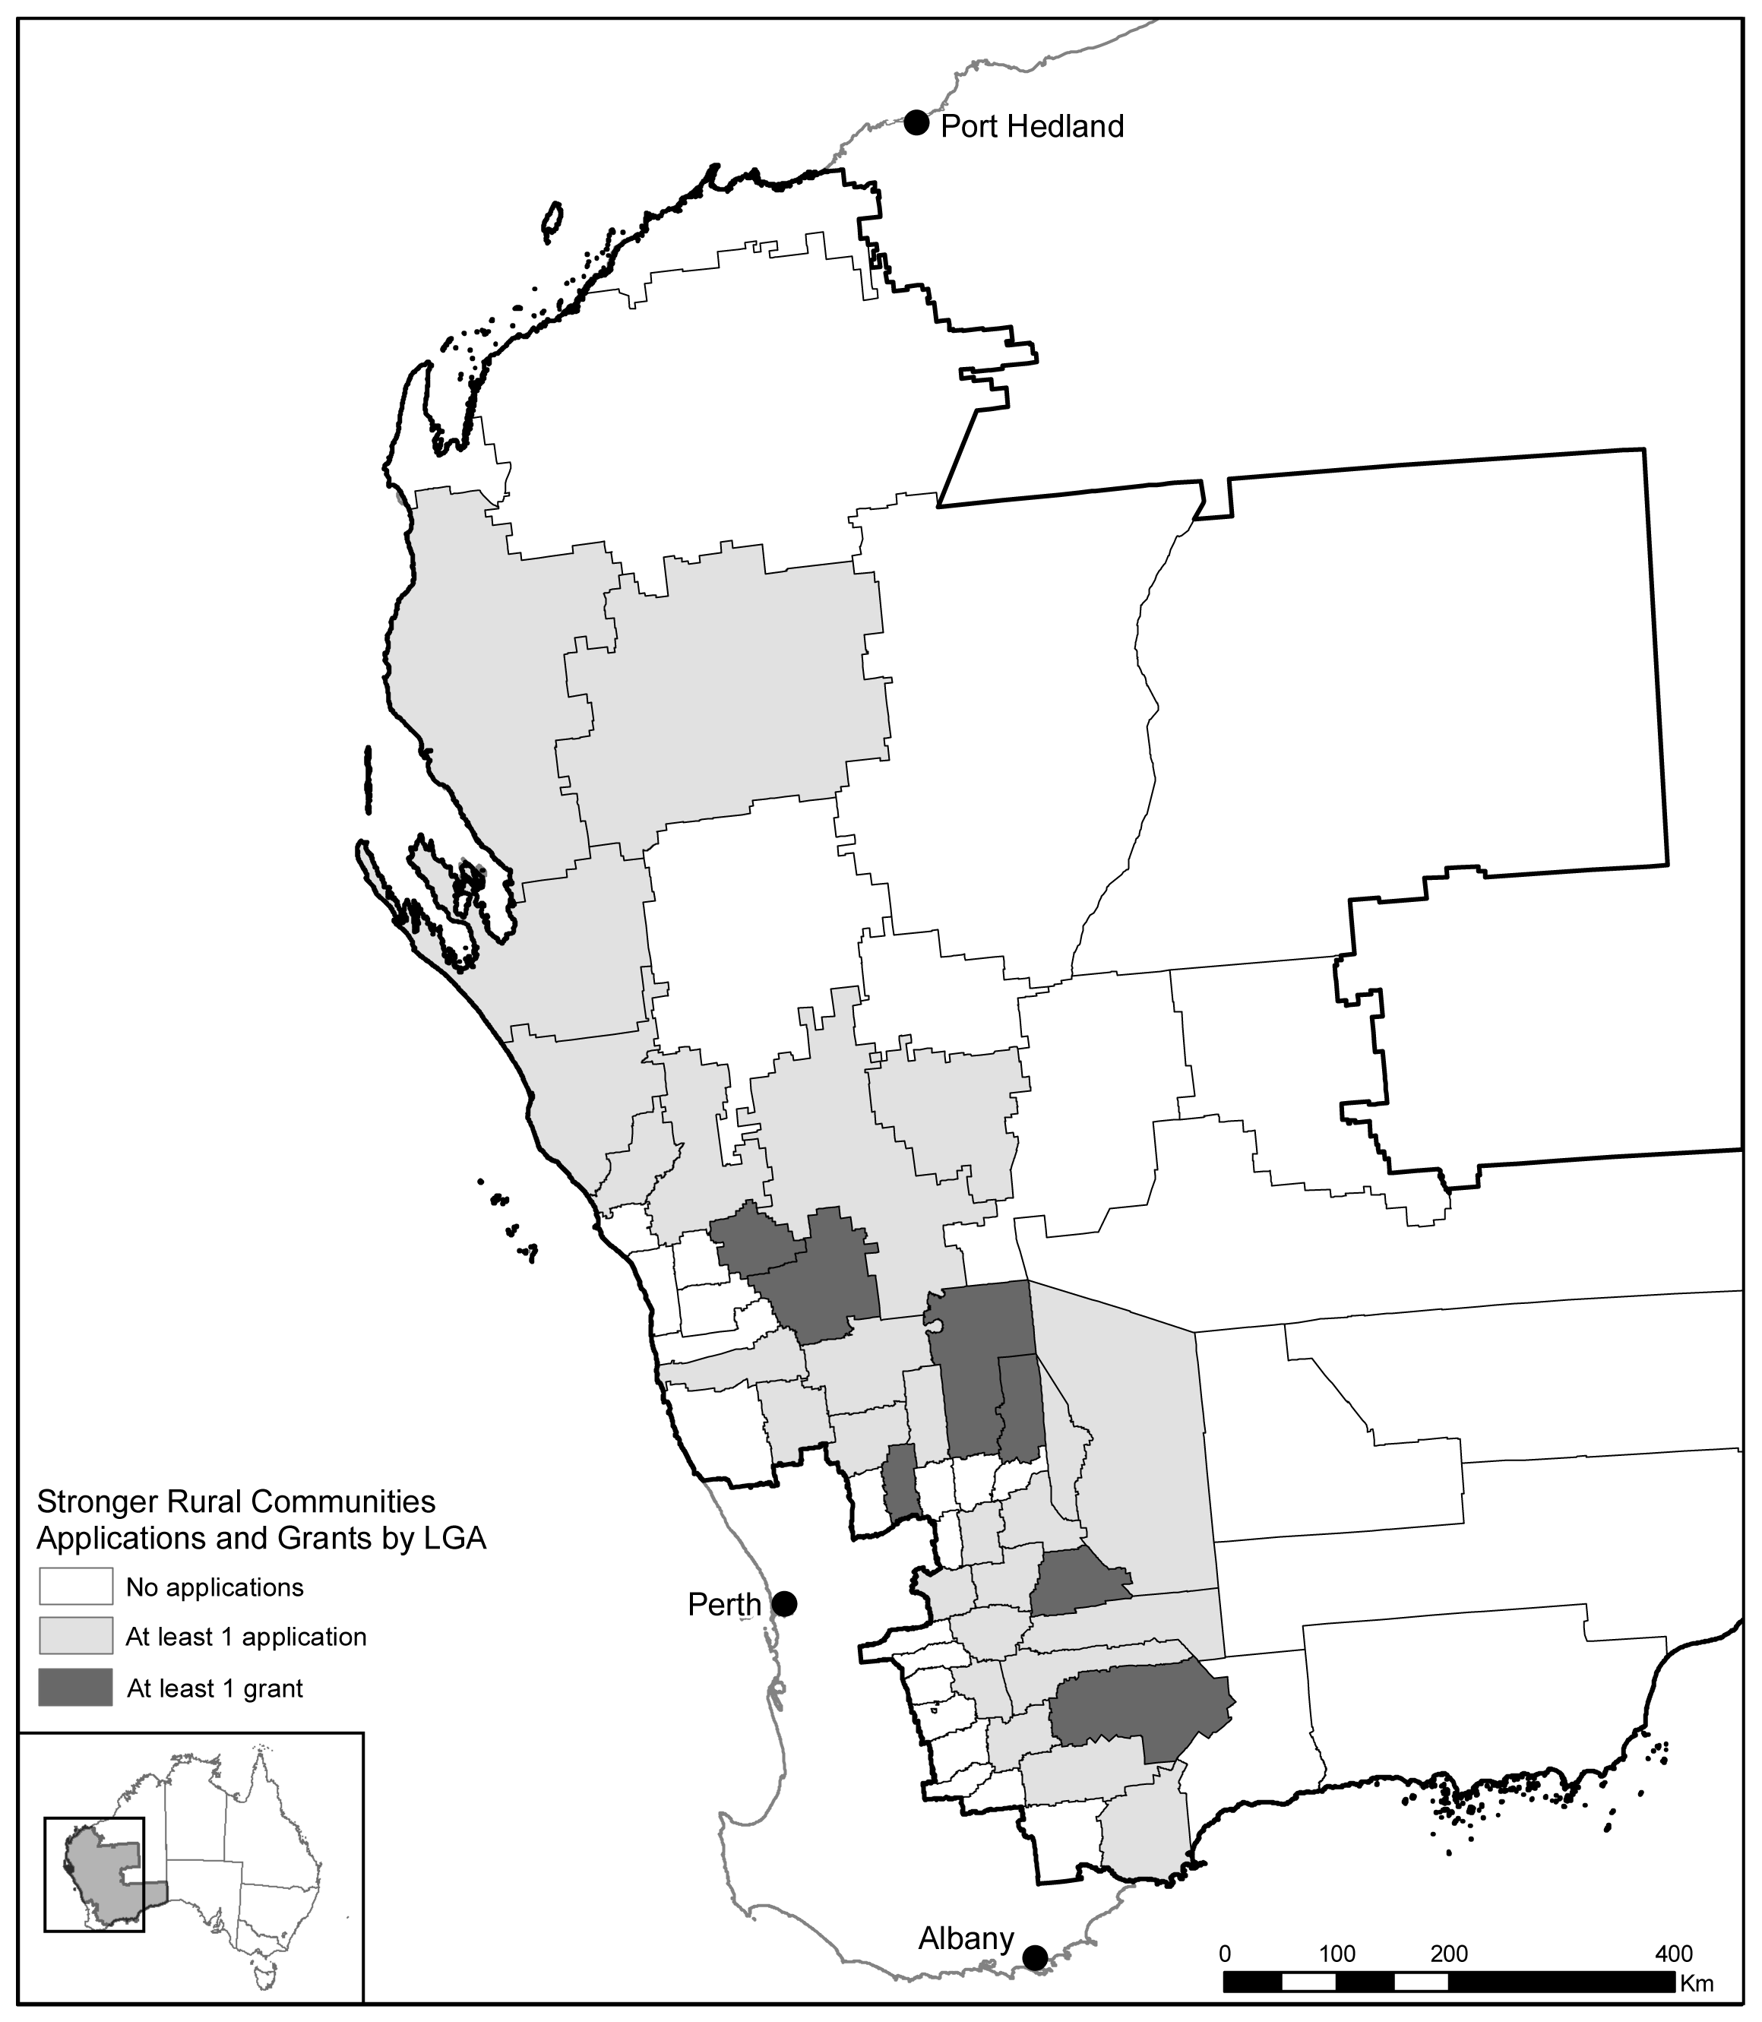
Source: Stronger Rural Communities applications, Department of Agriculture, Fisheries and Forestry (DAFF).
Applicants sought a total of just over $5 million in grant funding. Seven applicants sought the maximum grant of $300 000, while 10 applicants sought grant funding of $30 000 or less. The smaller grant proposals were mainly focused on assistance related to hosting community events or for minor renovations to existing infrastructure. The average grant amount applied for was $121 000.
On 10 November 2010, the Minister for Agriculture, Fisheries and Forestry announced that eight Stronger Rural Communities grants totalling $896 000 would be awarded across seven local government areas in the pilot region (see Table 6.1).
Table 6.1: Stronger Rural Communities grant recipients
Recipient | Project | Grant
Shire of Mukinbudin | Upgrade Mukinbudin Sporting Complex | $82 005
Shire of Dowerin | Part fund the relocation of four local sporting clubs into one central location | $150 000
Beacon Progress Association | Build premises in Beacon for community activities | $206 914
Lake Grace Development Association | Fund the ‘Living Communities’ program—to increase community resilience | $72 040
Shire of Narembeen | Upgrade Narembeen Community Shed | $96 000
Shire of Perenjori | Renovate Perenjori Sports Club | $227 950
Canna Progress Association Incorporated | Upgrade Canna Hall | $50 000
Lake Varley Branch of the Country Women’s Association of Western Australia | Refurbish Varley Hall | $11 579
TOTAL |  | $896 488
Source: Department of Agriculture, Fisheries and Forestry (data supplied 18 May 2011)
The Department of Agriculture, Fisheries and Forestry delivered the Stronger Rural Communities program. The program is not being continued in its 2010–11 form under the extension of the pilot from 1 July 2011. However, in 2011–12, the Western Australian Government will provide $1.3 million for an alternative suite of support measures for communities, families, individuals and businesses in the pilot region.

Delivery
The Stronger Rural Communities program assessment process was undertaken by the National Rural Advisory Council with support from the Department of Agriculture, Fisheries and Forestry. In the panel’s view, the process was conducted efficiently and in accordance with program guidelines.
As prescribed in the Stronger Rural Communities Program Guidelines, to be eligible the applicant had to demonstrate that the community for which funding was sought was facing significant hardship due to an agricultural downturn, including providing evidence of:
- a significant downturn in the local agriculture sector
- the community’s reliance on the agriculture sector
- the community’s socio-economic vulnerability to the impacts of an agricultural downturn.
Data was provided by the Australian Bureau of Agricultural and Resource Economics and Sciences and the Australian Bureau of Statistics to assist in the assessment of applications. The panel noted the difficulty in applying the eligibility criteria of ‘hardship’.
Throughout its consultations in Western Australia, the panel heard from farmers and other community members of the need to strengthen communities in rural and remote Western Australia. The panel heard that there was inherent value in maintaining vibrant, productive farming communities.
This sentiment was captured by the Rural, Remote and Regional Women’s Network of Western Australia:
Stronger rural communities are about the social fabrication and population. People who are happy, connected, and positive can make for a thriving community. People who are depressed, anxious, disconnected, and negative can make for a declining community. Without people our rural areas will not be stronger. They simply will not be.
The panel noted that the majority of funded projects (seven out of eight) were infrastructure related. The panel heard concerns about the infrastructure focus of the funding.
the program did little to increase the capacity of rural communities and funded projects that will require ongoing maintenance and assistance from councils. Future assistance should be more visionary and aim to encourage local entrepreneurship, leadership and investment in the community.
Primary Industries and Resources SA questioned whether infrastructure projects deliver the gains for social capital and community networks that are desired under such a program. They cited the South Australian experience of supporting community events from a relatively small project fund, which delivered outcomes in excess of the amount of money spent.
In a view that contrasted to those presented above, the Australian Association of Agricultural Consultants WA said its experience of grants of a community nature is that they bring people together during difficult times. The panel also heard that the implementation of projects funded under the Stronger Rural Communities program brought communities together and has had positive social impacts. Recipients also reported that their projects would help build social capital in their communities over the longer-term.
In the panel’s view, it was too early to assess the extent to which the Stronger Rural Communities grants will help build the social capital of communities and increase their resilience to significant hardships caused by agricultural downturns.

Costs
The program cost $1.1 million. A range of community projects were funded and the program was administered effectively.

Preliminary outcomes
Grant recipients provided reports with statements explaining how their projects are helping to build the social capital of their community and increase resilience to hardship. The panel noted that recipients responded very positively, with most reporting enhanced community networks and use of facilities. Summaries of the statements by Stronger Rural Communities grant recipients follow.
Shire of Mukinbudin: Mukinbudin Sporting Complex upgrade
The grant recipient reports that the enhancement of the function room has not only improved the quality of the room, it has also increased the accessibility to a broader range of community members. As a result there has been an increase in interest in using the facility for functions. Since completion of the project successful events have been held there, including a sporting day that attracted 150 locals and 100 other guests. The events facilitated by the function room encourage social interaction and engagement, helping to build community resilience by allowing people suffering hardships to stay connected to each other and the community.
Shire of Dowerin: Dowerin Community Function Centre
Development of the Dowerin Community Function Centre is a long-term plan that hopes to provide a centralised, shared community and sporting facility. Funding from the Stronger Rural Communities grant has contributed to the fit-out of the main function facility and the children’s playground. This has generated a more family friendly venue and it is hoped that the improvements will encourage more residents to participate in social events. Co-location of different clubs in the one centre will promote greater social interaction between those clubs and community feeling is very positive, with people looking forward to using the new equipment.
Beacon Progress Association: The Beacon Co-op Building Project
This project to build a premises for community activities was still under construction but the grant recipient reported that there was a lot of enthusiasm in the community and that people were looking forward to the finished product. The planning and delivery of this project created significant networks within the community and encouraged social participation. The grant had taken the pressure off volunteers that were contributing to the existing Co-op and has helped to generate enthusiasm in the wider community to pitch in and help. It was anticipated by the grant recipient that the new cafe will provide a venue for social events and new employment opportunities.
Lake Grace Development Association: Living Communities Lake Grace
This project provided the Lake Grace community with a stock take of their social capital, which should encourage greater use of these resources in the future. It highlighted the need for more social interaction and pointed to ways in which this could be achieved. Two successful social events have been held as a result of this project—late night shopping and a business expo. These are now intended to be regular events in the Lake Grace community calendar. Workshops conducted as part of the stock take were well attended by the community and the information gained through them will help to develop new social opportunities.
Shire of Narembeen: Narembeen Community Shed
The Shire of Narembeen has used its grant to make repairs and improvements to the community shed, including better roofing, plumbing, electrics and access for the disabled. The shed provides a meeting venue for a number of community groups and the improvements have expanded the activities that can be held there and the groups that can use it. Both the project and subsequent events held at the shed have developed a range of skills in participants as well as providing goals, hobbies and connection between the different groups. This has been particularly notable in the older generation, which increasingly makes up a greater proportion of the local population. Ongoing projects have already started at the shed, such as the renovation of old farm equipment for displays. Future activities are planned for the shed, such as health workshops and woodwork and metalwork instruction for school students.
Shire of Perenjori: Upgrade to Perenjori Sports Club roof and kitchen
The Sports Club is considered central to social fabric of the Perenjori community and the renovations should increase its availability to different activities and people. It is also hoped that the upgraded facility will help to forge links with surrounding communities through use of the venue for regional events. The renovations have resulted in the club being awarded certification as a ‘food preparation area’. This will allow functions such as Friday and Sunday night dinners and fundraising events to take place at the club. The grant recipient anticipates a large turnout for the reopening as so many community members have expressed their interest in the improved facility.
Canna Progress Association Incorporated: Canna Hall upgrade
Community interest and participation in the volunteer aspects of this project have been strong. The local people are enthusiastic about helping to finish the upgrade of the hall, and events are being planned for its reopening. The grant recipient reported a demonstrated increase of pride in the community and believes that the building will provide an attractive and comfortable meeting place for various groups of local people to socialise and to share concerns and ideas. The upgraded hall will provide more opportunity for local groups to hold meetings and events and will encourage community participation in social events.
Lake Varley Branch of the Country Women’s Association of Western Australia: Refurbishment of Varley Hall by the Lake Varley Country Women’s Association
The planning and implementation of this project brought together a number of local people, with the organiser endeavouring to get as many people involved as possible. This in itself built connections and networks as people worked towards a common goal. The refurbishment of Varley Hall has provided a welcoming environment for community members to gather and socialise. Regular functions are planned such as coffee mornings and ‘bring and share’ meal evenings. Participants in the events at the hall have reported a reduction in stress through the opportunity to discuss community issues in a relaxed and social atmosphere. This reduction in stress, combined with greater social connectivity will increase the resilience of the community when faced with hardship.

Other government support to increase community resilience
The panel noted that the programs being trialled as part of the pilot complemented a range of national and state government community, family and business support measures.
In November 2010, the Western Australian Government announced an additional $5 million Dry Season Assistance Scheme for communities in up to 100 shires. This included community service and social support grants and additional assistance for small businesses.
The Department of Regional Australia, Regional Development and Local Government is working to improve the social capital and resilience of regional Australia in collaboration with Regional Development Australia―a network of 55 committees made up of local leaders who work with government, business and community groups―to deliver outcomes for their regions. Members of this network are working to develop regional plans, which are the result of extensive consultation with their communities. These plans set out the key economic, social and environmental issues and priorities for each region, and provide guidance for all levels of government on future policy development and program delivery across the country.
Regional Development Australia has promoted and supported the recent call for submissions to the Regional Development Australia Fund—an Australian Government program driving the development of new infrastructure projects and initiatives that contribute to the long-term economic growth of communities across the country.

Conclusions
The panel was satisfied that the Stronger Rural Communities program was implemented efficiently and as required under its guidelines.
In the panel’s view, the objectives of the program are more closely aligned with regional and rural community development policy than with national drought policy. The panel noted that there were other Australian and state government programs to build resilience and infrastructure in regional and rural communities. Given the overlap in funding community infrastructure between the Stronger Rural Communities program and other government programs at both state and federal levels, the panel sees little merit in the continuation of this program under national drought policy.

Farm Exit Support and Beyond Farming

Key points

Farm Exit Support
- The Farm Exit Support program does not appear to be a strong mechanism for encouraging structural adjustment because it does not address the non-monetary reasons why farmers in significant financial difficulty prefer to remain on their farms.
- Some of those looking to exit farming were unable to sell their farm in the pilot period.
- Income support and training programs could be better utilised to provide further support to those considering their options outside farming.

Beyond Farming
- The Beyond Farming program provided support to a number of farmers considering their options outside farming.
- While this program has the potential to address some of the non-monetary reasons why farmers prefer to remain on their farms, low uptake suggests that the program needs more time to become integrated into the community.

Rationale and objectives
These programs aimed to facilitate structural adjustment in the farming sector by providing farmers who were considering their options outside farming with opportunities to discuss these options with former farmers and to help eligible farmers who sold their farm to make a fresh start.

Farm Exit Support

Program description
The Farm Exit Support program aimed to help farmers in significant financial difficulty to re-establish themselves in careers other than farming.
Three grants were available:
- the Farm Exit Support Grant—up to $150 000 for eligible farmers who sold their farm business during the pilot period
- the Farm Exit Support Advice and Re-training Grant—up to $10 000 for recipients of the Farm Exit Support Grant for professional advice and retraining
- the Farm Exit Support Relocation Grant—up to $10 000 for recipients of the Farm Exit Support Grant to help with relocation expenses and accessing job-seeking services after they sold their farm.
Interested farmers were able to test their eligibility for the program by lodging an application for a pre-assessment, which provided an indication of whether they would receive a grant or not, based on their current situation. The pre-assessment was indicative only, and the farmer had to have their eligibility tested again if they made an application for the exit grant after selling the farm.
Eligibility criteria were almost identical to the Exceptional Circumstances (EC) Exit Grant, except that an EC declaration was not required to access the grant. Recipients of the Farm Exit Support Grant had to undertake not to become an owner or operator of a farm business for five years after the date of settlement of the sale of the farm.
Centrelink delivered the Farm Exit Support program on behalf of the Department of Agriculture, Fisheries and Forestry.

Participant snapshot
Centrelink advised that to 30 June 2011, 27 farmers had expressed interest in the Farm Exit Support program by lodging an application for either a pre-assessment or a grant. Applicants were located in 13 (19 per cent) of the 67 local government areas in the pilot region.
Nineteen farmers tested their eligibility by applying for a pre-assessment prior to selling the farm. Five of these subsequently sold their farm and went on to apply for the exit grant. A further six farmers would have been eligible for the exit grant based on their pre-assessment had they been able to sell their farm during the pilot period.
Thirteen farmers applied for the exit grant (including the five referred to above who undertook a pre-assessment).
Five farmers received exit grants in the period to 30 June 2011.

Targeting
The key difference between the Farm Exit Support program and the EC Exit program was that Farm Exit Support was not contingent on the farm being within an EC declared area. In this way, eligible farmers could be assisted to adjust regardless of the cause of financial difficulty. The poor seasonal conditions during much of the pilot period did not allow this new aspect to be fully tested.
Drought affects the marketability of farming land. The ability to sell farming property becomes difficult. As this [farm sale] is a criterion for the Farm Exit Support program, farmers wanting to access this program may be hindered in doing so because of their inability to finalise the sale of farming property.

Preliminary outcomes
The five grants paid under the Farm Exit Support program exceeded the level of uptake estimated by the Department of Agriculture, Fisheries and Forestry. However, the panel considered that, relative to the farm population in the pilot region and in the context of achieving meaningful structural adjustment, uptake of exit grants under this program was low. The panel considered that the non-monetary barriers to farm exit identified in the national review of drought policy remained significant factors.
The [EC Exit Grant] fails to address the non-monetary reasons why many farmers remain on farm—the lack of formal recognition and portability of the skills learned during farming and the reluctance to move away from the family home and the local community.
There are many farmers who are psychologically attached to their property and policy measures, such as exit assistance, are largely unwanted, nor are incentives to move to another profession. Many farmers are more than willing to continue suffering varying degrees of social deprivation to maintain their generational bond to the property.
The panel noted, however, that the uptake was consistent with previous exit programs, which have also failed to attract substantial farmer participation.
In the short timeframe of the pilot and its review, the panel was not able to determine if those farmers who received the Farm Exit Support grant were better off by doing so. Follow-up surveys with recipients in 6 to 12 months would be needed.
It was not possible to determine if those receiving Farm Exit Support grants would have left farming even in the absence of the program. The national review of drought policy determined that “there is little evidence to suggest that a transition out of farming would not occur just as readily in the absence of exit grants as they are currently structured”. This calls into question the cost effectiveness of such programs.

Eligibility criteria
To be eligible for the Farm Exit Support grant, farmers must have owned their farm for at least five years, been in control of the farm business, derived significant income from and contributed significant labour and capital to the farm business and must have sold their farm on commercial terms and at arm’s length.
The panel heard about the challenges that some of these criteria created.
In WA at present the lack of land sales is leaving about 40+ farmers (that we know of) trapped with few options if leasing/contracting/off farm work will exclude them from this grant. These rules are contributing to slowing adjustment.
The panel was advised by the Department of Agriculture, Fisheries and Forestry that the program guidelines do not specifically exclude a farmer from obtaining off-farm work or leasing their property. Rather, an assessment is made of the impact of any off-farm work and leasing on the applicant’s control of the enterprise and the level of their labour, capital and income contributed and derived. Nevertheless, the panel considers that there may be scope for more flexibility to ensure that adjustment is not been hindered in cases where genuine efforts by farmers to move out of farming are already being made.

Sale of farm within pilot period
To be eligible for the Farm Exit Support grant, farms had to be sold before 30 June 2011. The panel heard about the difficulties in selling a farm in Western Australia within one year.
Most properties in WA do not sell within 12 months. To have sold the farm by 30th June 2011 is unrealistic.
Data provided to the panel by Centrelink supported this view. There were six applicants unable to sell their farms before 30 June 2011 who would otherwise have been eligible for the Farm Exit Support grant.

Assets test
The Farm Exit Support program targeted farmers in significant financial difficulty, with the full grant payable to those with $350 000 or less in net assets after the sale of the farm.
The panel noted the criticism of previous exit schemes about net asset tests being too low and thereby excluding too many farmers. However, the panel did not hear widespread feedback of this nature from pilot stakeholders and only one submission specifically supported an increase of the asset threshold.

Delivery
Feedback from stakeholders raised no issues with the delivery of this program.

Costs
Farm Exit Support was demand driven, with the cost determined by the number of grant recipients. At 30 June 2011, grants totalling $667 095 had been paid to five recipients.

Links to other programs
Beyond Farming (discussed later in this chapter) sought to address some of the non-monetary reasons why farmers prefer to remain on their farms. The panel believes there is also scope to better utilise other programs to assist those considering their options outside of farming, such as Farm Planning and Farm Family Support.
Farmers undertaking the Farm Planning program worked through a number of modules that assisted them in better understanding their current business performance and, in doing so, could help them to reach a view about the long-term viability of their farm business.
Farmers receiving Farm Family Support payments were required to undertake a Farm Financial Assessment and prepare an Action Plan. For those facing long-term financial difficulties with their farm business, the Action Plan process could help to identify the steps needed to transition out of farming, including addressing any advice and training needs.

Conclusions
There is little evidence from Farm Exit Support or from similar farm exit programs that they facilitate structural adjustment in the industry.
Consistent with past reviews of drought policy, the panel is of the view that exit packages alone are not an inducement to leave farming for most farmers because they do not address the non-monetary reasons why farmers prefer to remain on their farms.
The panel noted that Beyond Farming was being trialled as part of the pilot to help address non-monetary reasons for staying on-farm. The panel also sees value utilising other programs such as Farm Planning and Farm Family Support to further support farmers who are considering their options outside farming.

Beyond Farming

Program description
The Beyond Farming program made former farmers available to discuss farm exit experiences, options and opportunities outside farming. It was introduced to address the national review of drought policy finding that non-financial barriers to farm exit and lack of exit information inhibit this type of adjustment.
As a new program, the level of interest in and sensitivity around discussing exit was difficult to estimate. Promotional activities emphasised the importance of considering the options for selling or retiring as an important part of farm business and succession planning for all farmers. The program was provided as a free and confidential information service to interested farmers.
The Australian Government provided $130 000 in funding (including departmental funding) for one year. Beyond Farming was delivered by the Western Australian Council of Social Service (WACOSS) on behalf of the Australian Government.

Participant snapshot
The Beyond Farming program selected and trained 20 former farmers from Western Australia as volunteer mentors. Over the pilot period, 14 current farmers in Western Australia were formally matched with mentors, which suggests that the program needs more time to become integrated into the community.

Targeting
The Beyond Farming program was made available to all farmers and their families in the pilot region interested in discussing opportunities outside of farming.

Preliminary outcomes
As the first program to formally attempt to facilitate exit involving farmers that have previously made the decision to leave, there is no benchmark to guide the panel on the effectiveness of the program. The Department of Agriculture, Fisheries and Forestry estimated that five mentors and 25 matched farmers would participate in the program.
At 30 June 2011 there were 19 current farmers who had formally registered to be matched with a former farmer (including two outside the pilot region). Of these, 14 had been matched with mentors and discussed their circumstances and options. The panel was advised by WACOSS that most of the participating current farmers indicated that they had decided to exit farming and were planning or taking steps to do so, including retirement, other employment or business options and study. Three were participating in a program to accredit their farming skills.
The panel heard some promising feedback from participants about the value of this program.
When you have had an active life in farming, and the time has come to give it up due to age and disabilities, it can be quite a difficult and lonely time. I have appreciated having phone calls from my mentor … sharing my problems being most helpful.
The Rural, Remote and Regional Women’s Network of Western Australia suggested that providing opportunities for informal mentoring could improve the effectiveness of the program.
In the period February to June 2011, WACOSS recorded informal mentoring discussions that occurred at rural community events and farm planning workshops. These involved a mentor sitting down with a current farmer to have an in-depth discussion about life after farming. According to WACOSS reports, at least 30 informal mentoring sessions between current farmers and Beyond Farming mentors took place, adding value to the program.
The panel saw merit in this program continuing to allow more time to determine its longer-term impact.

Delivery
Newspaper advertising sought expressions of interest from former farmers across Western Australia to become volunteer mentors in the program. WACOSS received 93 enquiries and 31 formal expressions of interest, from which 20 mentors were selected and trained. Mentors with extensive farming experience across the pilot region were selected, according to a mix of criteria, skills and farming experiences, including: a successful move out of farming into rewarding retirement, new work and/or life opportunities; police clearances; communication skills and ability to develop rapport with farmers and a good understanding of the role.
Newspaper advertising invited interested farmers to contact WACOSS to be matched with a mentor. Famers and mentors were then matched by WACOSS according to farmers’ interests and needs. Most contacts were by phone.
WACOSS staff and Beyond Farming mentors also attended rural events to promote the program. While the focus was primarily on providing information about the program, there was also interest among current farmers in having ‘on-the-spot’ conversations with mentors, which suggests that this less formal approach may be preferable among those considering exit or retirement options. WACOSS advised that the ability to report outcomes from these informal contacts was more difficult.

Costs
The Beyond Farming program cost $130 000 (including departmental costs) to run in 2010-11. The panel felt it was too soon to reach a view on the cost effectiveness of the program, but noted that greater uptake would need to be demonstrated over time as the program becomes integrated into the community.

Links to other programs
The panel believes that there is merit in forming close linkages between Beyond Farming and other programs. As for the Farm Exit Support program, there may be opportunities for closer links with aspects of Farm Planning and Farm Family Support, or similar programs that encourage farmers to assess their financial situation and the long-term viability of their farm business.
The panel heard that attendance by mentors at two Farm Planning courses was well received and that mentors were able to provide detailed assistance on planning options. One of the Beyond Farming mentors was also a facilitator in the Farm Planning program, providing opportunities for cross-promotion.

Conclusions
The panel sees merit in a program where current farmers are connected with former farmers to discuss life beyond farming. The panel considers that the Beyond Farming program has the potential to address some of the non-monetary reasons why farmers prefer to remain on their farms. Low uptake suggests that the program needs more time to become integrated into the community.
The panel noted that Beyond Farming would continue under the extension of the pilot.

Other measures

Key points
- The panel recognises the importance to farm businesses of ongoing access to the Farm Management Deposits scheme and other tax provisions for primary producers.
- The panel also recognises the importance of further research and development, including the utility of longer-term seasonal forecasting tools.
- The panel appreciates that payments for ecosystem services can provide a useful alternative income stream for some farm businesses.
- The panel does not believe that governments should underwrite a multi-peril crop insurance scheme or subsidise loans for farm businesses.

Introduction
As part of its consultations with stakeholders, the panel heard support for a range of other measures that could help farm businesses to better manage and prepare for future challenges such as drought, in addition to those offered in the pilot. The panel noted that there is a suite of other measures already available to primary producers―such as tax provisions―that account for unique circumstances faced by farm businesses and recognises the importance of ongoing access to these.
The panel also noted that farmers can adopt a number of on-farm risk management actions, such as fodder conservation and destocking. These can vary greatly from farm to farm however, and are not discussed here.

Tax provisions

Farm Management Deposits
The Farm Management Deposits (FMD) scheme was established in 1999 to assist primary producers to deal more effectively with fluctuations in their cash flow resulting from climate variations and changes in market prices. The FMD scheme is consistent with broader government objectives to encourage farm businesses to manage risk and become more self-reliant and has been recognised as broadly effective in achieving these goals.
The FMD scheme encourages primary producers to carry over income from years of good cash flow and to draw down on that income in years of reduced cash flow. Any primary production income deposited in an FMD account is tax-deductible in the year the deposit is made. Tax on the income is paid in a subsequent year when the primary producer withdraws that income. The scheme allows primary producers to defer payment of tax and smooth income across variable years.
The FMD scheme is available to individual primary producers Australia-wide, regardless of climatic events or personal or business circumstances, and is widely utilised and supported as an effective risk management tool. However, there have consistently been calls to increase the cap on deposits and allow trusts and companies to access the scheme.

Deposit cap
The maximum allowable FMD holding per primary producer is $400 000. In 2007 the cap was raised from $300 000 to $400 000 as a result of a review that recommended an increase to restore the real value of the cap.
In their submissions to the 2008–09 national review of drought policy, a range of industry organisations and other stakeholders called for the cap to be increased again. Some have argued for the cap’s removal altogether, while others have called for it to be indexed. The Victorian Farmers Federation argument—that farms are getting larger and need to preserve larger volumes of cash for bad years—typifies the views expressed by industry stakeholders.
If a cap needs to exist, it should be more in keeping with the development of progressively larger farms.
A range of other stakeholders supported the national review of drought policy’s recommendation that the FMD scheme be retained without changes.
There are 33 708 FMD account holders and 40 098 FMD accounts. The vast majority of FMD accounts contain amounts of less than $50 000 and only 280 (less than 1 per cent of the total) have balances close to the cap of between $350 001 and $400 000 (see Figure 8.1). The panel also noted that individual members of a farm business can hold up to $400 000 each, meaning for example, that a partnered couple running a farm business could hold up to $800 000 between them in FMD accounts. The panel sees no case to increase the cap.
Figure 8.1: Number of FMD accounts by deposit value
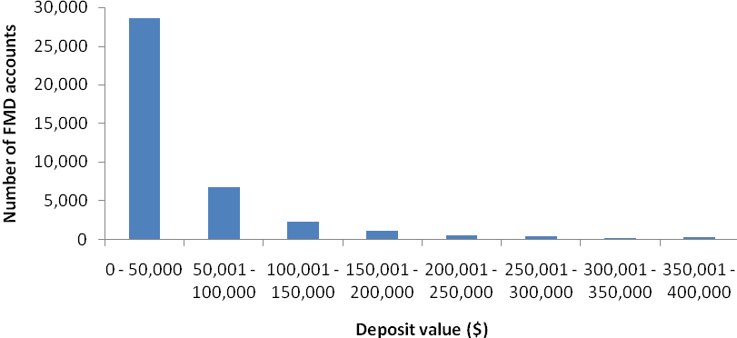
Source: Department of Agriculture, Fisheries and Forestry (data supplied 14 July 2011).
The cost of the FMD scheme to government revenue is estimated at $81 million per year over the five years to 2010–11. Any increase in the cap would increase the costs of the program over time.

Extension of FMD scheme to companies and trusts
Farm Management Deposits are only available to individual primary producers; not companies and trusts. In their submissions to the 2008–09 national review of drought policy a range of industry organisations called for FMD eligibility to be extended to companies and trusts. Typically, the argument made was that many farm businesses operate as companies or trusts, or both, and as such these entities should be able to access the scheme.
Trusts
Income retained in a trust (income not distributed to the beneficiaries of the trust) in the year that it is earned is taxed at the top marginal rate. In contrast, income deposited in a FMD is treated as a tax deduction in the year of the deposit. As such, allowing trust income to be deposited in a FMD would bring the tax rules governing the scheme into conflict with the tax rules governing trusts. The panel noted that significant legislative and policy changes would be required to extend eligibility to trusts.
The panel also noted that the eligible individual beneficiaries of a primary production trust are able to deposit distributions from that trust in a FMD. The panel saw no case for extending FMD eligibility to trusts.
Companies
The national review of drought policy noted that the FMD scheme is likely to be a more efficient means of encouraging financial self-reliance than many other measures. Maintaining the administrative simplicity of the FMD scheme is desirable. Extending it to companies would increase complexity and administrative costs and also increase the cost to government revenue, though it is difficult to estimate these costs. The panel believes a future evaluation of the scheme should examine whether access to FMDs should be extended to companies.

Conclusions
Farm Management Deposits are an effective risk management tool for primary producers and they should be retained in their present form. Any future evaluation of the program should consider the potential benefits of raising the deposit cap and extending eligibility to companies. The panel does not recommend that FMD scheme eligibility be extended to trusts.

Other tax provisions
The taxation laws include a number of special provisions for primary producers to deal more effectively with fluctuations in their income as well as a range of other measures that recognise the unique aspects of operating a primary production business. Primary producers can also access different tax treatments dependent upon their business structure. Companies, partnerships, trusts and sole traders all have varying tax provisions.
Some examples of tax provisions include the following:
- income tax averaging enables farmers to even out their income and tax payable over a maximum of five years to allow for good and bad years. This ensures that primary producers do not pay more tax over a number of years than taxpayers on comparable but steady incomes
- tax relief that enables farmers to apply for more time to pay tax debts or arrange to make payments by instalment without interest being charged
- profits from the forced disposal or death of livestock, including for reasons such as drought, may be spread over a period of five years or deferred for use to reduce the cost of replacement livestock
- industry-specific tax relief is also available, for example that relating to the proceeds of the sale of two wool clips arising in an income year because of an early shearing caused by drought, fire or flood. A woolgrower can elect to defer the profit on the sale of the advanced shearing clip to the following year.
A comprehensive list of tax provisions available to primary producers is at Appendix E.
The panel noted that primary producers can access tax benefits for natural resource management activities that may provide a broader public benefit. For example, farmers are able to claim deductions for capital expenditure in the year it is incurred for Landcare operations, such as fencing areas affected by land degradation.
The panel also noted that there is overlap between the operation of FMDs (see 8.2.1) and income tax averaging.
The panel supports the current suite of taxation measures available to primary producers. They encourage self-reliance and preparedness and accommodate the unique circumstances that are faced by primary production businesses.

Research and development
Research and development (R&D) and extension can enhance the productivity, competitiveness and sustainability of farm businesses and can encourage farmers to adopt technologies to improve self-reliance and help them prepare for future climatic and economic challenges.
Investment in R&D for agriculture is undertaken primarily through the Rural R&D Corporations, state and territory governments, the Commonwealth Scientific and Industrial Research Organisation (CSIRO), the tertiary education sector, cooperative research centres and private sector businesses. The Productivity Commission estimated that in 2008–09 funding for rural R&D and related extension activity in Australia was around $1.5 billion.
In 2007, the Australian Government reviewed its rural R&D priorities, which focus R&D investment in areas of greatest need and ensure that the R&D objectives of government and the primary industries are met. The priorities include a number of cross-industry issues, such as supporting effective natural resource management and building resilience to climate variability and climate change.
The Australian, state and Northern Territory governments, Rural R&D Corporations, CSIRO and universities are jointly developing the National Primary Industries Research, Development and Extension Framework to encourage greater collaboration and promote continuous improvement in the investment of R&D and extension resources nationally.
The panel supports continued funding from government, industry and private organisations for rural R&D and extension. The panel supports the focus of the Australian Government’s rural R&D priorities on identifying R&D and extension activities that will develop and improve climate information tools, including forecasting models, to enable producers to make informed risk management decisions, build resilience to climate impacts, and enable industries to respond and better adapt to climate change in a timely and sustainable manner.

Seasonal forecasting
The national review of drought policy identified that more research is required to improve seasonal to inter-annual forecasts and their delivery to decision makers in rural Australia.
Australia has a highly variable climate. More accurate, reliable and location-specific seasonal forecasts could improve farmer self-reliance and encourage the adoption of appropriate climate change and risk management practices in Australian agriculture.
The panel noted that the availability of more accurate seasonal forecasts also has the potential to benefit other sectors as well, such as through increased preparedness and planning for natural disaster management and better management and allocation of water resources.
Stakeholders typically support the development of improved seasonal forecasting models to provide farmers with the ability to make informed decisions regarding their specific production system.
The panel noted there are a range of decision support tools available, including on websites and computer software provided by various agencies such as the Bureau of Meteorology. The panel strongly supports the development of a user-friendly, up-to-date and reliable seasonal forecasting tool with locally relevant information on climatic conditions and future seasonal climate variability to support farmers in their risk management practices and decision making.

Payments for ecosystem services
Payments for ecosystem services encourage landholders to manage their land to deliver ecosystem services that provide a broader benefit to the community, such as the preservation of forested land to protect biodiversity and water catchments.
For example the Environmental Stewardship Program, delivered as part of the broader Australian Government Caring for our Country program, engages landholders and land managers in contracts to maintain and improve the condition and extent of targeted high public-value environmental assets on private land. In return, landholders and land managers receive a government payment for the cost of conservation.
The Australian Government is also establishing the Carbon Farming Initiative, a carbon offsets scheme to provide new economic opportunities for farmers, forest growers and landholders to reduce carbon pollution. The initiative will give farmers, forest growers and landholders the ability to receive carbon credits for carbon emissions saved or stored and to export or sell these credits into domestic voluntary and international carbon markets.
Some stakeholders consider that payments for ecosystem services improve the condition of agricultural land, which has benefits at the onset of drought, and diversifies farm income, providing a stable income stream.
The panel supports ecosystem payments for farmers as an appropriate way to enhance the management of natural resources and provide public benefits. Such payments have the advantage of providing farmers with an additional and potentially stable source of income that reduces farm income volatility and helps manage risk. The panel noted that not all farmers will be able to access such payments.

Multi-peril crop insurance
Multi-peril crop insurance (MPCI) insures farmers against multiple risks including drought, flood and disease. There are no such commercial schemes available in Australia. The main reasons that these schemes have not been developed are problems of systemic risk, asymmetric information and moral hazard.
‘Systemic risk’ describes the situation in which many farmers can be subject to the same risk at the same time, making it difficult for insurance companies to spread risk across their client base.
‘Asymmetric information’ describes the problem for insurers that farmers will normally be in a better position to judge the risks that they face. This can lead to a problem of ‘adverse selection’ when those farmers with higher risks will tend to take up insurance while those with lower risks will not.
‘Moral hazard’ describes the risk that, once a farmer has taken out insurance they may be less inclined to properly manage farm risks.
Studies in Australia have concluded that MPCI would not be commercially viable without significant government assistance. Some stakeholders have called for government to underwrite or subsidise such schemes. However, the panel noted that if government were to underwrite an MPCI scheme, all of those risks that have prevented the development of such a scheme in the private sector would be carried by the taxpayer.
The experience of other countries, such as the United States, Canada, India and Spain, highlights the risk of government-supported MPCI schemes. Insurance premiums in these countries have needed substantial subsidies from government. In the United States, for example, farmer-paid premiums account for only 30 per cent of the total cost of the Federal Crop Insurance Program, while the United States Government covers the remaining 70 per cent.
The panel considers that the only way to ensure an MPCI scheme underwritten by government operates at neutral cost to the taxpayer would be to charge a compulsory levy on all farmers covered by the scheme. However, this would lead to farm businesses with lower risks effectively subsidising the cost of insuring farm businesses with higher risks. A levy is unlikely to attract broad industry support for this reason.
At the time of this review a small trial of a commercial discretionary mutual fund arrangement was under way in Western Australia. The mutual fund arrangement is not subject to the same regulatory burden as insurance and differs from insurance in that there is no strict legal obligation on the fund’s trustee to pay on claims made. However, the premise is similar to that of insurance: farmers pay a premium in return for a payout in the event that their crop fails.
The company running the trial scheme, CBH Group in conjunction with Willis Australia, has been able to address some of the issues associated with asymmetric information and moral hazard due to its unique record of historical grain yields, often down to individual farm level, in areas of Western Australia. A more detailed description of how the scheme works is at Box 8.1. The panel awaits the outcomes of this trial with interest.
Box 8.1: CBH Mutual—cost of production cover trial
CBH Mutual’s Cost of Production Cover is a product designed to help wheat and barley growers manage risk through providing them with a payment if their yield is below a certain pre-specified level. The underwritten value of production is based on the size of the grower’s intended planting area, historical average yield over the last 10 years, a $250 per tonne price for wheat and barley and their choice of cover: 30, 40, 50 or 60 per cent of expected revenue.
If, due to adverse seasonal conditions, the actual value of production as calculated under the terms of the scheme is below the underwritten value of production, the grower can make a claim for the amount of the difference.

Government-supported loan arrangements
Supported loan arrangements can include low-interest loans and income-contingent loans.
Low-interest loans are loans offered at concessional interest rates. The loans can be structured any number of ways and may have a prescribed maximum amount; have a prescribed repayment term; have a fixed or variable interest rate for part or all of the term; have a non-repayable grant component; or have an interest and/or repayment-free period.
Income-contingent loans are a type of long-term low-interest loan with flexible repayments based on the future income of the recipient. In periods when the recipient has low income their loan repayments are reduced or nil. An example of an income contingent loan is the Higher Education Loan Program available to university students.
Some stakeholders consider that supported loans could:
- provide financial assistance to farmers during natural disasters
- encourage farmers to invest in drought preparedness measures
- be provided to young farmers or new entrants as establishment assistance
- replace Exceptional Circumstances Interest Rate Subsidies.
Other stakeholders consider that there is no failure of commercial credit markets in providing finance to viable customers, including during periods of hardship, to warrant government-supported loan arrangements. Some stakeholders also consider income-contingent loans could encourage farmers to take on more debt.
A previous review noted concerns that low-interest loans may increase the price of land and that those in receipt of the loans may have an unfair advantage in the marketplace when bidding for property.
The panel considers that measures that encourage self-reliance such as FMDs (see 8.2.1) are more appropriate than supported loan arrangements. The panel noted that supported loans could encourage farmers to increase debt and take on more risk than they otherwise might, and considers that farmers with longer-term viability should be able access commercial credit markets to obtain finance if required.

Appendix A: Abbreviations
ABARES | Australian Bureau of Agricultural and Resource Economics and Sciences
CSIRO | Commonwealth Scientific and Industrial Research Organisation
DAFWA | Department of Agriculture and Food Western Australia
EC | Exceptional Circumstances
FMD | Farm Management Deposits
IAP | independent advisory panel
LGA | local government area
MPCI | multi-peril crop insurance
NRM | natural resource management
OECD | Organisation for Economic Co-operation and Development
PMP | National Property Management Planning Campaign
R&D | research and development
RFCS WA | Rural Financial Counselling Service Western Australia
RSO | Centrelink rural services officer
WACOSS | Western Australian Council of Social Service

Appendix B: Biographies of panel members
Mick Keogh (Chair) is the Executive Director of the Australian Farm Institute, an independent organisation that conducts research into public policy issues affecting the Australian farm sector. Mr Keogh, previously General Manager Policy at the NSW Farmers’ Association, grew up on a farm in southern New South Wales and has also managed a beef cattle research station on the NSW north coast.
Sue Middleton is a farmer from the wheatbelt region of Western Australia and manages, with her husband and his family, a diversified farm with 40 staff across three locations. Ms Middleton was the Rural Industries Research and Development Corporation Australian Rural Woman of the Year for 2010.
Bob Granger is a widely respected company director and board chair. He was an Associate Commissioner with the Productivity Commission during its inquiry into government drought support in 2008–09.

Appendix C: Consultations with pilot participants and other stakeholders
The Drought Pilot Review Panel met with pilot participants, delivery organisations, industry groups, banks and other interested parties during the course of the review.
In April 2011 the panel visited various locations in the pilot region and met with Farm Planning participants and Farm Family Support recipients.
Consultations with pilot participants, 18–21 April 2011
Date | Location | Programs | Number of participants
18 April 2011 | Carnarvon  Dalwallinu | Farm Planning  Farm Planning | 4  8
19 April 2011 | Dalwallinu  Merredin | Farm Family Support  Farm Family Support | 9  12
20 April 2011 | Lake Grace  Lake Grace | Farm Family Support  Farm Planning | 12  15
21 April 2011 | Esperance | Farm Planning | 5
 |  | TOTAL | 65
During May 2011, the panel met with pilot program delivery organisations, industry groups, banks and other interested parties in Perth and Canberra.
Consultations with delivery organisations and other stakeholders, 2–18 May 2011
Date | Location | Organisation
2 May 2011 | Canberra | National Farmers’ Federation  Department of Health and Ageing  ANZ Banking Group  National Australia Bank  Westpac Bank  Rabobank Australia Ltd  Commonwealth Bank of Australia
9 May 2011 | Perth | Centacare Goldfields  Centrecare Inc.  Relationships Australia Western Australia  Western Australian Council of Social Service
10 May 2011 | Perth | Western Australian Farmers Federation  CBH Group  Pastoralists and Graziers Association of Western Australia  Australian Association of Agricultural Consultants WA Inc.
11 May 2011 | Perth | headspace  Rural, Remote and Regional Women’s Network Reference Group  AACL  Grower Group Alliance  Curtin University
12 May 2011 | Perth | Honourable Terry Redman MLA, Minister for Agriculture and Food Western Australia  Dry Seasons Advisory Committee  Department of Agriculture and Food Western Australia
13 May 2011 | Perth | Farm Planning lead facilitators  Centrelink rural services officers and social workers
18 May 2011 | Canberra | Centrelink  Primary Industries Standing Committee Drought Group  Department of Families, Housing, Community Service and Indigenous Affairs

Appendix D: Submissions received by the Drought Pilot Review Panel
The Drought Pilot Review Panel invited interested individuals, organisations and communities to have their say on the pilot of drought reform measures by making a submission. The 55 submissions the panel received are listed below.
Submission number | Author | State/Territory
1 | T. Cockerham | WA
2 | South Coast National Resource Management Inc. | WA
3 | J. Lenstra | WA
4 | Name withheld*
5 | L. White* | WA
6 | A. Stewart* | WA
7 | Shire of Merredin* | WA
8 | Name withheld*
9 | R. and B. Clare | WA
10 | National Rural Women’s Coalition | Vic
11 | headspace | Vic
12 | Pastoralists’ Association of West Darling | NSW
13 | Shire of Sandstone | WA
14 | Name withheld*
15 | Name withheld*
16 | Solum Wheatbelt Business Solutions | WA
17 | Northern Territory Department of Resources | NT
18 | South Australian Farmers Federation | SA
19 | Rural Community Support Service | WA
20 | Goldfields Nullarbor Rangelands Biosecurity Association Inc. | WA
21 | I. Brown | WA
22 | Name withheld*
23 | K. and M. Norman | WA
24 | Gascoyne Catchments Group Inc. | WA
25 | Centacare Geraldton | WA
26 | G. Rijnhart | WA
27 | Western Australian Council of Social Service Inc. | WA
28 | Tasmanian Rural Counselling Inc. | Tas
29 | Primary Industries and Resources SA | SA
30 | Wheatbelt Development Commission | WA
31 | M. Brooks | WA
32 | Relationships Australia – Western Australia* | WA
33 | Name withheld*
34 | G. Lang | WA
35 | C. Joyce* | WA
36 | M. and S. Harcourt Smith | WA
37 | Western Australian Local Government Association | WA
38 | National Farmers’ Federation | ACT
39 | Name withheld*
40 | Western Australian Farmers Federation | WA
41 | Australian Association of Agricultural Consultants Western Australia Inc. | WA
42 | Rural Financial Counselling Service Western Australia | WA
43 | B. Tuckett* | WA
44 | Rural, Remote and Regional Women’s Network | WA
45 | Regional Development Australia Wheatbelt WA | WA
46 | NSW Farmers’ Association | NSW
47 | Victorian Farmers Federation | Vic
48 | Centrelink* | ACT
49 | D. Barber | WA
50 | Australian General Practice Network and beyondblue | ACT
51 | Name withheld*
52 | Pastoralists and Graziers Association of Western Australia Inc. | WA
53 | K. Strange | WA
54 | Department of Primary Industries, Parks, Water and Environment* | Tas
55 | NSW Department of Trade and Investment, Regional Infrastructure and Services | NSW
* Confidential submission

Appendix E: Tax provisions for primary producers
This table was compiled by the Department of Agriculture, Fisheries and Forestry in consultation with the Australian Taxation Office (ATO). It should not be seen as definitive and should not replace tax advice from a professional adviser. DAFF checked the content against material available on the ATO website on 1 August 2011

Provisions directly supporting the drought pilot objectives
Tax provision | Year/s | Description | Conditions
Income averaging | Average out income over five years | Tax averaging enables eligible persons to even out their income and tax payable over a maximum of five years to allow for fluctuations. This ensures that they do not pay more tax over a number of years than taxpayers on comparable but steady incomes.  When the eligible person’s average income is less than their taxable income—excluding capital gains—they receive an averaging tax offset.  When the eligible person’s average income is more than their taxable income—excluding any capital gains—they must pay extra income tax, which is included in the tax assessed. | The amount of the averaging tax offset or extra income tax is calculated automatically and the eligible person’s notice of assessment will show their averaging details.
Farm Management Deposits scheme | Deduction for amounts deposited and defer tax liability on deposits to another income year | The Farm Management Deposits (FMD) scheme is designed to enable primary producers to deal with uneven income flows by making deposits during prosperous years and withdrawals during less prosperous years.  Subject to certain conditions, deposits are deductible in the year in which they are made. If primary producers withdraw any deposits that they have previously claimed as a tax deduction, the withdrawals are treated as assessable income in the year in which they are made.  In the 2011–12 Budget the government announced that it would amend four aspects of FMDs:  - Allowing primary producers affected by natural disasters to access their FMDs within 12 months of making a deposit while retaining concessional tax treatment under the scheme  - Making minor changes to the administration of FMDs will allow primary producers to hold FMDs with more than one financial institution;  - Requiring more timely and frequent reporting from the authorised deposit taking institutions  - Amending the Banking Act 1959 will allow FMD accounts that have not been operated for at least seven years to be only treated as unclaimed monies if the financial institution is unable to contact the FMD holder following reasonable efforts to do so. | Amounts that are withdrawn within 12 months of deposit will not receive concessional treatment unless the exceptional circumstances provisions apply.  Limits:  - Total deposit limit is $400 000  - Non-primary production taxable income limit is $65 000  - Minimum deposit or withdrawal is $1000
Water facilities—this also applies to irrigation water providers. | Deduction for the capital expenditure over three income years | A water facility includes plant or a structural improvement, or an alteration, addition or extension to plant or a structural improvement, which is primarily or principally for the purpose of conserving or conveying water. Irrigation water providers can deduct one-third of the capital expenditure they incurred on a water facility in the income year in which they incurred the expenditure and one-third in each of the following two years. | These deductions are not available to a partnership (allocated to each partner instead).  Irrigation water providers can claim the deduction even if they are a lessee of the land.
Landcare operations—this is also available to other users of rural land. | Deduction for capital expenditure in the year it is incurred | A Landcare operation is one of the following operations:  - erecting fences to separate different land classes in accordance with an approved land management plan  - erecting fences primarily and principally to keep out animals from areas affected by land degradation in order to prevent or limit further damage and assist in reclaiming the areas  - constructing a levee or similar improvement  - constructing drainage works—other than the draining of swamps or low-lying land—primarily and principally to control salinity or assist in drainage control  - an operation primarily and principally for eradicating or exterminating animal pests from the land  - an operation primarily and principally for eradicating, exterminating or destroying plant growth detrimental to the land  - an operation primarily and principally for preventing or combating land degradation other than by the use of fences  - an extension, alteration or addition to any of the assets described in the first four dot points or an extension to an operation described in the fifth to seventh dot points.  A Landcare operation also includes:  - a repair of a capital nature to an asset which is deductible under a Landcare operation  - constructing a structural improvement that is reasonably incidental to levees or drainage works deductible under a Landcare operation  - a repair of a capital nature, or an alteration, addition or extension to a structural improvement that is reasonably incidental to levees (or similar improvements) or drainage works deductible under a Landcare operation. | These deductions are not available to a partnership (allocated to each partner instead).  Users of rural land can claim the deduction even if they are a lessee of the land.
Profit from forced disposal or death of livestock | Spread profit over a period of five years  OR  Defer the profit and use it to reduce the cost of replacement livestock in the disposal year or any of the next five years | Primary producers can spread or defer profits can be made where they dispose of the stock, or they die, because:  - land is compulsorily acquired or resumed under an Act  - a state or territory leases land for a cattle tick eradication campaign  - pasture or fodder is destroyed by fire, drought or flood and the primary producer will use the proceeds of the disposal or death mainly to buy replacement stock or to maintain breeding stock for the purpose of replacing the livestock  - they are compulsorily destroyed under an Australian law for the control of a disease (including bovine tuberculosis) or they die of such a disease, or  - the primary producer receive official notification under an Australian law dealing with contamination of property. | When profit is deferred, any unused part of the profit is included in assessable income in the fifth income year.

General tax provisions available to primary producers
Tax provision | Year/s | Description |  | Conditions
Tax relief for people affected by drought. |  | Assistance is available to farmers and other taxpayers whose income is derived from drought affected areas. Farmers who are finding it difficult to pay their tax debts can apply for more time to pay or arrange to make payments by instalment without interest being charged. |  | Circumstances are considered on a case-by-case basis as people from different regions and industries have been affected to varying degrees.
Depreciating assets—applies to all taxpayers | Deduction for the decline in value of depreciating assets each year | The decline in value of a depreciating asset is determined by using either the prime cost or the diminishing value method. Both methods are based on the effective life of an asset. An immediate deduction is available for certain assets that cost $300 or less. Low-cost assets and low-value assets can be allocated to a low-value pool and the decline in value of all the assets in the pool is done in a single calculation.  From 1 July 2012, small businesses have access to an upfront tax write-off, equal to the first $5000 of the purchase price for vehicles purchased for their small business. |  | For most depreciating assets, the taxpayer choose whether to self-assess the effective life or use the Commissioner of Taxation’s Taxation Ruling that is in force at the time the taxpayer first uses it.
Trusts—applies broadly, not just to primary producers | Low income tax offsets | In the 2011–12 Budget, the government announces a reduction in effective tax-free threshold of a minor (i.e. children under 18 years of age) from $3333 to $416; with all unearned income above this amount taxed at the child penalty tax rates.  Minors who are exempt from the unearned income rules, such as disabled minors, will retain access to low-income tax offsets.  Minors receiving income that is exempt from the unearned income rules, which includes compensation payments and inheritances, will also continue to be eligible for low-income tax offsets.
Carbon sink forests | Deduction for capital expenditure in the year it is incurred for an initial five year period (starting 1 July 2007) or  a concessional capital write–off from 1 July 2012 onward | Concessional tax treatment for business costs of establishing qualifying carbon sink forests.  A business can claim a deduction for the cost of establishing a carbon sink forest where the trees:  - are established for the primary and principal purpose of carbon sequestration  - the trees in the carbon sink forest must display certain characteristics, and  - meet the requirements of the guidelines about environmental and natural resource management in relation to the establishment of trees for the purposes of carbon sequestration. |  | This deduction is not available to carbon forest sinks that are operating under a managed investment scheme.
Double wool clips | Defer the profit on the sale of the second clip to the next year | Tax relief is available in relation to the proceeds of the sale of two wool clips arising in an income year because of an early shearing.  A wool grower can elect to defer the profit on the sale of the clip from the advanced shearing to the next year. |  | Double wool clip needs to be as a result of drought, fire or flood.
Insurance recoveries | Spread amount over a period of five years | Where the primary producer has an assessable insurance recovery for loss of livestock or for loss by fire of trees that were assets of a primary production business carried on in Australia, they can elect to include the amount in assessable income in equal instalments over five years.
Grapevines planted before 1 October 2004 | Deduction for the decline in value at a rate of 25 per cent each year | The specific rules for working out the decline in value of grapevines only apply to grapevines that were planted and first used in a primary production business before 1 October 2004. |  | For grapevines planted and first used on or after 1 October 2004, the deduction is worked out under the provisions relating to horticultural plants.
Fuel tax credits | Credit claimed for fuel used in the previous business activity statement (BAS) period | Fuel tax credits (FTCs) provide businesses with a ‘credit’ for the fuel tax (excise or customs duty) included in the price of fuel used in business activities, machinery, plants, equipment and heavy vehicles.  Diesel and fuel oil have been eligible for fuel tax credits since 1 July 2006, when used in agriculture, forestry or fishing activities. From 1 July 2008 all taxable fuels (including petrol) used in these activities are eligible. The rate claimed is 38.143 cents per litre.  Vehicles greater than 4.5 tonne gross vehicle mass (GVM) travelling on a public road (including emergency vehicles) are eligible for the rate of 38.143 cents per litre minus the road user charge. The road user charge is subject to change. |  | Must be registered for GST and FTC (except if only claiming for domestic electricity generation).  Claimed though the BAS (can be monthly, quarterly, yearly or as specified by the ATO).  Fuels that are not eligible are aviation fuels, alternative fuels (LPG, CNG, LNG, ethanol or biodiesel) and fuels used in light vehicles of 4.5 tonne GVM or less travelling on a public road.  The heavy vehicle rate will change in line with the road user charge.
Horticultural plants | Deduction for the decline in value at a rate of 7 to 40 per cent per year | Eligible persons can claim a deduction for the decline in value of horticultural plants based on their effective life: |  | Only applies to expense incurred after 9 May 1995.  The capital expenditure incurred in establishing the plants does not include the cost of purchasing or leasing land, or expenditure on draining swamp or low-lying land or on clearing the land.  Does not apply to forestry plants.
Horticultural plants |  | Effective life | Annual write-off rate
Horticultural plants |  | 3 to less than 5 years | 40 per cent
Horticultural plants |  | 5 to less than 6 2/3 years | 27 per cent
Horticultural plants |  | 6 2/3 to less than 10 years | 20 per cent
Horticultural plants |  | 10 to less than 13 years | 17 per cent
Horticultural plants |  | 13 to less than 30 years | 13 per cent
Horticultural plants |  | 30 years or more | 7 per cent
Horticultural plants |  | The deduction for the decline in value of horticultural plants is based on the capital expenditure incurred in establishing the plants.  The rates are most concessional at the lower effective life when compared to other taxpayers who must use a percentage that varies with the slightest change to the effective life.
Luxury car tax | A refund of 8 per cent of the cost of a luxury car | Luxury car tax (LCT) of 33 per cent applies to certain vehicles over the luxury car tax threshold ($57 466 for the 2010–11 year).  In certain circumstances primary producers and tourism operators will be able to claim a refund of 8 per cent of the cost of the car (to a maximum of $3000). |  | Primary producers can only claim a refund for one eligible car per financial year. LCT refunds are claimed via a separate refund form and cannot be claimed through BAS.
Small business entity concessions—this applies to all small business entities |  | Small businesses can choose one or more tax concession, which include:  - small business tax break  - simplified trading stock rules  - simplified depreciation rules  - immediate deductions for prepaid expenses  - 25 per cent entrepreneurs’ tax offset |  | Qualify if a small business entity—aggregated turnover less than $2 million
Non-commercial losses (NCL) | Exemption from NCL provisions for current income year | If an individual has a net loss from a business activity they carry on as either a sole trader or in partnership, they are only able to offset business losses against income from other sources if:  - they operate a primary production business and their assessable income from other sources is less than $40 000, excluding any net capital gain  - their adjusted taxable income is less than $250 000 and their business activity satisfies one of four tests  - the Commissioner of Taxation exercises discretion to allow the loss to be claimed; or  - the loss is solely due to a deduction claimed under the small business and general business tax break.  This is an integrity measure designed to stop people with other income offsetting business losses against that income. For example, some people incurred losses while building up a business that was then sold at a capital profit, while others were claiming a deduction for what may be a hobby or a holiday retreat. |  | If the NCL measures do apply, the loss cannot be claimed in the year it arises. Instead, it is deferred to the next year in which the individual carries on the business activity or one of a similar kind. The deferred loss is offset against any profit from the activity in that future year.
Zone tax offset—this applies to all people living in what are designated as remote areas | Receive a fixed amount and a percentage of a base amount | The zone tax offset is available to people who have lived or worked in a remote or isolated area of Australia. They receive a fixed amount and a percentage of a base amount.  Remote areas are classed as either zone A or zone B. There are also special areas within these zones. To qualify the person must have lived or worked in a remote area—not necessarily continuously—for:  - 183 days or more during the income year, or  - 183 days or more during the last two income years—including at least one day in this income year—and they did not claim a zone tax offset in their tax return for the previous income year. |  | If the person qualifies for both an overseas forces tax offset and a zone tax offset, they can claim only one of them.  A remote or isolated area does not including an offshore oil or gas rig.
Fringe Benefits Tax | Phasing in of statutory rate | As of 10 May 2011, the FBT concessionary rates are being phased out, the statutory rate of 20 per cent will apply to all vehicles by 1 April 2014. |  | People who use their vehicle for a significant amount of work-related travel will still be able to use the log book method to ensure their car fringe benefit excludes any business use of the vehicle.
Electricity connections and telephone lines for small businesses. | Deduction for capital expenditure over ten income years | Small businesses can claim a deduction in equal instalments over 10 years for capital expenditure incurred in connecting:  - mains electricity to land on which a business is carried on or in upgrading an existing connection to such land, or  - a telephone line brought on or extending to land being used to carry on a primary production business. |  | The deduction for electricity connections was to provide assistance to persons who, particularly in remote areas of Australia, face the often heavy cost of obtaining the facility of a mains electricity supply.  These deductions are not available to a partnership (allocated to each partner instead).

References
Agforce 2008, Submission to the Productivity Commission draft inquiry report into government drought support.
Agriculture and Food Policy Reference Group 2006, Creating our future: agriculture and food policy for the next generation.
Australian Bureau of Agricultural and Resource Economics and Sciences (2011 unpublished), Assessing the feasibility of farm risk management options.
Australian General Practice Network 2008, Submission to the Productivity Commission draft inquiry report into government drought support.
Australian Government Land and Coasts 2011, Caring for our Country Business Plan 2011- 12, Sustainable farm practices information sheet, www.nrm.gov.au/business-plan/11-12/priorities/sustainable/infosheet-scope1.html , accessed 12 July 2011.
Botterill L.C. 2002, Government responses to farm poverty 1989–1998, a report for the Rural Industries Research and Development Corporation, no. 02/163, December.
Botterill L.C. and Chapman B. 2008, Submission to the Productivity Commission draft inquiry report into government drought support.
Centrelink 2011, Assets test, www.centrelink.gov.au/internet/internet.nsf/payments/chartab.htm , accessed 13 July 2011.
Commonwealth of Australia 2011, Tax expenditure statement 2010.
Council of Australian Governments 2010, National Partnership Agreement on the pilot of drought reform measures in Western Australia, May.
Department of Agriculture and Food Western Australia (2011 unpublished), Farm Planning entry and exit questionnaires.
Department of Agriculture, Fisheries and Forestry 2001, Report on impact: Stage 2 (1996-2000) National Property Management Planning Campaign, National Resources Management Business Unit, Canberra.
Department of Agriculture, Fisheries and Forestry 2006, 2006 Review of the Farm Management Deposits Scheme.
Department of Agriculture, Fisheries and Forestry 2007, Rural Research and Development Priorities, Canberra.
Drought Review Panel 2004, Consultations on National Drought Policy—preparing for the future, Canberra.
Growcom 2008, Submission to the Productivity Commission draft inquiry report into government drought support.
Hennessy K., Fawcett R., Kirono D., Mpelasoka F., Jones D., Bathois J., Stafford Smith M., Mitchell C., and Plummer N. 2008, An assessment of the impact of climate change on the nature and frequency of exceptional climatic events, Bureau of Meteorology and Commonwealth Scientific and Industrial Research Organisation, July.
House of Representatives 2011, Explanatory Memorandum, Carbon Credits (Carbon Farming Initiative) Bill 2011, Parliament of the Commonwealth of Australia.
Kenny P., Knight S., Peters M., Stehlik D., Wakelin B., West S. and Young L. 2008, It’s about people: changing perspectives on dryness—a report to government by an expert social panel, Commonwealth of Australia.
Kimura S. and Antón J. 2011, ‘Risk management in agriculture in Australia’, OECD Food, Agriculture and Fisheries Working Papers, no. 39, OECD Publishing.
Kimura S., Antón J. and LeThi C. 2010, ‘Farm level analysis of risk and risk management strategies and policies: cross country analysis’, OECD Food, Agriculture and Fisheries Working Papers, no. 26, OECD Publishing.
National Farmers’ Federation 2008, Submission to the Productivity Commission draft inquiry report into government drought support.
Organisation for Economic Co-operation and Development (OECD) 2010, Producer and Consumer Support Estimates database.
Pastoralists and Graziers Association of Western Australia 2008, Submission to the Productivity Commission draft inquiry report into government drought support.
Primary Industries Ministerial Council 2011, communiqué, 15 April.
Productivity Commission 2005, Trends in Australian agriculture, research paper, Canberra.
Productivity Commission 2009, Government drought support, report no. 46, final inquiry report, Melbourne.
Productivity Commission 2011, Rural Research and Development Corporations, report no. 52, final inquiry report, Canberra.
Queensland Farmers Federation 2008, Submission to the Productivity Commission draft inquiry report into government drought support.
Rural Financial Counselling Service – NSW Bourke 2008, Submission to the Productivity Commission draft inquiry report into government drought support.
Rural Financial Counselling Service – NSW central coast 2008, Submission to the Productivity Commission draft inquiry report into government drought support.
Rural Financial Counselling Service – Tasmania 2008, Submission to the Productivity Commission draft inquiry report into government drought support.
South Australian Farmers Federation 2008, Submission to the Productivity Commission draft inquiry report into government drought support.
Victorian Farmers Federation 2008, Submission to the Productivity Commission draft inquiry report into government drought support.
Western Australian Council of Social Service (2011 unpublished), Beyond Farming – Twelve Month Report to Department of Agriculture Forestry and Fisheries.
Western Australian Farmers Federation 2008, Submission to the Productivity Commission draft inquiry report into government drought support.
The review was also informed by unpublished data received directly from the Australian Bureau of Agricultural and Resource Economics and Sciences, Centrelink, the Department of Agriculture and Food Western Australia, the Department of Agriculture, Fisheries and Forestry, the Department of Families, Housing, Community Services and Indigenous Affairs and the Department of Health and Ageing.

Productivity Commission 2009, Government drought support, report no. 46, final inquiry report, Melbourne, p. 87.
Primary Industries Ministerial Council 2011, communiqué, 15 April.
K. Hennessy, R. Fawcett, D. Kirono, F. Mpelasoka, D. Jones, J. Bathois, M. Stafford Smith, C. Mitchell, and N. Plummer 2008, An assessment of the impact of climate change on the nature and frequency of exceptional climatic events, Bureau of Meteorology and CSIRO, July.
P. Kenny, S. Knight, M. Peters, D. Stehlik, B. Wakelin, S. West and L. Young 2008, It’s about people: changing perspectives on dryness—a report to government by an expert social panel, Commonwealth of Australia.
Productivity Commission, Government drought support.
Productivity Commission 2005, Trends in Australian agriculture, research paper, Canberra, p. 19.
S. Kimura, J. Antón and C. LeThi 2010, ‘Farm level analysis of risk and risk management strategies and policies: cross country analysis’, OECD Food, Agriculture and Fisheries Working Papers, no. 26, OECD Publishing, p. 12.
S. Kimura and J. Antón 2011, ‘Risk management in agriculture in Australia’, OECD Food, Agriculture and Fisheries Working Papers, no. 39, OECD Publishing; S. Kimura et al., ‘Farm level analysis of risk and risk management strategies and policies: cross country analysis’.
Source: OECD 2010, Producer and Consumer Support Estimates database.
Productivity Commission, Government drought support.
Australian Bureau of Agricultural and Resource Economics and Sciences (ABARES) (data supplied 6 April 2011).
Productivity Commission 2009, Government drought support, report no. 46, final inquiry report, Melbourne, pp. 198–99.
P. Kenny, S. Knight, M. Peters, D. Stehlik, B. Wakelin, S. West and L. Young 2008, It’s about people: changing perspectives on dryness—a report to government by an expert social panel, Commonwealth of Australia.
Council of Australian Governments 2010, National Partnership Agreement on the pilot of drought reform measures in Western Australia, May, Schedule C, p. C-3.
There was a ‘lead facilitator’ who, as the name suggests, was responsible for planning and leading the course overall and several other facilitators present at Farm Planning courses to assist participants with the development of their strategic plan.
DAFWA, email communication, 6 July 2011.
DAFWA questionnaires (data supplied 15 July 2011).
Source: Australian Bureau of Agricultural and Resource Economics and Sciences (ABARES) (data supplied 6 April 2011). Data compiled from farm surveys, which include responses from all individuals owning part of the farm business or receiving a share of the farm business income, plus salaried farm managers in the case of corporate farms of agricultural establishments that have an estimated value of agricultural operations exceeding $40 000 in the wheat and other crops, mixed livestock–crops, sheep, beef, sheep–beef or dairy industries.
DAFWA questionnaires (data supplied 15 July 2011).
DAFWA questionnaires (data supplied 15 July 2011).
Farm Planning participant, Esperance consultation forum, 21 April 2011.
Submission 44, Rural, Remote and Regional Women’s Network.
Farm Planning participant, Dalwallinu consultation forum, 18 April 2011.
Farm Planning participant, Lake Grace consultation forum, 20 April 2011.
Submission 9, R. and B. Clare.
Farm Planning participant, DAFWA questionnaire (data supplied 15 July 2011).
P. Kenny et al., It’s about people, p. 12.
Submission 43, B. Tuckett.
Independent advisory panel member, email communication, 2 June 2011.
DAFWA questionnaires (data supplied 15 June 2011).
DAFWA questionnaires (data supplied 15 June 2011).
IAP member, email communication, 2 June 2011.
IAP member, email communication, 2 June 2011.
Farm Planning participant, Dalwallinu consultation forum, 18 April 2011.
Submission 53, K. Strange.
Submission 9, R. and B. Clare.
Stage 2 of PMP was a facilitated strategic farm planning program conducted across Australia from 1996 to 2000 that was designed to improve business and human resources management and practices, sustainable resource management, and a more developed culture of ongoing learning.
Department of Agriculture, Fisheries and Forestry 2001, Report on impact: Stage 2 (1996–2000) National Property Management Planning Campaign, National Resources Management Business Unit, Canberra, p. 16.
DAFWA (data supplied 15 July 2011).
Farm Planning participant, Esperance consultation forum, 21 April 2011.
Farm Planning participant, Lake Grace consultation forum, 20 April 2011.
Submission 42, Rural Financial Counselling Service Western Australia.
Submission 53, K. Strange.
IAP member, email communication, 2 June 2011.
Farm Planning participant, DAFWA questionnaire (data supplied 15 July 2011).
Farm Planning participant, DAFWA questionnaire (data supplied 15 July 2011).
A number of Farm Planning participant responses to DAFWA questionnaire responses called for facilitators with more relevant local, agricultural and/or NRM knowledge.
Submission 40, Western Australian Farmers Federation.
Farm Planning participant, DAFWA questionnaire (data supplied 15 July 2011).
Farm Planning participant, DAFWA questionnaire (data supplied 15 July 2011).
Submission 52, Pastoralists and Graziers Association of Western Australia Inc.
Farm Planning participant, DAFWA questionnaire (data supplied 15 July 2011).
Farm Planning participant, DAFWA questionnaire (data supplied 15 July 2011), consultation forum feedback and submissions from participants (for example: submission 36, M. and S. Harcourt Smith).
Farm Planning participant, DAFWA questionnaire (data supplied 15 July 2011).
Farm Planning participants, Lake Grace consultation forum, 20 April 2011.
Farm Planning participant, Carnarvon consultation forum, 18 April 2011.
Farm Planning lead facilitators, personal communication, 13 May 2011.
Farm Planning participant, DAFWA questionnaire (data supplied 15 July 2011).
Farm Planning participant, Esperance consultation forum, 21 April 2011.
Farm Planning participant, Lake Grace consultation forum, 20 April 2011.
Submission 9, R. and B. Clare.
See, for example, P. Kenny et al., It’s about people, p. 32.
P. Kenny et al., It’s about people, p. 1.
DAFWA, email communication, 6 July 2011.
Farm Planning participants, Dalwallinu consultation forum, 19 April 2011.
DAFWA questionnaires (data supplied 15 July 2011).
Submission 41, Australian Association of Agricultural Consultants Western Australia Inc.
Farm Planning participant, DAFWA questionnaire (data supplied 15 July 2011).
Farm Planning participant, Esperance consultation forum, 21 April 2011.
Farm Planning participant, Lake Grace consultation forum, 20 April 2011.
Cost of the course only. Does not include additional budgeted amounts of $1000 per farm business for the costs associated with attending the Farm Planning course and $500 per farm business to have their plan assessed by an independent advisory panel.
DAFWA, email communication, 6 July 2011.
P. Kenny, S. Knight, M. Peters, D. Stehlik, B. Wakelin, S. West and L. Young 2008, It’s about people: changing perspectives on dryness—a report to government by an expert social panel, Commonwealth of Australia.
Department of Agriculture and Food Western Australia (data supplied 15 July 2011).
Department of Agriculture and Food Western Australia (data supplied 15 July 2011).
Submission 40, Western Australian Farmers Federation.
Submission 16, Solum Wheatbelt Business Solutions.
Productivity Commission 2009, Government drought support, report no. 46, final inquiry report, Melbourne, p. 202.
Submission 36, M. and S. Harcourt Smith.
Submission 41, Australian Association of Agricultural Consultants Western Australia Inc.
Submission 40, Western Australian Farmers Federation; Submission 52, Pastoralists and Graziers Association of Western Australia Inc.
Australian Government Land and Coasts 2011, Caring for our Country Business Plan 2011–12, Sustainable farm practices information sheet, www.nrm.gov.au/business-plan/11-12/priorities/sustainable/infosheet-scope1.html, accessed 12 July 2011.
Submission 42, Rural Financial Counselling Service Western Australia.
Submission 38, National Farmers’ Federation.
Submission 31, M. Brooks.
Submission 44, Rural, Remote and Regional Women’s Network.
Productivity Commission 2009, Government drought support, report no. 46, final inquiry report, Melbourne, p. 216.
L.C. Botterill 2002, Government responses to farm poverty 1989—1998, a report for the Rural Industries Research and Development Corporation, no. 02/163, December.
Productivity Commission, Government drought support, pp. 220–21.
Centrelink (data supplied 15 July 2011).
Centrelink (data supplied 15 June 2011).
K. Hennessy, R. Fawcett, D. Kirono, F. Mpelasoka, D. Jones, J. Bathois, M. Stafford Smith, C. Mitchell, and N. Plummer 2008, An assessment of the impact of climate change on the nature and frequency of exceptional climatic events, Bureau of Meteorology and CSIRO, July.
P. Kenny, S. Knight, M. Peters, D. Stehlik, B. Wakelin, S. West and L. Young 2008, It’s about people: changing perspectives on dryness—a report to government by an expert social panel, Commonwealth of Australia, p. 14.
Submission 41, Australian Association of Agricultural Consultants Western Australia Inc.
P. Kenny et al., It’s about people, pp. 21–22.
Productivity Commission, Government drought support.
G. Hall and M. Scheltens, cited in P. Kenny et al., It’s about people, p. 24.
Farm Family Support recipient, Lake Grace consultation forum, 20 April 2011.
Farm Family Support recipient, Lake Grace consultation forum, 20 April 2011.
P. Kenny et al., It’s about people, Recommendation 20, p. 41.
Submission 31, M. Brooks.
Submission 37, Western Australian Local Government Association.
Submission 42, Rural Financial Counselling Service Western Australia.
Centrelink (data supplied 15 June 2011).
Centrelink (data supplied 15 June 2011).
Centrelink (data supplied 15 June 2011).
Productivity Commission, Government drought support, pp. 223–27.
National Farmers’ Federation, personal communication, 2 May 2011.
Submission 40, Western Australian Farmers Federation.
Submission 52, Pastoralists and Graziers Association of Western Australia Inc.
Centrelink (data supplied 15 July 2011).
Productivity Commission, Government drought support, p. 228.
Centrelink (data supplied 15 June 2011).
Centrelink (data supplied 15 July 2011).
Submission 40, Western Australian Farmers Federation.
Centrelink (data supplied 15 June 2011).
Centrelink 2011, Assets test, www.centrelink.gov.au/internet/internet.nsf/payments/chartab.htm , accessed 13 July 2011.
Productivity Commission, Government drought support, pp. 222–23.
Centrelink (data supplied 15 June 2011).
Productivity Commission, Government drought support, p. 232.
Productivity Commission, Government drought support, pp. 229–33.
Productivity Commission, Government drought support, p. 232.
Submission 41, Australian Association of Agricultural Consultants Western Australia Inc.
Submission 9, R. and B. Clare.
P. Kenny et al., It’s about people, p. 49.
Centrelink (data supplied 15 June 2011).
Productivity Commission, Government drought support, pp. 233–34.
P. Kenny, S. Knight, M. Peters, D. Stehlik, B. Wakelin, S. West and L. Young 2008, It’s about people: changing perspectives on dryness—a report to government by an expert social panel, Commonwealth of Australia.
P. Kenny et al., It’s about people, pp. 38–39.
Submission 42, Rural Financial Counselling Service Western Australia.
Farm Family Support recipient, Dalwallinu consultation forum, 19 April 2011.
Farm Family Support recipient, Dalwallinu consultation forum, 19 April 2011.
Centrelink (data supplied 15 July 2011).
Centrelink, email communication, 14 July 2011.
Submission 41, Australian Association of Agricultural Consultants Western Australia Inc.
P. Kenny et al., It’s about people, p. 26.
Submission 25, Centacare Geraldton.
P. Kenny, S. Knight, M. Peters, D. Stehlik, B. Wakelin, S. West and L. Young 2008, It’s about people: changing perspectives on dryness—a report to government by an expert social panel, Commonwealth of Australia, p. 22.
P. Kenny, et al., It’s about people, p. 25.
Submission 44, Rural, Remote and Regional Women’s Network.
Submission 37, Western Australian Local Government Association.
Submission 29, Primary Industries and Resources SA.
Grant recipient project milestone reports to the Department of Agriculture, Fisheries and Forestry.
Centrelink (data supplied 15 July 2011).
EC Exit was available to a farmer whose farm was in an area that had been EC declared at any time since the program’s introduction in September 2007.
Submission 30, Wheatbelt Development Commission.
Productivity Commission 2009, Government drought support, report no. 46, final inquiry report, Melbourne, p. xxxii.
P. Kenny, S. Knight, M. Peters, D. Stehlik, B. Wakelin, S. West and L. Young 2008, It’s about people: changing perspectives on dryness—a report to government by an expert social panel, Commonwealth of Australia, p. 11.
Productivity Commission, Government drought support, p. 155.
Submission 42, Rural Financial Counselling Service Western Australia.
Submission 24, Gascoyne Catchments Group Inc.
Centrelink (data supplied 15 July 2011).
Productivity Commission, Government drought support, p. 154.
Submission 24, Gascoyne Catchments Group Inc.
Productivity Commission, Government drought support, pp. 154–56.
Department of Agriculture, Fisheries and Forestry (data supplied 15 July 2011).
Beyond Farming participant, in: Western Australian Council of Social Service (2011 unpublished), Beyond Farming – Twelve Month Report to Department of Agriculture Forestry and Fisheries.
Submission 44, Rural, Remote and Regional Women’s Network.
See for example, Productivity Commission 2009, Government drought support, report no. 46, final inquiry report, Melbourne; and Agriculture and Food Policy Reference Group 2006, Creating our future: agriculture and food policy for the next generation, Canberra, p. 186.
Although a primary producer can hold multiple FMD accounts, they cannot collectively hold more than $400 000 across those accounts.
Department of Agriculture, Fisheries and Forestry 2006, 2006 Review of the Farm Management Deposits Scheme.
These calls were in submissions to the Productivity Commission draft inquiry report into government drought support from the National Farmers’ Federation; the Pastoralists and Graziers Association of Western Australia; the South Australian Farmers Federation; the Victorian Farmers Federation; the Western Australian Farmers Federation; the Queensland Farmers’ Federation; Agforce; and Growcom. All submissions are dated 2008.
Victorian Farmers Federation, 2008, Submission to the Productivity Commission draft inquiry report into government drought support.
These were the Rural Financial Counselling Service—NSW central coast; the Rural Financial Counselling Service—NSW Bourke; the Rural Financial Counselling Service—Tasmania; L. Botterill and B. Chapman; and the Australian General Practice Network.
Commonwealth of Australia 2011, Tax expenditure statement 2010, p. 84.
These calls were in submissions to the Productivity Commission draft inquiry report into government drought support from the National Farmers’ Federation; the Pastoralists and Graziers Association of Western Australia (p. 1); the South Australian Farmers Federation; and the Queensland Farmers’ Federation (p. 6).
‘Special professionals’, such as authors, performing artists and sportspeople, can also access income tax averaging arrangements.
Productivity Commission 2011, Rural Research and Development Corporations, report no. 52, final inquiry report, Canberra.
Department of Agriculture, Fisheries and Forestry 2007, Rural Research and Development Priorities, Canberra.
K. Hennessy, R. Fawcett, D. Kirono, F. Mpelasoka, D. Jones, J. Bathois, M. Stafford Smith, C. Mitchell, and N. Plummer 2008, An assessment of the impact of climate change on the nature and frequency of exceptional climatic events, Bureau of Meteorology and CSIRO, July; and Productivity Commission 2009, Government drought support.
House of Representatives 2011, Explanatory Memorandum, Carbon Credits (Carbon Farming Initiative) Bill 2011, Parliament of the Commonwealth of Australia.
Productivity Commission, Government drought support, pp. 207–08.
Productivity Commission, Government drought support, pp. 207–08, citing Industries Assistance Commission 1986, Crop and Rainfall Insurance, report no.393, Canberra; Multi Peril Crop Insurance Task force (Western Australia) 2003, MPCI report to the Ministry for Agriculture, Forestry and Fisheries; and Ernst and Young 2000, Multi Peril Crop Insurance Project Phase Two report: Assessing the Feasibility of Establishing Multi Peril Crop Insurance in Australia, report prepared for the Department of Agriculture, Fisheries and Forestry, November.
Australian Bureau of Agricultural and Resource Economics and Sciences (2011 unpublished), Assessing the feasibility of farm risk management options.
Submission 12, Pastoralists’ Association of West Darling.
National Farmers’ Federation 2008, Submission to the Productivity Commission draft inquiry report into government drought support.
Drought Review Panel 2004, Consultations on National Drought Policy—preparing for the future, Canberra, pp. 68–69.
Submission 12, Pastoralists’ Association of West Darling.
Drought Review Panel, Consultations on National Drought Policy.
Available to small business.
Available to small businesses with an ABN and registered for GST.

