Reporting period 2010/11

Final report

prepared for

4 February 2014

Waste generation and resource recovery in Australia

Reporting period 2010/11

Final report version 2.6

4 February 2014

Disclaimer

This report has been prepared for in accordance with the terms and conditions of appointment dated , and is based on the assumptions and exclusions set out in our scope of work. Information in this document is current as of . This report has been compiled based on secondary information and data provided by other parties; as such it relies on the accuracy of the provided material. Although the data has been reviewed, the information provided was assumed to be correct unless otherwise stated.

While all professional care has been undertaken in preparing this report, Blue Environment Pty Ltd cannot accept any responsibility for any use of or reliance on the contents of this report by any third party.

©

Blue Environment prints on 100% recycled content paper

Authors

Paul Randell, Joe Pickin, Bill Grant

Reviewers

Christine Wardle, Joe Pickin

Blue Environment Pty Ltd

ABN 78 118 663 997

Suite 212B, 757 Bourke Street, Docklands Vic 3008

email: [blue@blueenvironment.com.au](mailto:blue@blueenvironment.com.au)

web: [www.blueenvironment.com.au](http://www.blueenvironment.com.au)

Phone +61 3 8102 9372

+61 3 5426 3536

CONTENTS

Executive summary vii

E1 Summary 2010/2011 data vii

E2 Summary of the trends, 2006/07 to 2010/11 x

E3 Organic wastes summary xi

E4 Policy frameworks, barriers and opportunities xii

E5 Data reliability xiii

1. Introduction 1

1.1 Report structure 1

1.2 Data layout 2

1.3 Data reliability 2

1.4 Other notes on the data 3

2. Waste data context 3

2.1 Population 4

2.2 Economic activity — gross state product 5

2.3 Average income per capita 6

2.4 Urbanisation 7

3. Australia 2010/11 8

3.1 Australia 2010/11 total and per capita tonnage and resource recovery rate 8

3.2 Australia 2010/11 waste stream data 10

3.3 Australia 2010/11 data by material category 13

4. National trends, 2006/07 to 2010/11 15

5. International data comparison 18

5.1 Waste generation 18

5.2 Municipal solid waste trends 20

6. Australian Capital Territory 25

6.1 ACT 2010/11 25

6.2 ACT trends 2006/07 to 2010/11 27

7. New South Wales 29

7.1 NSW 2010/11 29

7.2 NSW trends 2006/07 to 2010/11 31

8. Northern Territory 33

8.1 NT 2010/11 33

8.2 NT trends 2006 – 10 33

9. Queensland 34

9.1 Qld 2010/11 35

9.2 Qld trends 2008/09 to 2011/12 37

10. South Australia 39

10.1 SA 2010/11 39

10.2 SA trends 2006/07 to 2010/11 41

11. Tasmania 43

11.1 Tas 2010/11 43

11.2 Tas trends 2006/07 to 2010/11 44

12. Victoria 47

12.1 Vic 2010/11 47

12.2 Vic trends 2006/07 to 2010/11 49

13. Western Australia 51

13.1 WA 2010/11 51

13.2 WA trends 2006/07 to 2010/11 52

14. Data summary tables (2010/11) 55

14.1 Data sources for jurisdictions’ data sections 6 – 14 64

15. Organic waste data analysis 65

15.1 National and jurisdictional recovery 66

15.2 Recovery trends 68

15.3 Trends by jurisdiction 69

15.4 Products and markets 70

16. Product-specific (product stewardship) data 74

16.1 TVs and computers recycling scheme 74

16.2 MobileMuster (mobile phones) 75

16.3 FluoroCycle (mercury-containing lamps) 76

16.4 Australian Packaging Covenant 76

16.5 Product stewardship for end-of-life tyres 77

17. Local government data 79

18. Waste management frameworks (strategies, policies and targets) 80

19. Barriers to resource recovery 90

20. The environmental impacts of waste management 93

20.1 The environmental impact of landfills 93

20.2 The environmental impacts of other waste operations 97

20.3 Environmental impacts of waste electrical and electronic equipment 98

20.4 Dumping and littering 100

20.5 The environmental benefits of resource recovery 100

21. Waste data collation definitions 102

21.1 Materials consumption 102

21.2 Waste 103

21.3 Waste avoidance 105

21.4 Reuse 105

21.5 Recycling 106

21.6 Energy recovery 107

21.7 Treatment 107

21.8 Disposal 107

21.9 Waste generation 108

21.10 Resource recovery 108

21.11 Resource recovery rate 109

22. Scope and method of data reporting 111

23. Data sources and assumptions 114

References (from report & associated workbooks) 116

Appendices

A NSW data quality declaration 122

Tables

Table 1: Assessment of the data reliability in this report by jurisdiction 3

Table 2: Change in per capita data by jurisdiction over the reporting period (excluding fly ash) 17

Table 3: Comparison of per capita solid waste generation, disposal and recovery in selected OECD nations 18

Table 4: Comparison of total solid waste generation, disposal and recovery in selected OECD nations 19

Table 5: Comparison of Australian total MSW generation, disposal and recycling performance with other selected OECD nations 20

Table 6: Comparison of per capita MSW generated, disposed and recycled per year between Australia and other selected OECD nations 21

Table 7: Comparison of MSW management methods in selected OECD nations 21

Table 8: ACT waste reuse data 28

Table 9: Summary of collated data regarding recovery of organics, 2010/11 67

Table 10: Trends in organics recovery reported by ROU survey respondents 68

Table 11: Trends in organics recovery based on ROU surveys, 2005/06 to 2010/11 69

Table 12: MobileMuster data, 2005/06 to 2010/11 75

Table 13: Packaging consumption and recycling rates, 2011 77

Table 14: Fate of end-of-life tyres by equivalent passenger units, 2009/10 78

Table 15: Local government kerbside collection data by jurisdiction 79

Table 16: Summary table of key elements of each jurisdictions waste strategies, policies 81

Table 17: Assessment of Australia’s implementation of key elements of high resource recovery frameworks during the data reporting period 90

Table 18: Barriers to resource recovery suggested by jurisdictions 91

Table 19: AWT maximum listed capacity compared to waste generation and disposal tonnages 92

Table 20: Landfill types and wastes received 93

Table 21: Landfill methane emissions by jurisdiction, 2009/10 96

Table 22: Global demand and EEE* demand for certain metals, 2006 99

Table 23: Details of scope and data collation method applied in WGRRA 112

Table 24: Major assumptions used in compiling the data for WGRRA 115

Figures

Figure 1: Population growth by jurisdiction 4

Figure 2: GSP growth by jurisdiction 5

Figure 3: Average weekly incomes per capita by jurisdiction (gross), 2011 6

Figure 4: Percentage of population living in metropolitan or inner regional areas by jurisdiction 7

Figure 5: Australia 2010/11, per capita and total waste generation by management 8

Figure 6: Australia 2010/11, per capita and total waste generation by management by jurisdiction 9

Figure 7: Australia 2010/11, total waste generation by waste stream and management (excluding ACT) 10

Figure 8: Australia 2010/11, per capita waste generation by waste stream, management, and jurisdiction (excluding ACT) 11

Figure 9: Australia 2010/11, total waste generation by waste stream and management (excluding ACT) 12

Figure 10: Australia 2010/11, total waste generation by material category and management 13

Figure 11: Trends in per capita waste generation and management, Australia 2006/07 to 2010/11 15

Figure 12 Trends in total waste generation and management, Australia 2006/07 to 2010/11 16

Figure 13: Trends in per capita waste generation by jurisdiction over the reporting period 17

Figure 14: Comparison of total MSW generation in selected nations (kt/year) 22

Figure 15: Comparison of MSW generation per capita in selected nations (kg/capita/year) 23

Figure 16: Comparison of quantities of MSW disposed (i.e. not recovered) via diffent methods in selected nations (kg/capita/year) 23

Figure 17: Comparison of recovery rates for MSW in selected nations (% by weight) 24

Figure 18: Comparison of the per capita quantities of MSW resource recovery in selected nations (kg/capita/year) 24

Figure 19: ACT 2010/11, total waste generation by (a) management and (b) material category and management 26

Figure 20: Trends in per capita waste generation and management, ACT 2006/07 to 2010/11 27

Figure 21: Trends in total waste generation and management, ACT 2006/07 to 2010/11 28

Figure 22: NSW 2010/11, total waste generation by: (a) management (b) waste stream and management (c) material category and management 30

Figure 23: Trends in per capita waste generation and management, NSW 2006/07 to 2010/11 31

Figure 24: Trends in total waste generation and management, NSW 2006/07 to 2010/11 32

Figure 25: NT 2010/11, total waste generation by (a) management (b) waste stream and management (c) material category and management 34

Figure 26: Qld 2010/11, total waste generation by: (a) management (b) waste stream and management (c) material category and management 36

Figure 27: Trends in per capita waste generation and management, Qld 2008/09 to 2011/12 37

Figure 28: Trends in total waste generation and management, Qld 2008/09 to 2011/12 38

Figure 29: SA 2010/11, total waste generation by: (a) management (b) waste stream and management (c) material category and management 40

Figure 30: Trends in per capita waste generation and management, SA 2006/07 to 2010/11 41

Figure 31: Trends in total waste generation and management, SA 2006/07 to 2010/11 42

Figure 32: Tas 2010/11, total waste generation by: (a) management (b) waste stream and management (c) material category and management 44

Figure 33: Trends in per capita waste generation and management, Tas 2006/07 to 2010/11 45

Figure 34: Trends in total waste generation and management, Tas 2006/07 to 2010/11 46

Figure 35: Vic 2010/11, total waste generation by: (a) management (b) waste stream and management (c) material category and management 48

Figure 36: Trends in per capita waste generation and management, Vic 2006/07 to 2010/11 49

Figure 37: Trends in total waste generation and management, Vic 2006/07 to 2010/11 50

Figure 38: WA 2010/11, total waste generation by: (a) management (b) waste stream and management (c) material category and management 52

Figure 39: Trends in per capita waste generation and management, WA 2006/07 to 2010/11 53

Figure 40: Trends in total waste generation and management, WA 2006/07 to 2010/11 54

Figure 41: Production and sales of recycled organics products (2009/10) 70

Figure 42: Breakdown of products made from recovered organics (excluding manures and direct application to land) 72

Figure 43: Breakdown of markets for recycled organic products (excluding manures and direct application to land) 72

Figure 44: Landfill sizes and receipts in Australia 94

Figure 45: The trend in landfill methane emissions and capture 96

Figure 46: Materials giving rise to Australia’s landfill methane emissions, based on NGERS defaults 97

Figure 47: Typical composition of WEEE 98

Figure 48: The greenhouse benefits of recycling by material type 100

Figure 49: The ‘embodied greenhouse gas emissions’ of key wastes sent to landfill in Australia in 2010/11 101

Figure 50: The waste hierarchy 102

Figure 51: EU illustration of the definition of waste 104

Figure 52: Illustration of the definitions and scope of reporting in WGGRA 110

Abbreviations

|  |  |
| --- | --- |
| ABS | Australian Bureau of Statistics |
| ACOR | Australian Council of Recycling |
| ACT | Australian Capital Territory |
| ADAA | Ash Development Association of Australia |
| APC | Australian Packaging Covenant |
| AWT | advanced waste treatment |
| C&D | construction and demolition |
| C&I | commercial and industrial |
| CH4 | methane |
| CO2 | carbon dioxide |
| DCCEE | Department of Climate Change and Energy Efficiency (predecessor of DIICCSRTE) |
| DIICCSRTE | Department of Industry, Innovation, Climate Change, Science, Research & Tertiary Education |
| DSEWPaC | Department of Sustainability, Environment, Water, Population and Communities |
| EEE | electrical and electronic equipment |
| EfW | energy from waste |
| EPA | Environment(al) Protection Agency / Authority (names vary with jurisdiction) |
| EPHC | Environment Protection and Heritage Council |
| ERA | Extended Regulated Area (NSW) |
| EU | European Union |
| GSP | gross state product |
| GWP | global warming potential |
| HDPE | High-density polyethylene |
| kt | kilotonnes (thousands of tonnes) |
| LCD | liquid crystal display |
| LDPE | low-density polyethylene |
| MSW | municipal solid waste |
| Mt | megatonnes (millions of tonnes) |
| NEPC | National Environment Protection Council |
| NGERS | National Greenhouse and Energy Reporting System |
| NSW | New South Wales |
| NT | Northern Territory |
| NZ | New Zealand |
| OECD | Organisation for Economic Cooperation and Development |
| OEH | Office of Environment and Heritage |
| PACIA | Plastics and Chemicals Industry Association |
| PET | polyethylene terephthalate |
| PP | polypropylene |
| PS | polystyrene |
| PVC | polyvinyl chloride |
| Qld | Queensland |
| REC | Randell Environmental Consulting |
| RoE | recovery of energy |
| ROU | Recycled Organics Unit |
| RR | resource recovery |
| RRA | Regional Regulated Area (NSW) |
| SA | South Australia |
| SMA | Sydney Metropolitan Area (NSW) |
| t | tonnes |
| Tas | Tasmania |
| UK | United Kingdom of Great Britain and Northern Ireland |
| UNEP | United Nations Environment Program |
| US | United States of America |
| Vic | Victoria |
| WA | Western Australia |
| WEEE | waste electrical and electronic equipment |
| WGRRA | *Waste Generation and Recycling in Australia* (this report and accompanying databooks) |
| WMAA | Waste Management Association of Australia |
| yr | year |

# Executive summary

In June 2012, the Department of Sustainability, Environment, Water, Population and Communities (DSEWPaC) engaged Blue Environment Pty Ltd in association with Randell Environmental Consulting (REC) to report on *Waste Generation and Resource Recovery in Australia* (WGRRA) during 2010/11.

This report aims to present, analyse and discuss the most up-to-date set of Australian and jurisdictional solid waste data, focusing on:

* recycling
* energy recovery
* resource recovery (where resource recovery = recycling + energy recovery)
* disposal
* waste generation (where waste generation = resource recovery + disposal).

This is the fifth in a series of data compilations on waste and resource recovery in Australia. The four previous iterations were known as the *Waste and Recycling in Australia* reports. This version of the report has been re-titled to better reflect its focus and to differentiate it from the earlier reports, which did not extend to data interpretation or five-year time-series analysis.

Detailed data and analysis for 2010/11 are accompanied by trend data from 2006/07. The time series analysis of trends from 2006/07 has notrelied upon data from previous *Waste and Recycling in Australia* reports. To ensure that the trend analysis was based on consistently compiled data, the raw data were revisited and the annual figures were recalculated. The results may not always be consistent with previous *Waste and Recycling in Australia* reports.

The report structure is broadly grouped into three parts outlined below.

* Sections 3 to 14 include the main data presentation and analysis. These sections present the national data, international comparisons and jurisdictional data.
* Sections 15 to 20 provide analysis of a several important areas, namely: organics, product stewardship, and local government data, an overview of policy frameworks, barriers to resource recovery, and the environmental impacts of waste management.
* Sections 21 to 23 document the key definitions and data collation approaches that underpin the report. The report scope and method are discussed in detail here, including the degree of alignment with the method set out in Section 3 of the previous version of this report, *Waste and Recycling in Australia 2011*. An overview of the data collation assumptions used in the development of the report’s data is also provided.

## E1 Summary 2010/2011 data

In 2010/11, Australians on average generated 2.2 tonnes per capita of waste, 60% of which was recycled or recovered for embodied energy. Inclusion of fly ash from coal fired power stations increases average per capita waste generation by 28% to 2.8 tonnes, with a resource recovery rate of 56%. In total, Australia generated around 48 million tonnes (Mt) of waste excluding fly ash, and 62 Mt including fly ash.

The quantity of waste generated per capita in Australian jurisdictions appears to generally increase with income per capita and with the level of urbanisation. Tonnage totals correlate with population and gross state product (GSP). Figure E1 provides a summary of waste generation, management and resource recovery rate in each jurisdiction.

Figure E1: Australia by jurisdiction 2010/11 (a) per capita and (b) total waste generated by management including resource recovery rate (excluding fly ash)

(a)

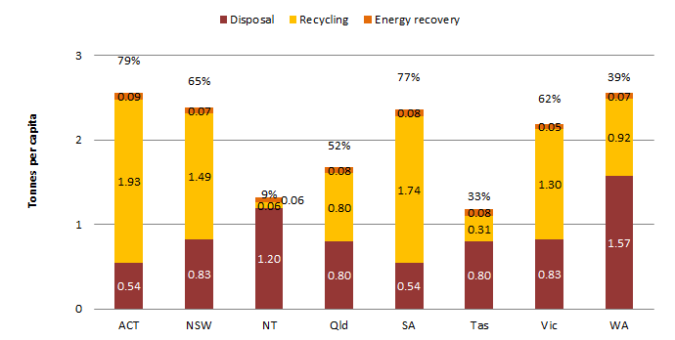

(b)

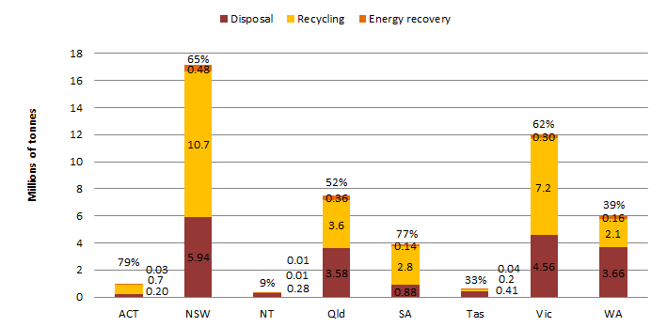

The resource recovery rate for each jurisdiction is given as a percentage above each column

### E1.1 2010/11 data international comparison

Australia generated more waste per capita than the US, Canada and NZ but less than the UK and Germany. This may be partly a manifestation of better data collection systems.

Australia’s recovery rate of 60% by weight compares well to nations other than Germany and the UK. Their higher level of performance reflects directives prohibiting unsorted waste going to landfill and greater use of advanced waste processing and energy from waste (EfW) facilities. It may also reflect greater viability of recycling due to higher waste disposal costs and denser populations.

A comparison was made of 2010/11 waste generation and recovery rates for municipal solid waste (MSW) among nations that are members of the Organisation for Economic Cooperation and Development (OECD). It found that:

* Australia was ranked the twelfth highest waste generator of MSW of the 34 nations considered, reflecting population, size and level of affluence.
* On a per capita basis, Australia was ranked seventh highest for MSW generation of the nations considered.
* Australia’s levels of MSW resource recovery were similar to those in the UK, Finland, Italy and the US, but were significantly below many northern and western EU nations and Korea. These nations make greater use of EfW facilities and often also divert a greater proportion of MSW to composting. Nations such as Switzerland, Austria, Sweden, Denmark, Norway and Belgium dispose of less than 2% by weight of MSW directly to landfill.

### E1.2 2010/11 waste stream and material category summary

In 2010/11, about 14 Mt of MSW was generated nationally. About 51% was recovered – the lowest resource recovery rate of the three main waste streams. Some 15 Mt of commercial and industrial (C&I) waste was generated, of which 59% was recovered. Construction and demolition (C&D) waste generation was around 18 Mt. At 66%, the resource recovery rate was the highest of the three streams.

Figure E2 shows the quantity of waste generated in Australia by material category in 2010/11. It also shows how the waste materials were managed and (above each column) the resource recovery rates. The organics and plastics categories perhaps present the greatest opportunities for improved recovery, given the range of end uses and, for plastics, a relatively strong commodity value.

Figure E2: Australia 2010/11, total waste generation by material category and management

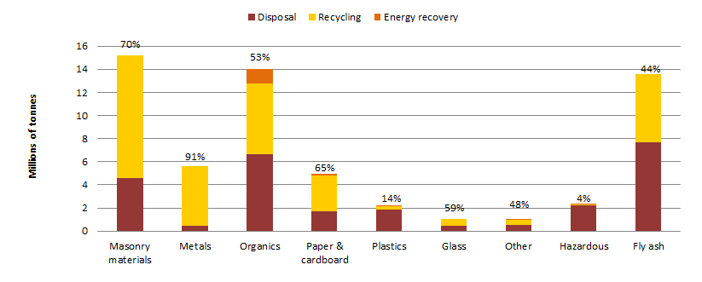

## E2 Summary of the trends, 2006/07­ to 2010/11

### E2.1 National per capita trends

The amount of waste generated per capita in Australia has been reasonably stable at around 2.1 tonnes per capita per year, with a small increase of 2.6% over the review period, or 0.6% per year.

The amount of waste recycled per capita in Australia increased significantly from around 1.0 tonne to around 1.2 tonnes per capita per year, an increase of around 20% in four years, or 4.6% per year. The amount of waste used for generating energy in Australia increased marginally from 60 to 70 kg per capita per year, or 8% or 2.0% per year.

Disposal of waste per capita in Australia decreased significantly from around 1.03 tonnes to around 0.88 tonnes per capita per year, a fall of around 15% in four years, or 4.0% per capita per year.

### E2.2 National total tonnage trends

Australia continued to generate more waste as the population grew, with waste generation increasing from around 44 Mt to around 48 Mt per year, an increase of 9.1% over four years, or 2.2% per year. Population increased at around 1.6% per year, so waste generation grew about 40% more quickly than population during the period.

The quantity of material recycled increased significantly from 21.4 Mt to 27.3 Mt per year, or by about 27% in four years, or 6.3% per year.

Waste used for energy recovery increased from about 1.32 Mt to 1.52 Mt per year, or by about 15% over four years, or 3.6% per year.

Australia’s total disposal tonnage decreased from about 21.5 Mt to about 19.5 Mt per year, or by about 9.5% over four years, or 2.5% per year.

Between 2006/07 and 2010/11the resource recovery rate in Australia increased by 9%, from 51% to 60%.

### E2.3 Per capita jurisdictional trends

Figure E2 shows the trends in per capita waste generation for each jurisdiction over the period. Possible causes for the variations over the period include changes in rainfall and data quality.

Figure E2: Trends in per capita waste generation by jurisdiction, 2006/07to 2010/11 (excl. fly ash)

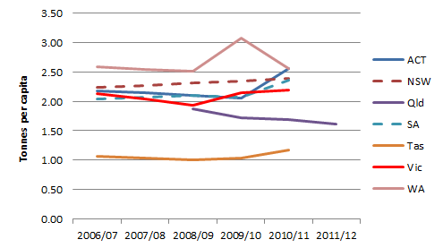

Relies on interpolation for all jurisdictions (07/08) and NSW (09/10). Qld data shown to 2011/12.

Table E2 includes a summary of the per capita change in the reporting parameters for each jurisdiction between 2006/07 and 2010/11 (for Qld, between 2008/09 and 2011/12).

Table E2: Change in per capita data by jurisdiction, between 2006/07 and 2010/11 (excluding fly ash)

|  |  |  |  |  |  |  |  |  |
| --- | --- | --- | --- | --- | --- | --- | --- | --- |
|  | ACT | NSW | Qld | SA | Tas | Vic | WA | Australia |
| **Disposal** | 16% | -19% | -10% | -16% | -5% | -13% | -12% | **-15%** |
| **Recycling** | 21% | 28% | -20% | 31% | 89% | 15% | 29% | **20%** |
| **Energy recovery** | -23% | 31% | 0% | 26% | 5% | 9% | -28% | **8.3%** |
| **Resource recovery rate** | 0% | 20% | -5% | 13% | 48% | 12% | 23% | **16%** |
| **Generation** | 18% | 7% | -14% | 16% | 10% | 2% | -1% | **2.6%** |

The data show mixed outcomes across the jurisdictions. Per capita generation rates increased in all jurisdictions except Qld and WA, and resource recovery rates grew in all except Qld. Disposal rates fell everywhere except the ACT.

## E3 Organic wastes summary

Section provides additional data on organic waste materials[1]. Key findings for 2010/11 were:

* An estimated 12 Mt of organic wastes were recovered. This includes: some 7.4 Mt of MSW, C&I and C&D organic wastes; 1.0 Mt of biosolids; the equivalent of 1.2 Mt of organics recovered via biogas energy recovery; and 2.1 Mt of wastes from primary production activities that entered waste management facilities.
* Landfill biogas energy represents around 17% of all estimated organics recovery.
* Paper products (3.1 Mt) and garden organics (2.9 Mt) contribute most to the organics recovery figures, followed by timber (0.73 Mt) and mixed organics sent to advanced waste treatment (AWT) facilities.
* When paper and cardboard products are excluded, Australians recover in the order of 200kg per capita of MSW, C&I and C&D organics.
* The ACT has very high per capita recovery of organic wastes, reflecting highly effective diversion of garden and timber organics at resource recovery facilities within the territory, as well as widespread use of ‘wool bale’ garden organics recovery services provided by private operators.
* NSW and Qld recover relatively high levels of biosolids.
* NSW and Vic recover relatively high levels of biogas for energy, reflecting landfill practices in those states.

Section also discusses the trends in organics recovery based on Recycled Organics Unit (ROU) data, with the following key findings. Over the six-year period from 2005/06 to 2010/11 there have been fairly consistent organics recovery in the ACT and NSW, modest increases in WA and SA and significant increases in recovery in Qld and Vic. Nationally, the reported levels of recovered organics increased by 45%. Improved data capture may have contributed to the increase.

## E4 Policy frameworks, barriers and opportunities

Table E3 provides a subjective and summarised assessment of Australian waste policy during the reporting period against common elements of best practice, reflecting the extent to which these elements are implemented across the jurisdictions. It would be overly simplistic to assume that Australia needs to implement any one of the key elements that are listed as medium or low in the following table. A detailed assessment of local implementation is required to understand whether any change would be consistent with existing policy settings and market conditions.

Table E3: Assessment of Australia’s implementation of key elements of high resource recovery frameworks during the data reporting period

|  |  |
| --- | --- |
| Key elements of framework | Rating |
| Targets set for reducing the generation of solid waste | Medium |
| Targets set for resource recovery from solid waste | High |
| Landfill levies applied at a rate sufficient to significantly promote recovery | Low to Medium |
| Hypothecation of landfill levy funds to waste initiatives & recovery infrastructure | Medium |
| Broad scale landfill disposal bans for untreated or unsorted solid wastes | Low |
| Comprehensive reporting requirements for waste management | Low to medium |
| Strict environmental controls over landfills | Medium |
| Source segregation of solid waste collection (i.e. avoiding mixed residual loads) | Medium |
| Use of a wide range of resource recovery technologies | Low to medium |

Table E3 implies that significant opportunities existed at the end of the data reporting period to further boost resource recovery rates through policy development. Since 2010/11 there have been levy increases in several jurisdictions, disposal bans in SA, resource recovery technology developments in Sydney and a slow tightening of landfill standards. Qld has established a very robust reporting system. Vic has removed its waste generation and resource recovery targets.

One of the common barriers to higher resource recovery rates can be a lack of resource recovery infrastructure that can process mixed wastes (i.e. AWT facilities). A desktop assessment was undertaken of the AWT capacity in each jurisdiction and the results compared to the waste generation and waste disposal for each jurisdiction (see Table E4 below).

Table E4: AWT maximum listed capacity compared to waste generation and disposal tonnages

|  |  |  |  |
| --- | --- | --- | --- |
| State | AWT maximum capacity listed (kt) | AWT capacity as percentage of waste generation in 2010/11 | AWT capacity as percentage of disposal in 2010/11 |
| ACT | 0 | 0% | 0% |
| NSW | 524 | 3% | 9% |
| NT | 0 | 0% | 0% |
| Qld | 313 | 4% | 9% |
| SA | 350 | 9% | 40% |
| Tas | 0 | 0% | 0% |
| Vic | 30 | 0% | 1% |
| WA | 255 | 4% | 7% |

Table E4 shows that NSW has the highest capacity of AWTs in operation in Australia. However, when compared to the tonnages of waste disposed, SA has the highest results, with the equivalent of 40% of 2010/11 waste disposal tonnage processable in the SITA Resource Co facility.

## E5 Data reliability

Waste data are often difficult and expensive to collect, and the requirements, scope and mechanisms for collection and reporting differ across the jurisdictions. In some cases, the authors needed to make estimates based on uncertain or sparse data, so the reliability of the results varies. A subjective assessment of the reliability of the data presented for each jurisdiction is summarised below. The assessment should be taken into consideration when making use of the data outputs.

Table E1: Assessment of the data reliability in this report by jurisdiction

|  |  |
| --- | --- |
| Data reliability assessment | Jurisdiction |
| High | ACT, NSW, Vic |
| Medium | Qld, SA, Tas, WA, Australia |
| Low | NT |

# Introduction

In June 2012, the Department of Sustainability, Environment, Water, Population and Communities engaged Blue Environment Pty Ltd in association with Randell Environmental Consulting to report on *Waste Generation and Resource Recovery in Australia* during 2010/11.

This report aims to present, analyse and discuss the most up-to-date set of Australian and jurisdictional solid waste data, focusing on:

* recycling
* energy recovery
* resource recovery (where resource recovery = recycling + energy recovery)
* disposal
* waste generation (where waste generation = resource recovery + disposal).

This is the fifth in a series of data compilations on waste and resource recovery in Australia. The four previous iterations were known as the *Waste and Recycling in Australia* reports. This version of the report has been re-titled to better reflect its focus and to differentiate it from the earlier reports, which did not extend to data interpretation or five-year time-series analysis.

Detailed data and analysis for 2010/11 are accompanied by trend data from 2006/07. The time series analysis of trends from 2006/07 has notrelied upon data from previous *Waste and Recycling in Australia* reports. To ensure that the trend analysis was based on consistently compiled data, the raw data were revisited and the annual figures were recalculated. The results may not always be consistent with previous *Waste and Recycling in Australia* reports.

This report has been compiled using state and territory government data and, to a lesser extent, from industry data. The compilation method aligns well with the approach outlined in the previous version of this report, *Waste and Recycling in Australia* *2011* (see section 22 for a details).

Throughout the development of this report, Blue Environment and REC worked closely with DSEWPaC and state and territory governments to ensure that the best possible data sources were used and that the processes and assumptions used were transparent. In addition, the data workbooks that underpin the report were audited by Ernst and Young, who found no significant flaws.

A large amount of data has been collated and analysed for the development of this report. Although the broad approaches are documented in this report (see the third bullet point below), it is not practical, nor does it add value, to describe in full all the data, assumptions and calculation steps taken. To ensure transparency, this report was submitted with two accompanying two Microsoft Excel workbooks. The first, *WGRRA database* contains the raw data and various manipulation steps to derive a common platform for analysis. The second workbook, *WGRRA data workbook*,compiles the manipulated data into a consistent framework for each jurisdiction and generates the main data outputs used in the report.

## Report structure

The report opens an overview of the context for national reporting (section 2). This section has been included to ensure that the ‘macro’ social and economic factors, such as population and economic activity, that affect the data are given due consideration before the results are presented.

Following section 2, the report structure is broadly grouped into three parts outlined below.

* Sections 3 to 14 include the main data presentation and analysis. These sections present the national data, international comparisons and jurisdictional data.
* Sections 15 to 20 provide analysis of a several important areas, namely: organics, product stewardship, and local government data, an overview of policy frameworks, barriers to resource recovery, and the environmental impacts of waste management.
* Sections 21 to 23 document the key definitions and data collation approaches that underpin the report. The report scope and method are discussed in detail here, including the degree of alignment with the method set out in Section 3 of the previous version of this report, *Waste and Recycling in Australia 2011*. An overview of the data collation assumptions used in the development of the report’s data is also provided.

## Data layout

In the data sections for Australia and for the states and territories (3 to 14), the 2010/11 data is presented first, followed by reporting and analysis of the trends in waste generation and management of waste for the 2006/07 to 2010/11 period.

The 2010/11 data is presented as follows.

1. Per capita and total tonnage data. This outlines how much waste the jurisdiction generated in per person and in total, and provides data on the management of the waste materials (i.e. was it recycled, recovered for energy or disposed).
2. Waste stream data. This summarises the sources of waste, i.e. the amount derived from MSW, C&I or C&D activities.
3. Material category data and analysis. This presents the amounts of the main materials (i.e. metal, plastic, organics, etc.) that make up the generated waste.
4. Waste reuse data (where available). Where waste reuse data has been provided by the jurisdiction, it is included as a total tonnage only (see section for further discussion).

Where appropriate, the resource recovery rate is included in charts as a percentage figure above the relevant data. Figures exclude data on fly ash (the waste from burning coal) except where stated in the chart headings. This applies to total and per capita tonnage figures and in the material category figures for all jurisdictions. This conforms to the agreed method of reporting fly ash separately.

Section tabulates the 2010/11 data set for each jurisdiction with as much detail as the input data allow. The full data set is included in the accompanying Microsoft Excel workbooks.

## Data reliability

Waste data are often difficult and expensive to collect, and the requirements, scope and mechanisms for collection and reporting vary across the various jurisdictions, industries and management routes drawn upon for this work. Data on the composition of waste to landfill, in particular, are estimated largely on the basis of periodic audits at a few landfills in various jurisdictions.

In recognition of these limitations, most of the data are presented to only two or three significant figures.

The reliability of the data presented varies by jurisdiction. A subjective assessment of the reliability of the data for each jurisdiction is provided below in the categories ‘high’, ‘medium’ and ‘low’. The categorisation was based on a range of considerations including:

* the extent to which the data obtained for the report covered the required waste categories, types and management routes across the jurisdiction
* the sizes of any gaps in the data provided
* the number of different data sources relied upon in this report to generate the required data
* the project team’s understanding of the methods used to obtain the data that was provided
* the number and types of assumptions that needed to be made to complete the data set.

The results of the assessment are shown in Table 1 below. The assessment should be taken into consideration when making use of the data outputs.

Table 1: Assessment of the data reliability in this report by jurisdiction

|  |  |
| --- | --- |
| Data reliability assessment | Jurisdiction |
| High | ACT, NSW, Vic |
| Medium | Qld, SA, Tas, WA, Australia |
| Low | NT |

The quality of the jurisdictional data used in the report was often not apparent to the project team and not well reported by the jurisdictions, and therefore does not strongly influence the above assessment. NSW produces an assessment of its input data quality, which could potentially be drawn upon as a template for other jurisdictions. The *Quality Declaration – Waste Avoidance and Resource Recovery (WARR) Strategy - recycling rates* is reproduced in Appendix A.

## Other notes on the data

It is important to note that the data in this report will not always reconcile with publically reported data from the states and territories. The differences in data result from differences in scope, method of compilation, and assumptions. This report and the accompanying workbooks are intended to provide transparency so that differences between the reported data sets can be reconciled if necessary.

During consultation with the states and territories, the inclusion or exclusion of waste arising from ‘natural disasters’ (such as major floods of fires) was discussed. All jurisdictions confirmed that the data used in this report included waste from natural disasters. Most stated that waste from natural disasters could be accounted for separately as it is exempt from landfill levy (which requires landfill operators to account for the waste separately).

Conclusions should not be drawn about the performance of jurisdictions over time nor comparisons made between jurisdictions without a firm understanding of local circumstances. For example: garden organics tonnages can change significantly over time and between jurisdictions due to rainfall; commercial waste profiles can vary between jurisdictions depending on the industries present; and the viability of recycling a material can vary depending on the distance from the point of generation and the main markets for the collected materials.

# Waste data context

Several macro level social and economic factors influence the waste data of Australia’s jurisdictions. These factors are listed below and considered further in this section:

1. Population – actual and rates of growth over the review period.
2. Economic activity – actual and changes over the review period.
3. Average income per capita.
4. Urbanisation, expressed by the proportions of the population living in metropolitan and regional areas.

A jurisdiction’s waste management is also affected by policy measures and the availability of recovery infrastructure (see sections 18 and 19).

## Population

The population of a jurisdiction has a direct impact on waste generation. Figure 1 shows each jurisdiction’s population and its increase from 2006/07 to 2010/11. New South Wales (NSW) has by far the largest population followed by Victoria (Vic), Queensland (Qld), Western Australia (WA), South Australia (SA), Tasmania (Tas), Australian Capital Territory (ACT) and Northern Territory (NT). WA has had the most significant increase in population since 2006/07 followed by NT, ACT, Qld, Vic, NSW, SA, and Tas. Overall, Australia’s population grew by around 6% over the period.

Figure 1: Population growth by jurisdiction

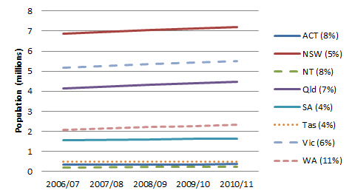

Source: ABS (2012a)

## Economic activity — gross state product

The most readily available measure of economic activity in a jurisdiction is the GSP. The Australian Bureau of Statistics (ABS 2012b) defines GSP as the total sum of exports of goods and services from a state net of the total sum of imports of goods and services. GSP provides an indication of the likely amount of waste generation, particularly from the C&I and C&D sectors. Figure 2 shows GSP by jurisdiction and notes the increase in GSP from 2006/07 to 2010/11. Unsurprisingly, the ranking of jurisdictional GSP is almost identical to the ranking of population.

Figure 2: GSP growth by jurisdiction

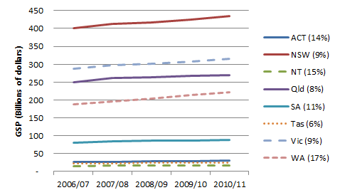

Source: ABS (2012c)

## Average income per capita

Figure 3 shows the average weekly income for each jurisdiction in 2011 (based on the 2011 census data). Historically, waste generation rates have typically increased as a population base becomes more affluent. This is due to increased consumption and also potentially by affluent populations investing in improved waste management systems that may result in the collection of materials previously managed outside of major waste management facilities (e.g. garden waste).

Figure 3: Average weekly incomes per capita by jurisdiction (gross), 2011

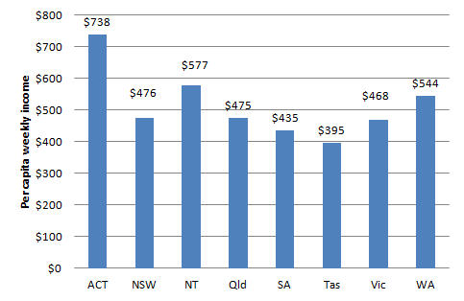

Source: ABS website <http://abs.gov.au/websitedbs/censushome.nsf/home/data?opendocument#from-banner=LN> (Jan 2013), estimated by dividing ABS average per household income data by the average number of people per household

## Urbanisation

Figure 4 shows, for each jurisdiction, the percentage of the population that lives in metropolitan or inner regional areas. Historically waste generation has been higher for populations with higher levels of urbanisation, reflecting the fact that rural areas tend to have:

* lower levels of affluence, and therefore lower levels of consumption and waste generation
* more primary production industries, the waste from which is outside the scope of this report
* less access to formal waste management systems and greater opportunities for on-site waste management, including by industry.

Figure 4: Percentage of population living in metropolitan or inner regional areas by jurisdiction

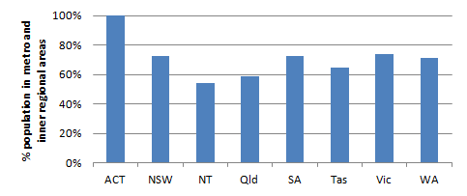

Source: ABS website <http://www.abs.gov.au/ausstats/abs@.nsf/Products/3218.0~2011~Main+Features~Main+Features?OpenDocument#PARALINK0> (Jan 2013)

# Australia 2010/11

## Australia 2010/11 total and per capita tonnage and resource recovery rate

Figure 5 illustrates the per capita and total tonnage of waste generated in Australia in 2010/11 and how the material was managed (i.e. recycled, recovered for energy, or disposed). In 2010/11, Australians on average generated 2.2 tonnes per capita of waste, 60% of which was recycled or recovered for embodied energy (the resource recovery rate is shown above each data column). Inclusion of fly ash from coal fired power stations increases average per capita waste generation by 28% to 2.8 tonnes, with a resource recovery rate of 56%. In total, Australia generated around 48 Mt of waste excluding fly ash, and 62 Mt including fly ash.

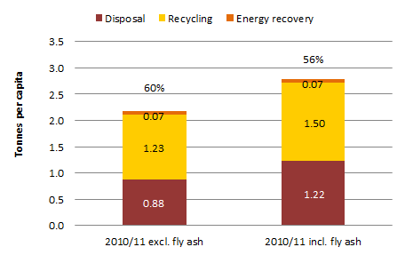Figure 5: Australia 2010/11, per capita and total waste generation by management

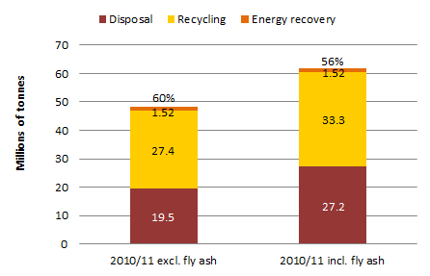

Figure 6 illustrates the waste generated per capita and in total for each jurisdiction, showing the proportions by management, and the resource recovery rates.

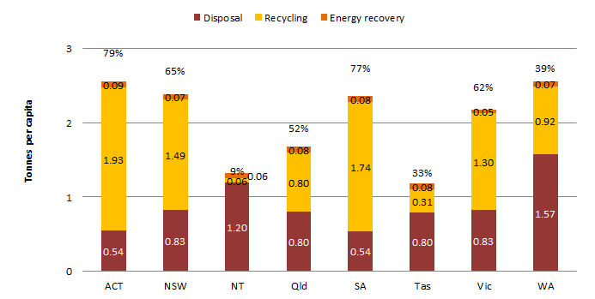The quantity of waste generated per capita in Australian jurisdictions appears to generally increase with income per capita and with the level of urbanisation (see Figure 3 and Figure 4)[2]. Tonnage totals correlate with population and GSP (see Figure 1 and Figure 2).

Figure 6: Australia 2010/11, per capita and total waste generation by management by jurisdiction

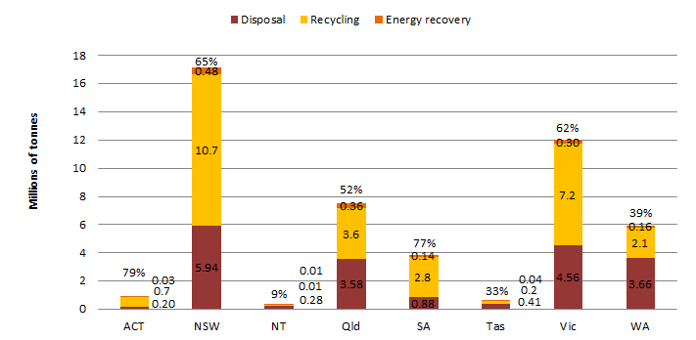

## Australia 2010/11 waste stream data

Figure 7 shows the main sources, or ‘streams’ of waste in Australia[3]. The three waste streams are MSW, C&I, and C&D waste. MSW includes waste from households and local government activities (e.g. from parks and garden maintenance). The C&D waste stream comprises wastes from the construction and demolition industry. The C&I waste steam comprises waste from every generator apart from households, local governments and the C&D industry, including offices, factories and institutions.

In 2010/11, about 14 Mt of MSW was generated nationally. About 51% was recovered – the lowest resource recovery rate of the three main waste streams. While some MSW waste is separated at its source for recycling (e.g. kerbside recyclables and garden wastes), the residual or landfill bin from households is a major part of MSW disposal tonnage. The contents of these bins are a complex mix of materials and can only be recovered using expensive and complex infrastructure that generally produces products of lower quality than those from source-separated wastes.

Around 15 Mt of C&I waste was generated, of which 59% was recovered. The C&I stream may present the greatest opportunities for improving recovery, especially for wastes that are delivered to landfill in homogenous loads (e.g. cardboard or food). Improving the performance of energy recovery at landfill would improve the resource recovery rates of both MSW and C&I.

C&D waste generation was around 18 Mt. At 66%, the resource recovery rate was the highest of the three streams. C&D recovery is well-established in most jurisdictions, but opportunities remain for recovering material from mixed C&D waste loads, which are often taken directly to landfill.

Figure 7: Australia 2010/11, total waste generation by waste stream and management (excluding ACT)

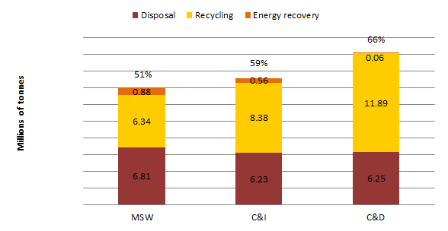

### Australia 2010/11 waste stream data by jurisdiction

Figure 8 illustrates per capita waste generation by waste stream and by management (including resource recovery rate) for each jurisdiction apart from the ACT. For further discussion, see the sections on each jurisdiction.

Figure 8: Australia 2010/11, per capita waste generation by waste stream, management, and jurisdiction (excluding ACT)

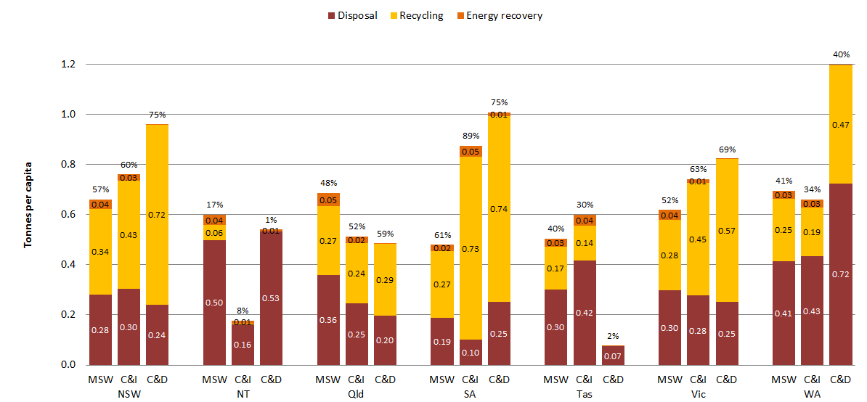

Figure 9 illustrates the total quantity of waste generated by waste stream and by management (including resource recovery rate) for each jurisdiction apart from the ACT. For further discussion, see the sections on each jurisdiction.

Figure 9: Australia 2010/11, total waste generation by waste stream and management (excluding ACT)

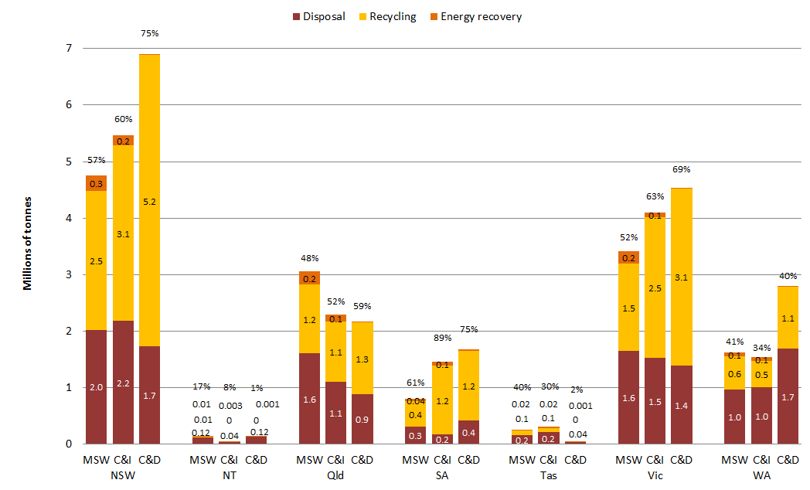

## Australia 2010/11 data by material category

Figure 10 shows the quantity of waste generated in Australia by material category in 2010/11, and also how each material was managed. Note that these data rely on estimates of landfill composition that have a significant degree of uncertainty. The discussion that follows provides a high level analysis of each material category shown in the chart.

Figure 10: Australia 2010/11, total waste generation by material category and management



Note: the sum of all materials listed above is about 2 Mt less than the national total for waste generation because some waste was not attributable to a particular category.

### Masonry material

About 15 Mt of waste masonry materials were generated, 70% of which were recycled. This category includes ‘heavy’ waste types such as concrete, bricks and rubble. Typically the masonry material types with lower recovery rates are mixed loads of demolition waste, which are often contain substantial amounts of rubble and plasterboard.

### Metals

Some 5.6 Mt of metals waste was produced of which 91% was recycled, representing the highest resource recovery rate of all the material categories. Metal recycling is advanced in every jurisdiction and boomed with high commodity prices. Some toxic metals (such as cadmium and cobalt) and rare and precious metals (such as gold and palladium) are still being landfilled with composite material products such as electronic waste (see section ). Whilst the tonnages may be low, the potential environmental impacts and value of the lost resources are high.

### Organics

In the bulk of this report, ‘organics’ includes food, garden wastes, timber and biosolids from sewage treatment works but excludes paper, cardboard, rubber and leather[4]. Around 14 Mt of organic waste was generated. The recovery rate was 53%, of which 83% was recycled (predominantly composting of garden organics) and 17% was energy recovery (predominantly from organics sent to landfills with gas collection systems linked to the electricity grid). Opportunities remain to improve organics resource recovery rates by diverting organic wastes—especially food—to resource recovery facilities, or by improving the landfill gas capture rates at landfills.

### Paper and cardboard

The paper and cardboard category totals about 5.0 Mt of waste, with resource recovery of 65%. The main opportunity for greater resource recovery would be to divert paper and cardboard to recycling facilities.

### Plastics

About 2.2 Mt of plastic waste was generated and about 14% was recovered. Given the generally strong commodity value of plastics and a well-established recycling industry in Australia, plastics may be the ‘low hanging fruit’ for improving resource recovery rates. Where the value of plastics is too low for recycling, processing plastics into refuse-derived fuels could be an alternative.

### Glass

The amount of waste glass generated was around 1.1 Mt, with a resource recovery rate of 59%. This is reasonable given the relatively low commodity value of glass (compared to plastic or cardboard) and the relative difficulty of recovering glass from mixed waste loads. Automated sorting equipment tends to break glass and it ends up in smaller and smaller pieces until it is not readily recoverable. Improved source-separation of glass into recycling systems would increase resource recovery rates.

### Other

This waste category consists of leather, textiles, tyres and other rubber. About 1.0 Mt was generated and 48% recovered. Increasing energy recovery from this category may be the best opportunity for improving recovery. For example, more waste tyres could be sent to cement kilns to offset fossil fuel requirements.

### Hazardous

The hazardous material category comprised 2.35 Mt of waste with a resource recovery rate of just 4% [5]. The bulk of this category is contaminated soils. For many types of contamination, treatment options are available to remove the hazard and enable reuse. The data on hazardous waste is likely to be of lower quality than most other streams because material may be recycled without recording of the input data, or may be treated to non-hazardous waste prior to being recorded.

### Fly ash

Australia generated around 14 Mt of fly ash in 2010/11. Around 7.7 Mt was disposed to landfills (normally backfilling the coal mine void at the power station) and around 6.0 Mt was recycled into products such as cement. With a resource recovery rate of 44% opportunities may exist to recycle more fly ash, provided contamination issues are appropriately managed.

# National trends, 2006/07 to 2010/11

This section looks at the overall trends in waste generation and management (i.e. recycling, energy recovery or disposal) for Australia for the period 2006/07 to 2010/11 (excluding fly ash).

Figure 11 shows the **per capita** waste generation for Australia and how the waste was managed.

Figure 11: Trends in per capita waste generation and management, Australia 2006/07 to 2010/11

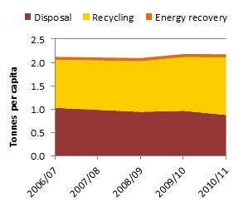

Relies on: population-based backwards extrapolation for NT (06/07 – 09/10) and Qld (06/07); and interpolation for all jurisdictions (07/08) and NSW (09/10).

Over this period the following **per capita** trends are illustrated:

* Waste generation in Australia has been reasonably stable at around 2.1 tonnes per capita per year with a small increase of 2.6% over the review period, or 0.6% per year.
* The resource recovery rate in Australia increased from 51% to 60% over the period.
* Waste recycling in Australia increased significantly from around 1.0 tonne to around 1.2 tonnes per capita per year, a rise of around 20% in four years, or 4.6% per year.
* Material used for producing EfW in Australia increased marginally from 60 to 70 kg per capita per year, or 8%, or 2.0% per year.
* Waste disposal in Australia decreased significantly, falling from around 1.03 tonnes to around 0.88 tonnes per capita per year, a fall of around 15% in four years, or 4.0% per capita per year.

Figure 12 shows the **total tonnage** of waste generated in Australia and how the waste was managed.

Figure 12 Trends in total waste generation and management, Australia 2006/07 to 2010/11

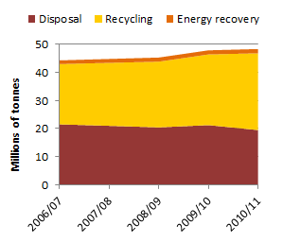

Relies on: population-based backwards extrapolation for NT (06/07 – 09/10) and Qld (06/07); and interpolation for all jurisdictions (07/08) and NSW (09/10).

Over the period the following **total waste generation** trends are illustrated:

* Australia continued to generate more waste as the population grew, with waste generation increasing from around 44 Mt to around 48 Mt per year, an increase of 9.1% over in four years, or 2.2% per year. Population increased at around 1.6% per year, so waste generation grew about 40% more quickly than population during the period.
* The total quantity of material recycled in Australia increased significantly from 21.4 Mt to 27.3 Mt per year, or by about 27% in four years, or 6.3% per year.
* Australia’s total energy recovery increased from about 1.32 Mt to 1.52 Mt per year, or by about 15% over four years, or 3.6% per year.
* Australia’s total disposal tonnage decreased from about 21.5 Mt to about 19.5 Mt per year, or by about 9% over four years, or 2.5% per year.
* The resource recovery rate in Australia increased from 51% to 60% between 2006/07 and 2010/11, an increase of 9% over the period.

Figure 13 shows the trends in **per capita** waste generation for each jurisdiction over the period[6]. Some surprising trends are shown, especially for WA, Qld and the ACT. These may have a range of causes, including variability in rainfall and, potentially, data quality. It is noteworthy that WA generated more waste per capita than the other jurisdictions – this could be related to WA’s method of estimating landfill tonnages, which is discussed in section 13.

Waste generation trends are analysed further in the sections of the report dedicated to each jurisdiction.

Figure 13: Trends in per capita waste generation by jurisdiction over the reporting period



Relies on interpolation for all jurisdictions (07/08) and NSW (09/10).

Table 2 provides a summary of the per capita change in the reporting parameters for each jurisdiction between 2006/07 and 2010/11 (for Qld, between 2008/09 and 2011/12).

Table 2: Change in per capita data by jurisdiction over the reporting period (excluding fly ash)

|  |  |  |  |  |  |  |  |  |
| --- | --- | --- | --- | --- | --- | --- | --- | --- |
|  | ACT | NSW | Qld | SA | Tas | Vic | WA | Australia |
| **Disposal** | 16% | -19% | -10% | -16% | -5% | -13% | -12% | **-15%** |
| **Recycling** | 21% | 28% | -20% | 31% | 89% | 15% | 29% | **20%** |
| **Energy recovery** | -23% | 31% | 0% | 26% | 5% | 9% | -28% | **8.3%** |
| **Resource recovery rate** | 0% | 20% | -5% | 13% | 48% | 12% | 23% | **16%** |
| **Generation** | 18% | 7% | -14% | 16% | 10% | 2% | -1% | **2.6%** |

The data show mixed outcomes across the jurisdictions. Per capita generation rates increased in all jurisdictions except Qld and WA, and resource recovery rates grew in all except Qld. Disposal rates fell everywhere except the ACT.

# International data comparison

This section considers Australia’s waste generation, disposal and recycling relative to other OECD nations. A few nations have been selected for more detailed analysis because they are likely to have similar cultural and socio-demographic characteristics as Australia.

## Waste generation

A summary of the waste generation, disposal and recycling performance between selected countries is shown in and , which show data on per capita solid waste and total solid waste respectively in 2006/07 and 2010/11. The tables show:

* As would be expected, the more populous industrialised countries produce more waste. Germany and the US generate eight to nine times as much solid waste as Australia.
* Differences in per capita waste generation figures may, in part, reflect different methods of data classification and collection. Germany has a very high rate of resource recovery, reflecting directives for mandatory recovery and the prohibition of unprocessed or unsorted materials from landfill, as well as extensive use of thermal energy recovery from waste. Germany also records high per capita generation of waste, reflecting high levels of heavy industry and possibly more extensive reporting of waste recovery than other nations. The observed increase in recovery rate and total waste generation in Germany is likely to be partly due to the capture of new sources of information about waste, including from mining and treatment of mineral resources.
* Australia generated more waste per capita waste than the US, Canada and NZ. Again, this may be partly a manifestation of better data collection systems.
* Australia’s recovery rate of 60% by weight compares well to nations other than Germany and the UK. Their higher level of performance reflects directives prohibiting unsorted waste going to landfill and greater use of advanced waste processing and EfW facilities. It may also reflect greater viability of recycling due to higher waste disposal costs and denser populations.
* Canada’s low diversion rate of 22% in 2006/07 and 24% in 2010/11 may be primarily due to the exclusion of a range of materials (such as asphalt, concrete, bricks, etc., which are considered to be waste) from waste data collected by Statistics Canada.

Table 3: Comparison of per capita solid waste generation, disposal and recovery in selected OECD nations

|  |  |  |  |  |  |  |  |  |
| --- | --- | --- | --- | --- | --- | --- | --- | --- |
| Country | Disposal | | Resource recovery | | Waste generation | | Resource recovery rate (%) | |
| *kg per capita* | | | | | |
| **2006/071,2** | **2010/11** | **2006/071,2** | **2010/11** | **2006/071,2** | **2010/11** | **2006/071,2** | **2010/11** |
| Canada | 862 | 773 | 245 | 243 | 1,107 | 1,016 | 22% | 24% |
| US | n/a | 812 | n/a | 535 | n/a | 1,348 | n/a | 40% |
| Germany | 639 | 416 | 2,418 | 4,222 | 3,058 | 4,638 | 79% | 91% |
| UK | n/a | 899 | n/a | 1,655 | n/a | 2,553 | n/a | 65% |
| Australia | 933 | 1,026 | 1,383 | 1,300 | 2,122 | 2,178 | 51% | 60% |
| NZ | n/a | 1,443 | n/a | 550 | n/a | 1,992 | n/a | 28% |

Table 4: Comparison of total solid waste generation, disposal and recovery in selected OECD nations

|  |  |  |  |  |  |  |  |  |  |  |
| --- | --- | --- | --- | --- | --- | --- | --- | --- | --- | --- |
| **Country** | **Population (‘000)** | | **Disposal** | | **Resource recovery** | | **Waste generation** | | **Resource recovery rate (%)** | |
| *Millions of tonnes* | | | | | |
|  | **2006/071,2** | **2010/113** | **2006/071,2** | **2010/11** | **2006/071,2** | **2010/11** | **2006/071,2** | **2010/11** | **2006/071,2** | **2010/11** |
| Canada4 | 31,613 | 33,477 | 27.3 | 25.8 | 7.7 | 8.1 | 35.0 | 34.0 | 22% | 24% |
| US | 298,75 | 311,592 | n/a | 253.1 | n/a | 166.7 | n/a | 419.9 | n/a | 40% |
| - MSW/C&I5 | 164.7 | 85.1 | 250.0 | 34% |
| - C&D6 | 88.4 | 81.6 | 170.0 | 48% |
| Germany7,8 | 82,438 | 81,800 | 52.7 | 34.0 | 199.4 | 345.4 | 252.1 | 379.4 | 79% | 91% |
| UK7,9 | 50,793 | 63,200 | n/a | 56.8 | n/a | 104.6 | n/a | 161.3 | n/a | 65% |
| - MSW | 12.5 | 14.1 | 26.5 | 53% |
| -C&I | 11.3 | 36.6 | 47.9 | 76% |
| - C&D | 33.0 | 53.9 | 86.9 | 62% |
| Australia2, 11 | 20,8932 | 22,222 | 21.5 | 19.5 | 22.82 | 28.9 | 44.32 | 48.3 | 51%2 | 60% |
| NZ10 |  | 4,367 | n/a | 6.3 | n/a | 2.4 | n/a | 8.7 | n/a | 28% |
| Notes:   1. All figures others than those for Australia and NZ are taken from the *Waste and Recycling in Australia 2009* report. 2. The figures for Australia shown are the revised estimates for 2006/07, which is a similar reference period to the other nations included in the 2009 report and shown here. The figures exclude fly ash tonnages 3. Demographic information for nations other than Australia is from OECD via <http://stats.oecd.org> 4. Statistics Canada (2012) 5. US EPA (2011) 6. US EPA (2003) 7. MSW data from OECD Stat Extracts via <http://stats.oecd.org/index.aspx?r=571968> 8. Statistisches Bundesamt (2010) via http://www.statistik-portal.de/Statistik-Portal/en/en_jb10_jahrtabu12.asp 9. DEFRA (Department of Environment, Food and Rural Affairs) <http://www.defra.gov.uk/statistics/environment/waste/> 10. Environment NZ (2007) 11. Australian resource recovery figures include recycling, organics recovery, and energy recovery including recovery of bio-gas energy from landfills. | | | | | | | | | | |

## Municipal solid waste trends

International data for MSW are more readily available, allowing broader international comparison of Australia’s MSW generation and management. Data from the OECD national reporting of MSW management have been used in the following assessment.

and Table 6 compare the selected countries’ MSW generation, disposal and resource recovery on a national and per capita basis respectively.

Table 5: Comparison of Australian total MSW generation, disposal and recycling performance with other selected OECD nations

|  |  |  |  |  |  |  |  |  |  |  |
| --- | --- | --- | --- | --- | --- | --- | --- | --- | --- | --- |
| **Country** | **Population (‘000)** | | **Disposal** | | **Resource recovery** | | **Waste generation** | | **Resource recovery rate (%)** | |
| *Millions of tonnes* | | | | | |
|  | **2006/07** | **2010/11** | **2006/07** | **2010/11** | **2006/07** | **2010/11** | **2006/07** | **2010/11** | **2006/07** | **2010/11** |
| Canada | 32,613 | 33,477 | 9.2 | 8.5 | 3.7 | 4.4 | 13.0 | 12.9 | 29% | 34% |
| US | 298,755 | 311,592 | 186.8 | 164.7 | 90.2 | 85.1 | 277.0 | 249.9 | 33% | 34% |
| Germany | 82,438 | 81,800 | 17.7 | 10.7 | 28.1 | 38.5 | 45.8 | 49.2 | 61% | 78% |
| UK | 50,793 | 63,200 | 20.2 | 16.3 | 8.9 | 16.2 | 29.1 | 32.5 | 31% | 50% |
| Australia | 20,893 | 22,222 | 7.2 | 6.8 | 5.8 | 7.2 | 13.0 | 14.0 | 45% | 51% |
| NOTES:   * Figures in columns headed ‘2006/07’ for all nations other than Australia and NZ have been taken from the *Waste and Recycling in Australia 2009* report. These data are based on reports from the period 2004 to 2008. * All Australian data are extracted from the *Waste Generation and Resource Recovery in Australia* workbook for the years 2006/07 and 2010/11 respectively. * Data for other nations in the ‘2010/11’ columns is derived from OECD Statistics Extracts via http://stats.oecd.org/index.aspx?r=571968 * Australian Resource Recovery figures include recycling, organics recovery, and energy recovery including recovery of bio-gas energy from landfills. | | | | | | | | | | |

There are large variations between the per capita figures for each country.

Table 6 shows that the US generates a much larger amount of MSW per capita (802 kg) than the European countries (between 336 and 602 kg per capita). This may in part be due to differences in data gathering and classification of waste; the US data for MSW includes commercial and some industrial wastes. All the countries have decreased their per capita MSW generation amount over time, except for Germany, which has increased (from 555 kg per capita to 602 kg per capita). This may reflect reduced consumption and waste due to the global financial crisis and greater austerity in these countries. Despite Germany’s increase in waste generation, its diversion rate has increased substantially.

Recent data from the UK for household waste from England only (i.e. not including Scotland, Wales and Northern Ireland) suggest high rates of resource recovery from this stream (77% by weight). This is likely to be due to wider adoption of advanced waste treatment including thermal energy from waste.

Table 6: Comparison of per capita MSW generated, disposed and recycled per year between Australia and other selected OECD nations

|  |  |  |  |  |  |  |  |  |
| --- | --- | --- | --- | --- | --- | --- | --- | --- |
| Country | Disposal | | Resource recovery | | Waste generation | | Resource recovery rate  % | |
| *kg per capita* | | | | | |
| **2006/07** | **2010/11** | **2006/07** | **2010/11** | **2006/07** | **2010/11** | **2006/07** | **2010/11** |
| Canada | 292 | 255 | 118 | 130 | 411 | 385 | 29% | 34% |
| US | 625 | 529 | 302 | 273 | 927 | 802 | 33% | 34% |
| Germany | 215 | 131 | 341 | 471 | 555 | 602 | 61% | 78% |
| UK | 398 | 258 | 176 | 256 | 574 | 514 | 31% | 50% |
| Australia | 342 | 307 | 280 | 326 | 622 | 632 | 45% | 51% |
| NOTES:   * Figures in columns headed ‘2006/07’ for all nations other than Australia and NZ have been taken from the *Waste and Recycling in Australia 2009* report. These data are based on reports from the period 2004–2008. * All Australian data are extracted from the *Waste Generation and Resource Recovery in Australia* workbook for the years 2006/07 and 2010/11 respectively. * Data for other nations in the ‘2010/11’ columns is derived from OECD Statistics Extracts via <http://stats.oecd.org/index.aspx?r=571968> * Australian Resource Recovery figures include recycling, organics recovery, and energy recovery including recovery of bio-gas energy from landfills. | | | | | | | | |

### Methods of MSW disposal

Methods of disposal vary from nation to nation, and this can affect recycling recovery rates. shows some different MSW management in selected nations. Australian recovery figures are shown with and without recovery of landfill biogas energy because other nations do not include this component.

Table 7: Comparison of MSW management methods in selected OECD nations

|  |  |  |  |  |  |  |
| --- | --- | --- | --- | --- | --- | --- |
| Country | Method of disposal of municipal waste | | | | | |
| Direct landfill disposal | Recycled | Composted | Energy recovery | Incineration without energy recovery | Other disposal |
| Canada | 66% | 34% | | | |  |
| United States | 54% | 25% | 9% | 12% |  |  |
| Germany | <1% | 46% | 17% | 14% | 18% |  |
| United Kingdom | 49% | 24% | 14% | 12% | <1% | 1% |
| Australia (excl. biogas recovery) | 55%  (49% if landfill biogas gas energy recovery is accounted for) | 45%  (51% incl. landfill biogas energy recovery) | | |  |  |

The US, UK and Australia have fairly similar rates for landfill disposal (49–55% of all MSW). Germany landfills less than 1%, recycles or composts 63% and incinerates the rest. Australia has the lowest rate of incineration with energy recovery (<1%), compared to rates of around 12–14% in the other countries.

### Broad international comparison

Australian MSW data are compared more broadly in the following figures:

* compares total MSW generation
* compares per capita MSW generation
* shows the per capita waste disposal of selected nations
* shows the relative recovery rate of different nations
* compares MSW per capita disposal to landfill, incineration without energy recovery or other disposal.

All Australian data presented is for the 2010/11 period. The OECD data used to generate these figures is derived from OECD *Stats Extracts for Municipal Waste Generation and Treatment[7]*. The comparison suggests:

* Australia was ranked the twelfth highest waste generator of MSW of the 34 nations considered, reflecting population, size and level of affluence. Australia is also ranked in the largest 15 economies in the OECD.
* On a per capita basis, Australia was ranked seventh highest for MSW generation of the nations considered.
* Australia’s levels of MSW resource recovery were similar to those in the UK, Finland, Italy and the US, but were significantly below many northern and western EU nations and Korea. shows these nations make greater use of energy recovery and often also divert a greater proportion of MSW to composting. Unsurprisingly, these nations also have lower per capita disposal to landfill. Nations such as Switzerland, Austria, Sweden, Denmark, Norway and Belgium dispose of less than 2% by weight of MSW directly to landfill.

Figure 14: Comparison of total MSW generation in selected nations (kt/year)

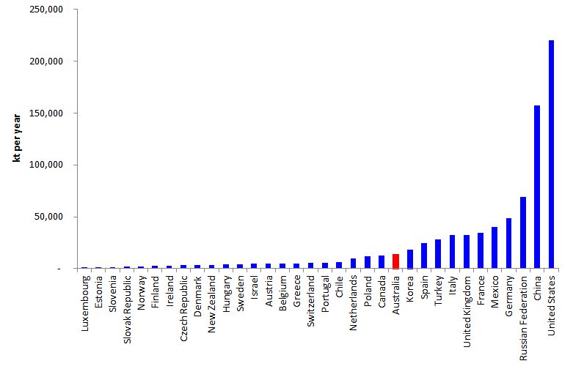

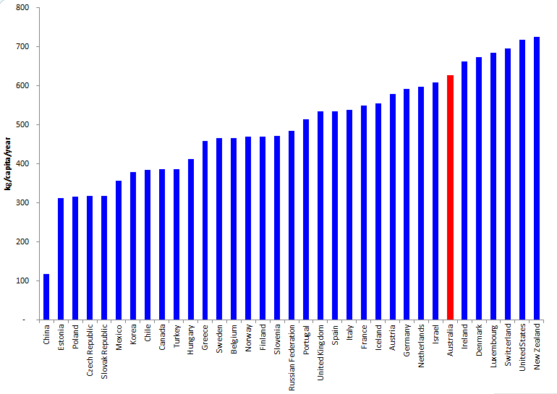Figure 15: Comparison of MSW generation per capita in selected nations (kg/capita/year)

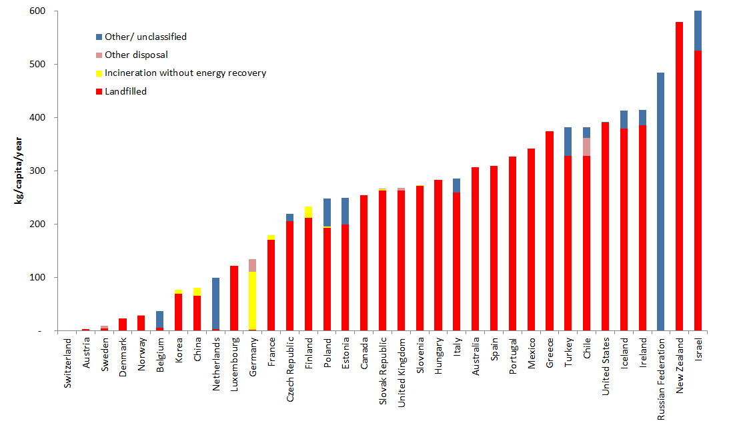Figure 16: Comparison of quantities of MSW disposed (i.e. not recovered) via diffent methods in selected nations (kg/capita/year)

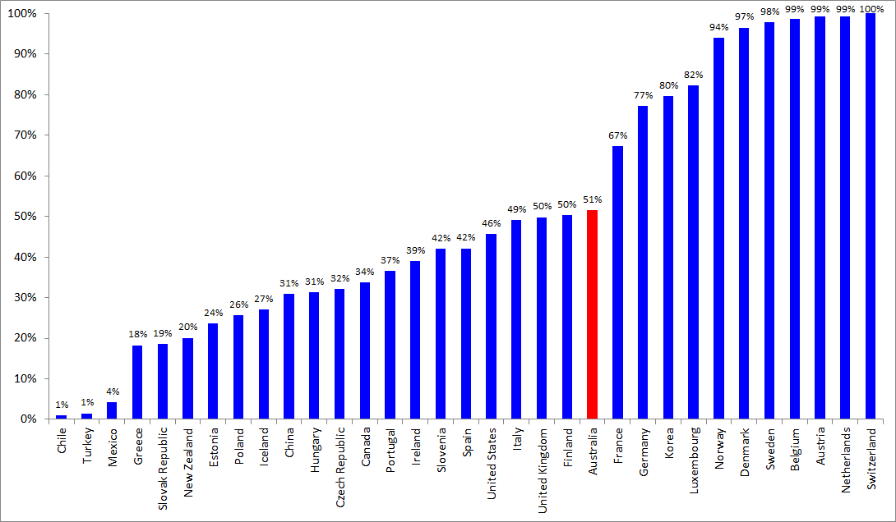Figure 17: Comparison of recovery rates for MSW in selected nations (% by weight)

Figure 18: Comparison of the per capita quantities of MSW resource recovery in selected nations (kg/capita/year)

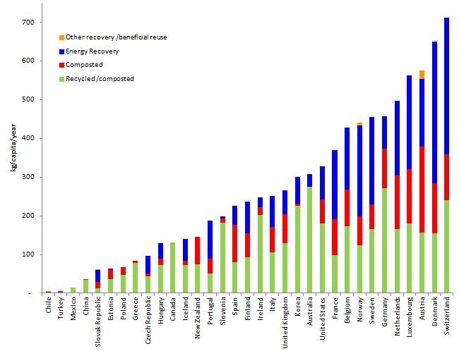

# Australian Capital Territory

## ACT 2010/11

### Per capita waste generation and resource recovery rate

In 2010/11, the ACT generated 2.6 tonnes of waste per capita (see Figure 6), which was the equal highest (with WA) in Australia. This high rate is consistent with the pattern of more waste per capita where incomes and urbanisation are high (see section 2).

The ACT also had Australia’s highest resource recovery rate at around 79% (see percentage above relevant bar in chart). This is 19% above the national average and reflects on ACT having:

* a well-developed resource recovery infrastructure
* high landfill fees that are equivalent to having the second highest landfill levy in Australia[8]
* well established policy directions to increase resource recovery, targeting 80% by 2015
* relatively compact size, with most of the population and business activity concentrated in Canberra.

### Total waste generated

Around 930 thousand tonnes (kilotonnes, or kt) of waste was generated in the ACT in 2010/11, lower than all jurisdictions except the Northern Territory and Tas (see Figure 19).

### Material categories

Figure 19 also shows the composition by material category of ACT’s waste. The majority of ACT’s waste consists of recovered organics, masonry materials, and paper and cardboard. This reflects the high levels of green and timber organics collection at ACT’s landfill and transfer stations, and also the low levels of industry (apart from construction and demolition) in the ACT. The estimated recovery rates for plastic (7%) and metals (37%) are well below the national average suggesting a lack of recovery infrastructure for these material categories and/or a lack of end market for the lower grade plastics and metals.

### Waste streams

The ACT does not collect data on the source streams of recycled material so waste steams analysis is not included here.

Figure 19: ACT 2010/11, total waste generation by (a) management and (b) material category and management

(a)

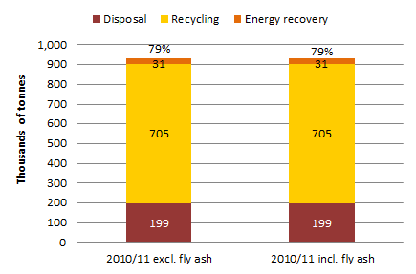

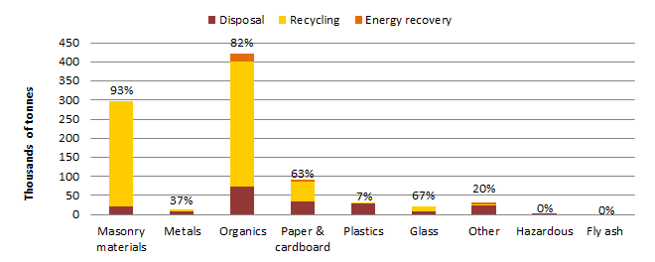(b)

## ACT trends 2006/07 to 2010/11

Figure 20 shows the trends in **per capita** waste generation and management for the period 2006/07 to 2010/11 in the ACT.

Figure 20: Trends in per capita waste generation and management, ACT 2006/07 to 2010/11

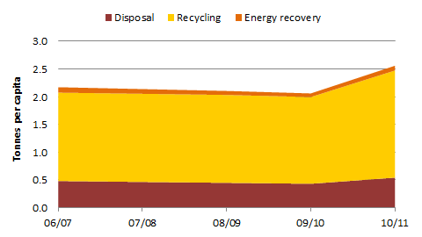

Relies on interpolation for 2007/08

Over this period the following **per capita** trends are illustrated:

* Waste generation in the ACT fell until 2009/10, then increased significantly, resulting in an overall increase in four years of 18%. Analysis of the data suggests the increase is partly the result of a large increase in garden organics recycling in 2010/11, from 167 to 272 kt. The increase may have resulted from several factors: the ending of the drought and consequent increases in plant growth; waste management facility upgrades; and improved reporting from organic waste processing facilities.
* The resource recovery rate remained almost unchanged at around 79%.
* Recycling in the ACT increased by 21%, which the data suggest is associated with the increase in garden waste recycling.
* Waste used for energy production decreased by around 23% due to an apparent decline in landfill gas recovery over the period.
* Waste disposal in the ACT fell until 2009/10, at which point it increased, resulting in an overall increase of 16%.

Figure 21 shows the trends in total waste generation and management for the period 2006/07 to 2010/11 in the ACT.

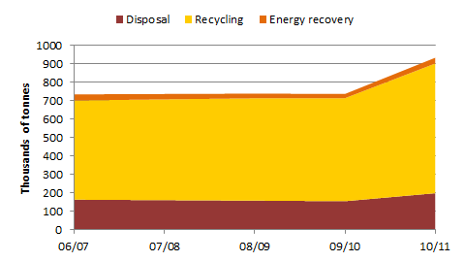Figure 21: Trends in total waste generation and management, ACT 2006/07 to 2010/11

Relies on interpolation for 2007/08

Over the period, the following trends in total waste tonnages are illustrated:

* waste generation tonnages were relatively stable until 2009/10 when they increased significantly, resulting in an overall 27% increase
* recycling increased by 31%
* energy recovery decreased by about 17%
* disposal increased by 25%.

### ACT waste reuse data 2006/07 to 2010/11

The ACT provided some data on waste reuse (listed as salvage and reuse) from the sales of materials and products from the landfills/transfer stations for reuse, which is included in the table below.

Table 8: ACT waste reuse data

|  |  |  |  |  |
| --- | --- | --- | --- | --- |
| Year | 06/07 | 08/09 | 09/10 | 10/11 |
| **Tonnes** | 2,312 | 1,177 | 1,672 | 928 |

# New South Wales

## NSW 2010/11

### Per capita waste generation and resource recovery rate

In 2010/11, 2.4 tonnes of waste was generated per capita in NSW (see Figure 6), the third highest of Australian jurisdictions. This is consistent with the pattern of greater levels of waste per capita where incomes and urbanisation are high (see section 2). The state’s large secondary and tertiary industry base is also likely to have influenced this figure.

NSW also had Australia’s third highest resource recovery rate at around 65%, which is 5% above the national average. This reflects:

* a well-developed resource recovery infrastructure including significant capacity to process residual MSW through AWT facilities and a well-established organics recycling industry
* the highest landfill levy for MSW in Australia
* scarcity of landfill space in the Sydney area
* established policy directions to increase resource recovery, including targets discussed below.

### Total waste generated

Total waste generation in NSW in 2010/11 was around 17 Mt excluding fly ash (22 Mt including fly ash), which is the highest in Australia (see Figure 22). This corresponds with NSW having the highest population and GSP in Australia. NSW generated 4.5 Mt of fly ash, which is around 35% of Australia’s total and is due to a high dependence on coal-fired power.

### Waste streams

* NSW MSW generation was about 4.8 Mt with a resource recovery rate of 57%, which is 6% above the Australian average. NSW is targeting a MSW of recovery rate of 66% by 2014.
* NSW C&I waste generation was about 5.5 Mt with a resource recovery rate of 60%, which is 1% above the Australian average. NSW is targeting a C&I recovery rate of 63% by 2014.
* NSW C&D waste generation was about 6.9 Mt with a resource recovery rate of 75%, which is 9% above the Australian average. NSW is targeting a C&D recovery rate of 76% by 2014.

The data reflect NSW’s well-established recovery infrastructure for MSW and C&D waste streams, sitting well above the national average. C&I recovery infrastructure appears to be less well established, sitting at about the national average.

### Material categories

In NSW the waste categories that make up the bulk of waste generation are masonry materials, fly ash, organics, metals, and paper and cardboard. The resource recovery rates are well above Australia’s average for all materials category apart from plastics, other, and hazardous categories. This suggests that plastics and ‘other’ categories contain large percentages of material that is difficult to recover or has poor end markets. The hazardous waste category is dominated by contaminated soils, suggesting treatment options are either too expensive or not readily available.

Figure 22: NSW 2010/11, total waste generation by: (a) management (b) waste stream and management (c) material category and management

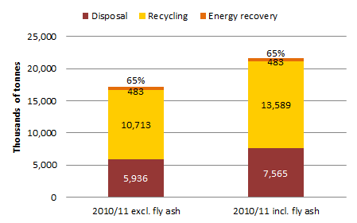(a)

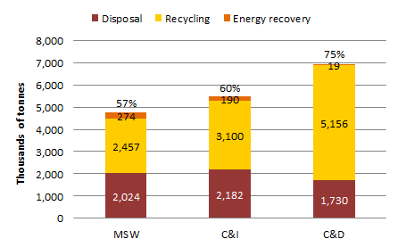(b)

## 

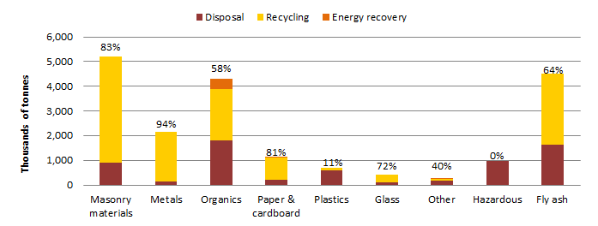 (c)

Note: the sum of all materials listed above is about 2 Mt less than the NSW waste generation total because some waste was not attributable to a particular category.

## NSW trends 2006/07 to 2010/11

Figure 23 shows the **per capita** trends in waste generation and management for the period 2006/07 to 2010/11 in NSW.

Figure 23: Trends in per capita waste generation and management, NSW 2006/07 to 2010/11

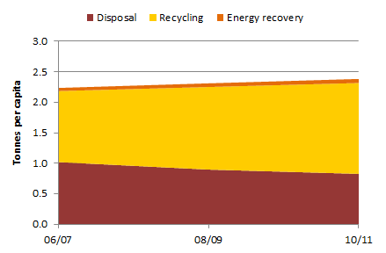

*Relies on interpolation for 07/08 and 08/09*

Over the period the following **per capita** trends are illustrated:

* waste generation in NSW has been relatively stable increasing at about 1.6% per year
* the resource recovery rate increased from 54% to 65% between 06/07 and 10/11
* recycling per capita increased significantly by 28%, probably reflecting the commissioning of AWT facilities for processing residual municipal waste in Sydney
* waste used for energy production in NSW increased around 31%
* waste disposal per capita in NSW decreased significantly by 19%.

Figure 24 shows the trends in total waste generation and management for the period 2006/07 to 2010/11 in NSW.

Figure 24: Trends in total waste generation and management, NSW 2006/07 to 2010/11

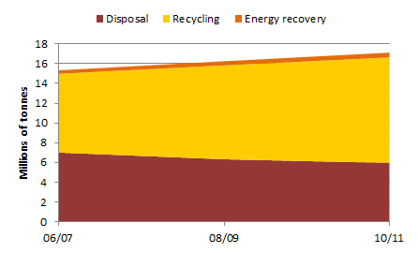

*Relies on interpolation for 07/08 and 08/09*

Over the period the following trends are illustrated in relation to total waste tonnages:

* waste generation increased by 12%, consistent with population and GSP growth
* recycling increased significantly by 34%
* energy recovery increased by about 38% due to increased landfill gas recovery
* disposal decreased significantly by 15%.

# Northern Territory

## NT 2010/11

### Data reliability

The low reliability of the waste data in this report for the NT requires a discussion before the data are considered. No waste data were available for whole of the NT. The data presented here are derived largely from the landfill and recovery centre that receives most of Darwin’s waste (Shoal Bay). It is assumed that waste generation per capita in the territory is the same as for the Darwin area and that no recycling occurs outside Darwin. Other recycling may well be occurring elsewhere in the NT, so recycling levels may be under-reported.

### Per capita waste generation and resource recovery rate

In 2010/11, the per capita rate of waste generation in the NT was about 1.3 tonnes (see Figure 6) which was the second lowest (above Tas ) in Australia. NT had Australia’s lowest resource recovery rate at around 9%, which is around 51% below the national average. This suggests a low level of resource recovery infrastructure in the NT compared to other jurisdictions, and significant difficulties transporting recyclables to markets.

### Total waste generated

Figure 25 suggests that about 300 kt of waste was generated in the NT in 2010/11. This is lower than any other jurisdiction, consistent with the NT’s low population and GSP. No fly ash was generated as there are no coal fired power stations.

### Waste streams

* NT MSW generation was an estimated 140 kt with a resource recovery rate of 17%, which is 34% below the Australian average.
* NT C&I waste generation was an estimated 41 kt with a resource recovery rate of 8%, which is 51% less than the Australian average.
* NT C&D generation was an estimated 120 kt with a resource recovery rate of 1%, which is 65% below the Australian average.

These figures reflect socio-economic factors, low population density over vast areas, and the lack of established resource recovery systems due to logistics costs and poor economies of scale.

### Material categories

The available NT data are not able to support analysis of material categories data.

## NT trends 2006 – 10

Insufficient data are available to support analysis of waste generation and management over the trend period[9].

Figure 25: NT 2010/11, total waste generation by (a) management (b) waste stream and management (c) material category and management

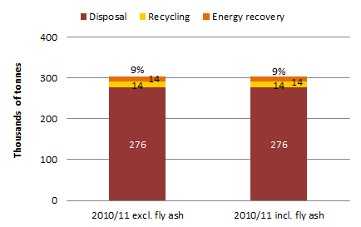 (a)

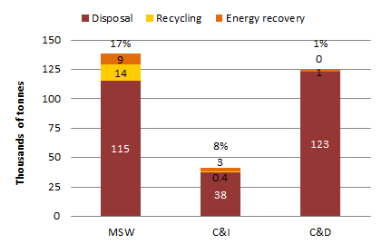

(b)

(c)

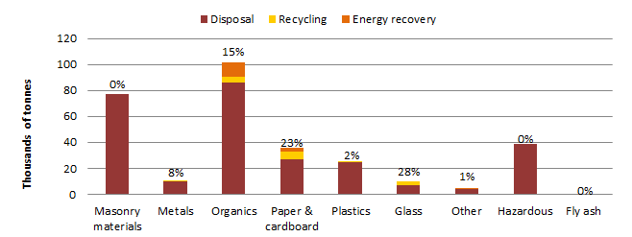

# Queensland

## Qld 2010/11

### Per capita waste generation and resource recovery rate

In 2010/11, per capita waste generation for Qld was 1.7 tonnes (see Figure 6), which was the third lowest in Australia, above the NT and Tas. This follows the pattern of lower waste generation in jurisdictions that have lower per capita incomes and less urbanised populations (see section 2).

Qld also had Australia’s third lowest resource recovery rate at around 52%, which is 8% below the national average and reflects:

* large transport distances that make recovery of some waste types cost-prohibitive
* the absence of a landfill levy (except for a six-month period in 2011/12)
* less developed resource recovery infrastructure.

### Total waste generated

Total waste generation in Qld for 2010/11 was around 7.5 Mt excluding fly ash and 13 Mt including fly ash (see Figure 26). This is the third highest of Australia’s jurisdictions, consistent with Qld’s ranking in relation to population and GSP. The almost 6 Mt of fly ash generated in Qld is around 40% of Australia’s total fly ash generation, reflecting the large number of coal-fired power stations in Qld.

### Waste streams

* Qld MSW generation was around 2.0 Mt with a resource recovery rate of 48%, which is 3% below the Australian average.
* Qld C&I waste generation was around 2.3 Mt with a resource recovery rate of 52%, which is 7% below the Australian average.
* Qld C&D waste generation was around 2.2 Mt with a resource recovery rate of 59%, which is 7% below the Australian average.

### Material categories

In Qld, the waste categories that make up the bulk of waste generation are fly ash, organics, masonry materials, paper and cardboard, and metals. The resource recovery rates for most material categories are below the national average. The exceptions being hazardous wastes with a resource recovery rate 10% higher than the national average.

Figure 26: Qld 2010/11, total waste generation by: (a) management (b) waste stream and management (c) material category and management

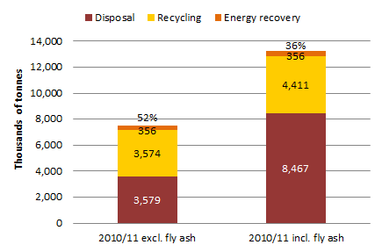 (a)

(b)

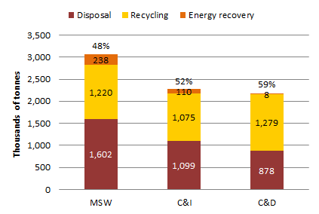

(c)

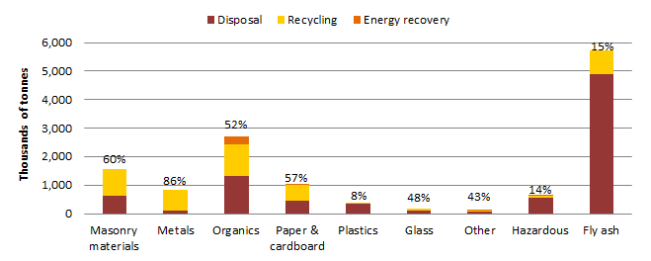

## Qld trends 2008/09 to 2011/12

Over the three-year period, Qld’s population increased by 4.5% and GSP increased by 6.5%. The Qld data suggest a reduction in waste generated of about 10% over this period. An increasing population and GSP and decreasing total waste generation is inconsistent with trends identified in the other jurisdictions and internationally. The Qld data (see accompanying Excel workbook) indicate that the decrease in waste is due mainly to decreasing disposal of MSW, C&D and contaminated soils. Large fluctuations in contaminated soils tonnages are not unusual. Other decreases in waste generation for Qld over the four-year period suggest that reporting to the Qld Government, and/or collation methods may have varied over the period. The Qld Government noted the following in relation to the unusual trends in the data:

* MSW was increasing till 08/09 and has trended downwards since.
* Councils may be recording landfill waste more accurately in recent years. Earlier estimates may have sometimes included garden organic wastes for recycling.
* The Qld *Waste Recycling and Reduction Act 2011* now requires reporting by local governments, landfills, recyclers and potentially waste generators, so future data should be of high quality.
* In 2011/12 the annual survey of organic waste processing was conducted by the government instead of the usual private organisation. This is likely to have resulted in a higher rate of reporting.
* Garden waste quantities are weather dependent and volatile. Cyclones can cause big peaks.
* Metal recycling rates have been trending downwards and could be linked to the Australian dollar. Glass recovery has also been slow and trending downwards.

shows the **per capita** trends in waste generation and management for the period 2008/09 to 2011/12. There were insufficient data to report on the 2006/07 period[10]. Qld was the only jurisdiction to provide 2011/12 data for reporting.

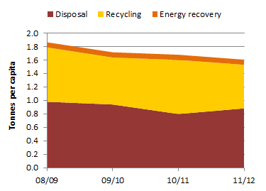Figure 27: Trends in per capita waste generation and management, Qld 2008/09 to 2011/12

Over the four-year period from 2008/09 to 2011/12, the following **per capita** trends are illustrated:

* waste generation fell by 14%
* the resource recovery rate decreased from 47% to 45% between 07/08 and 11/12
* recycling decreased by 20%
* waste tonnages used for energy recovery remained virtually unchanged
* waste disposal decreased by 10%.

Figure 29 shows the trends in total waste generation and management in Qld for the period 2008/09 to 2011/12.

Figure 28: Trends in total waste generation and management, Qld 2008/09 to 2011/12

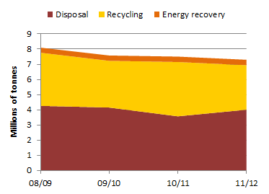

Over the four-year period the following trends are illustrated in relation to total waste tonnages:

* waste generation decreased by 10%
* recycling decreased by 16%
* waste tonnages used for energy recovery increased by 16%
* disposal decreased by 6%.

# South Australia

## SA 2010/11

### Per capita waste generation and resource recovery rate

In 2010/11, per capita waste generation for SA was about 2.4 tonnes (see ) which was the fourth highest in Australia. This follows the pattern of lower waste generation in jurisdictions that have lower per capita incomes and less urbanised populations (see section 2).

SA had Australia’s second highest resource recovery rate at around 77%, which is 17% above the national average and reflects:

* well-developed resource recovery infrastructure, including large organics recycling operations
* progressive waste management policies (including broad landfill prohibitions for unsorted waste, recovery targets and government investment in resource recovery infrastructure and programs)
* a moderate landfill levy.

### Total waste generated

About 3.9 Mt of waste was generated in SA for 2010/11 excluding fly ash, and 4.1 Mt including fly ash (see Figure 29). This is the fourth lowest in Australia, consistent with SA’s ranking in relation to population and GSP.

### Waste streams

* SA MSW generation was around 0.79 Mt with a resource recovery rate of 61%, which is 10% above the Australian average. SA is targeting a MSW recovery rate of 65% by 2015.
* SA C&I waste generation was around 1.4 Mt with a resource recovery rate of 89%, which is 30% above the Australian average. SA appears to have surpassed its C&I recovery rate target of 75% by 2015.
* SA C&D waste generation was around 1.7 Mt with a resource recovery rate of 75%, which is 9% above the Australian average. SA is targeting a C&D recovery rate of 90% by 2015.

These data reflect the well-established recovery industry for the MSW, C&D and C&I waste streams in SA.

### Material categories

In SA the waste categories that make up the bulk of waste generation are masonry, organics, metals, paper, cardboard and fly ash. The resource recovery rates for most material categories are well above the national average. The high recovery rates for glass and plastics are linked to the container deposit system operating in SA.

Figure 29: SA 2010/11, total waste generation by: (a) management (b) waste stream and management (c) material category and management

### 

(a)

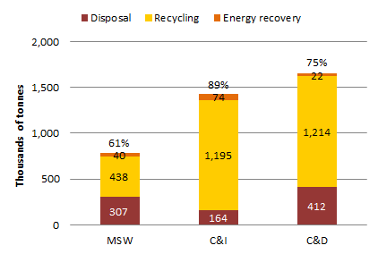

(b)

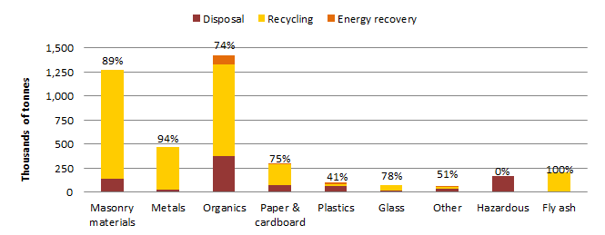 (c)

## SA trends 2006/07 to 2010/11

shows the **per capita** trends in waste generation and management for the period 2006/07 to 2010/11 in SA.

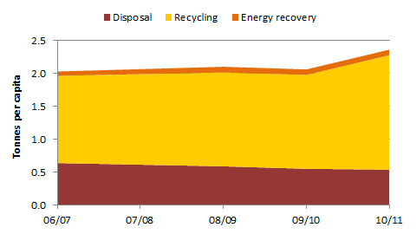Figure 30: Trends in per capita waste generation and management, SA 2006/07 to 2010/11

Over the period the following **per capita** trends are illustrated for waste in SA:

* waste generation increased by 16%
* the resource recovery rate increased from 69% to 77% between 06/07 and 10/11
* recycling increased by 31%
* waste tonnages used for energy recovery increased by 26%, mostly due to the commissioning of the SITA Resource Co facility
* waste disposal decreased by 16%.

shows the trends in total waste generation and management for the period 2006/07 to 2010/11 in SA.

Figure 31: Trends in total waste generation and management, SA 2006/07 to 2010/11

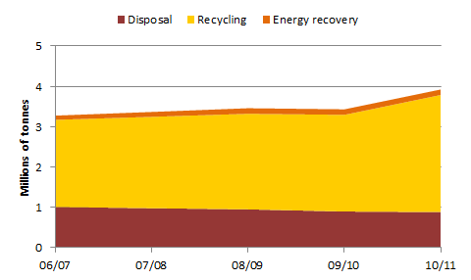

Over the period the following trends are illustrated in relation to total waste tonnages:

* waste generation increased by 20%
* recycling increased by 35%
* waste tonnages used for energy recovery increased by 30%
* disposal decreased by 13%.

# Tasmania

## Tas 2010/11

### Per capita waste generation and resource recovery rate

In 2010/11, Tas generated about 1.2 tonnes of waste per capita waste (see Figure 6) – the lowest of all Australian jurisdictions. This correlates with Tas having the lowest average income and a relatively low level of urbanisation (see section 2).

Tas had Australia’s second lowest resource recovery rate at around 33%, which is 27% below the national average and reflects on Tas having:

* significant difficulties transporting many recyclables to markets
* relatively (compared to some jurisdictions) under-developed resource recovery infrastructure
* a very low landfill levy ($2 voluntary landfill levy)
* no resource recovery targets.

### Total waste generated

Tas generated about 600 kt of waste in 2010/11 (see Figure 32). This is the second lowest figure for Australian jurisdictions, consistent with the Tas GSP being the second lowest and its population being the third lowest.

### Waste streams

* Tas MSW generation was around 260 kt with a resource recovery rate of 40%, which is 11% below the Australian average.
* Tas C&I waste generation was around 310 kt with a resource recovery rate of 30%, which is 29% below the Australian average.
* Tas C&D waste generation was around 39 kt with a resource recovery rate of 2%, which is 64% below the Australian average.

These data reflect the relatively underdeveloped resource recovery industry in Tas for all streams and in particular for C&D waste. During consultation with the Tas Government, it was noted that the definition of ‘clean fill’ in Tas is broader than other jurisdictions and encompasses includes some C&D materials such as brick and concrete rubble. This may partially explain the very low C&D generation tonnages in Tas, since materials are being sent to clean fill sites that do not report ‘waste’. Tas also noted that some C&D materials are crushed at two landfills that use the material on site for roads.

### Material categories

In Tas, the bulk of reported waste is organics and paper and cardboard. The resource recovery rates for most material categories are well below the national average (with the exception of glass).

Figure 32: Tas 2010/11, total waste generation by: (a) management (b) waste stream and management (c) material category and management

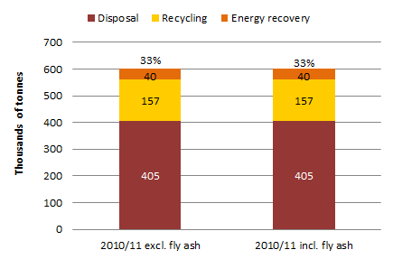

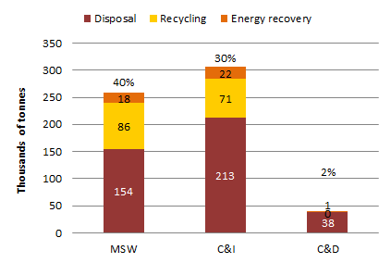

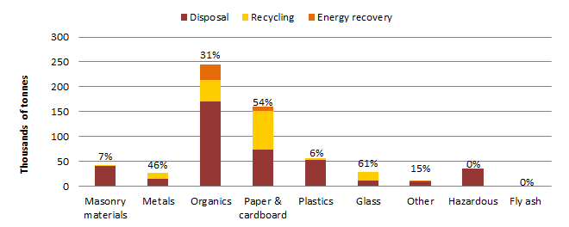

## Tas trends 2006/07 to 2010/11

Figure 33 shows the **per capita** trends in waste generation and management for the period 2006/07 to 2010/11 for Tas.

Figure 33: Trends in per capita waste generation and management, Tas 2006/07 to 2010/11

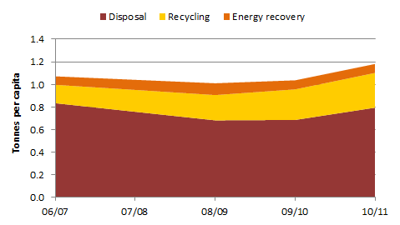

Over the period, the following **per capita** trends in Tas are illustrated:

* Waste generation decreased between 2006/07 and 2008/09 but increased thereafter, resulting in an overall increase of 10%.
* The resource recovery rate increased significantly from 22% to 33% between 06/07 and 10/11.
* Recycling increased dramatically by 89% in four years, mainly due to organics recycling, which jumped significantly in 2008/09 to levels that have been maintained since. Consultation with Tas confirmed that the increase resulted from the inclusion of waste tonnes from industrial secondary food processing (e.g. abattoir and rendering plants) that had previously not been reported[11].
* Waste tonnages used for energy recovery increased by 5%.
* Waste disposal decreased by 5% in four years.

Figure 34 shows the trends in total waste generation and management for the period 2006/07 to 2010/11 for Tas.

Figure 34: Trends in total waste generation and management, Tas 2006/07 to 2010/11

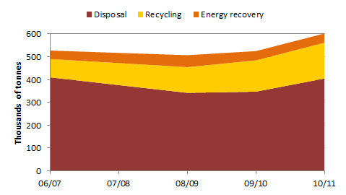

Over the period the following trends are illustrated in relation to total waste tonnages:

* waste generation increased by 14%
* recycling almost doubled increasing by 96%
* waste tonnages used for energy recovery increased by about 9%
* disposal decreased by 1%.

# Victoria

## Vic 2010/11

### Reconciliation with Vic reported data

As discussed in section 1, the data in this report do not always reconcile with other reported data by the jurisdictions. During consultation, Vic requested the discrepancies between its reported waste data and the data in this report were explicitly recognised. The discrepancies are due to differences in scope, method of compilation, and assumptions.

### Per capita waste generation and resource recovery rate

In 2010/11, Vic generated about 2.2 tonnes of waste per capita (see Figure 6), which is slightly less than SA and NSW and the fifth highest of Australia’s jurisdictions. This is consistent with the pattern of greater levels of waste per capita where incomes and urbanisation are high (see section 2). The large secondary and tertiary industry base in Vic is also likely to have influenced this figure.

Vic had Australia’s fourth highest resource recovery rate at around 62%, which is 2% above the national average and reflects:

* a moderate level of resource recovery infrastructure
* a history of progressive waste management policies and state government investment in infrastructure, market development and education programs
* a moderate landfill levy during the data period (with the exception of the hazardous waste levy, which was Australia’s highest).

### Total waste generated

Vic generated about 12 Mt of waste in 2010/11 excluding fly ash and 14.5 Mt including fly ash (see Figure 35). This was the second highest of Australia’s jurisdictions, consistent with its ranking in relation to population and GSP.

### Waste streams

* Vic MSW generation was around 3.4 Mt with a resource recovery rate of 52%, which is 1% above the Australian average. During the data period, Victoria was targeting a MSW recovery rate of 65% by 2014.
* Vic C&I generation was 4.1 Mt with a resource recovery rate of 63%, some 4% above the Australian average. At the time, Victoria was targeting a C&I recovery rate of 80% by 2014.
* Vic C&D generation was 4.5 kt with a resource recovery rate of 69%, which is 3% above the Australian average. At the time, Vic was targeting a C&D recovery rate of 80% by 2014.

These data reflect the relatively well established recovery industry for C&D and C&I wastes, and a moderate level of resource recovery infrastructure for MSW recovery.

### Material categories

In Vic, the categories that make up the bulk of waste are masonry, organics, fly ash, paper and cardboard, metals, and plastics. The resource recovery rates for most material categories are at or above the national average with the notable exceptions of organics and glass (at 10% and 6% below the national average respectively).

Figure 35: Vic 2010/11, total waste generation by: (a) management (b) waste stream and management (c) material category and management

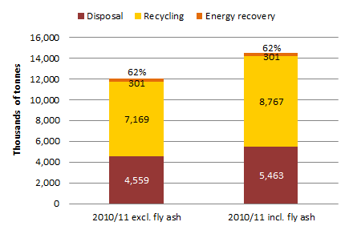

(a)

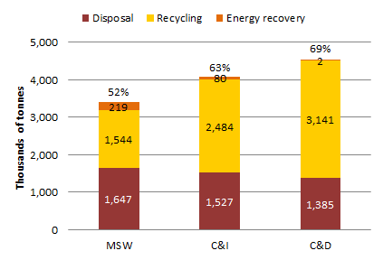(b)

(c)

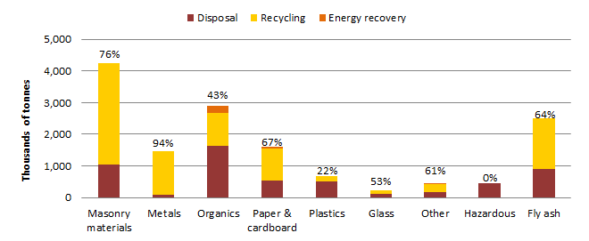

## Vic trends 2006/07 to 2010/11

shows the trends in **per capita** waste generation and management for the period 2006/07 to 2010/11 in Vic.

Figure 36: Trends in per capita waste generation and management, Vic 2006/07 to 2010/11

### 

Over the period the following **per capita** trends are illustrated for Vic:

* Waste generation was decreasing until 2008/09. It then increased to just above 2006/07 levels, resulting in an overall increase of 2%.
* The resource recovery rate increased from 55% to 62% between 2006/07 and 10/11.
* Recycling in Vic increased significantly in 2009/10, resulting in overall growth of 15%. The increase was apparently due to an expansion in concrete recycling , which jumped from 1.7 Mt in 2008/09 to 2.4 Mt in 2009/10.
* Waste used for energy in Vic increased by around 9%.
* Waste disposal in Vic decreased by 13%.

Figure 37 shows the trends in total waste generation and management for the period 2006/07 to 2010/11 in Vic.

Figure 37: Trends in total waste generation and management, Vic 2006/07 to 2010/11

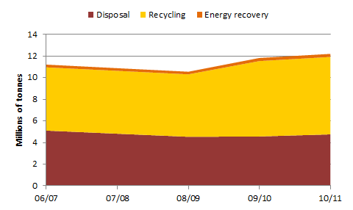

Over the period the following trends are illustrated in relation to total waste tonnages:

* waste generation increased by 9%
* recycling increased by 22%
* energy recovery increased by 15%
* disposal decreased by 7%.

# Western Australia

## WA 2010/11

### Per capita waste generation and resource recovery rate

In 2010/11, Western Australians generated about 2.6 tonnes of waste per capita (see ), which was the equal highest rate (with ACT) of Australian jurisdictions. This unexpectedly high rate may partly result from the apparent assumption in WA waste data that the rate of waste generation in regional and rural areas is equal to that in Perth[12]. Per capita disposal is estimated to have been 1.6 tonnes (79% above the national average of 0.88 tonnes) and Australia’s third lowest resource recovery rate (39%, which is 21% below the national average). The high landfill rate and low recovery rate are likely to be linked to the same data issue). Very large distances between collection points and recycling markets also constrain recycling in WA.

### Total waste generated

Total waste generation in WA during 2010/11 is estimated at about 6.0 Mt excluding fly ash and 6.6 Mt including fly ash (see ). This is the fourth highest of Australia’s jurisdictions, consistent with WA’s ranking in relation to population and GSP.

The estimate above is less than the waste generation estimate of 6.5 Mt reported by the Waste Authority (2012 p.18). The difference is mainly because the method for this report excludes soil, which was subtracted from the total based on the proportions identified by Waste Audit & Golder (2007).

### Waste streams

* WA MSW generation was around 1.6 Mt with a resource recovery rate of 41%, which is 10% below the Australian average. WA is targeting a MSW recovery rate of 50% in metropolitan areas by 2015.
* WA C&I waste generation was around 1.5 Mt with a resource recovery rate of 34%, which is 25% below the Australian average. WA is targeting a C&I recovery rate of 55% by 2015.
* WA C&D waste generation was around 2.8 Mt with a resource recovery rate of 40%, which is 26% below the Australian average. WA is targeting a C&D recovery rate of 60% by 2015.

These data may indicate relatively (compared to some jurisdictions) underdeveloped resource recovery infrastructure in WA. However, if the waste generation estimate is too high (see above), the true rates of resource recovery could be higher than those presented here.

### Material categories

In WA, the waste categories that make up the bulk of waste generation are masonry, organics, metals, paper and cardboard, metals, fly ash and plastics. Resource recovery rates for most material categories are below the national average.

Figure 38: WA 2010/11, total waste generation by: (a) management (b) waste stream and management (c) material category and management

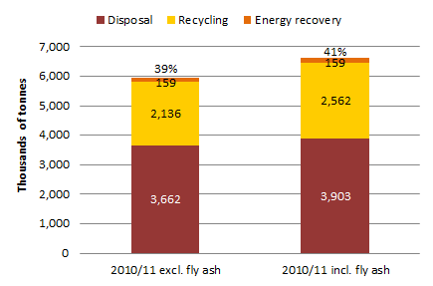

(a)

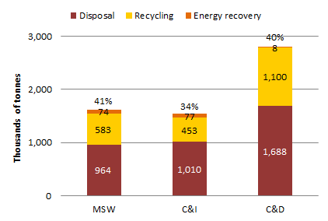(b)

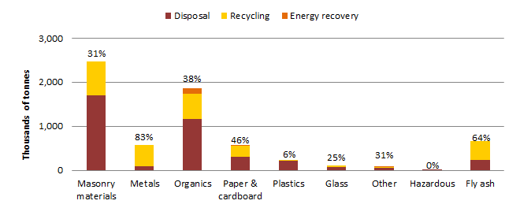(c)

## WA trends 2006/07 to 2010/11

shows the **per capita** trends in waste generation and management for the period 2006/07 to 2010/11 in WA.

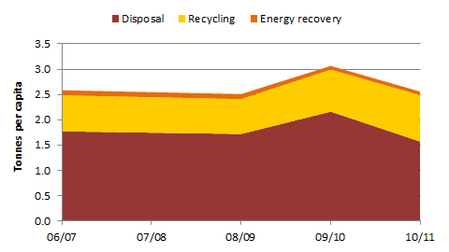Figure 39: Trends in per capita waste generation and management, WA 2006/07 to 2010/11

Over the period the following **per capita** trends are illustrated:

* Waste generation in WA is declined gently for most of the period but increased significantly in 2009/10. The increase is likely to be related to higher disposal rates due to a large rise in the landfill levy from $6 to $28 for MSW in 2009/10. Waste generators that had stockpiled waste requiring disposal may have offloaded the material before the introduction of the higher prices. The overall decrease was a 1%.
* The resource recovery rate increased from 31% to 39% between 2006/07 and 2010/11.
* Recycling in WA increased significantly by 29%. Analysis of the data suggests that the increase was mainly in recovery of waste concrete.
* Waste tonnes allocated to energy recovery diminished by 28%.
* Waste disposal in WA decreased by 12%.

Figure 40 shows the trends in total waste generation and management for the period 2006/07 to 2010/11 for WA.

Figure 40: Trends in total waste generation and management, WA 2006/07 to 2010/11

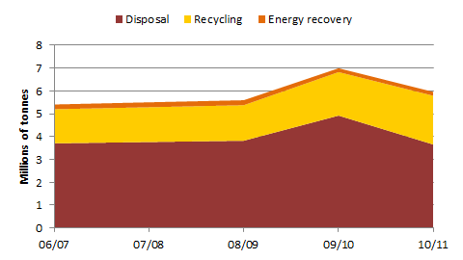

Over the period the following trends are illustrated in relation to total waste tonnages:

* waste generation increased by 10%
* recycling increased by 43%
* waste used for energy recovery decreased by 20%
* disposal declined by 2%.

# Data summary tables (2010/11)

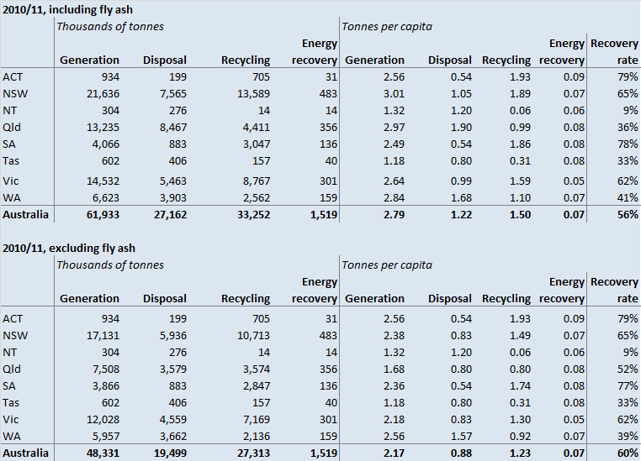

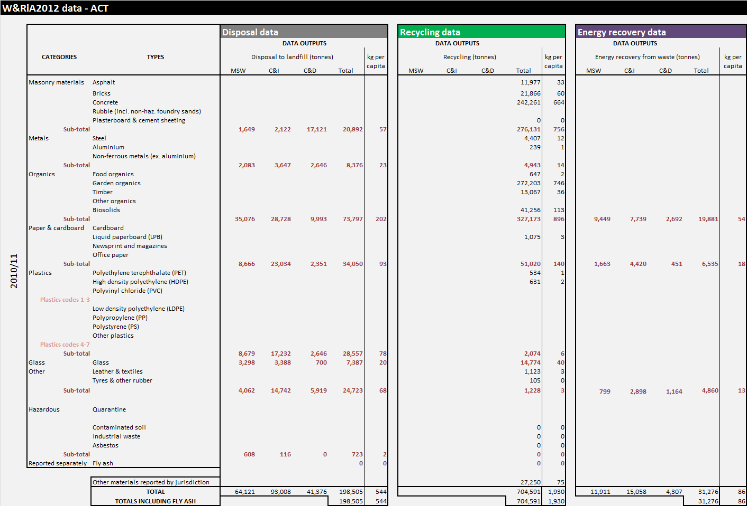

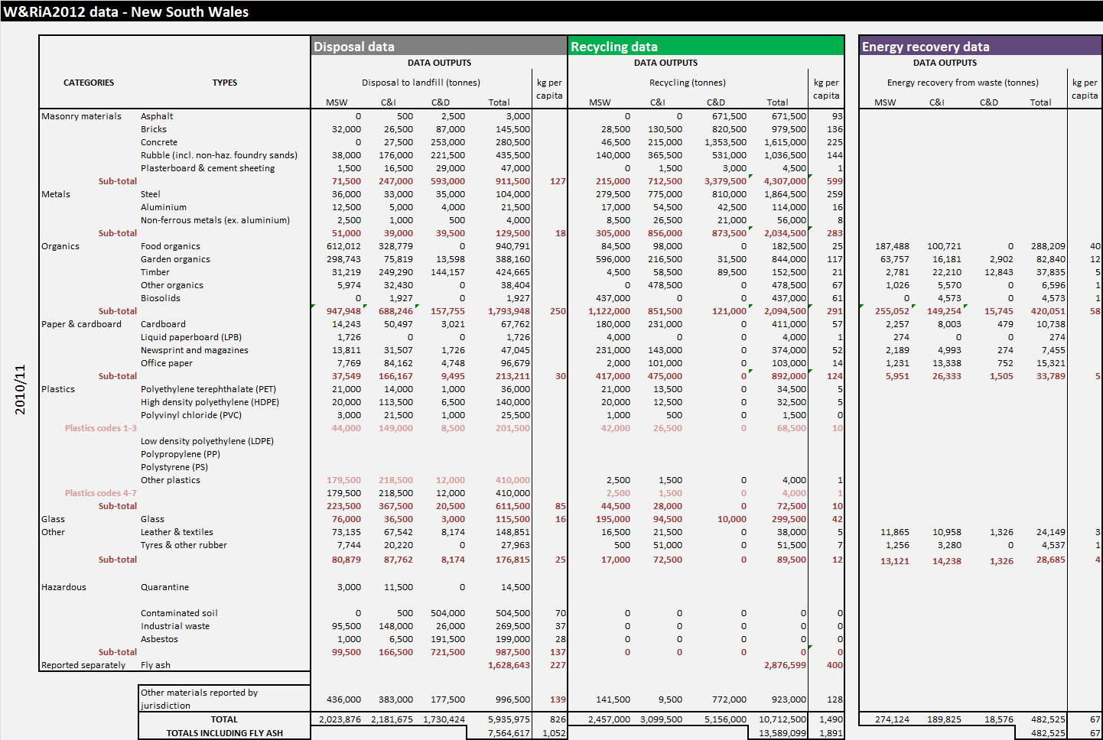

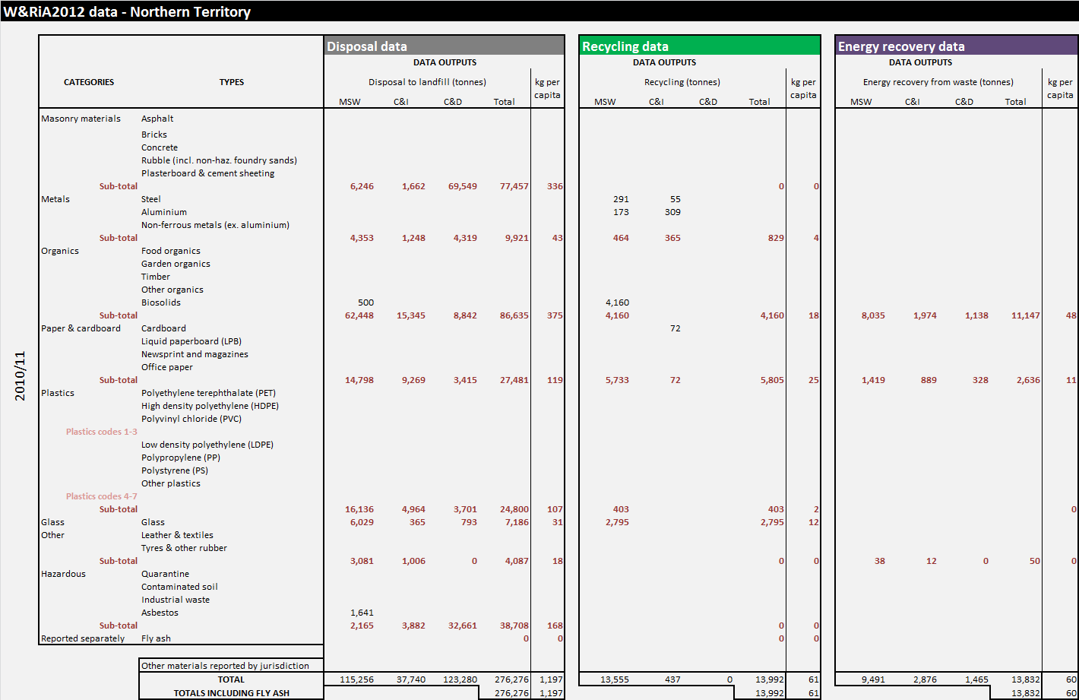

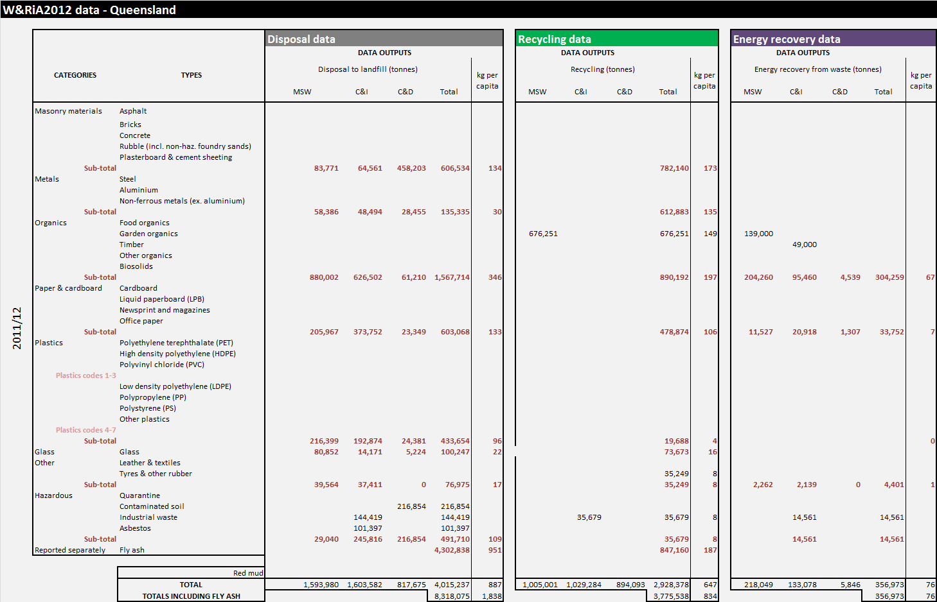

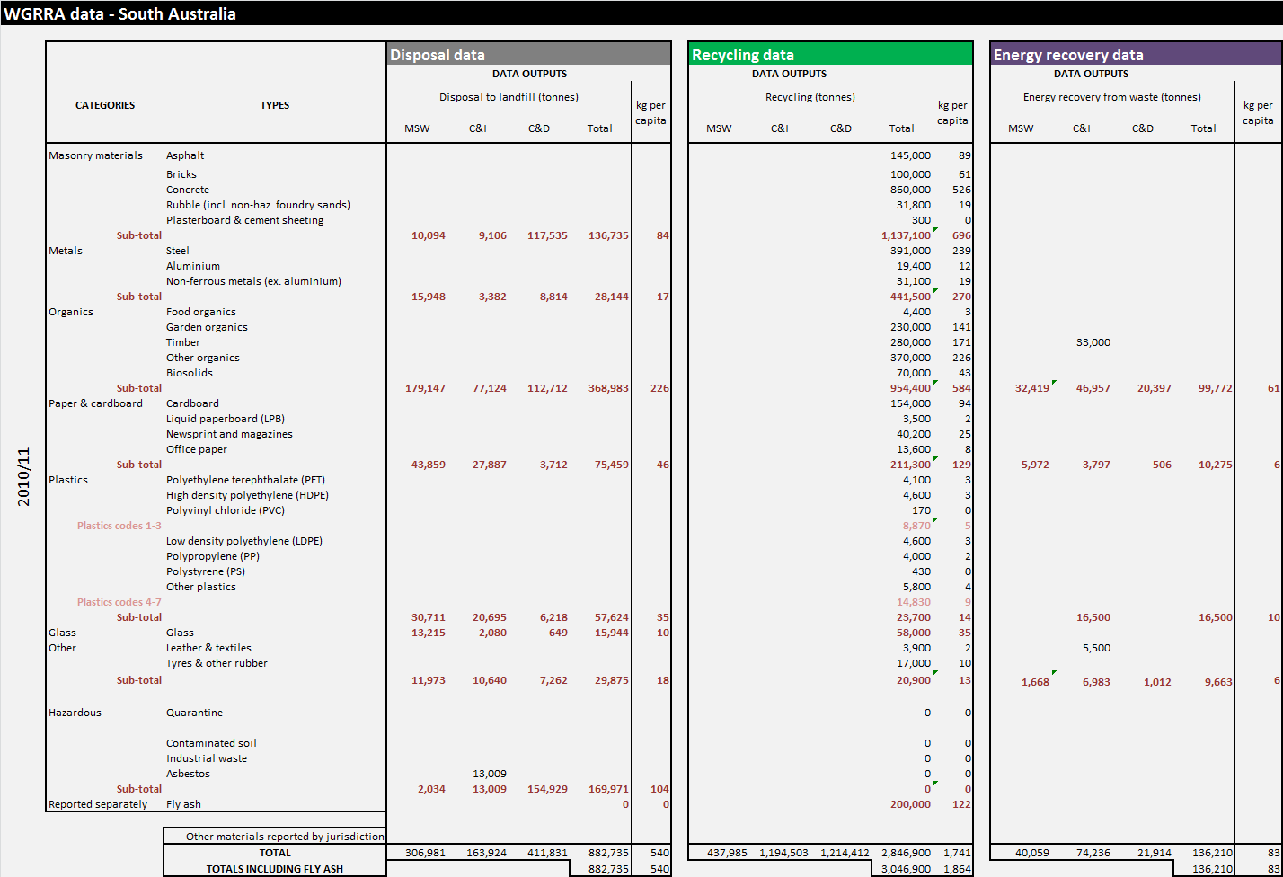

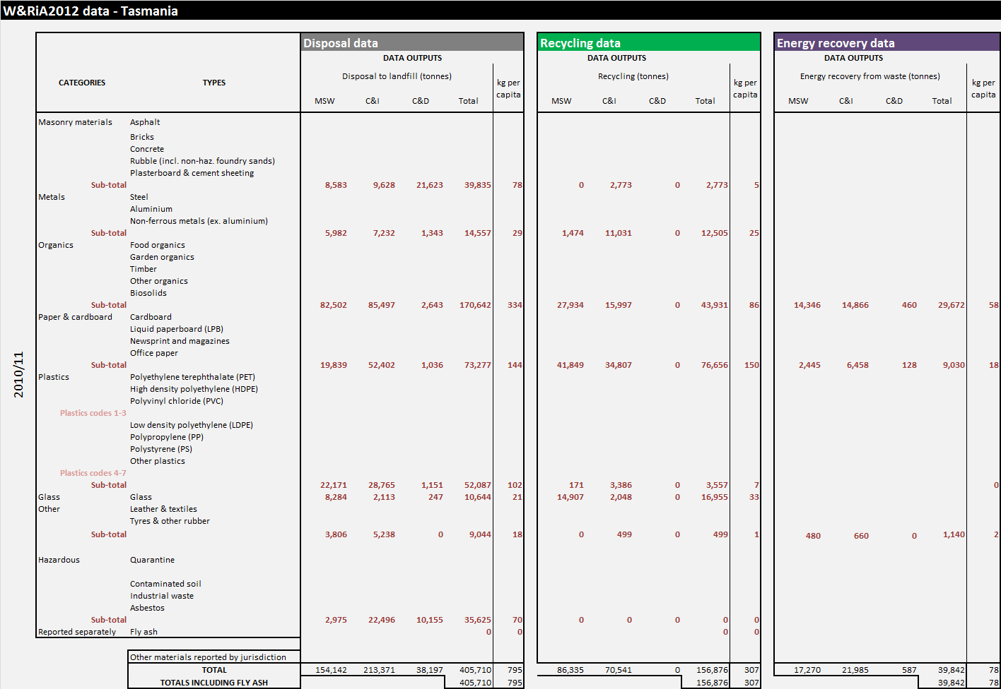

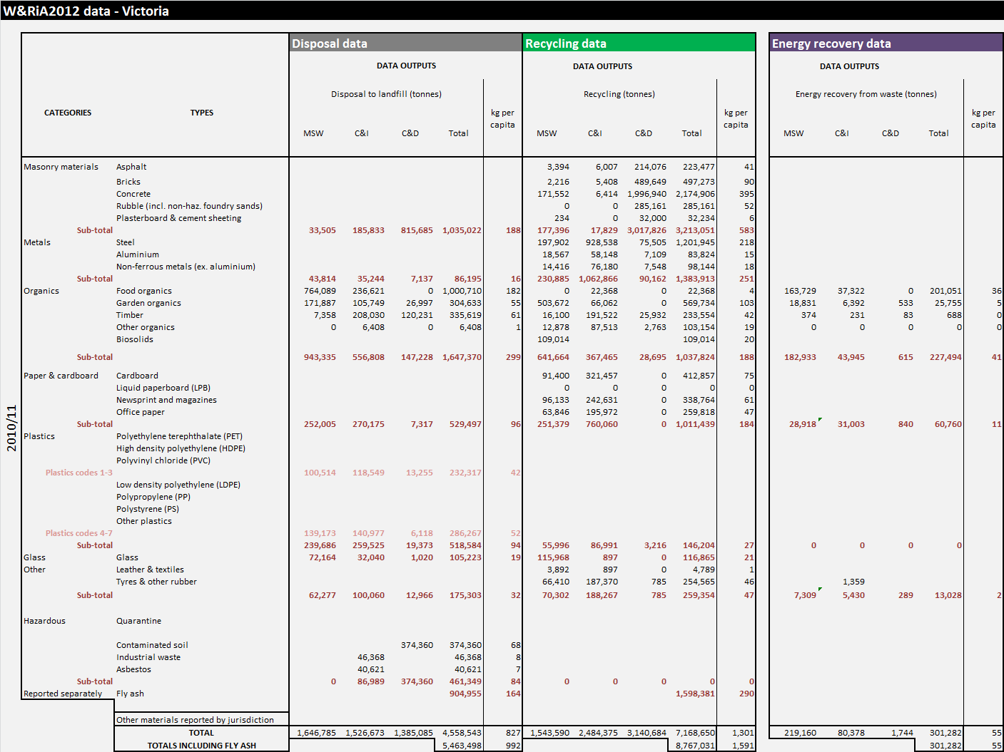

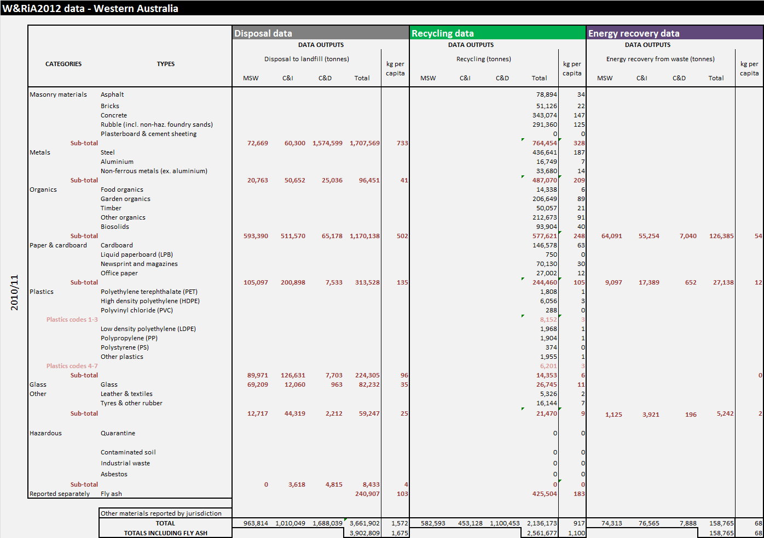

|  |  |
| --- | --- |
| Data sources for jurisdictions’ data sections 6 – 14 | |
| **ACT** | Communications with jurisdictional representatives, jurisdiction website, ABS (2012a, 2012d), ACT Government (2012a, b), Australian Packaging Covenant (APC) (2007, 2009, 2010), Australian Government (2012), DSEWPaC (2011), Plastics and Chemicals Industry Association (PACIA) (2008, 2010, 2011) and Recycled Organics Unit (ROU) (2007, 2009, 2010). |
| **NSW** | Communications with jurisdictional representatives, ABS (2012a, 2012d), Ash Development Association of Australia (ADAA) (2008, 2009, 2010, 2011), Australian Government (2012), Department of Environment and Climate Change (DECC) (2004), Department of Environment, Climate Change and Water (DECCW) (2011), Office of Environment and Heritage (OEH) (2011, 2012), O'Farrell (pers. comm.), PACIA (2008, 2010, 2011), ROU (2007, 2009, 2010), Waste Management Association of Australia (WMAA) (2008) and the websites of AWT operators. |
| **NT** | Communications with jurisdictional representatives, ABS (2012a, 2012d), ADAA (2008, 2009, 2010, 2011), Australian Government (2012), DSEWPaC (2011), National Environment Protection Council (NEPC) (2011), O'Farrell (pers. comm.) and ROU (2007, 2009, 2010). |
| **Qld** | Communications with jurisdictional representatives, ABS (2012a, 2012d), ADAA (2008, 2009, 2010, 2011), Australian Government (2012), Campbell (pers. comm.), DSEWPaC (2011), PACIA (2008, 2010, 2011), ROU (2007, 2009, 2010) and the websites of AWT operators. |
| **SA** | Communications with jurisdictional representatives, ABS (2012a, 2012d), ADAA (2008, 2009, 2010, 2011), Australian Government (2012), Campbell (pers. comm.), DSEWPaC (2011), ResourceCo (2012), ROU (2007, 2009, 2010), Zero Waste South Australia (ZWSA) (2007a, 2009, 2010, 2011), the websites of AWT operators, and the websites of ResourceCo., SITA and Adelaide Brighton Cement. |
| **Tas** | Communications with jurisdictional representatives, ABS (2012a, 2012d), ADAA (2008, 2009, 2010, 2011), Australian Government (2012), DSEWPaC (2011), O'Farrell (pers. comm.), PACIA (2008, 2010, 2011) and ROU (2007, 2009, 2010). |
| **Vic** | Communications with jurisdictional representatives, communications with Boral and GeoCycle, ABS (2012a, 2012d), ADAA (2008, 2009, 2010, 2011), Australian Government (2012), PACIA (2008, 2010, 2011), ROU (2007, 2009, 2010) and the websites of AWT operators. |
| **WA** | Communications with jurisdictional representatives, ABS (2012a, 2012d), ADAA (2008, 2009, 2010, 2011), Australian Government (2012), DEC (2007), DSEWPaC (2011), ROU (2007, 2009, 2010), Waste Audit & Golder (2007), Waste Authority (2008, 2009, 2010, 2012) and the websites of AWT operators. |

# Organic waste data analysis

Organic wastes form a significant portion of waste generated and an even more significant portion of waste sent to landfill. Degradation of organics in landfills generates the potent greenhouse gas methane, and also produces potentially polluting leachate.

This section considers the composition, sources and management pathways of solid organic waste.

A broader definition of ‘organic waste’ is applied here than in the main data collation. Firstly, this section considers paper and cardboard to be organic wastes, whereas in the main data collation they are reported separately. Secondly, in addition to considering organic waste from MSW, C&I and C&D sources, this section provides information about the recovery of primary industry organics for which data is readily available and publically reported. The expanded scope in this section provides a fuller picture of the capacity and outputs of organic waste recovery operations.,

Organic wastes considered in this section include:

* food organics
* garden organics
* woody/timber from secondary and tertiary (not primary) industry and urban use
* cardboard and paper
* biowaste (materials containing a mixture of garden and food organics)
* the organic component recovered from MSW through AWT facilities
* the organic component of waste in landfill effectively recovered through the recovery of biogas to energy.

Recovery pathways include:

* recycling to new products (paper/cardboard, timber)
* composting (which is considered a form of recycling in this report)
* energy recovery
  + thermal
  + biodigestion
  + biogas energy recovery from landfill
* land-farming.

The main sources of data used in this analysis are:

* State and territory jurisdictional data and estimates derived from such data. These are derived from a range of data gathering methods, and chiefly capture organics recovery from municipal and some industrial sources. The methods for classifying materials and gathering data vary from jurisdiction to jurisdiction.
* Annual surveys of the recycled organics industry conducted by the Recycled Organics Unit (ROU), a private institute formerly attached to the University of NSW. These surveys mainly capture recovery from identified organics recovery businesses. ROU surveys include data on recovery of organic wastes from primary industry sources and information about the products manufactured from recovered organics. The mainland states and the ACT are surveyed. Data from Tas and the Northern Territory are not collected. Some jurisdictions do not collect data on organic waste recycling, but rather rely on the ROU survey.
* Estimates of biogas energy recovery attributable to particular materials types. Biogas energy recovered from landfill is considered in this report to represent recovery of landfilled organics. There are challenges associated with estimating biogas energy recovery on an annual basis. Because organics in landfill degrade over decades, the amount of biogas energy recovered in a year can represent many years of landfilled organics. Seasonal conditions and management of landfills will influence the quantities of biogas generated and captured in a particular year. The establishment of AWT facilities in some capital cities and regional centres has presumably reduced the methane generation potential of landfilled residuals, which may result in a decline in biogas recovery in these locations. For the purposes of analysis it has been assumed that nationally, the annual rate of biogas energy recovery is directly related to the annual quantity of organics landfilled, and can therefore be treated as an annual quantity of organics recovered.

Different data sources do not always contain identical figures. Where there are discrepancies, jurisdictional data are generally relied upon throughout this section and the rest of the report.

## National and jurisdictional recovery

Table 9 shows the estimated recovery of organics in 2010/11, distinguishing between primary industry and other organic wastes. The unshaded data are derived from the jurisdictions; cells shaded grey contains data sourced from the ROU annual survey of organics reprocessing facility operators. Note that many organic wastes from primary industries are recovered off-site but may not be captured in the ROU survey. These include: primary industry wastes sent to feedlots; timber and sawdust used at sawmills to fire kilns; and poultry shed, feedlot and stable wastes supplied to landholders as a fertility enhancer.

The data show:

* Total recovery of an estimated 12 Mt of organic wastes. This includes: some 7.4 Mt of MSW, C&I and C&D organic wastes; 1.0 Mt of biosolids; the equivalent of 1.2 Mt of organics recovered via biogas energy recovery; and 2.1 Mt of wastes from primary production activities that entered waste management facilities.
* Landfill biogas energy represents around 17% of all estimated organics recovery.
* Paper products (3.1 Mt) and garden organics (2.9 Mt) contribute most to the organics recovery figures, followed by timber (0.73 Mt) and mixed organics sent to AWT facilities.
* When paper and cardboard products are excluded, Australians recover in the order of 200kg per capita of MSW, C&I and C&D organics.
* The ACT has very high per capita recovery of organic wastes, reflecting highly effective diversion of garden and timber organics at resource recovery facilities within the territory, as well as widespread use of ‘wool bale’ garden organics recovery services provided by private operators.
* NSW and Qld recover relatively high levels of biosolids.
* NSW and Vic recover relatively high levels of biogas for energy, reflecting landfill practices in those states.

Table 9: Summary of collated data regarding recovery of organics, 2010/11

| **Material** | **National** | **ACT** | **NSW** | **NT** | **Qld** | **SA** | **Tas** | **VIC** | **WA** |
| --- | --- | --- | --- | --- | --- | --- | --- | --- | --- |
| **Recovery of organic wastes from MSW, C&I and C&D sources** *(data in thousands of tonnes except where shown otherwise)* | | | | | | | | | |
| * Food | 268 | 0.6 | 183 |  |  | 4.4 | 44 | 22 | 14 |
| * Garden | 2,942 | 272 | 844 |  | 819 | 230 |  | 570 | 207 |
| * Timber | 729 | 13.1 | 153 |  |  | 280 |  | 234 | 50 |
| * Biowaste (mixed garden & food) | 55 |  | 55 | n/a |  |  | n/a |  |  |
| * MSW organics fraction recovery | 381 |  | 192 | n/a | 26 |  | n/a |  | 163 |
| **Sub-total** | **4,375** | **286** | **1,426** |  | **846** | **514** | **44** | **826** | **434** |
| Recovery per capita (kg/yr) | 0.20 | 0.78 | 0.20 |  | 0.19 | 0.31 | 0.09 | 0.15 | 0.19 |
| * Paper and cardboard | 3,060 | 51 | 892 | 6 | 571 | 211 | 77 | 1011 | 245 |
| **Sub-total** | **7,438** | **337** | **2,318** | **6** | **1,416** | **726** | **121** | **1,837** | **678** |
| Recovery per capita (kg/yr) | 0.33 | 0.92 | 0.32 | 0.03 | 0.32 | 0.44 | 0.24 | 0.33 | 0.29 |
| * Biosolids | 1,026 | 41 | 437 | 4 | 271 | 70 |  | 109 | 94 |
| **Biogas energy recovery from landfill** *(expressed as thousands of tonnes of organic material degraded in landfill)* | | | | | | | | | |
| * Food | 766 | 15 | 288 | 8 | 87 | 47 | 22 | 212 | 87 |
| * Garden | 184 | 3 | 83 | 2 | 23 | 12 | 5 | 33 | 23 |
| * Timber | 78 | 1 | 38 | 0.6 | 6 | 4 | 1 | 16 | 11 |
| * Other organics | 21 | 0.6 | 7 | 0.5 | 5 | 2 | 1 | 0.7 | 4 |
| * Biosolids | 7 | 0.2 | 5 | 0.1 | 0.6 | 0.5 | 0.2 | 0.0 | 1.0 |
| * Paper products | 181 | 6 | 34 | 3 | 32 | 10 | 9 | 61 | 27 |
| * **Sub-total** | **1,239** | **26.4** | **454** | **14** | **153** | **77** | **39** | **322** | **154** |
| **Other energy recovery** *(thousands of tonnes)* | | | | | | | | | |
| * Timber |  |  |  |  |  | 33 |  |  |  |
| Sub-total |  |  |  |  |  | 33 |  |  |  |
| **Other (including primary industry) organics recovery by ROU-surveyed organic recycling facilities** *(thousands of tonnes)* | | | | | | | | | |
| * Oils, grease trap and sludges | 263 | 24 | |  | 103 | 37 |  | 73 | 27 |
| * Paunch | 55 | 1 | |  | 39 | 9 |  | 3 | 4 |
| * Paper pulp | 24 | 7 | |  |  | 17 |  |  |  |
| * Sawdust (from forestry residuals) | 206 | 95 | |  | 75 |  |  | 9 | 27 |
| * Barks (from forestry residuals) | 770 | 123 | |  | 196 | 201 |  | 118 | 132 |
| * Straw | 27 | 1 | |  |  | 10 |  | 8 | 8 |
| * Manure | 461 | 175 | |  | 97 | 67 |  | 90 | 33 |
| * Animal bedding | 25 | 0 | |  | 1 | 1 |  | 12 | 11 |
| * Animal mortalities | 80 | 2 | |  |  | 4 |  | 69 | 5 |
| * Miscellaneous agricultural organics | 85 | 16 | |  | 42 | 17 |  |  | 10 |
| * Miscellaneous – non agricultural | 130 | 27 | |  | 31 | 21 |  | 27 | 23 |
| Sub-total | 2,124 | 470 | |  | 583 | 383 |  | 409 | 279 |
| **Total all (kt)** | **11,827** | **4,083** | | **24** | **2,423** | **1,289** | **159** | **2,678** | **1,204** |
| **Recovery per capita (kg/yr)** | 0.53 | 0.54 | | 0.10 | 0.54 | 0.79 | 0.31 | 0.49 | 0.52 |

*Shaded data are from ROU (Campbell, pers. comm.). Other data are as compiled within this report.*

## Recovery trends

Table 10 shows estimated trends in the recovery of different organics for the period 2006/07 to 2010/11, based on ROU survey data. This does not include recovery of paper and cardboard, landfill biogas energy generation or timber to energy recovery.

Table 10: Trends in organics recovery reported by ROU survey respondents

|  | 2005/06 | 2006/07 | 2007/08* | 2008/09 | 2009/10 | 2010/11 |
| --- | --- | --- | --- | --- | --- | --- |
| FACILITIES SURVEYED | 141 | 143 | 138 | 186 | 187 | 198 |
| ON-FARM | 29 | 28 | 28 | 48 | 51 | 45 |
| COUNCIL FACILITY | 3 | 4 | 5 | 8 | 6 | 6 |
| LICENSED COMMERCIAL | 101 | 104 | 99 | 102 | 105 | 142 |
| OTHER | 8 | 7 | 6 | 28 | 25 | 5 |
| % RESPONSE RATE | 98 | 97 | 97 | 97 | 94 | 99 |
| RAW MATERIALS PROCESSED (kt) | 4,373 | 5,169 | 4,4851 | 5,279 | 5,809 | 6,331 |
| Garden organics | 1,738 | 2,312 | 1,358 | 1,660 | 1,583 | 2,411 |
| Wood/sawdust (from C&I sources) | 229 | 247 | 141 | 211 | 259 | 292 |
| Food organics (food waste) | 82 | 79 | 124 | 136 | 212 | 151 |
| Paper pulp/sludge | 56 | 54 | 59 | 57 | 57 | 24 |
| MSW organic fraction | 174 | 238 | 233 | 237 | 283 | 381 |
| Biowaste (mixed garden and food) | 10 | 16 | 14 | 32 | 50 | 55 |
| Other—Miscellaneous | 93 | 64 | 55 | 69 | 57 | 130 |
| Paunch | 48 | 26 | 21 | 20 | 64 | 55 |
| SUB-TOTAL | 2,431 | 3,035 | 2,004 | 2,422 | 2,565 | 3,499 |
| PRIMARY PRODUCTION WASTES/BIOMASS (kt) | | | | | | |
| Sawdust (from forestry residuals) | 184 | 216 | 221 | 247 | 239 | 206 |
| Barks (from forestry residuals) | 500 | 539 | 593 | 770 | 777 | 769 |
| Straw | 21 | 14 | 17 | 25 | 25 | 27 |
| Manure | 475 | 478 | 703 | 682 | 658 | 460 |
| Animal bedding | 24 | 24 | 18 | 13 | 24 | 24 |
| Animal mortalities | 4 | 11 | 10 | 12 | 7 | 80 |
| Miscellaneous agricultural organics | 68 | 70 | 98 | 144 | 81 | 85 |
| SUB-TOTAL | 1,276 | 1,351 | 1,661 | 1,894 | 1,811 | 1,652 |
| Biosolids/grit/screenings | 492 | 620 | 626 | 682 | 1,150 | 917 |
| Oils, grease trap, sludges | 174 | 164 | 193 | 281 | 282 | 263 |
| SUB-TOTAL | 666 | 784 | 820 | 963 | 1,432 | 1,180 |

* Vic was not surveyed for the 2007/08 period so the apparent decline in organics recovery in that year is misleading. Organic waste recovery in Vic expanded rapidly between 2006/07 and 2008/09.

Table 10 suggests that levels of organics recovery grew during this period, although part of the increase may be due to a greater number of respondents to the ROU survey. Notable trends are:

* Quantities of reported garden organics recovery have fluctuated. Variability can be attributed to season/al variability—drought reduces volumes of garden organics and extreme storm event increase levels of garden organics recovery.
* Increases in food organics and mixed garden and food recovery (attributable mainly to NSW and Qld).
* Increases in recovery of the organics fraction of MSW (attributable mainly to AWT development in NSW and WA).
* An increase in ‘biowaste’ (mainly mixed garden and food) as more councils provide kerbside organic services for garden and food.
* Quantities of timber recovery have steadily increased.
* Some of the apparent changes over the years may be due to improved reporting (e.g. food organics), varying classification of materials (e.g. other – miscellaneous) or shifts of material streams from on-farm to commercial compost operations (e.g. primary production wastes).

## Trends by jurisdiction

shows trends in organics recovery in states and territories reported in ROU surveys. ROU surveys do not include recovery of paper products, landfill biogas energy recovery, and energy recovery from timber, but do include recovery of some primary production wastes not included part of the scope of this report. This is why the total organics figures shown differ from those estimated in and . However, because the ROU surveys have used a consistent auditing method, they provide useful data for monitoring trends in organics management.

Table 11: Trends in organics recovery based on ROU surveys, 2005/06 to 2010/11

|  |  |  |  |  |  |  |  |  |
| --- | --- | --- | --- | --- | --- | --- | --- | --- |
| State /territory | 2005/06 | 2006/07 | 2007/08 | 2008/09 | | 2009/10 | 2010/11 | % increase |
|  | *Kilotonnes* | | | |  | | | |
| ACT and NSW | 1,660 | 1,828 | 1,646 | 1,594 | | 1,808 | 1,789 | 8% |
| Qld | 1,179 | 1,794 | 1,613 | 1,702 | | 1,997 | 2,173 | 84% |
| SA | 566 | 628 | 628 | 633 | | 679 | 637 | 13% |
| VIC | 379 | 379 | n/a | 728 | | 628 | 999 | 164% |
| WA | 579 | 542 | 598 | 621 | | 696 | 733 | 27% |
| TOTAL | 4,363 | 5,170 | 4,485 | 5,279 | | 5,809 | 6,331 | 45% |
| % increase from 2005/06 |  | 19% | n/a | 21% | | 33% | 45% |  |
| % increase from previous year |  | 19% | n/a |  | | 10% | 9% |  |

n/a = Not available. Data for Vic were not reported for the 2007/2008 year.

This shows that, over the six-year period from 2005/06 to 2010/11:

* There have been fairly consistent organics recovery in the ACT and NSW and modest increases in WA and SA. Effective recovery systems were well established prior to 2005/06, and the major recovery operations were included in surveys from that period onwards.
* There have been significant increases in recovery in Qld and Vic. To some extent, this reflects improved performance of recovery systems, but it may be partly due to improved data capture.
* Nationally, the reported levels of recovered organics increased by 45%.

## Products and markets

The ROU surveys gather information about the products made from recovered organics and the markets into which these are sold. Data are aggregated, so it is not possible to differentiate between products made from organic wastes from MSW, C&I and C&D sources and those from primary industry. The market data collected are measured by volume (m3) rather than by tonne.

Figure 41 summarises production and sales of materials from the ROU Survey for 2009/10, the last year for which this detailed information was available at the time of writing.

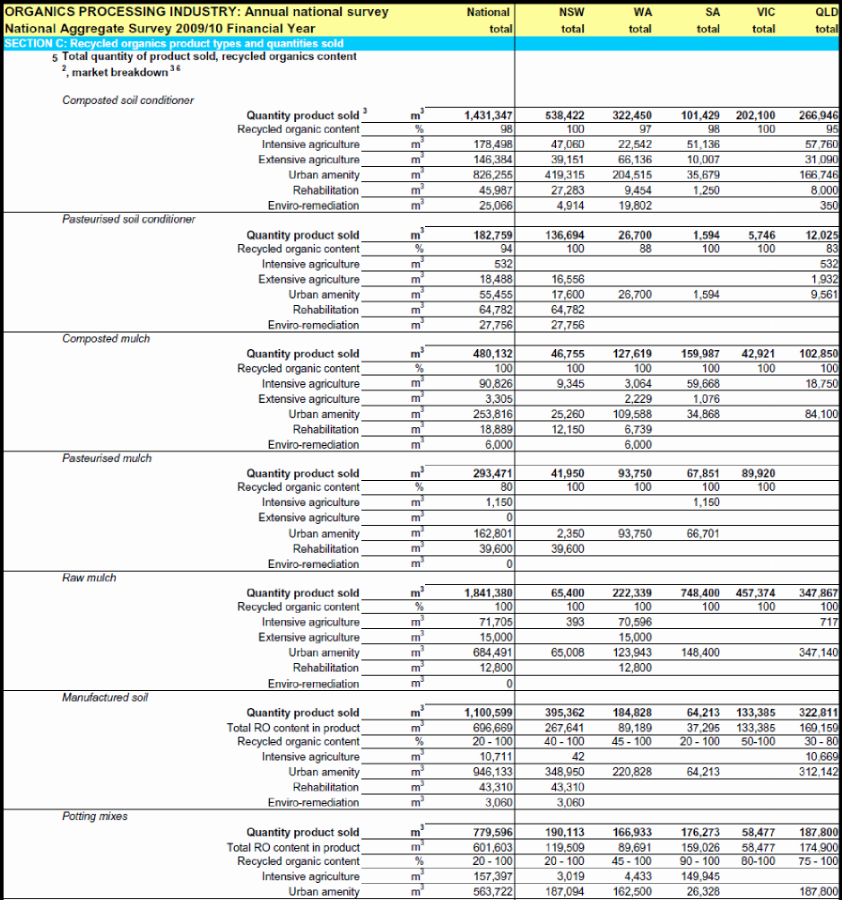Figure 41: Production and sales of recycled organics products (2009/10)

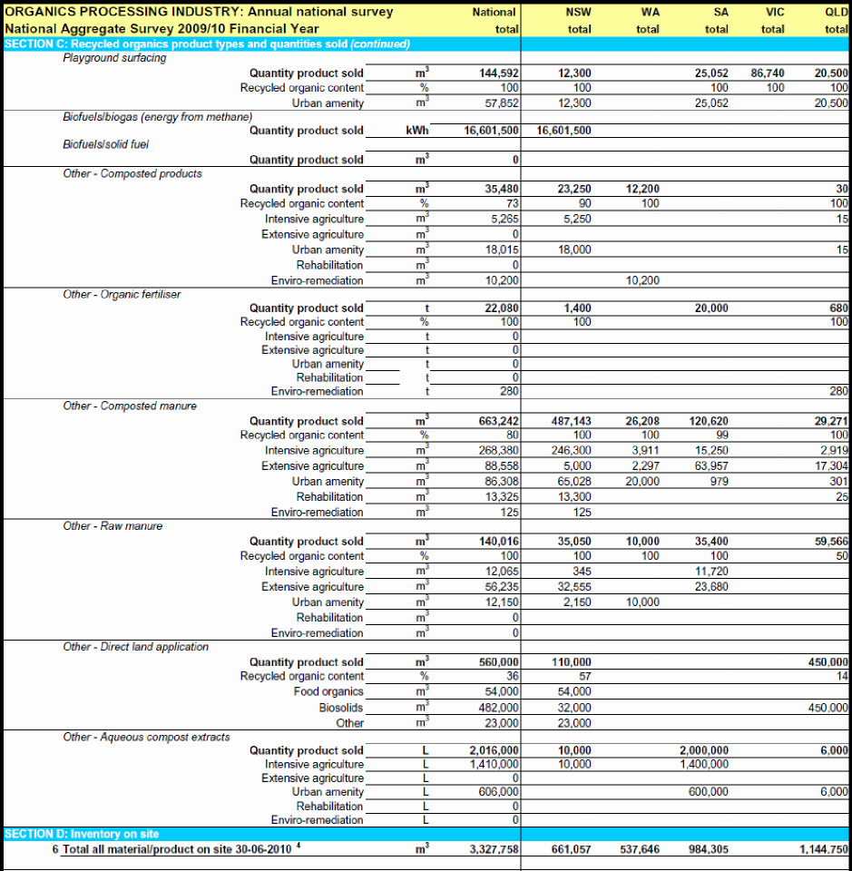Source: ROU 2010

and show the breakdown of products made from recovered organics (excluding manures and direct application to land) and the markets into which the products are sold.

Figure 42: Breakdown of products made from recovered organics (excluding manures and direct application to land)



Figure 43: Breakdown of markets for recycled organic products (excluding manures and direct application to land)



The figures above show:

* Other than paper products and organics in landfill from which biogas energy is recovered, most recovered organics are converted into:
  + mulch (sales of 2.6 million m3/yr), mostly ‘raw’ mulch in the form of timber and bark-derived landscaping product
  + soil conditioner (sales of 1.4 million m3/yr.)
* Almost 700,000 m3 /yr of processed recycled organics are used in the production of manufactured soils and a further and over 600,000 m3/yr is used in potting mixes.
* Manure-derived products, organic fertilisers and direct land application of organics account for about 1.4 million m3/yr out of a total of 7.1 million m3/yr of recycled organic products.
* Urban amenity markets are the main market for products, absorbing 56% or 3.2 million m3/yr of the total 5.7 million m3/yr of recycled organic products (excluding manure-derived products and direct application to land). Other markets for products are intensive agriculture (480,000 m3/yr or 8%), extensive agriculture (180,000 m3/yr or 3%) and rehabilitation and eco-remediation (280,000m3 or 5%).
* About 28% of sales are of products not allocated to a specific market. It is likely most of these sales are to the urban amenity market, with a lesser amount to intensive agriculture. Urban amenity market probably account for 65–70% of annual sales of recycled organic products by volume.
* At the time of the ROU survey, respondents had in the order of 3.3 million m3 on site. This is not surprising because many processes (such as composting) require materials to be processed for weeks. In addition, sales are typically seasonal and it is possible for sites to hold up to 50% annual inputs on site at some times of the year.

# Product-specific (product stewardship) data

This section provides a summary of the available data on products covered by a product stewardship scheme in Australia, either under the *Product Stewardship Act 2011* or industry schemes. The *Product Stewardship Act 2011* (page 3) provides the following definition of product stewardship:

*“Product stewardship is an approach to reducing the environmental and other impacts of products by encouraging or requiring manufacturers, importers, distributors and other persons to take responsibility for those products.”*

This responsibility extends to involvement in management of products at the end of their life. The Act lists the following types of product stewardship:

* **Voluntary product stewardship**: This involves accrediting voluntary arrangements to further the objects of the Act, and authorising the use of product stewardship logos in connection with such arrangements.
* **Co-regulatory product stewardship**: This involves requiring some manufacturers, importers, distributors and users of products to be members of co regulatory arrangements designed to further the objects of the Act.
* **Mandatory product stewardship**: This involves enabling regulations that require some persons to take specified action in relation to products.

Several product stewardship schemes that are currently established in Australia or are coming into effect in the near future aim to improve resource recovery rates. These are:

* National Television and Computer Recycling Scheme (co-regulatory)
* MobileMuster (mobile phones) (industry scheme)
* FluoroCycle (mercury containing lamps) (voluntary)
* Australian Packaging Covenant (co-regulatory)
* Product stewardship for end-of-life tyres (voluntary)

Available data for each of these schemes is discussed below.

## TVs and computers recycling scheme

The Environment Protection and Heritage Council completed a Regulatory Impact Statement that provided data on the scale of the TV and computer waste issue (EPHC 2009 p.3):

“*In 2007/08, 138,000 tonnes (31.7 million units) of new televisions, computers and computer products were sold in Australia, which is equivalent to 6.5 kg (1.5 new units) per person. In the same year 106,000 tonnes (16.8 million units) reached their end of life, which is close to 5 kg (one unit) per Australian. It is estimated that 84% (by weight) were sent to landfill, with only 10% (by weight) being recycled. Waste volumes are increasing with shorter life spans of product and increasing ownership of electrical products, with the volume of televisions, computers and computer products reaching their end of life expected to grow to 181,000 tonnes (44.0 million units) by 2027/28.”*

DSEWPaC’s website provides the following information and data on the scheme.

*“The National Television and Computer Recycling Scheme is intended to provide ’Australian householders and small business with access to free recycling services for televisions and computers, printers and computer products (such as keyboards, mice and hard drives) regardless of their brand and age. The Scheme does not cover other e-waste products. The Scheme will also allow other organisations, such as large business enterprises and government departments, to enter into agreements with industry arrangements to have televisions and computer products recycled under the Scheme. These agreements may be subject to costs and other conditions. The Scheme will be funded and run by industry and regulated by the Australian Government under the Product Stewardship Act 2011 and the Product Stewardship (Televisions and Computers) Regulations 2011. Recycling services are expected to commence in mid-2012 and expand across Australia by the end on 2013. To provide flexibility to suit local circumstances, services could take a number of forms, including a permanent collection site, take back events or mail back... Electronic waste, including televisions and computers, is growing three times faster than any other type of waste in Australia. The Scheme will boost the recycling of televisions and computers from an estimated 17 per cent of waste generated in 2010 to a target of 30 per cent in 2012–13. The Scheme recycling targets will then progressively increase each year, reaching 80 per cent of waste generated by 2021–22. The Scheme will also increase the amount of valuable materials recovered from waste televisions and computers, as well as reducing the amount of materials (including hazardous substances) entering the environment’”.*

Source: <http://www.environment.gov.au/settlements/waste/ewaste/about.html> (January 2013).

During consultation, DSEWPaC staff commented that the first year of reporting for TVs and computers is likely to be in 2013 so there are no publically available resource recovery data available for this report. DSEWPaC staff estimated that 25,000 tonnes of TVs and 20,000 tonnes of computers had been recovered by December 2012.

## MobileMuster (mobile phones)

MobileMuster is the mobile phone industry-funded recycling program, led by the Australian Mobile Telecommunications Association. Data from this organisation’s 2010/11 annual report are tabulated below.

Table 12: MobileMuster data, 2005/06 to 2010/11

|  |  |  |  |  |  |  |  |
| --- | --- | --- | --- | --- | --- | --- | --- |
|  | 2010/11 | 2010/11 | 2009/10 | 2008/09 | 2007/08 | 2006/07 | 2005/06 |
| Imports (estimated tonnes) | 1,232 | 1,123 | 1,297 | 1,581 | 1,775 | 1,478 | 1,446 |
| Mobile phone recovery collections (tonnes) | 106 | 100 | 103 | 122 | 97 | 78 | 42 |
| Estimated number handsets and batteries collected | 797,105 | 744,816 | 845,919 | 806,812 | 755,196 | 576,640 | 391,074 |
| Recovery rate of imports (%) | 8.6% | 8.9% | 7.9% | 7.8% | 5.5% | 5.3% | 3% |
| Estimated recovery rate (based on estimation of the number of phones actually discarded) (%) | 48% | 52.3% | 50.6% | 35 | 18.9 | 18% | 15% |
| Estimated disposal to landfill of discarded phones (%) | 4% | 4% | 3% | 2% | 4% | 5% | 9% |

Source: AMTA (2012)

## FluoroCycle (mercury-containing lamps)

DSEWPaC’s website provides the following overview of the FluoroCycle scheme:

*“FluoroCycle (www.FluoroCycle.org.au) is a voluntary, national scheme that aims to increase recycling of mercury-containing lamps. It commenced operations on 21 July 2010. The initial focus of the scheme is on those sectors that account for the largest consumption of mercury-containing lamps, the commercial and public lighting sectors. FluoroCycle is based on collaboration between industry and government. It is administered by the Lighting Council Australia and sponsored by the EPHC. It has been investigating the issues associated with the end-of-life management (disposal methods) for compact fluorescent lamps … and other mercury-containing lamps and, in May 2009, announced its support for FluoroCycle.*

*FluoroCycle is also supported by key industry bodies including the Australian Council of Recyclers, the Facility Management Association of Australia, the Australian Local Government Association, the Property Council of Australia and the National Electrical and Communications Association.”*

Source: <http://www.environment.gov.au/settlements/waste/lamp-mercury.html> (Jan. 2013).

The FluoroCycle website states that:

*“Currently it is estimated that 95% of mercury-containing lamps are sent to landfill in Australia. Mercury in landfill converts to the toxic methyl mercury and spreads through the wider environment through air, water and soil”.*

Source: [http://www.FluoroCycle.org.au/why-recycle.php](http://www.fluorocycle.org.au/why-recycle.php) (January 2013).

No publically available reporting of the recovery rates of mercury containing lamps was identified. At the time of writing no annual reporting is available for this scheme.

## Australian Packaging Covenant

Whilst packaging is not a true product category, it forms a significant part of the solid waste generated by the consumption of a huge range of products, and therefore warrants consideration in this section. The DSEWPaC website provides the following overview of the APC:

*“(The APC) is the third iteration of the National Packaging Covenant, which has been the leading instrument for managing the environmental impacts of consumer packaging in Australia since 1999. It is the voluntary component of a co regulatory arrangement based on the principles of shared responsibility through product stewardship, between key stakeholders in the packaging supply chain and all spheres of government…*

*The Covenant is designed to minimise the environmental impacts arising from the disposal of used packaging, conserve resources through better design and production processes and facilitate the re-use and recycling of used packaging materials.*

*The Covenant establishes a framework for the effective life cycle management of consumer packaging and paper products that will be delivered through a collaborative approach between all sectors of the packaging supply chain, consumers, collectors, reprocessors and all spheres of government”.*

Source: <http://www.environment.gov.au/settlements/waste/covenant/index.html> (Jan. 2013)

The Australian Packaging Covenant Council publishes an annual report that includes data on the recovery rates of the broad grouping of packaging types (grouped by material type), namely: paper/cardboard, glass, plastics, steel cans, aluminium cans. The most relevant data for this report is included below.

Table 13: Packaging consumption and recycling rates, 2011

|  |  |  |  |
| --- | --- | --- | --- |
| Covenant Performance Data for 2011 | | | |
| **Material Type** | **Total Consumption** *(tonnes)* | **Total Recycling** *(tonnes)* | **Recycling Rate** |
| Paper/Cardboard | 2,602,000 | 1,960,000 | 75.30% |
| Glass | 1,053,808 | 519,600 | 49.30% |
| Plastics | 532,251 | 199,812 | 37.50% |
| Steel cans | 127,601 | 43,583 | 34.20% |
| Aluminium cans | 57,196 | 36,600 | 64.00% |
| TOTAL | 4,372,856 | 2,759,595 | 63.10% |
| **Change in Packaging Recycling (by type, in tonnes), base year to current year** | | | |
| **Material Type** | **2003** | **2011** | **Change %** |
| Paper/Cardboard | 1,211,000 | 1,960,000 | 62% |
| Glass | 238,500 | 519,600 | 218% |
| Plastics | 127,397 | 199,812 | 57% |
| Steel cans | 29,871 | 43,583 | 46% |
| Aluminium cans | 28,500 | 36,600 | 28% |
| TOTAL | 1,635,268 | 2,759,595 | 69% |
| **Total Packaging Consumption and Recycling** *(in tonnes)***, base year to current year** | | | |
|  | **2003** | **2011** | **Change %** |
| Consumption | 4,172,433 | 4,372,856 | 4.80% |
| Recycling | 1,635,268 | 2,759,595 | 68.70% |
| Disposed to Landfill | 2,437,165 | 1,613,261 | -36.40% |
| Recycling Rate | 39.20% | 63.10% |  |

Source: Australian Packaging Covenant Council (2012)

## Product stewardship for end-of-life tyres

DSEWPaC’s website provides the following overview of the Product Stewardship for Tyres Scheme :

*“In November 2009, the EPHC agreed to work with the tyre industry on the establishment of a voluntary industry-led approach to product stewardship for tyres. The development of a product stewardship initiative was to assist in overcoming the impediments to markets for end-of-life tyres and tyre derived products and to gain more value from end-of-life tyres generated in Australia”.*

In 2012, Hyder Consulting prepared a report for the Council of Australian Governments *Standing Council on Environment and Water Study into domestic and international fate of end- of-life tyres*. The report included data on waste tyres that is relevant to this report (included in the table below). At the time of writing no annual reporting is available for this scheme.

Table 14: Fate of end-of-life tyres by equivalent passenger units, 2009/10

|  |  |  |  |  |  |  |  |  |  |  |  |
| --- | --- | --- | --- | --- | --- | --- | --- | --- | --- | --- | --- |
|  |  | Passenger tyres | | Truck tyres | | Passenger and truck tyres | | ‘Off the road' (e.g. tractor or mining truck) | | Total | |
| *All data are equivalent passenger units* | | | | | | | | | | | |
| **Domestic** | Recycling | 1,853,750 | 14.00% | 2,999,750 | 20.40% | 4,853,500 | 17.40% | 75,000 | 0.40% | 4,928,500 | **10.20%** |
| Energy recovery | 250,000 | 1.90% | - | 0.00% | 250,000 | 0.90% | - | 0.00% | 250,000 | **0.50%** |
| Civil engineering | 1,016,625 | 7.70% | 1,276,375 | 8.70% | 2,293,000 | 8.20% | 500,000 | 2.40% | 2,793,000 | **5.80%** |
| Licensed landfill | 1,450,073 | 11.00% | 161,119 | 1.10% | 1,611,192 | 5.80% | - | 0.00% | 1,611,192 | **3.30%** |
| Unknown* | 1,865,043 | 14.10% | 9,078,286 | 61.90% | 10,943,329 | 39.30% | 19,400,840 | 94.20% | 30,344,169 | **62.60%** |
| **SUB TOTAL** | 6,435,491 | 48.80% | 13,515,530 | 92.10% | 19,951,021 | 71.60% | 19,975,840 | 97.00% | 39,926,862 | **82.40%** |
| **International** | Reuse & retreading | 45,758 | 0.30% | 56,281 | 0.40% | 102,038 | 0.40% | 8,448 | 0.00% | 110,486 | **0.20%** |
| Recycling | 3,261,175 | 24.70% | 522,350 | 3.60% | 3,783,525 | 13.60% | 218,900 | 1.10% | 4,002,425 | **8.30%** |
| Energy recovery | 3,455,180 | 26.20% | 579,721 | 4.00% | 4,034,901 | 14.50% | 393,704 | 1.90% | 4,428,605 | **9.10%** |
| **SUB TOTAL** | 6,762,113 | 51.20% | 1,158,352 | 7.90% | 7,920,464 | 28.40% | 621,052 | 3.00% | 8,541,516 | **17.60%** |
| **TOTAL** |  | **13,197,603** |  | **14,673,882** |  | **27,871,485** |  | **20,596,893** |  | **48,468,378** |  |

Source: Hyder Consulting (2012)

* Data categorised as ‘Unknown’ represents balance of tyres which have not been recycled, recovered for energy, used in civil engineering or deposited in licensed landfill.

# Local government data

Local governments play a critical role in waste management across Australia. They are responsible for almost all of the domestic kerbside collections and own much of the waste infrastructure, particularly in regional and rural areas. They have been integral to the development of recycling and community education on waste management.

In 2011, DSEWPaC commissioned a report on the role and performance of Australia’s 559 local governments in relation to waste management. The following information is mostly extracted from the resulting report (Hyder Consulting 2011) and data workbook.

Comprehensive data on local government waste management are not available for most jurisdictions. NSW and Vic publish annual data on waste tonnages managed by local councils, as well as data on collection services, frequencies and bin types. More limited data are available for local governments in Qld, WA and SA. Cost data are available for all councils in Vic and most in Qld, SA and Tas.

Most local governments now contract waste collection services to private companies, although a significant minority retain some or all collection services in-house. In 2009/10, 82% of employment in the waste sector was through private companies.

Most garbage and recyclables are collected in wheelie bins. Where there is no kerbside recycling, garbage bins are often the large 240L type, but otherwise smaller 140L, 120L or even 80L bins are usually used. These are generally collected weekly. The most common recycling bin arrangement is a 240L bin collected fortnightly. A range of other service configurations are also used, including weekly collections, bins of different sizes, use of crates rather than bins, and split bins with half for recycling and half for garbage. Garden waste collections are also most often in 240L bins, but collection frequencies vary widely.

Table 15 compares some key waste management parameters across the jurisdictions for which reasonable quality data is available.

Table 15: Local government kerbside collection data by jurisdiction

|  |  |  |  |  |
| --- | --- | --- | --- | --- |
|  | ACT | NSW | Qld | Vic |
| Year |  | 09/10 | 08/09 | 09/10 |
| Councils providing a kerbside service: |  |  |  |  |
| recycling | 100% | 83% | 78% | 100% |
| garden waste | 0% | 42% |  | 57% |
| garbage | 100% | 99% | 92% | 100% |
| Kerbside collections |  |  |  |  |
| quantity (kg/hh/yr) |  | 1024 | 916 | 894 |
| recovery rate |  | 46% |  | 44% |
| estimated residual waste to AWT* | 0% | 24% | 4% | 0% |
| average cost ($/household) |  |  | $116 | $122 |

* AWT = advanced waste treatment – an alternative to direct disposal in landfill. Fractions estimated with reference to the population of councils sending waste to AWTs. Sources: Hyder Consulting (2011) & accompanying workbook, ABS (2012), Sustainability Victoria (2011).

# Waste management frameworks (strategies, policies and targets)

This section provides a summary of each jurisdiction’s waste management framework (strategies, policies and targets) over the data review period from 2006/07 to 2010/11 periods [13]. Table 16 summarises several key components of each jurisdiction’s frameworks that relate to, or are likely to have the most impact on the data presented in this report. This summary table was used in analysing and reporting each jurisdiction’s data in sections 6 to 13. Where policy or targets have been recently reviewed or updated (for example in Vic), both the previous and ‘new’ policies are included in the summary table.

To develop Table 16, each jurisdiction’s framework was assessed against the following key components of typical state-level waste management frameworks:

* the presence of a publically available waste management strategy
* the ‘high level’ goals or objectives of the strategy
* the jurisdiction’s targets for waste generation
* the jurisdiction’s targets for resource recovery rates (%)
* the jurisdiction’s landfill levies where applied ($/tonne)
* landfill disposal bans for solid wastes (waste type).

Table 16: Summary table of key elements of each jurisdictions waste strategies, policies

|  |  |  |  |  |  |  |  |  |  |  |  |  |  |  |
| --- | --- | --- | --- | --- | --- | --- | --- | --- | --- | --- | --- | --- | --- | --- |
| ACT Summary of strategy, policy, targets[14] | 2006 |  | 2011 | | | 2015 | | | 2020 | | | 2025 | | |
| Waste strategy/policy in place | *No Waste by 2010 Strategy* (1996) | | *ACT Waste Management Strategy 2011–2025* | | | | | | | | | | | |
| Policy goals summary |  |  | • The growth in ACT waste generation is less than the rate of population growth. • Reuse of goods expands in the ACT. • ACT leads Australia in low litter and incidents of illegal dumping. • ACT’s natural resources are protected and, where feasible, enhanced through waste management. • The ACT Waste Sector is carbon neutral by 2020: – energy generated from waste doubling by 2020 – waste resources are recovered for carbon sequestration by 2020. | | | | | | | | | | | |
| State targets for waste generation |  |  |  |  |  |  |  |  |  |  |  | Increase in waste generation is less than the rate of population growth. | | |
| State targets for recovery where set (%) |  |  |  |  |  | All streams 80% | | | All streams 85% | | | All streams 90% | | |
| Landfill fees where applied ($/tonne)[15] |  |  | MSW $68.67 | C&I/C&D $121.90 |  |  |  |  |  |  |  |  |  |  |
|  |  | For a mixed C&I waste load with greater than 50% recyclable material, fee is $166.25. | | | | | | |  |  |  |  |  |  |

| NSW summary of strategy, policy, targets[16] |  | 2007 | | | 2008 | | | 2009 | | | 2010 | | | 2011 | | | 2012 | 2013 | 2014 | | |
| --- | --- | --- | --- | --- | --- | --- | --- | --- | --- | --- | --- | --- | --- | --- | --- | --- | --- | --- | --- | --- | --- |
| Waste strategy/policy in place | *Waste Avoidance and Resource Recovery Strategy 2007* (2007) | | | | | | | | | | | | | | | | | | | | |
| Policy goals summary | Waste Strategy 2003 identified waste avoidance and resource recovery goals and targets in four key result areas. These are retained in the 2007 Strategy and are:  1. preventing and avoiding waste, to hold level the total waste generated for five years from the release of Waste Strategy 2003  2. increasing recovery and use of secondary materials  3. reducing toxicity in products and materials and  4. reducing litter and illegal dumping. | | | | | | | | | | | | | | | | | | | | |
| State targets for waste generation |  | Total tonnage of waste generation remains at 2003 levels | | | | | |  |  |  |  |  |  |  |  |  |  |  |  |  |  |
| State targets for recovery where set (%) |  | MSW 38% | C&I 44% | C&D 67% |  |  |  | MSW 44% | C&I 52% | C&D 73% |  |  |  |  |  |  |  |  | MSW 66% | C&I 63% | C&D 76% |
| Landfill levies where applied ($/tonne) |  |  |  |  | SMA (city) | ERA (semi urban) | RRA (rural) | SMA[17] | ERA | RRA | SMA | ERA | RRA | SMA | ERA | RRA | 2011/2012 SMA, $82.20, ERA, $78.60 per tonne and RRA $31.10 per tonne. The levy is scheduled to increase annually by $10/tonne plus CPI adjustments for the next five years.  2015/16 it will have reached $122.20 SMA per tonne and $71.10 ERA per tonne. | | | | |
|  |  |  |  | $46.7 | $40.0 | $0 | $58.8 | $52.4 | $10.0 | $70.3 | $65.3 | $20.4 | $80.3 | $76.8 | $30.4 |

|  |  |  |  |  |  |  |  |  |  |  |  |  |
| --- | --- | --- | --- | --- | --- | --- | --- | --- | --- | --- | --- | --- |
| NT Summary of strategy, policy, targets[18] | 2009 | 2010 | 2011 | 2012 | 2013 | 2014 | 2015 | 2016 | 2017 | 2018 | 2019 | 2020 |
| Waste strategy/policy in place | Territory 2030 *Strategic Plan* (2009). | | | | | | | | | | | |
| Policy goals summary | The Plan acknowledges that waste is a real issue for the NT. Waste management is addressed under some key areas of the Plan. The measures that the Plan recommends be adopted to achieve this include: 1. measure and monitor aggregated landfill at licensed landfill locations  2. measure and monitor the volume of recycling  3. provide more apartment complexes and residential areas with the capacity to recycle  4. encourage better packaging of products by Territory manufacturers  5. establish a container deposit system  6. encourage a reduction of waste from Territory building and development sites.  It is proposed the Plan is reviewed every five years over its lifetime to ensure that it is meeting the objectives and outcomes it has set for the NT. The first review is scheduled for 2015. | | | | | | | | | | | |
| State targets for recovery where set (%) | Target to ‘reduce the amount of waste being taken to our rubbish dumps by 50% by 2020’. | | | | | | | | | | | |

| Qld summary of strategy, policy, targets[19] | 2008 ( Qld baseline data) | | | 2011 | | | 2012 | | | 2014 | | | 2017 | | | 2020 | | |
| --- | --- | --- | --- | --- | --- | --- | --- | --- | --- | --- | --- | --- | --- | --- | --- | --- | --- | --- |
| Waste strategy/policy in place | *Queensland’s Waste Reduction and Recycling Strategy 2010–2020*[20] | | | | | | | | | | | | | | | | |  |
| Policy goals summary | The Strategy outlines guiding principles that are based on the waste and resource management hierarchy. On this basis it highlights that its broad goals are to: 1. reduce waste  2. optimise recovery and recycling  3. develop sustainable waste industries and jobs.  The Strategy has adopted a five-part approach to achieve these goals, which includes: 1. clear targets and priorities  2. setting a price signal—the waste disposal levy  3. stronger regulation  4. new programs and investment strategies  5. partnering for change. | | | | | | | | | | | | | | | | | |
| State targets for waste generation | 2.4 tonnes per person per year | | |  |  |  |  |  |  | 5% reduction 2.4 tonnes per person per year | | | 10% reduction 2.2 tonnes per person per year | | | 15% reduction 2 tonnes per person per year | |  |
| Reduce waste disposal to landfill, compared to business-as-usual projections |  |  |  |  |  |  |  |  |  | Reduce landfill disposal by 25% – 4.6 Mt of avoided landfill disposal since 2010 | | | Reduce landfill disposal by 40% – 9.9 Mt of additional avoided landfill disposal since 2014 | | | Reduce landfill disposal by 50% – 16.3 Mt of additional avoided landfill disposal since 2017 | | |
| State targets for recovery (%) | MSW 23% | C&I 18% | C&D 35% |  |  |  |  |  |  | MSW 50% | C&I 40% | C&D  50% | MSW55% | C&I50% | C&D  60% | MSW  65% | C&I60% | C&D  75% |
| States target for hazardous waste recycling | All streams 30% | | |  |  |  |  |  |  | 35% | | | 40% | | | 45% | | |
| Target 150: increase recycling of household waste to 150 kg per person per year | 64 kg per person per year | | |  |  |  |  |  |  | 80 kg per person per year | | | 100 kg per person per year | | | 150 kg per person per year | | |
| Landfill levies ($/tonne) | No landfill levies before 2011 | | | | C&I and C&D $35, MSW $0 | | Levies revoked—operational for seven months in 2011/12. | | | | | | | | | |  |  |

| SA summary of strategy, policy, targets[21] | 2010 | | | 2011 | | | 2012 | | | 2013 | | | 2014 | | | 2015 | | |
| --- | --- | --- | --- | --- | --- | --- | --- | --- | --- | --- | --- | --- | --- | --- | --- | --- | --- | --- |
| Waste strategy/policy in place | *South Australia’s Waste Strategy 2011-2015*, 2011. | | | | | | | | | | | | | | | | | |
| Policy goals summary | The strategy has two objectives:  1. to maximise the useful life of materials through reuse and recycling  2. to avoid and reduce waste. | | | | | | | | | | | | | | | | | |
| Reduction in landfill disposal |  |  |  |  |  |  |  |  |  |  |  |  |  |  |  | 25% reduction (from 2002/03) | | |
| State targets for recovery (%) |  |  |  |  |  |  | MSW 60% | C&I 65% | C&D 85% |  |  |  |  |  |  | MSW65% | C&I 75% | C&D 90% |
| Landfill levies ($/tonne) | 2010/2011 Metro $26, Rural $13 all stream | | | 2011/2012 Metro $35, Rural $17.5 all streams | | |  |  |  |  |  |  |  |  |  | Metropolitan at least $50 | | |
| Problematic and hazardous waste |  |  |  |  |  |  |  |  |  |  |  |  |  |  |  | Effective extended producer responsibility schemes in place | | |
| Landfill bans (waste type) | From 1 September 2010 | | | From 1 September 2011 | | | From 1/9/2012 | | | From 1 September 2013 | | |  |  |  |  |  |  |
|  | Hazardous waste | | | Vehicles | | | PVC or PS plastic packaging | | | Fluorescent lighting | | |  |  |  |  |  |  |
|  | Lead acid batteries | | | PP or LDPE plastic packaging | | | Fluorescent lighting | | | Computer monitors and televisions | | |  |  |  |  |  |  |
|  | Liquid waste | | | Whitegoods | | | Computer monitors and televisions | | | Other electrical or electronic equipment | | |  |  |  |  |  |  |
|  | Medical waste | | |  |  |  | Whole earth mover tyres | | |  |  |  |  |  |  |  |  |  |
|  | Oil |  |  |  |  |  |  |  |  |  |  |  |  |  |  |  |  |  |
|  | Whole tyres | | |  |  |  |  |  |  |  |  |  |  |  |  |  |  |  |
|  | Cardboard and paper | | |  |  |  |  |  |  |  |  |  |  |  |  |  |  |  |
|  | Glass packaging | | |  |  |  |  |  |  |  |  |  |  |  |  |  |  |  |
|  | Metals | | |  |  |  |  |  |  |  |  |  |  |  |  |  |  |  |

|  |  |  |  |  |  |  |  |  |  |  |  |  |
| --- | --- | --- | --- | --- | --- | --- | --- | --- | --- | --- | --- | --- |
| Tas summary of strategy, policy, targets[22] | 2009 |  |  |  |  |  |  |  |  |  |  |  |
| Waste strategy/policy in place | *Tasmanian Waste and Resource Management Strategy* | | | | | | | | | | | |
| Policy goals summary | The strategy sets out a series of objectives that are applicable state-wide. These are: | | | | | | | | | | | |
|  | 1. improved partnerships, coordination and planning | | | | | | | | | | | |
|  | 2. waste avoidance and sustainable consumption | | | | | | | | | | | |
|  | 3. waste minimisation and resource recovery | | | | | | | | | | | |
|  | 4. improved regulation and management of residual wastes | | | | | | | | | | | |
|  | 5. improved data collection and management systems | | | | | | | | | | | |
|  | 6. reduction of greenhouse gas emissions | | | | | | | | | | | |
| State targets for recovery where set (%) | No specific targets are included in the strategy document, citing poor data. | | | | | | | | | | | |
| Landfill levy ($/tonne) | Voluntary local government levy of $2 per tonne on waste disposed to landfill. | | | | | | | | | | | |

| Vic - summary of strategy, policy, targets[23] | | 2006 | 2007 | 2008 | 2009 | | | | 2010 | 2011 | 2012 | 2013 | 2014 | | | 2015 | 2034 |
| --- | --- | --- | --- | --- | --- | --- | --- | --- | --- | --- | --- | --- | --- | --- | --- | --- | --- |
| Waste strategy/policy in place |  | *Towards Zero Waste Strategy* | | | | | | | | | | | | | |  |  |
| Policy goals summary |  | The strategy’s vision is for Vic to be well advanced along the pathway of becoming a low waste society by 2014.The Vic *Towards Zero Waste Strategy* sets the strategic direction for solid waste management across all sectors. Although released in 2005, the Strategy seeks to minimise solid waste generation and maximise recovery of materials based on 2003 levels, with targets set to 2014. | | | | | | | | | | | | | |  |  |
| State targets for waste generation |  |  |  |  |  |  | |  |  |  |  |  | 1.5 Mt reduction in the projected quantity of solid waste generated, by 2014. | | |  |  |
| State targets for recovery (%) |  |  |  |  | 60% total | | | |  |  |  |  | 75% by weight of solid waste recovered for reuse, recycling and/or energy generation by 2014. | | |  |  |
|  |  |  |  |  | MSW 45% | | C&I 65% | C&D 65% |  |  |  |  | MSW 65% | C&I 80% | C&D 80% |  |  |
| Landfill levies ($/tonne) |  |  | 2006/07 |  | 2008/09 | |  |  | 2009/10 | 2010/11 | 2011/12 | 2012/13 |  |  | 2013/14 | 2014/15 |  |
| Rural | MSW |  | $6 |  | $7 | |  |  | $7 | $15 | $22 | $24.2 |  |  | $26.6 | $29.3 |  |
|  | Industrial |  | $11 |  | $13 | |  |  | $13 | $25 | $38.5 | $42.4 |  |  | $46.6 | $51.3 |  |
| Metropolitan and provincial | MSW |  | $8 |  | $9 | |  |  | $9 | $30 | $44 | $48.4 |  |  | $53.2 | $58.5 |  |
|  | Industrial |  | $13 |  | $15 | |  |  | $15 | $30 | $44 | $48.4 |  |  | $53.2 | $58.5 |  |
| New waste strategy/policy |  |  |  |  |  | |  |  |  |  |  |  | *Draft Victorian waste and resource recovery policy* | | | | |
| New policy goals summary |  |  |  |  |  | |  |  |  |  |  |  | 30-year vision for waste and resource recovery in Vic, including priorities over the next 10 years. Page 56 of the draft outlines primary outcomes as follows:  1. Reduced impacts from landfill leachates.  2. Reduced amenity impacts on local communities from waste management facilities.  3. Reduced greenhouse emissions intensity of waste to landfill by measures complementary to the carbon price.  4. Reduced waste entering the waste system.  5. Increased productivity of materials in the economy.  The following 'enabling outcomes' are listed:  1. Reduced barriers to the market-driven diversion of materials from landfill.  2. Waste management infrastructure system to meet priority needs.  3. Effective regulation of waste, meeting recognised benchmarks for efficient design and implementation.  4. Clearly defined roles, lines of accountability and oversight.  5. Fair and transparent distribution of costs to waste generators.  6. Effective monitoring; discouraging and penalising illegal dumping and littering. | | | | |

| WA summary of strategy, policy, targets[24] | 2006 | | | 2007 | 2008 | | | 2009 | | | 2010 | | | 2011 | 2012 | 2013 | 2014 | 2015 | | | 2020 | | |
| --- | --- | --- | --- | --- | --- | --- | --- | --- | --- | --- | --- | --- | --- | --- | --- | --- | --- | --- | --- | --- | --- | --- | --- |
| Waste strategy/policy in place |  |  |  |  |  |  |  | *Draft Waste Strategy for Western Australia (2009)* | | | | | | | *Western Australian Waste Strategy: Creating the Right Environment (2012)* | | | | | |  |  |  |
| Policy goals summary |  |  |  |  |  |  |  |  |  |  |  |  |  |  | *Creating the Right Environment* has five strategic objectives within which strategies relating to knowledge, infrastructure and incentives have been developed to support a coordinated approach to changing the behaviours of individuals, groups and organisations:  Strategy objective 1—Initiate and maintain long-term planning for waste and recycling processing, and enable access to suitably located land with buffers sufficient to cater for the State’s waste management needs.  Strategy objective 2—Enhance regulatory services to ensure consistent performance is achieved at landfills, transfer stations and processing facilities.  Strategy objective 3—Develop best practice guidelines, measures and reporting frameworks and promote their adoption.  Strategy objective 4—Use existing economic instruments to support the financial viability of actions that divert waste from landfill and recover it as a resource. Strategy objective 5—Communicate messages for behaviour change and promote its adoption, and acknowledge the success of individuals and organisations that act in accordance with the aims and principles in the Strategy and assist in its implementation. | | | | | | | | |
| State targets for recovery (%) |  |  |  |  |  |  |  |  |  |  |  |  |  |  |  |  |  | MSW 50% Metro only | C&I  55%  Whole state | C&D  60%  Whole  state | MSW 65% Metro only | C&I 70% Whole state | C&D 75% Whole state |
|  |  |  |  |  |  |  |  |  |  |  |  |  |  |  |  |  |  | MSW 30% Major regional centre | |  | MSW 50% Major regional centre | |  |
| Landfill levies ($/tonne) | $6 | $3 for inert waste | | | $7 |  |  | $8 |  |  | $28 | $12 inert waste | | | | |  |  |  |  |  |  |  |

# Barriers to resource recovery

Table 17 lists key elements that typically form the state or national level waste management frameworks in countries and jurisdictions that have a history of achieving high rates of resource recovery. It includes a subjective assessment of Australia’s level of implementation of each of these key elements (high, medium, or low) during the reporting period 2006/07 to 2010/11. The assessment is partly based on the content of section 18 and also on the project teams’ knowledge of best practice waste management frameworks for achieving high resource recovery rates.

It would be overly simplistic to assume that Australia needs to implement any one of the key elements that are listed as medium or low in the following table. A detailed assessment of local implementation is required to understand whether any change would be consistent with existing policy settings and market conditions.

Table 17: Assessment of Australia’s implementation of key elements of high resource recovery frameworks during the data reporting period

|  |  |
| --- | --- |
| Key elements of framework | Rating |
| Targets set for reducing the generation of solid waste | Medium |
| Targets set for resource recovery from solid waste | High |
| Landfill levies applied at a rate sufficient to significantly promote recovery | Low to Medium |
| Hypothecation of landfill levy funds to waste initiatives & recovery infrastructure | Medium |
| Broad scale landfill disposal bans for untreated or unsorted solid wastes | Low |
| Comprehensive reporting requirements for waste management | Low to medium |
| Strict environmental controls over landfills | Medium |
| Source segregation of solid waste collection (i.e. avoiding mixed residual loads) | Medium |
| Use of a wide range of resource recovery technologies | Low to medium |

Table 17 implies that significant opportunities existed at the end of the data reporting period to further boost resource recovery rates through policy development. Since 2010/11 there have been levy increases in several jurisdictions, disposal bans in SA, resource recovery technology developments in Sydney and a slow tightening of landfill standards. Qld has established a very robust reporting system. Vic has removed its waste generation and resource recovery targets.

During consultation with the states and territories, barriers to resource recovery were discussed. Table 18 lists the barriers to resource recovery suggested during consultation with the jurisdictions[25].

Table 18: Barriers to resource recovery suggested by jurisdictions

|  |  |
| --- | --- |
| State | Suggested barriers |
| ACT | Delays that can be experienced in gaining all approvals can be a barrier. ACT does not have the population for AWTs to be viable. Varying market prices also create uncertainty and are a barrier to investment. |
| NSW | Barriers are different for all streams.  C&I there is around 600,000 SME in NSW however waste remains a low priory for most SMEs. Away from home consumption creates issues that are difficult to manage.  MSW waste that is not kerbside (around 10-15%) mostly goes direct to landfill. Food waste recovery is a major challenge for MSW.  C&D is the biggest waste stream but the recovery is high. Contaminated soils are the major tonnage and in some instances landfilling the contaminated soils may be the best environmental solution (i.e. the emissions associated with treating the soils can in some cases off set the risks associated with landfilling). |
| Qld | The cost of disposal is relatively low in Qld. There is a lack of source-separation infrastructure. There is limited infrastructure to recover mixed wastes. There is limited activity to recover putrescible waste from household and SME’s. Regional recycling in more remote areas is difficult and Qld has large amount of pockets of industry and towns in remote areas. |
| SA | SA recommended referring to Zero Waste South Australia 2011 *Recycling Activity Report - SA 2010-11* for a detailed industry perspective on barriers to increasing resource recovery in SA. The report lists barriers by material category and is available at: <http://www.zerowaste.sa.gov.au/resource-centre/publications/reuse-recovery-and-recycling>. |
| Tas | There is now no direct shipping to Asia which restricts the recyclers export activities. The remote location of Tas waste is a major restriction for many materials, especially wastes that are difficult/expensive per tonne to transport. For example, for glass and C&D wastes if they cannot be recovered in Tas it is generally not viable to transport them interstate. For organics recovery, there appears to be a lack of synergy across industry to create the critical tonnages required (i.e. industry tends to look at things too narrowly and there is generally a lack of ability to see opportunities that could arise by combining the states organics streams). Disposal costs are low (round $80 to $90 per tonne) which is below the current costs to recover the materials. |
| Vic 22 | Large volumes of landfill capacity in close proximity to Melbourne, resulting in a competitive landfill market and relatively cheap landfill disposal (when compared to the cost of recovery). A limited range of resource recovery technologies in operation. Limited source-separation and/or sorting at landfill to enable recovery of homogeneous waste streams. Historical issues with odour generation from organics recovery facilities, resulting in the closure of some facilities and the restriction of capacity at other sites, resulting in current organics recovery facilities operating at capacity. Odour problems have closed some composting operations and created difficulties in locating new resource recovery facilities. |
| WA | Very limited local reprocessing infrastructure due to low economies of scale, this means the distances to markets are great (generally Asia), which means recycling is a volatile and financially marginal business. For regional areas, it can cost more to transport the collected recyclables to an aggregation point for export than they get for the material. As WA's population grows, these problems are reducing, but are still major barriers |

Lack of resource recovery infrastructure can be a significant barrier to higher resource recovery. A desktop assessment was undertaken of the AWT capacity in each jurisdiction and the results compared to the waste generation and waste disposal for each jurisdiction (see Table 19 below). Note that maximum capacity tonnage throughputs were used (as reported on the various providers’ websites), but often AWTs operate at less than the listed maximum throughput capacity.

Table 19: AWT maximum listed capacity compared to waste generation and disposal tonnages

|  |  |  |  |
| --- | --- | --- | --- |
| State | AWT maximum capacity listed (kt) | AWT capacity as percentage of waste generation in 2010/11 | AWT capacity as percentage of disposal in 2010/11 |
| ACT | 0 | 0% | 0% |
| NSW | 524 | 3% | 9% |
| NT | 0 | 0% | 0% |
| Qld | 313 | 4% | 9% |
| SA | 350 | 9% | 40% |
| Tas | 0 | 0% | 0% |
| Vic | 30 | 0% | 1% |
| WA | 255 | 4% | 7% |

Table 19 shows that NSW has the highest capacity of AWTs in operation in Australia. However, when compared to the tonnages of waste disposed, SA has the highest results, with the equivalent of 40% of 2010/11 waste disposal tonnage listed processable in the SITA Resource Co facility.

# The environmental impacts of waste management

The environmental impacts of waste management can be examined from the perspective of costs and benefits. Each waste management pathway has its environmental costs, and some have environmental benefits—particularly those that result in products that offset the need for production of goods from virgin materials, or which generate energy from renewable resources.

This section examines the broad environmental impacts of waste management, covering the environmental benefits of resource recovery, the environmental impact of landfills, the environmental impacts of other waste facilities, and the effects of solid waste that escapes into the environment.

## The environmental impact of landfills

### Landfills in Australia

Nearly all Australian waste that is not reused, recycled or used for energy recovery is disposed of in landfill. Landfills are usually in sited in large holes left by quarrying operations. They generally fall into three categories: inert, putrescible and hazardous, as described in . These categories are not absolute: some jurisdictions have no inert sites; some or all hazardous wastes can be sent to high-quality engineered putrescible sites; and NSW has a special landfill category for C&I waste.

Table 20: Landfill types and wastes received

|  |  |
| --- | --- |
| Landfill type | Wastes received |
| Hazardous | Industrial waste, contaminated soil and similar |
| Putrescible | Organic-rich materials, mainly from MSW and C&I sources |
| Inert | Low organic and not readily degradable material; mainly from C&D; also some C&I sources |

Modern putrescible landfills are engineered structures, with clay and geomembrane composite lining systems and with capacity to collect and treat leachate and gas. Waste is usually placed in contained cells and covered daily, typically with soil, to control odour emission, pests and litter. When cells are completed they are covered, capped and rehabilitated for use as parkland or sports fields. Higher management standards are generally prescribed for hazardous waste landfills, and lower standards for inert sites.

These activities are highly regulated in most jurisdictions. Government approval is needed, usually from a specialist environment agency, at each stage of the siting, design, operation and rehabilitation phases. There is typically an operational licensing arrangement including performance monitoring and reporting, which may extend for up to 30 years post-closure.

Landfills are mostly owned by local governments or private waste management companies. Over time, the proportion of private landfills has increased, especially in urban areas. Many council-owned sites are now managed by private operators on a contract basis. Over the past two decades many smaller landfills have closed, driven by stricter environmental standards and the better economies of scale obtained at larger regional facilities. Recycling facilities and transfer stations have often been established in place of closed landfills. Despite these closures, the majority of landfills still service smaller population centres and a few large sites accept the waste from the major cities (see ).

Figure 44: Landfill sizes and receipts in Australia

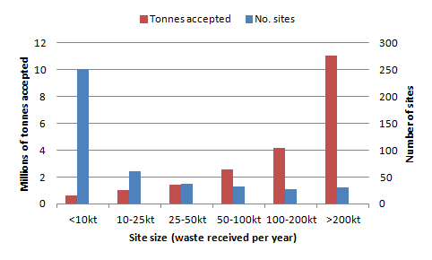

*Source: Waste Management Association of Australia(WMAA) landfill database[26]*

Landfill emissions result mainly from the decomposition of organic wastes. These chemical processes occur in a predictable sequence but over a timeframe that varies between, and sometimes within landfills. The types, quantities and timeframes of landfill emissions are therefore uncertain. Landfills generate liquid emissions (leachate) and gaseous emissions that can be environmentally damaging.

### Landfill leachate and its management

Landfill leachate contains a mix of pollutants including dissolved organic matter, heavy metals, hydrocarbons and salts. The potential for leachate to contaminate groundwater varies between sites with factors such as the height of the water table, permeability of the soil, waste types, landfill construction and landfill management.

Regulatory requirements generally do not permit discharge to groundwater, but it is also broadly recognised that all landfills will emit some leachate. Mechanisms to minimise the environmental impacts of leachate include:

* not siting landfills in areas where ground water is of good (drinkable) quality, or where the water table height is above the height of the landfill cell base
* lining cells with compressed clay, often enhanced by plastic or a geomembrane (Vic, NSW, WA and SA)
* using small cells that are rapidly filled and capped, so stormwater ingress is limited
* funnelling leachate to collection points using an engineered slope and a drainage layer, and then collecting the leachate for treatment and disposal.

In drier environments such as WA, leachate can be evaporated in shallow ponds and the residue returned to the landfill. Some facilities treat the leachate on-site then spread the treated liquid on the site for dust control. Others discharge to sewer, often after pre-treatment. In some cases, leachate is recycled back through landfill, partly as a means of promoting decomposition of organics in the landfill and so reducing the period of post-closure aftercare.

Some older landfills lack good leachate collection and treatment or have no collection and treatment system in place. These landfills are generally being phased out as they fill. Leachate pollutant concentrations tend to attenuate as the leachate plume passes through clay in the soil. The clay content on surrounding soils affects the distance that leachate plumes travel and leachate plumes will travel much further in sandy soils then in heavy clays.

### Landfill gas and its management

Landfill gas is a mixture of gases typically consisting of approximately equal measures of carbon dioxide (CO2) and methane (CH4), with traces of other gases. There are several reasons why landfills may need to manage their landfill gas, including that:

* accumulations and migration of off-site landfill gas can give rise to risks of explosions or asphyxiation
* landfill gas is odorous and can impact on neighbours and contribute to reduced air quality
* methane is a powerful greenhouse gas—this is discussed below.

Management of landfill gas can involve a range of techniques of varying degrees of sophistication and capital cost. Offsite migration can usually be controlled by venting alone, so long as groundwater levels are contained. Flares can be used to manage odours and greenhouse impacts by oxidising methane. At larger sites, landfill gas capture for energy generation can be profitable. Greenhouse policy responses have helped to spread this practice by pushing up the price for renewable energy.

### Greenhouse gas emissions from landfill

Landfills are the major source of greenhouse gas emissions from the waste sector and are covered by the National Greenhouse and Energy Reporting System (NGERS) and the Carbon Pricing Mechanism. The Department of Industry, Innovation, Climate Change, Science, Research and Tertiary Education (DIICCSRTE) collates NGERS reports with other sources to derive annual estimates of emissions of landfill methane[27]. In 2009/10, the most recent year for which data are available, landfills emitted an estimated 11.1 Mt CO2-e and captured and oxidised 4.3 Mt CO2-e, or 26% of the methane generated in landfills[28] [29]. Emissions from landfills represented 2.0% of Australia’s total emissions.

The trend in landfill methane emissions and gas capture is shown in . Gas capture is shown to have increased rapidly during the mid-1990s to mid-2000s, causing methane emissions to decline. Since then, gas capture has levelled off and emissions have begun to increase. It is understood that gas capture is increasing in response to carbon pricing, so the downward emission trend is likely to resume.

Figure 45: The trend in landfill methane emissions and capture

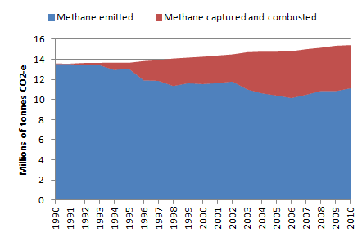

*Source: Australian Greenhouse Emissions Information System, DCCEE,* [*http://ageis.climatechange.gov.au/*](http://ageis.climatechange.gov.au/)

Landfill emissions from the various jurisdictions are shown in on a total and a per capita basis.

Table 21: Landfill methane emissions by jurisdiction, 2009/10

|  |  |  |  |  |  |  |  |
| --- | --- | --- | --- | --- | --- | --- | --- |
|  | NSW | NT | Qld | SA | Tas | Vic | WA |
| Total (Mt CO2-e) | 4.2 | 0.1 | 2.7 | 0.6 | 0.2 | 2.1 | 1.2 |
| Per capita (t CO2-e) | 0.58 | 0.49 | 0.61 | 0.38 | 0.43 | 0.38 | 0.51 |

*Source: DCCEE (2012). No landfill emission datum is available for the ACT*

The waste materials giving rise to Australia’s landfill methane emissions can be estimated using NGERS default factors for carbon content, decay behaviours, and waste stream composition. This is illustrated in (overleaf). Food waste and paper (including cardboard) are the main sources of emissions.

The discussion above is based on standard inventory and accounting approaches for emissions from landfills using DIICCSRTE factors and methods. When landfilling is considered from a more holistic life cycle perspective, two types of greenhouse benefit are revealed: the offsetting of fossil fuel associated with generating electricity from landfill gas (which is derived from renewable sources); and the long-term storage of organic carbon in landfills, which prevents its degradation to carbon dioxide. The significance of these two types of benefit varies with the waste types and the greenhouse profile of the offset electricity. Using standard DIICCSRTE factors and modelling to consider a landfill in Vic, which has the most greenhouse-intensive electricity in Australia, inclusion of these two factors in the balance means that a landfill could be considered ‘carbon neutral’ by recovering about 60% of the landfill gas it generates over its whole life-cycle. This rate is achievable at a well-managed landfill.

Figure 46: Materials giving rise to Australia’s landfill methane emissions, based on NGERS defaults

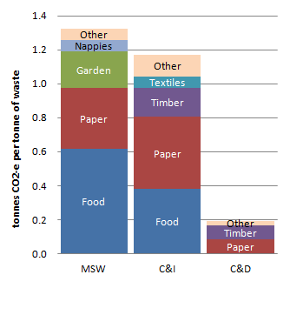

Methods for reducing methane emissions from landfills include:

* maximising methane capture and oxidation
* diversion of organic materials, especially garden and food waste, to composting and other organic processing methods
* increasing the oxidation of methane as it migrates through the aerobic upper layers of the landfill through the use of cover and capping materials that provide a good substrate for the relevant microbes
* constructing small cells that are rapidly capped so that gas collection can start quickly
* managing sites as bioreactors, where waste degradation is optimised so that gas generation occurs over more concentrated timeframe—this enhances the financial viability of methane capture.

## The environmental impacts of other waste operations

Most waste operations pose amenity risks such as noise, dust and litter. In addition to landfills, historically there have been particular concerns with hazardous waste treatment facilities and organic waste processing (composting).

There is a variety of hazardous waste treatment facilities, including thermal incinerators of hospital waste, chemical stabilisation treatments and processors of contaminated soil. The common feature is the risk of mobilisation—in dust, leaks or stacks—of hazardous contaminants. These types of facilities are tightly regulated to reduce these risks.

Organic processing operations pose risks in relation to odour and greenhouse gas emissions. Over the past five years, several large composting facilities in Vic have closed due to on-going serious odour issues, and organic processing facilities in WA and NSW have also been the subject of strong community complaints over odour. The greenhouse gas emissions from composting include both methane and nitrous oxide, but are generally small compared with landfills. Both odour and greenhouse gas emissions can be reduced through more frequent turning of composting piles and use of more sophisticated technologies such as forced aeration and biofiltration of air out-takes.

## Environmental impacts of waste electrical and electronic equipment

Waste electrical and electronic equipment (WEEE) includes a broad range of discarded products such as computers, office electronic equipment, entertainment devices, mobile phones, TVs, and fridges and washing machines (see Figure 47). WEEE management has the potential for significant environmental impact through the loss of scarce resources and leaching of toxic metals in landfill. As rates of consumption escalate, the volumes of WEEE and associated environmental risks are increasing rapidly.

Figure 47: Typical composition of WEEE

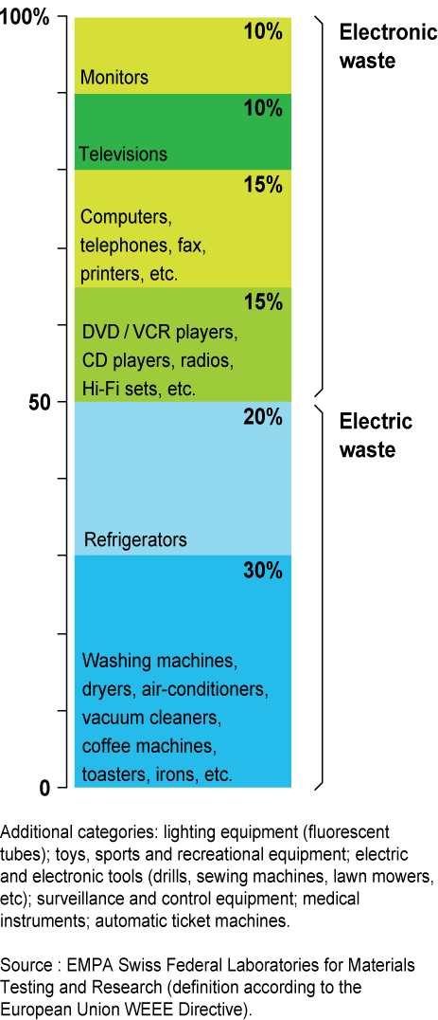

Data on the total amount of WEEE produced in Australia is not available. Data in relation to TVs and computers from EPHC (2009 p.3) is given in Section 16.1

The United Nations Environment Program (UNEP) and United Nations University’s *Recycling from e-waste to resources, July 2009*—a detailed analysis of WEEE environmental impacts—states that WEEE contains a:

*“...wide range of components made of metals, plastics and other substances… For example, a mobile phone can contain over 40 elements from the periodic table including base metals like copper (Cu) and tin (Sn), special metals such as cobalt (Co), indium (In) and antimony (Sb), and precious metals including silver (Ag), gold (Au) and palladium (Pd)”* (UNEP 2009, p.7).

At a global level the consumption of base and precious metals to manufacture electrical and electronic equipment highlights the need to improve the resource recovery rates of WEEE. Table 22 provides a summary of the 2006 production of critical metals and the tonnes used to produce electrical and electronic equipment and the market value of the metals. In 2006 demand for metals used in electrical and electronic equipment represented around 30% of the global demand for these metals; around 80% of the world’s demand of indium (transparent conductive layers in LCD glass); over 80% of ruthenium (magnetic properties in hard disks); and 50% of antimony (flame retardants).

Table 22: Global demand and EEE* demand for certain metals, 2006

|  |  |  |  |  |  |  |
| --- | --- | --- | --- | --- | --- | --- |
| Metal | Global primary production | Demand for use in EEE | Demand/ production | Price | Value in EEE | Main applications |
|  | *Tonnes* | *Tonnes* | *%* | *$US/kg* | *$US m* |  |
| **Ag (silver)** | 20,000 | 6,000 | 30 | 430 | 3 | Contacts, switches, solders |
| **Au (gold)** | 2,500 | 300 | 12 | 22,280 | 7 | Bonding wire, contacts, integrated circuits |
| **Pd (palladium)** | 230 | 33 | 14 | 11,413 |  | Multilayer capacitors, connectors |
| **Pt (platinum)** | 210 | 13 | 6 | 41,957 | 1 | Hard disk, thermocouple, fuel cell |
| **Ru (ruthenium)** | 32 | 27 | 84 | 18,647 | 1 | Hard disk, plasma displays |
| **Cu (copper)** | 15,000,000 | 4,500,000 | 30 | 7 | 32 | Cable, wire, connector… |
| **Sn (tin)** | 275,000 | 90,000 | 33 | 15 | 1 | Solders |
| **Sb (antimony)** | 130,000 | 65,000 | 50 | 6 |  | Flame retardant, cathode ray tube glass |
| **Co (cobalt)** | 58,000 | 11,000 | 19 | 62 | 1 | Rechargeable batteries |
| **Bi (bismuth)** | 5,600 | 900 | 16 | 31 |  | Solders, capacitor, heat sink… |
| **Se (selenium)** | 1,400 | 240 | 17 | 72 |  | Electro-optic, copier, solar cell |
| **In (indium)** | 480 | 380 | 79 | 682 |  | LCD glass, solder, semiconductor |
| **Total** | **15,493,000** | **4,670,000** | **30%** |  | **45** |  |

*\* electrical and electronic equipment*

*Source: UNEP 2009*

When WEEE is put into a landfill, toxic metals such as arsenic, cadmium, cobalt, chromium and zinc as well as halogenated aromatics (including polybrominated diphenyl ethers from flame retardant insulation cabling, which are known to be persistent organic pollutants) are likely to end up in landfill leachate and potentially be emitted from the landfill. In a recent commentary on increasing rates of contaminants in landfill leachate[30], Professor Ravi Naidu from the Cooperative Research Centre for Contaminated Assessment and Remediation of the Environment commented that:

*“Most of these materials have probably leaked from electronic waste, which includes old computers, mobile phones, refrigerators, televisions, batteries, wires with flame-retardant casings and more ... As e-waste only came into the picture 10 years or so ago, we used to dispose of most of it in landfills. Approximately 84% of e-waste was dumped, with only 10% being recycled in those days...Up until 2006 there was three times more e-waste going to landfill, and no fewer than 234 million electronic waste items were sent to landfill in 2009. The content of [polybrominated diphenyl ethers] found in Australian landfill leachates is much higher than those from Japan... One reason for this is that Japan incinerates its waste, decreasing the toxicity, while Australia disposes of them to landfill. As many of our landfills are not actually designed to accommodate e-waste, we run a high level of risk if contaminated water escapes from them. The answer is to develop manufacturing systems that minimise contamination in the first place, and which close the loop by efficiently recycling materials back into electronics production pipeline."*

## Dumping and littering

Illegal dumping involves significant quantities of material surreptitiously disposed of to avoid costs, while littering may be more thoughtless than malicious. Dumping and littering reduce aesthetic amenity and can be a danger to human health. Materials may be washed into waterways where they become a major hazard for aquatic animals through entanglement or ingestion.

Disposing of dumped and littered materials is an expensive burden on local governments and other agencies. Victorian local governments reported spending over $10m cleaning up litter and dumped rubbish during 2009/10 (Sustainability Victoria 2011 p.45). Anecdotally, dumping is claimed to increase with rising landfill costs. Cigarette butts are the most numerous littered item, and paper and plastic are the most voluminous (McGregor Tan Research 2010 p.23).

The Commonwealth Scientific and Industrial Research Organisation (CSIRO) recently undertook research into marine debris in Australian waters (Hardesty and Wilcox 2011). It found that marine debris is concentrated near major population centres, indicating that domestic sources are significant. The report noted that *“Australia is probably a net exporter of debris to some neighbouring marine regions and surrounding countries”* (p.20). The main items observed as washed ashore included cigarette products and plastic bags.

## The environmental benefits of resource recovery

Life cycle assessments have consistently demonstrated that for most materials and most circumstances, recycling results in net savings in energy and net reductions in greenhouse gas emissions (Ackerman 1997, Grant *et al*. 2003, ACOR 2008). The latter report suggested that recycling saved about 8.8 Mt CO2-e in 2006—equivalent to about 1.5% of Australia’s total emissions—due mainly to the avoided need to manufacture materials from virgin sources. The report also identified significant savings in water and energy use due to recycling. The greenhouse benefits of recycling various materials are shown in based on the Australian Council of Recycling (ACOR) report.

Figure 48: The greenhouse benefits of recycling by material type

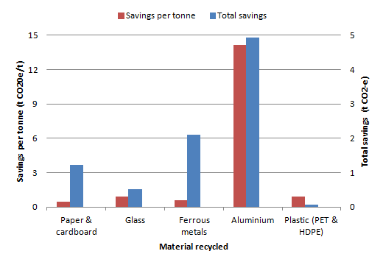

*Source: ACOR (2008)*

The production of compost from wastes, where a quality compost product is generated, is environmentally beneficial because the products can improve soil quality, retain soil moisture, promote plant growth, build soil carbon, recycle phosphorus and substitute for energy-intensive fertilisers.

Energy recovery from renewable organic wastes is beneficial because it offsets the need to generate energy from fossil fuels (e.g. coal and gas). The major source of energy from waste in Australia is currently from landfill gas used to generate electricity. Energy recovery from landfill gas started in the early 1990s and now consumes about a quarter of the methane produced by Australian landfills (see ). Various other waste processing facilities also generate minor amounts of electricity through anaerobic digestion.

### Embodied greenhouse gas in waste disposal to landfill

The manufacture of inorganic materials (e.g. metals and plastics) involves the use of energy and emission of greenhouse gases. When those materials are subsequently landfilled, these ‘embodied emissions’ can be considered lost as new virgin materials would need to be generated to replace them. illustrates the embodied emissions in four categories of inorganic wastes sent to landfill in Australia. The greatest loss of embodied emissions is shown to be plastic wastes. Note that the factors used to generate this chart are based on world-wide averages. The high carbon intensity of Australian energy production means that the true values are likely to be higher than those shown.

Figure 49: The ‘embodied greenhouse gas emissions’ of key wastes sent to landfill in Australia in 2010/11

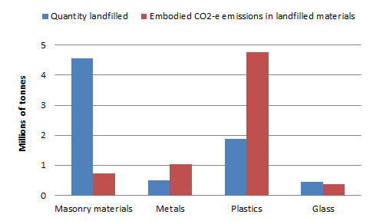

*Source of factor data: Hammond and Jones (2008)*

# Waste data collation definitions

Several definitions that inform the broad scope of the data in this report are discussed in this section[31], including:

* ‘materials consumption’
* ‘waste’
* the levels of the waste hierarchy (see ) from ‘waste avoidance’ through to ‘disposal’
* various other definitions that underlie this data collation including ‘waste generation’, ‘resource recovery’, and ‘resource recovery rate’.

The principle of managing waste according to the waste hierarchy is written into legislation or regulation in every jurisdiction in Australia and many waste policy targets and data collations are based on the various levels of the hierarchy.

Figure 50: The waste hierarchy



## Materials consumption

It is useful to consider and define the various stages of materials consumption to understand how materials recycling, energy recovery and disposal relate to material consumption. Materials consumption, for the purposes of waste data accounting and collation, typically involves the following five stages:

1. primary production of raw materials (mining) and livestock (agriculture)
2. raw material processing
3. manufacturing of products and materials
4. consumer use (consumption)
5. waste generation.

**Materials consumption:** is defined as the process of taking natural resources, converting them to materials for manufacturing and use by consumers, and the generation of wastes (which are either recovered or disposed).

## Waste

To enable solid waste data to be collated consistently and accurately it is important to define (solid) waste for the purposes of data collation.

### All waste

The Victorian *Environment Protection Act 1970* defines waste using several criteria. The most relevant for solid waste are:

*“(b) any discarded, rejected, unwanted, surplus or abandoned matter;*

*(c) any otherwise discarded, rejected, abandoned, unwanted or surplus matter intended for*

*i) recycling, reprocessing, recovery or purification by a separate operation from that which produced the matter;*

*ii) sale”*

The NSW *Protection of the Environment Operations Act 1997* defines wastes in several ways. The most relevant are:

*“a) any discarded, rejected, unwanted, surplus or abandoned substance, or*

*b) any otherwise discarded, rejected, unwanted, surplus or abandoned substance  
 intended for sale or for recycling, processing, recovery or purification by a separate  
 operation from that which produced the substance, or*

*c) any processed, recycled, reused or recovered substance produced wholly or partly from  
 waste that is applied to land, or used as fuel, but only in the circumstances prescribed  
 by the regulations…”*

The NSW Act also states that:

*“A substance is not precluded from being waste for the purposes of this Act merely because it is or may be processed, recycled, reused or recovered”.*

The *National Waste Report* (2010), published by the Standing Council on Environment and Water includes the following definition of waste:

*“... discarded, rejected, unwanted, surplus or abandoned matter intended for recycling, re–processing, recovery, reuse, or purification by a separate operation from that which produced the matter, or for sale, whether of any value or not”.*

In the European Union (EU) under the *Waste Framework Directive European Directive 2008/98/EC*, waste is defined as:

*“an object the holder discards, intends to discard or is required to discard”.*

The EU definition is illustrated below.

Figure 51: EU illustration of the definition of waste

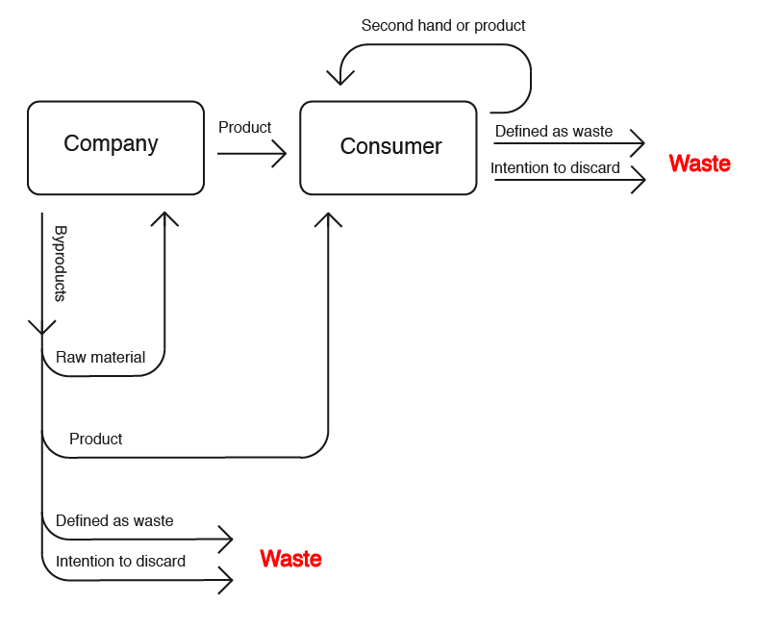

*Source: Waste Framework Directive European Directive 2008/98/EC*

The definitions discussed above do not characterise waste with reference to its perceived monetary value at the point in time that the waste is generated. Most emphasise the behaviour or actions of the consumer as much as the waste material.

In *Waste and Recycling in Australia 2011*, the Commonwealth Government took the following position in establishing the scope of what should be included in waste data reporting:

*“Recommendation 1 … the scope should be limited to waste material that is recycled, recovered for energy, and disposed. Re-use is excluded from the scope”.*

The definitions of waste (above) are inconsistent in relation to whether products or materials that are reused can be included in the definition of waste (‘reuse’ is defined below in). Several definitions encompass at least some reuse but the EU excludes reuse from waste (as shown at ). Including reuse in the definition of waste is impractical for data collation purposesbecause reuse is not readily quantifiable at a state or national level. Consistent with *Waste and Recycling in Australia 2011*, this report excludes reuse data (see 21.4 for further discussion).

**Waste (for data collation purposes):** materials or products that are unwanted or have been discarded, rejected or abandoned. Waste includes materials or products that are recycled, converted to energy, or disposed. Materials and products that are reused (for their original or another purpose without reprocessing) are not waste because they remain in use.

This definition of waste sets the broad scope of reporting in this document. Its application requires a number of additional assumptions and considerations, which are further discussed in section .

### Solid waste

Practical definitions for ‘solid’ are generally inadequate in the waste context. Materials such as processed sludges are often disposed to landfill as solid waste but can have a high liquid waste content.

DECCW (2009 p.5) defines liquid waste as follows:

*“Liquid waste means any waste that:*

* + - *has an angle of repose of less than 5 degrees above horizontal, or*
    - *becomes free-flowing at or below 60 degrees Celsius or when it is transported, or*
    - *is generally not capable of being picked up by a spade or shovel.”*

Adopting this approach, solid waste can be defined as below.

**Solid waste is waste that:**

1. can have an angle of repose of greater than 5 degrees above horizontal, or

2. does not become free-flowing at or below 60 degrees Celsius or when it is transported, or

3. is generally capable of being picked up by a spade or shovel.

## Waste avoidance

Waste avoidance is most easily understood by reference to examples in the contexts of manufacturing and consumer activities.

Examples of waste avoidance in the context of manufacturing include:

* increasing manufacturing efficiency through improved design so that less materials are required per unit of production (‘doing more with less’)
* designing products to be more durable (to increase product life and reuse of the product).

Examples of waste avoidance in the context of consumer activities include:

* ‘just in time’ purchasing to ensure products and materials do not expire before use
* government education programs to encourage consumers to buy products that are more durable, have less packaging, generate less waste during their use, and are easily recovered for material content when they become a waste.

Put simply, waste avoidance is any activity that results in the waste no longer being generated. It should not be confused with ‘disposal avoidance’. Activities that reduce the amount of wastes (which have already been generated) going to disposal (e.g. landfill) – for example by means of stockpiling, increasing recycling or energy recovery – are not waste avoidance.

**Waste avoidance:** is any activity that results in wastes not being generated or being generated in lesser quantities. Waste avoidance includes waste reduction, waste minimisation, and expanded reuse of products and materials. Methods for avoiding waste include (but are not limited to) improving manufacturing processes, improving product durability, and selecting products with a view to reduce waste (e.g. those that are more durable or have less packaging).

**Waste disposal avoidance:** is any activity that results in wastes being recycled, or recovered for energy.

## Reuse

Reuse is commonly confused with recycling. The distinction is that reuse involves second-hand use of a product without reprocessing, whereas recycling involves the reprocessing of a product into new materials.

Reuse occurs on a large scale across the community. Most occurs in established second-hand markets unrelated to waste. A smaller portion associated with materials donated to charity shops etc. could potentially be considered waste-related. An even smaller portion occurs through recovery of products or materials sent to a waste management facility (i.e. a landfill or transfer station). This ‘waste reuse’ is quantifiable for waste data purposes, although the associated tonnages are not significant in the context of waste recovery or overall reuse of products and materials.

The definition of waste applied in this report excludes reuse. It could be argued that some reuse should be included, but this is not adopted because the vast majority of reuse occurs outside waste management facilities with little data availability, and because reused products and materials ultimately remain in the economy. Reuse is therefore excluded from the main data presentation. This does not diminish its importance as a policy objective.

Policy efforts to promote reuse can be considered a type of waste avoidance, because they result in less waste generation. Waste generation trends may provide an indication of the extent to which waste avoidance and reuse are occurring.

Although reuse is not included in main data presentation, where jurisdictions provided ‘waste reuse’ data it is reported separately for information purposes.

**Reuse:** is the use of products or materials without reprocessing or remanufacture, but potentially with some repair.

It is worth noting that some non-consumer wastes are also reused. For example soil and rock which is moved around in large volumes/tonnages is often reused at an alternate site.

The following are examples of reuse using the above definition:

* wood pallets that are refurbished are considered to be reuse (those that are disassembled and shredded for the materials are considered to be recycled)
* second-hand timber collected as timber and sold as timber for building
* office and house furniture given away or sold to another party is reuse.
* second-hand clothes used as clothes (those turned into rags are considered to be recycled).

**Waste reuse:** is the reuse of a product or material that has entered a waste management facility (e.g. the sale of goods from a landfill or transfer station ‘tip shop’) for the same or a different purpose. These products or materials may also be repaired to extend their use.

## Recycling

Solid waste recycling occurs when wastes are collected, sorted, processed and converted into raw materials to be used in the production of new products. Composting is included in this definition. Materials that are reclaimed onsite during a manufacturing process and reutilised within this same manufacturing process are not considered to be recycled.

**Recycling**: is a series of activities by which solid wastes are collected, sorted, processed (including through composting), and converted into raw materials to be used in the production of new products.

## Energy recovery

In the context of this report, ‘energy recovery’ refers to processes release energy embodied in wastes and capture some of that energy for a beneficial purpose. Typically, energy is recovered from waste in specialist facilities (using processes such as incineration, pyrolysis or anaerobic digestion), or by the collection and combustion of methane gas collected from waste sent to landfill.

The most common uses for energy from solid wastes are:

* electricity generation, often for selling into the supply grid
* industrial processes – for example, waste tyres are used by some cement kilns as a supplementary fuel.

Unlike recycling, energy recovery leads to a loss of materials and is therefore positioned below recycling in the waste hierarchy. To work out the amount of material from which energy has been recovered, residuals need to be deducted. For example, in an anaerobic digestion process, the material from which energy has been recovered is equal to the input tonnes less the mass of compost or digestate (which is recycled) and the mass of any materials sent to landfill (which is disposed).

**Energy recovery:** is the process of recovering energy that is embodied in solid wastes. The amount of solid waste recovered by the processes is net of any materials recycled and/or disposed.

## Treatment

Treatment of wastes typically refers to hazardous wastes. The following definition is adopted:

**Treatment:** is the removal, reduction or immobilisation of a hazardous characteristic from wastes to enable the waste to be reused, recycled, sent to an EfW facility or disposed.

## Disposal

The US Environmental Protection Agency (EPA) defines disposal facilities as:

*“Repositories for solid waste including landfills and combustors intended for permanent containment or destruction of waste materials. Excludes transfer stations and composting facilities”.*

The Australian Standard defines disposal as:

*“The final stage in the management of the waste stream”.*

Disposal is the lowest level of the waste hierarchy and could potentially cover disposal to land, waterways or atmosphere.

**Solid waste disposal to land:** Almost the entire mass of solid waste that is legally disposed of is sent to landfill, regardless of the process used to manage the solid waste.

**Solid waste disposal to waterways:** The few examples of legal solid waste disposal to waterways (e.g. dredging spoils) do not warrant its inclusion in the definition of solid waste disposal for the purposes of solid waste data reporting.

**Solid waste disposal to atmosphere:** Whenever wastes are combusted or organic wastes decompose, a portion of the waste mass is effectively disposed to atmosphere as gaseous wastes. Accounting for the tonnes of solid wastes disposed to atmosphere (mainly as carbon dioxide) would be complex and would overlap with other areas of emission reporting and regulation (e.g. greenhouse gas reporting). For the purposes of this report, disposal of solid wastes to atmosphere is not, therefore, reported in solid waste disposal data.

**Disposal:** is solid waste that is deposited in a landfill, net of recovery of energy.

## Waste generation

For waste data collations, waste generation is commonly estimated as follows:

Waste generation = resource recovery (recycling + energy recovery) + disposal.

This provides a clear definition for waste generation, but not all waste generation can be readily measured and reported. The waste generation data presented in this report comprises that portion of waste for which data is readily available. Typically, this is data on wastes managed at a centralised waste facility offsite from the waste generation source. In some instances, waste that is managed onsite is also included e.g. disposal of fly ash onsite.

**Waste generation = resource recovery (recycling + energy recovery) + disposal[32]**

## Resource recovery

The Australian Standard defines resource recovery as:

*“ ...a process that extracts material or energy from the waste stream”.*

The *National Waste Report 2010* defines resource recovery as:

*“...the process of extracting materials or energy from a waste stream through reuse (using the product for the same or a different purpose without further production), recycling or recovering energy from waste”.*

The US EPA defines recovery as:

*“...the diversion of materials from the municipal solid waste stream for the purpose of recycling or composting. Excludes reuse and source reduction activities such as yard trimmings diverted to backyard (onsite) composting, the repair of wood pallets, and the refilling of beverage containers”.*Source: <http://www.epa.gov/osw/conserve/tools/recmeas/docs/guide_a.pdf> (Jan 2013).

This report adopts a definition for resource recovery that excludes reuse, is consistent with the Australian Standard and the US EPA definition. When a product or material remains in use, it has not been recovered for its resource value as is the case when it has been recycled or recovered for energy. This is consistent with the exclusion of reuse from the definitions of waste and waste generation as discussed above.

In some instances, the amount of products or materials reported as ‘recovered’ is the total tonnage of materials sent to an EfW facility, without subtracting the residual wastes that are disposed. The amount of residual wastes for some resource recovery processes can be significant (e.g. the tonnage of bottom ash from EfW facilities).

**Resource recovery:** is the sum of materials sent to recycling and energy recovery net of contaminants and residual wastes sent to disposal.

**Resource recovery = recycling + recovery of energy**

## Resource recovery rate

Based on the definitions outlined above for waste generation and resource recovery, the resource recovery rate is the tonnes of waste undergoing resource recovery expressed as a fraction of the tonnes of waste generated.

**Resource recovery rate (%) = resource recovery/waste generation**

illustrates the above definitions and how they relate to each other and the lifecycle of materials. It also illustrates the broad scope of reporting for WGRRA.

Figure 52: Illustration of the definitions and scope of reporting in WGGRA



# Scope and method of data reporting

illustrates the scope of reporting for WGRRA, as follows:

* waste reuse (reported separately and only where data is available)
* waste generation
* resource recovery
* recycling
* energy recovery
* disposal.

The definitions provided in section 21 outline the broad scope of reporting for *Waste Generation and Resource Recovery in Australia*.

The *Waste and Recycling in Australia 2011* report included the results of the first attempt to apply ‘the method’ of data collation set out in the Hyder (2010) Method Report. Section 3 of *Waste and Recycling in Australia 2011* included the final set of recommendations for collating national data. *Waste Generation and Resource Recovery in Australia* was required to follow these recommendations, or justify any divergence.

provides details of each of the recommendations from Section 3 of *Waste and Recycling in Australia 2011* and explains the few areas of divergence.

Table 23: Details of scope and data collation method applied in WGRRA

| *Waste and Recycling in Australia 2011* method and scope recommendation | Assessment of recommendation | WGRRA alignment |
| --- | --- | --- |
| Recommendation 1: The scope should be limited to waste material that is recycled, recovered for energy and disposed. Reuse is excluded from the scope. | WGRRA has attempted to identify ‘waste reuse’ data to enable separate reporting and deduction from waste generation tonnages. This is consistent with the recommendation of excluding reuse data from the main WGRRA data reporting. However, it diverges from the recommendation because waste reuse data are reported when provided. | Mostly aligned. |
| Recommendation 2: Waste generation and waste disposal quantities should be reported, as well as recycling and recovery rates. | Agreed. | Aligned. |
| Recommendation 3: Liquid and gaseous wastes should be excluded from the scope at this stage. | Agreed. WGRRA includes a definition of solid waste. The data provided for the report have not, however, been assessed to determine if they meet the definition of solid waste provided (i.e. if it was reported as solid, the data has been included). | Aligned. |
| Recommendation 4: Report waste generation data, disposal, energy recovery and recycling on a per capita basis using population figures that correspond to the end of the reporting period. | Agreed. | Aligned. |
| Recommendation 5: Waste and recycling should be reported by weight. | Agreed. | Aligned. |
| Recommendation 6: Waste converted to energy should be reported as a separate disposal pathway to recycling and disposal. | Agreed. | Aligned. |
| Recommendation 7: The definitions in the National Waste Report 2010 for the three major solid waste streams should be used. | Agreed. | Aligned. |
| Recommendation 8: Wastes generated by the core processes of primary production should be excluded from the scope. | Most primary production wastes cannot be readily quantified for national reporting. It is agreed that they should be excluded from the main data collation. However, it is not possible to identify and remove all primary production wastes tonnages from landfill, so some primary production waste may be included in the totals. The WGRRA data workbook documents any primary production tonnages that have been deducted for each jurisdiction’s total. In addition, on agreement, primary production organic wastes that are recovered in waste management facilities are reported in the organics section (15) where data is publicly available. | Aligned. |
| Recommendation 9: Pre-consumer wastes that are recycled on-site as part of the manufacturing process should be excluded from the scope. | Agreed. | Aligned. |
| Recommendation 10: Bark and sawdust from forestry operations, and mining and mineral processing wastes should be excluded from the scope. | Agreed, noting the issues raised under recommendation 8. | Aligned. |
| Recommendation 11: Organic agricultural wastes are excluded from the scope. | Agreed, noting the issues raised under recommendation 8. | Aligned. |
| Recommendation 12: Clean fill should be excluded from the scope. | Agreed. | Aligned. |
| Recommendation 13: Daily cover (that is clean fill) should be excluded from the scope. | Agreed. | Aligned. |
| Recommendation 14: Fly ash should be included in the scope, but is reported separately to the total of all other materials included in the scope. | Agreed. | Aligned. |
| Recommendation 15: Biosolids should be included in the scope. | Agreed. | Aligned. |
| Recommendation 16: Hazardous, prescribed or clinical wastes should be included in the scope. | Agreed. | Aligned. |
| Recommendation 17: Quarantine wastes should be included in the scope. | Agreed. | Aligned. |
| Recommendation 18: A consistent set of materials should be used to report the composition of waste streams. | Agreed. | Aligned. |
| Recommendation 19: Waste should be counted by the stream that it is collected in unless data is readily available. | Agreed. | Aligned. |
| Recommendation 20: Standard conversion factors should be used except for where states or territories have justification to apply jurisdiction or site specific conversion factors. | Agreed. | Aligned. |
| Recommendation 21: Residual material from recycling and waste to energy operations should not be counted as recovered material. | Agreed. | Aligned. |
| Recommendation 22: Recycling should be counted by material input (less residual material). | Agreed. | Aligned. |
| Recommendation 23: Waste should be counted once at the point of generation. | Agreed. | Aligned. |
| Recommendation 24: Stockpiles of reprocessed product or material that has been actively recovered should be considered to be recycled. | Agreed. | Aligned. |

# Data sources and assumptions

Each jurisdiction was asked to provide data on the tonnages: of each waste type; in each waste stream (MSW, C&I and C&D); by management (landfilled, recycled or used for energy recovery); in the reference year 2010/11 and, where available, in the financial years 2006/07, 2008/09, 2009/10 and 2011/12.

Jurisdictions were able to satisfy this request to different degrees. In most cases there were gaps for some waste types, categories, streams or management routes. In some cases data on hazardous waste was available from both hazardous waste tracking data and landfill data, and the figures were not always identical. No data were obtained for Qld (2006/07), NSW (2009/10) or NT (2006/07 to 2009/10). Qld was the only jurisdiction able to provide data for 2011/12.

Data were also obtained from a range of industry sources to supplement the jurisdictional data. These included data from: the Plastics and Chemicals Industry Association (PACIA) (plastics); the ROU (organic waste recycling); the Australian Ash Development Association (ADAA) (power station ash); the Australia and New Zealand Biosolids Partnership (biosolids from sewage works); the Clean Energy Council (energy recovery from organic wastes); and waste industry websites (various waste streams). Demographic and economic data were obtained from the ABS.

In some cases, values for a particular datum were available from more than one source. Greatest reliance was generally placed on jurisdictional waste data, where these were available. An alternative was used in a few cases where, in the professional judgement of the authors, there was good reason. For example, the tonnes of plastics recycled reported by the Qld Government were lower than those given for Qld by PACIA, so the industry survey was assumed to have identified additional tonnages and its total figures were applied.

Where data were not directly available from either jurisdictional or industry data, gaps were filled, where it was considered prudent, by means of assumption and calculation. The assumptions were founded on the professional judgement of the authors, with consideration of the similarities and differences between jurisdictions and circumstances. The methods for gap filling included assuming that:

* Proportions or rates in a jurisdiction, time period, area or waste stream were similar to those in another.
* Rates or values in a jurisdiction or area had particular values.
* Snapshot waste stream audits in a jurisdiction were proportionally representative of the entire jurisdictional waste stream.
* Average values from combining the results of waste stream audits in several jurisdictions were representative of national averages, and were applicable to jurisdictions and waste streams lacking representative snapshot audits. Some combining of audit results was undertaken by the project team, and some by third parties (e.g. as part of a national study of C&I waste, or in establishing default values for use under National Greenhouse and Energy Reporting legislation).

The major assumptions applied in compiling the jurisdictional and national waste data sections are specified in . Less significant assumptions are set all out in the ‘WGRRA database’ and ‘WGRRA data workbook’ adjacent to the calculation where the assumption is employed. In the database, assumptions are identified through the use of red font.

Table 24: Major assumptions used in compiling the data for WGRRA

| Assumption | Applicability | | |
| --- | --- | --- | --- |
| Wastes | Jurisdictions | Years |
| The mass of waste associated with energy recovery from landfill gas can be accurately back-calculated using NGERS default values (Australian Government 2012) assuming instantaneous emission of methane. | Organics to landfill | All | All |
| Jurisdictional waste audits were representative of the composition of waste streams to landfill. | Waste to landfill | ACT | All |
| WA |
| Waste to landfill excluding asbestos | SA |
| National average compositions were representative of the waste composition. The organic fractions were as set out in the NGERS Determination (Australian Government 2012). Other fractions were as derived from reviews of audits by the authors (MSW, C&D) or from another DSEWPaC study (C&I). | Waste to landfill | NT | 2010/11 |
| Tas | All |
| NSW | 2006/07, 2008/09 |
| Waste to landfill except hazardous | Qld | All |
| The default proportional splits of waste to landfill into the three streams given in NGERS (Australian Government 2012) applied. | Waste to landfill | NT | 2010/11 |
| SA | All |
| Jurisdictional organics data included out-of-scope primary production materials. ROU data on these quantities were representative so that the totals could be derived by deduction. | Organics to recycling | Qld | All |
| Landfill and recycling figures from Shoal Bay landfill combined with industry data on recycling plastics and biosolids were representative. Recycled tonnages from Shoal Bay that were not allocated to MSW were C&I. Waste generation per capita in non-metropolitan NT was identical to Darwin. No recycling occurred outside Darwin. | All | NT | 2010/11 |
| PACIA data, jurisdictional data on the split of MSW into organic and non-organic components, jurisdictional audits (MSW and C&D) and the national average composition of recycled C&I material were representative of the composition. | Recycling | NSW | 2006/07, 2008/09 |
| Queanbeyan waste (from NSW) is included from the totals reported in each category, and needs to be deducted. The proportion is equal to the reported proportion for privately delivered waste. | All | ACT | All |
| MSW tonnages equalled the sum of PACIA plastics data, biosolids data and recorded compost quantities applied to the Victorian proportional split of MSW and C&I. No C&D recycling occurred. For 09/10 and 10/11, the composition of C&I recycling not determined through the data listed above was equal to the national average. For 06/07 and 08/09, the jurisdictional total assumed to be too low because the C&I remainder is insufficient to cover the recorded quantities of plastic and organics, so categories other than plastic and organics were allocated in same proportion relative to MSW total as 08/09, so that the C&I quantity equalled the sum of the categories. | Recycling | Tas | All |

# References (from report & associated workbooks)

ABS (Australian Bureau of Statistics 2012a) *Australian Demographic Statistics, Mar 2012,* publication 3101.0, September, available from: <http://www.abs.gov.au/ausstats/abs@.nsf/mf/3101.0>

ABS (Australian Bureau of Statistics 2012b) *Australian System of National Accounts Concepts, Sources and Methods Australia 2012 Edition 3* available from: <http://www.abs.gov.au/ausstats/abs@.nsf/mf/5216.0>

ABS (Australian Bureau of Statistics 2012d) *Regional population growth, Australia,* publication 3218.0, July, available from: <http://www.abs.gov.au/ausstats/abs@.nsf/mf/3218.0>

ABS (Australian Bureau of Statistics 2012c) *Australian National Accounts: State Accounts, 2011-12,* publication 5220.0, November, available from: <http://www.abs.gov.au/AUSSTATS/abs@.nsf/DetailsPage/5220.02011-12?OpenDocument>

Ackerman F (1997) *Why Do We Recycle: Markets, Values, and Public Policy*. Island, Washington, DC

ACOR (Australian Council of Recycling 2008) *Australian Recycling Values - A Net Benefits Assessment*, prepared by Hyder Consulting, Sydney

ACT Government (2011), *ACT Waste Management Strategy 2010–2025*

ACT Government (2012a) *ACT Resource Recovery,* available from: <http://www.tams.act.gov.au/recycling-waste/reports_data_forms/statistics>

ACT Government (2012b) *Waste to ACT landfills,* available from: <http://www.tams.act.gov.au/recycling-waste/reports_data_forms/statistics>

ACT Government (2012c), *Waste Minimisation (Landfill Fees) Determination 2012 (No 1) Waste Minimisation Act 2001, section 45 (Determination of fees)* available from: <http://www.legislation.act.gov.au/di/2012-69/>

ADAA (Ash Development Association of Australia 2008) *Annual membership survey results 2008,* HBM Group Pty Ltd, Wollongong, available from: <http://www.adaa.asn.au/ccp-utilisation.php>

ADAA (Ash Development Association of Australia 2009) *Annual membership survey results 2009,* HBM Group Pty Ltd, Wollongong, available from: <http://www.adaa.asn.au/ccp-utilisation.php>

ADAA (Ash Development Association of Australia 2010) *Annual membership survey results 2010,* HBM Group Pty Ltd, Wollongong, available from: <http://www.adaa.asn.au/ccp-utilisation.php>

ADAA (Ash Development Association of Australia 2011) *Annual membership survey results 2011,* HBM Group Pty Ltd, Wollongong, available from: <http://www.adaa.asn.au/ccp-utilisation.php>

AEGIS (Australian Greenhouse Emissions Information System, Department of Climate Change and Energy Efficiency), available from: <http://ageis.climatechange.gov.au>

AMTA (2012) *MobileMuster The official recycling program of the mobile phone industry 2010-11 Annual Report,* available from: <http://www.mobilemuster.com.au/>

APC (2007) *Domestic waste audit, prepared for Thiess Services and ACT NoWaste,* November, available from: <http://www.tams.act.gov.au/__data/assets/pdf_file/0003/136740/Canberra_Audit_Report_1_2007.pdf>

APC (2009) *Kerbside Domestic Waste and Recycling Audit,* prepared for ACT NoWaste, December, available from: <http://www.tams.act.gov.au/__data/assets/pdf_file/0007/208663/ACTNOWaste_Domestic_Waste_Audit_Report_December_09.pdf>

APC (2010) *ACT Landfill Audits Combined Final Audit Report,* prepared for ACT NOWaste, July, available from: <http://www.tams.act.gov.au/recycling-waste/reports_data_forms/statistics>

Australian Government (2012) *National Greenhouse and Energy Reporting (Measurement) Determination,* available from: <http://www.comlaw.gov.au/Details/F2011C00469/Html/Text#_Toc298750665>

Australian Packaging Covenant Council (2012) *Australian Packaging Covenant Annual Report 2011* available from: <http://www.packagingcovenant.org.au/>

Campbell C, ROU (2013) Email to Joe Pickin of the project team dated 23 January containing not yet published data from a recent industry survey

DCCEE (Department of Climate Change and Energy Efficiency 2012) *Australian National Greenhouse Accounts, State and Territory Greenhouse Gas Inventories, 2009/10,* available from: <http://www.climatechange.gov.au/en/publications/greenhouse-acctg/state-territory-inventory-2010.aspx>

DCCEE (Department of Climate Change and Energy Efficiency 2012) *Australian National Greenhouse Accounts, State and Territory Greenhouse Gas Inventories, 2009/10*, available from: <http://www.climatechange.gov.au/en/publications/greenhouse-acctg/state-territory-inventory-2010.aspx>

DEC (WA Department of Environment and Conservation 2007) *Zero Waste Plan Development Scheme, Phase One report 2006-07,* available from: <http://www.zerowaste.wa.gov.au/media/files/documents/zwpds_phase1_0607.pdf>

DECC (NSW Department of Environment and Climate Change 2004) *Report into the Construction and Demolition Waste Stream Audit 2000-2004 Sydney Metropolitan Area,* available from: <http://www.environment.nsw.gov.au/warr/CnDWasteStream.htm>

DECC (NSW Department of Environment and Climate Change 2007) *Waste Avoidance and Resource Recovery Strategy 2007,* available from: <http://www.environment.nsw.gov.au/waste/index.htm>.

DECCW (NSW Department of Environment, Climate Change and Water 2009) *Waste Classification Guidelines Part 1: Classifying Waste*, available from: <http://www.environment.nsw.gov.au/resources/waste/08202classifyingwaste.pdf>

DECCW (NSW Department of Environment Climate Change and Water, 2011) Waste Avoidance and Resource Recovery Progress Report 2010, Vol 2, February, available from: <http://www.environment.nsw.gov.au/resources/warr/110061WARRSPRvolume2.pdf>

DEFRA (UK Department of Environment, Food and Rural Affairs 2012) *Local Authority Waste Management Statistics for England – Final Annual Results 2011/12*, <http://www.defra.gov.uk/statistics/environment/waste/wrfg23-wrmsannual/>

DEPHA (Tasmanian Department of Environment, Parks, Heritage and the Arts 2009) *Tasmanian Waste and Resource Management Strategy*

DSE (Victorian Department of Sustainability and Environment 2012) *Draft Victorian Waste and Resource Recovery Policy* available from: <http://www.dse.vic.gov.au/conservation-and-environment/sustainability/waste-management-and-resource-efficiency>

Department of the Chief Minister (2009) *Territory 2030 Strategic Plan*

DERM (Qld Department of Environment and Resource Management) (2010) *Queensland’s Waste Reduction and Recycling Strategy 2010–2020*.

DSEWPaC (Department of Sustainability, Environment, Water, Population and Communities 2011) *Biosolids snapshot,* prepared by Pollution Solutions and Design, available from: <http://www.environment.gov.au/wastepolicy/publications/biosolids-snapshot.html>

Environment NZ (2007) State of the Environment Report, Chapter 6, available from: <http://www.mfe.govt.nz/publications/ser/enz07-dec07/chapter-6.pdf>

EPA SA (Environmental Protection Agency of South Australia 2010) *Waste Guidelines–Waste Levy Regulations*

EPHC (Environment Protection and Heritage Council, October 2009) *Decision Regulatory Impact Statement: Televisions and Computers,* available from: <http://www.ephc.gov.au/sites/default/files/PS_TV_Comp__Decision_RIS__Televisions_and_Computers__200911_0.pdf>

European Commission website (Waste Statistics, downloaded January 2013) from: <http://epp.eurostat.ec.europa.eu/statistics_explained/index.php/Waste_statistics>

Eurostat Newsrelease no. 37, 8 March 2011, available from: <http://epp.eurostat.ec.europa.eu/cache/ITY_PUBLIC/8-08032011-AP/EN/8-08032011-AP-EN.PDF>

Forster P, Ramaswamy V, Artaxo P, Berntsen T, Betts R, Fahey DW, Haywood J, Lean J, Lowe DC, Myhre G, Nganga J, Prinn R, Raga G, Schulz M and Van Dorland R (2007) Changes in Atmospheric Constituents and in Radiative Forcing. In: *Climate Change 2007: The Physical Science Basis. Contribution of Working Group I to the Fourth Assessment Report of the Intergovernmental Panel on Climate Change* [Solomon S, Qin D, Manning M, Chen Z, Marquis M, Averyt KB, Tignor M and Miller HL (eds.)]. Cambridge University Press, Cambridge, UK and New York, USA, available from: ipcc-wg1.ucar.edu/wg1/Report/AR4WG1_Print_Ch02.pdf

Government of Victoria (2005) *Towards Zero Waste Strategy*

Grant T, James KL and Partl H (2003*) Life Cycle Assessment of Waste and Resource Recovery Options (including energy from waste)*. Prepared by the Centre for Design at RMIT and Nolan-ITU for EcoRecycle Victoria, Melbourne

Hammond G, Jones C, *Inventory of Carbon and Energy, Version 1.6a*, 2008

Hardesty BD and Wilcox C (2011) *Understanding the types, sources and at-sea distribution of marine debris in Australian waters,* Final Report to the Department of Sustainability, Environment, Water, Population and Communities, available from: [www.environment.gov.au/coasts/pollution/marine-debris/index.html](http://www.environment.gov.au/coasts/pollution/marine-debris/index.html)

Hyder Consulting (2010) *Incorporating a Revised Method for Compiling Waste and Recycling Data.*

Hyder Consulting (2011a) *Waste and Recycing in Australia 2011*, prepared for the Department of Sustainability, Environment, Water, Population and Communities, available from: <http://www.environment.gov.au/wastepolicy/publications/waste-recycling2011.html>

Hyder Consulting (2011b) *Role and Performance of Local Government, Waste and Recycling Related Data and Information* (and associated workbook), prepared for DSEWPaC, October, available from: <http://www.environment.gov.au/wastepolicy/publications/local-government.html>

Hyder Consulting (2012) *COAG Standing Council on Environment and Water, Study into domestic and international fate of end- of-life tyres,* prepared for Environment Protection and Heritage Council, May 2012, available from: <http://www.scew.gov.au/sites/www.scew.gov.au/files/resources/023a5607-0964-47e0-92cd-78fc0e6bb14e/files/hyder-end-life-tyres.pdf>

McGregor Tan Research (2010) *National Litter Index : Annual Report 2009/2010*, prepared for Keep Australia Beautiful National Association, July, available from <http://www.kab.org.au/litter-research/what-we-do/national-litter-index/>

Ministry for the Environment (NZ, 2007) *Environment New Zealand 2007, chapter 6, Waste,* available from: <http://www.mfe.govt.nz/publications/ser/enz07-dec07/>

NEPC (National Environment Protection Council 2011) *NEPC Report on the implementation of the Used Packaging Materials NEPM,* available from: <http://www.scew.gov.au/publications/annual-report/index.html>

OEH (NSW Office of Environment and Heritage, Department of Premier and Cabinet 2011) *Domestic waste and kerbside recycling in NSW - Report on the results of waste audits of household kerbside collection systems 2007-2008,* available from: <http://www.environment.nsw.gov.au/sustainbus/SustainabilityData.htm>

OEH (NSW Office of Environment and Heritage, Department of Premier and Cabinet, 2012) *NSW Local Government Waste and Resource Recovery Data Report as reported by councils 2009-10,* available from: <http://www.environment.nsw.gov.au/resources/warr/1264LGWARR0910.pdf>

O'Farrell K, SRU Consulting (2013) Email to Joe Pickin of the project team dated 9 January containing data from a recently completed study for DSEWPaC

PACIA (Plastics and Chemicals Industry Association 2008) *PACIA 2008 National Plastics Recycling Survey,* prepared by Hyder Consulting, available from: <http://www.pacia.org.au/reports/plasticsrecyclingsurveyarchive>

PACIA (Plastics and Chemicals Industry Association 2010) *PACIA 2010 National Plastics Recycling Survey,* prepared by Hyder Consulting, available from: <http://www.pacia.org.au/reports/plasticsrecyclingsurveyarchive>

PACIA (Plastics and Chemicals Industry Association 2011) *PACIA 2011 National Plastics Recycling Survey,* prepared by SRU, available from: <http://www.pacia.org.au/reports/plasticsrecyclingsurvey>

Population data sources (2013): OECD http://stats.oecd.org/index.aspx?r=389695; US <http://factfinder2.census.gov/faces/tableservices/jsf/pages/productview.xhtml?pid=ACS_11_1YR_B01003&prodType=table>; UK <http://www.ons.gov.uk/ons/dcp171778_292378.pdf>; EU <http://epp.eurostat.ec.europa.eu/cache/ITY_PUBLIC/3-28072011-AP/EN/3-28072011-AP-EN.PDF>; Canada <http://www12.statcan.gc.ca/census-recensement/2011/as-sa/98-310-x/98-310-x2011001-eng.cfm>; Germany <https://www.destatis.de/EN/FactsFigures/SocietyState/Population/CurrentPopulation/CurrentPopulation.html>

ResourceCo (2012) *Full Circle,* Issue 3, Winter, available from: <http://www.resourceco.com.au/about-us/publications/full-circle-newsletters.html>

ROU (Recycled Organics Unit 2007) *Organics Recycling in Australia Industry Statistics 2007,* available from: <http://www.recycledorganics.com/publications/index.htm#survey>

ROU (Recycled Organics Unit 2008) *Organics Recycling in Australia Industry Statistics 2009,* available from: <http://www.recycledorganics.com/publications/index.htm#survey>

ROU (Recycled Organics Unit 2009) *Organics Recycling in Australia Industry Statistics 2009,* available from: <http://www.recycledorganics.com/publications/index.htm#survey>

ROU (Recycled Organics Unit 2010) *Organics Recycling in Australia Industry Statistics 2010,* available from: <http://www.recycledorganics.com/publications/index.htm#survey>

Serpo A (2013) EarthPower rebirth an Aussie first, *Inside Waste* June p.22

South Australia Environment Protection (Waste to Resources) Policy 2010

Statistics Canada (2012) *Human Activity and the Environment - Waste Management in Canada, 2012 - Updated,* available from: <http://www.statcan.gc.ca/pub/16-201-x/16-201-x2012000-eng.pdf>

Statistische Amter des Bundes und der Lande (Germany) (2012) *Environment - Disposal of Wastes in 2010, by Waste Category,* available from: <http://www.statistik-portal.de/Statistik-Portal/en/en_jb10_jahrtabu12.asp>

Sustainability Victoria (2011) 2009/10 Local Government Annual Survey, November, available from: <http://www.sustainability.vic.gov.au/www/html/1825-publications---i-l.asp?intSiteID=4>

UNEP (United Nations Environment Program & United Nations University 2009) *Sustainable Innovation and Technology Transfer Industrial Sector Studies Recycling from e-waste to resources July 2009,* available from <http://www.unep.org/PDF/PressReleases/E-Waste_publication_screen_FINALVERSION-sml.pdf>

US EPA (2003) Estimating Building Related Construction and Demolition Materials Amounts available: <http://www.epa.gov/epawaste/conserve/imr/cdm/pubs/cd-meas.pdf>

US EPA (United States Environmental Protection Agency 2011) *Municipal Solid Waste Generation, Recycling, and Disposal in the United States, Tables and Figures for 2010*, December, available from: <http://www.epa.gov/epawaste/nonhaz/municipal/pubs/2010_MSW_Tables_and_Figures_508.pdf>

Waste Audit and Consultancy Services and Golder Associates (2007) *Disposal Based Audits of the C&I and the C&D Waste Streams,* prepared for the Department of Environment and Conservation WA, available from: <http://www.zerowaste.wa.gov.au/media/files/documents/zwpds_phase1_0607.pdf>

Waste Authority (2008) Review of Total *Recycling Activity in Western Australia 2006-07,* prepared by Cardno, available from: <http://www.wasteauthority.wa.gov.au/resources/category/report>

Waste Authority (2009) *Recycling Activity in Western Australia 2009-10,* prepared by Hyder Consulting, available from: <http://www.wasteauthority.wa.gov.au/resources/category/report>

Waste Authority (2010) *Recycling Activity in Western Australia 2007-08 and 2008-09,* prepared by Hyder Consulting, available from: <http://www.wasteauthority.wa.gov.au/resources/category/report>

Waste Authority (2012) *Recycling Activity in Western Australia 2010-11,* prepared by Hyder Consulting.

Western Australian Waste Authority (2010b) *Waste Strategy for Western Australia March 2010*

WMAA (Waste Management Association of Australia 2008) *Resource Recovery Industry Survey: Construction & Demolition Sector For the financial year ending 30 June 2007,* prepared for DECC (NSW), available from: <http://www.wmaa.asn.au/uploads/documents/RRIS_CDReport_DECC.pdf>

ZWSA (Zero Waste South Australia Dec 2009) *ZWSA Food Waste Pilot Kerbside Audit 2008 - 2009 Master Report*, prepared by EC Sustainable.

ZWSA (Zero Waste South Australia 2007a) *Recycling Activity Report - SA 2006-07,* prepared by Hyder Consulting, available from: <http://www.zerowaste.sa.gov.au/resource-centre/publications/reuse-recovery-and-recycling>

ZWSA (Zero Waste South Australia 2007b) *Disposal Based Survey,* October/November 2007, prepared by Waste Audit and Consultancy Services, available from: <http://www.zerowaste.sa.gov.au/upload/resources/publications/landfill/Landfill_Audit_2007_1.pdf>

ZWSA (Zero Waste South Australia 2009) *Recycling Activity Report - SA 2008-09,* prepared by Hyder Consulting, available from: <http://www.zerowaste.sa.gov.au/resource-centre/publications/reuse-recovery-and-recycling>

ZWSA (Zero Waste South Australia 2010) *Recycling Activity Report - SA 2009-10,* prepared by Rawtec in association with InfraPlan, available from: <http://www.zerowaste.sa.gov.au/resource-centre/publications/reuse-recovery-and-recycling>

ZWSA (Zero Waste South Australia 2010b) *South Australia’s Waste Strategy 2010–2015*

ZWSA (Zero Waste South Australia 2011) *Recycling Activity Report - SA 2010-11,* prepared by Rawtec in association with InfraPlan, available from: <http://www.zerowaste.sa.gov.au/resource-centre/publications/reuse-recovery-and-recycling>.

NSW data quality declaration

* 1. NSW data quality declaration

Quality Declaration – Waste Avoidance and Resource Recovery (WARR) Strategy - recycling rates

**Institutional Environment**

**Data Collectors**

The *Waste Avoidance and Resource Recovery Strategy Progress Report 2012* presents Waste Avoidance and Resource Recovery (WARR) recycling rates that were derived using a combination of data. The principal waste disposal data was collected by the NSW Environment Protection Authority (EPA). The principal waste recovery data was collected for the EPA using private contractors (MS2, Industry Edge) and national industry associations (Plastics and Chemicals Industries Association (PACIA), Waste Management Association of Australia (WMAA) and Compost Australia). Resource recovery data was also collected from Local Government councils. Most of the supplementary data used in the collation of WARR recycling rates was collected by the EPA.

**Collection Authority**

The EPA collects mandatory monthly disposal and recovery tonnages from disposal facilities that pay the waste environment levy under s.88 of the **Protection of the Environment Operations Act 1997**. Mandatory annual waste disposal tonnages provided by waste facilities in the rest of the state are collected under the **Protection of the Environment Operations (Waste) Regulation 2005**.

Local government councils are required under NSW legislation to report annual resource recovery data. Recovery data collected through private contractor and national industry association surveys is voluntary. Contractors sign an undertaking with the EPA regarding the security and confidentiality of the data collected.

**Data Compilers**

Recovery data collected by private contractors and national industry associations is compiled by these bodies (aggregated data are provided to the EPA). Disposal data is compiled by the EPA. The EPA combines disposal and recovery information to compile the final WARR recovery rates included in the WARR report. The EPA is a NSW state government department.

**Confidentiality and security**

The EPA

Data supplied electronically to the EPA is accessible only to the user providing the data and to relevant the EPA officers. Data is protected from unauthorised access. Users require a username and password to access the system and need to be authorised to view and/or edit and/or certify data. The system keeps an audit trail of all users accessing and editing reports. There is no opportunity for users to view reports or data provided by other users. Personal information provided on the EPA forms is also regulated by the **Privacy and Personal Information Protection Act 1998 (NSW)**.

WMAA

Providers are informed that the data they provide:

1. will be kept confidential and data from an individual business will not be revealed and will be aggregated on a state basis for publication
2. is confidential to the contractor and only aggregated data is supplied to the EPA

WMAA also sign an undertaking with the EPA regarding the security and confidentiality of the data collected.

Industry Edge, MS2, PACIA, Compost Australia

Providers are given assurances of the privacy of their data as determined by the contractors’ Privacy policy.

**Relevance**

Under the **(NSW) Waste Avoidance and Resource Recovery Act 2001**, the EPA is required to report against the *Waste Avoidance and Resource Recovery Strategy (WARR)* every 2 years. The Act promotes waste avoidance and resource recovery in NSW and the strategy sets goals and targets which are monitored. This exercise is related only to quantifying recycling rates – not waste avoidance. Using a baseline year of 2000, the WARR strategy sets recycling targets for each of the three major waste streams and this report provides data for the 2010-11 year.

Both disposal and recovery data are required to calculate the WARR recycling rate (see ‘Concepts’ section). Data sources are listed below.

For disposal data:

1. The EPA: *Section 88 Waste Contributions Monthly Report* – (mandatory monthly disposal and recovery tonnages collected from disposal facilities that pay the Waste and Environment Levy);
2. The EPA: *Regional Waste Data System* – (Mandatory annual waste disposal tonnages provided by waste facilities in the rest of the State).

For recovery data:

The EPA *NSW Reprocessing Industry Surveys 2010-11* (voluntary surveys) as listed below:

* survey of paper reprocessors undertaken by Industry Edge on behalf of the EPA;
* survey of glass reprocessors undertaken by MS2 on behalf of the EPA;
* survey of C&D reprocessors undertaken by WMAA;
* survey of metals, textiles and rubber reprocessors undertaken by the WMAA;
* national survey of organics reprocessors undertaken by Compost Australia on behalf of the EPA, other jurisdictions and the organics processing and recycling industry;
* national survey of plastics reprocessors undertaken by PACIA on behalf of the EPA, other jurisdictions and the plastics industry (contracted to independent consultants, Hyder Consulting).

The EPA *Yearly Local Government Waste and Resource Recovery Data Return*

The EPA *Section 88 Waste Contributions Monthly Report (WCMR)*

Disposal data is recorded in a variety of ways (e.g. mixed waste, single material loads) and some estimation is required to split tonnages received at disposal facilities into component materials. The EPA conducts audits of mixed waste to obtain ratios which are used to estimate these splits. A number of assumptions and extrapolations are also used to allocate Reprocessing survey tonnages to a source waste stream as this source stream information is not reported by most reprocessors, a major exception being resource recovery data reported by Local Government.

The following supplementary data sources are used in the calculation of WARR recycling rates:

1. Office of Environment and Heritage (OEH) 2011 *– Domestic Kerbside Waste and Recycling in NSW 2007-08*. <http://www.environment.nsw.gov.au/warr/datareport.htm>

California Integrated Waste Management Board, [California 2008 Statewide Waste Characterization Study](http://www.calrecycle.ca.gov/Publications/General/2009023.pdf), August 2009.

DECCW (NSW) *2008 C&I Disposal Based Survey June/July/August 2008* <http://www.environment.nsw.gov.au/resources/warr/105WasteSurveypt1.pdf> <http://www.environment.nsw.gov.au/resources/warr/105WasteSurveyappend.pdf>

1. DECC *Sustainable Commercial and Industrial Waste Stream Garbage Bag Survey: Final Report Dec 2008*

DECC (NSW) *2007 Report into the Construction and Demolition Waste Stream Audit 2000-05 Sydney Metropolitan Area*. <http://www.environment.nsw.gov.au/warr/cndwastestream.htm>

ABS 2009: *3218.0 Regional Population Growth April 2009*.

Office of Environment and Heritage (OEH) *2009 Domestic Kerbside Waste and Recycling in NSW. Sept. 2009*

NSW EPA *Domestic Kerbside Waste and Recycling in NSW 2012.* To be published

**Scope**

Disposal data

All NSW waste facilities report waste tonnages disposed to landfill (Note: no data is available for waste that is disposed of illegally).

Recovery data

The WARR report aims to include data on all materials collected and moved off-site for reprocessing in NSW as an input into the overall recovery rates for the three waste streams. The report does not cover ‘waste avoidance’, it only records off-site recycling or reprocessing. Waste avoidance includes those reuse or recycling activities that occur on-site, e.g. a factory that uses its own process off-cuts to be reprocessed into products or householders that compost their own kitchen waste.

The main mechanism for collecting this data is the EPA (NSW) *NSW Reprocessing Industry Surveys 2010-11*. The target population is all businesses and households in NSW that reprocess/reuse waste collected in NSW or export/transfer waste collected in NSW interstate for reprocessing/reuse. However, there are a number of limitations in being able to achieve this aim. The current state of the EPA’s waste intelligence combined with practical difficulties in collecting data means that this survey cannot at this stage capture recycling of every possible material, especially those avoided by on-site composting, reprocessing or reuse. Due to these limitations, the survey currently focuses on six groups of materials and the survey population is all businesses involved in reprocessing these materials during the survey period:

* Metals/textiles/rubber
* Construction and demolition
* Paper
* Glass
* Plastics
* Compost

Reprocessor survey data is supplemented by:

The EPA Yearly Local Government Waste and Resource Recovery Data Return. The scope is all NSW local government councils. Data is collected from all councils that reprocess material at their facilities.

The EPA (NSW) Section 88 Waste Contributions Monthly Report (WCMR). The scope is all licensed waste facilities in the Greater Sydney Region and the Regional Regulated Area (RRA). Data is collected on all materials recycled from landfills that are sold directly to the public or to facilities not included in the Reprocessor surveys. (No recycling data is collected from landfills outside these regions).

**Reporting units**

* Waste facilities. A waste facility is any premise used for the storage, treatment, processing, sorting or disposal of waste.
* Businesses with reprocessing or reuse activity. Note that the primary activity of these units is not always reprocessing or reuse of materials. For example in the construction industry many company’s resource recovery activities are a response to handling by-products of their core business activities.
* Local government councils

**Frame**

The EPA maintains a list of all NSW waste facilities including those licensed and unlicensed.

The *NSW Reprocessing Industry Surveys 2010-11* survey frames are developed and maintained for each material type by the relevant contractor. Generally, the combined survey frame contains most relevant large businesses that are expected to account for the bulk of reprocessing activity. However, there are deficiencies in the frame. In the construction and demolition waste stream, materials reprocessed or reused on another site without first passing through a reprocessor is not captured on the frame. Similarly, some C&I materials are sent from one business to another to be used as raw materials.

**Concepts used**

Waste

The **Protection of the Environment Operations Act 1997** defines ‘waste’.

The WARR Strategy focuses on solid wastes that, unless recovered and diverted to beneficial uses, would be disposed of to solid and inert waste landfills throughout NSW.

WARR recycling rates

The WARR recycling rate for any waste stream is calculated using this formula:

Recycling Rate of that stream = Total diverted from landfill from that stream * 100

-------------------------------------------------------- % Total generated in that stream

Where: Total diverted from landfill = Total recycled, reused or reprocessed

Total Generated = Total disposed to landfill + Total diverted

**Level of Geography**

WARR recycling rate data is available for NSW, the Sydney Metropolitan Area (SMA) and the Extended Regulated Area (ERA – Hunter, Central Coast and Illawarra).

**Key data items**

Key data items of interest for the WARR report are total tonnages disposed, total recycled tonnages, total waste generated tonnages and the percentage recycled rate which are available by NSW, Sydney and the ERA by the three waste streams (MSW, C&I and C&D).

These key data items are mainly derived from the component data items listed below:

Disposal data items:

* Weighed Tonne Quantity
* Regulated Region Weighed Exempted Tonne
* Other Facility Tonne Quantity
* Unweighed Tonne Quantity
* Regulated Region Unweighed Exempted Tonne
* Regulated Region Rebate_ Deduction Tonne
* Transported Disposal Deduction Tonne
* Total Disposed Tonne

Data items are collected by region by stream (and by material in some cases).

Reprocessor Survey data items:

* Total tonnes of unprocessed (material) recovered (collected) in NSW for reprocessing during the 2010-11 financial year
* Total tonnes reprocessed in NSW during the 2010-11 financial year
* Total tonnes disposed to landfill due to contamination or unsuitability during the 2010-11 financial year
* Total tonnes sent interstate for reprocessing during the 2010-11 financial year
* Total tonnes sent overseas for reprocessing during the 2010-11 financial year
* Total tonnes reprocessed during the 2010-11 financial year

Data items are collected by material type.

**Standard Classifications**

Disposal data

The key classifications used are:

* Waste stream
* Material Composition Code
* Region -

For purposes of reporting their data, waste facilities are classified using LGA to the following regions:

* SMA – Sydney Metropolitan Area
* ERA – Extended Regulated Area (Hunter, Central Coast and Illawarra
* RRA – Regional Regulated Area
* Rest of NSW

RRA and Rest of NSW data are combined to create NRA data (Non regulated Area) when reporting WARR recycling rates and are reported as Rest of NSW in the WARR progress Report 2012.

Recovery data

Key classifications include:

* Material
* Region (for some surveys only)

**Timeliness**

As required by the *Waste Avoidance and Resource Recovery Strategy (WARR)*, NSW recycling rates are derived every 2 years. The last WARR report covered the 2008-09 period and this report provides WARR recycling ratios for the 2010-11 period. The next report is expected to be released in 2014, providing updated recycling ratios for the 2012-13 period.

Waste disposal data collected in monthly and annual returns is aggregated and trends reported publicly in the EPA Annual Reports, State of the Environment Reports and other relevant waste publications.

**Accuracy**

WARR recycling rates are compiled from a number of data sources including census and sample surveys.

The EPA use compositional audits to apportion waste to material type and as an input into the calculation of WARR recycling rates. These audits use sample survey method. Two types of error can occur in estimates that are based on a sample survey: sampling error and non-sampling error. Sampling error occurs when a sample, rather than the entire population, is surveyed. It reflects the difference between estimates based on a sample and those that would have been obtained had a census been conducted. Significant research was undertaken

to select samples for the EPA compositional audits that were representative.

Non-sampling error arises from inaccuracies in collecting, recording and processing the data. Every effort was made to minimise reporting error, by the careful design of audit forms and field procedures, efficient data processing procedures and intensive training of audit field staff (or the use of experienced contractors).

Disposal data is collected by a census of NSW waste facilities. All licensed waste facilities in the GSR and RRA report tonnages disposed to landfill via the *Section 88 Waste Contributions Monthly report (WCMR)*. Tonnages are recorded using weighbridges. The majority of data is submitted on line, externally by the facility into the EPA’s WCMR data base. Waste facilities outside the GSR and RRA report annually via a form. The EPA audit data reported by facilities using weighbridge software. Every effort is made to reduce reporting error by the careful design of collection instruments and efficient data processing techniques.

The Reprocessor Surveys are a census of all businesses that have been identified as reprocessing materials in the six target categories. For the surveys conducted by the WMAA (Metals, Textiles and Rubber/ Construction and Demolition), data was collected using an on-line return. Response rates were 75% or higher for these surveys, and data was adjusted to account for non-response.

The remaining Reprocessor surveys had high response rates. Data was not adjusted for non-response. These contractors design the method of their collections.

Other factors affecting data accuracy

When combining a range of data sources to calculate WARR rates, a number of assumptions and extrapolations are required, for example when allocating Reprocessing survey tonnages to a source waste stream (this source stream information is not reported by most reprocessors).

In theory, WARR rates should capture recycling of every possible material. As explained, some recycling activity is not captured especially those avoided by on-site composting, reprocessing or reuse, so recycling rates are under reported.

**Coherence**

Since the inception of WARR reporting, THE EPA have actively sought to improve the quality and scope of collected data as more intelligence on the waste and recycling industries becomes available. This has an impact which needs to be considered when analysing the time series. In the 2010 WARR report (covering the 2008-09 period), the total amount of materials reported as entering the NSW waste management system increased by 0.9 million tonnes since 2006–07, and by almost 4.5 million tonnes since 2002–03. However, about 30% of the increase from 2002-03 was due to improved measurement and reporting of disposal and recycling tonnages, rather than any actual increase in tonnages. For the 2010 report, this included improved reporting from regional areas and reporting on additional material streams, such as textiles, rubber and previously unreported organics streams. This expansion in the range of materials now measured accounts for approximately 1–1.3 million tonnes of the increase in waste generation reported between 2006–07 and 2008–09. Most of the actual increases in waste generation were recycled materials.

Recycling data recorded in the WARR report may differ to that reported in THE EPA fact sheets based on the 2008-09 Reprocessor surveys. WARR report data includes all sources of data that can be identified, not just the materials reported by the commercial reprocessors covered in the survey.

Disposal data may differ to that reported in the THE EPA’s *Local Government Survey report* as data in that survey, although verified to some degree, is self reported. More accurate data is obtained through facility reporting by such mechanisms as the WCMR. Levied facilities are audited via weighbridge software and can be considered accurate.

**Interpretability**

Further definition of some relevant terms can be found in the *Waste Contribution Monthly report*, Section 8 ‘Definitions’ -

<http://www.environment.nsw.gov.au/resources/wr/2009wcmr.pdf>.

Section 8 also contains the classification ‘Material Composition Codes’ and the classification of Local Government Areas by region (SMA, ERA, RRA, Rest of NSW).

A Glossary for the WARR report is contained in the publication *Waste Avoidance and Resource Recovery Strategy Progress Report 2010, Volume 2* –

<http://www.environment.nsw.gov.au/resources/warr/110061WARRSPRvolume2.pdf>

Related published datasets:

1. *2009 National Plastics Recycling Survey* (link included on homepage) <http://www.pacia.org.au/Content/media-21.12.2009-1.aspx>
2. DECCW *Glass reprocessing/reuse 2008-09* factsheet <http://www.environment.nsw.gov.au/resources/sustainbus/10212GlassReprocessing08_09.pdf>
3. DECCW *Paper reprocessing 2008-09* factsheet <http://www.environment.nsw.gov.au/resources/sustainbus/09779PaperRecovery08_09.pdf>
4. DECCW *Organics reprocessing 2008-09* factsheet <http://www.environment.nsw.gov.au/resources/sustainbus/10534OrganicsReprocessing.pdf>

DECCW (NSW) *2008 C&I Disposal Based Survey June/July/August 2008* (includes information on audit methodology and sample collection instruments) <http://www.environment.nsw.gov.au/resources/warr/105WasteSurveypt1.pdf> <http://www.environment.nsw.gov.au/resources/warr/105WasteSurveyappend.pdf>

DECC (NSW) *2007 Report into the Construction and Demolition Waste Stream Audit 2000-05 Sydney Metropolitan Area.* *2008* (includes information on audit methodology) <http://www.environment.nsw.gov.au/warr/cndwastestream.htm>

1. DECC *Sustainable Commercial and Industrial Waste Stream Garbage Bag Survey: Final Report Dec 2008*
2. THE EPA 2011 *– Domestic Kerbside Waste and Recycling in NSW 2007-08*. <http://www.environment.nsw.gov.au/warr/datareport.htm>
3. *NSW Local Government Waste and Resources Recovery report 2008-09*.

<http://www.environment.nsw.gov.au/warr/datareport.htm>

1. In this section of the report, organic waste is taken to include paper and cardboard and also primary production wastes for which data is readily available and publically reported.
2. The data set is too small for a robust statistical assessment of the influence on waste generation of these two factors (i.e. per capita income; and the proportion of the population living in metropolitan areas). Regression analysis was nevertheless applied with the independent variables set to equal each factor separately and then both together. The proportion of the variability in the waste generation figures explained was slightly higher when both were included.
3. ACT tonnages are excluded because that jurisdictions does not collect data on the sources of recycled materials by stream.
4. Section 15 presents data on organic wastes that includes paper, cardboard and primary production wastes for which data is readily available and publically reported,
5. Hazardous wastes were the subject of a separate study commissioned by DSEWPaC in 2012—the *Hazardous Waste Data Assessment 2012.*The figures stated in that report do not reconcile with those stated here because that report includes liquid wastes and has obtained a more thorough overview of wastes that are treated or otherwise managed without entering the waste data stream.
6. NT is not included as insufficient data was available prior to the 2010/11 period (see section 8 for further discussion)
7. Available at: <http://stats.oecd.org/index.aspx?r=571968> (April 2013)
8. The ACT Government owns the only landfill in the jurisdiction and so, unlike other jurisdictions, does not need to apply a levy that is separate from the gate fee.
9. To enable the Australian trends to be calculated (in Figure 11), waste generation and management tonnages in 2006/07 to 2009/10 were estimated by back-casting 2010/11 data based on population.
10. *Waste and Recycling in Australia 2009* reported 2006/07 data for Qld but it was not possible to harmonise the data set with the more recent data.
11. This is a good example of the need to consider waste management data in context, and to understand why the data has changed before conclusive statements can be made regarding any improvements or reductions in resource recovery rates.
12. The Waste Authority (2012) explains that the waste generation rate per capita for the whole state is assumed to be similar to that of metropolitan WA. Landfill tonnages outside Perth are estimated by subtracting known tonnages of recycling from the assumed tonnes generated.
13. Previous *Waste and Recycling in Australia* reports documented jurisdictional policy and strategy frameworks at the time of writing the report, rather than at the time of the reported data. This created a mismatch where these frameworks had changed in the interim, and reduced the capacity to relate the waste data to the policy and strategy framework.
14. Sources: http://www.environment.act.gov.au/waste, <http://www.tams.act.gov.au/recycling-waste> (Jan 2013), ACT Government (2011), ACT Government (2012c)
15. *Note: ACT Government landfill fees represent effectively the ‘gate fee’. For other jurisdictions the landfill levy forms only part of the gate fee and any additional landfill operator charges are additional to the landfill levies listed.*
16. Sources: <http://www.environment.nsw.gov.au/waste/index.htm(Jan> 2013), DECC NSW (2007).
17. SMA – Sydney metropolitan area; 2 ERA – extended regional area; 3 RRA – regional regulated area
18. Sources: [www.territory2030.nt.gov.au](http://www.territory2030.nt.gov.au) , [www.epa.nt.gov.au](http://www.epa.nt.gov.au), (Jan2013), The Department of the Chief Minister (2009)
19. Sources: DERM (2010), [www.derm.qld.gov.au](http://www.derm.qld.gov.au) (Jan 2013).
20. The status of the Department of Environment and Resource Management (2010) *Queensland’s Waste Reduction and Recycling Strategy 2010–2020* is unclear following the removal of the landfill levy in July of 2012 (which was to fund the strategy implementation).
21. Sources: [www.zerowaste.sa.gov.au](http://www.zerowaste.sa.gov.au), [www.epa.sa.gov.au](http://www.epa.sa.gov.au), Zero Waste SA (2010), South Australia Environment Protection (Waste to Resources) Policy 2010, EPA South Australia (2010).
22. Sources: [www.environment.tas.gov.au](http://www.environment.tas.gov.au), [www.taswaste.com.au](http://www.taswaste.com.au) (January 2013), Tasmania Department of Environment, Parks, Heritage and the Arts (2009)
23. Sources: [www.sustainability.vic.gov.au](http://www.sustainability.vic.gov.au), [www.epa.vic.gov.au](http://www.epa.vic.gov.au) (January 2013), Government of Victoria (2005),
24. Sources: [www.dec.wa.gov.au](http://www.dec.wa.gov.au), zerowastewa.com.au (Jan2013), Western Australian Waste Authority (2010) Draft II Waste Strategy for Western Australia, March 2010.
25. Victorian barriers were compiled based on the authors’ local knowledge.
26. The WMAA database contains information from a 2007 landfill survey of 462 landfills. More recent information is unavailable. It is understood that at least 200 mostly small landfills did not provide data for that survey.
27. By convention, carbon dioxide from organic waste is not counted as having a greenhouse impact since it is derived from the natural short-term carbon cycle.
28. Taking into account the NGERS assumption that 10% of methane is oxidised prior to emission as it passes through the aerobic upper layers of the landfill.
29. Methane and other gases are compared with CO2 by means of their relative global warming potential (GWP), but this is problematic. A molecule of methane is typically resident in the atmosphere for a few decades whereas CO2 can remain in the atmosphere for centuries. Comparisons of warming impacts over the whole lifespan of the gases place the same importance on warming occurring centuries from now as warming in the immediate decades. But comparisons of warming over the residency period of the shorter-lived gas ignore warming that occurs after that time. The standard compromise is to compare gases over a 100-year time frame, as in this report, in which case methane has a GWP of 21. If the warming effects are compared over a 20 year period, methane has a GWP of 72 and the impacts of landfills are much more significant (Forster et al. 2007). Some leading climate change scientists have argued that methane management should be considered a separate management issue that is more urgent than standard GWP factor suggests.
30. *E-waste making Aus landfill leachate toxic (January 2013)* [*http://www.ben-global.com/storyview.asp?storyID=9586462&section=Recycling&sectionsource=s1450132#.USLQN6VBPy4*](http://www.ben-global.com/storyview.asp?storyID=9586462&section=Recycling&sectionsource=s1450132#.USLQN6VBPy4)
31. The discussion and definitions in this section are broadly based on an unpublished report prepared by Randell Environmental Consulting for Sustainability Victoria in 2012.
32. Waste reuse is excluded.