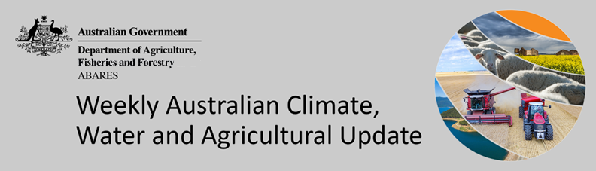
No. 36/2022

15 September 2022

Summary of key issues
- For the week ending 14 September 2022, tropical moisture combined with cold fronts brought significant rainfall over large parts of eastern and southern Australia. Weekly rainfall totals exceeding 50 millimetres were recorded in alpine areas of New South Wales and Victoria, inland parts of southern Queensland as well as isolated parts of South Australia and Tasmania. Meanwhile, high-pressure systems over remaining parts of the country resulted in clear, dry conditions (see Section 1.1).
- This week the Australian Bureau of Meteorology announced that a third consecutive La Niña event has become established in the tropical Pacific Ocean. For winter crops across eastern Australia, current soil moisture levels are generally sufficient to support strong yield potentials. However, above average rainfall through spring is likely to disrupt the maturation and harvesting of crops, as well as contributing to waterlogging, quality downgrades and lodging. Further significant rainfall through spring may also interrupt the planting of summer crops. For summer crops that are planted, the added soil moisture will support yield potentials (see Section 1.2).
- Below average rainfall globally during August is likely to result in lower-than-expected wheat production potential in Argentina, the European Union, and parts of the Russian Federation. Further, the conflict in Ukraine continues to generate uncertainty around wheat, corn and sunflower production for 2022. Below average rainfall and above average temperatures in recent months have also negatively affected corn production across parts of Argentina, Brazil, the European Union and the United States. Global production conditions have deteriorated compared to those used to formulate ABARES forecasts of global grain supplies and world prices in its September 2022 edition of the Agricultural Commodities Report. As a result, global grain and oilseed production is likely to be lower than that forecast earlier in September (see Section 1.3).
- Over the 8-days to 22 September 2022, troughs, low-pressure and frontal systems are forecast to result in showers and scattered storms across south-eastern Australia. High-pressure systems will provide clear, dry conditions across remaining parts of the country. Waterlogging and frost events remain the biggest potential downside risk to yields over the coming weeks. For the most part, above average soil moisture levels will support strong yield potentials, with crops flowering and grain filling during early spring. In Central Queensland, harvesting of winter crops and planting of long-season summer crops will get underway in the coming weeks (see Section 1.4).
- Water storage in the Murray–Darling Basin (MDB) increased by 231 gigalitres (GL) between 7 September 2022 and 14 September 2022. The current volume of water held in storage is 23,472 GL, which represents 93% of total capacity. This is 9% or 1,898 GL more than at the same time last year.
- Allocation prices in the Victorian Murray below the Barmah Choke increased from $53 per ML on 2 September 2022 to $60 per ML on 9 September 2022. Prices are lower in the Goulburn-Broken and regions above the Barmah choke due to the binding of the Goulburn intervalley trade limit and the Barmah choke trade constraint.

Climate

Rainfall this week
For the week ending 14 September 2022, tropical moisture combined with cold fronts brought significant rainfall over large parts of eastern and southern Australia. Weekly rainfall totals exceeding 50 millimetres were recorded in alpine areas of New South Wales and Victoria, inland parts of southern Queensland as well as isolated parts of South Australia and Tasmania. Meanwhile, high-pressure systems over remaining parts of the country resulted in clear, dry conditions.
In Australian cropping regions, rainfall totals of between 10 and 50 millimetres were recorded across New South Wales, Queensland, Victoria, South Australia and isolated parts of Western Australia. Rainfall in excess of 50 millimetres was recorded in cropping regions in south-eastern New South Wales, southern Queensland and central South Australia. Little to no rainfall was recorded in remaining cropping regions of Western Australia for the week ending 14 September 2022.
Moderate to heavy rainfall across New South Wales and Queensland adds to already saturated soils in some regions, exacerbating waterlogging in low lying areas and negatively impacting winter crop development. In Central Queensland, the recent rainfalls will have delayed the harvesting of early-sown winter crops and sowing of long-lived summer crops. Growers will be looking to increase harvesting and sowing activity over the coming weeks if conditions allow. Excessively wet conditions can cause quality downgrades and lodging in unharvested mature crops.
In other cropping regions across south-eastern Australia, the recent rainfall will have boosted plant available moisture. As winter crops approach flowering and grain filling during spring, soil moisture levels will be critical to supporting yield potentials. In Western Australia, rainfall in recent weeks has also boosted soil moisture levels heading into spring. However, nationally the wet conditions have increased fungal disease pressure for winter crops, which may negatively impact yield potentials if not managed.

Rainfall for the week ending 14 September 2022
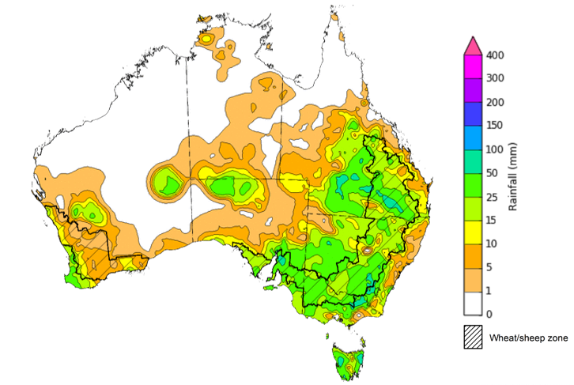
©Commonwealth of Australia 2022, Australian Bureau of Meteorology Issued:14/09/2022
Note: The rainfall analyses and associated maps utilise data contained in the Bureau of Meteorology climate database, the Australian Data Archive for Meteorology (ADAM). The analyses are initially produced automatically from real-time data with limited quality control. They are intended to provide a general overview of rainfall across Australia as quickly as possible after the observations are received. For further information go to http://www.bom.gov.au/climate/rainfall/

La Niña event underway
This week the Australian Bureau of Meteorology announced that a third consecutive La Niña event has become established in the tropical Pacific Ocean. Sea surface temperatures across the equatorial Pacific have been cooling since June and have now met the La Niña threshold. Meanwhile, atmospheric indicators, such as the Southern Oscillation Index, have maintained a La Niña-like pattern since the dissipation of the last event in autumn 2022. Climate models suggest that the current La Niña event may peak during spring and dissipate in early 2023.

The strengthening of trade winds and the increase in sea surface temperatures to the north of Australia contribute to above average cloudiness and rainfall across eastern Australia during spring. The persistence of La Niña climatic patterns through summer can also contribute to above average summer rainfall. For winter crops across eastern Australia, current soil moisture levels are generally sufficient to support strong yield potentials. However, above average rainfall through spring is likely to disrupt the maturation and harvesting of crops, as well as contributing to waterlogging, quality downgrades and lodging. Further significant rainfall through spring may also interrupt the planting of summer crops. For summer crops that are planted, the added soil moisture will support yield potentials.

La Niña’s impact on the Australian climate through spring
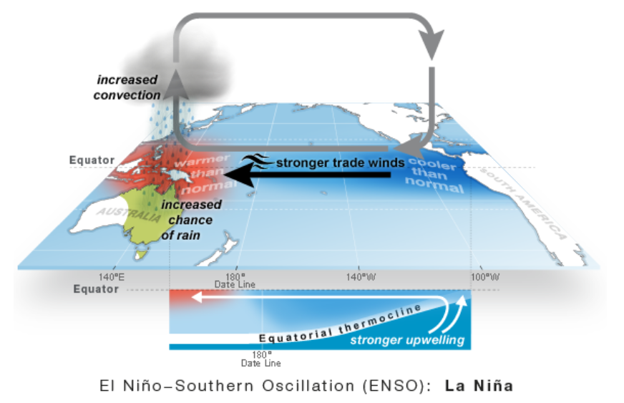
©Commonwealth of Australia 2022, Australian Bureau of Meteorology

Global production conditions and climate outlook
Crop production is affected by long-term trends in average rainfall and temperature, interannual climate variability, shocks during specific growth stages, and extreme weather events (IPCC 2012). Some crops are more tolerant than others to certain types of stresses, and at each growth stage, different types of stresses affect each crop species in different ways.
The precipitation anomalies and outlooks presented here give an indication of the current and future state of production conditions for the major grain and oilseed producing countries which are responsible for over 80% of global production. This is an important input to assessing the global grain supply outlook.
August precipitation percentiles and current production conditions
As of the end of August 2022, rainfall was mixed for the world’s major grain-producing and oilseed-producing regions.
In the northern hemisphere, precipitation was below average across parts of central United States, northern areas of the European Union, western areas of the Russian Federation, western Canada and parts of southern-eastern China. Precipitation was above average for parts of eastern and south-western United States and north-eastern and western China. Precipitation was close to average across the remainder of the major grain-producing and oilseed-producing regions in the northern hemisphere.
In the southern hemisphere, August precipitation was below average for parts of southern Argentina. Precipitation was above average for parts of western and eastern Australia and the southwest of Brazil. Precipitation was close to average across the remainder of major grain-producing and oilseed-producing regions in the southern hemisphere.

Global precipitation percentiles, August 2022

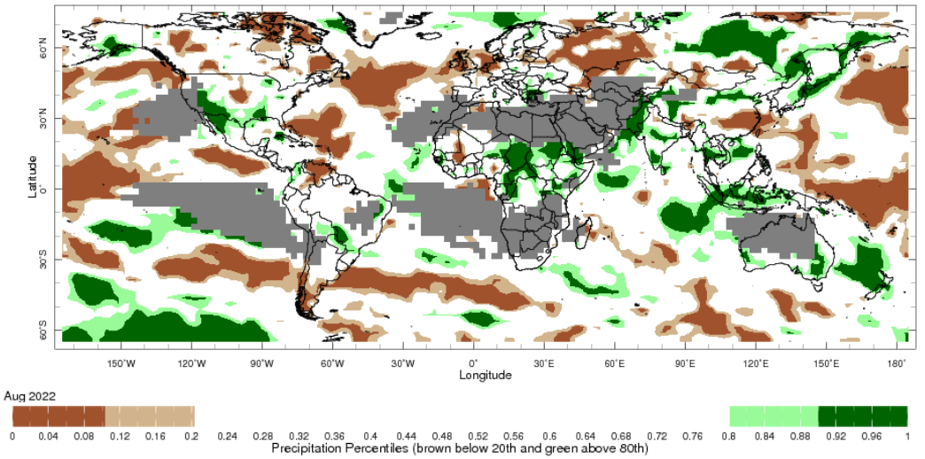
Note: The world precipitation percentiles indicate a ranking of precipitation for August, with the driest (0th percentile) being 0 on the scale and the wettest (100th percentile) being 1 on the scale. Percentiles are based on precipitation estimates from the NOAA Climate Prediction Center's Climate Anomaly Monitoring System Outgoing Precipitation Index dataset. Precipitation estimates for August 2022 are compared with rainfall recorded for that period during the 1981 to 2010 base period.
Source: International Research Institute for Climate and Society
As at 28 August 2022 global production conditions were generally favourable for soybeans, but quite variable for the production of wheat, rice and corn.
In the northern hemisphere production conditions for wheat have been mixed. Climatic conditions have been favourable for wheat harvesting in Canada, China, Turkey and the United Kingdom. Production conditions were variable for the European Union, the Russian Federation and the United States with dryness and excess heat in some areas negatively affecting yield prospects. In the Ukraine, the ongoing war has reduced yields in areas impacted by conflict, but yields have been good elsewhere. In the southern hemisphere, production conditions are generally favourable in Australia. However, in Argentina dry conditions continue to be a concern, with recent rainfall improving conditions in some regions.
In Argentina, harvesting of late-planted corn crops is drawing to a close under favourable conditions with mixed yields, while sowing of early-planted corn is proceeding under dry conditions. In Brazil, harvesting nears the end for the summer-planted crop under favourable conditions in most regions. In Mexico, sowing for the spring-summer season is continuing under favourable conditions. In the European Union, China and the United States, growing conditions are mixed, with hot and dry conditions negatively affecting yield prospects in some regions, while conditions in other areas remain favourable. In India sowing of the Kharif crop is complete and conditions appear favourable. In Ukraine, production conditions remain mixed due hot, dry conditions and the ongoing war in southern and eastern regions.
Extreme heat and dry conditions in China’s Yangtze River basin are negatively impacting yield potentials for single-season and late-season rice. Meanwhile, growing conditions remain favourable in other regions. In the Philippines and Thailand, plant growth of wet-season rice is continuing under generally favourable conditions, with harvest beginning for early sown crops in the Philippines. In Thailand the total sown area is expected to have increased compared to last year due to ample rainfall. In Vietnam, the harvest of winter-spring rice is ongoing in the north while the sowing of summer-autumn rice begins under favourable conditions. In Indonesia, harvesting of wet-season rice is wrapping up as dry season sowing begins under favourable conditions. In India, transplanting of the Kharif rice crop is mostly complete under favourable conditions, with total area down on last year.
In the United States, growing conditions remain generally favourable for soybeans, although hot, dry conditions across western growing regions are starting to negatively impact crops. In Canada, dry conditions have eased over parts of Ontario, while conditions remain favourable in other parts of the country. In China and India, conditions are favourable, with total sown area having increased in China but remaining steady in India. In Ukraine, climatic conditions remain supportive of plant growth in western, central and northern regions, while hot, dry weather and the war continues to bring uncertainties in eastern and southern areas.
Crop conditions, AMIS countries, 28 August 2022
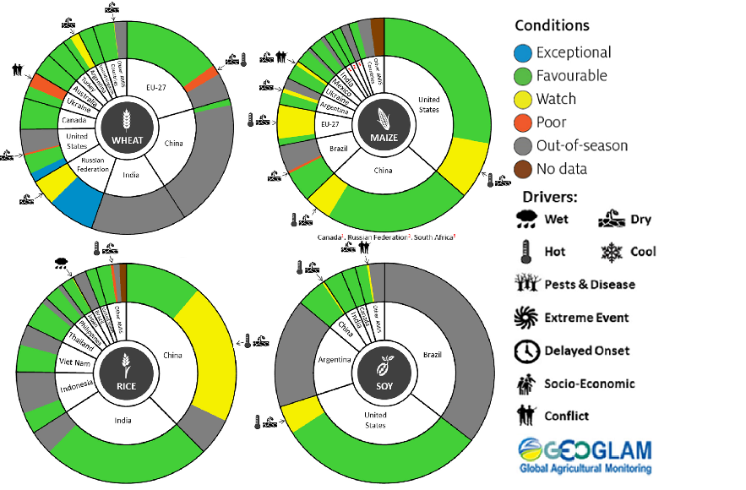
AMIS Agricultural Market Information System.
Source: AMIS
The global climate outlook for October 2022 to December 2022 indicates that variable rainfall conditions are expected for the world's major grain-producing and oilseed-producing regions. Outlooks and potential production impacts for the major grain and oilseed producing countries are presented in the table.
Rainfall outlook and potential impact on the future state of production conditions between October 2022 to December 2022
Region | October- December rainfall outlook | Potential impact on production
Argentina | Below average rainfall is expected across most of Argentina between October to December 2022. | Below average rainfall is likely to adversely affect the heading and grain development of wheat and the planting and establishment of cotton and late-planted corn in October. These conditions may also adversely impact early corn silking, and the flowering of cotton and late corn in November and December.
Black Sea Region | Below average rainfall is forecast for southern Kazakhstan, eastern Ukraine, and the southeast of the Russian Federation. For remaining areas there is no strong tendency towards either above or below average rainfall between October to December 2022. | Average rainfall is likely to support boll development and grain filling for cotton, corn and sunflower, as well as the development of winter wheat and canola in October. In November and December winter wheat and canola will enter dormancy, and average rainfall is likely to provide sufficient snowpack to prevent winterkill.
Brazil | Above average rainfall is more likely in northern and central Brazil, while below average rainfall is more likely across the south of Brazil. | Below average rainfall in parts of southern Brazil will provide favourable conditions for harvesting of wheat in October and November. However, below average rainfall is likely to adversely affect flowering of corn and soybeans in December. Above average rainfall in northern and central Brazil will benefit the planting and growth of soybeans and first crop corn.
Canada | Above average rainfall is expected across parts of Alberta, but there is no strong tendency towards below or above average rainfall across remaining parts of Canada between October to December 2022. | Average to above average rainfall may result in some delays in harvesting and grain quality concerns for canola, corn, soybean, spring wheat and sunflower in October and November. Average to above average rainfall is also likely to provide sufficient snowpack to prevent winterkill of winter wheat in December.
China | Above average rainfall is likely across central China and below average across western and eastern China in October to December 2022. | Below average rainfall in western and eastern China is likely to benefit the harvesting of cotton, corn, sorghum, soybean, sunflower, groundnuts and single rice. However, these conditions will likely negatively impact grain filling of late-sown rice in October and November.
Europe | Below average rainfall more likely for parts of south-eastern and south-western Europe between October to December 2022. | Below average rainfall may support harvesting of corn, cotton, sorghum, soybean and sunflower in south-eastern and south-western Europe. Average rainfall across the remainder of Europe is likely to benefit the planting of canola and winter wheat during October to December.
South Asia (India) | Above average rainfall between October to December 2022 is likely across much of India. | Average to above average rainfall is likely to benefit cotton boll formation in the south during October and the planting of canola and winter wheat in November. However, these conditions may impede harvesting of corn, sorghum, rice, millet, groundnuts and sunflower.
Southeast Asia (SEA) | A strong likelihood of above average rainfall is forecast across SEA between October to December 2022. | Above average rainfall in SEA is likely to impede corn and rice harvesting in October.
The United States of America | Above average rainfall is more likely for parts of the north-western US and below average rainfall is more likely across much of central, southern and eastern US. | Below average rainfall across central, southern and eastern US is likely to support harvesting of soybeans, sunflower, millet, cotton, rice, corn, sorghum and groundnuts in October and November. The average rainfall conditions expected across the northern US is likely to support establishment and growth of canola and winter wheat, as well as provide sufficient snow cover in December.

Rainfall forecast for the next eight days
Over the 8-days to 22 September 2022, troughs, low-pressure and frontal systems are forecast to result in showers and scattered storms across south-eastern Australia. High-pressure systems will provide clear, dry conditions across remaining parts of the country.
In Australian cropping regions, rainfall totals of between 10 and 50 millimetres are expected across New South Wales, southern Queensland, as well as most of Victoria and South Australia. Little to no rainfall is forecast for remaining cropping regions in eastern South Australia, north-western Victoria, and Western Australia during the next 8-days.
The moderate rainfall forecast across cropping regions in northern New South Wales and southern Queensland will increase risk of ongoing waterlogging across low-lying areas. These wet conditions will prolong the inability to access fields for disease management and top dressing. This may result in increased disease pressure and delays in the timely application of urea, presenting a potential downside risk to the current well above yield expectations in some growing regions.
Waterlogging and frost events remain the biggest potential downside risk to yields over the coming weeks. For the most part, above average soil moisture levels will support strong yield potentials, with crops flowering and grain filling during early spring. In Central Queensland, harvesting of winter crops and planting of long-season summer crops will get underway in the coming weeks. Central Queensland growers will be hoping for clear, dry conditions to facilitate timely planting and harvesting operations.

Total forecast rainfall (mm) for the period 15 September to 22 September 2022
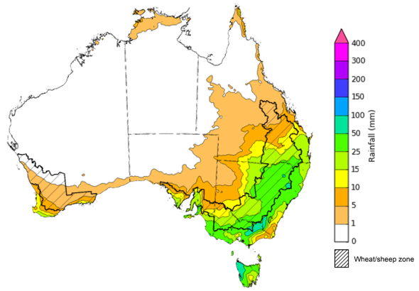
©Commonwealth of Australia 2022, Australian Bureau of Meteorology Issued 15/09/2022

Water
Note: This rainfall forecast is produced from computer models. As the model outputs are not altered by weather forecasters, it is important to check local forecasts and warnings issued by the Bureau of Meteorology.

Water markets – current week
Water storage in the Murray–Darling Basin (MDB) increased by 231 gigalitres (GL) between 7 September 2022 and 14 September 2022. The current volume of water held in storage is 23,472 GL, which represents 93% of total capacity. This is 9% or 1,898 GL more than at the same time last year.

Water storages in the Murray-Darling Basin, 2013–2022
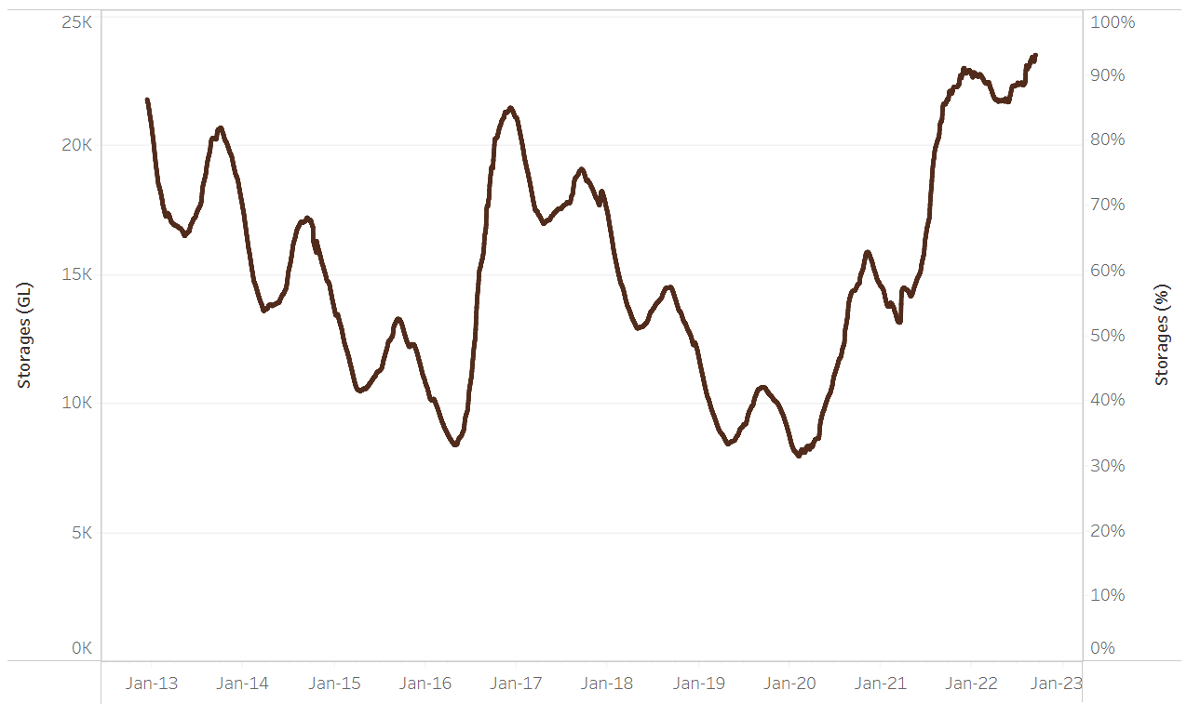
Allocation prices in the Victorian Murray below the Barmah Choke increased from $53 per ML on 2 September 2022 to $60 per ML on 9 September 2022. Prices are lower in the Goulburn-Broken and regions above the Barmah choke due to the binding of the Goulburn intervalley trade limit and the Barmah choke trade constraint.
Water storage data is sourced from the Bureau of Meteorology.

Region | $/ML
NSW Murray Above | 28
NSW Murrumbidgee | 142
VIC Goulburn-Broken | 40
VIC Murray Below | 60

Surface water trade activity, Southern Murray–Darling Basin

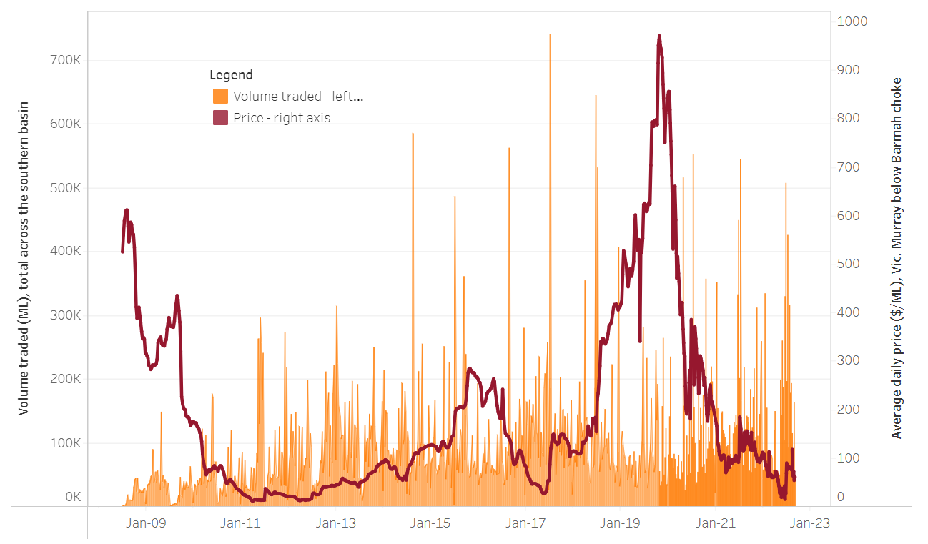
To access the full, interactive, weekly water dashboard, which contains the latest and historical water storage, water market and water allocation information, please visit http://www.agriculture.gov.au/abares/products/weekly_update/weekly-update-150922
The trades shown reflect estimated market activity and do not encompass all register trades. The price is shown for the VIC Murray below the Barmah choke. Historical prices (before 1 July 2019) are ABARES estimates after removing outliers from BOM water register data. Prices after 1 July 2019 and prior to the 30 October 2019 reflect recorded transaction prices as sourced from Ruralco. Prices after the 30 October 2019 are sourced from Waterflow. Data for volume traded is sourced from the BOM water register. Data shown is current at 15 September 2022.

Commodities

Indicator | Week ended | Unit | Latest price | Previous week | Weekly change | Price 12 months ago | Annual change
Selected world indicator prices
AUD/USD Exchange rate | 14-Sep | A$/US$ | 0.69 | 0.69 | 1% | 0.73 | -5%
Wheat – US no. 2 hard red winter wheat, fob Gulf | 14-Sep | US$/t | 425 | 386 | 10% | 345 | 23%
Corn – US no. 2 yellow corn, fob Gulf | 14-Sep | US$/t | 327 | 322 | 1% | 237 | 38%
Canola – Rapeseed, Canada, fob Vancouver | 14-Sep | US$/t | 651 | 665 | -2% | 755 | -14%
Cotton – Cotlook 'A' Index | 14-Sep | USc/lb | 124 | 122 | 2% | 101 | 22%
Sugar – Intercontinental Exchange, nearby futures, no.11 contract | 14-Sep | USc/lb | 18.0 | 17.9 | 0% | 20 | -10%
Wool – Eastern Market Indicator | 07-Sep | Ac/kg clean | 1,306 | 1,330 | -2% | 1,423 | -8%
Wool – Western Market Indicator | 10-Aug | Ac/kg clean | 1,459 | 1,449 | 1% | 1,346 | 8%
Selected Australian grain export prices
Milling Wheat – APW, Port Adelaide, SA | 14-Sep | A$/t | 540 | 538 | 0% | 430 | 26%
Feed Wheat – ASW, Port Adelaide, SA | 14-Sep | A$/t | 495 | 495 | 0% | 425 | 16%
Feed Barley – Port Adelaide, SA | 14-Sep | A$/t | 456 | 459 | -1% | 350 | 31%
Canola – Kwinana, WA | 14-Sep | A$/t | 1,027 | 1,022 | 0% | 868 | 18%
Grain Sorghum – Brisbane, QLD | 14-Sep | A$/t | 439 | 435 | 1% | 364 | 20%
Selected domestic livestock indicator prices
Beef – Eastern Young Cattle Indicator | 14-Sep | Ac/kg cwt | 1,042 | 1,034 | 1% | 1,003 | 4%
Mutton – Mutton indicator (18–24 kg fat score 2–3), Vic | 14-Sep | Ac/kg cwt | 559 | 548 | 2% | 636 | -12%
Lamb – Eastern States Trade Lamb Indicator | 14-Sep | Ac/kg cwt | 746 | 727 | 3% | 893 | -16%
Pig – Eastern Seaboard (60.1–75 kg), average of buyers & sellers | 10-Aug | Ac/kg cwt | 378 | 378 | 0% | 318 | 19%
Goats – Eastern States (12.1–16 kg) | 29-Jun | Ac/kg cwt | 1,030 | 879 | 17% | 818 | 26%
Live cattle – Light steers ex Darwin to Indonesia | 17-Aug | Ac/kg lwt | 420 | 480 | -13% | 320 | 31%
Live sheep – Live wethers (Muchea WA saleyard) to Middle East | 14-Sep | $/head | 93 | 113 | -18% | 114 | -18%

Indicator | Week ended | Unit | Latest price | Previous week | Weekly change | Price 12 months ago | Annual change
Global Dairy Trade (GDT) weighted average prices ª
Dairy – Whole milk powder | 07-Sep | US$/t | 3,610 | 3,417 | 6% | 2,936 | 23%
Dairy – Skim milk powder | 07-Sep | US$/t | 3,575 | 3,524 | 1% | 2,608 | 37%
Dairy – Cheddar cheese | 07-Sep | US$/t | 5,046 | 5,005 | 1% | 3,442 | 47%
Dairy – Anhydrous milk fat | 07-Sep | US$/t | 5,677 | 4,990 | 14% | 3,873 | 47%
a Global Dairy Trade prices are updated twice monthly on the first and third Tuesday of each month.

Selected world indicator prices
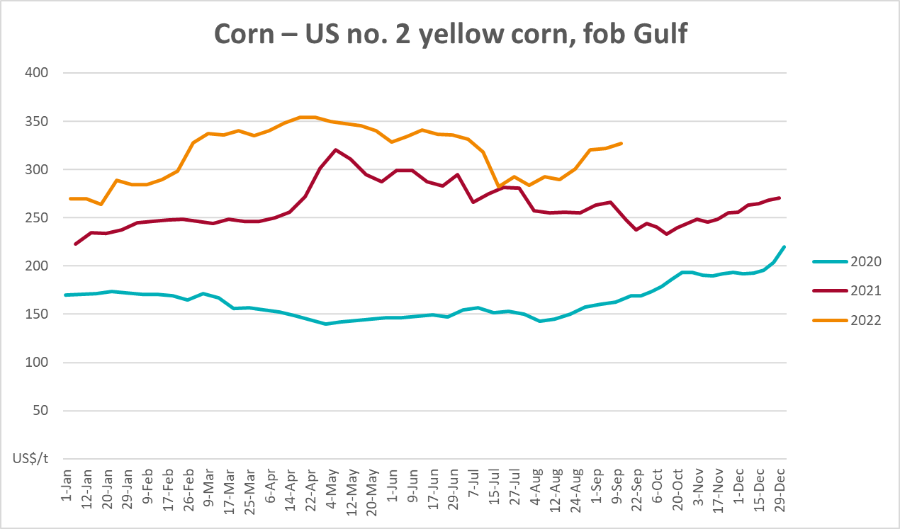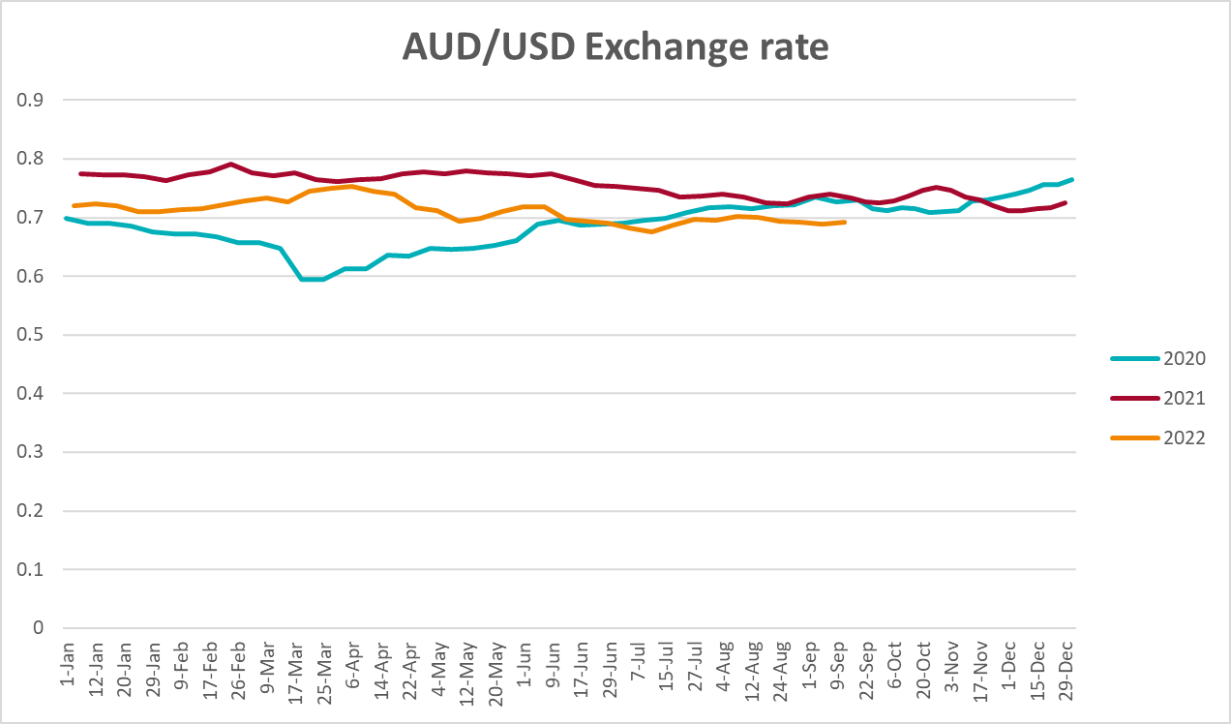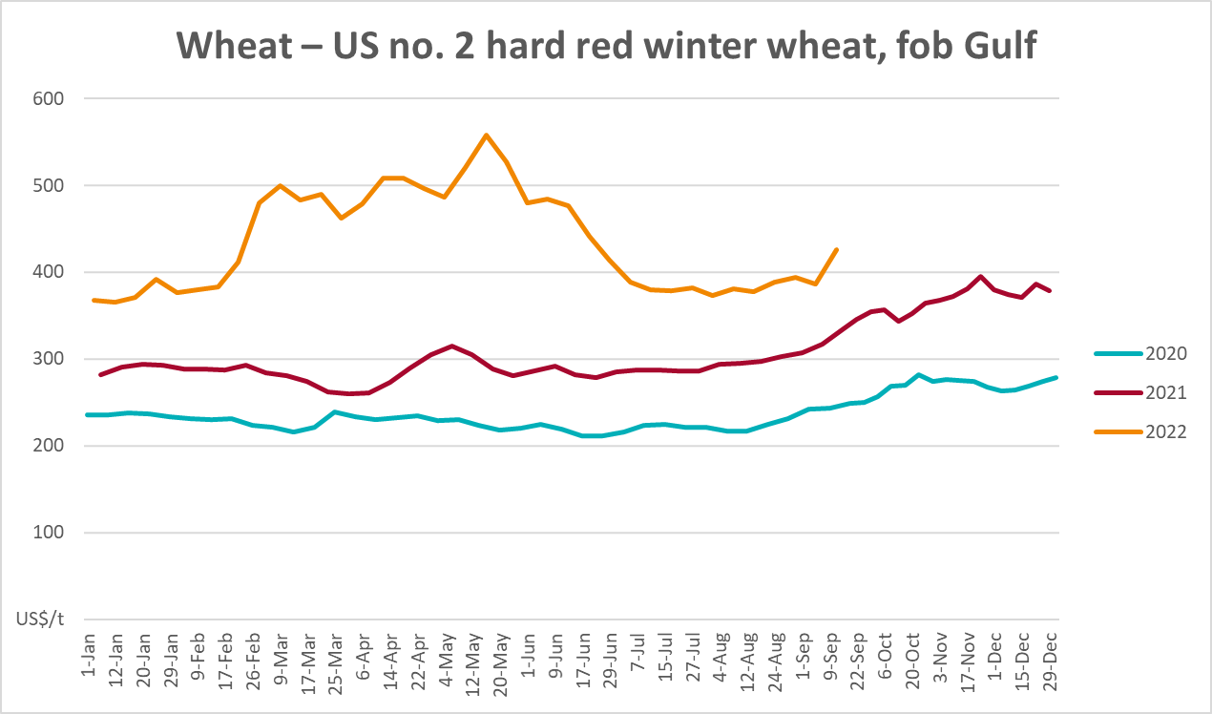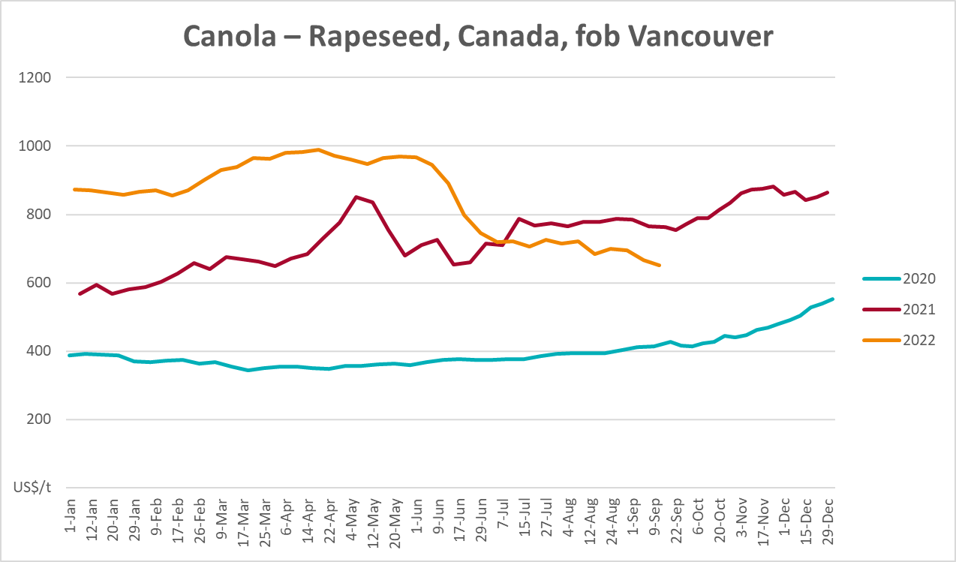
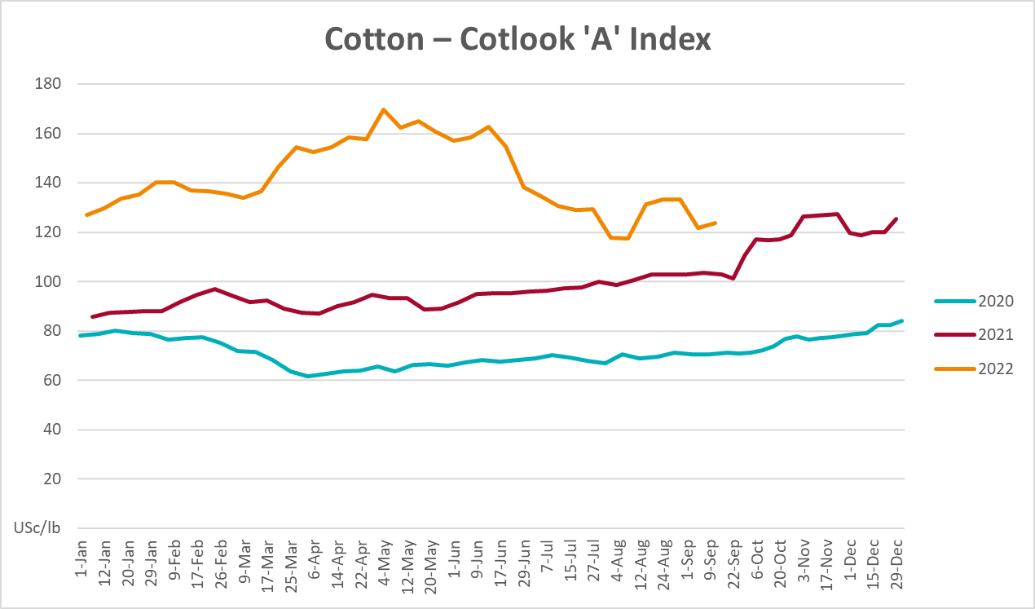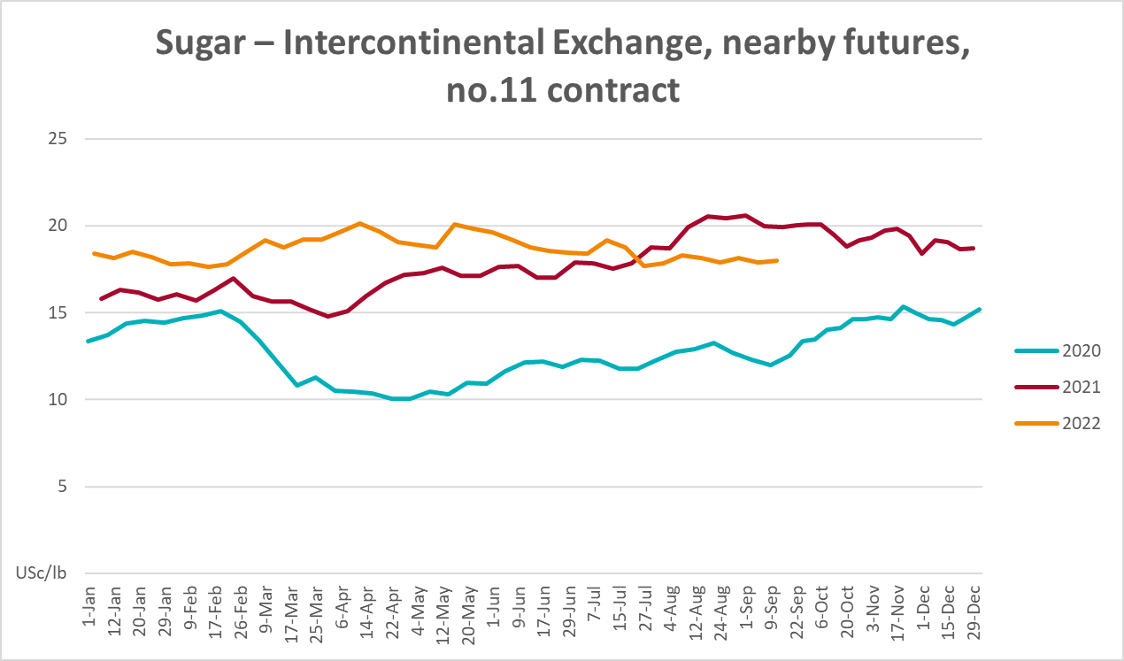
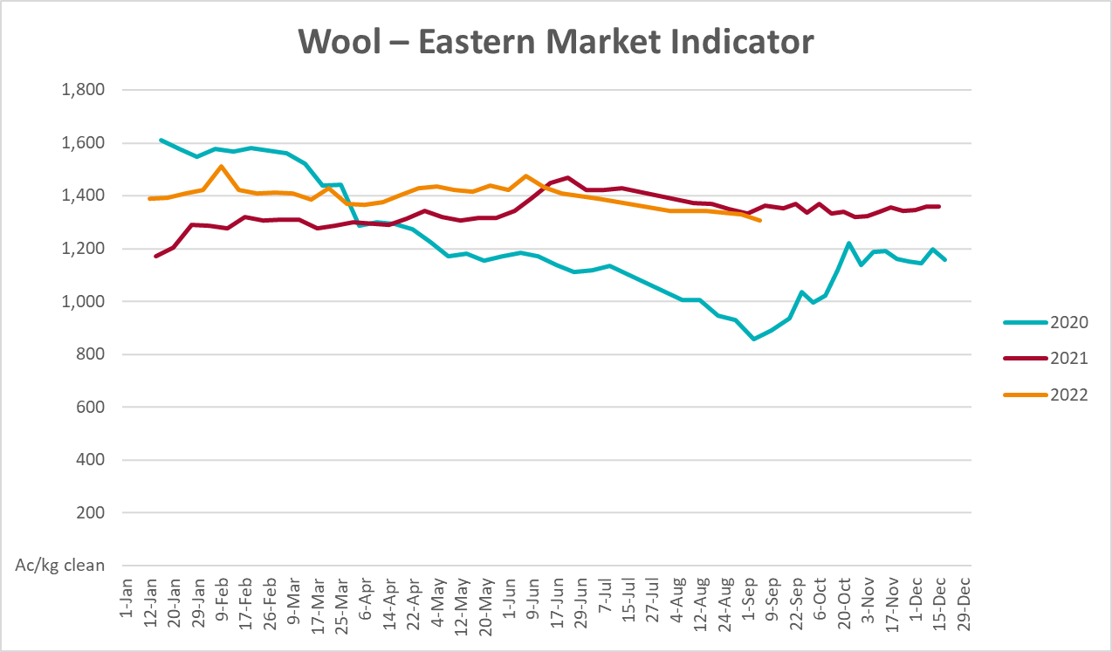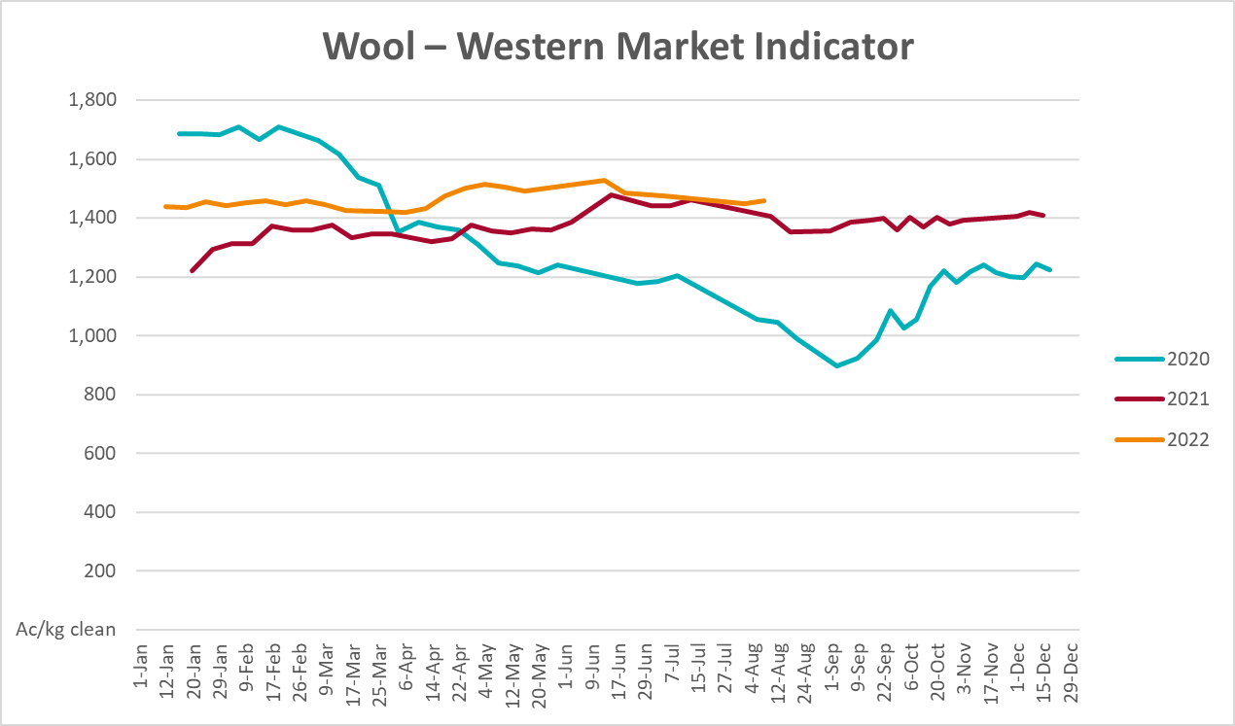

Selected domestic crop indicator prices
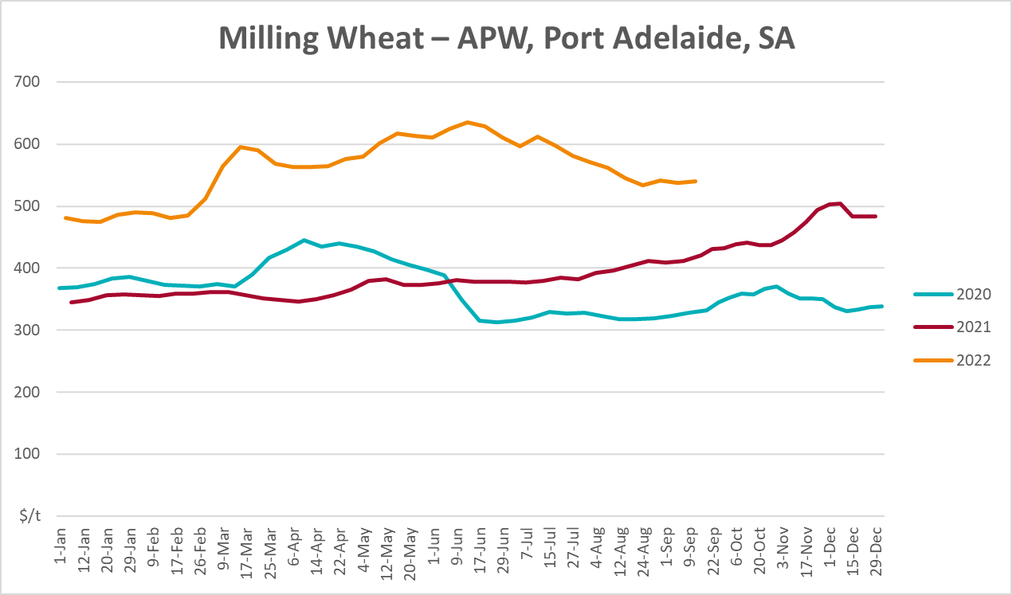
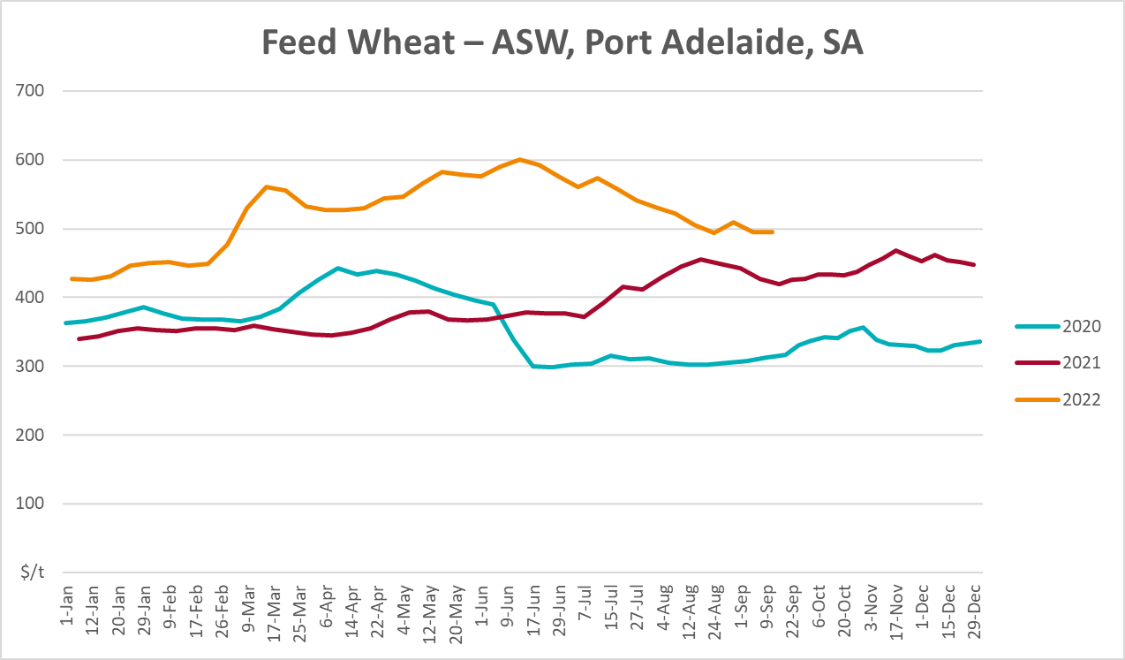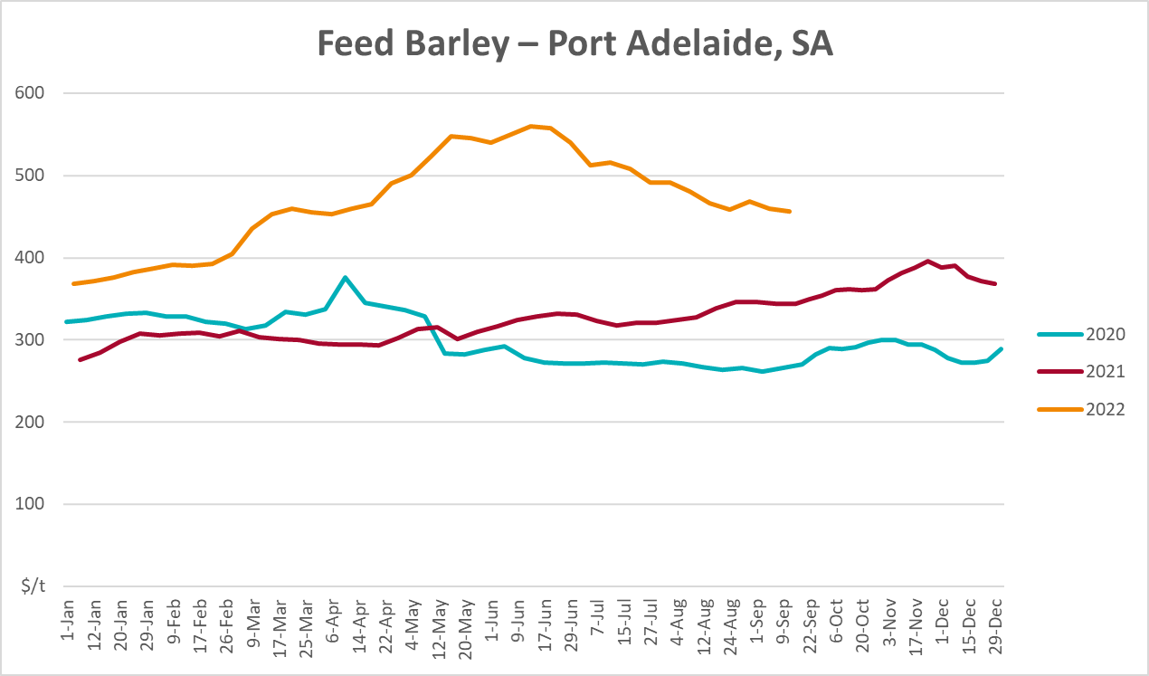
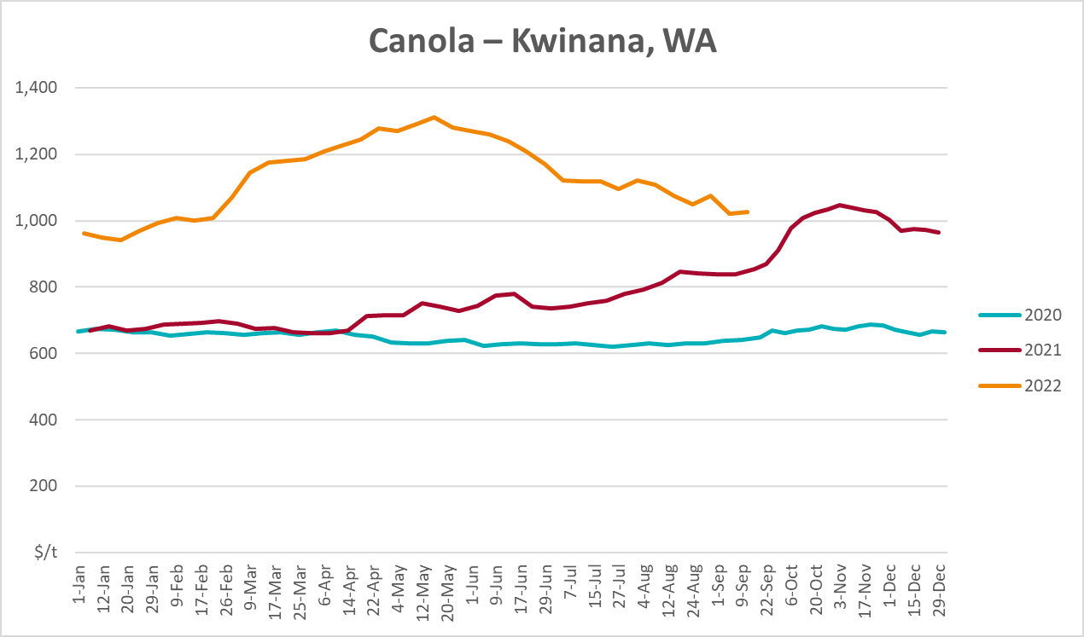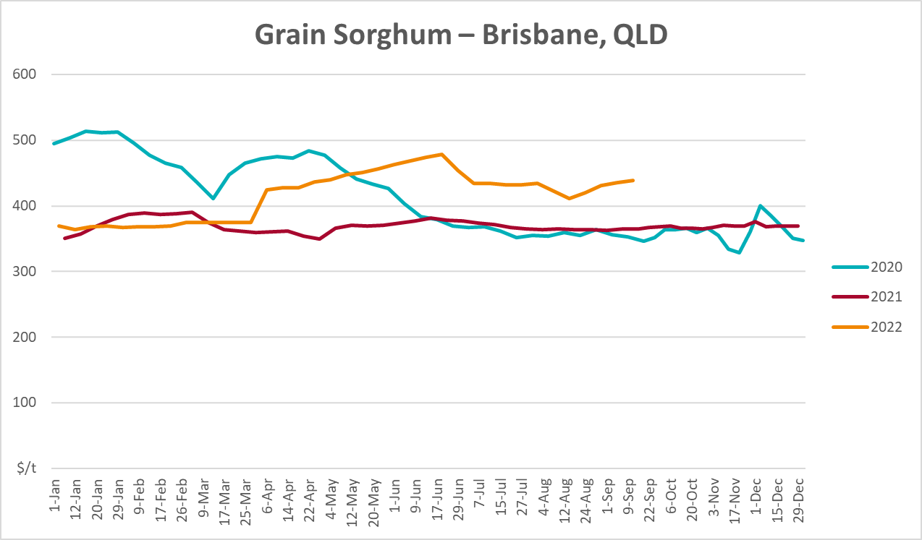

Selected domestic livestock indicator prices
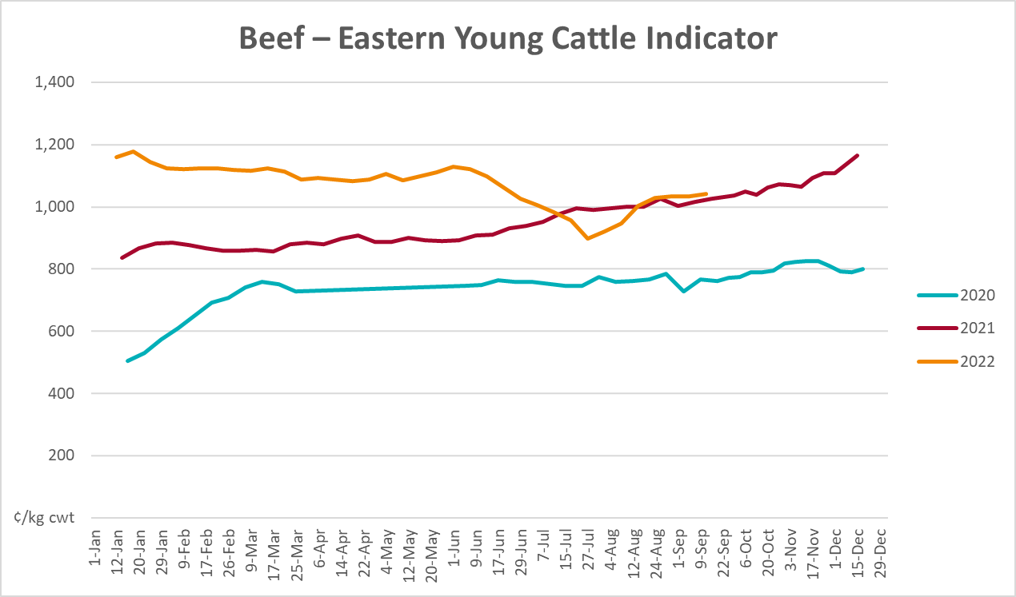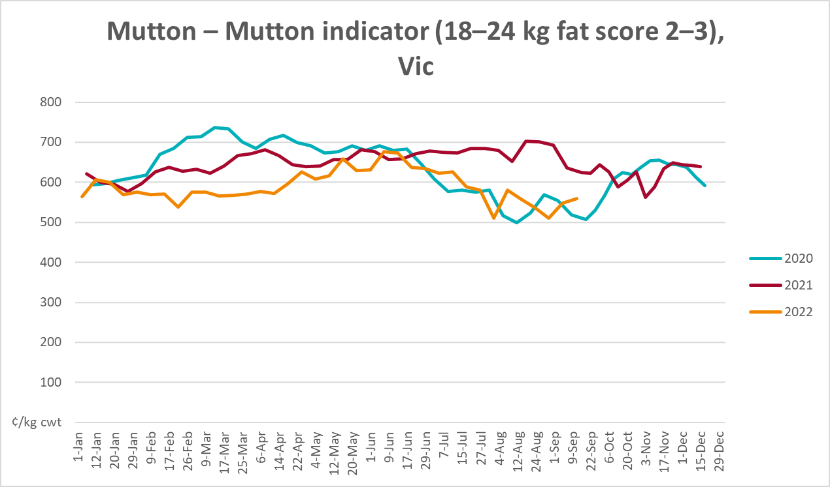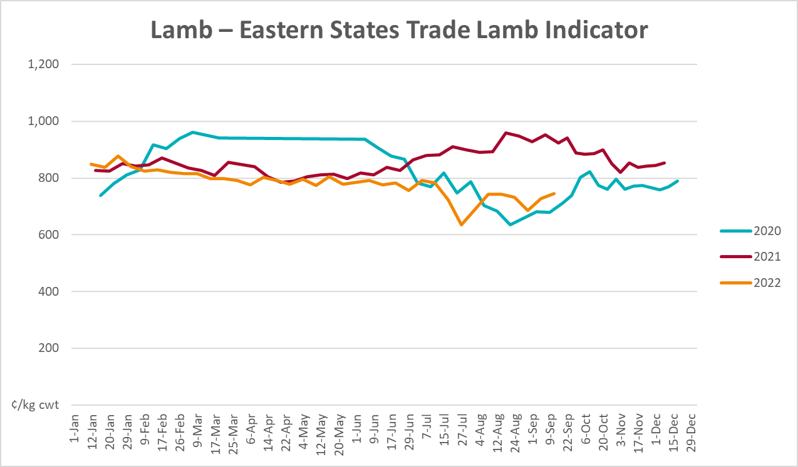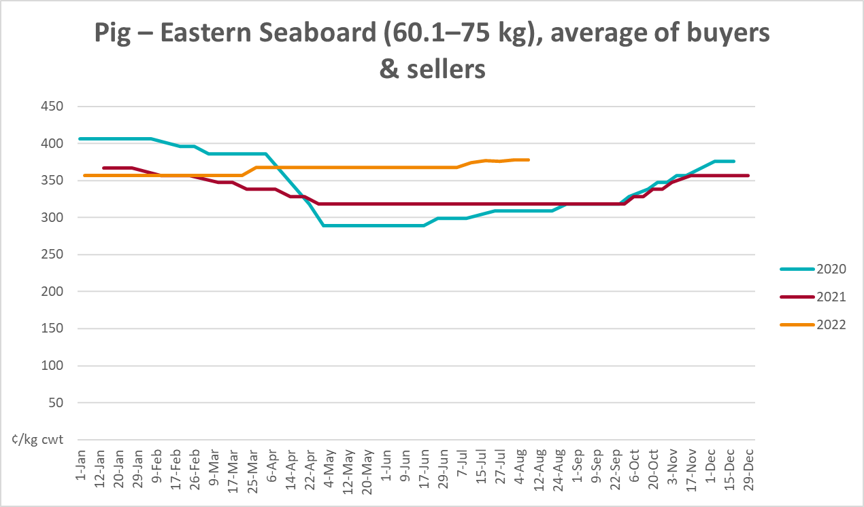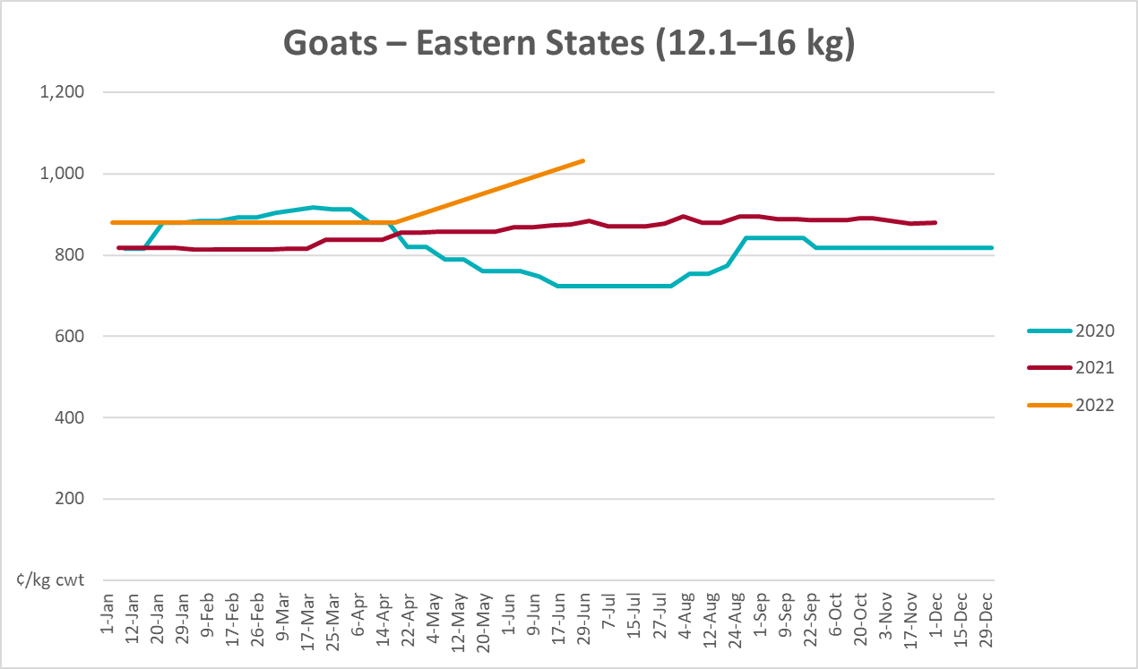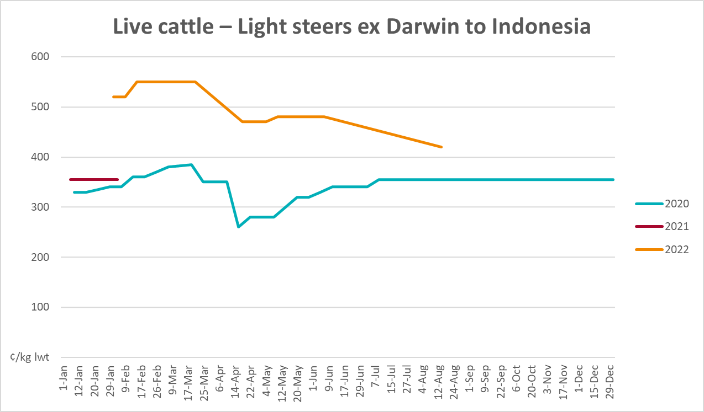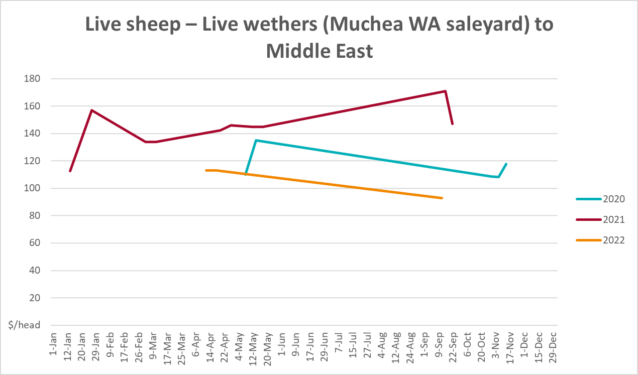

Global Dairy Trade (GDT) weighted average prices
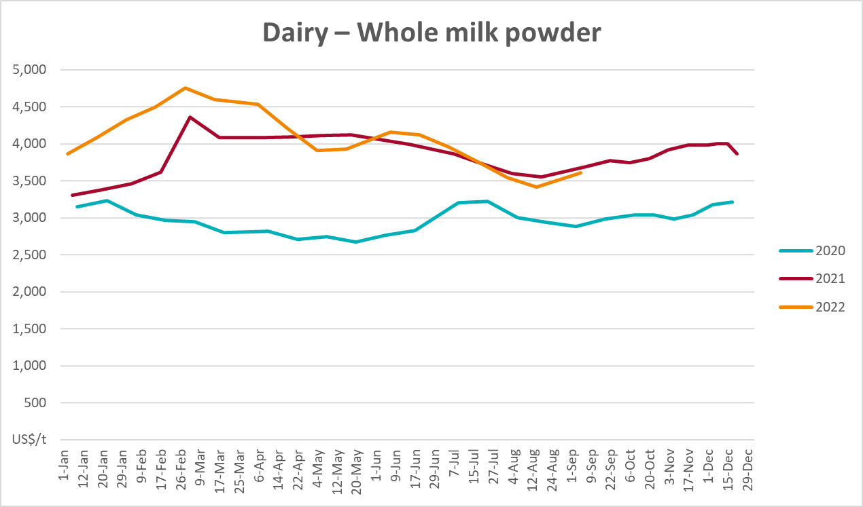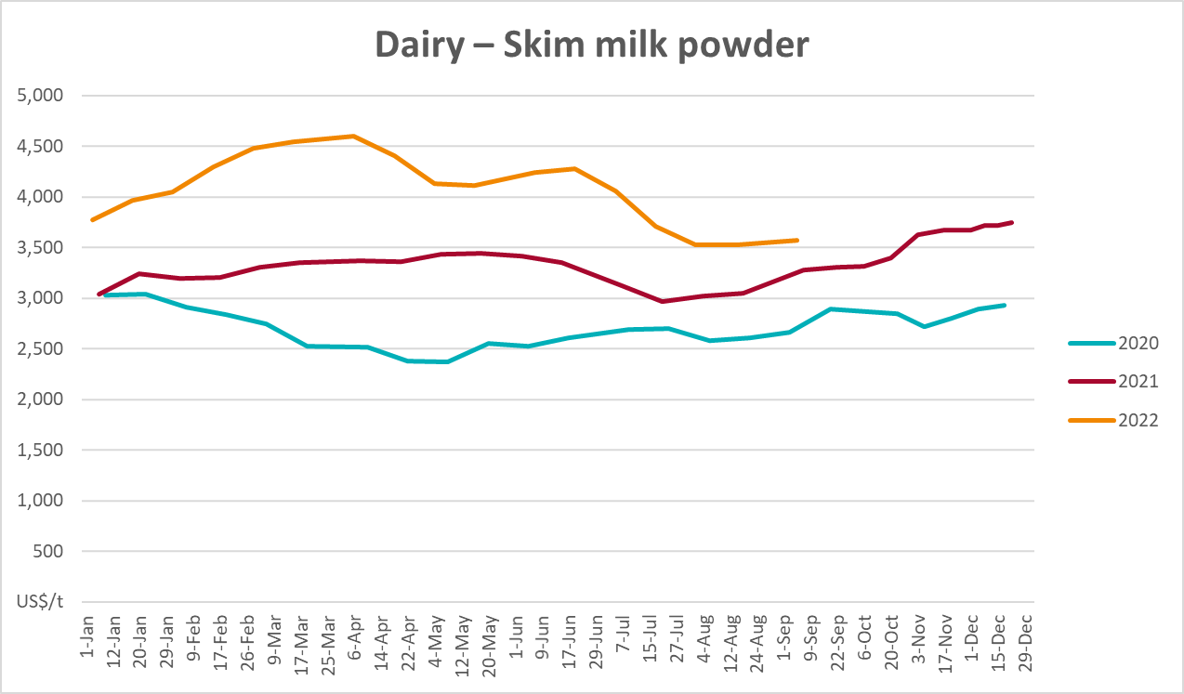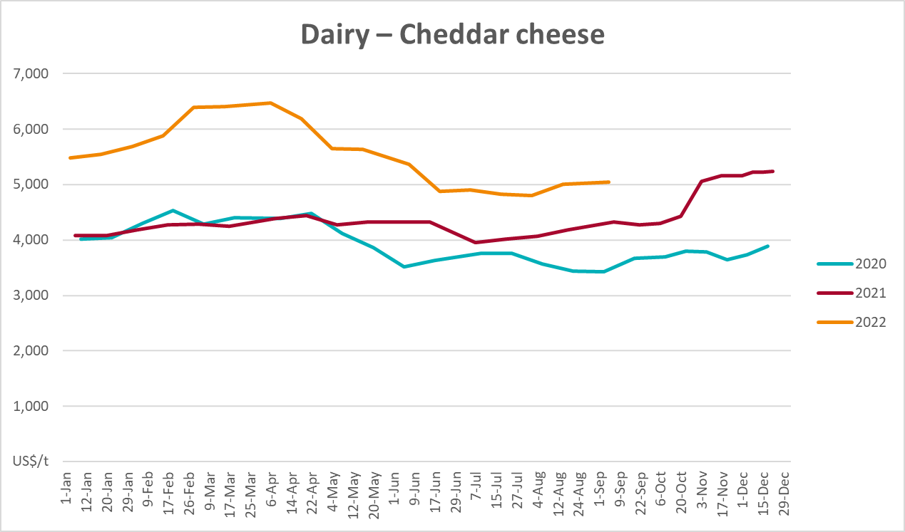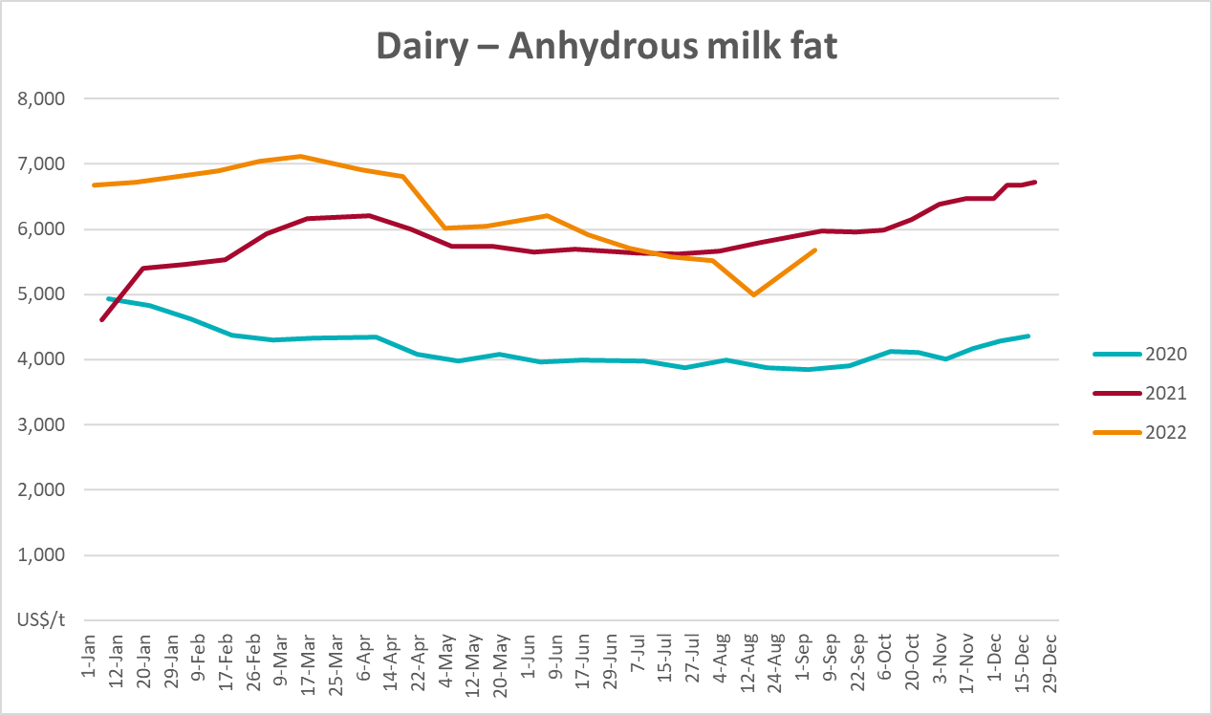

Selected fruit and vegetable prices
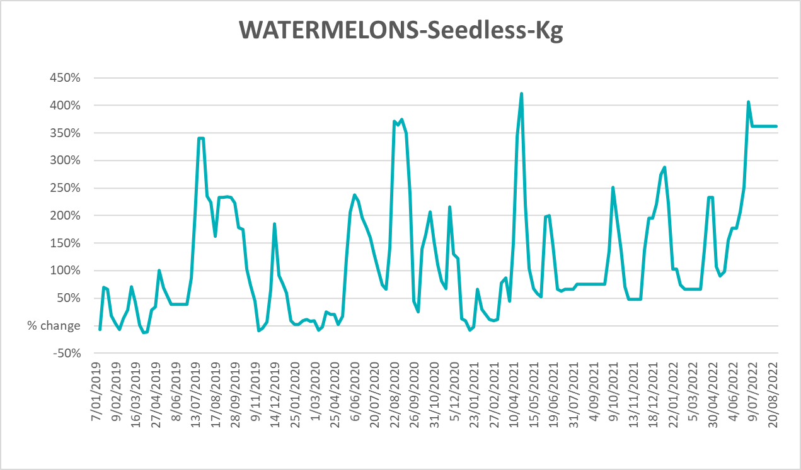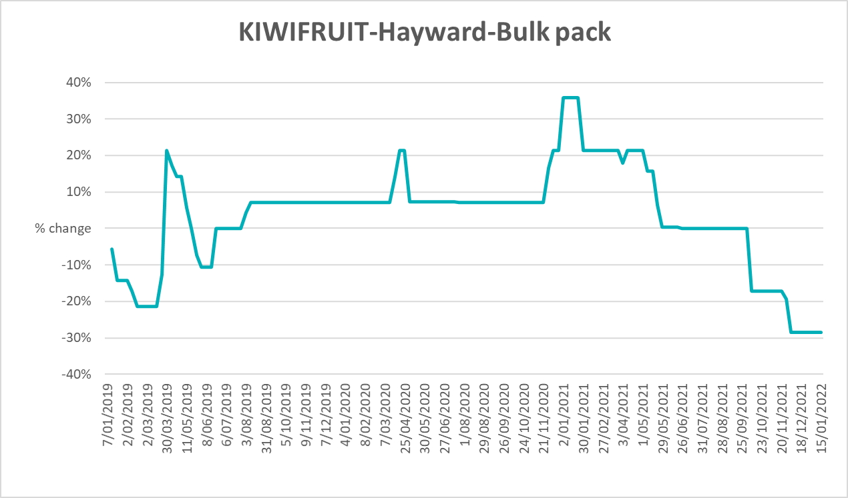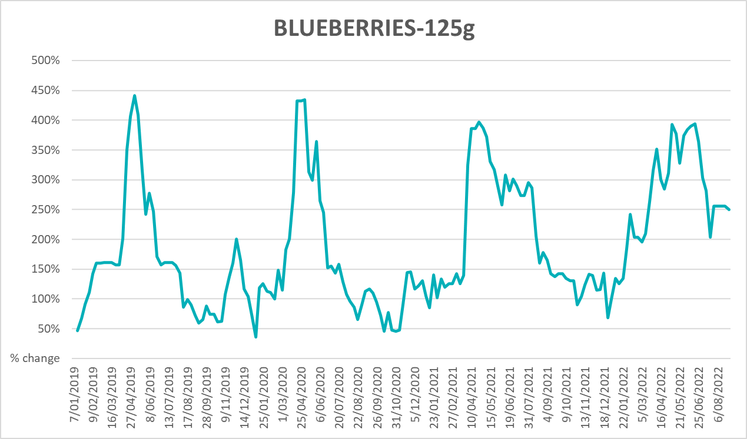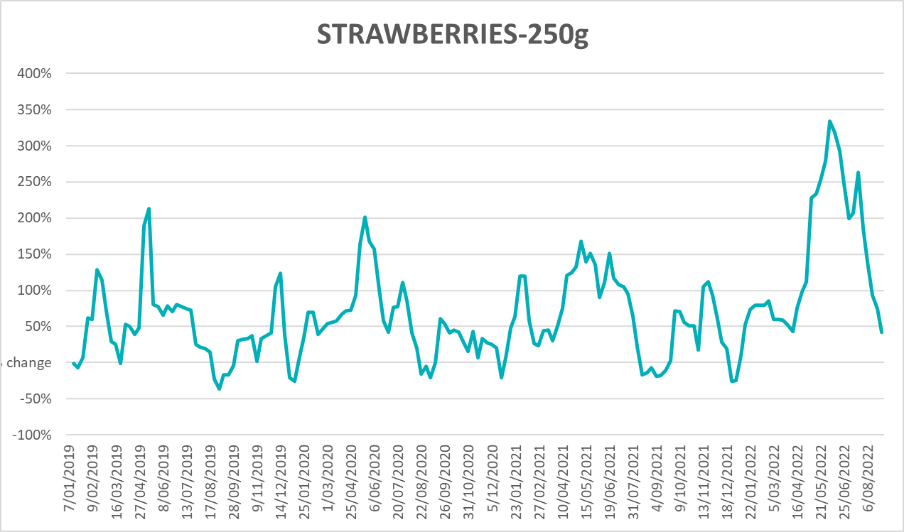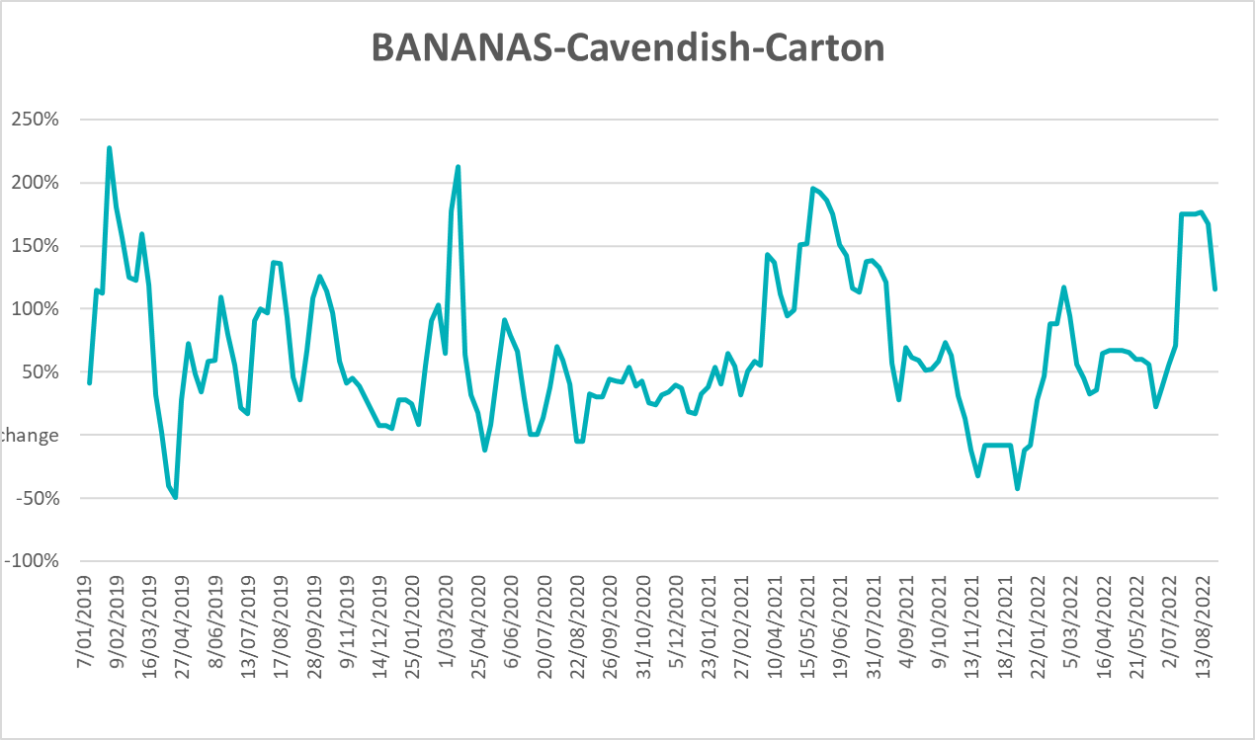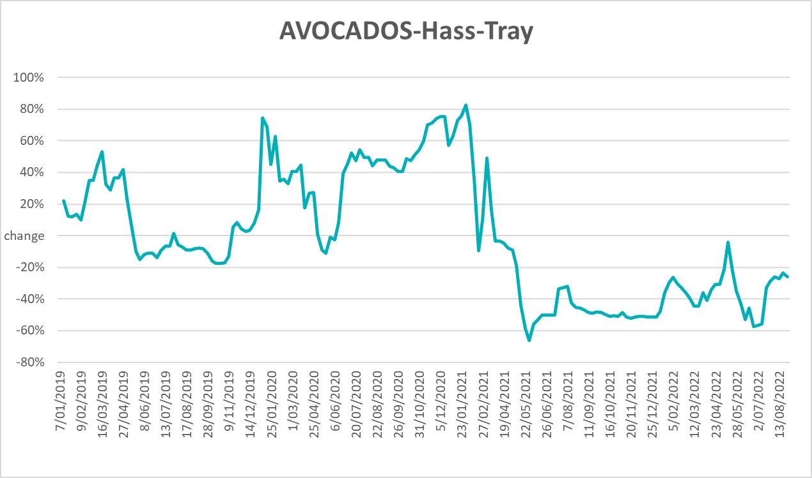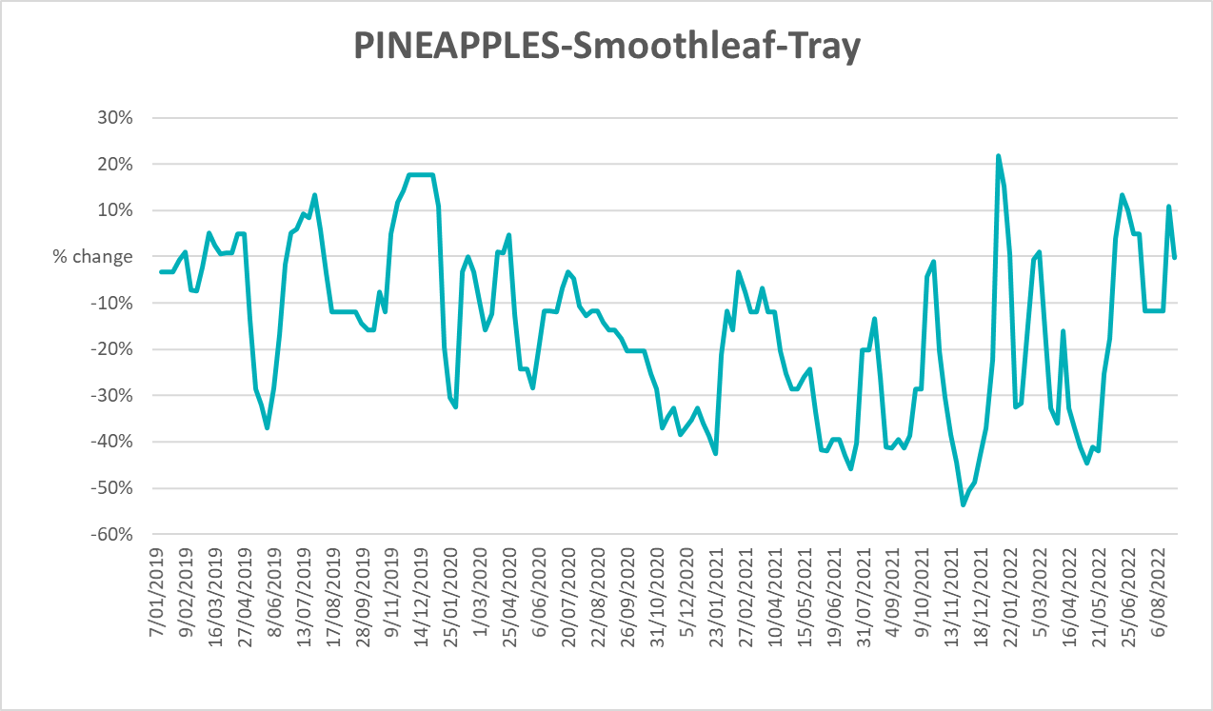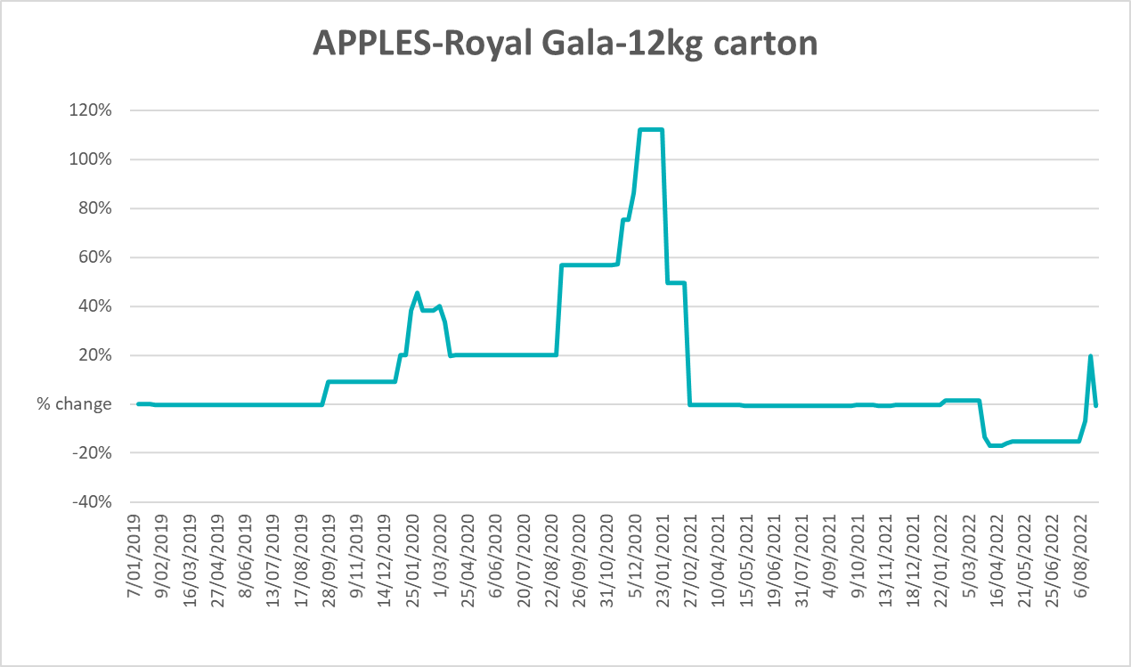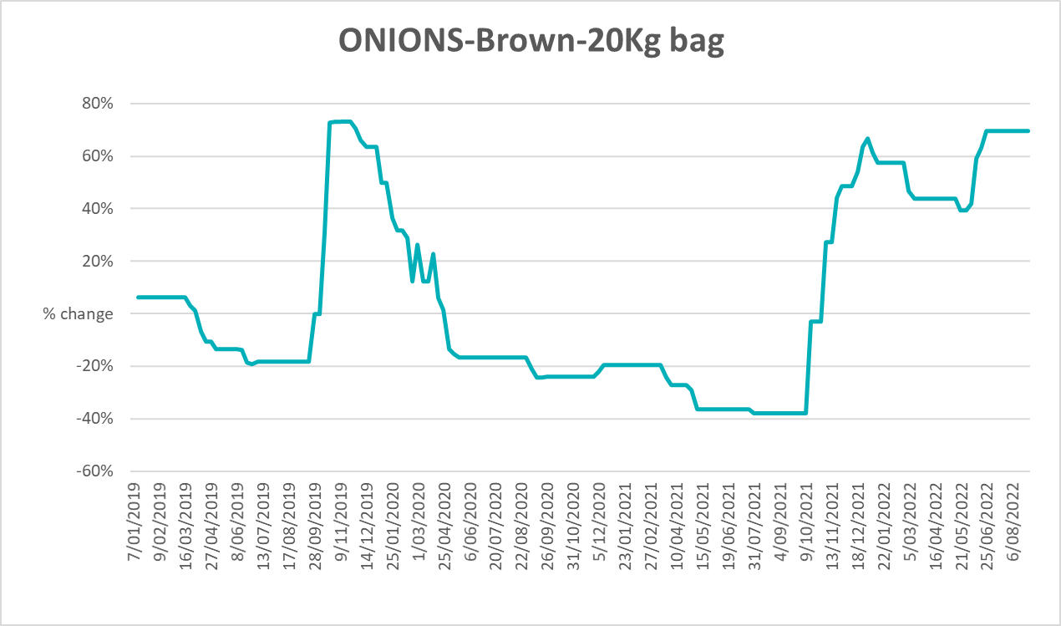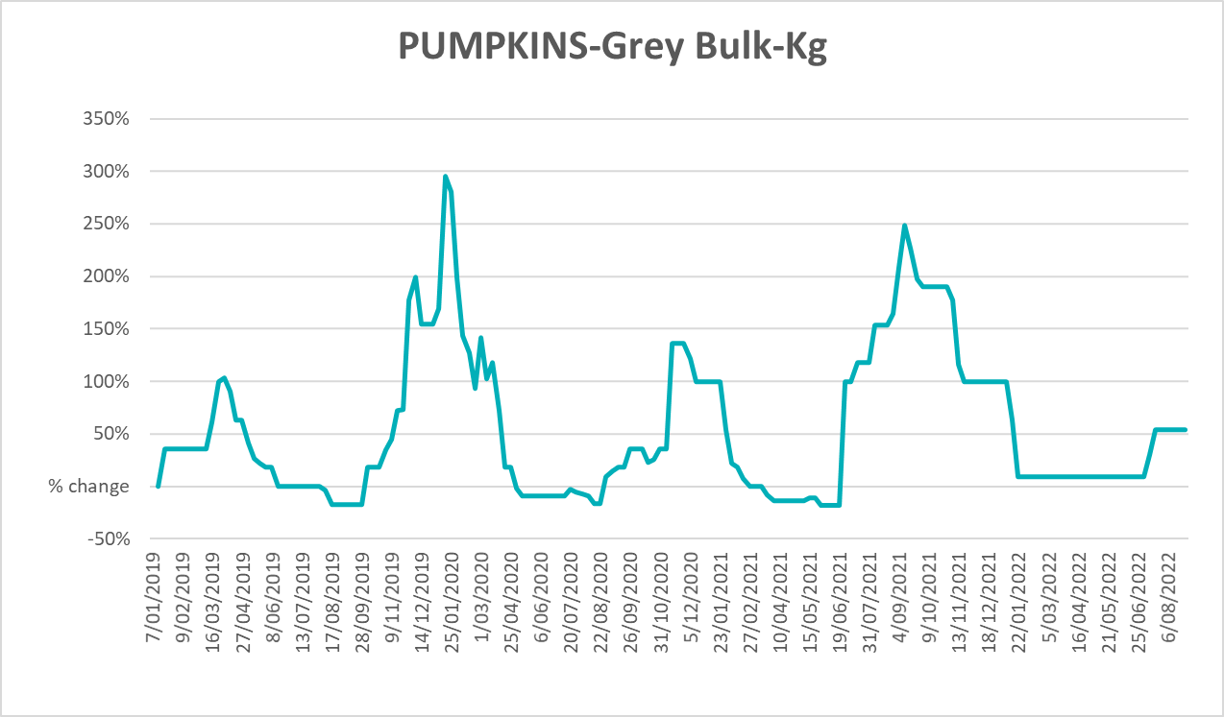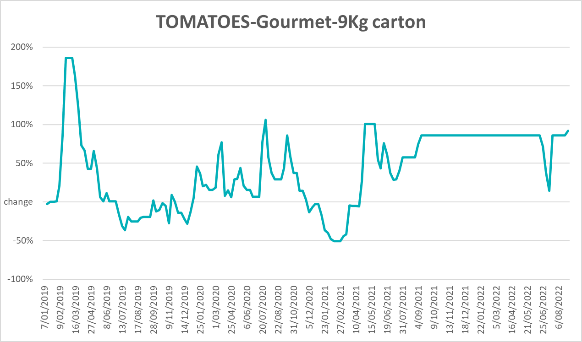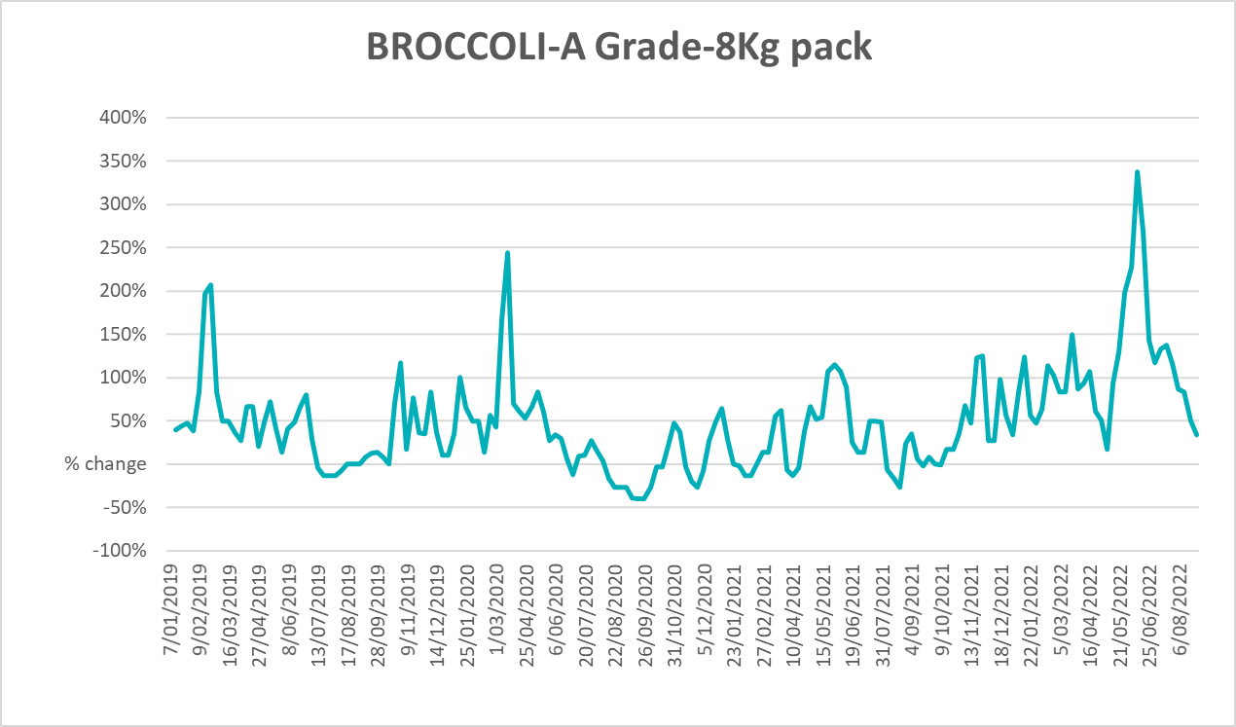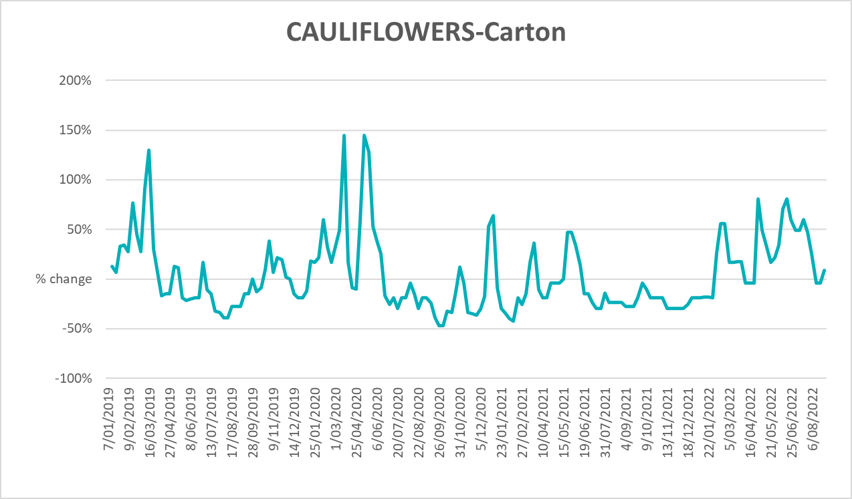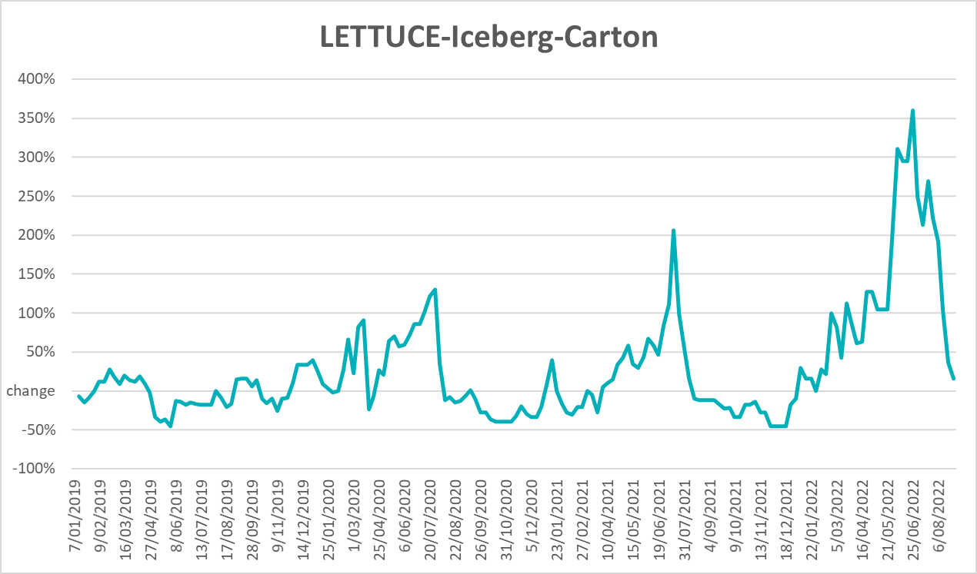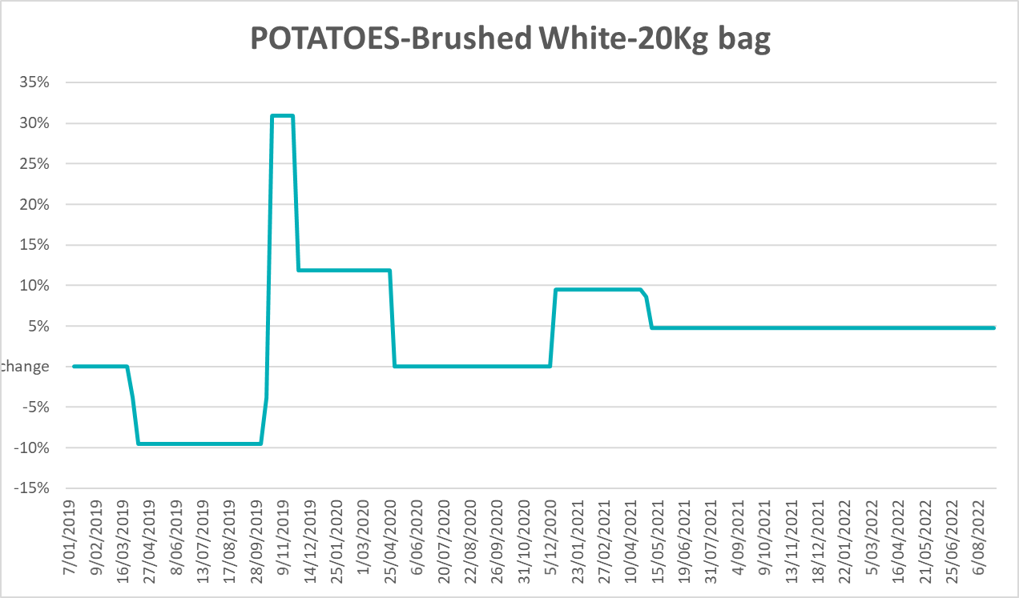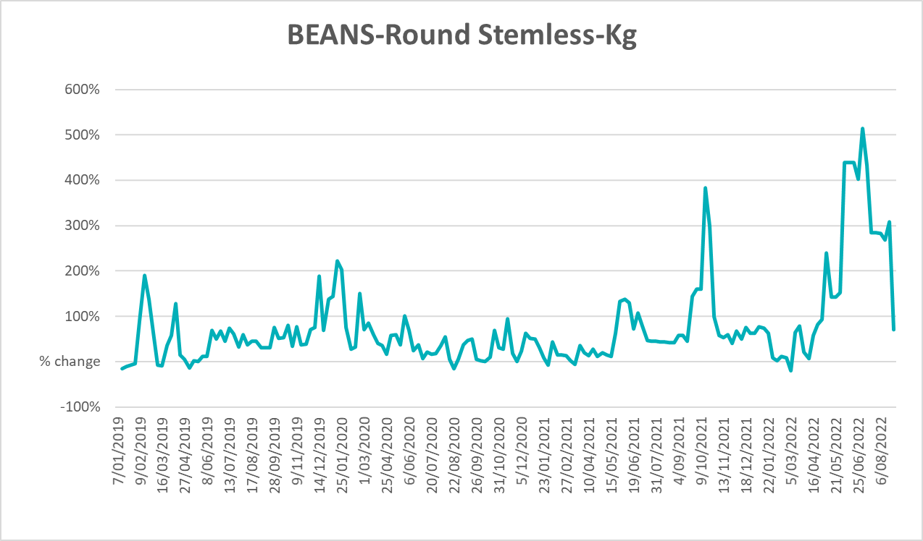

Selected domestic fodder indicator prices
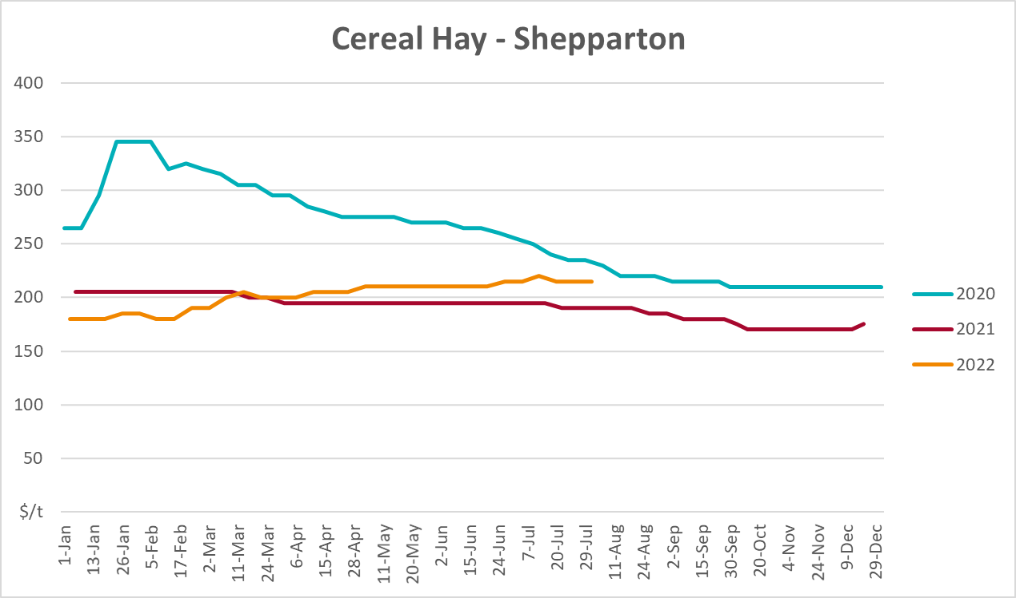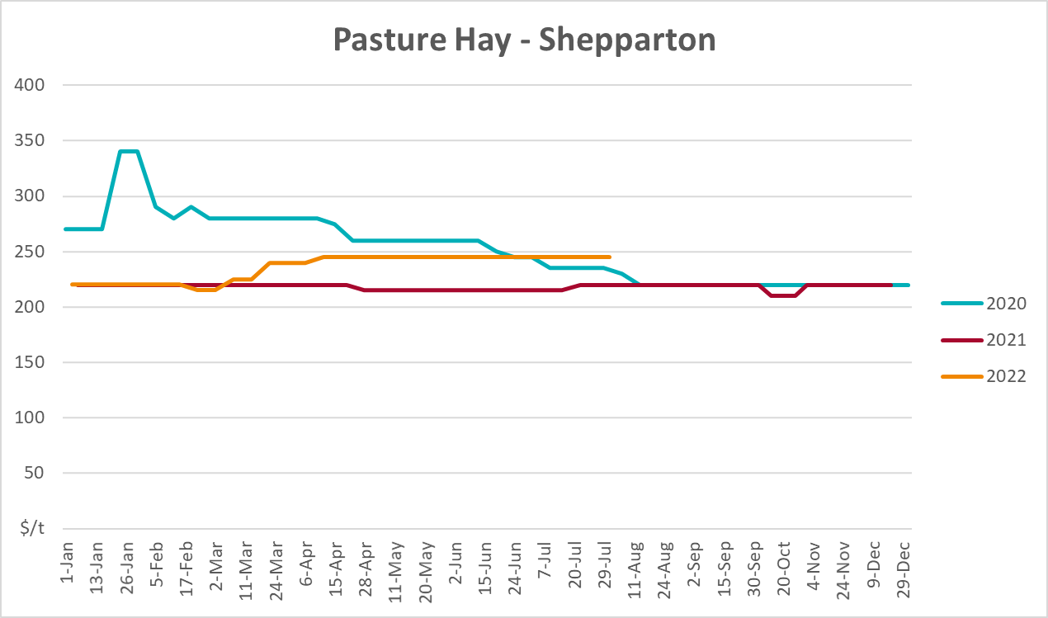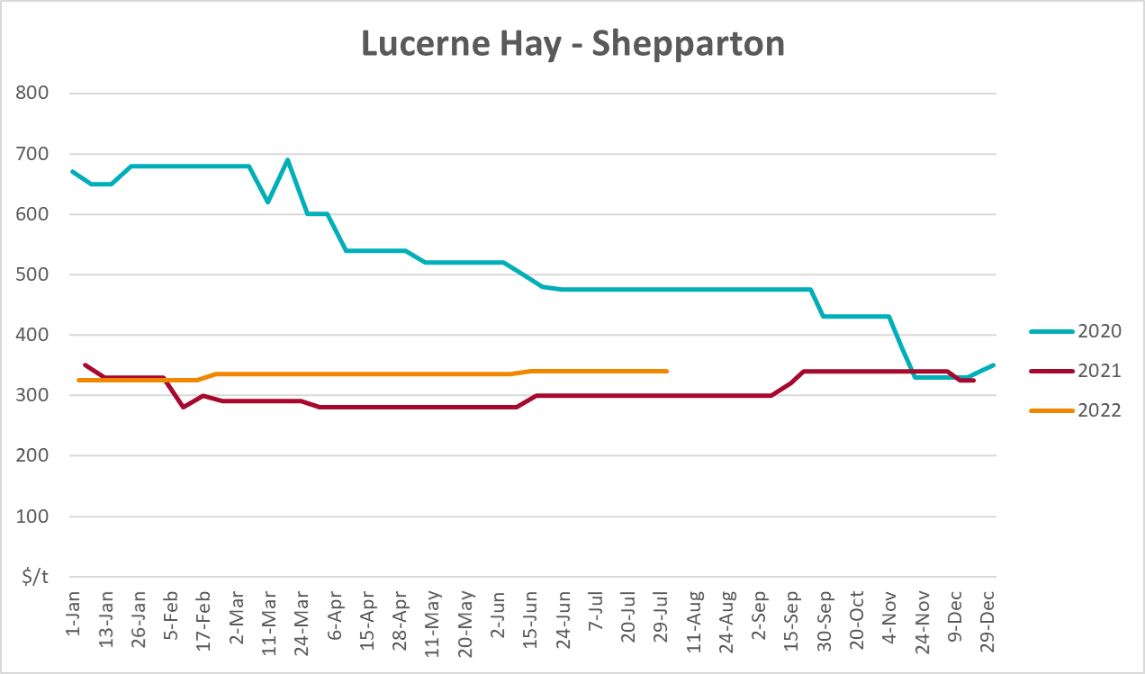

Data attribution

Climate
Bureau of Meteorology
- Weekly rainfall totals: www.bom.gov.au/climate/maps/rainfall/
- Monthly and last 3-month rainfall percentiles: www.bom.gov.au/water/landscape/
- Temperature anomalies: www.bom.gov.au/jsp/awap/temp/index.jsp
- Rainfall forecast: www.bom.gov.au/jsp/watl/rainfall/pme.jsp
- Seasonal outlook: www.bom.gov.au/climate/outlooks/#/overview/summary/
- Climate drivers: http://www.bom.gov.au/climate/enso/
- Soil moisture: www.bom.gov.au/water/landscape/
Other
- Pasture growth: www.longpaddock.qld.gov.au/aussiegrass/
- 3-month global outlooks: Environment and Climate Change Canada, NOAA Climate Prediction Center, EUROBRISA CPTEC/INPE, European Centre for Medium-Range Weather Forecasts, Hydrometcenter of Russia, National Climate Center Climate System Diagnosis and Prediction Room (NCC), International Research Institute for Climate and Society
- Global production: https://ipad.fas.usda.gov/ogamaps/cropmapsandcalendars.aspx
- Autumn break: Pook et al., 2009, https://rmets-onlinelibrary-wiley-com.virtual.anu.edu.au/doi/epdf/10.1002/joc.1833

Water
Prices
- Waterflow: https://www.waterflow.io/
- Ruralco: https://www.ruralcowater.com.au/
Bureau of Meteorology:
- Allocation trade: http://www.bom.gov.au/water/dashboards/#/water-markets/mdb/at
- Storage volumes: http://www.bom.gov.au/water/dashboards/#/water-storages/summary/drainage
Trade constraints:
- Water NSW: https://www.waternsw.com.au/customer-service/ordering-trading-and-pricing/trading/murrumbidgee
- Victorian Water Register: https://www.waterregister.vic.gov.au/TradingRules2019/

Commodities
Fruit and vegetables
- Datafresh: www.freshstate.com.au
Pigs
- Australian Pork Limited: www.australianpork.com.au
Dairy
- Global Dairy Trade: www.globaldairytrade.info/en/product-results/
World wheat, canola
- International Grains Council
World coarse grains
- United States Department of Agriculture
World cotton
- Cotlook: www.cotlook.com/
World sugar
- New York Stock Exchange - Intercontinental Exchange
Wool
- Australian Wool Exchange: www.awex.com.au/
Domestic wheat, barley, sorghum, canola and fodder
- Jumbuk Consulting Pty Ltd: http://www.jumbukag.com.au/
Cattle, beef, mutton, lamb, goat and live export
- Meat and Livestock Australia: www.mla.com.au/Prices-and-market
© Commonwealth of Australia 2022

Ownership of intellectual property rights
Unless otherwise noted, copyright (and any other intellectual property rights, if any) in this publication is owned by the Commonwealth of Australia (referred to as the Commonwealth).

Creative Commons licence
All material in this publication is licensed under a Creative Commons Attribution 4.0 International Licence except content supplied by third parties, logos and the Commonwealth Coat of Arms.
Inquiries about the licence and any use of this document should be emailed to copyright@awe.gov.au.


Cataloguing data
This publication (and any material sourced from it) should be attributed as:
ABARES 2022, Weekly Australian Climate, Water and Agricultural Update, Australian Bureau of Agricultural and Resource Economics and Sciences, Canberra, 15 September 2022. CC BY 4.0 DOI: https://doi.org/10.25814/5f3e04e7d2503
ISSN 2652-7561
This publication is available at https://www.agriculture.gov.au/abares/products/weekly_update
Department of Agriculture, Fisheries and Forestry
GPO Box 858 Canberra ACT 2601
Telephone 1800 900 090
Web agriculture.gov.au/abares

Disclaimer
The Australian Government acting through the Department of Agriculture, Fisheries and Forestry, represented by the Australian Bureau of Agricultural and Resource Economics and Sciences, has exercised due care and skill in preparing and compiling the information and data in this publication. Notwithstanding, the Department of Agriculture, Fisheries and Forestry, ABARES, its employees and advisers disclaim all liability, including liability for negligence and for any loss, damage, injury, expense or cost incurred by any person as a result of accessing, using or relying on any of the information or data in this publication to the maximum extent permitted by law.

Statement of Professional Independence
The views and analysis presented in ABARES publications, including this one, reflect ABARES professionally independent findings, based on scientific and economic concepts, principles, information and data. These views, analysis and findings may not reflect or be consistent with the views or positions of the Australian Government, or of organisations or groups who have commissioned ABARES reports or analysis. More information on professional independence is provided on the ABARES website.

Acknowledgements
This report was prepared by Matthew Miller and Cameron Van-Lane.

