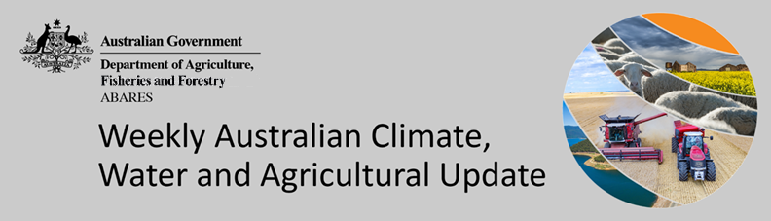
No. 31/2022

11 August 2022

Summary of key issues
- For the week ending 10 August 2022, low-pressure troughs and cold fronts across southern and eastern Australia brought rainfall and strong winds. Over northern parts of the country, high-pressure systems dominated, bringing clear, dry conditions (see Section 1.1).
- The moderate rainfall received across central New South Wales and central Queensland over the past 8-days has increased the risk of waterlogging, with soil moisture levels already well above average. In Western Australia, rainfall consolidated falls received the previous week, boosting plant available water for the coming weeks.
- Oceanic and atmospheric El Niño–Southern Oscillation (ENSO) indicators remain neutral, reducing its influence on Australia’s climate patterns. However, a negative Indian Ocean Dipole (IOD) event has become established in the tropical Indian Ocean, and the Southern Annular Mode (SAM) has recently returned to positive values. Given current and expected conditions, the IOD and SAM are likely to be the major influences on late winter and early spring rainfall across Australia (see Section 1.2).
- The outlook for September 2022 indicates that there is a 75% chance of rainfall totals between 10 and 50 millimetres across much of New South Wales, south-eastern and parts of north-eastern Queensland, Victoria, southern South Australia, the south-west of Western Australia, Tasmania and isolated parts in the north of the Northern Territory. Rainfall totals in excess of 100 millimetres are expected across alpine regions of New South Wales and Victoria, as well as western Tasmania (see Section 1.3).
- Over the 8-days to 18 August 2022, low-pressure troughs and cold fronts are expected to bring rainfall to large areas of south-western and south-eastern Australia. However, high-pressure systems across remaining parts of the country are expected to result in clear, dry conditions. This forecast rainfall is expected to increase soil moisture levels across cropping regions in southern New South Wales, Victoria, South Australia and Western Australia. Across these regions, soil moisture levels have declined in recent months to below average to average levels. Rainfall in parts of southern Queensland and central New South Wales will add to above average soil moisture levels and may lead to waterlogging in isolated areas, negatively impacting crop development (see Section 1.4).
- Water storage in the Murray–Darling Basin (MDB) increased by 698 gigalitres (GL) between 3 August 2022 and 10 August 2022. The current volume of water held in storage is 22,927 GL, which represents 91% of total capacity. This is 15% or 2,997 GL more than at the same time last year.
- Allocation prices in the Victorian Murray below the Barmah Choke decreased from $79 per ML on 29 July 2022 to $78 per ML on 5 August 2022. Prices are lower in the Goulburn-Broken and regions above the Barmah choke due to the binding of the Goulburn intervalley trade limit and Barmah choke trade constraint.

Climate

Rainfall this week
For the week ending 10 August 2022, low-pressure troughs and cold fronts across southern and eastern Australia brought rainfall and strong winds. Over northern parts of the country, high-pressure systems dominated, bringing clear, dry conditions.
Rainfall totals of between 10 and 50 millimetres were recorded across much of New South Wales, southern and central parts of Queensland, the east and south-west of Victoria, parts of southern and northern South Australia, the south-west of Western Australia, most of Tasmania, as well as isolated areas in the south of the Northern Territory. Rainfall totals in excess of 50 millimetres were recorded in alpine areas of New South Wales and Victoria, the central-east of New South Wales, the south-west of Western Australia and western Tasmania. Remaining parts of Australia received little to no rainfall.
In Australian cropping regions, rainfall totals of between 10 and 50 millimetres were recorded across most of New South Wales, parts of southern and northern Queensland, isolated parts of Victoria, western areas of South Australia, as well as most of Western Australia. Rainfall totals in excess of 50 millimetres were recorded across central-eastern cropping regions in New South Wales. Little to no rainfall was recorded across remaining cropping regions for the week ending 10 August 2022.
The moderate rainfall received across central New South Wales and central Queensland over the past 8-days has increased the risk of waterlogging, with soil moisture levels already well above average. Given the late start to the season for many growers, the rain will further delay field access for pest management and top dressing. In Western Australia, rainfall consolidated falls received the previous week, boosting plant available water for the coming weeks. While yield potentials remain favourable at this stage, more rainfall will be needed in spring, and frost events during critical reproductive stages present a significant downside risk to production potential given the advanced growth stage of many crops. Despite limited rainfall across Victoria and South Australia, root zone soil moisture levels remain close to average, with sufficient plant available water to support ongoing crop development.

Rainfall for the week ending 10 August 2022
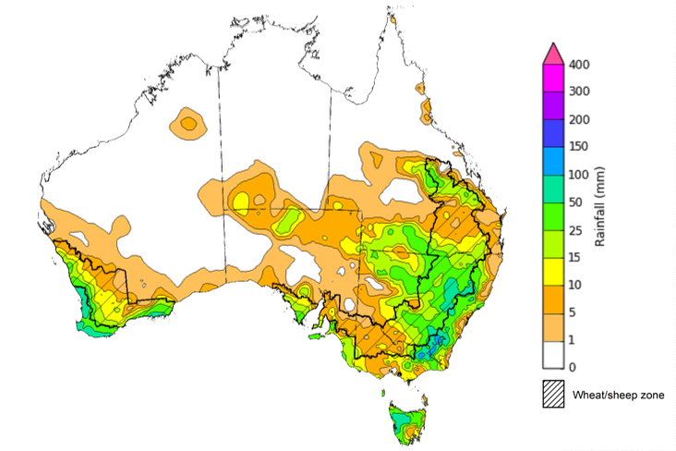
©Commonwealth of Australia 2022, Australian Bureau of Meteorology Issued:10/8/2022
Note: The rainfall analyses and associated maps utilise data contained in the Bureau of Meteorology climate database, the Australian Data Archive for Meteorology (ADAM). The analyses are initially produced automatically from real-time data with limited quality control. They are intended to provide a general overview of rainfall across Australia as quickly as possible after the observations are received. For further information go to http://www.bom.gov.au/climate/rainfall/

Climate Drivers
Throughout the late winter and early spring period the climate drivers with the largest potential impact on Australia’s climate patterns are the El Niño–Southern Oscillation (ENSO), the Indian Ocean Dipole (IOD) and the Southern Annular Mode (SAM). These climate drivers are likely to influence pasture growth across southern Australia and the growth and yield prospects for winter crops.
Oceanic and atmospheric ENSO indicators remain neutral, reducing its influence on Australia’s climate patterns. However, some atmospheric indicators, such as the Southern Oscillation Index and Pacific trade winds have maintained a La Niña-like pattern. Most international climate models expect the ENSO to remain neutral throughout the remainder of winter, although five of the seven models predict the development of a La Niña event in late spring. A negative IOD event has become established in the tropical Indian Ocean, and the SAM has recently returned to positive values. Given current and expected conditions, the IOD and SAM are likely to be the major influences on late winter and early spring rainfall across Australia.
Sea surface temperature (SSTs) anomalies in the tropical Pacific Ocean close to the equator have been cooler than average in some parts and close to average in other parts over the previous week. Small pockets of weak warm anomalies were detected in the eastern Pacific along the equator. SSTs were slightly cooler than average over much of the tropical central and eastern Pacific south of the equator. Neutral Pacific equatorial sea surface temperatures are associated with neutral ENSO conditions.
Warm sea surface temperature anomalies continue across the eastern Indian Ocean and the southern Maritime Continent, while cool anomalies are present near the Horn of Africa and the north-west of the Indian Ocean basin. The temperature gradient established across the tropical Indian Ocean underpin the recent establishment of a negative IOD event.

Difference from average sea surface temperature observations 25 July to 31 July 2022
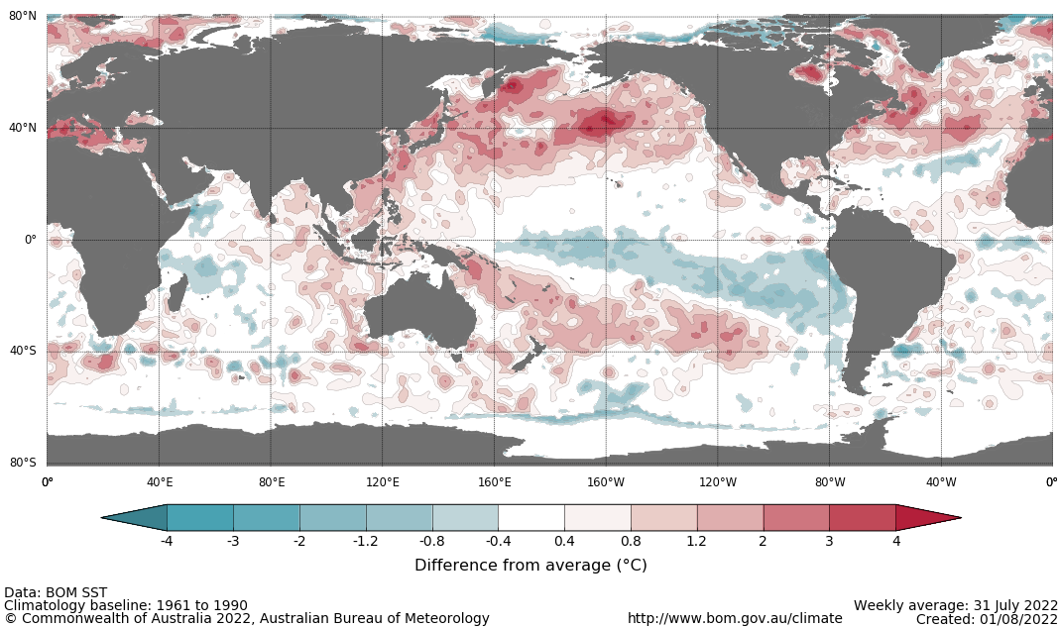
A negative IOD event is underway, following eight weeks of values close to or exceeding the negative IOD threshold (−0.4 °C). Warmer than average water temperatures in the east of the Indian Ocean and cooler than average temperatures in the west are associated with above average rainfall across southern Australia throughout winter and spring, as well as the far north. It is also associated with the early onset of northern Australia rainfall.
As at 31 July 2022, the Indian Ocean Dipole (IOD) weekly value was -0.9°C. All international climate models surveyed by the Bureau of Meteorology predict the negative IOD event to persist until late spring.

International climate model outlooks for the IOD index in November 2022
INCLUDEPICTURE "http://www.bom.gov.au/climate/model-summary/archive/20220802.iod_summary_5.png" \* MERGEFORMATINET INCLUDEPICTURE "http://www.bom.gov.au/climate/model-summary/archive/20220802.iod_summary_5.png" \* MERGEFORMATINET INCLUDEPICTURE "http://www.bom.gov.au/climate/model-summary/archive/20220802.iod_summary_5.png" \* MERGEFORMATINET INCLUDEPICTURE "http://www.bom.gov.au/climate/model-summary/archive/20220802.iod_summary_5.png" \* MERGEFORMATINET INCLUDEPICTURE "http://www.bom.gov.au/climate/model-summary/archive/20220802.iod_summary_5.png" \* MERGEFORMATINET INCLUDEPICTURE "http://www.bom.gov.au/climate/model-summary/archive/20220802.iod_summary_5.png" \* MERGEFORMATINET 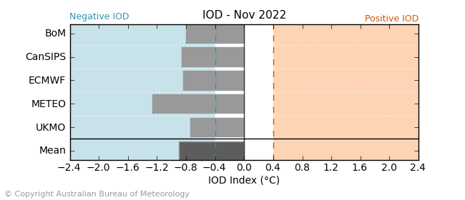
The Southern Annular Mode (SAM) is currently strongly positive, with neutral and positive values being recorded throughout much of June and July. SAM is expected to return to near-neutral values and remain neutral to positive over the coming weeks. The SAM refers to the north-south shift of the band of rain-bearing westerly winds and weather systems in the Southern Ocean compared to the usual position. A positive SAM in winter is associated with increased rainfall for parts of eastern Australia. It is also associated with decreased rainfall for western and central Victoria, the south-east of South Australia, the west of Western Australia and Tasmania.

Southern Annular Mode (SAM) daily index
INCLUDEPICTURE "http://www.bom.gov.au/clim_data/IDCK000080/sam_index.daily.20220808.png?1660103726551" \* MERGEFORMATINET INCLUDEPICTURE "http://www.bom.gov.au/clim_data/IDCK000080/sam_index.daily.20220808.png?1660103726551" \* MERGEFORMATINET INCLUDEPICTURE "http://www.bom.gov.au/clim_data/IDCK000080/sam_index.daily.20220808.png?1660103726551" \* MERGEFORMATINET INCLUDEPICTURE "http://www.bom.gov.au/clim_data/IDCK000080/sam_index.daily.20220808.png?1660103726551" \* MERGEFORMATINET INCLUDEPICTURE "http://www.bom.gov.au/clim_data/IDCK000080/sam_index.daily.20220808.png?1660103726551" \* MERGEFORMATINET INCLUDEPICTURE "http://www.bom.gov.au/clim_data/IDCK000080/sam_index.daily.20220808.png?1660103726551" \* MERGEFORMATINET 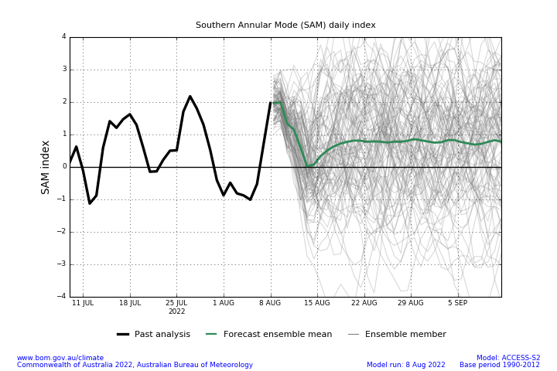

National Climate Outlook
These climate outlooks are generated by ACCESS–S (Australian Community Climate Earth-System Simulator–Seasonal). ACCESS–S is the Bureau of Meteorology's dynamic (physics-based) weather and climate model used for monthly, seasonal and longer-lead climate outlooks.
For further information, go to http://www.bom.gov.au/climate/ahead/about/
The Bureau of Meteorology’s latest rainfall outlook indicates wetter than average conditions are expected across most of Australia during September. The ACCESS-S climate model suggests there is close to a 60% chance of exceeding median for parts of eastern, central and much of western Australia, with below median rainfall likely for the south-west of Western Australia, south-western Victoria and western Tasmania.
The outlook for September 2022 indicates that there is a 75% chance of rainfall totals between 10 and 50 millimetres across much of New South Wales, south-eastern and parts of north-eastern Queensland, Victoria, southern South Australia, the south-west of Western Australia, Tasmania and isolated parts in the north of the Northern Territory. Rainfall totals in excess of 100 millimetres are expected across alpine regions of New South Wales and Victoria, as well as western Tasmania.
Across cropping regions there is a 75% chance of rainfall totals of between 25 and 50 millimetres across eastern New South Wales, southern Victoria, central South Australia and isolated parts of Western Australia. There is a 75% chance of rainfall less than 25 millimetres for northern and western New South Wales, the northwest of Victoria, parts of eastern and western South Australia, most of Queensland, and central and eastern cropping regions in Western Australia. These falls are likely to be sufficient to support the current yield potential of winter crops and average or better pasture growth potential, given average to above average soil moisture level across most southern Australian growing regions.
Rainfall totals that have a 75% chance of occurring September 2022
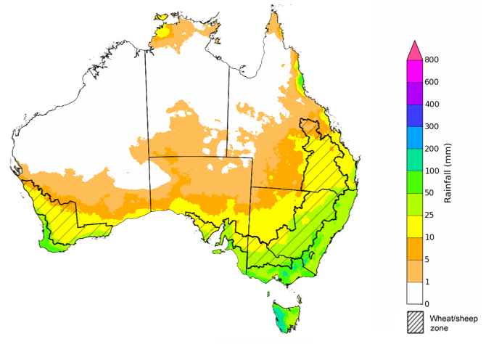
©Commonwealth of Australia 2022, Australian Bureau of Meteorology Issued: 04/08/2022

The rainfall outlook for September to November 2022 suggests there is a greater than 75% chance of exceeding median rainfall across most of New South Wales, Queensland, Victoria, South Australia and the Northern Territory. For remaining regions of Australia, there is no strong tendency towards above or below median rainfall, except for parts of north-western Western Australia and south-western Tasmania where below median rainfall is likely between September to November 2022 (Bureau of Meteorology ‘National Climate Outlook’, 4 August 2022).
Bureau of Meteorology rainfall outlooks for September to November have greater than 55% past accuracy across most of eastern and central Australia. Outlook accuracy is greater than 65% across large areas of New South Wales, Victoria and parts of Queensland. Past accuracy is low (less than 50%) for western and southern parts of Western Australia.
Chance of exceeding the median rainfall September to November 2022
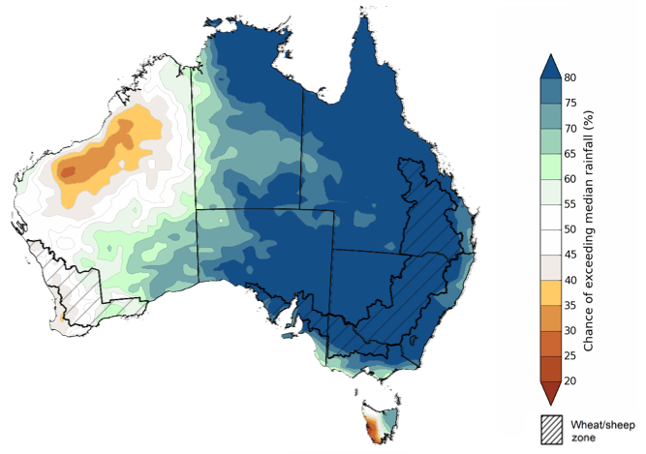
©Commonwealth of Australia 2022, Australian Bureau of Meteorology Issued: 04/08/2022
The outlook for September to November 2022 suggests there is a 75% chance of rainfall totals between 50 and 200 millimetres across Victoria, most of New South Wales and Queensland, southern parts of South Australia, the south-west and far north of Western Australia, Tasmania and the north and south-west of the Northern Territory. Rainfall totals in excess of 200 millimetres are forecast for alpine regions of New South Wales and Victoria, coastal areas of New South Wales, Queensland and Victoria, the far north of the Northern Territory and western Tasmania.
Across cropping regions, there is a 75% chance of receiving between 50 and 100 millimetres across parts of western New South Wales, north-western Victoria, much of South Australia and southern parts of Western Australia. Totals of between 100 and 200 millimetres are expected across much of eastern New South Wales and Queensland, southern Victoria and central South Australia.
The high probability of above average rainfall across eastern and southern cropping regions through spring is likely to provide mixed results. For much of southern New South Wales, Victoria and South Australia, where winter crops were planted in a timely manner and conditions have been favourable thus far, above average rainfall and mild temperatures will support strong yield development through spring. However, above average rainfall across central and northern New South Wales and Queensland is likely to exacerbate waterlogging issues, contribute to the leaching of fertilizers and impede crop development. These all present a potential downside risk of realising current strong crop yield predictions. However, for regions that avoid waterlogging issues, the rainfall will improve yield potentials. If realised, the near-average rainfall outlook for Western Australia through spring should be sufficient to support winter crops through critical development stages, and setup winter crops for strong yields.
Rainfall totals that have a 75% chance of occurring September to November 2022
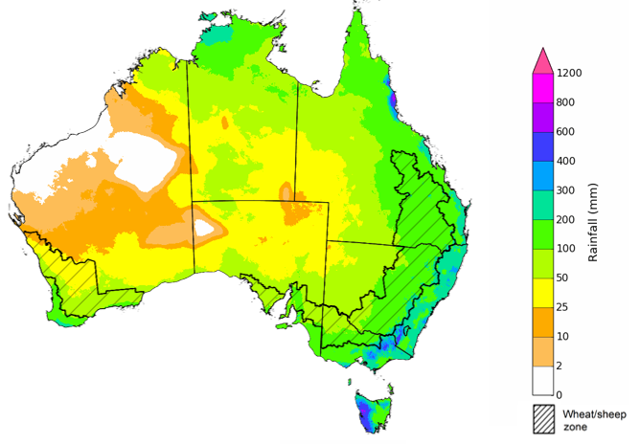
©Commonwealth of Australia 2022, Australian Bureau of Meteorology Issued: 04/08/2022
The temperature outlook for September to November 2022 indicates that maximum temperatures across most of Australia are likely to be close to the 1990-2012 average (the difference in the range of - 1°C to +1°C), with slightly lower than average temperatures across northern New South Wales and southern Queensland. Minimum temperatures are expected to be slightly above average for much of the northern Australia, and close to average for the rest of Australia (Bureau of Meteorology ‘National Climate Outlook’, 4 August 2022).
Predicted maximum temperature anomaly for September to November 2022

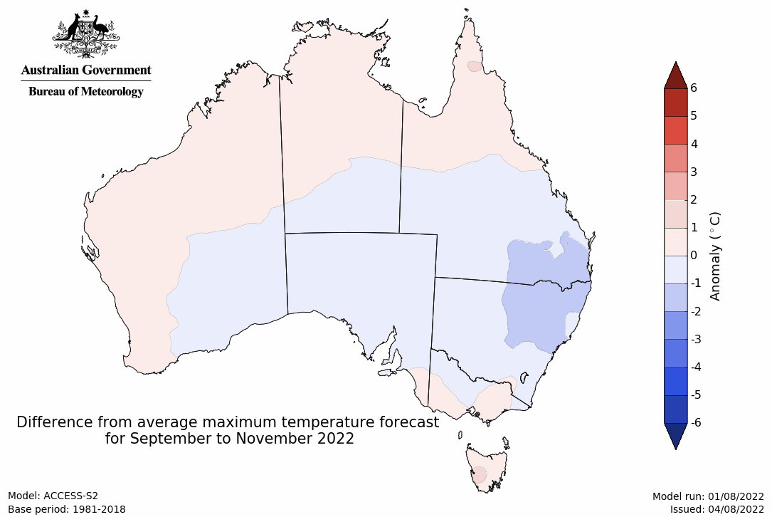
Predicted minimum temperature anomaly for September to November 2022
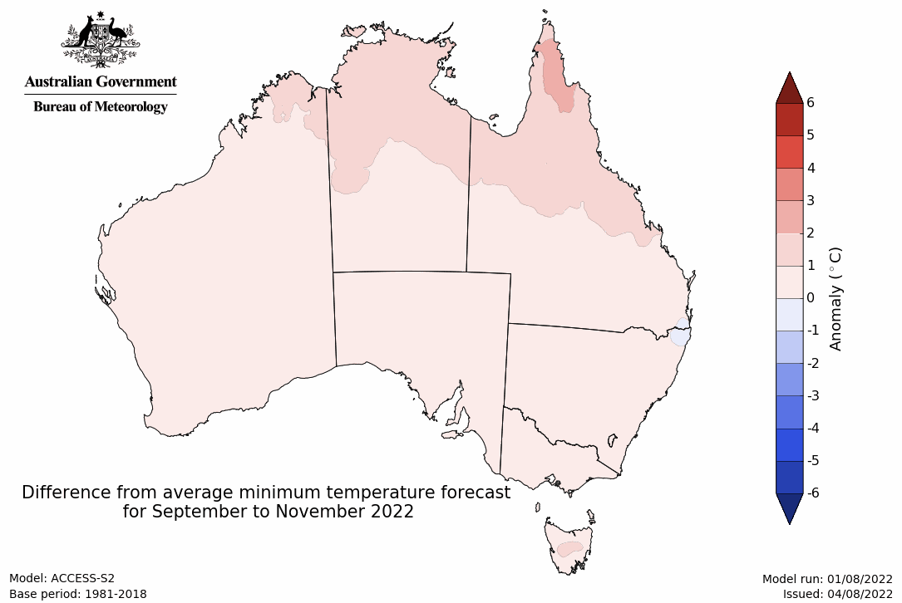

Rainfall forecast for the next eight days
Over the 8-days to 18 August 2022, low-pressure troughs and cold fronts are expected to bring rainfall to large areas of south-western and south-eastern Australia. However, high-pressure systems across remaining parts of the country are expected to result in clear, dry conditions.
Rainfall totals of between 10 and 50 millimetres are forecast for much of central and eastern New South Wales, Victoria, southern Queensland, the south-east of South Australia and south-west of Western Australia. Rainfall totals in excess of 50 millimetres are forecast for alpine regions of New South Wales, eastern Victoria and most of Tasmania. Little to no rainfall is forecast across remaining parts of Australia over the next 8-days.
In Australian cropping regions, rainfall totals of between 10 and 50 millimetres are expected across most of New South Wales, Victoria and South Australia, southern Queensland and Western Australia. Little to no rainfall is forecast for all remaining cropping regions during the next 8-days.
This forecast rainfall is expected to increase soil moisture levels across cropping regions in southern New South Wales, Victoria, South Australia and Western Australia. Across these regions, soil moisture levels have declined in recent months to below average to average levels. The expected rainfall will support the continued development of winter crops over the coming weeks. Rainfall in parts of southern Queensland and central New South Wales will add to above average soil moisture levels and may lead to waterlogging in isolated areas, negatively impacting crop development. However, dry conditions are forecast for most northern and central Queensland winter cropping regions, allowing soil profiles to drain, benefitting winter crop development.

Total forecast rainfall (mm) for the period 11 August to 18 August 2022
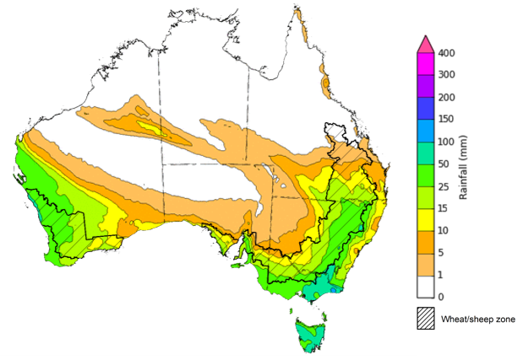
©Commonwealth of Australia 2022, Australian Bureau of Meteorology Issued:11/8/2022

Water
Note: This rainfall forecast is produced from computer models. As the model outputs are not altered by weather forecasters, it is important to check local forecasts and warnings issued by the Bureau of Meteorology.

Water markets – current week
Water storage in the Murray–Darling Basin (MDB) increased by 698 gigalitres (GL) between 3 August 2022 and 10 August 2022. The current volume of water held in storage is 22,927 GL, which represents 91% of total capacity. This is 15% or 2,997 GL more than at the same time last year.

Water storages in the Murray-Darling Basin, 2013–2022
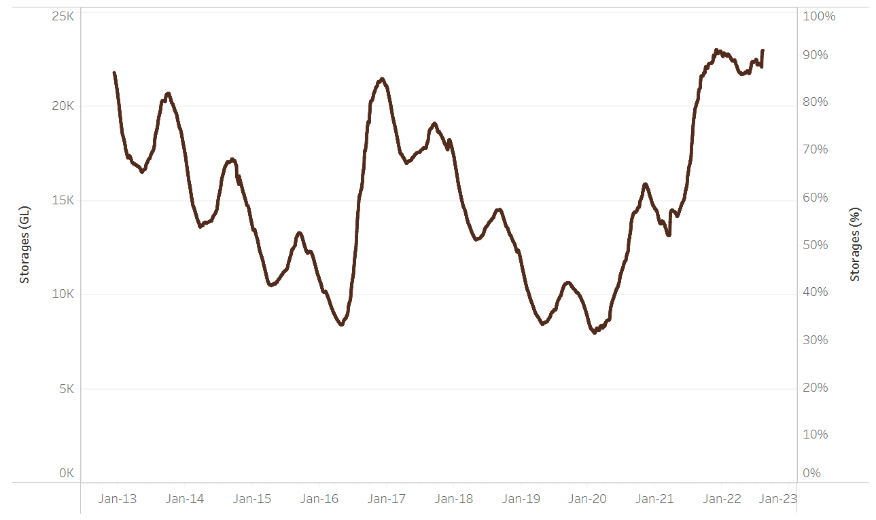
Allocation prices in the Victorian Murray below the Barmah Choke decreased from $79 per ML on 29 July 2022 to $78 per ML on 5 August 2022. Prices are lower in the Goulburn-Broken and regions above the Barmah choke due to the binding of the Goulburn intervalley trade limit and Barmah choke trade constraint.
Water storage data is sourced from the Bureau of Meteorology.

Region | $/ML
NSW Murray Above | 46
NSW Murrumbidgee | 78
VIC Goulburn-Broken | 66
VIC Murray Below | 78

Surface water trade activity, Southern Murray–Darling Basin

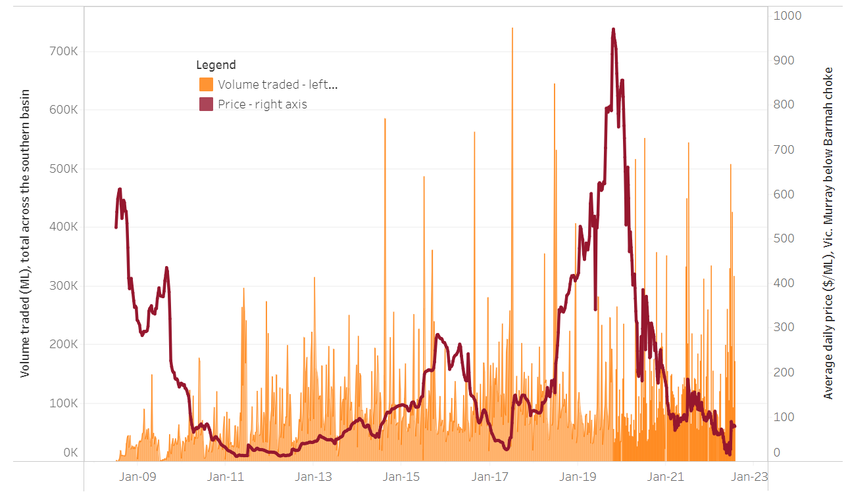
To access the full, interactive, weekly water dashboard, which contains the latest and historical water storage, water market and water allocation information, please visit http://www.agriculture.gov.au/abares/products/weekly_update/weekly-update-110822
The trades shown reflect estimated market activity and do not encompass all register trades. The price is shown for the VIC Murray below the Barmah choke. Historical prices (before 1 July 2019) are ABARES estimates after removing outliers from BOM water register data. Prices after 1 July 2019 and prior to the 30 October 2019 reflect recorded transaction prices as sourced from Ruralco. Prices after the 30 October 2019 are sourced from Waterflow. Data for volume traded is sourced from the BOM water register. Data shown is current at 11 August 2022.

Commodities

Indicator | Week ended | Unit | Latest price | Previous week | Weekly change | Price 12 months ago | Annual change
Selected world indicator prices
AUD/USD Exchange rate | 10-Aug | A$/US$ | 0.70 | 0.69 | 0% | 0.73 | -5%
Wheat – US no. 2 hard red winter wheat, fob Gulf | 10-Aug | US$/t | 373 | 375 | -1% | 333 | 12%
Corn – US no. 2 yellow corn, fob Gulf | 10-Aug | US$/t | 296 | 305 | -3% | 258 | 15%
Canola – Rapeseed, Canada, fob Vancouver | 10-Aug | US$/t | 712 | 740 | -4% | 779 | -9%
Cotton – Cotlook 'A' Index | 10-Aug | USc/lb | 115 | 112 | 3% | 103 | 12%
Sugar – Intercontinental Exchange, nearby futures, no.11 contract | 10-Aug | USc/lb | 18.0 | 17.8 | 2% | 21 | -13%
Wool – Eastern Market Indicator | 06-Jul | Ac/kg clean | 1,388 | 1,407 | -1% | 1,315 | 6%
Wool – Western Market Indicator | 06-Jul | Ac/kg clean | 1,473 | 1,486 | -1% | 1,333 | 11%
Selected Australian grain export prices
Milling Wheat – APW, Port Adelaide, SA | 10-Aug | A$/t | 561 | 576 | -3% | 409 | 37%
Feed Wheat – ASW, Port Adelaide, SA | 10-Aug | A$/t | 521 | 535 | -3% | 405 | 29%
Feed Barley – Port Adelaide, SA | 10-Aug | A$/t | 481 | 493 | -2% | 333 | 44%
Canola – Kwinana, WA | 10-Aug | A$/t | 1,107 | 1,126 | -2% | 846 | 31%
Grain Sorghum – Brisbane, QLD | 03-Aug | A$/t | 436 | 434 | 1% | 365 | 19%
Selected domestic livestock indicator prices
Beef – Eastern Young Cattle Indicator | 10-Aug | Ac/kg cwt | 935 | 908 | 3% | 995 | -6%
Mutton – Mutton indicator (18–24 kg fat score 2–3), Vic | 10-Aug | Ac/kg cwt | 517 | 521 | -1% | 704 | -27%
Lamb – Eastern States Trade Lamb Indicator | 10-Aug | Ac/kg cwt | 716 | 619 | 16% | 924 | -22%
Pig – Eastern Seaboard (60.1–75 kg), average of buyers & sellers | 27-Jul | Ac/kg cwt | 376 | 377 | 0% | 328 | 15%
Goats – Eastern States (12.1–16 kg) | 12-Jan | Ac/kg cwt | 879 | 879 | 0% | 818 | 8%
Live cattle – Light steers ex Darwin to Indonesia | 01-Jun | Ac/kg lwt | 480 | 480 | 0% | 320 | 50%
Live sheep – Live wethers (Muchea WA saleyard) to Middle East | 20-Apr | $/head | 113 | 113 | 0% | 122 | -7%

Indicator | Week ended | Unit | Latest price | Previous week | Weekly change | Price 12 months ago | Annual change
Global Dairy Trade (GDT) weighted average prices ª
Dairy – Whole milk powder | 03-Aug | US$/t | 3,544 | 3,757 | -6% | 2,829 | 25%
Dairy – Skim milk powder | 03-Aug | US$/t | 3,524 | 3,709 | -5% | 2,609 | 35%
Dairy – Cheddar cheese | 03-Aug | US$/t | 4,798 | 4,825 | -1% | 3,631 | 32%
Dairy – Anhydrous milk fat | 03-Aug | US$/t | 5,518 | 5,580 | -1% | 3,993 | 38%
a Global Dairy Trade prices are updated twice monthly on the first and third Tuesday of each month.

Selected world indicator prices
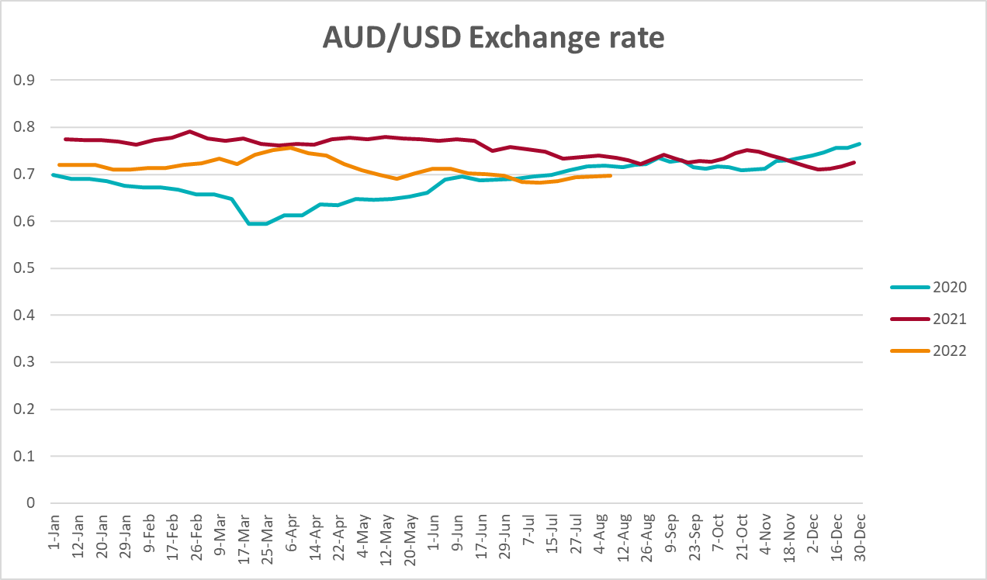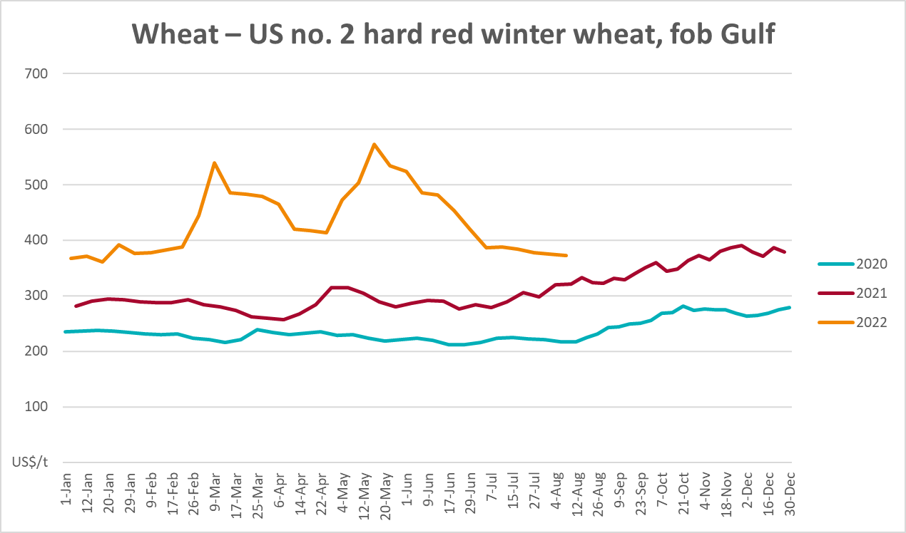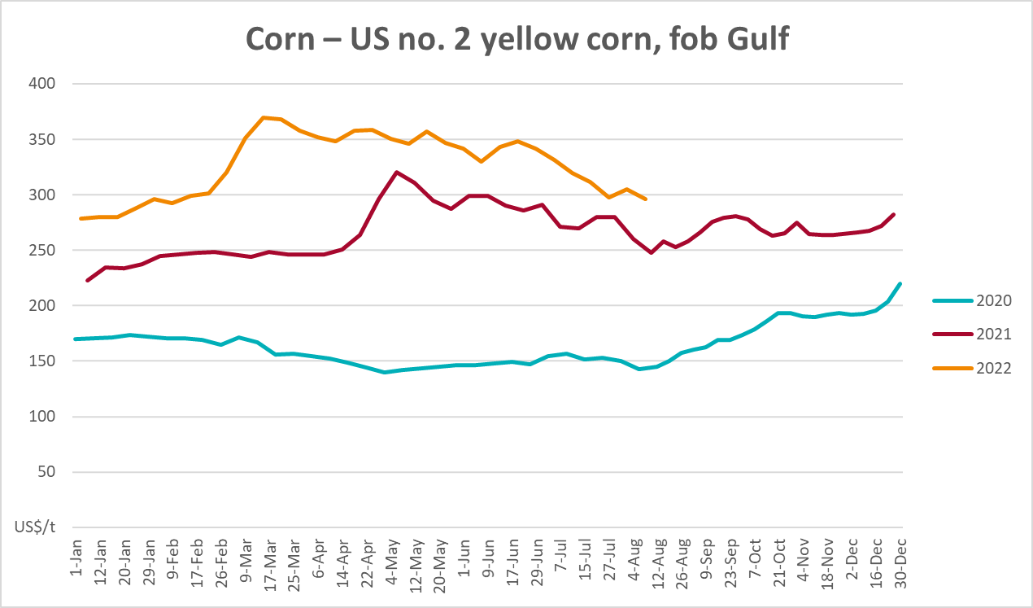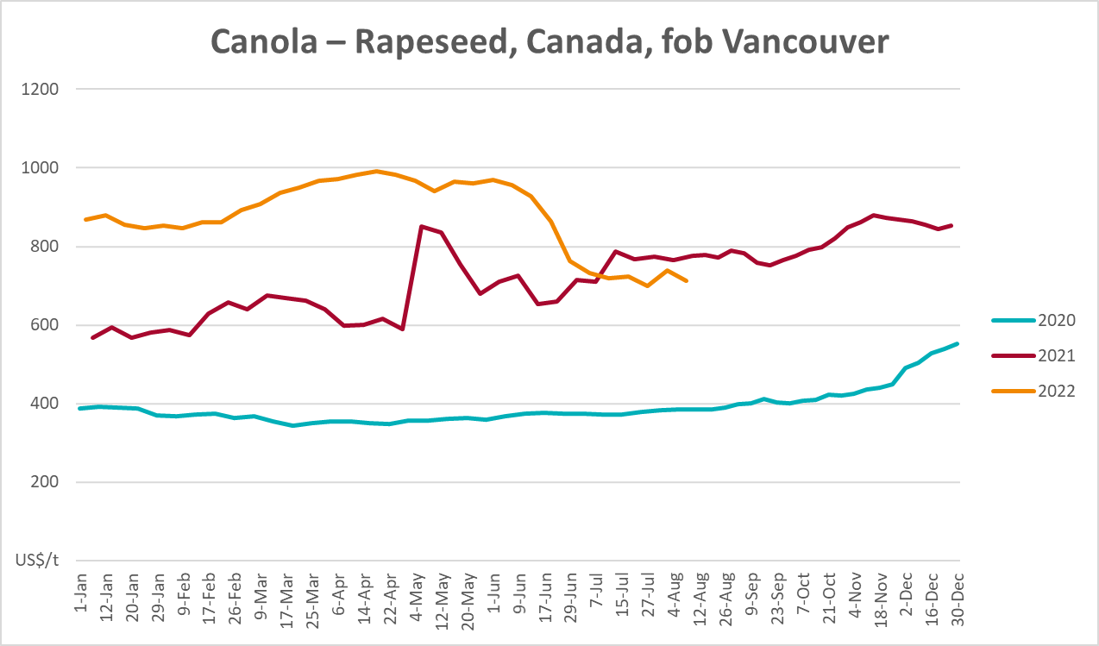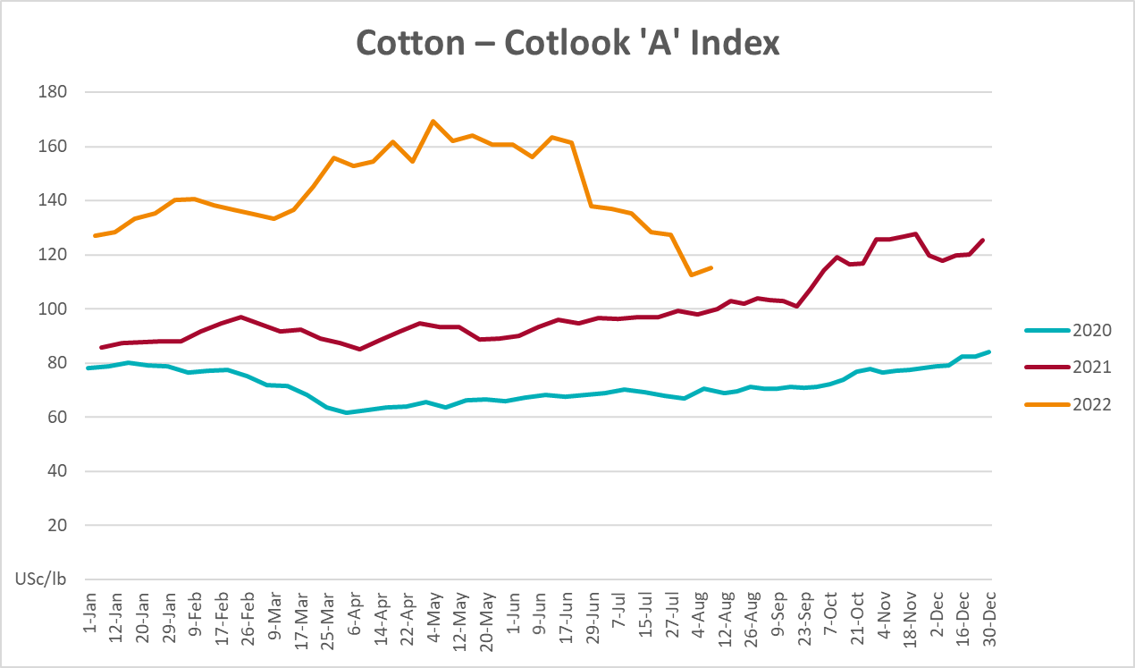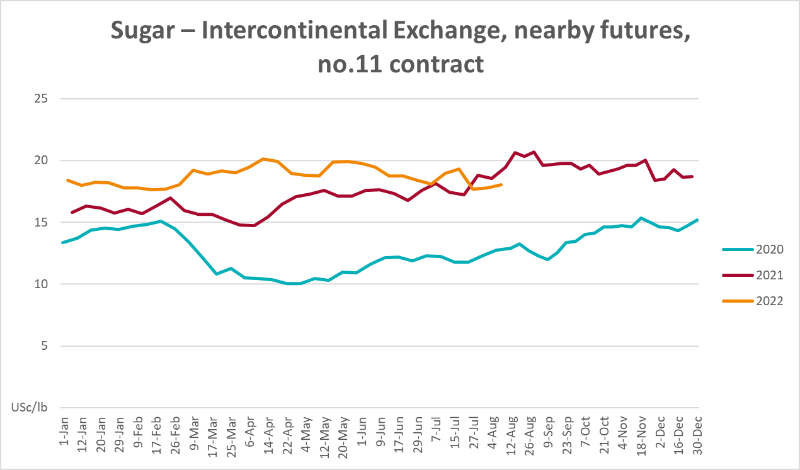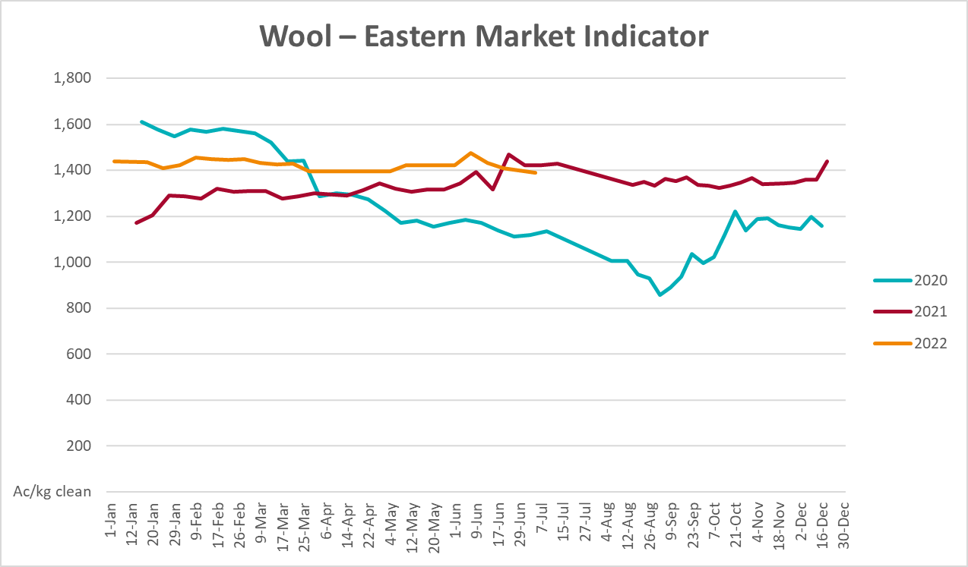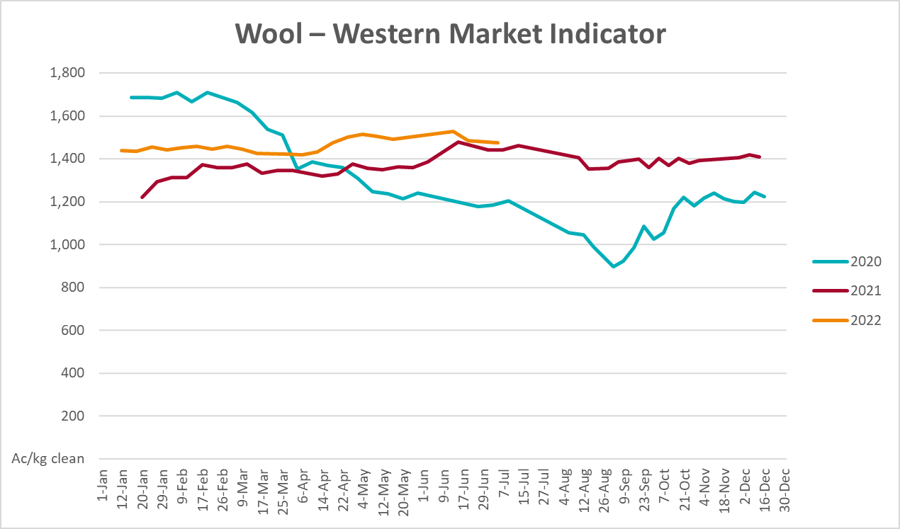

Selected domestic crop indicator prices
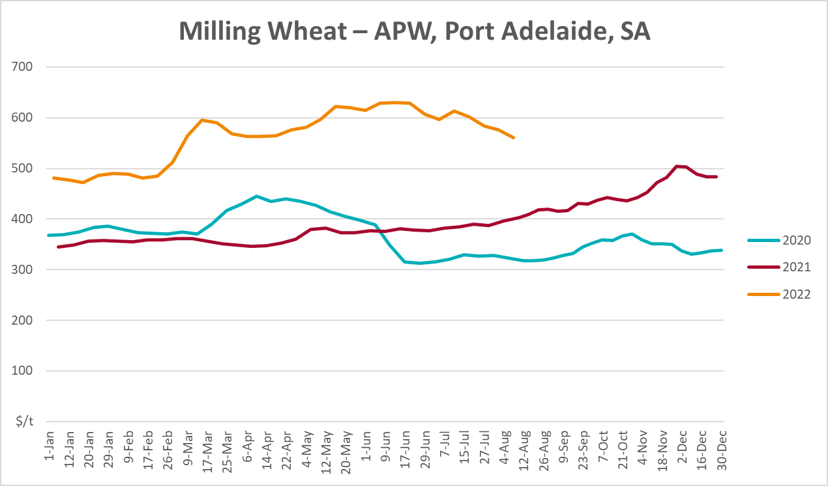
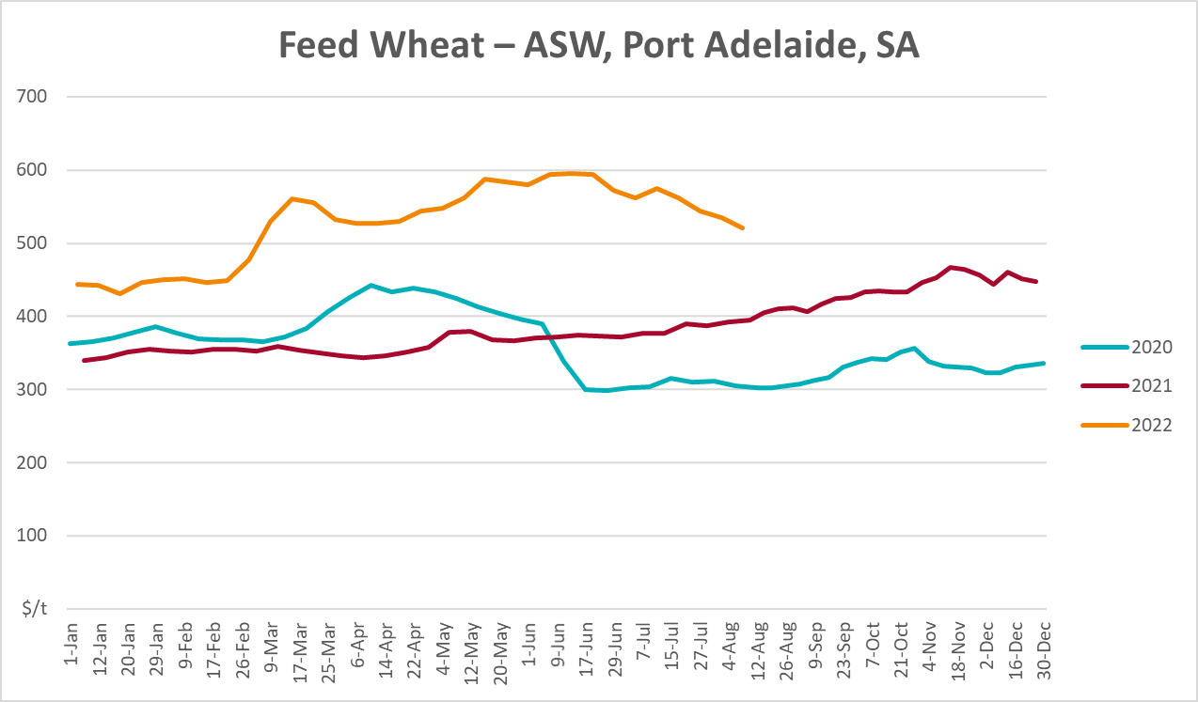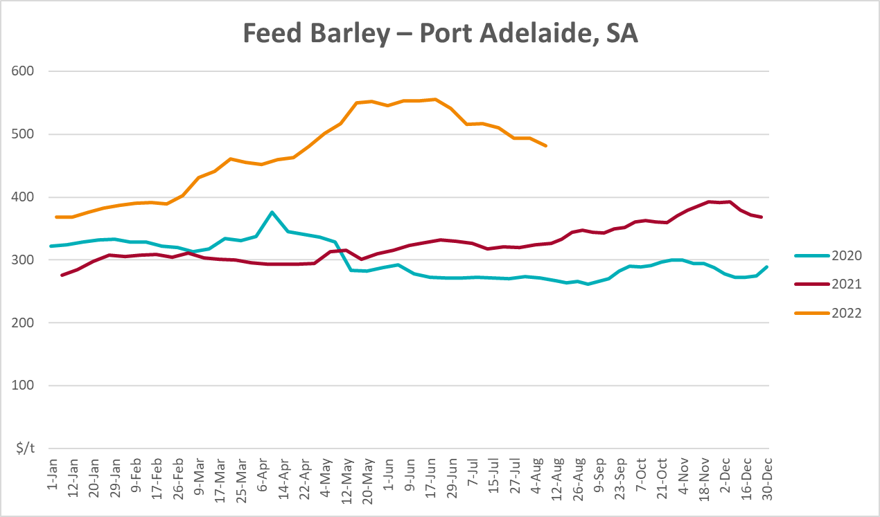
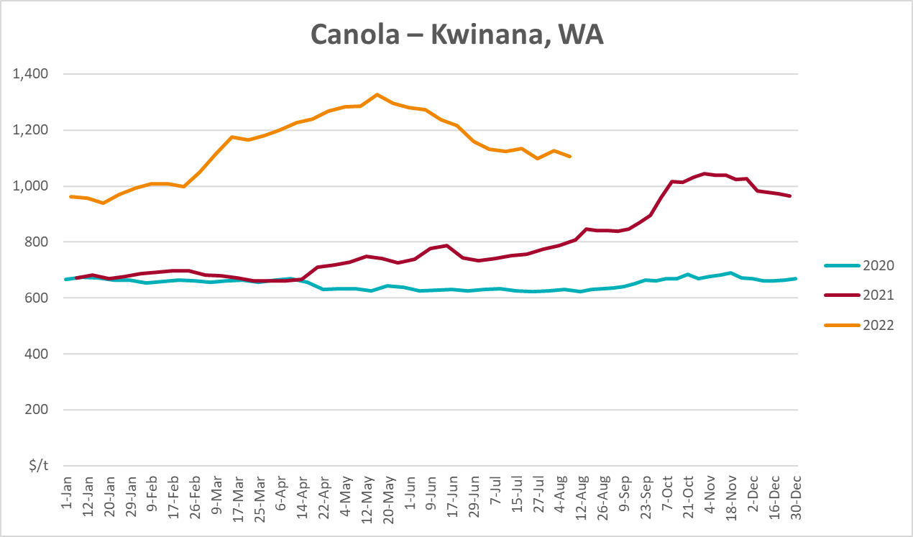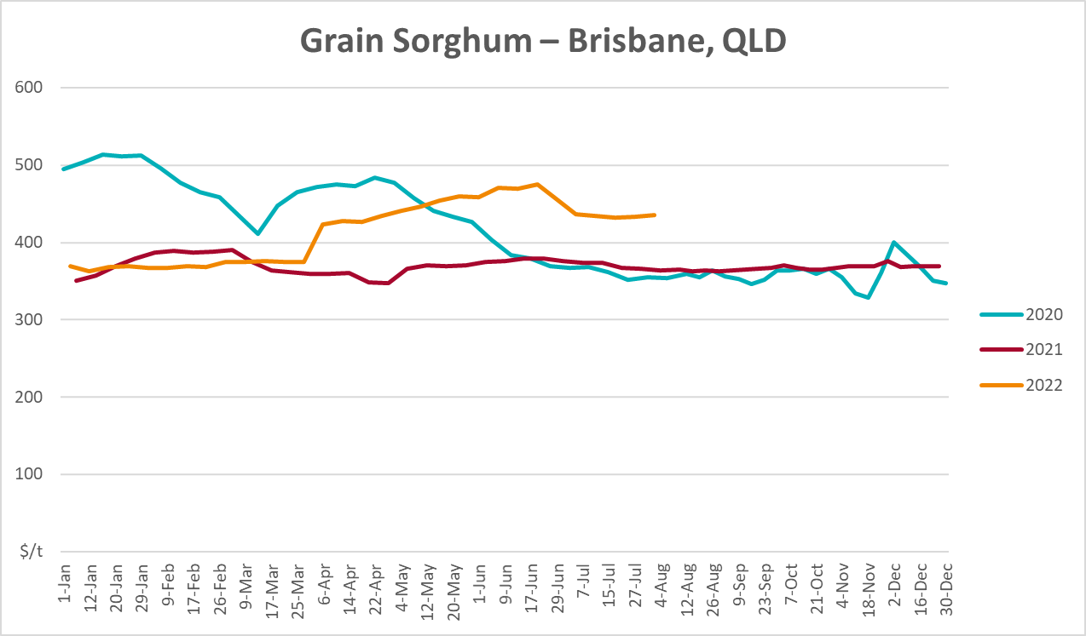

Selected domestic livestock indicator prices
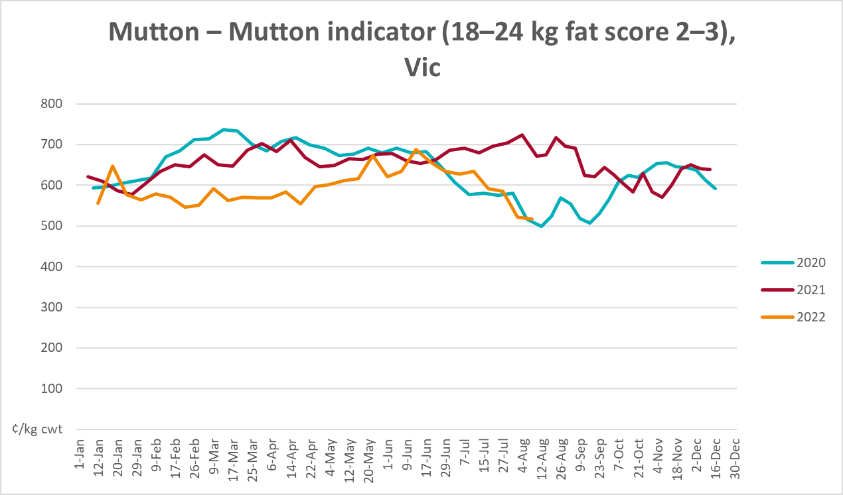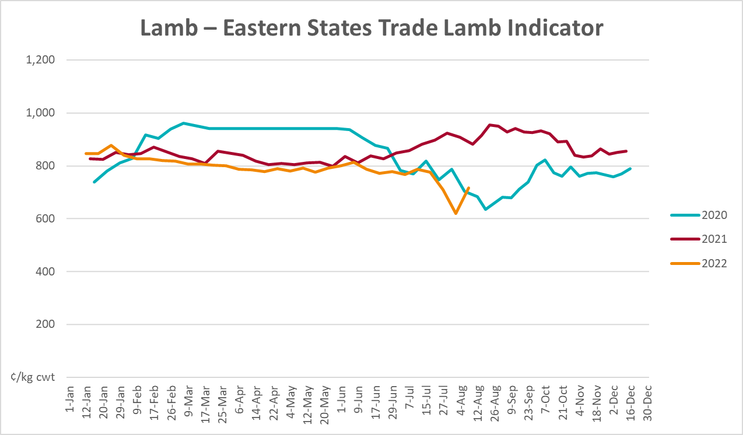
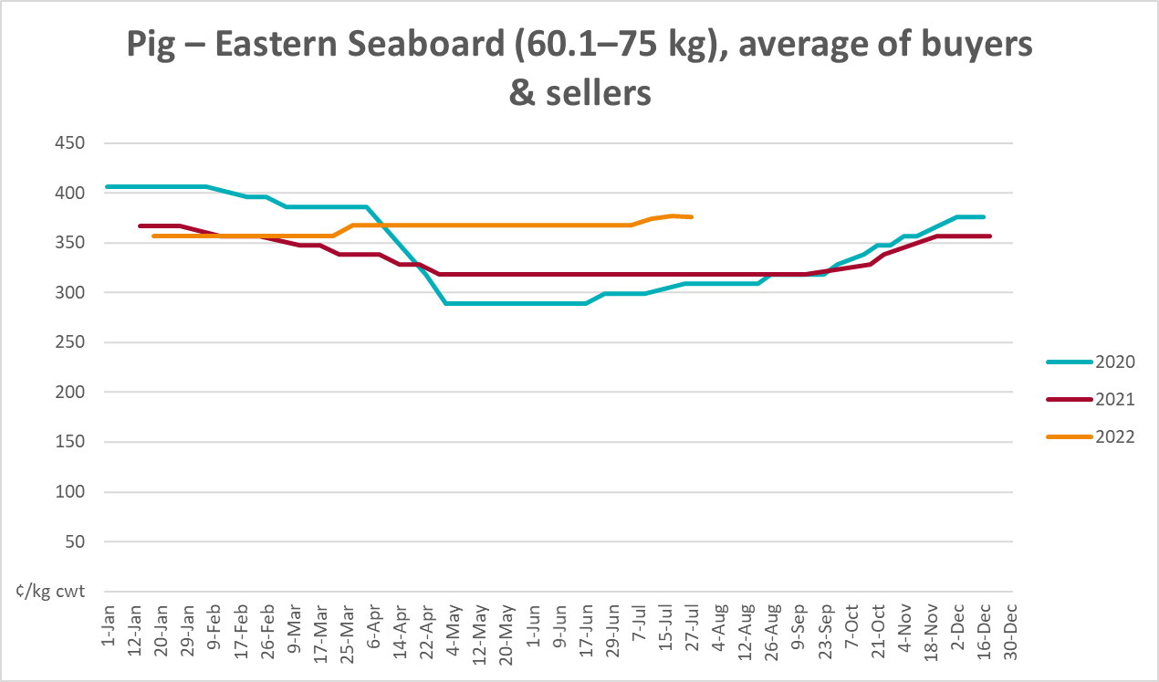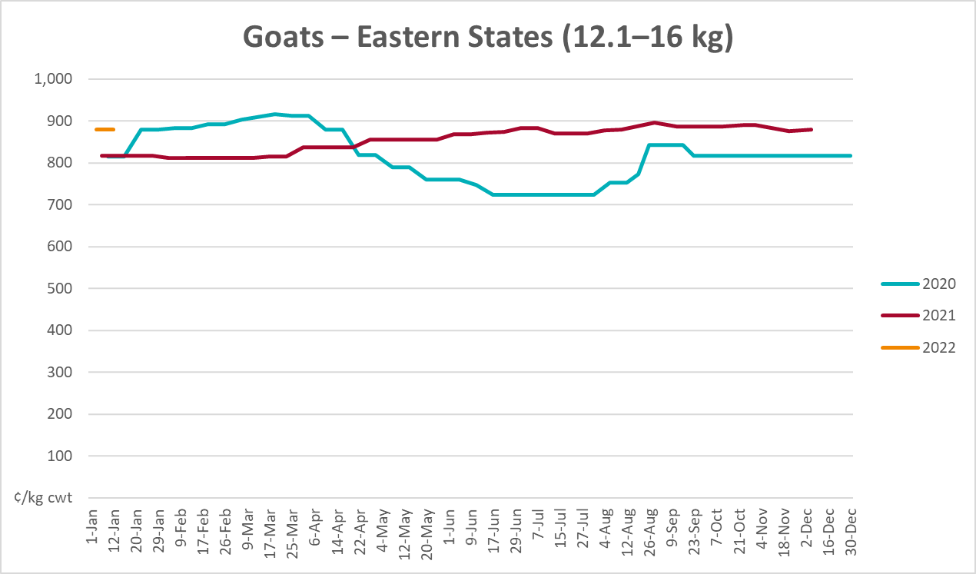
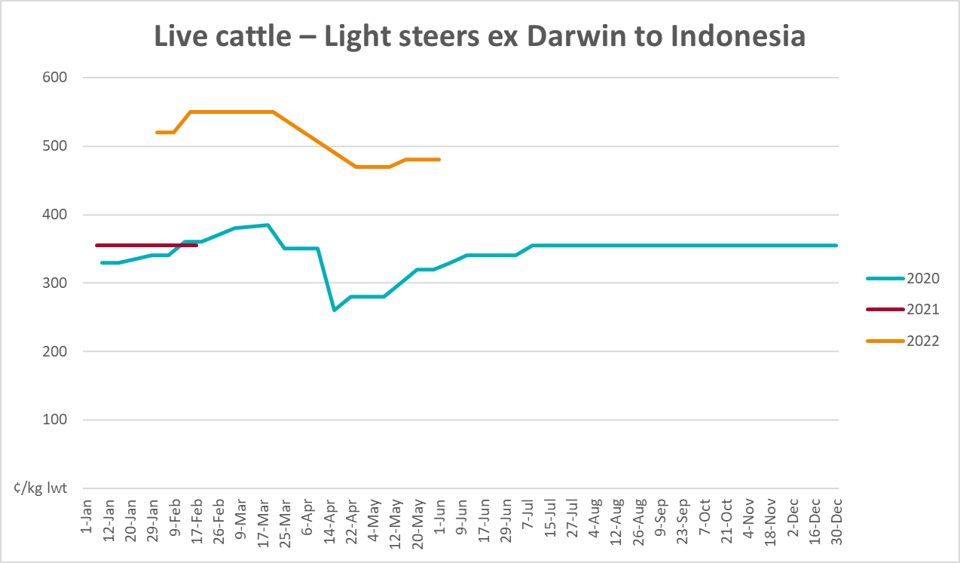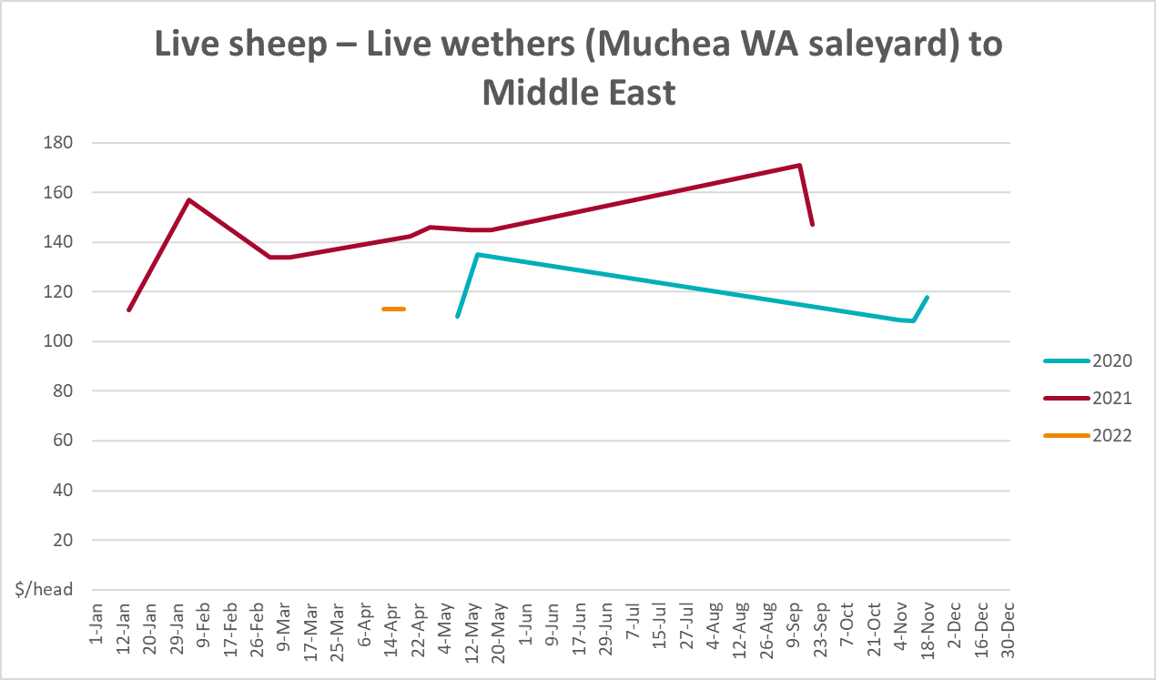

Global Dairy Trade (GDT) weighted average prices
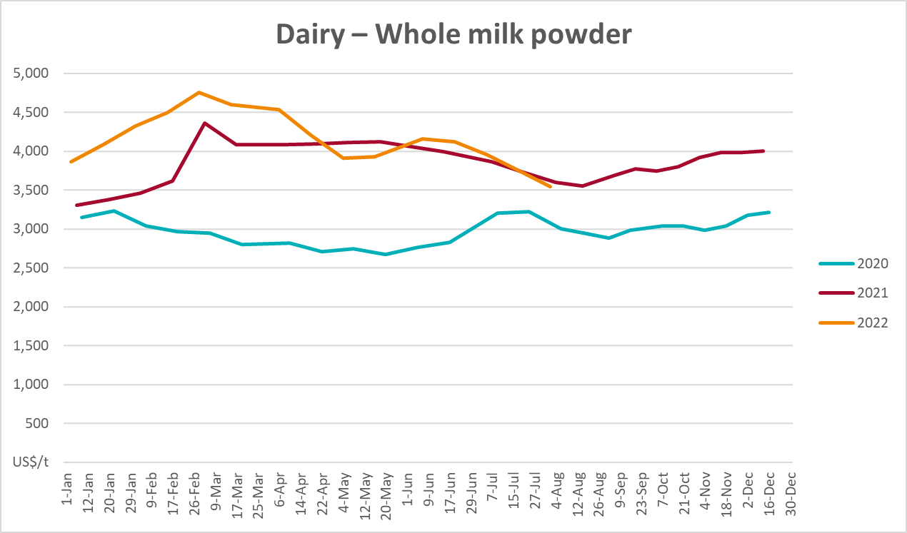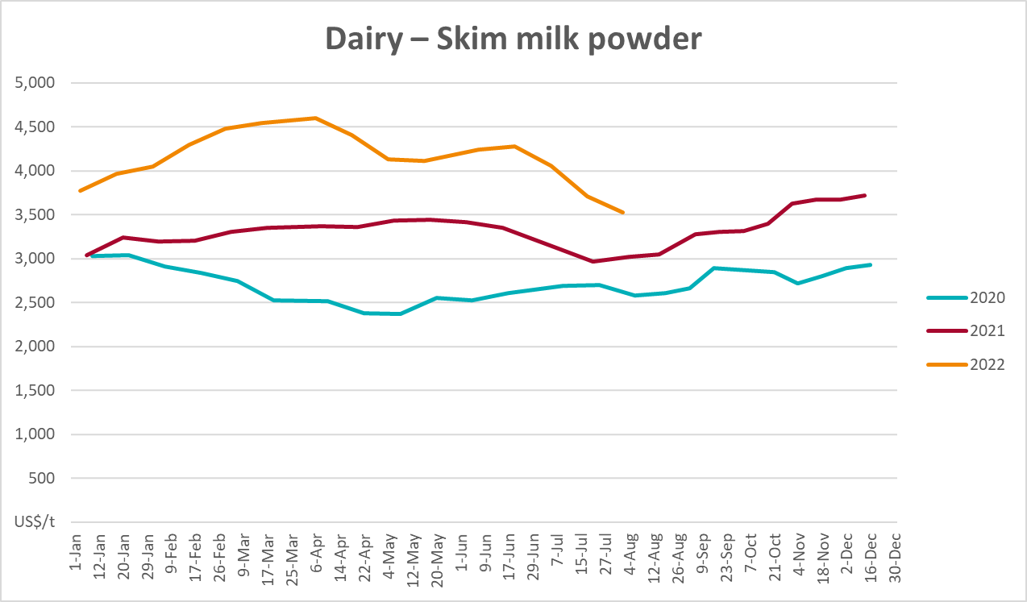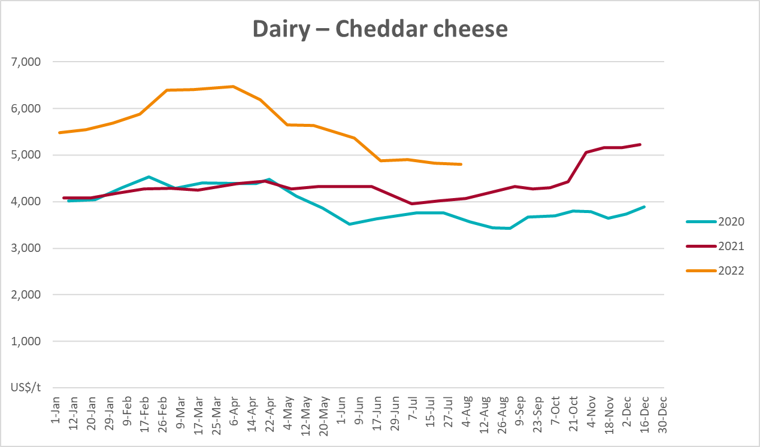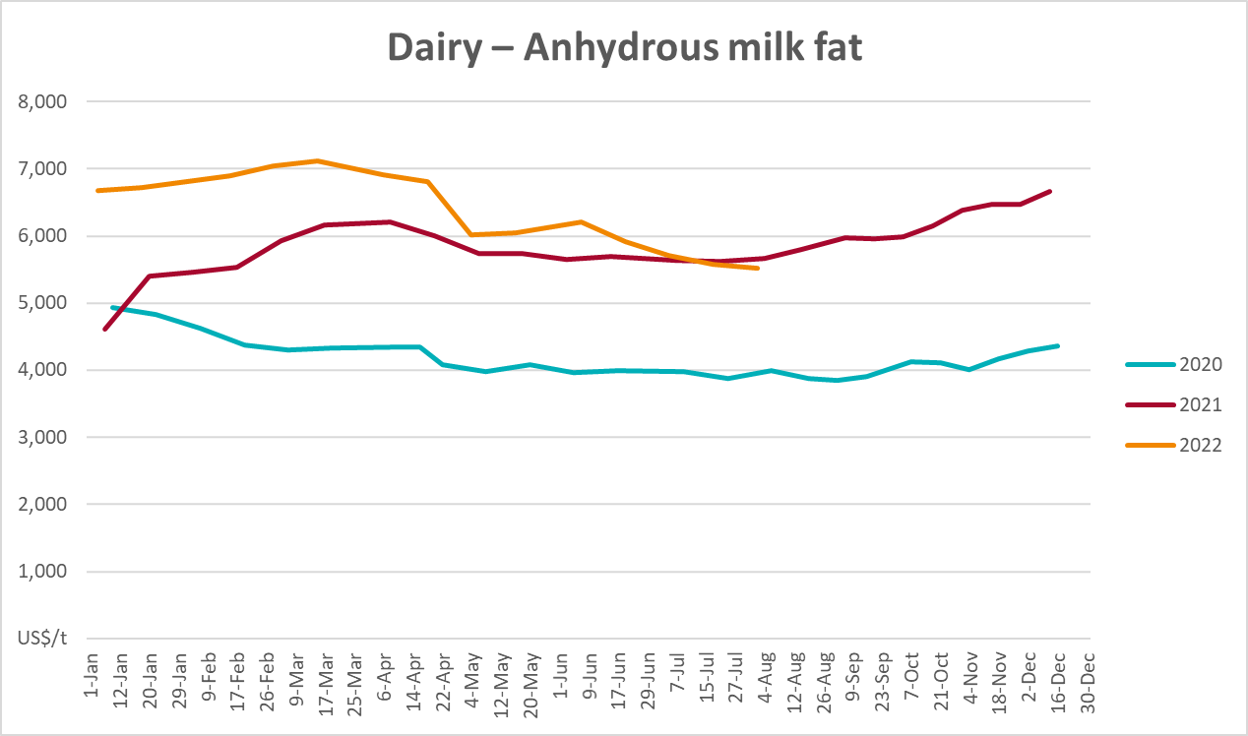

Selected fruit and vegetable prices
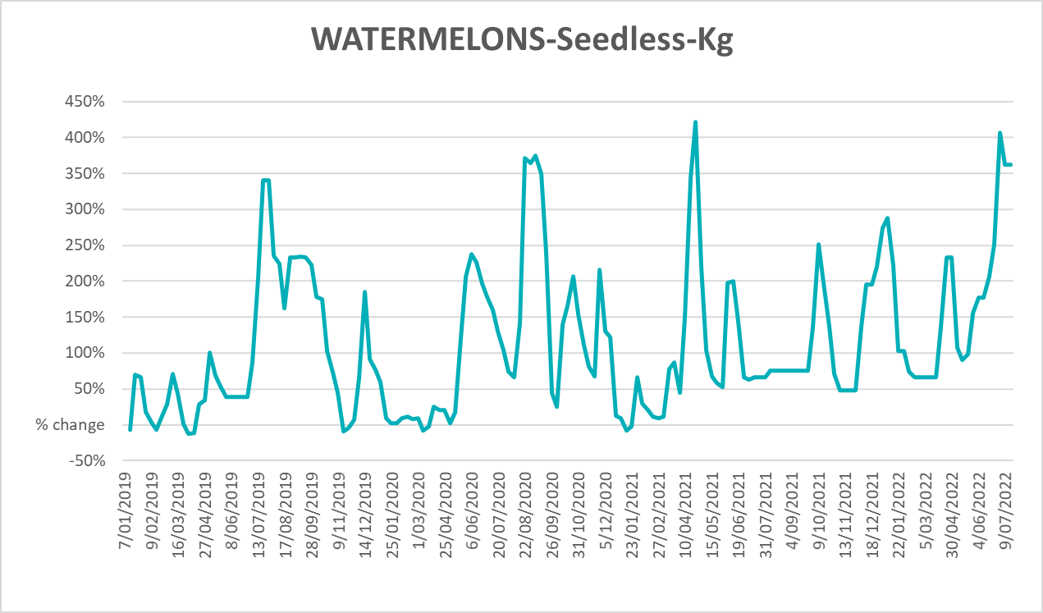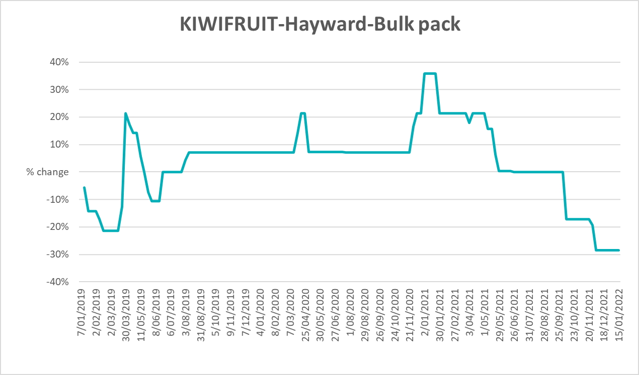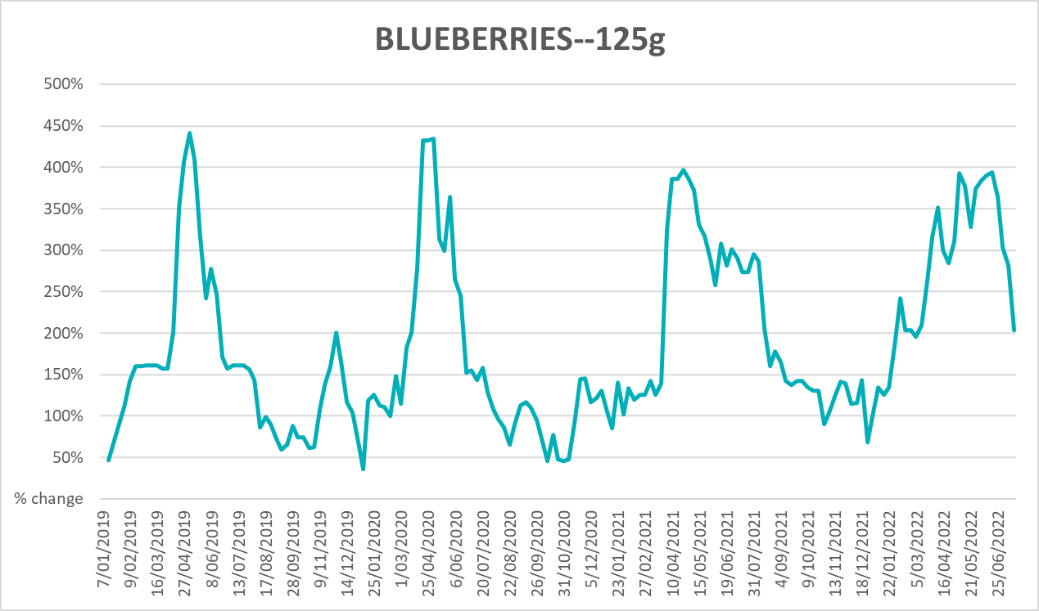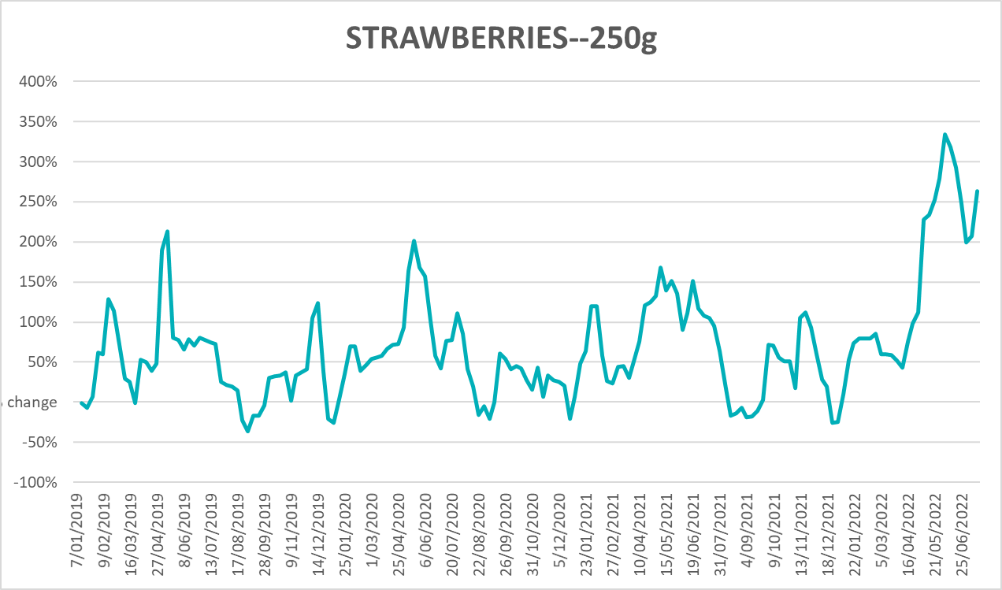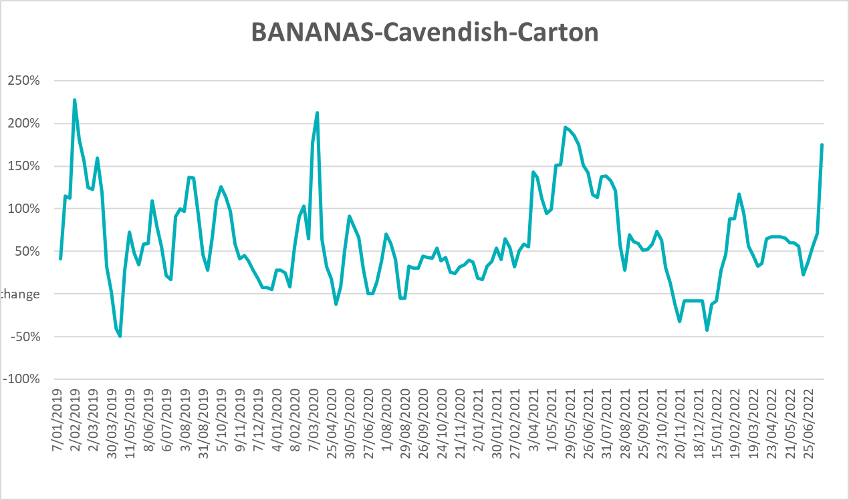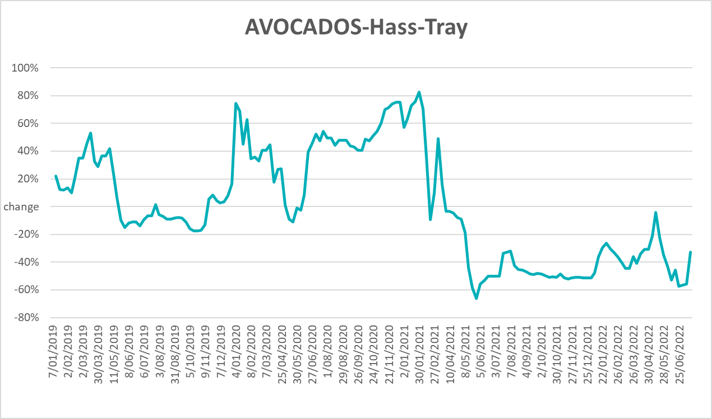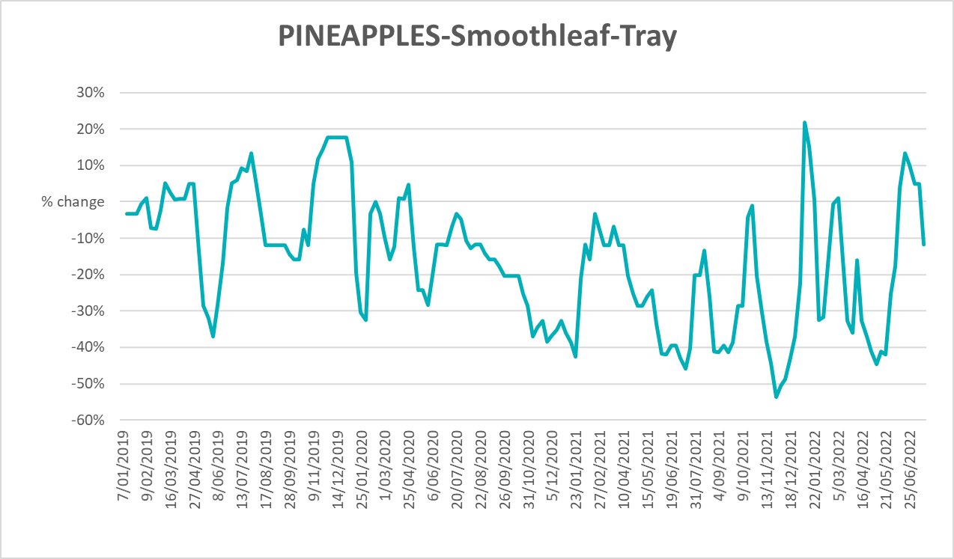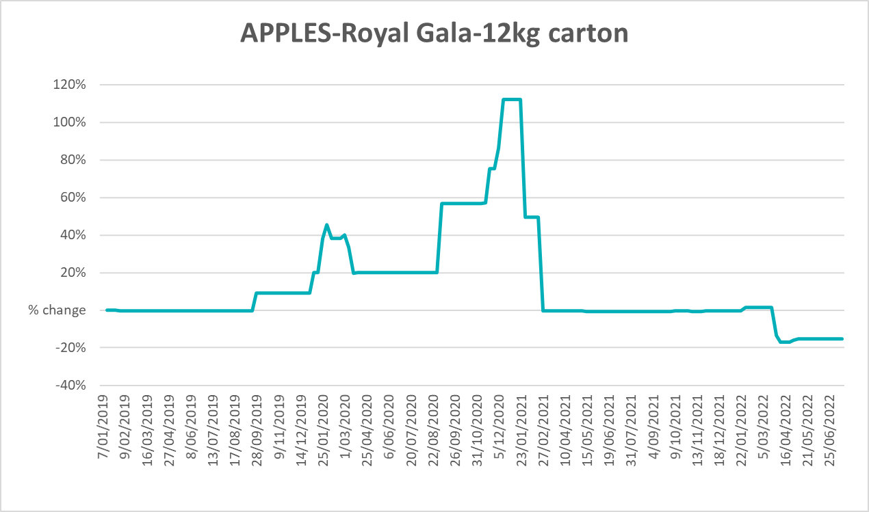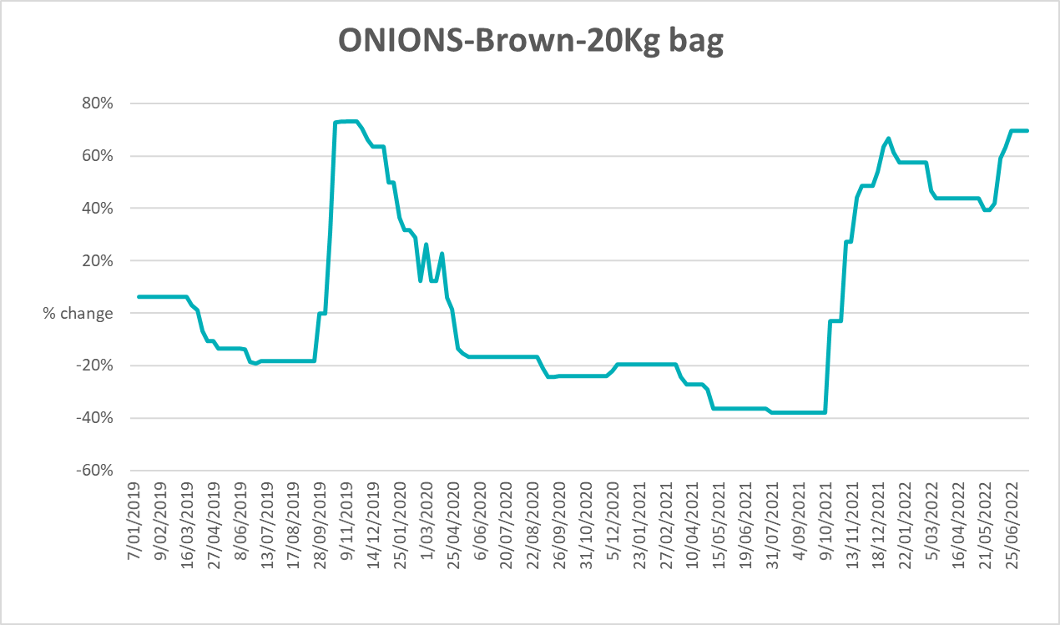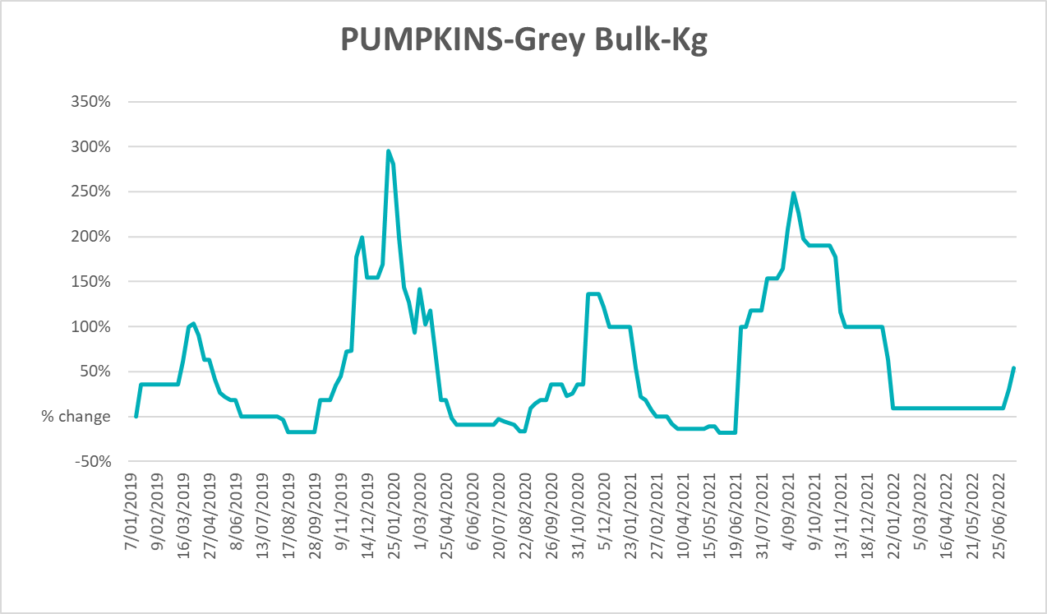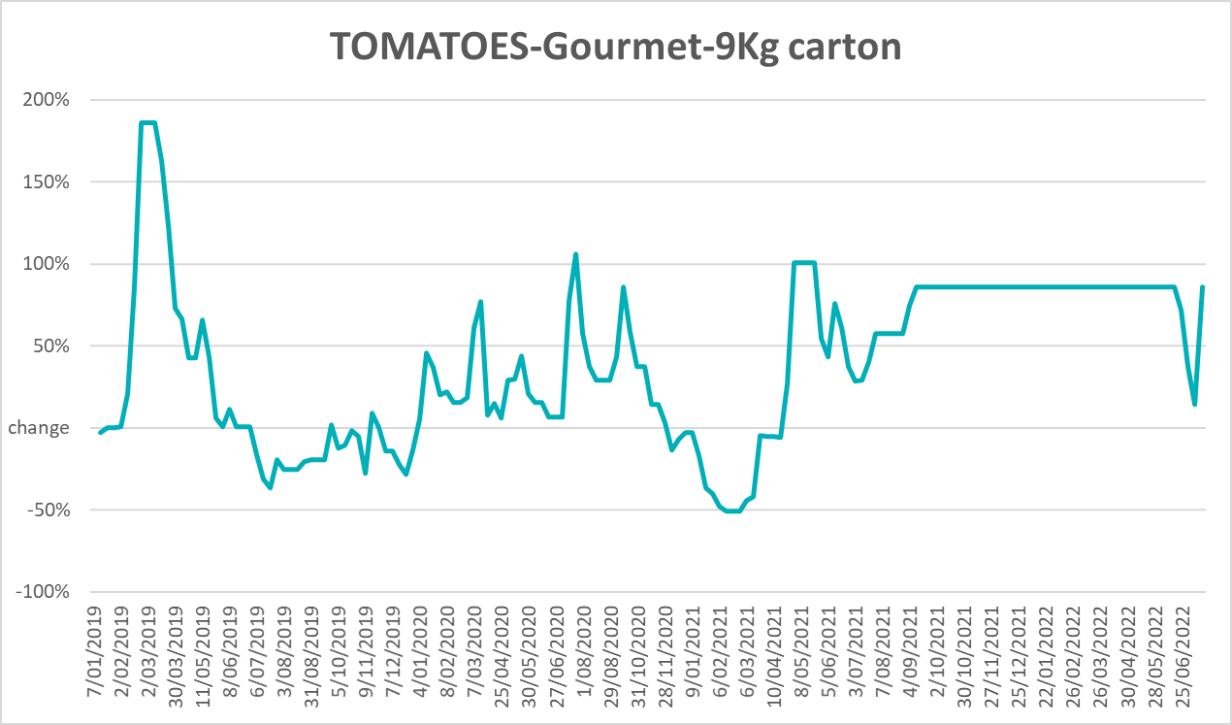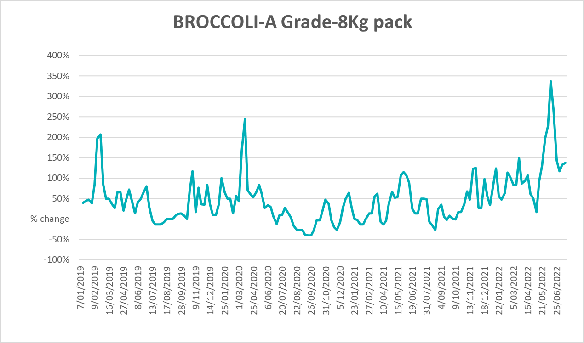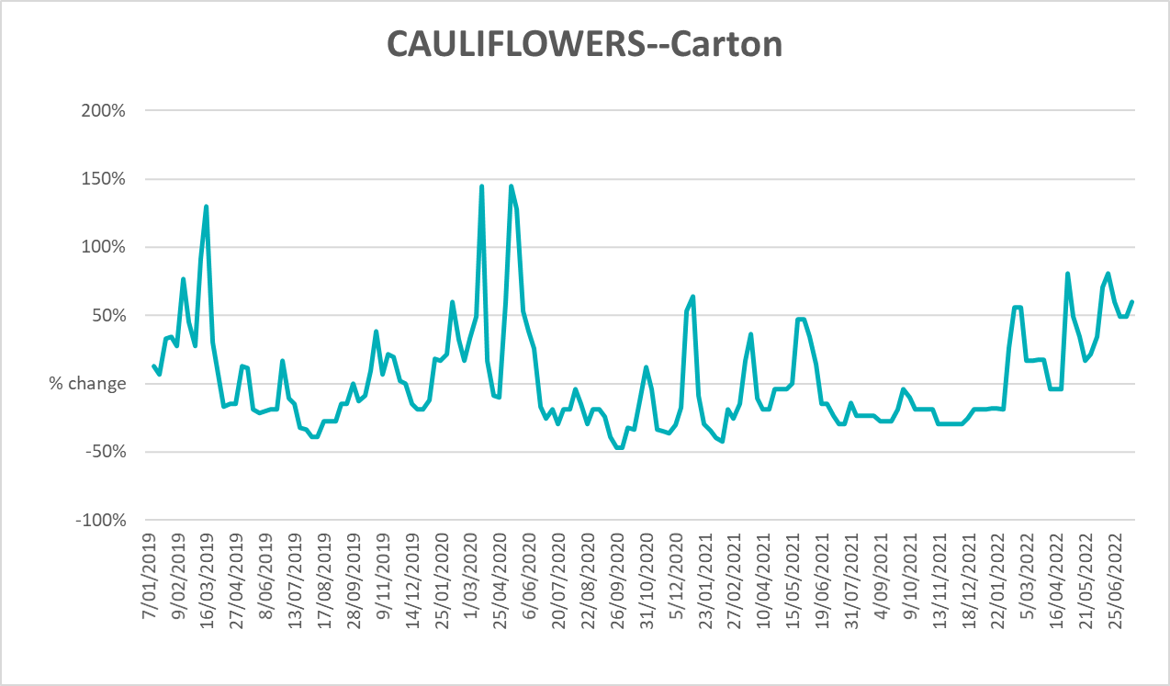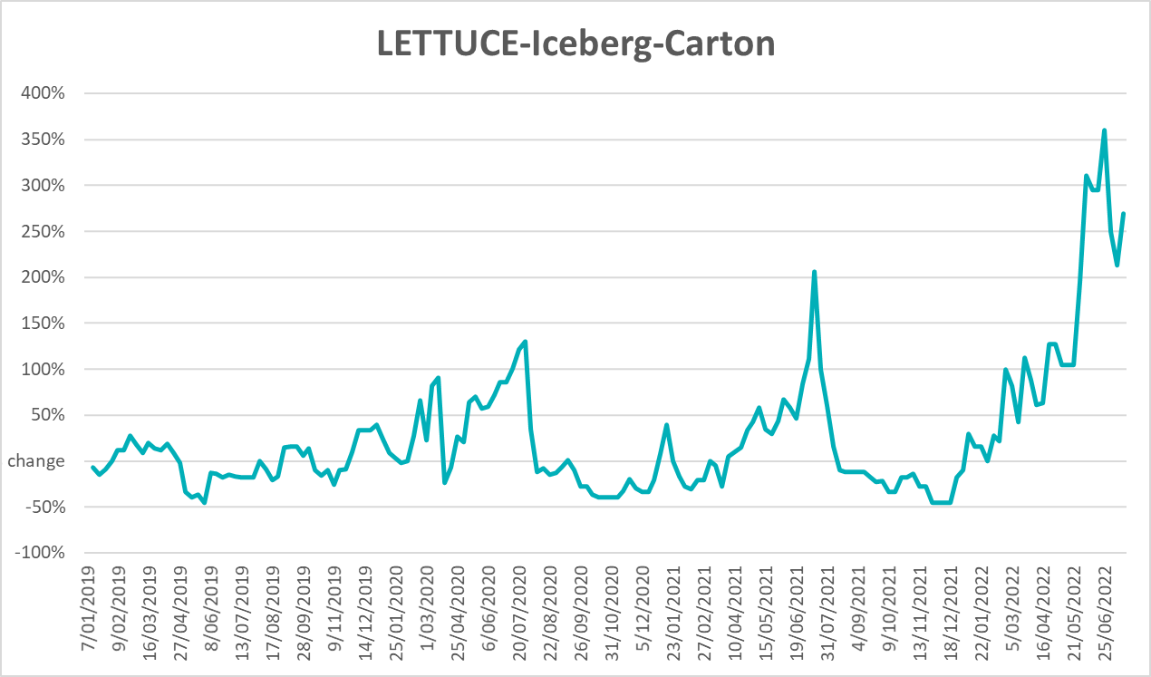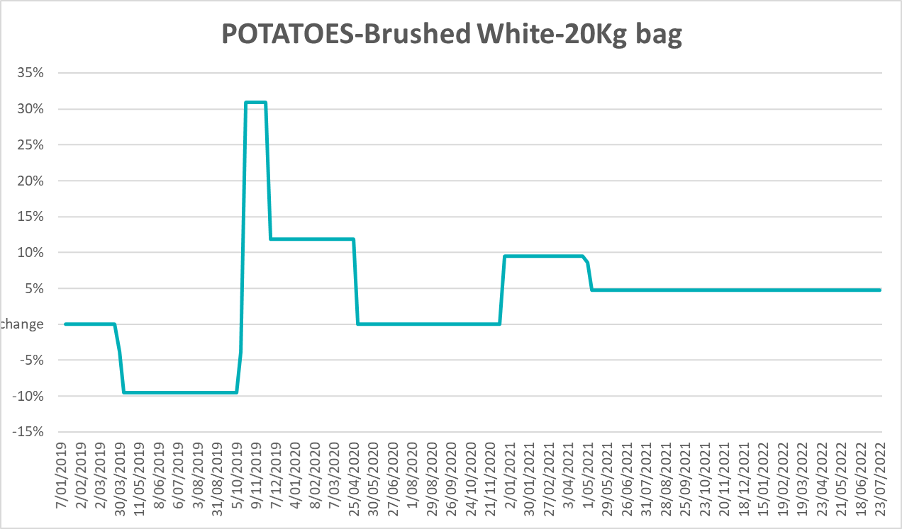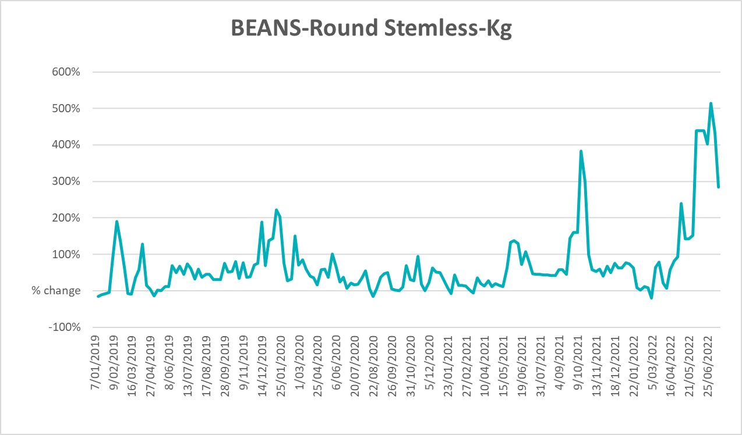

Selected domestic fodder indicator prices
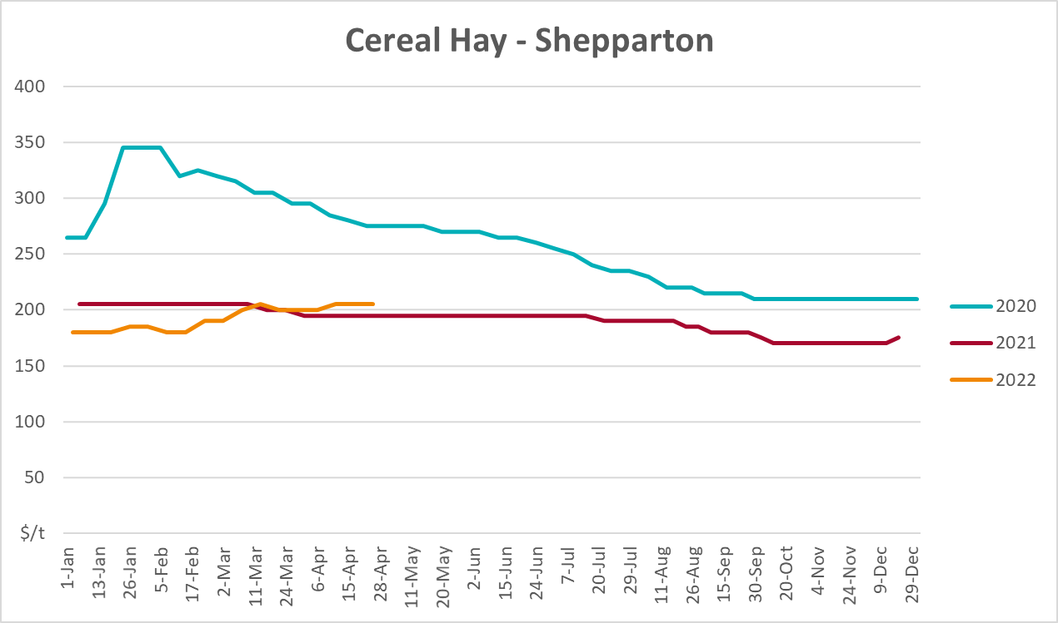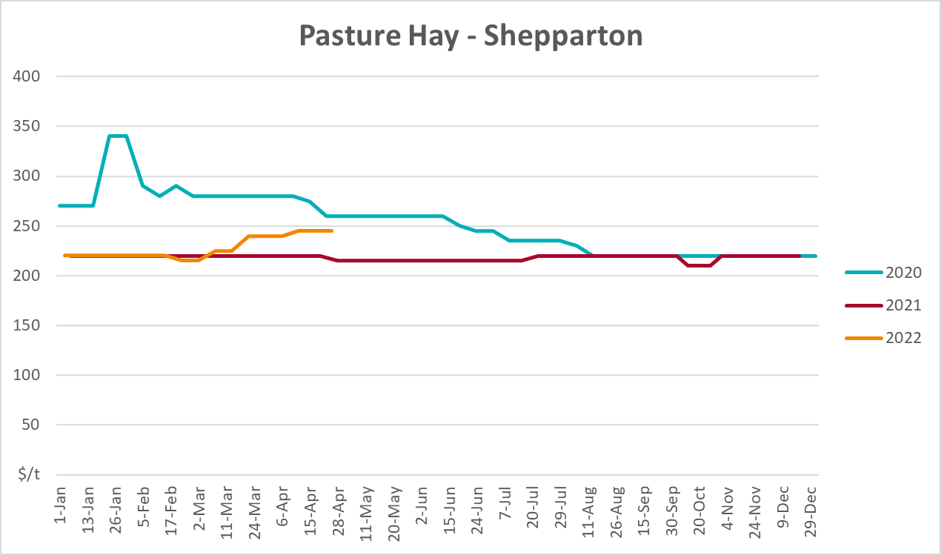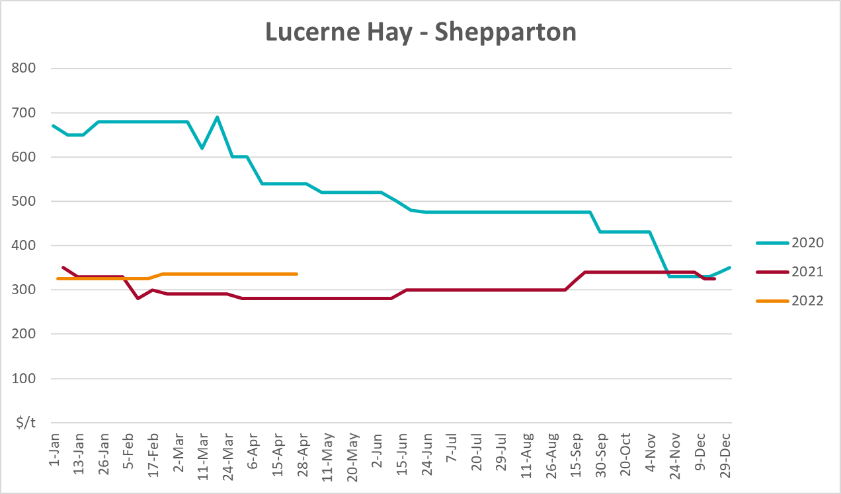

Data attribution

Climate
Bureau of Meteorology
- Weekly rainfall totals: www.bom.gov.au/climate/maps/rainfall/
- Monthly and last 3-month rainfall percentiles: www.bom.gov.au/water/landscape/
- Temperature anomalies: www.bom.gov.au/jsp/awap/temp/index.jsp
- Rainfall forecast: www.bom.gov.au/jsp/watl/rainfall/pme.jsp
- Seasonal outlook: www.bom.gov.au/climate/outlooks/#/overview/summary/
- Climate drivers: http://www.bom.gov.au/climate/enso/
- Soil moisture: www.bom.gov.au/water/landscape/
Other
- Pasture growth: www.longpaddock.qld.gov.au/aussiegrass/
- 3-month global outlooks: Environment and Climate Change Canada, NOAA Climate Prediction Center, EUROBRISA CPTEC/INPE, European Centre for Medium-Range Weather Forecasts, Hydrometcenter of Russia, National Climate Center Climate System Diagnosis and Prediction Room (NCC), International Research Institute for Climate and Society
- Global production: https://ipad.fas.usda.gov/ogamaps/cropmapsandcalendars.aspx
- Autumn break: Pook et al., 2009, https://rmets-onlinelibrary-wiley-com.virtual.anu.edu.au/doi/epdf/10.1002/joc.1833

Water
Prices
- Waterflow: https://www.waterflow.io/
- Ruralco: https://www.ruralcowater.com.au/
Bureau of Meteorology:
- Allocation trade: http://www.bom.gov.au/water/dashboards/#/water-markets/mdb/at
- Storage volumes: http://www.bom.gov.au/water/dashboards/#/water-storages/summary/drainage
Trade constraints:
- Water NSW: https://www.waternsw.com.au/customer-service/ordering-trading-and-pricing/trading/murrumbidgee
- Victorian Water Register: https://www.waterregister.vic.gov.au/TradingRules2019/

Commodities
Fruit and vegetables
- Datafresh: www.freshstate.com.au
Pigs
- Australian Pork Limited: www.australianpork.com.au
Dairy
- Global Dairy Trade: www.globaldairytrade.info/en/product-results/
World wheat, canola
- International Grains Council
World coarse grains
- United States Department of Agriculture
World cotton
- Cotlook: www.cotlook.com/
World sugar
- New York Stock Exchange - Intercontinental Exchange
Wool
- Australian Wool Exchange: www.awex.com.au/
Domestic wheat, barley, sorghum, canola and fodder
- Jumbuk Consulting Pty Ltd: http://www.jumbukag.com.au/
Cattle, beef, mutton, lamb, goat and live export
- Meat and Livestock Australia: www.mla.com.au/Prices-and-market
© Commonwealth of Australia 2022

Ownership of intellectual property rights
Unless otherwise noted, copyright (and any other intellectual property rights, if any) in this publication is owned by the Commonwealth of Australia (referred to as the Commonwealth).

Creative Commons licence
All material in this publication is licensed under a Creative Commons Attribution 4.0 International Licence except content supplied by third parties, logos and the Commonwealth Coat of Arms.
Inquiries about the licence and any use of this document should be emailed to copyright@awe.gov.au.


Cataloguing data
This publication (and any material sourced from it) should be attributed as:
ABARES 2022, Weekly Australian Climate, Water and Agricultural Update, Australian Bureau of Agricultural and Resource Economics and Sciences, Canberra, 11 August 2022. CC BY 4.0 DOI: https://doi.org/10.25814/5f3e04e7d2503
ISSN 2652-7561
This publication is available at https://www.agriculture.gov.au/abares/products/weekly_update
Department of Agriculture, Fisheries and Forestry
GPO Box 858 Canberra ACT 2601
Telephone 1800 900 090
Web agriculture.gov.au/abares

Disclaimer
The Australian Government acting through the Department of Agriculture, Fisheries and Forestry, represented by the Australian Bureau of Agricultural and Resource Economics and Sciences, has exercised due care and skill in preparing and compiling the information and data in this publication. Notwithstanding, the Department of Agriculture, Fisheries and Forestry, ABARES, its employees and advisers disclaim all liability, including liability for negligence and for any loss, damage, injury, expense or cost incurred by any person as a result of accessing, using or relying on any of the information or data in this publication to the maximum extent permitted by law.

Statement of Professional Independence
The views and analysis presented in ABARES publications, including this one, reflect ABARES professionally independent findings, based on scientific and economic concepts, principles, information and data. These views, analysis and findings may not reflect or be consistent with the views or positions of the Australian Government, or of organisations or groups who have commissioned ABARES reports or analysis. More information on professional independence is provided on the ABARES website.

Acknowledgements
This report was prepared by Matthew Miller and Cameron Van-Lane.

