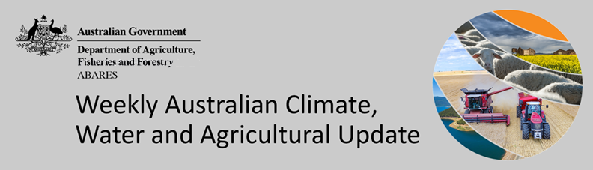
No. 30/2022

4 August 2022

Summary of key issues
- For the week ending 3 August 2022, low-pressure troughs and cold fronts swept across southern Australia, resulting in rainfall and strong winds. Over remaining parts of the country, high-pressure systems brought clear, dry conditions (see Section 1.1).
- Continued rainfall across Western Australian cropping regions over the past week has boosted soil upper layer soil moisture levels to average to well above average. Despite another week of relatively dry conditions across Queensland cropping regions, soil moisture levels remain above average. Conditions across cropping regions of south-eastern Australia remain mixed, with further rainfall over the coming weeks needed to maintain winter crop yield potentials.
- Rainfall during July 2022 was 2% above average for Australia as a whole. Rainfall was above average to extremely high for parts of eastern and northern New South Wales, northern and eastern Queensland and the north of the Northern Territory. However, rainfall was extremely low to below average for most of western and southern New South Wales, Victoria, South Australia, Tasmania and scattered areas of southern Western Australia (see Section 1.2).
- Modelled pasture growth was extremely low to below average across parts of south-western and south-eastern Queensland, southern Victoria, south-eastern South Australia, south-eastern Western Australia, and parts of central Northern Territory. In contrast, modelled pasture growth was above average to extremely high across much of New South Wales, northern Victoria, central and northern Queensland, large areas of the west and north of Western Australia and parts of north-eastern and central South Australia (see Section 1.4).
- Over the 8-days to 11 August 2022, low-pressure troughs and cold fronts are expected to bring rainfall to parts of southern and south-eastern Australia. However, high-pressure systems across remaining parts of the country are expected to result in clear, dry conditions. The forecast rainfall is expected to increase soil moisture levels across cropping regions in New South Wales, Victoria and South Australia. The expected rainfall will support the continued development of winter crops over the coming weeks. The largely dry conditions forecast across Western Australia over the next 8-days follows two weeks of moderate rainfalls, with ample soil moisture to sustain winter crops over the coming weeks. Rainfall in parts of southern Queensland will add to above average soil moisture levels and may lead to waterlogging in isolated areas, negatively impacting crop development. However, dry conditions are forecast for most cropping regions in Queensland (see Section 1.5).
- Water storage in the Murray–Darling Basin (MDB) increased by 66 gigalitres (GL) between 27 July 2022 and 3 August 2022. The current volume of water held in storage is 22,226 GL, which represents 88% of total capacity. This is 14% or 2,717 GL more than at the same time last year.
- Allocation prices in the Victorian Murray below the Barmah Choke decreased from $80 per ML on 22 July 2022 to $79 per ML on 29 July 2022. Prices are lower in the Goulburn-Broken and regions above the Barmah choke due to the binding of the Goulburn intervalley trade limit and Barmah choke trade constraint.

Climate

Rainfall this week
For the week ending 3 August 2022, low-pressure troughs and cold fronts swept across southern Australia, resulting in rainfall and strong winds. Over remaining parts of the country, high-pressure systems brought clear, dry conditions.
Rainfall totals of between 10 and 50 millimetres were recorded across parts of southern and northern New South Wales, scattered parts of Queensland, much of southern Victoria and South Australia, the west of Western Australia, as well as most of Tasmania. Rainfall totals in excess of 50 millimetres were recorded in alpine areas of New South Wales and Victoria, the south-west of Western Australia and western Tasmania. Remaining parts of Australia received little to no rainfall.
In Australian cropping regions, rainfall totals of between 10 and 50 millimetres were recorded across parts of eastern New South Wales, southern Victoria, western parts of South Australia, as well as most of Western Australia. Rainfall totals in excess of 50 millimetres were recorded across central and western parts of cropping regions in Western Australia. Little to no rainfall was recorded across remaining cropping regions for the week ending 3 August 2022.
Continued rainfall across Western Australian cropping regions over the past week has boosted soil upper layer soil moisture levels to average to well above average. The increase in soil moisture levels will support yield potentials for winter crops as they progress through vegetative growth stages and approach critical reproductive stages in spring. The favourable start to the winter cropping season has resulted in above average crop biomass, and if plant available water remains supportive, above average yields may eventuate. Despite another week of relatively dry conditions across Queensland cropping regions, soil moisture levels remain above average. Conditions across cropping regions of south-eastern Australia remain mixed, with further rainfall over the coming weeks needed to maintain winter crop yield potentials.

Rainfall for the week ending 3 August 2022
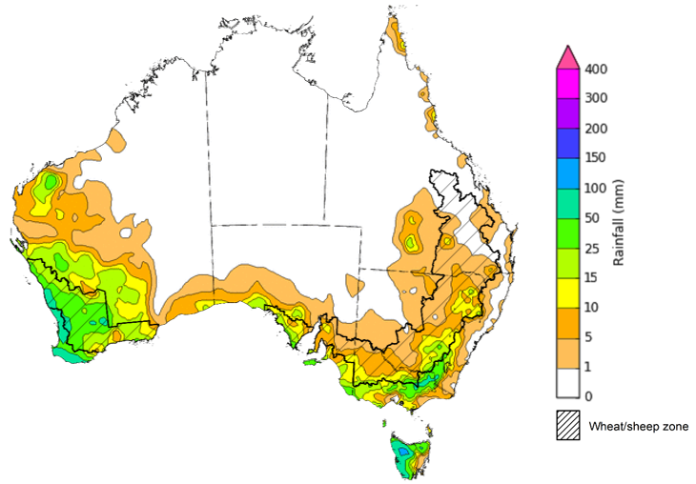
©Commonwealth of Australia 2022, Australian Bureau of Meteorology Issued:3/8/2022
Note: The rainfall analyses and associated maps utilise data contained in the Bureau of Meteorology climate database, the Australian Data Archive for Meteorology (ADAM). The analyses are initially produced automatically from real-time data with limited quality control. They are intended to provide a general overview of rainfall across Australia as quickly as possible after the observations are received. For further information go to http://www.bom.gov.au/climate/rainfall/

Monthly rainfall
Rainfall during July 2022 was 2% above average for Australia as a whole, but significantly below average across Victoria, South Australia, Western Australia and Tasmania. The main climate influences for July were a dissipating La Niña event in the Pacific and the likely development of a negative Indian Ocean Dipole (IOD), both producing warmer than average oceans to the north of Australia. These warmer than average ocean temperatures are associated with above average rainfall for eastern and northern Australia. However, high-pressure systems dominated much of southern Australia throughout July, resulting in below average to average rainfall.
Rainfall was above average to extremely high for parts of eastern and northern New South Wales, northern and eastern Queensland and the north of the Northern Territory. However, rainfall was extremely low to below average for most of western and southern New South Wales, Victoria, South Australia, Tasmania and scattered areas of southern Western Australia.
July rainfall was average to above average across cropping regions in central and northern New South Wales, Queensland and much of Western Australia. Below average falls recorded in cropping regions of southern New South Wales, Victoria, South Australia, as well as scattered areas of Western Australia.
The average to below average rainfall across New South Wales and southern Queensland followed above average rainfalls in May, which allowed soil profiles to drain. Therefore, significant progress was made in the planting of winter crops particularly in northern New South Wales. Previous heavy opening rainfalls across southern cropping regions have provided a positive start to the winter cropping season, with the below average to average rainfall across southern cropping regions having a negligible impact on crop development due to sufficient soil moisture stores.

Rainfall percentiles for July 2022

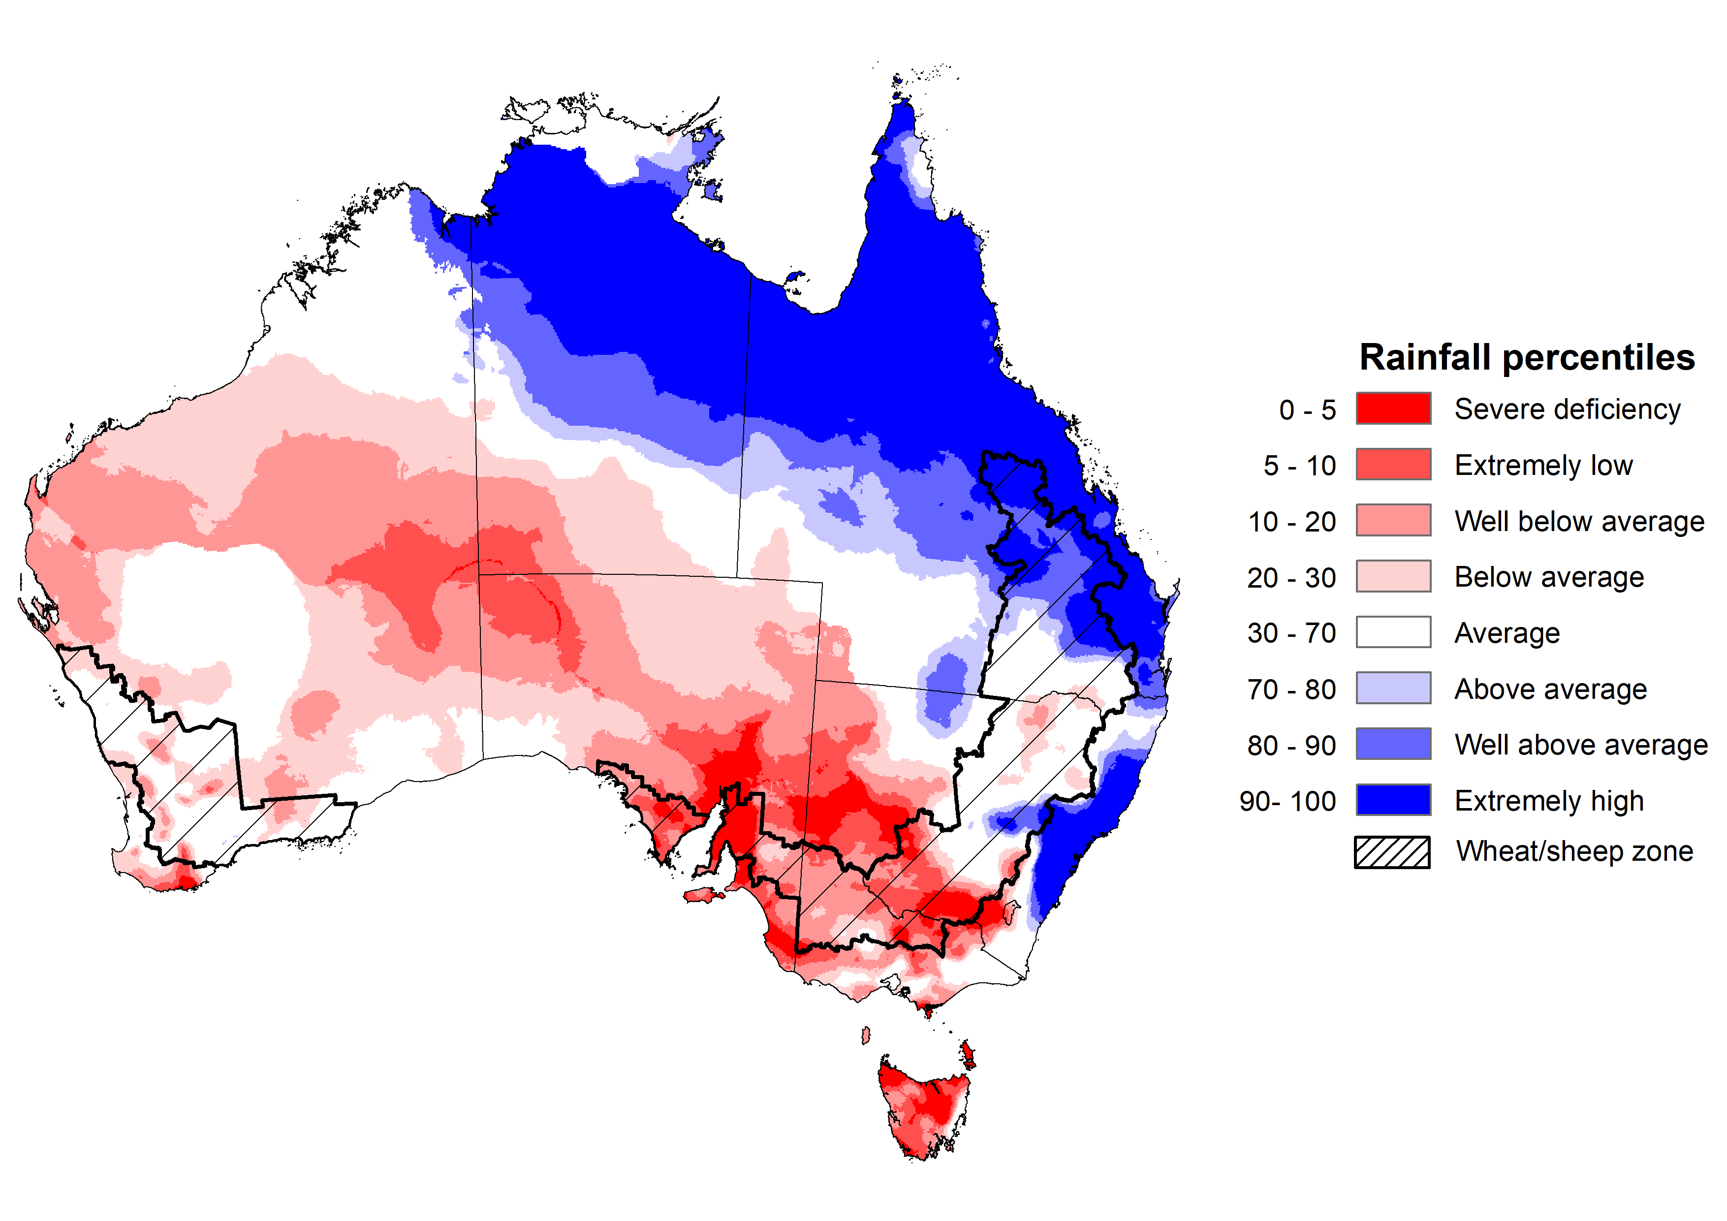
Note: Rainfall for July 2022 is compared with rainfall recorded for that period during the historical record (1900 to present). For further information, go to http://www.bom.gov.au/jsp/awap/
Source: Bureau of Meteorology

Monthly soil moisture
Upper layer soil moisture in July 2022 was extremely low for this time of year across large areas of western and southern New South Wales, parts of south-western Queensland, the north-west of Western Australia, much of South Australia and northern Victoria, isolated parts in the south of the Northern Territory and much of Tasmania. Extremely high upper layer soil moisture was evident in northern and eastern Queensland, and parts of eastern New South Wales reflecting heavy rainfall events in these areas. Modelled upper layer soil moisture was generally average across the remainder of the country.
At this time of year, upper layer soil moisture is important for the establishment and early development of winter crops across Australian cropping regions. Too much upper layer soil moisture at this time can also impede access paddocks to undertake post-emergent weed and pest management activities.
Upper layer soil moisture was average to above average for this time of year across cropping regions in central and northern New South Wales, Queensland and Western Australia. Upper layer soil moisture was below average for much of southern New South Wales, Victoria and South Australia. Following extremely high upper layer soil moisture in previous months, the below average to average upper layer soil moisture conditions in July across New South Wales and Queensland have allowed field access.

Modelled upper layer soil moisture for July 2022

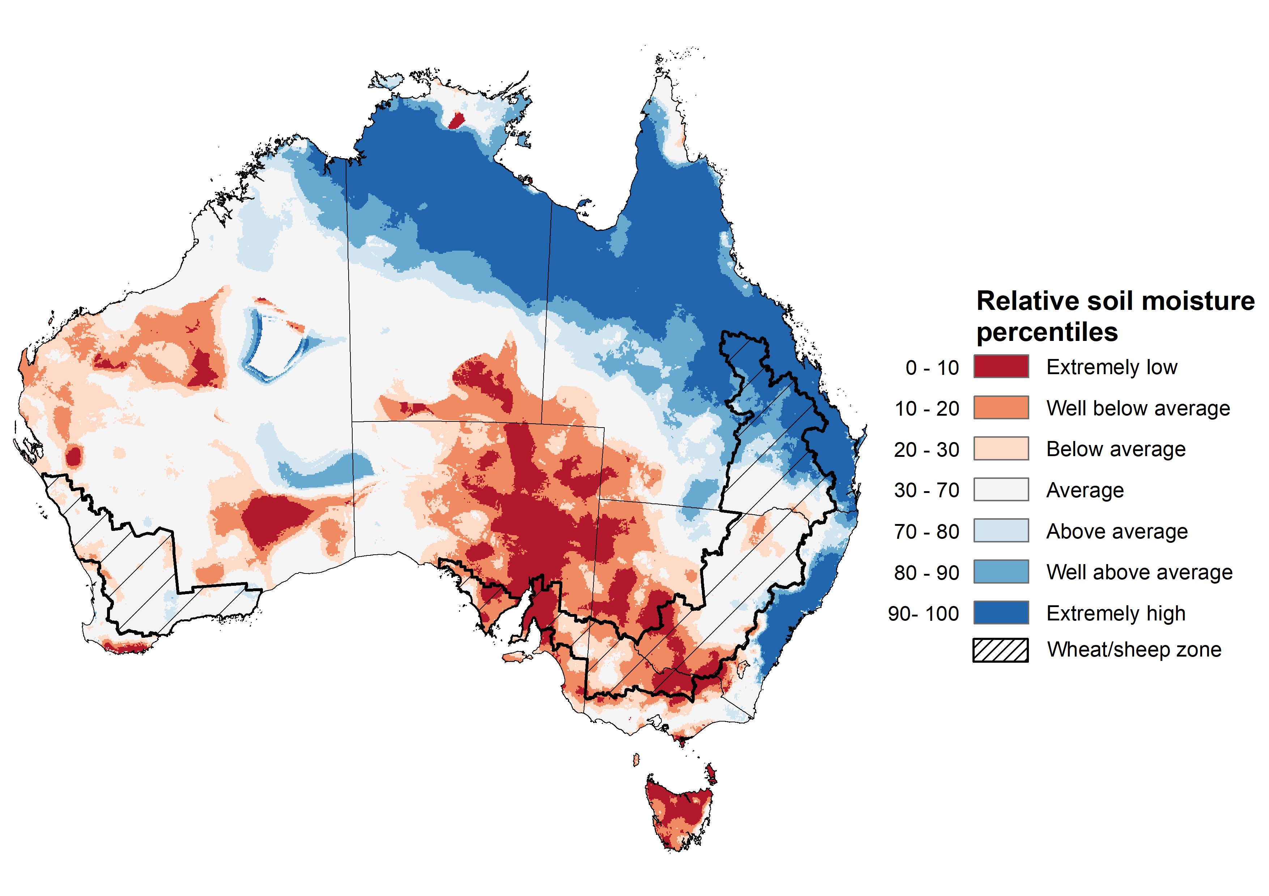
Note: This map shows the levels of modelled upper layer soil moisture (0 to 10 centimetres) during July 2022. This map shows how modelled soil conditions during July 2022 compare with July conditions modelled over the reference period (1911 to 2016). Dark blue areas on the maps were much wetter in July 2022 than during the reference period. The bulk of plant roots occur in the top 20 centimetres of the soil profile. Soil moisture in the upper layer of the soil profile is therefore useful indicator of the availability of water, particularly for germinating seed.
Source: Bureau of Meteorology (Australian Water Resources Assessment Landscape model)

Lower layer soil moisture for July 2022 was well above average to extremely high for this time of year across eastern and central New South Wales, parts of south-eastern, central and northern Queensland, parts of northern Western Australia, large areas of the north of the Northern Territory. Lower layer soil moisture was well below average to below average in south-western Queensland, western Victoria, isolated parts of central South Australia, the south and west of Western Australia and the far north of the Northern Territory. Modelled lower layer soil moisture was generally average across the remainder of the country.
In cropping regions, lower layer soil moisture was well above average to extremely high across central New South Wales and much of Queensland. Lower layer soil moisture was extremely low to below average for much of western and northern Western Australian cropping regions. Lower layer soil moisture was generally average across remaining areas of New South Wales, Victoria, South Australia, as well as southern areas of Western Australia. The average levels of lower layer soil moisture will support yield potentials across New South Wales, Victoria, southern Western Australia and South Australia as winter crops continue to develop and their root systems extend into lower soil layers. Conversely, below average lower layer soil moisture across large areas of Western Australia presents a significant downside risk to yield potentials without ongoing timely rainfall events in the coming months.
Well above average to extremely high lower layer soil moisture levels across central New South Wales and much of Queensland also present a downside risk to yields. These areas are subject to increased chances of exceeding medial rainfall over the next three months, increasing the potential of ongoing saturated soils and waterlogging reducing potential yields.
Modelled lower layer soil moisture for July 2022
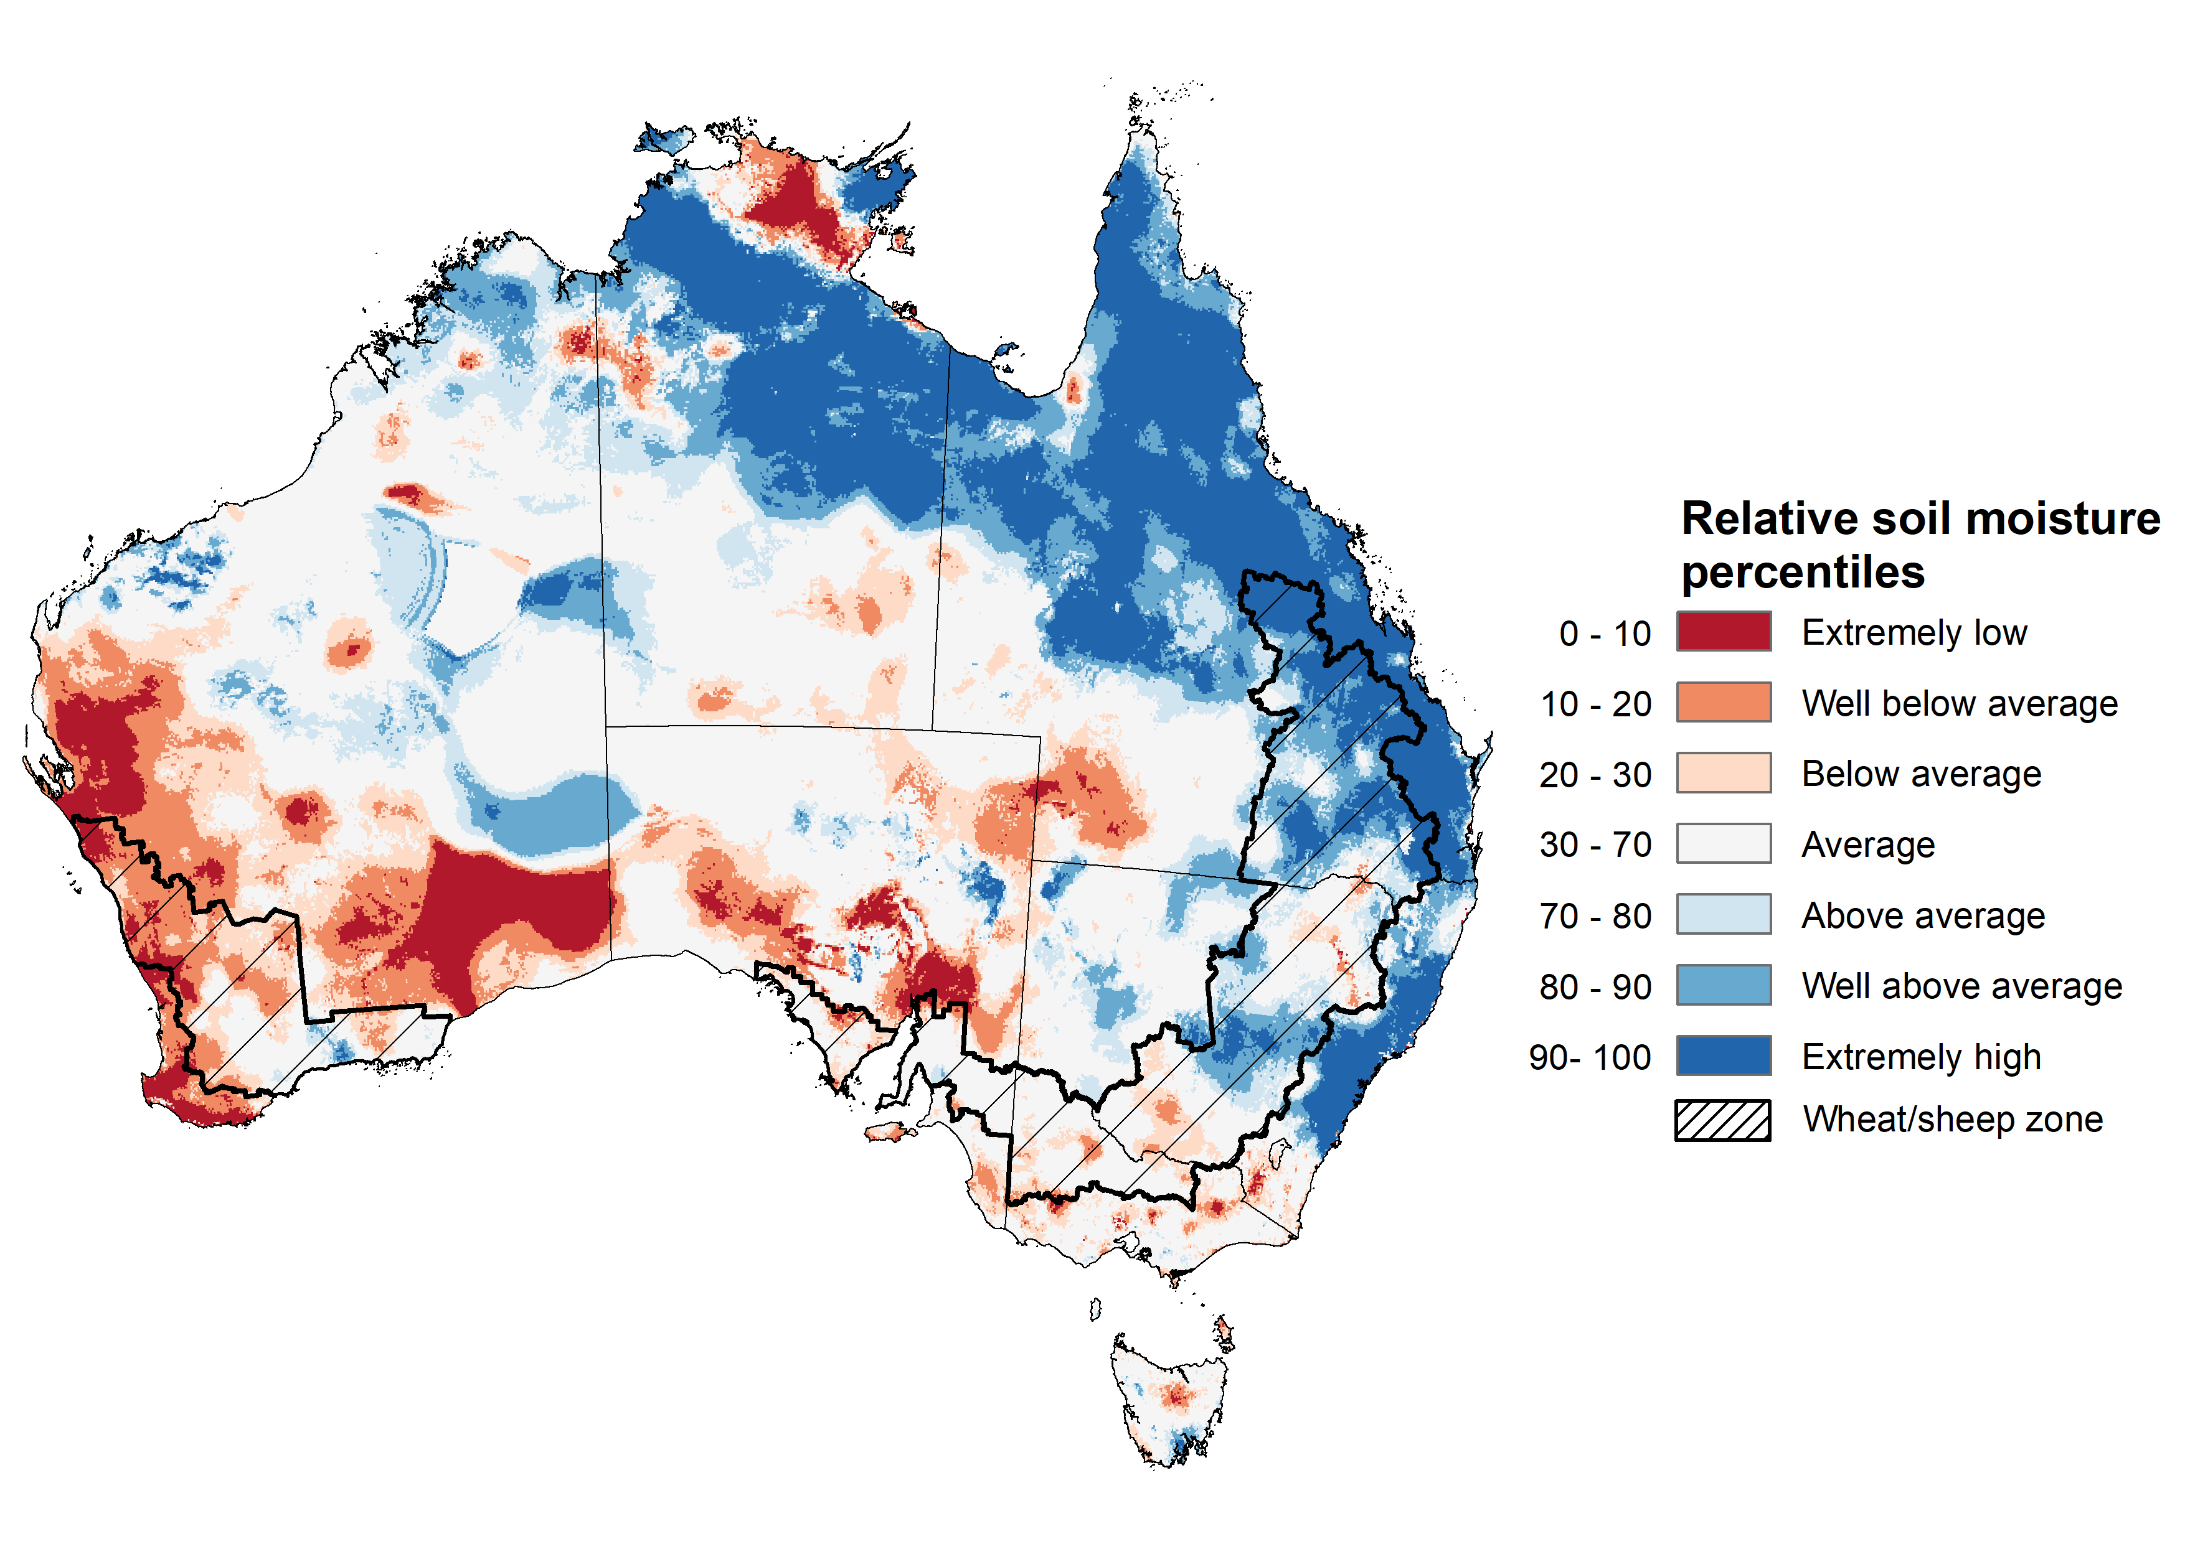
Note: This map shows the levels of modelled lower layer soil moisture (10 to 100 centimetres) during July 2022. This map shows how modelled soil conditions during July 2022 compare with July conditions modelled over the reference period (1911 to 2016). Dark blue areas on the maps were much wetter in July 2022 than during the reference period. The dark red areas were much drier than during the reference period. The bulk of plant roots occur in the top 20 centimetres of the soil profile. The lower layer soil moisture is a larger, deeper store that is slower to respond to rainfall and tends to reflect accumulated rainfall events over longer time periods.
Source: Bureau of Meteorology (Australian Water Resources Assessment Landscape model)

Pasture growth
Pasture growth during the May to July period is typically low across large areas of central and northern Australia as it enters a seasonally low growth period due to cooler temperatures and little to no rainfall. Across southern Australia, May to July pasture growth influences the number of livestock that can be supported without supplementary feeding over winter and the level of reliance on hay and grain during this period.
For the 3 months to July 2022, low rainfall totals limited pasture production across scattered areas of southern and eastern Australia. In contrast, average or better rainfall and generally average soil moisture benefitted pasture production across large areas of western and eastern Australia.
Modelled pasture growth was extremely low to below average across parts of south-western and south-eastern Queensland, southern Victoria, south-eastern South Australia, south-eastern Western Australia, and parts of central Northern Territory. As a result, livestock producers across parts of southern Queensland, southern Victoria, southern Western Australia and south-eastern South Australia will be heavily reliant on rainfall over the remainder of winter to build soil moisture levels and supplementary feed to maintain current stock numbers.
In contrast, modelled pasture growth was above average to extremely high across much of New South Wales, northern Victoria, central and northern Queensland, large areas of the west and north of Western Australia and parts of north-eastern and central South Australia. This growth is likely to enable farmers to continue to rebuild stock numbers and provide opportunities to replenish fodder supplies during spring.

Relative pasture growth for 3-months ending July 2022 (1 May to 31 July 2022)
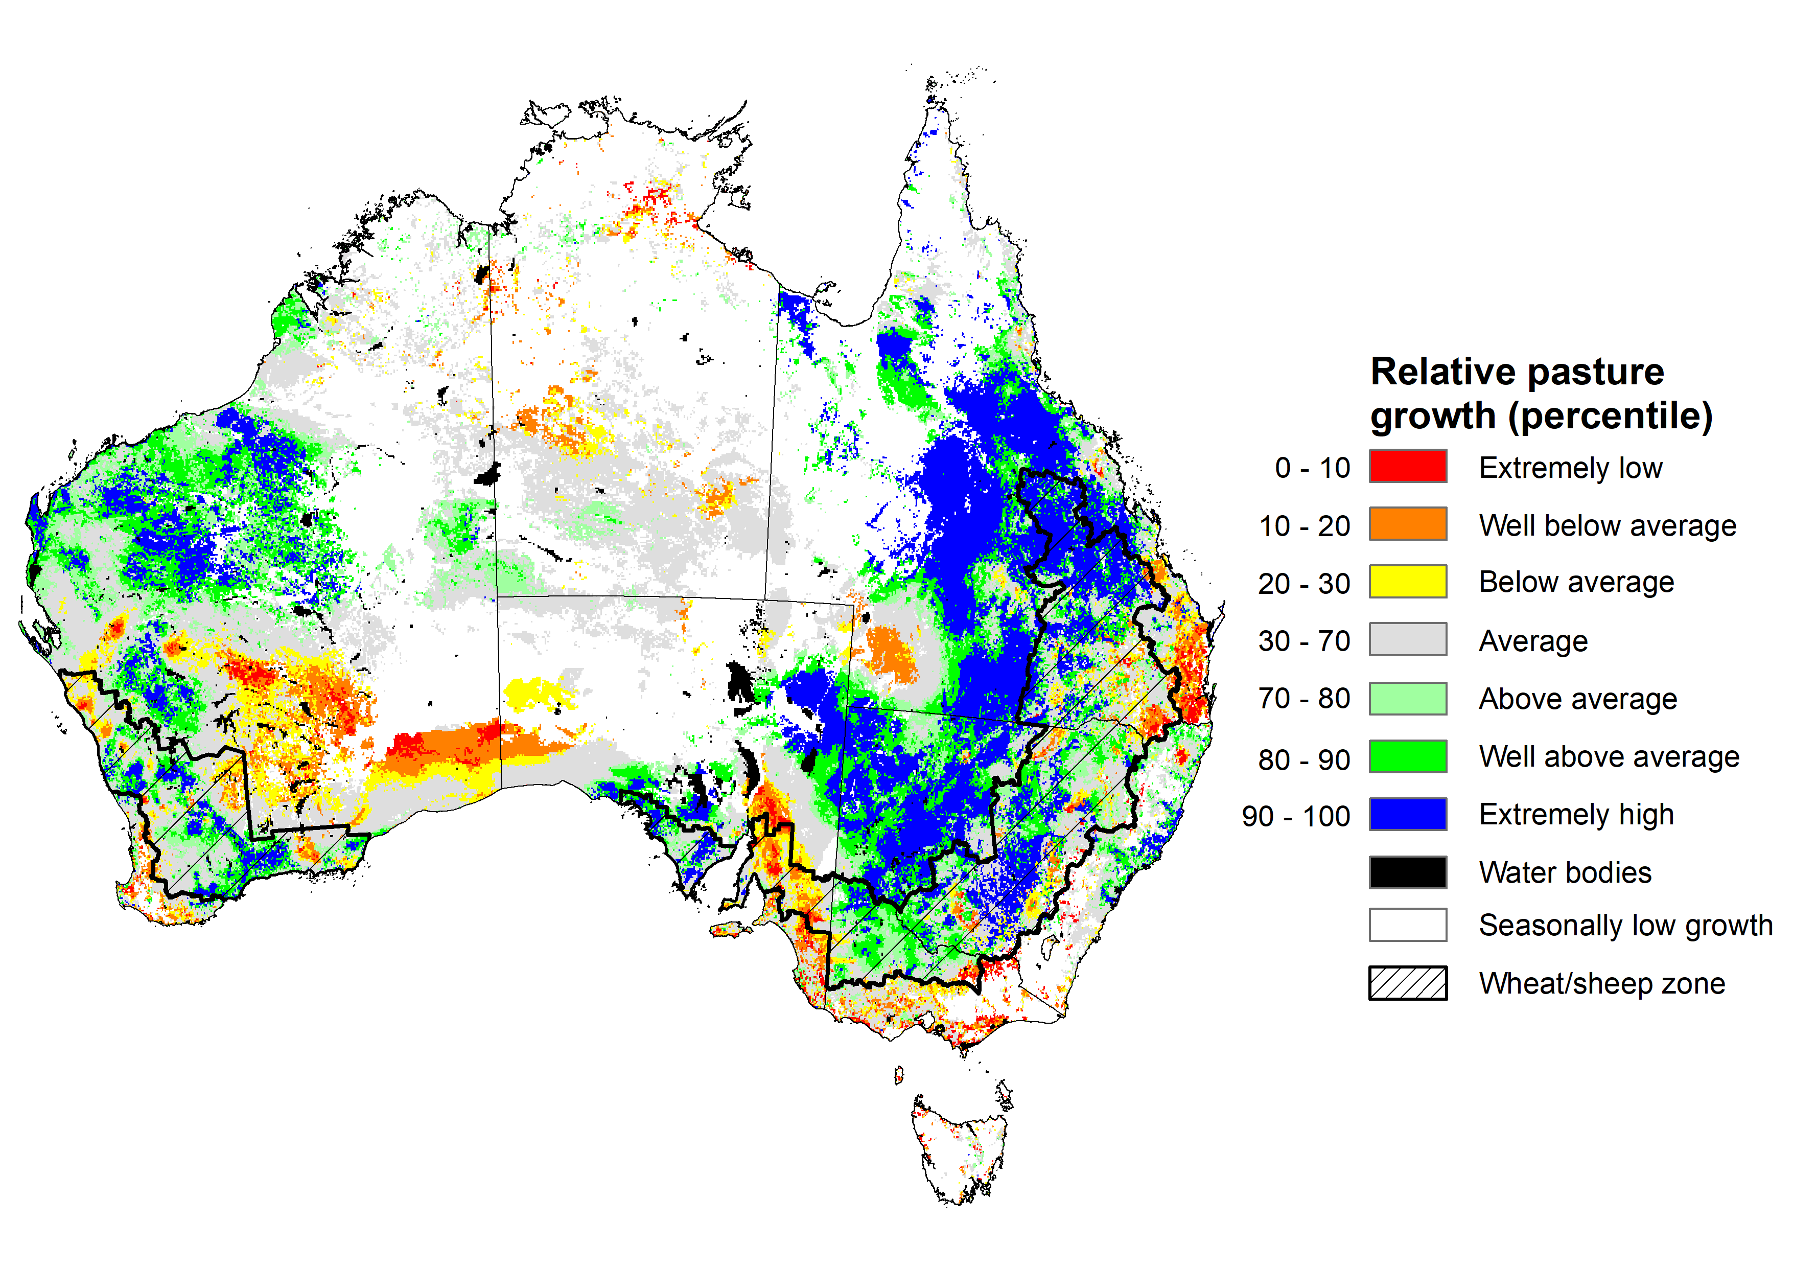
Notes: AussieGRASS pasture growth estimates are relative to the long-term record and shown in percentiles. Percentiles rank data on a scale of zero to 100. This analysis ranks pasture growth for the selected period against average pasture growth for the long-term record (1957 to 2016). Pasture growth is modelled at 5km2 grid cells.
Source: Queensland Department of Science, Information Technology and Innovation

Rainfall forecast for the next eight days
Over the 8-days to 11 August 2022, low-pressure troughs and cold fronts are expected to bring rainfall to parts of southern and south-eastern Australia. However, high-pressure systems across remaining parts of the country are expected to result in clear, dry conditions.
Rainfall totals of between 10 and 50 millimetres are forecast for much of New South Wales and Victoria, southern Queensland, the south-east of South Australia and south-west of Western Australia, as well as much of Tasmania. Rainfall totals in excess of 50 millimetres are forecast for alpine regions of New South Wales and Victoria. Little to no rainfall is forecast across remaining parts of Australia over the next 8-days.
In Australian cropping regions, rainfall totals of between 10 and 50 millimetres are expected across most of New South Wales, Victoria and South Australia, southern Queensland and southern parts of Western Australia. Rainfall in excess of 50 millimetres is forecast for isolated parts of south-eastern New South Wales. Little to no rainfall is forecast for all remaining cropping regions during the next 8-days.
The forecast rainfall is expected to increase soil moisture levels across cropping regions in New South Wales, Victoria and South Australia. Across these regions, soil moisture levels have declined in recent weeks to below average to average levels. The expected rainfall will support the continued development of winter crops over the coming weeks. However, further rainfall will be required in spring. The largely dry conditions forecast across Western Australia over the next 8-days follows two weeks of moderate rainfalls, with ample soil moisture to sustain winter crops over the coming weeks. Rainfall in parts of southern Queensland will add to above average soil moisture levels and may lead to waterlogging in isolated areas, negatively impacting crop development. However, dry conditions are forecast for most cropping regions in Queensland.

Total forecast rainfall (mm) for the period 4 August to 11 August 2022
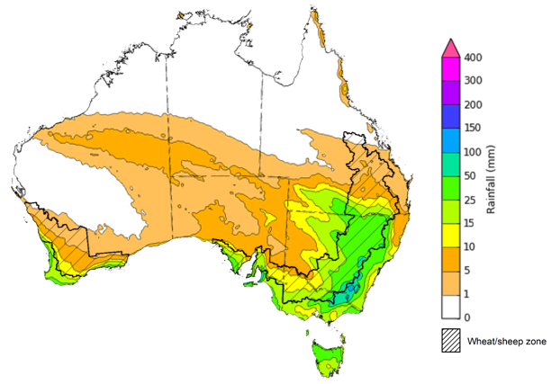
©Commonwealth of Australia 2022, Australian Bureau of Meteorology Issued:4/8/2022

Water
Note: This rainfall forecast is produced from computer models. As the model outputs are not altered by weather forecasters, it is important to check local forecasts and warnings issued by the Bureau of Meteorology.

Water markets – current week
Water storage in the Murray–Darling Basin (MDB) increased by 66 gigalitres (GL) between 27 July 2022 and 3 August 2022. The current volume of water held in storage is 22,226 GL, which represents 88% of total capacity. This is 14% or 2,717 GL more than at the same time last year.

Water storages in the Murray-Darling Basin, 2013–2022
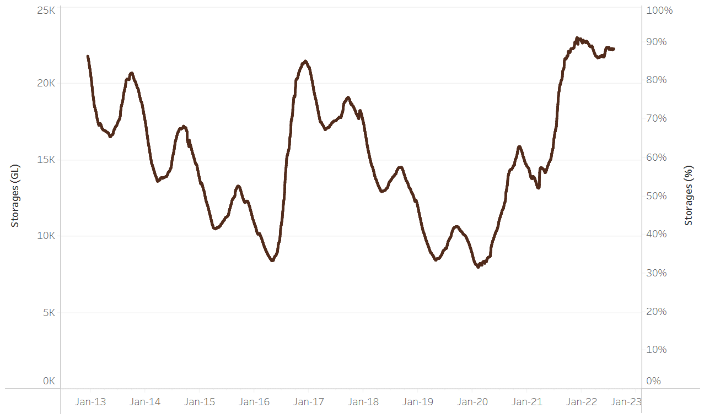
Allocation prices in the Victorian Murray below the Barmah Choke decreased from $80 per ML on 22 July 2022 to $79 per ML on 29 July 2022. Prices are lower in the Goulburn-Broken and regions above the Barmah choke due to the binding of the Goulburn intervalley trade limit and Barmah choke trade constraint.
Water storage data is sourced from the Bureau of Meteorology.

Region | $/ML
NSW Murray Above | 50
NSW Murrumbidgee | 95
VIC Goulburn-Broken | 69
VIC Murray Below | 79

Surface water trade activity, Southern Murray–Darling Basin

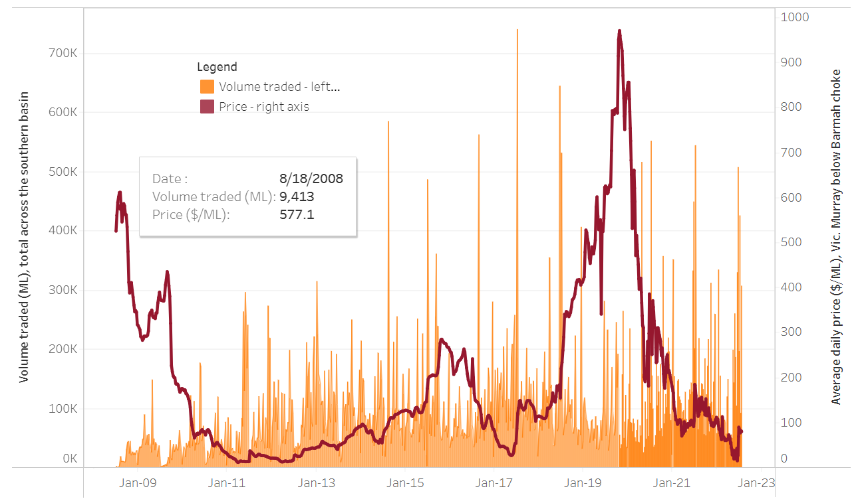
To access the full, interactive, weekly water dashboard, which contains the latest and historical water storage, water market and water allocation information, please visit http://www.agriculture.gov.au/abares/products/weekly_update/weekly-update-040822
The trades shown reflect estimated market activity and do not encompass all register trades. The price is shown for the VIC Murray below the Barmah choke. Historical prices (before 1 July 2019) are ABARES estimates after removing outliers from BOM water register data. Prices after 1 July 2019 and prior to the 30 October 2019 reflect recorded transaction prices as sourced from Ruralco. Prices after the 30 October 2019 are sourced from Waterflow. Data for volume traded is sourced from the BOM water register. Data shown is current at 4 August 2022.

Commodities

Indicator | Week ended | Unit | Latest price | Previous week | Weekly change | Price 12 months ago | Annual change
Selected world indicator prices
AUD/USD Exchange rate | 03-Aug | A$/US$ | 0.69 | 0.69 | 0% | 0.73 | -5%
Wheat – US no. 2 hard red winter wheat, fob Gulf | 03-Aug | US$/t | 375 | 378 | -1% | 321 | 17%
Corn – US no. 2 yellow corn, fob Gulf | 03-Aug | US$/t | 305 | 298 | 2% | 248 | 23%
Canola – Rapeseed, Canada, fob Vancouver | 03-Aug | US$/t | 740 | 700 | 6% | 777 | -5%
Cotton – Cotlook 'A' Index | 03-Aug | USc/lb | 112 | 127 | -12% | 100 | 12%
Sugar – Intercontinental Exchange, nearby futures, no.11 contract | 03-Aug | USc/lb | 17.8 | 17.7 | 1% | 19 | -9%
Wool – Eastern Market Indicator | 06-Jul | Ac/kg clean | 1,388 | 1,407 | -1% | 1,315 | 6%
Wool – Western Market Indicator | 06-Jul | Ac/kg clean | 1,473 | 1,486 | -1% | 1,333 | 11%
Selected Australian grain export prices
Milling Wheat – APW, Port Adelaide, SA | 03-Aug | A$/t | 576 | 583 | -1% | 402 | 43%
Feed Wheat – ASW, Port Adelaide, SA | 03-Aug | A$/t | 535 | 543 | -2% | 395 | 35%
Feed Barley – Port Adelaide, SA | 03-Aug | A$/t | 493 | 494 | 0% | 326 | 51%
Canola – Kwinana, WA | 03-Aug | A$/t | 1,126 | 1,097 | 3% | 808 | 39%
Grain Sorghum – Brisbane, QLD | 03-Aug | A$/t | 436 | 434 | 1% | 365 | 19%
Selected domestic livestock indicator prices
Beef – Eastern Young Cattle Indicator | 03-Aug | Ac/kg cwt | 908 | 936 | -3% | 991 | -8%
Mutton – Mutton indicator (18–24 kg fat score 2–3), Vic | 03-Aug | Ac/kg cwt | 521 | 585 | -11% | 696 | -25%
Lamb – Eastern States Trade Lamb Indicator | 03-Aug | Ac/kg cwt | 619 | 710 | -13% | 898 | -31%
Pig – Eastern Seaboard (60.1–75 kg), average of buyers & sellers | 29-Jun | Ac/kg cwt | 368 | 368 | 0% | 347 | 6%
Goats – Eastern States (12.1–16 kg) | 12-Jan | Ac/kg cwt | 879 | 879 | 0% | 818 | 8%
Live cattle – Light steers ex Darwin to Indonesia | 01-Jun | Ac/kg lwt | 480 | 480 | 0% | 320 | 50%
Live sheep – Live wethers (Muchea WA saleyard) to Middle East | 20-Apr | $/head | 113 | 113 | 0% | 122 | -7%

Indicator | Week ended | Unit | Latest price | Previous week | Weekly change | Price 12 months ago | Annual change
Global Dairy Trade (GDT) weighted average prices ª
Dairy – Whole milk powder | 03-Aug | US$/t | 3,544 | 3,757 | -6% | 2,829 | 25%
Dairy – Skim milk powder | 03-Aug | US$/t | 3,524 | 3,709 | -5% | 2,609 | 35%
Dairy – Cheddar cheese | 03-Aug | US$/t | 4,798 | 4,825 | -1% | 3,631 | 32%
Dairy – Anhydrous milk fat | 03-Aug | US$/t | 5,518 | 5,580 | -1% | 3,993 | 38%
a Global Dairy Trade prices are updated twice monthly on the first and third Tuesday of each month.

Selected world indicator prices
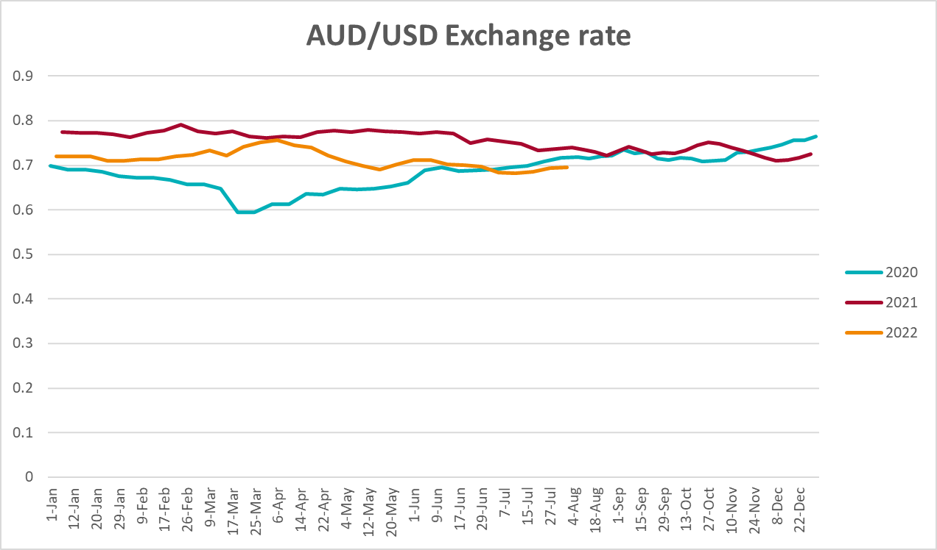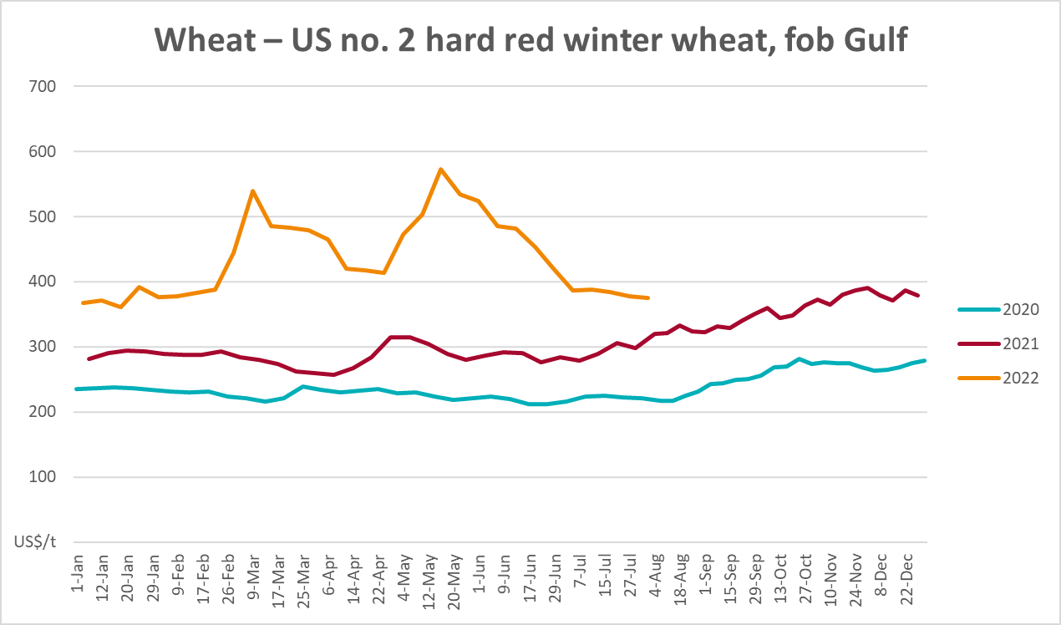
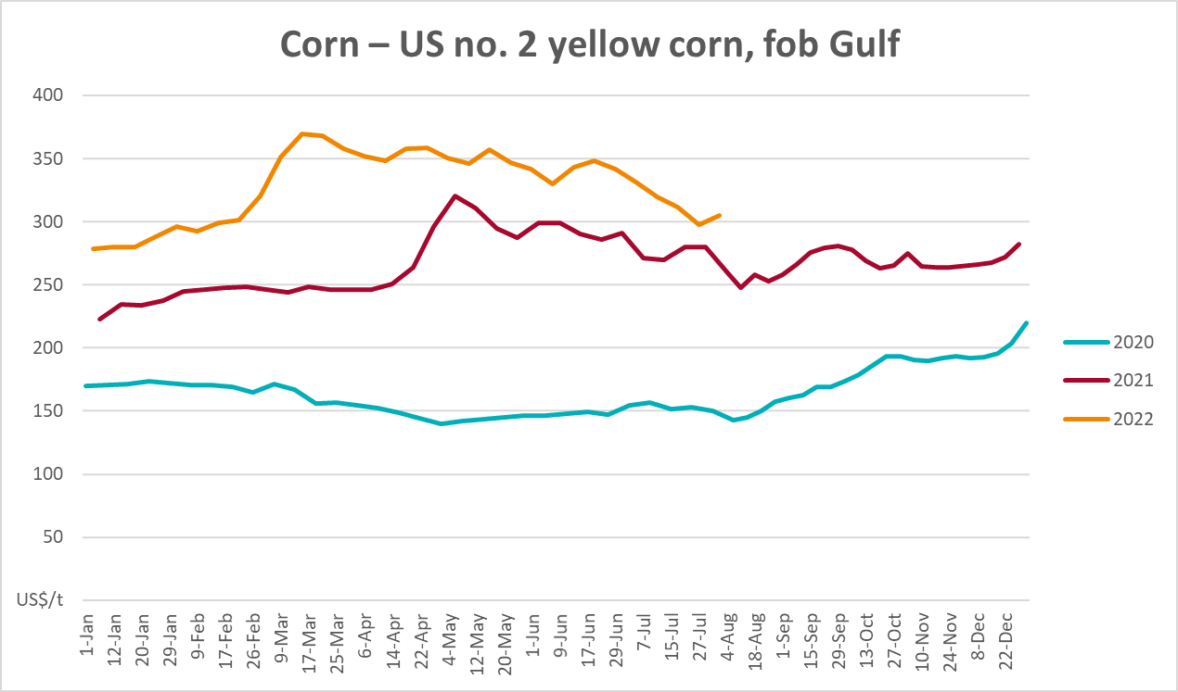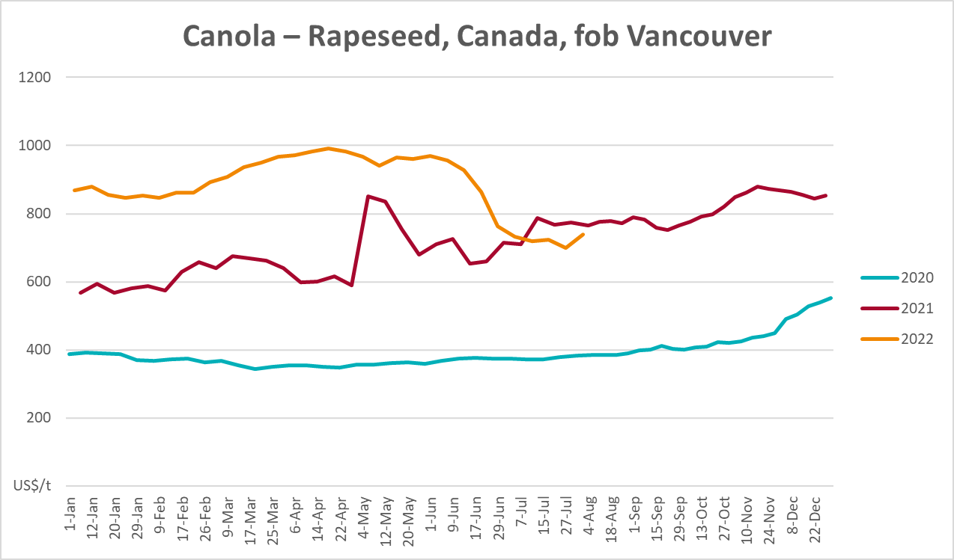
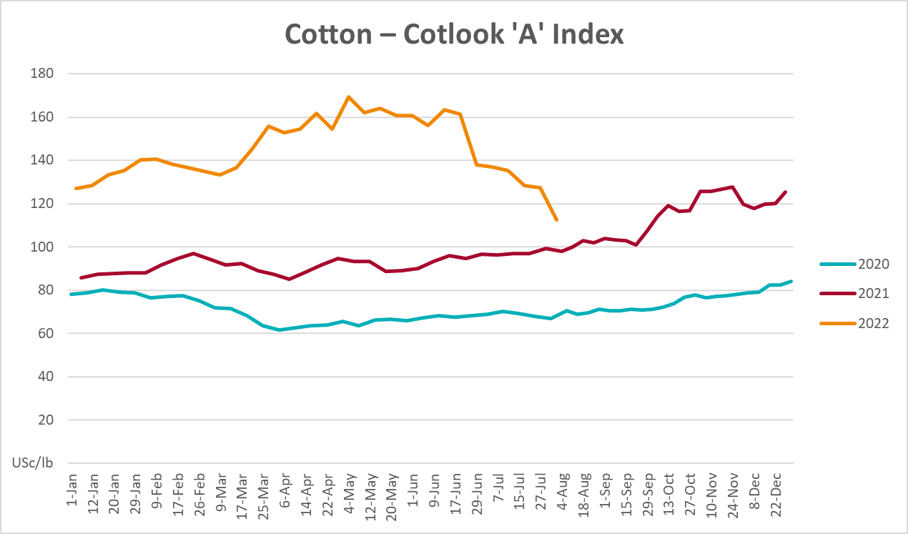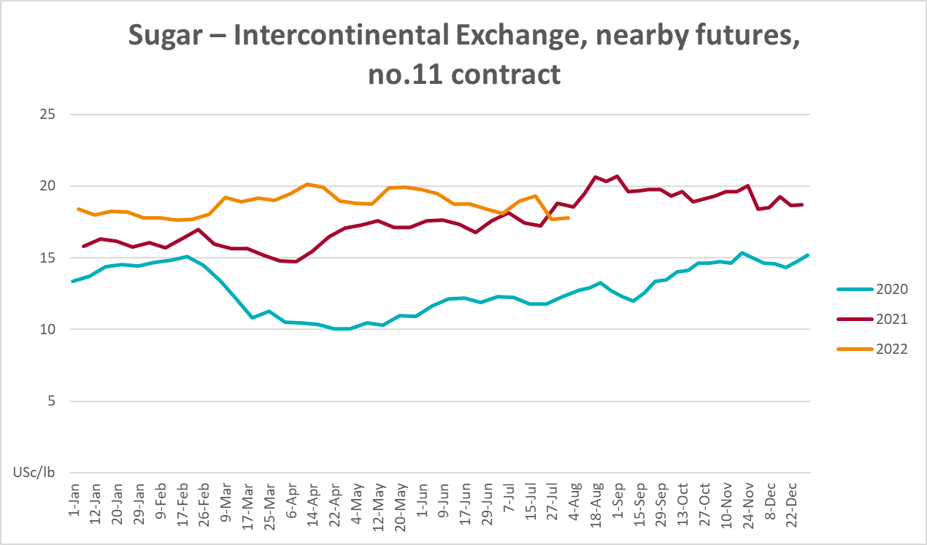
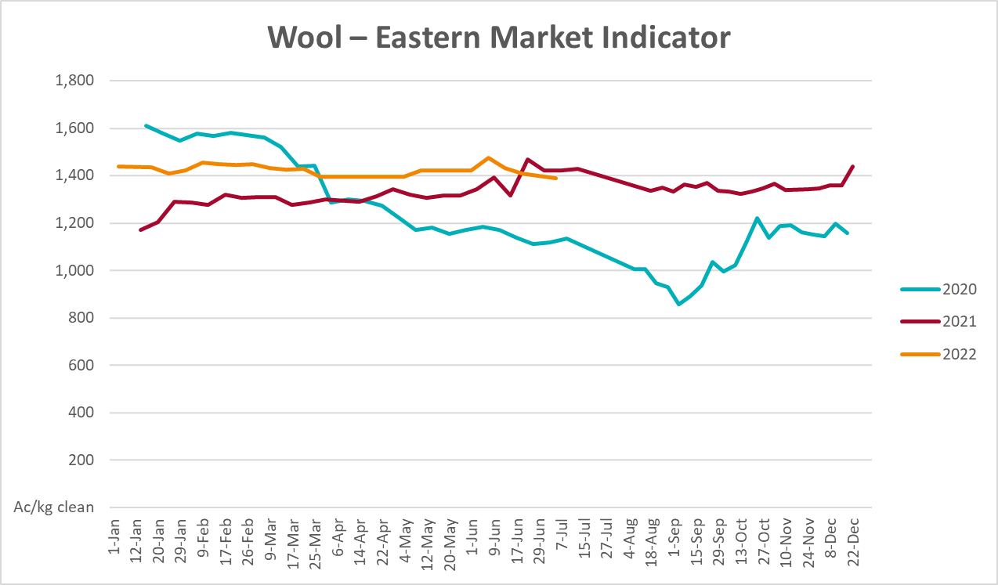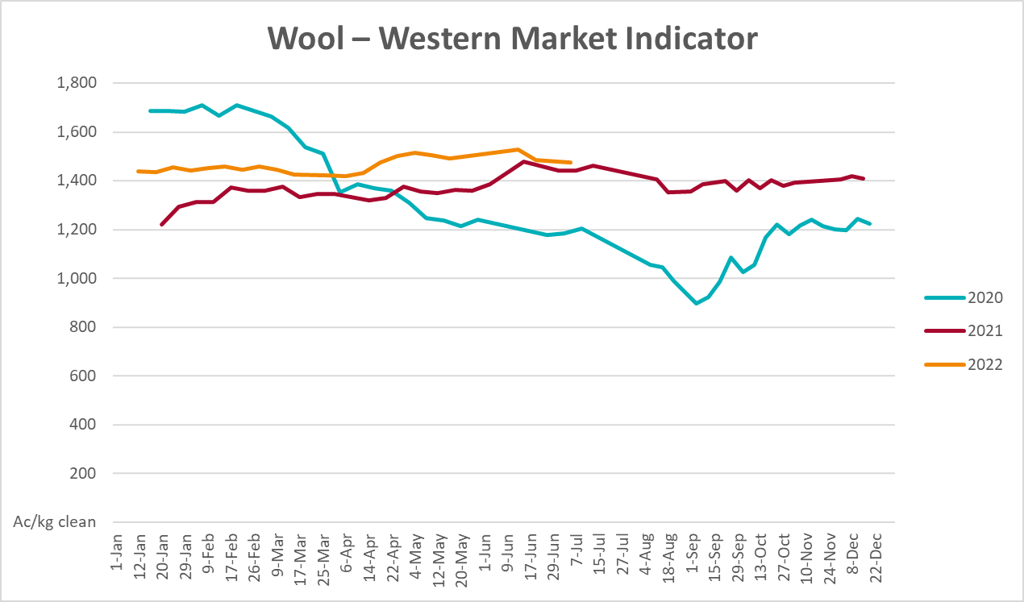

Selected domestic crop indicator prices
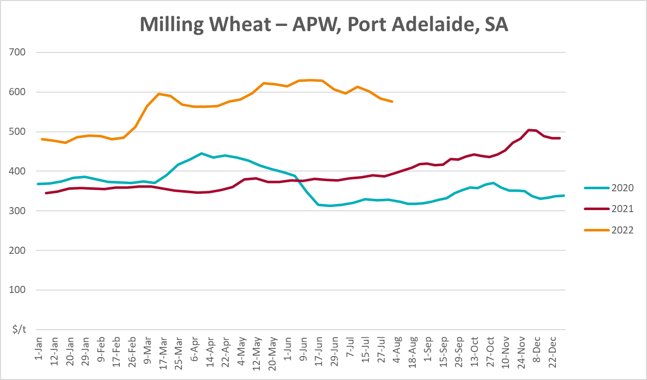
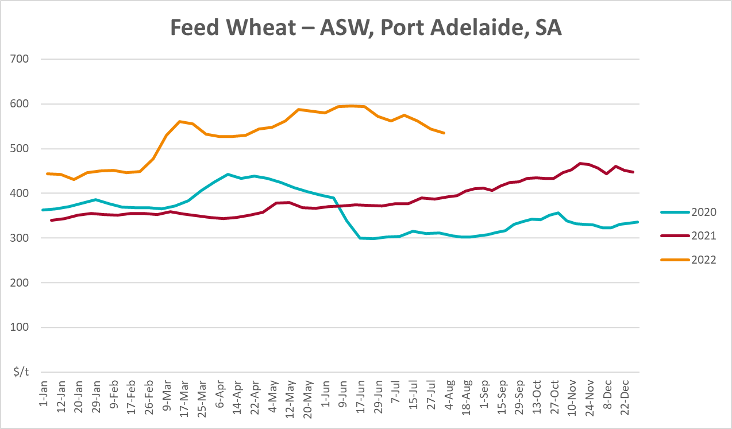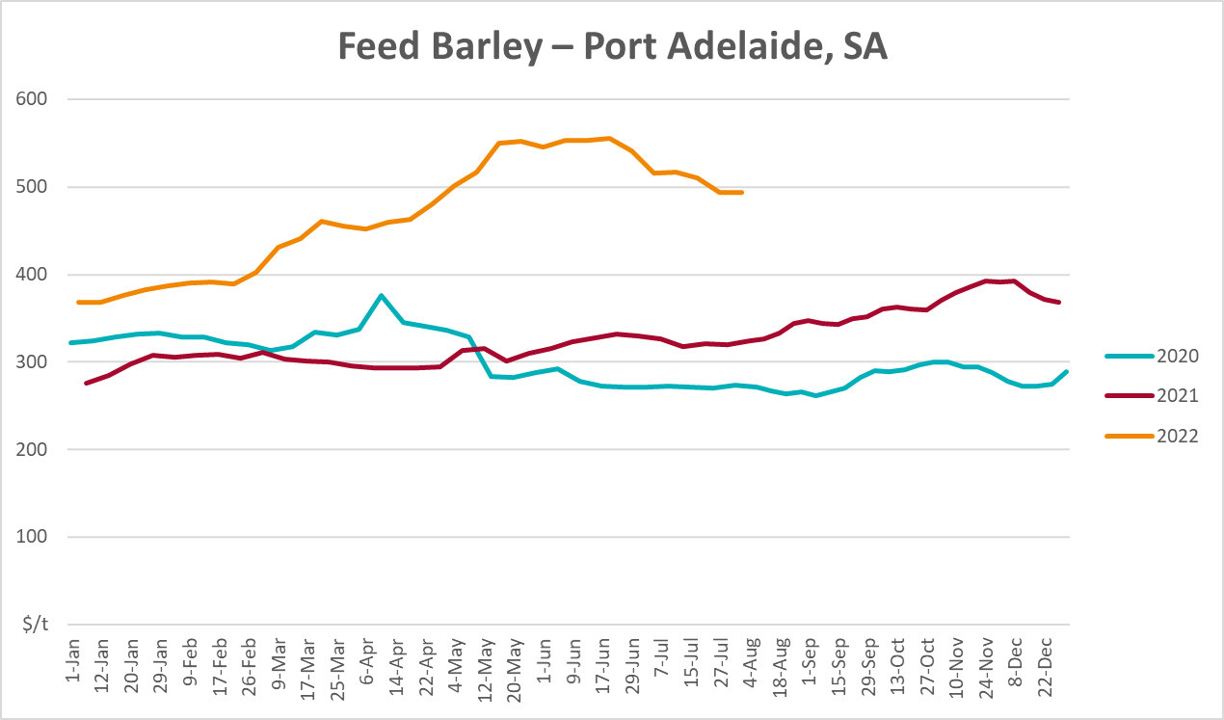
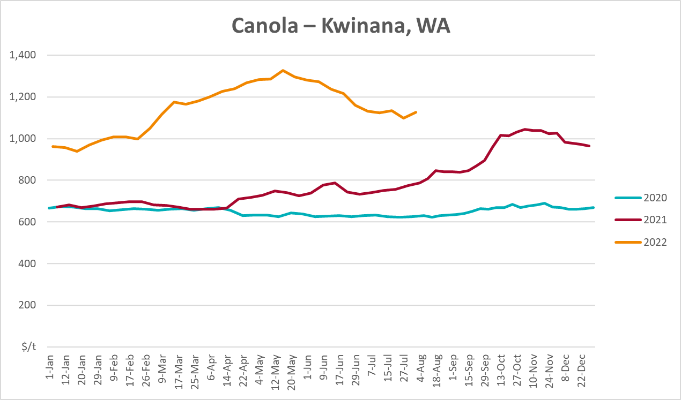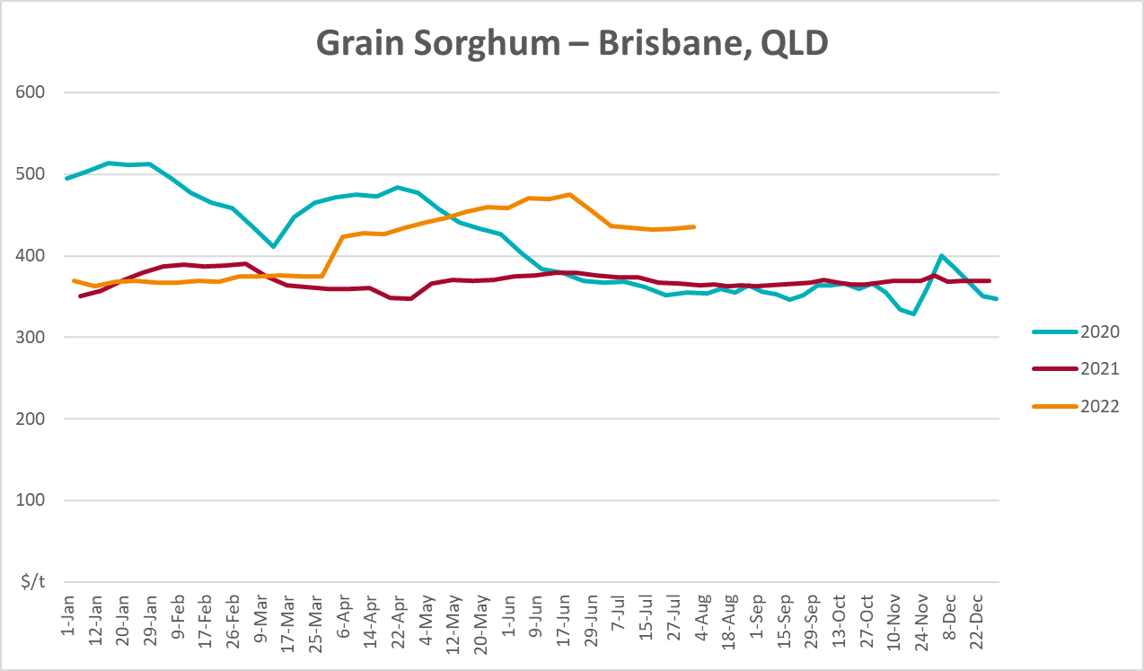

Selected domestic livestock indicator prices
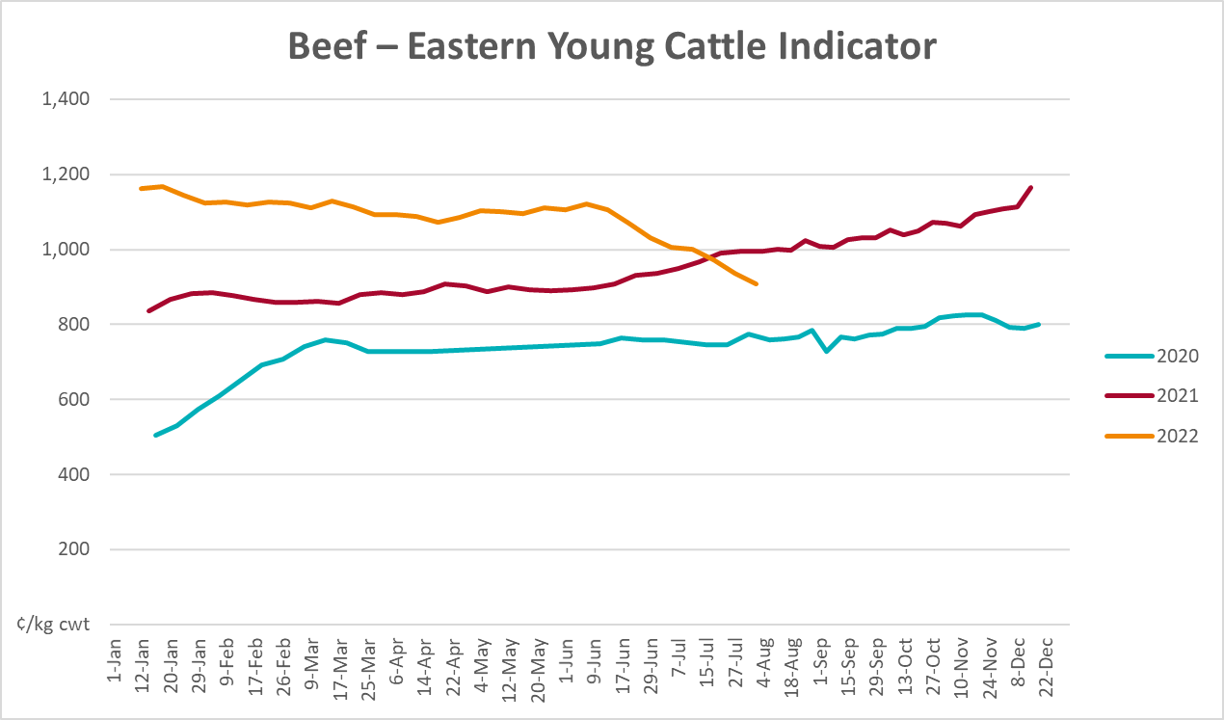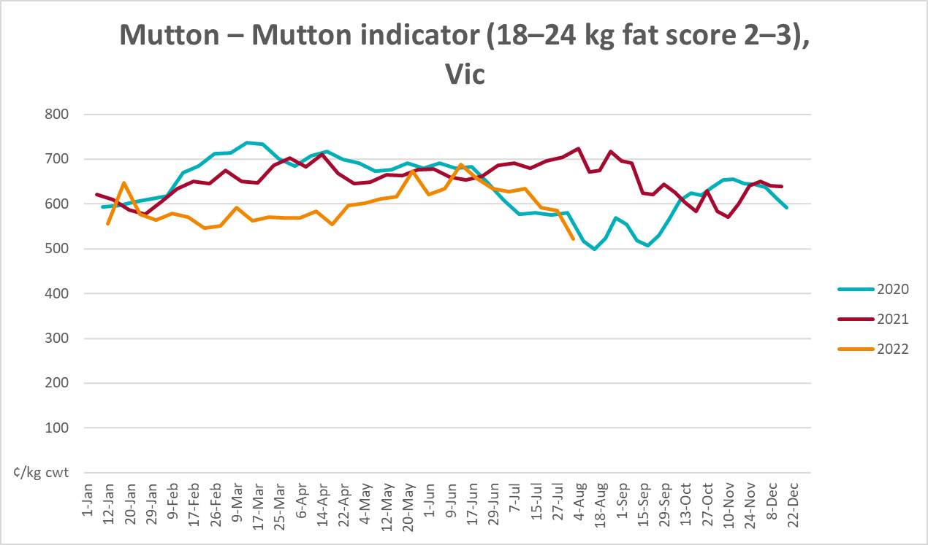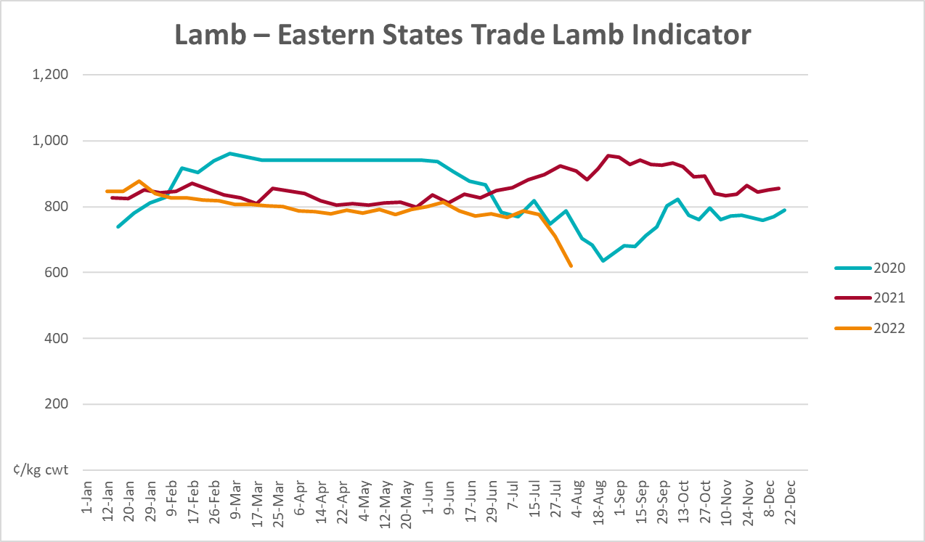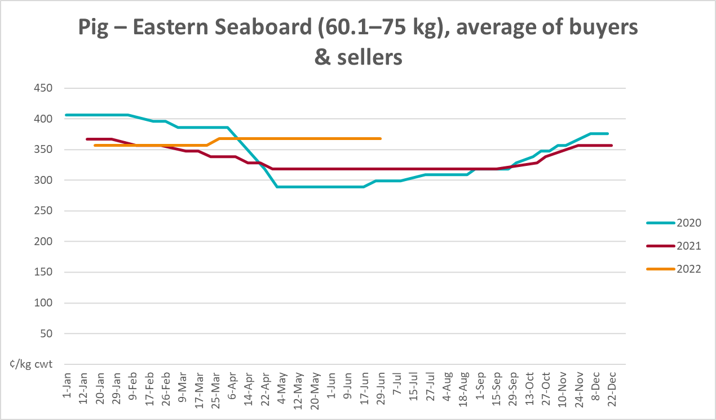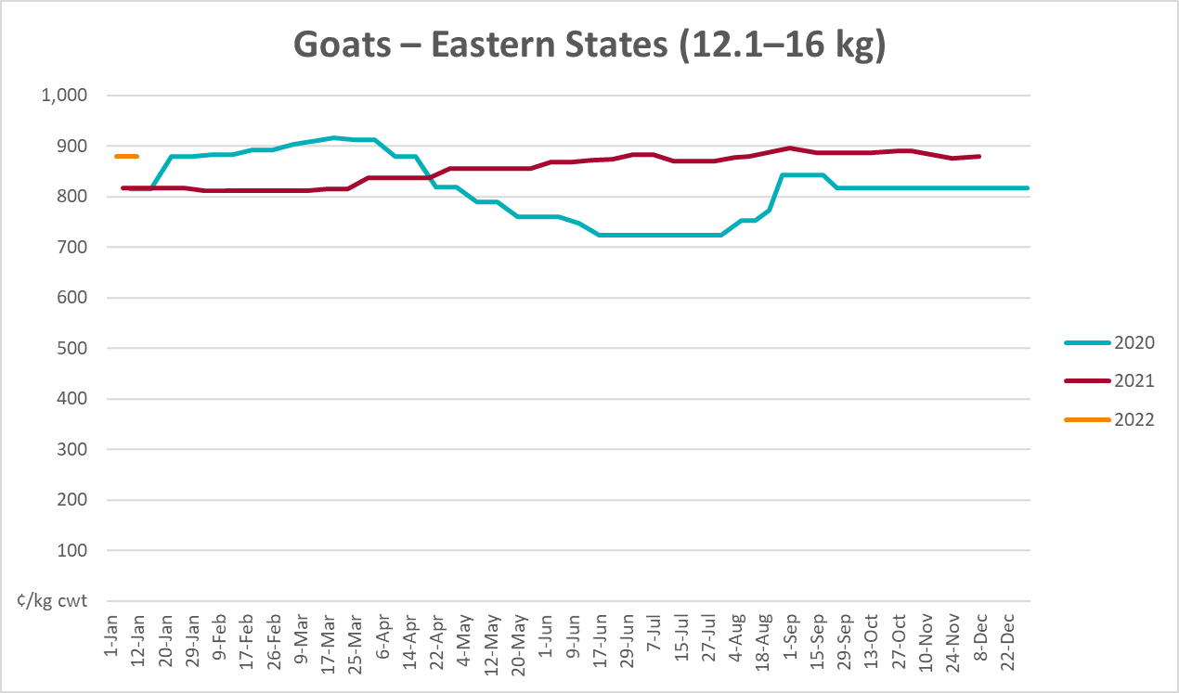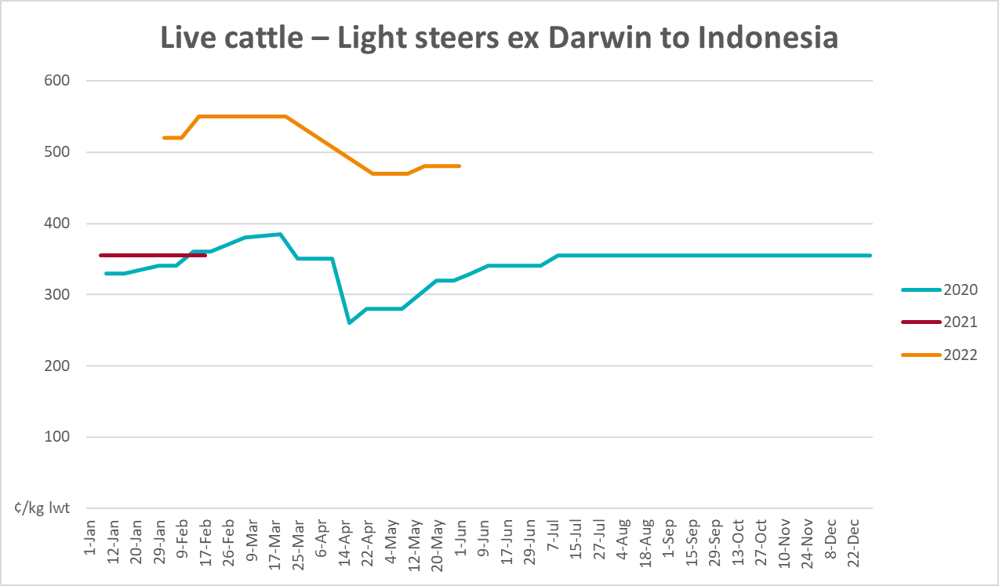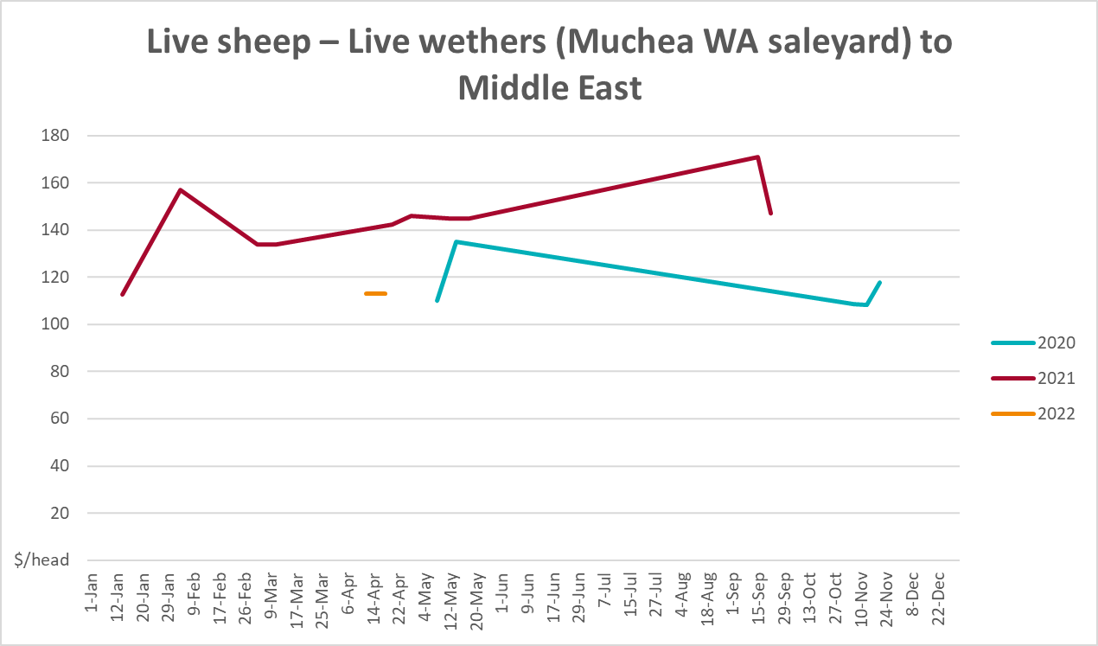

Global Dairy Trade (GDT) weighted average prices
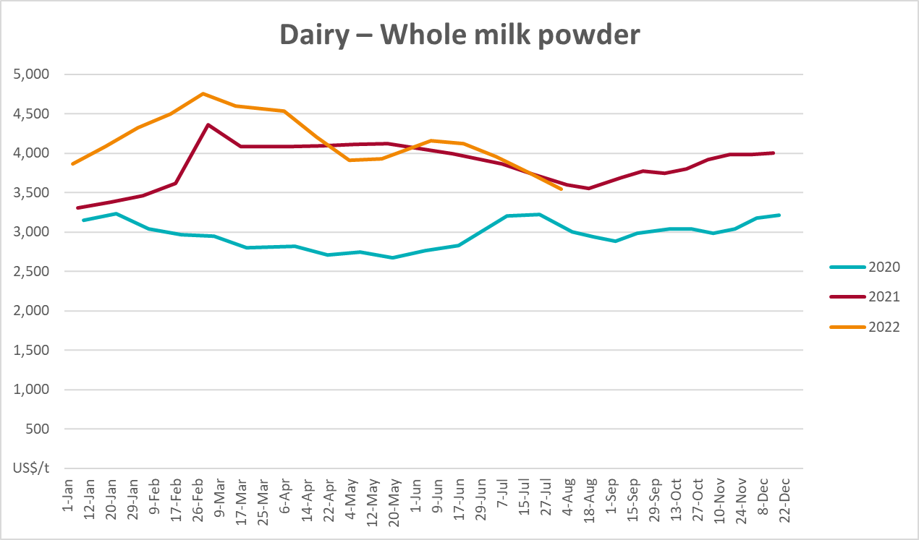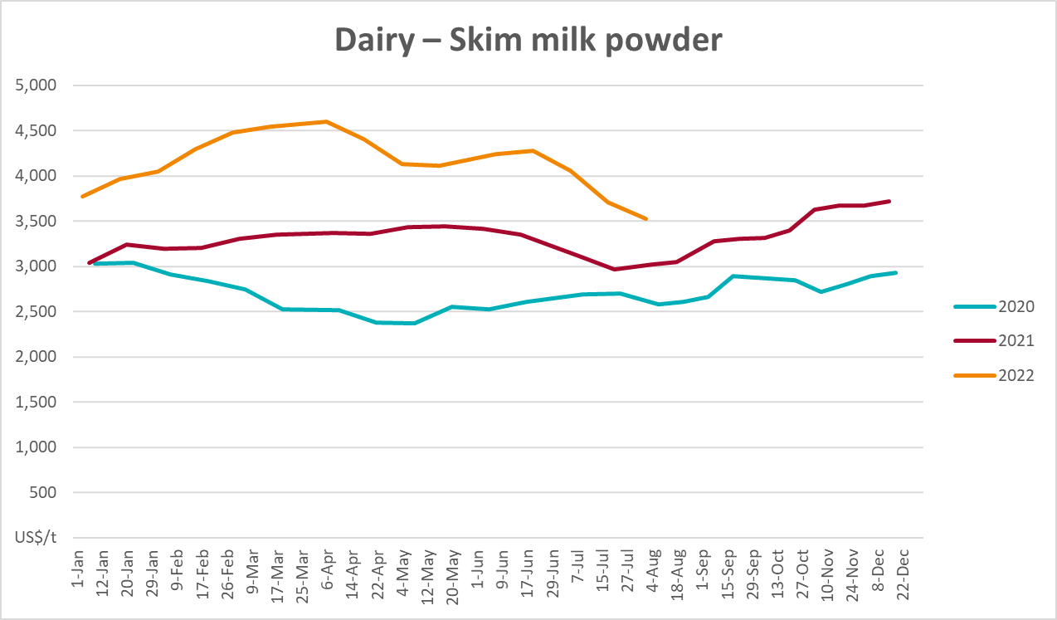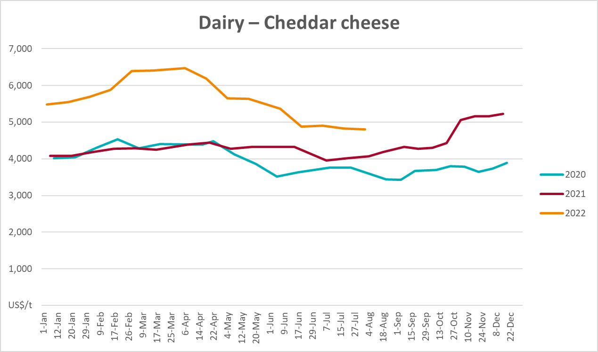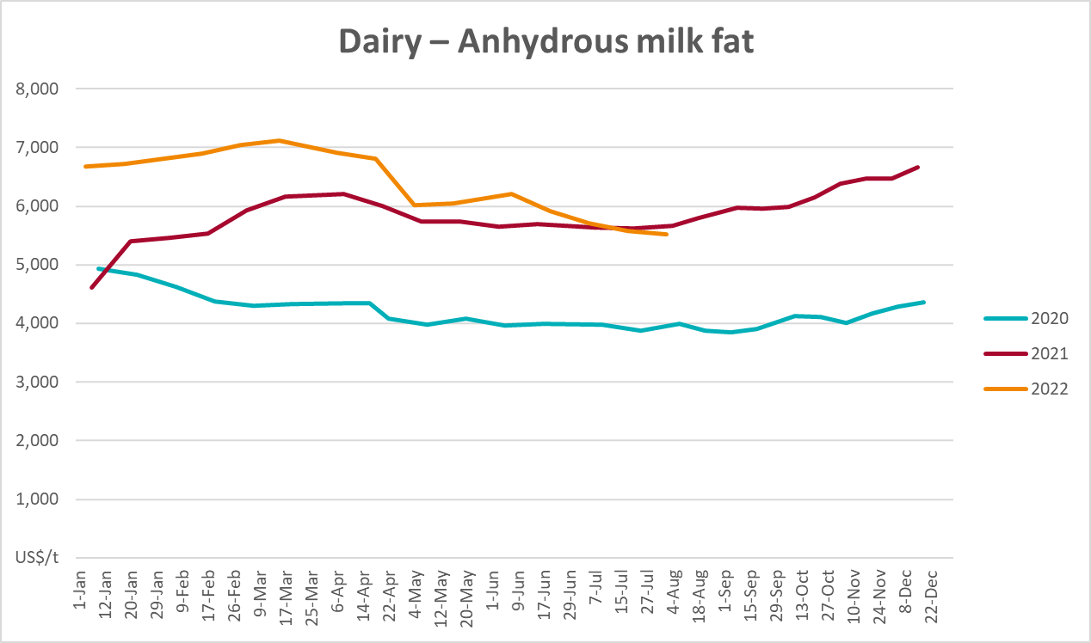

Selected fruit and vegetable prices
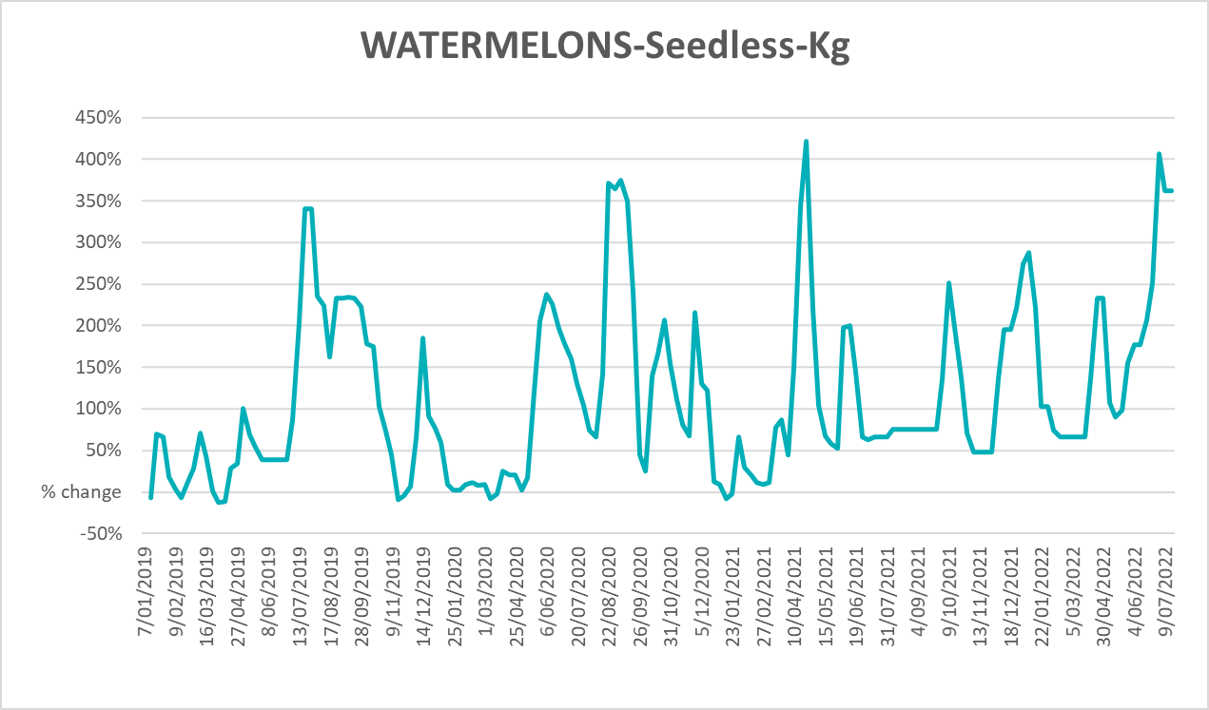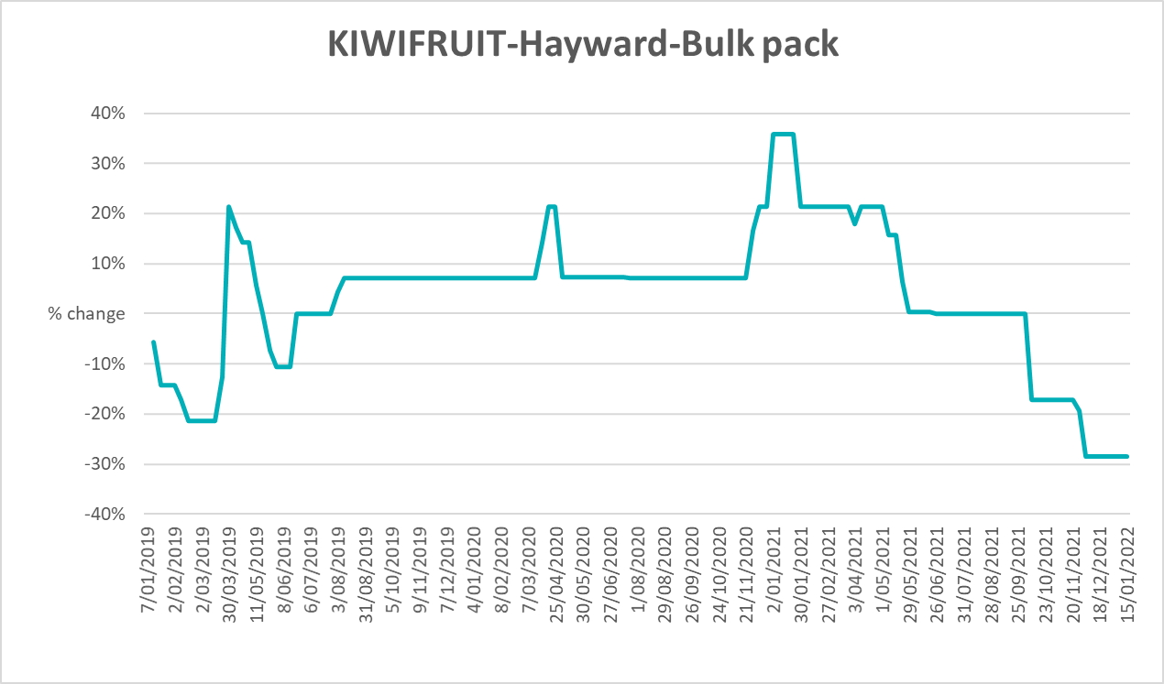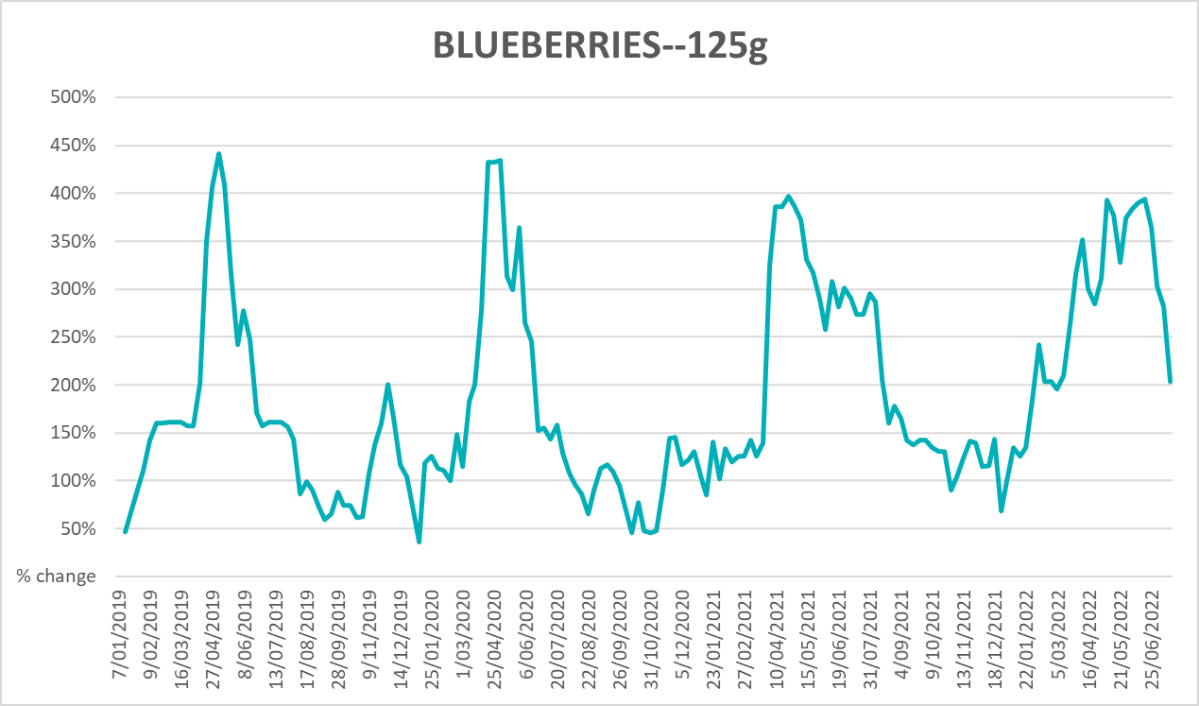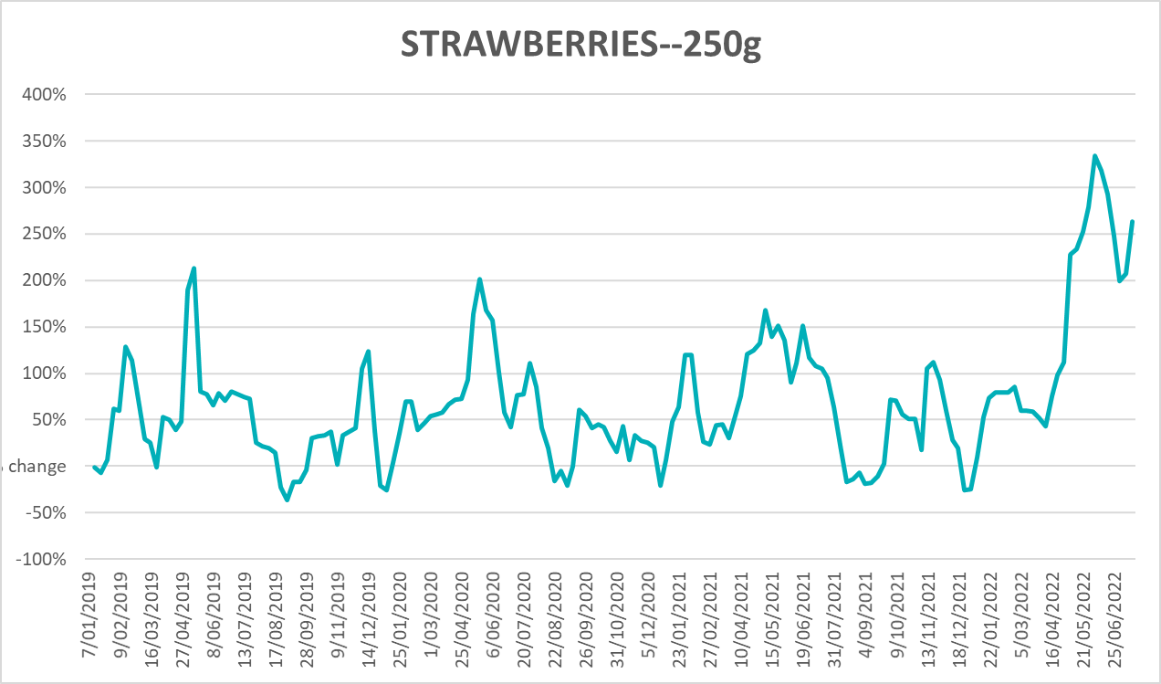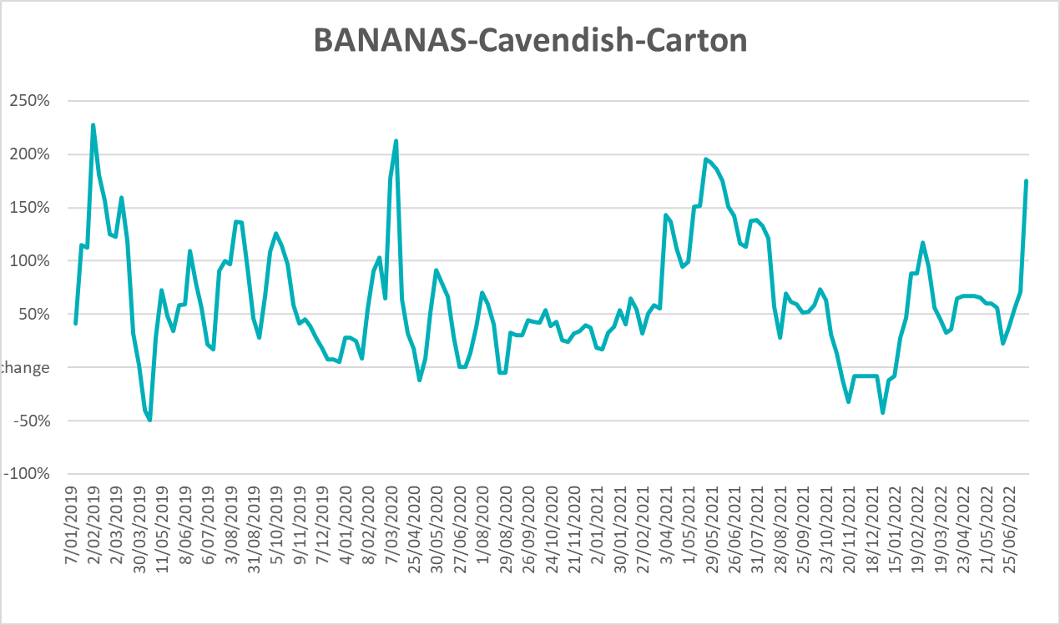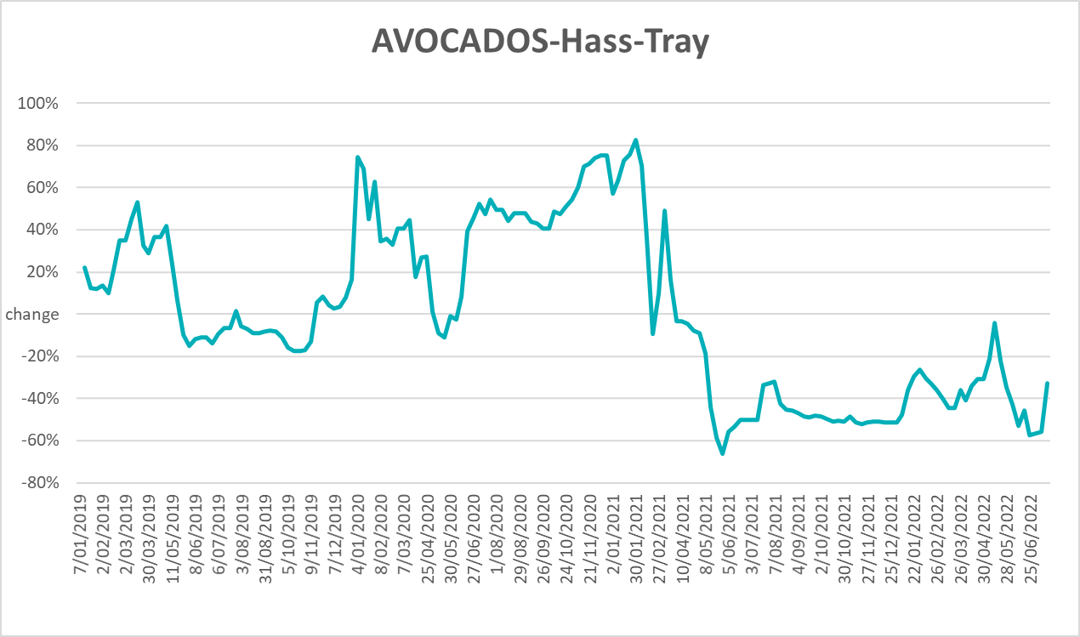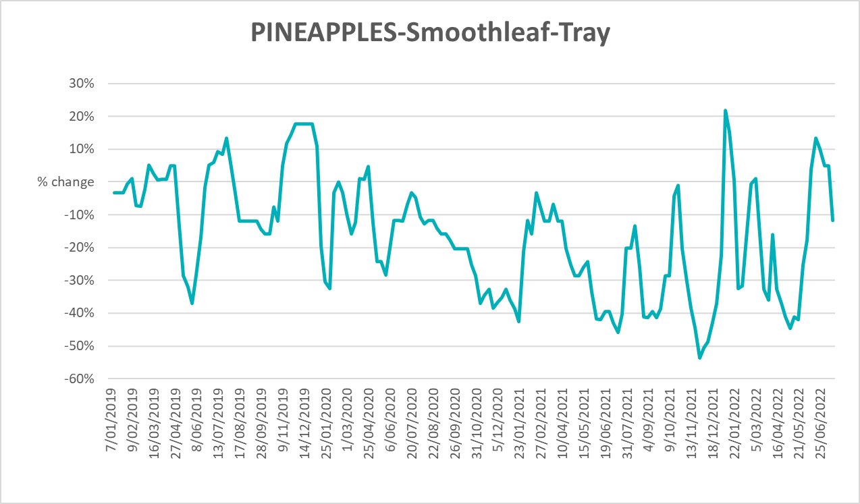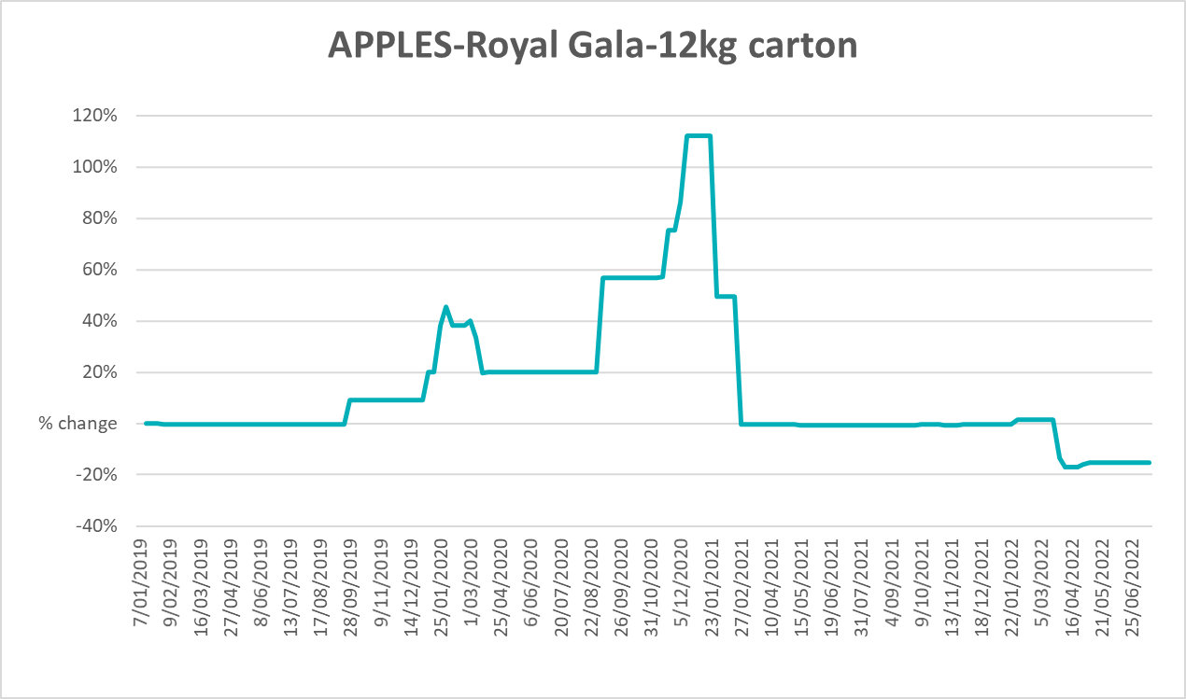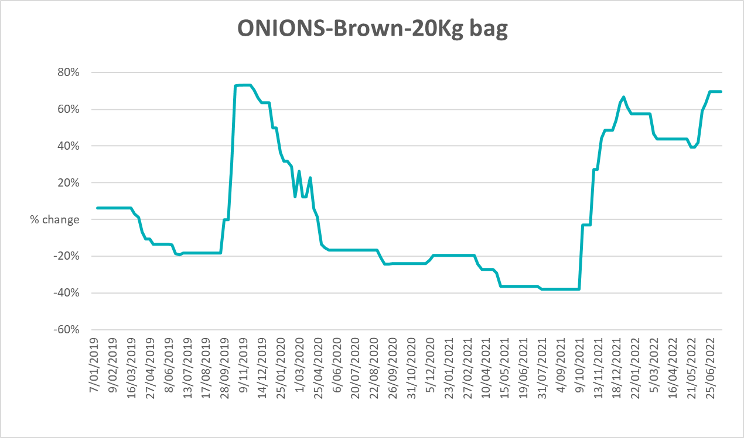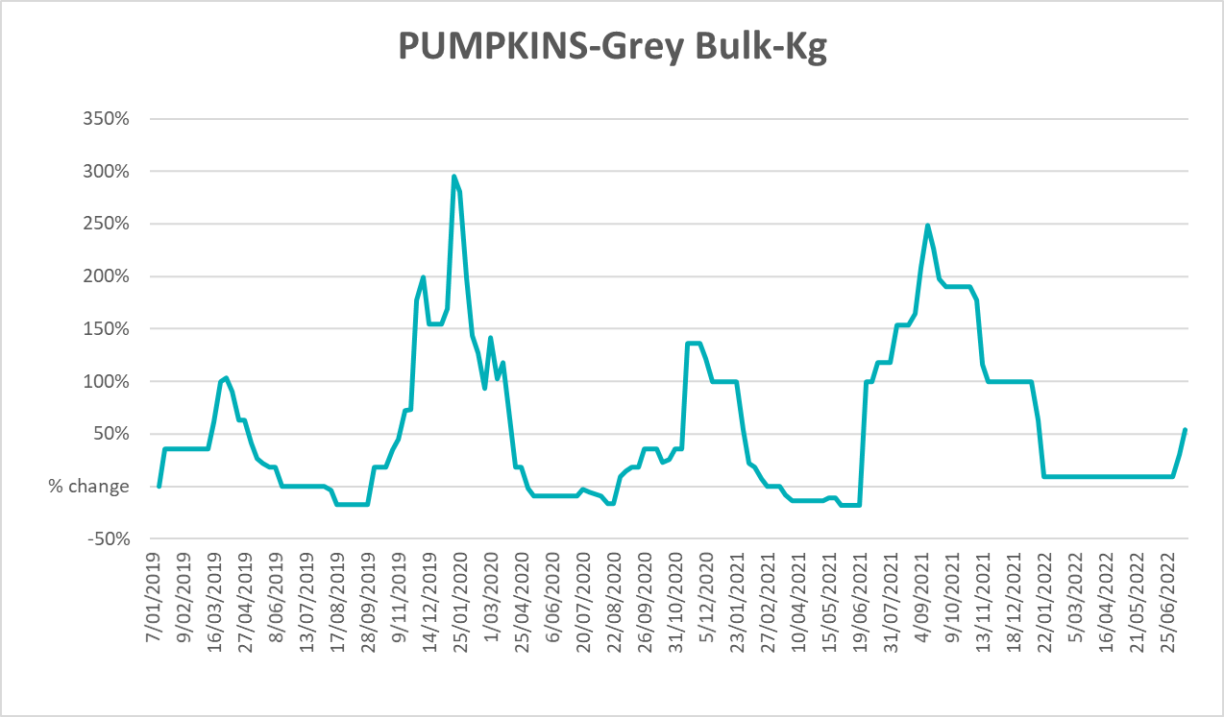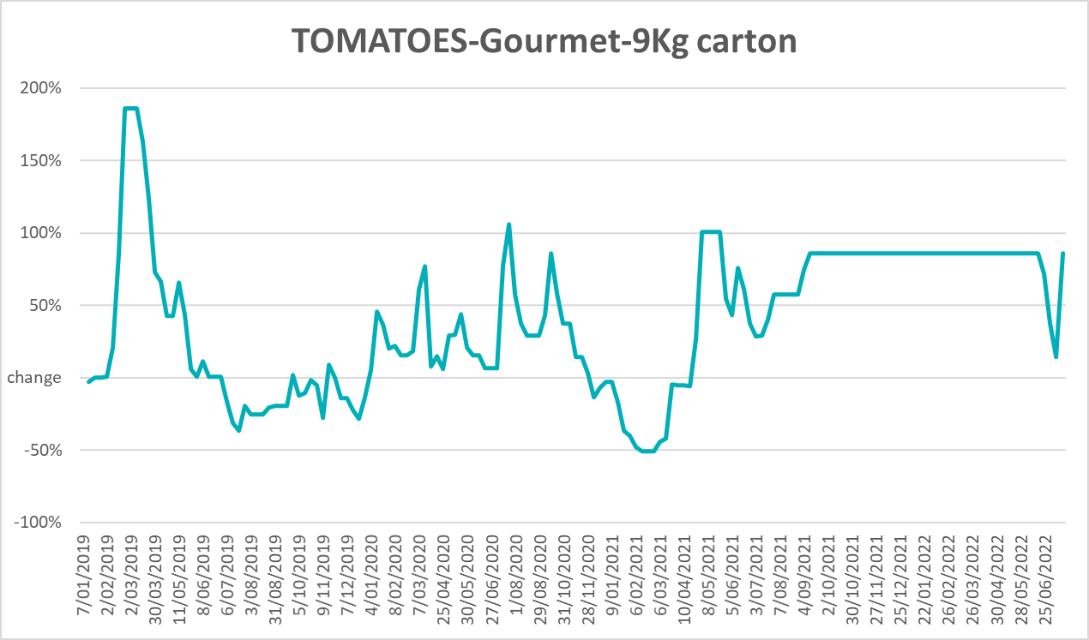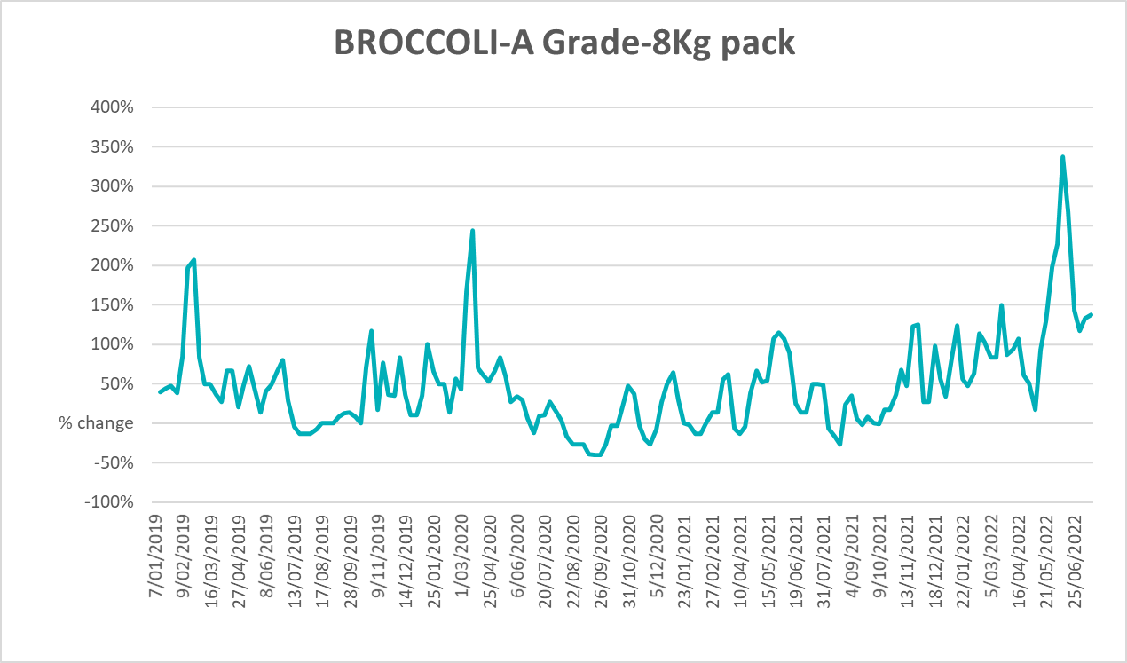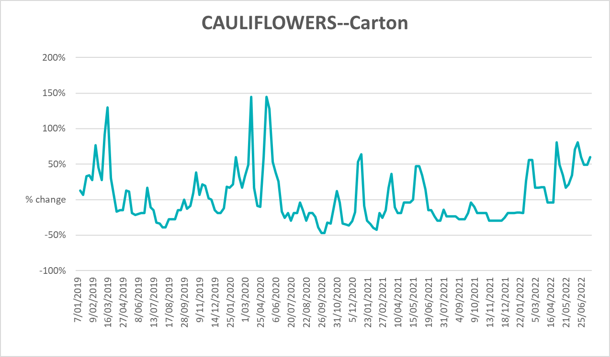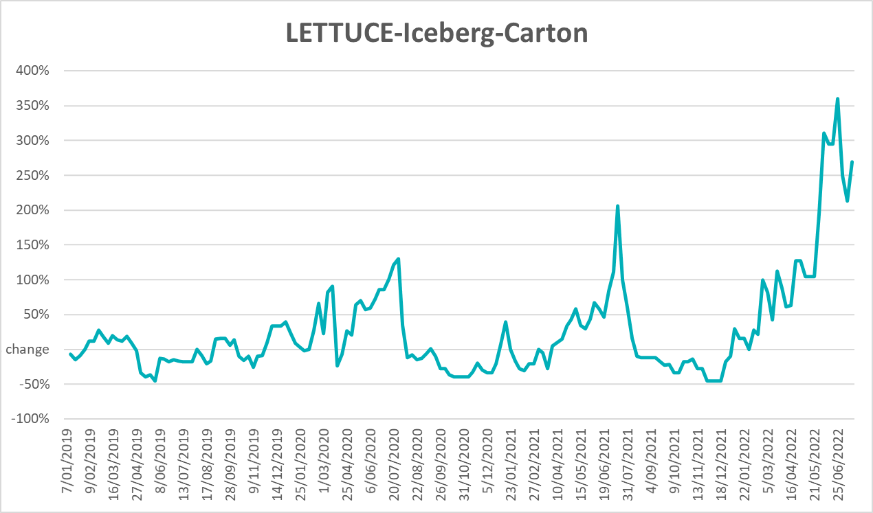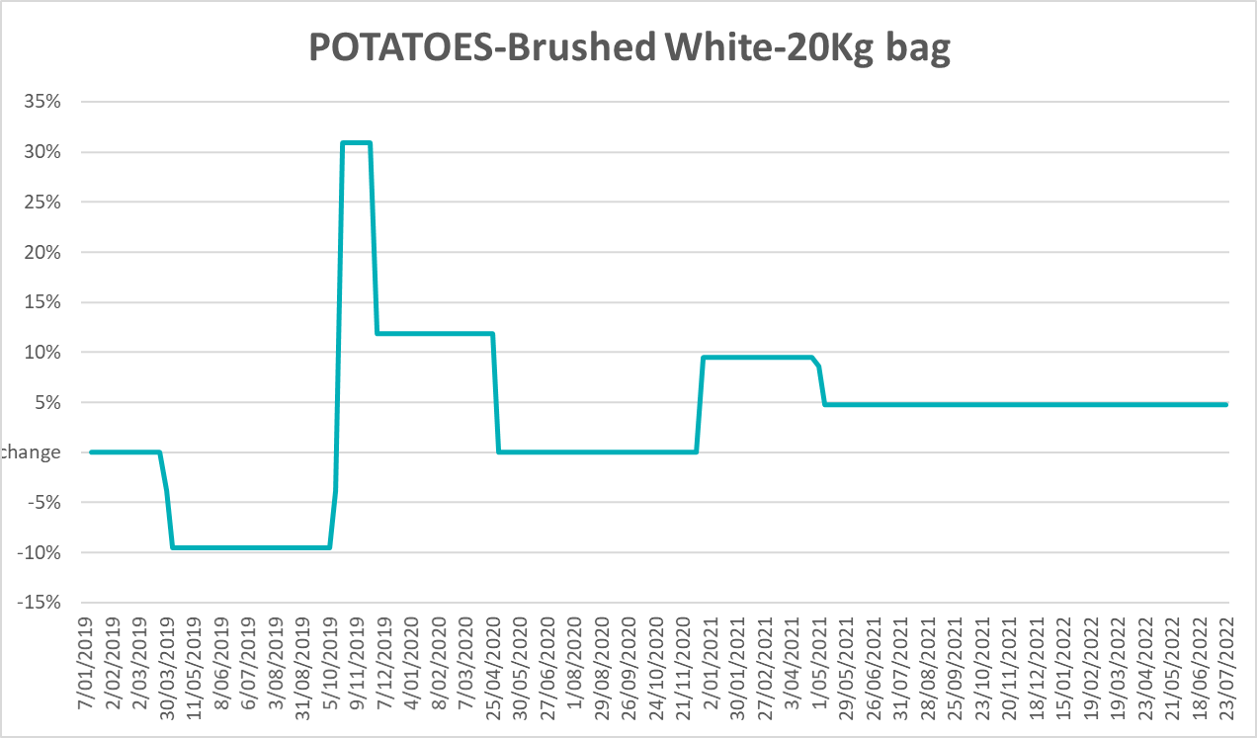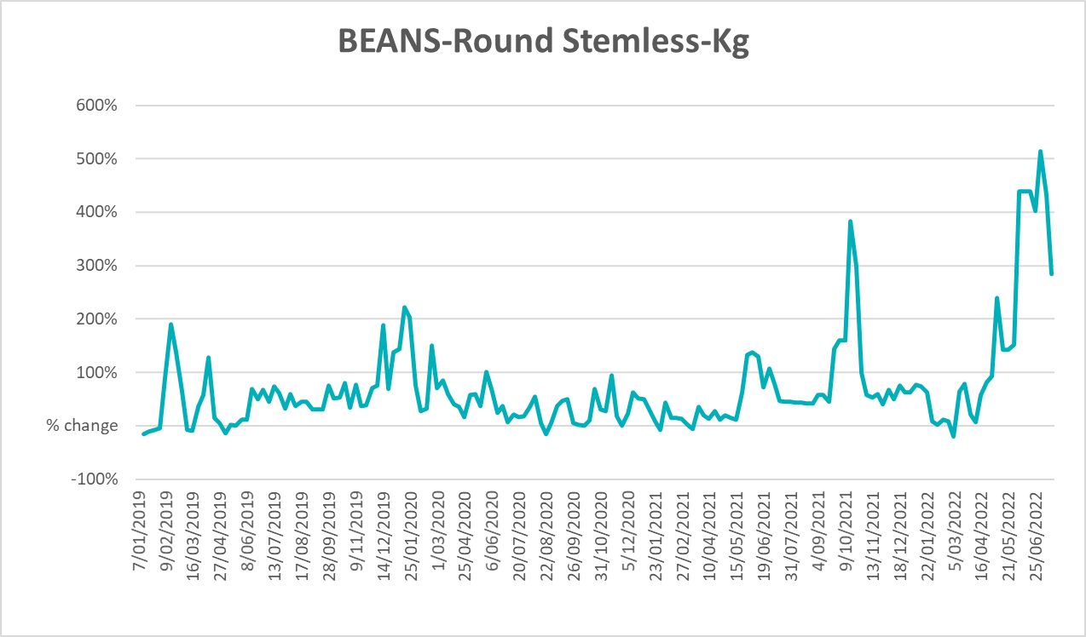

Selected domestic fodder indicator prices
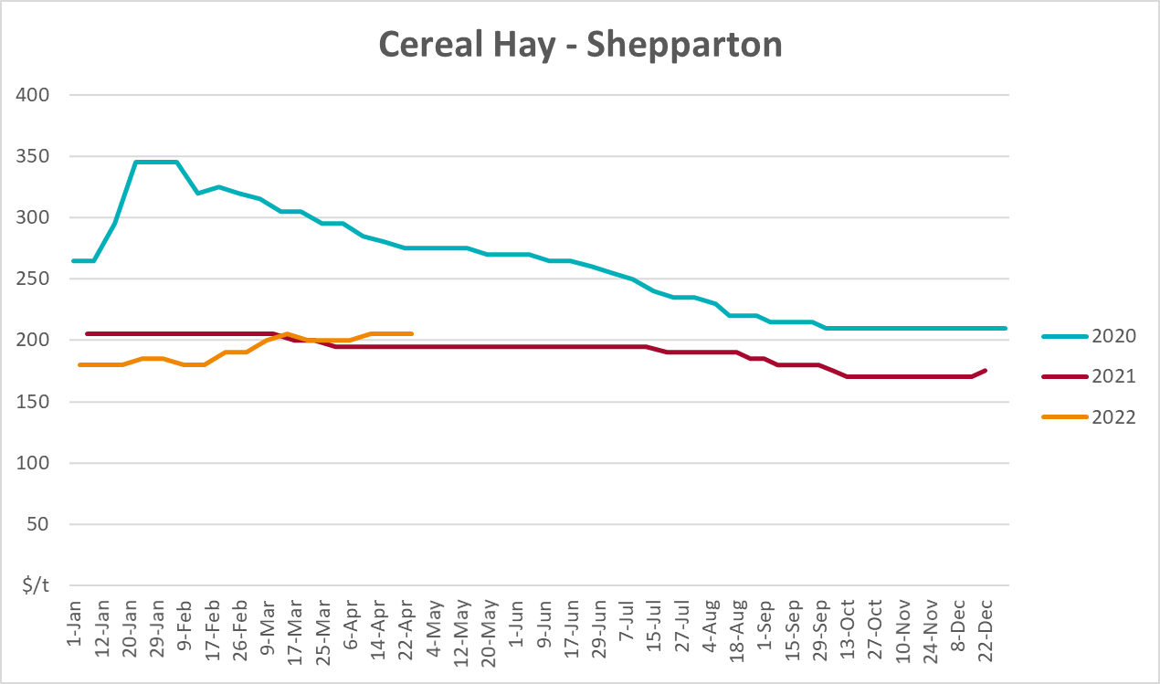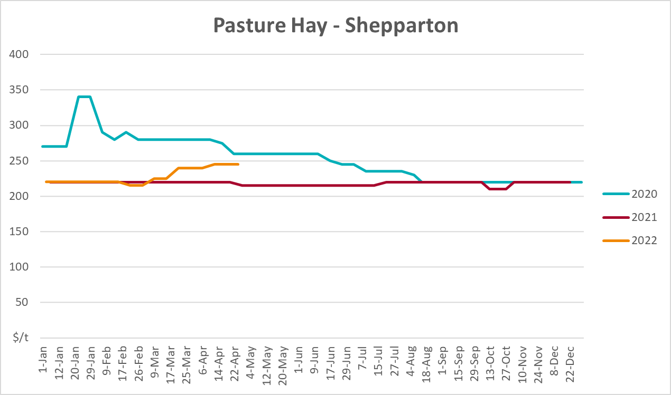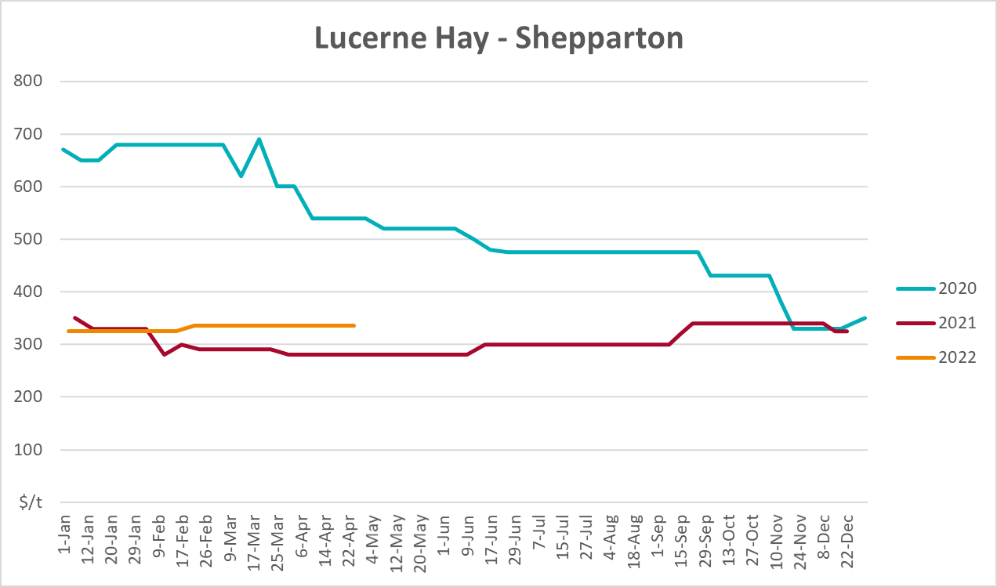

Data attribution

Climate
Bureau of Meteorology
- Weekly rainfall totals: www.bom.gov.au/climate/maps/rainfall/
- Monthly and last 3-month rainfall percentiles: www.bom.gov.au/water/landscape/
- Temperature anomalies: www.bom.gov.au/jsp/awap/temp/index.jsp
- Rainfall forecast: www.bom.gov.au/jsp/watl/rainfall/pme.jsp
- Seasonal outlook: www.bom.gov.au/climate/outlooks/#/overview/summary/
- Climate drivers: http://www.bom.gov.au/climate/enso/
- Soil moisture: www.bom.gov.au/water/landscape/
Other
- Pasture growth: www.longpaddock.qld.gov.au/aussiegrass/
- 3-month global outlooks: Environment and Climate Change Canada, NOAA Climate Prediction Center, EUROBRISA CPTEC/INPE, European Centre for Medium-Range Weather Forecasts, Hydrometcenter of Russia, National Climate Center Climate System Diagnosis and Prediction Room (NCC), International Research Institute for Climate and Society
- Global production: https://ipad.fas.usda.gov/ogamaps/cropmapsandcalendars.aspx
- Autumn break: Pook et al., 2009, https://rmets-onlinelibrary-wiley-com.virtual.anu.edu.au/doi/epdf/10.1002/joc.1833

Water
Prices
- Waterflow: https://www.waterflow.io/
- Ruralco: https://www.ruralcowater.com.au/
Bureau of Meteorology:
- Allocation trade: http://www.bom.gov.au/water/dashboards/#/water-markets/mdb/at
- Storage volumes: http://www.bom.gov.au/water/dashboards/#/water-storages/summary/drainage
Trade constraints:
- Water NSW: https://www.waternsw.com.au/customer-service/ordering-trading-and-pricing/trading/murrumbidgee
- Victorian Water Register: https://www.waterregister.vic.gov.au/TradingRules2019/

Commodities
Fruit and vegetables
- Datafresh: www.freshstate.com.au
Pigs
- Australian Pork Limited: www.australianpork.com.au
Dairy
- Global Dairy Trade: www.globaldairytrade.info/en/product-results/
World wheat, canola
- International Grains Council
World coarse grains
- United States Department of Agriculture
World cotton
- Cotlook: www.cotlook.com/
World sugar
- New York Stock Exchange - Intercontinental Exchange
Wool
- Australian Wool Exchange: www.awex.com.au/
Domestic wheat, barley, sorghum, canola and fodder
- Jumbuk Consulting Pty Ltd: http://www.jumbukag.com.au/
Cattle, beef, mutton, lamb, goat and live export
- Meat and Livestock Australia: www.mla.com.au/Prices-and-market
© Commonwealth of Australia 2022

Ownership of intellectual property rights
Unless otherwise noted, copyright (and any other intellectual property rights, if any) in this publication is owned by the Commonwealth of Australia (referred to as the Commonwealth).

Creative Commons licence
All material in this publication is licensed under a Creative Commons Attribution 4.0 International Licence except content supplied by third parties, logos and the Commonwealth Coat of Arms.
Inquiries about the licence and any use of this document should be emailed to copyright@awe.gov.au.


Cataloguing data
This publication (and any material sourced from it) should be attributed as:
ABARES 2022, Weekly Australian Climate, Water and Agricultural Update, Australian Bureau of Agricultural and Resource Economics and Sciences, Canberra, 4 August 2022. CC BY 4.0 DOI: https://doi.org/10.25814/5f3e04e7d2503
ISSN 2652-7561
This publication is available at https://www.agriculture.gov.au/abares/products/weekly_update
Department of Agriculture, Fisheries and Forestry
GPO Box 858 Canberra ACT 2601
Telephone 1800 900 090
Web agriculture.gov.au/abares

Disclaimer
The Australian Government acting through the Department of Agriculture, Fisheries and Forestry, represented by the Australian Bureau of Agricultural and Resource Economics and Sciences, has exercised due care and skill in preparing and compiling the information and data in this publication. Notwithstanding, the Department of Agriculture, Fisheries and Forestry, ABARES, its employees and advisers disclaim all liability, including liability for negligence and for any loss, damage, injury, expense or cost incurred by any person as a result of accessing, using or relying on any of the information or data in this publication to the maximum extent permitted by law.

Statement of Professional Independence
The views and analysis presented in ABARES publications, including this one, reflect ABARES professionally independent findings, based on scientific and economic concepts, principles, information and data. These views, analysis and findings may not reflect or be consistent with the views or positions of the Australian Government, or of organisations or groups who have commissioned ABARES reports or analysis. More information on professional independence is provided on the ABARES website.

Acknowledgements
This report was prepared by Matthew Miller and Cameron Van-Lane.

