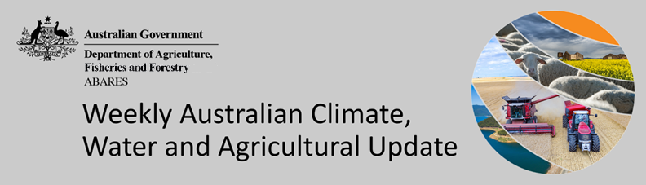
No. 28/2022

21 July 2022

Summary of key issues
- For the week ending 20 July 2022, cold fronts brought moderate rainfall to parts of southern Australia. Meanwhile, high-pressure systems dominated much of the country bringing clear, dry conditions (see Section 1.1).
- Predominantly dry conditions across New South Wales and Queensland over the past week allowed the harvest of remaining summer crops and final sowing of winter crops to continue. Light to moderate rainfall in Western Australia over the past week will have boosted plant available water, but further rainfall will be required to support ongoing yield development.
- Below average rainfall globally during June is likely to result in lower-than-expected wheat production potential in the United States, the European Union, and parts of Canada. Further, the conflict in Ukraine has generated additional levels of uncertainty around wheat, corn and sunflower production for 2022. Below average rainfall and above average temperatures in recent months have also negatively affected corn and soybean production across parts of Argentina, Brazil, the European Union and the United States. Global production conditions have deteriorated compared to those used to formulate ABARES forecasts of global grain supplies and world prices in its June 2022 edition of the Agricultural Commodities Report. As a result, global grain and oilseed production is likely to be lower than that forecast in June (see Section 1.2).
- Over the 8-days to 28 July 2022, a series of troughs, low-pressure systems and associated cold fronts are expected to bring light to moderate rainfall across parts of eastern and southern Australia. For much of the country, high-pressure systems will dominate, resulting in clear, dry conditions (see Section 1.3).
- Dry conditions forecast across much of New South Wales and southern Queensland will allow growers to harvest what remains of summer crops, as well as the late planting of winter cereal crops. The rainfall forecast for cropping regions of Western Australia will provide an ideal follow up to rainfall recorded last week, following several weeks of relatively dry conditions and declining soil moisture levels.
- Water storage in the Murray–Darling Basin (MDB) decreased by 23 gigalitres (GL) between 13 July 2022 and 20 July 2022. The current volume of water held in storage is 22,170 GL, which represents 88% of total capacity. This is 23% or 4,189 GL more than at the same time last year.
- Allocation prices in the Victorian Murray below the Barmah Choke decreased from $86 per ML on 8 July 2022 to $81 per ML on 15 July 2022. Prices are lower in the Goulburn-Broken, Murrumbidgee and regions above the Barmah choke due to the binding of the Murrumbidgee export limit, Goulburn intervalley trade limit and Barmah choke trade constraint. The large increase in prices in all regions is due to the start of the new water year.

Climate

Rainfall this week
For the week ending 20 July 2022, cold fronts brought moderate rainfall to parts of southern Australia. Meanwhile, high-pressure systems dominated much of the country bringing clear, dry conditions.
Rainfall totals of between 10 and 50 millimetres were recorded across isolated areas of New South Wales, South Australia, the east and south of Victoria, as well as the south-west of Western Australia and northern and western Tasmania. Rainfall totals in excess of 50 millimetres were recorded in isolated parts of south-west Western Australia and western Tasmania. Remaining parts of Australia received little to no rainfall.
In Australian cropping regions, rainfall totals of between 10 and 25 millimetres were recorded in across southern and western parts of Western Australia. Little to no rainfall was recorded across remaining cropping regions for the week ending 20 July 2022.
Predominantly dry conditions across New South Wales and Queensland over the past week allowed the harvest of remaining summer crops and final sowing of winter crops to continue. The significant rainfall received in New South Wales and Queensland throughout the winter sowing window has inhibited many growers from planting their intended winter program, and further rainfall since the start of July has likely exacerbated waterlogging issues in some areas.
However, the rainfall has boosted soil moisture levels and is likely to improve yield potentials for planted crops. Soil moisture levels remain average to above average across cropping regions of New South Wales and Queensland, while soil moisture levels are below average to average in Victoria, South Australia and Western Australia. Light to moderate rainfalls in Western Australia over the past week will have boosted plant available water, but further rainfall will be required to support ongoing yield development.

Rainfall for the week ending 20 July 2022
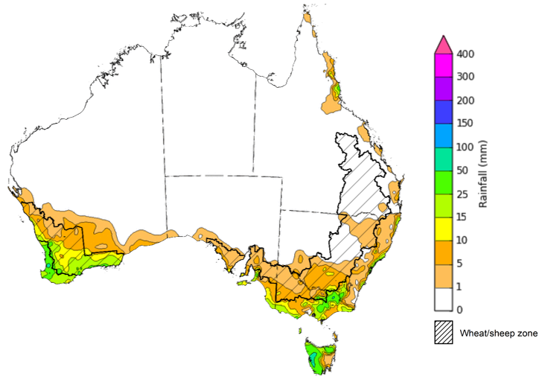
©Commonwealth of Australia 2022, Australian Bureau of Meteorology Issued:20/7/2022
Note: The rainfall analyses and associated maps utilise data contained in the Bureau of Meteorology climate database, the Australian Data Archive for Meteorology (ADAM). The analyses are initially produced automatically from real-time data with limited quality control. They are intended to provide a general overview of rainfall across Australia as quickly as possible after the observations are received. For further information go to http://www.bom.gov.au/climate/rainfall/

Global production conditions and climate outlook
Crop production is affected by long-term trends in average rainfall and temperature, interannual climate variability, shocks during specific growth stages, and extreme weather events (IPCC 2012). Some crops are more tolerant than others to certain types of stresses, and at each growth stage, different types of stresses affect each crop species in different ways.
The precipitation anomalies and outlooks presented here give an indication of the current and future state of production conditions for the major grain and oilseed producing countries which are responsible for over 80% of global production. This is an important input to assessing the global grain supply outlook.
June precipitation percentiles and current production conditions
As of the end of June 2022, rainfall was mixed for the world’s major grain-producing and oilseed-producing regions.
In the northern hemisphere, precipitation was below average in eastern and central United States, across much of the European Union, Ukraine and parts of Kazakhstan and the Central and Southern regions of the Russian Federation. Precipitation was above average for parts of western United States, central Canada and southern China. Precipitation was close to average across the remainder of the major grain-producing and oilseed-producing regions in the northern hemisphere.
In the southern hemisphere, June precipitation was below average for Argentina, as well as parts of southern Brazil and western and eastern Australia. Precipitation was above average for parts of South Africa and the far north of Brazil. Precipitation was close to average across the remainder of major grain-producing and oilseed-producing regions in the southern hemisphere.

Global precipitation percentiles, June 2022

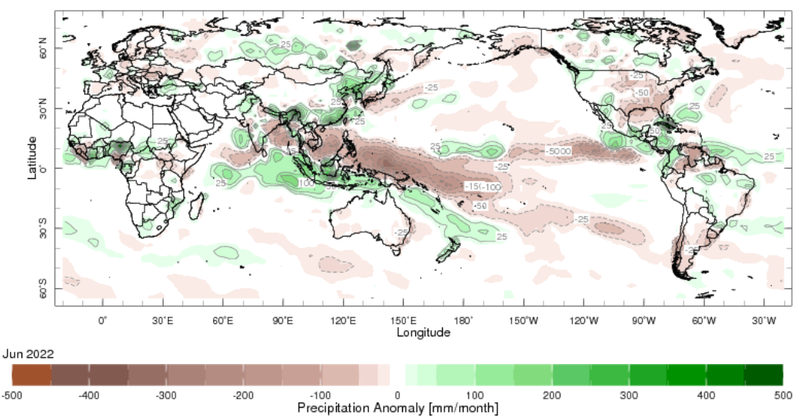
Note: The world precipitation percentiles indicate a ranking of precipitation for June, with the driest (0th percentile) being 0 on the scale and the wettest (100th percentile) being 1 on the scale. Percentiles are based on precipitation estimates from the NOAA Climate Prediction Center's Climate Anomaly Monitoring System Outgoing Precipitation Index dataset. Precipitation estimates for June 2022 are compared with rainfall recorded for that period during the 1981 to 2010 base period.
Source: International Research Institute for Climate and Society
As at 28 June 2022 global production conditions were generally favourable for rice and soybeans, but mixed for the production of wheat and corn.
In the northern hemisphere production conditions for wheat have been mixed. Climatic conditions have been favourable for wheat development in China, the Russian Federation and the United Kingdom. Production conditions were variable for the European Union, Canada, Kazakhstan and the United States with dryness and excess heat in some areas and excessive moisture in others negatively affecting yield prospects. In the Ukraine hot and dry conditions have accelerated grain ripening and brought forward harvest in the south. However, the ongoing war has reduced the area that can be harvested in and near the conflict zones, which is generated ongoing uncertainty for the global wheat production outlook.
In Argentina, harvesting of early and late-planted corn crops is continuing with reduced yields due to earlier hot and dry weather. In Brazil, production conditions are variable as harvest commences for the summer-planted crop as a lack of rain in the south-east regions is likely to negatively impact yields. In Mexico harvesting is ongoing under favourable conditions. In the European Union, Russia and the United States growing conditions are predominately favourable. In China spring-planted maize is maturing in the south, while hot and dry conditions in parts of the Northern China Plain are slowing development. In Ukraine, sowing of corn is progressing but field access is mixed due the ongoing war. There is likely to be a reduction in the total sown area compared to last year.
In China, high rainfall and low solar radiation in the south are reducing potential yields of early-season rice, while single-season rice is seeing favourable growing conditions. In the Philippines and Thailand, plant and growth of wet-season rice is continuing under generally favourable conditions. In Thailand the total sown area is expected to increase compared to last year due to ample rainfall. In Vietnam, the harvest of winter-spring rice is ongoing in the north while the sowing of summer-autumn rice begins. In the south, the summer-autumn rice growth is preceding under favourable conditions. In Indonesia, harvesting of wet-season rice is wrapping up under favourable conditions with an increase in the total harvested area compared to last year, however, sowing of dry-season rice has been significantly delayed and remains at low levels.
Harvesting of soybean is wrapping up in Argentina under generally favourable conditions except for in La Pampa, Santa Fe, and San Luis where yields have been reduced due to an earlier in-season drought. In the United States, growing conditions are favourable as sowing is wrapping up despite earlier delays in Minnesota and North Dakota. In Canada, growing conditions are favourable in the main producing province of Ontario, while mixed growing conditions are evident in the Prairies due to dryness in Saskatchewan and excess moisture in Manitoba. In China, sowing is ongoing under favourable conditions. In Ukraine, sowing is wrapping up while of the ongoing war continues to bring production uncertainties.
Crop conditions, AMIS countries, 28 June 2022
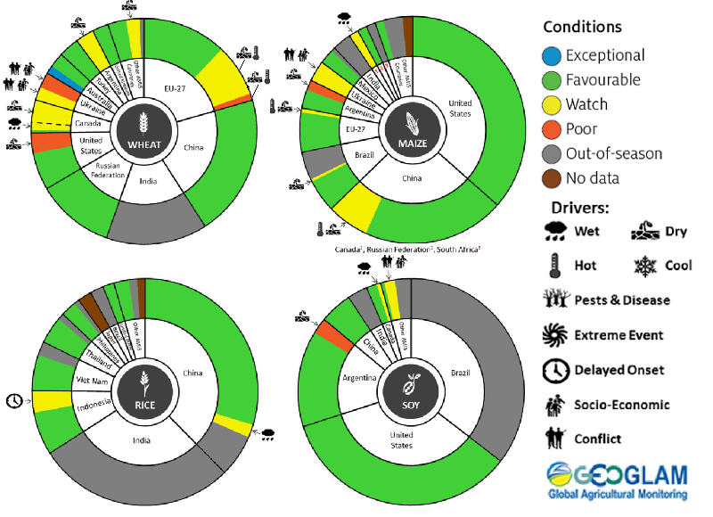
AMIS Agricultural Market Information System.
Source: AMIS
The global climate outlook for August 2022 to October 2022 indicates that variable rainfall conditions are expected for the world's major grain-producing and oilseed-producing regions. Outlooks and potential production impacts for the major grain and oilseed producing countries are presented in the table.
Rainfall outlook and potential impact on the future state of production conditions between August 2022 to October 2022
Region | August - October rainfall outlook | Potential impact on production
Argentina | Below average rainfall is expected across most of Argentina between August and October 2022. | Below average rainfall is likely to adversely affect the heading and filling of wheat and planting of corn, cotton and soybeans through September and October.
Black Sea Region | Ukraine - Below average rainfall is more likely across much of Ukraine.  Kazakhstan - Average rainfall is more likely across parts of Kazakhstan.  The Russian Federation – Average rainfall is more likely across most of Russia, with below average rainfall more likely in across Central and Southern Russia | Average rainfall between August and October 2022 is likely to support spring wheat filling and harvesting in the north of the Black Sea Region. In the south of the Black Sea Region, average rainfall is likely to support cotton, corn and sunflower development and winter wheat and rapeseed harvesting and planting.
Brazil | Above average rainfall is more likely across parts of northern Brazil and below average rainfall is more likely across southern Brazil between August and October 2022. | Below average rainfall in southern Brazil is likely to adversely affect wheat heading and filling in August and September leading up to harvest in October, as well as corn and soybean planting and development in September and October.
Canada | Average rainfall is more likely for much of Canada, especially across major production regions between August and October 2022. | Average rainfall is likely to benefit corn, soybeans and sunflower flowering in August and support grain development through September and October.
China | Average to above average rainfall is more likely across much of China between August and October 2022. | Average to above average rainfall is likely to support the development and harvest of cotton, rice, corn, sorghum, soybean, sunflower, groundnuts and spring wheat. Additionally, average to above average rainfall is likely to support late rice heading in September and planting of winter wheat and rapeseed in October.
Europe | Below average rainfall is more likely for most of Europe between August and October 2022 | Below average rainfall may adversely impact the yield prospects of corn, cotton and sorghum in northern Europe. Below average rainfall may also impact winter wheat and rapeseed planting in parts of northern Europe during October.
South Asia (India) | Average to above average rainfall is more likely across much of India between August and October 2022 | Above average rainfall is likely to benefit corn, sorghum, rice, millet, groundnuts and sunflower flowering and filling in August and September leading up to harvest in October, and cotton blooming in the south in September.
Southeast Asia (SEA) | Above average rainfall is more likely for parts of southern Southeast Asian countries and below average rainfall is more likely for southern Myanmar and the Island of Sumatra in Indonesia between August and October 2022. | Above average rainfall between August and October 2022 is likely to support corn and rice filling and maturing in SEA leading up to harvest in October.
The United States of America | Above average rainfall is likely for much of the eastern US and below average rainfall is more likely for most southern and central growing regions between August and October 2022 | Across the east of the US average to above average rainfall is likely to benefit soybeans, sunflower and millet flowering in August and the development of these crops as well as rice, corn, sorghum and groundnuts leading up to harvest in October. Below average rainfall is likely to continue to adversely affect the yield prospects of corn, spring wheat and soybeans in central and southern US.

Rainfall forecast for the next eight days
Over the 8-days to 28 July 2022, a series of troughs, low-pressure systems and associated cold fronts are expected to bring light to moderate rainfall across parts of eastern and southern Australia. For much of the country, high-pressure systems will dominate, resulting in clear, dry conditions.
Rainfall totals of between 10 and 50 millimetres are forecast for isolated parts of eastern, northern and southern New South Wales, large areas of south-eastern Queensland, Victoria, the south-east of South Australia and the south-west of Western Australia, as well as much of Tasmania. Rainfall totals in excess of 50 millimetres are forecast for isolated parts of the south-west of Western Australia. Little to no rainfall is forecast across remaining parts of Australia over the next 8-days.
In Australian cropping regions, rainfall totals of between 10 and 50 millimetres are expected across parts of southern New South Wales, central and northern Queensland, much of Victoria, as well as most of Western Australia. Little to no rainfall is forecast for all remaining cropping regions during the next 8-days.
Dry conditions forecast across much of New South Wales and southern Queensland will allow growers to harvest what remains of summer crops, as well as the late planting of winter cereal crops. For most growers in eastern Australia who planted winter crops in the typical planting window, the dry conditions will allow field access for crop management activities. The rainfall forecast for cropping regions of Western Australia will provide an ideal follow up to rainfall recorded last week, following several weeks of relatively dry conditions and declining soil moisture levels.
Winter crops in Western Australia have had a favourable start to the season, with substantial rainfall early in the season and above average temperatures throughout June. The rainfall expected over the coming week will boost soil moisture levels across Western Australian cropping regions and support continued crop development. The outlook through spring is also expected to provide sufficient rainfall to support yield potentials as the crop enters critical stages of flowering and grain filling.

Total forecast rainfall (mm) for the period 21 July to 28 July 2022
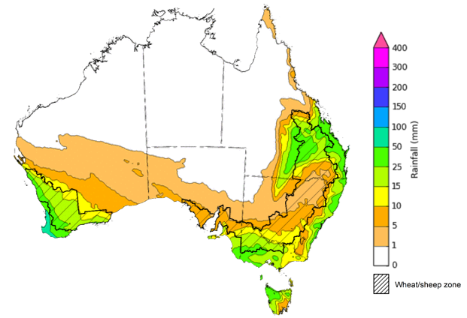
©Commonwealth of Australia 2022, Australian Bureau of Meteorology Issued:21/7/2022

Water
Note: This rainfall forecast is produced from computer models. As the model outputs are not altered by weather forecasters, it is important to check local forecasts and warnings issued by the Bureau of Meteorology.

Water markets – current week
Water storage in the Murray–Darling Basin (MDB) decreased by 23 gigalitres (GL) between 13 July 2022 and 20 July 2022. The current volume of water held in storage is 22,170 GL, which represents 88% of total capacity. This is 23% or 4,189 GL more than at the same time last year.

Water storages in the Murray-Darling Basin, 2013–2022
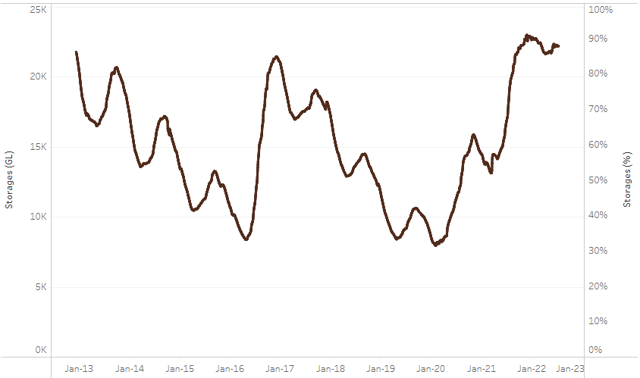
Allocation prices in the Victorian Murray below the Barmah Choke decreased from $86 per ML on 8 July 2022 to $81 per ML on 15 July 2022. Prices are lower in the Goulburn-Broken, Murrumbidgee and regions above the Barmah choke due to the binding of the Murrumbidgee export limit, Goulburn intervalley trade limit and Barmah choke trade constraint. The large increase in prices in all regions is due to the start of the new water year.
Water storage data is sourced from the Bureau of Meteorology.

Region | $/ML
NSW Murray Above | 56
NSW Murrumbidgee | 85
VIC Goulburn-Broken | 65
VIC Murray Below | 81

Surface water trade activity, Southern Murray–Darling Basin

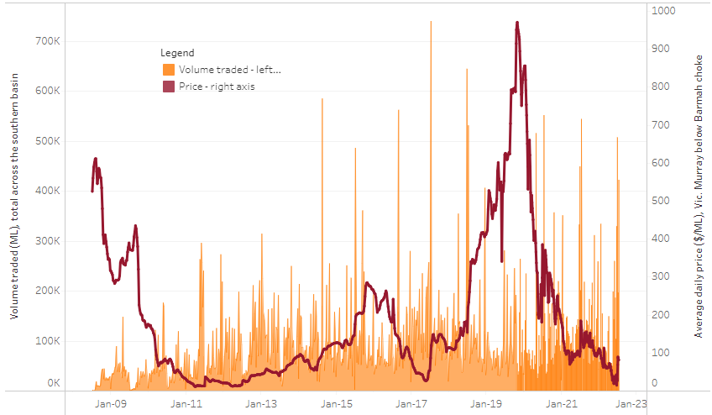
To access the full, interactive, weekly water dashboard, which contains the latest and historical water storage, water market and water allocation information, please visit http://www.agriculture.gov.au/abares/products/weekly_update/weekly-update-210722
The trades shown reflect estimated market activity and do not encompass all register trades. The price is shown for the VIC Murray below the Barmah choke. Historical prices (before 1 July 2019) are ABARES estimates after removing outliers from BOM water register data. Prices after 1 July 2019 and prior to the 30 October 2019 reflect recorded transaction prices as sourced from Ruralco. Prices after the 30 October 2019 are sourced from Waterflow. Data for volume traded is sourced from the BOM water register. Data shown is current at 21 July 2022.

Commodities

Indicator | Week ended | Unit | Latest price | Previous week | Weekly change | Price 12 months ago | Annual change
Selected world indicator prices
AUD/USD Exchange rate | 20-Jul | A$/US$ | 0.69 | 0.68 | 1% | 0.74 | -7%
Wheat – US no. 2 hard red winter wheat, fob Gulf | 20-Jul | US$/t | 384 | 388 | -1% | 298 | 29%
Corn – US no. 2 yellow corn, fob Gulf | 20-Jul | US$/t | 311 | 320 | -3% | 280 | 11%
Canola – Rapeseed, Canada, fob Vancouver | 20-Jul | US$/t | 722 | 720 | 0% | 773 | -7%
Cotton – Cotlook 'A' Index | 20-Jul | USc/lb | 128 | 135 | -5% | 99 | 29%
Sugar – Intercontinental Exchange, nearby futures, no.11 contract | 20-Jul | USc/lb | 19.3 | 19.0 | 2% | 19 | 3%
Wool – Eastern Market Indicator | 06-Jul | Ac/kg clean | 1,388 | 1,407 | -1% | 1,315 | 6%
Wool – Western Market Indicator | 06-Jul | Ac/kg clean | 1,473 | 1,486 | -1% | 1,333 | 11%
Selected Australian grain export prices
Milling Wheat – APW, Port Adelaide, SA | 20-Jul | A$/t | 602 | 613 | -2% | 387 | 55%
Feed Wheat – ASW, Port Adelaide, SA | 20-Jul | A$/t | 562 | 574 | -2% | 387 | 45%
Feed Barley – Port Adelaide, SA | 20-Jul | A$/t | 510 | 517 | -1% | 319 | 60%
Canola – Kwinana, WA | 20-Jul | A$/t | 1,133 | 1,123 | 1% | 773 | 47%
Grain Sorghum – Brisbane, QLD | 20-Jul | A$/t | 432 | 435 | -1% | 365 | 18%
Selected domestic livestock indicator prices
Beef – Eastern Young Cattle Indicator | 20-Jul | Ac/kg cwt | 973 | 1,000 | -3% | 948 | 3%
Mutton – Mutton indicator (18–24 kg fat score 2–3), Vic | 20-Jul | Ac/kg cwt | 592 | 634 | -7% | 691 | -14%
Lamb – Eastern States Trade Lamb Indicator | 20-Jul | Ac/kg cwt | 776 | 787 | -1% | 857 | -9%
Pig – Eastern Seaboard (60.1–75 kg), average of buyers & sellers | 29-Jun | Ac/kg cwt | 368 | 368 | 0% | 347 | 6%
Goats – Eastern States (12.1–16 kg) | 12-Jan | Ac/kg cwt | 879 | 879 | 0% | 818 | 8%
Live cattle – Light steers ex Darwin to Indonesia | 01-Jun | Ac/kg lwt | 480 | 480 | 0% | 320 | 50%
Live sheep – Live wethers (Muchea WA saleyard) to Middle East | 20-Apr | $/head | 113 | 113 | 0% | 122 | -7%

Indicator | Week ended | Unit | Latest price | Previous week | Weekly change | Price 12 months ago | Annual change
Global Dairy Trade (GDT) weighted average prices ª
Dairy – Whole milk powder | 20-Jul | US$/t | 3,757 | 3,961 | -5% | 2,761 | 36%
Dairy – Skim milk powder | 20-Jul | US$/t | 3,709 | 4,063 | -9% | 2,530 | 47%
Dairy – Cheddar cheese | 20-Jul | US$/t | 4,825 | 4,908 | -2% | 3,520 | 37%
Dairy – Anhydrous milk fat | 20-Jul | US$/t | 5,580 | 5,706 | -2% | 3,960 | 41%
a Global Dairy Trade prices are updated twice monthly on the first and third Tuesday of each month.

Selected world indicator prices
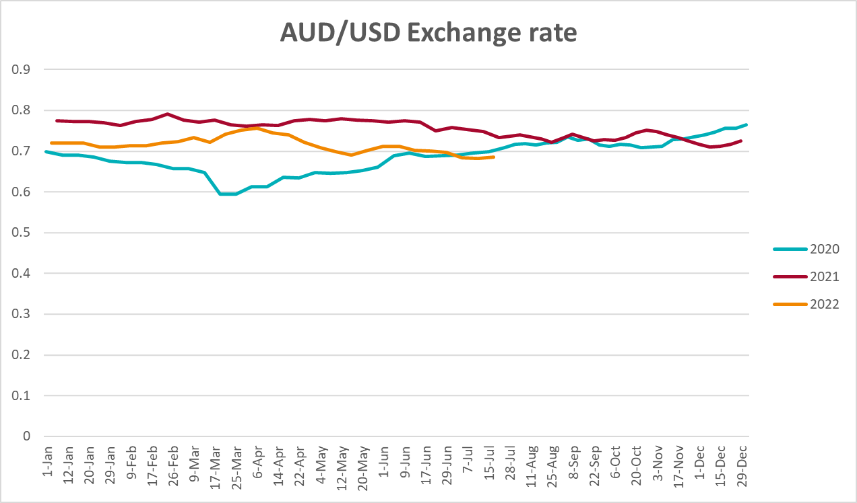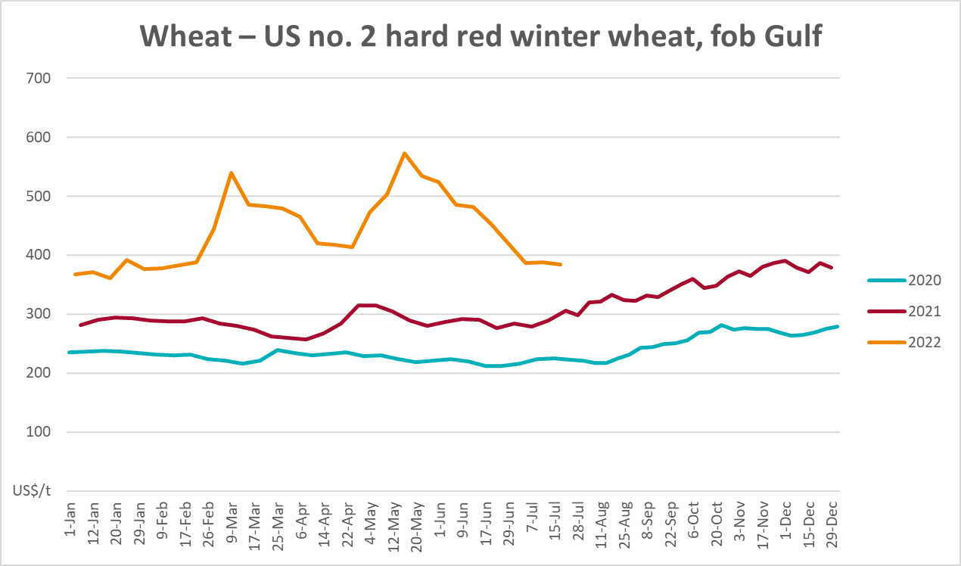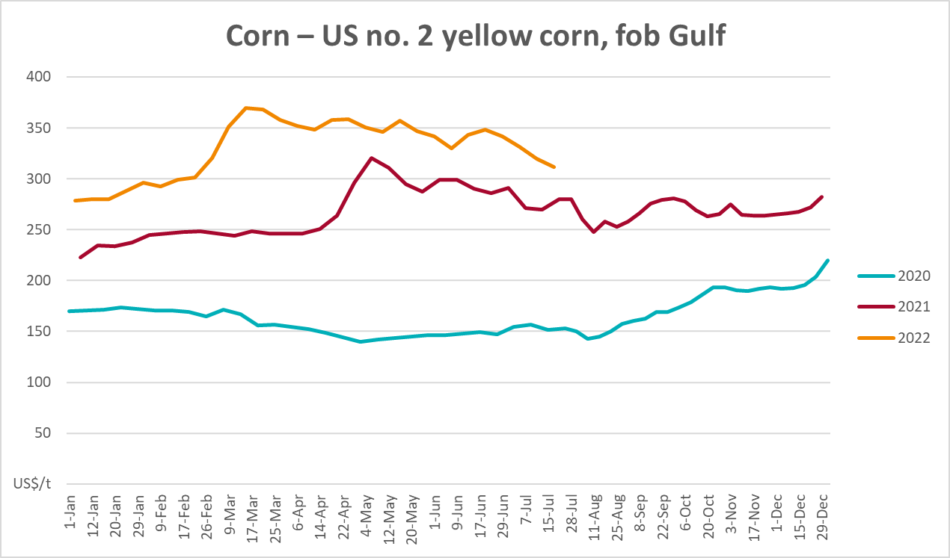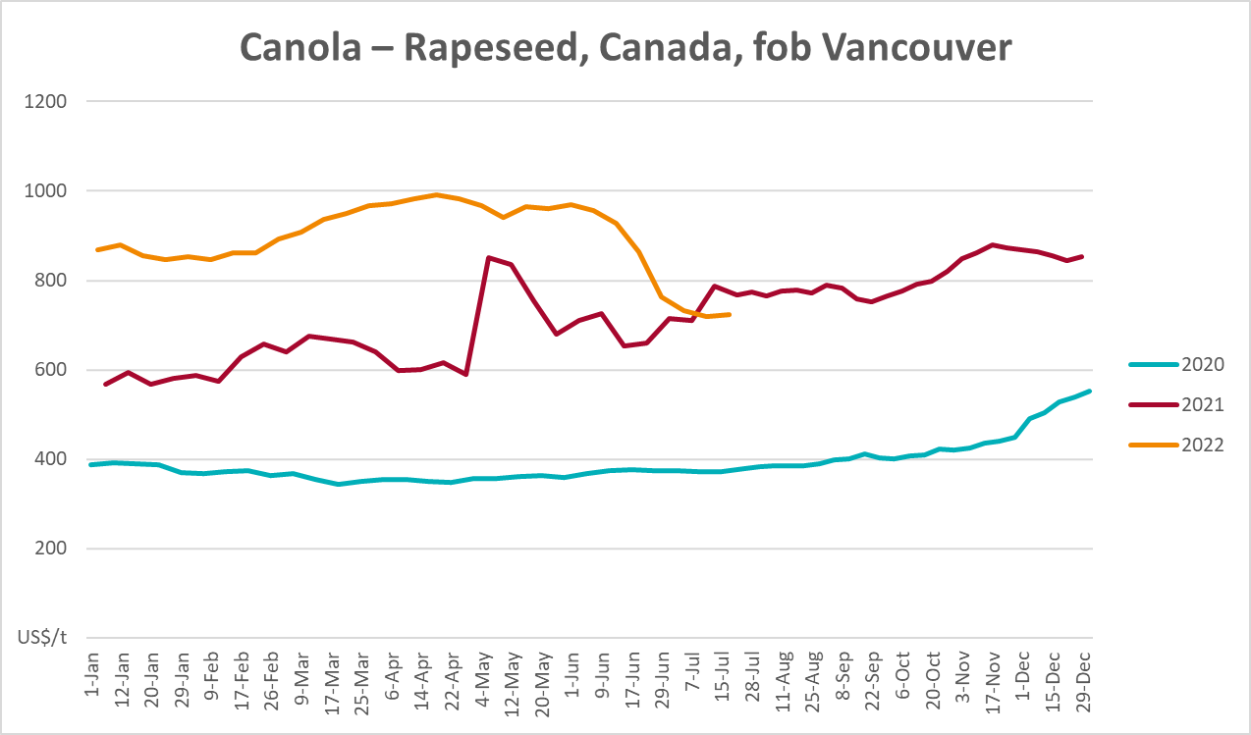
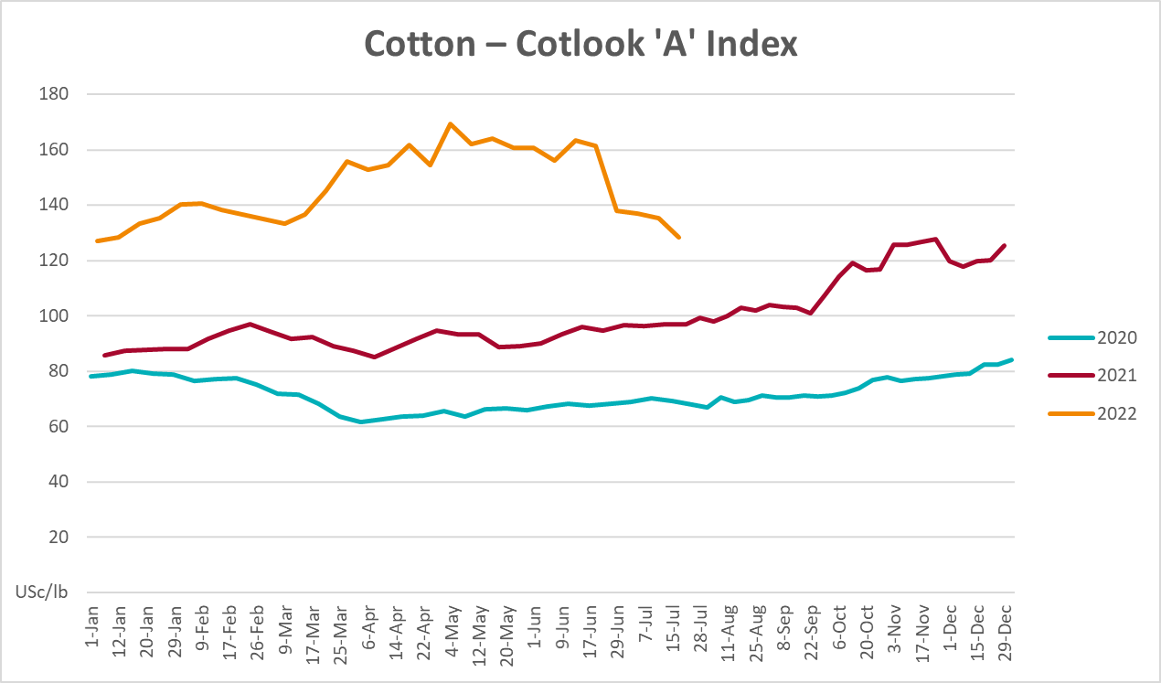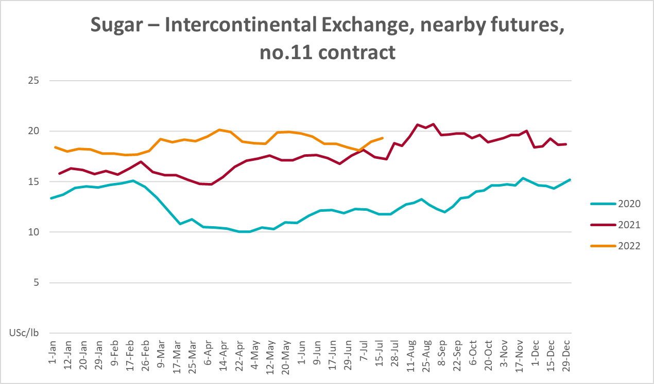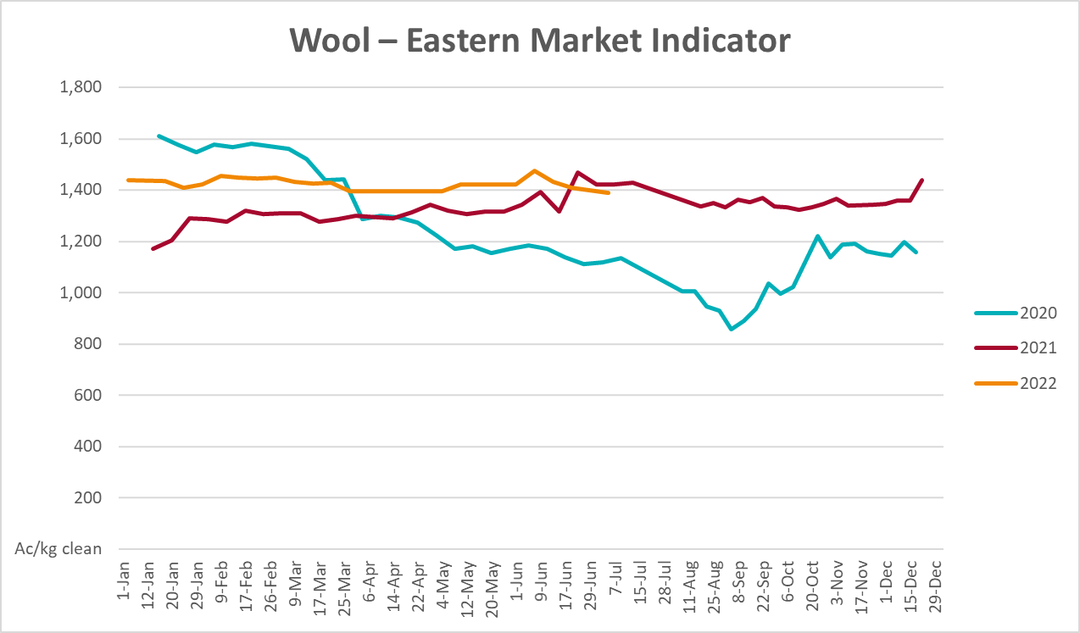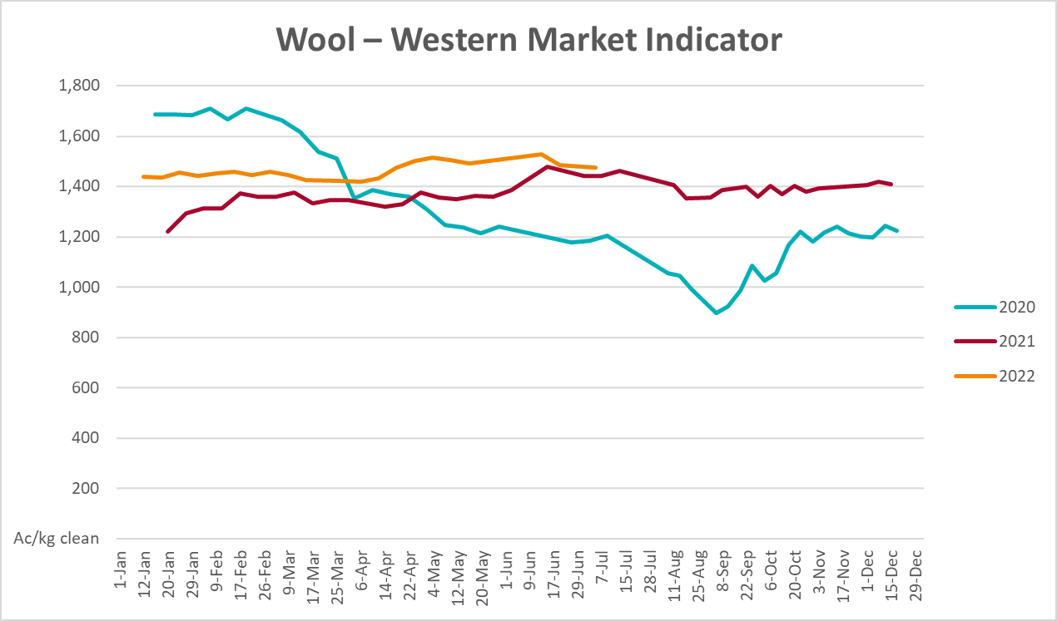

Selected domestic crop indicator prices
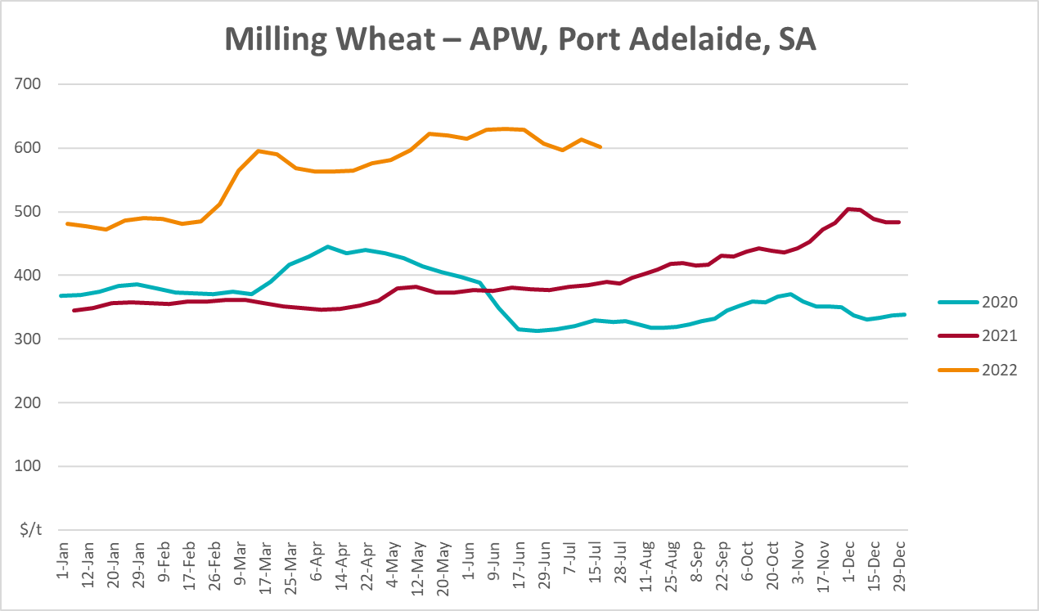
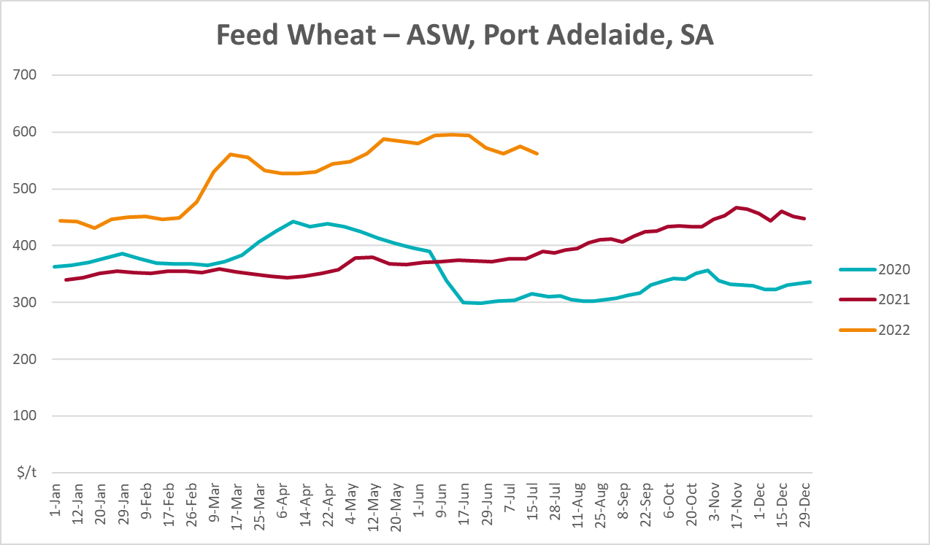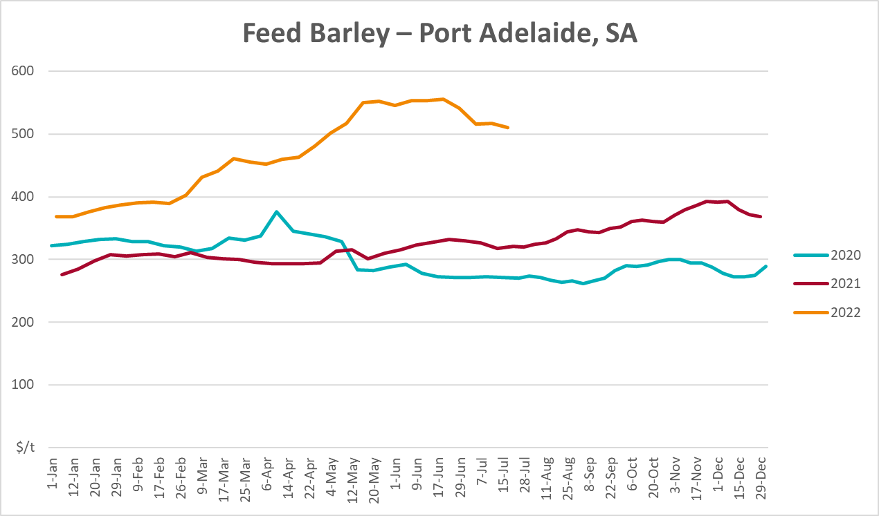
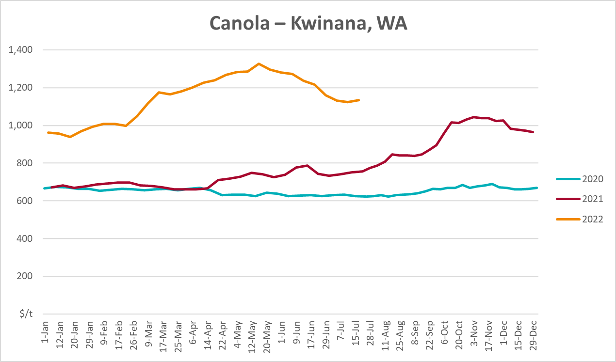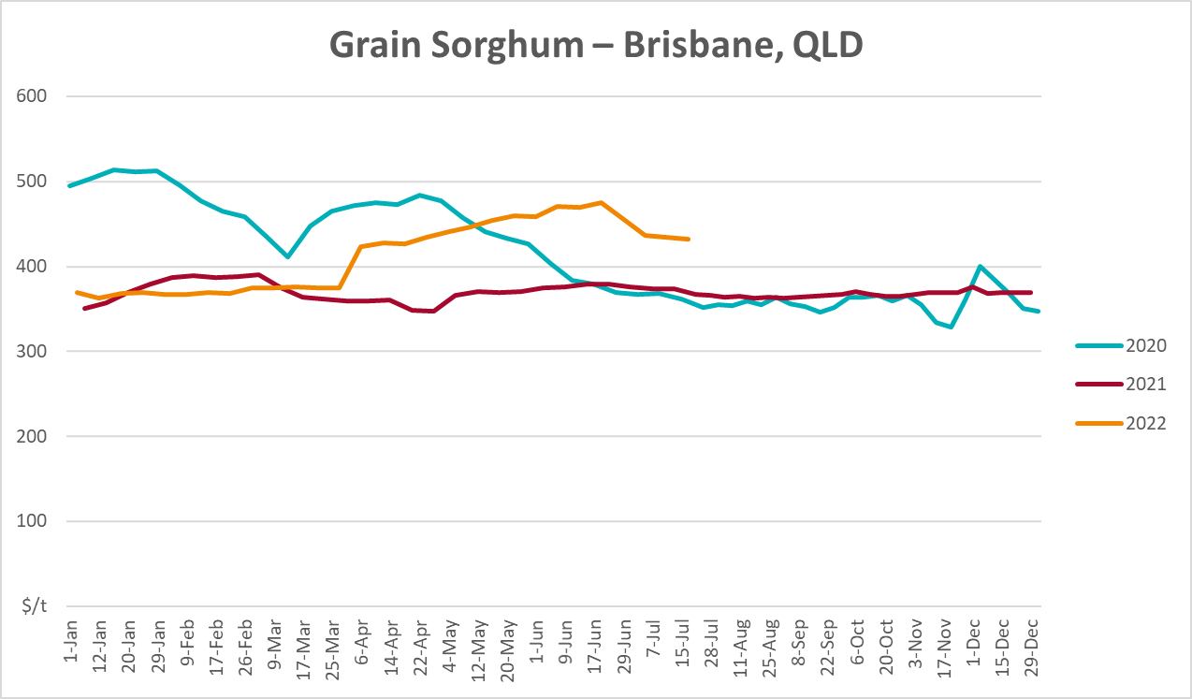

Selected domestic livestock indicator prices
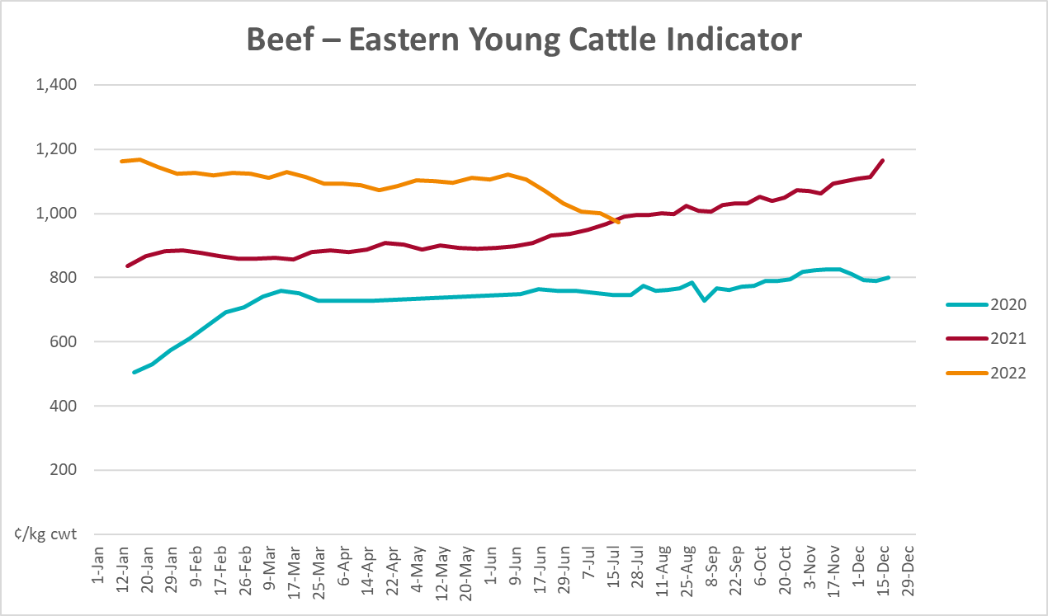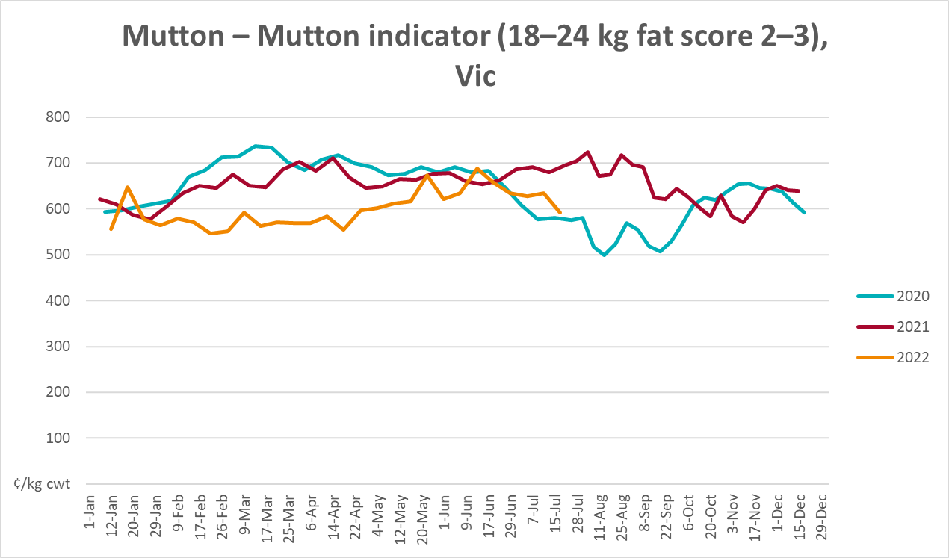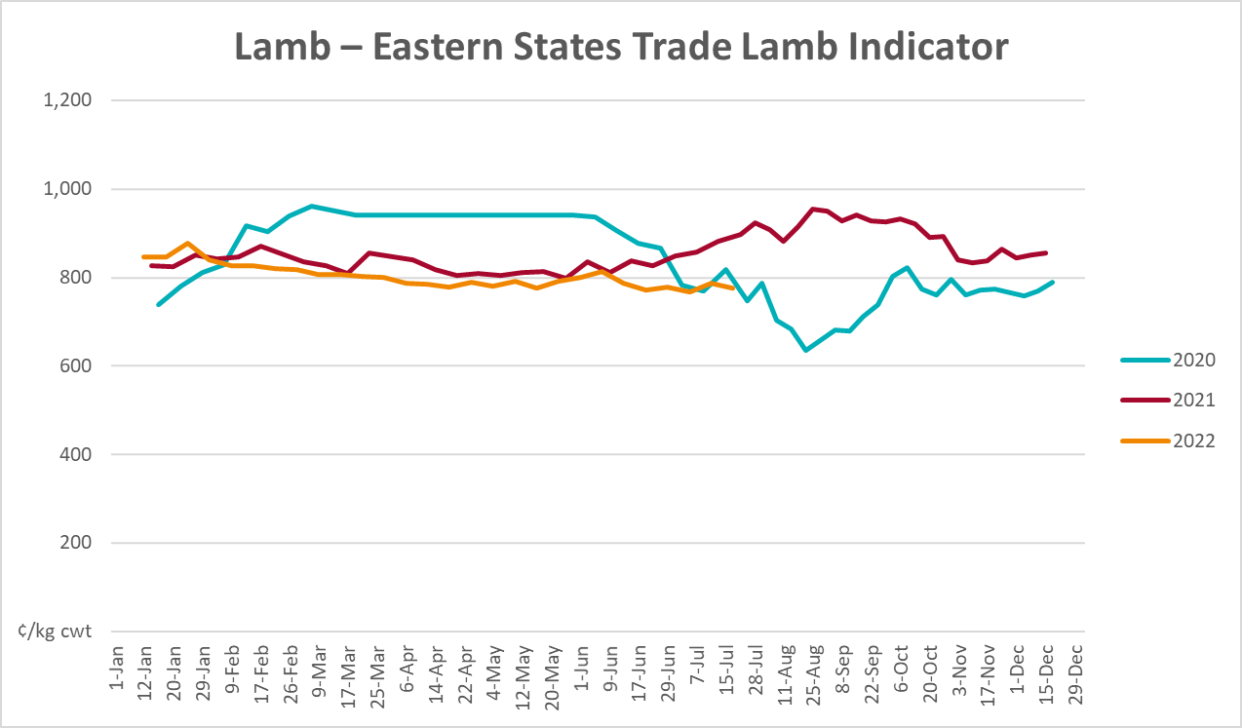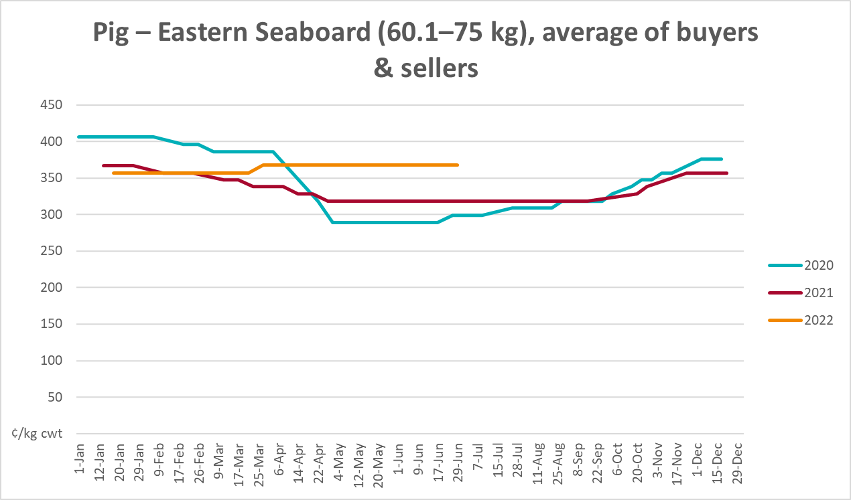
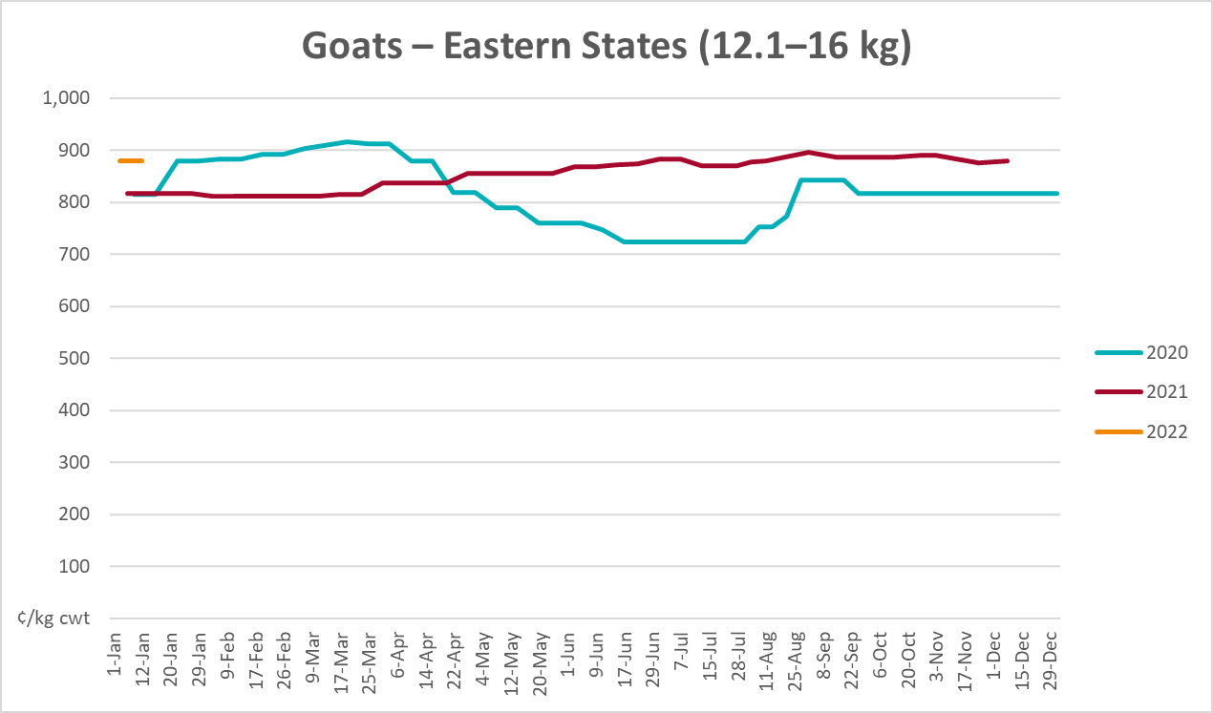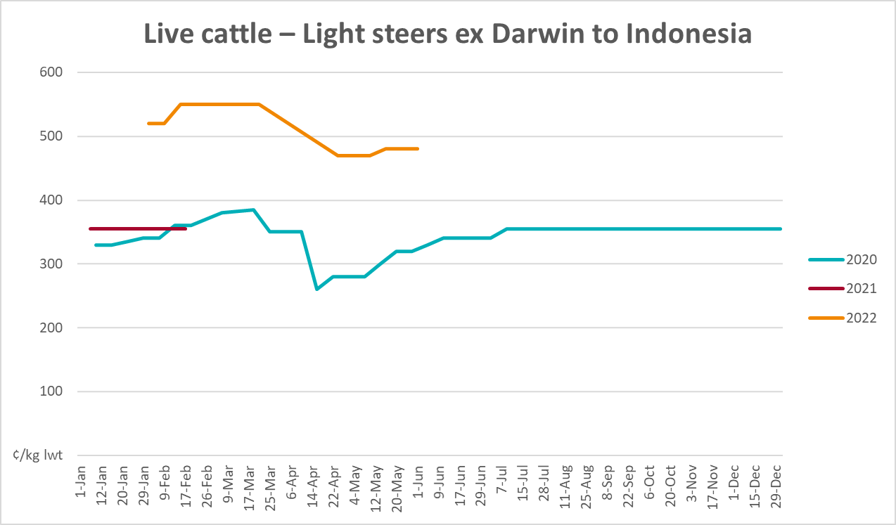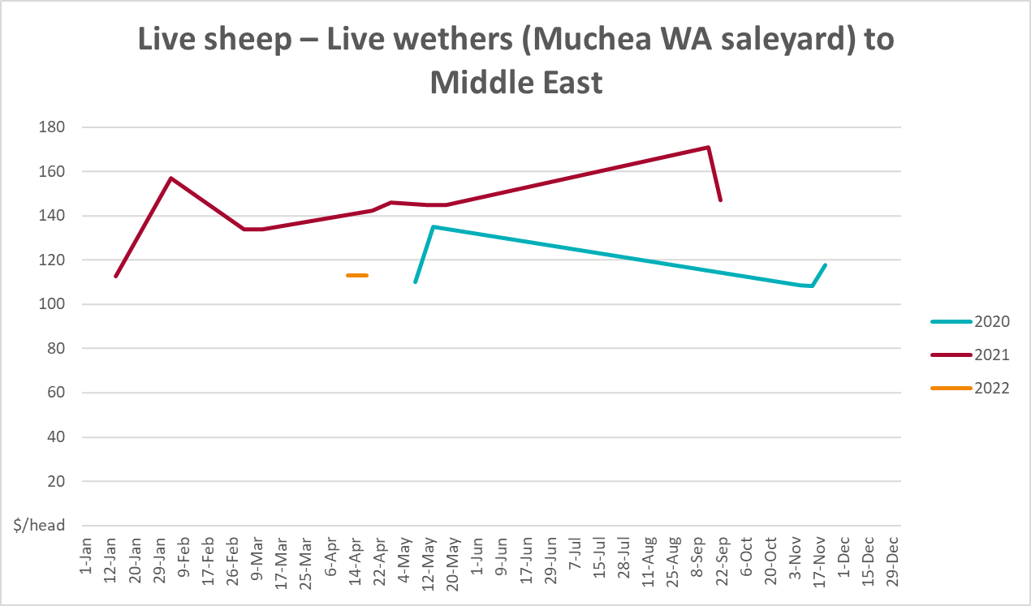

Global Dairy Trade (GDT) weighted average prices
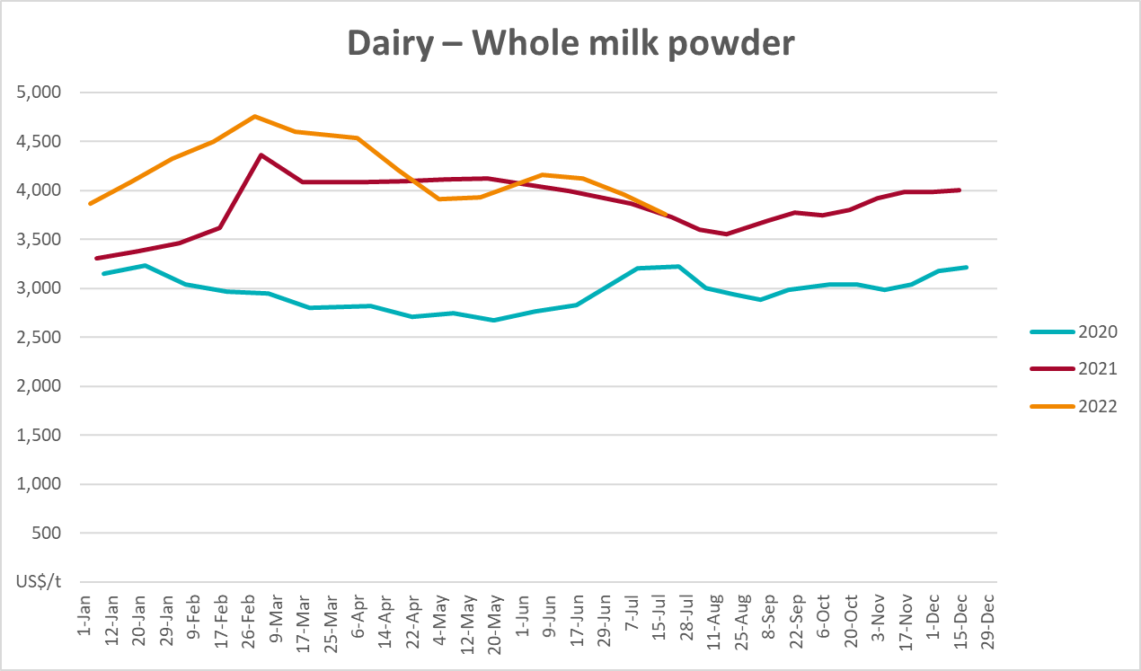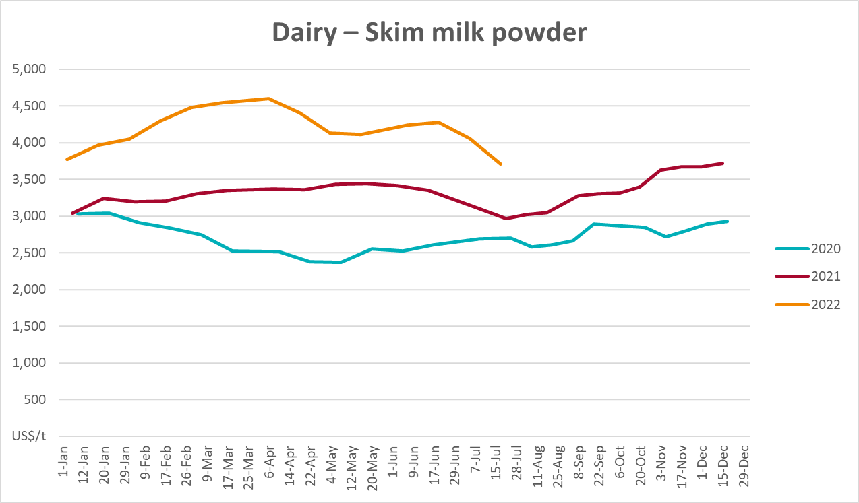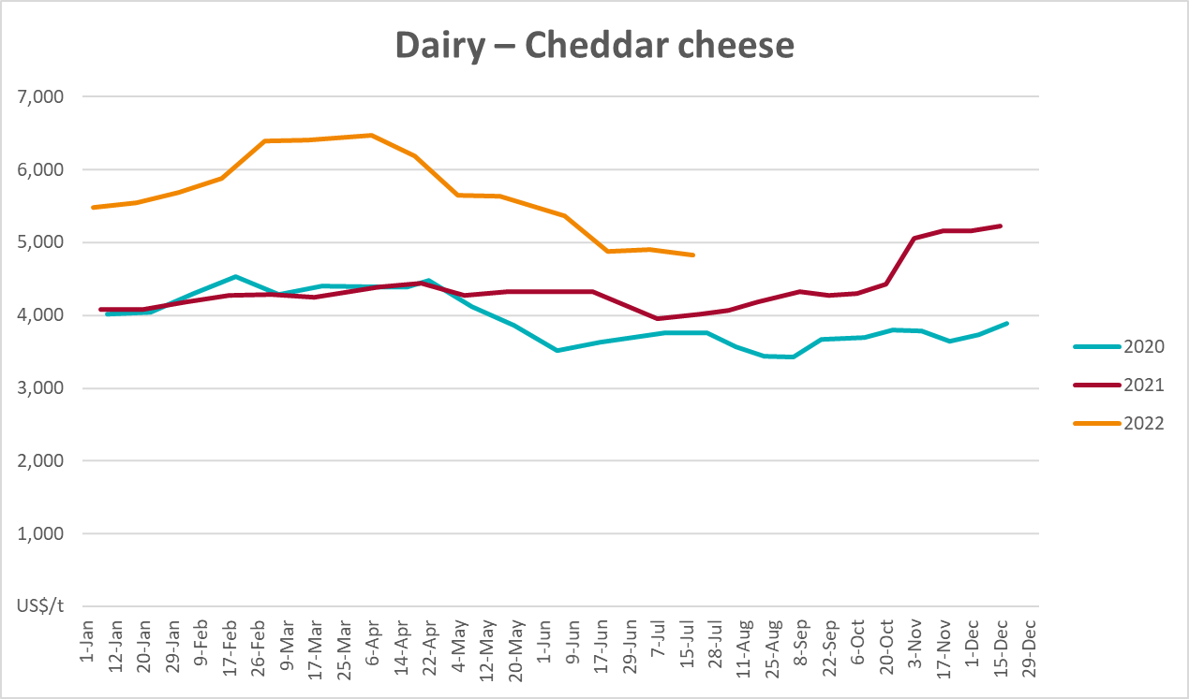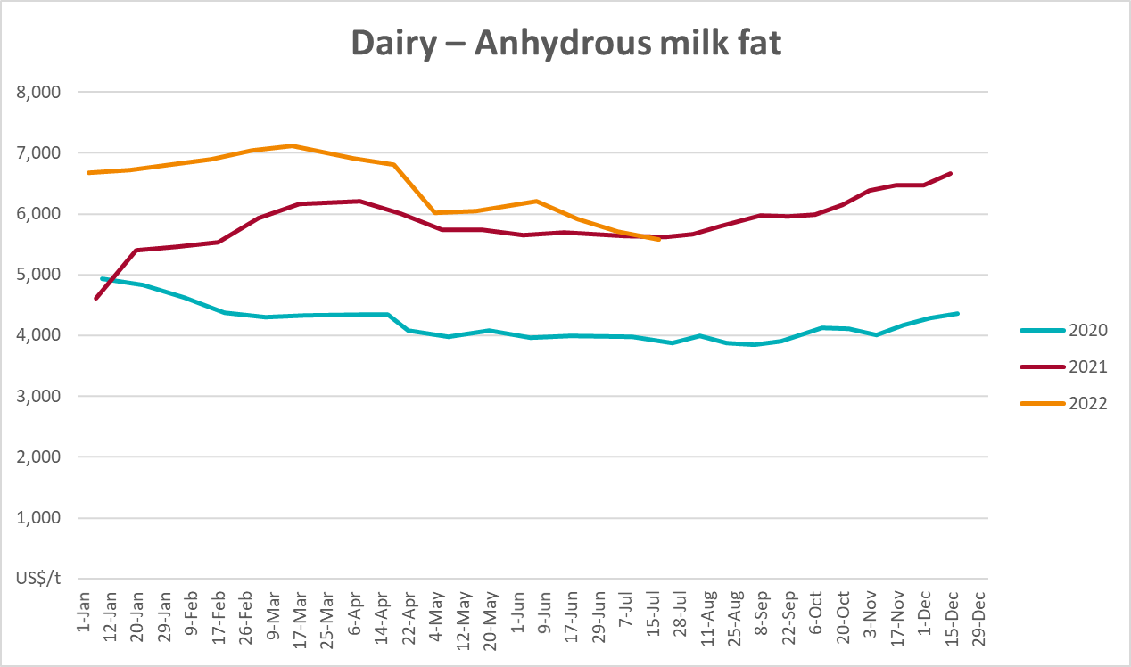

Selected fruit and vegetable prices
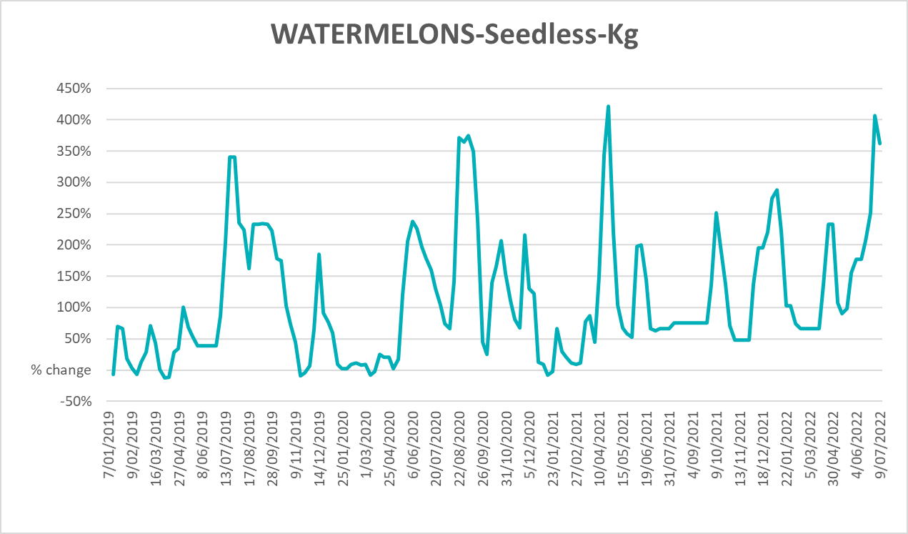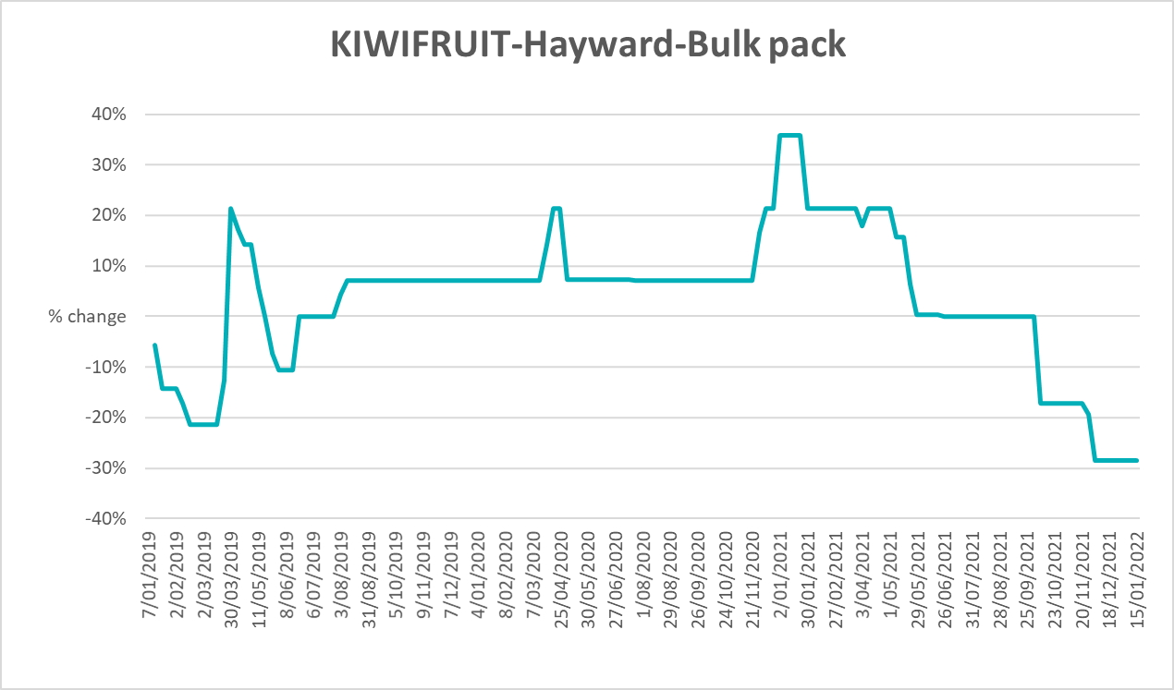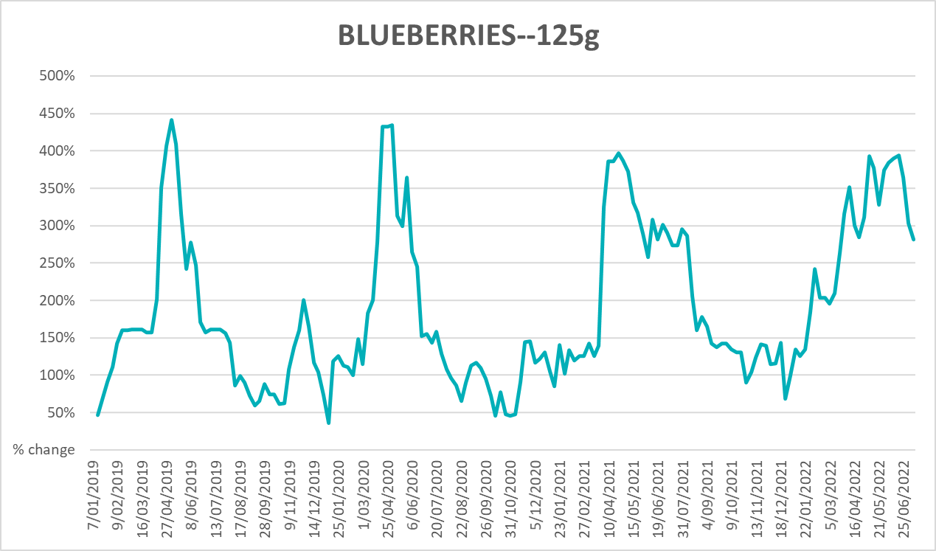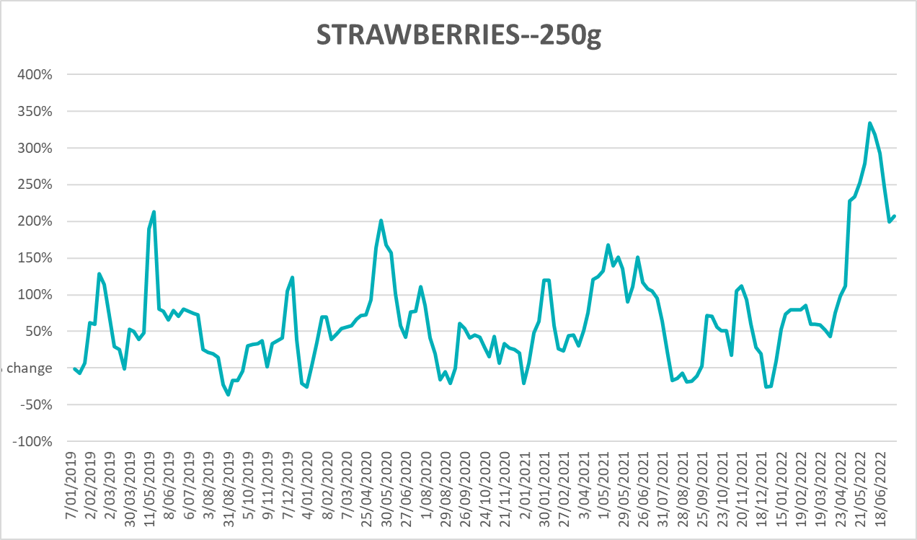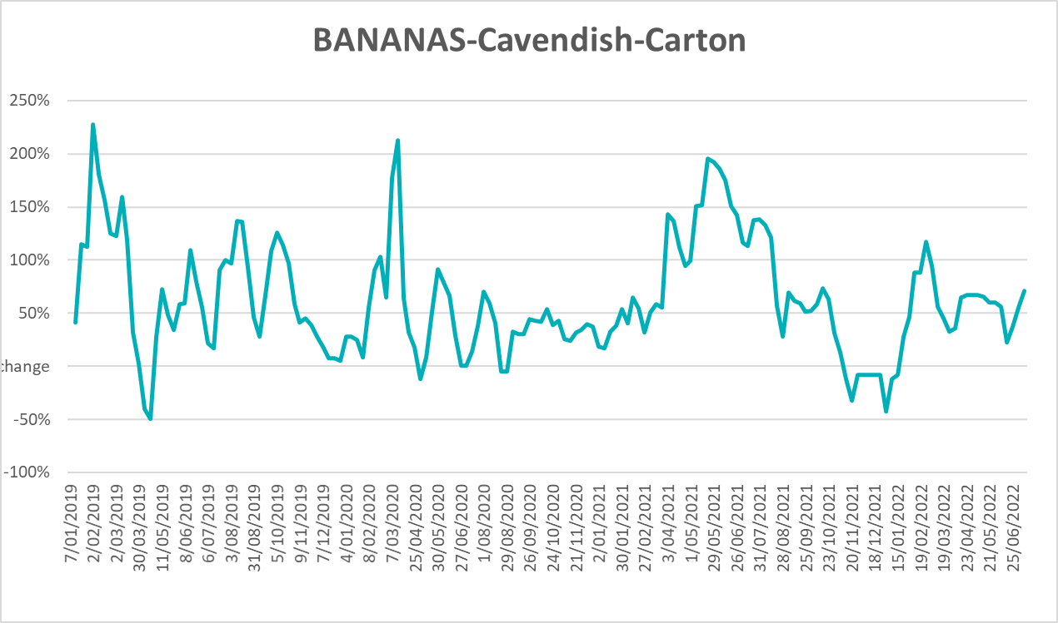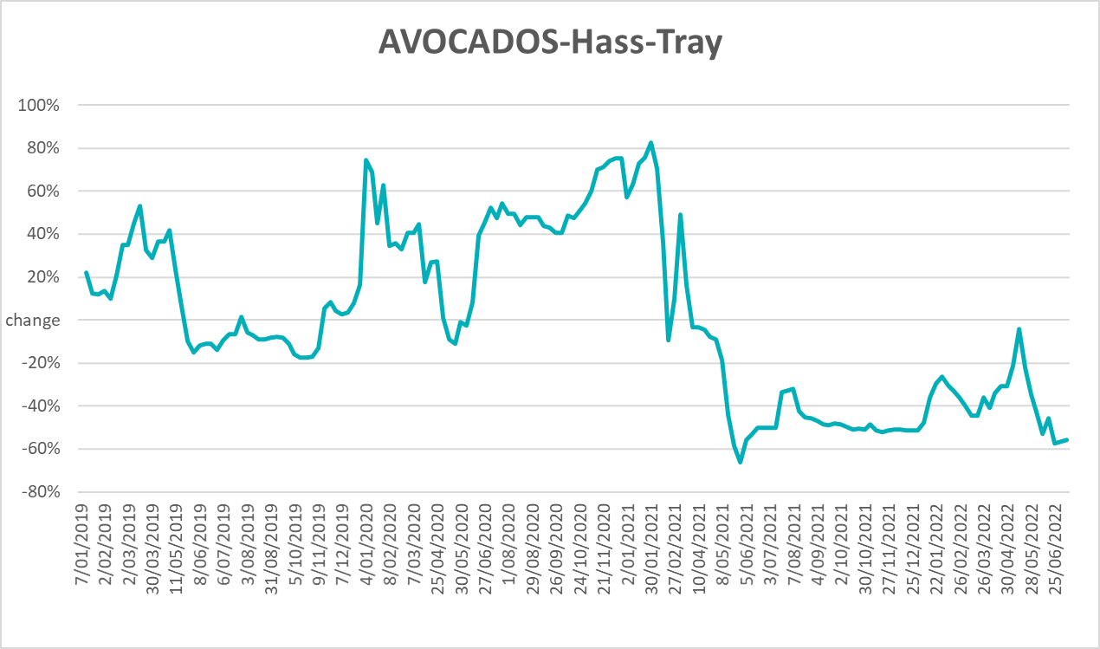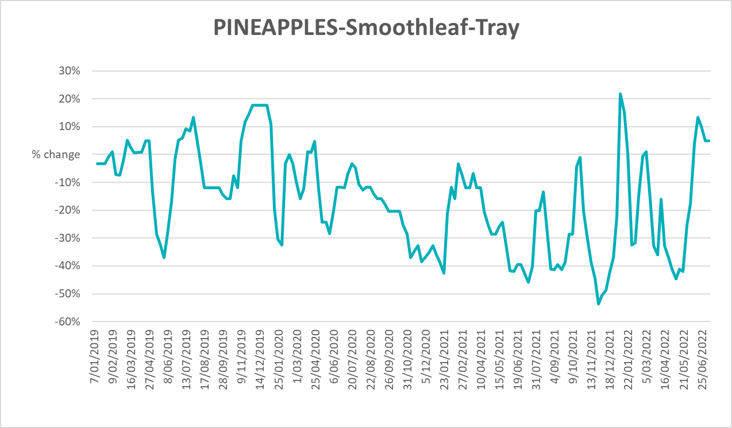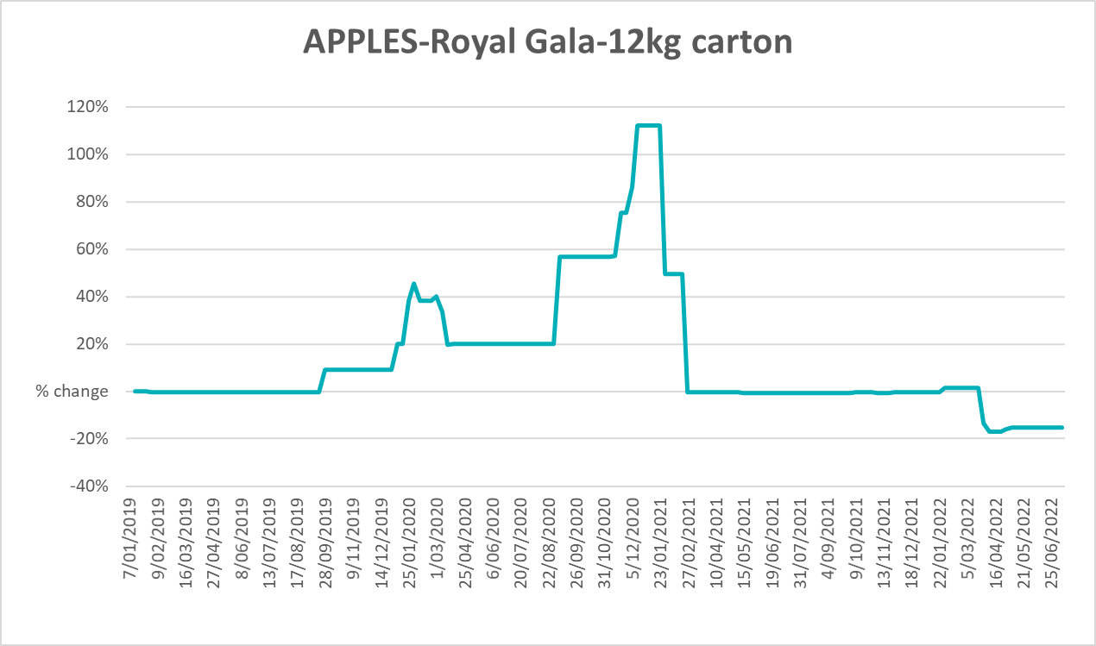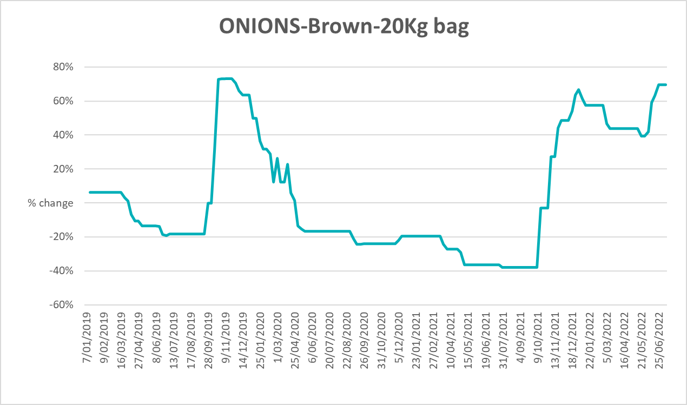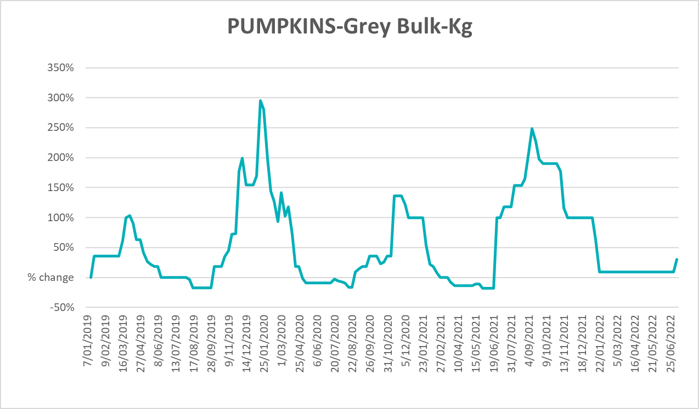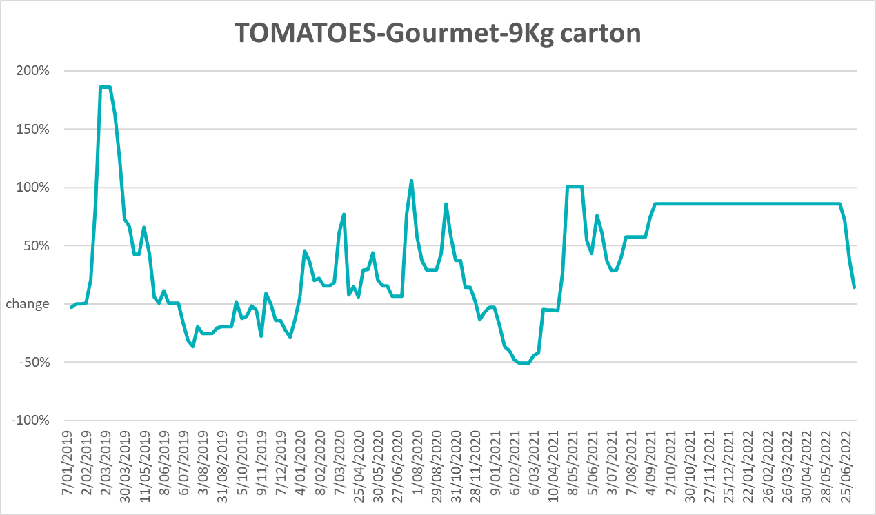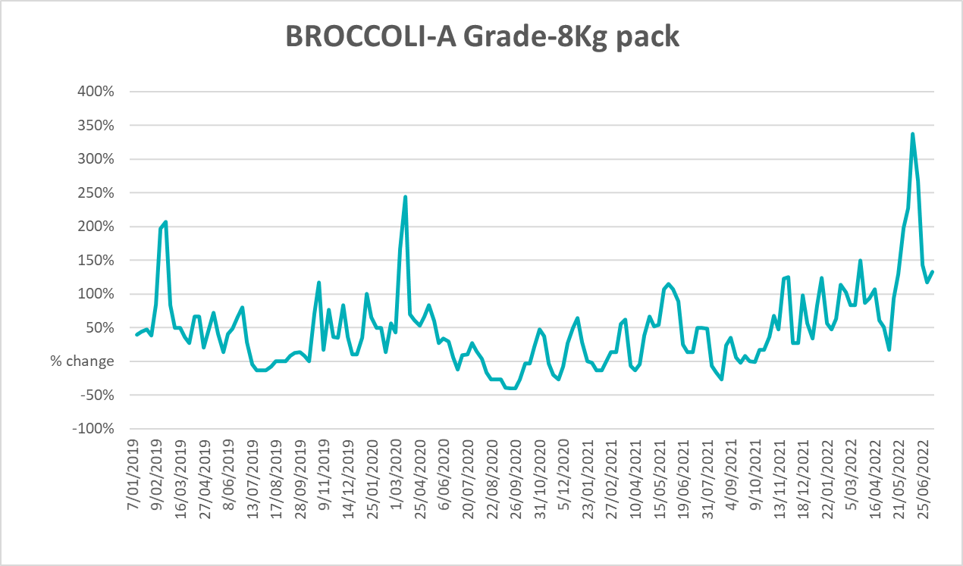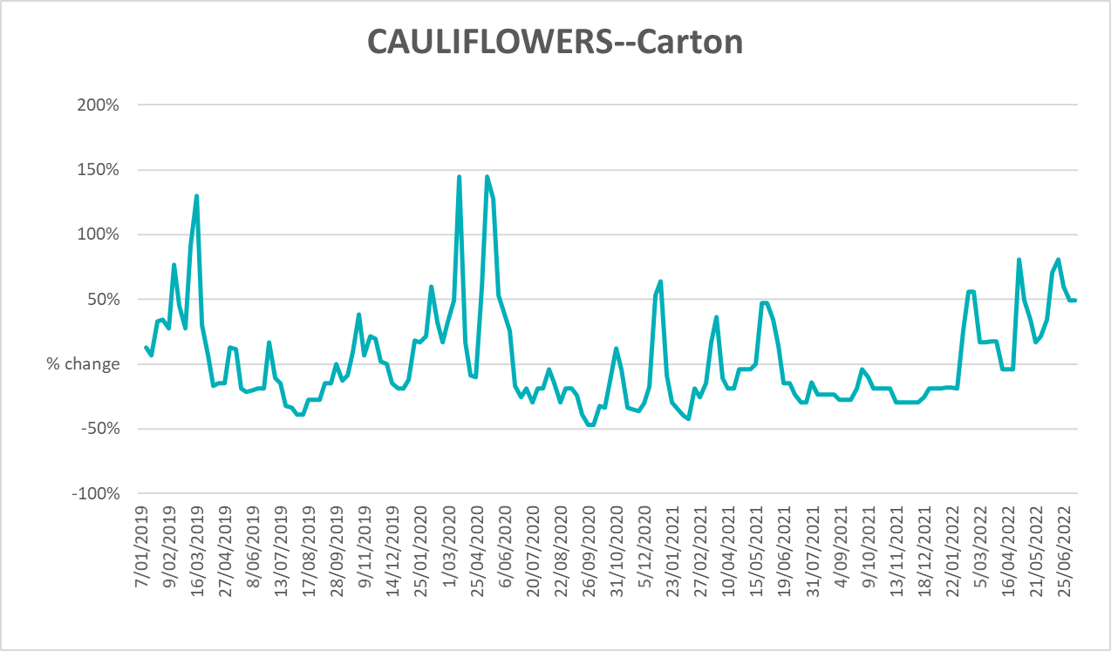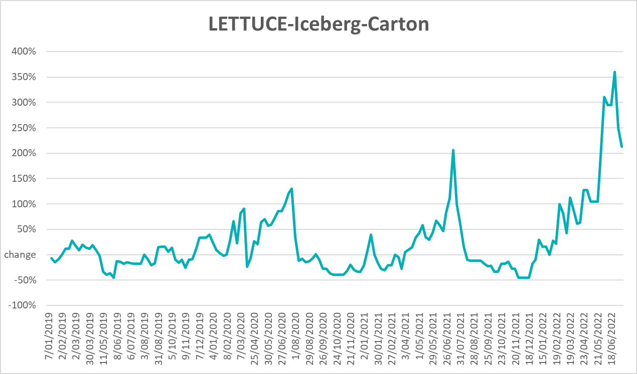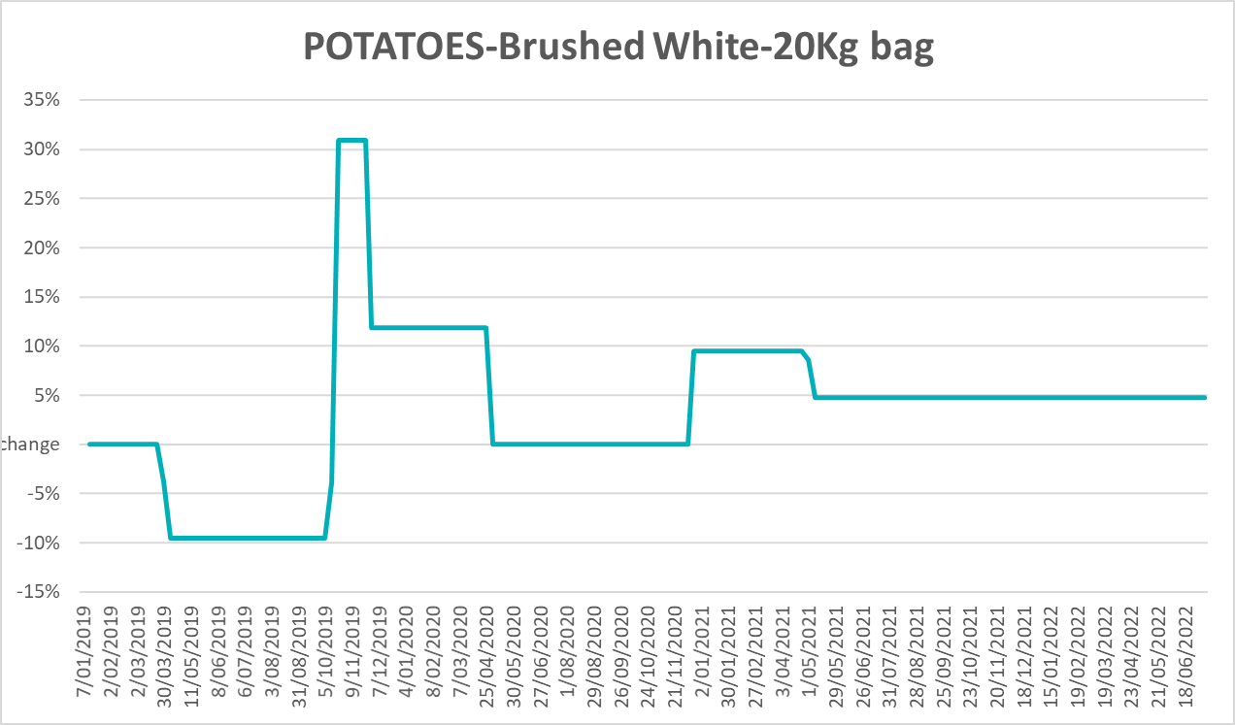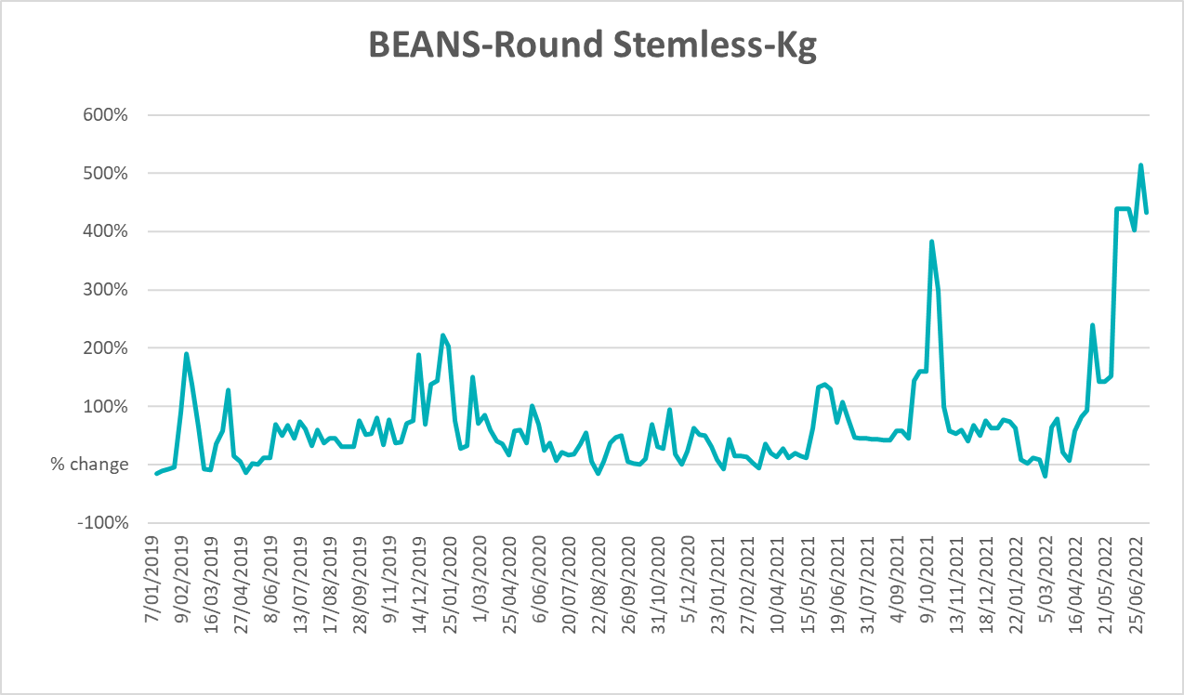

Selected domestic fodder indicator prices
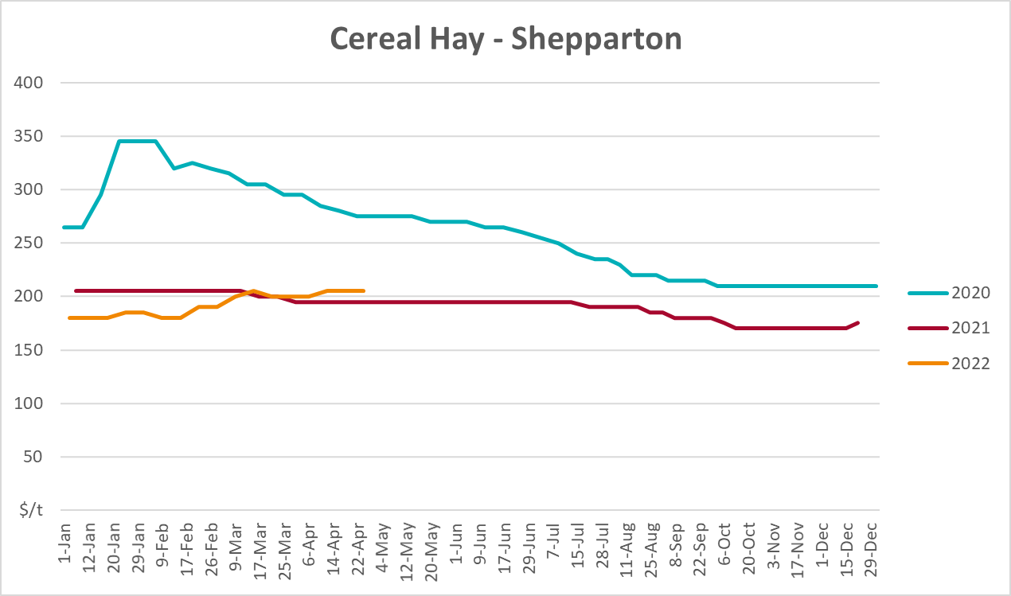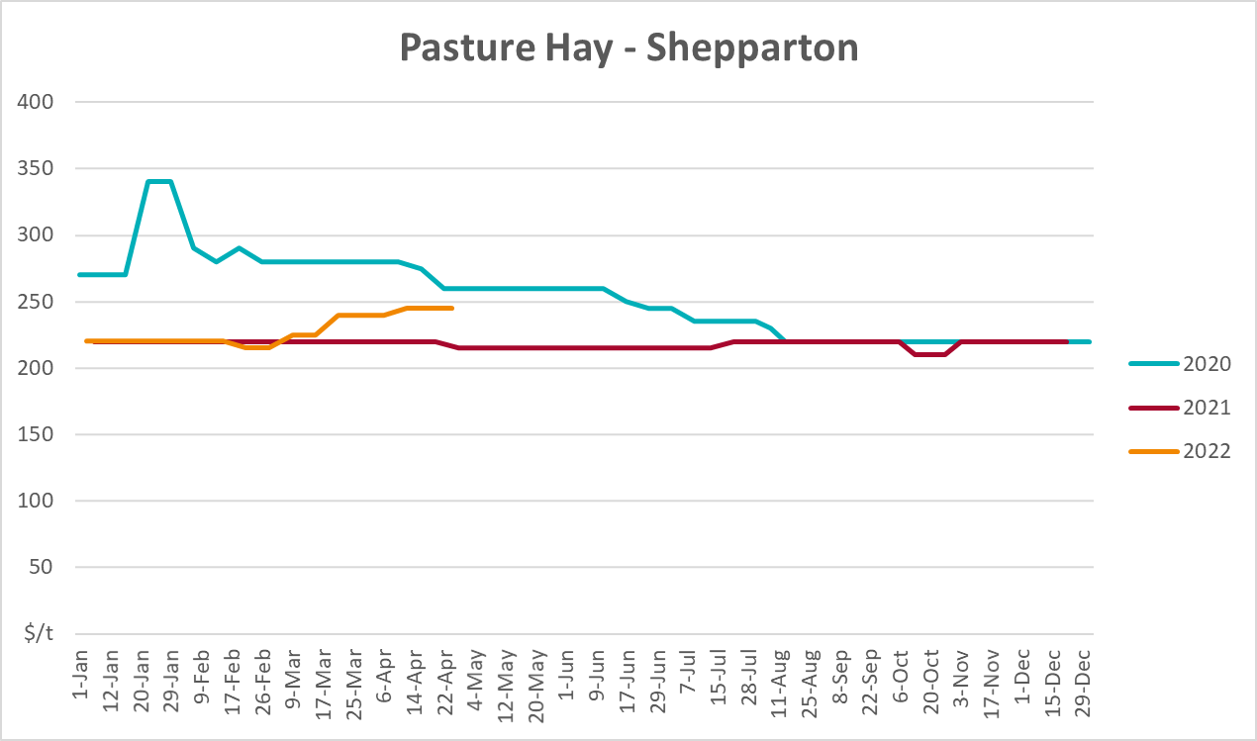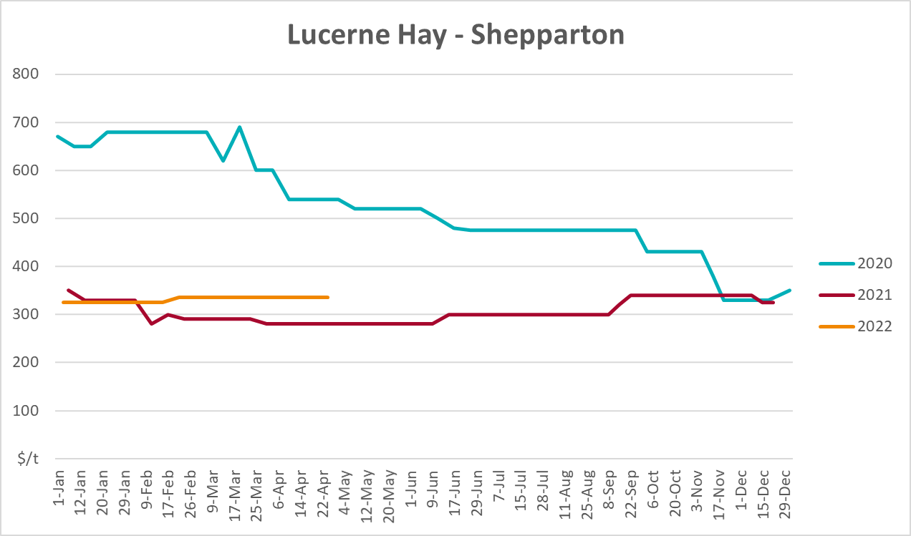

Data attribution

Climate
Bureau of Meteorology
- Weekly rainfall totals: www.bom.gov.au/climate/maps/rainfall/
- Monthly and last 3-month rainfall percentiles: www.bom.gov.au/water/landscape/
- Temperature anomalies: www.bom.gov.au/jsp/awap/temp/index.jsp
- Rainfall forecast: www.bom.gov.au/jsp/watl/rainfall/pme.jsp
- Seasonal outlook: www.bom.gov.au/climate/outlooks/#/overview/summary/
- Climate drivers: http://www.bom.gov.au/climate/enso/
- Soil moisture: www.bom.gov.au/water/landscape/
Other
- Pasture growth: www.longpaddock.qld.gov.au/aussiegrass/
- 3-month global outlooks: Environment and Climate Change Canada, NOAA Climate Prediction Center, EUROBRISA CPTEC/INPE, European Centre for Medium-Range Weather Forecasts, Hydrometcenter of Russia, National Climate Center Climate System Diagnosis and Prediction Room (NCC), International Research Institute for Climate and Society
- Global production: https://ipad.fas.usda.gov/ogamaps/cropmapsandcalendars.aspx
- Autumn break: Pook et al., 2009, https://rmets-onlinelibrary-wiley-com.virtual.anu.edu.au/doi/epdf/10.1002/joc.1833

Water
Prices
- Waterflow: https://www.waterflow.io/
- Ruralco: https://www.ruralcowater.com.au/
Bureau of Meteorology:
- Allocation trade: http://www.bom.gov.au/water/dashboards/#/water-markets/mdb/at
- Storage volumes: http://www.bom.gov.au/water/dashboards/#/water-storages/summary/drainage
Trade constraints:
- Water NSW: https://www.waternsw.com.au/customer-service/ordering-trading-and-pricing/trading/murrumbidgee
- Victorian Water Register: https://www.waterregister.vic.gov.au/TradingRules2019/

Commodities
Fruit and vegetables
- Datafresh: www.freshstate.com.au
Pigs
- Australian Pork Limited: www.australianpork.com.au
Dairy
- Global Dairy Trade: www.globaldairytrade.info/en/product-results/
World wheat, canola
- International Grains Council
World coarse grains
- United States Department of Agriculture
World cotton
- Cotlook: www.cotlook.com/
World sugar
- New York Stock Exchange - Intercontinental Exchange
Wool
- Australian Wool Exchange: www.awex.com.au/
Domestic wheat, barley, sorghum, canola and fodder
- Jumbuk Consulting Pty Ltd: http://www.jumbukag.com.au/
Cattle, beef, mutton, lamb, goat and live export
- Meat and Livestock Australia: www.mla.com.au/Prices-and-market
© Commonwealth of Australia 2022

Ownership of intellectual property rights
Unless otherwise noted, copyright (and any other intellectual property rights, if any) in this publication is owned by the Commonwealth of Australia (referred to as the Commonwealth).

Creative Commons licence
All material in this publication is licensed under a Creative Commons Attribution 4.0 International Licence except content supplied by third parties, logos and the Commonwealth Coat of Arms.
Inquiries about the licence and any use of this document should be emailed to copyright@awe.gov.au.


Cataloguing data
This publication (and any material sourced from it) should be attributed as:
ABARES 2022, Weekly Australian Climate, Water and Agricultural Update, Australian Bureau of Agricultural and Resource Economics and Sciences, Canberra, 21 July 2022. CC BY 4.0 DOI: https://doi.org/10.25814/5f3e04e7d2503
ISSN 2652-7561
This publication is available at https://www.agriculture.gov.au/abares/products/weekly_update
Department of Agriculture, Fisheries and Forestry
GPO Box 858 Canberra ACT 2601
Telephone 1800 900 090
Web agriculture.gov.au/abares

Disclaimer
The Australian Government acting through the Department of Agriculture, Fisheries and Forestry, represented by the Australian Bureau of Agricultural and Resource Economics and Sciences, has exercised due care and skill in preparing and compiling the information and data in this publication. Notwithstanding, the Department of Agriculture, Fisheries and Forestry, ABARES, its employees and advisers disclaim all liability, including liability for negligence and for any loss, damage, injury, expense or cost incurred by any person as a result of accessing, using or relying on any of the information or data in this publication to the maximum extent permitted by law.

Statement of Professional Independence
The views and analysis presented in ABARES publications, including this one, reflect ABARES professionally independent findings, based on scientific and economic concepts, principles, information and data. These views, analysis and findings may not reflect or be consistent with the views or positions of the Australian Government, or of organisations or groups who have commissioned ABARES reports or analysis. More information on professional independence is provided on the ABARES website.

Acknowledgements
This report was prepared by Matthew Miller

