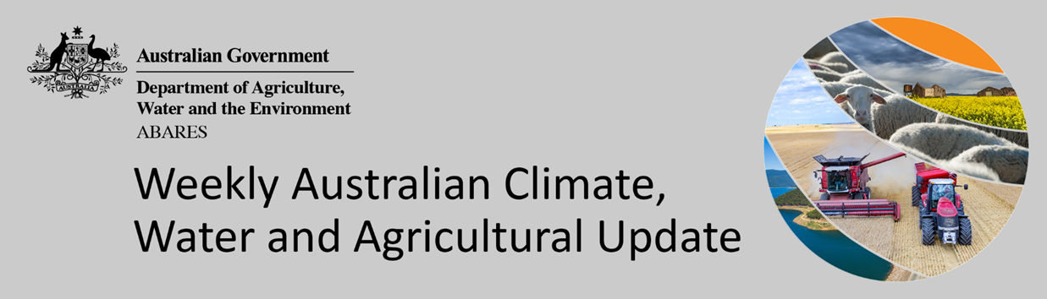
No. 25/2022

30 June 2022

Summary of key issues
- For the week ending 29 June 2022, low-pressure systems and associated cold fronts brought rainfall to southern parts of the country, while isolated troughs resulted in rainfall in parts of central and north-eastern Australia. For much of the country, high-pressure systems dominated, providing clear, dry conditions (see Section 1.1).
- The persistence of dry conditions across New South Wales and Queensland cropping regions over recent weeks has allowed growers to access fields. Consequently, harvesting of summer crops has progressed substantially, with much of the late harvested crop impacted by quality downgrades. The improved field access has also allowed the sowing of winter cereal crops to make significant headway in recent weeks. Across growing regions of southern Australia, winter crops have had a favourable start to the season, with soil moisture levels remaining average to above average. Soil moisture levels in cropping regions of Western Australia are currently below average to average, and further rainfall will be required to support ongoing crop development.
- Greenness anomalies at 25 June 2022 indicate that vegetation greenness was above normal throughout most of the cropping regions in New South Wales, central and southern Queensland and northern Victoria. This indicates above average vegetation growth and vigour for this time of year—due to well above average autumn and early winter rainfall in these regions. However, vegetation greenness was closer to average in cropping areas in central South Australia and parts of northern New South Wales and southern Victoria, indicating below average to average vegetation growth and crop vigour for this time of year (see Section 1.2).
- Over the 8-days to 7 July 2022, an East Coast Low and troughs across north-eastern Australia are expected to bring significant rainfall to eastern parts of the country. Meanwhile, high pressure systems are forecast to dominate remaining parts of the country, resulting in clear, dry conditions. The forecast rainfall for the coming week will likely bring winter sowing activity to a close across New South Wales and Queensland. Dry conditions have allowed significant progress over recent weeks, but the closing of the planting window combined with significant rainfalls will severely restricting further planting opportunities. The forecast rainfall will support the emergence and establishment of recently planted winter crops, as well as boosting soil moisture levels for the coming months (see Section 1.3).
- Water storage in the Murray–Darling Basin (MDB) increased by 36 gigalitres (GL) between 22 June 2022 and 28 June 2022. The current volume of water held in storage is 22,152 GL, which represents 88 of total capacity. This is 36% or 5,858 GL more than at the same time last year.
- Allocation prices in the Victorian Murray below the Barmah Choke decreased from $18 per ML on 17 June 2022 to $11 per ML on 24 June 2022. Prices are lower in the Murrumbidgee and regions above the Barmah choke due to the binding of the Murrumbidgee export limit and Barmah choke trade constraint.

Climate

Rainfall this week
For the week ending 29 June 2022, low-pressure systems and associated cold fronts brought rainfall to southern parts of the country, while isolated troughs resulted in rainfall in parts of central and north-eastern Australia. For much of the country, high-pressure systems dominated, providing clear, dry conditions.
Rainfall totals of between 10 and 50 millimetres were recorded in parts of southern and alpine areas of Victoria, isolated parts of north-eastern Queensland, the south-east of South Australia and the south-west of Western Australia, as well as central areas of the Northern Territory and northern Tasmania. Rainfall totals in excess of 50 millimetres were recorded across western Tasmania. Remaining parts of Australia received little to no rainfall.
Little to no rainfall was recorded across Australian cropping regions for the week ending 29 June 2022. The persistence of dry conditions across New South Wales and Queensland cropping regions over recent weeks has allowed growers to access fields. Consequently, harvesting of summer crops has progressed substantially, with much of the late harvested crop impacted by quality downgrades. The improved field access has also allowed the sowing of winter cereal crops to make significant headway in recent weeks.
However, the delays in planting as well as isolated areas still too wet to access has likely prompted some of the area intended for winter crop production to be withheld until summer planting commences. Across growing regions of southern Australia, winter crops have had a favourable start to the season, with soil moisture levels remaining average to above average. Soil moisture levels in cropping regions of Western Australia are currently below average to average, and further rainfall will be required to support ongoing crop development. Overall, recent dry conditions have allowed growers to access fields for post-emergence spraying for pests and disease.

Rainfall for the week ending 29 June 2022
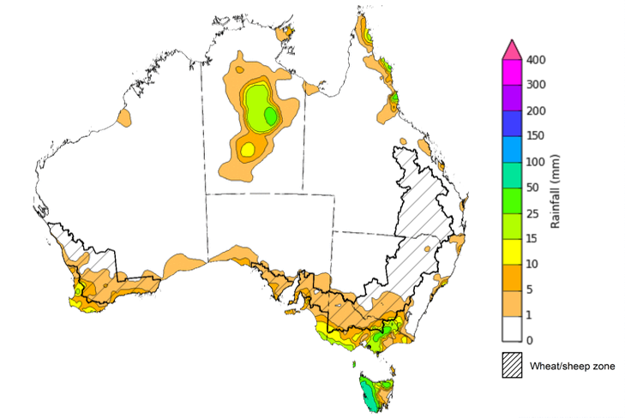
©Commonwealth of Australia 2022, Australian Bureau of Meteorology Issued: 29/6/2022
Note: The rainfall analyses and associated maps utilise data contained in the Bureau of Meteorology climate database, the Australian Data Archive for Meteorology (ADAM). The analyses are initially produced automatically from real-time data with limited quality control. They are intended to provide a general overview of rainfall across Australia as quickly as possible after the observations are received. For further information go to http://www.bom.gov.au/climate/rainfall/

Vegetation greenness anomalies
For the week ending 17 June 2022 vegetation greenness anomalies analysis indicates that plant health was well above average for this time of year for Australian croplands. Vegetation greenness anomalies are based on Normalized Difference Vegetation Index (NDVI) land surface data collected from satellites and shows the level of photosynthetic activity (or greenness) of plants. It can indicate the effectiveness of rainfall for plant growth and can be used to help assess the impacts of seasonal conditions on crop production.

Vegetation greenness anomalies, at 25 June 2022
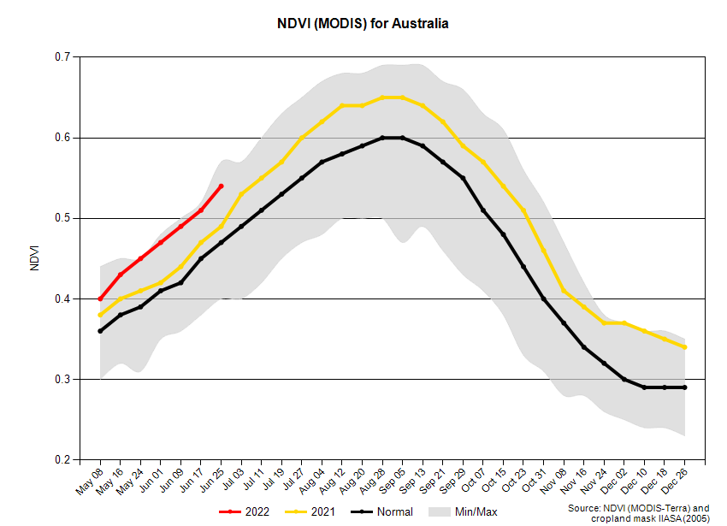
Greenness anomalies at 25 June 2022 indicate that vegetation greenness was above normal throughout most of the cropping regions in New South Wales, central and southern Queensland and northern Victoria. This indicates above average vegetation growth and vigour for this time of year—due to well above average autumn and early winter rainfall in these regions. However, vegetation greenness was closer to average in cropping areas in central South Australia and parts of northern New South Wales and southern Victoria, indicating below average to average vegetation growth and crop vigour for this time of year.

Vegetation greenness anomalies, at 25 June 2022
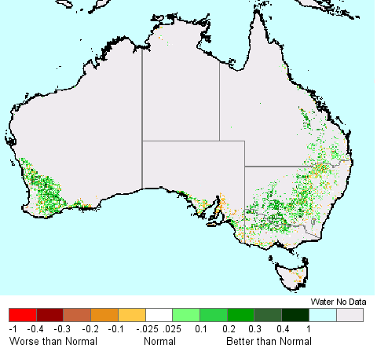
Source: National Aeronautics and Space Administration

Rainfall forecast for the next eight days
Over the 8-days to 7 July 2022, an East Coast Low and troughs across north-eastern Australia are expected to bring significant rainfall to eastern parts of the country. Meanwhile, high pressure systems are forecast to dominate remaining parts of the country, resulting in clear, dry conditions.
Rainfall totals of between 10 and 50 millimetres are forecast for eastern New South Wales and Victoria, as well as large parts of Queensland, the north of the Northern Territory, the south-west of Western Australia and Tasmania. Rainfall in excess of 50 millimetres is forecast for coastal regions of New South Wales and Queensland. Little to no rainfall is forecast across remaining parts of Australia over the next 8-days.
In Australian cropping regions, rainfall totals of between 10 and 50 millimetres are expected across much of New South Wales and Queensland. Rainfall in excess of 50 millimetres is forecast for cropping regions in central New South Wales and eastern Queensland. Little to no rainfall is forecast for all remaining cropping regions during the next 8-days.
The forecast rainfall for the coming week will likely bring winter sowing activity to a close across New South Wales and Queensland. Dry conditions have allowed significant progress over recent weeks, but the closing of the planting window combined with significant rainfalls will severely restricting further planting opportunities. The forecast rainfall will support the emergence and establishment of recently planted winter crops, as well as boosting soil moisture levels for the coming months. Winter crops across Victoria, South Australia and Western Australia are expected to continue to develop through vegetative growth stages, supported for the most part by near-average soil moisture levels. However, the shallow, sandy soils of Western Australia mean that plant available moisture decreases more rapidly, and further rainfall will be needed in the coming weeks.

Total forecast rainfall (mm) for the period 30 June to 7 July 2022
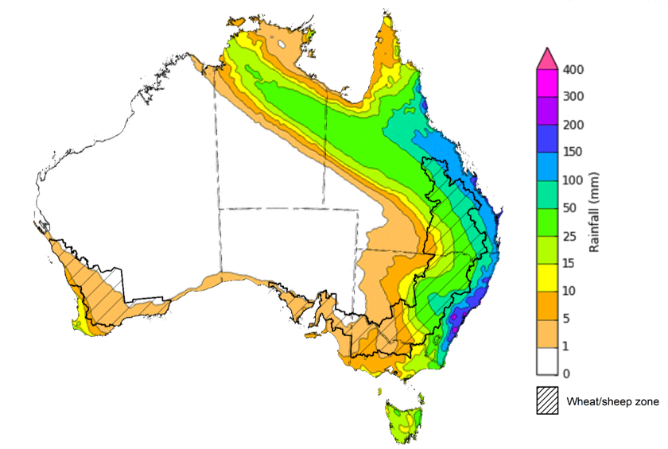
©Commonwealth of Australia 2022, Australian Bureau of Meteorology Issued:29/6/2022

Water
Note: This rainfall forecast is produced from computer models. As the model outputs are not altered by weather forecasters, it is important to check local forecasts and warnings issued by the Bureau of Meteorology.

Water markets – current week
Water storage in the Murray–Darling Basin (MDB) increased by 36 gigalitres (GL) between 22 June 2022 and 28 June 2022. The current volume of water held in storage is 22,152 GL, which represents 88 of total capacity. This is 36% or 5,858 GL more than at the same time last year.

Water storages in the Murray-Darling Basin, 2013–2022
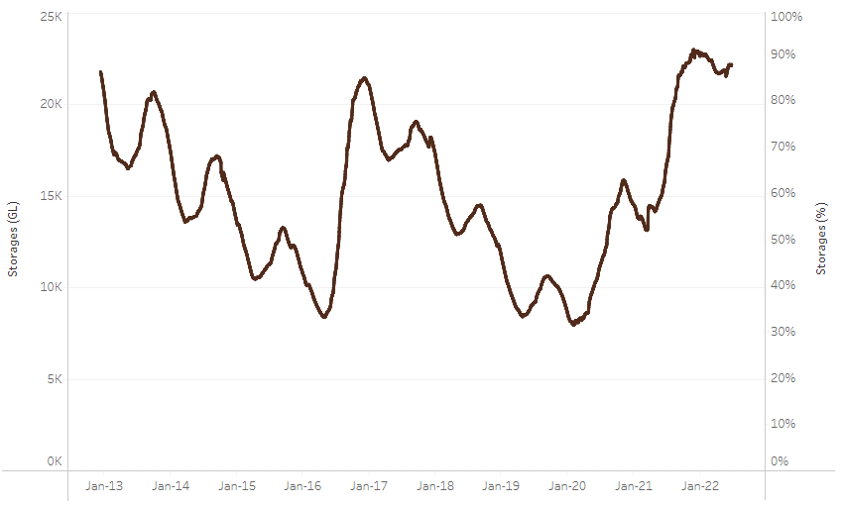
Allocation prices in the Victorian Murray below the Barmah Choke decreased from $18 per ML on 17 June 2022 to $11 per ML on 24 June 2022. Prices are lower in the Murrumbidgee and regions above the Barmah choke due to the binding of the Murrumbidgee export limit and Barmah choke trade constraint.
Water storage data is sourced from the Bureau of Meteorology.

Region | $/ML
NSW Murray Above | 1
NSW Murrumbidgee | 1
VIC Goulburn-Broken | 18
VIC Murray Below | 11

Surface water trade activity, Southern Murray–Darling Basin

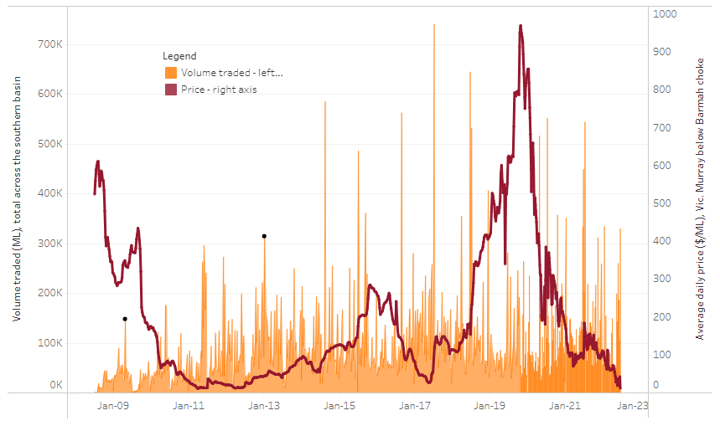
To access the full, interactive, weekly water dashboard, which contains the latest and historical water storage, water market and water allocation information, please visit http://www.agriculture.gov.au/abares/products/weekly_update/weekly-update-300622
The trades shown reflect estimated market activity and do not encompass all register trades. The price is shown for the VIC Murray below the Barmah choke. Historical prices (before 1 July 2019) are ABARES estimates after removing outliers from BOM water register data. Prices after 1 July 2019 and prior to the 30 October 2019 reflect recorded transaction prices as sourced from Ruralco. Prices after the 30 October 2019 are sourced from Waterflow. Data for volume traded is sourced from the BOM water register. Data shown is current at 30 June 2022.

Commodities

Indicator | Week ended | Unit | Latest price | Previous week | Weekly change | Price 12 months ago | Annual change
Selected world indicator prices
AUD/USD Exchange rate | 29-Jun | A$/US$ | 0.70 | 0.70 | -1% | 0.75 | -8%
Wheat – US no. 2 hard red winter wheat, fob Gulf | 29-Jun | US$/t | 420 | 453 | -7% | 279 | 51%
Corn – US no. 2 yellow corn, fob Gulf | 29-Jun | US$/t | 342 | 348 | -2% | 271 | 26%
Canola – Rapeseed, Canada, fob Vancouver | 29-Jun | US$/t | 764 | 864 | -12% | 710 | 8%
Cotton – Cotlook 'A' Index | 29-Jun | USc/lb | 138 | 161 | -15% | 96 | 43%
Sugar – Intercontinental Exchange, nearby futures, no.11 contract | 29-Jun | USc/lb | 18.4 | 18.8 | -2% | 18 | 1%
Wool – Eastern Market Indicator | 24-Jun | Ac/kg clean | 1,474 | 1,467 | 0% | 1,319 | 12%
Wool – Western Market Indicator | 06-Apr | Ac/kg clean | 1,417 | 1,421 | 0% | 1,222 | 16%
Selected Australian grain export prices
Milling Wheat – APW, Port Adelaide, SA | 29-Jun | A$/t | 607 | 628 | -3% | 381 | 59%
Feed Wheat – ASW, Port Adelaide, SA | 29-Jun | A$/t | 572 | 594 | -4% | 376 | 52%
Feed Barley – Port Adelaide, SA | 29-Jun | A$/t | 541 | 555 | -3% | 326 | 66%
Canola – Kwinana, WA | 29-Jun | A$/t | 1,161 | 1,215 | -4% | 740 | 57%
Grain Sorghum – Brisbane, QLD | 29-Jun | A$/t | 457 | 475 | -4% | 373 | 22%
Selected domestic livestock indicator prices
Beef – Eastern Young Cattle Indicator | 29-Jun | Ac/kg cwt | 1,032 | 1,070 | -3% | 907 | 14%
Mutton – Mutton indicator (18–24 kg fat score 2–3), Vic | 29-Jun | Ac/kg cwt | 634 | 657 | -4% | 653 | -3%
Lamb – Eastern States Trade Lamb Indicator | 29-Jun | Ac/kg cwt | 775 | 771 | 0% | 837 | -7%
Pig – Eastern Seaboard (60.1–75 kg), average of buyers & sellers | 30-Mar | Ac/kg cwt | 368 | 357 | 3% | 347 | 6%
Goats – Eastern States (12.1–16 kg) | 12-Jan | Ac/kg cwt | 879 | 879 | 0% | 818 | 8%
Live cattle – Light steers ex Darwin to Indonesia | 01-Jun | Ac/kg lwt | 480 | 480 | 0% | 320 | 50%
Live sheep – Live wethers (Muchea WA saleyard) to Middle East | 20-Apr | $/head | 113 | 113 | 0% | 122 | -7%

Indicator | Week ended | Unit | Latest price | Previous week | Weekly change | Price 12 months ago | Annual change
Global Dairy Trade (GDT) weighted average prices ª
Dairy – Whole milk powder | 22-Jun | US$/t | 4,125 | 4,158 | -1% | 2,745 | 50%
Dairy – Skim milk powder | 22-Jun | US$/t | 4,276 | 4,240 | 1% | 2,373 | 80%
Dairy – Cheddar cheese | 22-Jun | US$/t | 4,875 | 5,365 | -9% | 4,115 | 18%
Dairy – Anhydrous milk fat | 22-Jun | US$/t | 5,913 | 6,201 | -5% | 3,973 | 49%
a Global Dairy Trade prices are updated twice monthly on the first and third Tuesday of each month.

Selected world indicator prices
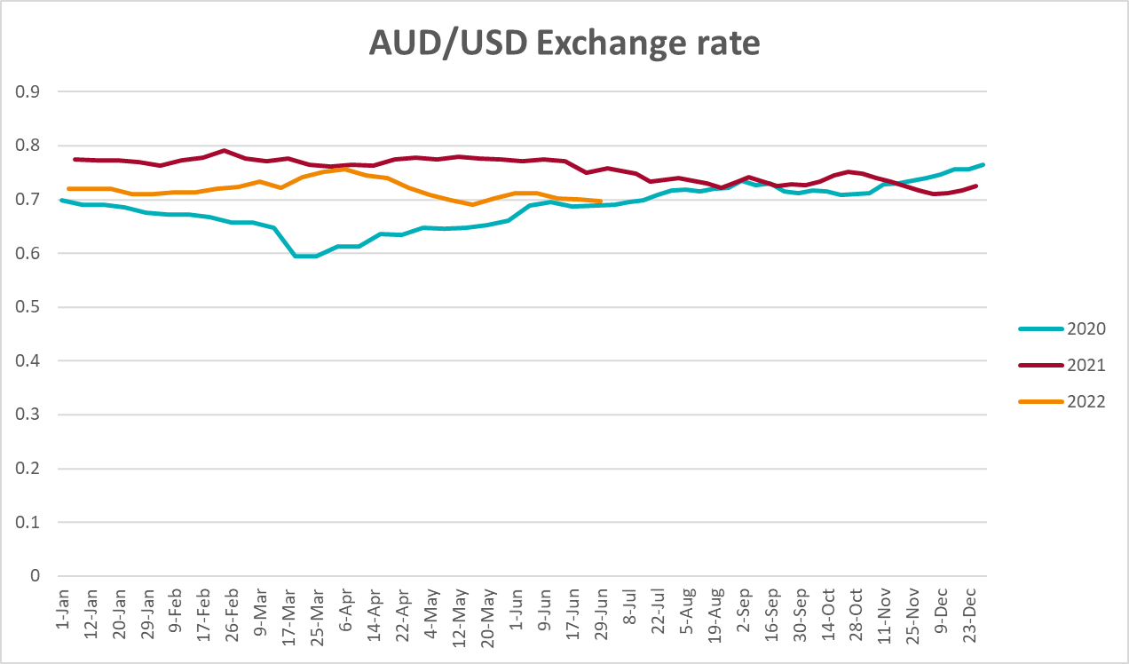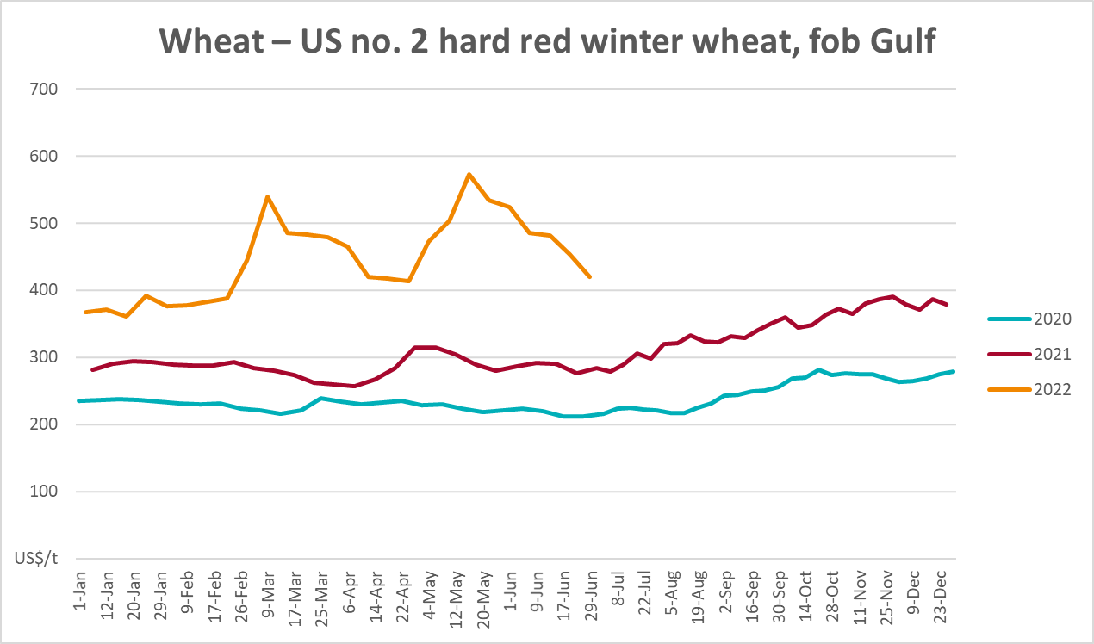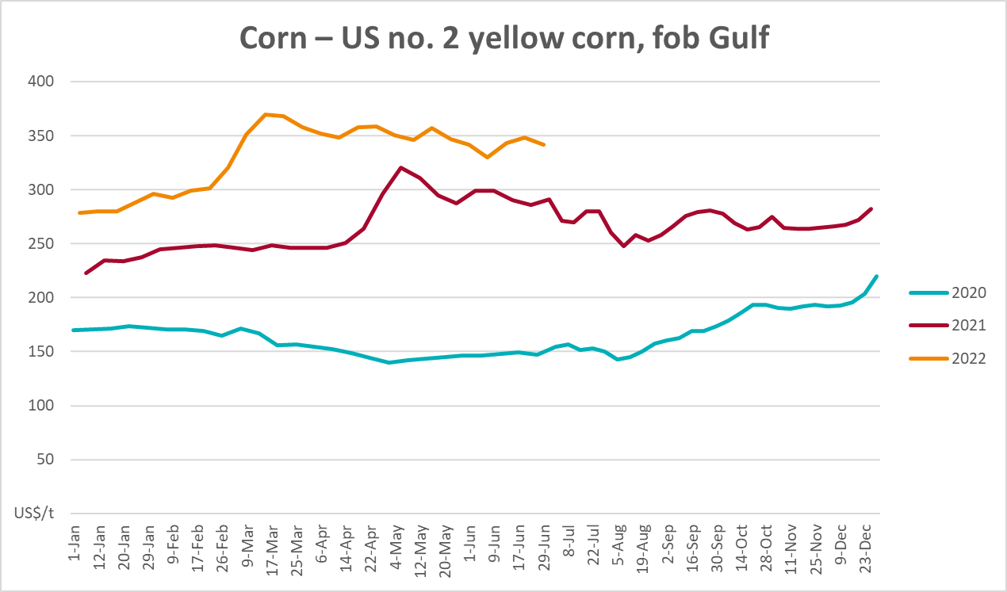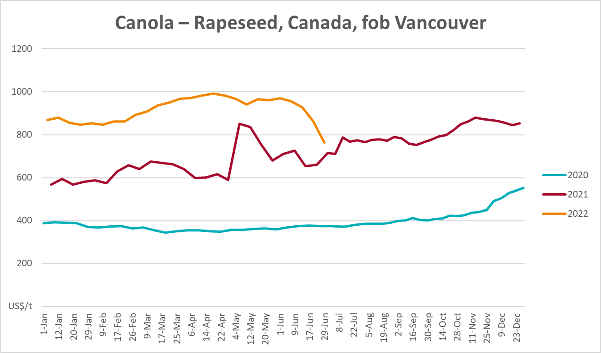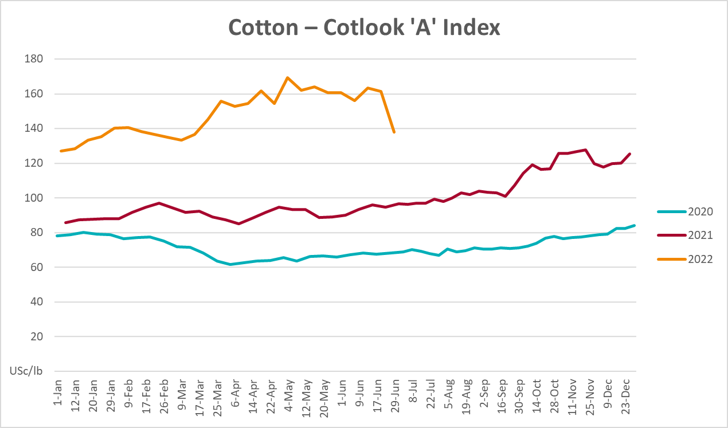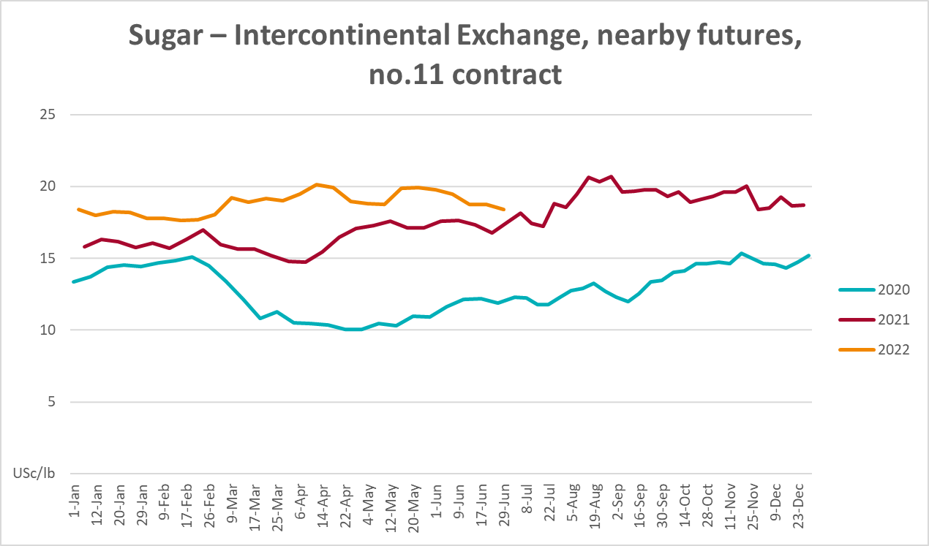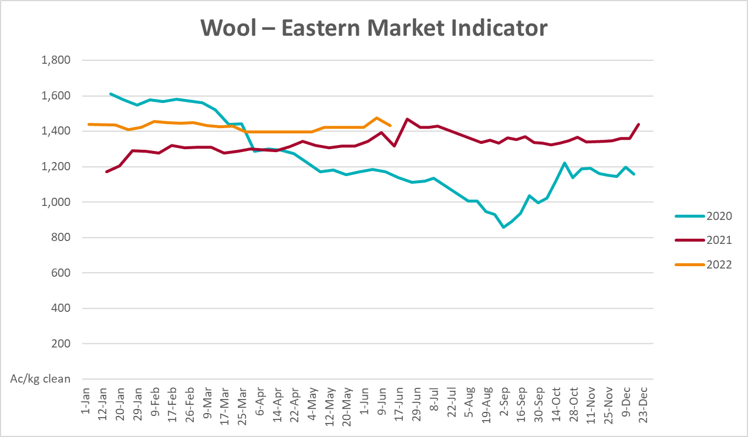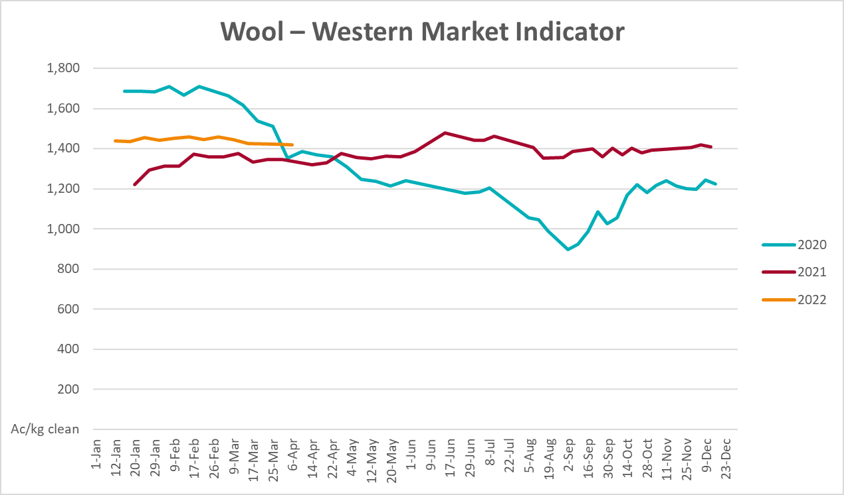

Selected domestic crop indicator prices
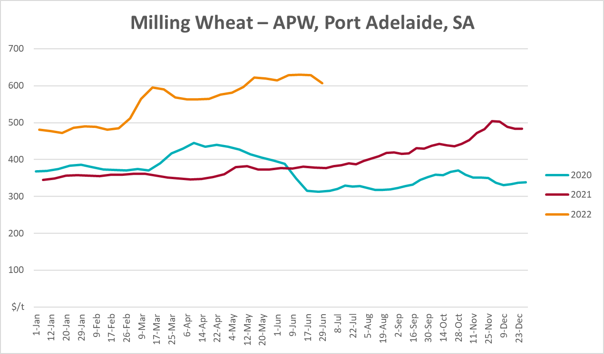
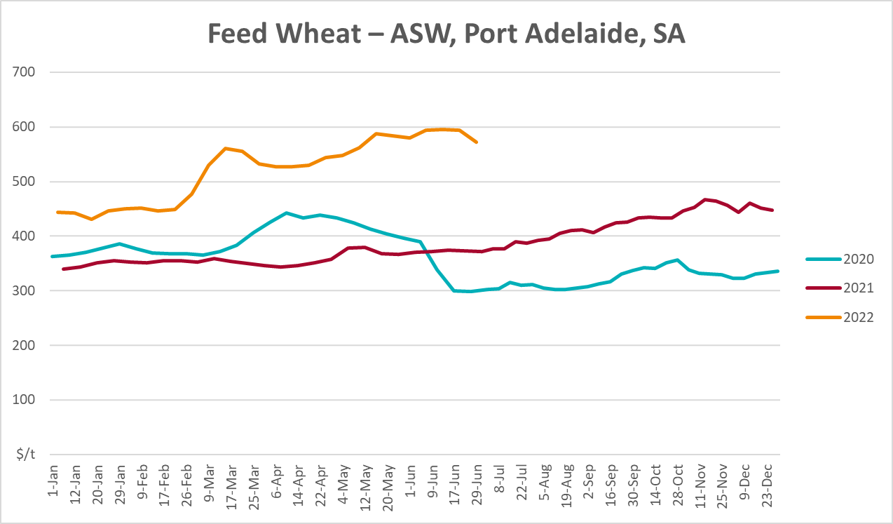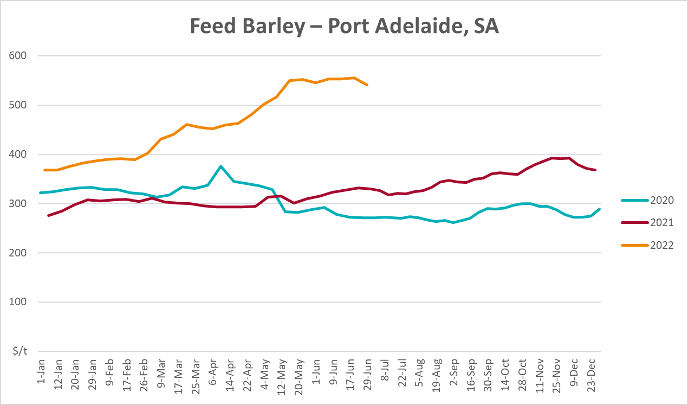
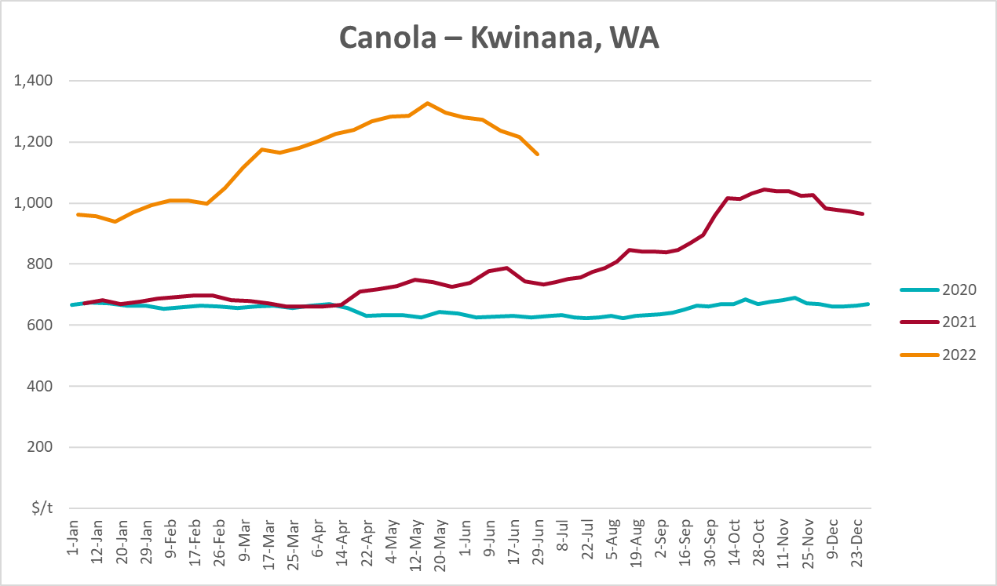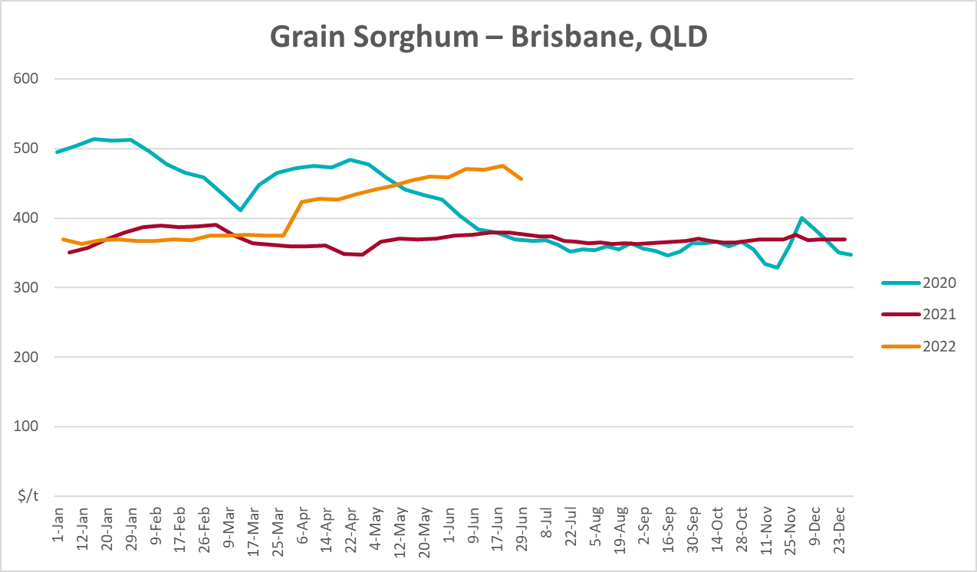

Selected domestic livestock indicator prices
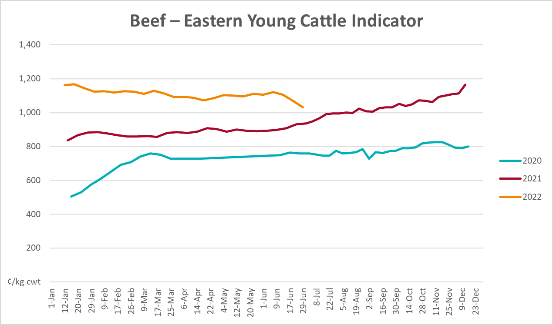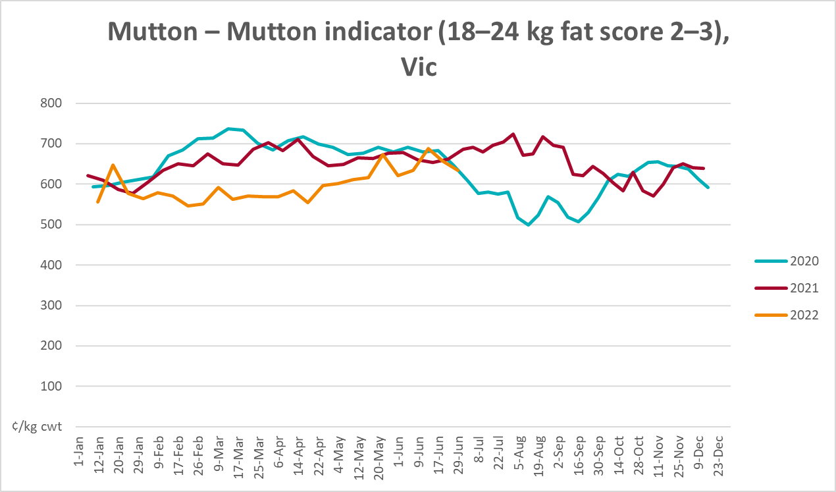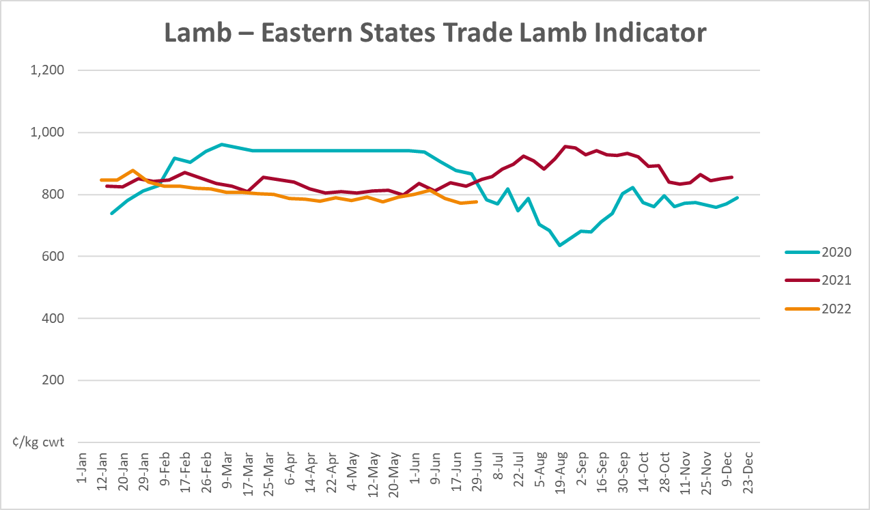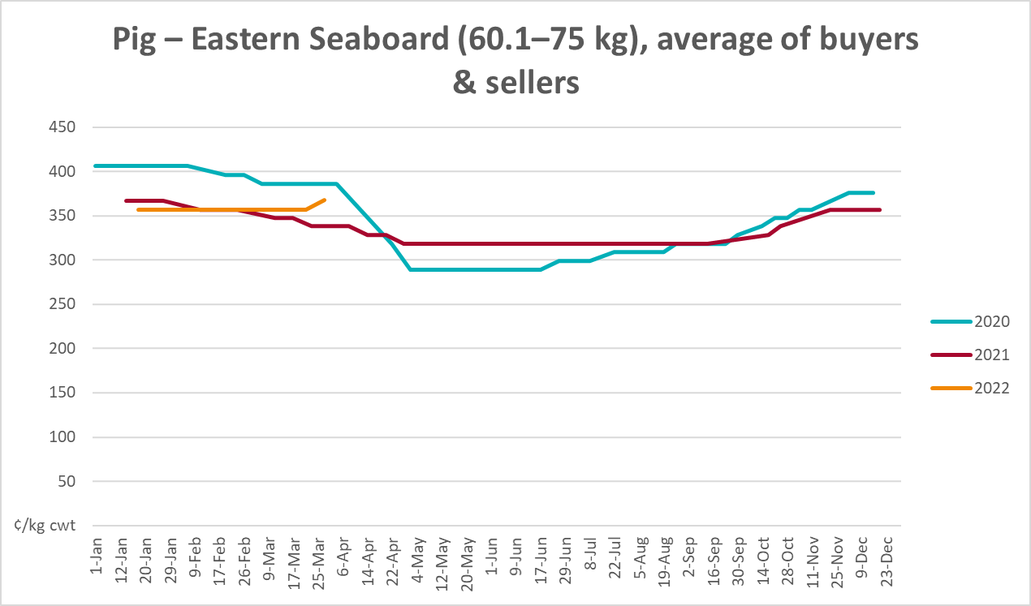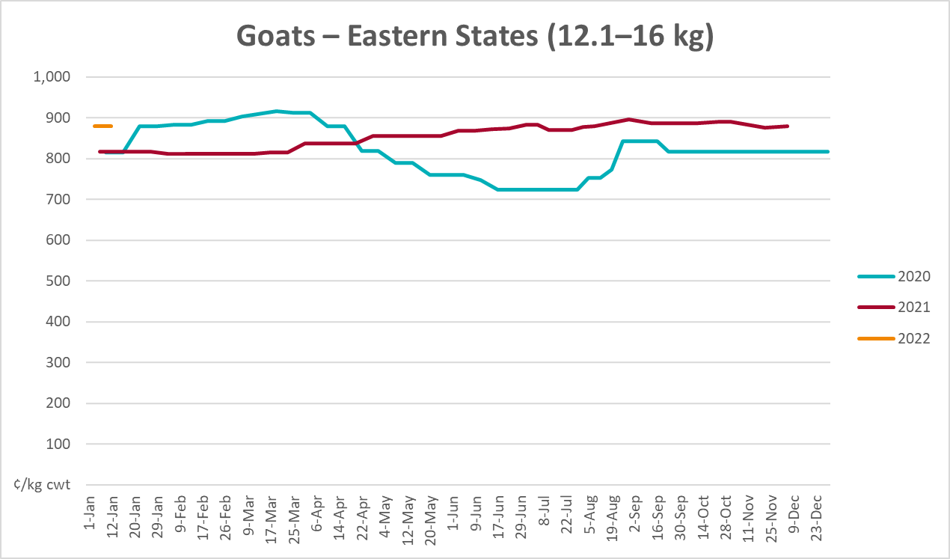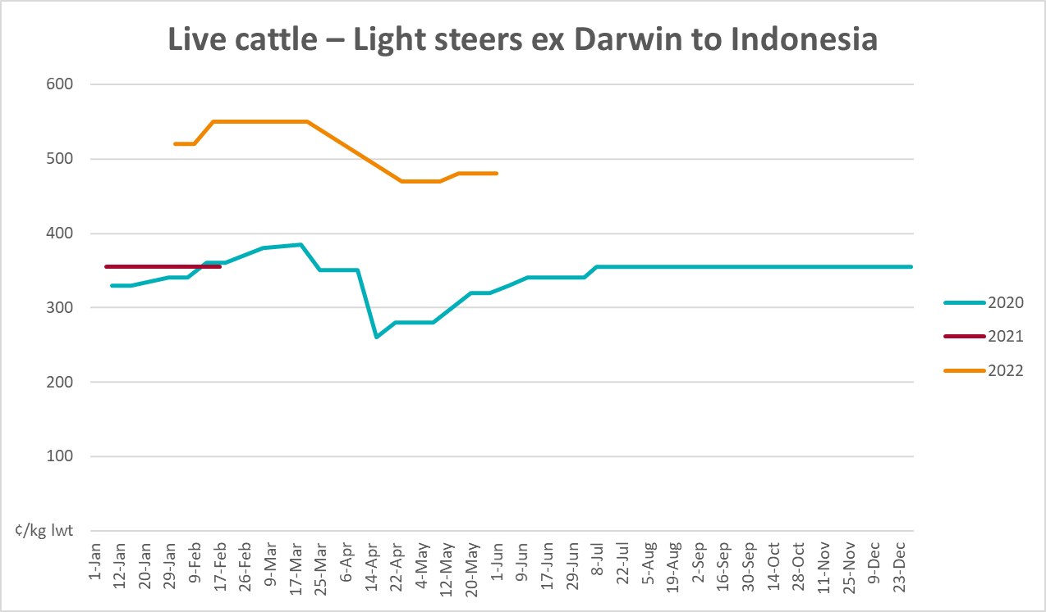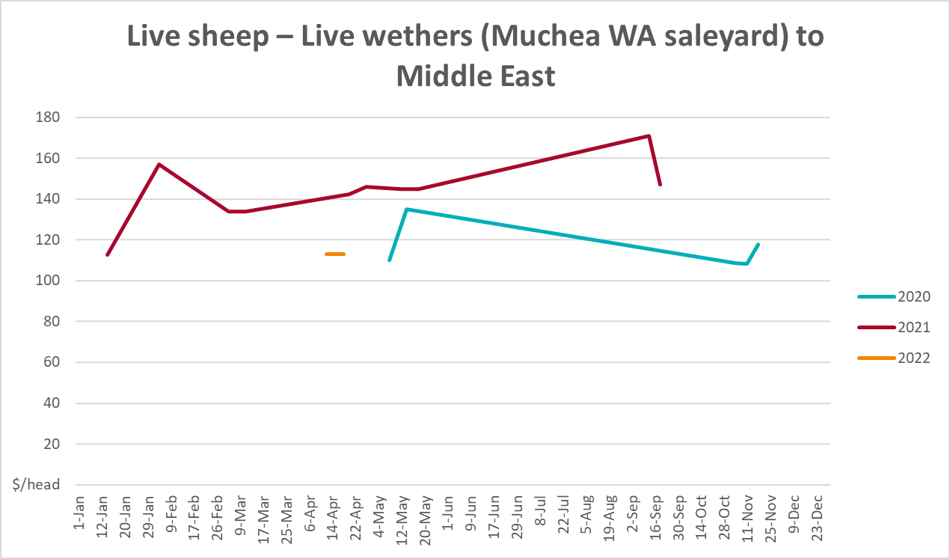

Global Dairy Trade (GDT) weighted average prices
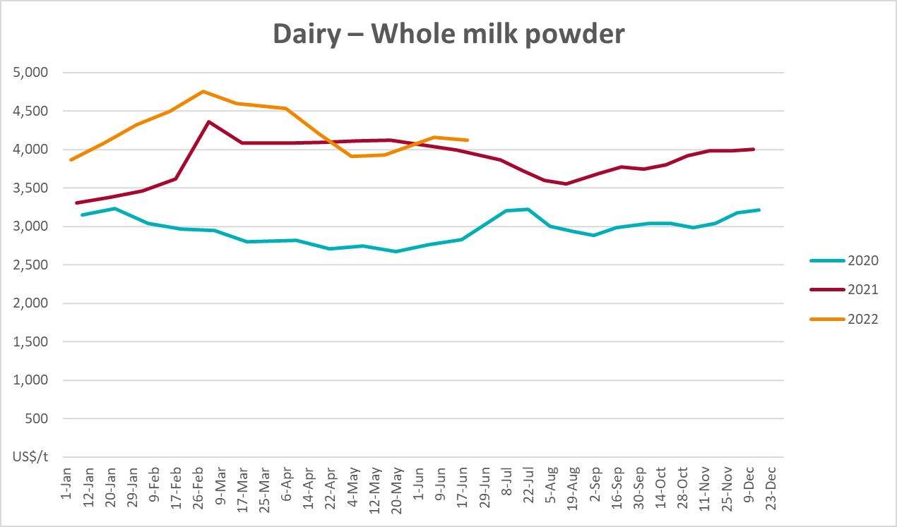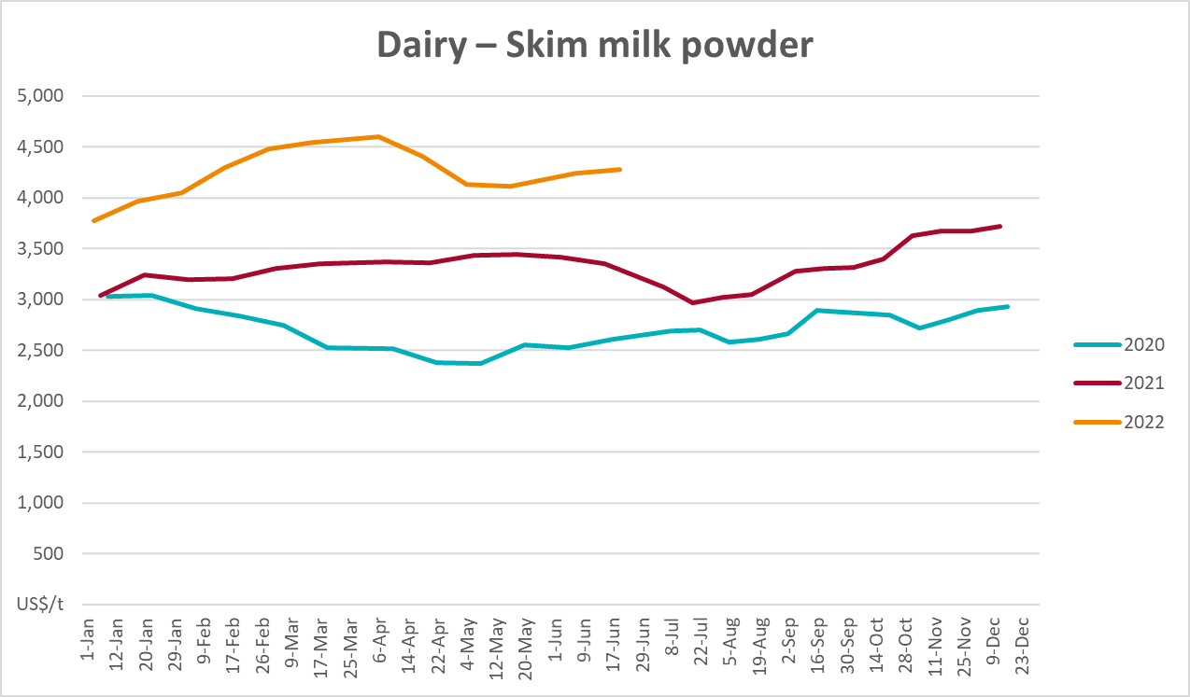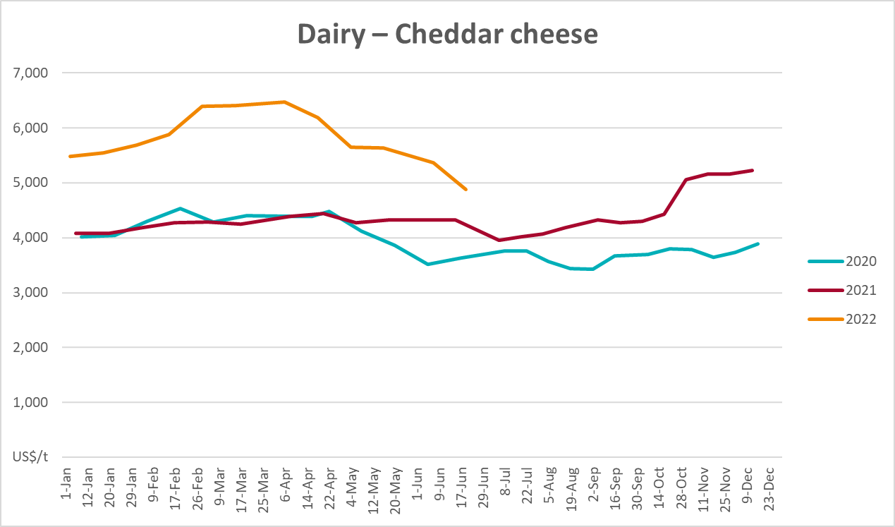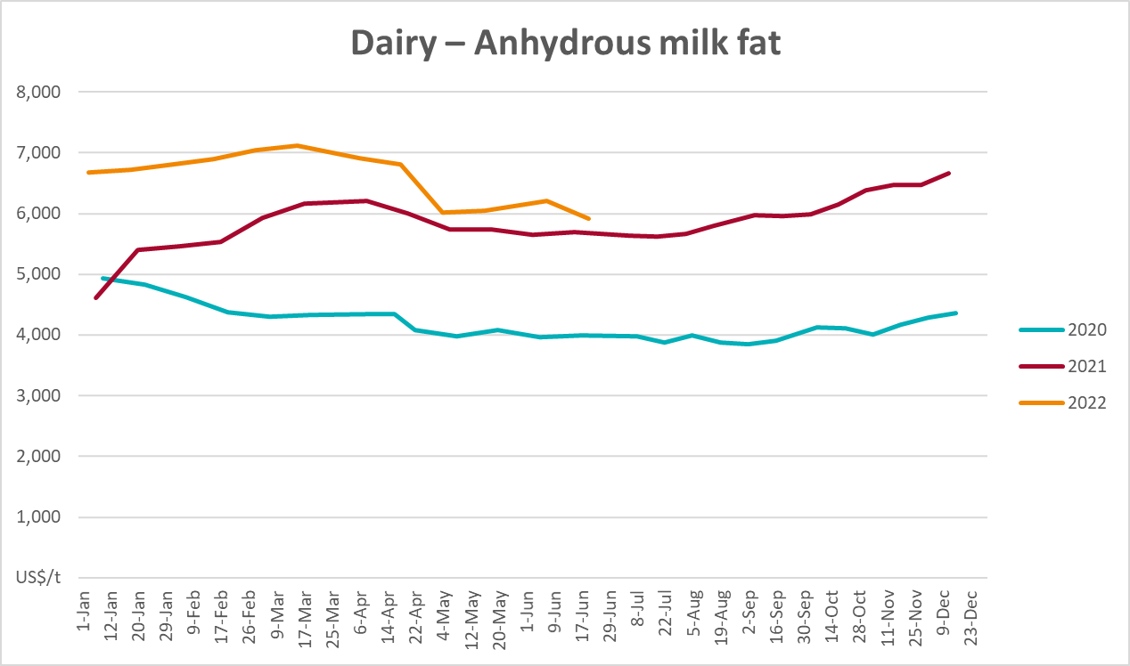

Selected fruit and vegetable prices
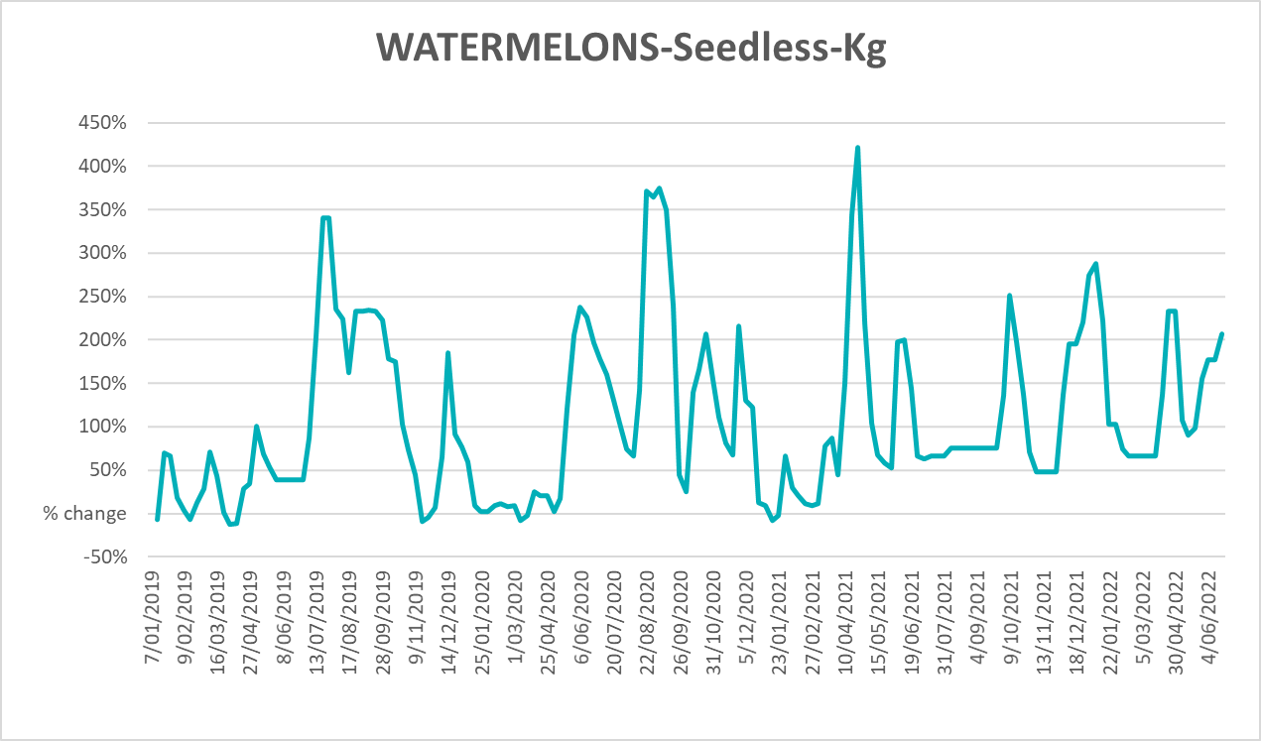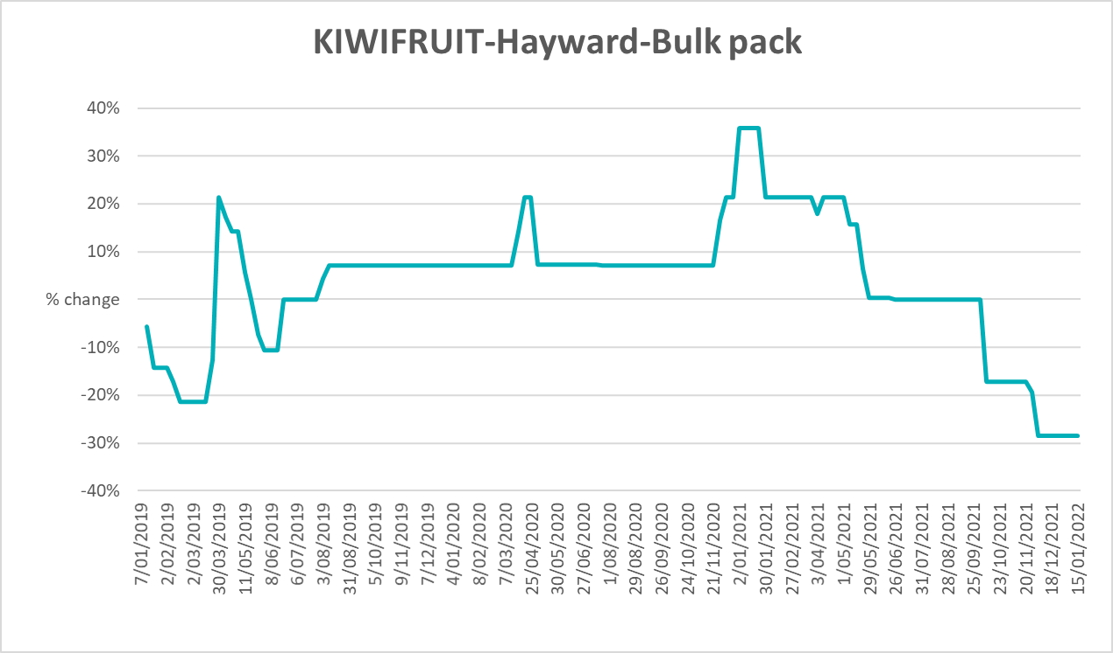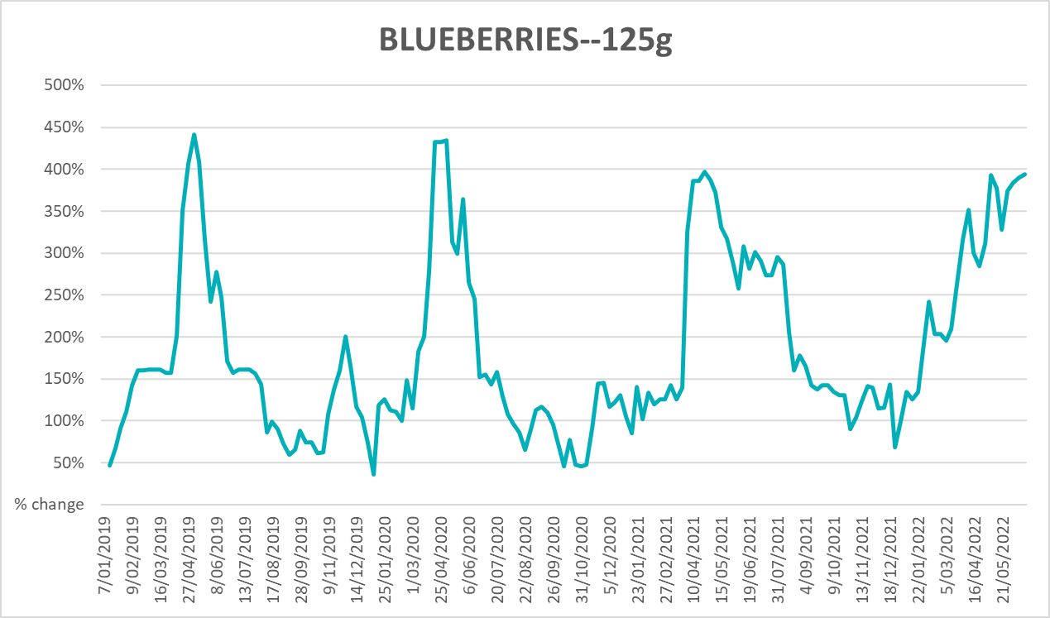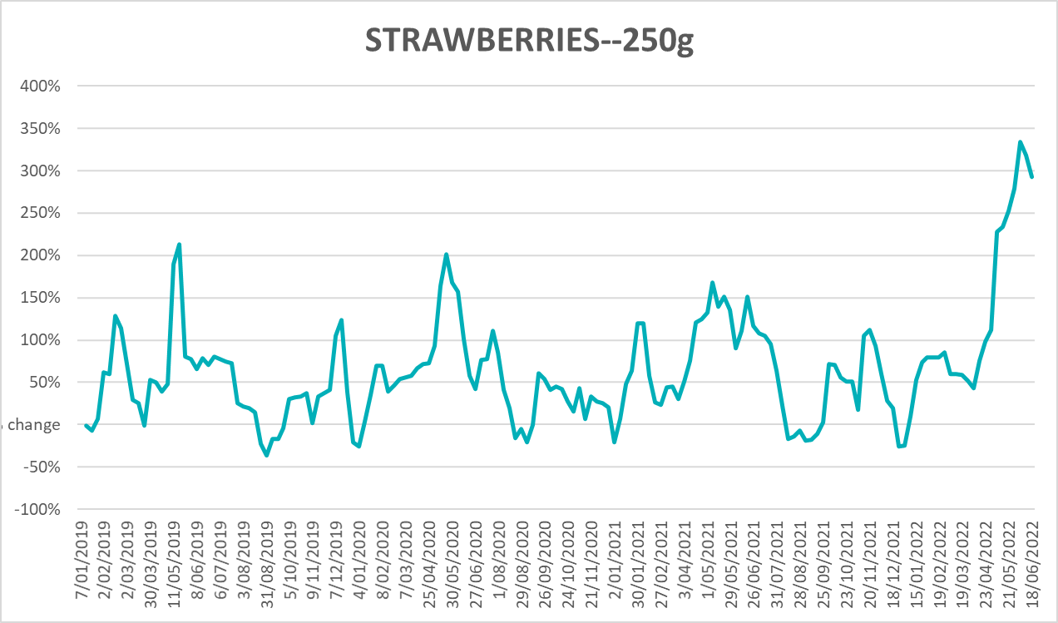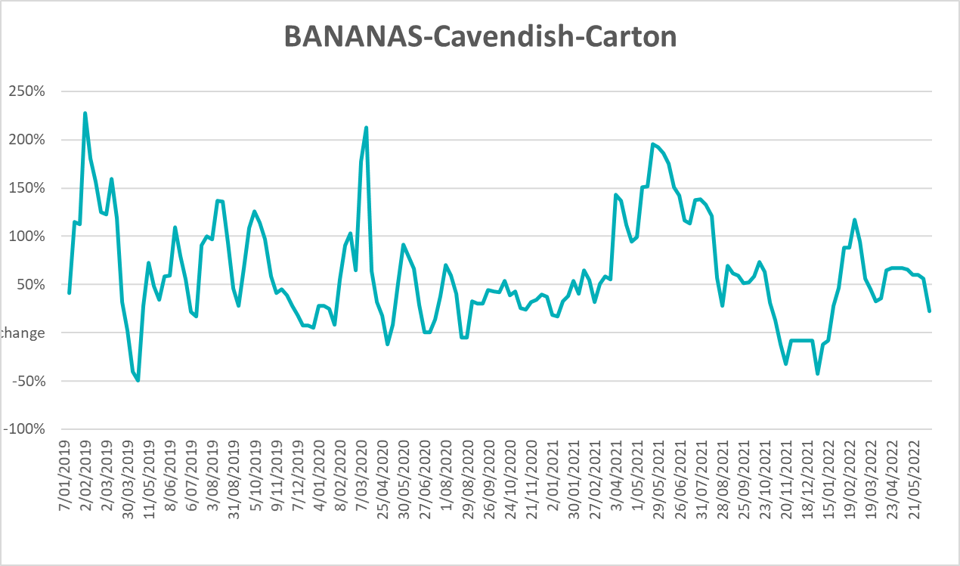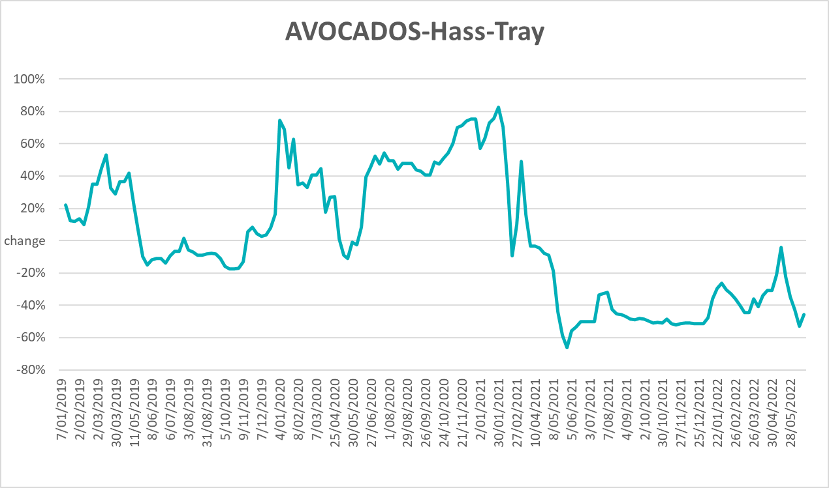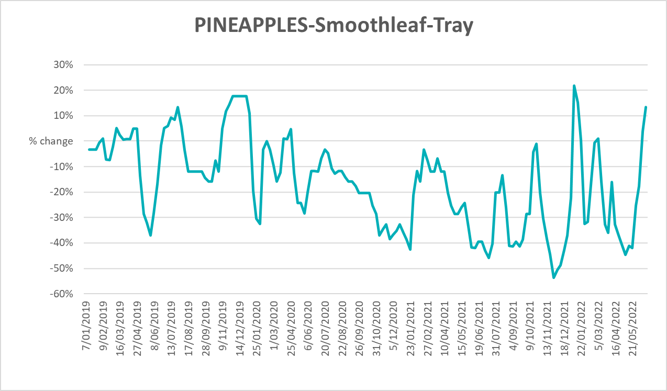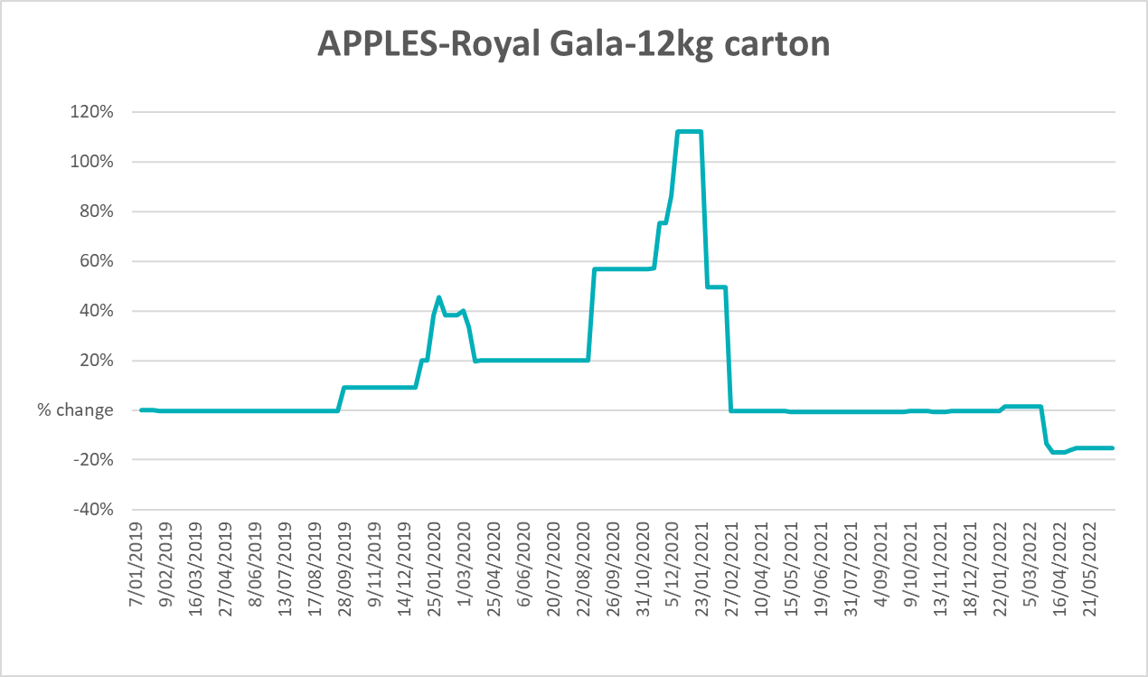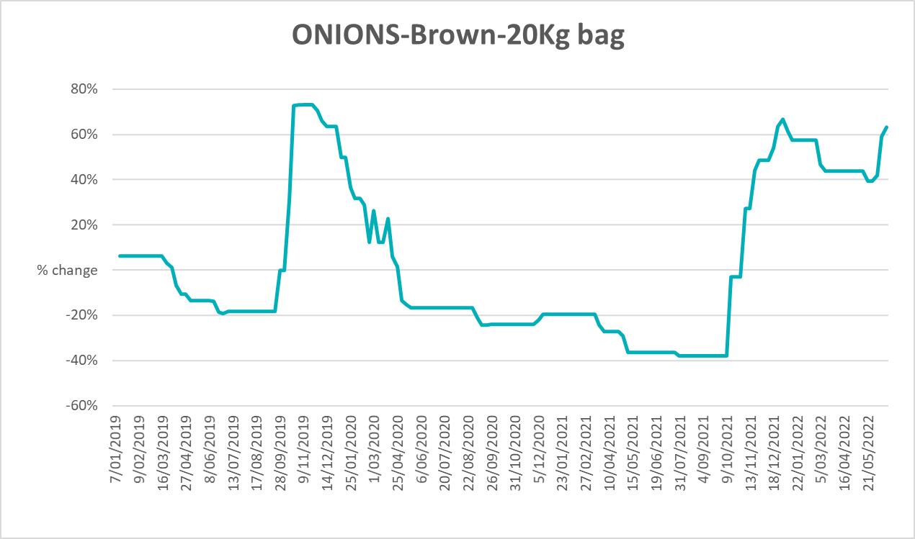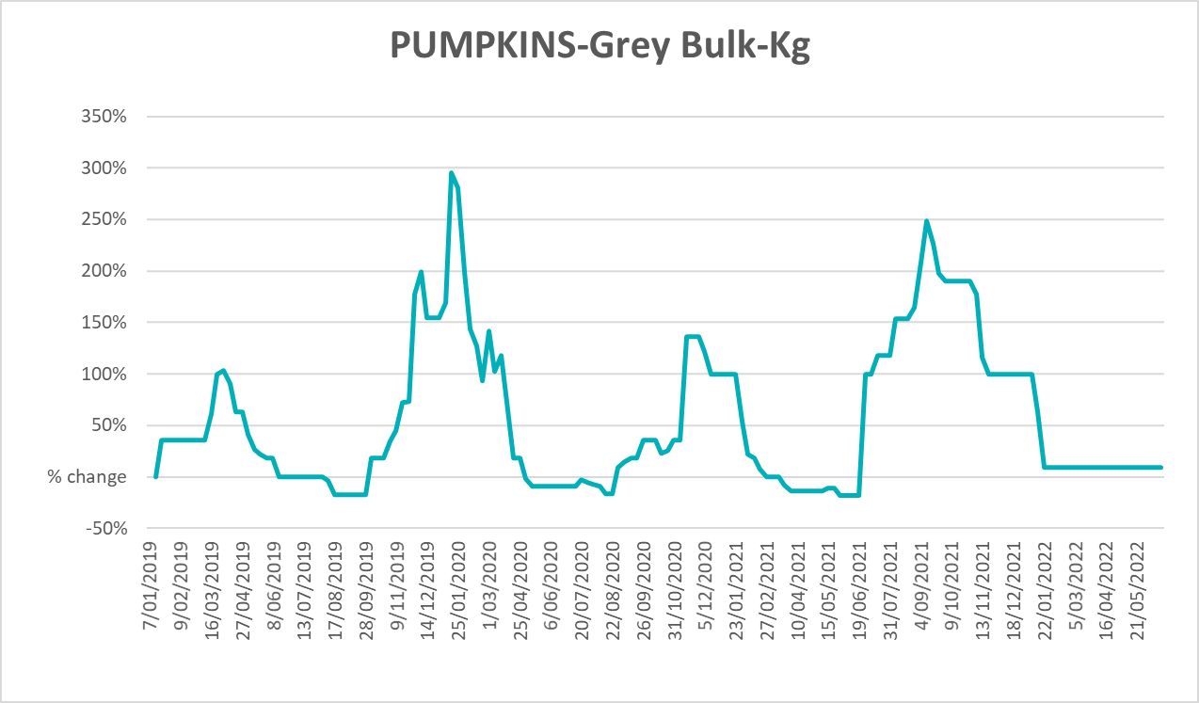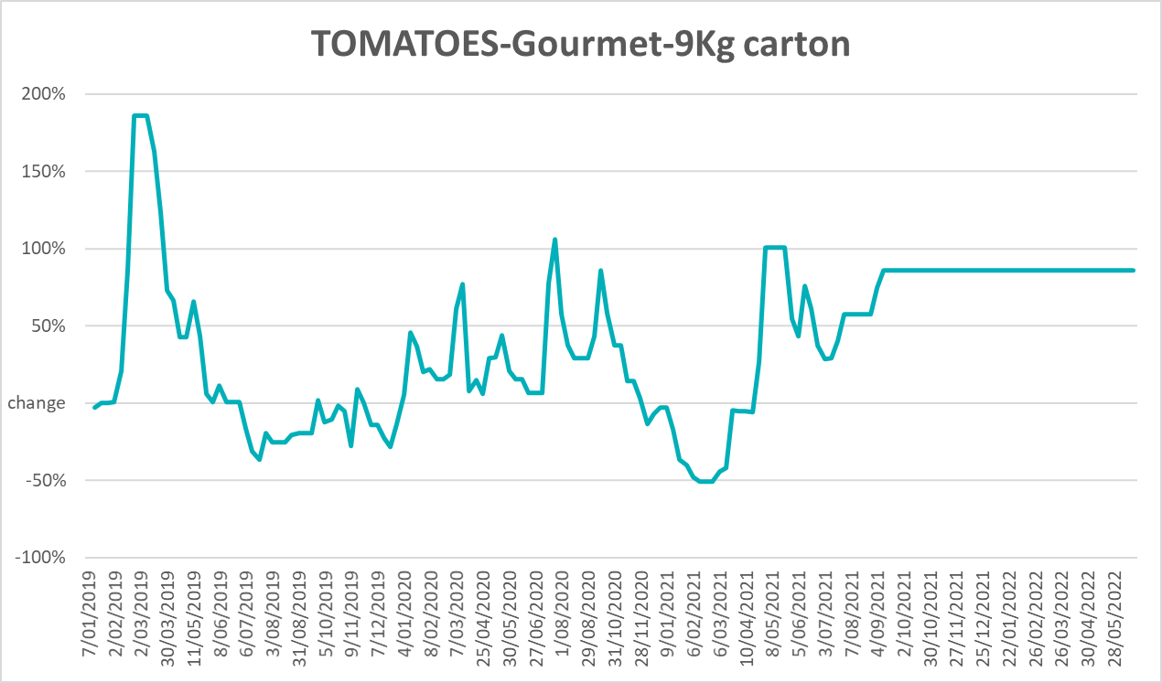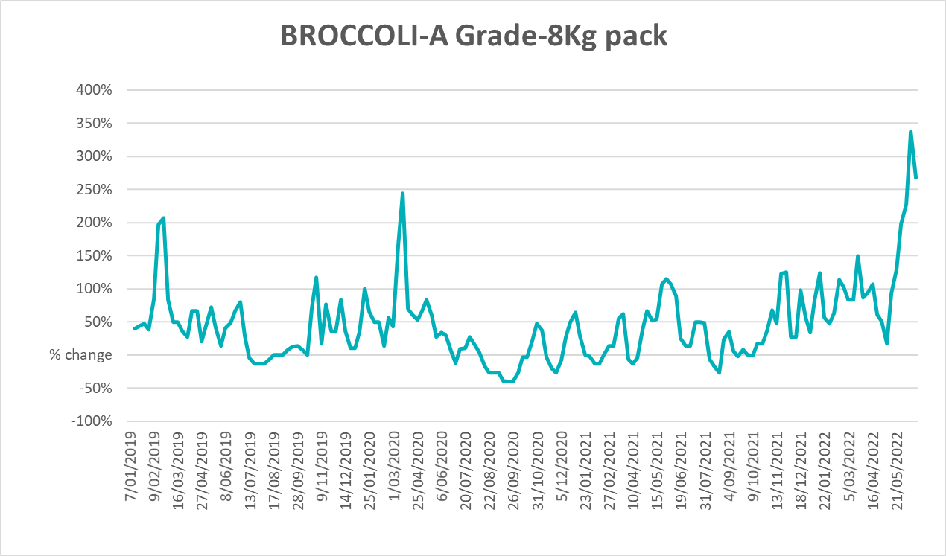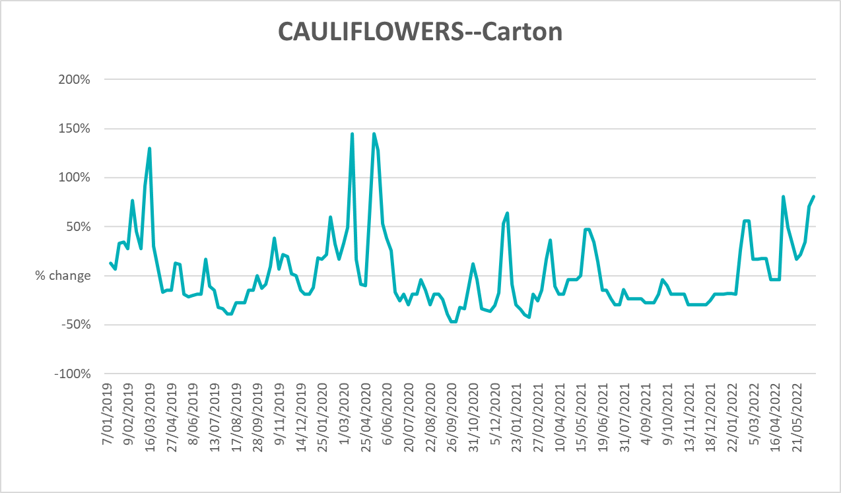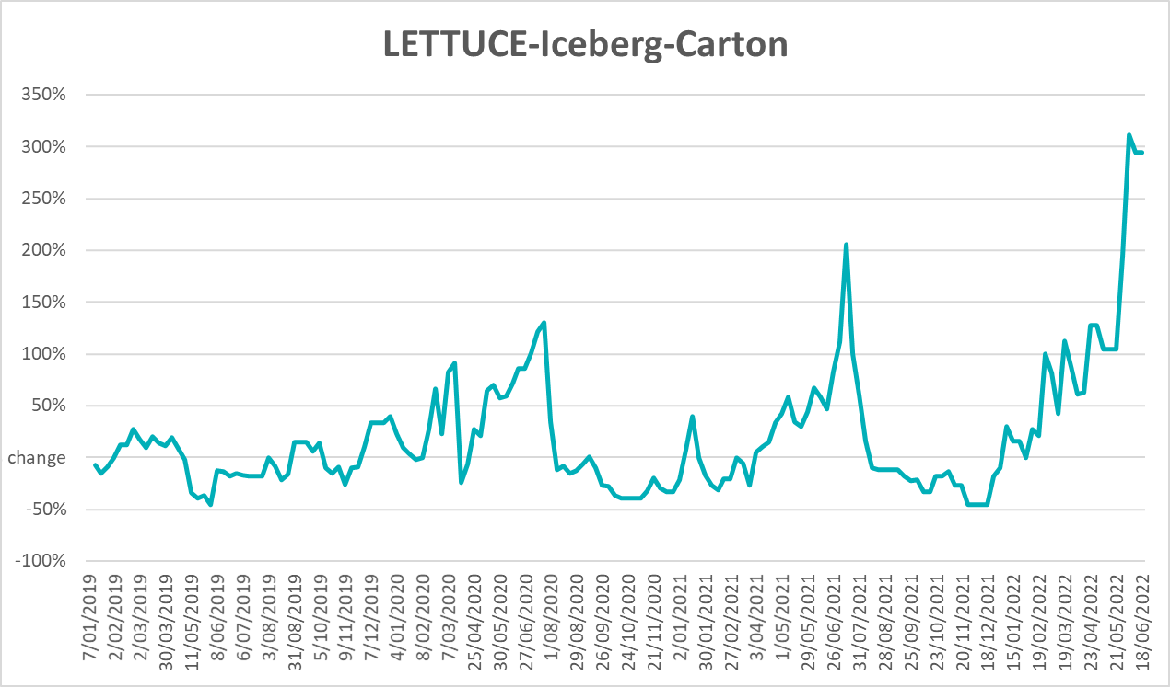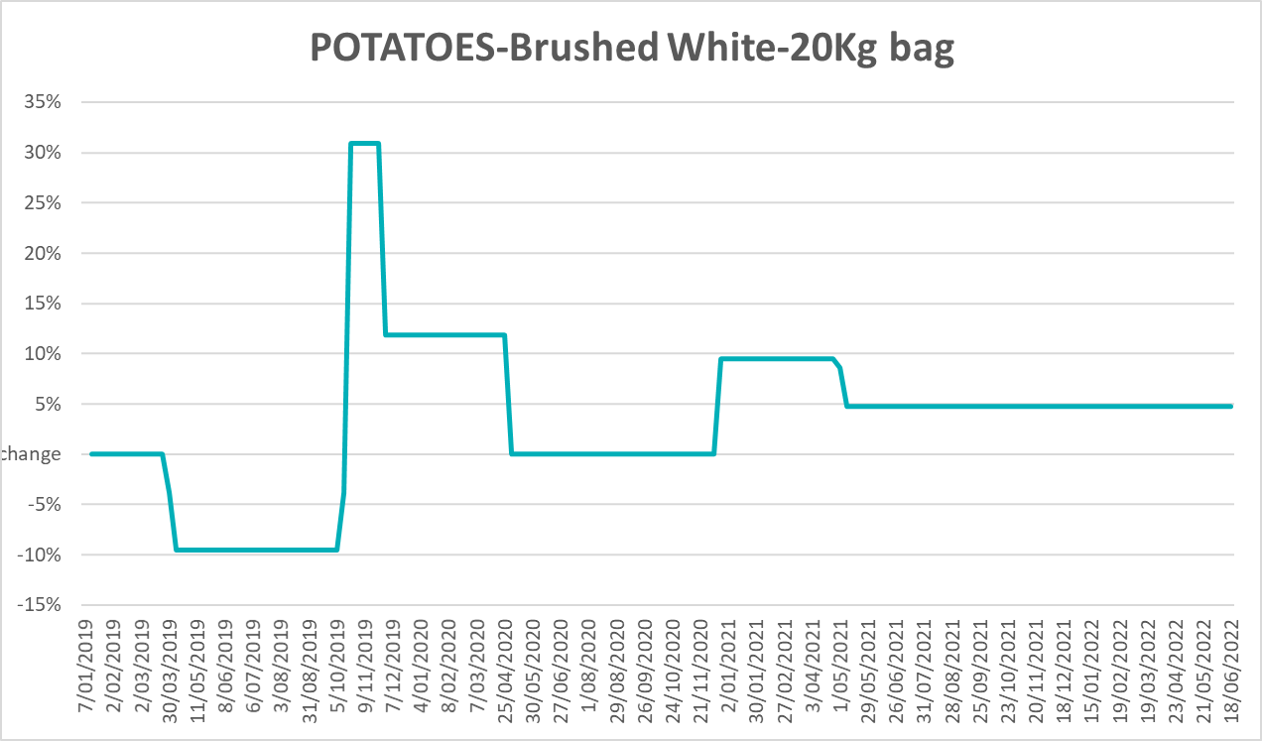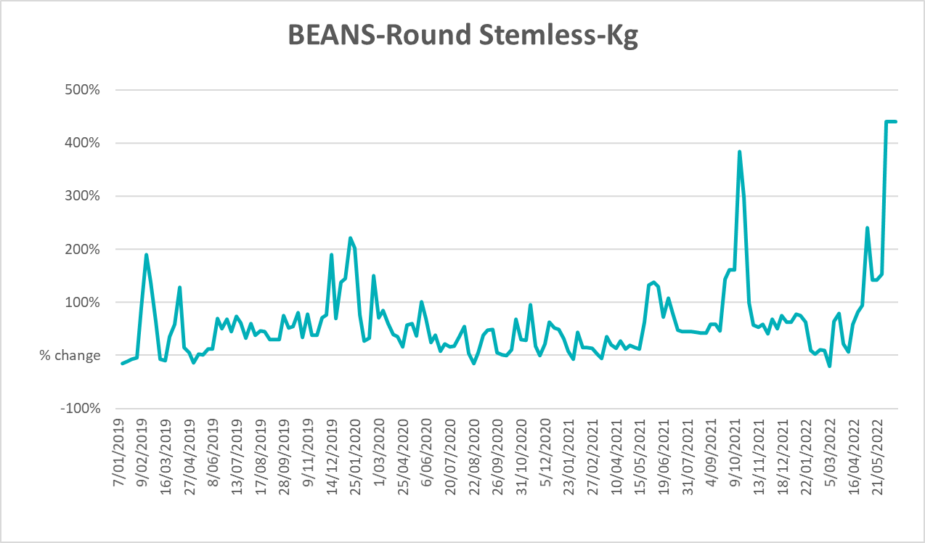

Selected domestic fodder indicator prices
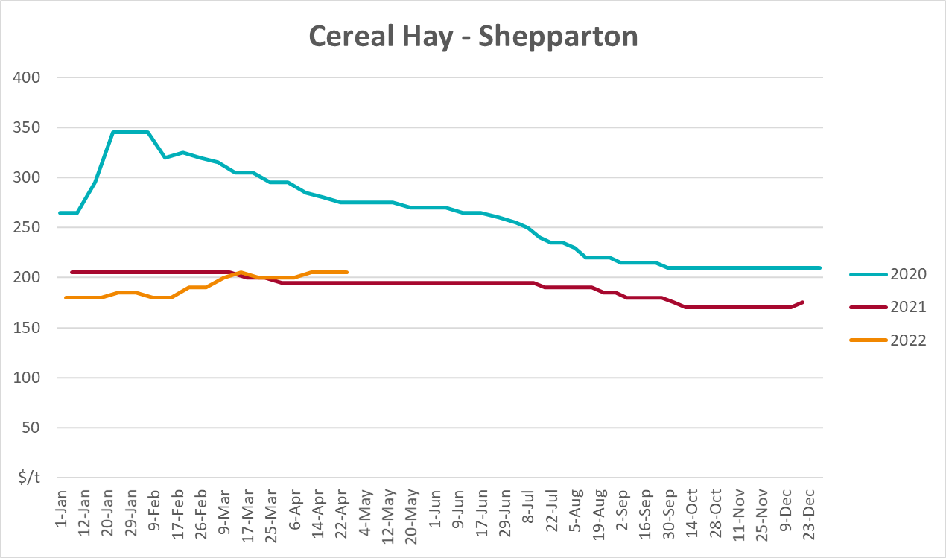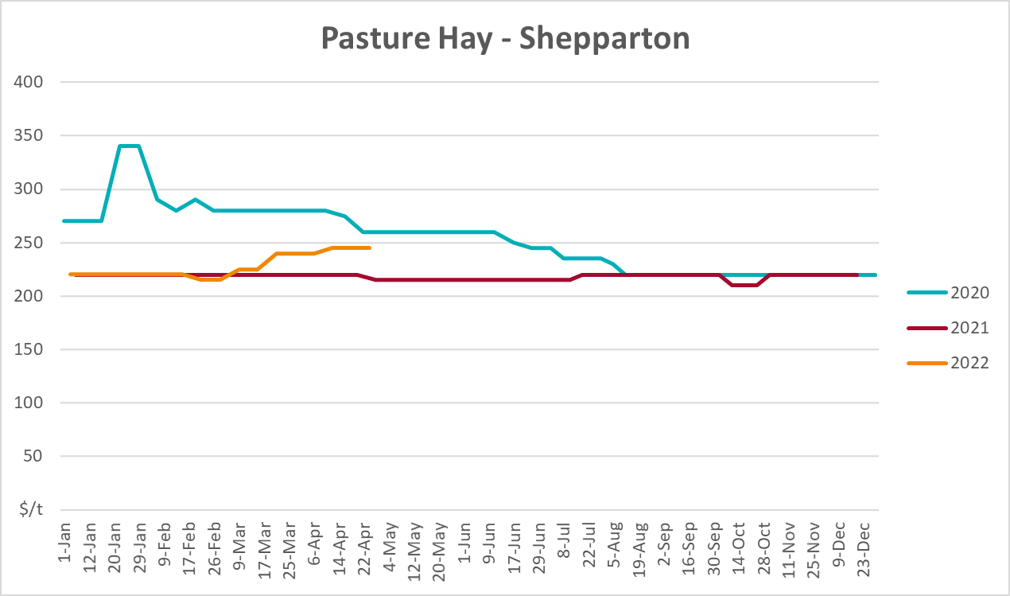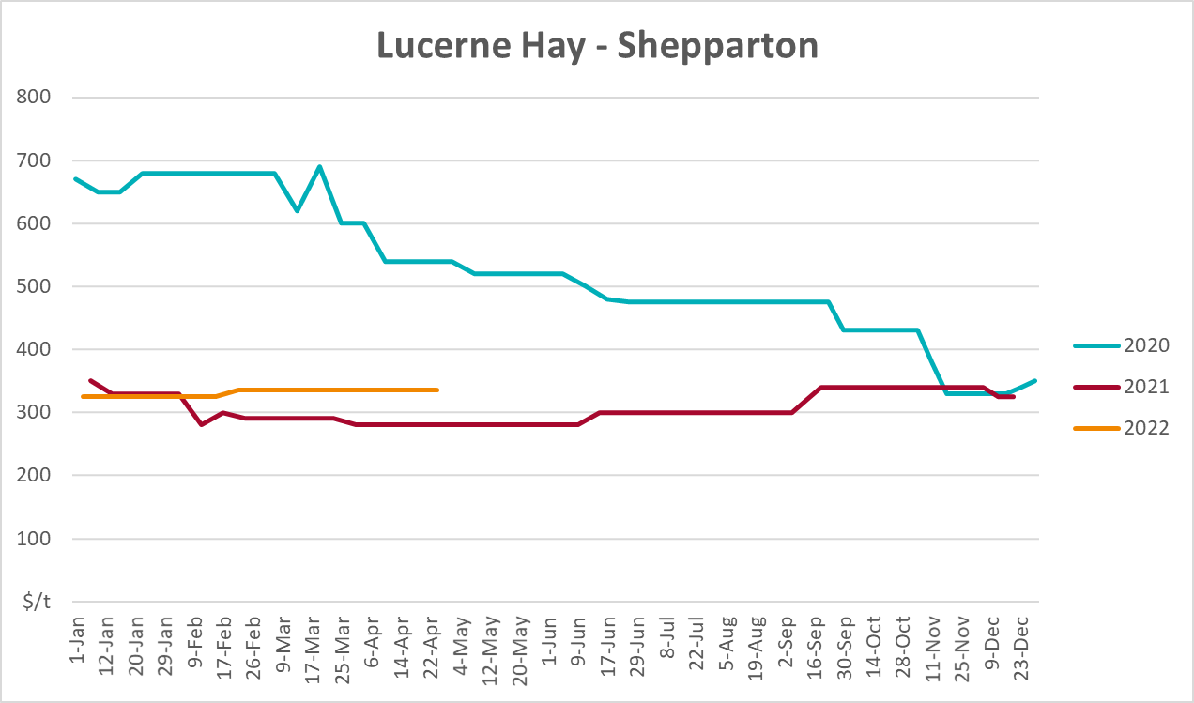

Data attribution

Climate
Bureau of Meteorology
- Weekly rainfall totals: www.bom.gov.au/climate/maps/rainfall/
- Monthly and last 3-month rainfall percentiles: www.bom.gov.au/water/landscape/
- Temperature anomalies: www.bom.gov.au/jsp/awap/temp/index.jsp
- Rainfall forecast: www.bom.gov.au/jsp/watl/rainfall/pme.jsp
- Seasonal outlook: www.bom.gov.au/climate/outlooks/#/overview/summary/
- Climate drivers: http://www.bom.gov.au/climate/enso/
- Soil moisture: www.bom.gov.au/water/landscape/
Other
- Pasture growth: www.longpaddock.qld.gov.au/aussiegrass/
- 3-month global outlooks: Environment and Climate Change Canada, NOAA Climate Prediction Center, EUROBRISA CPTEC/INPE, European Centre for Medium-Range Weather Forecasts, Hydrometcenter of Russia, National Climate Center Climate System Diagnosis and Prediction Room (NCC), International Research Institute for Climate and Society
- Global production: https://ipad.fas.usda.gov/ogamaps/cropmapsandcalendars.aspx
- Autumn break: Pook et al., 2009, https://rmets-onlinelibrary-wiley-com.virtual.anu.edu.au/doi/epdf/10.1002/joc.1833

Water
Prices
- Waterflow: https://www.waterflow.io/
- Ruralco: https://www.ruralcowater.com.au/
Bureau of Meteorology:
- Allocation trade: http://www.bom.gov.au/water/dashboards/#/water-markets/mdb/at
- Storage volumes: http://www.bom.gov.au/water/dashboards/#/water-storages/summary/drainage
Trade constraints:
- Water NSW: https://www.waternsw.com.au/customer-service/ordering-trading-and-pricing/trading/murrumbidgee
- Victorian Water Register: https://www.waterregister.vic.gov.au/TradingRules2019/

Commodities
Fruit and vegetables
- Datafresh: www.freshstate.com.au
Pigs
- Australian Pork Limited: www.australianpork.com.au
Dairy
- Global Dairy Trade: www.globaldairytrade.info/en/product-results/
World wheat, canola
- International Grains Council
World coarse grains
- United States Department of Agriculture
World cotton
- Cotlook: www.cotlook.com/
World sugar
- New York Stock Exchange - Intercontinental Exchange
Wool
- Australian Wool Exchange: www.awex.com.au/
Domestic wheat, barley, sorghum, canola and fodder
- Jumbuk Consulting Pty Ltd: http://www.jumbukag.com.au/
Cattle, beef, mutton, lamb, goat and live export
- Meat and Livestock Australia: www.mla.com.au/Prices-and-market
© Commonwealth of Australia 2022

Ownership of intellectual property rights
Unless otherwise noted, copyright (and any other intellectual property rights, if any) in this publication is owned by the Commonwealth of Australia (referred to as the Commonwealth).

Creative Commons licence
All material in this publication is licensed under a Creative Commons Attribution 4.0 International Licence except content supplied by third parties, logos and the Commonwealth Coat of Arms.
Inquiries about the licence and any use of this document should be emailed to copyright@awe.gov.au.


Cataloguing data
This publication (and any material sourced from it) should be attributed as:
ABARES 2022, Weekly Australian Climate, Water and Agricultural Update, Australian Bureau of Agricultural and Resource Economics and Sciences, Canberra, 30 June 2022. CC BY 4.0 DOI: https://doi.org/10.25814/5f3e04e7d2503
ISSN 2652-7561
This publication is available at https://www.awe.gov.au/abares/products/weekly_update
Department of Agriculture, Water and the Environment
GPO Box 858 Canberra ACT 2601
Telephone 1800 900 090
Web awe.gov.au/abares

Disclaimer
The Australian Government acting through the Department of Agriculture, Water and the Environment, represented by the Australian Bureau of Agricultural and Resource Economics and Sciences, has exercised due care and skill in preparing and compiling the information and data in this publication. Notwithstanding, the Department of Agriculture, Water and the Environment, ABARES, its employees and advisers disclaim all liability, including liability for negligence and for any loss, damage, injury, expense or cost incurred by any person as a result of accessing, using or relying on any of the information or data in this publication to the maximum extent permitted by law.

Statement of Professional Independence
The views and analysis presented in ABARES publications, including this one, reflect ABARES professionally independent findings, based on scientific and economic concepts, principles, information and data. These views, analysis and findings may not reflect or be consistent with the views or positions of the Australian Government, or of organisations or groups who have commissioned ABARES reports or analysis. More information on professional independence is provided on the ABARES website.

Acknowledgements
This report was prepared by Matthew Miller and Cameron Van-Lane.

