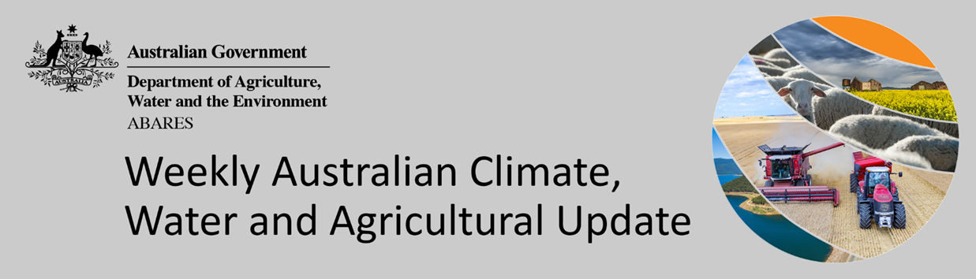
No. 5/2022

10 February 2022

Summary of key issues
- For the week ending 9 February 2022, blocking high-pressure systems to the south of Australia resulted in clear, dry conditions across southern parts of the country. Meanwhile, low-pressure troughs over northern and eastern parts of Australia resulted in significant rainfall (see Section 1.1).
- Recent rainfall across Queensland cropping regions has likely stalled the harvesting of early sown summer crops, especially on the Darling Downs. For late sown crops, especially in Central Queensland, the rainfall has likely supported germination and establishment.
- El Niño-Southern Oscillation (ENSO) indicators suggest that La Niña is currently active in the tropical Pacific. La Niña events are associated with above-average rainfall for northern and eastern Australia during spring and summer. International climate models expect the La Niña event will dissipate over the coming months. Despite the easing of La Niña atmospheric and oceanic patterns, they are likely to continue influencing rainfall patterns in northern and eastern Australia over the coming months (see Section 1.2).
- The outlook for March 2022 indicates that there is a 75% chance of rainfall totals between 10 and 100 millimetres across eastern New South Wales, eastern and northern Queensland, southern Victoria, the north of Western Australia and the Northern Territory, and Tasmania. Rainfall totals in excess of 100 millimetres are expected in parts of north-eastern New South Wales, northern Queensland, the north of the Northern Territory and Western Australia, and western Tasmania. (see Section 1.3).
- The outlook for March to May 2022 suggests there is a 75% chance of rainfall totals between 50 and 200 millimetres across much of eastern New South Wales, eastern and northern Queensland, southern Victoria, southern parts of South Australia, the south-west and far north of Western Australia, northern parts of the Northern Territory and eastern Tasmania. Rainfall totals in excess of 200 millimetres are forecast for north-eastern New South Wales, northern parts of Queensland and the Northern Territory and western Tasmania.
- Over the 8-days to 17 February 2022, rainfall is expected to be restricted to northern, western and isolated areas of eastern Australia. Troughs are expected to bring heavy rain and storms to large areas of Australia’s tropical north and the western half of Western Australia, while onshore winds are expected to bring showers along the eastern seaboard. Meanwhile, high pressure systems are expected to bring mostly dry conditions to much of southern and central Australia (see Section 1.4).
- Water storage in the Murray–Darling Basin (MDB) decreased by 240 gigalitres (GL) between 2 February 2022 and 9 February 2022. The current volume of water held in storage is 22,300 GL, which represents 88 of total capacity. This is 61% or 8,420 GL more than at the same time last year.
- Allocation prices in the Victorian Murray below the Barmah Choke decreased from $85 per ML on 28 January 2022 to $75 per ML on 4 February 2022. Prices are lower in the Goulburn-Broken, Murrumbidgee, and regions above the Barmah Choke due to the binding of the Goulburn intervalley trade limit, Murrumbidgee export limit, and Barmah Choke trade constraint.

Climate

Rainfall this week
For the week ending 9 February 2022, blocking high-pressure systems to the south of Australia resulted in clear, dry conditions across southern parts of the country. Meanwhile, low-pressure troughs over northern and eastern parts of Australia resulted in significant rainfall.
Rainfall totals of between 10 and 100 millimetres were recorded across parts of eastern New South Wales, much of Queensland, the north of Western Australia and the north and centre of the Northern Territory, as well as isolated parts of Victoria, South Australia and Tasmania. Rainfall totals in excess of 100 millimetres were recorded in north-eastern New South Wales and northern parts of Queensland, Western Australia and the Northern Territory. Remaining parts of New South Wales, Victoria, South Australia and Western Australia received little to no rainfall.
In cropping regions, rainfall totals of between 10 and 100 millimetres were recorded across much of Queensland and parts of north-eastern New South Wales. Little to no rainfall was recorded across cropping regions in remaining parts of New South Wales, as well as Victoria, South Australia and Western Australia.
Recent rainfall across Queensland cropping regions has likely stalled the harvesting of early sown summer crops, especially on the Darling Downs. However, given the dry conditions through much of January, the recent rainfall is unlikely to have caused significant damage to mature crops. For late sown crops, especially in Central Queensland, the rainfall has likely supported germination and establishment.

Rainfall for the week ending 9 February 2022

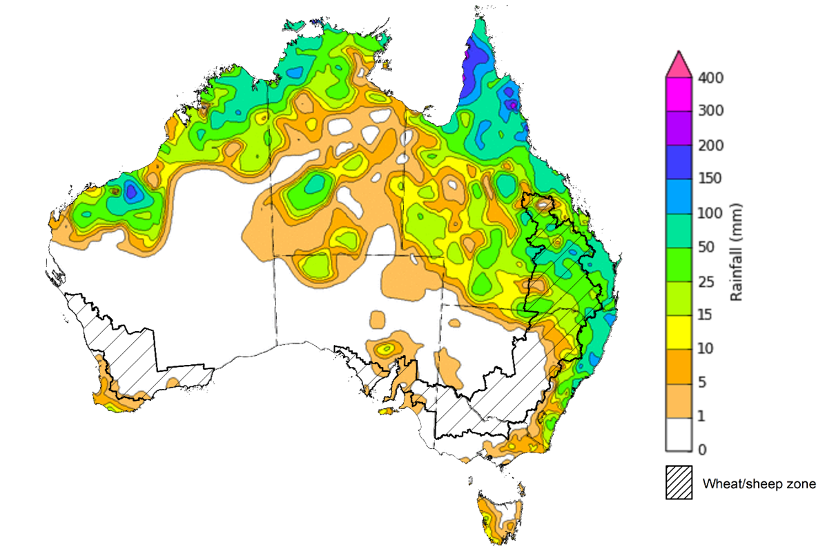

©Commonwealth of Australia 2022, Australian Bureau of Meteorology Issued: 9/2/2022
Note: The rainfall analyses and associated maps utilise data contained in the Bureau of Meteorology climate database, the Australian Data Archive for Meteorology (ADAM). The analyses are initially produced automatically from real-time data with limited quality control. They are intended to provide a general overview of rainfall across Australia as quickly as possible after the observations are received. For further information go to http://www.bom.gov.au/climate/rainfall/

Climate Drivers
Throughout summer the climate drivers with the largest potential impact on Australia’s climate patterns are the El Niño–Southern Oscillation (ENSO), the Southern Annular Mode (SAM) and the Madden-Julian Oscillation (MJO). These climate drivers are likely to influence the growth and development of summer crops in northern growing regions and pasture growth across northern Australia with the northern wet season.
ENSO indicators suggest that La Niña is currently active in the tropical Pacific. La Niña events are associated with above-average rainfall for northern and eastern Australia during spring and summer. International climate models expect the La Niña event will dissipate over the coming months. For 2021-22 to be considered a La Niña year, the event must remain active for at least three months. Despite the easing of La Niña atmospheric and oceanic patterns, they are likely to continue influencing rainfall patterns in northern and eastern Australia over the coming months.
The SAM has recently returned to positive values and expected to remain positive over the next two to three weeks. The SAM refers to the north-south shift of the band of rain-bearing westerly winds and weather systems in the Southern Ocean compared to the usual position. During summer, a positive SAM is associated with above average rainfall for eastern parts of Australia at this time of year, as well as below average rainfall for south-westerly exposed coastal areas.
Below average sea surface temperature (SST) anomalies have persisted in the central and eastern tropical Pacific Ocean over the past two weeks. SST in the equatorial Pacific are expected to begin warming as sub-surface waters become warmer. Current SST anomalies reflect typical La Niña patterns, with below average SST along the equator, and warm SST anomalies to the north and south. Despite the easing of negative Indian Ocean Dipole (IOD) conditions, warm SST anomalies persist to the north-west of Australia.

Difference from average sea surface temperature observations 24 to 30 January 2022
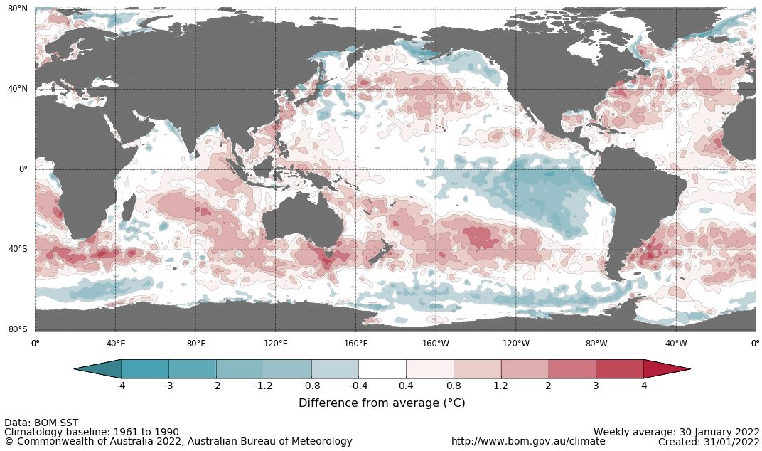

International climate model outlooks for the NINO 3.4 region in March 2022
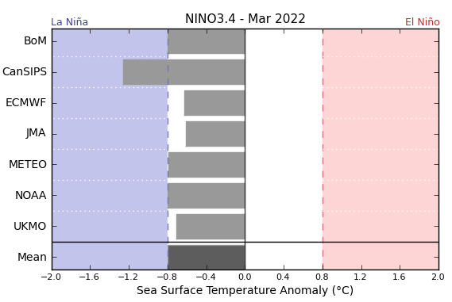
©Commonwealth of Australia 2022, Australian Bureau of Meteorology Issued: 1/2/2022
A La Niña event is currently at or near its peak in the Pacific Ocean. Most climate models surveyed by the Bureau of Meteorology expect the La Niña event to dissipate in early Autumn, with only two of the seven models expecting it to remain active in April 2022. ENSO events typically decay and return to neutral conditions in Autumn. For the period ending 7 February 2022, the 30-day SOI was +8.7. For the period ending 30 January 2022, the 90-SOI was +9.6, both above the La Niña threshold of +7. Above average SST anomalies have continued across parts of the Maritime Continent and northern Australia. Trade winds across the western tropical Pacific have remained stronger than average, while cloudiness near the Date Line has been consistently below average since June 2021.These indications are consistent with the ongoing La Niña event.

30-day Southern Oscillation Index (SOI) values ending 7 February 2022
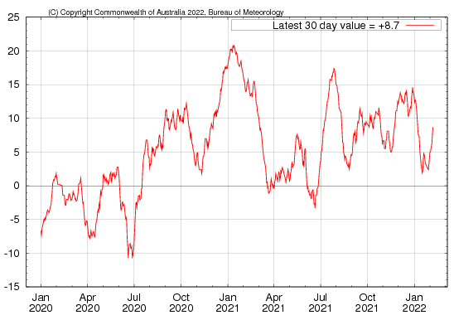

National Climate Outlook
These climate outlooks are generated by ACCESS–S (Australian Community Climate Earth-System Simulator–Seasonal). ACCESS–S is the Bureau of Meteorology's dynamical (physics-based) weather and climate model used for monthly, seasonal and longer-lead climate outlooks.
For further information, go to http://www.bom.gov.au/climate/ahead/about/
The Bureau of Meteorology’s latest rainfall outlook indicated wetter than average conditions are expected across eastern parts of Australia during March. The ACCESS-S climate model suggests there is close to a 55% chance of exceeding median March rainfall totals across much of eastern Australia.
The outlook for March 2022 indicates that there is a 75% chance of rainfall totals between 10 and 100 millimetres across eastern New South Wales, eastern and northern Queensland, southern Victoria, the north of Western Australia and the Northern Territory, and Tasmania. Rainfall totals in excess of 100 millimetres are expected in parts of north-eastern New South Wales, northern Queensland, the north of the Northern Territory and Western Australia, and western Tasmania.
Across cropping regions there is a 75% chance of rainfall totals of between 10 and 50 millimetres across most of New South Wales, Queensland and eastern parts of Western Australia. There is a 75% chance of rainfall less than 10 millimetres for most of Victoria, South Australia and remaining parts of Western Australia. The wetter than average conditions expected for most eastern Australian cropping regions is likely to support the growth and development of late-sown summer crops but may interfere with the harvesting of early-sown crops in New South Wales and Queensland.
Rainfall totals that have a 75% chance of occurring March 2022
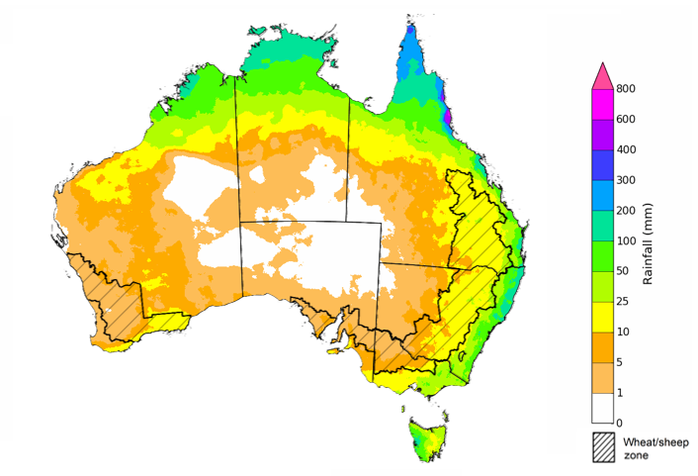
©Commonwealth of Australia 2022, Australian Bureau of Meteorology Issued: 3/2/2022

The rainfall outlook for March to May 2022 suggests there is a greater than 55% chance of exceeding median rainfall across much of New South Wales and Queensland, and parts of Victoria, South Australia, Western Australia and the far north of the Northern Territory. For much of northern Queensland, there is a greater than 70% chance of exceeding median rainfall. For remaining regions of Australia, there is roughly an equal chance of above and below median rainfall, with only isolates areas western Tasmania expecting to receive below average rainfall between March and May 2022 (Bureau of Meteorology ‘National Climate Outlook’, 3 February 2022).
Bureau of Meteorology rainfall outlooks for March to May have greater than 55% past accuracy across most of eastern and central Australia. Outlook accuracy is greater than 65% across isolated parts of the country. However, there is low past accuracy for parts of north-western New South Wales, western Queensland, the north-east and north-west of South Australia, as well as large areas in southern parts of Western Australia.
Chance of exceeding the median rainfall March to May 2022
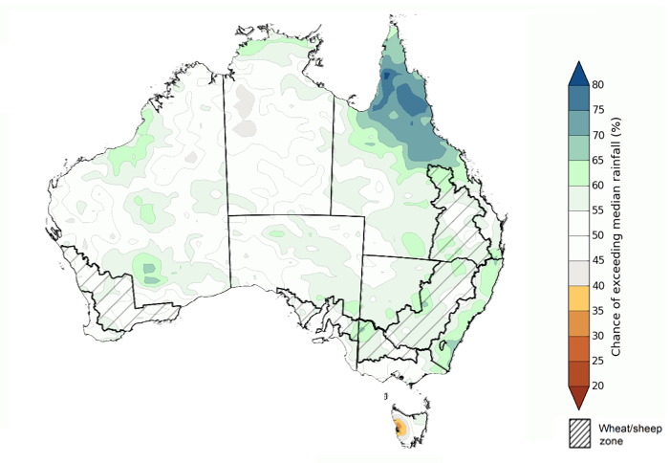
©Commonwealth of Australia 2022, Australian Bureau of Meteorology Issued: 3/2/2022

The outlook for March to May 2022 suggests there is a 75% chance of rainfall totals between 50 and 200 millimetres across much of eastern New South Wales, eastern and northern Queensland, southern Victoria, southern parts of South Australia, the south-west and far north of Western Australia, northern parts of the Northern Territory and eastern Tasmania. Rainfall totals in excess of 200 millimetres are forecast for north-eastern New South Wales, northern parts of Queensland and the Northern Territory and western Tasmania.
Across cropping regions, there is a 75% chance of receiving between 50 and 200 millimetres across much of New South Wales, Queensland, southern Victoria, and isolated parts of South Australia and Western Australia. Rainfall totals in excess of 200 millimetres are forecast for northern cropping regions in Queensland. Totals of less than 50 millimetres are expected across remaining cropping regions in Victoria, and South Australia and Western Australia.
These rainfall totals are slightly below average to average for this three-month period across most New South Wales and Queensland cropping regions, and slightly below average for cropping regions in Victoria, South Australia and Western Australia. Following a relatively dry January, upper layer soil moisture levels are below average to average across summer cropping regions in New South Wales and Queensland, which may impede germination and establishment of late sown summer crops. Lower soil moisture levels, on the other hand, are above average to average across summer cropping regions, which will support yield potentials of earlier sown crops. For both early and late sown summer crops, more rainfall will be required over the coming weeks to support ongoing development and yield potentials.
Rainfall totals that have a 75% chance of occurring March to May 2022

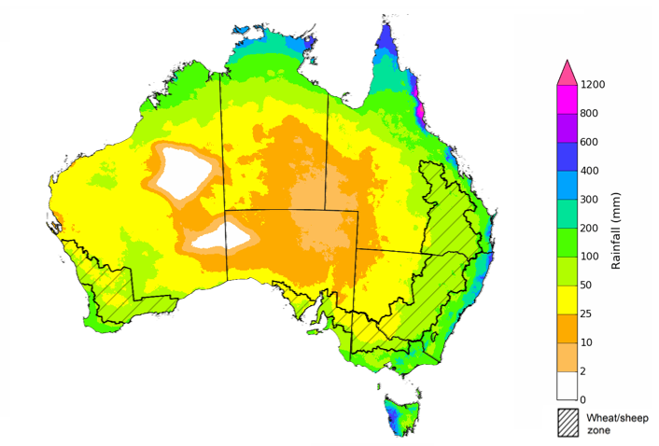
©Commonwealth of Australia 2022, Australian Bureau of Meteorology Issued: 3/2/2022
The temperature outlook for March to May 2022 indicates that maximum temperatures across most of Australia are likely to be close to the 1990-2012 average (- 1°C to 1°C). Minimum temperatures are expected to be slightly above average for parts of Queensland and the Northern Territory, and close to average for the rest of Australia (Bureau of Meteorology ‘National Climate Outlook’, 3 February 2022).
Predicted maximum temperature anomaly for March to May 2022

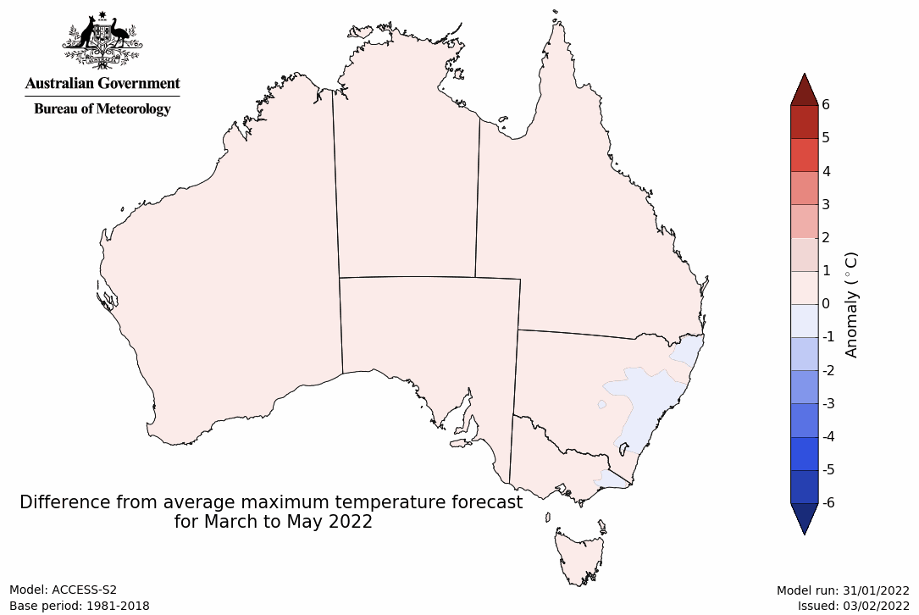
Predicted minimum temperature anomaly for March to May 2022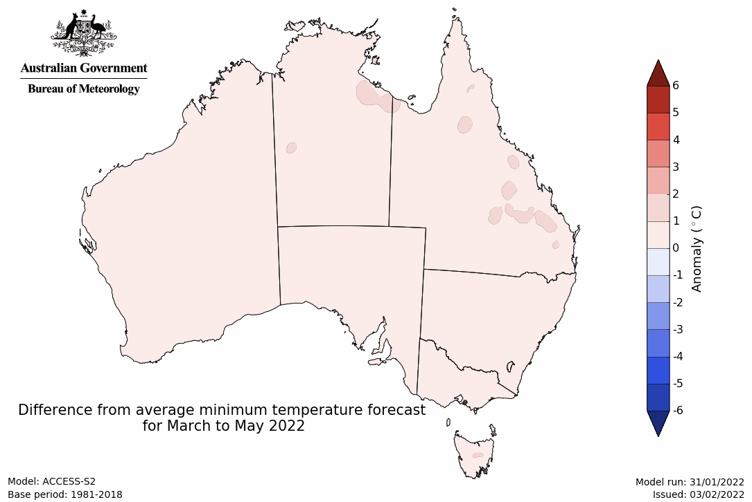

Rainfall forecast for the next eight days
Over the 8-days to 17 February 2022, rainfall is expected to be restricted to northern, western and isolated areas of eastern Australia. Troughs are expected to bring heavy rain and storms to large areas of Australia’s tropical north and the western half of Western Australia, while onshore winds are expected to bring showers along the eastern seaboard. Meanwhile, high pressure systems are expected to bring mostly dry conditions to much of southern and central Australia.
Rainfall totals of between 10 and 25 millimetres are forecast for the far east of New South Wales and Victoria, as well as parts of eastern and northern Queensland, the north and west of Western Australia and the north of the Northern Territory. Rainfall in excess of 25 millimetres is expected across parts of the north of Western Australia and the Northern Territory, and scattered areas of northern and eastern Queensland.
In Australian cropping regions, rainfall totals of between 10 and 25 millimetres are expected across as most of Western Australia. Little to no rainfall is forecast for all remaining cropping regions during the next 8-days.
While little or no rainfall is expected across most summer cropping regions, soil moisture levels through the entire rootzone remain average to above average which will continue to support above average production prospects. The heavy rainfall forecast for much of Northern Australia will continue to boost pasture growth rates during this peak production season, and in the west of Australia it will build soil moisture levels following below average rainfall during the last 3-months.

Total forecast rainfall (mm) for the period 10 February to 17 February 2022
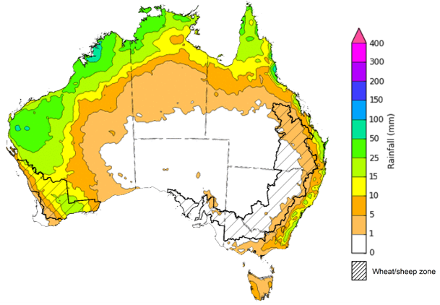
©Commonwealth of Australia 2022, Australian Bureau of Meteorology Issued: 10/02/2022

Water
Note: This rainfall forecast is produced from computer models. As the model outputs are not altered by weather forecasters, it is important to check local forecasts and warnings issued by the Bureau of Meteorology.

Water markets – current week
Water storage in the Murray–Darling Basin (MDB) decreased by 240 gigalitres (GL) between 2 February 2022 and 9 February 2022. The current volume of water held in storage is 22,300 GL, which represents 88 of total capacity. This is 61% or 8,420 GL more than at the same time last year.

Water storages in the Murray-Darling Basin, 2013–2021
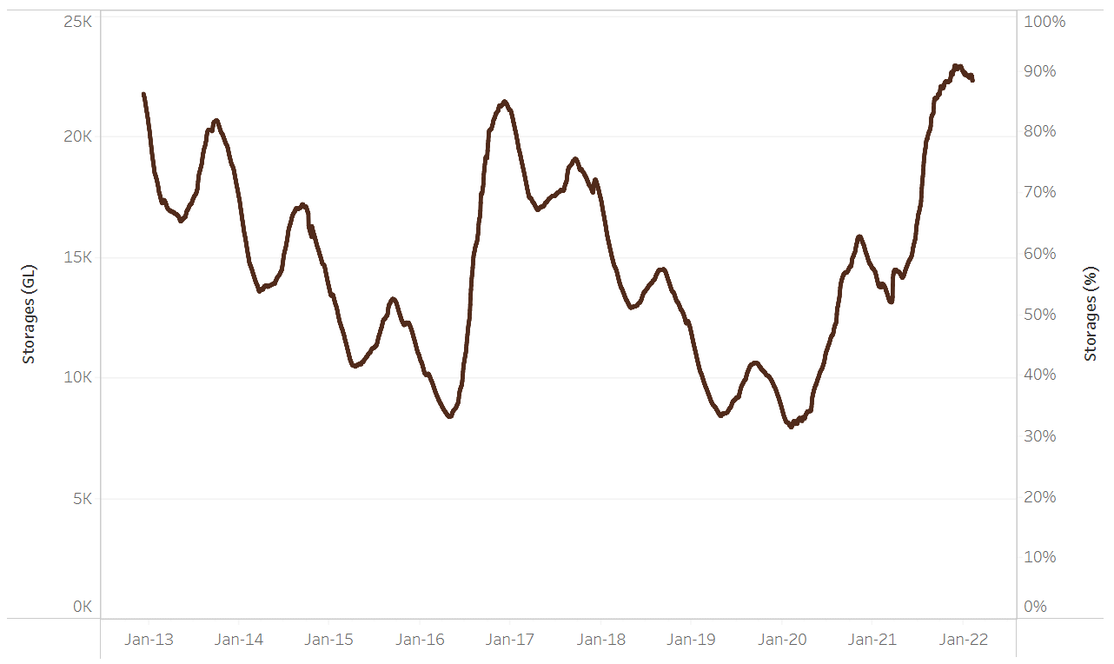
Allocation prices in the Victorian Murray below the Barmah Choke decreased from $85 per ML on 28 January 2022 to $75 per ML on 4 February 2022. Prices are lower in the Goulburn-Broken, Murrumbidgee, and regions above the Barmah Choke due to the binding of the Goulburn intervalley trade limit, Murrumbidgee export limit, and Barmah Choke trade constraint.
Water storage data is sourced from the Bureau of Meteorology.

Region | $/ML
NSW Murray Above | 36
NSW Murrumbidgee | 29
VIC Goulburn-Broken | 63
VIC Murray Below | 75

Surface water trade activity, Southern Murray–Darling Basin

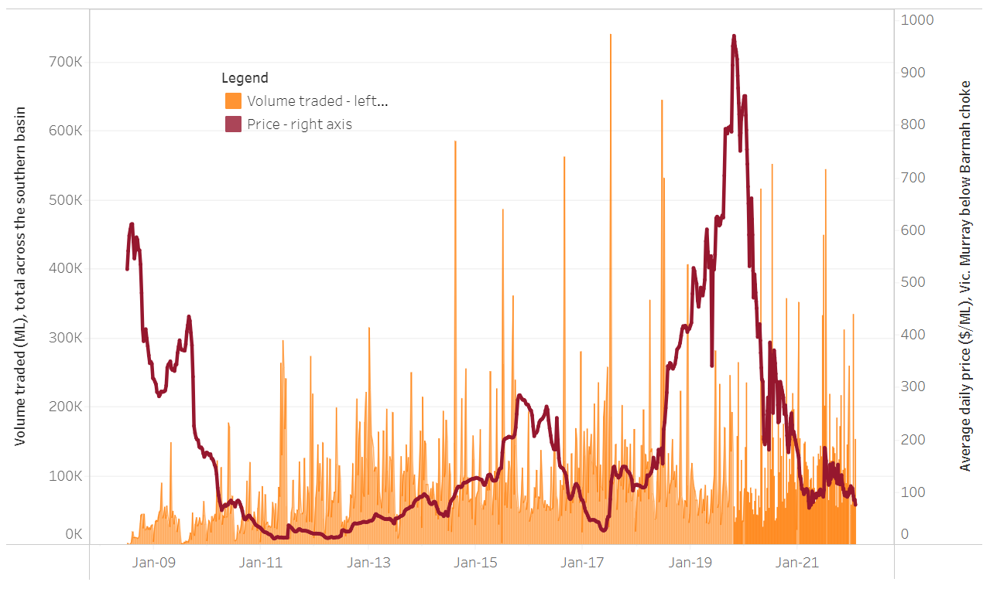
To access the full, interactive, weekly water dashboard, which contains the latest and historical water storage, water market and water allocation information, please visit http://www.agriculture.gov.au/abares/products/weekly_update/weekly-update-100222
The trades shown reflect estimated market activity and do not encompass all register trades. The price is shown for the VIC Murray below the Barmah choke. Historical prices (before 1 July 2019) are ABARES estimates after removing outliers from BOM water register data. Prices after 1 July 2019 and prior to the 30 October 2019 reflect recorded transaction prices as sourced from Ruralco. Prices after the 30 October 2019 are sourced from Waterflow. Data for volume traded is sourced from the BOM water register. Data shown is current at 9 February 2022.

Commodities
Due to technical issues the commodity prices and charts have not been updated this week. These will be updated in the next edition of ABARES Weekly Australian Climate, Water and Agricultural Update.
Indicator | Week ended | Unit | Latest price | Previous week | Weekly change | Price 12 months ago | Annual change
Selected world indicator prices
AUD/USD Exchange rate | 02-Feb | A$/US$ | 0.71 | 0.72 | -1% | 0.77 | -8%
Wheat – US no. 2 hard red winter wheat, fob Gulf | 02-Feb | US$/t | 380 | 395 | -4% | 288 | 32%
Corn – US no. 2 yellow corn, fob Gulf | 02-Feb | US$/t | 296 | 288 | 3% | 246 | 20%
Canola – Rapeseed, Canada, fob Vancouver | 02-Feb | US$/t | 864 | 869 | -1% | 574 | 51%
Cotton – Cotlook 'A' Index | 02-Feb | USc/lb | 139 | 135 | 4% | 92 | 52%
Sugar – Intercontinental Exchange, nearby futures, no.11 contract | 02-Feb | USc/lb | 17.9 | 18.5 | -3% | 16 | 14%
Wool – Eastern Market Indicator | 02-Feb | Ac/kg clean | 1,436 | 1,426 | 1% | 1,150 | 25%
Wool – Western Market Indicator | 15-Dec | Ac/kg clean | 1,408 | 1,417 | -1% | 984 | 43%
Selected Australian grain export prices
Milling Wheat – APW, Port Adelaide, SA | 02-Feb | A$/t | 491 | 482 | 2% | 355 | 38%
Feed Wheat – ASW, Port Adelaide, SA | 02-Feb | A$/t | 461 | 452 | 2% | 351 | 31%
Feed Barley – Port Adelaide, SA | 02-Feb | A$/t | 387 | 379 | 2% | 308 | 26%
Canola – Kwinana, WA | 02-Feb | A$/t | 986 | 960 | 3% | 693 | 42%
Grain Sorghum – Brisbane, QLD | 02-Feb | A$/t | 367 | 367 | 0% | 389 | -6%
Selected domestic livestock indicator prices
Beef – Eastern Young Cattle Indicator | 02-Feb | Ac/kg cwt | 1,121 | 1,170 | -4% | 866 | 30%
Mutton – Mutton indicator (18–24 kg fat score 2–3), Vic | 02-Feb | Ac/kg cwt | 564 | 576 | -2% | 586 | -4%
Lamb – Eastern States Trade Lamb Indicator | 02-Feb | Ac/kg cwt | 873 | 834 | 5% | 790 | 10%
Pig – Eastern Seaboard (60.1–75 kg), average of buyers & sellers | 26-Jan | Ac/kg cwt | 357 | 357 | 0% | 309 | 16%
Goats – Eastern States (12.1–16 kg) | 19-Jan | Ac/kg cwt | 879 | 879 | 0% | 818 | 8%
Live cattle – Light steers ex Darwin to Indonesia | 17-Feb | Ac/kg lwt | 355 | 355 | 0% | 360 | -1%
Live sheep – Live wethers (Muchea WA saleyard) to Middle East | 22-Sep | $/head | 147 | 171 | -14% | 126 | 17%

Indicator | Week ended | Unit | Latest price | Previous week | Weekly change | Price 12 months ago | Annual change
Global Dairy Trade (GDT) weighted average prices ª
Dairy – Whole milk powder | 02-Feb | US$/t | 4,324 | 4,082 | 6% | 3,099 | 40%
Dairy – Skim milk powder | 02-Feb | US$/t | 4,051 | 3,963 | 2% | 2,867 | 41%
Dairy – Cheddar cheese | 02-Feb | US$/t | 5,684 | 5,546 | 2% | 4,015 | 42%
Dairy – Anhydrous milk fat | 02-Feb | US$/t | 6,800 | 6,720 | 1% | 4,929 | 38%
a Global Dairy Trade prices are updated twice monthly on the first and third Tuesday of each month.

Selected world indicator prices
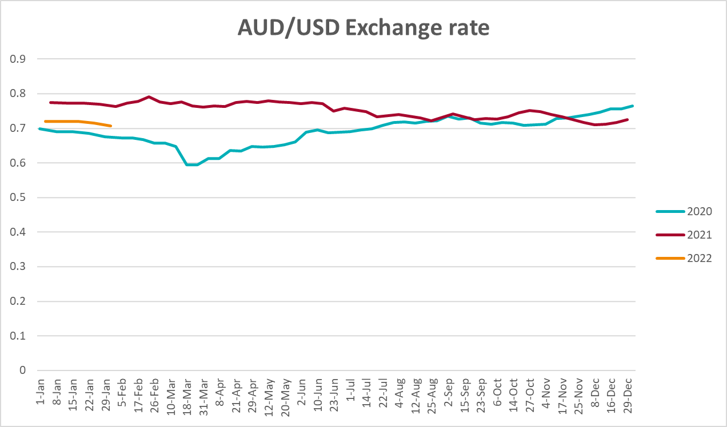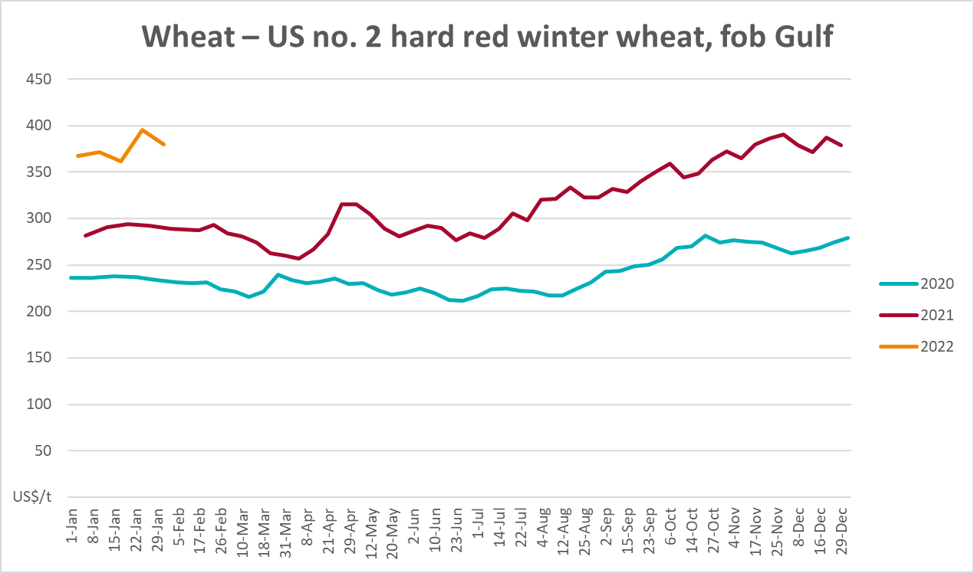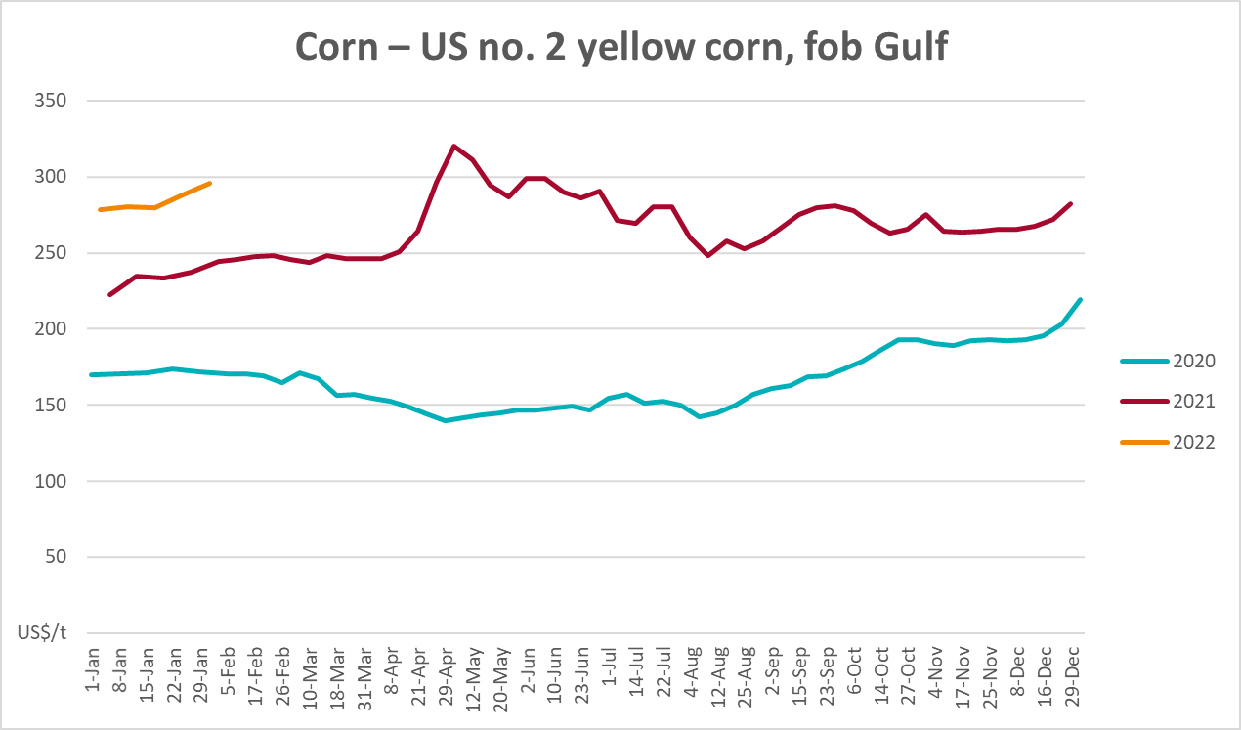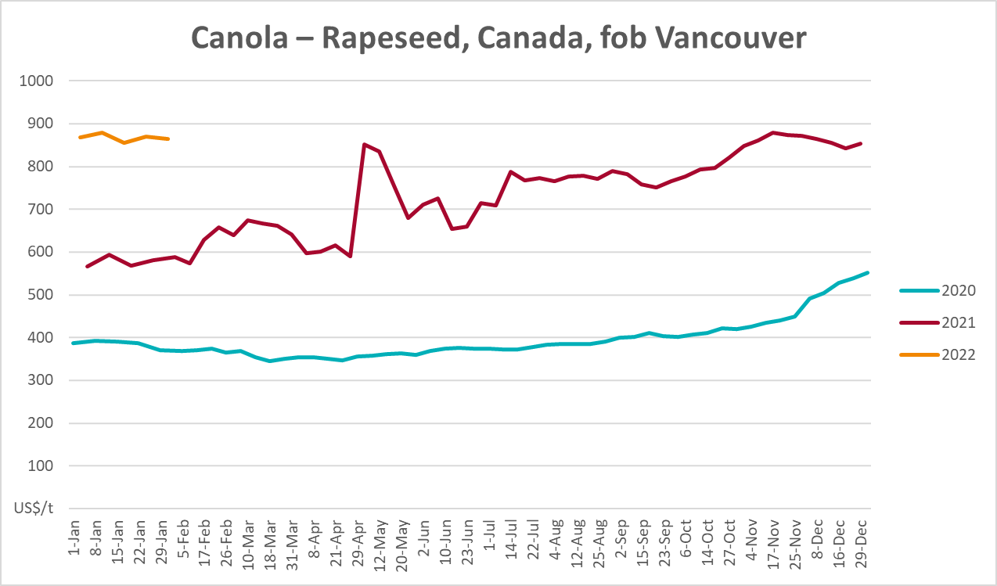
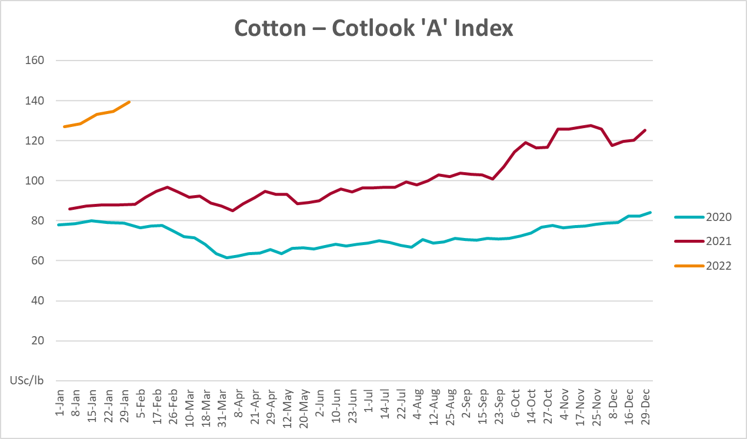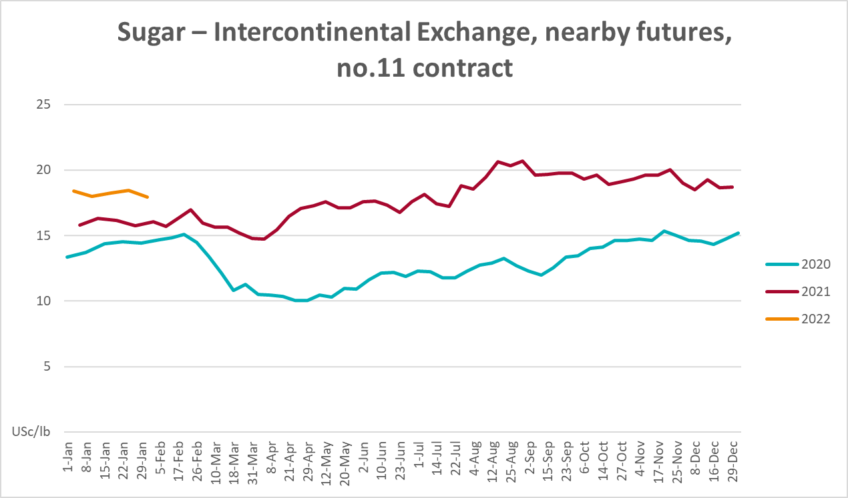
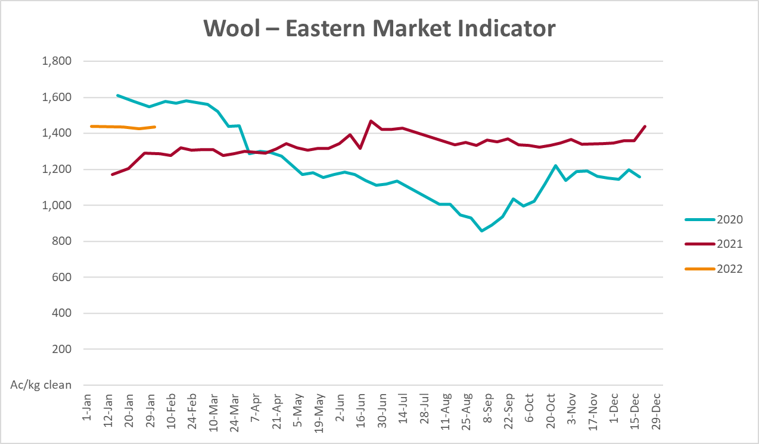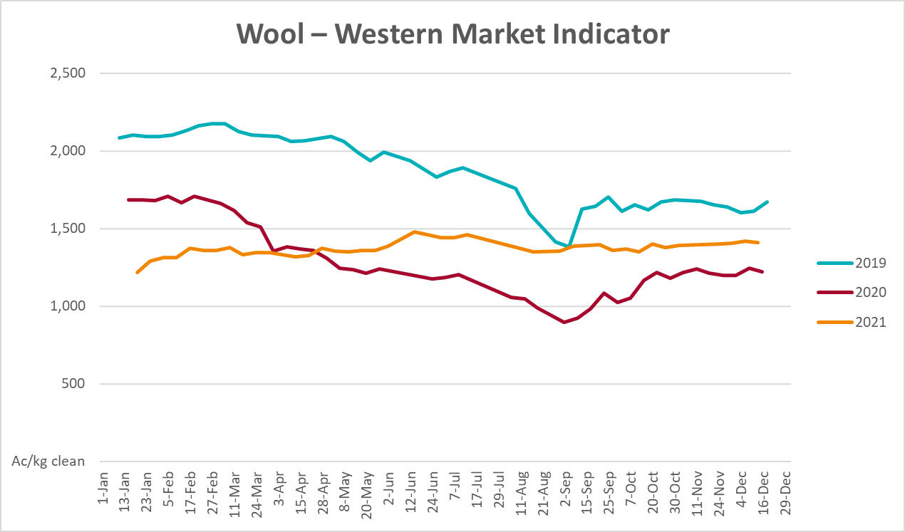

Selected domestic crop indicator prices
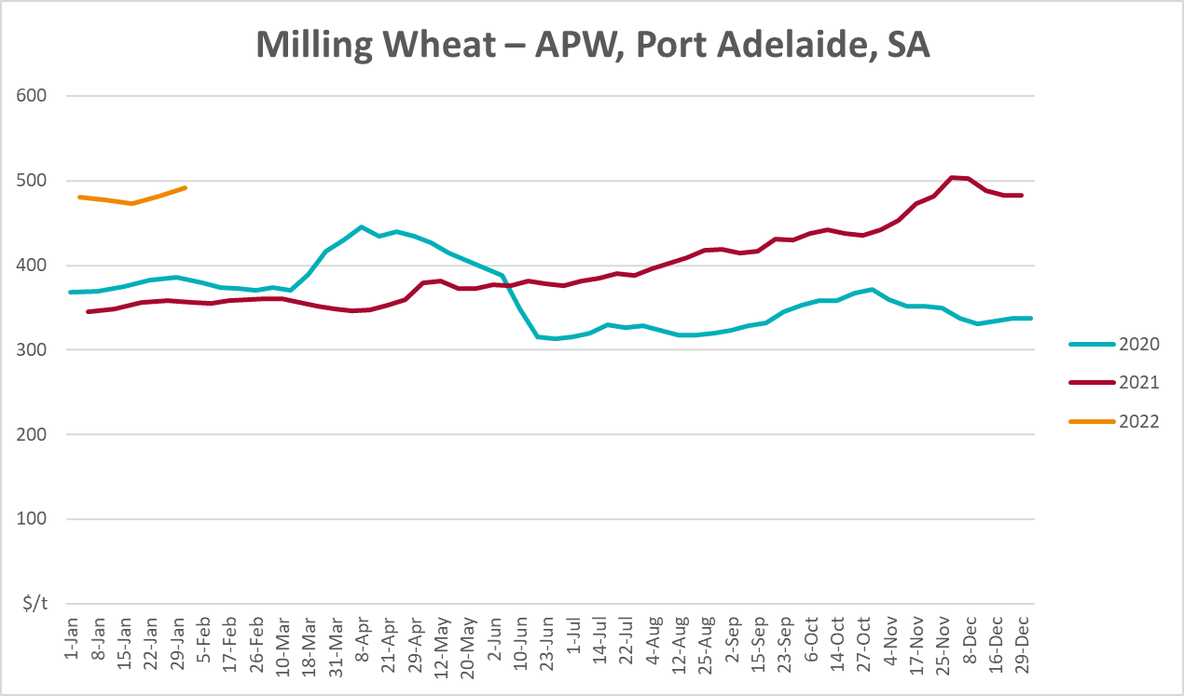
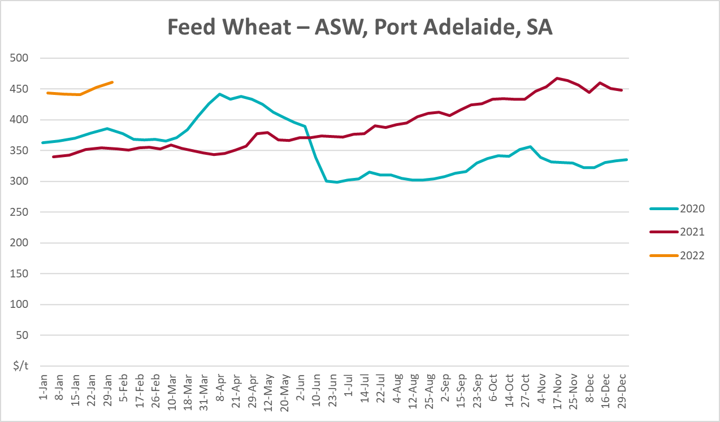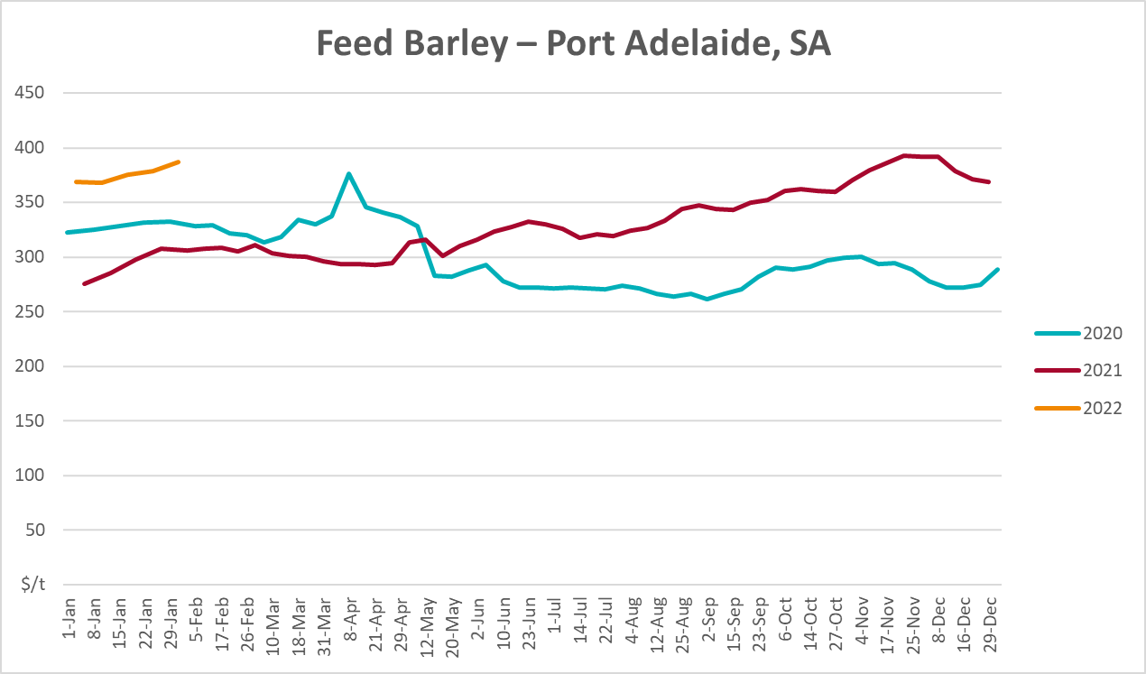
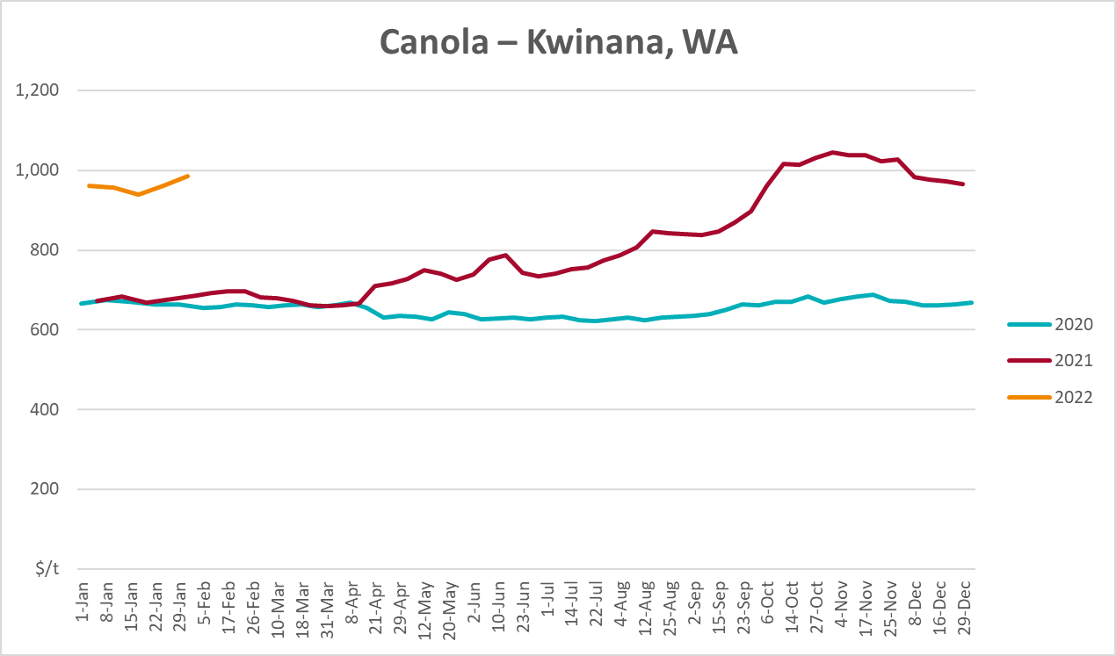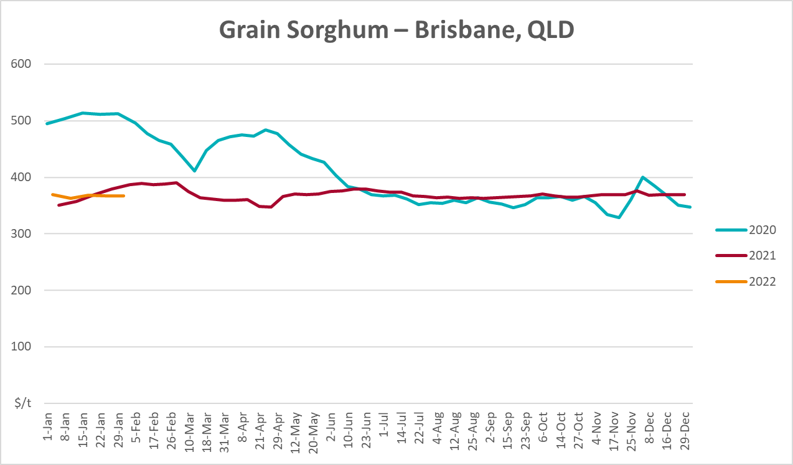

Selected domestic livestock indicator prices
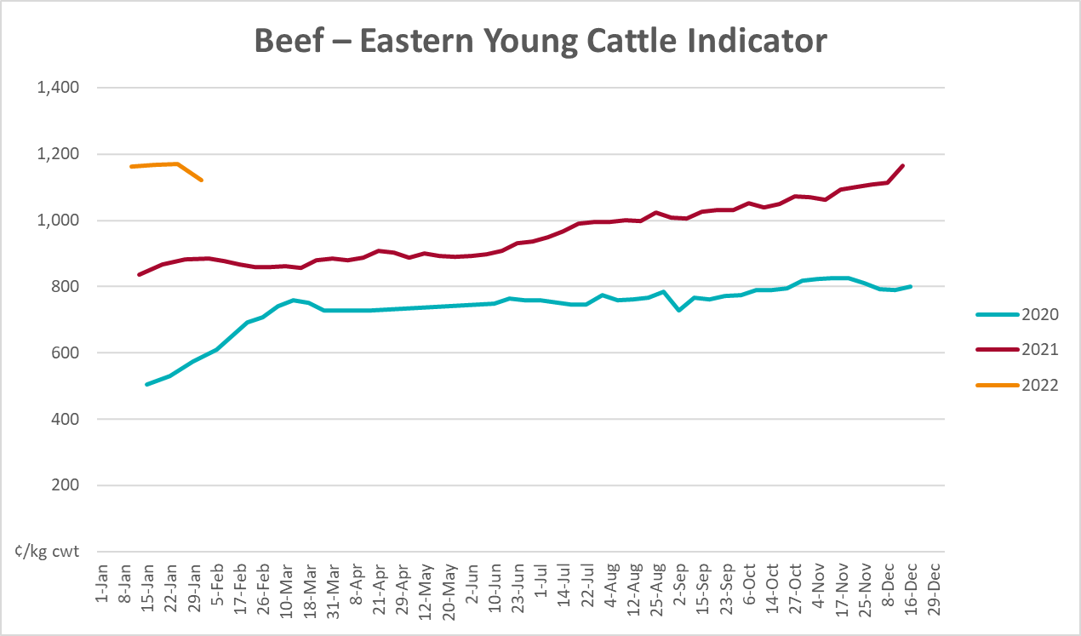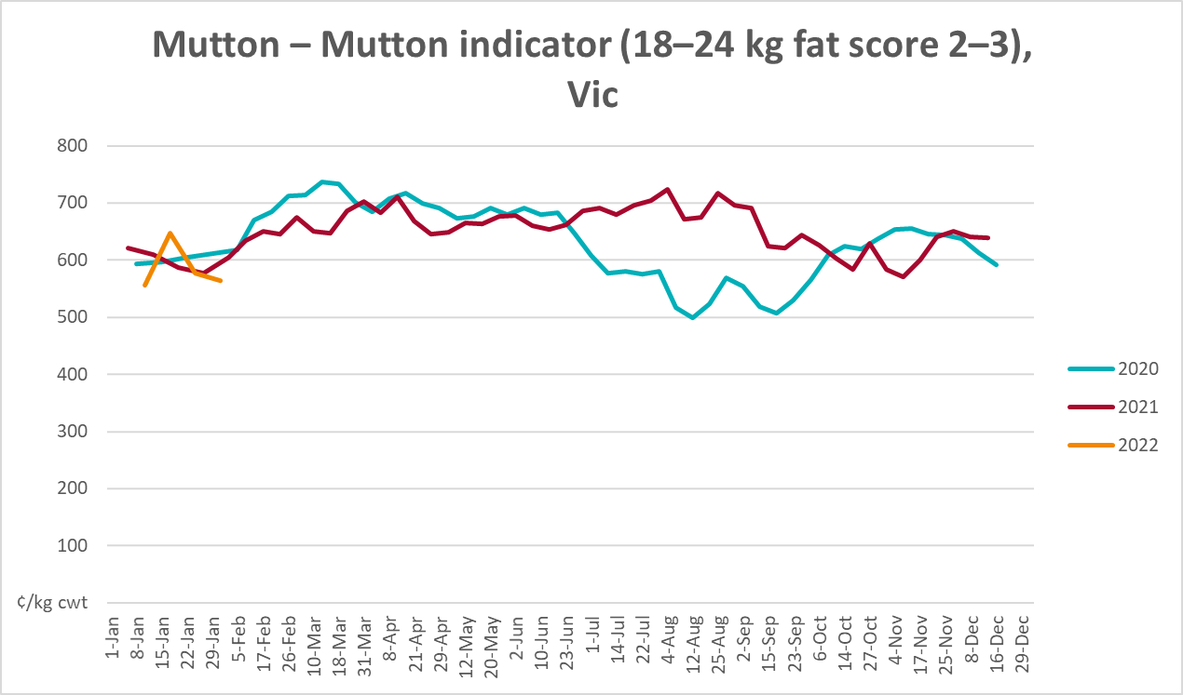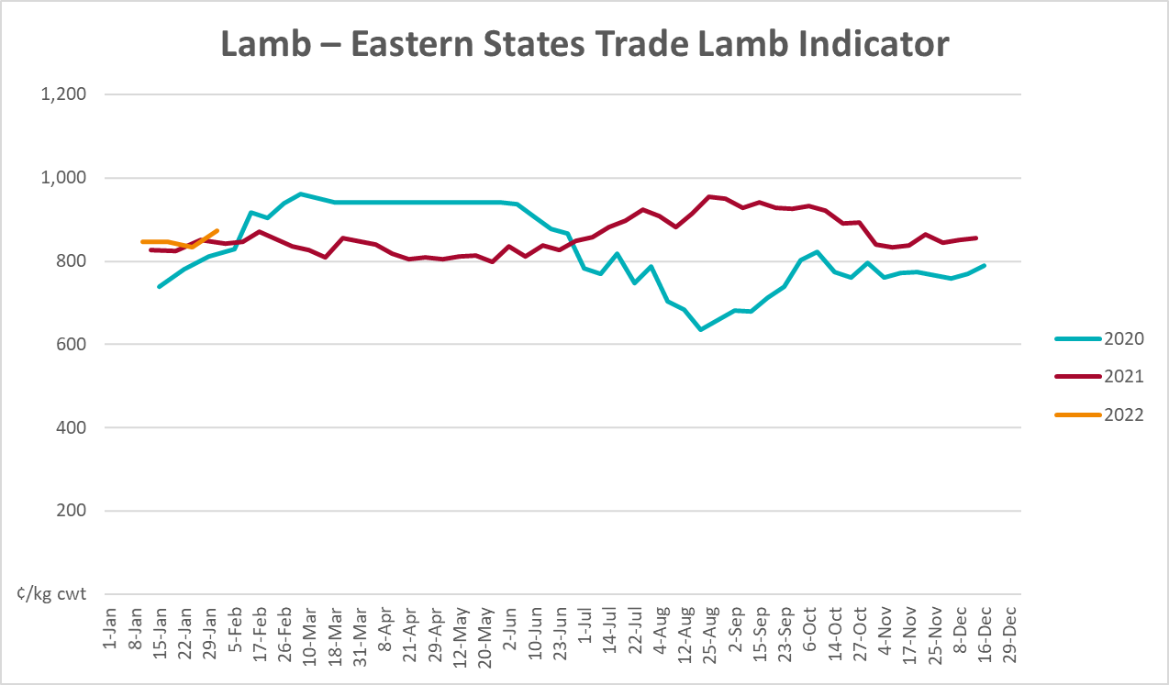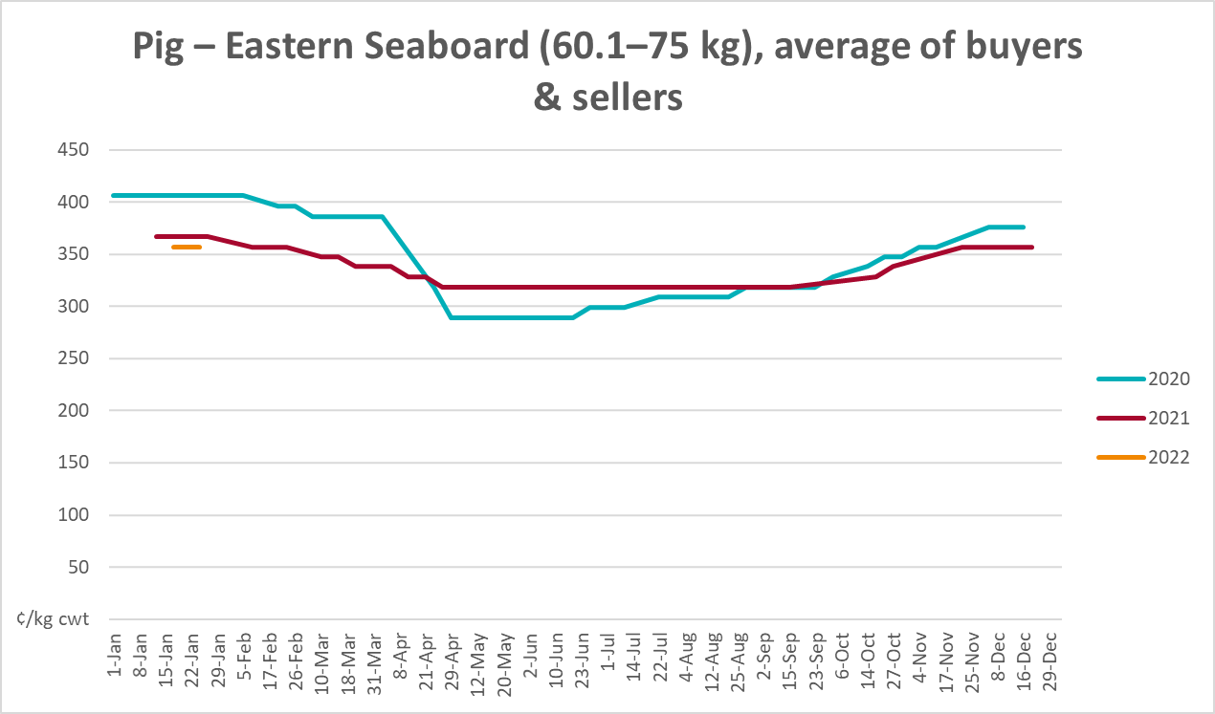
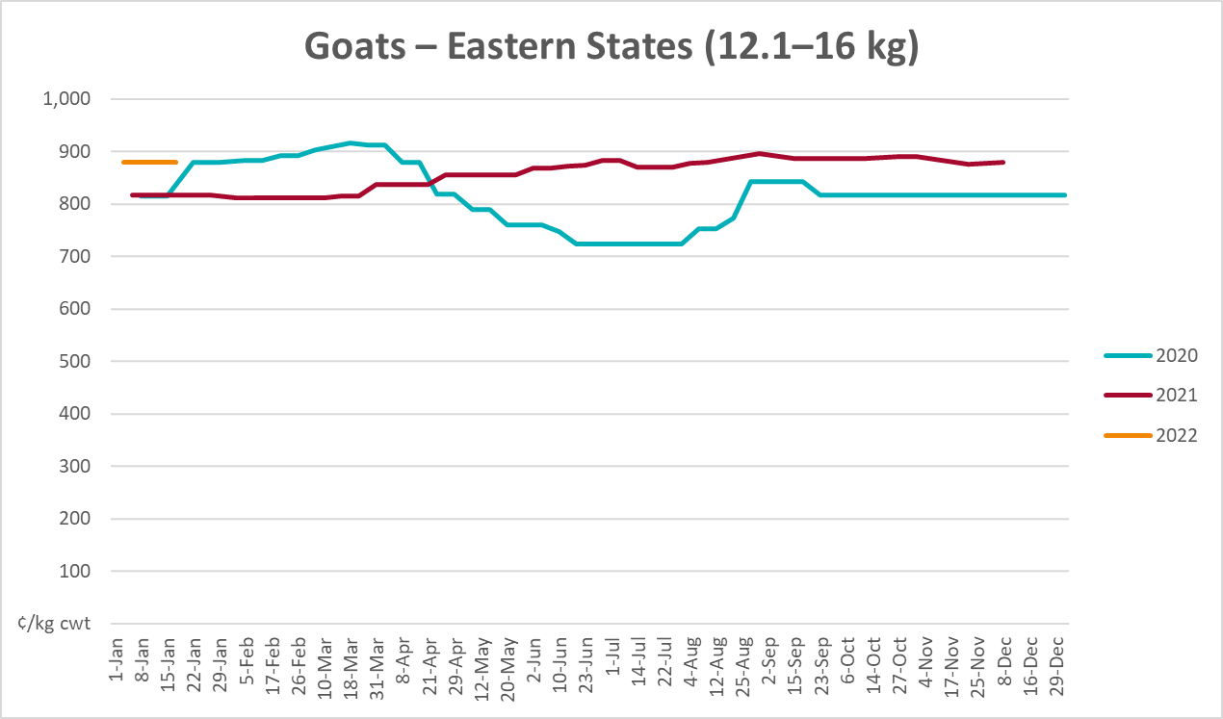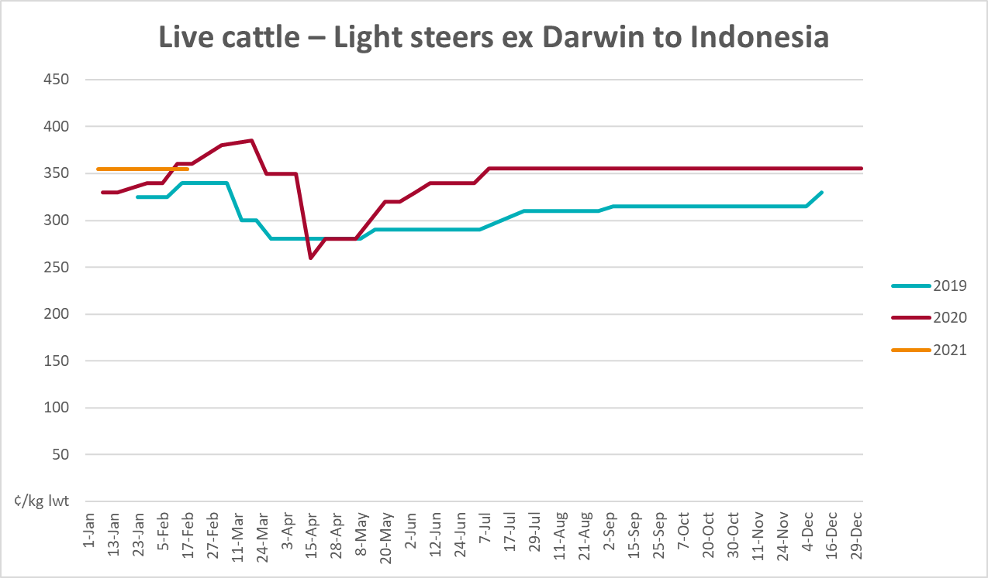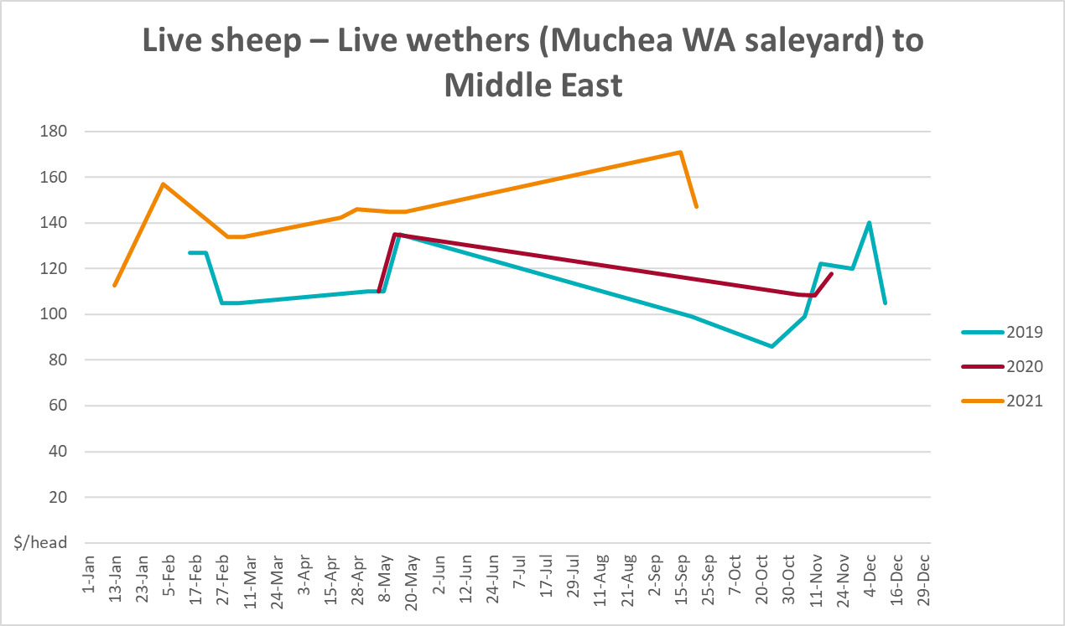

Global Dairy Trade (GDT) weighted average prices
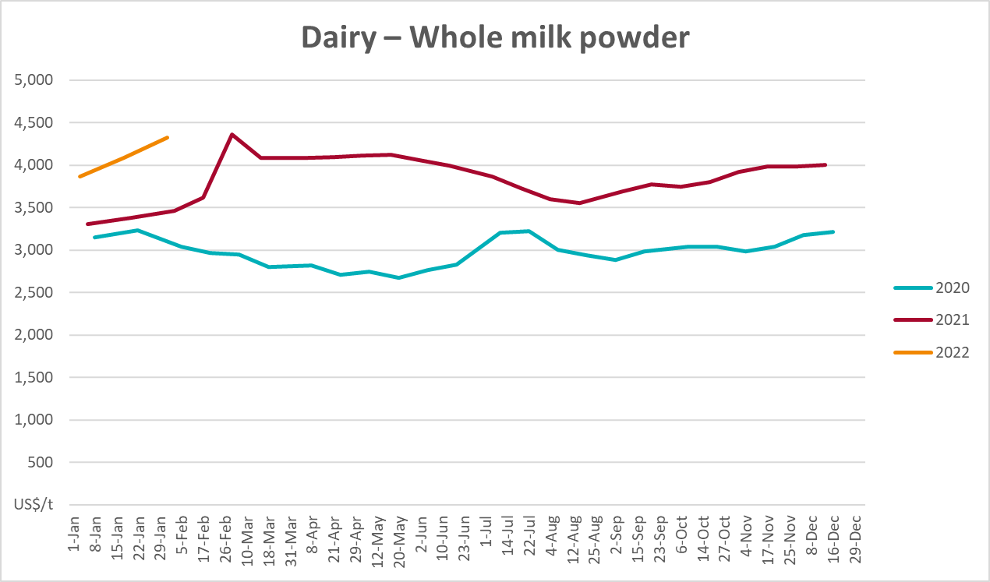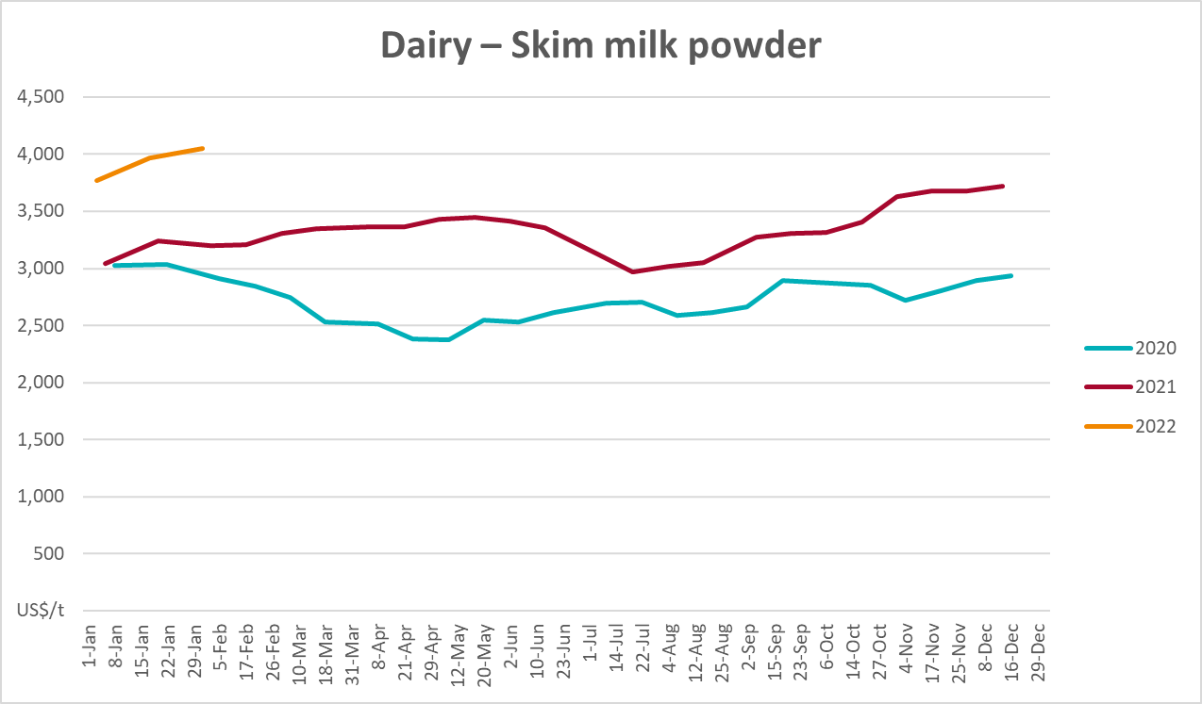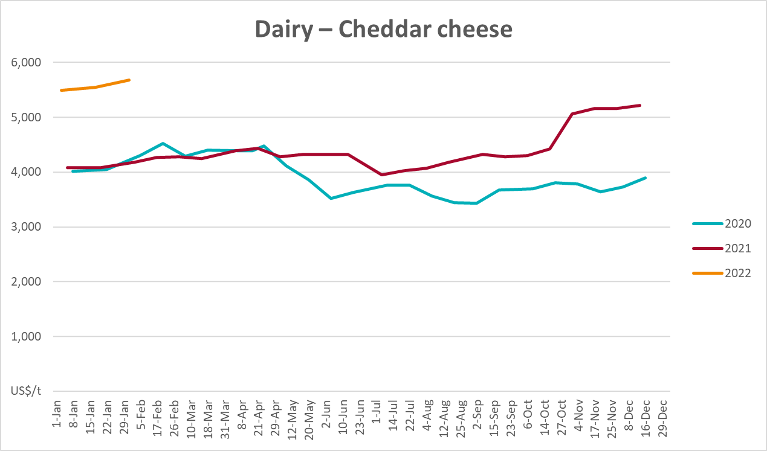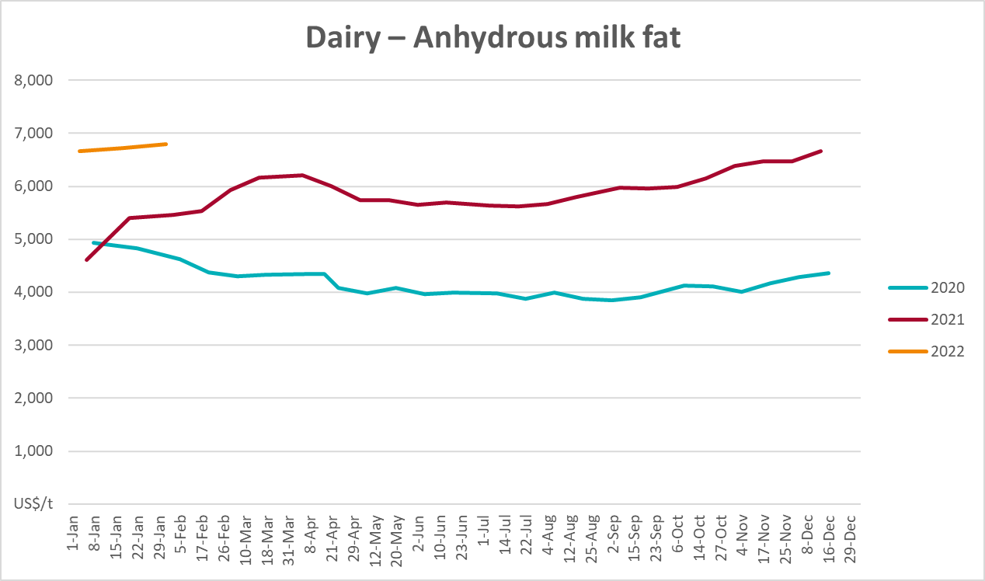

Selected fruit and vegetable prices
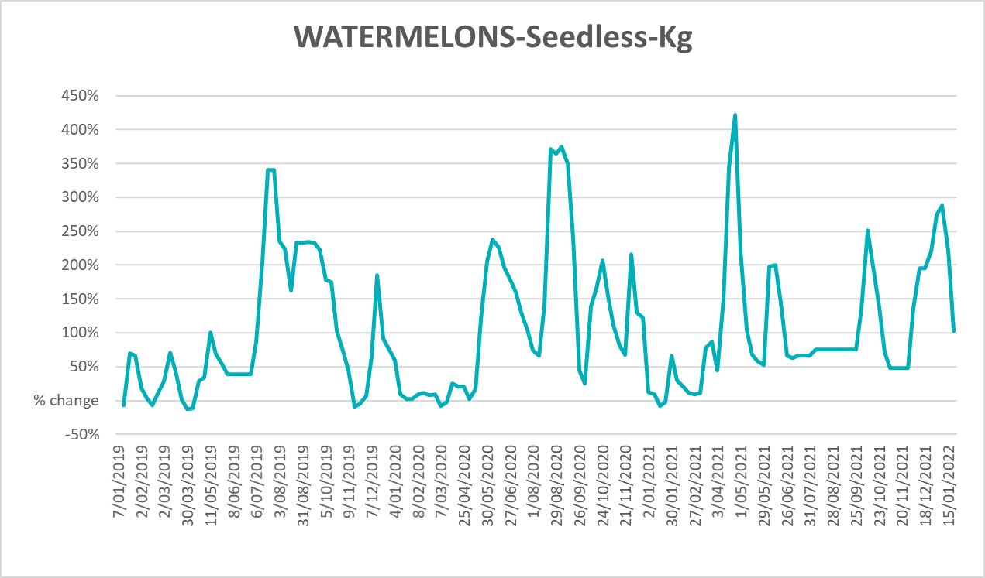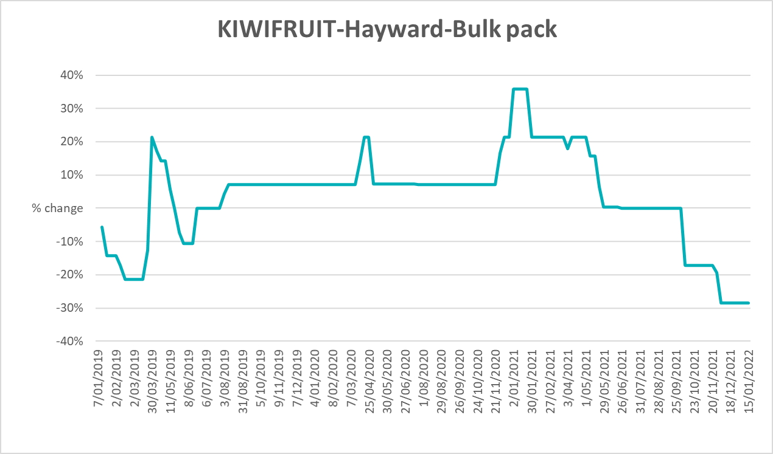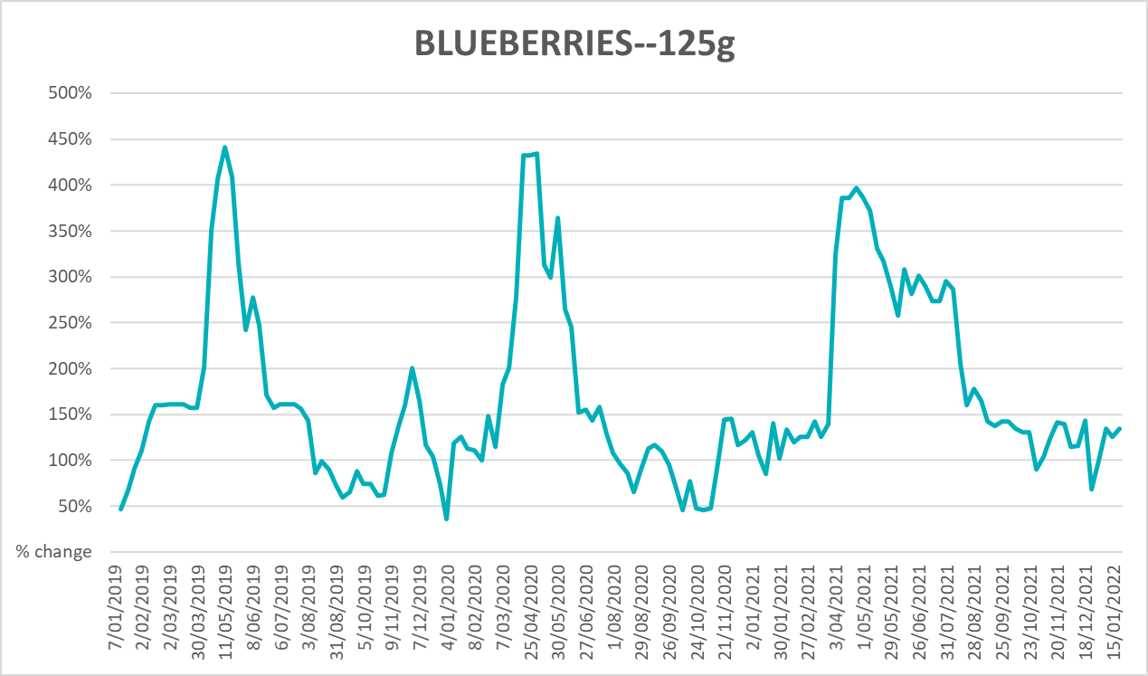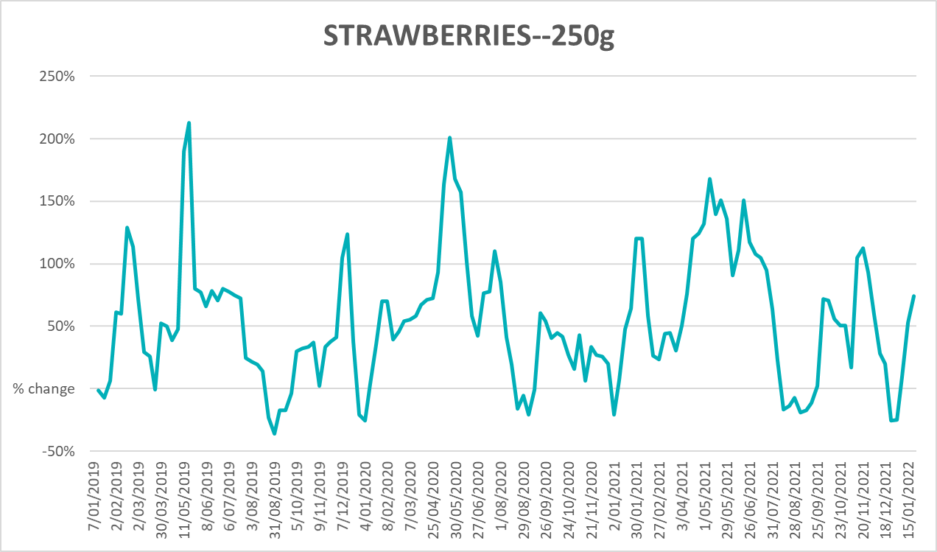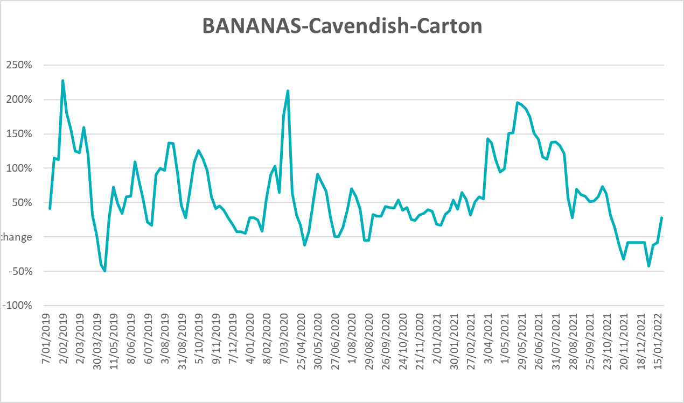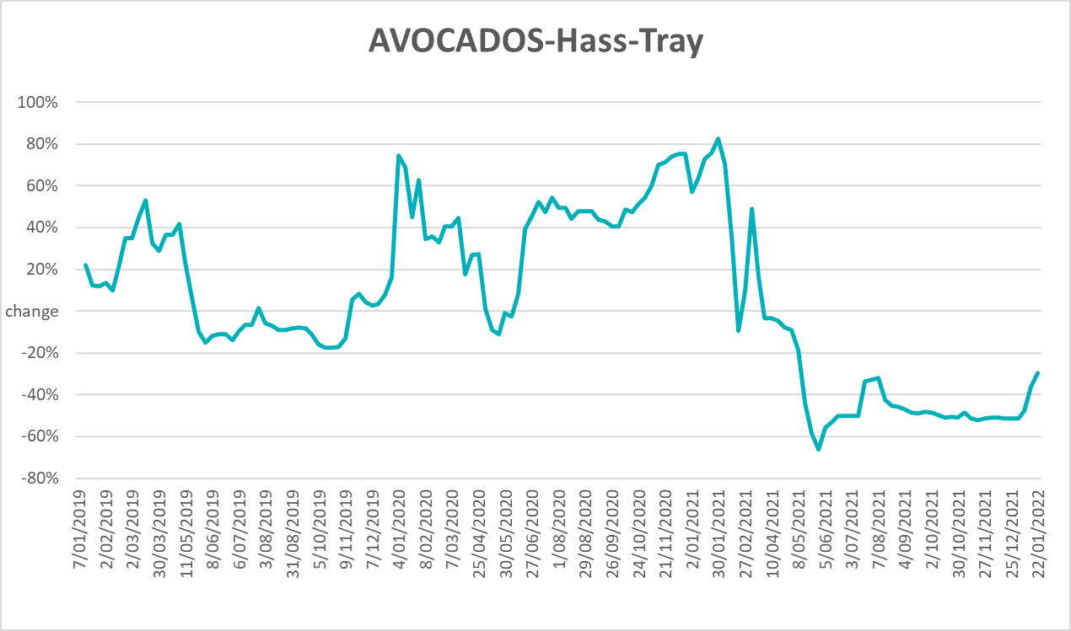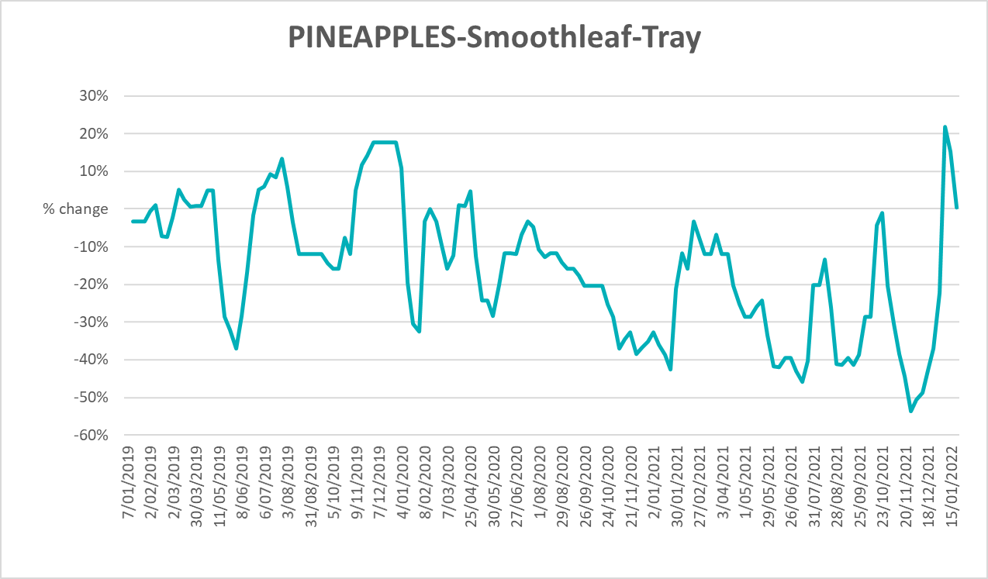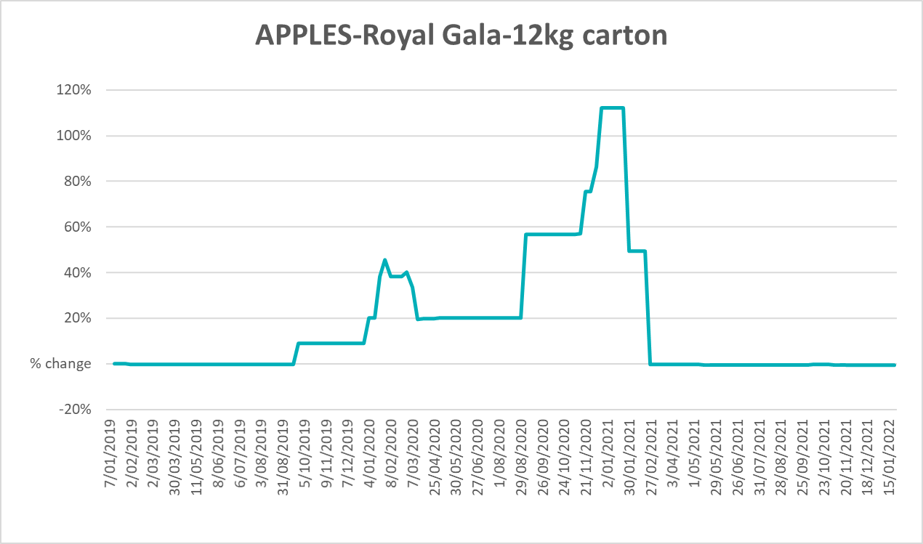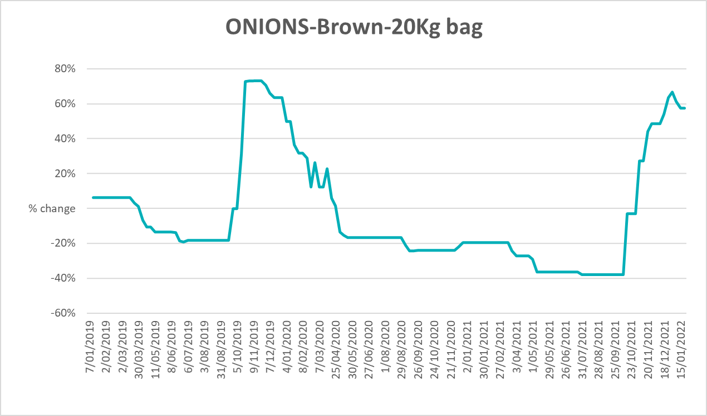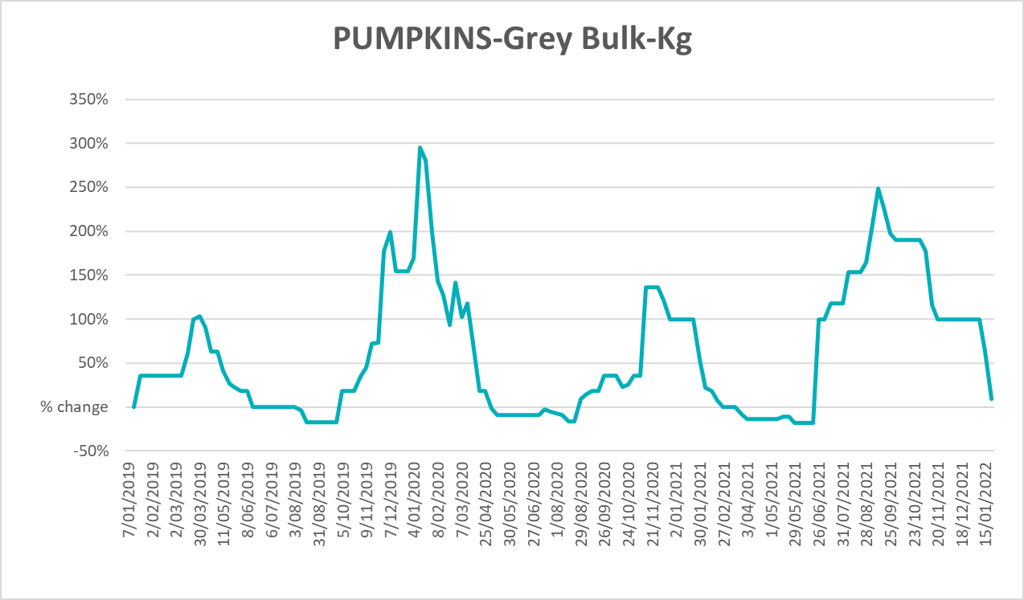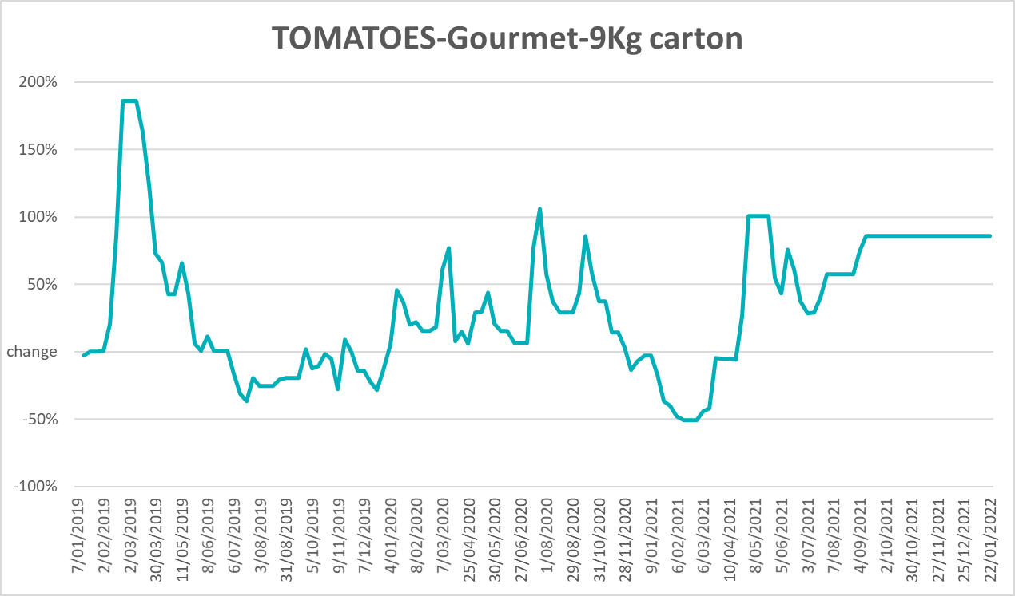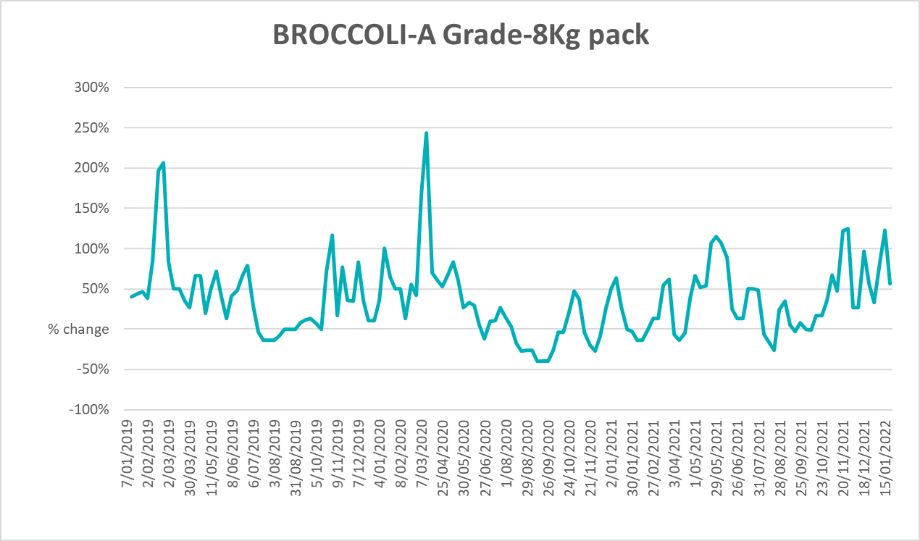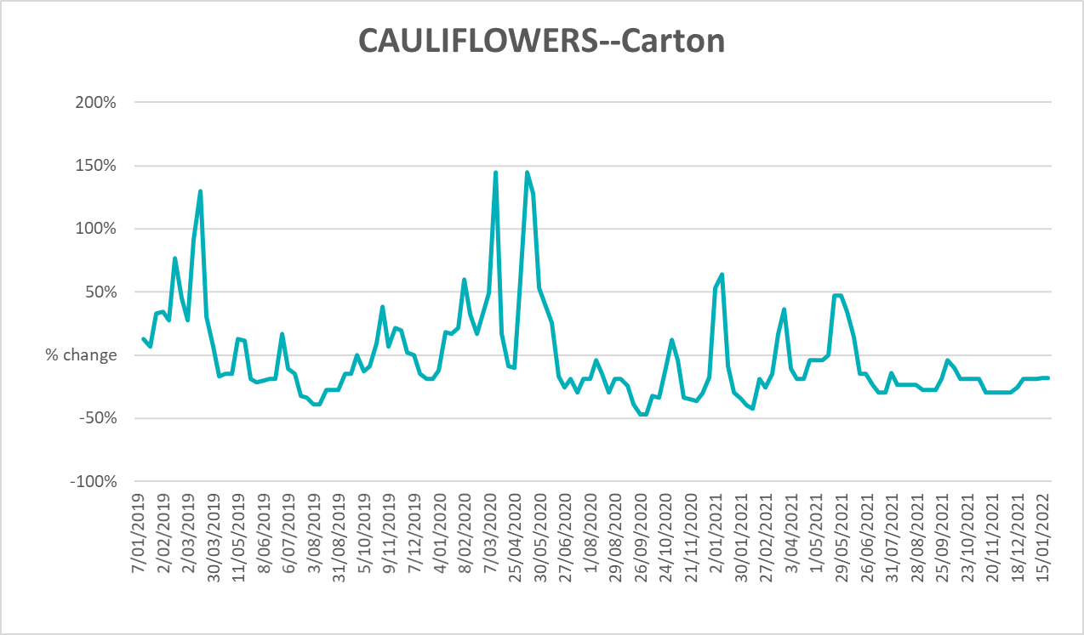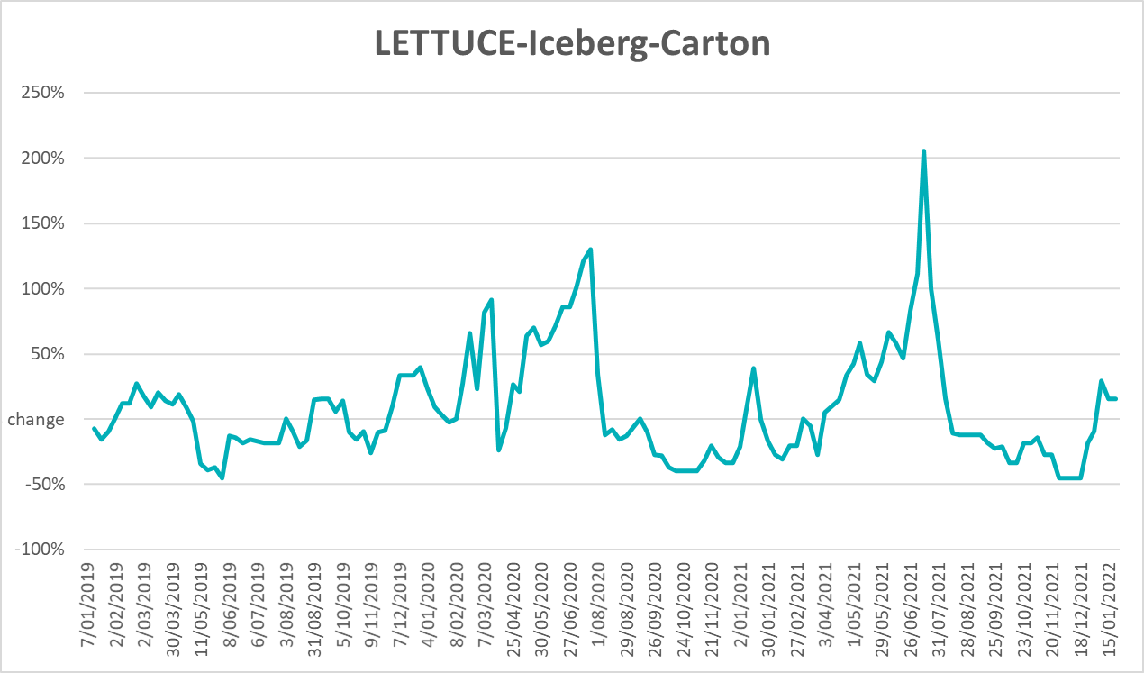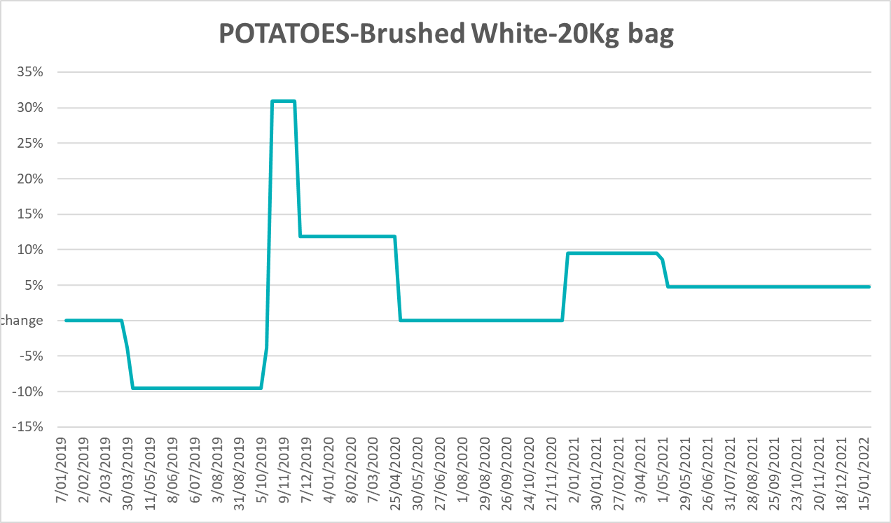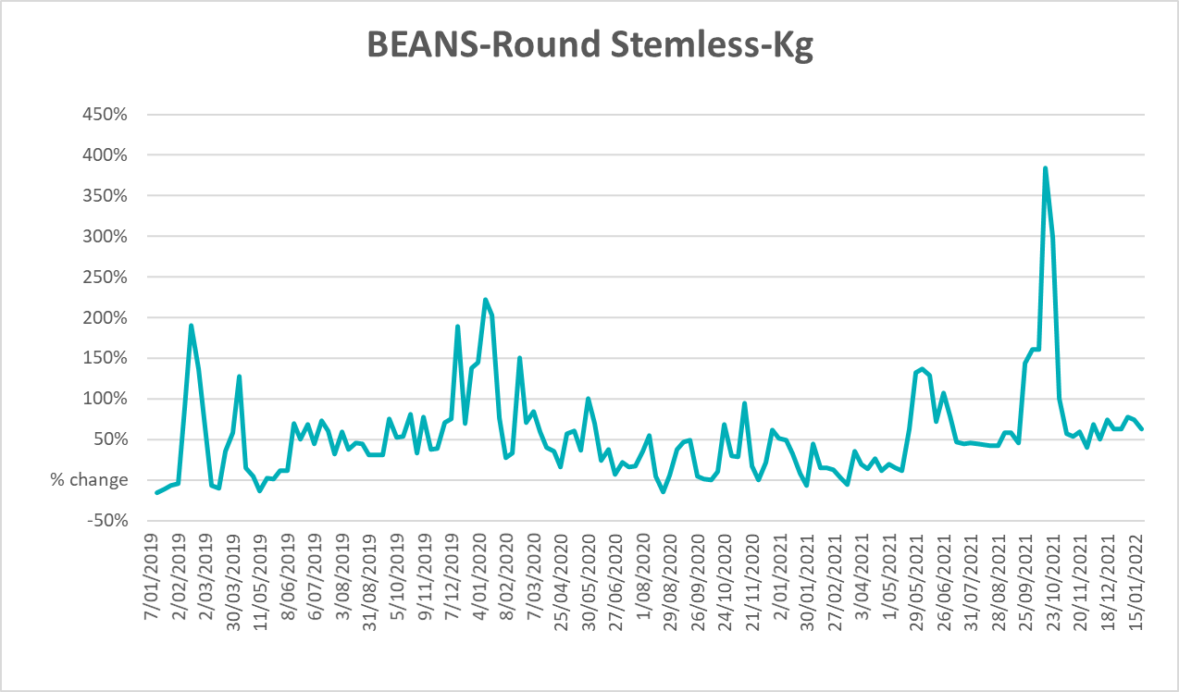

Selected domestic fodder indicator prices
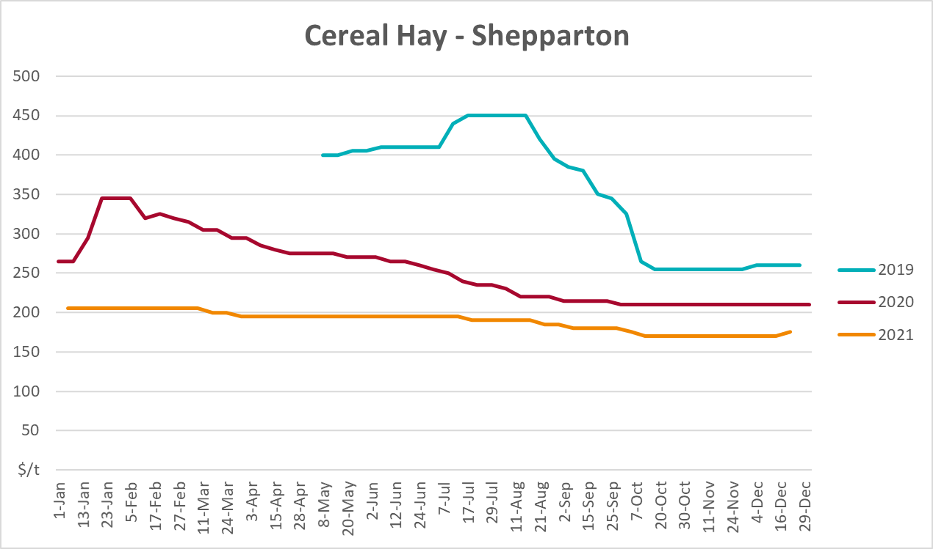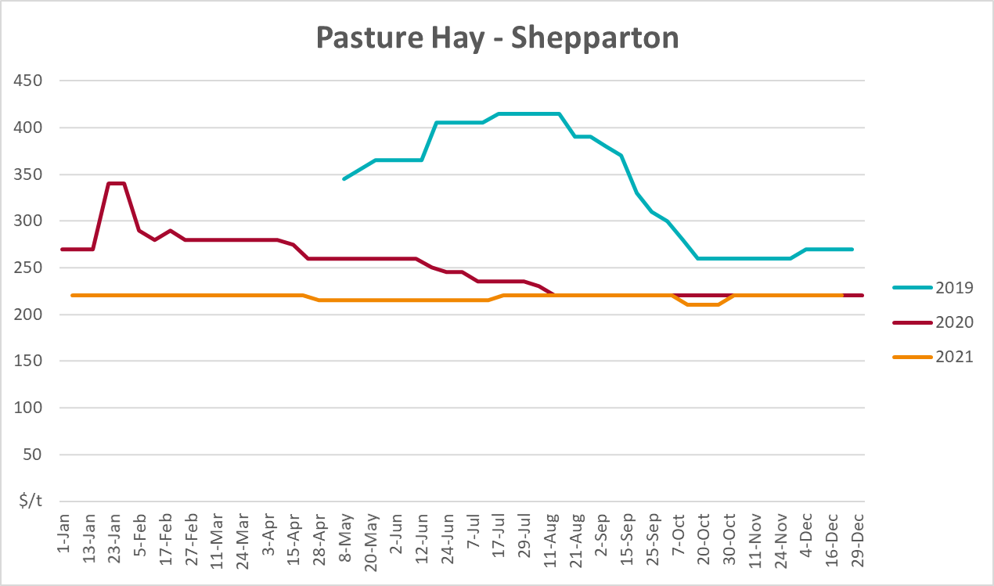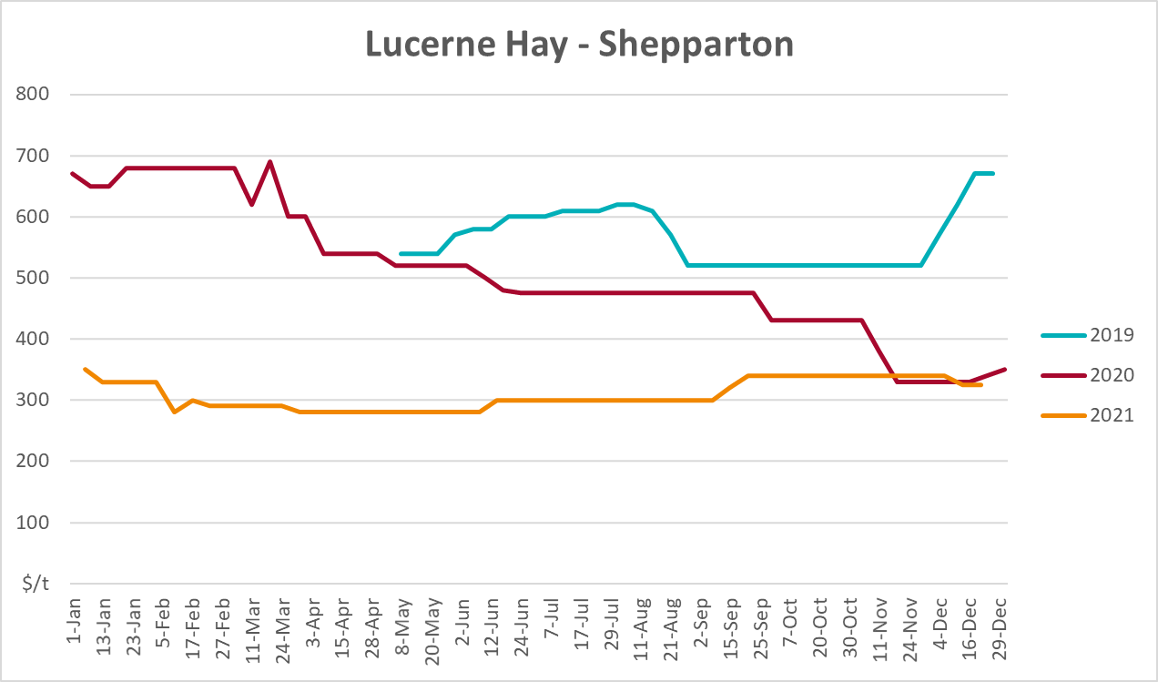

Data attribution

Climate
Bureau of Meteorology
- Weekly rainfall totals: www.bom.gov.au/climate/maps/rainfall/
- Monthly and last 3-month rainfall percentiles: www.bom.gov.au/water/landscape/
- Temperature anomalies: www.bom.gov.au/jsp/awap/temp/index.jsp
- Rainfall forecast: www.bom.gov.au/jsp/watl/rainfall/pme.jsp
- Seasonal outlook: www.bom.gov.au/climate/outlooks/#/overview/summary/
- Climate drivers: http://www.bom.gov.au/climate/enso/
- Soil moisture: www.bom.gov.au/water/landscape/
Other
- Pasture growth: www.longpaddock.qld.gov.au/aussiegrass/
- 3-month global outlooks: Environment and Climate Change Canada, NOAA Climate Prediction Center, EUROBRISA CPTEC/INPE, European Centre for Medium-Range Weather Forecasts, Hydrometcenter of Russia, National Climate Center Climate System Diagnosis and Prediction Room (NCC), International Research Institute for Climate and Society
- Global production: https://ipad.fas.usda.gov/ogamaps/cropmapsandcalendars.aspx
- Autumn break: Pook et al., 2009, https://rmets-onlinelibrary-wiley-com.virtual.anu.edu.au/doi/epdf/10.1002/joc.1833

Water
Prices
- Waterflow: https://www.waterflow.io/
- Ruralco: https://www.ruralcowater.com.au/
Bureau of Meteorology:
- Allocation trade: http://www.bom.gov.au/water/dashboards/#/water-markets/mdb/at
- Storage volumes: http://www.bom.gov.au/water/dashboards/#/water-storages/summary/drainage
Trade constraints:
- Water NSW: https://www.waternsw.com.au/customer-service/ordering-trading-and-pricing/trading/murrumbidgee
- Victorian Water Register: https://www.waterregister.vic.gov.au/TradingRules2019/

Commodities
Fruit and vegetables
- Datafresh: www.freshstate.com.au
Pigs
- Australian Pork Limited: www.australianpork.com.au
Dairy
- Global Dairy Trade: www.globaldairytrade.info/en/product-results/
World wheat, canola
- International Grains Council
World coarse grains
- United States Department of Agriculture
World cotton
- Cotlook: www.cotlook.com/
World sugar
- New York Stock Exchange - Intercontinental Exchange
Wool
- Australian Wool Exchange: www.awex.com.au/
Domestic wheat, barley, sorghum, canola and fodder
- Jumbuk Consulting Pty Ltd: http://www.jumbukag.com.au/
Cattle, beef, mutton, lamb, goat and live export
- Meat and Livestock Australia: www.mla.com.au/Prices-and-market
© Commonwealth of Australia 2022

Ownership of intellectual property rights
Unless otherwise noted, copyright (and any other intellectual property rights, if any) in this publication is owned by the Commonwealth of Australia (referred to as the Commonwealth).

Creative Commons licence
All material in this publication is licensed under a Creative Commons Attribution 4.0 International Licence except content supplied by third parties, logos and the Commonwealth Coat of Arms.
Inquiries about the licence and any use of this document should be emailed to copyright@awe.gov.au.


Cataloguing data
This publication (and any material sourced from it) should be attributed as:
ABARES 2021, Weekly Australian Climate, Water and Agricultural Update, Australian Bureau of Agricultural and Resource Economics and Sciences, Canberra, 10 February 2021. CC BY 4.0 DOI: https://doi.org/10.25814/5f3e04e7d2503
ISSN 2652-7561
This publication is available at https://www.agriculture.gov.au/abares/products/weekly_update
Department of Agriculture, Water and the Environment
GPO Box 858 Canberra ACT 2601
Telephone 1800 900 090
Web awe.gov.au/abares

Disclaimer
The Australian Government acting through the Department of Agriculture, Water and the Environment, represented by the Australian Bureau of Agricultural and Resource Economics and Sciences, has exercised due care and skill in preparing and compiling the information and data in this publication. Notwithstanding, the Department of Agriculture, Water and the Environment, ABARES, its employees and advisers disclaim all liability, including liability for negligence and for any loss, damage, injury, expense or cost incurred by any person as a result of accessing, using or relying on any of the information or data in this publication to the maximum extent permitted by law.

Statement of Professional Independence
The views and analysis presented in ABARES publications, including this one, reflect ABARES professionally independent findings, based on scientific and economic concepts, principles, information and data. These views, analysis and findings may not reflect or be consistent with the views or positions of the Australian Government, or of organisations or groups who have commissioned ABARES reports or analysis. More information on professional independence is provided on the ABARES website.

Acknowledgements
This report was prepared by Matthew Miller and Cameron Van-Lane.

