# Commonwealth Environmental Water Office Water Management Plan 2021–22

Chapter 8 Macquarie Valley Water Plan

© Commonwealth of Australia 2021

**Ownership of intellectual property rights**

Unless otherwise noted, copyright (and any other intellectual property rights) in this publication is owned by the Commonwealth of Australia (referred to as the Commonwealth).

**Creative Commons licence**

All material in this publication is licensed under a [Creative Commons Attribution 4.0 International Licence](https://creativecommons.org/licenses/by/4.0/legalcode) except content supplied by third parties, logos and the Commonwealth Coat of Arms.

Inquiries about the licence and any use of this document should be emailed to [copyright@awe.gov.au](mailto:copyright@awe.gov.au).



**Cataloguing data**

This publication (and any material sourced from it) should be attributed as: Commonwealth of Australia 2021, Commonwealth Environmental Water Office Water Management Plan 2021–22: Macquarie Valley Water Plan, Canberra. CC BY 4.0.

ISBN 978-1-76003-434-4

This publication is available at [environment.gov.au/water/cewo/publications/water-management-plan-2021–22](https://www.environment.gov.au/water/cewo/publications/water-management-plan-2021-22).

For more information about Commonwealth environmental water, contact us at:

Commonwealth Environmental Water Office

Department of Agriculture, Water and the Environment

GPO Box 858 Canberra ACT 2601

Telephone 1800 803 772

Email [ewater@awe.gov.au](mailto:ewater@awe.gov.au)

Web [environment.gov.au/water/cewo](http://www.environment.gov.au/water/cewo)

For issues accessing links in this document, please visit the [homepage](https://www.environment.gov.au/water/cewo) or let us know by [email](mailto:ewater@awe.gov.au).

**Disclaimer**

The Commonwealth of Australia has made all reasonable efforts to identify content supplied by third parties using the format ‘© Copyright’ noting the third party.

The views and opinions expressed in this publication are those of the authors and do not necessarily reflect those of the Australian Government or the Minister for the Environment.

While reasonable efforts have been made to ensure that the contents of this publication are factually correct, the Commonwealth does not accept responsibility for the accuracy or completeness of the contents and shall not be liable for any loss or damage that may be occasioned directly or indirectly by, or reliance on, the contents of this publication.

**Acknowledgement of the Traditional Owners of the Murray–Darling Basin**

The Commonwealth Environmental Water Office respectfully acknowledges the Traditional Owners, their Elders past and present, their Nations of the Murray–Darling Basin, and their cultural, social, environmental, spiritual and economic connection to their lands and waters.

Contents

8 Macquarie Valley Water Plan 1

8.1 Region overview 1

8.2 Environmental objectives 3

8.3 First Nations environmental watering objectives 3

8.4 Recent conditions and seasonal outlook 3

8.5 Water delivery in 2021–22 10

8.6 Monitoring and lessons learned 12

References 14

**Tables**

Table MV1 Environmental demands and watering priorities, 2021–22, and outlook for coming year, Macquarie Valley 6

Table MV2 Key lessons learned in Macquarie Valley 12

**Maps**

Map MV1 Macquarie Valley 2

Map MV2 a) Macquarie Marshes vegetation mapping and b) Inundation frequencies, Macquarie Marshes, 1988 to 2008 11

## Macquarie Valley Water Plan

### Region overview

#### River system

The Macquarie Valley is located in Central Western New South Wales (NSW) extending from the Blue Mountains to the Barwon River, east of Brewarrina. The Macquarie River forms above Bathurst, where the Campbells and Fish rivers join, and flows into Burrendong Dam, south east of Wellington (Map MV1). Below the dam, tributary flows are provided by the Bell, Little and Talbragar rivers, and Wambangalong and Coolbaggie creeks. As the land flattens further west of Dubbo, the Macquarie River provides flows to distributary creeks, wetlands and rich alluvial river flats associated with braided channels, and provides important connections with the Barwon–Darling River.

Macquarie River flows are heavily influenced by large rainfall events in the upper catchment and flows in tributary systems. Two major storages, Windamere Dam (capacity 368 gigalitres) on the Cudgegong River (WaterNSW 2021a), and Burrendong Dam on the Macquarie River (storage capacity of 1,188 gigalitres, with additional storage capacity of 489 gigalitres in the flood mitigation zone) (WaterNSW 2021b), regulate catchment water supplies.

#### Traditional Owners

The rivers and wetlands of the Macquarie River Valley hold significant spiritual and cultural importance for Aboriginal people (NSW DECCW 2010). In the upper and middle Macquarie Valley, the Aboriginal people are the Wiradjuri, while on the plains the Bogan River forms the boundary between the Ngemba and Ngiyampaa Nations to the west and the Wayilwan Nation to the east (MDBA 2021). Wayilwan country includes most of the Castlereagh catchment, except the north-east corner, which is the traditional land of the Kamilaroi (MDBA 2021). The Commonwealth Environmental Water Office (CEWO) respectfully acknowledges these Nations, their Elders past and present, as the Traditional Custodians of the lands on which this chapter is focused.

#### Important sites and values

The valley includes the Macquarie Marshes wetland complex on the lower reaches of the Macquarie River, of which, parts of the northern, southern and eastern Marshes are listed as a Wetland of International Importance under the Ramsar Convention (NSW DECCW 2010). These areas were recognised under the Ramsar Convention for being a unique example of a wetland type in the region in terms of their size and their diversity of wetland types, supporting species of conservation significance and biological diversity, providing refuge during adverse conditions, and regularly supporting large numbers of waterbirds (NSW OEH 2012). This includes those listed under international migratory agreements (JAMBA, ROKAMBA, CAMBA). The Ramsar site contains a range of habitats including core areas of semi-permanent wetlands, such as forests and woodlands, reed beds, marshes, rushlands and open lagoons. These vegetation types have been identified as critical components of the Ramsar site (NSW OEH 2012).

Other assets in the valley downstream of Burrendong Dam, where water for the environment can be delivered, include the Macquarie River channel, the unregulated components of the lower Macquarie River and the distributary creek system to the west of the Marshes.

The Macquarie Marshes and Macquarie River support numerous species listed as endangered or vulnerable under the Environment Protection and Biodiversity Conservation Act 1999, for example, the Australian painted snipe, Australasian bittern, and Murray cod (NSW OEH 2012). The aquatic community of the Macquarie also forms part of the Lowland Darling River aquatic ecological community, which is listed as endangered under the NSW Fisheries Management Act 1994 (NSW DPI 2007).

#### Stakeholder engagement

In the Macquarie River Valley, the planning, management, and delivery of Commonwealth water for the environment is undertaken in conjunction with a range of partners and stakeholder groups. Key stakeholders in the Macquarie include the NSW Department of Planning, Industry and Environment – Environment, Energy and Science (DPIE – EES), the Department of Primary Industries (DPI) – Fisheries, WaterNSW, and the Macquarie Cudgegong Environmental Flow Reference Group (EFRG), who provide advice to water managers on priorities for water use.

Local Engagement Officers from the Commonwealth Environmental Water Office (CEWO) also work with different stakeholders as part a broader program of engagement around the management of the Commonwealth environmental water entitlements. As part of this work, Local Engagement Officers have been engaging directly with members of the local Aboriginal community.

Map MV Macquarie Valley

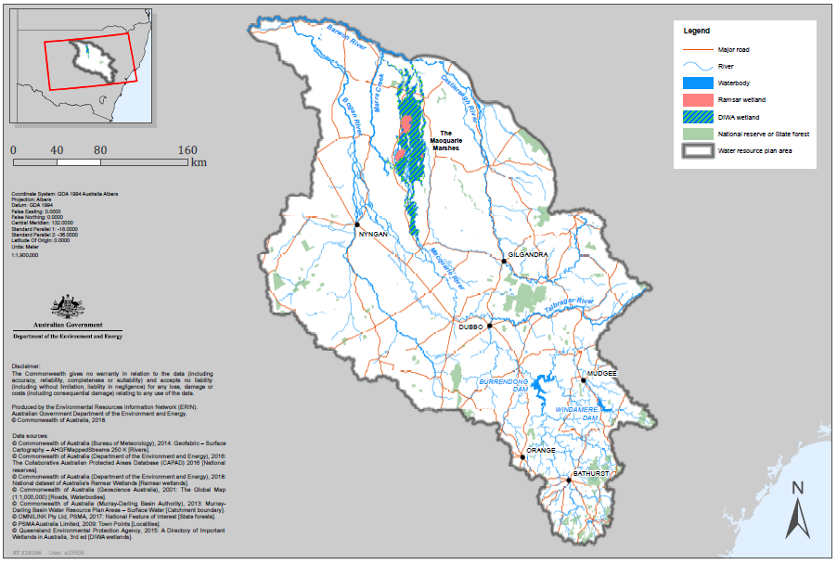

Source: Department of the Environment and Energy (2018)

Note: DIWA refers to the Directory of Important Wetlands in Australia.

### Environmental objectives

Based on long-term environmental objectives in the Basin Plan, state long-term watering plans, site management plans (including Ramsar site ecological character descriptions), and best available knowledge, the following objectives are relevant for environmental watering in the Macquarie Valley.

The objectives that are targeted in a particular year may vary, depending on available water, catchment conditions, operational feasibility, and demand for environmental water. These objectives will continue to be revised as part of the Commonwealth Environmental Water Office’s (CEWO) commitment to adaptive management. The objectives are:

* Vegetation – Maintain the condition, growth and survival of riparian, in-channel, floodplain and wetland vegetation.
* Waterbirds – Increase waterbird abundance and maintain species diversity by supporting naturally triggered breeding events, and maintaining suitable refuge, feeding and breeding habitat.
* Native fish – Prevent loss of native fish species and improve population structure and distribution, by supporting opportunities for movement, dispersal, reproduction, and recruitment.
* Other vertebrates – Support opportunities for the reproduction and recruitment of other native aquatic species, including frogs and turtles.
* Connectivity – Support longitudinal connectivity, including with the Barwon River, and lateral connectivity between the river and floodplain.
* Processes/water quality/resilience – Support key ecosystem functions and promote productivity; maintain water quality in channels and pools; and maintain drought refuge habitat.

### First Nations environmental watering objectives

The CEWO is committed to working with First Nations groups to better understand their objectives. The CEWO will use environmental flows to contribute to these objectives where possible and where this is consistent with the Commonwealth Environmental Water Holder’s statutory responsibility of protecting and restoring environmental assets in the Basin (see [Chapter 2](http://www.environment.gov.au/water/cewo/publications/water-management-plan-2021-22)).

As the next steps, CEWO will develop and implement a work program to work with First Nations groups in the northern Basin. This work program will be developed in collaboration with First Nations groups and will be integral in continuing to build relationships and our capacity with First Nations groups. It will also ensure First Nations groups actively participate in the planning and management of environmental flows.

### Recent conditions and seasonal outlook

#### Recent conditions and environmental water use

The Macquarie Valley experienced its worst drought on record between 2017–18 and 2019–20. During this time rainfall was well below average, with highest on record temperatures, and inflows to Burrendong Dam were just one-third of the previous lowest volume.

Access to general security and planned environmental water accounts was restricted to 70% of the 1 July 2018 carryover balance in 2018–19. Further restrictions were then put in place in 2019–20, with all allocations of water for the environment (along with other general security water) being held in a drought sub-account. Consequently, no water for the environment was able to be delivered at that time.

The mid-Macquarie River was shut off downstream of Warren in late August 2019, resulting in cease to flow conditions, necessitating the rescue of native fish from drying refuge pools over summer. Extended cease to flow conditions resulted in no flows into the Macquarie Marshes for 10 to 12 months. The ongoing very hot and dry conditions affected the condition of vegetation in the Marshes. During the spring and summer large areas had little or no ground cover. A fire in spring 2019 also burnt large areas of the north marsh reedbed (part of the Ramsar site).

Late summer and autumn rainfall and flows in early 2020 provided much needed water to parts of the Macquarie Marshes. Commonwealth and NSW supplementary water entitlements were used to ensure some additional water was left instream to help support recovery in the Macquarie River and Marshes.

Commonwealth and NSW water for the environment was delivered during spring and summer in 2020–21 to the mid-Macquarie River and Macquarie Marshes to support recovery of these systems. This water was designed to support the breeding and recruitment of Murray cod, inundate core areas of the Macquarie Marshes to support wetland vegetation recovery, and maintain breeding and feeding habitat for waterbirds, frogs and other animals. Areas that were inundated, including the burnt north marsh reedbed, responded well to the flows. Areas that did not receive sufficient water remain in poorer condition. Murray cod and water dependent frog species were observed breeding during the delivery of water for the environment. A good diversity of waterbirds was also observed in the Marshes, including Australian painted snipe, Latham’s snipe, Australasian bittern, sharp-tailed sandpipers, brolga, ibis, spoonbills, magpie geese and ducks.

Good rainfall and tributary flows in autumn 2021 provided additional water to the mid-Macquarie River and Marshes. As of 8 June 2021, Burrendong Dam was at 57.9%, up from around 39% at the end of January 2021 (WaterNSW 2021c). Allocations of General Security entitlements were increased by another 1% on 10 June 2021, taking the total to 68% of entitlement (NSW DPIE – Water 2021).

Learn more about previous [Commonwealth environmental water use in the Macquarie Valley](http://www.environment.gov.au/water/cewo/catchment/macquarie/history).

#### Seasonal outlook

The La Niña climate pattern that was bringing more rainfall has now ended. However, other climate drivers may provide conditions over coming months that are conducive to more rainfall. According to the Bureau of Meteorology outlook, the forecast is for above average rainfall between June and August across the Macquarie Valley (BoM 2021a) and between July and September (BoM 2021b). This forecast indicates that the recent increase in rainfall may continue over winter, although conditions can change quickly in the northern Basin. Maximum temperatures across the Macquarie Valley are forecast to be average to below average between June and August (BoM 2021c), and between July and September (BoM 2021d).

#### Water availability

Commonwealth environmental water is managed in conjunction with other held and planned environmental water managed by NSW. Other flows such as tributary flows, consumptive water and other water orders may also support environmental demands in the Macquarie Valley. As of 10 June 2021, there was 82 gigalitres of planned environmental water and 99 gigalitres of Held Environmental Water available out of the 750 gigalitres of the available resources in the Macquarie (NSW DPIE 2021).

The volume of Commonwealth water for the environment carried over in the Macquarie Valley for use in 2021–22 is 71 gigalitres. The Commonwealth also holds around 8.3 gigalitres of supplementary water in the Macquarie Valley. However, delivery of this water is dependent on access announcements being made by WaterNSW.

Based on the expected available volume of water held by the Commonwealth and other water holders, as well as recent and forecast catchment conditions, it is expected that the overall resource availability will be low to high in 2021–22. Forecast allocation of regulated (surface water) Commonwealth environmental water in 2021–22 under different water availability scenarios is provided in table 4 of [Chapter 2](http://www.environment.gov.au/water/cewo/publications/water-management-plan-2021-22).

#### Environmental demands

The environmental water demands for assets in the Macquarie Valley in 2021–22 are shown in Table MV1. The capacity to contribute to these environmental demands is contingent on water availability and conditions in the catchment throughout the year.

Table MV Environmental demands and watering priorities, 2021–22, and outlook for coming year, Macquarie Valley

| Environmental assets | Target values | Indicative demand (for all sources of water in the system) | | Watering history (from all sources of water)7 | 2021–22 | | Implications for future demands |
| --- | --- | --- | --- | --- | --- | --- | --- |
| Flow/volume | Required frequency (maximum dry interval) | Environmental demands for water (all sources) | Potential Commonwealth environmental water contribution? | Likely urgency of demand in 2022–23 if watering occurred as planned in 2021–22 |
| **Mid-Macquarie River (Burrendong – Marebone Weir)**  **Native fish habitat and spawning including threatened species such as Murray cod, freshwater catfish**  **In-stream aquatic ecosystems**  **Riparian vegetation** | Fish refuge: all guilds  Aquatic ecosystems | **Baseflows:** small (>200 ML/d), very regular flows through to end of system, wetting waterholes and in-stream storages. Ideally depth >0.3 m above commence to flow level, to allow some movement and prevent pool stratification.  Note: Very low flows in the mid-Macquarie River have the same flow rate and requirements as baseflows (>200 ML/day). Cease to flow events should be avoided. | Ideally: continuous flow  (Max interval: continuous flow) | **Demand expected to be met by essential regulated supplies in all but the most extreme dry years.**  **Minimum baseflows have been achieved in all years, other than in 2019–20 when extreme dry flow conditions meant that the Macquarie River was shut off downstream of Warren Weir in late August 2019 until tributary flows improved conditions in February 2020.**  **Baseflows are ideally required continuously to maintain in-stream habitat, and will be required again in 2021–22. Therefore, the environmental demand has been assessed as high.** | High | Expected to be met by essential regulated supply, so a secondary priority for CEW.  Potential use of CEW under very low water availability scenario, subject to environmental water being available for delivery. | High |
| Fish spawning– flow generalists (e.g. Australian smelt, carp gudgeon)  + in-channel specialists (e.g. Murray cod, freshwater catfish) | **Small freshes:** Small fresh 1(SF1) >500 ML/d anytime (but ideally Oct to Apr) for 10 days. Small fresh 2 (SF2) >500 to 6,000 ML/day for at least 14 days at Baroona in Sep to Apr (Sep to Dec for Murray cod spawning); and conditioning flow in winter (July to mid-August). | Ideally: SF1:annually  (Max interval: 3 years for large-bodied generalists; 5 years in-channel specialists; 1 year for small-bodied)  SF2: 5 to 10 years in 10 | **Small freshes were achieved in all years between 2015–16 and 2020–21, excluding in 2019–20 when these flows were only partially met.**  **These flows are ideally provided annually, particularly for small bodied fish, so are required again in 2020–21. Therefore, the environmental demand has been assessed as high.** | High | High priority for CEW under low to high water resource availability scenarios, subject to natural tributary flows and water temperature. | High |
| Flow specialists guild movement and breeding | **Priming flow:** >5 000 ML total flows at Baroona over 3 days with approx. 7 day recession (tributary pulse).  **Spawning pulse:** initial peak ≥ 5,000 ML/day at Baroona for >2 days with event lasting for >7 days. (35 to 40 days total event).  **Dispersal flow:** Initial pulse >3,000 ML total flows over 3 days at Baroona.  Second pulse minimum 2,000 ML/day peak with recession. Approx. 10d duration total events. (Oct to March)  Water temperature for all pulses ≥19oC. | Ideally: 3 to 5 years in 10 (up to twice per year)  (Max interval: 4 years) | **Flows for native fish flow specialists were** met in 2020–21, and before that in **2012–13. In 2019–20, tributary flows contributed to priming and dispersal flows. However, spawning flows were not achieved at times that temperatures were suitable, and/or the required flow rates were not achieved along the Macquarie River down to Marebone.**  **Before 2020–21, the maximum interval** of 4 years **between events for these flows had been exceeded. The required frequency has not been achieved. Considering the extreme drought conditions and fish kills experienced between 2017–18 and 2019–20, it is unlikely that recent improvements in flows have been sufficient to support the longer-term recovery of native fish flow specialists in the mid-Macquarie River. Therefore, the environmental demand for water in 2021–22 has been assessed as critical.** | Critical | Although the demand for water is very high, the capacity to target spawning pulses using regulated environmental water is limited in most years.  Possible use of CEW (e.g. supplementary) under moderate to high water resource availability scenarios to augment freshes and support movement.  Subject to natural tributary flows, water temperature, and significant river rises that will cue movement and possibly spawning of flow specialists. | Moderate |
| Fish movement  In stream + riparian vegetation | **Large freshes and bankfull:** 10,000 to 20,000 ML/day at Baroona for a minimum of 3 days (to drown out key weirs).  (Gin Gin drowns out at 18,000 ML) | Ideally: 2 in 10 years  (Max interval: 2 to 4 years) | **Large freshes were last achieved in 2016–17, when flows >10,000 ML/day were achieved at Baroona on three occasions, for 6, 3 and 28 days respectively in Sept to Oct 2016, and in 2011–12 before that. These flows were partially met in 2019–20 and 2020–21. To meet the desired frequency of these flows, water is required in 2021–22. Therefore, the environmental demand has been assessed as high.** | High | Although the demand for water is high, this is a secondary priority for CEW in 2021–22.  Possible use of CEW (e.g. supplementary) under moderate to high water resource availability under certain conditions. | Low |
| **Macquarie Marshes**  **Includes areas of Ramsar listed wetlands**  **Nationally significant wetlands**  **Waterbird breeding and foraging habitat**  **Habitat and breeding ground for frogs**  **Native fish habitat** | Blue and Purple inundation zones  (4,000 to 9,000 ha) | 30 to 60 GL at Marebone over 3 months between June and April to inundate reed beds, lagoons, mixed marsh, and water couch.  Volume required to meet demand may vary depending on antecedent conditions. | Ideally: annually  (Max interval: 2 years) | **Demand has been met in most parts of the Marshes in most years since 2012–13. This demand was met in the Northern, Southern and Eastern Marshes in 2020–21, based on the flow volume, inundation extent and duration.**  **Environmental water deliveries along with rainfall and supplementary events contributed flows to the Marshes. Around 145 GL of water was recorded at Marebone in Aug to Oct, and around 125 GL in Oct to Dec. Flows continued through summer to the Southern and Northern Marshes, with approximately 65.2 GL reaching Oxley and 56.4 GL reaching Pillicawarrina in Nov to Jan.**  **Overall, the demand for water in 2020–21 has been assessed as high, to continue supporting the recovery and growth of core wetland vegetation, and to provide habitat for a range of aquatic species. This is based on the annual need for water, and the prolonged extreme dry conditions between 2017 and early 2020.** | High | A high priority for CEW under very low to high water resource availability scenarios. | High |
| Pink inundation zone  (19,000 ha) | 100 GL at Marebone over 3 months between June and April to inundate reeds, water couch, mixed marsh, river red gum forest, river cooba.  Volume required to meet demand may vary depending on antecedent conditions. | Ideally: 8 in 10 years  (Max interval: Groundcover – 2 years; trees 4 to 7 years) | **Demand met in 2012–13, 2016–17 and again in 2017–18 in all areas of the Marshes, excluding the Eastern Marshes in 2017–18, which was not inundated for the target duration. Demand was either partially met or not met in years in between, including in 2020–21 when it was partially met.**  **Although around 145 GL of water passed Marebone in Aug–Oct, and around 125 GL in Oct to Dec, this demand was not fully met. Extreme dry conditions between 2017 and early 2020 meant that the volume of water was insufficient to achieve the required duration of inundation to support all vegetation types in all areas of the pink zone.**  **Ideally these flows are provided 8 in 10 years but have only been met 3 in the last 9 years. This area requires water in 2021–22 to contribute to 8 in 10 year frequency, avoid damage, and to build resilience, including in Ramsar sites. This environmental demand has been assessed as moderate (for trees) to high (for groundcover).** | Moderate to High | A high priority for CEW under moderate to high water resource availability scenarios, subject to water availability and conditions. | Moderate to High |
| Red inundation zone  (50,000 ha) | 250 GL at Marebone over 3 to 5 months between June and April to inundate river red gum woodland, river cooba, inner coolibah woodland.  Volume required to meet demand may vary depending on antecedent conditions. | Ideally: 1 in 3 years  (Max interval: 4 to 7 years) | **Demand met in 2016–17 and 2012–13 in all areas of the Marshes. However, as this flow has now not been met in the last four years the ideal frequency has now been exceeded, and water is needed in 2020–21. Therefore, the demand is considered high to critical.** | High to Critical | Possible use under high or very high water resource availability scenarios. Would require other water sources to meet. | Low |
| Orange and green inundation zones  (81,000 to 145,000 ha) | 400 to 700 GL at Marebone over 5 months between June and April to inundate outer river red gum (RRG) woodland, coolibah, and black box.  Volume required to meet demand may vary depending on antecedent conditions. | Ideally: 1 in 4 years (RRG), or 1 in 8 years (other veg)  (Max interval: 7 years (RRG) 20 years (other veg)) | **Demand last met in 2016–17 in all areas of the Marshes and previously in 2010–11. Some minor inundation occurred in 2011–12 and 2012–13. The condition of this area may be affected by low inflows and below average rainfall during extreme drought conditions. Demand is considered moderate to high, requiring water in 2021–22, particularly to maintain river red gum woodland, which is approaching the required frequency threshold.** | Moderate to High | Low priority for use of CEW in 2021–22 and only able to contribute to this demand when coordinated with major flow event. | High |
| **Lower Macquarie River (Marshes – Barwon River)**  **Native fish habitat and dispersal**  **Provides connectivity between Macquarie and Barwon catchments**  **In-stream aquatic ecosystems and floodplain vegetation** | In-stream aquatic ecosystems  Fish Connectivity | **In-channel flows:** Minimum 20 ML/day at Bells Bridge for 45 days. | Ideally: annually  (Max interval: 1 to 2 years) | **Small in-channel flows were met in the lower Macquarie in each year between 2016–17 and 2018–19 (usually between Aug and Jan), and again in 2020–21 (between Jul and Jan).**  **The lower Macquarie has experienced prolonged cease to flow conditions in many other years, particularly in 2019–20.**  **These flows ideally occur annually and are required again in 2021–22. Therefore, the environmental demand has been assessed as high.** | High | Possible use under low to moderate water resource availability scenarios, subject to tributary flows. Needs may be partially met by other flows (e.g. environmental water delivered to the Marshes). | High |
| Fish Connectivity | System connectivity between the Macquarie and Barwon catchments: for example in-channel flow targeting minimum rates of 140 ML/day at Bells Bridge (minimum depth of 50 cm) to connect the lower Macquarie River and the Barwon River for a minimum of 28 days. | 5 years in 10  (Max interval: 4 years) | **A suitable connection between the lower Macquarie and Barwon rivers was achieved in 2016–17 and again in 2020–21, resulting from a combination of environmental water, rainfall, and natural flows. Based on flows at Bell’s Bridge this demand may also have been partially met in 2017–18 and 2018–19.**  **Ideally these connection flows are achieved 5 years out of 10, however, they have only been met 3 in the last 9 years. Therefore, water is required again in 2021–22, and the environmental demand has been assessed as high.** | High | High priority for CEW under moderate to very high water resource availability scenarios only, subject to suitable conditions and operational feasibility. | Moderate to High |
| Fish  Instream and riparian vegetation  Connectivity | **Large freshes:** >700 ML/day at Bells Bridge for 5 days. Can occur at any time for large fresh 1 (LF1) (but ideally Jul to Sep), or Oct to Apr for large fresh 2 (LF2). | Ideally:  LF1: 5 to 10 in 10 years  (max. interval 2 years)  LF2: 3 to 5 in 10 years  (max. interval 4 years) | **Over the last 9 years assessed, the demand for large freshes in the lower Macquarie has only been met once, in spring 2016–17, and partially met in 2012–13. These flows were not met in any other year over that time.**  **Considering these flows are required more frequently, and the maximum interval for both Large Fresh 1 and 2 have now been exceeded, the environmental demand has been assessed as critical.** | Critical | Possible use under high to very high water resource availability scenarios only, subject to suitable conditions and operational feasibility. | High |
| **Unregulated Distributary creeks**  **(Marra Creek Lower Crooked Creek)**  **Native fish habitat**  **In-channel and riparian habitat**  **Connectivity with Barwon–Darling catchment** | Fish  In channel and riparian vegetation Increased frequency and duration of connectivity to Barwon–Darling | Baseflows and freshes to Marra Creek and/or the lower Crooked Creek.  Volumes required dependent on which creeks are targeted.  Some connectivity may be provided by replenishment flows. | Required frequency unknown (1 in 1 to 3 years based on key vegetation) | **Demand was met in 2016–17 and 2012–13, with stock and domestic replenishment flows partially contributing to demand in some creeks in years in between.**  **Some flows were recorded in Crooked and Marra creeks following rainfall and delivery of stock and domestic water during 2021–22, partially meeting this demand. Marra Creek received flows in August and March/April, but had otherwise minimal flows (total around 12 GL at Carinda and 8.5 GL at Billybingbone to early April). Crooked Creek received more persistent but low flows (average 31 ML/day), with a total of around 10 GL at the Profile Gauge to early May.**  **Considering this demand has not been fully met since 2016–17, water is required in the next 1 to 2 years. Therefore, the environmental demand has been assessed as moderate to high.** | Moderate to High | Possible use of CEW under moderate to very high water resource availability scenarios, subject to water availability and operational feasibility. | Moderate |
| **Prioritised critical refuge habitat – various locations as required in exceptional circumstances**  **Refuge habitat**  **Native fish (e.g. olive perchlet), water rat and tortoise survival**  **Water quality** | Fish (all guilds) and other aquatic dependent biota refuge  Aquatic ecosystems | Baseflows to replenish significant refuge pools at high risk of drying down in exceptionally dry circumstances.  Volumes required are likely to be relatively small, but dependent on which refuge pools are targeted. | As required only during extremely dry conditions | **Demand expected to be met by essential regulated supplies in all but the most extreme dry years.**  **While extreme dry conditions persisted for much of 2019–20, conditions have continued to improve since, and regulated supplies, rainfall and tributary flows have maintained critical habitat in 2020–21. Therefore, the demand for water to support refuge pools in 2021–22 has been assessed as low.** | Low | Expected to be met by essential regulated supplies so a low priority for the use of CEW.  Likely only to be used under a very low water availability scenario, subject to environmental water being available for delivery. | Variable depending on climatic conditions:  If extreme dry conditions persist, demand may be Critical;  Should conditions become significantly wetter, demand may reduce to Low or Very Low |

Notes: The Macquarie Marshes Ramsar site includes parts of the northern, southern and eastern areas of the Macquarie Marshes. The Ramsar site contains a range of habitats including core areas of semi-permanent wetlands, such as forests and woodlands, reed beds, marshes, rushlands and open lagoons. These vegetation types have been identified as critical components of the Ramsar site. By maintaining this wetland vegetation, other critical components of the Ramsar site may be supported, including waterbird breeding and foraging habitat.

Contributions to meet Barwon–Darling environmental requirements may be considered subject to water availability, antecedent conditions and environmental demands (see chapter 9 of the [CEWO Water Management Plan 2021–2](http://www.environment.gov.au/water/cewo/publications/water-management-plan-2021-22)2).

Information on environmental demands has been sourced from the Macquarie-Castlereagh Long-Term Water Plan (NSW DPIE 2020), Barma Water Resources et al. (2011), NSW DECCW (2010), MDBA (2012), Thomas et al. (2015), and Torrible et al. (2011), in conjunction with advice from NSW DPIE – EES and NSW DPI – Fisheries.

All watering history sourced from NSW DPIE – EES and NSW DPI – Fisheries, and data from the following gauges (WaterNSW 2021d) – 421090 Macquarie River at d/s Marebone Weir, 421001 Macquarie River at Dubbo, 421147 Macquarie River at Pillicawarrina, 421088 Marebone Break at d/s Regulator, 421107 Marra Creek at Billybingbone Bridge, 421097 Marra Creek at Carinda Road, 421146 Gum Cowal at Bifurcation, 421907 Macquarie River at Brewon, 421127 Macquarie River at Baroona, 421016 Crooked Creek at Profile, 421012 Macquarie River at Carinda (Bells Bridge), 421022 Macquarie River at Oxley Station.

**Key**

|  |  |
| --- | --- |
| Potential watering in 2021–22 | |
|  | High priority for Commonwealth environmental watering (likely to receive water even under low water availability) |
|  | Secondary priority for Commonwealth environmental watering (watering to occur only if natural trigger is met, or under moderate to high water resource availability); or water demand likely to be met via other means |
|  | Low priority for Commonwealth environmental watering (under high to very high water resource availability); or unable to provide water because of constraints or insufficient water |
| Environmental demands (demand is considered at a generalised scale; there may be specific requirements that are more or less urgent within the flow regime) | |
|  | High to critical demand for water (needed in that particular year or urgent in that particular year to manage risk of irretrievable loss or damage) |
|  | Moderate demand for water (water needed in that particular year, the next year, or both) |
|  | Low demand for water (water generally not needed in that particular year) |

### Water delivery in 2021–22

Based on the demand for water for the environment, water availability (supply), and catchment conditions, the overall purpose for managing Commonwealth water for the environment in the Macquarie River Valley in 2021–22 is to protect, maintain, and where possible improve, the health and resilience of aquatic ecosystems in the Macquarie River and Marshes, and other important sites in the valley as required.

Consistent with the demands and purpose identified, the CEWO is considering supplying water for the environment to the following actions in 2021–22 to build on improvements seen in 2020–21 and continue drought recovery in the Macquarie River and Marshes.

Deliver water to the Macquarie Marshes in late winter and spring to target the inundation of 9,000 to 19,000 ha (blue, purple and some pink inundation zones – Map MV2) of core wetland vegetation (reeds, water couch, mixed marsh, inner river red gum, which are critical components of the Ramsar site). Delivery of water for the environment to the Macquarie Marshes would:

* support further wetland recovery
* maintain the current extent of water couch and mixed marsh in good condition (key foraging areas)
* support and improve numbers of small-bodied native fish (a key food source)
* support vegetation condition and structure at colony sites (where possible) to improve ‘event readiness’ for future colonial bird breeding.

Deliver water to the mid-Macquarie River in spring 2021 to support the recruitment of native fish and population recovery. Delivery of water for the environment to the mid-Macquarie River would:

* support the breeding of in-channel specialists (e.g. Murray cod)
* support the condition and survival of native fish that were bred in spring 2020.

Depending on water availability and conditions, water for the environment may also be delivered to:

* support viable colonial waterbird breeding events, should they occur naturally
* connect the lower Macquarie and Barwon rivers to support the movement and dispersal of native fish (e.g. golden perch) as opportunities arise.

There is a critical demand to provide flows to support native fish flow specialist movement and breeding in the mid-Macquarie River, and large freshes in the lower Macquarie. Similarly, there is a high to critical demand for water to inundate up to 50,000 ha of the Macquarie Marshes. However, there is currently insufficient water for the environment available to meet these demands. The capacity to meet these demands would depend on an increase in water availability and suitable tributary inflows.

As in previous years, the use of Commonwealth and NSW environmental water in the Macquarie Valley will be adaptively managed together throughout 2021–22, in response to changing water resource availability and environmental conditions and demands.

Map MV a) Macquarie Marshes vegetation mapping and b) Inundation frequencies, Macquarie Marshes, 1988 to 2008

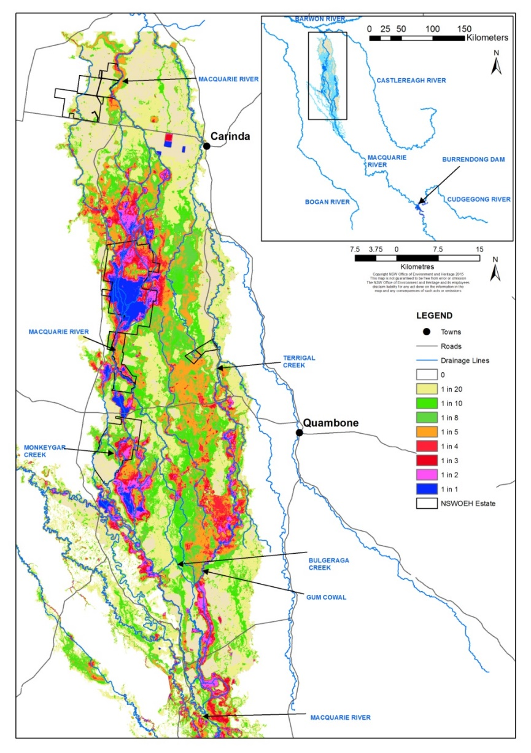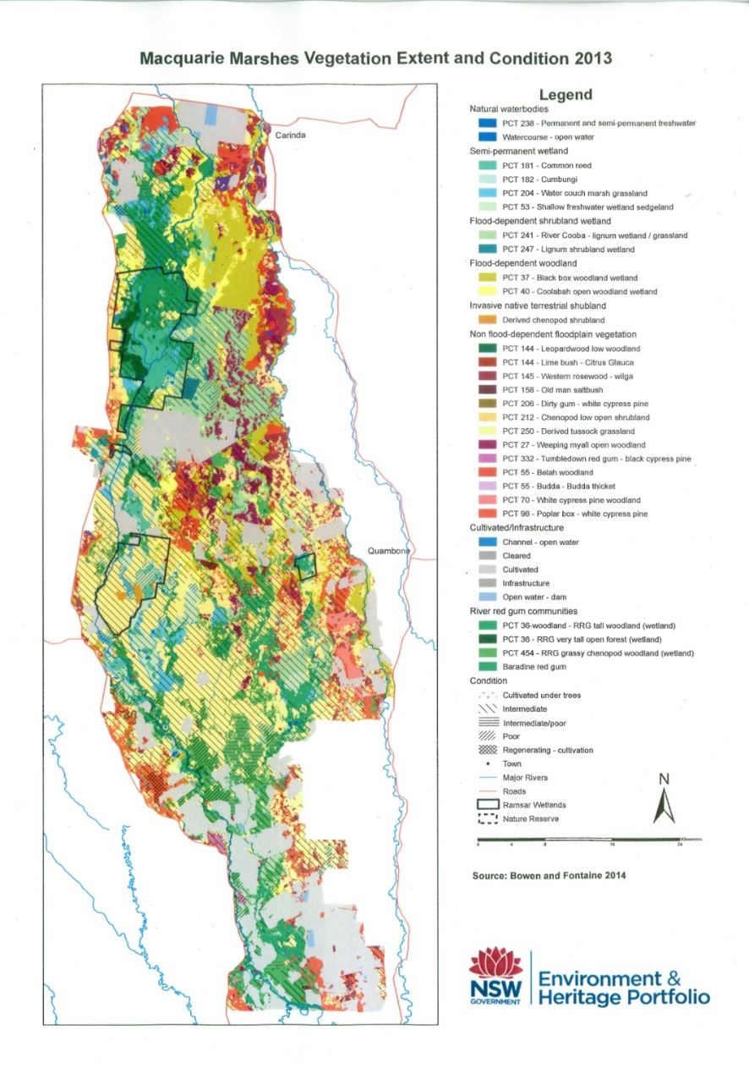

1. Source: Bowen & Fontaine 2014 b) Source: Thomas et al. 2015

### Monitoring and lessons learned

#### Monitoring

In the Macquarie River Valley, monitoring is primarily undertaken by NSW agencies including NSW DPIE – EES (vegetation, waterbirds and frogs), NSW DPI – Fisheries (native fish), and WaterNSW (hydrology and flow delivery data). The CEWO has also funded a number of short-term intervention monitoring projects to evaluate the environmental responses of native fish, waterbirds, and freshwater mussels.

Learn more about [monitoring activities funded by the CEWO in the Macquarie Valley](http://www.environment.gov.au/water/cewo/catchment/macquarie/monitoring).

#### Lessons learned

Outcomes from monitoring and lessons learned in previous years are a critical component for the effective and efficient use of Commonwealth water for the environment. These learnings are incorporated into the way environmental water is managed.

Key findings from fish, flow, frog and waterbird monitoring in the Macquarie Valley are summarised in Table MV2.

Table MV Key lessons learned in Macquarie Valley

| Theme | Lessons learned |
| --- | --- |
| Native fish **a** | * Spring/early summer delivery has been associated with peaks in breeding of some small-bodied opportunistic fish species (e.g. Australian smelt, un-specked hardyhead, Murray-Darling rainbowfish), particularly on the receding tail of flows, or during sustained periods of increased flow. * Spring/early summer delivery is also likely to support recruitment of native species such as Murray cod and freshwater catfish, by increasing flows and boosting in-stream productivity in the river. |
| Frogs **b** | * High frog abundance reflect patterns of wetland inundation, high aquatic plant growth and warm survey temperatures, which make the conditions highly conducive to frog breeding activity and frog detection. * Local weather and inundation extent influence the activity of some species. Increased inundation increases the number of sites with conditions suitable for breeding, and the calling of flow-responsive species. * Flooding events are very important for increasing overall abundance of flow-responsive species, by supporting breeding and enabling frogs to move between wetlands. * Longer duration of inundation is important for frogs to complete metamorphosis. The highest breeding success has occurred in years with longer wetland duration (2016, 2018 and 2020). Maintaining water levels in the Marshes into late November increases frog recruitment. |
| Waterbirds **c** | * Delivery in winter/spring (into summer if possible) provides suitable wetland habitat for nationally threatened and internationally recognised migratory species and coincides with warmer temperatures and peak activity for waterbirds and their food supplies. * A slow steady contraction of inundated area is preferable, particularly for wading species. * Delivery to parts of the Marshes during dry conditions supports a diverse range of waterbirds and provides important feeding and refuge habitat. |
| Connectivity **d** | * Connectivity between Macquarie and Barwon rivers can be achieved using water for the environment and is important for allowing the movement of native fish between rivers for spawning, dispersal and recruitment. |
| Other aquatic animals e | * Persistence of healthy populations of freshwater mussels (particularly *Alathyria jacksoni*, which is endemic to the Murray–Darling Basin) is dependent on permanent river reaches and waterholes. The provision and protection of minimum baseflows is vital to their persistence, and for populations to recover from the significant losses experienced during the 2017–20 drought. * Recolonisation of freshwater mussels is dependent on the recovery and movement of native fish populations through the northern Basin. Therefore, the minimum flow requirements of native fish also need to be provided to support recovery of both fish and mussel populations. |

**a** Stocks et al. (2015), Davis, Asmus & Stocks (2017). **b** Ocock & Spencer (2017), Ocock & Spencer (2018), Walcott et al. (2019), NSW DPIE – EES (2021). **c** Spencer et al. (2016), McGinness et al. (2017), Brandis (2017), NSW OEH (2019). **d Davis, Asmus & Stocks (2017), WaterNSW (2017)**. **e** Sheldon et al. (2020).

### References

Barma Water Resources in association with IRPEC Pty Ltd & Paul Wettin 2011, Environmental Water Delivery: Macquarie River, unpublished report to the Commonwealth Environmental Water Office, Canberra.

Bowen, S & Fontaine, K 2014, Vegetation Communities of the Macquarie Marshes, NSW Office of Environment and Heritage, Sydney.

Brandis, K 2017, [High resolution monitoring of waterbird colonies in the Macquarie Marshes](http://www.environment.gov.au/water/cewo/publications/high-resolution-monitoring-waterbird-colonies-macquarie-marshes), University of NSW, Sydney, accessed 7 April 2021.

BOM 2021a, [Rainfall—The chance of above median for June to August 2021](http://www.bom.gov.au/climate/outlooks/#/rainfall/median/seasonal/0), Bureau of Meteorology, Canberra, accessed 11 May 2021.

——2021b, [Rainfall—The chance of above median for July to September 2021](http://www.bom.gov.au/climate/outlooks/#/rainfall/median/seasonal/1), Bureau of Meteorology, Canberra, accessed 11 May 2021.

——2021c, [Temperature—the chance of above median maximum temperature for June to August](http://www.bom.gov.au/climate/outlooks), Bureau of Meteorology, Canberra, accessed 11 May 2021.

——2021d, [Temperature—the chance of above median maximum temperature for July to September](http://www.bom.gov.au/climate/outlooks), Bureau of Meteorology, Canberra, accessed 11 May 2021.

Davis, S, Asmus, MW & Stocks, JR 2017, [Making the connection: Designing, delivering and monitoring flows between catchments. A case study in the Macquarie and Barwon rivers April–June 2017](http://www.environment.gov.au/water/cewo/publications/making-the-connection), NSW Department of Primary Industries, Dubbo, accessed 7 April 2021.

McGinness, H, Martin, J, Robinson, F, Davies, M, Piper, M, Keyte, P, Suter, S, Spencer, J, Rees, J, Webster, E, Brandis, K, Kingsford, R, Doerr, V & Mac Nally, R 2017, [Waterbird movements and breeding success in the Macquarie Marshes, NSW 2016–17](http://www.environment.gov.au/water/cewo/publications/waterbird-movements-breeding-success-macquarie-marshes-final-report-2017), CSIRO, Canberra, accessed 7 April 2021.

MDBA 2012, [Assessment of environmental water requirements for the proposed Basin Plan: Macquarie Marshes](http://www.mdba.gov.au/sites/default/files/archived/proposed/EWR-Macquarie-Marshes.pdf), Murray–Darling Basin Authority, Canberra, accessed 20 April 2021.

—— 2021, [Macquarie-Castlereagh](https://www.mdba.gov.au/water-management/catchments/macquarie-castlereagh), Murray–Darling Basin Authority, Canberra, accessed 8 April 2021.

NSW DECCW 2010, [Macquarie Marshes Adaptive Environmental Management Plan. Synthesis of information, projects and actions](https://www.environment.nsw.gov.au/research-and-publications/publications-search/macquarie-marshes-adaptive-environmental-management-plan), NSW Department of Environment, Climate Change and Water, Sydney, accessed 8 April 2021.

NSW DPI 2007, [Endangered ecological communities in NSW – Lower Darling River Aquatic Ecological Community](https://www.dpi.nsw.gov.au/__data/assets/pdf_file/0003/634557/Lowland-Darling-River-aquatic-ecological-community.pdf), Primefacts, vol. 173, accessed 8 April 2021.

NSW DPIE 2020, [Macquarie–Castlereagh Long-Term Water Plan. Part B: Macquarie–Castlereagh Planning Units](https://www.environment.nsw.gov.au/research-and-publications/publications-search/macquarie-castlereagh-long-term-water-plan-part-b-planning-units), NSW Department of Planning, Industry and Environment, Sydney, accessed 20 April 2021.

NSW DPIE – EES 2021, *Spring 2020 frog surveys in the Macquarie Marshes – February 2021*, NSW Department of Planning, Industry and Environment – Environment, Energy and Science, Sydney.

NSW DPIE – Water 2021[, Macquarie and Cudgegong Regulated Rivers Water Source: Water allocation update](https://www.industry.nsw.gov.au/__data/assets/pdf_file/0004/385555/WAS-macquarie-20210610.pdf), NSW Department of Planning, Industry and Environment – Water, Sydney, May, PUB21/359, accessed 16 June 2021.

NSW OEH 2012, [Macquarie Marshes Ramsar site: Ecological character description – Macquarie Marshes Nature Reserve and U-Block components](https://www.environment.nsw.gov.au/-/media/OEH/Corporate-Site/Documents/Water/Wetlands/macquarie-marshes-ramsar-site-ecological-character-description-120517.pdf), NSW Office of Environment and Heritage, Sydney, accessed 8 April 2021.

—— 2019, Waterbird surveys in the Macquarie Marshes, spring 2018*,* NSW Office of Environment and Heritage, Sydney.

Ocock, JF & Spencer, J 2017*,* Summary of observations from two years of monitoring frogs in the Macquarie Marshes, NSW Office of Environment and Heritage, Sydney.

——2018, Results from spring frog surveys in the Macquarie Marshes (2011–2017), NSW Office of Environment and Heritage, Sydney.

Sheldon, F, McCasker, N, Hobbs, M, Humphries, P, Jones, H, Klunzinger, M & Kennard, M 2020, [Habitat and flow requirements of freshwater mussels in the northern Murray–Darling Basin](http://www.environment.gov.au/water/cewo/publications/habitat-flow-requirements-freshwater-mussels-northern-murray-darling-basin), report to the Commonwealth Environmental Water Office, Canberra, accessed 20 May 2021.

Spencer, J, Hosking, T, Ocock, J & Suter, S 2016, OEH waterbird surveys in the Macquarie Marshes – spring 2015, NSW Office of the Environment and Heritage, Sydney.

Stocks, JR, Scott, KF, Rodgers, MP, Walsh, CT, van der Meulen, DE, & Gilligan, D. 2015, [Short-term intervention monitoring of a fish community response to an environmental flow in the mid and lower Macquarie River: 2014–2015 watering year](http://www.environment.gov.au/water/cewo/publications/stim-fish-macquarie-2014-15), NSW Department of Primary Industries, Batemans Bay, accessed 7 April 2021.

Thomas, RF, Kingsford, RT, Lu, Y, Cox, SJ, Sims, NC & Hunter, SJ 2015, ‘Mapping inundation in the heterogeneous floodplain wetlands of the Macquarie Marshes, using Landsat Thematic Mapper’, Journal of Hydrology, vol. 524, pp. 194–213.

Torrible, L, Wettin, P, Barma, D, Wilson, G, Hobcroft, D, & O’Cock, J 2011, Post flood assessment and determination of environmental water requirements for Gunningbar Creek, Lower Crooked Creek, Marra Creek and the lower Macquarie River, prepared by IRPEC Pty for BWR on behalf of the Australian Government Department of Sustainability, Environment, Water, Population and Communities, Canberra.

Walcott, A, Ocock, J, Spencer, J & Wilson, E 2019, Frog and tadpole surveys in the Macquarie Marshes, spring 2018, NSW Office of Environment and Heritage, Sydney.

WaterNSW 2017, [Lower Macquarie Catchment Temporary Water Monitoring 2017](http://www.environment.gov.au/water/cewo/publications/lower-macquarie-catchment-temporary-water-monitoring-2017), Dubbo, accessed 7 April 2021.

——2021a, [Burrendong Dam](https://www.waternsw.com.au/supply/visit/burrendong-dam), Sydney, accessed 7 April 2021.

——2021b, [Windamere Dam](https://www.waternsw.com.au/supply/visit/windamere-dam), Sydney, accessed 7 April 2021.

——2021c, [Real Time Data – Major Dams: Burrendong Dam](https://realtimedata.waternsw.com.au/), Sydney, accessed 14 May 2021.

——2021d, [Real time data: 421 – Macquarie River Basin](https://realtimedata.waternsw.com.au/), Sydney, accessed 7 May 2021.