**Data on imports of waste and recovered materials into Australia, 2021**

*28 September 2021, Sally Donovan and Joe Pickin*

*©The Department of Agriculture, Water and the Environment*

Blue Environment was commissioned by the Department of Agriculture, Water and the Environment to collate, analyse and report data on imports of waste and recovered materials during 2020-21[1]. The analysis builds on a previous assessment covering the period 2016-17 to 2018-19. The import tonnages and reported values are from the Australian Bureau of Statistics (ABS).

Summary

In 2020-21, Australia imported about 199,000 tonnes of waste materials within the national waste reporting scope of ‘core waste plus ash’, with a reported value of $140 million[2]. Almost half the quantity was scrap metals. The main sources were New Zealand (42%), India (20%) and the USA (20%).

A further 2.04 million tonnes of non-core waste were imported with a reported value of $514 million. This material comprised granulated slag, a by-product of iron and steel manufacture, from Japan, and various types of agricultural by-product.

The total of 2.23 million tonnes of imported waste and recovered materials is about half of the waste exports for the same year, which were 4.25 million tonnes with a reported value of $3.20 billion.

Background

Exports of wastes and recovered materials captured the Australian public’s attention when China imposed restrictions on waste imports. Prominent news stories followed showing the impacts of plastic, textile and other wastes in export destinations. Australia is gradually introducing bans on the exports of some of these materials.

The Department of Agriculture, Water and the Environment has produced monthly and annual reports on Australia’s waste exports for the past three years[3]. This report complements those reports by documenting data on waste imports. It explores types of waste and recovered materials imported, including quantities, reported value, places of origin and jurisdiction of destination. It builds on a previous analysis that covered the years 2016-17 to 2018-19.

The report is based on ‘Harmonized Tariff Item Statistical Classification’ (HTISC) import codes, which are mapped to waste[4], or partly to waste, and identified as either:

* core waste plus ash, where ‘core waste’ is materials generally managed by the solid waste industry and the inclusion of ash[5] brings this total in line with the headline values of national waste reporting
* non-core waste from agriculture or industrial processing, which are included here for completeness.

Waste materials may be imported into Australia for a range of reasons: recycling; treatment of hazardous waste; aggregation with Australian wastes for re-export; re-import of Australian materials after treatment overseas; or for industrial use (particularly of non-core wastes). It is important to understand these flows for waste infrastructure planning and in the broader context of circular economy policy.

Annual trends in imports of waste and recovered materials

Figure 1 shows the tonnage and reported value of imports of waste and recovered materials during 2020-21. Historical data from 2016-17 to 2018-19 is shown for comparison. The top half of the figure shows core waste plus ash, while the bottom shows non-core wastes.

About 199,000 tonnes of core waste and ash were imported during 2020-21. Quantities rose from 2016-17 to 2018-19, then dropped off in 2020-21. The main imports are metals (mainly scrap steel and ferrous wastes), hazardous waste and ash.

A further 2.04 million tonnes of non-core waste were imported, comprising granulated slag (slag sand) and organics. These non-core wastes represent 88-92% of total waste imports in each year.

In aggregate, about 2.23 million tonnes of waste and recovered materials were imported in 2020-21.

Figure 1 Imports of waste and recovered materials into Australia by type, showing quantity (thousands of tonnes) to the left and reported value ($m) to the right. The time period is financial year ending in June of the year stated.

**Non-core waste**

**Core waste plus ash**

The reported value of Australian imports of waste and recovered materials is shown over the same timeframe on the right side of Figure 1. The value of imported core waste plus ash materials was $140m, the main portions being metals (45%), hazardous (11%) and tyres (27%). The non-core wastes had a reported value in 2020-21 of $514 million, of which 98% was in the organics.

Imports of core waste

Imports of **glass** waste were 17,000 tonnes in 2020-21, which was unusually high compared to previous years, and much higher than exports which were just 377 tonnes. New Zealand accounted for 95%. Owens-Illinois owned the only glass recycling plant in New Zealand[6], which reportedly had large stockpiles of waste glass, as well as various plants in Australia. These were purchased by Visy, which declared an intention to increase the recycled component of the glass from one-third to two-thirds[7]. The imports may be stock transfers between plants.

There are 30 codes in the **hazardous waste** category, but the largest shares in 2020-21 were residual lyes from wood pulp manufacturing (65%) and slag, ash and residues containing lead (18%). In previous years, slag, ash and residues containing metals and arsenic were the major imports.

Australia imported around 92,000 tonnes of scrap **metals** in 2020-21, larger than in previous years, but insignificant compared to exports which were nearly 2.5 million tonnes. Waste and scrap of alloy steel accounted for 94% of metal imports and mainly came from New Zealand and USA. Copper waste and scrap was the second biggest import accounting for 3%. Around 85% of this came from the Pacific Island region including New Zealand, Fiji, New Caledonia, Vanuatu, and Papua New Guinea.

|  |  |
| --- | --- |
| Imports of **paper and cardboard** were 3,300 tonnes in 2020-21, down from 6,800 tonnes in 2018-19. Tonnages have historically been volatile. These quantities are a small fraction of exports of these materials, which exceeded a million tonnes in 2020-21. Figure 2 shows imports by grade 2020-21. Pulp from recycled fibre made up the largest share, mainly arriving from Germany and the USA. Although derived from waste, this is a high-quality feedstock material, that does not require reprocessing before use. The USA provided some unsorted scrap and ‘mechanical’[8]. | Figure 2 Imports of waste-derived paper and cardboard into Australia by grade, 2020-21 |
|  |

|  |  |
| --- | --- |
| In 2020-21 Australia imported 9,800 tonnes of scrap **plastics**, which is about 8% of the tonnes exported. This is low compared to previously reported years, in which imports exceeded 12,000 tonnes. Figure 3 shows the imports of scrap plastics by grade in 2020‑21, showing that mixed scrap is by far the largest portion. The main exporters were South Korea and China but small amounts came from many places. Polymers of ethylene were the second highest portion, and also declined from earlier years. Small amounts of vinyl were received mainly from Singapore and minor volumes of styrene were received from various countries.  Figure 4 shows the imports of waste **tyres** into Australia by grade and country of origin. Imports are mainly solid or cushion rubber tyres (47%) coming from South East Asia and scrap rubber from shredded tyres (42%) coming from Malaysia (48%), Denmark (12%), India (8%) and Italy (8%). A small number of used pneumatic tyres were also received mainly from Netherlands (50%) and Taiwan (19%). In 2020-21, 1,300 tonnes of retreaded tyres were received, around 75% of which was from Malaysia. Some of these imports may be Australian scrap tyres processed overseas and brought back for subsequent on-shore use or re-export.  Figure 5 shows the imports of scrap **textiles** into Australia by grade in 2020-21. The largest category is worn clothing, which was mainly from Pakistan (27%) and UAE (11%). Around one third of worn clothing was re-imports[9], with port of loading noted to be unspecified ports in the UAE. The UAE was the main receiver of Australia’s exports in this category in 2020‑21 so this is likely to be related to this trading relationship. Used or new rags were also mainly from Pakistan (31%) and China (22%) with smaller amounts coming from many other places. These are likely to be Australian textile wastes sent overseas for cutting then reimported for sale as rags. Synthetic fibre waste was mainly from France (93%) and cotton waste was only from India. | Figure 3 Imports of waste plastics into Australia by grade, 2020-21 |
|  |
| Figure 4 Imports of waste tyres into Australia by grade, 2020-21 |
|  |
| Figure 5 Imports of waste textiles into Australia by grade, 2020-21 |
|  |

Around 36,000 tonnes of material were imported into Australia that would be classified as **ash**5. This was nearly all from India (95%).

Imports of non-core waste

About 1.15 million tonnes of **granulated slag** was imported in 2020-21. This is a by-product of iron and steel manufacture imported for use as a supplementary cementitious material in concrete. It can replace up to 65% of cement in concrete without compromising the quality of the finished product, and reduces the energy requirements (and greenhouse gas emissions) of concrete production[10]. Australia’s demand for cement has grown since 2016-17[11] and this is reflected in the consistently increasing imports of granulated slag over this time. An alternative supplementary cementitious material to granulated slag is fly ash. If imported granulated slag replaced Australian fly ash in cement, it could harm waste recovery rates. However, Cement Concrete and Aggregates Australia notes that growing volumes of granulated slag in use are linked to ‘the decline in fly ash availability in many areas’10.

Over 880,000 tonnes of organic wastes were imported, mainly solid waste residues from the extraction of soya-bean oil. In 2016-17, 2017-18 and 2020-21, these residues accounted for over 90% of total organic wastes imported. In 2018-19 there was also a large amount of solid waste residues of palm nuts and kernels. While included here as waste, these materials are likely to be productively used in foods, cosmetics, textile and pharmaceutical industries[12].

Unit values of imported waste

Table 1 shows the reported average value of imported waste in Australian dollars per tonne.

Table 1 Average unit values of imported waste by category

|  |  |  |
| --- | --- | --- |
| **Waste category** | **2021 $/tonne** | **2017, 2018, 2019 ($/tonne)** |
| Glass | $155 | $154 - $258 |
| Hazardous (excl. tyres) | $666 | $186 - $403 |
| Metals | $692 | $501 - $1120 |
| Paper & cardboard | $771 | $289-$699 |
| Plastics | $618 | $664-$779 |
| Textiles, leather & rubber | $2,245 | $1484-$1906 |
| Tyres | $2,679 | $2452-$3,073 |
| Ash5 | $105 | $73-$97 |
| Granulated slag (slag sand) from the manufacture of iron or steel | $8 | $8-$10 |
| Organics | $573 | $438-$510 |

The value of scrap glass, plastics and granulated slag have remained relatively consistent, while scrap metal imports have been volatile, similar to metal exports.

Textiles, leather and rubber was the second highest value category in all years, and higher than the equivalent export codes. For example, the average value of worn clothing over the five-year period is over $2,000 per tonne, while exports of materials in this category averaged around $850 per tonne in 2021. This indicates this category may contain relatively high-quality materials compared to exports.

The value of paper and cardboard is driven by pulps of fibres from recovered paper and paperboard, which were unusually low in 2016-17, but consistent in other years. The values here are higher than those of exported paper and cardboard, which contains large volumes of low-grade mixed materials.

The unit values of organic and hazardous wastes were consistent until 2018-19, but rose in 2020-21. The value of organics reflects the price of solid residues from soya-bean oil extraction, while hazardous waste seems to be affected by unusually high value of arsenic containing slag, ash and residues in 2020-21.

The unit value of tyres has been consistently high.

Countries of origin

Australia imported waste and recovered materials from over 70 countries in 2020-21. Figure 6 shows 2020‑21 total imports by the top 10 countries of origin in thousands of tonnes, showing core waste plus ash on the left and for non-core waste on the right.

For core waste plus ash, the largest share of the imports came from New Zealand (42%) and was mainly metals (78%) and glass (22%). Following them was India (20%), which exported mainly ash5 (98%). The USA (20%) was the third largest, providing mainly metals (88%). Imports from Singapore were mostly hazardous materials (71%). South Korea exported plastic waste to Australia (82%) while Germany sent mostly paper and cardboard (76%). Imports from Taiwan were a mix of different materials.

About 56% of Australia’s non-core waste was imported from Japan, comprising almost entirely granulated slag. Imports from Argentina accounted for 38% of these tonnes, which was nearly all oil-cake and solid residues of soya-bean oil extraction. This has high value at an average of $536 per tonne, so Argentina represented 80% of the total value of non-core waste imports.

China and Malaysia feature in both columns within Figure 6. Imports from China were mainly granulated slag (52%) and hazardous waste (22%). Imports from Malaysia were mostly organics (65%) and tyres (32%).

Figure 6 Imports of waste and recovered materials into Australia by top 10 place of origin, showing core waste plus ash (left) and non-core waste (right)

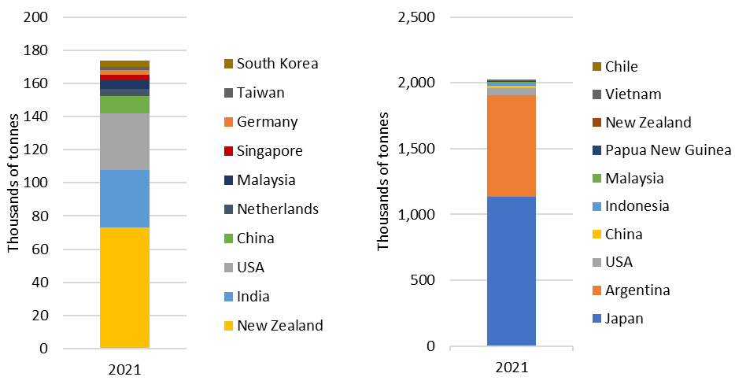

Receiving jurisdictions of imported waste

Figure 7 shows the quantities of waste imported into each jurisdiction, showing core waste plus ash to the left and non-core waste to the right. Table 2 shows the categories of waste received by each jurisdiction, including both core waste plus ash and non-core waste.

Victoria and Queensland received the most waste imports, (31% and 26% respectively), comprising mostly granulated slag and organics. Victoria also received more scrap glass (9,100 tonnes), plastics (5,800 tonnes) and tyres (4,400 tonnes) than any other jurisdiction. Queensland received the most hazardous waste (10,200 tonnes). SA and WA received large amounts of granulated slag and organics, and SA received the most ash waste5 (32,700 tonnes). NSW received 51% of materials in the scope of core waste plus ash, which was mainly metals (85%).

For comparison, in 2020-21, 25% of Australia’s waste exports originated from Victoria, 24% from Queensland and NSW, 19% from WA, 6% from SA, less than 1% from everywhere else.

ACT does not appear in the figures as it did not receive any waste imports and Tasmania is barely visible as it received less than 1000 tonnes of mainly low value organic materials.

Figure 7 Imports of waste to Australia by destination in 2020-21, showing core waste plus ash (left) and non-core waste (right)

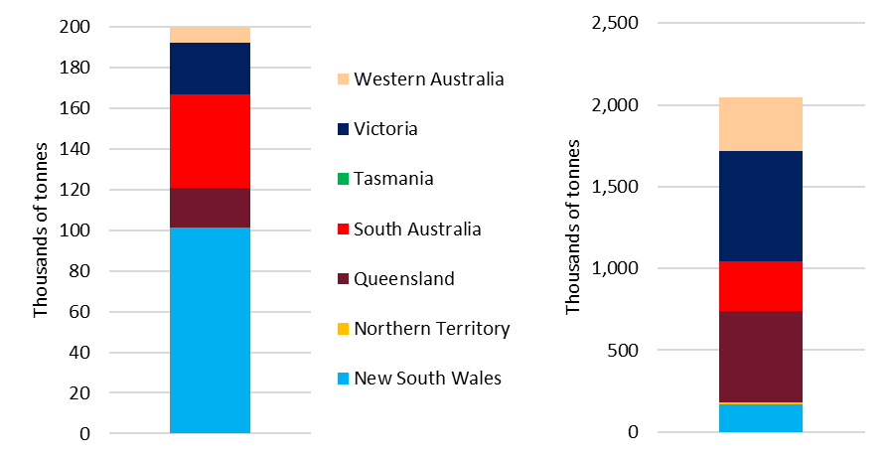

Table 2 Waste types received by jurisdiction, 2020-21 (thousands of tonnes)

|  |  |  |  |  |  |  |  |  |  |  |
| --- | --- | --- | --- | --- | --- | --- | --- | --- | --- | --- |
| *Data in*  *thousands of tonnes* | Glass | Hazardous (excl. tyres) | Metals | Paper & cardboard | Plastics | Textiles, leather & rubber | Tyres | Ash5 | Granulated slag | Organics |
| New South Wales | 0.7 | 2.7 | 86.3 | 0.2 | 3.8 | 1.1 | 3.6 | 2.5 | 0.1 | 163.1 |
| Northern Territory |  |  |  |  |  |  | 0.01 | 0.02 | 12.0 |  |
| Queensland | 0.4 | 10.2 | 3.9 | 1.0 | 0.1 | 0.5 | 3.2 | 0.3 | 305.1 | 253.8 |
| South Australia | 6.4 | 4.7 | 0.04 | 0.3 | 0.1 | 0.2 | 1.3 | 32.7 | 165.2 | 135.4 |
| Tasmania |  | 0.02 |  |  |  |  |  |  |  | 0.9 |
| Victoria | 9.1 | 1.5 | 1.4 | 1.5 | 5.8 | 1.4 | 4.4 | 0.03 | 410.7 | 266.2 |
| Western Australia | 0.0 | 4.7 | 0.04 | 0.4 |  | 0.7 | 1.4 | 0.3 | 259.7 | 63.3 |

Context – Australian core waste plus ash imports compared

Table 3 compares the amount of waste and recovered materials generated in, imported into and exported from Australia, falling into the national waste reporting scope of core waste plus ash. Imports are small compared with exports in terms of both tonnage and value. Exports account for about 6% of Australia’s total waste generation. Imports are less than 0.3% of the scale of waste generation (excluding non-core wastes).

Table 3 Comparison of Australia’s waste generation to exports and imports

|  |  |  |  |  |  |
| --- | --- | --- | --- | --- | --- |
| Financial year ending | Waste generated in Australia | Waste exported from Australia | | Waste imported to Australia | |
| *(thousands of tonnes[13])* | *(thousands of tonnes)* | *($ millions)* | *(thousands of tonnes)* | *($ millions)* |
| 2017 | 69,000 | 4,000 | $2,620 | 217 | $100 |
| 2018 | 73,000 | 4,190 | $2,690 | 243 | $132 |
| 2019 | 74,100 | 4,240 | $2,980 | 245 | $121 |
| 2021 | *Data unavailable* | 3,870 | $2,980 | 199 | $140 |

1. The import codes mapped to waste and recovered materials were updated in 2020-21. Details are given in the accompanying workbook (under ‘Ref lists’). The historical data presented here has been updated.
2. Dollar values refer to Australian dollars. Historical values are inflated based on the annualised consumer price index.
3. These reports are available from <http://www.environment.gov.au/protection/waste/publications>.
4. There is some uncertainty involved in mapping import trade codes to wastes, especially for primary production wastes and by-products, and for trade codes that may be mixes of waste and non-waste material.
5. The description of this code is ‘*Slag and ash, not elsewhere specified (including seaweed ash (kelp)) (excluding ash and residues from the incineration of municipal waste and those of HS 2618, HS 2619 or HS 2620)*’. It was previously mapped to ‘ash’ and is referred to as such throughout this document. The large quantities imported calls this mapping into question – it may be mostly a type of slag.
6. The Rubbish Trip (2018) [Sometimes smashing, sometimes crushing: The story of glass in New Zealand](http://therubbishtrip.co.nz/be-a-tirading-kiwi/sometimes-smashing-sometimes-crushing-the-story-of-glass-in-new-zealand/).
7. Visy (2020) [Visy acquires glass manufacturing business](https://www.visy.com.au/newsroom/2020/7/16/visy-acquires-glass-manufacturing-business).
8. This is fibre pulp manufactured by grinding or similar mechanical processes, rather than by chemical treatment. Imports in this category will be primarily newspapers and magazines, which are commonly made from mechanical pulp.
9. Australian material taken overseas for processing then brought back here.
10. A technical summary on this material is available from Cement Concrete and Aggregates Australia at [https://www.ccaa.com.au/  
    imis_prod/documents/TECH_NOTE_78_-_Ground_Slag.pdf](https://www.ccaa.com.au/imis_prod/documents/TECH_NOTE_78_-_Ground_Slag.pdf).
11. Cement Industry Federation (2020) [Production statistics](https://cement.org.au/australias-cement-industry/about-cement/australias-cement-industry/).
12. Ancuta P & Sonia A (2020) Oil press-cakes and meals valorization through circular economy approaches: A review, *Applied Science* 10(21): 7432.
13. *National Waste report 2020*, available from <https://www.environment.gov.au/system/files/pages/5a160ae2-d3a9-480e-9344-4eac42ef9001/files/national-waste-report-2020.pdf>.