|  |  |
| --- | --- |
| O:\ISF shared\Images\_ISF brand images\Strips2_MG_7350.jpg | |
| C:\Users\116254\Oxygen Enterprise\ISF shared\CSI\Marketing & Comms\ISF logo and branding\ISF Logo (2015)\- PNG\ISF Logo_Colour.png**UTS INSTITUTE FOR SUSTAINABLE FUTURES** |  |
| Waste Fires in Australia: Cause for Concern? |
| Prepared for: |
| department of the environment  Australian government |
| **2016** | |

SECTION BREAK – DO NOT DELETE

ABOUT THE AUTHORS

The Institute for Sustainable Futures (ISF) was established by the University of Technology Sydney in 1996 to work with industry, government and the community to develop sustainable futures through research and consultancy. Our mission is to create change toward sustainable futures that protect and enhance the environment, human well-being and social equity. We seek to adopt an inter-disciplinary approach to our work and engage our partner organisations in a collaborative process that emphasises strategic decision-making.

|  |  |
| --- | --- |
| For further information visit: | [**www.isf.uts.edu.au**](http://www.isf.uts.edu.au) |

Research team:   
Alex Fattal, Senior Research Consultant  
Dr Scott Kelly, Research Principal  
Ariane Liu, Research Consultant  
Dr Damien Giurco, Professor of Resource Futures

Citation

Cite this report as:

Fattal, A., Kelly, S., Liu, A., Giurco, D. 2016., Waste Fires in Australia: Cause for Concern? Prepared for the Department of Environment, Canberra by the UTS Institute for Sustainable Futures, Sydney.

ACKNOWLEDGEMENTS

The Institute for Sustainable Futures would like to thank the NSW Environmental Protection Agency and Sustainability Victoria for advice and help in preparing this report.

review

|  |  |  |  |
| --- | --- | --- | --- |
| Version | Lead Authors | Reviewed by | Date |
| Draft | AF, SK | DG | 13 May 2016 |
| Draft to client | AF, SK, AL, DG | DG | 13 May 2016 |
| Final Draft | AF, SK, AL, DG | SK | 19 May 2016 |
| Final | AF, SK, AL, DG | DG | 23 June 2016 |

**Institute for Sustainable Futures**

University of Technology Sydney

PO Box 123 Broadway, NSW, 2007 Australia  
Tel +61 2 9514 4950

© UTS June 2016

UTS: INSTITUTE FOR SUSTAINABLE FUTURES

June 2016

**Waste Fires in Australia: Cause for Concern**

Prepared for: Department of the Environment, Canberra

|  |
| --- |
| **Authors**  Alex Fattal  Scott Kelly  Ariane Liu  Damien Giurco |

Table of Contents

1 Summary 1

2 Methodoldogy 3

3 Key findings 4

3.1 Outline 4

3.2 Australian Waste Industry and Fires 4

3.3 Causes of fires 6

3.4 Extinguishing a Fire 8

3.5 Hazardous waste 8

4 Case Studies 11

4.1 Chester Hill, NSW 11

4.2 Wingfield, SA 13

4.3 Somerton, Victoria 14

4.4 Broadmeadows, Victoria 15

4.5 Piallgio, ACT 17

4.6 Case studies in other literature 17

5 Impacts of fires 21

5.1 Health and Safety 21

5.2 Environmental Impacts 22

5.3 Economic Impacts 23

6 Recommendations 24

6.1 Policy Considerations 24

6.2 a note on methane at landfills 25

6.3 Areas for further investigation 25

7 Sources 27

# Summary

The Hazardous Waste Section of the Commonwealth Department of the Environment commissioned this report to gain greater insight into the problem of waste fires in Australia.

This report aims to understand the risks associated with waste fires in Australia to better examine how the potential impacts of these fires can be minimised. In this report we show that waste fires pose a serious risk to people, the environment and the economy. Currently, the issue of waste fires is poorly understood, with limited information on, the causes, number of incidences, risks location and their impact on society, the environment and the economy within Australia. We show that there is a growing need to take waste fires seriously with regular reporting, risk management strategies and effective guidelines to prevent both the occurrence and severity of future waste fires. In particular, we recommend that all States in Australia be compelled to keep an accurate record of the occurrence and size of waste fires as they occur and that these statistics be regularly reviewed to identify the potential for emerging risks (e.g. lithium battery fires).

Waste fires can arise across all stages of the waste management chain (both publically- and privately-owned), including waste collection, transport, transfer stations, recycling and disposal at landfill (whether hazardous, mixed or inert). The source of combustible material also varies greatly and includes tyres, used oils, green waste, wood waste, solvents, batteries, municipal solid waste and so on. Fires therefore have the potential to cause significant harm to people and the environment through the release of hazardous chemicals to the atmosphere and ground water supplies.

The economic costs of waste fires can be significant. Preventing and preparing for waste fires offers the best defence against the risk of injury, death, property damage, environmental degradation and economic loss. Research has shown the cost of prevention is less expensive than the cost of fighting waste fires and clean-up costs after a fire has occurred. The direct economic costs incurred by waste fires include: property damage, fire-fighting personnel time, fire-fighting consumables and equipment, waste facility downtime, environmental clean-up costs contaminated water supplies and long-term health effects. Indirect costs include traffic delays, public transport disruption, disruption to daily working schedules and lower real-estate values. Waste fires burn for extended periods, sometimes days and weeks, and can take significant resources to extinguish. Fire fighting personnel who are engaged in extinguishing these fires are then not available to respond to fire emergencies occurring elsewhere. This has the effect of increasing response times and increasing fire risks elsewhere in the region.

Waste fires, when they occur, receive substantial media attention with newspaper headlines and images designed to grab public attention. The siting of landfills is also a controversial subject. Homeowners and business owners often resist the siting of landfills in their areas due to the perception that these facilities will lead to noxious fumes, health effects and have adverse influences on property values. Despite the immediate attention that waste fires often receive by the media, they remain a dangerous threat to people, the environment and society.

The targeted focus of this report means the findings are not a comprehensive representation of *all* waste-related fires in the last five years. However, this report usefully identifies the characteristics of the issues and trends in the international literature, synthesises available information to date and provides a summary of the key sources of waste fire in Australia. Therefore the report provides a basis for illustrating the key dimensions of the issue and a framework for better characterising the issues in future.

This report sets out:

* the methodology used in the research undertaken;
* the results, including special mention of key issues and case studies;
* recommendations for future work; and
* an outline of the sources used.

# Methodoldogy

This chapter sets out the methodology used to undertake the review of waste fires.

During this project ISF undertook research into occurrences and characteristics of waste fires using desktop research via the following channels:

* Australian press: using tools such as Factiva we reviewed press reports of incidents relating to hazards from the disposal of batteries, especially relating to landfill and the transport of waste.
* Examine publically available data: we compiled relevant data on fire occurrences relating to batteries from Australia, including from fire services or EPA licence breaches.
* International literature review: we examined international publications from both research and regulatory bodies on the relevant issues, including the safe disposal of batteries.
* Stakeholder interviews: discussions with key knowledge holders from across industries and state government agencies (such as fire departments, EPAs).

# Key findings

## Outline

This chapter sets out the key findings from the research. It is set out in three components. Firstly we look into the key causes and impacts of fires. We then examine a number of case studies that elaborate on the issues discussed.

## Australian Waste Industry and Fires

This section provides a brief outline of the rate of occurrence of fires in the waste industry in Australia and overseas.

According to the most recent annual reporting of statistics published by fire departments across Australia there were:

* 5,652 rubbish fires in NSW[[1]](#footnote-2)
* 3,583 other fires (which includes rubbish) in Western Australia[[2]](#footnote-3),
* 1,003 outside rubbish fires in South Australia; and[[3]](#footnote-4),
* 1,723 (16%) of all fires attended by the fire services in Tasmania.[[4]](#footnote-5)

We are uncertain if the reporting standards represented above are consistent for each state as the terminology for each fire department is slightly different. The statistics collected above represent only those fires that involved the dispatch of resources from fire departments.

**An extensive desktop search for statistics on the frequency and type of waste fires that occur in Australia found that there is no centralised dataset of this information.** Moreover, there is a paucity of data on waste fires by State, region or municipal level on waste fires more generally.

Upon request, we have received information on the incidence of fires in New South Wales from the state Environmental Protection Authority. This information sets out details of 197 waste fires in New South Wales facilities from the beginning of 2014 to April 2016.

Waste and product statistics

Figure 1 shows the total amount of waste generation and disposed by category in Australia, roughly ordered from more flammable to less flammable materials. As shown, over half of all waste sent to land fill is potentially flammable with roughly 10% of waste in landfills being potentially toxic (plastics, industrial waste, rubber etc.).



Figure 1: Waste generation and disposal by type[[5]](#footnote-6)

In Figure 2, based off the data supplied from New South Wales, we can see that organic products, including green waste, timber waste and compost, are those more likely to combust. We can also see that from the statistics supplied, there is a large degree of uncertainty about the products that are involved in recorded fires.

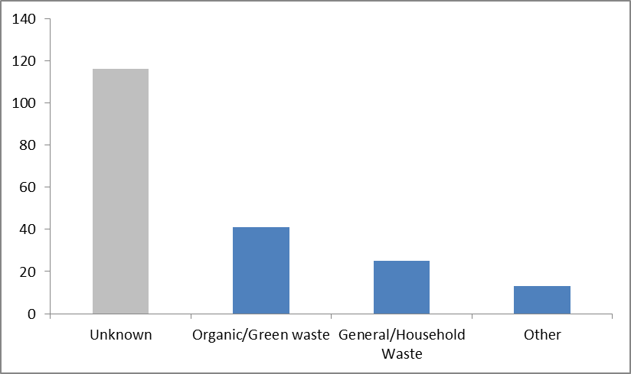

Figure 2: Products burnt in waste fires in New South Wales[[6]](#footnote-7)

## Causes of fires

This section sets out international and Australian experience on the common causes of fires in the waste industry. According to a report commissioned by the USFA (United States Fire Administration), over half of fires in landfill have no known cause.[[7]](#footnote-8)

Depending on the type of landfill fire and its contents fires can often smoulder for weeks, producing odorous and noxious smoke that is not only an annoyance for people in the area but also poses a risk to public health and safety. Burning waste often contains dangerous chemical compounds that can cause respiratory conditions and substantially reduce visibility around the landfill site causing hazard for people operating a vehicle in the area. Even when the smoke is benign it can aggravate existing respiratory conditions.

There are two types of landfill fires: above surface and underground, each type will be discussed in detail below.

Surface Fires

Surface fires usually involve the combustion of waste on or close to the surface and burn at relatively low temperatures. These fires are generally characterised by dense white smoke producing particulates and soot from incomplete combustion processes.  
The smoke produced can contain noxious substances such as organic acids, irritating agents and other compounds that may be hazardous if breathed in by humans and wildlife. When materials such as tyre rubber or plastics burn the temperatures generated can be high, making the fire difficult to extinguish. Higher temperature fires also cause the breakdown of volatile compounds, which emit dense black smoke. The cause of surface fires can be classified as either being accidental or deliberate, from causes such as arson, or the dumping of hot materials.

Underground Fires

Underground fires in landfills occur deep below the surface and can involve materials that are days, months or even years old. These fires are generally more difficult to extinguish than surface fires. A major concern with underground fires is they have potential to cause voids in the landfill site and can cause cave-ins at the landfill surface.

Underground fires produce flammable and toxic gases from incomplete combustion (e.g. carbon monoxide) with the potential for underground fires to damage leachate containment liners and landfill gas collection systems.

A common cause of underground fires is an increase in the oxygen content of the landfill, which increases bacterial activity and raises internal temperatures (aerobic decomposition). If these hotspots come in contact with pockets of methane then it is possible for combustion to occur resulting in an underground fire. The minimum temperature required to potentially cause the ignition of nearby materials could be as low as 65°C.[[8]](#footnote-9)

We note that spontaneous ignition can occur when products have been stored for only a short period of time, particularly during the early stages of anaerobic decomposition.[[9]](#footnote-10)

A major concern of underground fires is that they have potential to smoulder for weeks or months at a time. Because these fires burn for such a long time they may cause a build-up of noxious gases, particularly heavy gases that are not as dispersible. This poses a potential health and safety risk to people in the immediate vicinity. It can be particularly problematic when an underground fire in one form of waste may slowly spread to another nearby, more hazardous waste type.

For example, municipal waste has been smouldering for years under a landfill in St Louis, US. This fire has been the subject of strong community concern because of its proximity to radioactive waste.

Detecting underground fires can be difficult. They are often only detected when smoke can be seen emanating from the landfill site. Build-up of carbon monoxide near the surface can also reach toxic unsafe levels. Generally underground fires can be confirmed by the following characteristics.

* Smoke, smouldering and burning odours emanating from the landfill site
* Substantial settlement of the landfill surface over a short period of time
* Combustion residue and soot in extraction wells and water headers on site
* Elevated levels of CO in excess of 1,000 parts per million (ppm).[[10]](#footnote-11)

Waste fire causes

Figure 3 shows the cause of waste fires recorded for NSW. In line with international experience, the cause of many of these fires is unknown. Where the fire cause is known, arson followed by spontaneous combustion is the primary causes. We note that one of the fires in the “other” category was caused by a battery “igniting itself”. Looking at the data, we can observe that most of the fires caused by spontaneous combustion, occurred in organic waste.

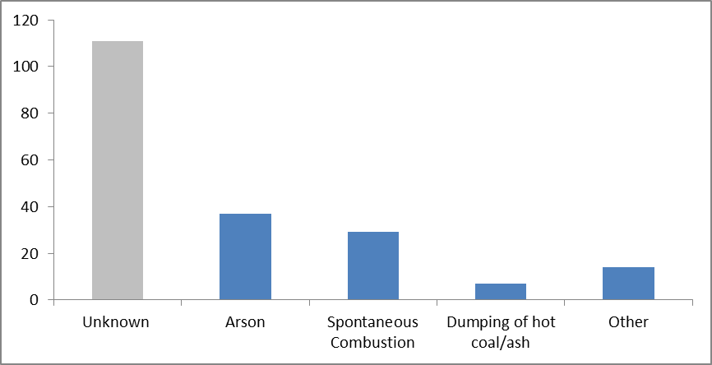

Figure 3: Causes of fires in New South Wales[[11]](#footnote-12)

## Extinguishing a Fire

Extinguishing landfill fires can be a complicated and drawn out process, which requires experienced fire fighters to employ a range of tactics. Each fire needs to be assessed and treated on a case by case basis. Important factors that need to be considered include the type of material that has been ignited, depth of fire, hazardous material, and the fire’s ignition source.

Wind and inclement weatherare important factors that can increase the risk for fire fighters working to extinguish a fire. These factors can directly affect how and when the fire spreads.

The type of suppressant used to extinguish landfill fires can also be an issue. The use of large amounts of water on waste fires can worsen the fire by increasing the rate of aerobic decomposition thus increasing the heat available inside the landfill. The volume of water used to supress a fire can also overwhelm a landfill’s leachate collection system and contaminate ground or surface water sources.

When chemical suppressants are used such as foam, these can add toxic chemicals to the surrounding environment and the water table. There are two primary types of firefighting foam. Class A foam offers a special formulation of hydrocarbon surfactant. It is designed to reduce the surface tension of water providing deeper penetration and increased effectiveness. When aerated correctly, class A foam acts to insulate fuels, protecting them from ignition. Class B foam is used to extinguish fires involving flammable and combustible liquids. There are both disadvantages and advantages to using foam when fighting waste fires.

The decision to use foam and the type used is often made by the incident on-scene commander after the risks and benefits for the specific circumstance have been considered.[[12]](#footnote-13)

Landfill sites are often not equipped with sufficient firefighting resources to supress large fires requiring specialist firefighting equipment to be brought in. This is certainly the case when hazardous material has been set on fire, requiring specialised personnel and protective equipment. Often a team of people is required over an extended period of time to contain the fire. This can be particularly problematic for jurisdictions that rely on volunteers, such as rural areas.

Under-ground fires can be difficult as they often require the use of heavy equipment such as bulldozers and excavators to dig out burning waste to be extinguished. It is also possible that fires might compromise the structural integrity of land-fill sites posing a potential hazard for personnel, equipment and buildings in the area.

## Hazardous waste

Landfill sites containing hazardous waste can be particularly dangerous. Old landfill sites in particular have an increased likelihood of containing hazardous and toxic materials due to the, relatively speaking, historically more relaxed approach to illegal dumping of hazardous and toxic materials.

When fire fighters are given incorrect information about the contents of a waste fire (such as toxic material or radioactive waste) this can be particularly dangerous. The presence of hazardous waste is therefore an important factor when considering the risk of landfill fires to the health and safety of people. Hazardous waste also poses a threat leading to the contamination of land, waterways and atmosphere. Once hazardous waste has led to the contamination of the environment it can be a very costly process to clean up and monitor.

Australia has 208 sites where hazardous waste is treated and stored.[[13]](#footnote-14) The Australian Waste Infrastructure Database lists the key facilities across Australia where hazardous waste is received, stored, processed, treated and disposed. The key purpose of this dataset was to provide locational information on key hazardous waste infrastructure. The dataset also includes information on the type of hazardous waste received and what type of treatment facility and technologies are used.

The dataset identified 66 hazardous sites in Victoria compared with 58 in NSW, which is inconsistent with their respective populations. The dataset lists 14 hazardous landfill sites in Victoria and only 1 in NSW which is the only landfill in the state licensed to dispose of restricted solid waste (as classified by NSW Waste Classification Guidelines, Department of Environment, Climate Change and Water NSW, 2009). There are around 100 other landfills in NSW which are licenced to accept general solid waste, which can contain contaminants under pre-specified limits.

Table 1: Sites where hazardous waste stored

|  |  |
| --- | --- |
| **Jurisdiction** | **No. of sites or facilities listed in dataset** |
| Australia Capital Territory | 3 |
| New South Wales | 58 |
| Northern Territory | 5 |
| Queensland | 24 |
| South Australia | 15 |
| Tasmania | 4 |
| Victoria | 66 |
| Western Australia | 33 |
| **Total Facilities** | **208** |

|  |
| --- |
| **BOX 1: Lithium battery fires**  Lithium batteries are increasingly being used in household products and devices, from lithium button cells to laptop batteries.  There is a risk of fire in the transport of batteries, leading to the UN aviation agency prohibiting cargo shipments of lithium-ion batteries on passenger aircraft due to “concerns by pilots and plane makers that they are a fire risk”.[[14]](#footnote-15) In addition, batteries can cause fires when being transported by land or sea. For example, a fire caused by lithium ion batteries resulted in the evacuation of the terminal at the port in Colombo, Sri Lanka.[[15]](#footnote-16)  In Australia, a lithium battery short-circuited and ignited a fire in the cargo hold of an aircraft during loading.[[16]](#footnote-17) Additionally, the Australian Battery Recycling Initiative has received reports “of at least two fires in a Victorian landfill that are believed to have been caused by Li-ion batteries. In Western Australia a recycling truck caught fire after a home-made Li-ion battery was compacted inside the vehicle.”[[17]](#footnote-18)  Whilst many collectors of mixed batteries (e.g. councils, supermarkets) have not had instances of coin or other cells leading to short-circuiting and fire, one instance was noted at a lithium battery recycling facility where a coin cell lodged between a tack-welded series of larger batteries to initiate a fire.  The rise of lithium battery storage being used at homes in conjunction with solar cells is also of concern to fire fighters. If prominent signage is not in place at the premises relating to the size and exact chemistry of the battery storage (which to date has been common, however it has been identified as an issue to address) can deter fire fighters from getting as close to a building in the fighting of a fire than they otherwise would. |

# Case Studies

This section sets out a summary of a number of fires that have occurred across Australia over the last five years. This looks at media reporting of the causes and impacts of these fires.

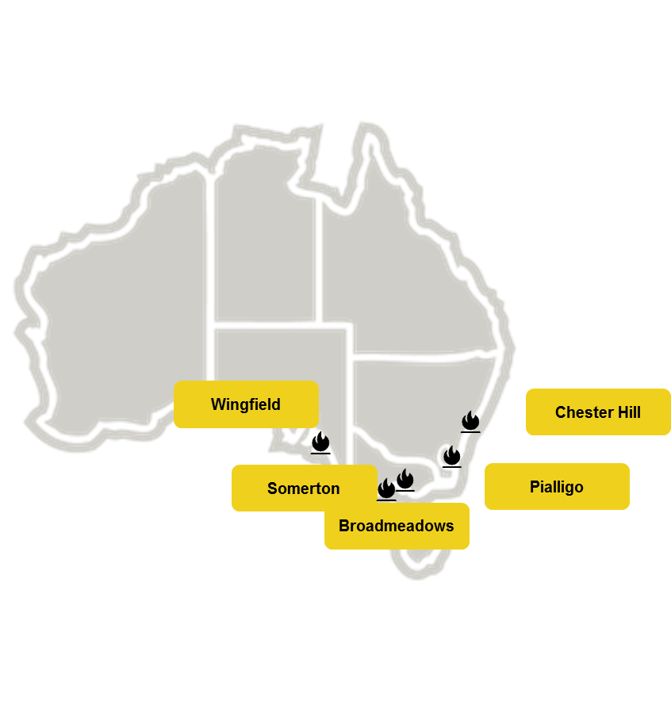

Figure 4: Location of Case Studies in the report

## Chester Hill, NSW

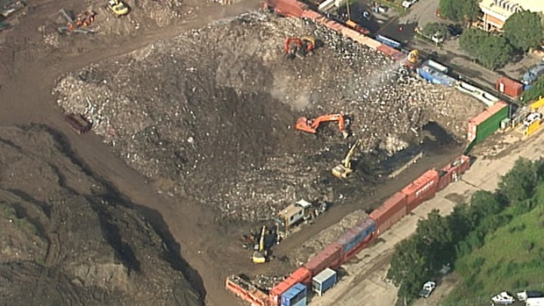

Figure 5: Chester Hill, removal of smouldering waste[[18]](#footnote-19)

A fire in Chester Hill burnt a stockpile of waste for more than two months before finally being extinguished in April 2014.[[19]](#footnote-20) The fire occurred at Number 1 Demolition and Excavation, a waste and recycling business located on Miller Road. Although the fire had been contained, the fire periodically reignited - a common feature of smouldering fires.

Of major concern from this incident was that the EPA had previously known about poor operating practices of Number 1 Demolition and Excavation for five years and had issued three clean-up notices, many extensions and six fines totalling $26,500. However, its waste stockpile was allowed to build up exceeding legal limits multiple times. Even though warnings and fines were issued there was little attempt from the operators at the site to remedy the situation. The maximum penalty for a company’s non-compliance to a clean-up notice is capped at $1 million. In this case, the final cost of the fire including damage and clean-up costs exceeded $2 million. This fee was ultimately covered by the Environmental Trust (a NSW government grants fund for environmental expenditure) as the EPA had only secured a $100,000 bond for clean-up costs after an incident.

The clean up involved the removal of over 24,000 tonnes of building and demolition waste, and 1.4 million litres of run-off water into groundwater and local waterways. The EPA did not press charges for negligence leading to the fire. In addition, test results on the impacts of suppressant foam on water systems that killed fish in a nearby creek were never publicly released. Dozens of complaints were recorded by people suffering from anxiety and health problems, due to the acrid smoke smell both from the fire itself and from dumper trucks carrying the burning material away from the site through populated areas. The EPA revoked the site operators’ license, so that it would no longer be able process waste on the site.[[20]](#footnote-21)

The lack of public information was particularly criticised. There were disagreements between NSW Health and the EPA concerning communications to residents about how the EPA had communicated they were going to respond to the incident. In addition the EPA provided incorrect contact details to residents for contacting a public health unit angering many residents in the area further.[[21]](#footnote-22)

## Wingfield, SA

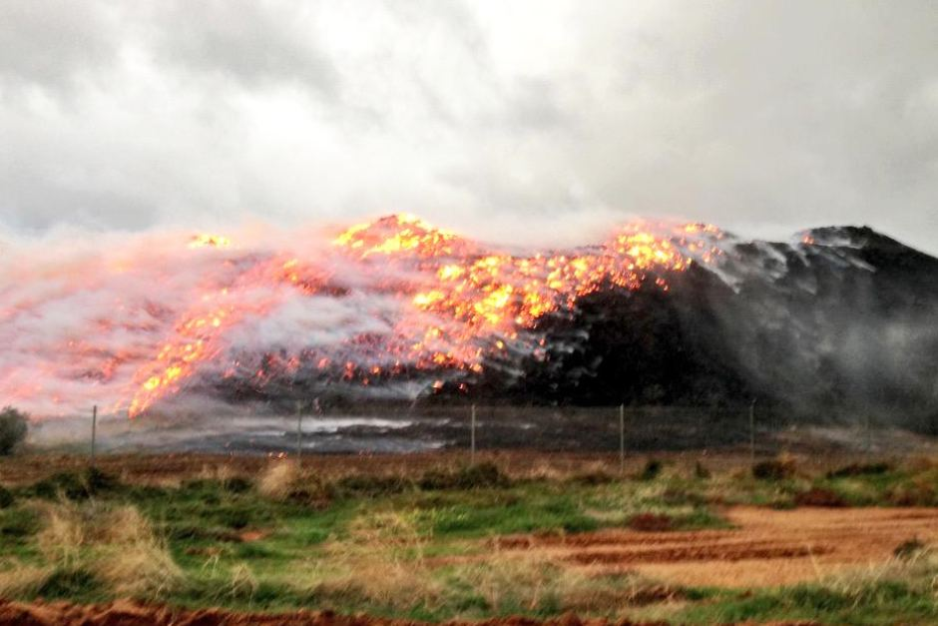

Figure 6: Wingfield tyre fire[[22]](#footnote-23)

In Wingfield SA, a series of waste fire incidents were reported over the last five years at the Wingfield Waste & Recycling Centre. The resource recovery and waste recycling operation contains a collaborative cluster of commercial businesses, including Orara, Adelaide Resource Recovery (ARR), Jeffries Group and Transpacific Industries, that operate individual commercial operations on a common 94-hectare site.

Six waste fires were experienced on the site between 2011 and October 2013 by ARR, which manages construction and demolition waste at the Hanson Road site. This included three mulch fires in the three months from August to October 2012 and a further incident in October 2013 in which a fire in a pile of processed mulch derived from waste materials burned for days, causing fears of health-related problems for up to 40 Metropolitan Fire Service crew. Another fire occurred on 5 May 2015, when a large pile of combustible recycling material ignited at the facility, producing thick smoke and spreading to the surrounding areas.

On 25 July 2013, a flash fire was also caused at the Cleanaway Operations Pty Ltd (formerly Transpacific Industries), which handles residual waste. The fire at its chemical waste processing plant on George St, Wingfield occurred during an attempt to distil an industrial solvent (Cyanex Isopar M Mixture) from chemical waste. One worker sustained burns and five others were exposed.

A review of ARR by the EPA determined that the size of stockpiles, which were up to 9.5 metres high, needed to be reduced. The installation of thermal imaging technology to check heat levels in waste piles and hydrants on the site not connected to mains water were also recommended. The EPA also reported considering the use of drones to monitor activities at the centre.

## Somerton, Victoria

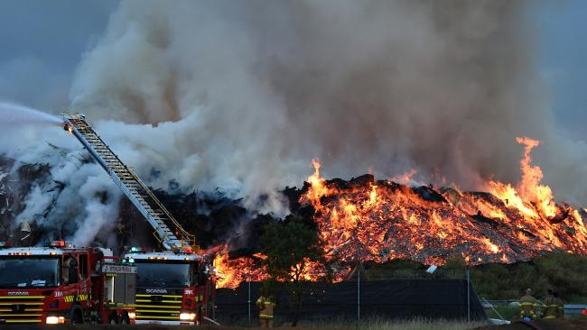

Figure 7: Somerton, Victoria[[23]](#footnote-24)

This fire occurred in a waste facility in November 2015 in Somerton Victoria. Somerton is an urban area in Melbourne. The fire was ignited by a lightning strike on a timber pile at 2:30am on 20 November.[[24]](#footnote-25) The fire spread and at its peak covered an area of 1,600 square meters and was 10 meters high. The fire lasted for six days.

Smoke from the fire caused the closure of the Hume Highway in both directions. In addition, the fire brigade put out a “watch and act” alert for residents in the local area. Residents were initially requested to stay indoors due to the potential for adverse health effects from inhaling toxic smoke.

At the height of the fire on 20 November, one hundred firefighters were involved in containing suppressing the blaze. This included a water bombing helicopter and firefighters from Canberra.[[25]](#footnote-26)

The run off from the fire and the materials used in the firefighting effort entered local waterways. Melbourne Water placed barriers but this was not successful in stopping the run-off contaminating approximately 7km of the nearby Merri Creek. The waterway was discoloured by this run-off.[[26]](#footnote-27)

The former operator of the site had previously been ordered not to add additional material to the site. Before the fire he had been fined $59,000 plus court costs for not complying with this order. In addition, there had been an order to remove all the materials from the site by June 2015.[[27]](#footnote-28) Due to the status of the site, there was minimal visibility of the precise products that were burnt. In addition, the local council was required to absorb “excessive” costs relating to the fire.[[28]](#footnote-29)

## Broadmeadows, Victoria

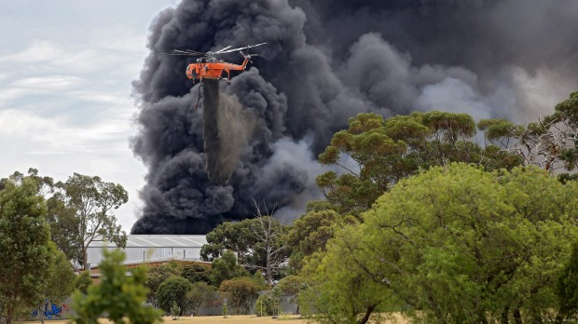

A tyre fire at a recycling facility in northern urban Melbourne in January 2016 was potentially caused by an electrical fault in a tractor.[[29]](#footnote-30) The facility had about 150,000 tyres at the time it ignited, and the fire burnt for about a day. The fire burnt through approximately 70% of the stockpile causing a large black pillar of smoke visible from tens of kilometres away. Approximately 100 firefighters were at the fire location on the first day, with aerial support. About 70 firefighters were engaged to stay overnight. About 10,000L of water had been put on the fire at the height of the firefighting efforts. EPA monitoring indicated that the average air quality was in the “unhealthy all” category for fine particulates over the day. This was largely due to spikes of emissions corresponding to actions to extinguish the blaze. The EPA did not detect volatile organic compounds above safe ranges from the emergency.[[30]](#footnote-31) Run off water from the site was successfully contained by Melbourne Water throughout the emergency. The polluted water that entered creeks was disposed via the sewerage system.[[31]](#footnote-32)

|  |
| --- |
| **BOX 2: Tyre stock piles and fires**  Tyre stockpiles are a particularly high fire risk compared to other waste types. Tyres have quite a high ignition point, so it can be initially difficult to cause them to ignite. However, once on fire, tyre fires are difficult to extinguish.  In particular, the shape of a tyre will preserve heat, while the external membrane acts as shield for firefighting activities. Furthermore, using water on a tyre fire my just spread the materials rather than extinguish the flames. The fumes emitted by a tyre fire are toxic, carcinogenic, and/or mutagenic making tyre fires particularly problematic and sometimes dangerous to extinguish.[[32]](#footnote-33)  In 2015, Victoria introduced new requirements for storing old tyres. From 29 April 2015, premises that store more than 40 tonnes or 5000 equivalent passenger units of tyres require approval from the Victorian Environmental Protection Authority. We note that in 2011, Victoria had the highest tonnage of tyre and other waste generated.    Figure 8:Amount of rubber and tyre waste generated by state (2011) [[33]](#footnote-34)    Figure 9: Correct storage for indoor tyres |

## Piallgio, ACT

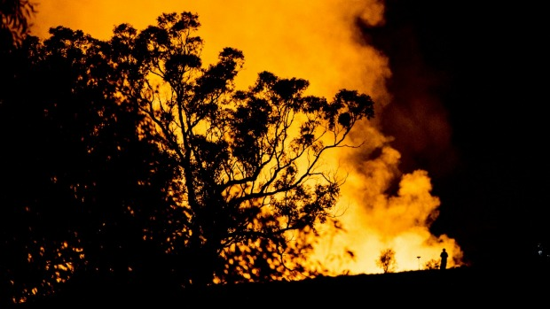

In Piallgio ACT, a waste fire at Canberra Concrete Recyclers began on 4 July 2015 and burned for six days until it was contained and extinguished. The waste fire occurred in a big pile of recycled building material and rubble (i.e. offcuts of timber, nails and roofing materials). When firefighters arrived they found a pile alight of about 40 metres by 30 metres in size.

ACT Fire and Rescue crews were joined by volunteer firefighters from the ACT Rural Fire Service to extinguish hot spots, using heavy plant machinery to reach the source of the fire. The cause of the fire is unclear, but it seems to have started deep down in the pile, generating so much heat that no matter whether foam or water was applied, the fire absorbed material before it could cool and be extinguished so the burning material had to be separated into a makeshift dam for it to cool. The fire caused smoke to billow across the surrounding area. Health warnings were issued by the Health Directorate to people with asthma, other chronic respiratory and/or chronic cardiac diseases to not perform vigorous exercise, and stay inside if affected.

## Case studies in other literature

Fires Services Victoria commissioned a report by IRS Services examining three waste fires.[[34]](#footnote-35)

The three incidents examined in this report were:

* **Brooklyn Landfill**, Old Geelong Rd Brooklyn at 00:28 hrs on Monday 23nd January 2012
* **Knox Transfer Station** at 251 George St Wantirna South at 13:11 hrs on Thursday 26th January 2012 (Australia Day)
* **Werribee Landfill** at West Rd Werribee at 17:04 hrs on Friday 27th January 2012

IRS Services note that a commonality in all of these incidents was an inadequacy of water supply impeding firefighter efforts. As part of the review, overhead photos of the incidents were taken demonstrating the impact of the fires.

Brooklyn Landfill

This transfer station is within a large site in an old quarry that has been used as a landfill site for a number of years. The fire occurred on a Sunday night in a transfer station pit where waste had accumulated over the weekend. The exact cause is still unknown but mostly likely ignition occurred from hot material or ash that had been deposited on the waste site from earlier in the day. This may have caused smouldering ignition deep within the heap that flared once it reached the surface of the rubbish pile. A photo of the site while the fire was underway is shown in Figure 10.

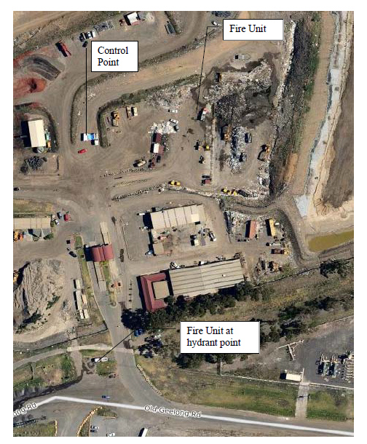

Figure 10: Fire units extinguishing fire at Brooklyn Landfill[[35]](#footnote-36)

Knox Transfer Station

The Knox Transfer station is used for dumping materials before processing. After this stage materials are sorted for waste recovery and transfer to landfill.

The fire was caused by hot pieces of spring steel dropping from a conveyer onto other materials.

Staff at the facility attempted to move equipment out of the fire but were prevented due to the heat. Destroyed machinery was valued at $800,000, and damage to the building was valued at $50,000. An image of the site can be seen in Figure 11, with the fire area circled

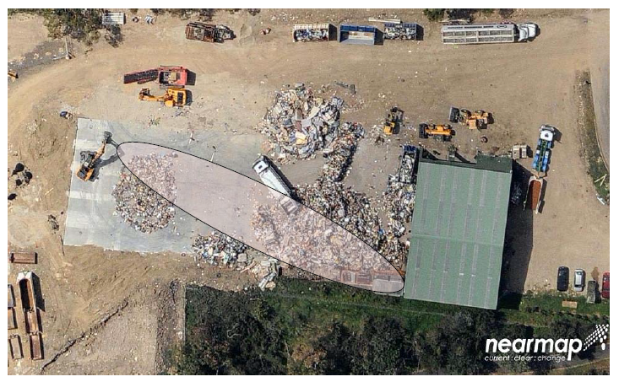

Figure 11: Fire location at Knox Waste Facility[[36]](#footnote-37)

Werribee Landfill

This is a large landfill and transfer station in a former quarry. The business next door is a quarry that still operates. The fire that started in this facility could only be accessed through the neighbouring quarry, which had to cease operations.

The firefighter used A-class foam and water from a nearby dam to combat the literaturened : out of the fire, reporting. ed fires would more than offset theseher regions.ntsd the environment fire. It was noted in reports that the dam was below the runoff of both the quarry and the landfill. Therefore, leachates were probably sprayed onto the fire, but no ill health effects were observed. An aerial view of the site can be seen in Figure 12.

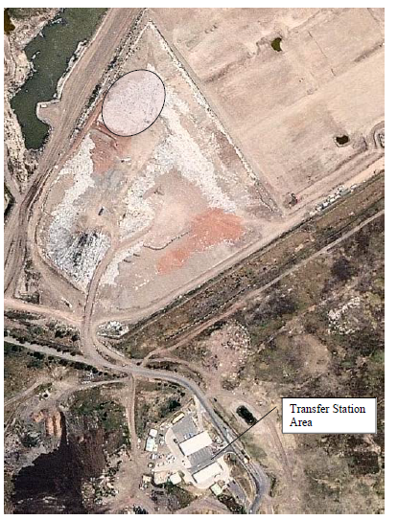

Figure 12: Werribee Transfer Station. Area where fire occurred is circled[[37]](#footnote-38)

# Impacts of fires

Waste fires have impacts on society, environment and economy. The fires themselves pose a threat to injury and human life. Smoke containing hazardous chemicals can be particularly dangerous, as it can be inhaled by members of the community relatively far from the incident.

The immediate environment around the landfill site can also be contaminated. Land, air and water pollution need to be carefully monitored after a fire has occurred. The damage and clean-up costs associated with waste fires can be particularly significant. Hazardous substances exacerbate the impacts of the waste fires across social, environmental and economic dimensions.

## Health and Safety

Landfill fires pose a genuine risk to health, injury and human life. An uncontrolled fire in a waste disposal area places at risk the people within the immediate vicinity. If a landfill fire spreads beyond the landfill site, the people in the homes and businesses in the immediate vicinity are also placed at risk.

Fires at waste facilities or in transit represent health and safety hazard to staff at the facility, responders, and members of the public. Particular risks caused by fires include:

* release of noxious and toxic fumes;
* flames and potential explosions; and
* change of topology of waste piles.

Air toxins

The smoke from waste fires can contain noxious particulate matter due to incomplete combustion, which can have the effect of aggravating existing pulmonary conditions and lead to longer term health effects. The danger to health from breathing in waste fire smoke depends on the toxicity of what is burnt and the length of exposure of the individual. Due to the potentially toxic nature of fumes the public is often advised to stay within their houses. This can be seen in the case studies described in section 4.

Fires can lead to toxins being released into the atmosphere. Of particular concern is the potential release of dioxins. Although dioxins are naturally present in nature, exposure at high levels have been linked to cancer, liver damage, skin rashes as well as reproductive and developmental disorders. These can be created as by-products of the incomplete combustion of organic materials in the presence of chlorine.

Accidental fires at landfills and the uncontrolled burning of residential waste are considered the largest source of dioxin emissions in the United States.

Some waste types, including tyres, can lead to the release of particles of a size smaller than 2.5µm in smoke (referred to as PM2.5). These can be absorbed directly into the bloodstream and can aggravate initial pulmonary conditions and have serious long term side-effects. [[38]](#footnote-39)

## Environmental Impacts

Pollution released into the local atmosphere and water runoff used during fire-fighting activities poses a genuine risk to the local environment. When a landfill fire occurs it is important that air and water quality issues are addressed early in the fire-fighting operation. Thinking ahead about the potential for environmental contamination before and during a waste fire is therefore necessary and important for minimising consequences.

Instances of fire can lead to wider environmental impacts through a variety of factors. These include:

* water contamination;
* air pollution and toxins;
* greenhouse gas emissions (methane and carbon dioxide);

Water Contamination

Leachate is a potentially dangerous pollutant that is caused by the passage of liquid through solid waste in a landfill. Leachate is defined as the “liquid that has passed through or emerged from solid waste and contains soluble, suspended, or miscible materials as the liquid passes through the waste”. Leachate is therefore a pollutant that must be carefully managed. Landfills must operate in a manner that protects the environment, particularly surface and ground water from contamination. This is usually achieved through the use of a composite liner and leachate collection systems.

Landfill sites must therefore operate in a manner that protects the environment, particularly surface and ground water from leachate contamination. During an underground fire, the composite liner leachate systems can be potentially compromised, increasing the risk of leachate leaking into underground water systems. In addition, the increased run-off due to water added by firefighting activities could lead to leachate capacities being exceeded.[[39]](#footnote-40)

Greenhouse gas impact

Greenhouse gas emissions, most notably methane, are the result of the decomposition of organic materials in the landfill (e.g. yard waste, food and paper). The amount of methane that is produced is a function of site-specific factors such as the composition of waste, available moisture and landfill size. Because standard landfill management dictates the covering of waste, the decomposition of waste is largely anaerobic. This often results in the production of large quantities of methane and carbon dioxide.

Landfill disposal of municipal solid waste represents one of the largest anthropogenic global methane emission sources. It has been estimated that approximately 50% of the gas emitted from landfill sites is methane; 45% is carbon dioxide the remaining gas is composed of nitrogen oxygen, hydrogen and other gases. Methane is a particularly potent greenhouse gas with a global warming potential 21 times that of CO2 (over a 100-year period) and 56 times that of CO2 over a 20-year period. If methane is burnt, such as from a fire inorganic waste, it produces CO2 and H2O. Although CO2 has a lower global warming potential, the added risk of dangerous chemicals being released into the atmosphere from a waste fire can be hazardous.

## Economic Impacts

The costs associated with fighting waste fires, and subsequent environmental monitoring can be significant. This raises important questions about who has ultimate responsibility for covering the costs of prevention and who covers the costs associated with extinguishing and managing the fire once it has occurred. Does responsibility ultimately fall on local government, the operator of the landfill, the fire department or some other organisation? The mismatched incentives between different jurisdictions, companies and organisations may not be sending the right regulatory and economic signals for proper landfill maintenance and landfill fire prevention.

The occurrence of waste fires has a strong economic impact on the facilities where they occur, the local community and the wider population.

Examples of economic impacts caused by fires above and beyond any damage to the facility include:

* Economic loss faced by other businessesin the area. As set out in section 5.2 there is potential for toxins and noxious gases to be released into the atmosphere. These could lead to nearby businesses having to shut down temporarily, or reduce their level of service.
* Firefighting activities or smoke causes animpediment to the operation of infrastructure and transport for the surrounding area. For example, the Somerton fire discussed in section 4.3 resulted in the temporary closure of a major arterial road in Melbourne.
* The cost of response from fire departments, and other emergency services, is embedded within their standard operational costs but servicing waste fires might mean they are slow to respond to other emergencies. If it is a large fire it might also mean that fire fighters are called in from other regions. These risks are amplified when waste fires burn for extended periods of time some times up to many months. In some circumstances, fire departments can be actively involved in supressing a fire for many days or weeks on end. As such, waste fires can represent a substantial cost of resources to fire departments.
* Any health impacts in surrounding communities, as discussed in section 5.1, represent an economic cost of a fire.
* There are also costs associated with clean up, or preventing further environmental damage to air or water quality as discussed in sections 5.2
* There have been international examples of agricultural areas being contaminated, and crops subsequently destroyed, due to dioxins in food supply from fires in municipal waste.[[40]](#footnote-41)

We note that many of these costs, while in existence, are difficult to quantify. In the Chester Hill case study is Section 4.1, the cost of the fire for the authorities was estimated at over $2 million. We note that recovering these costs in the aftermath of a fire at a waste facility is likely to be difficult. In the aftermath of a fire, the waste facility may not be in a financial position to meet its obligations.

# Recommendations

## Policy Considerations

Prevention of fires and mitigation

Preventing and preparing for waste fires offers the best defence against the risk of injury, death, property damage, environmental degradation and economic loss. Research has shown the cost of prevention is less expensive than the cost of fighting waste fires and clean-up costs after a fire has occurred. The principal methods often employed for waste fire prevention often include effective waste-site management, correct storage of hazardous waste (e.g. tyre stockpiles, hazardous chemicals) and appropriate methane gas detection and collection. **Effective waste transport and site management is vital for the prevention of waste fires, as is a better understanding of risk factors, especially for newer waste streams such as lithium batteries.**

Effective site-management measures include:

* the prohibition of all forms of deliberate burning on the landfill site;
* thoroughly inspecting and controlling incoming refuse;
* compacting refuse buried to prevent hot spots from occurring;
* prohibit smoking onsite;
* maintain good site security;
* correct storage of tyre stockpiles;
* designated staff responsible for the prevention of waste fires;
* regular fire drills;
* effective fire-fighting equipment and trained personnel;
* fire breaks constructed around the landfill site to prevent the fire spreading and causing bush fires;
* clear signage and advertising for the correct disposal of different waste types; and,
* clearly marked areas for the disposal of hazardous waste.[[41]](#footnote-42)

Compilation of statistics

Waste fires are a complex and ongoing problem for Australia. **Our study highlights that there is an urgent need for the collection and reporting of waste fire statistics in a standardised form.** These statistics would be collated at a federal level with a regulatory requirement for fire departments from each state, along with all waste storage and sorting facilities to record and submit annual statistics on waste fires. We note that in developing guidelines for the compilation of data, special care would need to be taken to account for commercial sensitivities or privacy issues. In addition, we recognise there may be concerns about highlighting security flaws that allow or encourage arson.

Furthermore, waste facilities are often private enterprises, and the sourcing of this information may be commercially sensitive. In addition, collecting and reporting on information represents a cost, however, the benefits of avoided waste fires would more than offset the cost of data collection and reporting (in economic and also environmental and community costs).

We recommend the following data and information is recorded by waste facilities for each fire:

* where the fire occurred (if known);
* ignition source (if known);
* dominant fuel source;
* if a hazardous material was involved;
* time to extinguish;
* water contamination;
* air pollution;
* disruption to public; and
* any damage to property, including cost;

We propose that this information, potentially anonymised, should be published on a regular basis. This will improve transparency on the number, causes and impacts of fires.

In addition we propose that fire departments record and report on:

* the number of callouts to waste facilities;
* the maximum resources used (ie number of appliances/brigades dispatched);
* length of time that fire department presence was required;
* observed property damage;
* products burnt; and
* a qualitative statement on the techniques used to resolve the situation, and their effectiveness

All of this information should be made publically available, along with any assessment by environmental agencies on impacts.

## methane and landfills

Methane gas is a highly flammable gas that represents a particular fire hazard. Methane levels need to be monitored in and around landfill sites and when these levels reach concentrations making them explosive; the landfill operator must take immediate steps to mitigate the risks to people and the site. On sites that have specialised methane gas collection systems special care must be taken. Operators of these systems must ensure they not to overdraw the system and cause ignition. Once the methane has been collected in controlled manner it can either be burnt (flared) or converted into energy. Flaring is common practice in small and medium size landfill sites. Burning methane converts the methane to carbon dioxide. Not only is CO2 a less potent greenhouse gas but also combusting methane reduces odour, and decreases the risk of fires and explosions.

Another common approach is converting landfill gas to energy. When methane is burnt in a controlled manner it can be converted into electricity, heat or steam. When methane is burnt, in a controlled process, a powerful greenhouse gas is converted into energy and pollution is removed from the atmosphere.

## Areas for further investigation

An international review of the literature has shown that many other countries have studied landfill fires in much greater depth than Australia.

We consider that there may be merit in the following detailed estimation into the economic costs of fires. Such a report could take into account experience and modelling to determine the total cost of fires in different facilities. This could take into account costs relating to:

* deployment of fire brigades and other emergency services;
* environmental impacts such as toxins released into the air, waterways and greenhouse gas emissions;
* health impacts
* interference of the operation of nearby businesses,
* reduction of utility of nearby residents due to odour etc.; and
* clean up costs.

# Sources

This section outlines a collection of international and Australian resources on the topic of fires in waste that were compiled in creating this report.

**Academic Articles**

Downard, J., Singh, A., Bullard, R., Jayarathne, T., Rathnayake, C., Simmons, D., Wels, B., Spak, S., Peters, T., Beardsley, D., Stanier, C. and Stone, E. (2015). Uncontrolled combustion of shredded tires in a landfill – Part 1: Characterization of gaseous and particulate emissions. *Atmospheric Environment*, 104, pp.195-204.

Ibrahim, M., Göransson, G., Kaczala, F., Hogland, W. and Marques, M. (2013). Characterization of municipal solid waste temporary storage sites: Risks posed to surrounding areas as a consequence of fire incidents. *Waste Management*, 33(11), pp.2296-2306.

Ibrahim, M. and Hogland, W. (2013). Organizing preliminary storage sites of organic material, waste fuels and recyclables and their separating distance from populated areas. *J Mater Cycles Waste Manag*, 16(2), pp.270-281.

Slack, R., Gronow, J. and Voulvoulis, N. (2004). Hazardous Components of Household Waste. *Critical Reviews in Environmental Science and Technology*, 34(5), pp.419-445.

Vassiliadou, I., Papadopoulos, A., Costopoulou, D., Vasiliadou, S., Christoforou, S. and Leondiadis, L. (2009). Dioxin contamination after an accidental fire in the municipal landfill of Tagarades, Thessaloniki, Greece. *Chemosphere*, 74(7), pp.879-884.

**Government Reports**

Department of Fire and Emergency Services, *Annual Report 2014-15,* 2015 p.153 Available at: <http://www.dfes.wa.gov.au/publications/Pages/annualreports.aspx>

Environment Agency, 2007, Review and Investigation of deep-seated fires within landfill sites. United Kingdom. Available at: <https://www.gov.uk/government/publications/review-and-investigation-of-deep-seated-fires-within-landfill-sites>

Environment Protection Authority Victoria, 2016, *Broadmeadows Tyre Fire: Air Quality*, March 2016. Available at: <http://www.epa.vic.gov.au/our-work/publications/publication/2016/march/1618>

Fire and Rescue NSW, *Annual Report 2014-15*, 2015, p. 4. Available at: <http://www.fire.nsw.gov.au/page.php?id=453>

Department of the Environment. 2011. Hyder Consulting. *Waste and Recycling in Australia 2011*, Workbook. Available at: <https://www.environment.gov.au/protection/national-waste-policy/publications/waste-and-recycling-australia-2011>

Department of the Environment. Australia’s Hazardous Waste Infrastructure Report. 2014. <http://www.environment.gov.au/protection/publications/hazardous-waste-infrastructure-australia>

IRS Services, Towards Improved Fire Management in Landfill Sites, July 2012, Available at: [http://fire-com-live-wp.s3.amazonaws.com/wp content/uploads/FireManagement\_Landfill\_July\_2012.pdf](http://fire-com-live-wp.s3.amazonaws.com/wp-content/uploads/FireManagement_Landfill_July_2012.pdf)

South Australian Metropolitan Fire Service, Annual *Report 2013-14,* 2014 p 75. Available at: <http://www.mfs.sa.gov.au/site/publications/annual_reports.jsp>

State Fire Commission, Tasmania, *Annual Report 2014-15*, 2015 p. 19. Available at: <http://www.fire.tas.gov.au/Show?pageId=colAnnualReports>

TriData Corporation, Landfill Fires: Their Magnitude, Characteristics, and Mitigation, 2002. United States Fire Administration. Available at: <https://www.usfa.fema.gov/downloads/pdf/publications/fa-225.pdf>

**Advice and guidelines on waste handling and fire safety**

Waste Industry Safety and Health Forum (WISH), 2014. Reducing Fire Risk at Waste Management Sites, October 2014. Available at: <http://www.hse.gov.uk/waste/wish.htm>

Submission on managing e-waste in Victoria. ABRI, 1 Dec 2015 <http://delwp.vic.gov.au/__data/assets/pdf_file/0013/324130/Australian-Battery-Recycling-Initiative.pdf>

**Newspaper Articles**

ABC, 2015, Neighbours, authorities tried to shut down illegal dump where fire rages in Melbourne's north, 20 November 2015, accessed: <http://www.abc.net.au/news/2015-11-20/fire-crews-battle-huge-rubbish-fire-somerton-melbourne/6956946>

Butt C and Gough D; 2016, “EPA knew burning Broadmeadows tyre pile was a fire risk”; The Age 13 January 2016 <http://www.theage.com.au/victoria/epa-knew-burning-broadmeadows-tyre-pile-was-a-fire-risk-20160112-gm4p7p.html>

Canberra Times, ACT firefighters join Country Fire Authority to fight Somerton tip fire , Canberra Times, November 23 2015, accessed: <http://www.canberratimes.com.au/act-news/act-firefighters-join-country-fire-authority-to-fight-somerton-tip-fire-20151122-gl57w9.html>

Canterbury Bankstown Express, ‘Fire goes out, after two months’, 29 Apr 2014.

Economy Next, Sri Lanka container fire in port said under control, 15 June 2016. <http://www.economynext.com/Sri_Lanka_container_fire_in_port_said_under_control-3-5263.html>,

Hume City Council, 2015, Somerton Fire: Community Information. 29 November 2015 accessed: <http://www.hume.vic.gov.au/About_Us_Contact_Details/Your_Council/Media_Publications_Forms/Media_Releases/Media_Releases_2015/Somerton_Fire_Community_Information>

The Leader, Community News. <http://www.heraldsun.com.au/leader/north-west/firefighters-battle-large-blaze-in-somerton/news-story/a579202645b76eb79aa8b49469f8332b>

Melbourne Water, 2016 Polluted runoff effectively contained at Broadmeadows, 15 January 2016. Available at: <http://www.melbournewater.com.au/aboutus/news/Pages/Polluted-runoff-effectively-contained-at-Broadmeadows.aspx>

Michell L, 2016, Hume council slams EPA over fire costs, Star Weekly, April 18 2016, Available at: <http://www.starweekly.com.au/news/council-slams-epa-over-fire/>

O’Brien, N; 2014; Chester Hill fire costs $2 million to clean up; Sydney Morning Herald, 3 August 2014, Accessed: <http://www.smh.com.au/nsw/chester-hill-fire-costs-2-million-to-clean-up-20140716-ztivl.html>

Reuters, Lithium-ion batteries banned as cargo on passenger flights. 23 February 2016. Available at: <http://www.theguardian.com/world/2016/feb/23/lithium-ion-batteries-banned-as-cargo-on-passenger-flights>.

Daily Mirror, June 2016. Several containers aboard a ship on fire. Available at: <http://www.dailymirror.lk/110972/Several-containers-aboard-a-ship-on-fire>

Lithium battery fire sparks Mayday. Lithium battery fire sparks Mayday, 9 Sept 2014



1. NSW: Fire and Rescue NSW, Annual Report 2014-15, 2015, p. 4 [↑](#footnote-ref-2)
2. WA: Department of Fire and Emergency Services, Annual Report 2014-15, 2015 p.153 [↑](#footnote-ref-3)
3. SA: South Australian Metropolitan Fire Service, Annual Report 2013-14, 2014 p 75. [↑](#footnote-ref-4)
4. Tas: State Fire Commission, Annual Report 2014-15, 2015 p. 19 [↑](#footnote-ref-5)
5. Department of the Environment. Waste and Recycling Report. 2011. [↑](#footnote-ref-6)
6. ISF analysis of NSW EPA Collected Waste Fire Data. 2016. [↑](#footnote-ref-7)
7. Tridata Coproration, 2002, p 18. [↑](#footnote-ref-8)
8. Tridata Coproration,2002, p 18. [↑](#footnote-ref-9)
9. Ibrahim et al, 2013. [↑](#footnote-ref-10)
10. Tridata Corporation, p. 14. [↑](#footnote-ref-11)
11. ISF analysis of NSW EPA Data [↑](#footnote-ref-12)
12. Tridata Corporation, 2002, p16. [↑](#footnote-ref-13)
13. Department of the Environment. Australia’s Hazardous Waste Infrastructure Report. 2014. <http://www.environment.gov.au/protection/publications/hazardous-waste-infrastructure-australia> [↑](#footnote-ref-14)
14. Reuters, Lithium-ion batteries banned as cargo on passenger flights <http://www.theguardian.com/world/2016/feb/23/lithium-ion-batteries-banned-as-cargo-on-passenger-flights>, 23 February 2016. [↑](#footnote-ref-15)
15. Economy Next, Sri Lanka container fire in port said under control, <http://www.economynext.com/Sri_Lanka_container_fire_in_port_said_under_control-3-5263.html>, 15 June 2016. [↑](#footnote-ref-16)
16. Lithium battery fire sparks Mayday, Lithium battery fire sparks Mayday, 9 Sept 2014 [↑](#footnote-ref-17)
17. Submission on managing e-waste in Victoria <http://delwp.vic.gov.au/__data/assets/pdf_file/0013/324130/Australian-Battery-Recycling-Initiative.pdf> , ABRI, 1 Dec 2015 [↑](#footnote-ref-18)
18. The Sydney Morning Herald <http://www.smh.com.au/nsw/chester-hill-fire-costs-2-million-to-clean-up-20140716-ztivl.html> [↑](#footnote-ref-19)
19. O’Brien, N; 2014; Chester Hill fire costs $2 million to clean up; *Sydney Morning Herald*, 3 August 2014, Accessed: <http://www.smh.com.au/nsw/chester-hill-fire-costs-2-million-to-clean-up-20140716-ztivl.html> [↑](#footnote-ref-20)
20. Canterbury Bankstown Express, ‘Fire goes out, after two months’, 29 Apr 2014. [↑](#footnote-ref-21)
21. O’Brien, N; 2014; Chester Hill fire costs $2 million to clean up; *Sydney Morning Herald*, 3 August 2014, Accessed: <http://www.smh.com.au/nsw/chester-hill-fire-costs-2-million-to-clean-up-20140716-ztivl.html> [↑](#footnote-ref-22)
22. ABC <http://www.abc.net.au/news/2015-05-06/waste-industry-calls-inquiry-recurring-wingfield-dump-fires/6449974> [↑](#footnote-ref-23)
23. Source: The Leader, Community News. <http://www.heraldsun.com.au/leader/north-west/firefighters-battle-large-blaze-in-somerton/news-story/a579202645b76eb79aa8b49469f8332b> [↑](#footnote-ref-24)
24. ABC, 2015, Neighbours, authorities tried to shut down illegal dump where fire rages in Melbourne's north, 20 November 2015, accessed: <http://www.abc.net.au/news/2015-11-20/fire-crews-battle-huge-rubbish-fire-somerton-melbourne/6956946> [↑](#footnote-ref-25)
25. Canberra Times, ACT firefighters join Country Fire Authority to fight Somerton tip fire , *Canberra Times*, November 23 2015, accessed: <http://www.canberratimes.com.au/act-news/act-firefighters-join-country-fire-authority-to-fight-somerton-tip-fire-20151122-gl57w9.html> [↑](#footnote-ref-26)
26. Hume City Council, 2015, Somerton Fire: Community Information. 29 November 2015 accessed: <http://www.hume.vic.gov.au/About_Us_Contact_Details/Your_Council/Media_Publications_Forms/Media_Releases/Media_Releases_2015/Somerton_Fire_Community_Information> [↑](#footnote-ref-27)
27. Michell L, 2016, Hume council slams EPA over fire costs, *Star Weekly,* April 18 2016, access <http://www.starweekly.com.au/news/council-slams-epa-over-fire/> [↑](#footnote-ref-28)
28. Michell L, 2016, Hume council slams EPA over fire costs, *Star Weekly,* April 18 2016, access <http://www.starweekly.com.au/news/council-slams-epa-over-fire/> [↑](#footnote-ref-29)
29. Butt C and Gough D; 2016, “EPA knew burning Broadmeadows tyre pile was a fire risk”; *The Age* 13January 2016.

    <http://www.theage.com.au/victoria/epa-knew-burning-broadmeadows-tyre-pile-was-a-fire-risk-20160112-gm4p7p.html> [↑](#footnote-ref-30)
30. Environment Protection Authority Victoria, 2016, *Broadmeadows Tyre Fire: Air Quality*, March 2016 [↑](#footnote-ref-31)
31. Melbourne Water, 2016 *Polluted runoff effectively contained at Broadmeadows,* <http://www.melbournewater.com.au/aboutus/news/Pages/Polluted-runoff-effectively-contained-at-Broadmeadows.aspx>, 15 January 2016. [↑](#footnote-ref-32)
32. Downard et al, 2015, p. 196. [↑](#footnote-ref-33)
33. Department of Environment. Waste and Recycling Report. 2011. [↑](#footnote-ref-34)
34. IRS Services, *Towards Improved Fire Management in Landfill Sites,* July 2012, Available at <http://fire-com-live-wp.s3.amazonaws.com/wp-content/uploads/FireManagement_Landfill_July_2012.pdf> [↑](#footnote-ref-35)
35. Image sourced IRS Services p36 [↑](#footnote-ref-36)
36. Image sourced IRS Services p29 [↑](#footnote-ref-37)
37. Image sourced IRS Services p33 [↑](#footnote-ref-38)
38. Ibrahim, 2014, pp 270 -271 [↑](#footnote-ref-39)
39. TriData Corporation, 2002, p 4. [↑](#footnote-ref-40)
40. Vassiliadiaou I, et al 2009, “*Dioxin contamination after an accidental fire in the municipal landfill of Tagarades, Thessaloniki, Greece*”, Chemosphere, Issue 74 pp. 879 – 884. [↑](#footnote-ref-41)
41. Waste Industry Safety and Health Forum. 2014. [↑](#footnote-ref-42)