# Viral encephalopathy and retinopathy (VER)

Also known as viral nervous necrosis (VNN)

From Aquatic animal diseases significant to Australia: identification field guide, 5th edition

Figure 1 Darkened colouration in seven-band grouper (Hyporthodus septemfasciatus) with VER

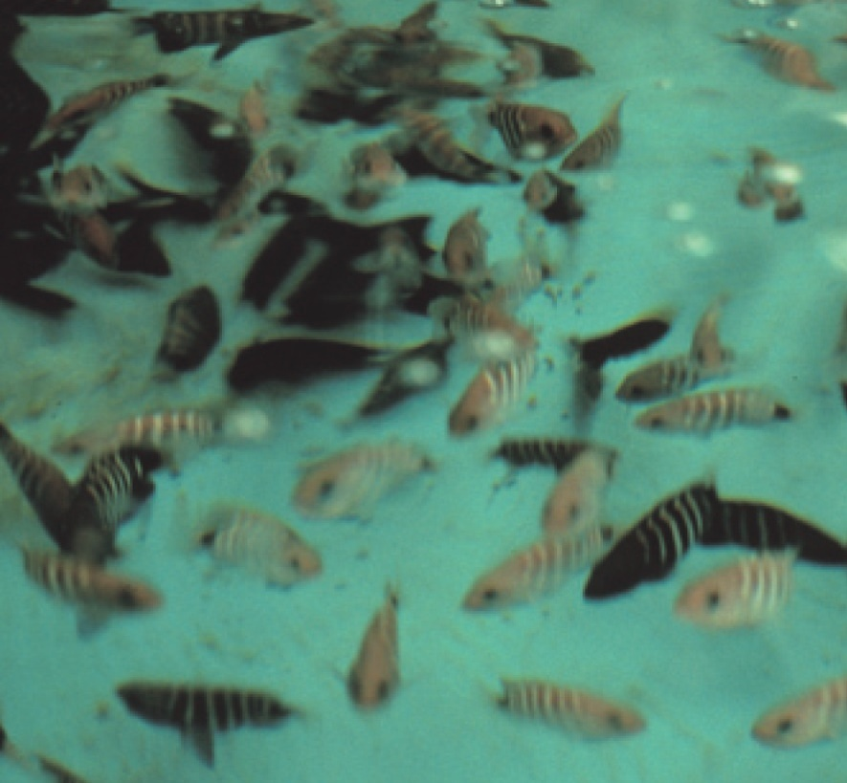

Note: Dark groupers are diseased, light fish are normal. Change in colouration is an important indicator for VER (species differ in what colour change occurs; diseased barramundi become lighter).

Source: B Munday

## Signs of disease

Important: Animals with this disease may show one or more of these signs, but the pathogen may still be present in the absence of any signs.

Disease signs at the farm, tank or pond level are:

* 50% to 100% cumulative mortality over a period of 48 hours to several weeks
* higher mortalities in larvae and juvenile fish (9 to 28 days old), although older fish (greater than 28 days) may also be affected
* anorexia
* abnormal swimming behaviours, including erratic, uncoordinated darting, spiral and/or looping swim pattern, corkscrew swimming
* fish resting belly-up (loss of equilibrium)
* hyperactivity
* sporadic protrusion of the head from the water.

Gross pathological signs are:

* colour change
  + affected fish may become lighter ( such as larval barramundi) or darker (such as larval groupers), depending on the species affected and their environment
* blindness
* abrasions
* emaciation
* over-inflated swim bladder (the only significant internal gross pathological sign).

Microscopic pathological signs are:

* vacuolation of central nervous tissues, including retina
* intracytoplasmic inclusions in brain tissues as crystalline arrays or aggregates.

## Disease agent

VER or VNN is a disease caused by a Betanodavirus, in the family Nodaviridae. In Australia, VER was formerly referred to as barramundi picorna-like virus.

## Host range

Table 1 Species known to be susceptible to VER

| Common name | Scientific name |
| --- | --- |
| Amberjacka | Seriola dumerili |
| Atlantic halibuta | Hippoglossus hippoglossus |
| Archer fish | Toxotes chatareus |
| Atlantic salmonb | Salmo salar |
| Australian bassa | Macquaria novemaculeata |
| Banded archerfisha | Toxotes jaculatrix |
| Barcoo grunter | Scortum barcoo |
| Barfin floundera | Verasper moseri |
| Barramundia | Lates calcarifer |
| Brown-marbled groupera | Epinephelus fuscoguttatus |
| Chinese catfisha | Silurus asotus |
| Cobiaa | Rachycentron canadum |
| Convict surgeonfish | Acanthurus triostegus |
| Coral trout | Plectropomus leopardus |
| Crimson snappera | Lutjanus erythropterus |
| Common solea | Solea solea |
| Dusky grouper | Epinephelus marginatus |
| Eastern freshwater coda | Maccullochella ikei |
| Estuarine rockcoda | Epinephelus tauvina |
| Estuary catfish | Cnidoglanis macrocephalus |
| European eela | Anguilla anguilla |
| European seabassa | Dicentrarchus labrax |
| Floundersa | Paralichthyidae |
| Giant groupera | Epinephelus lanceolatus |
| Gilt-head sea breama | Sparus aurata |
| Golden grey mulleta | Chelon auratus |
| Golden perch | Macquaria ambigua |
| Grouper and estuary coda | Epinephelus spp. |
| Haddocka | Melanogrammus aeglefinus |
| Humpback groupera | Cromileptes altivelis |
| Japanese floundera | Paralichthys olivaceus |
| Japanese parrotfisha | Oplegnathus fasciatus |
| Japanese seabassa | Lateolabrax japonicus |
| Japanese tilefish | Branchiostegus japonicus |
| Longtooth groupera | Epinephelus bruneus |
| Luderick | Girella tricuspidata |
| Macquarie perch | Macquaria australasica |
| Malabar groupera | Epinephelus malabaricus |
| Mangrove jacka | Lutjanus argentimaculatus |
| Milkfish | Chanos chanos |
| Mulletsa | Mugilidae, all species |
| Mulloway | Argyrosomus japonicus |
| Murray cod | Maccullochella peelii peelii |
| Narrowstripe cardinalfish | Pristiapogon exostigma |
| Nile tilapia | Oreochromis niloticus |
| Orange-spotted groupera | Epinephelus coioides |
| Permita | Trachinotus falcatus |
| Red druma | Sciaenops ocellatus |
| Red mullet | Mullus barbatus |
| Red-spotted groupera or Hong Kong grouper | Epinephelus akaara |
| Russian sturgeona | Acipenser gueldenstaedtii |
| Samson fish | Seriola hippos |
| Senegalese solea | Solea senegalensis |
| Seven-band groupera | Hyporthodus septemfasciatus |
| Shi druma | Umbrina cirrosa |
| Silver perch | Bidyanus bidyanus |
| Silver trevallya | Pseudocaranx dentex |
| Six bar grouper | Epinephelus sexfasciatus |
| Sleepy cod | Oxyeleotris lineolata |
| Snubnose darta | Trachinotus blochii |
| Spotted coral grouper | Plectropomus maculatus |
| Spotted knifejawa | Oplegnathus punctatus |
| Spotted wolffish | Anarhichas minor |
| Striped trumpetera | Latris lineata |
| Thread-sail filefisha | Stephanolepis cirrhifer |
| Tiger grouper hybrid | Epinephelus fuscoguttatus × E. lanceolatus |
| Tiger puffera | Takifugu rubripes |
| Tilapias | various genera and species |
| Turbota | Scophthalmus maximus |
| White groupera | Epinephelus aeneus |
| White seabassa | Atractoscion nobilis |
| Winter floundera | Pseudopleuronectes americanus |
| Winter whiting | Sillago maculata |
| Yellowfin bream | Acanthopagrus australis |
| Yellowtail kingfish | Seriola lalandi |

**a** Naturally susceptible. **b** Experimentally susceptible to disease via intraperitoneal injection. Note: Other species have been shown to be experimentally susceptible.

Table 2 Non-fish carriers

| Common name | Scientific name |
| --- | --- |
| Molluscs | Various genera and species |
| Polychaetes | Nereis spp. |

## Presence in Australia

VER has been officially reported from New South Wales, the Northern Territory, Queensland, South Australia, Tasmania and Western Australia. It is primarily reported to affect larvae or fry.

Map 1 Presence of VER, by jurisdiction

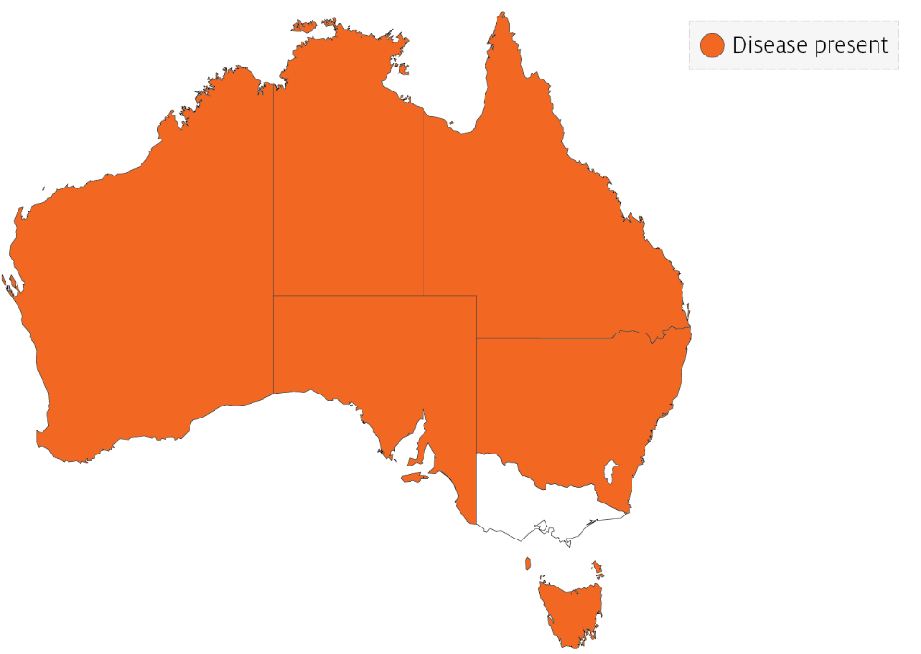

## Epidemiology

* VER has occured in at least 70 species of marine fish from 16 families, and has been diagnosed in all inhabited continents.
* Most fish are affected as larvae or juveniles. However, in recent years, mortalities have occurred in older fish up to harvest size, particularly in European seabass, groupers (Epinephelus spp.) and Atlantic halibut. Disease incidence in the groupers and seabass has been associated with high water temperatures.
* Susceptibility and mortality are age dependent. Onset of clinical disease in younger fish of some species results in higher mortality.
* Batches of barramundi larvae for aquaculture are now routinely screened for this disease in Australia.
* The incubation period for the disease in barramundi is 4 days, with typical disease onset 9 to 28 days after hatching, rarely occurring in older fish (50 to 60 days old). In silver trevally, disease onset is 1 day after hatching.
* Transmission is believed to occur both horizontally through the water column (via mouth, gills and skin), and vertically (parent to offspring). The rate of transmission may be influenced by stressors, including handling, repeated spawning, high stocking densities, high ambient temperature and virulence of the particular Betanodavirus strain. Sand worms of the family Nereidae, genus Nereis, and bivalves collected in proximity to infected farms have had positive detection of Betanodavirus.
* The virus can survive for 1 year in the right environmental conditions (pH 2 to 9 and 15°C) and can persist subclinically in infected live fish. Therefore, fish products and by-products may facilitate the spread of virus to unaffected areas.
* Cumulative mortality at 1 month is typically 50% to 100% in barramundi and 100% in silver trevally. In Australian hatcheries, 100% mortality in less than 3 days in larval fish is typical.

## Differential diagnosis

The list of similar diseases in the next section refers only to the diseases covered by this field guide. Gross pathological signs may also be representative of diseases not included in this guide. Do not rely on gross signs to provide a definitive diagnosis. Use them as a tool to help identify the listed diseases that most closely account for the observed signs.

## Similar diseases

Grouper iridoviral disease and Tilapia lake virus (TiLV) disease.

## Sample collection

Only trained personnel should collect samples. Using only gross pathological signs to differentiate between diseases is not reliable, and some aquatic animal disease agents pose a risk to humans. If you are not appropriately trained, phone your state or territory hotline number and report your observations. If you have to collect samples, the agency taking your call will advise you on the appropriate course of action. Local or district fisheries or veterinary authorities may also advise on sampling.

## Emergency disease hotline

See something you think is this disease? Report it. Even if you’re not sure.

Call the Emergency Animal Disease Watch Hotline on **1800 675 888**. They will refer you to the right state or territory agency.

## Microscope images

Figure 2 Transverse histological section through head of larval (20 day old) barramundi (Lates calcarifer) with VER

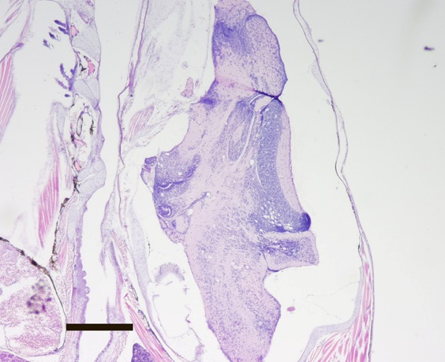

Note: Vacuoles associated with VER infection are readily visible in the brain. Haematoxylin and eosin stain. 20x magnification, scale bar = 300µm

Source: B Jones

## Further reading

CEFAS International Database on Aquatic Animal Diseases [Viral Encephalopathy and Retinopathy](https://www.cefas.co.uk/international-database-on-aquatic-animal-diseases/disease-data/?id=67)

Department of Agriculture, Water and the Environment [AQUAVETPLAN disease strategy manual: Viral encephalopathy and retinopathy](http://www.agriculture.gov.au/animal/aquatic/aquavetplan/viral-encephalopathy-retinopathy)

World Organisation for Animal Health [Manual of diagnostic tests for aquatic animals](http://www.oie.int/en/international-standard-setting/aquatic-manual/access-online)

These hyperlinks were correct at the time of publication.

## Contact details

Emergency Animal Disease Watch Hotline 1800 675 888

Email [AAH@agriculture.gov.au](mailto:AAH@agriculture.gov.au)Website [agriculture.gov.au/pests-diseases-weeds/aquatic](http://www.agriculture.gov.au/pests-diseases-weeds/aquatic)

© Commonwealth of Australia 2020

This work is copyright. It may be reproduced in whole or in part subject to the inclusion of an acknowledgement of the source and no commercial usage or sale.