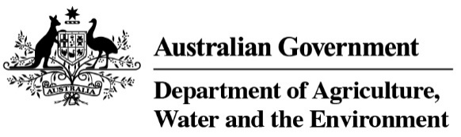

## Video transcript for Su McCluskey - Special Representative for Australian Agriculture.

Hi, I’m Su McCluskey, the first Special Representative for Australian Agriculture.

I’m a beef cattle farmer at Yass, near Australia’s capital, Canberra.

I’ve been farming for over 30 years and raise cattle here on mainly native pastures.

I need to manage the seasonal changes and the challenges.

In drought, I hand feed my stock every day and truck in water for them.

But we have had wonderful seasons for the past two years and the cattle are healthy and happy.

I love it here. I love the landscape, I love my cattle, I love being part of the rural community.

The challenges just make me more resilient.

And because I love the land, I make it my business to look after it, like all Australian farmers do.

When I am not farming, I contribute to the agricultural and community sectors as a director on several boards and I have worked in regulation reform and risk management.

I bring a depth of experience and expertise to this new role.

I’ll be encouraging governments and others to work towards ensuring the world can produce food and fibre in the most sustainable and efficient way.

I will also perform an important public leadership role, emphasising the importance of trade for global food security and the critical role that the multilateral system and standard setting bodies play.

It’s so important to strengthen our engagement at a time when trade in agriculture is facing huge challenges.

I’m looking forward to sharing the great stories of Australian agriculture when I meet with farmers, trade officials, government officials and farm advocates from around the world.

And of course, what will be clear is there’s no one-size-fits-all when it comes to solving the challenges of climate adaption and the impacts of agriculture on soil, water and biodiversity health.

That’s it for now, looking forward to working with you!

ENDS