Levies Online User Guide
Cattle and livestock Livecorp return

Note: This return is for the cattle (exporters) and livestock (exporters) charge

How to enter your return in Levies Online
1 | Click ‘My Returns’ on the left side of the screen. |   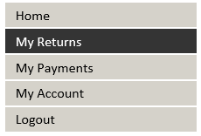
2 | Click ‘New Return’. | 
3 | Select your return type & period.  Click ‘Continue’. | 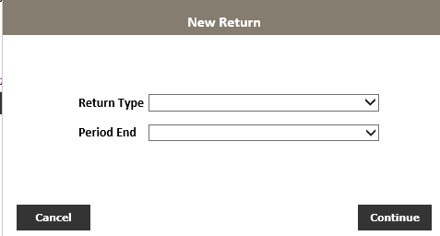  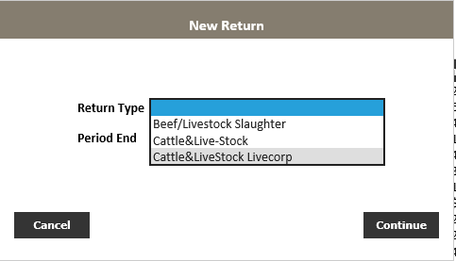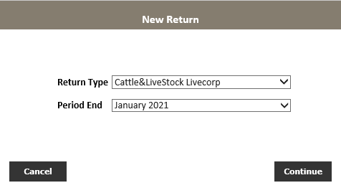
4 | Click ‘Enter Return’. | 
5 | Select ‘commodity type’ from the Levy/Commodity dropdown menu.  All options in the Levy/Commodity  drop-down box apply to the  Cattle & livestock Livecorp return. | 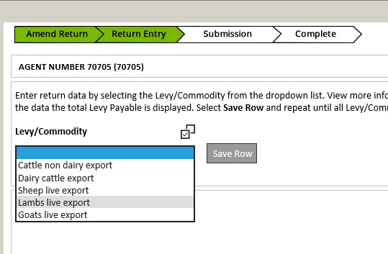  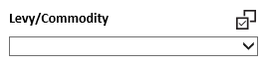
6 | Enter values (as required) of the commodity and click ‘Save Row’ to save.  Select the ‘Save Row’ button to save your Levy/Commodity data. | 
7 | Repeat steps 5-6 for all transactions relating to this return.
8 | When all data has been entered and saved click ‘Next Step’. | 
P | Review return details.  Click ‘declaration tick-box’.  Click ‘Submit Return’. | 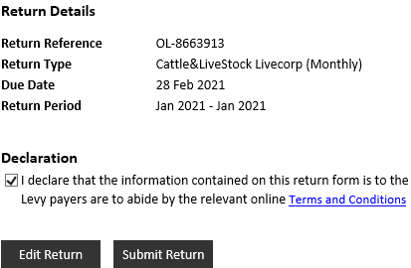
10 | Click ‘Ok’. | 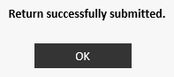
You will receive an email from leviesonline@awe.gov.au confirming your return has been successfully submitted.
(E.g. Subject: 42246 Jan 2021 – Jan 2021 Cattle & Livestock Livecorp (monthly) levy return – submitted)

How to enter a NIL return
1 | Click ‘My Returns’ on the left side of the screen.
2 | Click ‘New Return’.
3 | Select your return type & period.  Click ‘Continue’.
4 | Click ‘Nil Return’. | 
5 | Click the declaration tick-box.  Click ‘Submit Return’.
6 | Click ‘Ok’.
You will receive an email from leviesonline@awe.gov.au confirming your return has been successfully submitted.
(E.g. Subject: 42246 Jan 2021 – Jan 2021 Cattle & Livestock Livecorp (monthly) levy return – submitted)

How to amend your return
1 | Click the ‘My Returns’ menu item on the left side of your screen.
2 | Click the ‘pencil icon’ () next to the return you wish to edit.
3 | Click Yes. | 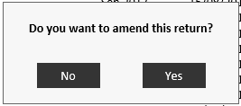
4 | Click the ‘pencil icon’ to edit return amounts and select ‘save row’.  Click the ‘red cross’ to delete a row of data. | Pencil icon to edit row  Red cross to delete a row of data
5 | Click ‘Next Step’. | 
6 | Review return details.  Click the ‘declaration tick-box’.  Click ‘Submit Return’.
7 | Click ‘Ok’.
You will receive an email from leviesonline@awe.gov.au confirming your return has been successfully submitted.
(E.g. Subject: 42246 Jan 2021 – Jan 2021 Cattle & Livestock Livecorp (monthly) levy return – submitted)

