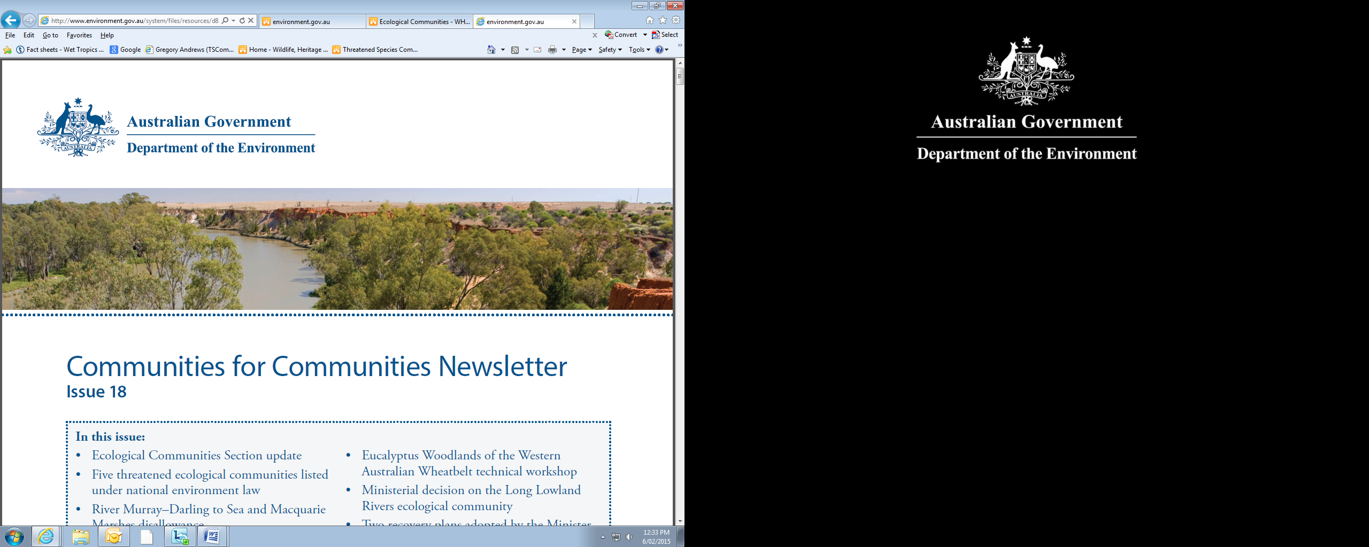

Threatened Species Commissioner Report to the Minister for the Environment

February 2015

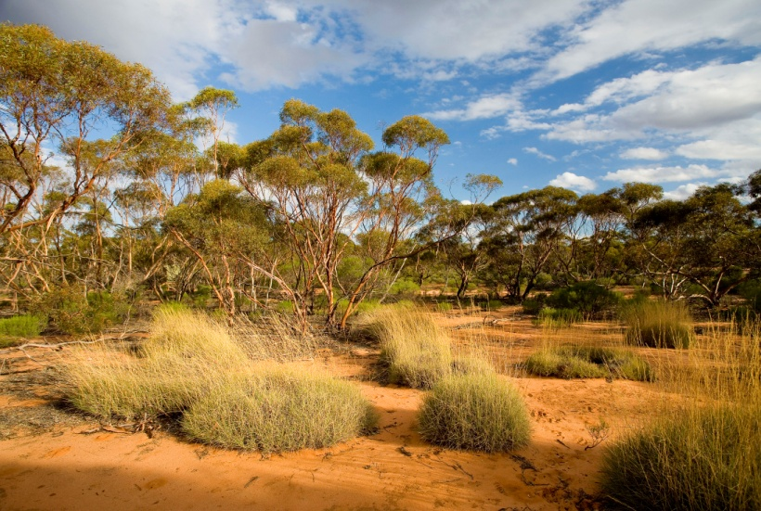
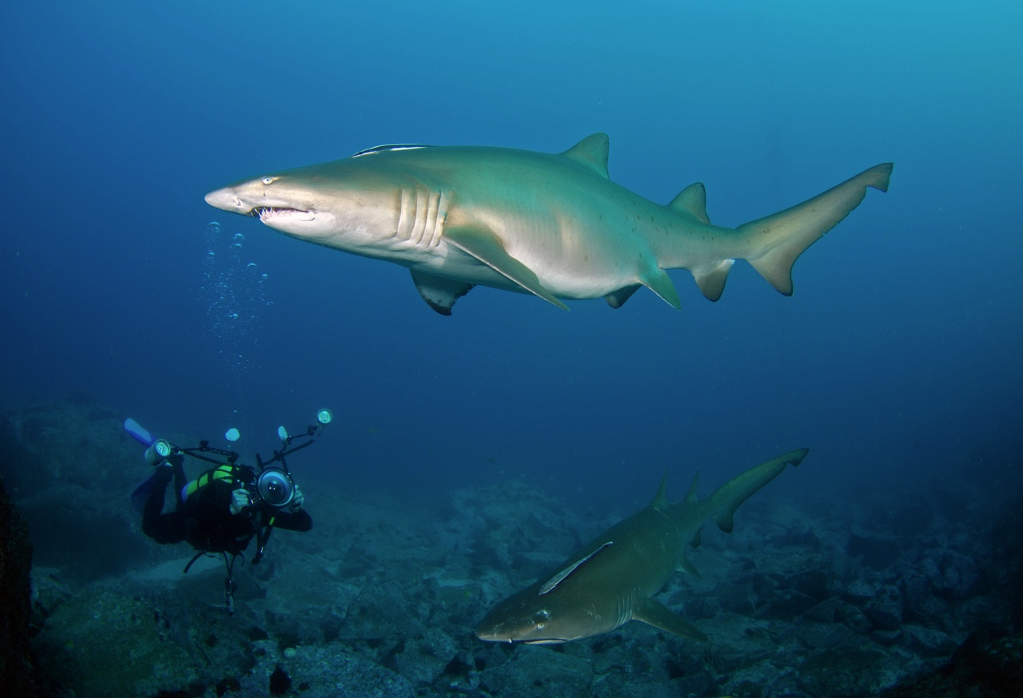
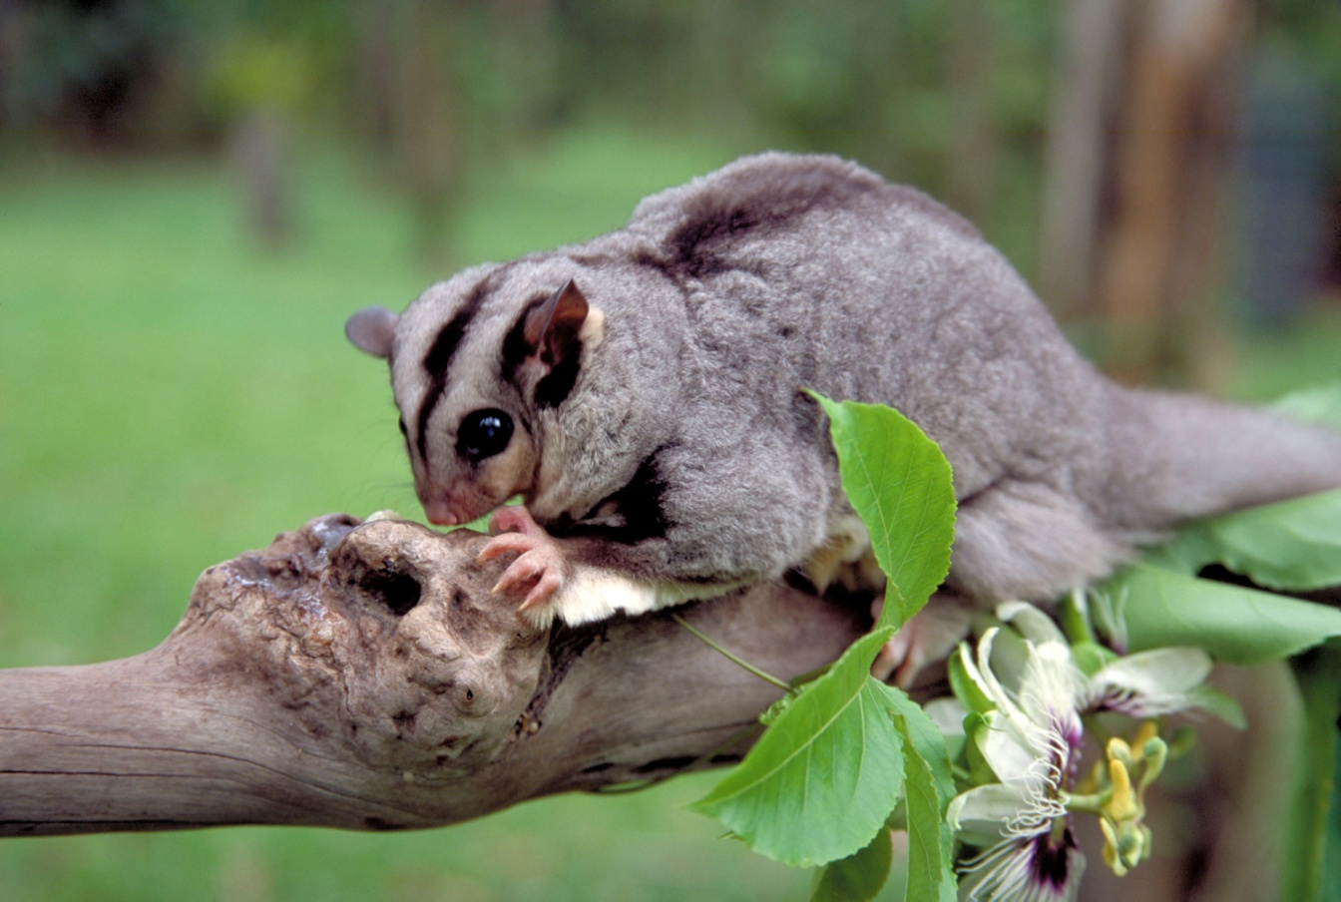
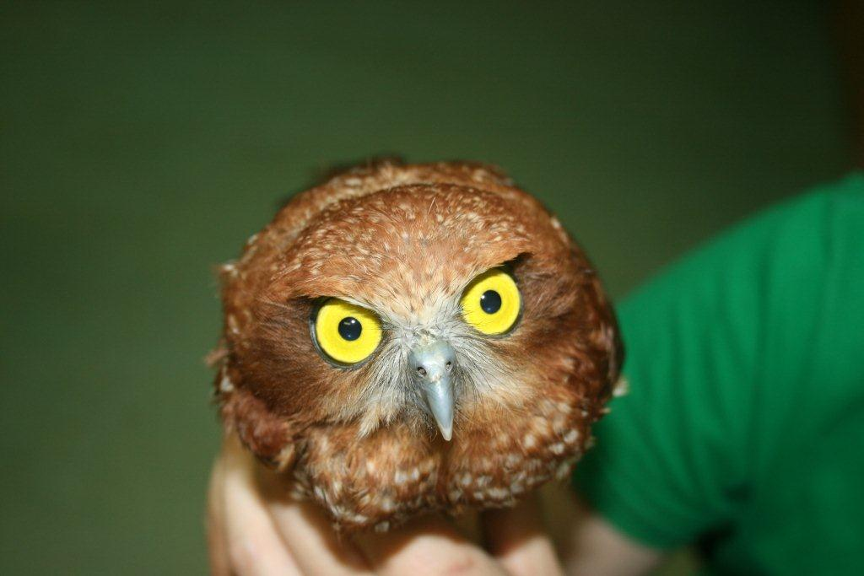
Table of Contents

Introduction 3
Achievements 4
Mobilising resources 4
Feral cats 6
Eradicating cats on Christmas Island – A Case Study 7
Reaching a broader audience 8
Key findings 9
Threatened Species Commissioner model 9
A focus on the threats 10
Community engagement and participation 10
Threatened species prioritisation 12
Science and technology enabling innovation 12
Tracking progress 13
Future directions 14
Focusing on threats 14
Threatened Species Strategy 14
Threatened Species Summit 14
Acknowledgements 14
Appendix A – Terms of Reference 15

Cover photograph credits
Christmas Island Hawk Owl – Neil Hamilton, WA Department of Parks and Wildlife
Gluepot Reserve – Nick Rains
Grey Nurse Shark – David Harasti
Mahogany Glider – Wet Tropics Management Authority - QLD

Introduction

Australia’s extinction history is unacceptable. Australia has lost 29 mammals since European settlement. According to the Action Plan for Australian Mammals, another 56 land-based mammals are at risk of extinction, and 11 of these are critically endangered. The total list of threatened species has grown to over 1750 plants and animals. The Threatened Species Commissioner model brings a new national focus and effort to secure our threatened flora and fauna. It is an opportunity to rethink our approach. Located within the Australian Government Department of the Environment and supported by a threatened species unit and an informal group of expert advisors, the role of the Commissioner is to champion the development and implementation of practical actions, and to bring partners and resources together to deliver on-the-ground change that protects and recovers Australia’s most threatened plants and animals.

Growing community awareness and support for threatened species is also an important part of the job. Over the past six months I have reached out to the community, forged partnerships and worked collaboratively with all levels of government, scientists, ‘Friends of..’ groups, the non-profit sector, and industry to secure more resources, build new, innovative and strategic approaches, encourage better coordination of conservation efforts, share information and promote action.

In this context it is important to understand and communicate that the Australian Government has committed over $76 million for threatened species recovery since 2014.

This report outlines achievements in: growing community awareness and support; drawing focus to the threat of feral cats; and investing in conservation projects with threatened species outcomes. It also outlines key findings of the last six months and future directions.

Australia’s animals and plants symbolise the uniqueness of Australia as a nation. We have a responsibility to maintain them as they are our natural assets and part of our national identity. It is thus a privilege to be part of this Australian Government commitment to promote and drive practical solutions to protecting and recovering Australia’s threatened animals and plants.
More information about the Threatened Species Commissioner role is available on the department’s website and on my Facebook and Twitter feeds.

Achievements

Mobilising resources
A key role of the Threatened Species Commissioner, as set out in the terms of reference (at Attachment A), is to work collaboratively with all levels of government, scientists, the non-profit sector, industry and the community to bring together new and strategic ways to deliver conservation actions.

By working closely with the National Landcare Programme, and the Green Army and 20 Million Trees initiatives, the Australian Government is injecting a focus on threatened species into the $2 billion of natural resource management funding available. During this time engagement across Australia has raised the awareness of Australian Government programmes and promoted the opportunities for community participation.

Through the Green Army programme the Australian Government has supplied 157 project teams for work to protect threatened species (representing a contribution of over $30 million), and a further 97 project teams for work that provides potential ancillary benefits to threatened species. The majority of the 58 successful projects under the 20 Million Trees initiative are contributing to threatened species or threatened ecological community conservation. This represents a total of over $9 million towards threatened species outcomes via habitat restoration and improving the extent, connectivity and condition of native vegetation. Through the 25th Anniversary Landcare Grants, at least 92 of the 291 successful projects will address threatened species protection or recovery as part of their on-ground activities. These 92 projects total over $1.5 million of funding for local action and local priorities.

The Australian Government also funds Natural Resource Management (NRM) organisations to work with communities to identify and set local priorities for investment. This supports farmers, landcare and other community groups to better protect and manage Australia’s natural resources, including threatened species. Funding for registered NRM organisations is currently under negotiation, but is expected to provide support for threatened species recovery through a range of on-ground activities, including feral cat management.

Since July 2014, the Australian Government has allocated approximately $2 million of funding to threatened species recovery in Commonwealth National Parks and a further $743,200 for projects to protect and recover threatened species at 11 locations outside of National Parks. In addition, the Government has also committed $30 million to the National Environmental Science Programme (NESP) Threatened Species Hub which will help build the scientific basis for ongoing efforts to recover threatened species.

Recent Australian Government funding that supports the protection and recovery of threatened species includes:
Project | Species | Funding (GST inc)
Nest to Turtle Protection programme grants | Multiple species including Leatherback, Green, Loggerhead, Hawksbill, Flatback and Olive Ridley turtles, plus a number of migratory birds | $3.5 million
Establishing enclosures for the Southern Corroboree Frog | Southern Corroboree Frog | $150,000
Activating guardian dog trials for Eastern Barred Bandicoot | Eastern Barred Bandicoot (mainland) | $120,000
Pre-translocation studies for Mallee Emu-wren | Mallee Emu-wren | $110,000
Restoration of habitat for declining migratory shorebirds at Snake Island | Temperate Coastal Saltmarsh, Fairy tern | $35,200
Evaluating threats and recovery of the Southern Bent-wing bat | Southern Bent-wing bat | $50,000
Direct conservation actions for the Spotted handfish in the Derwent River | Spotted handfish | $50,000
Intensive cat control in quoll establishment period in Southern Flinders Ranges | Western Quoll | $55,000
Connectivity of Kangaroo Island narrow leaved Mallee Woodland | Kangaroo Island Narrow-leaved Mallee Woodland, 3 listed plant species | $50,000
Captive breeding of the Western Ground Parrot at Perth Zoo | Western Ground Parrot | $40,000
Grey Nurse Shark SNP Marker Development | Grey Nurse Shark (east coast population) | $50,000
Strategic connectivity for the Mahogany glider | Mahogany Glider | $33,000
Management of fire, weeds and feral animals in priority areas at Kakadu National Park | Threatened plants, bird and small mammals | $450,000
Reintroduction of toad smart northern quolls at Kakadu National Park | Northern Quoll | $200,000
Creating a wildlife refuge on Field Island at Kakadu National Park | Migratory birds, Flatback Turtle and small mammals | $50,000
A rescue plan for threatened plants at Kakadu National Park | 7 EPBC listed flora species | $50,000
Supporting cat eradication of Christmas Island | Christmas Island Flying-Fox, forest birds, ground-nesting seabirds and native reptiles | $500,000
Enhance and expand rodent control on Norfolk Island | Norfolk Island Parrot, plant species, snails, ground-nesting seabirds and forest birds | $300,000
Improving the viability and genetic diversity of the ANBG ex-situ collections (plants and seed) | Nationally threatened plant species | $240,000
Identifying critical issues constraining threatened plant recovery across Commonwealth terrestrial reserves | 56 EPBC listed flora species | $115,000
Reintroduction of Long-nosed Potoroo and Southern Brown Bandicoot at Booderee National Park | Long-nosed Potoroo and Southern Brown Bandicoot | $80,000
Programme funds
20 Million Trees | A range of species to be addressed through the funding of 54 projects | Over $9 million
Green Army | A range of species to be addressed through the supply of 157 project teams | Over $30 million
25th Anniversary Landcare Grants | A range of species to be addressed through the funding of over 92 projects | Over $1.5 million
National Environmental Science Programme Threatened Species Hub | Multiple species supported by on-the-ground action-based science | $30 million

Feral cats
The feral cat poses a significant threat to Australia’s native animals, and has quickly emerged as a key focus. Invasive animal experts, farmers, national park rangers and conservation practitioners have all been engaged to better understand the nature of the threat and to identify practical, on-ground options for addressing the problem.
A key early achievement on feral cats was the Australian Government’s decision to allocate $500,000 to bolster efforts on Christmas Island to make the island cat free (see case study on page 7). Engaging directly with the community at places like Christmas Island, and most recently, Kangaroo Island has helped to galvanise community resolve to tackle feral cats.
The Threatened Species Scientific Committee is updating the national Threat Abatement Plan for feral cats which will include priority actions to address cat numbers and impacts.
Curiosity® feral cat bait represents a positive and innovative new approach to feral cat control and the Government is working to expedite the registration and roll-out of this new bait.
Raising awareness and support in the community will be key to maintaining effort on feral cats. More work needs to be done as many Australians are still not aware of the extent of the feral cat problem. Encouraging greater community participation and setting clear and measurable targets on feral cat reduction (and eradication where feasible) will be important to ensure sustained and effective effort.
Looking ahead, we need to further investigate options for investment that recognise the multiple dimensions to the feral cat problem. These could include expanding the feral-proof enclosure network, innovative science-based conservation measures like reintroducing native predators, using smart-baiting, toxin delivery and monitoring technologies, innovations such as guardian and detector dogs, more targeted feral cat management at important refuge sites and better managing inappropriate fire regimes.
Community involvement is also essential to an enduring outcome for many of our threatened species. Engagement with farmers, NRM practitioners and rural and regional communities has revealed the potential for growing community-based trapping and cat management activities. There are also opportunities to mobilise community participation by better utilising technology. For example, community-based smart-phone applications would allow people to report feral cat sightings and grow the available data on feral cat numbers, behaviours, impacts and eradication.

Case Study

Eradicating cats on Christmas Island
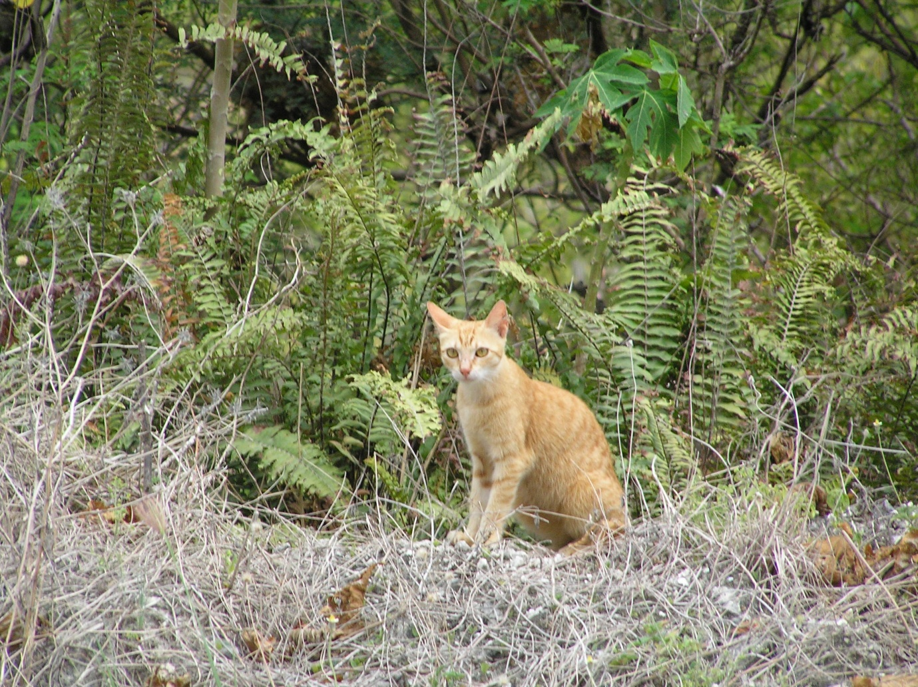
In November 2014, the Australian Government provided $500,000 to support feral cat eradication at Christmas Island. This funding will contribute to a suite of investments with multiple partners, including Phosphate Resources Limited and Parks Australia, to systematically and comprehensively address the threats posed to the island’s native fauna by feral cats, black rats and crazy ants.
Feral cats and black rats have been implicated in species declines and in some cases, the extinction of mammals and reptiles on the island, many of which are found nowhere else on earth.

The plan to control feral cats will adopt an integrated and staged pest management approach with a focus on cat control in settled areas first, before moving into forested areas, and ultimately culminating in an island-wide eradication. The $500,000 of funding will directly support the implementation of the management plan.
A feral cat on Christmas Island - Neil Hamilton, WA Department of Parks and Wildlife

The plan builds on control efforts to-date,
is co-ordinated by the Shire, Parks Australia and Western Australian Department of Parks and Wildlife, and represents a strong collaborative community approach to restoring and protecting biodiversity. The community has been involved in the process of registering their domestic cats, modeling responsible pet ownership and reporting sightings of feral cats since 2010.

Funding mobilised for this project, will enable Parks Australia to:
- Complete forest baiting trials that will support island-wide baiting
- Refine the baiting methods to mitigate any off-target risks
- Monitor a series of survey sites, using motion sensor cameras, to determine cat and rat densities
- Form a community steering group to guide and advise on the eradication plan
- Conduct the first round of island-wide baiting particularly in the National Park from May to October during the Park’s biennial island-wide survey of red crabs and crazy ants
- Increased rat management within the township
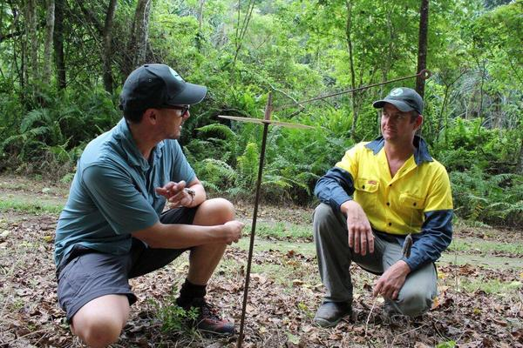
The Christmas Island community and the relevant business and government stakeholders should be applauded for the leadership they have shown in setting the target of complete cat eradication and the steps they have already taken. Furthermore, the dedication and enthusiasm of the rangers at Christmas Island National Park is inspirational. They are champions of our native plants and animals.
Christmas Island Natural Resource Manager Dion Maple explaining the innovative methods used to deliver baits specifically to feral cats and avoid non-target species.

Reaching a broader audience
Engaging the community in a discussion about threatened species recovery has been a priority over the last 6 months. I have met a range of threatened species stakeholders across Australia, including volunteer groups, non-government organisations, scientists, zoos and wildlife sanctuaries, Indigenous rangers, communities and leaders, and all relevant state and federal government agencies.

A national profile for threatened species recovery has also been established through social media. On Twitter, @TSCommissioner tweets have been seen more than 350,000 times and the account has 1,750 followers. On Facebook, the Threatened Species Commissioner page has been viewed 56,000 times, with better performing posts reaching 2,000-3,000 people each. On Youtube, the Threatened Species Commissioner channel has generated over 350 views since it started in December.

Through interviews and direct comment via the media the profile of threatened species issues has been raised and the actions being taken to address them promoted. Over 80 media items (total audience of approximately 2.5 million) have largely focused on the establishment of the Threatened Species Commissioner, threatened species grant announcements, and the threat posed by feral cats.

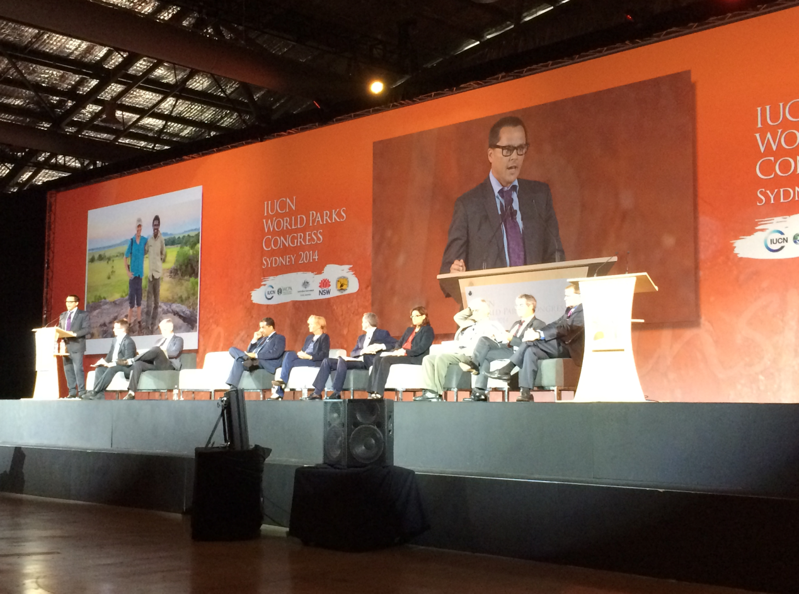

The Commissioner model received strong support at the World Parks Congress in November 2014 with a call for more countries to establish a Threatened Species Commissioner.

Key findings

The contribution to threatened species conservation of scientific experts, threatened species practitioners and community volunteers across Australia cannot be overstated. I am indebted to these groups and individuals for so generously sharing their experience and knowledge. Their insights, combined with guidance from informal group of expert advisors have established a number of key policy learnings that will inform the work ahead.

Threatened Species Commissioner model
The ability to mobilise support from within the National Landcare Programme is greatly enhanced by embedding the Commissioner position in the Biodiversity Conservation Division of the Department of the Environment. As part of the Department’s Senior Executive, I can help shape policy and programme settings to deliver threatened species outcomes. Recent Australian Government commitments of over $76 million support practical actions for threatened species and demonstrate a national focus on threatened species protection.
Engaging the community and threatened species practitioners in a discussion about threatened species not only provides an opportunity to hear about the issues impacting at a local scale, but also the effectiveness of government programmes in addressing them. This feedback assists in ongoing improvements to Australian Government programme design and delivery.

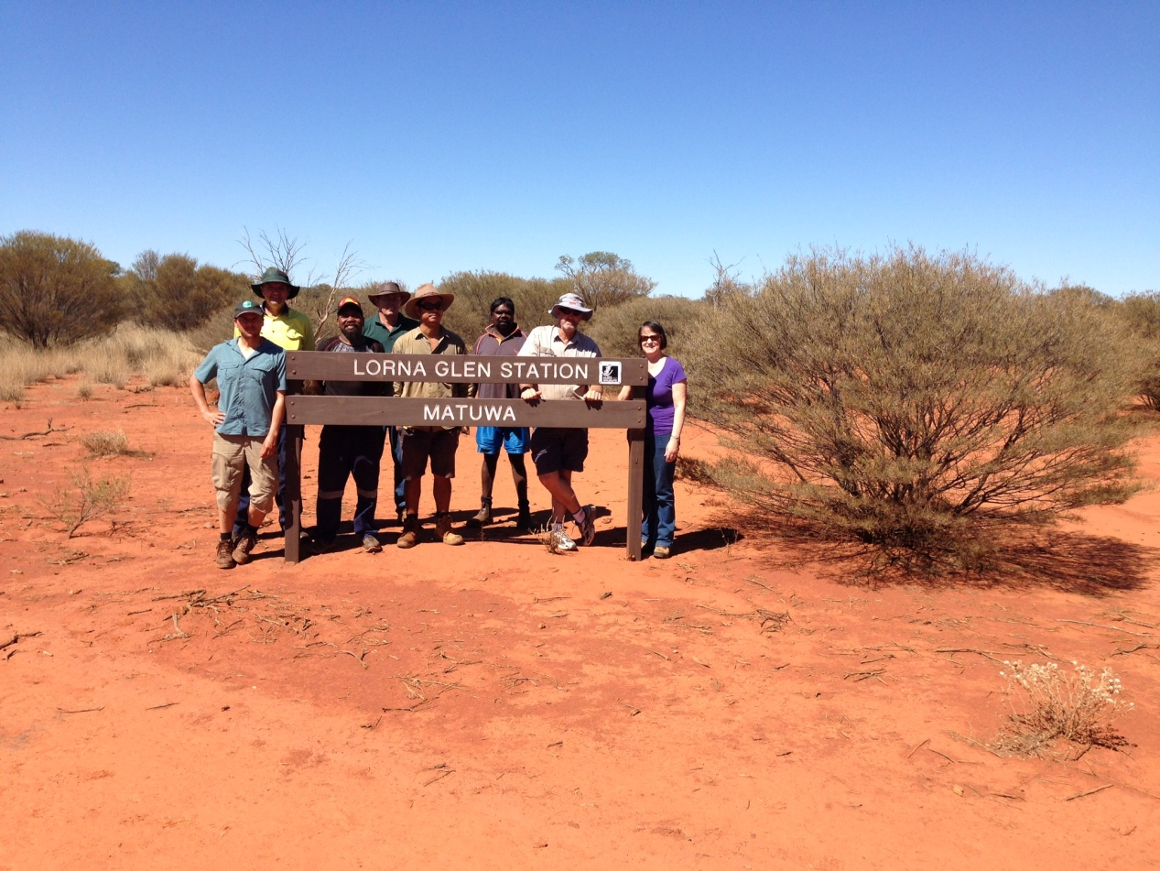

Traditional owners on Martu land in the western deserts of Western Australia are exploring Green Army opportunities to recover threatened species and manage feral pests.

A focus on the threats
Channeling efforts into tackling threats is critically important and will in some cases help to recover multiple threatened species. For example, the Action Plan for Australian Mammals makes clear that feral cats are the single largest threat to Australia’s mammals; field visits and community consultations have revealed that many other animals are at risk from feral cats. As we further develop a process for priorisiting our interventions and investments, a threat-based approach will become important. This emerging theme could be reflected in a future review of the terms of reference.

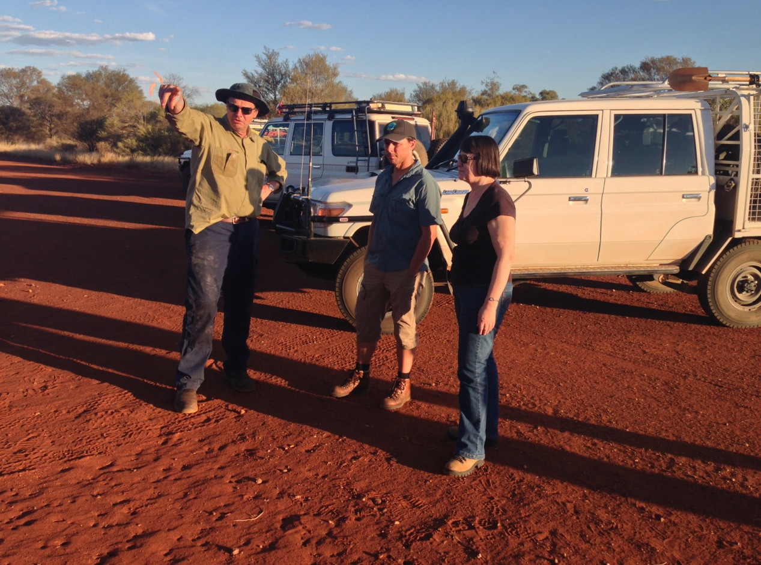

Western Australia’s chief scientist Keith Morris explains the benefits to multiple small mammals and reptiles of broad-scale baiting for feral cats and feral herbivore exclusion at Lorna Glen Station in Western Australia.

Community engagement and participation
Through engagement across Australia it has become very clear that empowered local communities are critical to sustainable outcomes for threatened species. From Christmas Island, Kakadu National Park, Kangaroo Island, Tasmania and the south west of Western Australia, there are examples of threatened species recovery success because local communities are engaged and taking action. These dedicated and largely volunteer-based communities need continued support and encouragement. The Gilbert’s Potoroo is one such example of a community-driven conservation success story. Assumed extinct until 1994, the Action Plan for Australian Mammals suggests that its status could be reduced from Critically Endangered to Endangered. Since the formation of the Gilbert’s Potoroo Action Group in 1994, Potoroo numbers have increased three fold. Key to this success has been over twenty years of sustained volunteer effort by the local community, underpinned by financial and scientific support from governments and scientific experts.
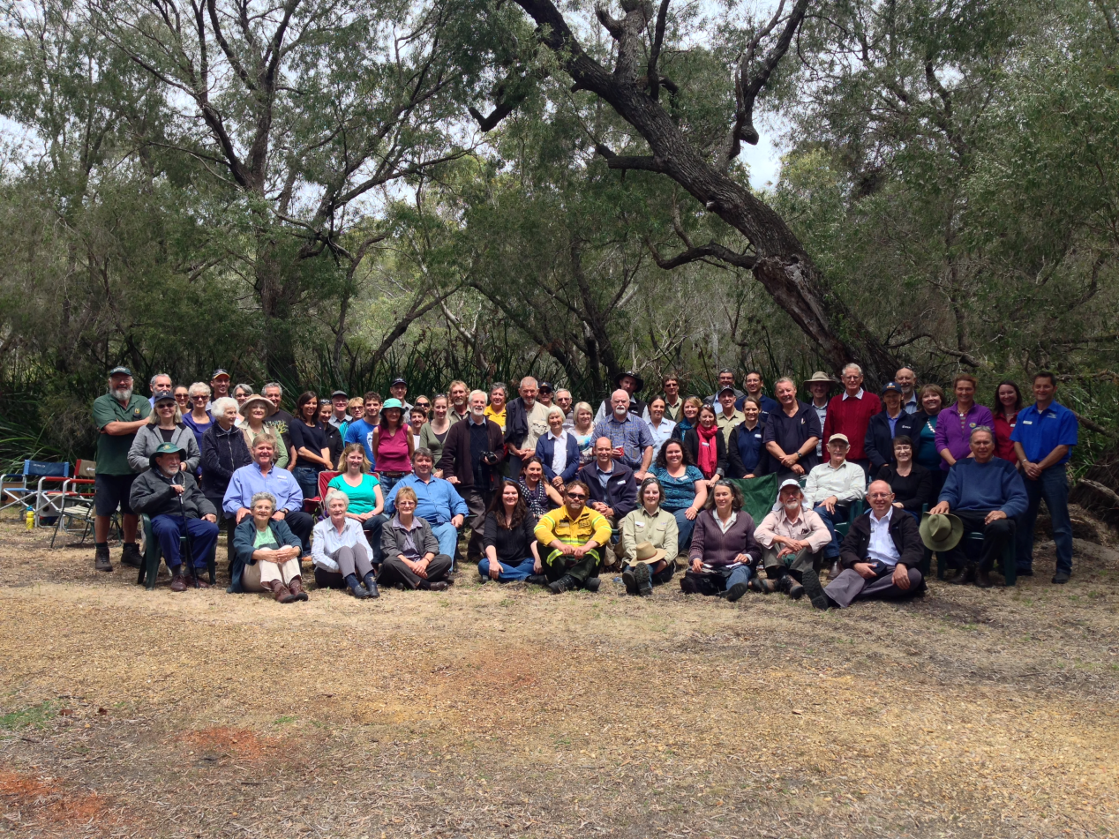

Gilbert’s Potoroo Action Group near Albany in West Australia has been critical to its successful recovery.

In Victoria, the Friends of the Helmeted Honeyeater provide another example of community driven action. This group co-ordinates around 70 volunteers to monitor and feed threatened birds, grow and sell plants to raise funds, and create more habitat. The numbers in the wild are on the rise thanks to this work that also includes a partnership between the friends group and Zoos Victoria, which manages a captive breeding and release programme. The critically endangered Orange-bellied Parrot benefits from a considerable volunteer support at its only known breeding site in Tasmania. This effort has been estimated at around 1100 volunteer days over three years. Community engagement and participation is key to the long-term protection and recovery of threatened species.

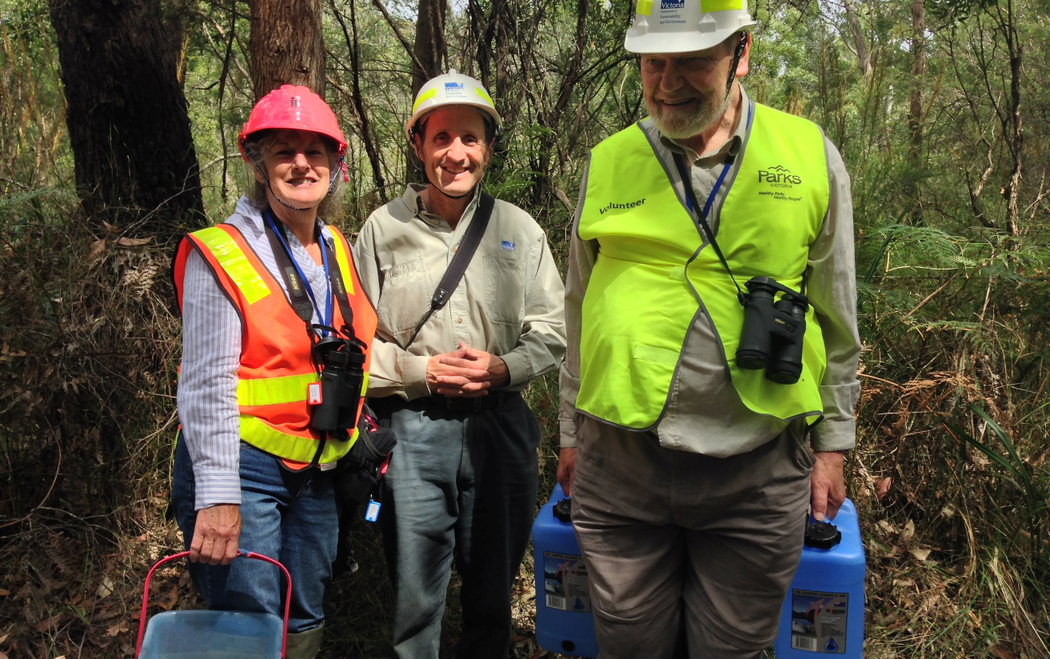
Volunteers with the Friends of the Helmeted Honeyeater feed, monitor and care for critically endangered birds at Yellingbo in the Yarra Valley in Victoria.

Threatened species prioritisation
The need for a coherent and robust policy framework on threatened species prioritisation is clear. Establishment of the Threatened Species Commissioner position and initial engagement has raised the profile of threatened species issues and the action being taken by the Australian Government. As a consequence, suggestions are regularly received for ways to recover various threatened species. While all these ideas have merit, formalising a clear and detailed Australian Government policy framework to prioritise our effort has never been more important to ensure efficient and transparent threatened species investment.

Science and technology enabling innovation
The rate and proliferation of developments in science and technology can strengthen our capacity to arrest species Australia’s species decline. The following examples provide just some of the innovative approaches enabled by progress in these areas:
- studies of close-kin genetics can help us understand population dynamics of threatened species like grey nurse sharks and river sharks
- the process of mixing isolated populations that were once connected, or gene-pool widening, can increase the vigour of species like the endangered mountain pygmy possum whose genetic make-up has narrowed considerably
- predator awareness training for captive-bred birds increases their survival rates in the wild
- computer assisted sensor technology can increase the efficacy of feral cat baiting
- smart-phone technology strengthens community participation in identifying, trapping and eradicating feral cats
- drones can reduce the costs associated with monitoring species
- guardian dogs can protect threatened species in the wild and detector dogs can increase success rates in removing feral animals
- landscape-scale adjustments such as fire and herbivore management practices can ‘tip the balance’ back to one that favours endemic species by reducing feral predator efficiency.

Lastly, the new $30 million NESP Threatened Species Recovery Hub will support an increase in our threatened species knowledge and presents a significant opportunity to trial innovative on-the-ground conservation actions and demonstrate effective threatened species interventions.

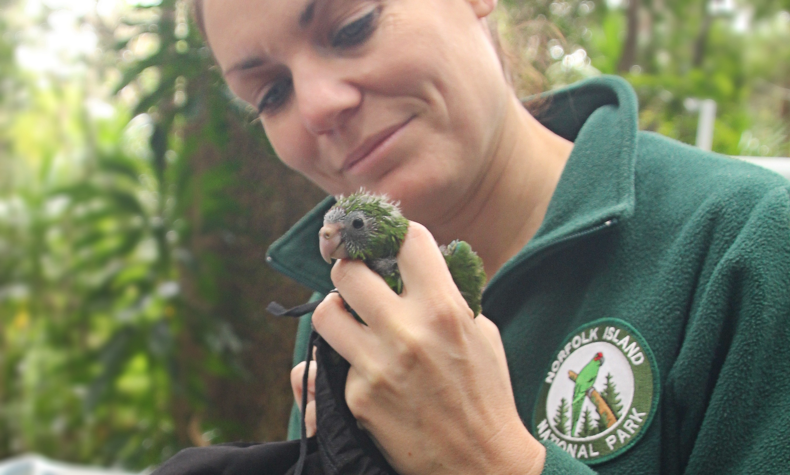
Ranger Abigail Smith conducting scientific monitoring of the Green Parrot at Norfolk Island National Park.

Tracking progress
Targets are essential for measuring progress towards threatened species recovery. They can also provide incentive for action. Targets such as the goal of ending mammal extinctions by 2020 and increasing the population of at least 20 threatened mammals by 2020 are seen as a positive and practical manifestation of the Government’s commitment to combating species extinction. There is also a sound policy basis for the focus on mammals. The scientific and operational actions to save threatened mammals generally yield benefits for other animals and plants occupying the same habitat. Mammals also play an important role in cultivating a more healthy and resilient ecosystem.
Further targets covering a range of species groups and threats would help to mobilise support and prioritise action.

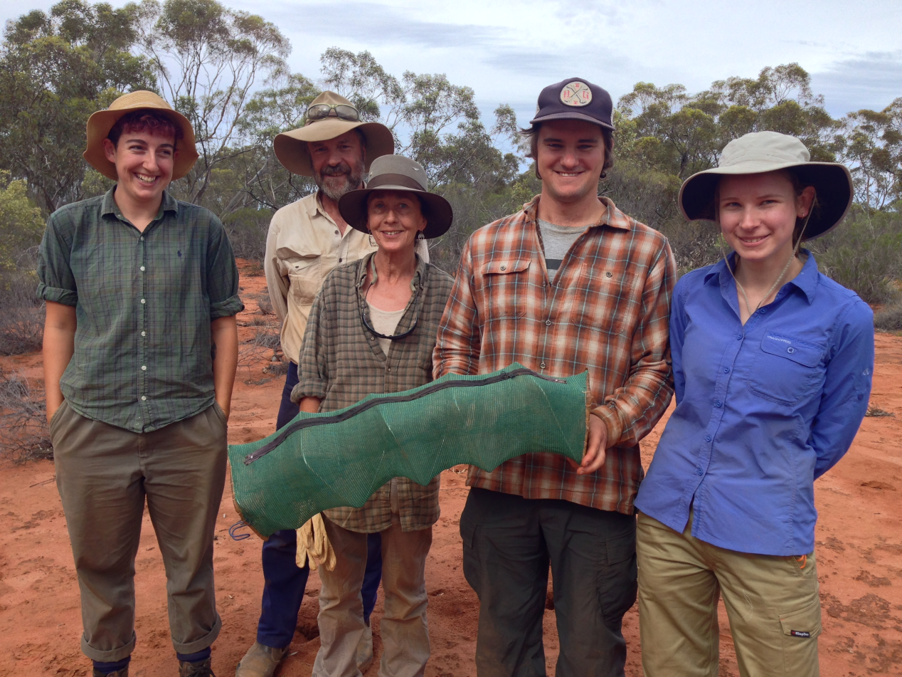
Volunteers at Australian Wildlife Conservancy’s Scotia Sanctuary undertake systematic species monitoring that builds an inventory that can be measured and costed to improve threatened species recovery effectiveness.

Future directions

There will be a continued strong focus on mobilising resources from a wide range of sources, pursuing partnerships beyond government and engaging directly with the community to support and encourage action. The insight gained through discussions over the last 6 months reveal some areas where in the coming year strong gains can be made for threatened species.

Focusing on threats, including clear and measurable targets on feral cats
Given the number of threatened animals and plants in Australia and the limited resources available, there is value in using a threat perspective when considering threatened species interventions. This approach is more likely to lead to sustainable outcomes and can establish a strong value-for-money proposition where multiple species are impacted by the same threat. An example in support of this approach is provided by feral cats that are the single most significant threat to many of Australia’s small ground-dwelling fauna.

Threatened Species Strategy
The suite of initial actions now underway and the Australian Government’s specific commitments to tackle feral cats and recover threatened mammals has generated considerable momentum. This positive setting provides a solid basis for commencing a process for prioritisation and the development of a threatened species strategy to provide a clear narrative on the Australian Government’s threatened species policy and investment decisions.
I anticipate that such a strategy could:
- provide a clear and concise policy explanation for why and how the Australian Government engages in threatened species recovery
- outline the principles for prioritising our actions and resources
- identify how communities and individuals can take action
- establish targets
- outline specific actions that reverse the decline of threatened species.

Threatened Species Summit
A Threatened Species Summit scheduled to take place later this year will generate further momentum by outlining the Australian Government’s agenda for threatened species recovery. It will bring together state and territory governments, NRM organisations, businesses, trusts, scientists and non-government organisations with leadership from the Australian Government. Necessary preparations for the summit have begun.

Acknowledgements

I acknowledge with gratitude the advice I have received from so many across the country. I would like to thank my group of informal advisors (Professor Helene Marsh, Rachel Lowry Samantha Vine and Atticus Fleming) for their support and advice as well as members of the Threatened Species Scientific Committee. I would like to thank the leadership team of the NESP Threatened Species Recovery Hub and the many local community people that have welcomed me on site visits and shared their experiences in saving Australia’s unique plants and animals. I pay respect to Indigenous peoples who have welcomed me on their land and shared their culture. And I would like to pay particular thanks to staff and colleagues in the Department, without whom I would have achieved very little.

Appendix A – Terms of Reference
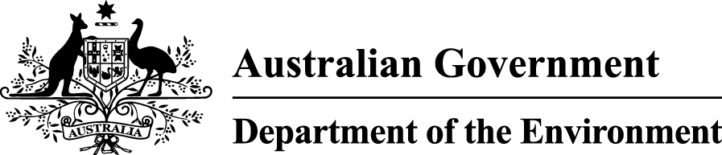

Threatened Species Commissioner
Terms of Reference

Background

The Threatened Species Commissioner brings a new national focus and effort to address the growing number of plants and animals in Australia that are faced with extinction.

The Commissioner, sitting within the Australian Government Department of the Environment, champions the development and implementation of practical conservation actions designed to secure priority national threatened species in the wild for at least the next 100 years.

An important part of the Commissioner’s role is bringing together partners to deliver the agreed programme of conservation actions for priority threatened species - whether through funding or contributing other skills and expertise.

The Commissioner also leads efforts to report on the outcomes of conservation actions for priority threatened species, including the effectiveness of specific investments and achievements in terms of the goals of securing priority species in the wild.

A key role for the Commissioner is to work collaboratively with all levels of government, scientists, the non-profit sector, industry and the community to build on new initiatives and strategic approaches to threatened species conservation being trialled and implemented across the country; to better coordinate conservation effort; and to share information about these activities.

The work of the Commissioner complements but does not duplicate or override the important statutory responsibilities of the Threatened Species Scientific Committee.

The Commissioner also draws upon a group of informal expert advisors in developing a programme of conservation actions for priority threatened species.

Roles/responsibilities

In the short term (first 12 months):

- Work with stakeholders to identify priority nationally listed threatened species for which conservation actions are likely to be successful.
- Work with stakeholders to identify the highest priority actions to secure those species in the wild for at least the next 100 years.
- Identify and secure partners and resources to implement and monitor this programme of high priority actions over the longer term.
- Contribute to a process of reform to simplify and streamline the statutory recovery planning process.

In the medium to long term (1 – 5 years):
- Advise on and direct conservation actions in priority national threatened species recovery programmes in collaboration with the programme coordinators.
- Develop a strategic approach to threatened species conservation, including a prioritisation framework for species and conservation actions, building on government, non-government and community-based threatened species initiatives.
- Work closely with the Threatened Species Scientific Committee to strengthen the connection between the statutory listing and recovery planning processes and the implementation of conservation actions.
- Identify opportunities for longer term resourcing models, including co-investment and partnerships, to support the threatened species conservation programme.
- Monitor the effectiveness of priority conservation actions and report to the Minister and to the public.

Outcomes

- Implementation of conservation actions for priority nationally listed species.
- Priority threatened species are secured in the wild for at least the next 100 years.
- More integrated, complementary threatened species conservation efforts at a national level.
- Targeted, practical and cost effective investment in threatened species conservation actions.
- Clear and accessible public reporting on effectiveness of threatened species conservation actions.
- A more strategic approach to threatened species conservation to better inform government policy, planning and investment.

