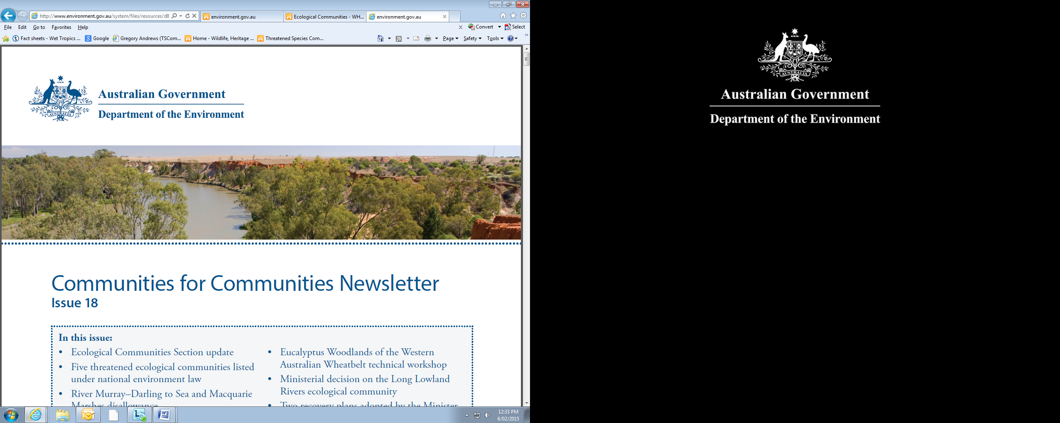

**Threatened Species Commissioner Report to the Minister for the Environment**

December 2015

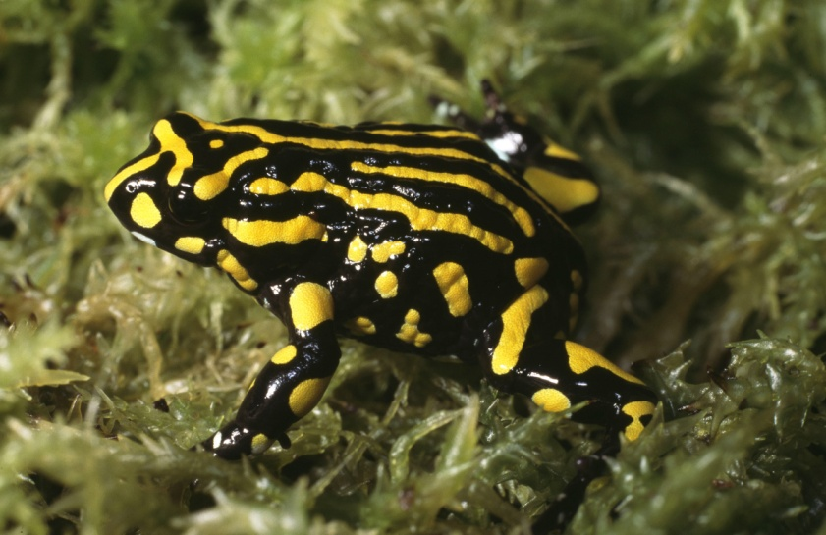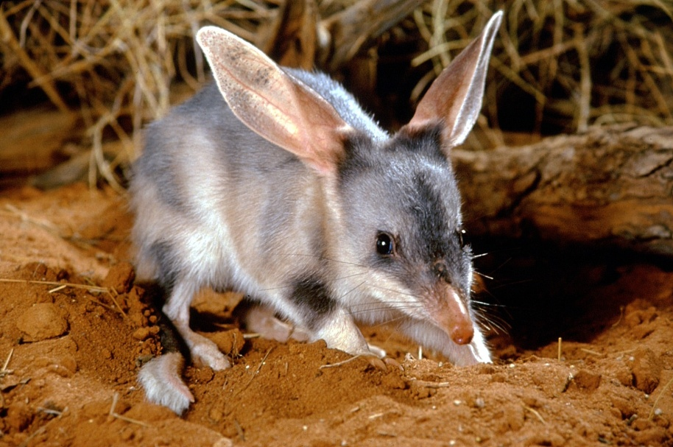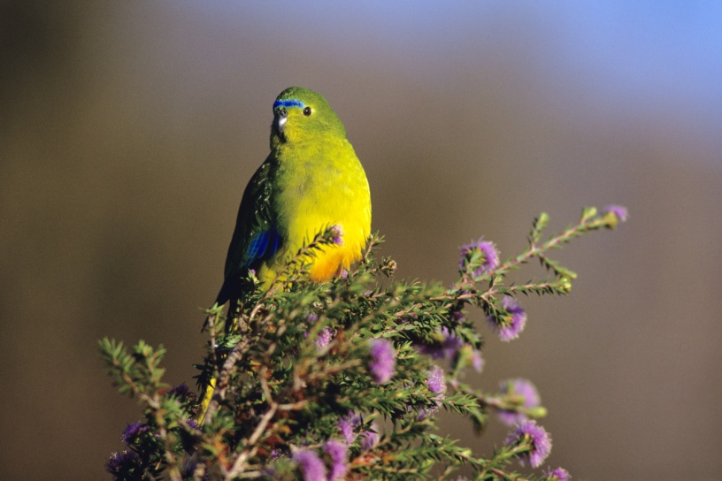

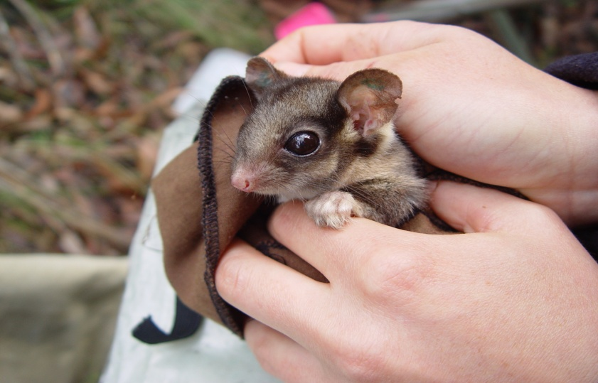

**Table of Contents**

**Introduction** 3

**Achievements** 4

**Mobilising resources** 4

**Threatened Species Summit 2015** 6

**Threatened Species Strategy** 7

*Priority species* 7

*Prioritisation principles* 7

*Projects in support of the Threatened Species Strategy* 7

**Community engagement** 10

**Next steps** 12

**Threatened Species Strategy implementation** 12

*Tackling feral cats and their impacts* 12

*Green Army and 20 Million Trees programmes* 13

*Natural Resource Management organisations* 13

*National Environmental Science Programme Threatened Species Recovery Hub* 15

**Threatened species protection through partnerships** 15

*Partnership with states and territories* 15

*Public private partnership* 15

**Monitoring and reporting** 16

*FeralCatScan* 16

*MERIT* 17

*Conservation management zones* 17

*Future reporting* 17

**Cover photograph credits**

Greater bilby ­– Dept of Environment and Heritage QLD

Orange-bellied parrot – Dave Watts

Leadbeater’s possum – Dan Harley

Southern corroboree frog – Steve Wilson

# **Introduction**

I have been Threatened Species Commissioner for almost 16 months, in which time a national Threatened Species Summit has been held and the Threatened Species Strategy has been published, setting ambitious targets for protecting threatened species. Both are a first for Australia.

We have also seen the rollout of the National Environmental Science Programme’s Threatened Species Recovery Hub and a considerable boost to on-ground activity for threatened species recovery through Australian Government programmes.

The Threatened Species Strategy*,* launched at theThreatened Species Summiton 16 July 2015, explains how the policies and programmes of the Australian Government work to protect and recover threatened species. The five-year Action Plan in the strategy identifies mammals, birds and plants as the first set of threatened species to be addressed, and resolves to tackle the devastation inflicted on Australia’s threatened species by feral cats. Australia’s first Threatened Species Strategy is available on the Department of the Environment’s [website](http://www.environment.gov.au/ts-strategy).

With feral cats already contributing to 28 mammal extinctions and threatening the survival of another 142 unique Australian animals, the Threatened Species Strategy’s feral-cat targets are ambitious – to cull two million cats and to establish five feral-cat free islands, 10 large mainland predator exclosures, and 12 million hectares of best practice feral-cat management, all by 2020. Action towards these targets has already commenced as a result of the $5.4 million announced at the summit to tackle feral cats. Work to eradicate feral cats is intensifying at a number of important sites across Australia and, with strong community support, momentum is building for much more. I am looking forward to the gains we will make by removing feral cats from our landscape. For example, our joint– investment with the Queensland Government to establish a feral-cat free area within Astrebla and Diamantina National Parks will help recover the Greater bilby – one of the 20 priority mammals named in the Threatened Species Strategy.

The Australian Government has built on these strong policy and programme settings by committing more than $131 million to on-ground projects that support threatened species recovery since 2014. This includes partnerships worth $6.6 million with state and territory governments announced at the Threatened Species Summit.

This report outlines what I, in my role as the Threatened Species Commissioner, with your support and the resources of your department, have delivered over the last 12 months and points to the next steps.

My first report mentioned the role we can all play in protecting our threatened species. I have continued to convey that message to community-based groups, land managers, scientists, businesses and governments across Australia. I have also participated in many public events and media responses to grow the level of support for threatened species recovery.

My second report documents those efforts and shows how our planning is translating into projects benefitting threatened species. As the Threatened Species Commissioner, I am focused on ensuring that the targets in the Threatened Species Strategy are met and that broader national efforts continue to support improved trajectories for Australia’s threatened plants and animals.

Regular updates on the work underway to meet our targets can be found on the Threatened Species Commissioner’s [Facebook](https://www.facebook.com/TSCommissioner/) page and [Twitter](http://www.twitter.com/tscommissioner) feed.

# **Achievements**

## **Mobilising resources**

Since 2014, more than $131 million has been committed to projects in support of threatened species. The majority of these projects have been funded in natural resource funding that includes the National Landcare Programme, and the Green Army and 20 Million Trees programmes.

For example:

* Green Army Round 3 generated $22.3 million of resourcing for 116 projects that are achieving positive outcomes for threatened species such as bilbies, mala, cassowaries and hooded plovers (by improving habitat and reducing the impact of feral cats and other predators) and also supporting recovery of threatened ecological communities such as Mabi rainforest and Yellow-box grassy woodlands.
* Action to eradicate feral cats is intensifying, supported by National Landcare Programme funding and Green Army projects. This includes $1.7 million to help Western Australians roll out the new Eradicat bait to protect threatened species like the western ground parrot, numbat, Gilbert’s potoroo and the black flanked rock wallaby.
* Through the 20 Million Trees Programme, the Australian Government is supporting the recovery of the critically endangered helmeted honeyeater and Leadbeater's possum. Three projects are delivering over 790,000 trees to expand and connect crucial habitat, with the help of multiple partner organisations and ‘Friends of’ groups. There are 88 projects funded through the 20 Million Trees Programme that are benefitting threatened species.

|  |  |  |
| --- | --- | --- |
| **Table 1: Approved and announced funding for threatened species** | | |
| **Programme** | **Number of projects (as at 29 August 2015)** | **Funding (GST ex)** |
| Green Army* | 273 | $48m |
| 20 Million Trees * | 88 | $30.2 |
| 25th Anniversary Landcare Grants* | 92 | $1.5m |
| First tranche of Threatened Species Commissioner projects ** (including Commonwealth National Parks Projects) | 12 | $2.7m |
| Threatened Species Summit Projects** | 20 | $6.6m |
| Tasmanian Devil Conservation Projects | 1 | $3.3m |
| Turtle and Dugong Protection Plan | 4 | $5.0m |
| Nest to Ocean Turtle Protection Program** | 1 | $3.5m |
| Raine Island Recovery Project** | 1 | $0.4m |
| National Environmental Science Programme Threatened Species Recovery Hub | 7*** | $30m |
| **Total** | **499** | **$131.2m** |

* Funding for these projects is used for a broad range of activities, not only threatened species conservation activities. Figures provided for these programmes are approximate. ** Funding for these projects is provided in conjunction with State & Territory Governments. *** Negotiations for the roll out of the NESP Hub are continuing.Further projects will be subsequently approved, to a total of $30m.

**CASE STUDY – Connecting the dots for mahogany gliders**

On the Stone River near Ingham, a $30,000 grant to Terrain Natural Resource Management (NRM) has been secured through the Threatened Species Commissioner model. The grant is ‘connecting the dots’ by improving habitat connectivity, while also encouraging an integrated, strategic approach to conserving the mahogany glider.

Coordinated by Terrain NRM, the project is creating and improving habitat for the mahogany glider after some of its home was destroyed by Cyclone Yasi. With strong support from local Queensland Wildlife Protection Society members, Green Army teams are working with Indigenous rangers to support farmers like Sam Torrisi to restore habitat along the banks of the Stone River. This will give mahogany gliders greater access to food, improve their genetic diversity, and reduce their exposure to threats like cars and feral cats. Importantly, riparian revegetation on Sam’s property will also reduce nutrient flows from the Stone River, resulting in a healthier Great Barrier Reef. Sam will also benefit from more stable riverbanks on his property, which can reduce the damage caused by floods.

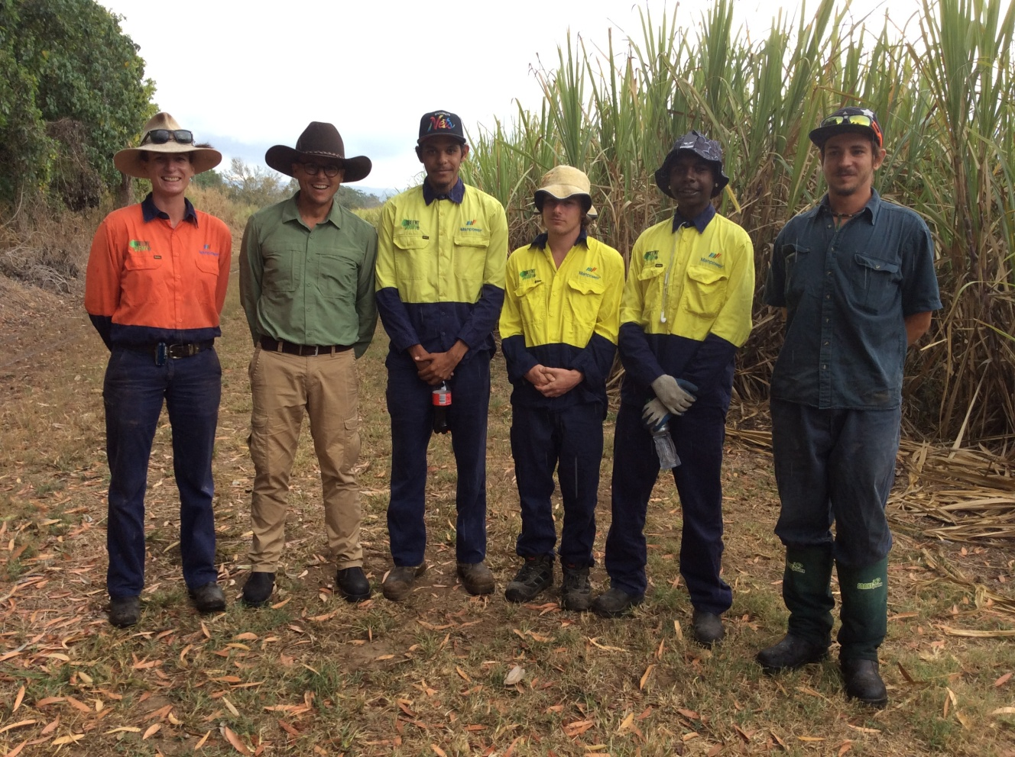

A Green Army team on Sam Torrisi’s property, part of an integrated approach to increase habitat and improve connectivity for the mahogany glider, while also stabilising riverbanks which can reduce the impact of floods. Photo courtesy of Erin Lake

## 

## **Threatened Species Summit 2015**

Australia’s first Threatened Species Summit brought together state and territory government ministers, scientific experts, natural resource management organisations and community groups to focus on protecting threatened species. Delegates were provided with an international perspective on threatened species recovery from New Zealand’s Minister for Conservation, the Hon Maggie Barry ONZM, and United States Ambassador John Berry.

The summit provided a platform to explore solutions and promoted practical and effective ways of tackling the threats to Australia’s animals and plants. Presentations from state ministers, scientific, advocacy and conservation organisations, scientists and community groups had a common message: by working together, we will be able to achieve the ultimate goal of the Threatened Species Strategy — halt the decline of Australia’s threatened plants and animals and support their recovery. There were panel discussions and presentations on topics ranging from approaches to feral-cat control, use of Indigenous fire management practices to protect threatened species and innovative partnerships for on-ground action, including a tree-planting collaboration between Greening Australia and Alzheimer’s Australia. The summit raised the profile of threatened species nationally, and reached over six million Australians through 129 media stories.

Feedback I received from summit participants has been unanimously positive, with many indicating it had been vital for bringing a national focus to threatened species and building momentum for action across all sectors.

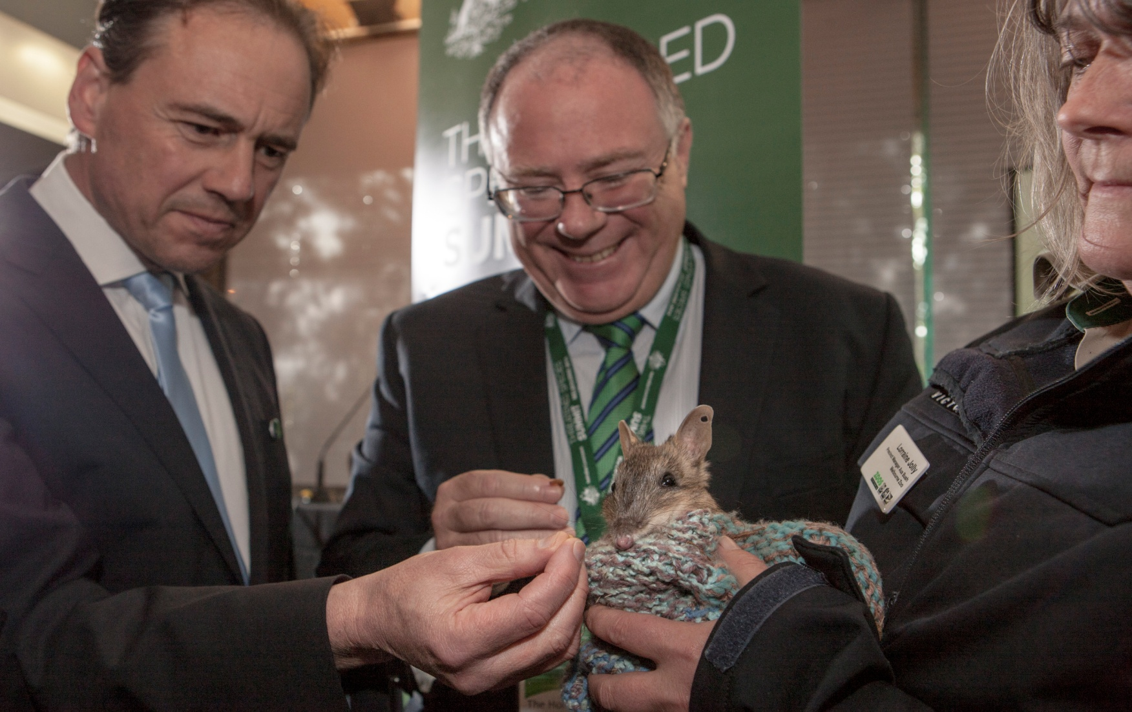

The Hon. Greg Hunt, Minister for the Environment, and the Hon. Ian Hunter, South Australian Minister for Sustainability, Environment and Conservation, feeding an eastern barred bandicoot at the Threatened Species Summit. The eastern barred bandicoot is one of the priority mammals identified in the Threatened Species Strategy. Photo courtesy of Andrew Tatnell

## **The Threatened Species Strategy**

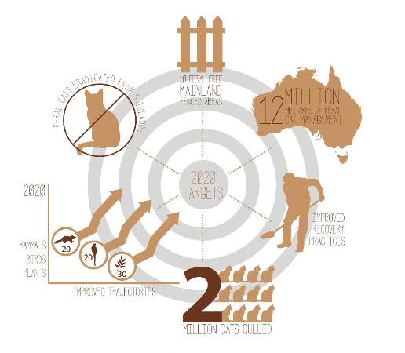The centrepiece of the Threatened Species Summit was the launch of Australia’s first [Threatened Species Strategy](http://www.environment.gov.au/system/files/resources/51b0e2d4-50ae-49b5-8317-081c6afb3117/files/ts-strategy.pdf). Based on our approach of science, action and partnership, the strategy will achieve long-term goals of improving species trajectories and supporting recovery.

The strategy includes a 2015-16 Action Plan that sets a number of targets over five years:

* tackling feral cats and their impacts
* improving the trajectories of 20 mammals
* improved population trajectories for 20 bird species
* protecting Australia’s plants
* improving recovery practices.

Hard and measurable targets in the Threatened Species Strategy

These headline targets are underpinned with 87 hard and measurable sub-targets on immediate, one, three and five year timeframes. The strategy provides a framework to prioritise effort and work in partnership with the community and state and territory governments to protect threatened species. Identifying priority threatened species, using an agreed set of prioritisation principles, maximises the results that can be achieved with the money available.

*Priority species* — In line with the Threatened Species Commissioner terms of reference, the strategy includes priority species for action. The Australian Government is committed to supporting improved trajectories for at least 20 mammals, 20 birds and 30 plants by 2020. The first 12 mammals and birds have been identified using expert advice and applying the prioritisation principles. The remaining eight birds and mammals, and the priority plants, will be identified within the next year using the strategy’s prioritisation principles. These priority species help to focus effort, build partnerships and provide clear measures of success.

*Prioritisation principles* —The prioritisation principles in the strategy will help to identify where Australian Government investment can be most beneficial to the greatest number of plants and animals. They allow comparisons between projects and ensure every dollar invested in threatened species recovery goes as far as it can to avoid extinctions. These principles are already being applied to investment decisions and will continue to be a critical part of the new national approach to threatened species protection.

*Projects in support of the Threatened Species Strategy* — Implementation of the Threatened Species Strategy is underway. Projects worth $6.6 million were announced at the summit that will help to deliver the targets in the strategy. A list of projects initiating the implementation of the strategy is provided at Table 2. Further details on the projects can be found at the Threatened Species Strategy webpage ([www.environment.gov.au/ts-strategy](http://www.environment.gov.au/ts-strategy)).

|  |  |  |
| --- | --- | --- |
| **Table 2: $6.6 million in support of the Threatened Species Strategy** | | |
| Project | Key species | Funding  (GST excl.) |
| Tackling feral cats |  | |
| Threatened animal recovery through feral-cat control, WA | Numbat, woylie, black-flanked rock-wallaby, western ringtail possum, western quoll, western ground parrot | $1.7 million |
| Kimberley feral-cat bait trial, WA | Northern quoll | $250,000 |
| Groote Eylandt biodiversity initiative, NT | Northern quoll, brush-tailed rabbit rat, pale field rat, northern hopping mouse | $235,000 |
| Cat and fox detection dogs to protect mountain pygmy possum and Konoom, NSW | Mountain pygmy possum, Konoom (smoky mouse) | $140,000 |
| Grooming traps for targeted feral-cat control, SA | Greater bilby, woylie, black-flanked rock-wallaby, night parrot, brindled nail-tail wallaby | $100,000 |
| National FeralCatScan app | Feral-cat management | $45,000 |
| Safe havens for threatened species recovery |  | |
| Establishment of a large feral-free enclosure at New Haven Wildlife Sanctuary, NT | Golden bandicoot, greater bilby, mala, western quoll | $750,000 |
| Supporting brush-tail rock wallaby breeding facility at Waterfall Springs Conservation Foundation, NSW | Brush-tailed rock-wallaby | $70,000 |
| Disease-free enclosures for breeding populations of northern corroboree frogs, ACT | Northern corroboree frog | $20,000 |
| Support for the nationally significant woodlands conservation sanctuary in Mulligan’s Flat, ACT | Eastern bettong, New Holland mouse | $600,000 |
| Establishment of a feral predator-free area at Astrebla Downs National Park, QLD | Greater bilby, kowari, plains mouse, plains wanderer | $1.2 million |
| Eastern barred bandicoot recovery actions, VIC | Eastern barred bandicoot | $55,000 |
| Habitat improvement projects |  | |
| Restoration of central Australian water places for biodiversity outcomes, NT | Red cabbage palm, black-footed rock-wallaby, brush-tailed mulgara | $320,000 |
| Conservation actions for hooded plovers, NSW | Hooded plover | $40,000 |
| Improving the condition of native temperate grassland sites, ACT | Grassland earless dragon, striped legless lizard, golden sun moth, multiple threatened plant species | $4,651 |
| Final phase of the goat eradication programme on Kangaroo Island, SA | Glossy black cockatoo | $92,500 |
| Implementation of dedicated management for a nationally threatened species hotspot at Mt Lewis, Mt Spurgeon and Mt Windsor National Parks in QLD | Northern bettong, northern quoll, spotted-tail quoll, southern cassowary | $200,000 |
| Emergency intervention projects |  | |
| Central rock rat conservation in the West MacDonnell ranges, NT | Central rock-rat, long-tailed dunnart, black-footed rock-wallaby | $220,000 |
| Emergency conservation actions for the plains wanderer, NSW | Plains wanderer | $100,000 |
| Implementation of critical recovery actions for the orange-bellied parrot, TAS | Orange-bellied parrot | $525,000 |

**CASE STUDY — Innovating to tackle feral cats**

Increasingly, innovative solutions are being incorporated into threatened species recovery programmes. One such area of innovation is the use of highly trained dogs to reduce the threat of feral-cat and fox predation, and to locate both threatened species and invasive predators.

**Protecting endangered bandicoots**

As one of the priority species in the Threatened Species Strategy, the eastern barred bandicoot is benefitting from Australian Government funding. Funding of $55,000 has been committed to improve the genetic health of the Victorian population, and $120,000 is being used to trial use of an Italian sheepdog breed – the maremma – to defend it against foxes and cats. The maremma dog trial is in partnership with Zoos Victoria, the Eastern Barred Bandicoot Recovery Team and Mt Rothwell Conservation and Research.

Maremmas have already been used successfully to protect little penguins in Victoria. If they do the same for eastern barred bandicoots, then their use with other native species such as brush‑tailed rock wallabies and southern brown bandicoots can be explored.

**Detector dogs to hunt feral cats and save endangered mountain pygmy‑possums**

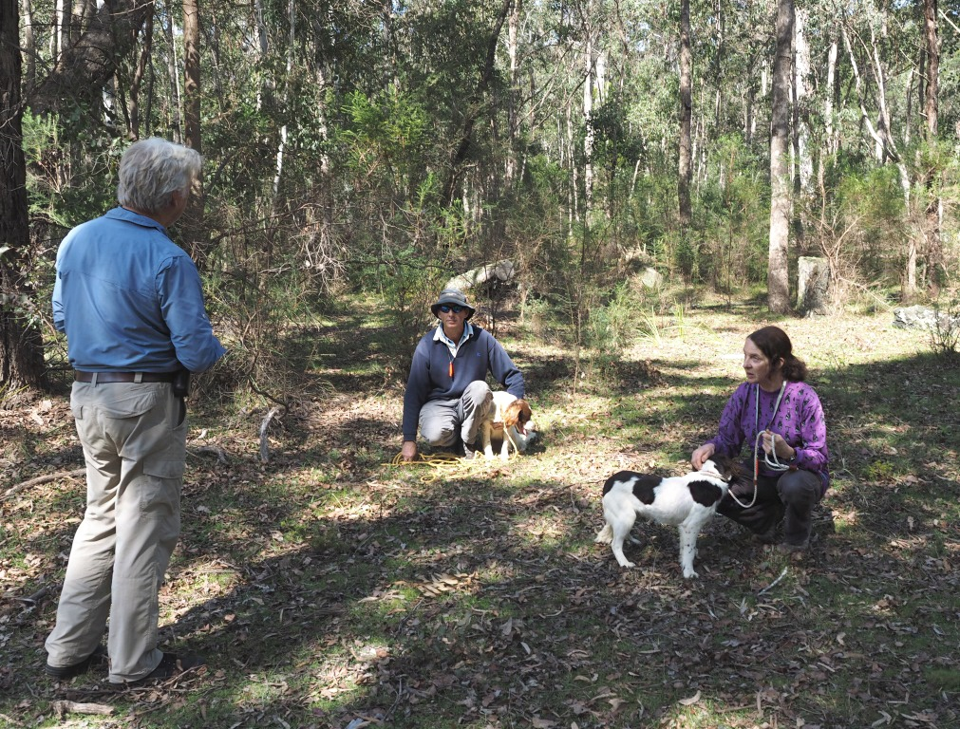Like many of our native species, the threatened

mountain pygmy-possum and the smoky mouse,

or Konoom, have experienced population

decline due to feral-cat and fox predation.

In a new partnership with the

NSW Government, the Australian

Government has contributed $140,000

towards an innovative approach to address

the threat posed by feral predators.

Two trained ‘detector dogs’ will assist in the

trapping and removal of the feral predators

and locating of Konoom.

In an innovative approach to species monitoring and conservation, two detector dogs are being trained to locate feral cats and native Konooms in NSW. Photo courtesy of Steve Austin

The training of ”Dottie” and ”Maggie May” is

progressing well. Field trials are occurring this   
year, involving newly trained handlers

and a skilled pest control officer.

## **Community engagement**

Over the last 12 months I have spent a significant amount of time engaging directly with communities at grassroots levels and raising awareness of, and support for, threatened species. This has provided me with a strong sense of the invaluable contribution made by those outside government to the recovery of threatened species. From this comes greater insight into how governments and their programmes can better partner with the community on what must be done to recover threatened species.

By visiting community groups and conservation projects, I can often validate the work being done and help sustain the passion and commitment to on-ground action from local communities and recovery teams. In August 2015, New Zealand appointed a Threatened Species Ambassador with similar terms of reference to mine. We engage regularly and both share a strong view of the significant value of community engagement and support.

Increasingly, the community and threatened species recovery groups are seeing the role of Commissioner as one that brings people together to find negotiated solutions. The recent emergency intervention for the orange-bellied parrot clearly demonstrates the importance of this emerging role. It involved bringing together a diverse range of stakeholders and negotiating a complex suite of recovery initiatives to address the species’ alarming population decline. The actions of the emergency taskforce, supported by joint funding, have recently resulted in the release into the wild of up to 13 birds from the captive-bred population. The Hon. Jeremy Rockliff MP, acting Tasmanian Minister for Environment, Parks and Heritage, said he was pleased to see the release of the birds, noting that “Our Department’s wildlife staff have been working closely with the expert group brought together by the Threatened Species Commissioner to implement actions they have identified”.

Engagement with the community extends online via a Threatened Species Commissioner twitter feed and Facebook page. On the day of the Threatened Species Summit, 130 Twitter contributors participated by posing questions and comments under the dedicated #TSsummit hash tag. Summit-related posts on the Threatened Species Commissioner’s Facebook page were seen almost 240,000 times. A summit webcast was made available for those wishing to review proceeding and has been downloaded more than 1600 times.

Throughout the year, my tweets appeared in timelines more than a million times in 2014-15. Facebook posts were displayed more than 220,000 times, reaching more than 100,000 people since November 2014. With more than 3200 Twitter and 1500 Facebook followers to date, social media is becoming a powerful tool for promoting discussion and awareness of threatened species issues and for encouraging and validating conservation efforts of community groups and organisations. Inclusion of threatened species protection issues in mainstream media also advances engagement with the community. Requests for information from media outlets continue to increase.

**CASE STUDY— Orange-bellied parrot emergency response**

In June 2015, at Minister Hunt’s request I chaired an emergency intervention meeting for orange-bellied parrots, in the wake of Psittacine Beak and Feather Disease being detected in the wild population. At the meeting, 21 of Australia’s key orange-bellied parrot experts and stakeholders unanimously agreed on the components of a strategic response to the outbreak. Participants included members of the Orange-bellied Parrot Recovery Team, BirdLife Australia, Friends of the Orange-bellied Parrot, state governments, academics, avian experts, captive breeders, virologists, animal disease specialists and zoos.

The workshop provided an opportunity to re-scope work funded through a partnership between the Australian and Tasmanian governments and for participants to collaborate on an approach based on science, action and partnership. The workshop identified areas for immediate attention, including boosting the captive breeding and release programme, adjusting management practices for wild and captive populations, and investing in more science to better understand the disease.

The Office of the Threatened Species Commissioner continues to liaise with workshop participants to ensure that agreed actions and commitments are progressing. The first parrots of 2015 are now returning to Melaleuca and they are more likely to thrive during this breeding season as a result of the actions agreed to at this workshop.

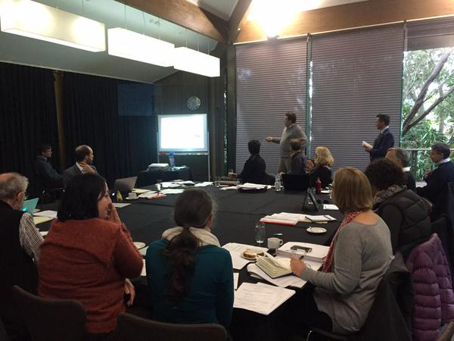

Twenty-one of Australia’s key orange-bellied parrot experts and key stakeholders participated in the orange-bellied parrot emergency intervention meeting at Melbourne Zoo. Photo courtesy of Mark Holdsworth

# **Next steps**

## **Threatened Species Strategy implementation**

Implementation of the Threatened Species Strategy has begun, with $6.6 million already allocated to on-ground actions that will help to deliver on the targets in the strategy. A feral-cat taskforce has been established. The identification of a further eight birds and eight mammals for priority action is close to being finalised, along with the identification of target plant species. I have been progressing this work within the Department of the Environment, and with state and territory governments, scientific experts, recovery teams and community groups.

### *Tackling feral cats and their impacts*

Meeting the Threatened Species Strategy’s ambitious feral-cat targets will require concerted national effort. On 1 December, I chaired the first feral-cat taskforce meeting. The taskforce will help consolidate and strengthen actions by states and territories and natural resource management organisations to eradicate feral cats. In addition to the states, territories and NRM organisations, the taskforce also includes the Department of Agriculture and Water Resources, the RSPCA, the National Environmental Science Programme and Threatened Species Scientific Committee representatives, the Invasive Species Council and Invasive Animals Cooperative Research Centre.

The Department has also updated the t[hreat abatement plan for predation by feral cats](http://www.environment.gov.au/biodiversity/threatened/publications/tap/threat-abatement-plan-feral-cats). This statutory document gives detailed scientific advice that underpins action on feral cats. The Threatened Species Strategy builds on the threat abatement plan by setting out new targets for feral-cat eradication on islands, in fenced areas and across the landscape. Together, these two documents support the agreed approach of science, action and partnership.

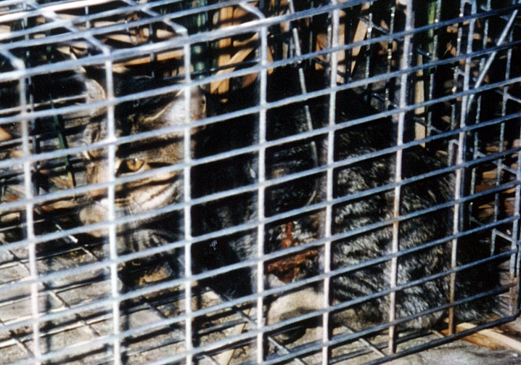On 17 July, the Australian Government, with agreement from all states and territories, made a national declaration in relation to feral cats. All states and territories will review arrangements within their respective jurisdictions and, where necessary, remove unnecessary barriers to effective and humane control of feral cats. This will allow new feral-cat eradication programmes to access the $50 million for management of established pest animals announced as part of this year’s national Agriculture Competitiveness White Paper. I will be working with the Department of Agriculture and Water Resources, state and territory governments and NRM regional organisations to encourage more action through this funding, especially given that efforts to eradicate feral cats can also reduce foxes and wild dogs and their impacts.

To help measure and report on feral cats and their impacts, the Australian Government has funded the FeralCatScan ‘app’. FeralCatScan is being used in a number of sites, including Kangaroo Island, as a management tool for feral-cat actions. It also has strong potential as a citizen science and participation tool and a roll-out strategy is being developed to encourage greater community engagement.

Feral cat trapped in South Australia. Photo courtesy of the South Australian Department of Environment, Water and Natural Resources

### *Green Army and 20 Million Trees programmes*

The Green Army and 20 Million Trees programmes continue their strong focus on delivering outcomes for threatened species. The latest round (Round 4) of the Green Army Programme includes funding for local projects that directly support the protection and recovery of threatened species, including through feral-cat eradication. The 20 Million Trees Programme has recently sought applications for projects (Round 2) that directly benefit threatened species and ecological communities, including projects that reestablish threatened plant species and restore suitable habitat for threatened fauna.

The contribution these projects make to threatened species recovery will feature in future reporting on the implementation of the Threatened Species Strategy.

### *Natural Resource Management organisations*

Through the National Landcare Programme, the Australian Government continues to invest in 56 regional Natural Resource Management (NRM) organisations to take practical action to protect threatened species in all parts of Australia. Partnerships through NRM organisations are often key to ensuring local communities are engaged and investments optimise action in tackling threats to Australia’s plants and animals.

A project to eradicate feral cats from Kangaroo Island provides a good example of this partnership approach. Featured at the Threatened Species Summit earlier in the year, this project is community driven and coordinated by the Kangaroo Island NRM board, the local council and local residents. Kangaroo Island NRM is continuing to work towards implementing a feral-cat eradication programme and is receiving support from the Invasive Animals Cooperative Research Centre for monitoring and reporting efforts through the use of the FeralCatScan app.

In September this year, I undertook field work in far north Queensland and saw firsthand a number of Green Army projects which were leveraged with other funding initiatives and community input, with the help of Terrain NRM, local farmers and Indigenous groups. The projects were benefiting species such as the cassowary, mahogany glider and Lumholtz tree kangaroo, among others. Over the next year, we will continue to work with NRM organisations to ensure the delivery of targets in the Threatened Species Strategy, particularly its feral-cat targets. I look forward to celebrating the significant role played by our regional NRM organisation in 2016 when we report against our first suite of targets.

**CASE STUDY — Threatened species projects in Commonwealth National Parks**

An extra $2 million to boost the recovery of threatened species in the Commonwealth national park estate is contributing to 10 threatened species projects. The projects help safeguard existing populations of threatened species and trial new approaches to improve their long-term survival, for example, through seed banking of plants and captive management and reintroductions of mammal species. The projects also tackle threats to species survival in the wild, such as feral animals, weeds and altered fire regimes. Fact sheets on the specific projects are at <http://www.environment.gov.au/biodiversity/threatened/commissioner/projects>.

**Christmas Island feral-cat eradication**

Christmas Island is undertaking an ambitious plan to completely eradicate feral cats from the island. The plan is underpinned by a long-term cat-control partnership between the Australian and Western Australian governments, the local community, biodiversity experts and major organisations including the Shire of Christmas Island and Christmas Island Phosphates.

The first island-wide deployment of Eradicat® feral-cat baits has been completed, with more than 70% of the island being successfully baited and over 15,000 baits deployed. Motion sensor cameras are monitoring cat abundance and distribution before and after baiting.

Predation by feral cats is one of the most significant processes threatening Christmas Island’s biodiversity, and successful eradication of this introduced pest will take pressure off a number of threatened species, including the critically endangered Christmas Island flying-fox, and the endangered emerald dove and thrush, as well as ground-nesting seabirds and native reptiles.

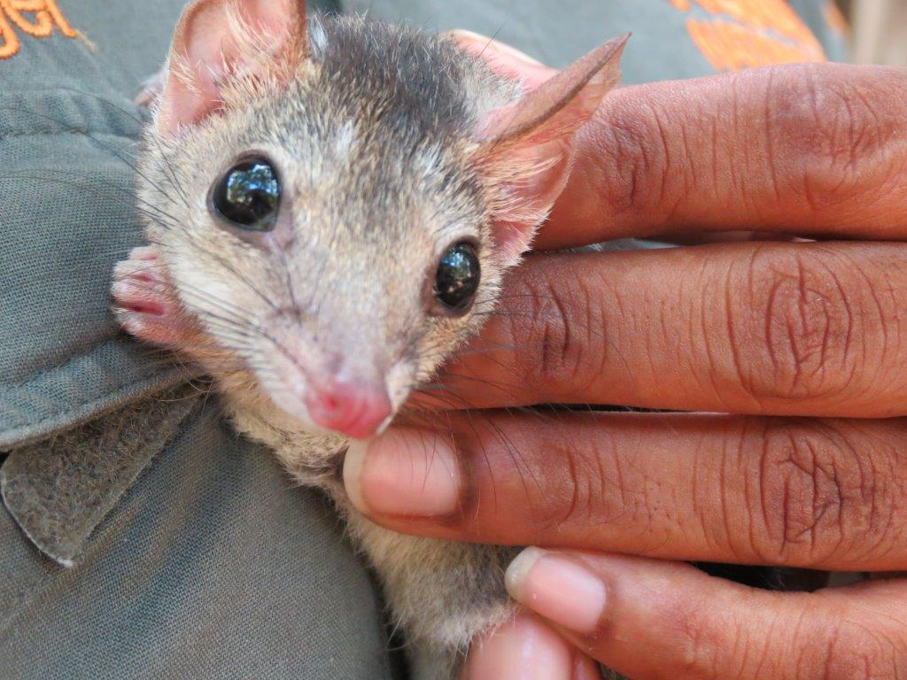**Kakadu Threatened Species Projects**

Four projects have started in Kakadu National Park to reduce threats and support threatened species recovery, including: intensive work targeting the threats of fire, weeds and feral animals; collecting and banking seed from Kakadu’s threatened plants; creating a wildlife refuge on Gardangarl (Field Island) for species struggling on the mainland; and reintroducing ‘toad smart’ northern quolls into Kakadu’s south.

Expanding the ‘toad smart’ quolls project at Kakadu National Park. The quolls will be trained not to eat cane toads, which are highly poisonous.

Photo courtesy of Parks Australia

The ‘toad smart’ quolls project builds on research conducted in Kakadu since 2010. The work has revealed that the trained ‘toad smart’ females not only survived and reproduced, but that the new generations also learnt from their mothers to avoid eating cane toads. More quolls will be trained at the Territory Wildlife Park not to eat the highly poisonous cane toad. After training, the quolls will be reintroduced to the Mary River region in Kakadu’s south, establishing a population in an area where they haven’t been seen since 2004.

Two seed collecting trips have targeted plant species for banking, with 25 seed collections made from 15 species. The project has also included in-field training in seed collection with park staff and Gundjeihmi Aboriginal Corporation rangers. Collecting work will continue in early 2016.

### *National Environmental Science Programme Threatened Species Recovery Hub*

A first research plan under the Threatened Species Recovery Hub of the National Environmental Science Programme has been confirmed. This plan includes research into control methods for feral cats, trials of threatened plant reintroductions, adaptive management of recovery actions for species including Leadbeater’s possum and eastern bristlebird, and research into best practice translocations of threatened species.

A further research plan for the hub is under development and will include new projects and additional funding for research that supports decision making, monitors recovery success and delivers on-ground action for threatened plants, animals and threatened ecological communities. By providing the scientific understanding and evidence needed to underpin best practice recovery action, this hub will deliver real improvements in threatened species trajectories.

## **Threatened species protection through partnerships**

### *Partnership with states and territories*

Everyone has a role to play in the fight against extinction, and partnerships with state and territory governments are key to turning around the trajectories of threatened species across Australia. As emphasised in the strategy, working together across jurisdictions and between government and non‑government organisations maximises the benefits we can gain from the limited resources available, by coordinating funding and sharing expertise.

State and territory governments are making considerable contributions to threatened species protection. Recent commitments to threatened species protection by New South Wales ($100 million) and Victoria ($5.2 million) will play an important role in the national recovery of threatened species. Further, all projects announced at the Threatened Species Summit are partnerships between the Australian Government and state and territory governments.

### *Public private partnership*

Investment and partnership with the private sector will be another important focus over the next 12 months. The Threatened Species Strategy confirms the Australian Government’s commitment to encouraging and brokering environmental investment through partnerships with the private sector.

An example of what is possible is the Parks Australia Bush Blitz nature discovery programme - a multi-million dollar partnership between BHP Billiton, the Earthwatch Institute Australia and the Australian Government. This example of a large and highly successful public private partnership has seen the discovery of more than 900 new species and added thousands of species records to our knowledge base.

The Australian Business and Biodiversity Initiative is an internationally recognised partnership between governments, business and the not-for-profit sector to support the integration of biodiversity conservation into business practices and policies in Australia.

The Australian Government is also assisting the Woodlands and Wetlands Trust to establish and expand feral free exclosures in the ACT and reintroduce threatened mammals and birds. When complete, threatened species will be able to thrive and multiply without the threat of feral predators.

A lesson I have learned from across the Tasman Sea is the significant role that the private sector can play. Half of the New Zealand Threatened Species Ambassador’s salary and all of her air travel costs are covered by Air New Zealand. There is a opportunity for more collaboration with the business sector in the fight against extinction in Australia. To achieve the targets in the Threatened Species Strategy, I am looking forward to promoting more engagement between government, business and the not-for-profit sector on conservation and sustainability and will be looking for innovative ways to develop these partnerships.

## **Monitoring and Reporting**

Monitoring and reporting is an important part of any recovery effort. Through this function we track progress to ensure milestones are met, we generate data that informs adaptive management, and most importantly, we provide a level of transparency in the spending of public money. Well designed and accessible public reporting can also build the momentum of threatened species recovery by validating the efforts of those involved.

The NESP Threatened Species Recovery Hub is assisting by looking into ways in which reporting can be improved. This involves generating:

* new information on threatened species and ecological communities
* better prediction of threatened species trajectories
* practical adaptive management for threatened species conservation and recovery programs improvement.

### *FeralCatScan*

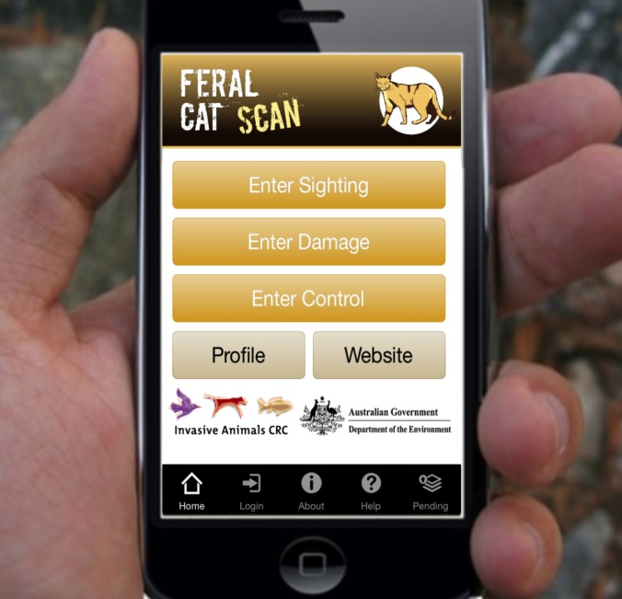[*FeralCatScan*](http://www.feralscan.org.au/feralcatscan/default.aspx) is a new website and mobile ‘app’ made possible through a project between the Invasive Animals CRC and the Australian Government. This innovative tool enables anyone in the community to record feral-cat observations including feral-cat sightings, feral-cat management and impacts on native species.

Land managers, conservation organisations, governments, Indigenous ranger groups, local councils and natural resource management groups are all involved in reducing the impact of predation by feral cats. Part of the role of Threatened Species Commissioner is to help consolidate, coordinate and complement the national effort. Using *FeralCatScan* as a central repository for feral-cat management data will allow for a national view of the problem, and help to deliver targeted feral-cat management in the areas where they have the greatest impact. A suite of FeralScan products is now available to report foxes, wild dogs and rabbits in addition to feral cats. Information on how to access *FeralCatScan* is available at [www.feralcatscan.org.au](http://www.feralcatscan.org.au).

Report sightings, damage and control on the FeralCatScan app. Photo courtesy of Peter West

### *MERIT*

Another important input to reporting on threatened species recovery is the Monitoring, Evaluation, Reporting and Improvement Tool (MERIT). This innovative, real-time data capture system, developed in collaboration with the Department of the Environment and the Atlas of Living Australia, is providing the mechanism for our natural resource management programmes to capture on-ground action being taken to support threatened species recovery.

### *Conservation Management Zones*

The Department of the Environment has also recently released information on the 23 [Conservation Management Zones](https://www.environment.gov.au/biodiversity/conservation-management-zones). These are geographic areas, classified according to their ecological and threat characteristics. They provide a framework for gathering on-ground knowledge and expertise about the environment. The information available is designed to support Australians of all ages and backgrounds to engage with, understand and manage, Australia’s unique biodiversity and landscapes. The zones also contain a great snapshot of the threatened species and ecological communities in the area.

### *Future Reporting*

A robust project management framework has been established to report on progress against each of the targets in the Threatened Species Strategy. Achieving the targets is a national effort and reporting on them will involve all levels of government, non-governmental organisations, experts and communities.

Future Threatened Species Commissioner progress reports will be structured to address each of the 87 individual sub targets contained in the strategy. This reporting will supersede the six monthly updates provided to date and will shift to an annual reporting regime. This will better align with reporting cycles from key delivery programmes and organisations.