threatened species
strategy

acknowledgement of traditional owners and country
The Department acknowledges the traditional owners of country throughout Australia and their continuing connection to land, sea and community.
We pay our respects to them and their cultures and to their elders both past and present.

from the minister
AUSTRALIA IS HOME TO SOME OF THE WORLD’S MOST AMAZING AND UNIQUE SPECIES.
More than 80 per cent of our mammals and 90 per cent of our trees, ferns and shrubs occur nowhere else on earth. But since European settlement, in just over 200 years, over 130 of Australia’s known species have become extinct, lost to us and to the world forever. The list of those threatened with extinction continues to grow.
Australia’s threatened species are ours to protect and we all have a role to play. Clearly ‘business as usual’ for threatened plants and animals in Australia would mean more extinctions. As Minister for the Environment, I am drawing a line in the sand and asking the community to join me. This Strategy outlines the Government’s new national approach to threatened species and how we can all take decisive action to protect and recover our plants and animals at risk of extinction.
Through the four pillars of the Plan for a Cleaner Environment-—Clean Air, Clean Land, Clean Water, and Heritage Protection—the Australian Government has set a clear direction for the way we protect the environment. The Plan for a Cleaner Environment helps to promote a resilient environment that can adapt to challenges like invasive species and climate change.
The Australian Government has established a new national approach to threatened species, and this Strategy is a plan for how we will prioritise effort and work in partnership with the community and state and territory governments over the next five years.
Our approach is based on science, action and partnership. To facilitate this, we have appointed a Threatened Species Commissioner in the Department of the Environment and since 2014 have directly committed more than $80 million to projects with threatened species outcomes. This Threatened Species Strategy and accompanying Action Plan sets out our plan to win the battle against extinction and includes hard and measurable targets to ensure accountability for outcomes.
New Government initiatives, such as the Green Army, 20 Million Trees and National Landcare Programmes, ensure we are working better with, and investing more in, local communities to reduce threats to our plants and animals, create safe havens and new habitat for them and improve the quality of the habitat that already exists. Through our commitment to take decisive action on feral cats and other invasive species, we will significantly reduce the impact of feral predators and increase the resilience of our native species.
Based on science and focused on action and accountability, this Strategy is a call for action in the fight against extinction. Halting the decline of Australia’s threatened plants and animals and supporting their recovery requires a coordinated team approach. We call on Australians from all sectors to join us and commit to this cause with renewed effort.
The Hon Greg Hunt MP
Minister for the Environment

from the threatened species commissioner
THIS IS AUSTRALIA’S FIRST THREATENED SPECIES STRATEGY. IT SETS OUT AN AMBITIOUS PLAN TO TURN SPECIES TRAJECTORIES AROUND.
Given the animals and plants at risk, and losses we have already endured, a strategic response is required. Our threatened species deserve no less, and by working on the basis of science, focusing on practical action, and partnering with state and territory governments and the community, it’s possible.
Over the past year my office and I have reached out to the community, forged partnerships and worked collaboratively with all levels of government, scientists, ‘Friends of’ groups, the non-profit sector and industry. Together, we have been able to secure more resources, build innovative approaches, encourage better coordination of conservation efforts, share information and promote action. I have been particularly humbled but also enthused by the effort and care that so many Australian communities have for our unique animals and plants.
This Strategy reflects the conversations I have been having around Australia. It explains why Australia should care about our threatened plants and animals, why we should be prioritising resources and effort more effectively, how we can do this, and what we will do differently. It reflects the need for collaboration and coordination of the many initiatives, programmes and opportunities for species conservation, building on (and celebrating) success to date, while also recognising new and reinvigorated approaches are needed to better deliver effective outcomes.
The Strategy outlines the Australian Government’s priority actions and targets to incentivise threatened species recovery and ensure accountability. It is an invitation to state and territory governments, the non-government and private sector and local communities to join us.
Australians can have development that is sustainable and at the same time protect our remarkable animals and plants. But with one of the highest rates of extinction in the modern world, we can’t win the war on extinction by doing more of the same. We need to act differently, adaptively, and decisively. We need to learn from our mistakes and build on our successes.
A strategic approach, with action areas and targets, underpinned by principles for prioritisation, give us the best chance of success. I look forward to working with the community to implement this Australian Government Strategy.
Gregory Andrews
Threatened Species Commissioner
Department of the Environment

Table of Contents
acknowledgement of traditional owners and country 2
from the minister 3
from the threatened species commissioner 4
Table of Contents 5
introduction 7
ours to protect—Australia’s threatened species 9
our approach— Science, action, partnership 13
science 13
action 14
partnership 14
science-based management 15
focusing our effort— Principles for prioritisation 16
national systems for protection and recovery 19
listing 19
effective planning to recover species 19
regulatory protection 20
australian government programmes, policies and the threatened species commissioner 21
valuing science - the threatened species recovery hub 25
actions in australia's protected areas and reserves 27
essential partnerships— We all have a role to play 28
state and territory governments 28
local landcare, community groups and regional natural resource management organisations 28
essential partners 30
supporting indigenous peoples' protection of plants and animals 30
working with farmers and private landholders 31
business protecting threatened species 33
2015/16 action plan 34
four key action areas 35
tackling feral cats 35
safe havens for species most at risk 36
improving habitat 36
emergency intervention to avert extinctions 37
targets 38
tackling feral cats and their impacts 40
20 mammals by 2020 44
20 birds by 2020 46
protecting australia's plants 48
improving recovery practices 50

accountability, monitoring and reporting on action 52
measuring progress 52
related links 54

introduction
THE AUSTRALIAN GOVERNMENT’S THREATENED SPECIES STRATEGY OUTLINES A BOLD, NEW AND ACTION-BASED APPROACH TO PROTECTING AND RECOVERING OUR NATION’S THREATENED PLANTS AND ANIMALS.
This Strategy sets out a road map and highlights how our approach of science, action and partnership can be used to achieve the long-term goal of reversing species declines and supporting species recovery.
Australia is a country rich in unique plants and animals. They are core to our identity, culturally significant to Indigenous peoples, important to the health of our environment and a strong contributor to our economy. Our distinctive plants and animals are a gift and ours to protect.
To address the decline of Australia’s threatened species, the community has called for a more action-based, prioritised, targeted, and coordinated approach to managing the threats and conserving the habitat of our animals and plants, thus giving them a better opportunity to survive and thrive.
The Australian Government’s Strategy involves:
- Pursuing a science-based approach; by engaging the best scientists and using evidence-based decision making, we ensure the actions we choose are the ones most likely to succeed.
- Setting out clear actions; the Government is supporting communities to take practical action, streamlining the regulatory framework and setting hard measurable targets to direct action and ensure accountability in actions taken.
- Building partnerships; we all have a role to play to ensure that threatened species are protected for the future and only by working together can we use resources to their best effect in protecting and recovering threatened species.
Giving weight to the science, action and partnership approach in this Strategy is an Action Plan with practical and measurable action areas and targets.

THE STRATEGY
The first section sets out why we should all be working to protect threatened species and the Australian Government’s commitment to science, practical action and working in partnership. Importantly, it also outlines key principles for prioritisation of resources and effort to ensure maximum results for each dollar invested in the fight against extinction.

THE ACTION PLAN
The Action Plan is the first installment of a five-year Australian Government response. It starts now, with hard and measurable targets from year one onwards. It will be reported on and updated annually.

Key action areas that are priorities for the Australian Government are:
- Tackling feral cats
- Safe havens for species most at risk
- Improving habitat
- Emergency intervention to avert extinctions
Targets to measure success are:
- 2 million feral cats culled by 2020
- 20 threatened mammals improving by 2020
- 20 threatened birds improving by 2020
- Protecting Australia’s plants
- Improving recovery guidance
The future for threatened species action and recovery is one fuelled by genuine collaboration and concerted effort between all players: the Australian Government, state and territory governments, Indigenous groups, community groups, non-government organisations, business, scientific organisation, private landholders and others. It is only together that we can protect the future of Australia’s threatened species.

ours to protect—Australia’s threatened species
australia is a country rich in unique plants, animals and ecosystems.
We have more endemic mammals and reptiles than any other country in the world and more unique plants than 98 per cent of the world’s countries—species which occur nowhere else on earth. These plants and animals are as much a part of our heritage and identity as Kakadu, Ningaloo, Uluru and the Great Barrier Reef.
For many thousands of years before European arrival, Indigenous Australians worked to shape the landscape and to protect and conserve the plants and animals found here. They are still doing this. Today, Australia’s unique species and ecosystems remain central to our identity and well-being and are so culturally significant they are part of our every day lexicon, used as names for our sporting teams and appearing on our money and official coat of arms.
But so many of our species have become so rare that many Australians have never heard of or seen them. We need to grow awareness in the Australian community of our threatened animals and plants, and the value and significance they have to our nation. The Australian Government’s vision is for everyone to understand and identify with our native species; to know that reversing our species declines goes hand-in-hand with sustainable development; and for everyone to play a role in the fight against their extinction.
Our plants and animals contribute significantly to our economy. More than 3.3 million people visit Australia each year to experience and celebrate our natural wonders, contributing an estimated $23 billion to the Australian economy each year. Australia’s protected areas, including our national parks and marine protected areas, are crucial to the survival of our biodiversity; they also provide enormous dividends for the Australian economy.
For example, the tourism on the Great Barrier Reef, genetic resources derived from biodiversity, and employment through protected area management all contribute to Australia’s economic prosperity.
Our native species existence also confers benefits on the environment that allow us to profit from the landscape. For example, our native bats and birds help control pest insects, spread seeds and maintain our forests. Our plants provide food and shelter, while also capturing and storing carbon, combating salinity, keeping river banks stable, reducing erosion and improving water quality. Tasmanian devils, quolls and other native predators help to control invasive species such as rabbits, foxes and cats which damage the productivity of Australia’s farming sector. The diggings of small mammals like bettongs and bilbies help maintain healthy soils: the foundation of our ecosystems.
Australia is one of only two developed mega-diverse countries in the world —countries with extraordinarily high levels of biodiversity. This carries a responsibility but also an opportunity to lead the world in effective and practical approaches to environmental management. It provides a living laboratory for world-leading science and education services in demand by the rest of the world. It is an incubator for environmental services and natural resource management knowledge that Australia uses domestically and exports internationally.
Australia’s biodiversity is under threat. Many plants and animals are in danger of extinction. The key threats are well known and include: pressures from invasive species such as feral cats and weeds, inappropriate fire regimes, loss of habitat and a changing climate. This Strategy responds to the need for a more prioritised, targeted and coordinated approach to managing these threats, giving our native species a better opportunity to survive and thrive in their natural environment.
Australia’s native species are a gift. They are ours to protect now and for future generations. We all have a role to play.
species endemic to australia
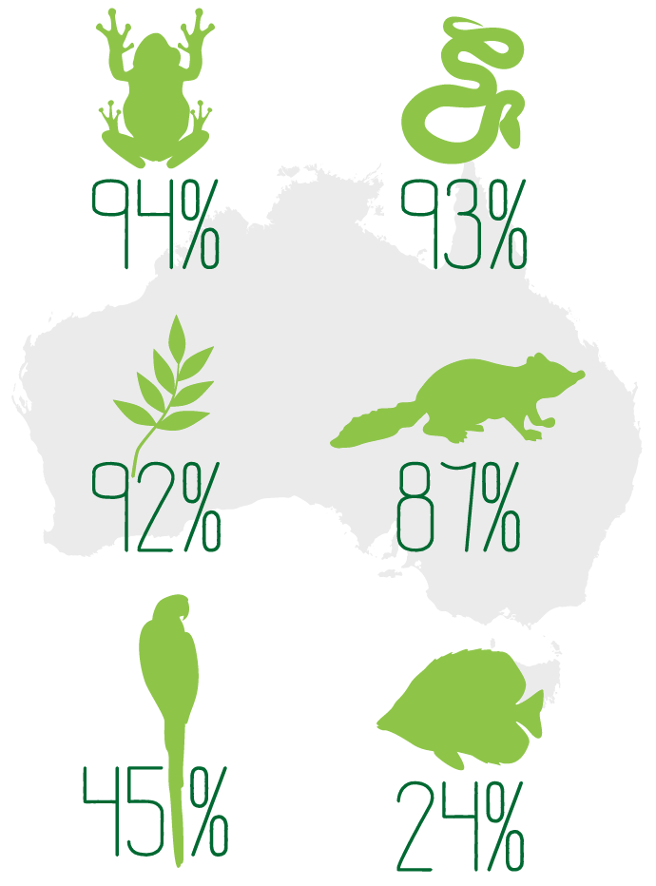
our goal
australia currently has a growing list of almost 1800 plants and animals listed nationally as threatened.
Now is the time to work together and act to stop the decline and turn around the trajectory of species at risk of extinction.
The Australian Government’s long-term goal is to halt the decline of Australia’s threatened plants and animals and support their recovery. We aim to do this by addressing the threats and by acting to support recovery, while at the same time ensuring that the development that underpins our economic and social wellbeing is sustainable. We are committed to using the best available science, taking action and working in partnership with the states and territories and the broader community to achieve this goal. Winning the battle against extinction requires team work.
Australia takes an active role internationally and is party to a number of significant international treaties that guide and influence the way we protect our native plants and animals.
- The Ramsar Convention on Wetlands commits Australia to protecting our wetlands of international importance.
- The Convention on the Conservation of Migratory Species of Wild Animals and three bilateral migratory bird agreements guide our protection of species that travel across vast oceans or fly from country to country.
- The Convention on International Trade in Endangered Species of Wild Fauna and Flora ensures that international trade does not threaten species with extinction.
- The International Convention for the Regulation of Whaling directs efforts to conserve whale populations.
- The Convention on Biological Diversity directs our conservation efforts and sustainable use of natural resources, and the sharing of the benefits from use of genetic resources.
- The World Heritage Convention sets out our duties in identifying and protecting world heritage and national heritage locations.
As a party to the Convention on Biological Diversity, Australia has agreed with other countries to implement the Strategic Plan for Biodiversity 2011–2020, including its Aichi Biodiversity Targets. The Aichi Biodiversity Targets are a set of 20 targets which recognise the urgent need for action by everyone to help reduce, and eventually halt, the loss of biodiversity at a global level.
Aichi Biodiversity Target 12 aims to prevent threatened species extinction and improve their conservation status: By 2020 the extinction of known threatened species [will have been] prevented and their conservation status, particularly of those most in decline, [will have been] improved and sustained.
As Australians, we are stewards of our biodiversity and ecosystems, not just for ourselves but also for the world. This Threatened Species Strategy provides a plan of action towards meeting the Australian Government’s contribution to the commitments Australia has made to protect our unique biodiversity and halt extinction.
The key action areas and targets in the Action Plan show how the Australian Government is contributing to Aichi Target 12. Australia’s overall response is dependent on all levels of government taking action and working in partnership with business, the non-government sector and the broader community.
mammal extinctions - australia vs the world
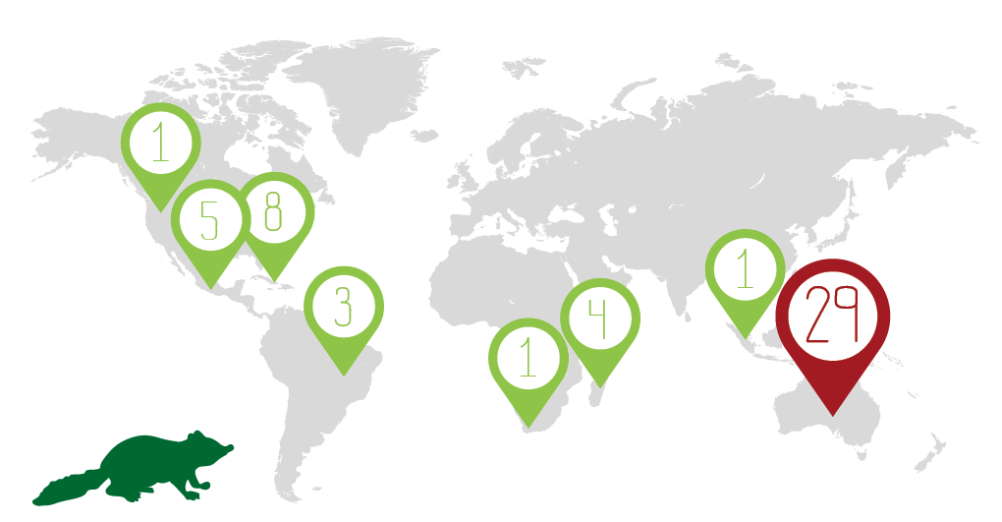

our approach— Science, action, partnership
the australian government's approach to protecting and recovering australia's threatened plants and animals.
Our approach is based on the first principles of scientific evidence, on-ground action and collaborative partnerships with state and territory governments, community groups, Indigenous groups, non-government organisations, business, scientific organisations, private landholders, local government and others - we all have a role to play. The principles cannot be applied in isolation. The science directs and informs the action and evaluates the management response, but the success of the action depends on effective collaboration between the partners. A genuine integration of science, action and partnership will achieve the greatest benefits for threatened species.
State and territory governments play an integral role in protecting and recovering threatened species and are critical partners in the Australian Government’s approach. They administer their own threatened species programmes under state legislation and collaborate with the Australian Government and other key participants in jointly implementing many recovery programmes for nationally listed species. States and territories manage national parks and other threatened species conservation programmes, using their regional knowledge and expertise.
The Australian Government relies on state and territory governments, and key non-government and community groups, to help deliver on-ground actions. Existing and future partnerships, are thus fundamental to achieving the targets set out in this Strategy.

science
Knowledge is key. By engaging the best scientists and using evidence-based decision making, we can be confident the actions we choose are the ones most likely to succeed. By monitoring results, we learn what works and adapt interventions to get the best outcomes. Recognising and incorporating Indigenous Australians’ unique knowledge of the environment, gained and passed down over countless generations, adds another dimension to this growing scientific base.
At the core of the Government’s science-based approach is a dedicated $30 million Threatened Species Recovery Hub under the $142.5 million National Environmental Science Programme (NESP). A partnership with some of Australia’s leading scientists and institutions, the Hub is investing in on-the-ground science-based actions to support species recovery, measuring the effectiveness of actions, and charting the recovery of threatened species in this Strategy.
Our science must take account of climate change and its impacts. Climate change is a fundamentally different biodiversity threat to existing environmental stresses due to its geographic extent, magnitude and speed of potential changes, also in the way that it can exacerbate other threats such as inappropriate fire regimes. A changing climate is driving change in species distribution and the composition and functioning of biological communities.
The Government is investing in adaptation research capacity through the National Climate Change Adaptation Research Facility, which synthesises the best adaptation research to produce practical, hands-on tools and information for local decision-makers, including in threatened species recovery.
We also rely on the scientific community more broadly, funded by states and territories, universities, private institutions and philanthropic sources, to build the evidence to underpin action.

action
Knowing what to do is the first step; the next is taking action. The Australian Government is committed to ensuring that actions to protect and recover threatened species are based on prioritisation of resources and effort, and backed with hard and measurable targets.
The Government invests significantly in managing our natural resources, with more than $2 billion over four years for initiatives such as the Green Army, 20 Million Trees and National Landcare Programmes. These programmes enable communities and regional Natural Resource Management (NRM) organisations to take practical action to protect threatened species in all parts of Australia.
Effective recovery action relies on the involvement of state and territory governments which have statutory obligations. The dedicated efforts of volunteers, community groups, scientists and non-government organisations, are also important to the protection and recovery of threatened species, especially where local decisions are critical to achieving successful outcomes.

partnership
We all benefit from our natural environment and we all have a role to play in its conservation. Sustainable development is a shared opportunity and responsibility: it will fail if left to governments alone. To make our actions effective and sustainable, we partner and coordinate with community, scientists and other researchers, non-government organisations (big and small), state and territory governments, regional NRM organisations, local Landcare groups, local government and the business sector.
Only by working together can we effectively prioritise and maximise resources to protect threatened species. A partnership approach between all of these groups gives us the best chance to achieve positive results for threatened species.
Australian Government leadership in these partnerships is critical to help avoid wasteful duplication, conflict between competing priorities, and well-intended but counter-productive initiatives. Threatened species do not respect human borders and boundaries.
Dedicated community groups, such as ‘Friends of’ groups are excellent stewards and advocates for the species they support. Support for their volunteer effort can provide a good return on investment.

science-based management

case study

Bringing scientists, Indigenous people and government together to save threatened species
One of Australia’s worst environmental weeds, bitou bush, infests large parts of coastal eastern Australia, including in Booderee National Park. The way bitou bush has historically been managed in the park is to first spray it with ultra-low volume herbicide, wait for the dead plants to dry (called curing) and then burn the treated area before respraying to kill the young bitou bush plants that germinate after fire. Despite a long history of this practice, critical questions were unanswered. Does this spray-burn-spray treatment work? And did it have negative effects on animals like the eastern bristlebird, for which Booderee National Park is one of the last population strongholds?
The groups involved recognised that the best way to answer these questions was through a weed control monitoring partnership, involving the National Park manager, scientists from the Australian National University’s Fenner School, and the local community, including the traditional owners at Wreck Bay Aboriginal Community. This was the beginning of an eight-year long project with very positive outcomes.
The research showed that the spray-burn-spray method could effectively remove bitou bush while allowing the majority of native plants to recover. It is both the most ecologically effective and cost-effective approach to bitou bush control. Even better, new research work being conducted under the Australian Government’s NESP shows that the eastern bristlebird —which avoids areas where bitou bush is prevalent—will colonise those environments where this noxious weed has been removed.
This story highlights the importance of partnerships; connecting government, science and Indigenous people in monitoring to conserve Australia’s threatened species.

focusing our effort—Principles for prioritisation
australia currently has almost 1800 nationally listed threatened species and many more are being assessed for listing.
Our native plants and animals deserve the prioritisation of effort and resources that Australia puts into expenditure of public monies in other sectors with limited budgets, for example, health, education, infrastructure and defence. There are many good project ideas and initiatives that can help our threatened species and, just as with other sectors, resources will always be limited. We need to ensure resources and efforts for threatened species recovery are targeted to where we can get the biggest benefit from each dollar invested. When deciding which projects or initiatives to support, we need to ensure the best use of our effort, money and time.
To the right are the principles the Australian Government considers when examining threatened species recovery initiatives. The principles help identify where Australian Government investment can be most beneficial and help the greatest number of plants and animals. They allow comparison between projects and ensure every dollar invested in threatened species recovery goes as far as it can to avoid extinctions. They help get the best results with the money available.
The principles for prioritisation look at a project proposal or initiative overall and help to weigh up the relative benefits. They have been used in framing the investment decisions for funding announced in this Strategy and will be used to guide future investment decisions of the Australian Government. Further guidance on the principles for prioritisaiton will be produced to support their application.

Science
Conservation status | The species has a listing status under the Environment Protection and Biodiverstiy Conservation Act
Importance to the environment | The species plays an important role in the environment, benefits other species, or is essential to the function and health of its ecosystem (i.e. a pollinator or top predator)
Uniqueness | The species is unique, like nothing else on earth, or has very few close relatives
Importance to people | The species is particularly valued by the community, is well-known and part of local or broader community identity, is culturally significant to Indigenous people, or helps tourism, agriculture or the economy

action

Chance of success | The action has a high chance of success and strong supporting scientific evidence
Benefit | The action is likely to be effective in protecting species now and into the future
Umbrella action | The action benefits multiple species or habitats
Cost | The action is cost effective, offers best value for money and may secure multiple outcomes

partnership

Community | Community groups are engaged and results are likely to be sustained through long-term community effort
State and territory governments | The initiative involves, or has the potential to involve, state and territory governments and does not duplicate their existing work
Broader leveraging | The initiative involves, or has the potential to involve, other organisations and leverage broader funding or contributions
Australian Government programmes and policies | The initiative is supported by complementary policies, programmes or existing investments

prioritisation in action

CASE STUDY

Prioritisation in action – Christmas Island cat eradication
The Australian Government recently considered and approved a project to eradicate feral cats from Christmas Island. Prioritisation principles were applied when deciding on support for this initiative.

Science
Christmas Island is home to a number of species found nowhere else in the world. It is also one of the world’s most important seabird rookeries. Its isolation means that many of the species have evolved together and established a highly connected web of life unique to the island. There are 17 species listed as threatened under the Environment Protection and Biodiversity Conservation Act 1999 (EPBC Act) found on the island and numerous species of migratory seabirds. The island’s plants and animals are also particularly important for tourism on the island, which provides income for the local population.

Action
Feral cats are considered a major threat to the animals on Christmas Island and are a key threatening process under the EPBC Act. The project aims to eradicate stray and feral cats from the island by 2020 and is underpinned by science, proven control techniques and a program for managing domestic cat programme. This indicates a high likelihood of success.
Our contribution of $500 000 will leverage approximately $1.75 million in funding and $500 000 of in-kind contributions. This will contribute directly to the recovery of 10 listed threatened species and create a feral-free safe haven for the future. Knowledge gained from the project can be transferred to other island eradications, thus lowering the cost of those actions.

Partnership
The eradication plan for the island is a collaborative partnership between the Australian and Western Australian governments, the local community, biodiversity experts and major organisations including the Shire of Christmas Island and Phosphate Resources Limited.

Overall
This project has strong potential to significantly benefit numerous threatened species, along with many other species on the island, it increases community awareness and action concerning feral cats, and leverages almost $2 million in funding from other sources. All the works are underpinned by science and supported by a wide range of stakeholders.
This project represents a strong investment of funding with strong conservation outcomes.

national systems for protection and recovery
the australian government has a suite of programmes, policies and on-ground management measures in place to support australian plants and animals.
The Australian Government is one of a number of important players in protecting threatened species and achieving sustainable development, with state and territory governments also having a strong role to play. Our suite of systems complements actions by state and territory governments and are delivered and supported by a number of important partners.

listing
The first step in protecting Australia’s threatened native plants and animals is through recognition under the EPBC Act. The EPBC Act is the Australian Government’s principle piece of environment legislation and provides protection through the identification and listing of species and ecological communities as threatened. It also allows for the formal recognition of key threatening processes that impact native plants and animals.
Any person may nominate a native species or ecological community for listing under the EPBC Act. Nominations are subject to rigorous scientific assessment by the Threatened Species Scientific Committee and must be supported by a high level of evidence. Recommendations made by the Committee are then considered by the Australian Government Minister for the Environment, who decides whether the species or ecological community will be listed or not. Through the National Review of Environmental Regulation, most governments across Australia have agreed to a nationally consistent assessment methodology for listing plants, animals and ecological communities as threatened, based on the best practice standards established by the International Union for the Conservation of Nature. This will permit the development of a single operational list of threatened species in each jurisdiction, which will be simpler for business and the community to understand.

effective planning to recover species
All species listed as threatened under national environmental law require conservation advice and some may have a recovery plan in place. These key planning documents, prepared collaboratively with stakeholders, set out the actions needed to stop the decline, and support recovery of, a threatened species. These documents, reviewed by the Threatened Species Scientific Committee before being endorsed by the Australian Government, provide the detailed, evidence-based actions for protecting threatened species. Threat Abatement Plans are also major instruments for conservation and, in some cases, provide a very cost-effective way of benefitting multiple threatened species.
Protecting threatened species requires prioritisation of effort, and efficient and effective government plans and programmes. The Australian Government is working to ensure this by applying its principles for prioritisation, updating threatened species lists with the most current information, and ensuring priority species recovery plans and conservation advices have the best available guidance on actions for their protection and recovery.
Effective recovery planning and successful implementation also requires effective recovery teams. These groups typically bring together interested states and territories, non-government organisations, scientists, land managers and community groups. Recovery planning and implementation calls for adaptive management and coordination of effort across state borders and a cooperative approach with all stakeholders.

regulatory protection
Threatened species and ecological communities are considered matters of national environmental significance. Any project or development that is likely to have a significant impact on a matter of national environmental significance must be assessed under the EPBC Act. This ensures projects that impact on nationally listed threatened species are subject to rigorous assessment under national environment law.
The assessment process requires project proponents to consider how to avoid and mitigate the impacts on threatened species. In some cases, impacts are required to be offset. Offsets must be in accordance with the EPBC Act offset policy and must be additional to existing conservation measures. In some cases, offsets can be used to implement actions specified in species recovery plans. For example, offsets have been used to fund research into Tasmanian devil facial tumor disease.
As well as ensuring protection in Australia for matters of national environmental significance, the Australian Government regulates all native species exports, to make sure they will not have a significant impact on the wild populations. International environmental law plays an important role in preventing species declines.
The Australian Government is also committed to delivering a One-Stop Shop for environmental approvals that will accredit state planning systems under national environmental law, to create a single environmental assessment and approval process for nationally protected matters. The One-Stop Shop policy aims to simplify the approvals process for businesses, lead to swifter decisions and improve Australia’s investment climate, while maintaining high environmental standards.

australian government programmes, policies and the threatened species commissioner
Threatened species benefit directly and indirectly from Australian Government investments through the Plan for a Cleaner Environment. Through the Green Army, 20 Million Trees and National Landcare Programmes, the Australian Government is protecting threatened species as part of a $2 billion investment in natural resource management. In less than one year, over $80 million has been committed through these programmes to support threatened species conservation.
The Threatened Species Commissioner is central to the Australian Government’s new national approach to securing our threatened species from extinction. Located within the Australian Government Department of the Environment the Commissioner is supported by a threatened species unit and an informal group of expert advisors. The Commissioner champions development and implementation of practical actions, participates in and influences policy and programme development, brings partners and resources together to deliver on-the-ground change, promotes awareness of threatened species at a national level and supports local communities and their efforts to avoid extinction.

Green Army
The Green Army Programme partners with local communities to deliver conservation and heritage projects, whilst providing practical skills and training to young Australians aged between 17 and 24.
The Government is investing more than $700 million over four years, building to a workforce of 15 000 people by 2018.
To date, of the 704 projects announced, the Green Army Programme has already supplied over 270 projects that directly support threatened species recovery, and a significant number more that provide ancillary benefits.
Green Army teams are undertaking activities like pest and disease management, revegetation, seed collection, plant propagation, fire management, fencing and monitoring activities. Many of these are recommended actions in recovery plans. At Mulligans Flat in the ACT, Green Army participants are helping to restore a box gum grassy woodland ecosystem and are supporting the reintroduction of animals that have been extinct from the area for many years. Green Army pest control activities to destroy rabbit warrens are enhancing the quality of the woodland, improving habitat for native species. Eastern quolls, a species extinct from the region, will be reintroduced to the area next year.

case study

Green Army protecting threatened species in the desert
The Green Army Mala Breeding Facility project in Alice Springs is building breeding of the central Australian subspecies of mala (Lagorchestes hirsutus). The subspecies are now extinct and only held in captivity. The project implements a recommendation, made by a research team at Macquarie University, that all mala carrying rare alleles (gene variants) be sent to the Desert Park for breeding with known genetic lines. The capacity to do this must be increased.
The project involves the construction of three steel enclosures joined by a central access way. The Green Army Team has been involved with preparation of the steel parts, digging of holes, concreting and mesh attachment. Further to this will be plumbing and irrigation to the enclosures, with habitat construction and shade construction where appropriate. The Green Army participants are learning a range of construction skills and have also gained various accreditations in habitat construction and running animal programmes in parks. The morale is high as the programme is very hands on, and participants have the opportunity to start and finish a significant project.

20 Million Trees Programme
The Australian Government has committed to plant 20 million trees by 2020 to improve the extent, connectivity and condition of native vegetation that supports native species (including threatened species and ecological communities) and contribute to reducing greenhouse gas emissions. $50 million over four years has been committed to deliver the programme.
To date, more than $25 million is being directed towards tree planting projects that have a direct threatened species outcome by restoring habitat through improving the extent, connectivity and condition of native vegetation. In addition to the 95 per cent of successful projects under the first round of the small grants, a further 22 projects in the large scale delivery programme will contribute to the conservation of threatened species or ecological communities by planting 6.75 million trees to the value of $16.3 million. This funding includes $1.85 million for recovery of the helmeted honeyeater and Leadbeater’s possum through three projects delivered by grant recipients and service providers north east of Melbourne.

case study

20 Million Trees project supporting threatened birds in Western Australia
Through the 20 Million Trees Programme, the Australian Government is supporting recovery of Carnaby’s black-cockatoo and the malleefowl in the Fitzgerald Biosphere Reserve in southern Western Australia. The project will plant over 90 000 trees and shrubs to provide habitat corridors in an area next to the Fitzgerald River National Park.
This project will be an important addition to the Gondwana-Link Wildlife Corridor.
It’s a collaborative partnership between the local Indigenous community and multiple agencies, who will work together to establish 100 hectares of woodland and mallee heath for these iconic threatened species.

National Landcare Programme
The Government has reformed how natural resource management funding is directed by creating the National Landcare Programme.
The Australian Government will invest more than $2 billion through the National Landcare Programme over four years from 2014-15. Based on the principles of simple, local and long-term, the programme incorporates a greater role for regional NRM organisations, along with their communities. They determine local and regional priorities and take practical action towards improving their local environment and promoting the long term sustainability and management of Australia’s natural resources, including threatened species.
One of the requirements of the regional stream of the National Landcare Programme is that all regional NRM organisations must spend at least 20 per cent of their Australian Government funding on local on-ground projects and related activities that are delivered by, or directly engage, the local community, including Landcare and other community groups. All regional NRM organisations have embraced this requirement, with expected investment of more than $120 million in community natural resource management activities nationally.
The reformed delivery approach allows regional NRM organisations, in consultation with their communities, to determine the most appropriate delivery mechanisms to address threatened species priorities in their local area and region. Almost half of the sub-projects under the regional stream of the National Landcare Programme totaling over $190 million (as of July 2015), are contributing towards outcomes for threatened species or threatened ecological communities.

Emissions Reduction Fund
Biological adaptation is critical to building the resilience of Australia’s threatened species and ecological communities under conditions of climate change and extreme weather events, but there are limits to adaptation. Ecosystems stand to benefit the most from efforts to reduce carbon emissions and slow the warming trend. The Australian Government is firmly committed to meeting its emissions reduction target of 5 per cent below 2000 levels by 2020. At the centre of the Government’s response is the Emissions Reduction Fund, which provides incentives to reduce emissions in Australia Innovative methods to reduce emissions, like savannah burning, can also create important habitat for some threatened mammals, birds, lizards and plants.

The Reef Trust
The Reef Trust funds on-ground action to address key threats to the long-term sustainability of the Great Barrier Reef. These investments have strong connections to, and benefits for, the threatened species of the reef. Actions implemented include a crown-of-thorns starfish eradication plan, and removal of threats to protected species like marine turtles. The Reef Trust is also a vehicle for promoting partnerships, not only to deliver projects on the ground, but also to receive funds from government offsets for development in reef catchments and potentially philanthropic funds.
The Reef 2050 Long-Term Sustainability Plan commits to developing an investment framework, which will include identifying mechanisms to enable diverse funding approaches. This will facilitate greater opportunities for partnerships and private investment to work effectively alongside public investment. Outcomes of this work may inform investment diversification in other areas, such as threatened species.

Commonwealth Environmental Water Holder
The Commonwealth Environmental Water Holder is responsible for government policies and programmes that seek to protect and restore environmental assets—rivers, floodplains and wetlands—that contain a wide diversity of life and provide habitat for native animals and plants. Over half of the Murray-Darling Basin’s native fish species are considered rare, threatened or of conservation concern. Through the Commonwealth Environmental Water Holder and other initiatives, more effective use of water is benefiting species in the Murray-Darling Basin and other Australian river systems.

Indigenous land and sea management programmes
More than $400 million over five years has been committed through Indigenous ranger and land and sea management programmes to support Indigenous management and protection of threatened plants, animals and places. These programmes reflect Indigenous aspirations to care for country and support the integration of Indigenous ecological knowledge into contemporary practices to deliver enduring environmental, cultural, social and economic outcomes.
Benefits to the environment and our threatened plants and animals increase as links between Australian Government programmes are strengthened and further leveraged with those of the state and territories and non-government organisations.. For example, the levels of fish and turtle breeding may improve if feral pig impacts on riverbanks are reduced, especially in conjunction with release of environmental water by the Commonwealth Environmental Water Holder.
These programmes, combined with action and investment by state and territory governments, environmental non-government organisations and Australian industry, provide us with ways to increase threatened species populations.

valuing science - the threatened species recovery hub
Recognising that science provides the robust evidence base needed to plan and direct conservation management activities, the Australian Government established a dedicated $30 million Threatened Species Recovery Hub under the $142.5 million NESP. Led by some of the Australia’s leading ecologists, this Threatened Species Recovery Hub is investing in on-the-ground research to turn species recovery trajectories upwards. It is also providing capability to measure the effectiveness of actions and to chart the recovery of threatened species in this Strategy.
Projects already approved from within the Threatened Species Recovery Hub include: trialling evidence-based management tools to reduce the impacts of introduced predators; managing fire regimes the save threatened flora and fauna; enhancing threatened species outcomes on Christmas Island; and the science of translocation, reintroduction and conservation fencing for threatened fauna. The Threatened Species Recovery Hub will also be delivering better understanding and analysis on use of offsets, use of islands for species protection and quantifying benefits of threatened species management in rural and regional economies.
And in addition to the $30 million Threatened Species Recovery Hub, other investments under the NESP, particularly the Northern Australia Environmental Resources, Tropical Water Quality and Marine Biodiversity Hubs, are also contributing significantly to threatened species recovery. Examples in these hubs include projects to investigate the role of feral cats in small mammal declines in Kakadu National Park, understanding and managing the Shared Urban Habitat, and Studying Northern Australia hotspots for the recovery of threatened sawfish and river sharks.
The Australian Government has demonstrated an unbroken commitment to high quality environmental science, beginning with the $100 million Commonwealth Environment Research Facilities, followed by the $68.5 million National Environmental Research Programme, and now through the $142.5 million NESP.

case study

Future and emerging scientific opportunities to control invasive species
Science and technology are developing rapidly and this can open up new and exciting opportunities in the battle against extinction, especially where the threats are invasive species. While the conservation community may seemingly face a range of intractable problems in its mission to protect threatened species, newly emerging developments like gene-drive technologies can offer us hope. New biological tools being developed for biomedicine, as part of the new fields of synthetic biology and genomic technology are worth exploring.
For example, scientists have developed extremely precise genome-editing techniques which can make it possible to safely adjust the genes of invasive non-native plants and animals. These tools could be used to develop a sophisticated biological tools that, could for example, produce a safe and highly targeted biological control for feral cats or rats on islands.
Of course, these technologies are still in early stages of development and scientists, including at the CSIRO, are examining closely the risks to ensure complete environmental safety and undertake full benefit and risk assessments. While the Government’s $30 million investment in the NESP Threatened Species Hub has a primary emphasis on practical action to recover our threatened species, these emerging opportunities are also something the NESP, in partnership with organisations such as the CSIRO, could explore.

A number of initiatives across the Australian Government and other sectors provide information on the state of Australia’s ecosystems, both marine and terrestrial. These include the National Collaborative Research Infrastructure Strategy through the Integrated Marine Observing System, the Terrestrial Ecosystem Research Network, and the Atlas of Living Australia.
Other initiatives that provide some of the environmental information underpinning management of threatened species include:
- The Australian Institute of Marine Science provides data on the Great Barrier Reef and other marine ecosystems in northern Australia.
- Geoscience Australia and CSIRO contribute to high-resolution mapping of seabed environments and terrestrial vegetation to better understand the distribution of habitats, key to the support of threatened species.
- The Australian Antarctic Division and the Antarctic Climate & Ecosystems Cooperative Research Centre have been studying Antarctic and Southern Ocean ecosystems, including whales, for decades.
- The Australian Academy of Science has developed “Foundations for the Future: A long-term plan for Australian ecosystem science” This document articulates a long-term framework for coordinating ecosystem science across the full range of ecosystems and across research sectors including government agencies, academic institutions, and the community as a whole.
These and other government-supported research efforts, including work within academic institutions, provide a base that can be built upon to support the Threatened Species Strategy.

actions in australia's protected areas and reserves
The National Reserve System protects more than 17 per cent of Australia’s land and inland waters. It is a cornerstone of our efforts to protect threatened species, threatened ecological communities and natural values. It is made up of Commonwealth, state and territory reserves, protected areas run by conservation organisations and areas protected by farmers on their working properties. Over one third of the National Reserve System is made up of Indigenous Protected Areas, making the Indigenous land managers of these areas critical in the management of Australia’s threatened species. National Reserve System land conserves examples of our natural landscapes, protects important habitat and provides wildlife corridors across 10 000 properties.
These protected areas exemplify the partnerships required to protect threatened species, including partnerships with Indigenous traditional owners, state and territory governments, private landholders and non-government organisations.
The quality of habitat protected under the National Reserve System is critical, as is the connectivity of these reserves. The Australian Government is working to strengthen its partnerships with community and business across our protected area network to improve the management, quality and interconnection of the network. For example, on Christmas Island, where nearly two thirds of the island is Commonwealth National Park, an innovative partnership involving the Australian and Western Australian governments, a mining company, the local community and biodiversity experts is eradicating cats from the island. This will significantly benefit the threatened seabirds, mammals and reptiles on the Island.
We are looking to work with partners and leverage new and existing programmes, such as the Green Army, 20 Million Trees and the National Landcare Programme to better manage the reserve system and improve the quality and connectivity of habitat for threatened species across the broader landscape.
In the ocean, the Australian Government has rights and responsibilities over a marine reserve estate unparalleled in the world. It covers nearly 14 million km2 of ocean—more than the area of the Australian continent itself. These marine reserves offer protection to many areas important to threatened marine species, and more broadly, supports thousands of marine species, including some unique to Australia and some that travel thousands of kilometers throughout the world’s oceans.
A review of Commonwealth Marine Reserves is also underway to consider what management arrangements will best protect our marine environment and accommodate the many activities that Australians love to enjoy in our oceans. In addition, our marine bioregional plans aim to strengthen the operation of our national environmental law and coordinate species recovery and environmental protection efforts across the Australian Government, state and territory agencies and coastal communities.

essential partnerships— We all have a role to play

state and territory governments
As key players in protecting and recovering Australia’s threatened plants and animals and promoting sustainable development, state and territory governments are core partners for the Australian Government. State and territory governments are primary agents for land management and environmental protection across Australia. They run their own statutory processes to protect and list threatened species, they administer their own threatened species programmes, and they collaborate with the Australian Government and other key participants in implementing recovery programmes for many of Australia’s threatened species. States and territories manage most of Australia’s national parks and many valuable threatened species conservation programmes.
Much of the knowledge and expertise in management of threatened species across Australia also sits within state and territory agencies. As many state-listed species are also listed nationally, states and territories collaborate with the Australian government and other key participants in jointly preparing and implementing many recovery programmes for nationally listed species. This ensures coordinated and collaborative effort across all state and territory boundaries.

local landcare, community groups and regional natural resource management organisations
Experience shows that when efforts to protect threatened species are supported by active, local community groups, they are much more likely to succeed.
Regional NRM organisations and local councils play an integral role across Australia in engaging and working with local communities to deliver nationally important environmental outcomes.
In partnership with local councils, Landcare groups and other community groups, and drawing on Australian Government funding, regional NRM organisations support delivery of significant on-ground conservation initiatives which protect threatened species and their habitat. These organisations will be crucial in achieving the priority actions and targets in the Strategy. Through the National Landcare Programme, they also have a particular role to empower local community and Landcare groups. Achieving our targets to reduce the impacts of feral cats, for example, will require close collaboration with regional NRM organisations, and their continued partnership with local community groups and land managers across Australia.
Recovery Teams, local Landcare groups, ‘Friends of’ groups and the community in general are crucial in our fight to save our threatened plants and animals. We all have a role to play.
The Australian Government recognises this, investing more than $450 million over four years through the National Landcare Programme regional funding stream. This includes more than $120 million (more than 20 per cent of regional funding) for small projects that community and Landcare groups can access through their regional NRM organisations.
This means that farmers, Landcare and other community groups have access to funding to continue important practical action in local communities, with significant benefits to threatened species. The Australian Government is also interested in pursuing other partnership arrangements with community groups where no programme funding is currently available.

case study

Friends of the Helmeted Honeyeater
In 1989, the helmeted honeyeater was on the brink of extinction. The population was at a critically low level of 50 individuals and the future of the species was in doubt. The same year, the Friends of the Helmeted Honeyeater was formed and they committed themselves to supporting the recovery of the species.
For the past 25 years, this group has been working in partnership with the Helmeted Honeyeater Recovery Team and the Zoos Victoria captive breeding programme to secure the future of the helmeted honeyeater. The group provides important supplementary feeding to the birds, monitors wild birds, released birds and the success of young, maintains a native nursery that contributes to revegetation projects in the area, and raises community awareness. The supplementary feeding programme alone, which runs daily, has 65 volunteers, who contribute approximately 575 hours per month to the cause.
This year, the group reported an impressive 46 fledglings and in excess of 130 individual birds. This is the largest number of individual birds seen since the start of the recovery programme in 1989. Without the dedication and active support of the Friends of the Helmeted Honeyeater, and the strong collaboration between the group, the Recovery Team and captive breeding programme, this species would not be recovering as it is.
Work by the Friends of the Helmeted Honeyeater Group and Greening Australia to restore habitat for the critically endangered species is now supported by an additional $108 962 of 20 Million Trees funding for an extra 30 000 plants. Best of all, the birds have been seen using plantings as young as four years old.

essential partners

supporting indigenous peoples' protection of plants and animals
The Australian Government recognises and values the experiences, perspectives and cultures of Indigenous Australians. We support the aspirations of Indigenous peoples to maintain, protect and manage their culture, language, land and sea country and heritage. Aboriginal and Torres Strait Islander people play a key role in protecting and managing Australia’s environment and heritage.
Indigenous land and sea managers have many strong and effective partnerships with the Australian Government to protect Australia’s plants and animals. These include:
- Working on Country Indigenous rangers
- Indigenous Protected Areas
- a specialised Indigenous Ranger Programme under the Reef 2050 plan
- initiatives like Traditional Use of Marine Resource Agreements (many of which address traditional use of turtle and dugong)
- joint management of three iconic national parks
Strengthening this relationship and drawing on the traditional ecological knowledge of Aboriginal and Torres Strait Islander people to protect Australia’s threatened species will continue to be of great importance to the Australian Government and our country.

case study

Reintroducing warru (black-flanked rock-wallaby) to country
To reduce the risk of warru (black-flanked rock-wallaby) ‘finishing up’, Indigenous Martu rangers, funded under the Australian Government Working on Country Programme, have helped to reintroduce a warru colony at Pinpi (Durba Springs).
In 2013, one of the most significant viable populations of the warru (Petrogale lateralis lateralis) was at Kaalpi (Calvert Range) in a remote part of Western Australia. These warru were vulnerable to local catastrophic events, such as drought, introduced diseases, predation or severe bushfire.
Since the early 1990s, the Western Australian Department of Parks and Wildlife and Martu (traditional owners) have monitored the warru population at Kaalpi and controlled feral predators: initially foxes and, since 2003, feral cats. As warru numbers increased, Parks and Wildlife, Kanyirninpa Jukurrpa and Martu rangers decided to reintroduce them to Pinpi.
“It was his dream to translocate the black-flanked rock-wallaby. To look after this country. We have to carry on this important work for him.” Lindsay Crusoe, Jigalong ranger, speaking in memory of Arthur Samson, senior Jigalong ranger who passed away in 2013
In 2012, intensive trapping at Kaalpi was used to assess the size and demographics of the population. This data confirmed that a proportion of the Kaalpi warru could be moved without significantly impacting on the viability of the existing population.
In August 2013, the relocation took place a huge logistical effort over two weeks. Warru were trapped, micro-chipped and, based on weight and age, selected for translocation. Larger animals were also fitted with radio collars. Martu rangers assisted Parks and Wildlife staff in the process, learning valuable hands-on skills and achieving a Certificate II in Animal Handling. The animals were kept in a cool dark cave and released by Martu rangers at suitable sites in the late afternoon. With the support of BHP Billiton, The Nature Conservancy Australia and Parks and Wildlife, Kanyirninpa Jukurrpa has committed to supporting predator control and monitoring warru at Jilukurru for at least five years. Monitoring to date has revealed healthy adults and several young, an excellent result which exceeds expectations.

working with farmers and private landholders
The commitment of farmers and private landholders to the conservation of Australia’s native plants and animals cannot be underestimated. Farmers know the land and depend on it. They are dedicated and experienced conservationists. They manage a significant portion of the Australian landscape. Farmers are custodians of more than half of Australia’s land area and hold invaluable knowledge of their land and the natural resources it contains. Some of the most important habitat for threatened species exists on farms and other private land: rivers, wetlands, remaining stands and corridors of native vegetation.
Protecting threatened species and agricultural productivity can go hand in hand. Issues affecting the productivity of our agricultural sector, such as invasive species and salinity, also affect the health of our native species. And many landholders already actively manage threatened species as part of their normal business. Farmers managing feral foxes that threaten their livestock are also removing a key predator of small mammals, birds and reptiles on the same property. By planting native trees along paddock lines to manage erosion, habitat and food for species is created and native plant species are given an opportunity to thrive. In some instances, strategic grazing of stock can protect habitat for species such as the plains wanderer or the grassland earless dragon.

case study

On-farm management for threatened species in the Wimmera region
Without farmers like Peter and Mary French, much of Australia’s vital habitat for threatened species would be lost forever. Their approach to farm management has safeguarded important on-farm ecosystems while still maintaining the productive capacity of their land and business.
Their farm enterprise is located in the Wimmera region of western Victoria, and has a mix of cattle, sheep and cropping. The farm has been in the family for over 100 years. The family places a high value on maintaining both the cultural and natural heritage of the farm; in fact, they see them as one and the same.
Recognising the value of the biodiversity on their farm, they actively manage the land to protect and maintain significant remnants of threatened buloke and swamp sheoak woodlands that are essential refuges for threatened plants and animals.
Through active management of weeds and pests, planting trees and fencing off natural areas from stock, Peter and Mary have protected habitat for nationally listed red-tailed black-cockatoo, growling grass frogs and striped legless lizards.
Through a collaborative partnership with the Trust for Nature, and support from the Australian Government and the private sector, the French family has protected its land forever with a conservation covenant.
They are now seeing the results, with regular visits from endangered red-tailed black-cockatoos.
They do not see what they do for the farm’s threatened species as a burden. Once the initial work has been done, they say it is not that much extra work to keep it maintained, especially when compared with the benefits.
“Even if we don’t know what’s there, it’s great to know that it’s protected – and you know it’s important when you see the species coming back.” Peter French

The commitment of farmers and private landholders to the conservation of Australia's native plants and animals cannot be underestimated.
The Australian Government’s recognition that farmers and other landholders can be significant allies and partners in protecting threatened plants and animals is reflected in simple, local and long-term grass roots environmental action under the National Landcare Programme. The role of states and territories and non-government organisations in managing threatened species and their habitat is critical, with many championing partnership approaches and innovative models which provide crucial support for species on private land. Conservation trusts and conservation covenant programmes have been pivotal for securing populations of key species and habitats, guaranteeing protection and best practice management over the long term in many instances.
Local community engagement and involvement is key to ensuring the sustainability of the natural assets upon which they depend. The Australian Government will continue to value and support farmers and private land managers in local and regional efforts that protect and improve the natural assets that underpin farm productivity and livelihoods.

business protecting threatened species
There are many examples of successful protection of threatened species that would not have been possible without the support of the Australian business community. These range from Australia’s biggest businesses, like BHP Billiton’s support for the recovery of threatened small mammals in South Australia’s arid zone, to local industry support, like the Mount Buller and Mount Stirling Resort Management Board’s work to protect threatened mountain pygmy possums in Victoria’s alpine zone. Beyond their regulatory requirements, business is looking at ways to help in the fight for Australia’s threatened plants and animals through initiatives like the Australian Businesses for Biodiversity Initiative and Bushblitz, a partnership between Parks Australia, BHP Billiton and Earthwatch.
These partnerships are a great example of the kind of momentum and partnership the Threatened Species Strategy is looking to encourage. The Australian Government is looking to encourage interest in threatened species across all sectors to deliver the best outcomes.

case study

Mt Buller Alpine resort saving the mountain pygmy-possum
The mountain pygmy-possum lives above the snow-line in Australia’s alpine areas and is dangerously close to extinction, with climate change, habitat impacts and feral cats some of its key threats. In response to a rapid decline, in 2006 Mt Buller and Mt Stirling Alpine Resort, in partnership with the local ski lift company and the Victorian Government, developed a five-year emergency Recovery Plan to protect the species and its habitat.
Mt Buller resort adapted many of its business practices to support the possum, including:
- detailed habitat mapping and revegetation works
- constructing tunnels under roads and between habitat patches to reduce isolation
- dedicated feral cat control
- training to ensure snowmobile use does not impact habitat and complete stoppage of snow-grooming in some key areas
- implementation of a wide range of activities to raise public awareness for the species
As a result of the emergency action, the population has been improving and has now reached the highest numbers since 1996.
The Alpine Resort Management Board fully integrated the protection and recovery of this species into its business as usual activities. Without this dedication, ongoing effort, work in partnership, the mountain pygmy-possum would not have been recovering at Mt Buller.

2015/16 action plan
This action plan starts now with on-the-ground actions and hard and measurable targets from year one onwards.
It is the first installment of a five-year Australian Government response to the risk of species extinction. It will require strong partnerships. We all have a role to play in the fight against extinction and the Australian Government cannot succeed without key players joining with us. Engagement with state and territory governments on this Action Plan will be particularly important, and so will collaboration with the broader community, non-government organisations, businesses, and the scientific sector.
Based on principles for prioritisation outlined in this Strategy, the best available knowledge and technology, and the immediate needs of Australia’s threatened species, this plan sets out areas where the Australian Government will focus its efforts to achieve significant, positive impacts. The plan includes key action areas and targets to measure success. It is flexible and adaptive and will be monitored and reviewed annually by the Department of the Environment in consultation with delivery partners. The Department, through the Threatened Species Commissioner, will report on it annually to the Minister for the Environment and to the public.
Not all groups of threatened plants and animals are explicitly referenced in this first plan. The set of actions has been identified on the basis of expert input, community and expert consultation and consideration of the Australian Government’s principles for prioritisation. Implementing this first set of actions will build broader momentum for species recovery while also offering protection to other species that live in similar habitats. Protecting ecosystems that support an individual threatened species also offers protection for the other plants, reptiles, frogs, insects, birds and mammals that live within it.
Recovery plans and conservation advices remain a critical part of planning for the recovery of individual species and will continue to provide the scientific evidence and recommended actions. This Action Plan is based on the science available in these planning documents and supports recovery planning as set out in the Environment Protection and Biodiversity Conservation Act 1999 (EPBC Act).

four key action areas

tackling feral cats
The scientific evidence is unequivocal that feral cats are one of the greatest threats to Australia’s land-based mammals. They have been a major contributor to the extinction of at least 27 mammals since they were first introduced to Australia. Today, they imperil at least 142 species or more than one third of our threatened mammals, reptiles, frogs and birds.
As an extinction driver for so many of our native animals, and a threat that has been relatively neglected in the past, tackling the threat of feral cats is the highest priority of this Action Plan.
The Government is acting now and will immediately scale up evidence-based action and innovative measures to manage the impact of feral cats. Our forward actions will include:
- development and deployment of Curiosity®, the new humane feral cat bait
- working with protected area partners to increase feral cat management in reserves
- supporting the establishment of feral-free areas and feral cat free islands as safe havens for threatened species
- trapping by Green Army teams and through the National Landcare Programme
- intense feral cat management at significant species locations, such as breeding sites
- working with local councils and regional NRM organisations to scale up cat eradication and cat management programmes
- supporting community-led initiatives and citizen science
- exploring new and innovative management techniques
- utilising the National Environmental Science Program (NESP) to explore emerging scientific opportunities

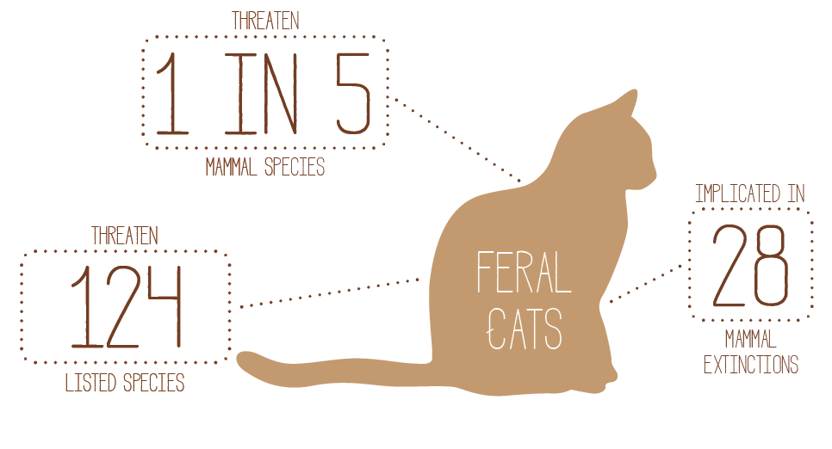

safe havens for species most at risk
Safe havens provide threatened plants and animals with long-term protection from threats and create areas where risks to specific plants and animals can be removed, not just managed. Within these areas, species are able to thrive and increase their numbers without the pressure of threats. Examples of safe havens that the Australian Government will aim to promote and protect include:
- feral predator exclosures that provide predator-free habitat for small and mid-sized mammals and other ground-dependent species
- islands from which all invasive animals and plants are eradicated
- disease-free enclosures to protect against diseases such as chytrid fungus in frogs
- protecting refugia for small mammals and other ground-dwelling species with increased management measures at these important locations
- sites with many threatened plants that are intensively managed to reduce threats such as fire
- ex situ threatened species insurance populations and seed orchards
Existing havens are already successfully protecting species like the bridled nail-tail wallaby, southern corroboree frogs and the mala while also providing valuable scientific data on longer term means of recovery.

improving habitat
All animals and plants need suitable and high quality habitat to survive. Improving the extent, connectivity and condition of habitat supports threatened species recovery. All levels of government, non-government organisations, landholders, the community and industry can partner to minimise the consequences of habitat loss, fragmentation and degradation.
The Australian Government is committed to protecting and recovering ecological communities because they provide vital habitat for multiple species as well as natural services to the environment and industry. These include clean air, clean land and clean water, breeding habitat and food sources for threatened species, and unique landscapes for tourism and recreation. A changing climate is driving change in species distributions, and in the composition and functioning of communities and ecosystems. Protecting ecological communities thus helps ensure other plants and animals do not become threatened.
Australian Government programmes such as 20 Million Trees and the Green Army, help create, improve, revegetate and rehabilitate habitat critical to threatened species.
The Australian Government contributes to improved habitat for threatened species by working with partners to improve the management of our protected areas and the quality of the reserve estate. By further strengthening relationships with community and business to help support the management of our protected areas, we help to ensure that the reserve system provides refuge and protects critical habitat for threatened species. Especially important are partnerships with Indigenous land and sea managers, with Indigenous Protected Areas making up more than one third of the National Reserve System.
Through our policies and programmes, the Australian Government works with state and territory governments, local governments, community groups and non-government organisations to:
- protect significant vegetation communities, wetlands and marine ecosystems
- re-establish vegetation connectivity and natural pathways such as wildlife corridors
- revegetate riparian and coastal zones which link aquatic and terrestrial environments
- create artificial wetlands
- ensure best practice management of our reserve system
- deliver broad landscape-scale revegetation and management of weeds

emergency intervention to avert extinctions
At times, species may be pushed dangerously close to extinction or face significant impacts within a short timeframe. A combination of introduced threats and environmental factors can significantly increase the risk of extinction and we must be quick to respond. In these situations, the Australian Government may need to redirect resources and efforts to stabilise and recover the species. This Action Plan is thus intentionally flexible and responsive to such changes.
The Australian Government’s immediate and strategic response to an outbreak of Psittacine Beak and Feather Disease (PBFD) in orange-bellied parrots is one example of emergency intervention. New scientific evidence showed PBFD was again in the population and killing young birds. This new outbreak has the potential to render all wild breeding a failure. In initiating an emergency response, the Australian and Tasmanian governments are partnering to support disease mitigation activities, improve the captive breeding and recovery programme and continue to support captive birds that are released into the wild.
The Australian Government has partnered with the Tasmanian Government to provide an additional $525 000 to support the response, which will also trial new innovative nest boxes and a ‘soft release’ aviary to reduce other threats to survival while actions to deal with PBFD are implemented. The response also involved an emergency meeting of experts, chaired by the Threatened Species Commissioner, to build a cooperative and coordinated response.
Another successful example is the emergency response recently applied on Raine Island, where changed sand profiles on the beach caused sea turtle nests to fail and an alarming rate of adult female deaths. The science showed that failure of the Raine Island breeding site would result in a significant loss to the North Great Barrier Reef green turtle population. In an emergency response funded by the Queensland and Australian Governments, sand on the beaches was re-profiled and other remedial actions were taken to reduce the number of turtles dying on the rocks, and begin the process of long-term recovery.

targets
targets are necessary to ensure accountability and can also incentivise action.
The targets we have set in this Action Plan are based on significant input from experts and consultation with the community. They also take into account the Australian Government’s prioritisation principles. They focus action where it is needed most, where we know we can be effective, and where the greatest benefit to threatened species can be achieved. Not all groups of animals and plants are explicitly referenced in the targets. They are the first installment.
Accountability, monitoring and reporting are essential in all areas of public expenditure, and Australia’s threatened species deserve no less. The targets will be monitored, reviewed and reported on annually, and revised where appropriate. Progress will be measured and the management response adapted if required. Accountability is also built into the targets themselves. The recovery practices target, for example, includes the establishments of an annual reporting method for recovery teams that is focused on actions and outcomes. The NESP Threatened Species Recovery Hub will also support the delivery and measurement of the targets. Approved projects include the research trials and on-ground actions that will help us meet the targets, and projects which support adaptive management, science-based decision making and monitoring and reporting environmental outcomes.
The targets are intended to be flexible, responsive and adaptable. Implementing this first set will build broader momentum for species recovery and also offer protection to other species that live in similar habitats. As we improve trajectories, demonstrate accountability and mobilise more resources for the tasks at hand, we will be able to set new targets if necessary.
Australia has committed to implementing the Convention on Biological Diversity’s Strategic Plan for Biodiversity 2011–2020, which includes the Aichi Biodiversity Target 12 to prevent extinction of known threatened species by 2020. The targets in this Action Plan build momentum for species recovery and work towards achieving this international commitment.

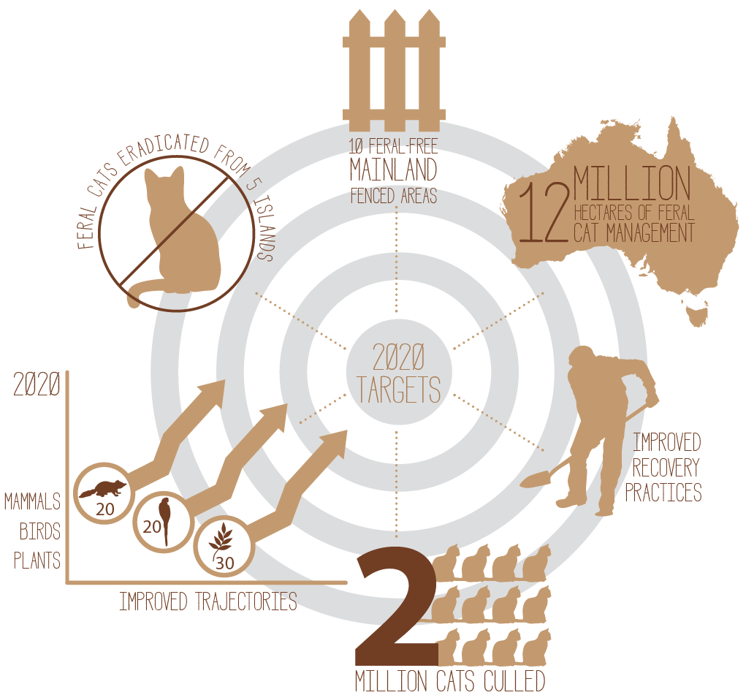

tackling feral cats and their impacts
the australian government has released a new threat abatement plan for predation by feral cats.
This Action Plan includes a number of objectives and actions for reducing feral cat impacts on threatened species, based on advice from leading scientists and on-ground pest managers. This Action Plan, which is consistent with the new feral cat Threat Abatement Plan, focuses on delivering four feral cat targets:
- eradication of feral cats from five islands
- 10 feral cat free mainland exclosures established
- best practice feral cat control established across 10 million hectares of open landscapes
- best practice feral cat control implemented in 2 million hectares of Commonwealth land
By undertaking these feral cat control actions, we will improve outcomes for a range of affected threatened species identified under the other targets.
The Australian Government will establish a Feral Cat Taskforce in the Office of the Threatened Species Commissioner to bring together officials across all jurisdictions and lead implementation, monitoring and reporting on progress towards these targets. A key consideration of the Taskforce will be ensuring that the management of other invasive species, such as foxes, rats and rabbits, is considered in areas where cat control is undertaken.

Now
- Feral Cat Taskforce established
- Funding committed for establishment of two new mainland feral-free areas at Astrebla Downs National Park and Newhaven Wildlife Sanctuary
- Funding committed for expansion of an existing feral-free area at Mulligans Flat Woodland Sanctuary
- Funding committed for commencement of feral cat eradication programme on at least one new island—Groote Eylandt
- Funding committed for up to 1 million hectares of best practice feral cat management in various locations across Western Australia
- Funding committed for development and trialling of innovative feral cat grooming trap devices
- Funding committed for feral cat detector dogs to protect the mountain pygmy-possum in Kosciusko National Park NSW
- Feral cat Threat Abatement Plan approved and launched
- Feral CatScan app to monitor and report on feral cat sightings and management actions

Year 1
- Action commenced for feral cat eradication on five islands
- Action commenced on three mainland feral-free areas to secure threatened species and identify two more areas for action
- Undertake cat management across 1 million hectares, using the best techniques for each location
- Identify priority locations on Commonwealth land and commence action for best practice feral cat management
- Curiosity® cat bait approved and deployed
- 100 per cent of feral cats culled in Australia to be reported in Cat Scan phone app
- 150 000 feral cats culled at the national level

Year 3
- Eradication of feral cats underway on five identified islands
- Five remaining mainland feral-free areas identified and with actions underway
- 5 million hectares of cat control, using the best techniques for each location
- Best practice feral cat management across 1 million hectares of Commonwealth land
- 1 million feral cats culled at the national level

Year 5
- Feral cats eradicated from five islands
- 10 feral cat free mainland exclosures established
- 10 million hectares of feral cat action, using the best techniques for each location
- Best practice feral cat action implemented across 2 million hectares of Commonwealth land
- 2 million feral cats culled at the national level

Delivery
These targets will be achieved through a number of actions including;
- baiting
- trapping
- shooting
- fencing
- use of detector dogs
- improved fire and land management practices
- other science-based and innovative measures as they are developed and become available, on the basis that they are humane and effective

reducing feral cat numbers nationally
This Action Plan sets the nation an ambitious vision for the eradication of feral cats, which are a major threat to Australia’s threatened species. Many land managers across Australia are already culling feral cats as part of their ongoing land management practices. This existing effort, combined with renewed commitment to action as a result of this Threatened Species Strategy, should realise our ambition to see a dramatic rise in the number of feral cats culled in Australia. Increased abundance of threatened species is, of course, our headline indicator for success, but having an ambition to dramatically reduce the number of cats remains important. This is particularly important as a catalyst to tackle feral cats from local to national levels and to bring a focus to measuring and reporting on action.
This strategy, sets ambitious one, three and five year feral cat eradication targets that as a nation we should work together to achieve
YEAR 1 – 150 000 feral cats culled
YEAR 3 – 1 million feral cats culled
YEAR 5 – 2 million feral cats culled
Of course this will not be easy to achieve, but it is important that Australia consolidates its efforts to reduce feral cat numbers and save our threatened species.

Feral CatScan
To assist in understanding our efforts in this regard, the Australia Government has funded and made available Feral CatScan, a national feral cat mapping and reporting system for landholders, community groups, local councils, Indigenous groups, regional NRM organisations and pest managers. It is free and available for download onto iPhone and Android devices. It enables real time recording of feral cat management activities, including feral cat sightings, eradication and impacts on native species.
This tool will enable us to capture cat management action already happening and new action generated by the targets in the Strategy. We call on Landcare groups, farmers, state and territory governments, land managers and the community to report their feral cat management outcomes into the CatScan app to help achieve the national targets.
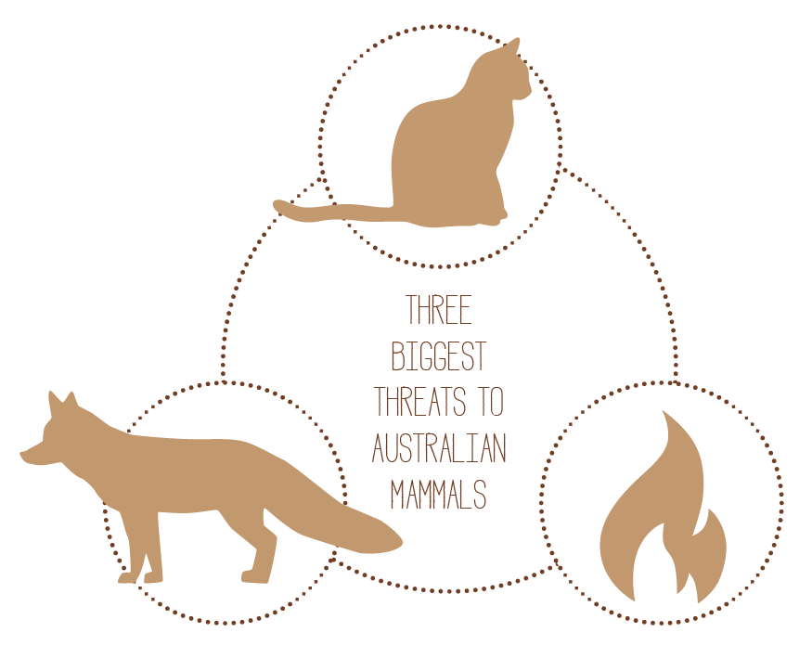

20 mammals by 2020
the australian government is committed to supporting improved trajectories of at least 20 threatened mammals by 2020.
This is a significant commitment, representing around one third of land based mammals at risk of extinction.
Recovery actions for these 20 mammals will consider conservation advices and recovery plans, and the impacts of threats such as invasive species, habitat loss, habitat alteration and fire. Addressing and implementing a range of other recovery actions such as developing safe havens and secure populations, captive breeding, habitat management and other innovative techniques will also support recovery.
A range of existing programmes support threatened species. Strengthening these existing partnerships and collaborating on new initiatives that align with the Australian Government’s principles for prioritising resources and effort will allow us to meet these targets.
Delivering actions in support of these 20 priority mammals will support other native flora and fauna, both threatened and not threatened, that occur in the same environment.

Now
- Funding committed for introduction of new genetic stock into captive bred eastern barred bandicoot population
- Funding committed for West MacDonnell Ranges central rock-rat conservation work, including aerial baiting of feral cats
- Funding committed for a brush-tailed rock-wallaby breeding facility
- Funding committed under feral cat targets which will directly benefit mammals
An initial group of 10 threatened mammals has been identified for action, plus two earmarked for emergency intervention. These include:
- Numbat
- Mala
- Mountain pygmy-possum
- Greater bilby
- Golden bandicoot
- Brush-tailed rabbit-rat
- Eastern bettong
- Western quoll
- Kangaroo Island dunnart
- Eastern barred bandicoot
An additional two mammals identified for emergency intervention:
- Leadbeater’s possum
- Central rock-rat

Year 1
- Action commenced for at least five of the 10 identified mammals (listed on the previous page)
- Planning complete on actions for 10 identified mammals
- Action commenced for Leadbeater’s possum and central rock-rat
- Additional eight mammals identified for priority conservation, in consultation with partners

Year 3
- Actions underway for all 20 mammals to improve their population trajectory
- At least 10 identified mammals demonstrating an improved trajectory
- Projects evaluated and management adapted where required

Year 5
- 20 priority mammals have improved trajectories

DELIVERY
These targets will be achieved through a number of actions including;
- building fenced areas
- habitat improvement
- captive breeding
- translocations
- invasive species control
- disease mitigation
- improved fire management practices
- native predator reintroduction

20 birds by 2020
the australian government is committed to supporting improved trajectories of at least 20 threatened australian birds by 2020.
Recovering birds in danger of extinction is possible because we have access to high quality science, we know what to do, and we can act in partnership with states and territories, non-government organisations and many committed community groups. Continued participation in existing bird recovery projects, as well as collaboration with partners on new initiatives, will deliver the best results. Supported actions will reflect conservation advices and recovery plans, and specifically target the threats. Addressing and implementing a range of other recovery actions such as habitat restoration and captive breeding, and other innovative techniques like predator exclusion devices at nesting sites, will support recovery.
Threatened birds exist across a wide range of Australian habitats, including wooded areas, deserts, wetlands and inter-tidal mudflats. Many of the actions taken to protect birds also protect the reptiles, frogs and insects that exist in the same habitat, as well as the habitat itself.

Now
- Funding committed for implementation of critical recovery actions in Tasmania for orange-bellied parrot, including ongoing captive breeding and release
- Funding committed for hooded plover research and population analysis in NSW
- Funding committed for a goat eradication programme on Kangaroo Island, reducing the pressures on the glossy black-cockatoo
- Funding committed for feral cat and fox control under Western Shield across more than 850 000 hectares of conservation reserves, including western ground parrot habitat
An initial group of 10 birds has been identified for action, plus two for emergency intervention. These include:
- Norfolk Island green parrot
- Mallee emu-wren
- Plains wanderer
- Alligator Rivers yellow chat
- Night parrot
- Helmeted honeyeater
- Norfolk Island boobook owl
- Hooded plover
- Eastern bristlebird
- Regent honeyeater
Birds nominated for emergency intervention:
- Orange-bellied parrot
- Western ground parrot
The remaining eight birds for action will be selected on the basis of science and after consultation with the community.

Year 1
- Action commenced for at least five of the 10 identified birds (listed above)
- Planning complete on actions for all identified birds
- Action commenced for orange-bellied parrot and western ground parrot
- Remaining eight birds identified for priority conservation and planning in place for action, in consultation with partners

Year 3
- Actions underway for all 20 birds to improve their population trajectory
- At least 10 identified birds demonstrating an improved trajectory
- Projects evaluated and management adapted where required

Year 5
- 20 priority bird have improved trajectories

Delivery
These targets will be achieved through a number of actions including;
- habitat improvement
- captive breeding
- translocations
- invasive species control
- disease mitigation
- improved fire management practices
- building fenced areas
- native predator reintroduction

protecting australia's plants
more than 90 per cent of australia's native plants are found nowhere else on earth.
Plants are the basis of almost all environmental systems, natural and man-made. Clean air and clean water depend on plants, and plants provide shelter and food for animal life.
The Australian Government is committed to acting in partnership to secure Australia’s plant species from extinction. In line with international targets, such as the Aichi Targets and those set out in the Global Strategy for Plant Conservation, action is being taken to help protect individual plant species and secure our floral heritage. Through programmes like 20 Million Trees and the Green Army, the Government is working with the community to protect and recover many of Australia’s threatened plants in the wild. These programmes are also supporting critical revegetation and restoration projects that will provide important habitat for Australia’s most threatened animals.
Partnerships are crucial for safeguarding Australia’s threatened plants. The Australian Seed Bank Partnership, for example, brings together Australia’s nine conservation seed banks to create a safety net for Australia’s diverse flora. Importantly, the initiative is also taking steps to ensure seed collections have sufficient genetic diversity to create functional and self-sustaining populations in the wild.
As part of the yearly cycle of reporting and revision, the list of identified plants will grow, and may change, based on the most up-to-date science.

Now
- Seven Green Army Teams at Killalea State Park to undertake weed removal, track construction, revegetation and fencing to protect two EPBC Act listed plant species (Cynanchum elegans and Zieria granulata.
- Four Green Army Teams at Tuggerah Lakes to protect the bioconvex paperbark and magenta lilly-pilly through undertaking erosion control, revegetation, site mapping and monitoring, weed control, seed collection and propagation
- Four Green Army teams on the north coast of NSW to protect stinking cryptocarya habitat in several coastal littoral rainforest and vine thicket sites
- Planting 82 600 trees on the Southern Yorke Peninsula in South Australia to protect nationally listed plants including the silver daisy bush, funded through the 20 Million Trees Programme
- Enhancing the EPBC Act listed Proteaceae Dominated Kwongkan Shrubland threatened ecological community by planting over 550 000 plants in the Gondwana Link corridor through the 20 Million Trees Programme

Year 1
- Ensure at least 80 per cent of projects funded through the 20 Million Trees and Green Army Programmes support the recovery of threatened plants and animals by providing suitable threatened species habitat
- Recovery actions underway for at least 20 threatened plants
- Recovery actions underway for at least 20 threatened ecological community sites
- Priority species and communities for on-ground recovery action and seed collection are identified
- Projects designed to fill gaps in collections and genetic representativeness and support on-ground recovery are identified for priority species and communities

Year 3
- Recovery actions underway for at least 30 plants
- Recovery actions underway for at least 40 threatened ecological community sites
- At least 50 per cent of Australia’s known threatened plant species stored in conservation seed banks

Year 5
- 100 per cent of Australia’s known threatened plant species stored in one or more of Australia’s conservation seed banks
- Recovery actions underway for at least 50 plants
- Recovery actions underway for at least 60 threatened ecological community sites
- At least 30 priority plant species have improved trajectories

DELIVERY
These targets will be achieved through a number of actions including;
- seed collection and storage
- propogation
- revegetation
- building fenced areas
- translocations
- invasive species control
- disease mitigation
- improved fire management practices

improving recovery practices
recovery plans and teams are needed to help recover threatened species, and recovery teams need good systems and procedures to support their efforts.
Successful recovery requires collaborative and effective governance structures to coordinate and rigorously monitor recovery action. As a conservation community, we must be communicating effectively, driving coordinated effort and supporting effective models such as recovery teams. The Australian Government is committed to improving the recovery of our threatened plants and animals and will ensure guidance and support is provided to recovery teams across Australia.
Conservation advices and recovery plans are key planning documents that inform and guide species recovery. They set out the current knowledge and scientific understanding of our threatened plants, animals and ecological communities, and guide the action required to stop declines and support their recovery. They also outline potential partnerships and broader actions which can be undertaken by local councils, government agencies, non-government organisations and community groups.

Now
- Australian Government and majority of states and territories agree to common assessment method for species listing
- Feral cat Threat Abatement Plan approved and launched
- Draft marine debris Threat Abatement Plan released for public comment
- Comprehensive review commenced to identify high-priority threatened species (including plants, fish, frogs, reptiles and invertebrates) and threatened ecological communities which require updated conservation advices or recovery plans
- Identified birds and mammals in the 2020 recovery targets of this Action Plan included in the comprehensive review

Year 1
- Australian Government and all states and territories agree to common assessment method for species listing
- All identified birds and mammals in the 2020 recovery targets of this Action Plan have up-to-date conservation advices or recovery plans in place
- Based on comprehensive review, a work plan is established and completed to ensure conservation advices or recovery plans are up-to-date for identified high-priority species and ecological communities
- Database of all recovery teams made publicly available
- Australian Government, in consultation with the states and territories, publishes best practice guidelines for recovery team governance
- Australian Government, in consultation with the states and territories, establishes method to allow recovery teams to report annually on progress, with a focus on recovery actions and outcomes

Year 3
- Australian Government and majority of states and territories operate under the common assessment methodology for species listing
- All 20 birds and 20 mammals with 2020 recovery targets in the Action Plan have up-to-date conservation advices or recovery plans in place
- Based on the work plan, up-to-date conservation advices or recovery plans are in place for all high-priority species and ecological communities
- All active recovery teams follow best practice governance procedures
- All active recovery teams report annually on progress
- All projects funded under the 20 Million Trees and Green Army Programmes, that involve threatened species or ecological community recovery, are guided by the relevant conservation advice or recovery plans
- Identified high-priority species and ecological communities reviewed, and work plan for updating conservation advices and recovery plans is varied as required

Year 5
- All states and territories operate under the common assessment methodology for species listing
- Based on the updated work plan, effective and up-to-date recovery plans, conservation advices and threat abatement plans in place for all priority species and threats

accountability, monitoring and
reporting on action

measuring progress
this action plan identifies key action areas and sets targets to measure progress
Monitoring and reporting is an important part of any recovery effort. Reporting helps to validate efforts and partners, maintain momentum for action, and ensure effective and efficient investment.
Regular measurement gives clarity on whether investments are improving the trajectory of threatened species and allows for adaptive management— learning from what has been done and doing it better. Knowing how we are doing is also important in reporting progress against our international obligations such as preventing the extinction of known threatened species and improving their conservation status (Aichi target 12).
The Department of the Environment’s Threatened Species Commissioner currently reports twice yearly to the Minister for the Environment. These biannual reports will cover the actions identified in the Action Plan and summarise results of investments against them. Whether it’s the number of animals or plants, numbers of burrows or nests, or another more appropriate measure, reporting helps to justify investment and gives clarity on achieving value for money.
To ensure thorough accountability, systematic annual reporting against each of the targets in the plan will be completed by the Office of the Threatened Commissioner. This will occur through engagement across all levels of government, non-government organisations, experts and communities involved in implementing the Action Plan. Annual reviews of the Action Plan will also take account of improving information and scientific understanding so that scientific evidence continues to inform action.
Measuring success and reporting also has a national focus. Meetings of Environment Ministers and the Environment Senior Officials Group regularly discuss monitoring and reporting as a permanent agenda item. Improvement of existing monitoring and reporting frameworks, to better track the impacts of our investments and the recovery of species, will also allow for better information to feed into our adaptive management approach.
The Australian Government has built on its investment into the Atlas of Living Australia to develop the Monitoring, Evaluation, Reporting and Improvement Tool (MERIT)—an innovative real-time data capture and reporting system for environmental and natural resource management programmes. MERIT will provide accurate data on progress towards many of the actions in the Threatened Species Strategy, particularly those funded by the Australian Government. Further refinement and continual improvement of MERIT will enhance our ability to measure the impact of our actions on threatened species and their recovery.
Reporting of progress in recovering threatened species also occurs in reviews of individual recovery plans, the State of the Environment Report, scientific papers, state and territory government reports, and evaluations by non-government organisations like the International Union for Conservation of Nature. All of these information sources help to provide measurement of success.

related links
Threatened Species Strategy – www.environment.gov.au/ts-strategy
Threatened Species Commissioner – www.environment.gov.au/biodiversity/threatened/commissioner
Plan for a Cleaner Environment – www.environment.gov.au/cleaner-environment
EPBC Act and threatened species regulatory protection – www.environment.gov.au/biodiversity/threatened
Feral cat Threat Abatement Plan – www.environment.gov.au/biodiversity/threatened/publications/tap/predation-feral-cats
Australia’s international role in conserving biodiversity – www.environment.gov.au/biodiversity/international-activities and www.environment.gov.au/water/wetlands/ramsar
National Environment Science Programme – www.environment.gov.au/science/nesp
Green Army Programme – www.environment.gov.au/land/green-army
20 Million Trees Programme – www.environment.gov.au/land/20-million-trees
National Landcare Programme – www.nrm.gov.au/national-landcare-programme
Emissions Reduction Fund - www.environment.gov.au/climate-change/emissions-reduction-fund
The Reef Trust – www.environment.gov.au/marine/gbr/reef-trust
Commonwealth Environment Water Holder – www.environment.gov.au/water/cewo
Indigenous Land and Sea Management programmes – www.environment.gov.au/indigenous/index.html
Parks Australia – www.environment.gov.au/topics/national-parks
National Reserve System – www.environment.gov.au/land/nrs
Commonwealth Marine Reserves – www.environment.gov.au/topics/marine/marine-reserves
Atlas of Living Australia – www.ala.org.au

