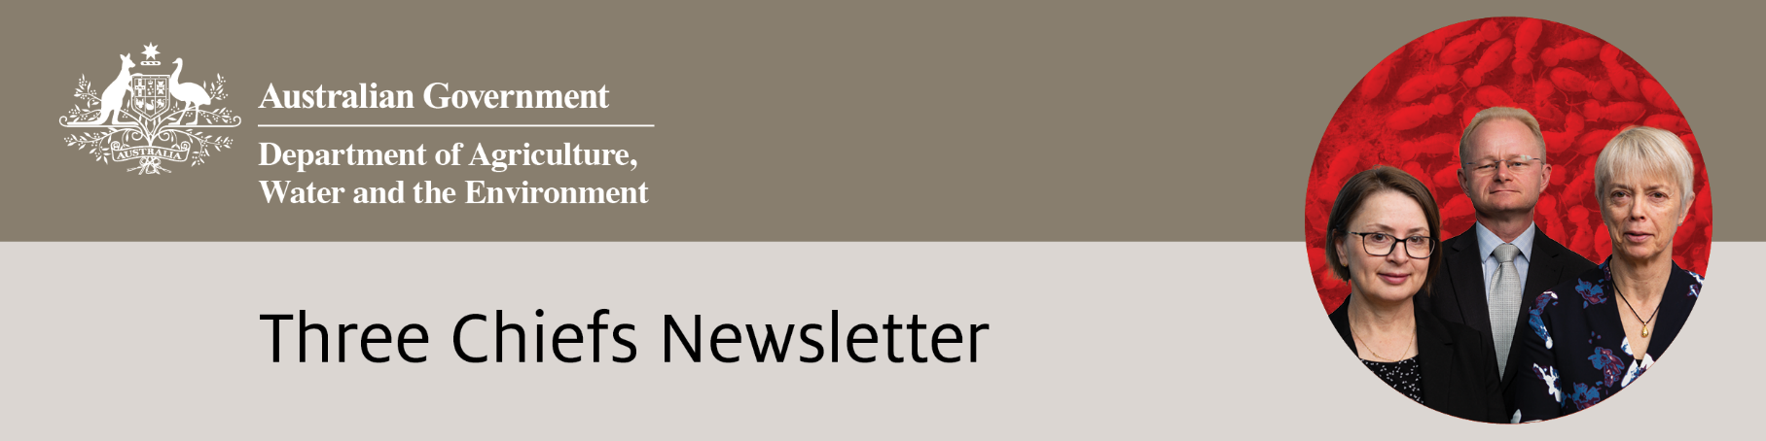

Edition No. 2021/2

# June 2021

It has been a busy period with the Australian Chief Veterinary and Chief Plant Protection Officers having a successful meeting with the Prime Minister to discuss biosecurity threats and risk pathways. The Australian Chief Veterinary Officer, Dr Mark Schipp, completed a successful three-year term as President of the OIE and assumed the chair of the Animal Health Quadrilateral Alliance. The Australian Chief Plant Protection Officer, Dr Gabrielle Vivian-Smith travelled internationally for the first time since the pandemic began, voyaging to New Zealand for the Better Border Biosecurity (B3) conference held in Wellington. She also participated in the G20 meeting of agricultural chief scientists in June. ACPPO team representatives attended the Hort Connections 2021 conference in Brisbane and managed a plant biosecurity information booth to mark the International Year of Plant Health and the International Year of Fruits and Vegetables. They engaged with a wide variety of stakeholders as well as visiting state and regional offices. The Chief Environmental Biosecurity Officer, Dr Robyn Cleland, presented at the Australasian Vertebrate Pest Conference and kicked off the 2021 webinar series drawing attention to the most unwanted environmental biosecurity threats.

**Australian Chief Environmental Biosecurity Officer (**[**ACEBO**](https://www.agriculture.gov.au/biosecurity/environmental/cebo)**)**

**Threat abatement planning**

The department has an important role in dealing with threats to our native species and ecological communities. One of the ways the department manages these threats is by listing key threatening processes and developing threat abatement plans under the Environment Protection and Biodiversity Conservation Act 1999 (EPBC Act).

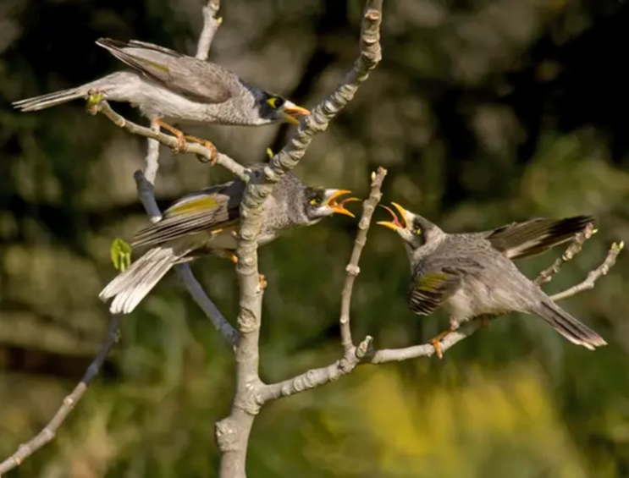Key threatening processes are processes that threaten native species and ecological communities, such as predation by feral cats and the incidental catch of seabirds during oceanic longline fishing operations. When a key threatening process is listed, the Minister for the Environment must decide if a threat abatement plan will be useful to manage the threat.

The goal of a threat abatement plan is to provide guidance on actions and research priorities that can be used for threat abatement. There are also threat abatement advices, which are like plans but the threat abatement requirements are less complex. The Threatened Species Scientific Committee and the department work together to draft threat abatement plans and advice, and plans are then made by the Minister for the Environment.

**Photo 1: Noisy Miners (*Manorina melanocephala*).**

**Photo credit: Getty Images**

The department is currently revising the existing threat abatement plans for the cane toad (*Bufo marinus*), and predation by the European Red Fox, and is also working on a threat abatement advice for aggressive exclusion of birds from potential woodland and forest habitat by over-abundant noisy miners (*Manorina melanocephala*). Although the noisy miner is a native species, it excludes other native birds from habitat and preys on their nests. It has been implicated in the decline of endangered birds such as the regent honeyeater (*Anthochaera phrygia*).

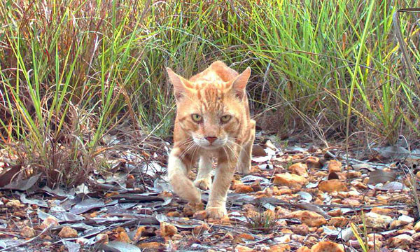The department uses threat abatement plans and advices to assess funding proposals and set policy. For example, the threat abatement plan for predation by feral cats has enabled the development of feral cat baits such as the Curiosity bait. The plan also provides direction for groups like the Feral Cat Taskforce. By developing and implementing plans to manage threatening processes, the department gets better outcomes for our native species and ecological communities.

**Photo 2: A feral cat (*Felis catus*).**

**Photo credit: Getty images**

**Achievements**

**ACEBO**

Supported and presented at the Australasian Vertebrate Pest Conference and Kids Conference

Hosted the 2021 webinars series

Supported a graduate industry project on invasive ants

Participated workshops assessing risk of ornamental fish species in Australia

**ACPPO**

Met with the Prime Minister along with ACVO to discuss biosecurity threats and risk pathways

Celebrated World Bee Day on 20 May with a special newsletter and webinar

Panel member at the Better Biosecurity conference in New Zealand

Assumed role of country representative of the Pacific Plant Protection Organisation (PPPO) and presented at the May PPPO Talanoa session

Hosted a biosecurity information booth at the Hort Connections conference

Australian representative at G20 Meeting of Agricultural Chief Scientists

Hosted webinar on invasive pests and climate change

**OCVO**

Chaired World Organisation for Animal Health’s (OIE) 88th General Session and completed a successful three-year term as President of the OIE

Assumed Chair of the Animal Health Quadrilateral Alliance

Participated in meetings of the One Health Global Leaders Group on Antimicrobial Resistance

Along with ACPPO met the Prime Minister to discuss biosecurity threats and risk pathways

Led discussions with industry and jurisdictional partners on emerging animal health threats

Delivered presentation on biosecurity governance as a panellist as part of One Health Poultry Hub roadmap series

Campaigned to increase awareness of canine ehrlichiosis in Australia

**Public consultation on the new National Environment and Community Biosecurity RD&E Strategy**

A new draft National Environment and Community Biosecurity Research, Development & Extension Strategy (NECBRDES) has been developed under the guidance of the national Environment and Invasives Committee over the last 18 months. The strategy highlights the impact that biosecurity risks pose to our natural environment and way of life. The strategy will help government, community groups, industry and researchers to:

* set and revise research priorities
* identify actions that improve knowledge sharing between different sectors and industries
* improve communication between policy, researchers and end users, and
* reduce the effect of biosecurity risks by using research outcomes.

The new strategy builds on the first strategy that ran from 2016-2020. This new strategy will help us develop a strategic approach to environmental and community biosecurity research, development and Extension (RD&E). It aims to enhance the value of existing and future investments in RD&E through improved collaboration, effective allocation of resources and strong leadership.

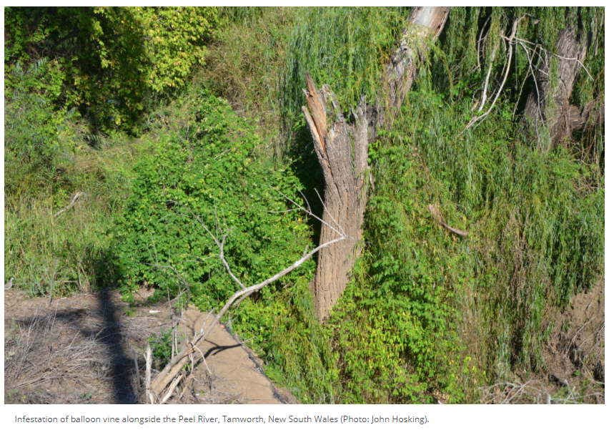We want to know what outcomes you would like to see in environment and community biosecurity RD&E over the next 10 years. You can also let us how you’d like to participate in delivering on the strategy.

We invite you to have your say by reading the draft strategy and taking the survey to provide your feedback and comments on the strategy.

**Photo 3: Infestation of balloon vine alongside the Peel River, Tamworth, NSW**

**Photo credit: John Hosking,** [**https://research.csiro.au/nswweeds/balloon-vine/**](https://research.csiro.au/nswweeds/balloon-vine/)

Your feedback will help shape our approach to community participation and how we work together to protect our environment from invasive pests, weeds and diseases. Consultation closes on 16 July 2021 – Have Your Say <https://haveyoursay.awe.gov.au/necbrdes>

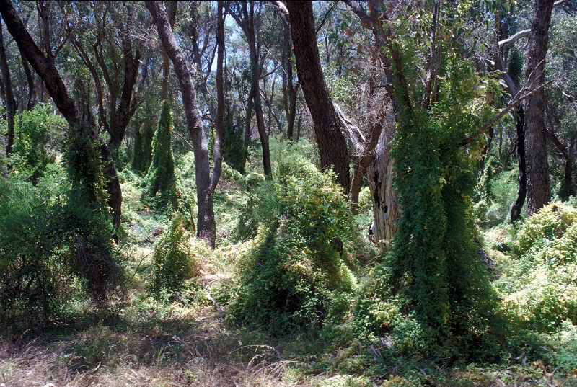

**Photo 4: Bridal creeper infestations choke Australia’s bush environments threatening a number of native species. CSIRO has been working on biological control options for this weed since the late 1980s. Since the early 2000s a leafhopper and rust fungus imported from South Africa have had a major impact in reducing bridal creeper populations throughout Australian coastal ecosystems. Photo credit: <https://blog.csiro.au/weed-whacking-wins-in-the-biocontrol-battle/>**

**Staff Profile - Corey Williams-Daly**

**Upcoming Events**

**30 June & 1 July:** Australasian Honey Bee Conference 2021, Perth

**1 July:** IYPH Closing Ceremony <http://www.fao.org/plant-health-2020/events/events-detail/en/c/1258706/>

**22 July:** ACPPO webinar – Next generation RNA based biopesticides for sustainable crop protection - [Click here to join the meeting](https://teams.microsoft.com/l/meetup-join/19%3ameeting_OGZiMWJiNzctOWFkMS00ZmRmLWJhNDAtMWFmYzhmY2Y0MDc5%40thread.v2/0?context=%7b%22Tid%22%3a%222be67eb7-400c-4b3f-a5a1-1258c0da0696%22%2c%22Oid%22%3a%22a5054f9c-276d-40d7-8d1d-375e3fd2a3aa%22%7d)

**August 2021:** UK-Australia Chief Veterinary Officers Forum

**4-6 August:** The National Landcare Conference to be hosted in Sydney from <https://nationallandcareconference.org.au/>

**14-22 August:** National Science week

**23-24 August:** Crawford Conference on the Biosecurity, Health, Trade Nexus  
<https://www.crawfordfund.org/news/food-nutrition-security-your-invitation-to-our-2021-annual-conference/>

**1 September:** Australian Cattle Veterinarians Conference, Canberra

**10-11 September:** Zoonoses Conference, Australasian Society for Infectious Diseases

**22-23 November: AgCatalyst 2021**<https://www.csiro.au/en/work-with-us/industries/agriculture/agcatalyst/agcatalyst-2021>

**23-26 November: Australasian Plant Pathology Society Conference**

**Useful Links**

NEW NATIONAL BIOSECURITY WEBSITE  
[www.biosecurity.gov.au](http://www.biosecurity.gov.au)

Environmental Biosecurity Office exotic pests webinar series: <https://haveyoursay.awe.gov.au/2021-environmental-biosecurity-webinars>

National Environment and Community Biosecurity Research, Development & Extension Strategy – Have Your Say:  
<https://haveyoursay.awe.gov.au/necbrdes>

Scientific Review - The impact of climate change on plant pests  
<http://www.fao.org/documents/card/en/c/cb4769en>

Plant biosecurity in Australia timelines <https://planthealthyear.org.au/about/plant-biosecurity-in-australia/>

Plant Health Australia Biosecurity training [Biosecurity online training for researchers](https://www.planthealthaustralia.com.au/resources/training/biosecurity-online-training/)

National Priority Plant Pests cards <https://www.agriculture.gov.au/sites/default/files/documents/nppp-playing-cards_2.pdf>

Exotic Plant Pest Hotline <https://www.agriculture.gov.au/pests-diseases-weeds/report>

Corey Williams-Daly recently joined the Environmental Biosecurity Office as a part of the Indigenous Apprentice Program (IAP) to assist with bringing an indigenous perspective to protecting Australia’s unique environment and has shared his experiences below:

*I am currently undertaking the Indigenous Apprentice Program with the Environmental Biosecurity Office as a Policy Officer in the Strategy and Support. I was born and raised in Canberra and am of Aboriginal decent. I am a Wiradjuri man with family on my father’s side from Riverina New South Wales, branching from Tumut to Gundagai. With a historic family lineage that stretches back thousands of years and links to the stolen generation only as far back as my grandmother, I have a real passion and sense of pride in representing First Nations people and my family at a federal government level.*

*I hope to expand on my passion for land management in my new role. My first real exposure to land management was in the Green Army, where I worked to help protect local nature reserves and rural properties from exotic weeds and pests. During this time, I achieved my chemical qualification and met satisfactory standards in all the training. Being involved in the Indigenous team helped me further my knowledge about the connections my people have to the land. The six-month program has prepared me for my new role and is part of the reason why I chose the Department of Agriculture, Water and the Environment as my first preference for the IAP.*

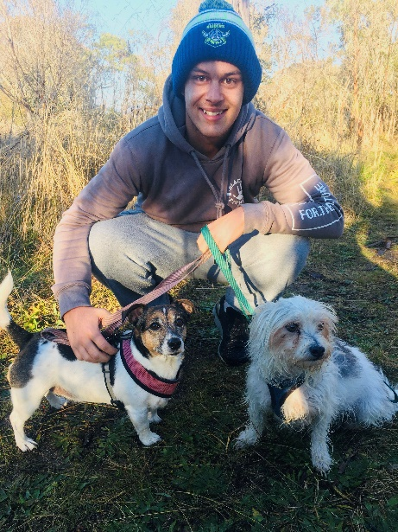*This work is close to my heart and motivates me to be involved as a proud representative of the First Nations peoples. I look forward to working closely with internal and external stakeholders to help protect Australia’s unique ecosystems and environment. Overall, I am motivated to prove to my people and all indigenous peoples that the possibilities are endless, and the doors are open to further opportunities more than ever before.*

**Photo 5: Corey with his dogs**

**Photo supplied**

**Australian Chief Plant Protection Officer (**[**ACPPO**](http://agriculture.gov.au/plant/health/acppo)**)**

***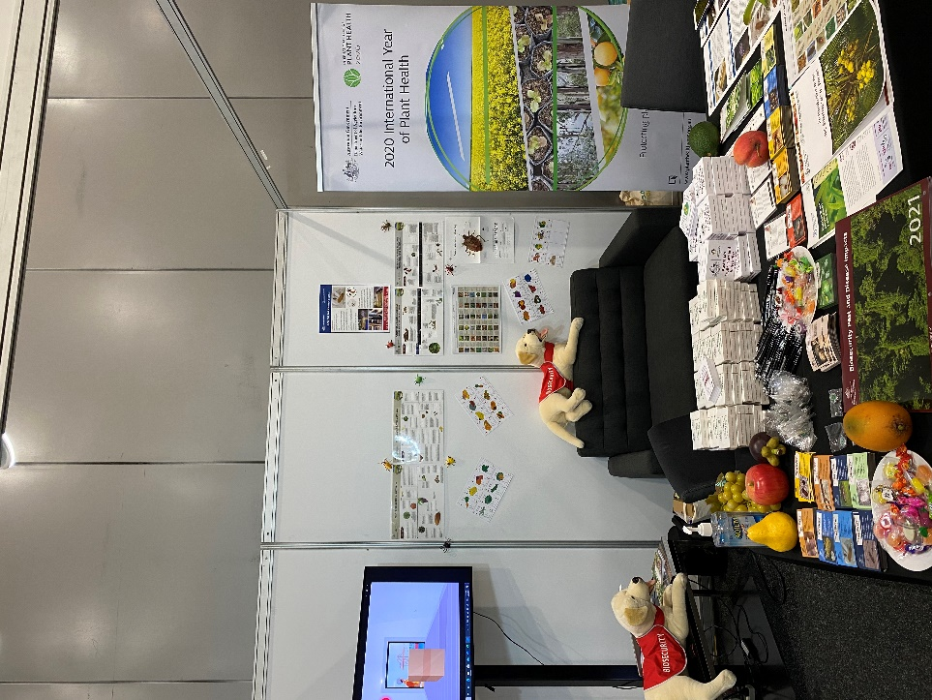*Promoting plant biosecurity at Hort Connections**

In early June, staff from the Australian Chief Plant Protection Office were joined by those in Biosecurity Plant Division and the Agricultural Policy Division for Hort Connections 2021, the biggest horticultural industry expo in the Southern Hemisphere attended this year by over 2200 delegates. The conference, held in Brisbane, boasted a trade show, with ACPPO sponsoring a booth to engage with stakeholders on the department’s work in plant biosecurity and to also mark the International Year of Plant Health 2020 (IYPH) and International Year of Fruits and Vegetables 2021 (IYFV).

**Photo 6: The DAWE information booth displaying merchandise and information about plant biosecurity. Photo credit: Mona Akbari**

.

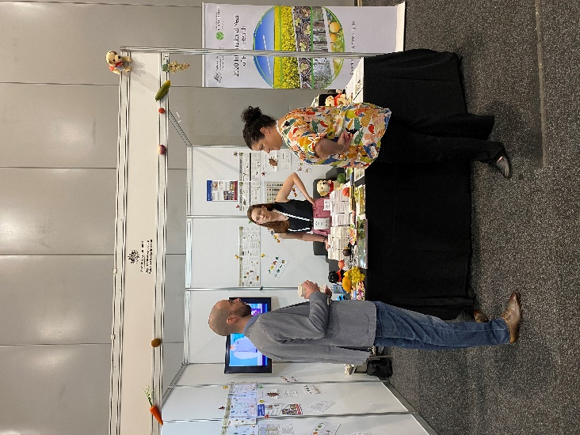The 2021 conference theme was “celebrating the international year of fruits and vegetables”, recognising the horticulture industry and the important role fruits, vegetables and floral industries have in human nutrition, health, wellbeing, and global food security. The event was a valuable opportunity for the horticulture sector to come together, network, learn about the latest innovations and to build business relationships. The program included presentations, tours and an awards ceremony recognizing excellence in the horticulture sector.

The conference presentations on trade and market access and on crop protection were particularly relevant. Representatives from the Queensland Department of Agriculture and Fisheries gave talks on approaches in the pest management of fall armyworm and serpentine leaf miner, with sample insects available for viewing at their stall. There was also a well-attended collaborative workshop on seed pathways examining concerns with diseases in imported seeds, transmission of endemic pathogens from seeds, the cost of disinfestation and import risk assessments.

**Photo 7: Keira Beattie (centre) and Amanda Twomey (right) discussing biosecurity with a conference delegate Photo credit: Mona Akbari**

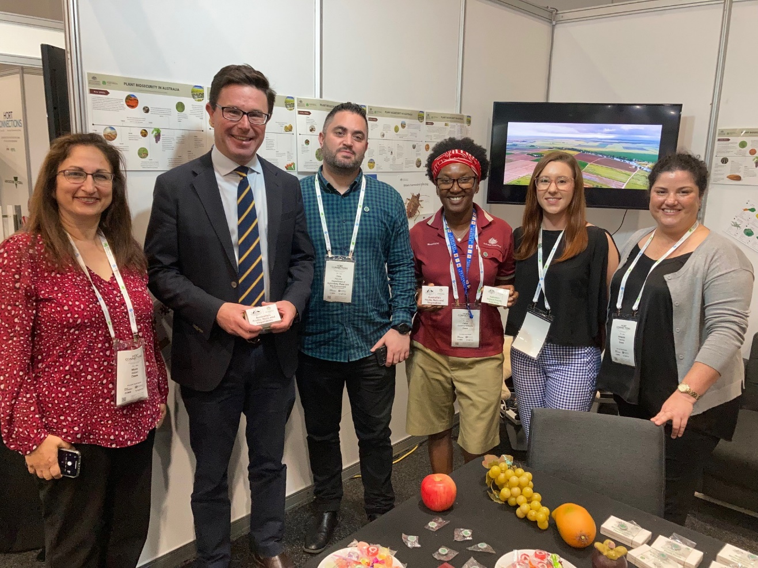

**Photo 8: The Minister for Agriculture visited our DAWE stall (left to right), Mona Akbari, Minister Littleproud, Chris Percival, Carol Quashie-Williams, Keira Beattie, Amanda Twomey Photo credit: DAWE**

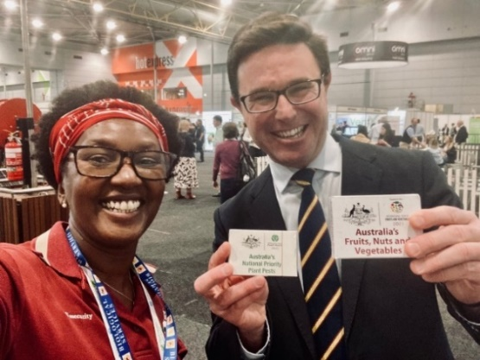Most importantly for the department, the event was an opportunity to showcase the work that is done to maintain Australia’s plant health status, including preparedness and response to detections of emergency plant pests. Minister for Agriculture, The Hon David Littleproud MP, spent time at the information booth discussing the importance of plant health and the success of the horticultural industries with the team. The departmental booth was a huge success with hundreds of stakeholders visiting to talk about plant biosecurity over the course of two days. Delegates included farmers, industry, researchers, chemical and biological control companies, state government staff, financial advisors, engineers and educational specialists. The IYPH and IYFV playing cards created by Carol Quashie-Williams and the children in her ‘STEM Professionals in Schools’ education program were especially popular, with some delegates seen playing the card games during the breaks. Each deck of cards has pictures and nutritional information on fruits and vegetables or about the top 42 plant pests and diseases. A pdf is available with the IYPH playing cards: <https://www.agriculture.gov.au/sites/default/files/documents/nppp-playing-cards_2.pdf>.

**Photo 9: Carol Quashie-Williams and Minister Littleproud showcasing the popular IYPH and IYFV playing cards at Hort Connections 2021 Photo credit: Mona Akbari**

**Khapra eDNA trial at Port of Brisbane**

ACPPO staff Dr Mona Akbari and Keira Beattie recently visited the DAWE Fisherman’s island office at the Port of Brisbane for a tour of the department’s eDNA trial for khapra beetle in sea containers. This research is being conducted by the department’s Biosecurity Plant Division in partnership the Centre for Invasive Species Solutions, the University of Canberra and Qube Holdings.

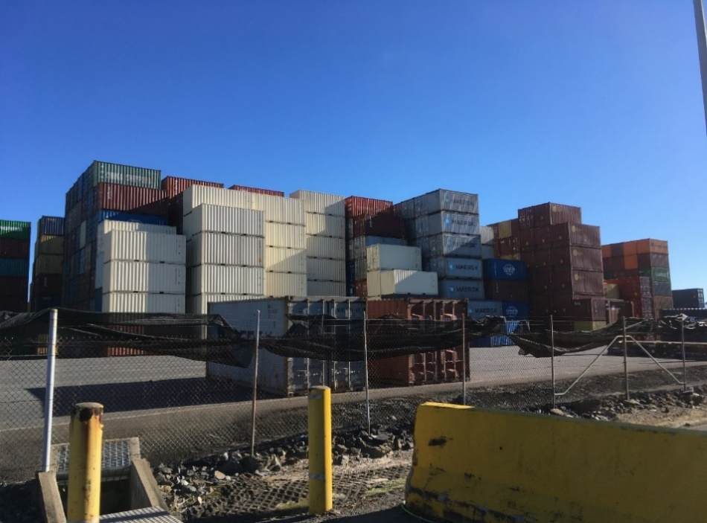Khapra beetle is a significant threat to Australia’s grain industry, and it can infest a large number of commodities (for the most part dried plant products). More recently, at least 67% of khapra beetle interceptions have been from contaminated sea containers, rather than from the imported product itself.

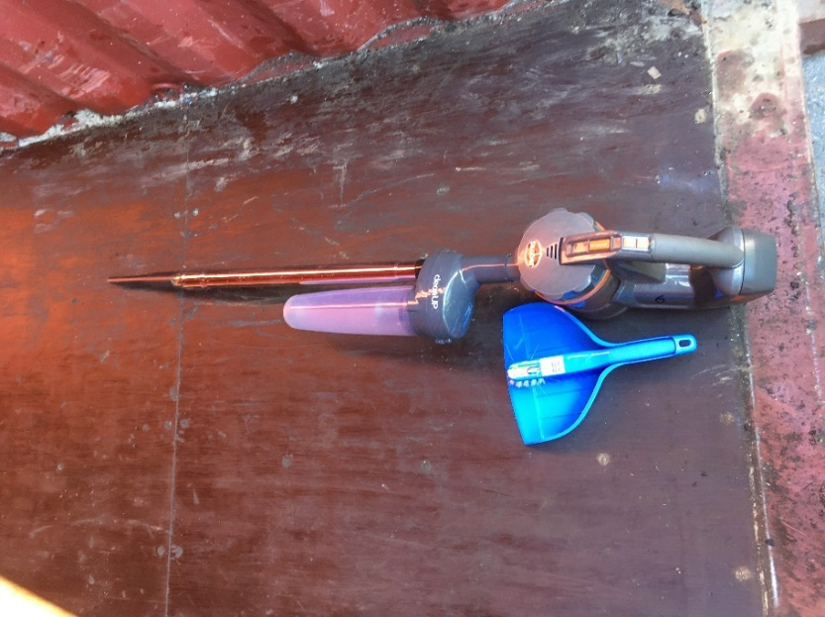Due to the beetles’ small size, preference for inhabiting crevices and ability to survive for up to five years without food, they can remain undetected under floors and in cracks and crevices in sea containers. Once a food source such as grain is present, khapra beetles can re-emerge and infest the new material in the container.

**Photo 10: Empty container facility at the Brisbane Port where the khapra trial is taking place. Photo credit: Keira Beattie**

Enhanced innovation can help us detect biosecurity threats such as khapra beetle faster and more accurately. Environmental DNA (eDNA) is a rapidly evolving technology that could enhance our biosecurity system. eDNA is derived from shed cells and other excretions left behind by organisms in the environment. By collecting soil, dust or water samples we can test to determine if an organism’s DNA is present. If it is present, we can go a step further and test for eRNA which may mean the organism is not only present, but alive!

**Photo 11: Vacuum cleaner with dust interceptor to inhibit cross-contamination of samples Photo credit: Keira Beattie**

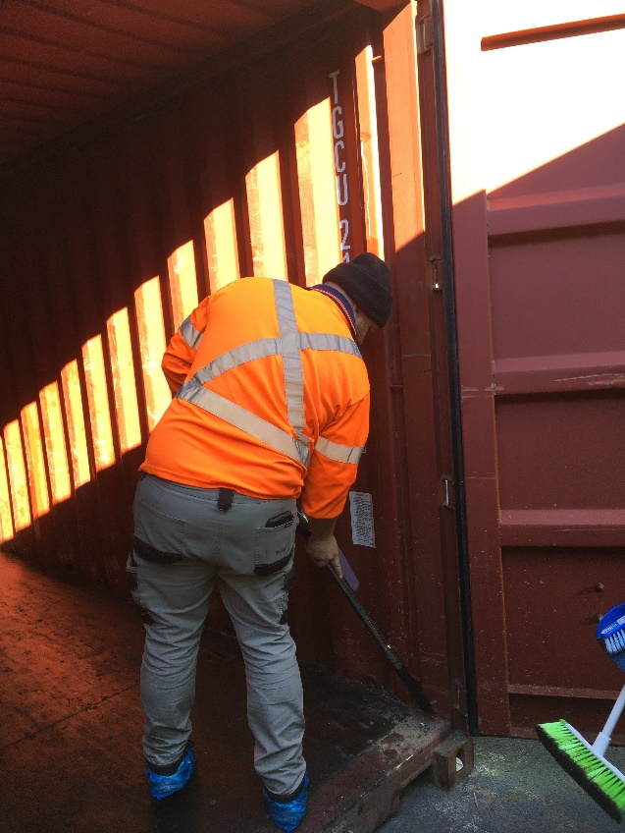Through the Centre for Invasive Species Solutions, Dr Alejandro Trujillo-Gonzalez (University of Canberra) has developed a real-time eDNA test for khapra beetle as part of the [Biosecurity Innovation Program](https://www.agriculture.gov.au/biosecurity/research-innovation/program). Over the next few months, our officers and the sea container park staff will be collecting samples for Dr Trujillo-Gonzalez to test for the presence of khapra beetle. Samples are being collected by vacuuming and sweeping the inside, underside and door seals of containers.

Containers (20 and 40 foot) that have held a range of agricultural and non-agricultural goods from a variety of countries will be sampled. The results of this survey will allow us to identify the rate of containers contaminated with khapra beetle arriving in Australia and as a result, will inform our assessment of the risk posed by containers. It may result in changes to our [khapra beetle urgent actions](https://www.agriculture.gov.au/pests-diseases-weeds/plant/khapra-beetle/urgent-actions). The trial is continuing until later in the year.

**Photo 12: Vacuuming inside a shipping cleaner to obtain a sample. Photo credit: Keira Beattie**

**Plant Health Hero**

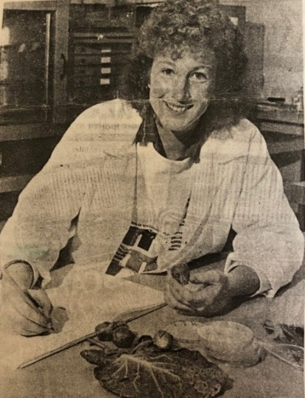**Lois Ransom - A career in plant protection**

Plant health is a pervasive issue, one with a revolving door of problems that requires endless efforts to find solutions. Many people have dedicated their careers to plant health to protect Australia’s native plants and agricultural industries from exotic pests and diseases. Lois Ransom, retired Assistant Secretary for Plant Import Operations in the Department of Agriculture, Water and the Environment, is a perfect example of a plant health hero.

“I have been involved in many aspects of plant health during the last 30 years,” said Lois Ransom. In her long career there have been many highlights. Starting out as a plant pathologist in Tasmania, to chairing the governing body of the world organisation for plant health – the International Plant Protection Convention, Lois’ career has been exciting from the beginning. Most recently Lois was called in, following her retirement, to assist with the devising the [khapra beetle urgent actions](https://www.agriculture.gov.au/pests-diseases-weeds/plant/khapra-beetle/urgent-actions) and she is still actively promoting plant biosecurity on social media.

**Photo 13: Lois Ransom as a plant pathologist in Devonport, 1989   
Photo Credit: The Advocate**

“A notable moment from the early years of my career was being able to discover a new rust disease, Puccinia, on peas, which had jumped hosts. It was a scientific odyssey,” said Lois.

Lois advocates the importance of plant health and its impact on Australian agriculture and its environment., emphasising that plants are critical for life.

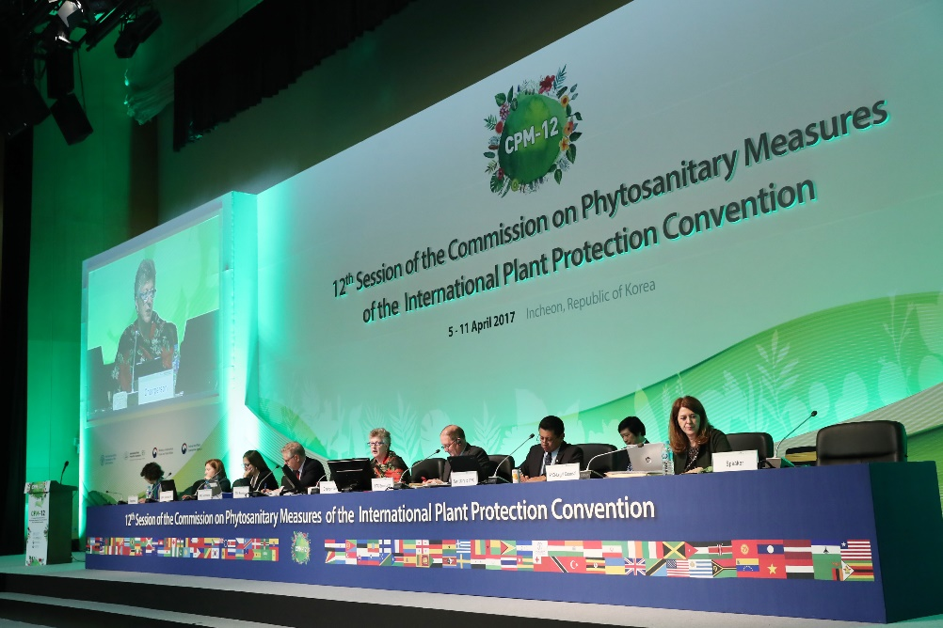“Plants produce oxygen and sequester carbon. They provide 80% of our food and 100% of the feed for livestock.”

**“**Healthy plants are a must for efficient production of safe food and the other functions they fulfil as hosts of native fauna and flora, and urban and natural ecosystems.”

Lois has been instrumental in keeping plants healthy to optimise the return to the grower. She has developed and implemented biosecurity policies to protect Australia from exotic pests and has established national biosecurity systems to detect and respond to plant pest incursions.

**Photo 14: Lois Ransom at the IPPC, Republic of South Korea in 2017  
Photo Credit: IPPC Secretariat**

Lois has played a key role in building an international plant health framework that safeguards the world from the impact of plant pests arising through trade, the movement of people, ships and containers. She was awarded the Public Service Medal in 2019 for her outstanding public service through the strengthening of Australia’s plant biosecurity system. She also was instrumental in the establishment of the International Year of Plant Health in 2020.

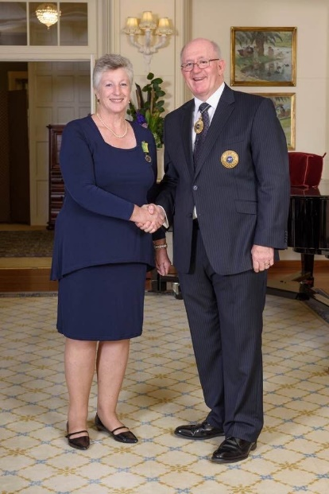Lois still has aspirations to improve plant protection and biosecurity.

“There are significant resources applied to managing plant health, but there is also a lot of unnecessary duplication that would free up further resources for reinvestment if it was reduced or stopped,” says Lois.

Lois continues to promote improved coordination of plant health activities within Australia and around the world, including international standard setting, research, sharing information and integrating plant health into ‘One Health’. She suggests that leveraging actions from international aid investment and outcomes-driven programs would help solve priority problems for maximum local, national, regional and international impact.

“A future of plant health must involve partnership across government, industries, and communities based on shared responsibilities and outcomes.”

**Photo 15: Lois Ransom receiving the Public Service Medal in 2019 with Sir Peter Cosgrove. Photo Credit: Government House**

**CONTACT ACPPO:** [acppo@agriculture.gov.au](mailto:acppo@agriculture.gov.au), **ACVO:** [ocvo@agriculture.gov.au](mailto:ocvo@agriculture.gov.au), **ACEBO:** [acebo@agriculture.gov.au](mailto:acebo@agriculture.gov.au)

**Australian Chief Veterinary Officer (**[**ACVO**](http://www.agriculture.gov.au/animal/health/acvo)**)**

# **Chief Veterinary Officer Mark Schipp completes term as OIE President**

In the last week of May, Australian Chief Veterinary Officer, Dr Mark Schipp, chaired the 88th General Session of the World Organisation for Animal Health (OIE). The global event marked the completion of Dr Schipp’s three-year term as OIE President.

**Photo 16: Dr Schipp preparing to chair the 88th General Session of the World Organisation for Animal Health.   
Photo Credit: OCVO**

The General Session is the key annual meeting of the OIE and was held virtually for the first time with great success. Over the course of a week the global animal health landscape was analysed, elections held, and important resolutions adopted – including those that support international trade, and safeguard the health and welfare of animals. The technical item for 2021 was ‘Lessons learned from the pandemic: how OIE can support Veterinary Services to achieve One Health Resilience’. The challenges of the pandemic have highlighted the importance of the work of the OIE. They also present an important opportunity for OIE members to strengthen relationships under the One Health framework—the interconnection between humans, animals and our shared environment.

The Aquatic Animal Health Commission presented several changes to their code and manual, including on decapod iridescent virus 1 which threatens many crustacean production systems in our region. Congratulations to Dr Ernst, who was re-elected to his role as President of the Aquatic Commission. Dr Ernst presented the Aquatic Animal Health Strategy which received commendations from a wide range of Delegates. The first such strategy, it will improve aquatic animal health and welfare worldwide and assist the rapidly growing industry to further contribute to food security and poverty alleviation.

Congratulations to Dr Trevor Drew, Director of the Australian Centre for Disease Preparedness, who was elected as Vice President of the Scientific Commission for Animal Diseases. Congratulations also to Dr Hugo Federico Idoyaga Benitez of Paraguary who was elected as OIE President and has now assumed this role.

During his term as OIE President, Dr Schipp achieved increased member engagement and participation in international standard setting, through strong advocacy and Australian funding for international workshops on implementation of standards related to animal health and welfare. The OIE Observatory is being implemented, collating data on the relevance and impact of the OIE’s standards to members, allowing this information to support more effective solutions to global animal health and welfare challenges.

Dr Schipp also effectively pursued administrative modernisation and training that has improved transparency and governance within the OIE. This is of critical importance in the current global environment where multilateral institutions are being subject to increasing strain and scrutiny.

A key objective from the outset of Dr Schipp’s term was strengthening the veterinary voice in global discussions. This was achieved amidst the unfolding COVID-19 pandemic, including with the development of a Wildlife Health Framework by the OIE Working Group for Wildlife. This framework creates new approaches to wildlife health management that will be critical for minimising the future risk of zoonoses, including those with pandemic potential.

Strengthening the veterinary voice is also strongly reflected in the OIE’s 7th Strategic Plan 2021-2025 that was adopted during the General Session. This plan outlines the OIE’s vision to provide leadership in global animal health governance, and recognises the importance of partnerships to effectively meet rapidly changing global challenges and societal expectations.

**Photo 17: Dr Schipp chairing the 88th General Session of the World Organisation for Animal Health. Photo Credit: OCVO**

Dr Schipp’s leadership during his term as OIE President has reinforced Australia’s global influence on a wide range of issues related to animal health and welfare. As a member of the OIE Council for the next three years in the role of Past President, Dr Schipp will continue to represent the interests of Australia and our region, guiding the OIE to meet their ambitious and vital objectives.

**Animal Health Quadrilateral Alliance**

Australia’s geographic isolation has been an asset in maintaining our favourable animal health status in the past. However, in today’s globalised and highly connected world, being an active member of the international animal health community is more important than it ever has been.

Multilateral collaborations should not be limited by geography. In fact, there is much value in collaborating with allies further afield. Since the Animal Health Quadrilateral Group (Quads) was conceived over three decades ago, the technical animal health collaborations between four likeminded countries—Australia, Canada, New Zealand and the United States—have continued to strengthen.

The group’s initial objectives, to improve strategic participation and influence at the World Organisation for Animal Health (OIE), and develop strategies on common Quads international trade issues, have expanded over time – with a number of significant achievements.

The group has helped strengthen animal health approaches in their individual countries as well as globally. This includes influencing international animal health standards for trade, establishing an arrangement to share foot-and-mouth disease vaccines, developing a Quads arrangement to support the resumption of safe trade from areas that remain disease-free in the event of an exotic animal disease outbreak, and establishing an International Animal Health Emergency Reserve with other countries to support outbreak response efforts.

In addition to these more formal achievements, the group has fostered the sharing of technical animal health knowledge through working groups and valuable informal networks.

The biosecurity landscape, and the world in which we live, continues to evolve, and so too must our work. In recognition of this, a new Quads strategy for 2021 to 2026 has recently been finalised, with substantial contribution from Australia. This strategy is designed to support the Quads countries to achieve their objectives of preserving and strengthening the integrity and effectiveness of the rules-based global order for international trade in animals and their products, with a particular focus on strategic participation and influence at the OIE.

It also articulates the purpose of combining, amplifying and leveraging the influence, investment and effort of the likeminded countries in achieving desired global animal health, biosecurity and trade outcomes. The COVID-19 pandemic influenced the strategy, with a concerted push to strengthen international One Health capabilities and capitalise on increasing global awareness of health security challenges posed by the intersection of humans, animals and the environment.

The strategy was finalised at the annual Quads meeting in April 2021, which included another positive and noteworthy development – the introduction of the United Kingdom as a new member. Following Brexit, the addition of the United Kingdom was seen by many as a natural fit. With five members, the group has been renamed the **Quads Alliance**. The participation of the United Kingdom will enhance the group’s collective ability to influence policies, uphold international evidence-based standards, and collaborate to mitigate threats to animal health and biosecurity.

The chair of Quads rotates annually between members, and the April meeting saw the Australian Chief Veterinary Officer, Dr Mark Schipp, commence this role for the second time. Under his leadership, the new Quads Alliance will continue to build on past successes, with a strong vision for the future.

**Global Burden of Animal Diseases project (GBADs)**

At the May 2021 World Organisation for Animal Health (OIE) 88th General Session, the need to collaborate with partners to be able to better respond to global challenges was highlighted. This forms one of the key objectives in the OIE’s Strategic Plan for 2021-2025.

A great example of such collaboration is the Global Burden of Animal Diseases (GBADs) program, which is applying a socio-economic and environmental lens when analysing the impact of animal diseases on livestock production, livelihoods, nutrition and human well-being.

Despite hundreds of millions of dollars being invested globally on disease mitigation every year to improve livestock health and productivity, a systematic way to determine the burden of animal disease on the health and wellbeing of people is not available. Development of the GBADs framework will enable investment to target animal health issues that have the most significant impact on animal and human wellbeing.

Murdoch University and the CSIRO’s Australian Centre for Disease Preparedness (ACDP) are involved in this important work. The team at Murdoch University are focused on animal health ontologies, and attribution - exploring the links between animal populations and production systems, calculations of production outputs, and classification of disease. The attribution work involves calculating the burden caused by a specific disease, such as African swine fever, then identifying what the main diseases are that affect animals in a particular country or region.

At the CSIRO, their work is focused on defining production systems. For example, if looking at the burden of disease in cattle, there are many different groups to consider – such as beef cattle, dairy cattle, and those on pasture or in feedlots. In a practical context for Australian veterinarians and farmers, GBADs will provide information to add value to their management of animal health and welfare. For example, for those involved in herd health work, the health of a particular herd will be able to be compared to what a disease-free herd looks like.

GBADs will also inform biosecurity measures, enabling prediction of which diseases to prepare for, based on what’s happening in neighbouring countries. More information about GBADs is available at <https://animalhealthmetrics.org/>

**Pest Profile – White spot disease**

White spot disease (WSD) is a highly contagious viral infection that only affects crustaceans, including prawns, crabs, yabbies and lobsters. The disease is caused by white spot syndrome virus (WSSV) and is primarily spread through the movement of infected animals or contaminated water. During the 1990s, WSD spread rapidly throughout prawn-farming regions in Asia and became established in prawns farmed in the Americas. WSD caused extensive losses in farmed prawns and is causing damage to wild freshwater crayfish populations in the United States.

Infected crustaceans may have a loose shell with numerous calcium deposits, which appear as white spots (0.5-2.0 mm in diameter) on the inside surface of the shell and a pink to red-brown discolouration on body surfaces and appendages. Other pathological signs include heavy fouling on the surface and gills by external parasites and delayed, or sometimes completely absent clotting reaction of the haemolymph (a fluid equivalent to blood) of infected prawns.

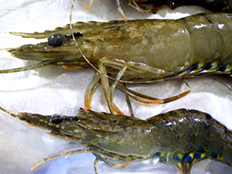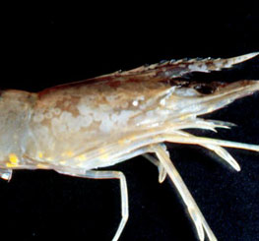WSD is more commonly observed in farmed prawns than wild prawns. Symptoms of disease in farmed prawns include unusually high (80%+) and rapid onset of mortality, prawns coming to the edge or water surface of the pond, prawns demonstrating unusual swimming patterns and reduced feeding and failure to thrive.

**Photo 18: White spot on Prawn**

**Photo credit: D V Lightner**

**Photo 19: White spot on prawn**

**Photo credit: Queensland Department of Agriculture and Fisheries**

**New National Biosecurity Website**

The Australian Government has launched a [new national biosecurity website](https://www.biosecurity.gov.au/) on 28 June 2021 as a first stop for all biosecurity information. It brings together biosecurity resources from the Australian, state and territory governments, industries and non-government agencies. The website is a quick and easy way for the public to find answers to their biosecurity questions. Use the website to access advice, information for reporting, managing biosecurity risks and educational resources.

Please visit the site for the latest biosecurity news and resources: [www.biosecurity.gov.au](http://www.biosecurity.gov.au/)

**CONTACT ACPPO:** [acppo@agriculture.gov.au](mailto:acppo@agriculture.gov.au), **ACVO:** [ocvo@agriculture.gov.au](mailto:ocvo@agriculture.gov.au), **ACEBO:** [acebo@agriculture.gov.au](mailto:acebo@agriculture.gov.au)