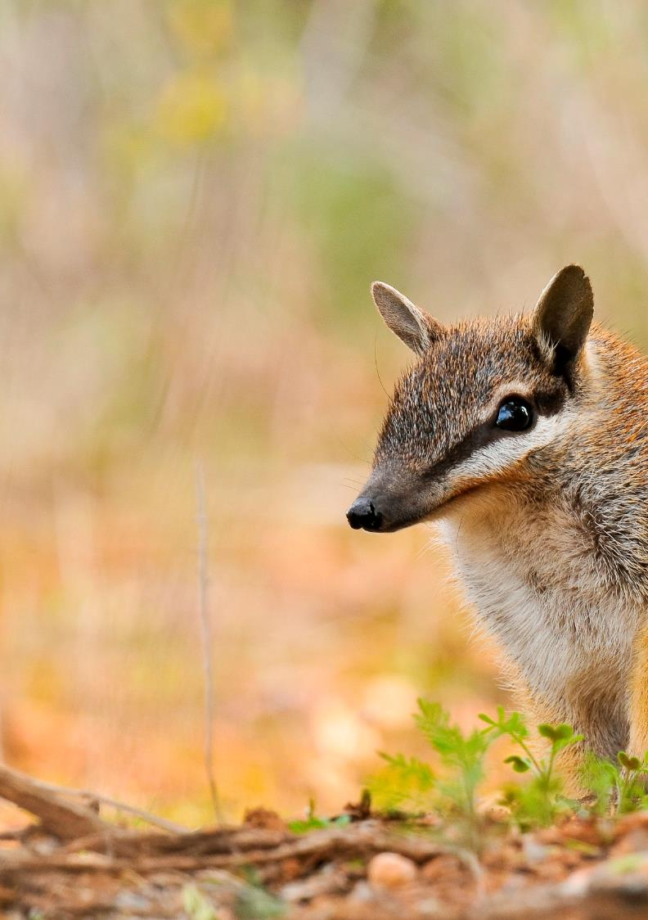

threatened

species

strategy

year one report

image credits

Cover photo: (front and back) Numbat © Australia Wildlife Conservancy, W. Lawler

Page 4: Eastern Barred Bandicoot © Zoos Victoria; Gregory Andrews and Warru © Gregory Andrews

Page 7: Yellow-footed Rock-wallaby © Robert McLean

Page 8: Feral cat © Sporting Shooters Association; Feral cat in trap © Sam Dutton

Page 9: John Read with feral cat grooming trap © Gregory Andrews

Page 10: Baby Numbats in log © Rob McLean; Hugh Davies with Brush-tailed Rabbit-rat on Melville Island © Hugh Davies

Page 11: Western Quoll © Department of Parks and Wildlife, WA

Page 12: Helmeted Honeyeater © Nick Bradsworth; Australasian Bittern, © Andrew Silcocks

Page 13: Abi Smith with a Norfolk Island Green Parrot chick © Cassie Jones

Page 14: Shy Susan © Murray Fagg, Australian National Botanic Gardens; Botanists vouchering specimens © Department of the Environment and Energy

Page 15: Magenta Lilly Pilly © Erin Lake

Page 16: Trapping at Arid Recovery © Gregory Andrews; Cassowary © Tim Faulkner

Page 17: Meeting of the Upper Torrens Land Management Project team in Mount Pleasant © John Baker

Page 18: Christmas Island coastline © Department of the Environment and Energy

Page 19: Golden Bandicoot © Australia Wildlife Conservancy, R. Knowles

**p**

**© Commonwealth of Australia, 2016.**

**creative_commons_licence.jpg**

***Threatened Species Strategy—Year One Report*** is licensed by the Commonwealth of Australia for use under a Creative Commons Attribution 4.0 International licence with the exception of the Coat of Arms of the Commonwealth of Australia, the logo of the agency responsible for publishing the report, content supplied by third parties, and any images depicting people. For licence conditions see: http://creativecommons.org/licenses/by/4.0/

This report should be attributed as ‘*Threatened Species Strategy—Year One Report*, Commonwealth of Australia 2016’.

The Commonwealth of Australia has made all reasonable efforts to identify content supplied by third parties using the following format ‘© Copyright, [name of third party] ’.

**Disclaimer**

The views and opinions expressed in this publication are those of the authors and do not necessarily reflect those of the Australian Government or the Minister for the Environment and Energy.

acknowledgement of country

The Department acknowledges the traditional owners of country throughout Australia and their continuing connection to land, sea and community. We pay our respects to them and their cultures and to their elders both past and present.

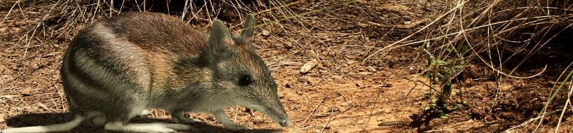

commissioner’s message

On 16 July 2015, Australia’s first Threatened Species Strategy was launched in Melbourne. This marked the beginning of a challenging and valuable journey to change the fate of Australia’s threatened species.

This report to Minister for the Environment and Energy, the Hon Josh Frydenberg MP, captures the progress made during year one of implementing this ambitious plan. The journey has been rewarding, difficult and full of learning, but overwhelmingly positive.

The Strategy reinvigorates Australia’s approach to protecting threatened species. It explains why we should care and outlines principles for prioritising Australian Government resources and effort. It establishes a five year Action Plan with clear, measurable targets for feral cats, mammals, birds, plants and recovery practices.

Australian Government programs and investments, like the National Landcare Programme and regional NRM organisations, have sharpened their focus on threatened species and are core to the outcomes we are delivering. From community feedback, I have seen a genuine shift in the interest and understanding of threatened species. Australia is now well and truly behind the fight against extinction.

I am pleased to say that we have met the majority of the Strategy’s targets for year one and are delivering some great outcomes for so many of our threatened species.

We have a big two years ahead of us as we work towards delivering the year three targets in the Strategy. More action and effort is needed to make this happen, and it will not be easy. But it is a challenge I am up for and I know Australia is too. I will be looking to grow the maturity of the Strategy by intensifying action where it is most needed, building the partnerships required to fight extinction and to applying knowledge gained in year one to enhance the relevance and effectiveness of the Strategy. I am looking forward to supporting Minister Frydenberg in launching a Threatened Species Prospectus, with the aim of growing and leveraging investment from the private sector in saving species.

**Gregory Andrews**

Threatened Species  
Commissioner

I encourage anyone who is interested in being involved in the conversation about threatened species, or who would like to learn more about how Australia is fighting extinction, to follow me on [Facebook](https://www.facebook.com/TSCommissioner?fref=ts) or [Twitter](https://twitter.com/TSCommissioner). Details of the stories and projects mentioned within this report are on those sites or on the Department’s [website](https://www.environment.gov.au/biodiversity/threatened/publications/strategy-home).

Everything we have achieved this year has been the result of partnership and collaboration. I would like to thank and acknowledge all the community organisations, Indigenous groups, zoos, governments, NGOs, scientists and passionate people that have contributed to the national effort to fight extinction. I am so proud and encouraged by the huge step forward we have made in just one year and I am looking forward to continuing this important journey with Australia, with the support and direction of Minister Frydenberg.

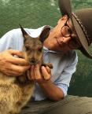C:\Users\a18512\AppData\Local\Microsoft\Windows\Temporary Internet Files\Content.Outlook\8I29FT6T\Gregory e - sig.png

a year in highlights

* **$80.8 million** in funding mobilised by the Australian Government for **432 threatened species projects** in the Threatened Species Strategy’s first year \*
* **21 out of 26 year one targets met** in the Strategy and **seven** **overachieved**
* Around **160 Western Quolls thriving** in the Flinders Ranges after being reintroduced in partnership with state governments, the Foundation for Australia’s Most Endangered Species and community groups
* **Norfolk Island Green Parrot** numbers increased by **over 200 per cent** since 2013 thanks to joint efforts with Parks Australia, non-government organisations and the Norfolk Island community
* Funding of emergency baiting to **prevent extinction of Gilbert’s Potoroo and the Western Ground Parrot** in Western Australia, and the **Central Rock‑rat** in the Northern Territory
* **Helmeted Honeyeater population** in Victoria has more than **doubled since June 2014** thanks to partnership with Zoos Victoria and the local community
* Detector dogs funded to **protect the Mountain Pygmy-possum** in Kosciuszko National Park
* **Eastern Bettong and Eastern Quoll now thriving** on the mainlanddue to reintroductions at Mulligans Flat Nature Reserve in the Australian Capital Territory
* **$30 million Threatened Species Recovery Hub** delivering world-class science through the National Environmental Science Programme
* An estimated **211,000 feral cats** culled across Australia due to national effort
* Construction commenced on **Australia’s biggest feral predator free area** at Newhaven Sanctuary in partnership with the Australian Wildlife Conservancy
* **Threatened species raised as a national issue** with increased coverage on national radio, TV, print and social media
* **Australia’s threatened species stories shared** with countless community groups, universities, high schools, environmental NGOs, zoos, scientists, farmers, journalists, local councils, state governments and international visitors
* The Threatened Species Commissioner **visited every state and territory and two external territories** to grow on-ground action for threatened species

*\* Since 2014, total funding mobilised to support threatened species is $210 million.*

where we are working

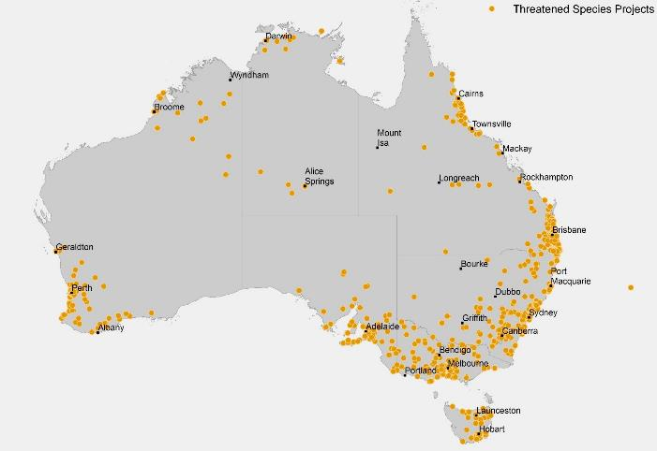



target tracking

Of the 26 targets to be completed in year one of the Strategy, we **successfully delivered 21**. Four targets were partially completed and only one was not achieved. All targets relating to the mammals, birds and plants were completed in full. We **overachieved on seven targets**. Further information about how we went against each target can be found on each target page.

21

1





4

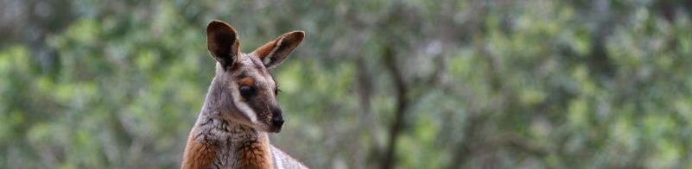INSERT

threatened species strategy overview

The Threatened Species Strategy provides a national approach to achieve the recovery of our threatened plants and animals, based on science, action and partnership. It includes principles for prioritising our resources and effort, to support targeted species and allocate funding to projects.

The Threatened Species Strategy contains a five year Action Plan that sets out areas where the Australian Government will focus to achieve significant, positive results. The Action Plan areas are:

* **Tackling feral cats** – Feral cats are one of the greatest threats to Australia’s mammals and have contributed to at least 28 of the 30 mammal extinctions Australia has endured since European colonisation.
* **Creating safe havens for species most at risk** – Safe havens provide threatened plants and animals with long-term protection. Within these areas species are able to thrive.
* **Improving habitat** – Improving the extent, connectivity and condition of habitat supports threatened species recovery.
* **Intervening in emergencies to avert extinctions** – allows flexibility for the Government to direct resources to species pushed dangerously close to extinction, for example responding to an outbreak of Pisittacine Beak and Feather Disease in Orange-Bellied Parrots.

The Action Plan also contains one, three and five year targets, which allow us to measure success. The year five targets include:

* **Feral cat targets** – including culling two million feral cats, establishing 10 mainland feral-free fenced areas, achieving 12 million hectares of best-practice feral cat management and eradicating feral cats from five islands by 2020.
* **Improving the population trajectories** of 20 threatened mammals, 20 threatened birds and 30 threatened plants by 2020 (i.e. the targeted species).
* **Improving recovery practices** – by ensuring common assessment methodology for species listing, ensuring recovery plans and conservation advices are in place for all targeted species and improving the governance and reporting of recovery teams.

The [Threatened Species Strategy](http://www.environment.gov.au/system/files/resources/51b0e2d4-50ae-49b5-8317-081c6afb3117/files/ts-strategy.pdf) has a full description of the action plan and the targets. Its [four‑page outline](https://www.environment.gov.au/system/files/resources/1d21a645-b662-47fc-83c9-74905730d148/files/ts-strategy-summary-2016.pdf) has a complete list of the targeted species (also on page 19 of this report). This report describes progress against the Strategy’s year one targets and outlines future directions as we move towards year three.

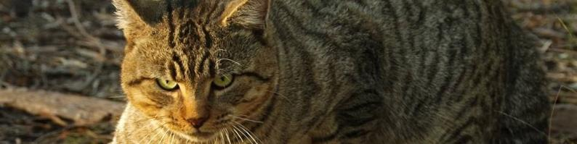

tackling feral cats and their impacts

|  |  |  |
| --- | --- | --- |
| feral cats year 1 - how did we do? | | |
| **Action commenced for feral cat eradication on five islands** | Targeted islands for feral cat eradication have been identified. Action is underway on each island, including community engagement, eradication trials and culling. | **✓** |
| **Action commenced on three mainland feral-free areas to secure threatened species and identify two more areas for action** | Action has commenced for fenced areas at Newhaven Sanctuary and Mulligan’s Flat. At least five additional fenced areas are planned nationally. | **✓** |
| **Undertake feral cat management across one million hectares, using the best techniques for each location** | We have overachieved on this target with 1.4 million hectares of feral cat management in Western Australia alone. Different techniques being used include aerial baiting, skilled shooting and trapping, detector dogs, exclusion fencing, cat squirter traps and Indigenous hunting. | **✓✓** |
| **Identify priority locations on Commonwealth land and commence action for best practice feral cat management** | Action has occurred in priority locations within Kakadu National Park and on Christmas Island. | **✓** |
| **Curiosity® cat bait approved and deployed** | This target was partially met. Assessment by the Australian Pesticides and Veterinary Medicines Authority is ongoing and has delayed delivery of this target. Approval is expected in March 2017. A commercialisation strategy is underway. | • |
| **100 per cent of feral cats culled in Australia to be reported in Cat Scan phone app** | This target was not met. [FeralCatScan](http://www.feralcatscan.org.au/) was launched at the Threatened Species Summit and much has been done to promote use of the app across Australia. It is raising awareness in the community and is being used strategically on Kangaroo Island. Due to limited ability to drive uptake, not all cats culled are reported in the app. | • |
| **150,000 feral cats culled at the national level** | An estimated 211,000 feral cats were culled. | **✓** |

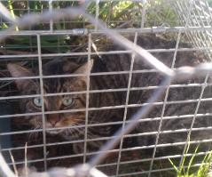

where to now?

The next challenge is creating more open landscapes where threatened species have a competitive advantage. Increased connection with Indigenous Ranger groups and the approval of Curiosity® feral cat bait will help grow open landscape action on feral cats and increase threatened species populations on the mainland.

* over **$11 million invested** in feral cat control action and research
* construction commenced on **australia’s biggest feral predator free area** at newhaven
* **211 000** cats culled nationally



working smarter, not harder

Innovation is essential to reducing feral cat numbers in Australia, with 99.8 per cent of the country inhabited by feral cats.

In the last 12 months, Ecological Horizons has begun testing and trial deployment of the [cat squirter trap](https://www.youtube.com/watch?v=AnpJBI_502U), a cat specific robotic bait station that selectively targets feral cats. This technology will overcome some of the barriers to controlling feral cats in remote and regional Australia. Already, communities and land managers on Bruny Island, Kangaroo Island, western Queensland and South Australia are looking integrate this new tool into their feral cat control.

The Australian Government invested $100,000 to help develop the prototype into a final product, creating another innovative, humane and effective feral cat management tool. Along with Curiosity feral cat bait, and guardian dogs, these innovative approaches are improving how we tackle threats and protect threatened species.

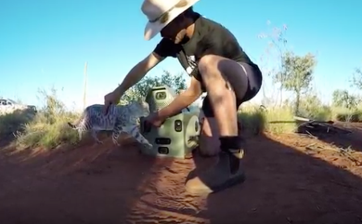

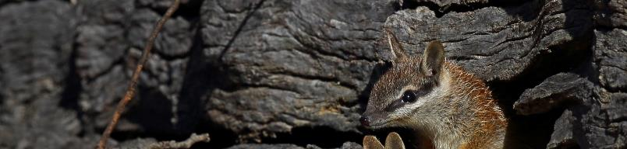

20 mammals by 2020

|  |  |  |
| --- | --- | --- |
| mammals year 1 - how did we do? | | |
| **Action commenced for at least five of the 10 identified mammals** | We overachieved on this target. All 20 mammals identified in the Strategy have at least one [project](http://www.environment.gov.au/biodiversity/threatened/species/20-mammals-by-2020) contributing to the recovery of the species. | **✓✓** |
| **Planning complete on actions for 10 identified mammals** | We overachieved on this target. All 20 mammals identified in the Strategy have forward workplans established from now until 2020. These are flexible and adaptable to new knowledge and species needs. | **✓✓** |
| **Action commenced for Leadbeater’s Possum and Central Rock-rat** | The [Leadbeater’s possum Action Plan](http://www.environment.gov.au/system/files/resources/721c9646-18be-402e-a2bd-3a9ac06547d4/files/leadbeaters-possum-action-plan.pdf) was released on 31 August and outlines action underway for the species.  Two projects funded under the Strategy, West MacDonnell Ranges feral cat control and the Newhaven Sanctuary, are supporting the recovery of the Central Rock-rat. | **✓** |
| **Additional eight mammals identified for priority conservation, in consultation with partners** | The [additional eight mammals](http://www.environment.gov.au/biodiversity/threatened/publications/factsheet-threatened-species-strategy-action-plan-2015-16-20-mammals-by-2020) were annouced by the Minister on 22 January 2016. | **✓** |

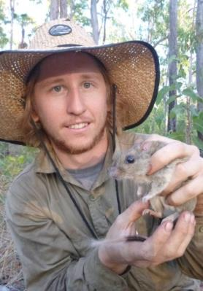

where to now?

Work is underway for all 20 mammals, but some species require additional targeted action to progress their recovery. Work plans established for each species have identified those most in need and we will be seeking to drive action for these species in the coming years. Some examples are the Northern Hopping‑mouse, Kangaroo Island Dunnart, Brush-tailed Rabbit-rat and Western Ringtail Possum.

Many species we are targeting have large distributions and their recovery efforts are managed by multiple partners. Coordinating recovery efforts and measuring improvement in these species will be difficult, however we are working closely with Australia’s leading scientists to establish meaningful ways to measure success. We are also seeking to streamline recovery efforts under the Improving Recovery Practices Target.

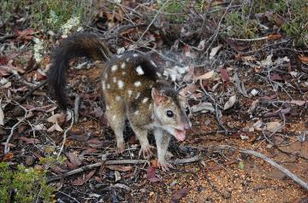

western quoll success

Last year, the Western Quoll made its formal return to the Flinders Ranges in South Australia. It was the species’ first time back in the area in over 130 years.

In May 2015, 37 adult Western Quolls were flown more than 2,000km from Western Australia to the Flinders Ranges National Park in South Australia. These were followed by 15 more quolls.

The quolls settled in well and have been breeding. Today, there is estimated to be around 160 Western Quolls thriving in the National Park.

An Australian Government grant to the Foundation for Australia’s Most Endangered Species (FAME) contributed $55,000 to return of the Western Quoll to South Australia. The project is a partnership between FAME, the South Australian Department of Environment, Water and Natural Resources, the Western Australia Department of Parks and Wildlife and the Sporting Shooters Association. It is also the first public-private partnership of its kind in South Australia.

* **eastern bettong** and **eastern quoll** populations thriving on the mainland
* extinction of the **central rock-rat** prevented by emergency feral cat baiting
* two detector dogs in kosciuszko np saving the **mountain pygmy‑possum**



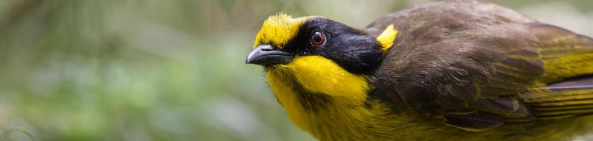

20 birds by 2020

|  |  |  |
| --- | --- | --- |
| birds year 1 - how did we do? | | |
| **Action commenced for at least five of the 10 identified birds** | We overachieved on this target. All ten birds listed in the strategy have at least one [project](http://www.environment.gov.au/biodiversity/threatened/species/20-birds-by-2020/night-parrot) contributing to their recovery. | **✓✓** |
| **Planning complete on actions for all identified birds** | We overachieved on this target. All 20 birds identified in the Strategy have forward workplans established from now until 2020. These are flexible and adaptable to new knowledge and species needs. | **✓✓** |
| **Action commenced for Orange‑bellied Parrot and Western Ground Parrot** | Emergency actions for Orange-bellied Parrot and Western Ground Parrot have commenced, including emergency and scheduled predator control, and habitat augmentation. | **✓** |
| **Remaining eight birds identified for priority conservation and planning in place for action, in consultation with partners** | The [remaining eight birds](http://www.environment.gov.au/biodiversity/threatened/publications/threatened-species-strategy-action-plan-2015-16-20-birds-2020) were annouced by the Minister on 22 January 2016. | **✓** |

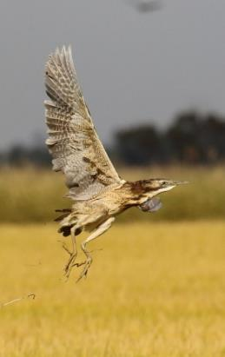

where to now?

We have seen good progress in projects for many of our 20 targeted birds. But large habitat ranges, which in some cases stretch to other countries, and gaps in knowledge will be barriers to recovery.

Continued effort is required on all of the targeted species, however, particular focus on the barriers to recovery for species like the Eastern Curlew, Regent Honeyeater, Plains Wanderer and Australasian Bittern is required.

Recovery actions are often long term, with species improvements not realised until new habitat is matured. We are working closely with Australia’s leading scientists to establish meaningful ways to measure success in nearer timeframes.

* twice the number of **helmeted honeyeaters** surviving in the wild
* **night parrot** protected with new reservein qld
* emergency feral cat baiting for **western ground parrots**



green parrot recovery

In 2013, the number of Norfolk Island Green Parrots was estimated to be as low as 50 to 100 birds.

A combination of predation by feral black rats and feral cats, and nest competition from introduced birds meant the Norfolk Island Green Parrot was on a trajectory to extinction.

But the outlook has changed, thanks to a $300,000 Australian Government grant to support direct, on ground action and intensified local community effort. A network of 1,800 rat bait stations now covers the National Park and 80 nest sites have been established in tree trunks, which are now regularly used by the parrots.

The number of Green Parrots has now grown to nearly 400. The next step is to establish another population on nearby Phillip Island, which is free of feral animals, and the rangers are working hard to prepare the island for its new inhabitants.

This is an excellent example of what can be achieved when scientific expertise supports on-ground action to protect threatened species.

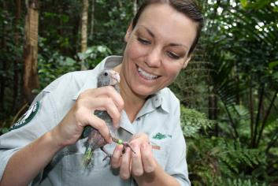

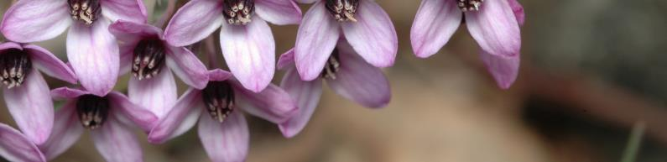

protecting australia’s plants

|  |  |  |  |
| --- | --- | --- | --- |
| plants year 1 - how did we do? | | | |
| **Ensure at least 80 per cent of projects funded through the 20 Million Trees and Green Army Programmes support the recovery of threatened plants and animals by providing suitable habitat** | This target has been achieved. More than 82 per cent of Green Army and 20 Million Trees projects funded since the release of the Strategy support the recovery of threatened plants, animals and their habitat though actions including planting trees, removing weeds and debris and controlling pests. | **✓** |
| **Recovery actions underway for at least 20 threatened plants** | We overachieved on this target with recovery actions underway for 27 threatened plant species through 22 projects under the 20 Million Trees Program. This is in addition to over 100 threatened plant species benefiting from Green Army projects since the release of the Strategy. | **✓✓** |
| **Recovery actions underway for at least 20 threatened ecological community sites** | We overachieved on this target with recovery actions underway through the 20 Million Trees Programme at 54 threatened ecological community sites across Australia. | **✓✓** |
| **Priority species and communities for on-ground recovery action and seed collection are identified** | [30 plants](http://www.environment.gov.au/biodiversity/threatened/publications/threatened-species-strategy-action-plan-2015-16-30-plants-by-2020) targeted for recovery by 2020 were announced by the Minister on 7 September 2016. Parks Australia and the Australian Seed Bank Partnership have identified priorities for seed collection to 2020. | **✓** |
| **Projects designed to fill gaps in collections and genetic representativeness and support on-ground recovery are identified for priority species and communities** | All 30 plants targeted in the Strategy have workplans established from now until 2020. These include on ground recovery and seed collection. Recovery actions are underway in 19 different ecological communities through the 20 Million Trees Program. | **✓** |

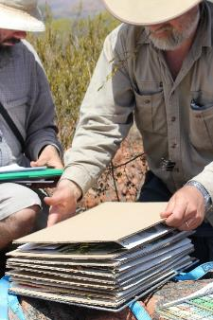

where to now?

Work is underway for many of the 30 plants including on-ground recovery actions, seed-banking, and using plant orchards and nurseries to help grow plants to be returned to the wild. Partnerships with private landowners will be important for protecting species on private land. While almost 50 per cent of known threatened species are now protected in Australia’s national seed banks, challenges exist for species that can’t be stored using traditional methods. Scientists from the Australian Seed Bank Partnership, Parks Australia and CSIRO are working on new methods to guarantee these species can also be insured.

* **mossman fairy orchid** back from extinction after rediscovery
* 429 480 trees being planted to enhance the **lowland rainforest of subtropical aust. ecological community**
* nine projects recovering the **silver daisy bush**



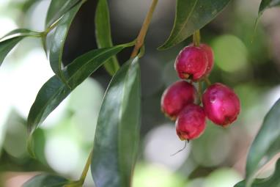

saving the magenta lilly pilly

The Magenta Lilly Pilly (*Syzygium paniculatum*) is a vulnerable rainforest tree endemic to the NSW coast. Its numbers declined as urban areas on the coast developed and habitat fragmentation, invasive weeds and grazing increased.

The Threatened Species Strategy has put in place multiple recovery projects across the Magenta Lilly Pilly’s range.

With the help of the 20 Million Trees Programme, the Hunter Wetlands Centre will increase the national population of Magenta Lilly Pilly by over 33 per cent from the current known population of 1,200 wild plants. Volunteers are working with project partners to collect and grow trees from seed, and once suitable habitat has been established they will replant the trees back into the wild.

Four Green Army projects are also working nearby to improve habitat for the species through weeding and revegetation.

Further down the coast at the southern limit of the Magenta Lilly Pilly, Booderee National Park rangers are protecting the species habitat and growing plants in the nursery as well as increasing numbers in Booderee Botanic Gardens.

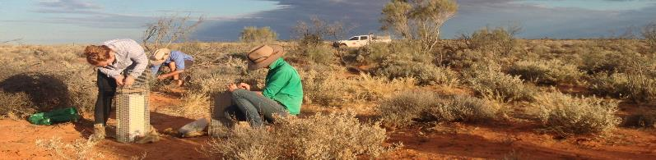

improving recovery practices

|  |  |  |
| --- | --- | --- |
| recovery practices year 1 - how did we do? | | |
| **Australian Government and all states and territories agree to common assessment method for species listing** | All jurisdictions have endorsed the Common Assessment Method. | **✓** | |
| **All identified birds and mammals in the 2020 recovery targets of this Action Plan have up-to-date conservation advices or recovery plans in place** | All targeted birds and mammals identified at the launch of the Strategy have up to date conservation advices or recovery plans in place. | **✓** | |
| **Based on comprehensive review, a work plan is established and completed to ensure conservation advices or recovery plans are up-to-date for identified high-priority species and ecological communities** | Forward work plan completed for identified high-priority species and ecological communities. | **✓** | |
| **Database of all recovery teams made publicly available** | This target was partially met. Public consultation is being undertaken to identify recovery teams to be nationally registered and their details will be included in a database to be made publicly available. | • | |
| **Australian Government, in consultation with the states and territories, publishes best practice guidelines for recovery team governance** | This target was partially met. *Draft* *Recovery Team governance and best practice guidelines* were made available for comment on 7 Oct 2016. | • | |
| **Australian Government, in consultation with the states and territories, establishes method to allow recovery teams to report annually on progress, with a focus on recovery actions and outcomes** | This target was partially met. *Draft Recovery Team Annual Progress Report – Guidelines* were made available for comment 7 Oct 2016. | • | |

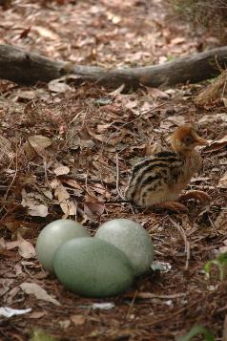

where to now?

Finalising the recovery team database, best practice guidelines and reporting mechanisms are immediate priorities for the year ahead. These will help improve recovery outcomes for the targeted species in the Strategy and many other threatened species. Key to delivering recovery outcomes will be the documents that guide on-ground actions for species. We are working towards all targeted birds, mammals and plants having up-to-date recovery plans or conservation advices in place by year three.

In addition, as the Common Assessment Method continues to be implemented across Australia, the efficiency of threatened species assessment processes will improve. Different jurisdiction lists will progressively become better aligned.

* 22 specieshave  **new recovery plans**
* 171 species have a **new conservation advice**
* b**est practice workshop held** with 30 leading recovery experts



streamlining species listing

For many years, threatened species have been assessed and listed by different jurisdictions using different categories and criteria. As a result, species can be listed in multiple jurisdictions under different threat categories. This can confuse their conservation status, hinder their protection and also increase business costs. It also duplicates effort as species can be assessed multiple times.

In July 2015, Environment Ministers endorsed a common assessment method for assessing threatened species. A formal agreement has since been signed by Western Australia, the Northern Territory, the Australian Capital Territory, Tasmania and the Australian Government. All jurisdictions, including those who are yet to sign, are involved in implementing the common assessment method.

Along with assessments of species not currently listed, the common assessment method will align the status of species which are already listed. An initial group of 20 endemic Western Australian species is being considered for listing, de-listing, or a transfer of category under the [EPBC Act list of threatened species](https://www.environment.gov.au/epbc/about/epbc-act-lists) to bring them into line with their status under Western Australian law.

This project is a great example of the improved governance that results from cooperation, collaboration and good communication across jurisdictional borders.

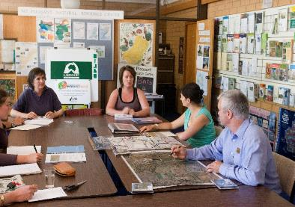

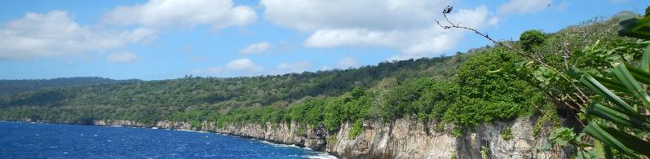

towards year 3

This report has described the progress that has been made during year one of the Strategy. We are now turning our attention to scaling up efforts to meet the year three targets. We are aiming to commence additional recovery actions for targeted species and see more population trajectories begin to improve. Building partnerships will be critical to achieving these next targets and I will be championing initiatives that will facilitate further collaboration between governments and the private and non-profit sectors. I will also be looking to apply knowledge gained in year one to enhance the relevance and effectiveness of the Strategy. A key way to do this involves annually reviewing the Action Plan to ensure it is still relevant and delivering positive outcomes. Feedback on the Action Plan has been positive and no substantial changes are expected to be recommended in the near future. We will, however, look to sharpen the focus of the feral cat targets to deliver better outcomes for the 124 threatened species across Australia that they threaten.

threatened species recovery fund

On 5 June 2016, the Australian Government announced a dedicated $5 million Threatened Species Recovery Fund to support the excellent work undertaken by local community groups fighting extinction. Nine community groups have already been announced to receive support to recover species like the extremely rare Gilbert’s Potoroo, the remarkable Eastern Curlew and the unique Ormeau Bottle Tree. The remaining funds will go to community groups working on projects that strongly align with the Threatened Species Strategy. Allocating the remaining funds to quality projects will by a key priority over the next two to three years.

feral cat target

Our work to control feral cats will remain a key focus over coming years. Strong progress has been made on tackling the threat of feral cats, including establishing feral‑free exclosures and identifying the five islands for feral cat eradication. This work will continue and ramp up. However, for the majority of threatened species, the long-term goal for recovery is survival in an open landscape. To achieve this, we must increase our focus on the open landscape target - managing feral cats over 12 million hectares. In recent visits to remote Indigenous Protected Areas, I have been impressed by the work of Indigenous rangers controlling feral cats, and threatened species are thriving on many of their properties as a result. I am keen to help others learn from these efforts.

threatened species prospectus

The Threatened Species Prospectus will contain a suite of project proposals that can support delivery of targets in the Threatened Species Strategy. This prospectus will provide an opportunity for the business and philanthropic sectors to partner with governments and conservation and community groups by co-funding critical work needed to recover our most threatened native animals and plants.

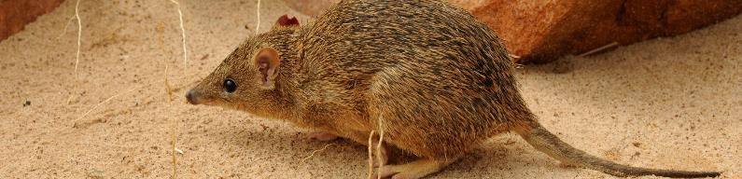

all our targeted species

|  |  |  |  |  |
| --- | --- | --- | --- | --- |
| mammals | | | | |
| Eastern Barred Bandicoot | Golden Bandicoot | Kangaroo Island Dunnart | Western Ringtail Possum | Leadbeater’s Possum |
| Mala | Brush-tailed  Rabbit-rat | Numbat | Eastern Quoll | Gilbert’s Potoroo |
| Mountain  Pygmy-possum | Eastern Bettong | Woylie | Western Quoll | Mahogany Glider |
| Bilby | Christmas Island Flying-fox | Central Rock-rat | Northern  Hopping-mouse | Black-footed  Rock-wallaby |

|  |  |  |  |  |
| --- | --- | --- | --- | --- |
| birds | | | | |
| Norfolk Island Green Parrot | Eastern Bristlebird | Alligator Rivers Yellow Chat | Cassowary | Eastern Curlew |
| Malleefowl | White-throated Grasswren | Golden-shouldered Parrot | Western Ground Parrot | Red-tailed  Black-cockatoo |
| Helmeted Honeyeater | Norfolk Island Boobook Owl | Plains Wanderer | Regent Honeyeater | Australasian Bittern |
| Night Parrot | Mallee Emu-wren | Hooded Plover | Orange-bellied Parrot | Swift Parrot |
|  | | | | Christmas Island Frigatebird |

|  |  |  |  |  |
| --- | --- | --- | --- | --- |
| plants | | | | |
| Small Purple Pea | Magenta Lilly Pilly | Ant Plant | Southport Heath | Turnip Copperburr |
| Little Mountain Palm | Kakadu Hibiscus | Bulberin Nut | Morrisby’s Gum | Matchstick Banksia |
| Vincentia Banksia | Central Australian Cabbage Palm | Whibley’s Wattle | Shy Susan | Glossy-leafed Hammer-orchid |
| Mongarlowe Mallee | Purple Wattle | Silver Daisy Bush | Silver Gum | Black Grevillea |
| Caley’s Grevillea | Ormeau Bottle Tree | Fleurieu Leek Orchid | Spiny Rice Flower | Fitzgerald’s  Mulla-mulla |
| Fairy Bells | Mossman Fairy Orchid | Blue Top Sun Orchid | Button Wrinklewort | Scaly-leaved Featherflower |

|  |  |  |  |  |
| --- | --- | --- | --- | --- |
|  |  |  |  |  |

