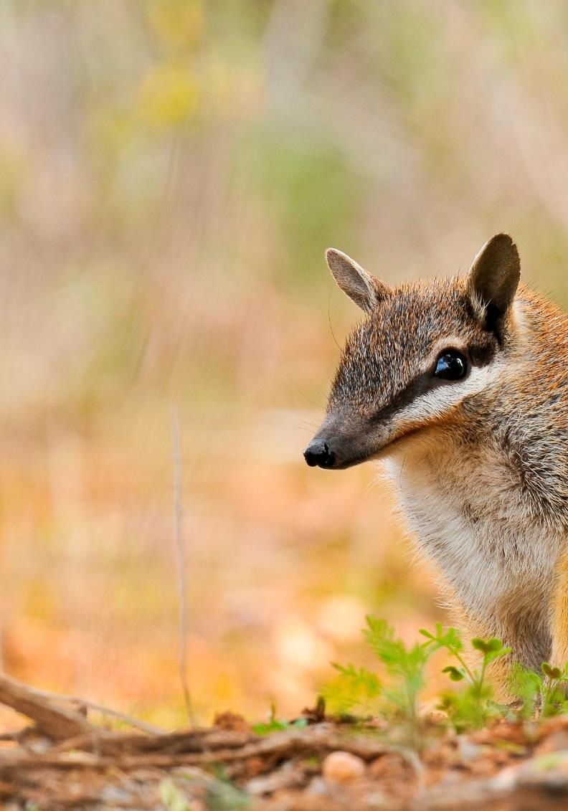

threatened

species

strategy

year four report

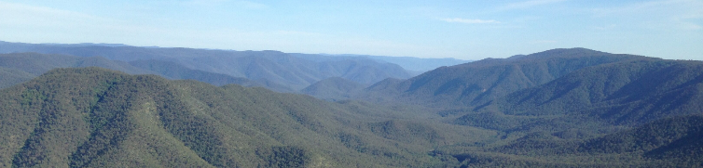

Photo: Kerry Cameron

acknowledgement of country

The Department of Agriculture, Water and the Environment acknowledges the Traditional Owners of country throughout Australia and their continuing connection to land, sea and community. We pay our respects to them and their cultures and to their Elders both past and present. We are committed to working respectfully with Aboriginal and Torres Strait Islander peoples and give particular acknowledgement to their use, knowledge and custodianship of Australia's native plants and animals over countless generations.

The Department supports Aboriginal and Torres Strait Islander peoples and their aspirations to maintain, protect and manage their culture, language, land and sea country and heritage. For more information please see the [Reconciliation Action Plan](http://www.environment.gov.au/system/files/resources/a3314fd3-7705-4af0-acf8-ef35a1801318/files/reconciliation-action-plan-2016-19.pdf).

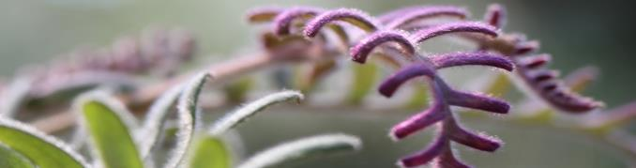

Photo: Erin Lake

commissioner9s message

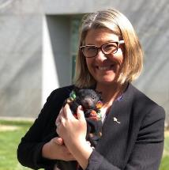The Australian Government’s Threatened Species Strategy commenced in 2015 and I’m pleased to deliver this progress report to mark the conclusion of the Strategy’s 4th year. This report discusses progress made to save species from mid 2018 to mid 2019, as well reflecting on successful community engagement events held to celebrate Threatened Species Day in September 2019.

Last year, the year 3 report was a major halfway milestone for the Threatened Species Strategy, providing an important record of progress made towards meeting 21 targets for action. It reported on population trajectories for each of the Strategy’s priority birds and mammals, and also reported against targets to reduce the impacts of feral cats on threatened species, to ensure recovery actions were underway for priority plants and to improve recovery practices for all species. Eleven of these targets were met, four were partially met and six were unmet. In year 4, we continued work to support all targets, with a sharpened focus on those the year 3 report identified as needing greater effort and resources. The Australian Government’s primary support for threatened species projects is being directed through Regional Land Partnerships and some great examples of practical action delivered through this and other programs in year 4 are described on the following pages.

I’m grateful for the numerous opportunities during year 4 to continue our threatened species recovery work with threatened species researchers, land managers and conservation practitioners, as well as with Australia’s magnificent volunteer community. Actions to recover threatened species represent a huge collective effort from all these groups. This has never been the case more than now, as we grapple with the impact of the 2019-20 bushfires on human life and communities, including the devastating impact on our environment. Initial reports on 20 January estimated more than 30% of the known or predicted distribution of 191 nationally listed threatened species was within the fire extent, including Strategy species such as the Kangaroo Island Dunnart. Fires continued to burn in February and March in some areas, impacting further habitat and species.

cid:image006.png@01D3C1E7.9EDA5030We now find ourselves in the final year of the Threatened Species Strategy, which is both exciting and challenging. In many parts of Australia, these challenges are amplified by severe impacts of the bushfires and the implications of the COVID-19 pandemic on our ability to get out in the field, however the incredible human response to wildlife in crisis in recent months provides a source of real hope that we can collectively secure positive outcomes for threatened species even in the most difficult circumstances.

**Dr Sally Box**

**Threatened Species Commissioner**

|  |
| --- |
| saving species success stories  threatened species strategy year 4 |
| **July 2018**  First **Eastern Quolls born** on the Australian mainland in over 50 years. |
| **November 2018**  Two **new populations of the Small Purple Pea** discovered near **Mudgee, NSW.** |
| **January 2019**  Project launched to deliver stage 1 of the **predator exclusion fence** enclosing the southern tip of the Yorke Peninsula. |
| **March 2019**  **350 new juvenile Ormeau Bottle trees** located in South East Queensland. |
| **June 2019**  Newhaven Wildlife Sanctuary declared free of all feral predators, including feral cats, making it the **largest feral predator-free area in Australia**. |
| **June 2019**  **891 Whibley's Wattles discovered** in the Tumby Bay region, bringing the total remnant population to over 1,800 plants. |
| **2018/19**  **3000 Silver Daisy Bushes were planted** across South Australia. The project was a finalist in the Australian Government Partnerships for Landcare Award. |

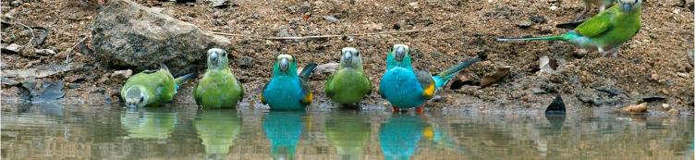

actions underway

Photo: Graeme Chapman

The beginning of the Threatened Species Strategy year 4 reporting period coincided with the commencement of the Australian Government’s $450 million **Regional Land Partnerships** program and the announcement of the $100 million **Environment Restoration Fund**. These major new targeted investments are working together to help deliver national environmental priorities, including supporting listed threatened species, during the 4th and 5th years of the Strategy.

Regional Land Partnerships is the largest sub-program under phase two of the National Landcare Program. The first year of Regional Land Partnerships in 2018-19 has already seen positive results that will help in the recovery of our threatened species and landscapes. The program is investing in 120 threatened species and 42 threatened ecological communities, through actions such as weed control, pest fauna control, habitat improvement, and community engagement. The program also contributes towards sustainable agricultural outcomes including improving soil, biodiversity and vegetation.

There are 74 Regional Land Partnerships projects benefiting 47 priority threatened species targeted for recovery under the Strategy. This includes 17 priority mammals, 18 priority bird species, and 12 priority plant species. Many of these species, including the Malleefowl, Hooded Plover, and Greater Bilby, have multiple projects being undertaken across regional and state boundaries.

There are also 78 Regional Land Partnerships projects improving the condition of threatened ecological communities. Multiple projects exist for many of these listed communities, such as for Coastal Saltmarsh, Box-gum Woodlands, Alpine Bog Communities, and Coastal Rainforests. Regional Land Partnerships projects are also reducing threats to our globally important Ramsar wetlands. These projects can also provide benefits for threatened species.

Other continuing programs have been working along with Regional Land Partnerships during year 4 of the Strategy. Some great outcomes for threatened species in year 4, achieved under a range of programs and by many partners, are described on the following pages.

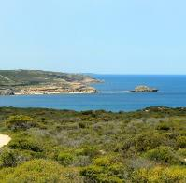**Great Southern Ark - Rewilding the Southern Yorke Peninsula landscape**

The Australian Government is investing $2.6 million through Regional Land Partnerships from 2018 to 2023 in the Great Southern Ark, a landscape recovery project in South Australia to rewild the Southern Yorke Peninsula. This project aims to develop a safe haven for threatened species, remove feral predators, restore habitat and improve agricultural productivity on the Peninsula.

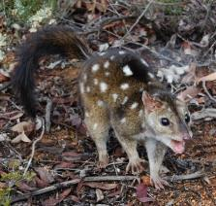In January 2019, the Northern and Yorke Natural Resources Management Board officially launched a new project to deliver the first stage of predator exclusion fence enclosing the southern tip of the Yorke Peninsula. The project is a collaboration between the Australian Government, Northern and Yorke Natural Resources Management Board, World Wide Fund for Nature, Fauna Research Alliance, Birdlife Australia, Zoos South Australia, Conservation Volunteers Australia and Yorke Peninsula Tourism.

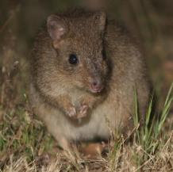Once completed, the 23 kilometre long predator exclusion fence will create a 140,000 hectare safe haven for native species. Foxes and cats will be removed from this area and a range of Australian threatened species will be reintroduced over the next 15 years. The first species for reintroduction will be the Woylie (Brush-tailed Bettong), with releases of Southern Brown Bandicoot, Red-tailed Phascogale and Western Quoll (Chuditch) planned for later years.

Photos: P & D McFarlane, WA Government, Mark Bundock

**Eastern Quolls** Twenty Eastern Quolls were relocated from Tasmania to Booderee National Park in March 2018 to determine whether a wild introduction was possible. By July, three of the females were found to have pouch young, the first Eastern Quolls born on the Australian mainland in over 50 years, and in November, six young quoll joeys were spotted leaving their mothers’ pouches and moving around independently. This fantastic result achieved by the Eastern Quoll Reintroduction Team is a great example of strong and effective partnership between conservation practitioners. Photo: Parks Australia

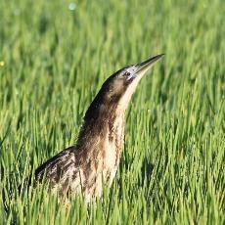**Bitterns in Rice**

The Australasian Bittern is under threat from habitat loss and drought, the largest population now nests in irrigated rice paddies in the Riverina. Despite difficult drought conditions, the Bitterns in Rice project is effectively supporting this unique species, with 500-1000 bitterns utilising Riverina rice fields, about 40% of the total global population.

The Australian Government is investing $1.5 million over four years through the Regional Land Partnerships *Boosting the Bunyip Bird Yield* project, which promotes agricultural practises that maintain habitat areas suitable for Australasian Bittern breeding. It provides information, training and incentives to landholders for bittern-friendly rice growing and works with environmental water holders to increase natural wetland habitat.

Photo: Matt Herring

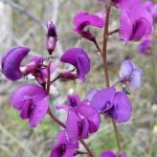

**Small Purple Pea**

Once wide-spread right across south-eastern Australia, the Small Purple Pea is now only found at 26 sites in New South Wales, the ACT, and Victoria. In late 2018, the Regional Land Partnerships *Searching for Swainsona* project found an impressive 72 plants in two new populations of this endangered perennial herb near Mudgee, NSW. This was a wonderful discovery in the early days of this project, a great result for Central Tablelands Local Land Services. Photo: S. Bond

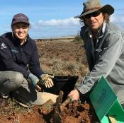**Whibley’s Wattle**

A one-year project funded through Regional Land Partnerships led to the discovery of 891 Whibley’s Wattles in the Tumby Bay region in South Australia, bringing the total known population to over 1,800 individual plants. Genetic testing later revealed that there was no in-breeding, which can be a concern in threatened plant populations. Delivered by Eyre Peninsula Natural Resources Management Board, the project also saw work to protect remnant Whibley’s Wattles through fencing, direct seeding, as well as rabbit and weed control.

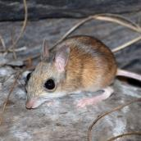Photo: Department of Natural Resources, SA

**Northern Hopping-mouse**

The Northern Hopping-mouse is a small, shy native rodent with an amazing talent for digging complex burrows up to five metres long. The species was previously known on mainland Australia, but its current range is not well understood and in the last few decades has only been seen on Groote Eylandt and before that in northeast Arnhem Land.

Through Regional Land Partnerships, the Australian Government is investing in a project with Territory Natural Resource Management to undertake surveys for Northern Hopping-mice across mainland Arnhem Land and on Groote Eylandt. In partnership with the Northern Territory Government, the Australian Government has also funded work to begin feral cat eradication on Groote Eylandt, to begin turning the island into a safe haven for Northern Hopping-mice. Photo: Rebecca Diete

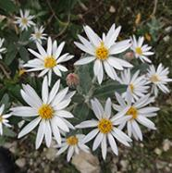**Silver Daisy Bush**

Increasing aridity and shifting rainfall patterns are placing Silver Daisy Bush populations at risk, particularly in the north of its range. Through the Threatened Species Recovery Fund, the Australian Government invested $249,780 in a project delivered by Trees For Life (SA) which planted 3,000 Silver Daisy Bushes across five Natural Resource Management regions in South Australia in 2018 and 2019. This covered the species’ entire range and was delivered collaboratively with strong community partners and six Natural Resource Management Boards.

This pioneering project used climate modelling to consider changes South Australia may face, which informed planting sites chosen for seedlings, and included new research to help counter in-breeding and increase genetic diversity. Photo: Department of Natural Resources, SA

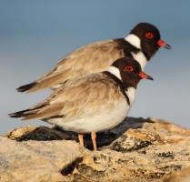**Hooded Plover**

The Hooded Plover is a small beach nesting bird easily disturbed by human activities, particularly off-leash dogs on beaches. *Protecting the Hooded Plover* is a project spanning five Natural Resource Management regions across Victoria and south-east South Australia, aimed at stabilising the Hooded Plover population along Australia’s south-eastern coastline. The project relies on an active volunteer base to undertake nest protection and monitoring. Volunteers have monitored over 526 kilometres of south-east Australian coastlines, and protective works, including fencing and signage, appear to have benefitted the “Hoodies”.

In 2019, a total of 43 fledglings were produced from 103 pairs monitored. Those nesting in high use recreational areas had additional support through fencing of nest areas and protective signage. Without protection, chick numbers from those breeding pairs were predicted to be as low as 10-20 chicks. Photo: Dean Ingwersen

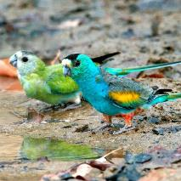

**Golden-shouldered Parrot**

The endangered Golden-shouldered Parrot, known as Alwal by the Olkola people, lives in grasslands and wooded areas on Cape York Peninsula where they burrow into termite mounds to make their nests. Priority actions needed to recover this species include protecting termite mounds and associated foraging habitat, controlling feral pigs and feral cats and implementing suitable burning regimes.

A multi-year Regional Land Partnerships project will allow [Cape York Natural Resource Management](https://www.facebook.com/CapeYorkNRM/?__tn__=K-R&eid=ARArCTLlNXN7qzuGjJIhyddDmwDPnPhOmOvScYfilDCPWWB3rkStfTv0PE10XhfBNeA9Sz89CvOcYAJV&fref=mentions&__xts__%5B0%5D=68.ARBUFtyYynoMR1tVRD0PAYhJD218RvEtNIo4FGbD7ygoxpqR_2vTcNeLOSVbRGsOOWRg0dbhqFhbJ2j9uZj6jZLpyUqqTKJUOFUk3yITOCA5qToNJqV2raUXmnIkOB9A5hTmyFAzu1X8v-9uJ-2ZpvU7pcIVVd1QTBI0s7XoSQe0Xl2Oa9-Fk2Fvd5qPQ3o9XU3AAu0Ws-f4uSA8UyTegR_H53wZLowL36eO69oRqYCYbavfQQhjQIMYZ9w2_YyGY5LmV_2d8vBKAFHUQbnfT_zzqov9dQdABJ2Az2HFNajl14f1U91QcrUp0taeRmYKCy5ckgaCJurbFsLYKWPb9906Pk99), [Northern Gulf Resource Management Group](https://www.facebook.com/northerngulf/?__tn__=K-R&eid=ARAHhsEUwldrMtdidq8Bqrs64r0GmwjKnmJ8wtqRPMBD1F1ay4_sUZIxtZ54Gv7DwofZnwI5SrUCpz52&fref=mentions&__xts__%5B0%5D=68.ARBUFtyYynoMR1tVRD0PAYhJD218RvEtNIo4FGbD7ygoxpqR_2vTcNeLOSVbRGsOOWRg0dbhqFhbJ2j9uZj6jZLpyUqqTKJUOFUk3yITOCA5qToNJqV2raUXmnIkOB9A5hTmyFAzu1X8v-9uJ-2ZpvU7pcIVVd1QTBI0s7XoSQe0Xl2Oa9-Fk2Fvd5qPQ3o9XU3AAu0Ws-f4uSA8UyTegR_H53wZLowL36eO69oRqYCYbavfQQhjQIMYZ9w2_YyGY5LmV_2d8vBKAFHUQbnfT_zzqov9dQdABJ2Az2HFNajl14f1U91QcrUp0taeRmYKCy5ckgaCJurbFsLYKWPb9906Pk99), Traditional Owners and other project partners to continue to manage habitat, address threats, and to conduct regular surveys to monitor parrot populations. A recent targeted survey in Staaten River National Park found good numbers of birds and active nesting burrows. Golden-shouldered Parrot habitat in the park appears to be in good condition thanks to effective fire management and a dedicated pest animal control program over recent years. Photo: Graeme Chapman

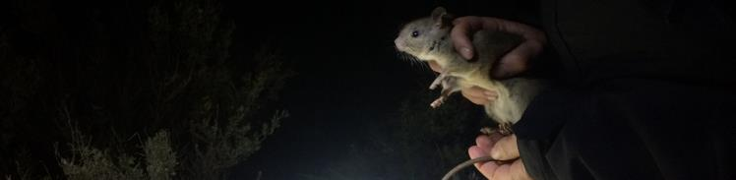

Photo: Katherine Tuft

science & planning

Using sound science to inform conservation planning is critical for effective decision-making about recovery of threatened species and ecological communities. This includes two-way communication with Indigenous Australians to incorporate their unique knowledge and understanding of our natural landscapes, as well as working closely with the scientific research community and threatened species managers. Engaging with these key holders of knowledge about threatened species gives us confidence that we are making sound evidence-based decisions about actions to support our precious native plants and animals.

Some examples of how the Office of the Threatened Species Commissioner has engaged with science and planning in year 4 of the Threatened Species Strategy include:

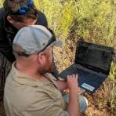

Attending or supporting **conservation workshops**, such as: the 6th Island Arks Symposium at Rottnest Island in Western Australia, a workshop to discuss and plan actions to support threatened birds on Norfolk Island, a recovery team workshop for Kangaroo Island Dunnarts and a workshop to support improved ecological monitoring to inform feral cat eradication. Photo: Oliver Tester

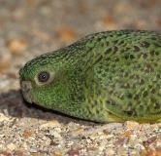

Participating in regional fora: the Threatened Species Commissioner took part in the **Species of the Desert Festival** in June 2019 on the Paruku Indigenous Protected Area near Mulan in Western Australia. Supported through Regional Land Partnerships the three-day festival brought together nearly 300 Indigenous rangers and Traditional Owners to share knowledge, create maps and talk about how right-way science can help us to better understand and conserve our remarkable desert species. Species in focus included the Greater Bilby, the Night Parrot and the Great Desert Skink. Photo: Steve Murphy

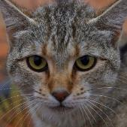

Chairing the national Feral Cat Taskforce and supporting **coordinated national action** to tackle the threat of feral cats. The Taskforce brings together feral cat researchers, non-government organisations, practitioners and representatives from every state and territory to share knowledge, coordinate action and build momentum within the community for improved best practice feral cat control. The Feral Cat Taskforce has met seven times in the four years since the Taskforce was established in 2015. Photo: Hugh McGregor

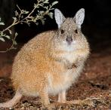

Utilising research undertaken by the National Environmental Science Program’s **Threatened Species Recovery Hub** which has demonstrated the need for a more strategic approach to the future construction of conservation infrastructure. The most recent science included an analysis of native species predator susceptibility combined with a national stocktake of species within safe havens. This research is informing a $10 million commitment announced in 2019 under the Environment Restoration Fund to support projects that can fill critical gaps in the national safe haven network.

Photo: Wayne Lawler

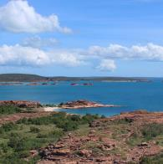Contributing to **conservation** **planning documents by external agencies**, including supporting development of both the Groote Archipelago Threatened Species Management Plan and Phillip Island Nature Parks Threatened Species Plan. Staff from the Office of the Threatened Species Commissioner contributed to planning and decision-making workshops in conjunction with a range of stakeholders including Traditional Owners, conservation scientists, state and local government representatives, land managers and representatives from the local community. The plans draw on Indigenous ecological knowledge, the best available science, and diverse perspectives to provide a road map for the coordinated management of these islands’ natural resources and the threatened species that call them home.

Photo: Groote Eylandt, PastMasters

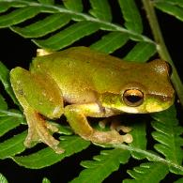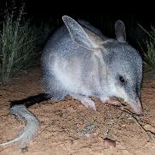The Threatened Species Scientific Committee, supported by the Department, made significant progress with Australian Government **conservation planning documents** during year 4 of the Strategy. These include the making of National Recovery Plans for Macquarie Perch and for the Littoral Rainforest and Coastal Vine Thickets of Eastern Australian threatened ecological community. In addition, national recovery plans for the Greater Bilby, Swift Parrot and the Bulberin Nut were open for public consultation for three months to provide opportunity for the community to comment on the draft plans. National Threat Abatement Plans were made to reduce the impacts of marine debris on vertebrate wildlife, of bycatch of seabirds during oceanic longline fishing and disease in terrestrial ecosystems caused by *Phythophthera cinnamomi*, and the *National Invasive Ant Biosecurity Plan 2018-2028* was released. The Threatened Species Scientific Committee also finalised listing decisions for 64 threatened species during year 4. This included approving updated conservation advices for over fifty of these species, with eleven species recommended for deletion from the EPBC Act list of threatened species.

Photos: Alexandra Ross (Greater Bilby), Queensland Government (Kroombit Treefrog)

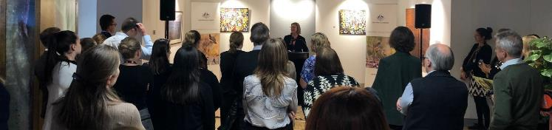

Photo: Kerry Cameron

community engagement

Community engagement is an ongoing priority for the Office of the Threatened Species Commissioner. While the Australian Government provides a national framework for the recovery of threatened species, solutions are more meaningful and enduring if they are tailored to local and regional circumstances. In 2019, the Commissioner and members of the Office listened and presented at large and small conferences, fora and symposiums, to help raise awareness about Australia’s threatened species, and to learn from members of the community and practitioners helping in the recovery of their local species.

Engaging with a wide range of conservation practitioners has given us greater insight into the various approaches for protecting and recovering threatened species across Australia. It is a privilege to meet with local communities and witness the incredible work underway that is powered by passionate and dedicated volunteers. Encouraging progress has been made for projects supported by the Australian Government and we value the on-ground connections to help grow our understanding of how government can better work with the community into the future. Some examples of community engagement during year four of the Threatened Species Strategy include:

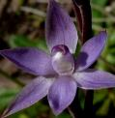

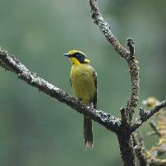Dr Fiona Fraser from the Office of the Threatened Species Commissioner opened the 2019 Orchid Conservation Symposium at the Royal Botanic Gardens Victoria. The Symposium brought together community groups, practitioners and scientists who are working to conserve orchids. Photo: Bob Bates

The Friends of the Helmeted Honeyeater celebrated their 30th Anniversary in May 2019. The Commissioner travelled to Lilydale in Victoria to present at the Anniversary and acknowledge the important work being done by the group. The Friends of the Helmeted Honeyeater have been crucial in averting the extinction of this species over the last three decades – through planting trees, controlling weeds, providing supplementary food, coordinating volunteers and raising funds. Community-led groups like the Friends of the Helmeted Honeyeater are a reminder of the importance of raising awareness and supporting on-ground works to protect our threatened species. Photo: Merryn Kelly

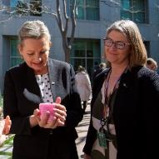

Every year to mark Threatened Species Day, the Minister for the Environment is joined by the Threatened Species Commissioner at Parliament House to share some of the successes and challenges in protecting and recovering threatened species with Australia’s national decision makers. This event in year 4 was a great success, with parliamentarians and their staff meeting threatened mammals kindly brought to Canberra by Aussie Ark, including two Tasmanian Devil joeys, two baby Eastern Quolls and a young koala called Gizmo.

Photo: Huw Graham-Matheson

The Threatened Species Commissioner hosted the Threatened Species Bake Off for the third year running in 2019. The nationwide competition invites the Australian public to bake a threatened species-themed dessert to raise awareness of Australia’s threatened species and Threatened Species Day. This year saw over 300 entries from across Australia, with the overall winner a beautiful creation of the Douglas Broad-headed Bee. This year’s competition had an Indigenous language focus, where entrants were encouraged to research the Indigenous name for their chosen species. Photo: Karen Cullen, overall winner of the 2019 Threatened Species Bake Off

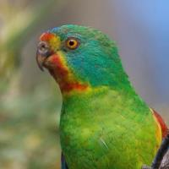

The Threatened Species Commissioner’s social media profile has continued to grow, with over 50,000 followers across three platforms – Twitter, Facebook and Instagram. Social media remains a powerful tool to champion Australia’s threatened species, grow awareness, encourage individual and community action, and communicate threatened species conservation efforts at a national level. We are considered a leader in using social media for Government – with the Office of the Threatened Species Commissioner presenting at the Future Social Media Strategy Forum in November 2018. Photo: Dejan Stojanovic

We continue to use social media and traditional media to promote awareness-raising and behavioural change initiatives. We encouraged Australians to opt for chocolate Bilbies and not Bunnies in April 2019. The vulnerable Greater Bilby once ranged over 75% of Australia, but its distribution has been greatly reduced due to predation from foxes and feral cats, more frequent fires and habitat degradation. The Bilbies Not Bunnies campaign has not only increased awareness of the plight of this iconic mammal, but a portion of the profits has supported charities such as [Save the Bilby Fund](https://www.facebook.com/savethebilby/?__tn__=K-R&eid=ARBNS7JYWb14M9L8oIdDPffCaCvxURPG4kLSUkqFbQjFF1N5Rdx6SLbz-EcrwGwYij6MR-T1K9udiC--&fref=mentions&__xts__%5B0%5D=68.ARDM6mc3EXV9Uj5DijJxPS1nMedRbw8uazdPcBmfMKqWTQrIJL95oLPlinXlWSUNE7SG42X-5CIEWz0umGtQ-NUEEI_4QxuCjhUkPIYe3QsgwB88Z_bWSQGOjH-hrj0hpFWAYabCkusTeaXIjWse8mcMKLCLlFevswlR1NUdhvbiHM91gnH7Z0EJCCKrdtHvWnSL-NByarpEUoGjHbpmffKyXx_NGnNahzcxfWcYyOzBLmDbDyQz49ALTuu2j3IgIY9iqqcfkQF4_zEbO4aJNCT0fT5qqsiM2CUVa-qcb7uCA4uyc3kW2k32Cb5ZjsccIdNf8rQ7SxCEgQOwGPn3yT205eiS) and the [Foundation for Rabbit Free Australia](https://www.facebook.com/RabbitFreeAustralia/?__tn__=K-R&eid=ARCXz1g9M1sICkLcFMMPTkdmke_2rJ74hgVSgms5v16euGyks9LI8P8pV8ZMGtaQguJd5BqONSyznRtG&fref=mentions&__xts__%5B0%5D=68.ARDM6mc3EXV9Uj5DijJxPS1nMedRbw8uazdPcBmfMKqWTQrIJL95oLPlinXlWSUNE7SG42X-5CIEWz0umGtQ-NUEEI_4QxuCjhUkPIYe3QsgwB88Z_bWSQGOjH-hrj0hpFWAYabCkusTeaXIjWse8mcMKLCLlFevswlR1NUdhvbiHM91gnH7Z0EJCCKrdtHvWnSL-NByarpEUoGjHbpmffKyXx_NGnNahzcxfWcYyOzBLmDbDyQz49ALTuu2j3IgIY9iqqcfkQF4_zEbO4aJNCT0fT5qqsiM2CUVa-qcb7uCA4uyc3kW2k32Cb5ZjsccIdNf8rQ7SxCEgQOwGPn3yT205eiS). Photo: Amy Mulcahy

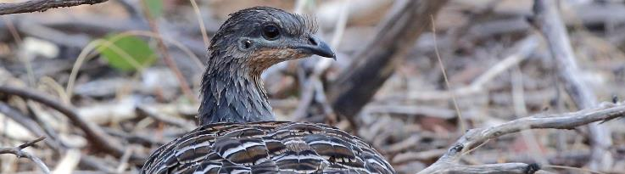

next steps - towards year 5

Photo: Andrew Silcocks

* The Threatened Species Strategy has now been in place for four years, focussing efforts for threatened species across Australia. Meeting the Strategy’s objectives has been embedded in the day to day business of the Department, leading to widespread on-ground action for priority species and to address identified environmental challenges, such as the need to reduce predation pressures by invasive species, establish insurance populations to avert extinction and improve recovery practices.
* Both the year 3 and year 4 reports highlight strong progress made towards meeting the Strategy’s quantifiable targets to fight species extinction. The next formal report – the final report for this first Threatened Species Strategy – will measure our progress after five years against targets set out in 2015. We are confident that we will meet many of these targets but also acknowledge that it’s unlikely we will meet them all. The targets were deliberately set to be ambitious, to push expectations and thereby increase potential for innovative solutions to protect, conserve and support threatened species in Australia. We also understand that recovery is a long and complex process and for many identified priority species there is still a lot of work to do. Our efforts to recover species will continue beyond the timeframe for this current Strategy, through continuing projects already underway through the Regional Land Partnerships program and the Environment Restoration Fund.
* The 5th and final year of this Strategy will focus on consolidating progress to date, while continuing efforts to meet the ambitious year 5 targets. We are also strongly focused on bushfire recovery efforts, given that the catastrophic summer fires of 2019-20 are likely to have caused significant set backs to the recovery of many threatened species, with the extent of these set backs still being determined. Some of these species include Strategy priority species, whose population trajectories we will report on at the end of year 5. For those priority species whose distribution overlaps extensively with fire-impacted areas, it is reasonable to expect their population trajectories will be negatively effected. This will amplify the challenge of the year 5 target to improve the trajectory of all priority species, however it also highlights that there is no better time for objective and clear consideration of how each priority species is faring, to help direct recovery efforts.

We are looking forward to continuing to work with the community and our valued partners to implement the Strategy in its final year and we expect the comprehensive year 5 report on the Strategy’s implementation will be published in early 2021. We will also be considering our future approach to the recovery of threatened species well beyond 2020 and will value stakeholder input in shaping this new vision.