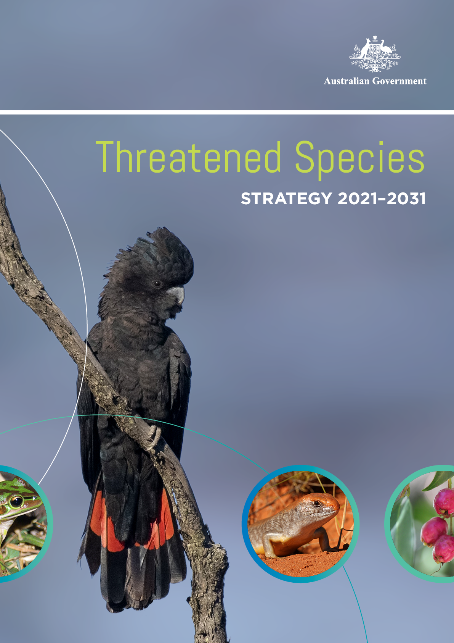

© Commonwealth of Australia 2021

**Ownership of intellectual property rights**Unless otherwise noted, copyright (and any other intellectual property rights) in this publication is owned by the Commonwealth of Australia (referred to as the Commonwealth).

**Creative Commons licence**All material in this publication is licensed under a Creative Commons Attribution 4.0 International Licence except content supplied by third parties, logos and the Commonwealth Coat of Arms.

Inquiries about the licence and any use of this document should be emailed to copyright@awe.gov.au.

**Cataloguing data**This publication (and any material sourced from it) should be attributed as: The Australian Government’s Threatened Species Strategy   
2021–2031 DAWE 2021, Department of Agriculture, Water and the Environment, Canberra, April. CC BY 4.0.

ISBN 978-1-76003-397-2

This publication is available at awe.gov.au/publications. Department of Agriculture, Water and the Environment   
GPO Box 858 Canberra ACT 2601   
Telephone 1800 900 090   
Web awe.gov.au

**Disclaimer**The Australian Government acting through the Department of Agriculture, Water and the Environment has exercised due care and skill in preparing and compiling the information and data in this publication. Notwithstanding, the Department of Agriculture, Water and the Environment, its employees and advisers disclaim all liability, including liability for negligence and for any loss, damage, injury, expense or cost incurred by any person as a result of accessing, using or relying on any of the information or data in this publication to the maximum extent permitted by law.

**Acknowledgements**The authors wish to thank all who have contributed information and provided input to assist with the preparation of this revised Strategy. This includes all who participated in the targeted workshops, responded to the on-line survey and discussion paper and contributed to finalising this document.

# CONTENTS

ACKNOWLEDGEMENT OF TRADITIONAL OWNERS AND COUNTRY 5

MINISTER’S FOREWORD 6

INTRODUCTION 7

AUSTRALIA’S THREATENED SPECIES AND ECOLOGICAL COMMUNITIES 8

Our biodiversity is under increased threat from multiple pressures 10

A summary of key threats 10

We can make a difference 11

THE AUSTRALIAN GOVERNMENT’S ROLE 12

Our international commitments 12

Protecting our threatened species and ecological communities is a shared responsibility 13

National systems for protection and recovery 13

ABOUT THE THREATENED SPECIES STRATEGY 16

What is the Threatened Species Strategy? 16

2015 Strategy history and achievements 17

A new threatened species strategy 19

OUR VISION 20

Our APPROACH 21

Science 21

Action 21

Partnerships 21

Objectives 23

Principles for selecting priority species and places 24

Six prioritisation principles 25

Risk of extinction 25

Multiple benefits 25

Feasibility and effectiveness 25

Importance to people 25

Uniqueness 26

Representativeness 26

Action areas 27

Direct Action Areas 27

Supporting Action Areas 27

FOCUS ON ACTION AREAS 28

ACCOUNTABILITY, MONITORING AND ENSURING SUCCESS 34

CONCLUSION 35

Related links 36

# ACKNOWLEDGEMENT OF TRADITIONAL OWNERS AND COUNTRY

**The Department of Agriculture, Water and the Environment acknowledges the traditional owners of country throughout Australia and their continuing connection to land, sea and community. We pay our respects to them and their cultures and to their elders past, present and emerging.**

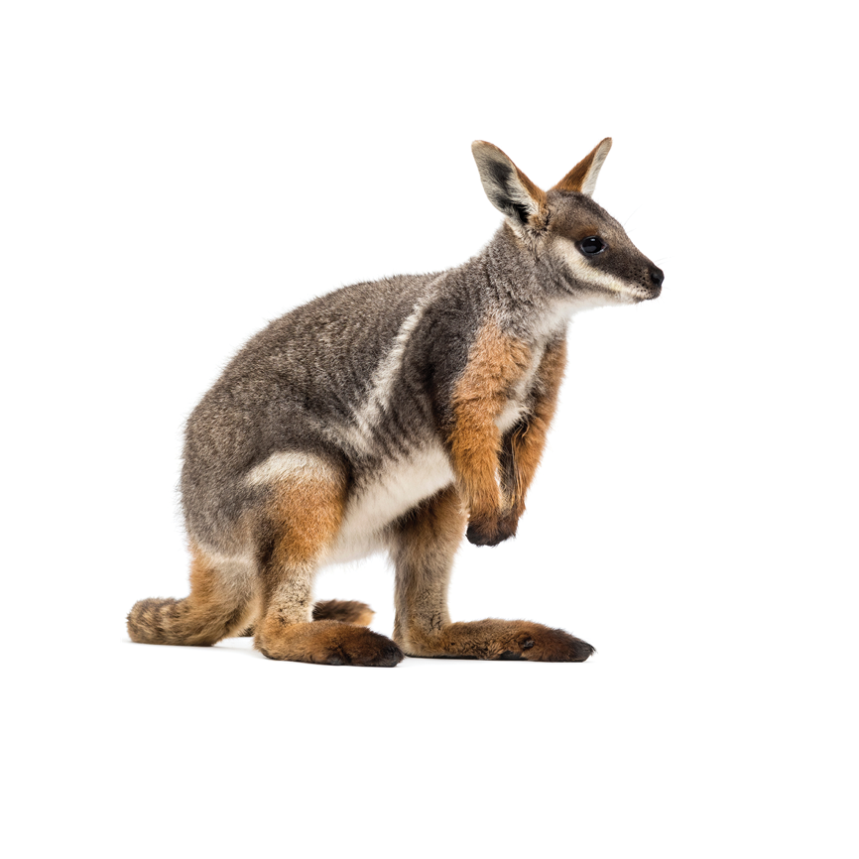

# MINISTER’S FOREWORD

**Australia’s unique array of native species and biodiversity is something we cherish,   
something that shapes much of our national identity and which is acknowledged for its   
global significance.**

At the heart of caring for our country and for our collective future is the need to work together to preserve that biodiversity. The threats from feral pests, changing climates, biosecurity hazards, and from our own human ‘presence’ are not new, but the strategies to meet these threats and others are constantly evolving. The Australian Government’s 2021-2031 Threatened Species Strategy highlights the need for both commitment and coordination as we plan the next phase of this process.

In the five years since the Commonwealth’s first ever Threatened Species Strategy, we have demonstrated the difference that can be made through raising awareness, focussing science-based strategies and through mobilising actions across our country. I’m proud to present the Australian Government’s second Threatened Species Strategy, which will guide even greater efforts over  
the next decade.

The 2021-2031 Threatened Species Strategy builds on the momentum created through the first Strategy, while expanding our ambition. It seeks to reduce the pressures on plant and animal populations and, ultimately, reduce the number of species in need of protection.

It is a strategy developed with input from environmental scientists, Commonwealth and State government agencies, environmental groups, Aboriginal and Torres Strait Islander organisations, private landholders, volunteer groups and private citizens.

Through the Office of the Threatened Species Commissioner, the Strategy will help coordinate the efforts across each of these partners, with further support from a new phase of the National Environmental Science Program which prioritises threatened species research, and from ongoing investments in the National Landcare Program, habitat restoration, safe havens and partnerships with zoos to establish captive breeding and species protection programs.

We all have a role to play in caring for our country and in supporting the recovery of our threatened species under this strategy – whether it is getting down on our hands and knees to pull out weeds, building barriers to keep out feral pests, installing nest boxes, collecting seeds, being citizen scientists to monitor where plants are growing and species are returning or just choosing the best things to plant in our own backyards.

Thanks for your care and thanks for your efforts protecting our unique biodiversity in the future.

**The Hon Sussan Ley MP**Minister for the Environment



# INTRODUCTION

**Our Australian plants and animals are unique and distinctive.**

They form a key part of our national identity, and are culturally significant to Aboriginal and Torres Strait Islander peoples, important to the health of our environment and a strong contributor to our economy.

Our native species and ecological communities face significant challenges with many compounding threats driving decline. Some of the main threats include invasive pests and weeds, habitat loss and fragmentation, and climate change and large-scale disasters.

The Australian Government launched the first Threatened Species Strategy in 2015 (the 2015 Strategy) to address these challenges, help prevent species decline and support species recovery. It established clear priorities to focus effort, introduced ambitious targets to measure progress and in 5 years delivered promising results to make a difference to Australia’s threatened species. Implementation was supported by the contributions of the Australian Government, state and territory governments, non-government organisations, scientists, and the community.

Building on progress to date, the 2021–2031 Threatened Species Strategy (the Strategy) delivers a framework for action to protect and recover our nation’s threatened plants and animals across Australia, spanning terrestrial, marine and freshwater environments. It sets a clear vision to drive practical on-ground action; identifies key action areas that are fundamental to the recovery of threatened species and ecological communities; and establishes principles for identifying priority threatened species and places to focus Australian Government effort.

**Two high-level objectives will guide the direction of the Strategy:**

**1. To improve the trajectories of priority threatened species by 2031**

**2. To improve the condition of priority places by 2031**

These objectives recognise the importance of measuring outcomes to track the impact of actions and continues the approach from the 2015 Strategy. A new place-based objective extends our focus to threat mitigation and habitat protection efforts across landscapes, providing location-specific support for threatened ecological communities and many threatened species.

The new Strategy will be underpinned by consecutive 5-year Action Plans. These Action Plans will be published as addendums to the Strategy, with the first to be released in the second half of 2021. Each Action Plan will identify priority species and places, outline specific actions to improve the trajectory and condition of species and places and set targets to measure progress. Five-year reviews will measure progress against targets and identify improvements to the Strategy and Action Plans to help meet the 10-year objectives.

Conservation is everyone’s business. This Strategy invites a collective effort toward the recovery of Australia’s unique threatened species. We can all play a role, whether it be through accelerating on-ground action, delivering new research and innovative tools, supporting or participating in community-led activities such as tree plantings, or raising awareness about how we can help our threatened species and ecological communities.

# AUSTRALIA’S THREATENED SPECIES AND ECOLOGICAL COMMUNITIES

**Australia is a country rich in unique plants, animals and ecosystems. We  
are one of 17 megadiverse countries with globally distinct levels of biodiversity.**

Our continent supports between 600,000 and 700,000 known species. More than 4,500 species of marine fish live in Australian inshore waters, Australian deserts support more lizard species than any other comparable environment, and 17% of the world’s parrots occur in Australia. Our continent is home to half of the world’s marsupial species. It is a centre for globally important Myrtaceae species (including our Eucalypts) and includes 2 global biodiversity hotspots – the south-western heathlands and woodlands, and the forests of eastern Australia.

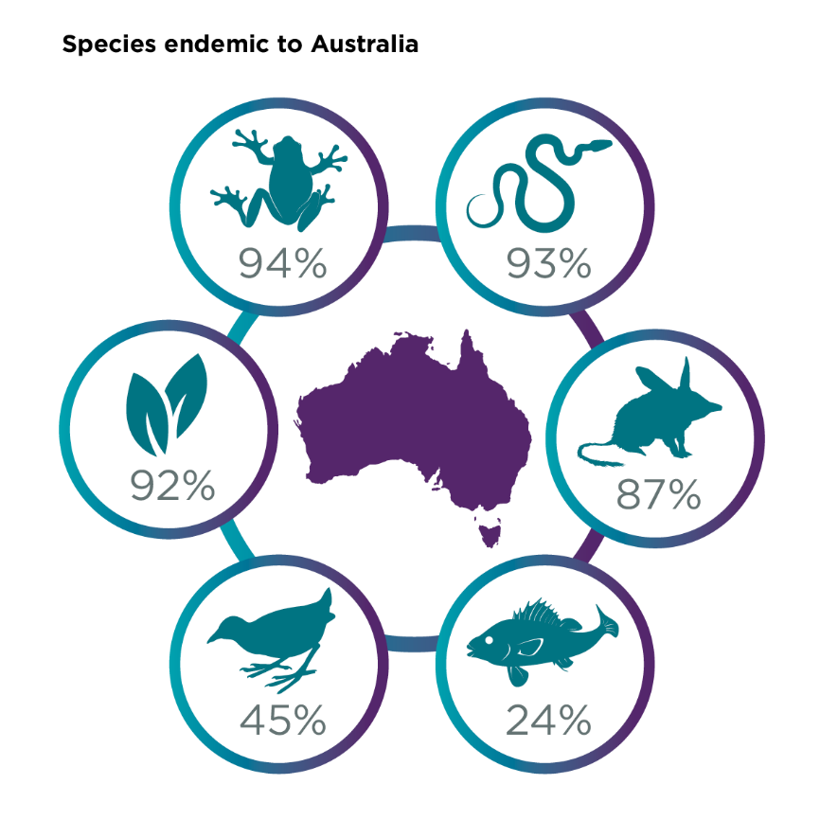

Many of Australia’s species are endemic to our continent – meaning they occur nowhere else on Earth. The uniqueness of Australia’s biodiversity is largely due to our continent being separated from other land masses for millions of years. We have more endemic mammals and reptiles than any other country in the world; over 90% of our flowering plants are unique to Australia, and in our southern coastal waters, as many as 90% of some groups of organisms are found nowhere else in the world.

Our native plants and animals evolved in isolation for over 45 million years and under many tens of thousands of years of interactions with our First Nations peoples. Through cultural practice, traditional owners have shaped the landscape, conserving the plants and animals inextricably connected to their lives and cultural identity. Traditional owners continue to care for country, contribute to our collective ecological knowledge and protect threatened and culturally significant plants and animals.

Australia’s unique species and ecosystems remain central to our health, well-being and national identity. Our biodiversity provides the building blocks for our survival, delivering services supporting clean air, water and shelter. As part of our everyday lexicon, species names are adopted by our sporting teams, appear on our money and official coat of arms, and inspire our art and culture.

Sadly, Australia has experienced significant biodiversity loss and decline. The period since European arrival has seen a rapid change in land management practices   
and the introduction of a diverse array of threats to Australia’s native species. Since European arrival, 104 extinctions of Australian species have been recognised under national environmental law.

Many Australian species – in particular mammals – have current distributions and population sizes that comprise only a minute proportion of their former range and abundance. Some of our species have become so rare that many Australians have never seen or interacted with them or heard about their plight.

Australia has more than 1,910 species listed as threatened under the *Environment Protection  
and Biodiversity Conservation Act 1999* (EPBC Act) across our marine, freshwater and terrestrial environments. Plants comprise more than half these species, with over 1,300 known to be threatened and at risk of extinction. More than 85 ecological communities – naturally occurring groups of native plants, animals and other organisms that interact in a unique habitat – are also listed as threatened.

With one of the highest rates of extinction in the modern world, it is clear that the trajectory for many of Australia’s native species must change. Australia’s threatened species and ecological communities are ours to protect now and for future generations. There is a lot to do and we all have a role to play.

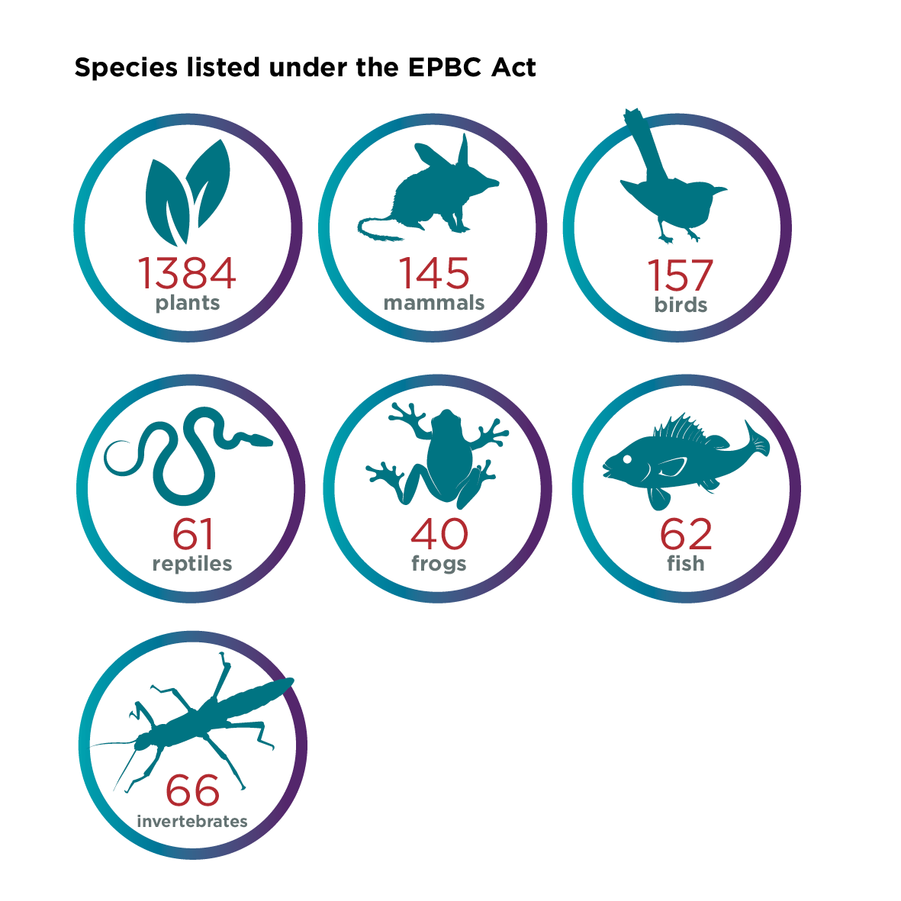

## Our biodiversity is under increased threat from multiple pressures

The short period since European arrival has led to substantial environmental change. Many plant, animal and pathogen species have been introduced, many vegetation types have been cleared, fire regimes have been modified, and freshwater and coastal environments have been transformed.

While hunting and deliberate culling was once a leading factor contributing to extinctions, conservation efforts have largely curtailed this threat. However, over the last 50 years Australia has witnessed a wave of extinctions due to emerging factors, including new invasive species and disease.

The impacts of some threats, such as invasive species and changes in fire regimes, are damaging in isolation, and devastating when they interact.

Today, many threatened species and ecological communities are suffering from the cumulative impact of multiple threats. The interactions between threats such as invasive species, habitat loss, changed fire regimes and altered hydrology have contributed to significant declines in species.

## A summary of key threats

**Invasive species**  
Invasive species, including feral animals (such as cats, foxes, deer, redfin perch, rabbits), weeds (such as exotic grasses and escaped garden plants) and diseases (such as Myrtle Rust, Phytophthera) impact native species through predation, habitat modification and degradation, and competition, reducing availability of resources.

**Clearing, fragmentation and declining quality of habitat**   
Clearing of native vegetation causes the loss, fragmentation and degradation of habitat, impacts water quality, disrupts essential ecosystem services, and increases the vulnerability of our native species to invasive species and fire.

**Climate change**   
A changing climate is impacting our threatened animals, plants and environments. It is reducing the number of animals and plants, and reducing the places where they occur. Rising temperatures, less rain, more intense and more frequent fires and storms, and ocean acidification are all having an impact.

**Changed fire regimes**   
Many of our native plants, animals and ecosystems are adapted to fire, and need fire at some stage in their life cycles to survive and flourish. Changes in fire regimes, including to frequency, timing and intensity of fires or in some cases the exclusion of fire, place many species and ecological communities (including aquatic ecosystems) at risk, by not supporting their climatic and ecological needs.

**Changed hydrology**   
Altered surface-water and groundwater hydrology can disrupt the timing and nature of ecological events, such as plant growth, and fish or bird breeding. River regulation can impact flow regimes, impact water quality (e.g. temperature, turbidity, dissolved oxygen) and create barriers to migration for aquatic biota.

While these key threats collectively impact high numbers of threatened species, a number of other threats to threatened species and ecological communities are also active, including pollution and overexploitation for human use. As concluded in the 2020 Independent Review of the EPBC Act, we need to build the resilience of Australia’s environment to withstand a range of current, emerging and future threats.

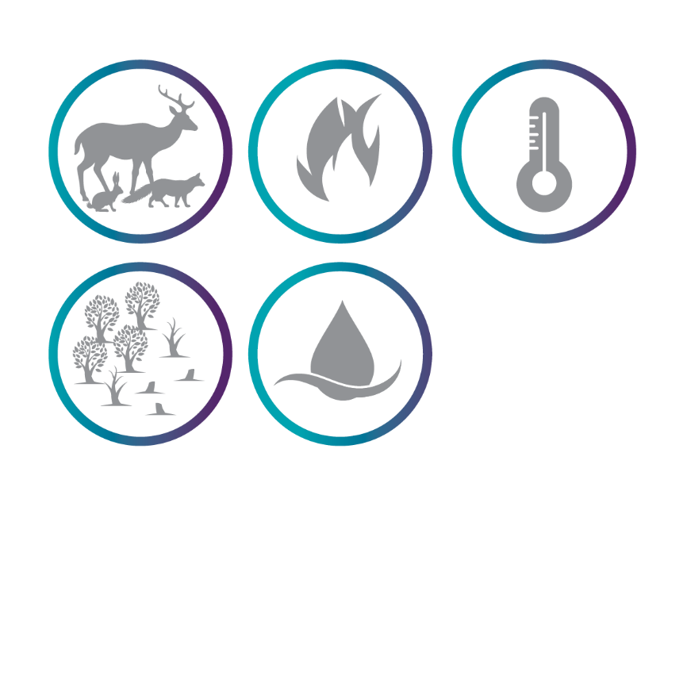

## We can make a difference

When we focus our effort, we can prevent extinction and put species on the path to recovery. There have been many success stories where species are still here due to collective action. Predator-free safe havens have prevented the Mala from going extinct and Humpback Whales have made a strong recovery since commercial whaling was banned.

There are many factors in the success of conservation efforts. Robust ecological knowledge and data, planning and coordination, effective legislation and policies, sufficient resources, monitoring   
and adaptive management are all key to species recovery. By working together, we can turn around species decline and ensure that future generations can enjoy Australia’s unique and diverse native animals, plants and ecological communities.

# THE AUSTRALIAN GOVERNMENT’S ROLE

## Our international commitments

Many of the most serious environmental pressures in Australia are global in scope and effect. Australia is a signatory to various international environmental agreements that are focused on conserving and protecting our living planet through cooperation between countries. Being a signatory party to these international agreements Australia joins with, and works alongside, other global country partners to help improve global and domestic environmental outlooks.

Through our international commitments, the Australian Government has the constitutional basis on which to create and implement national environmental legislation that underpins our regulatory activities.

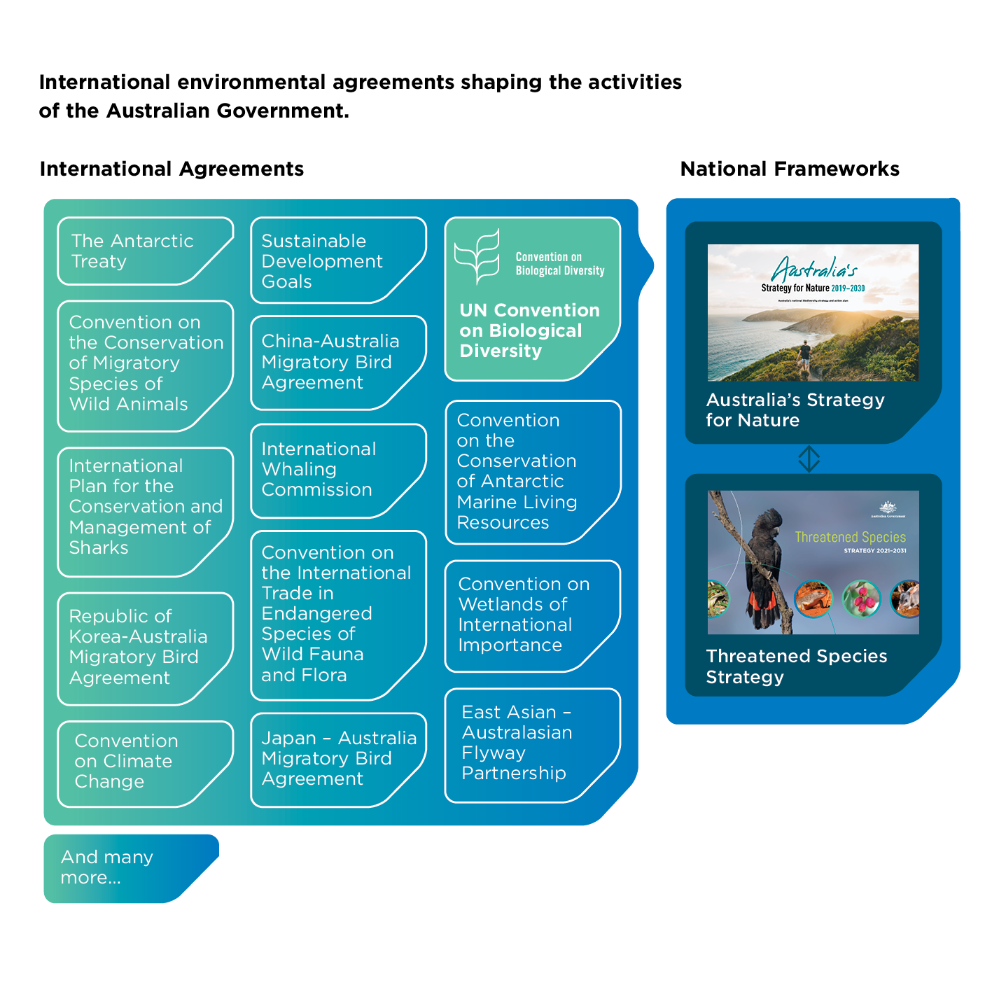

The **Convention on Biological Diversity (CBD)** is one of three international environment agreements that emerged from the Rio Earth Summit held in 1992. The CBD is the overarching global framework on biodiversity conservation for the United Nations system and links all related biodiversity-related conventions and cascading treaties.

Australia contributes to the CBD, delivering actions to meet global targets to conserve and use biodiversity in a sustainable manner and share benefits arising from genetic resources in a fair and equitable way.

Australia’s **Strategy** **for** **Nature** **2019–2030** is Australia’s biodiversity conservation strategy. It is the overarching framework for all national, state and territory and local strategies, legislation, policies, and actions that target nature. Australia’s Strategy for Nature coordinates national delivery of Australia’s commitments to the CBD, and other related multi-lateral and bilateral international agreements.

The Australian Government’s **Threatened** **Species** **Strategy** is a practical contribution to the national commitments set out in Australia’s Strategy for Nature – in particular the objectives and related progress measures to ‘maximise species secured in nature’.

## Protecting our threatened species and ecological communities is a shared responsibility

All governments across Australia – federal, state, territory and local – contribute to biodiversity conservation. State and territory governments are responsible for land and coastal waters management and the protection of species and communities within their jurisdictions. Species and ecological communities – and the threats they face – cross boundaries, so a national, coordinated approach to conserving our biodiversity across our broad land and seascapes is essential. The Australian Government has a primary role in managing and protecting matters of national environmental significance, including threatened species and ecological communities listed under the EPBC Act.

Many non-government actors complement, enhance, or lead efforts to protect and conserve Australia’s biodiversity. The actions of landholders, communities, traditional owners, the private sector and non-government organisations are critical in the recovery of our threatened species and threatened ecological communities. Indigenous rangers manage nearly half of our nation’s protected areas and other regional and remote landscapes and care for country that has enormous natural and cultural value.

Researchers and scientists inform robust and evidence-based decision making, which helps prioritise the actions needed to support species recovery. Dedicated community groups, such as ‘Friends of’ and citizen science groups are excellent stewards and advocates for the species they support, and they contribute meaningful data and information on how species are faring. Regional natural resource management (NRM) organisations determine local and regional priorities, targeting where to take practical action towards improving their local environment.

By working together, we can better focus and align efforts and use resources to their best advantage to protect and recover threatened species for the future.

## National systems for protection and recovery

The Australian Government delivers a suite of regulatory measures, policies, programs and on-ground management activities to support Australian plants, animals and ecological communities. These measures complement the work of state, territory and local governments and rely on the collaboration of many partners.

**Legislation and regulation**

The EPBC Act is the Australian Government’s central environmental legislation. It provides a legal framework to protect and manage nationally and internationally important flora, fauna, ecological communities and heritage places — defined as matters of national environmental significance.

The EPBC Act provides an annual cycle for nominating and assessing species for listing as threatened on advice from the independent Threatened Species Scientific Committee. The Common Assessment Method provides a consistent and harmonised approach to threatened species listings across Australia. Planning to recover species and ecological communities is undertaken through statutory conservation advices and recovery plans. Key threatening processes are also identified and listed under the EPBC Act, enabling threat abatement plans to be made to guide action to manage threats.

The EPBC Act also regulates significant impacts on listed species and communities and provides for strategic assessments that consider cumulative impacts to these matters. In 2020, Professor Graeme Samuel AC delivered the 10 yearly independent statutory review of the EPBC Act and the Australian Government is committed to working through the full detail of the recommendations with stakeholders.

Other Australian Government legislation that also supports threatened species protection and recovery include the Biosecurity Act 2015 and the Water Act 2007. The Biosecurity Act 2015 manages the biosecurity risks to Australia’s environment through regulation to prevent non-native pests, weeds and diseases from entering, emerging, establishing or spreading in Australia. The Water Act 2007 manages Australia’s largest water resource – the Murray Darling Basin – in the national interest. It aims to protect and restore the environmental assets of the Murray Darling Basin and also those outside the Basin where the Commonwealth owns water.

**National leadership and coordination**

National intergovernmental strategies like Australia’s Strategy for Nature, the Reef 2050 Long-Term Sustainability Plan, the Australian Pest Animal Strategy and the Australian Weeds Strategy provide overarching frameworks that help support and protect biodiversity by providing a focus on national effort and articulating objectives and roles.

The Australian Government also plays an important facilitation role in coordinating activities across government and non-government sectors to drive better outcomes for threatened species through coordinating groups such as the Feral Cat Taskforce and via plans, such as the National Carp Control Plan, which guide joint action.

The Australian Government helps to raise community awareness of threatened plants and animals in Australia, including through the Threatened Species Commissioner, who brings a national focus to threatened species and ecological communities, helping to raise their profiles through avenues such as social media, traditional media and community engagement.

The Australian Government also supports national data and information platforms to share knowledge about Australia’s species and ecological communities, working in partnership with Australian museums, herbaria and scientists.

**Land, water and marine management**

The Australian Government has direct land, water and marine tenure and species management responsibilities. These include the ongoing management of 6 national parks (of which half are managed jointly with the traditional owners) and the Australian National Botanic Gardens; 59 Australian Marine Parks; the Great Barrier Reef Marine Park; and Department of Defence properties. The Australian Government also manages water resources supporting national environmental assets of the Murray Darling Basin and in other places where the Commonwealth owns water. The Australian Government has a role in protecting the unique threatened marine and terrestrial species of the Antarctic region under the Protocol on Environment Protection to the Antarctic Treaty (Madrid Protocol) and other international agreements.

**Investment in research and on-ground actions**

The Australian Government invests in projects with on-ground outcomes for threatened species through a range of government programs. For example, funding through the National Landcare Program includes support for Australia’s NRM organisations to deliver local environmental and sustainable agriculture projects. Australian Government programs are increasingly incorporating monitoring of on-ground outcomes to better assess the impact of investments and inform future actions.

The Australian Government supports environmental and climate research through the National Environmental Science Program. This scientific research provides evidence for the design, delivery and on-ground outcomes of environmental programs; helps decision-makers, including from Aboriginal and Torres Strait Islander communities; builds resilience; and supports positive environmental, social and economic outcomes. The Australian Government also supports long-term monitoring, research and taxonomic – systematic studies through a range of programs, including the Great Barrier Reef Marine Monitoring Program, Regional Land Partnerships Long-term Monitoring Program, Australian Seed Bank Partnership programs and the Australian Biological Resources Study.

**Support Indigenous rangers and traditional owners**

The Australian Government provides funding to support the declaration and management of Indigenous Protected Areas (IPAs) which comprise close to half of the area of the National Reserve System. IPAs are areas of land owned or managed by Aboriginal and Torres Strait Islander groups. They are voluntarily managed as a protected area for biodiversity conservation through an agreement with the Australian Government.

The Australian Government supports Aboriginal and Torres Strait Islander peoples to protect and conserve land and sea country through the Indigenous Ranger Program. This important work on country contributes to the conservation of threatened species by protecting habitat, restoring traditional fire regimes and managing feral pests.

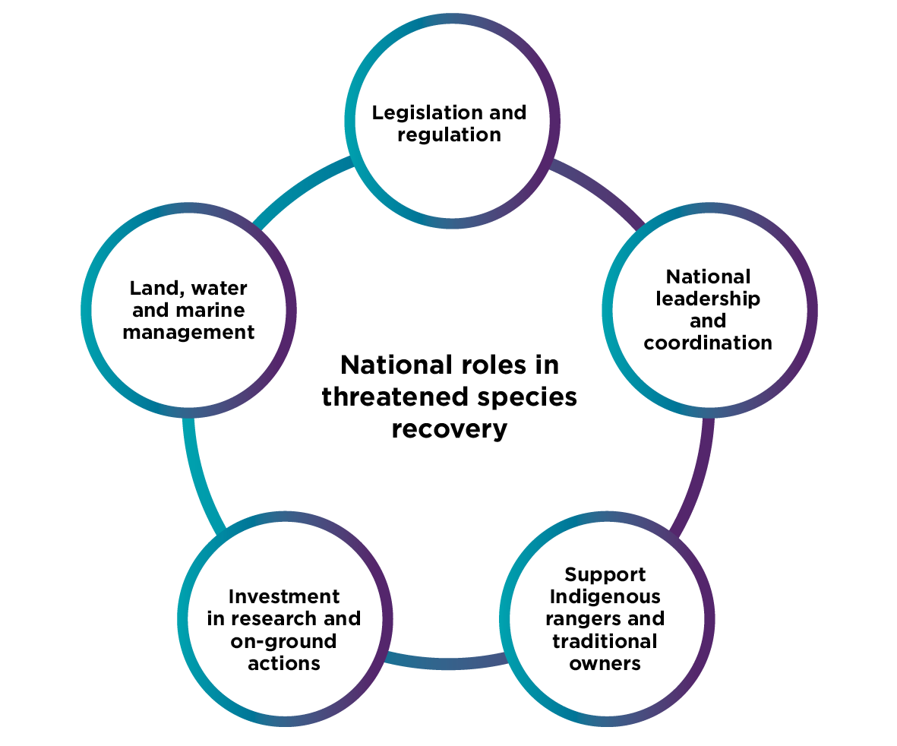

# ABOUT THE THREATENED SPECIES STRATEGY

## What is the Threatened Species Strategy?

The 2021–2031 Threatened Species Strategy outlines the Australian Government’s approach to protecting and recovering Australia’s threatened species and threatened ecological communities, setting a vision to focus action over the next 10 years. It functions as a road map to demonstrate how a combined approach of science, action and partnership can be used to achieve the long-term goal of reversing species declines and supporting species recovery, within a broader need for landscape-scale restoration to support all threatened species.

This new Strategy is an action-based policy that promotes practical on-ground actions supported by research and backed by measurable time-bound targets.

The Strategy establishes the principles underpinning the Australian Government’s priorities for action and investment in conservation of threatened species and threatened ecological communities. It helps to guide our investments in research and on-ground action and is informed by the outcomes and lessons learned from those programs.

Partnerships are critical for maximising resources and reducing duplication, and the Strategy provides a foundation for stakeholders to partner with the Australian Government.

The Strategy complements other Australian Government actions to protect threatened species and ecological communities, such as listing, strategic planning and the regulation of actions that impact them under the EPBC Act. The Strategy supports the objectives and operation of the EPBC Act – for example by increasing collection and synthesis of species data and information. It is consistent with the key reform directions recommended by Professor Graeme Samuel AC in the 2020 EPBC Act review and will be flexible to adapt and respond to any future legislative reforms.

## 2015 Strategy history and achievements

The Australian Government has supported threatened species outcomes through regulatory activities, conservation planning and program investments for many years, but the 2015 Strategy was the first Australian Government action-based policy dedicated to preventing extinction and recovering threatened species.

The 2015 Strategy set out an approach of science, action and partnerships to protect and recover Australia’s priority threatened plants and animals. It was boosted by prioritisation principles for focusing effort; and 4 key action areas where the Australian Government could achieve significant positive impacts.

Introducing measures of progress, the 2015 Strategy’s Action Plan included explicit and measurable targets to improve the trajectories of the 70 priority species, decrease the impacts of feral cats on our threatened species, increase the number of fenced areas and feral-free islands as safe havens, and improve recovery practices by 2020.

The 2015 Strategy’s targets were ambitious, with the view that it is best to set a high bar. Setting ambitious, outcomes focused targets was a strategic move to drive change, through incentivising action and ensuring accountability.

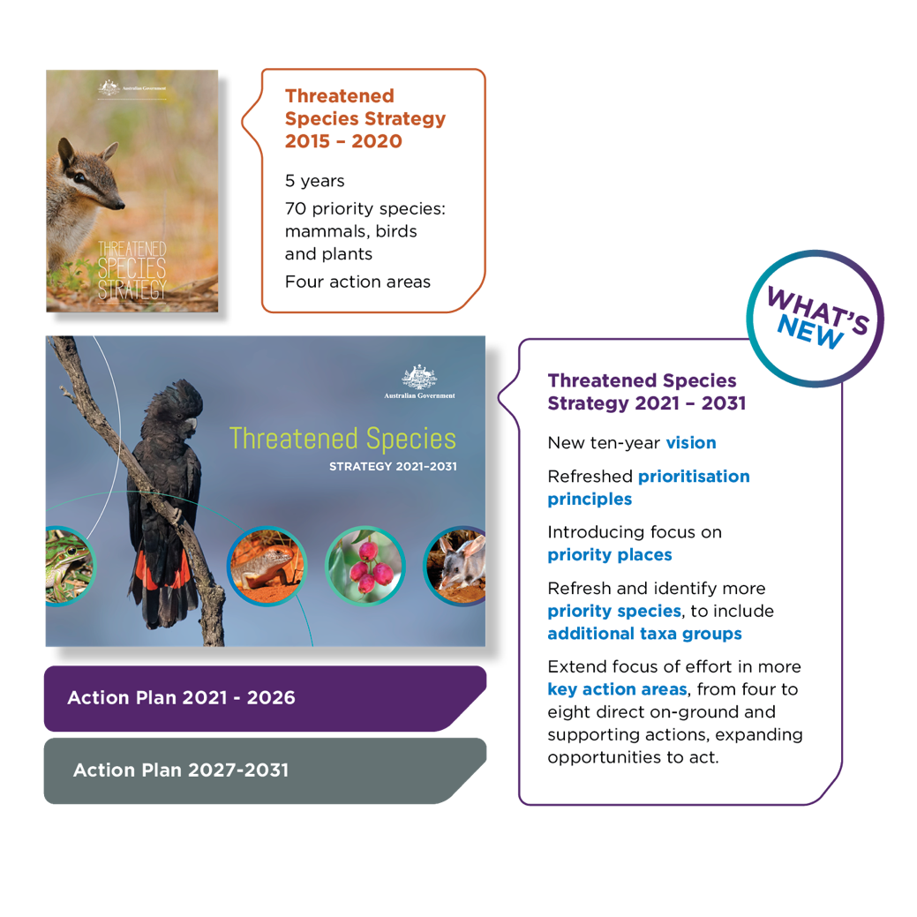

**Outcomes under the 2015 Strategy**

• Improved trajectory for 6 priority birds and 8 priority mammals within the space of 3 years.

• More than $535 million for over 1400 projects with outcomes that support threatened species mobilised by the Australian Government between 2014 and 2020.

• Legislative change to support feral cat management across all jurisdictions and on-ground control estimated to be occurring across more than 18 million hectares of the Australian   
landscape over 5 years.

• Increasing community awareness of Australia’s unique threatened species, the threats they   
face, and how we can all play a role in the fight against extinction.

Australia’s first Threatened Species Strategy was a successful model for raising awareness and mobilising action across the country to protect threatened species. Most importantly, it showed that focussed efforts can make a difference – if we reduce pressures on our wildlife then we can improve the trajectories of some of our most threatened species.

After 3 years, 6 birds and 8 mammals were on a better path. Populations of Norfolk Island Green Parrots had doubled through control of feral rats and cats together with nest protection and habitat rehabilitation, and emergency interventions had reduced the extinction risk of the Central Rock-rat and the Gilbert’s Potoroo.

The focus on priority plants led to the discovery of new populations of many species, such as the Purple Wattle. It prompted mass planting of other species such as the Silver Daisy Bush, and the number of threatened plants in conservation seed banks grew. In 5 years, we made significant inroads into tackling the impacts of feral cats, with many new predator-free safe havens established, and more than 18 million hectares of the Australian landscape under feral cat control.

Meeting ambitious targets within a 5-year time frame was always going to be a challenge and not all targets were achieved. This is a reminder that recovery can take time and the threats to our native species can be difficult to combat. We learned lessons along the way and our assessment of progress against targets is helping us to see which priority species need ongoing attention, and what actions are needed under future Action Plans. Annual progress reports on the 2015 Strategy are on the department’s website.

# A new threatened species strategy

**Australia’s Threatened Species Strategy 2021–2031 is the overarching framework for the Australian Government’s ongoing approach to protecting and recovering threatened species.**

This Strategy builds on the progress and lessons learned so far, including previous action taken by the Australian Government and its partners. The new 10-year strategy will continue to tackle the legacy threats that face threatened species, such as established feral pests and habitat loss, and will also address new and emerging challenges such as new invasive species and diseases and the impacts of climate change. The Strategy is consistent with the key reform directions in the 2020 EPBC Act review, which recommended a focus on landscape-scale planning to manage threats to and cumulative impacts on threatened species and approaches to foster private sector participation in restoration.

The Strategy will be accompanied by two 5-year Action Plans. Each consecutive Action Plan will establish priority species, places and actions to focus Australian Government efforts. Species and places of focus will be selected in accordance with prioritisation principles and we will measure and report on action and outcomes. The Strategy and accompanying Action Plans will guide the Australian Government’s priorities for investment under existing and ongoing environmental funding sources, such as the Natural Heritage Trust and associated programs. The Action Plans will also provide the opportunity to incorporate Australian Government reforms to the EPBC Act, including those in response to the recommendations of the 2020 EPBC Act review.

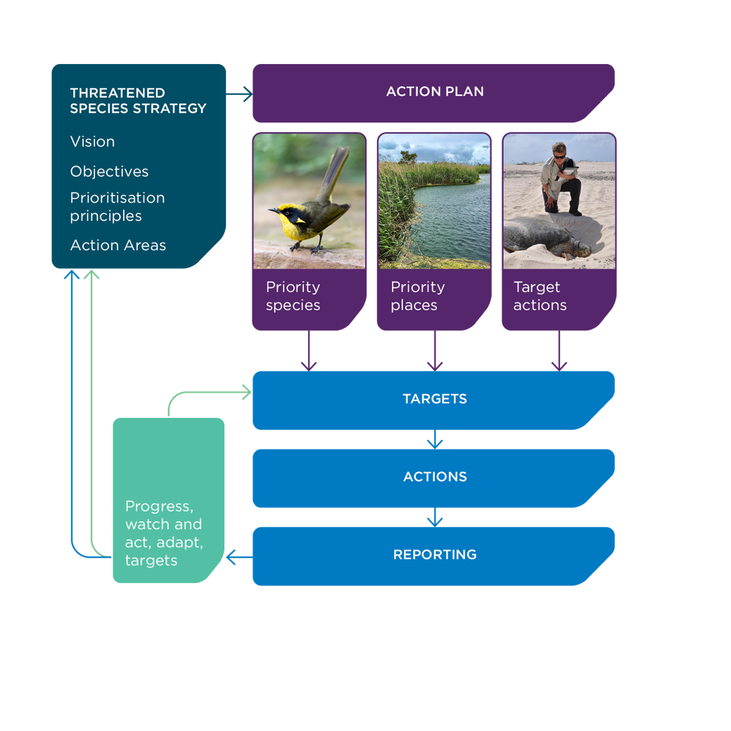

# OUR VISION

**Australia’s threatened species and ecological communities are valued, protected and on the path to recovery**

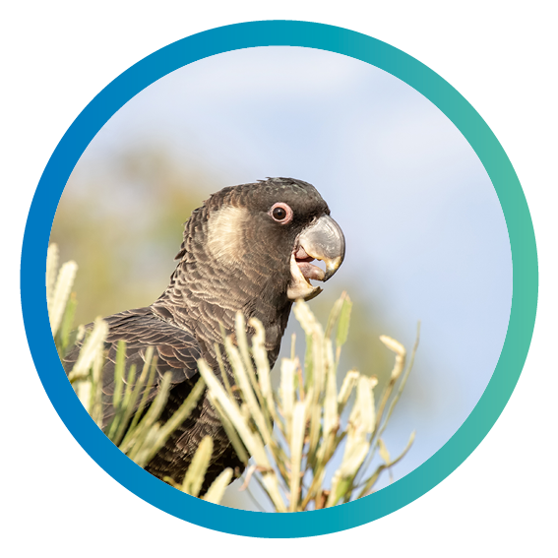

# Our APPROACH

**The Australian Government’s approach to managing threatened species is underpinned by science, action and partnerships.**

All 3 elements contribute to the work under the Strategy and Action Plans, from selecting species   
and priority places and determining actions to setting targets and reporting.

While science and good data can direct and inform actions and guide management responses, the success of the action depends on effective collaboration between all partners.

A genuine integration of science, action and partnership will achieve the greatest benefits for threatened species.

## Science

Knowledge is key. By engaging scientific experts and utilising reliable data for evidence-based decision making, actions will be chosen that are the most likely to succeed. By monitoring results and applying adaptive management approaches, successful actions can be identified, and interventions can be put in place to get better outcomes. By recognising and incorporating Aboriginal and Torres Strait Islander peoples’ immensely valuable ecological knowledge, gained and passed down over countless generations, we will deliver better outcomes for both the environment and people.

The Australian Government recognises that ecological knowledge about many threatened species is limited, due to lack of consistently collected, long-term, reliable and accessible data. The Strategy will support initiatives to improve the quality of data across the data supply chain, which will lead to improved evidence-based decision making for threatened species conservation.

## Action

Our knowledge informs our action. The Australian Government is committed to ensuring that actions to protect and recover threatened species and threatened ecological communities are based on prioritisation of resources and effort and backed with hard and measurable targets. Australian Government programs incorporate these priorities into investments and rely on science, environmental data and conservation planning documents to guide specific actions.

In this Strategy we will continue to support actions at local scales, such as habitat augmentation, where appropriate. We will also support more actions that will benefit threatened species across regional scales, such as threat mitigation, to increase the resilience of threatened species more broadly in the Australian landscape.

## Partnerships

Conservation is everyone’s business, and we all have a role to play.

Effective action relies on collaboration, including with state and territory governments and the dedicated efforts of volunteers, community groups, scientists, non-government organisations, land and sea managers and the business sector. It also relies on working closely with traditional owners, custodians of land and sea country for thousands of years, to enhance their involvement in decision-making, on-ground action, monitoring and research, through ‘right-way science’.

Working collectively builds on shared aspirations and brings together unique values and strengths to solve complex environmental challenges. By working together, resources can be more effectively prioritised and maximised to achieve positive results for threatened species and ecological communities. The strengths of all partners can achieve the best outcomes, from local knowledge and solutions, to the latest research and tools from across the globe. Australian Government leadership can coordinate efforts and resources, especially across jurisdictional boundaries.

# Objectives

**Two high-level objectives will guide the direction of the Strategy:**

**1. To improve the trajectories of priority threatened species by 2031**

**2. To improve the condition of priority places by 2031**

The objectives recognise the importance of outcome-based measurable targets to track the impact   
of collective action.

Focussing on priority threatened species will help target Australian Government effort and generate   
benefits for the priority species and other species that share their habitat. It continues the approach from the 2015 Strategy and will provide ongoing support to some previously identified priority species as well as new species from a broader range of taxonomic groups, including fish, amphibians, reptiles and invertebrates associated with a diverse range of environments including marine and freshwater ecosystems.

While the ultimate purpose is to remove species from the threatened species list, recovery is complex and takes time, particularly in the context of long-term historical decline. By measuring trajectories – that is whether a species is declining, stabilising or improving – we can assess how a species is tracking on the path to recovery.

Priority places is a new approach that recognises that some threatened species share habitat and that place-based action can support protection and recovery of more than one species. Place-based conservation can also provide coordinated action for poorly known and imperilled species, as well as listed threatened species. This new objective will focus efforts on threatened ecological communities and threatened species habitats, including places where many threatened species are co-located, mainland or island safe havens where major threats can be eliminated, and possible climate refuges for the future. Improvements in condition will be tailored to each place but could include actions to eliminate invasive pests or improve habitat quality.

Actions that will help meet these objectives for the identified priority species and places might include habitat restoration or wide-scale threat management. Actions such as these will have flow on benefits for other species that occupy the same habitats, landscapes and seascapes.

The list of priority species, continuing and new, and priority places will be set out in each consecutive Action Plan following a process of selection using the prioritisation principles.

# Principles for selecting priority species and places

**Prioritising attention and effort on selected species and action areas led to tangible conservation gains under the 2015 Strategy and this approach will  
be continued in this Strategy.**

Priority species and places will be selected in accordance with 6 prioritisation principles and included in the new Action Plan. The 6 prioritisation principles help us identify where Australian Government investment in threatened species recovery can be strategically targeted to best meet the Strategy objectives.

The 6 principles were developed in consultation with stakeholders and provide a transparent basis for the selection of species and places as priorities for coordinated, national attention under the Strategy’s Action Plans.

Five of the prioritisation principles (risk of extinction, multiple benefits, feasibility and effectiveness, importance to people and uniqueness) focus on characteristics of threatened species and places that make them good candidates for coordinated, national action. Not all species and places will align with all 5 principles. For example, some species at high risk of extinction may be poorly known by the community and yet have an important functional role in the ecosystem – just because a species is not charismatic does not mean it will not be a priority for action. The sixth principle – representativeness – applies to the suite of priority species and places; to ensure that there is a balance across different taxonomic groups, environments and parts of Australia.

# Six prioritisation principles

## Risk of extinction

Prioritising species and places under severe and imminent threat

* Threatened species at high risk of imminent extinction; or places that are critically important to threatened species where suitable habitat is at risk of a dramatic decline.
* Threatened species or ecological communities that are highly restricted or limited in distribution and/or size, and where a foreseeable chance event could cause extinction.

## Multiple benefits

Prioritising species and places where recovery action will benefit other species

* Threatened species that share common threats or habitats with other threatened species, so that action to mitigate the threat or improve habitat would benefit multiple threatened species.
* Places that contribute to the persistence of biodiversity (e.g. refugia under projected climate change impacts) and/or are important habitat for many species.
* Threatened species and places that provide demonstrated benefits to other species (e.g. a keystone species that has a functional role or a place that provides an ecosystem service).

## Feasibility and effectiveness

Prioritising species and places where action can make a difference and is cost-effective

* Threatened species and places where actions to mitigate threats or support recovery are well understood and can be practically implemented at ecologically meaningful scales (e.g. where the success of conservation actions has been effectively demonstrated through monitoring and evaluation).
* Threatened species and places where effective prior investment by the Australian Government can be built on and/or investment by other organisations and governments can be complemented.
* Threatened species and places where effective collaboration and coordination of conservation effort across organisations and governments will improve likelihood of recovery.

## Importance to people

Prioritising species and places of cultural significance

* Threatened species and places that hold special significance to communities, including Aboriginal and Torres Strait Islander peoples.
* Threatened species and places that are valued by the Australian community, with potential to build strong and continued support for conservation into the future.

## Uniqueness

Prioritising species and places that are unlike any other

* Threatened species that are taxonomically distinct – that is, species that have no close relatives.
* Threatened species or places that are unique to Australia and not found anywhere else.

## Representativeness

Achieving balance in selected species and places

* Include threatened species from a range of taxonomic groups, with a balance between charismatic and other species.
* Include threatened species and places from different parts of Australia, including land, freshwater and marine environments and from urban, regional   
  and remote areas.
* Include places from across a range of tenures, including public and private land, and with different levels of statutory protection.
* Include a range of different places (e.g., climate refugia, island and mainland safe havens, sites for restoration).

# Action areas

**This Strategy identifies 8 key action areas that are fundamental to the recovery of threatened species and where the Australian Government will focus and build on efforts.**

## Direct Action Areas

1. Mitigating new and established threats
2. Conserving, restoring and improving habitat
3. Emergency preparedness and response
4. Climate change adaptation and resilience

## Supporting Action Areas

1. Effective planning for conservation
2. Knowledge and tools
3. Forging stronger partnerships
4. Community leadership and engagement

They include direct on-ground actions, such as threat mitigation and habitat conservation and restoration, as well as supporting actions that strengthen the effectiveness of on-ground interventions, such as planning, research and community participation.

Action across these 8 areas supports the recovery of priority species and advance species recovery more broadly. They build on the momentum of action across 4 key areas targeted by the 2015 Strategy – tackling feral cats, safe havens for species most at risk, improving habitat, and emergency interventions to prevent extinctions.

Action areas are complementary and not mutually exclusive. For example, fire management activities designed to improve habitat condition could also help to mitigate the threat of invasive species. For many priority species and places, actions will be needed across multiple action areas. Some of these actions will focus on providing specific benefits at local scales for priority species, while others will be broader in range, with positive impacts across landscapes intended to benefit multiple species.

The Strategy identifies the broad action areas. The 5-year Action Plans will identify specific actions and targets under each of these 8 action areas. Actions will be focused on improving the trajectories of priority species and the condition of priority places but will also contribute more broadly to the Strategy’s long-term vision that **Australia’s threatened species are valued, protected and on the path to recovery.**

Conservation advices, recovery plans and threat abatement plans remain a critical part of planning for the recovery of individual species and ecological communities and will continue to provide scientific evidence and recommended actions. The Action Plans will support the implementation of these plans and advices for priority threatened species and in priority places.

## FOCUS ON ACTION AREAS

1. **Mitigating new and established threats**

Australia has seen a range of threats to our native species introduced since European arrival. Many of these threats now operate across much of our land, and in our oceans. They include feral predators, feral herbivores, invasive weeds, aquatic pests and changes to fire regimes. They operate independently and together to drive species decline.

Some threats have been established for over 100 years and are ubiquitous across Australia, while others arrived more recently and remain confined in limited locations. However, these need to be managed carefully as they will cause more harm if they spread. For example, Myrtle Rust is a significant emerging threat for many native Australian plants.

The Australian Government is focused on supporting threat mitigation actions that can be practically undertaken now or can begin in the next few years and that will make a real difference to threatened species during the Strategy’s time frame. These could include threat abatement planning at the appropriate scale; the development of new tools and technologies to effectively and efficiently manage feral pests and weeds across the landscape; and practical interventions that are coordinated across tenures and jurisdictions.

Under the Action Plans, threat mitigation actions could include coordinated threat management in open landscapes and threat elimination in targeted areas. Expanding the network of island and mainland predator-free safe havens and supporting wild-to-wild translocations will all help to manage and remove the threats and help boost wild populations of some of our most threatened species.

This action area will build on the success of our 2015 Strategy’s focus on feral cats and securing safe havens; and extend our efforts to other established or emerging invasive pests or weeds where there is a pressing need for Commonwealth leadership and coordination – for example, feral herbivores, major weeds and emerging plant diseases like Myrtle Rust.

Actions supported under the Strategy will complement the work of the Chief Environmental Biosecurity Officer in preventing the establishment and spread of exotic pests, weeds and diseases that could put additional pressure on our native terrestrial and marine species, complementing actions identified through the National Priority List of Exotic Environment Pests, Weeds and Diseases and across the biosecurity continuum of measures.

**2. Conserving, restoring and improving habitat**

All animals and plant species need suitable and high-quality habitat to survive and flourish. Improving the extent, connectivity and condition of habitat across our landscapes will support the persistence and recovery of threatened species.

Commonwealth, state and territory environmental laws regulate actions that involve land clearing and cause habitat loss, fragmentation and degradation. The Strategy complements the EPBC Act by enabling activities to restore and rehabilitate habitat and provide incentives for habitat conservation to support landscape-scale restoration. The Action Plans also provide the flexibility to respond to and implement any new approaches shaped by future legislative reforms.

The Strategy will support the protection, restoration and improvement of habitat for priority threatened species, and in identified priority places – which could include threatened ecological communities, habitats that support multiple threatened species, and climate change refugia. The Strategy will also support landscape level interventions that benefit threatened species more broadly, such as protecting key habitat in collaboration with landowners and land managers, connecting key habitat – for example through the creation of vegetation corridors to enable species movement; addressing barriers to fish passage in aquatic environments; and improving fire management practices, including cultural burning by traditional owners.

Actions could include identifying habitat critical to the survival of priority threatened species, delivery of incentives for the stewardship of threatened species habitat on private land; and on-ground interventions such as revegetation, installing environmental water flow measures, erosion control, effective weed and fire management and habitat augmentation (such as provision of artificial nesting hollows and artificial aquatic breeding habitat to support fish).

**3. Emergency preparedness and response**

Species can be pushed dangerously close to extinction or face significant impacts within a short timeframe, and we must be quick to respond. Responding rapidly to emergency events, such as disease outbreaks and bushfires, was an important feature of the first Strategy.

This Strategy and its five-year Action Plans will also be intentionally flexible in nature to enable rapid responses to natural disasters and other emergency events to help avert extinctions. The 2019–2020 Black Summer bushfires across southern and eastern Australia had a devastating impact on our native species and ecosystems, with experts identifying more than   
800 native plants, animals and ecological communities   
in need of urgent management intervention.

The Australian Government’s rapid and strategic emergency response to the bushfires, designed and delivered in collaboration with state and territory governments, scientific experts and the community, is supporting the persistence and recovery of many threatened species and their habitats. Ongoing efforts will be needed to recover and build the resilience of these bushfire-affected threatened plants and animals into the future. We understand that new risks and natural disasters may arise over the course of the Strategy.

These could include acute events, such as a severe storm, catastrophic fire, or a disease outbreak that rapidly diminishes wild populations, but may also include deepening chronic pressures, such as prolonged severe drought. Through the Strategy, we will strive to improve anticipation and preparation for emergencies so that the impact of future natural disasters and other damaging events on our threatened species is reduced, recognising that the intensity and frequency of such events is likely to increase with a changing climate. The Australian Government will work with state and territory governments, and the community, to identify how we can improve responses to future emergencies, including enhancing our agility to react and respond quickly when emerging risks are urgent. This could include better integration of biodiversity needs into emergency planning and response and enhanced collaboration in the collation and sharing of data to rapidly assess the impacts of disasters on plants and animals, consistent with recommendations of the Royal Commission into National Natural Disaster Arrangements.

Establishing insurance populations of threatened species is one strategy to ensure that future catastrophic events do not lead to species extinctions. The establishment of captive-bred populations and genome banks for threatened animals and seedbanks for threatened plants, complemented by wild-to-wild translocations and supported by the network of island and safe havens, help to reduce the risk of extinction from stochastic events.

**4. Climate change adaptation and resilience**

The changing climate is driving changes in species distribution and the composition and functioning of ecological communities, exacerbating the impacts of other pressures such as habitat fragmentation and invasive species.

Reducing the impact of established pressures on threatened species, such as by tackling invasive pests and weeds and conserving habitat, will build the resilience of our native species and support their capacity to adapt to a changing climate – but there are targeted actions that can be taken to improve the adaptive capacity of our native species and places.

Actions that are needed to assist threatened species to adapt to a changing climate, taking account of interactions with other threats, include risk-based conservation planning, identifying and conserving places that will be refugia for threatened species into the future and protecting and restoring habitat corridors to help threatened species migrate to new locations.

This will require a coordinated effort between public and private landholders, scientists, land and water resource managers and traditional owners; and further guidance to assist decision-makers.

We also need improved collection, storage and sharing of environmental data across government jurisdictions and research entities. This will require focussed collaboration across all elements of the data supply chain to build holistic and agreed solutions.

As parts of the landscape become unsuitable for species survival, translocations of species and populations into new, more suitable locations outside their natural range may be needed – in a process called ‘assisted colonisation’. Assisted colonisation has been attempted for native species like the Western Swamp Tortoise, whose wetland habitat is drying under a changing climate, and may be an important conservation strategy for many species into the future.

There will also be a need to undertake habitat restoration, including revegetation activities, and targeted environmental water delivery, with an eye to future climate scenarios. This could include planting species and provenances that are more likely to survive and thrive in a changing climate.

**5. Effective planning for conservation**

The Strategy will support a range of different approaches to conservation planning, including regional planning and multi-species planning, in addition to more focused single-species conservation advices and recovery plans. Supporting a suite of approaches recognises the complexity of issues facing threatened species and acknowledges that the most effective approaches to threat management and recovery action are different between species and across Australia’s diverse landscapes.

The Threatened Species Scientific Committee recommends that a combination of recovery instruments is appropriate, and implementation of the Strategy will be guided by the committee’s advice on the best approach for priority species and places. This aligns with reform directions recommended by the 2020 EPBC Act review, which highlighted the need for better planning, including a greater focus on regional planning to identify recovery priorities and inform investment and regulatory decisions at the landscape scale.

All species listed as threatened under the EPBC Act require a conservation advice and some species require a recovery plan, which may be incorporated in regional and multi-species recovery plans. These planning documents, prepared collaboratively with stakeholders, set out the actions needed to stop the decline, and support recovery of, one or more threatened species. They provide a detailed, evidence-based and objective-driven framework of action. Threat abatement plans are another instrument for conservation. They outline the research, management and other actions necessary to reduce the impact of a listed key threatening process on native species and ecological communities.

These statutory documents inform the specific actions that will be required to improve the trajectories of priority species and the condition of priority places under the Strategy. They also support decision-makers to assess the impact of actions on threatened species and ecological communities and guide investment in on-ground action and research, including the targeting of Australian Government investment.

The Australian Government is committed to ensuring we have conservation advices, recovery plans and threat abatement plans where required, for all listed threatened species, ecological communities and key threatening process under the EPBC Act.

Planning documents will continue to be developed and updated in collaboration with stakeholders. They will focus on supporting ‘right-way’ recovery planning involving traditional owners and Aboriginal and Torres Strait Islander land and sea managers in decision-making so that traditional ecological knowledge and practice are included in recovery actions, research and monitoring activities.

Implementation of conservation planning documents is a shared responsibility between all levels of government, non-government organisations, landholders, research scientists and community groups. Collaboration between all partners, supported by fit-for-purpose governance arrangements, is needed to coordinate effort and monitor progress. Through the Strategy and recovery teams, the Australian Government will work collaboratively with state and territory governments, and other recovery partners, to coordinate the implementation of conservation planning documents for priority species.

Recovery teams are a collaboration of partners brought together by a common purpose to develop and/or coordinate the implementation of a conservation advice, recovery plan or recovery program for one or more threatened species or ecological communities.

Not all recovery programs need a recovery team, as other arrangements are in place to guide recovery action, but they can be highly effective for threatened species with complex recovery needs and where many different people are involved in the recovery effort.

Through the Strategy, the Australian Government will support recovery teams by actively participating in teams, sharing best-practice guidelines for recovery team governance and working with recovery teams to facilitate national registration.

**6. Knowledge and tools**

Collecting and managing information about Australia’s environment – from species observations and soil characteristics to trends in water availability and climate variability – underpins evidence-based decisions.

By drawing on science – engaging with scientists, citizen scientists and data managers – and by incorporating traditional owners’ unique knowledge of the environment into our recovery programs, we can be confident we are choosing the actions most likely to succeed.

Action under the Strategy will be informed by research, through a close and continuing partnership with National Environmental Science Program research hubs and the scientific community more broadly.

We need to learn and adapt to what works to get the best outcome for our threatened species, and our knowledge base is improved by monitoring species’ population trends and the impacts of our interventions over time. Many of our threatened species are poorly understood and there is a need to improve long-term monitoring to inform management action and effectiveness.

Through the Strategy, we will support the development of monitoring standards and improved monitoring and national data-sharing for priority threatened species. This should include establishment of baseline data for priority species and places with ongoing collection of time-series data, where data is collected and stored under nationally agreed standards and protocols, so that we can assess progress against our objective to improve trajectories. This is linked to the Australian Government’s commitment to improving how we monitor threatened species outcomes from program investments such as the National Landcare Program.

Sharing up-to-date, accessible and accurate information at appropriate scales is important for decision-making for threatened species recovery. The Australian Government will continue to develop, improve and maintain tools, databases and repositories that enable data to be captured, collated, analysed and shared – for example, the Digital Environmental Assessment Program – Biodiversity Data Repository and the Species of National Environmental Significance spatial dataset. This will require close collaboration with state and territory governments to improve the quality of data and inter-operability of our data systems.

Australia is a large continent with widespread threats. To have a positive impact at scale, we need to find new, innovative tools and technologies to monitor threatened species and tackle threats more effectively and efficiently. Through the 2015 Strategy, the Australian Government supported the development and commercialisation of new feral cat control technologies (such as the Curiosity bait and Felixer Grooming Trap), and supported research trials of new monitoring techniques, including environmental DNA to detect species, as well as drones, spatial mapping systems and acoustic telemetry to monitor species movements.

The Strategy will support actions to develop and deploy new tools and technologies to improve threatened species and threatened ecological communities monitoring and drive threatened species recovery at scale. This could include digital and genetic surveillance technologies for pest and weed detection, tools for automated data collection, biobanking, development of new biocontrols, accelerated use of genomics and population genetics to inform species management, and exploration of the longer-term potential for the use of genetic and digital technologies for vertebrate pest control.

**7. Forging stronger partnerships**

We all have a role to play to ensure that threatened species are protected for the future. Only by working together can we use our collective expertise and resources to their best effect. The Strategy provides a platform for the Australian Government to strengthen relationships with existing conservation partners and build relationships with new partners – it is an invitation to the community to work together on shared threatened species priorities.

The new Strategy will build stronger partnerships across all levels of government, to ensure complementarity of effort and coordination of action to tackle threats, such as invasive pests and weeds that cross borders. We will continue to work closely with NRM organisations, which are important delivery partners for our programs, and with non-government organisations and local community groups, such as ‘Friends of’ groups, to identify shared priorities and support and showcase local action.

Through the Strategy, the Australian Government will partner with traditional owners to foster ‘right-way’ scientific research and support ‘right-way’ recovery of priority threatened species and places, engaging traditional knowledge and cultural aspirations in decision-making, recovery action and monitoring.

Landholders and land managers make an important contribution to the protection and conservation of threatened species, with farmers managing over half of Australia’s land area. We need to find new opportunities to work collaboratively with private landholders and the business sector to promote   
long-term stewardship of threatened species habitat.

Efforts to leverage capacity and funding are also important to species conservation. The 2020   
EPBC Act review found that to deliver the broad restoration required to address past loss, build   
resilience, and adjust the environmental trajectory from its current path of decline, greater collaboration is needed between governments and the private sector to invest in the environment. Innovative financing mechanisms and co-funding arrangements will be explored to help make the conservation dollars go further, and to support the private sector’s growing ambitions to invest in the management and restoration of our biodiversity.

**8. Community leadership and engagement**

Raising awareness of our threatened species and empowering the community to interact with nature and participate in and lead recovery efforts is a key focus of the Strategy. Effective conservation needs professional expertise – but it is also buoyed by those with the local knowledge, commitment and enthusiasm.

We can all connect with nature in different ways and experience the benefits it generates for our health, wellbeing and quality of life. Creating opportunities to learn more about, and interact with, our most threatened species builds awareness and generates increased public support for action and investment in recovery.

Through the Strategy and Action Plans, the Australian Government will continue efforts to raise the profile of Australia’s lesser-known species to help the Australian community get to know our remarkable plants and animals, understand what threats they face and promote ways in which the community can lead or get involved in recovery efforts.

Actions could include education campaigns – for example, to promote responsible pet ownership or planting of wildlife gardens; supporting citizen scientists to monitor threatened species; fostering local leadership in threatened species management; and encouraging community stewardship of local threatened plants and animals, including in our cities.

We will continue to share success stories, celebrate the people in our community who are our species champions and value the contributions made by traditional owners on country.

# ACCOUNTABILITY, MONITORING AND ENSURING SUCCESS

**Monitoring and reporting are an important part of any recovery effort.**

Reporting helps to validate efforts, maintain momentum for action, and ensure transparency, accountability and effective and efficient investment.

Regular measurement gives clarity on whether our collective efforts are improving the trajectory of threatened species and the condition of priority places and allows for adaptive management – learning from what has been done and doing it better. Knowing how we are doing is also important in reporting on progress against our international and national obligations to maximise the number of species secured in nature and improve their conservation status.

Measuring progress against the Strategy’s 2 outcome-based objectives will help us know whether the Action Plans are delivering results for our priority species and places. The Action Plans will identify specific actions and set targets to measure progress. They will include measurable, short-term activity-based targets as well as longer-term outcome-based targets – to track our action and its impact. Recovery can take time and it may not be possible to detect population change over short timeframes, so interim measures of progress will be needed.

The Office of the Threatened Species Commissioner will prepare 5-yearly reports on progress against the two 10-year objectives; and one mid-way report for each 5-year Action Plan on progress against targets. As conservation is a shared effort, reporting will reflect the collective effort and contribution of all partners involved in implementing the Action Plans.

The Strategy and Action Plans will be adaptive to the reporting outcomes and other information. For example, threatened species may be added or removed from the priority list based on new information. Species that are prioritised under the first five-year Action Plan, but do not need ongoing active intervention after 5 years may be placed on a ‘watch list’.

Reporting of progress in recovering threatened species also occurs in reviews of individual conservation advices and recovery plans, the State of the Environment Report, scientific papers, state and territory government reports, and evaluations by non-government organisations like the International Union for Conservation of Nature. All these information sources will help to inform   
our assessments of success.

# CONCLUSION

**The 2021–2031 Threatened Species Strategy is the next step in the Australian  
Government’s approach to protecting and recovering Australia’s threatened species and threatened ecological communities.**

It is also an invitation to all Australians to collaborate on threatened species conservation.

The Strategy sets the Australian Government’s high-level objectives, prioritisation principles and areas for action for the next 10 years. The Action Plans will provide the vital details about how the Strategy will be implemented.

While our native species face many challenges, together we can help realise our vision that Australia’s threatened species are valued, protected and on the path to recovery.

# Related links

**Atlas of Living Australia**ala.org.au

**Australian Biological Resources Study**environment.gov.au/science/abrs

**Australia’s international role in conserving biodiversity**environment.gov.au/biodiversity/international and environment.gov.au/water/wetlands/ramsar

**Australia’s Nature Hub**australiasnaturehub.gov.au

**Australia’s Strategy for Nature 2019-2030**australiasnaturehub.gov.au/national-strategy

**Australian Weeds Strategy and the Australian Pest Animal Strategy**agriculture.gov.au/pests-diseases-weeds/pest-animals-and-weeds

**Chief Environment Biosecurity Officer**agriculture.gov.au/biosecurity/environmental/cebo

**Commonwealth Environment Water Holder**environment.gov.au/water/cewo

**Commonwealth Marine Parks**parksaustralia.gov.au/marine

**Emissions Reduction Fund**cleanenergyregulator.gov.au/ERF

**Environmental Restoration Fund**environment.gov.au/environment-restoration-fund

**EPBC Act and threatened species regulatory protection**environment.gov.au/biodiversity/threatened

**Feral cat Threat Abatement Plan**environment.gov.au/biodiversity/threatened/publications/tap/threat-abatement-plan-feral-cats

**Independent review of the EPBC Act – 2020 final report**epbcactreview.environment.gov.au/resources/final-report

**Indigenous Ranger programs**  
niaa.gov.au/indigenous-affairs/environment/indigenous-ranger-program

**Indigenous Protected Areas**environment.gov.au/land/indigenous-protected-areas

**National Environmental Science Program**environment.gov.au/science/nesp

**National Landcare Program**nrm.gov.au/national-landcare-program

**National Priority List of Exotic Environmental Pests, Weeds and Diseases**agriculture.gov.au/biosecurity/environmental/priority-list

**National Reserve System**environment.gov.au/land/nrs

**Parks Australia**environment.gov.au/topics/national-parks/parks-australia

**Royal Commission into National Natural Disaster Arrangements**naturaldisaster.royalcommission.gov.au

**Species Profile and Threats Database**environment.gov.au/cgi-bin/sprat/public/sprat.pl

**The Reef Trust**environment.gov.au/marine/gbr/reef-trust

**Threatened Species Commissioner**environment.gov.au/biodiversity/threatened/commissioner

**Threatened Species Strategy**environment.gov.au/biodiversity/threatened/publications/strategy-home

**Threatened Species Scientific Committee**environment.gov.au/biodiversity/threatened/tssc