**Formatting guide for tea tree oil levy returns with levy payer information**

|  |  |
| --- | --- |
| **Who must lodge the levy return?** | A producer of tea tree oil who:   * produces and sells, by retail sale, tea tree oil in Australia; and * exports tea tree oil, with no intermediary,   if the total amount of levy the producer would be liable to pay in relation to tea tree oil sold by retail sale is equal to or greater than $25 in the financial year.  Note: A producer who sells tea tree oil by retail sale and does not export tea tree oil in a half year, must lodge an annual return (unless the total amount of levy the producer would be liable to pay in relation to tea tree oil sold by retail sale in the financial year is less than $25).  OR  A producer who only exports tea tree oil in a half-year (that is, the person who owns the tea tree oil immediately before export from Australia), with no intermediary.  OR  An intermediary in relation to a producer of tea tree oil, including a first purchaser, buying agent, selling agent or exporting agent. |
| **Who is the levy payer for this return?** | The producer - the person who owns the tea tree oil immediately before it is first sold in Australia or exported from Australia and is liable to pay the levy or charge. |

All levy returns for tea tree oil transactions from 1 January 2023 onwards must include levy payer information in addition to information required under Part 13 of Schedule 37 of the Primary Industries Levies and Charges Collection Regulations 1991 (PILCC Regulations).

An upload file will be required from 1 January 2023 by Levies Online as part of your levy return. The upload file is required to calculate the levy amount payable and record levy payer information for each levy payer. The file must capture levy payer information in accordance with subregulation 10(4B) of the PILCC Regulations.

The upload file must be completed in a particular way to allow the Levies Online to capture information and calculate levy amount correctly. You can use the upload template provided by the department or alternatively you can create your own report, as long as it contains the same information as per the upload template and is formatted according to the requirements identified below. Files must be a .csv file to be uploaded to Levies Online.

This formatting guide is specific to tea tree oil and provides guidance on data variations accepted by Levies Online.

Figure 1 below provides formatting requirements specific to the tea tree oil upload template. Item tag and value are specific to each commodity and enable identification of the leviable product that the levy payer is dealing with and to calculate the levy amount.

Figure 2 provides information on accepted formatting variations for levy payer information. The headers for all information in the upload template must be replicated with the exact spelling and spacing as provided by the template.

**Figure 1: formatting requirements specific to the tea tree oil upload template**

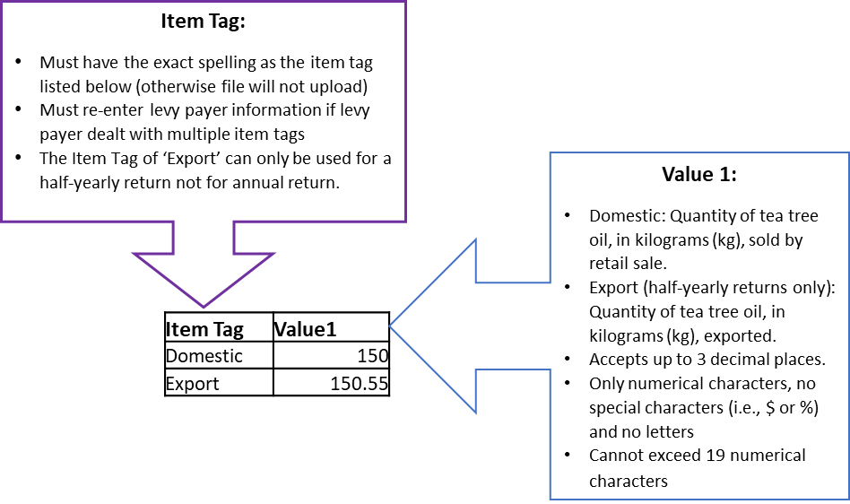

**Figure 2: formatting requirements for levy payer information**.

