*Australian Government Crest
*

STATE PARTY REPORT

ON THE STATE OF CONSERVATION

OF THE TASMANIAN WILDERNESS   
WORLD HERITAGE AREA (AUSTRALIA)

PROPERTY ID 181 quinquies

Front cover Mount Olympus at Dawn (Photo: Chris Anstey)


IN RESPONSE TO  
WORLD HERITAGE COMMITTEE DECISIONS   
WHC 34 COM 7B.38, WHC 34 COM 8B.46,   
WHC 36 COM 7B.36, WHC 37 COM 8B.47,   
WHC 38 COM 8B.47 and WHC 38 COM 10B.1

FOR SUBMISSION BY   
1 FEBRUARY 2015

© Commonwealth of Australia, 2015.

Creative Commons


State Party Report on the state of conservation of the Tasmanian Wilderness World Heritage Area (Australia) is licensed by the Commonwealth of Australia for use under a Creative Commons by Attribution 3.0 Australia licence with the exception of the Coat of Arms of the Commonwealth of Australia, the logo of the agency responsible for publishing the report, content supplied by third parties, and any images depicting people. For licence conditions see:   
http://creativecommons.org/licenses/by/3.0/au/

**Erratum**

page 15, *Crown Land* “Future Permanent Production Forest (FPPF) land comprises approximately 26 300 hectares and is a category of Crown land administered by Crown Land Services with on-ground management by the Parks and Wildlife Service under the *Crown Lands Act 1976* (Tas) with additional restrictions as outlined in the new *Forest (Rebuilding the Forest Industry) Act 2014* (Tas).”

This re-print corrects the Erratum as follows:

page 15, *Crown Land* “Future Potential Production Forest (FPPF) land comprises approximately 26 300 hectares and is a category of Crown land administered by Crown Land Services with on-ground management by the Parks and Wildlife Service under the *Crown Lands Act 1976* (Tas) with additional restrictions as outlined in the new *Forest (Rebuilding the Forest Industry) Act 2014* (Tas).”

This report should be attributed as ‘State Party Report on the state of conservation of the Tasmanian Wilderness World Heritage Area (Australia), Commonwealth of Australia 2015’.

STATE PARTY REPORT

ON THE STATE OF CONSERVATION

OF THE TASMANIAN WILDERNESS   
WORLD HERITAGE AREA (AUSTRALIA)

PROPERTY ID 181 quinquies

IN RESPONSE TO  
WORLD HERITAGE COMMITTEE DECISIONS   
WHC 34 COM 7B.38, WHC 34 COM 8B.46, WHC 36 COM 7B.36, WHC 37 COM 8B.47, WHC 38 COM 8B.47 and WHC 38 COM 10B.1

FOR SUBMISSION BY   
1 FEBRUARY 2015

Walls of Jerusalem (Photo: Grant Dixon)


Walls of Jerusalem (Photo: Grant Dixon)

Table of contents

Executive summary 1

1. Response from the state party to the world heritage committee’s decisions 3

1.1 Mechanism for stakeholder involvement 4

1.2 Impacts from adjoining forestry operations 5

1.3 Cultural heritage 8

1.4 Statement of Outstanding Universal Value 18

2. Other current conservation issues identified by the state party 19

2.1 State of the Tasmanian Wilderness World Heritage Area Report 19

2.2 Review of management plan 20

2.3 Research and monitoring priorities 20

2.4 Environmental impact assessment 20

2.5 Gordon River 23

2.6 Climate change 25

2.7 Lake Pedder Galaxias 25

2.8 Orange-bellied parrot 26

2.9 Biosecurity issues 28

2.10 Introduced species 31

2.11 Fire 32

2.12 Hickman’s Pygmy Shrimp 33

2.13 Privately owned or managed land 33

3. Potential major restorations, alterations and/or new construction(s) within the protected area 35

3.1 Tourism investment opportunities in the Tasmanian Wilderness 35

3.2 Cynthia Bay – Lake St Clair tourism developments 35

3.3 Walking track upgrades 37

3.4 Rehabilitation of former forestry areas 38

3.5 Privately owned or managed land 38

4. Appendices 40

4.1 World Heritage Committee Decisions 40

Decision: 34 COM 7B.38 40

Decision: 34 COM 8B.46 41

Decision: 36 COM 7B.36 42

Decision: 37 COM 8B.44 43

Decision: 38 COM 8B.47 44

Decision: 38 COM 10B.1 45

4.2 Map of gazetted boundaries 46

Image Credits 48

Falling Mountain (Photo: Chris Anstey)


Falling Mountain (Photo: Chris Anstey)

EXECUTIVE SUMMARY

This report on the State of Conservation of the Tasmanian Wilderness World Heritage Area (the property) responds to World Heritage Committee Decision 36 COM 7B.36 paragraph 9 (2012) that:

the State Party to submit to the World Heritage Centre, by 1 February 2015, an updated report on the state of conservation of the property, including data on the impacts of logging operations on the Outstanding Universal Value of the property and on the proposed management response, for examination by the World Heritage Committee at its 39th session in 2015.

The report also provides an update to the 2012 State of Conservation report which was prepared in response to previous World Heritage Committee Decisions 34 COM 7B.38 (2010), 34.COM 8B.46 (2010) and 36 COM 7B.36 (2012). The 2014 decisions of the World Heritage Committee are also addressed (38 COM 8B.47 and 38 COM 10B.1). Decisions are at Appendix 4.1.

The Tasmanian Wilderness World Heritage Area was inscribed on the World Heritage List in 1982 and extended in 1989, 2010, 2012 and 2013. The State Party’s request to remove approximately 74 000 hectares from the property in 2014 was not approved by the World Heritage Committee. The 1 584 459 hectare property, approximately 20 per cent of the State of Tasmania, continues to be protected under national and state environmental law.

The property is managed by the Tasmanian Government in accordance with national and state law and the property’s management plan. The Australian and Tasmanian Governments are committed to providing   
$A3.4 million each per annum for management of the property until June 2018.

A review of the management plan is underway. Public comment on the draft plan will be sought in early 2015.   
It is anticipated that a new management plan for the property will be completed in 2015.

The concerns of the World Heritage Committee with regard to impacts from adjoining forestry operations have been addressed through the addition, in 2013, of 172 276 hectares to the property’s northern and eastern boundaries. Operational separation zones that protect 2 367 hectares along the property’s boundary, combined with the measures included in Tasmania’s Forest Management System, ensure that adjoining forestry operations do not give rise to adverse impacts on the Outstanding Universal Value of the extended Tasmanian Wilderness.

The State Party is managing a wide range of conservation issues in the property, including work to save the Tasmanian devil from the devastating devil facial tumour disease and rehabilitating former forestry areas to restore their natural heritage values. Research and monitoring programmes continue to be undertaken within the property and in 2013 a Research and Monitoring Priorities document was finalised to direct work in this area for the period 2013-2018.

The improvement of facilities for visitors and development of tourism opportunities in the property with sensitive and appropriate tourism experiences and complementary infrastructure compatible with its natural and cultural heritage values will broaden the range of unique experiences for visitors.

Significant progress has been made since 2013 on undertaking further study and consultation with the Tasmanian Aboriginal community in order to provide more detailed information on the cultural values of the property and how these relate to its Outstanding Universal Value. A Statement of Outstanding Universal Value has been developed and is with the Advisory Bodies for consideration prior to submission to the World Heritage Committee. The review of the property’s management plan has included consultation with the Tasmanian Aboriginal community to identify cultural values. Records of Tasmanian Aboriginal heritage sites are being upgraded.

Planning for the next stage of the cultural values study has commenced. It is expected this stage will take a number of years to complete due to climatic conditions and terrain that limit opportunities for fieldwork, the Tasmanian Aboriginal community will be engaged continuously in the process, and there will be requirements for additional technical expertise. The State Party will report to the World Heritage Committee on this work in 2018.

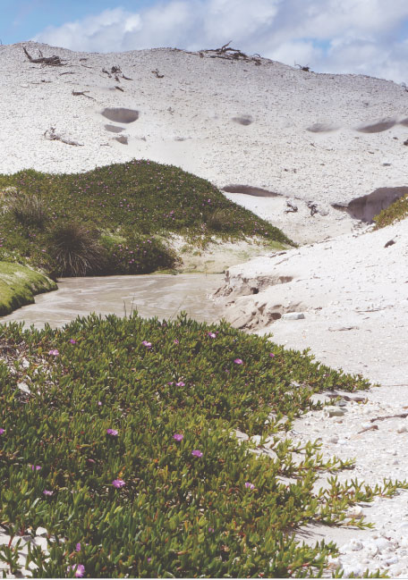

The coastline of the Tasmanian Wilderness World Heritage Area is rich with Aboriginal shell-middens (Photos: Tim Jones)

1. RESPONSE FROM THE STATE PARTY TO THE WORLD HERITAGE COMMITTEE’S DECISIONS

This document includes the progress report requested in paragraph 9 of the World Heritage Committee’s Decision 36 COM 7B.36.

The progress report responds to the World Heritage Committee Decisions 34 COM 7B.38, 34 COM 8B.46, 36 COM 7B.36, 38 COM 8B.47 and 38 COM 10B.1. It provides an update   
on previous State of Conservation reports.

The updated report is provided for examination by the Committee at its 39th session in 2015.

Pandani (Photo: Chris Ansley)


Pandani (Photo: Chris Ansley)

1.1. Mechanism for stakeholder involvement

Decision 34 COM 7B.38 paragraph 7: Also requests the State Party to finalise as soon as possible the creation of a mechanism involving all relevant stakeholders, to monitor, assess and manage the impact of forestry operations, road construction and regeneration on the integrity of the Tasmanian Wilderness World Heritage Area, and adjoining reserves, as previously requested by the committee.

State Party’s response

In June 2013 the World Heritage Committee approved Australia’s request for a minor boundary modification of the Tasmanian Wilderness (37 COM 8B.44). This modification added 172 276 hectares along the property’s northern and eastern boundary, encompassing stands of tall eucalypt forest, associated rainforest, significant karst and glacial landforms as well as alpine and sub-alpine environments. This added to the property Conservation Areas, Forest Reserves, National Parks, areas of former State Forest reserved from forestry operations, State managed reserves and small areas of privately owned land already managed for conservation.

The World Heritage Committee’s request that Australia create a mechanism involving all relevant stakeholders, to monitor, assess and manage the impact of forestry operations, road construction and regeneration on the integrity of the property, and adjoining reserves has been addressed through the extension of the property approved in   
June 2013 (37 COM 8B.44).

In 2013 the Tasmanian Government commenced a review of the 1999 management plan. The new management plan recognises that stakeholders have a right to participate in the ongoing management of the property. The new management plan acknowledges that community consultation is a fundamental component of policy development and decision making, with various stakeholders considered essential in the design and implementation of policy and decisions about management of the property.

The State Party considers the creation of a mechanism involving all relevant stakeholders has been addressed.

1.2. Impacts from adjoining forestry operations

Decision 34 COM 7B.38: paragraph 6: Notes the potential for impact on the integrity of the existing World Heritage property from adjoining forestry operations, and requests the State Party to maintain rigorous assessment   
and management systems to ensure that no such impacts arise.

Decision 36 COM 7B.36 paragraph 3: Welcomes the State Party’s commitment under the Tasmanian Forests Intergovernmental Agreement to provide interim protection to forests adjacent to the property from logging activities while assessments are undertaken to identify the values of these area, including the Upper Florentine, and areas within the Styx, Huon, Picton and Counsel River Valleys.

Decision 36 COM 7B.36 paragraph 5: Takes note however that a number of forest reserves adjoining the property appear to have been exempted from interim protection and that logging and road construction is ongoing in parts of the Styx, Huon, Picton and Counsel Areas, and requests the State Party to clarify in writing to the World Heritage Centre by 1 February 2013 that areas of potential Outstanding Universal Value are not exempted from interim protection,   
in order to retain their potential for possible addition to the World Heritage property.

Decision 36 COM 7B.36 paragraph 9: Also requests the State Party to submit to the World Heritage Centre,   
by 1 February 2015, an updated report on the state of conservation of the property, including data on the impacts   
of logging operations on the Outstanding Universal Value of the property and on the proposed management response,   
for examination by the World Heritage Committee at its 39th session in 2015.

State Party’s response

The potential for impact on the integrity of the Tasmanian Wilderness World Heritage Area from adjoining forestry operations (34 COM 7B.38 paragraph 6) and the provision of interim protection for forests   
adjacent to the property (36 COM 7B.36 paragraphs 3 and 5) has largely been addressed with the addition   
of 172 276 hectares to the property (37 COM 8B.44).

In June 2013 the World Heritage Committee approved Australia’s request for a minor boundary modification to the property to include over 120 000 hectares of State Forest within its boundary. As a result, fourteen forest areas adjacent to the property were incorporated. This modification included areas of the Florentine, Styx-Tyenna, Huon-Picton and Counsel River Valleys (Upper Derwent). Over 50 000 hectares of National Park and reserve and small areas of privately owned and managed land were also approved for inclusion in the property.

As the 2013 extension included the majority of adjacent areas that were previously subject to forestry operations (as outlined above), the State Party considers the need for the provision of data on the impacts of logging operations on the Outstanding Universal Value of the property and on the proposed management response has been addressed.

In 2013 the Australian Government, State of Tasmania and Forestry Tasmania entered into a Conservation Agreement to protect an operational separation zone along parts of the extended boundary where the property is within 100 metres of timber production coupes, thereby providing an additional measure to protect the values of the extended property. Conservation Agreements are legally binding agreements under the Australian Government’s Environment Protection and Biodiversity Conservation Act 1999. The primary objective of conservation agreements are for the protection and conservation of biodiversity in the land covered by the Agreement.

The Conservation Agreement[1] resulted in a net benefit to the conservation of biodiversity by protecting 2 367 hectares of land adjacent to the property. The areas protected under the Conservation Agreement are also identified and protected by Forestry Tasmania as informal reserves.

In the production forests outside the 2013 boundary, and beyond the operational separation zones, Tasmania’s Forest Management System ensures forestry operations do not give rise to adverse impacts on the Outstanding Universal Value of the property.

The Australian and Tasmanian Governments remain committed to the Tasmanian Regional Forest Agreement as the appropriate intergovernmental mechanism for the conservation and sustainable management of Tasmania’s forests. The Tasmanian Regional Forest Agreement is a 20-year agreement that was entered into between the State of Tasmania and the Commonwealth of Australia on 8 November 1997.

The Tasmanian Regional Forest Agreement requires a fully integrated and strategic Forest Management System to be in place. Tasmania’s Forest Management System is underpinned by the Forest Practices Act 1985 (Tas), which includes the statutory objective of achieving sustainable management of Crown and private forests with due care for the environment. A Forest Practices Code has been developed under this legislation, which provides a practical set of guidelines and standards for the protection of environmental values during forestry operations.

The Australian and Tasmanian Governments will commence a third five-year review of the Tasmanian Regional Forest Agreement to assess progress against specific milestones and commitments. The outcomes of the review will be considered in negotiations, expected to occur late in 2015, between the Australian and Tasmanian Governments to extend the Tasmanian Regional Forest Agreement.

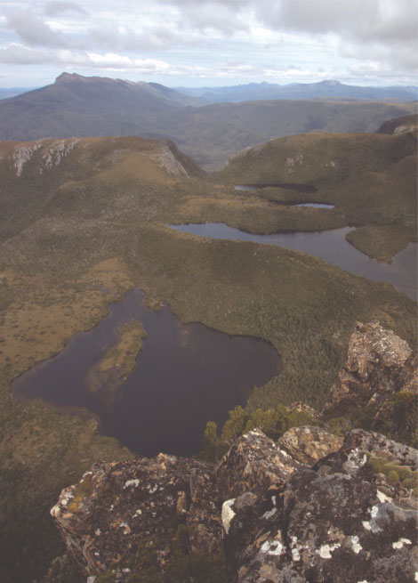

Lonely Tarns by N.Fitzgerald1.3. Cultural heritage

Decision 34 COM 8B.46 paragraph 5[2]: Recommends that the State Party consider further minor modifications to the boundaries to allow for inclusion of appropriate cultural sites, related to and complementing those within the property, with appropriate protection being put in place, and considering the past decisions of the World Heritage Committee on the boundaries of the property in relation to the natural and cultural values.

Decision 34 COM 8B.46 paragraph 6: Also recommends that the State Party augment its staff with cultural heritage specialists in order to ensure the adequate protection and management of cultural sites both within the property and immediately outside the boundaries.

Decision 36 COM 7B.36 paragraph 7: Notes the continuing commitment of the State Party to resource support for Aboriginal cultural heritage, and reiterates its recommendation to increase property staff with cultural heritage specialists, in order to ensure the adequate protection and management of cultural sites both within the property and immediately outside the boundaries.

Decision 36 COM 7B.36 paragraph 8: Welcomes the re-formed property Area Advisory Committee and recommends that it should include representatives of all stakeholders, including the Aboriginal community.

Decision 38 COM 8B.47 paragraph 4:

1. Undertake further study and consultation with the Tasmanian Aboriginal community in order to provide more detailed information on the cultural value of the property and how these relate to the Outstanding Universal Value.
2. Provide detailed information on the legal provisions for the protection of cultural heritage in the extended property;
3. Provide detailed information on the management arrangements for cultural heritage and in particular for the control of access to archaeological sites and sites of cultural significance.

**Deep in limestone caves are many ice-age ochre hand stencils sealed behind transparent calcite (Photo: Aboriginal Heritage Tasmania)
**

Deep in limestone caves are many ice-age ochre hand stencils sealed behind transparent calcite (Photo: Aboriginal Heritage Tasmania)

State Party’s response

1.3.1 Inclusion and protection of cultural sites in the property (34 COM 8B.46 4   
and 38 COM 8B.47 4(b))

Since 2010 three minor boundary modifications have added 196 195 hectares to the property. The areas added include 136 known Aboriginal cultural sites which include a number of cave sites, such as Riveaux Cave, that are likely to contribute to the property’s Outstanding Universal Value.

Protection of cultural sites in the property is provided under Australian and Tasmanian law. The relevant Australian law is the Environment Protection and Biodiversity Conservation Act 1999 (EPBC Act). The EPBC Act includes provisions that protect and manage the World Heritage values of the property as matters of national environmental significance. The EPBC Act protects the World Heritage values of a declared World Heritage property from significant impacts, including the impacts of actions that take place outside the property.

The relevant Tasmanian law is the Aboriginal Relics Act 1975 (Tas). Under the Act, it is illegal to “destroy, damage, deface, conceal, or otherwise interfere with a relic”. Cultural sites are also protected under Tasmania’s National Parks and Reserves Management Act 2002 and National Parks and Reserved Land Regulations 2009, which provide for the care, control, preservation and protection of National Parks and reserves. In particular, the National Parks and Reserved Land Regulations 2009 provide comprehensive protection for reserved land and prohibit removing, damaging, defacing or disturbing any Aboriginal relic or any object of archaeological interest.

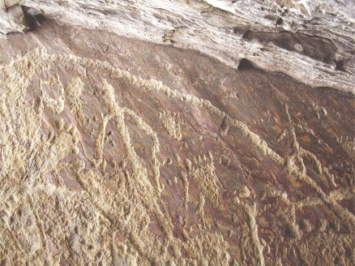

Human and Wallaby tracks adorn an Aboriginal rock shelter in South West Tasmania (Photo: Aboriginal Heritage Tasmania)

1.3.2 Cultural heritage specialists (34 COM 8B.46 6 and 36 COM 7B.36 7)

The Tasmanian Department of Primary Industries, Parks, Water and Environment employs six Aboriginal cultural heritage specialists, including four archaeologists and an Aboriginal Heritage Advisor in its Aboriginal Heritage Tasmania Division[3]. These cultural heritage specialists work to identify and protect sites within and outside the property. This number of staff has been steady since 2010, but was not reported in previous State Party Reports since they work across Tasmania, not just in the World Heritage property. These specialists provide expert advice to the Parks and Wildlife Service (within the same Tasmanian Government department) on Aboriginal heritage management in the property, including environmental impact assessments of new activities and advice on detailed planning and policy projects. The Tasmanian Government maintains a register of consulting archaeologists and Aboriginal heritage officers and engages consultants as required.

In addition, in 2013 an Aboriginal Liaison Officer was appointed to work full time on the property with the Tasmanian Aboriginal community to develop partnership projects. The Officer’s priority has been consulting with the community to inform the preparation of a new management plan for the property.

The first Aboriginal Trainee Ranger programme was run in the late 1990s. From this first training programme two participants have progressed to senior positions in Tasmanian and Australian Government indigenous land management. Since 2004 the Tasmanian Government, funded by the Australian Government, has managed trainee programmes for Aboriginal people in conservation and land management. Between 2004 and 2009 the trainee programme involved 14 Aboriginal people who were offered two year field officer positions and certified training. Several people progressed to full employment in national park and reserve management following completion of this traineeship, involving work across Tasmania, including knowledge sharing excursions into the property.

Since 2010 the Tasmanian Aboriginal Trainee Ranger programme[4] has provided four year formal academic and practical field training for up to five people. Aboriginal people enrolled in the programme assist in the management of the property and other reserves in Tasmania. The programme creates close links with the Aboriginal community, enables on-ground involvement for community members in National Park and reserve management and improves staff awareness and knowledge of Aboriginal culture and heritage. From the first intake, one person completed the training and is now permanently employed as a Ranger, three have progressed to diploma level qualifications and continue to be employed in the property at the Mount Field and Mole Creek field centres. A further two new trainees were engaged in 2014. Other trainees left their positions to take up other employment opportunities.

There is a commitment for all staff in the Department of Primary Industries, Parks, Water and Environment to receive Aboriginal cross-cultural awareness training. Regular formal training every few years has been provided to new and existing staff since the late 1990s.

1.3.3 Representation of stakeholders (36 COM 7B.36 8)

The World Heritage Area Advisory Committee has been replaced by the National Parks and Wildlife Advisory Council (NPWAC)[5], a statutory body under the National Parks and Reserves Management Act 2002 (Tas), which provides independent advice to the Tasmanian Government and, in the case of the property, the Australian Government. The twelve members of the NPWAC are appointed based on their expertise, rather than as the representatives of particular stakeholder groups or organisations. Persons nominated for membership must have the capacity to offer independent advice, taking into account community views and expectations. The NPWAC includes two Aboriginal members (male and female).

In 2012 the Tasmanian Government established the interim Aboriginal Heritage Council. Its role includes providing advice to the Tasmanian Government on the protection and management of Aboriginal heritage in Tasmania and facilitating consultation with the Tasmanian Aboriginal community. The interim Aboriginal Heritage Council provided advice about consultation requirements with the community to prepare the new management plan for the property.

The Tasmanian Wilderness World Heritage Area Management Plan 1999[6] recognises the special relationship between the property’s cultural heritage and the Tasmanian Aboriginal community and recognises that the property is best maintained when Tasmanian Aboriginal people play a major role in managing the property.

**Mushrooms (Photo: Chris Anstey)
**

Mushrooms (Photo: Chris Anstey)

1.3.4 Management arrangements (38 COM 8B.47 4(c))

Statutory principles in the Environment Protection and Biodiversity Conservation Regulations 2000 (Schedules 5, 5A and 5B) set out how the property is to be managed. Among other things, the principles stipulate that management should be in accordance with Australia’s obligations under the World Heritage Convention and that a management plan be prepared. The principles set out what should be included in the management plan, including the participation of Aboriginal people and the integrated management of all heritage values, including the property’s cultural values that are not part of the World Heritage listing.

Management arrangements for cultural heritage and, in particular, for the control of access to archaeological sites and sites of cultural significance are primarily achieved through the property’s 1999 management plan which applies to most of the land in the property listed at that date.

Land to which the new management plan will apply

The new management plan (see section 2.2) will provide management arrangements for over 97 per cent of the property that is reserved under the Nature Conservation Act 2002 (Tas) and for which the Director of National Parks and Wildlife is designated as the managing authority. Management arrangements for the remaining 42 500 hectares (less than three per cent) of the property that will not be not covered by the property’s new management plan are covered by other mechanisms that include the statutory protection of the cultural heritage of the property under Australian and Tasmanian laws (addressed below).

The National Parks and Reserves Management Act 2002 (Tas) provides the statutory basis for the development of management plans for reserves in Tasmania, governing their content, formulation, review and process for approval. The property’s 1999 management plan applies to all land within the property that was reserved under the National Parks and Wildlife Act 1975 (the forerunner to the Nature Conservation Act 2002). Areas added after 1999 and reserved under the Nature Conservation Act 2002 are managed in accord with the principles of the 1999 management plan, relevant Australian and Tasmanian Government legislation and the Tasmanian Reserve Management Code of Practice. The 1999 management plan does not apply to privately owned land.

The National Parks and Reserves Management Act 2002 sets management objectives for all reserve classes including to “encourage cooperative management programmes with Aboriginal people in areas of significance to them in a manner consistent with the purposes of reservation and the other management objectives.” Reserves within the property are managed with regard to this objective.

The 1999 management plan includes measures to identify, protect, conserve and, as necessary, rehabilitate the natural and cultural heritage values of the property. Including:

* protecting cultural heritage places, landscapes and values, and stabilising this heritage
* conserving cultural heritage places, landscape and values
* protecting, conserving and, where appropriate, presenting Aboriginal values
* increasing Aboriginal management of Aboriginal values
* restricting access to caves through a cave classification system
* managing threats to cultural heritage sites, such as uncontrolled visitor use, inappropriately sited infrastructure and coastal erosion due to sea level rise.

The property is also subject to an environmental management system that includes a range of operating systems and processes to identify and avoid, or minimise impacts on cultural and natural heritage values.

Examples of how the 1999 management plan objectives and prescriptions are implemented to control access to sites include:

* provision of a zoning scheme that preserves the remoteness of caves from walking tracks and roads and controls air access, such as by helicopters
* re-routing walking tracks so that they avoid cultural heritage sites. For instance, at the request of the Aboriginal community, Federation Peak bushwalking track was re-routed well away from the Wargata Mina Cave thereby also avoiding impacts from walkers camping near the cave
* discouraging the use of walking tracks that provide access to sites by classifying them at levels that deter visitors
* visits to sites of special significance (for example archaeological and Aboriginal sites) for management or research purposes is controlled to avoid unnecessary disturbance and risk of damage
* restricting or prohibiting access to caves where unacceptable damage has occurred, or is likely to occur
* investigating factors affecting cultural sites and implementing appropriate protection mechanisms.

The Tasmanian Government takes the approach that the locations of Aboriginal heritage sites are not made available to the public. However, site specific information is provided on request to land owners and managers so they can avoid impacting heritage or, if impacts to Aboriginal heritage cannot be avoided, by applying for a permit under the Aboriginal Relics Act 1975.

The Tasmanian Government’s Cave Access Policy[7] (2014) establishes protocols and procedures for respecting Aboriginal heritage in caves in National Parks and reserves declared under the Nature Conservation Act 2002. In addition, regulation 17 of the National Parks and Reserved Land Regulations 2009 provides a mechanism to limit access to sensitive sites, such as caves, by sign or public notice.

The new management plan will apply to areas managed under the National Parks and Reserves Management Act 2002.

Other land

The remaining 42 500 hectares (less than three per cent of the property), to which the property’s management plan does not apply, is privately owned land or Crown Land. Management arrangements for cultural heritage and access to archaeological sites and sites of cultural significance are controlled by the land owner or manager. Protection of archaeological sites and sites of cultural significance are provided for in the provisions of Australian and Tasmanian Government legislation.

Aboriginal Land

Aboriginal land is land that has been vested in the Aboriginal Land Council of Tasmania in trust for Aboriginal persons in perpetuity under the Aboriginal Lands Act 1995.

The Aboriginal Land Council of Tasmania owns approximately 730 hectares of land within the property, including the significant cave sites at Ballawinne, Kutikina and Wargata Mina. The Aboriginal Land Council of Tasmania controls access to this land.

The Tasmanian Land Conservancy

Comprising 1 742 hectares, the Tasmanian Land Conservancy (TLC) owns and manages the Skullbone Plains Reserve, Gordonvale Reserve and Liffey Reserve, within the property.

Management of Skullbone Plains Reserve and Liffey Reserve is in accordance with their statutory conservation covenants registered on the property titles under Tasmania’s Nature Conservation Act 2002. Skullbone Plains Reserve has been partly surveyed for its cultural heritage values. Aboriginal sites, including artefact scatters and usage, and several European cultural heritage sites, especially hut remains, are recorded on the TLC’s GIS database. Their importance and protection has been identified in the reserve management plan. Access to the Skullbone Plains Reserve is controlled via a series of locked gates and other deterrents to illegal access, thus the property has a low level of unregulated access. General public access is controlled by the TLC and visitors are required to comply with the conditions of access. Those seeking access for other purposes are required to sign a waiver of liability and an access licence agreement.

A conservation covenant for Gordonvale Reserve is being prepared. Gordonvale Reserve is registered in the Tasmanian Historic Archaeological Sites Catalogue and a cultural heritage site condition assessment was undertaken by the Tasmanian Government in 1994. Management and preservation of the cultural heritage values of this reserve are a key objective in the TLC’s draft management plan. Gordonvale is a very remote property in southwest Tasmania, completely surrounded by the Franklin-Gordon Wild Rivers National Park, which is part of the World Heritage Area. Access is either by helicopter or by foot across the Gordon River, via Maydena west of New Norfolk.

There are no known cultural heritage sites on the Liffey Reserve however no formal surveys have been undertaken. The existence of sites with local heritage value remains a possibility as the Liffey area has a long history of European and Aboriginal use.

Skullbone Plains (Photo: Matthew Newton)


Skullbone Plains (Photo: Matthew Newton)

Bush Heritage Australia

Bush Heritage Australia (BHA) owns and manages two reserves within the property, Liffey River Reserve and Coal Mine Creek Reserve, comprising 125.5 hectares. These reserves are protected under conservation covenants under Tasmania’s Nature Conservation Act 2002, with the purpose of protecting in perpetuity the flora and fauna, water quality and the natural diversity of the land.

To date, no cultural significant sites have been identified in either reserve, however detailed aboriginal cultural heritage assessments are planned for 2015 (Liffey River Reserve) and 2016 (Coal Mine Creek Reserve).

Hydro Tasmania

Hydro Tasmania owns and manages approximately 13 500 hectares of land within the property. This area includes 1 720 hectares of water storage or lake area. A number of Hydro Tasmania assets, such as dams, water conveyances and tunnels are also located on public land within the property.

The management of these assets is regulated under the 1999 management plan and in accordance with an Electricity Entities Operations Plan that is implemented by way of a Memoranda of Understanding between Hydro Tasmania and Tasmania Parks and Wildlife Service.

Management of cultural heritage values is detailed in an accredited Health, Safety and Environmental Management System, which includes specific procedures relating to cultural heritage management. These procedures ensure Hydro

Tasmania effectively identifies, assesses, protects and conserves Aboriginal cultural heritage.

Tas Networks

Tas Netwoks has a Memorandum of Understanding with Tasmania Parks and Wildlife Service which provides high level guidance on how to manage activities within the property and establishes expectations for routine maintenance activities associated with their assets within the property.

An Environment Handbook utilised by Tas Networks aims to increase environmental awareness and encourage better environmental management. The Environment Handbook is a practical reference tool on how to ensure that maintenance, inspection and construction activities do not impact various aspects of the environment including Aboriginal heritage values.

If new capital works projects are deemed to have a higher risk to Aboriginal heritage values an archaeologist and Aboriginal Heritage Officer will be engaged to survey the site. If Aboriginal heritage sites are located within the proximity of activities, exclusion zones will be established and site details will be provided to Aboriginal Heritage Tasmania.

Crown Land

Future Potential Production Forest (FPPF) land comprises approximately 26 300 hectares and is a category of Crown land administered by Crown Land Services with on-ground management by the Parks and Wildlife Service under the Crown Lands Act 1976 (Tas) with additional restrictions as outlined in the new Forest (Rebuilding the Forest Industry) Act 2014 (Tas). The management objectives for FPPF land are outlined in Schedule 3 of the new Act, these management objectives are similar to those for conservation areas under the Nature Conservation Act 2002 and include: “to conserve sites or areas of cultural significance and to encourage cooperative management programmes with Aboriginal people in areas of significance to them in a manner consistent with the purposes of reservation and the other management objectives”.

The Tasmanian Reserve Management Code of Practice applies. Land management practices, including arrangements for cultural heritage (in particular for the control of access to archaeological sites and sites of cultural significance) have regard to the World Heritage status of the property. A priority for management is investigation of existing uses, threats and risks to values.

New activities on Crown Land require approval under the Crown Lands Act 1976.

1.3.5 Further study and consultation with the Aboriginal Community on Cultural values (38 COM 8B.47 4(a))

The World Heritage Committee has requested the State Party undertake further study and consultation with the Tasmanian Aboriginal community in order to provide more detailed information on the cultural value of the property and how these relate to its Outstanding Universal Value.

Following the inscription of the property, surveys were undertaken to further identify its Aboriginal cultural heritage attributes and values. Between 1992 and 1999 a number of management actions were undertaken, including study and consultation on the cultural values of the property. These actions included consultation and involvement with the Aboriginal community in the management of Aboriginal heritage within the property. In addition, cultural heritage site surveys were undertaken to identify cultural heritage values at Adamsfield, Melaleuca, Frenchmans Cap, along the Overland Track and on the Central Plateau. These surveys were undertaken following consultation with, and advice from, the Tasmanian Aboriginal Land Council and once completed were entered on the Tasmanian Aboriginal Site Index (which is not publicly available due to the sensitivity of this information). Cultural Heritage Information System audits of Aboriginal cultural heritage were also completed.

A strategy (called Aboriginal interpretation of the Tasmanian Wilderness World Heritage Area, 1995) was developed by the Tasmania Parks and Wildlife Service for the management of Aboriginal cultural heritage in the property. The strategy identifies a number of principles and requirements for Aboriginal management, including recommendations for furthering management of Aboriginal cultural heritage particularly in the areas of identifying Aboriginal values and cross-cultural training of Tasmanian government staff. The strategy informed the development of the Larmairremener tabelti Aboriginal cultural walk at Lake St. Clair and the Needwonee Walk at Melaleuca.

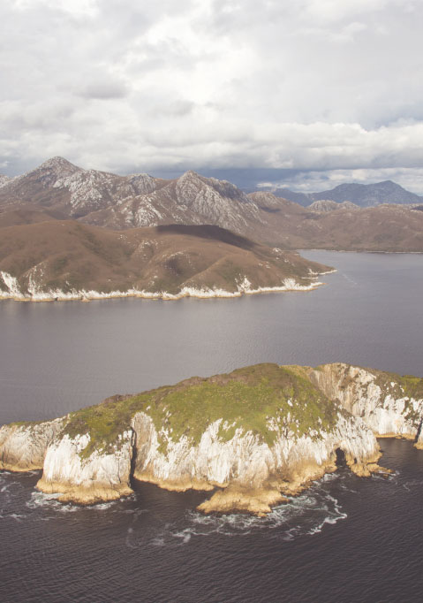  
Port Davey - Bathurst Harbour (Photo: Department of Primary Industries, Parks, Water and Environment)

The project Aboriginal Management in the Tasmanian Wilderness World Heritage Area (1996) clearly identified a range of Aboriginal values for the property including plants, animals, marine resources, minerals (ochre and rock sources), tracks and forests.

The 1999 management plan was developed in consultation with the Tasmanian Aboriginal community and has increased knowledge of the property’s cultural values. It contains a section on Aboriginal management based on a specific Aboriginal community consultation programme that was conducted.

Surveys of Aboriginal sites continued between 1999 and 2004 and increased the level of knowledge about Aboriginal cultural values associated with the property. Survey areas included: Macquarie Harbour northern shore, the southeast coast, the south coast, Port Davey and Bathurst Harbour, the inland southwest, the southwest coast, the Central Plateau and Walls of Jerusalem. All sites were recorded and registered in the Tasmanian Aboriginal Site Index and the findings of the surveys documented in reports. These reports are publicly available.

In addition, a number of regional and local surveys for Aboriginal sites (e.g. the Tana Trawna survey of the Central Plateau) have contributed to knowledge of the distribution and condition of Aboriginal heritage sites, and hence to the capacity to provide appropriate protection for these sites.

Laser scan recording of rock markings in the South Coast Cave during 2011 and 2012 involved the participation of Aboriginal staff and Aboriginal trainee rangers and was reviewed and considered by the interim Aboriginal Heritage Council. These activities increased access to information on cultural values of the property.

In its proposal for a minor boundary modification in 2013 the State Party acknowledged that additional work is required to identify cultural values that enhance criteria (iii), (v) and (vi).

Significant progress has been made since 2013 on undertaking further study and consultation with the Tasmanian Aboriginal community in order to provide more detailed information on the cultural values of the property and how these relate to its Outstanding Universal Value. Following the World Heritage Committee’s approval of the minor boundary modification in 2013, the Tasmanian Government implemented a consultation strategy to engage with Aboriginal organisations, groups and individuals in the development of the new management plan for the property. An Aboriginal cultural heritage specialist produced a report on the outcomes of the engagement process which includes a summary of the known cultural heritage values of the property, threats to those values and provides recommendations for management. The final report is not publicly available as engagement with the Tasmanian Aboriginal community was on the basis that their contributions would be included in the report on an in-confidence basis. The consultation confirmed that management of cultural heritage values[8] in the property will be improved by an increased understanding of the nature of these values.

Records of Tasmanian Aboriginal heritage sites are being upgraded. The Tasmanian Government is redeveloping its existing Aboriginal Sites Index[9] as a new Aboriginal Heritage Register. There are 962 Aboriginal sites recorded in the property. Since 2013 unpiloted aerial vehicles have been trialled to survey cultural sites in order to improve the quality of information recorded in the Aboriginal Heritage Register.

The World Heritage Committee requested that detailed information on the cultural values of the property be related to its Outstanding Universal Value. A Statement of Outstanding Universal Value for the property has been developed and is with the Advisory Bodies for consideration prior to submission to the World Heritage Committee. The Statement of Outstanding Universal Value includes information on the cultural heritage values for which the property was inscribed.

Planning is underway for the next stage of the additional study and consultation with the Tasmanian Aboriginal community requested by the World Heritage Committee. A detailed study and assessment of heritage value will benefit from the significant amount of work that has already been done in consultation with the Aboriginal community, including in the development of the new management plan. The next stage will take a number of years to complete because terrain and weather conditions limit opportunities for fieldwork. The Tasmanian Aboriginal community will be engaged continuously in the process.

The State Party would be in a position to report further progress to the World Heritage Committee on the cultural study at the World Heritage Committee’s meeting in 2018.

1.4 Statement of Outstanding Universal Value

Decision 38 COM 10B.1 paragraph 8: Reminds States Parties which have not already done so to submit their Retrospective Statements of Outstanding Universal Value by 1 February 2015 at the latest, as well as clarifications   
of boundaries by 1 December 2014.

State Party’s response

The Australian Government, in consultation with the Tasmanian Government, has prepared a Retrospective Statement of Outstanding Universal Value for the Tasmanian Wilderness World Heritage Area.

The Statement of Outstanding Universal Value incorporates known values of the property including the areas added in 2013. On 22 September 2014, the Australian Government sought comment from the technical Advisory Bodies to the World Heritage Convention: the International Union for Conservation of Nature and the International Council on Monuments and Sites on the Statement. Once comments have been received, a revised Statement of Outstanding Universal Value will be submitted to the World Heritage Committee for consideration.

On 25 July 2013 the Australian Government published information on the boundaries of areas added to the property in 2010, 2012 and 2013 in its Gazette of Government Notices. The map of gazetted boundaries is at Appendix 4.2. The Gazette Notice is publicly available on the Australian Government’s ComLaw website[10].

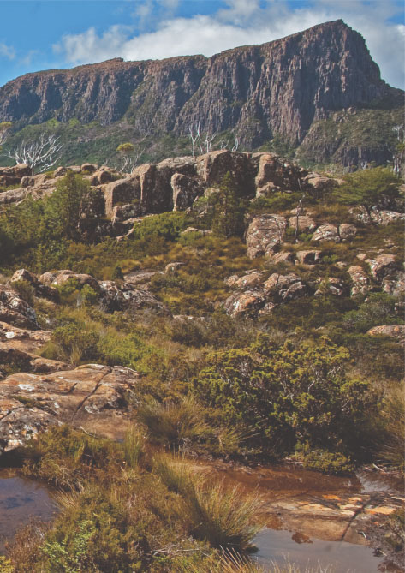

The Acropolis from The Labyrinth (Photo: Chris Anstey)

2. OTHER CURRENT CONSERVATION ISSUES IDENTIFIED BY THE   
STATE PARTY

This section provides an update on issues reported in the 2012 State of Conservation Report and identifies new issues for report to the World   
Heritage Committee.

2.1 State of the Tasmanian Wilderness World Heritage   
Area Report

The managing authority is preparing a second State of the Tasmanian Wilderness World Heritage Report (second report). The purpose of the second report is to provide all interested parties with a summary (including links to supporting evidence) of management achievements, progress, trends, and challenges over the term of the property’s statutory management plan from 1999 to the present. The second report will focus on the decade   
since the first State of the Tasmanian Wilderness World Heritage Report was completed in 2004.

The second report will capture insights about key factors that have contributed positively or negatively to management performance over the term of the plan to assist ongoing improvement in management of the property. It will include updated information on: the condition of the property’s Outstanding Universal Value; threats and risks to its Outstanding Universal Value; management of tourism, recreation and other uses; community engagement; and public support for the property.

As the 2013 extension included the majority of adjacent areas identified by the World Heritage Committee in parts of the Styx, Huon, Picton and Counsel Areas that were previously subject to forestry operations, the need to provide comprehensive data on the impacts of adjacent forestry operations on the property’s integrity and values, in the second report, within the framework of the review of the property’s management plan (36 COM 7B.36 paragraph 6), has been addressed.

The second report is being progressively assembled in parallel with the preparation of the review of the property’s management plan (refer Section 2.2) and it is anticipated that it will be completed in 2015.

2.2 Review of management plan

The Tasmanian Government’s preparation of a new management plan for the property commenced in late 2013. Preliminary consultation on the development of the new management plan was completed in 2014. The results of this consultation have informed the development of a new plan that will be released for further, formal public comment, in accordance with established statutory processes, in early 2015. It is expected that the new management plan will be finalised in 2015.

Gordon River (Photo: Department of Primary Industries, Parks, Water and Environment)


Gordon River (Photo: Department of Primary Industries, Parks, Water and Environment)

Consultation on the new management plan included a separate consultation process for Aboriginal people. The Aboriginal Liaison Officer developed an engagement and consultation strategy for the Aboriginal community to allow for organisations and individuals with a potential interest in the property to provide input into the development of the new management plan. The strategy has been well received and has facilitated a high level of engagement. Concurrently, an Aboriginal cultural heritage specialist was engaged to produce a discussion paper to stimulate dialogue and debate, which has been critical in the identification of values and management issues.

The process for preparing the new management plan has identified a range of issues in the areas added to the property in 2013 that will need to be investigated and managed. These include forestry and hydro-electricity infrastructure, in particular roads that may need to be retained and maintained, areas that require rehabilitation and areas infested with weeds and disease.

A comprehensive audit of the rehabilitation requirements for the areas added in 2013 will inform a strategic approach that will prioritise management efforts over time. The audit of the road network will need to consider additional issues, particularly existing legal rights, access to nearby forestry operations as well as the costs and opportunities for presentation of values to tourists. Guidance on the identification of the rehabilitation requirements and overall management of the road network will be included in the new management plan.

2.3 Research and monitoring priorities

A major review of natural values research and monitoring programmes within the property was completed in 2013[11]. The review considered the current understanding of the property’s natural heritage values, identified knowledge gaps and assessed threats to natural heritage values and measures to build resilience to environmental change. This report identifies research and monitoring priorities for the period 2013 to 2018.

2.4 Environmental impact assessment

The managing authority established an environmental management system (EMS) in 2013 that is consistent with ISO 14001. Major components of the EMS used to assist with management of the property are an environmental policy, aspects and impacts register, upgraded environmental impact assessment process, monitoring and evaluation framework, auditing of compliance with the 2003 Tasmanian Reserve Management Code of Practice and a supporting information management system.

2.5 Gordon River

The Gordon is the largest river system in the property and by discharge one of the largest rivers in Australia. It remains subject to several legacy disturbances that existed prior to the property’s inscription in the World Heritage List in 1982.

Since 1974 river regulation for hydroelectric power generation has substantially altered flow patterns by reducing peak floods, increasing the rate of water level change and to some extent reversing seasonality of flow, thereby limiting summer salt wedge incursion into the estuary. This last change has had a profound impact on several small meromictic lakes dependent upon occasional salt water recharge to maintain saline stratification. The decline in meromictic stability had been monitored since discovery of the lakes in the 1970s and by 2001 meromixis of Lake Fidler was described as precarious, while smaller Lake Morrison retained the merest remnant of meromixis. The power company, Hydro Tasmania, initiated a programme to recharge the salinity of Lake Fidler bottom water however that remained in the planning and approval stage when meromixis was lost in August 2003.

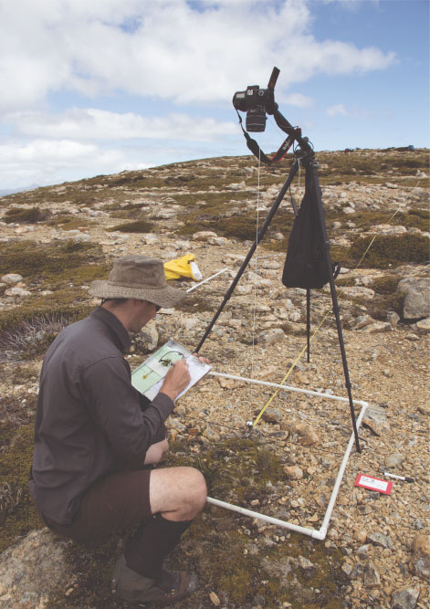  
Climate change photo monitoring on The Boomerang (Photo: Department of Primary Industries, Parks, Water and Environment)

Artificial recharge with seawater was undertaken in June and July 2004 with some success. Saline stratification was re-established, albeit with a more gradual chemocline. Several minor unassisted recharges have subsequently occurred. Contrary to expectations the significant microbial communities had failed to re-establish by the cessation of monitoring in 2010. Those values associated with the diverse and unusual microbiota that were formerly present should now be considered lost.

River regulation also affects in-stream biota, riparian vegetation and bank stability in the middle Gordon reaches between the power station and the Franklin confluence. The initial proposal and subsequent construction and operation of an undersea cable connecting the Tasmanian and mainland electrical grids led to detailed investigation of these impacts. An environmental flow regime has been introduced with some positive effects upon macroinvertebrates and fish. A ramp down rule was also introduced to mitigate seepage erosion of the banks caused by rapid decrease in water level. Monitoring and further studies showed the original version of that rule was not as effective as anticipated and a revised ramp down rule was implemented in 2012. The geomorphological model predicting the mitigation effects of the revised rule is supported by early erosion monitoring results. However, riparian vegetation remains susceptible to dieback during periods of sustained high discharge, resulting in reduced bank stability. Continued adjustment and channel widening in response to the altered flow regime appears unavoidable.

The lower Gordon River has been a tourist destination for well over a century. With the introduction of large, fast cruise vessels in the 1980s the formerly stable banks started rapidly eroding, taking with them millennia old Huon pines. Speed restrictions were introduced and in 1989 cruise boat access was limited to the lowermost reaches of the river in order to protect more sensitive river banks upstream. After extensive studies of bank response to vessel wake wave cruise boats are now individually limited to a speed at which the power of the largest wave wake remains below the threshold of erosion.

Regular monitoring has been conducted since 1987 and shows incremental reduction in the rate of erosion with progressive management actions. Some reversal of that trend has been observed in recent years and monitoring has been intensified to identify the cause. In 2013 the Lower Gordon River Erosion Monitoring Report[12] found recent bank erosion in commercially trafficked reaches to be between two and six times those expected due to sea level rise. To further reduce erosion, private user groups have agreed to a speed limit on their vessels and the possibility of no-impact cruises is being investigated. The goal of achieving an appropriate balance between conservation and opportunities for visitors appears achievable.

2.6 Climate change

In 2013 a report on the potential impacts of climate change on the fauna values of the Tasmanian Wilderness World Heritage Area was completed[13]. The report covers fauna values associated with terrestrial, freshwater and estuarine environments, as well as marine mammals which breed and or haul-out on the Tasmanian coast and offshore islands, and beach-nesting shorebirds. A standardised risk assessment framework was used to rank the risk of climate change to the principal fauna habitats of the property and to priority fauna species. The report provides management response options which, understandably, are constrained by the magnitude of shifts envisaged in terms of both spatial scale and the number of fauna habitats and species affected.

As noted in the 2012 State of Conservation Report, during 2001 and 2002, a joint Tasmanian Department of Primary Industries, Parks, Water and Environment and Forestry Tasmania research project was established assessing altitudinal change in biodiversity on the property boundary at Warra–Mount Weld.

The Warra-Mount Weld Altitudinal Transect survey is long-term study established to record inventory and distributional data for plants and animals along an altitudinal gradient (100 to 1 300m) to provide a baseline to document changes in their distribution and abundance due to climate change or other environmental events such as fire. The results of sampling for invertebrates (based on ordinal-level analysis), plants and birds in 2001 and 2002 were reported in 2001 and 2003[14]&[15]. A report based on species-level identification of invertebrates was completed in 2013[16].

In 2011 and 2012 the invertebrates of the Warra-Mount Weld Altitudinal Transect were resurveyed 10 years after the transect was established and first surveyed. Vegetation was also included in the 2011 and 2012 surveys. The data from this survey are being processed and analysed.

2.7 Lake Pedder Galaxias

The Pedder galaxias (Galaxias pedderensis) is endemic to Tasmania and was originally known only to occur in Lake Pedder and its inflowing streams. Lake Pedder and surrounding areas were inundated in 1972 as a result of damming for hydro-electricity. By the mid-1980’s very few Pedder galaxias were found left in the area. The last recorded Pedder galaxias in its natural habitat occurred during 1996 and intensive survey efforts have not yielded any further records of the species in its natural habitat. It is considered that the species is now extinct in what remains of its natural habitat.

However, as part of a Recovery Plan for the species two translocated populations were successfully established. A total of 34 fish were translocated to Lake Oberon, 12km southwest of Lake Pedder between 1991 and 1997. Following breeding success at Lake Oberon, 353 adult fish were translocated to the Strathgordon water supply dam located within the Lake Pedder catchment between 2001 and 2007. Monitoring has provided clear evidence that both populations are breeding well, and the abundance and mixed age-classes of both populations indicate that the populations are self-maintaining. Populations in Lake Oberon are stable with an estimated population of several thousand (surveyed in 2012). Populations in the Strathgordon water supply dam have been increasing to present (2014) with population size estimated to be more than 500. These populations are protected under Tasmania’s Threatened Species Protection Act 1995.

No areas of the species’ previously known habitat is considered suitable for reintroduction of the species, due to large numbers of introduced brown trout and climbing galaxias, which are known to predate and compete with the Pedder galaxias.

The priority recovery and threat abatement action required for this species is to continue to monitor presence   
of Pedder galaxias in Lake Oberon and Strathgordon water supply dam.

2.8 Orange-bellied parrot

The Orange-bellied parrot (Neophema chrysogaster) is a World Heritage value of the property and is listed as critically endangered under Australian legislation and endangered under Tasmanian legislation. There are thought to be fewer than 70 birds in the wild and the species is only known now to breed at Melaleuca in the property. Breeding occurs in the summer months between October and April, after which the birds migrate to the southern coastline of mainland Australia.

A National Recovery Plan (the Plan) for the Orange-bellied parrot was revised in 2014. This Plan reflects the national approach being taken by States, the Australian Government and other stakeholders in a concerted effort to ensure the long-term survival of the species in the wild. The Plan includes a range of management actions to improve the chances of survival of this iconic and endemic species including habitat management burns to provide suitable foraging habitat, provision of artificial nest boxes, supplementary feeding and mitigation of threats posed by disease, competitors and predators.

A captive insurance population is another important element in the recovery programme for this species. Releases of captive bred birds into the wild are seen as critical actions to promote long-term survival in the wild. In the 2013-14 breeding season 24 captive bred birds were released at Melaleuca. A number of these birds successfully bred and fledged chicks, augmenting the 2013-14 breeding productivity of the species. Importantly, a number of captive-bred and released adults and their wild-fledged offspring returned to the Melaleuca breeding site at the start of the 2014-15 breeding season, almost doubling the numbers of Orange-belled parrots returning to Melaleuca to breed. A translocation of 27 birds has recently been conducted at Melaleuca in the 2014-15 breeding season. Further translocations will be considered for coming breeding seasons.

Orange-bellied parrot (Photo: Department of Primary Industries, Parks, Water and Environment)


Orange-bellied parrot (Photo: Department of Primary Industries, Parks, Water and Environment)

2.9 Biosecurity issues

As reported in 2008, and reiterated in 2010 and 2012, several biosecurity issues have emerged in Tasmania, some of which may threaten World Heritage values. These emerging issues have been acknowledged in the review of the Tasmanian Wilderness World Heritage Area Management Plan and are being addressed as priorities.

In 2012, in partnership with Natural Resource Management South, the Tasmanian Department of Primary Industries, Parks, Water and Environment was successful in procuring funds from the Australian Government to complete a biosecurity infrastructure and education program to reduce the spread of chytrid fungus, mucor fungus, phytophthora, didymo and terrestrial weeds into and within the Tasmanian Wilderness.

Between 2012 and early 2014, seventeen bootwash stations were installed at all main trailheads into the property, along with three biosecure helipads and a mobile vehicle wash unit. An education programme targeted land management agencies and recreational park users, and included a series of educational YouTube videos.

The managing authority is developing and integrating a Biosecurity System into operating systems, to mitigate the spread of pests, weeds and disease associated with departmental activities. A Biosecurity Report is now functional within the Natural Values Atlas to map biosecurity threats and mitigation measures, and to assist with the planning of trips and activities.

Specific biosecurity issues with updates since the last State of Conservation report are discussed below.

Amphibian chytrid fungus

Chytridiomycosis is an infectious disease affecting amphibians worldwide. The disease has been recorded in many regions of mainland Australia and is now widespread in Tasmania. Three species of endemic frogs are amongst the World Heritage values of the property. As reported to the World Heritage Committee in 2008, a national threat abatement plan for this disease is in place and has recently been reviewed. Chytrid fungus has been detected along the margins of the property and, since the 2012 report, chytrid fungus has been detected at Birches Inlet which was previously thought to be chytrid negative based on several years of monitoring. The 2013 extensions to the property contain chytrid infected areas particularly those areas that have unsealed roads or have been subject to use by heavy machinery. Chytrid fungus has not spread to Melaleuca or Hartz Mountain - two key areas that contain at-risk species. These areas will be zoned “Chytrid Exclusion Areas”, with increased biosecurity awareness.

Ongoing broad scale and intensive monitoring aims to monitor the spread of the disease and to assess the impact of disease on susceptible species in the property, in particular the highly susceptible Tasmanian tree frog.

Husbandry techniques for captive maintenance of frogs have been developed in partnership with Bonorong Wildlife Park. Further work is required to develop captive breeding techniques.

More information on these issues is available at:   
http://www.environment.gov.au/biodiversity/threatened/ktp/frog-fungus.html   
http://www.environment.gov.au/resource/threat-abatement-plan-disease-natural-ecosystems-caused-phytophthora-cinnamomi

Walls of Jerusalem biosecurity measures (Photo: Peter Grant)


Walls of Jerusalem biosecurity measures (Photo: Peter Grant)

Devil facial tumour disease

The Tasmanian devil (Sarcophilus harrisii) is considered a World Heritage value, and is widely distributed in the Tasmanian Wilderness World Heritage Area. In 1996 a devastating disease, devil facial tumour disease, was detected in Tasmanian devils in the north-eastern corner of Tasmania and has spread rapidly through most of the devil population. The disease, nearly always fatal, is passed from devil to devil through biting. To date no cure or vaccine has been found.

The species is now listed as ‘endangered’ under Tasmanian and Australian environmental legislation. The Tasmanian devil has also been listed as ‘endangered’ on the Red List of the International Union for the Conservation of Nature (IUCN).

The disease continues to spread west and south and now affects approximately 80 per cent of the state. Statewide sightings of devils have generally declined by 80 per cent, with this figure remaining static over the past two years. In the north-east of Tasmania sightings have declined by 96 per cent. However, there have not been any local extinctions recorded with devil populations persisting at low densities in areas where the disease is established.   
It appears that devils in the more remote areas of the property remain free of the disease.

The Australian Government committed $A3.3 million in project funding in 2014 and the Tasmanian Government is providing $A2.3 million annually to the Save the Tasmanian Devil Program. Through the implementation of a diverse range of research and management actions, considerable progress has been made towards the program’s overall objective of ensuring the long-term survival of devils in the wild. The program is monitoring the spread of the disease, undertaking research to better understand the nature of the disease, protecting and managing disease free devils in the wild and establishing a disease free, genetically robust captive insurance population. This insurance population, dispersed across a number of facilities across Australia and already exceeding the goal of 500 animals, will provide animals that can ultimately be reintroduced back into the wild once the disease is no longer a threat.

More information on the Save the Tasmanian Devil Program is available at: http://www.tassiedevil.com.au.

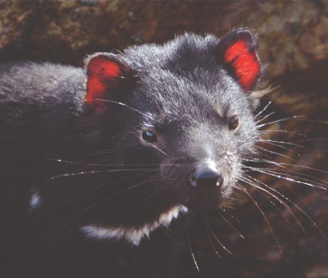

Tasmanian devil (*Sarcophilus harrisii*) (Photo: Department of Primary Industries, Parks, Water and Environment)

Phytophthora cinnamomi

As previously reported, Phytophthora cinnamomi is an introduced plant pathogen that can cause floristic and structural change in buttongrass communities below about 700m elevation in the property. It is established on many walking tracks in the south west and the road system within and adjacent to the property.

In 2010 a new infestation of Phytophthora cinnamomi was detected on the Loddon Plains, below Frenchmans Cap. To minimise the risk of further infestation, the wash down station and chemical based wash down unit was replaced and the walking track was rerouted and resurfaced. Trial monitoring of the stream for Phytophthora species was conducted on the boundary of the infection, which enhanced the knowledge of aquatic phytophthora species.

A management plan for Phytophthora cinnamomi is in place which aims to ensure better management of the pathogen and mitigate the risk of further infestation. Risk controls and education actions are substantially underway while monitoring and research remains an ongoing issue for management.

In May 2014 one of only two known sites of the endangered Lomatia tasmanica ‘King’s Holly’ was visited with the media. This species is thought to be the oldest plant clone on earth. The boundary of Phytophthora infection is located only 15 metres from the ‘Kings Holly’ stand, however in the absence of fire it is not considered to threaten the stand.

During 2013 and 2014 the Tasmanian Government has been collaborating with Murdoch University to undertake a survey of Phytophthora species via polymerase chain reaction and next generation sequencing from soil samples collected across a range of altitudes and climates. Initial results show a high diversity of these organisms in Tasmania. During this work Phytophthora cinnamomi has been isolated from areas in the property where it is not expressed symptomatically in the vegetation. Work to confirm these results is underway.

Myrtle rust

Myrtle rust, an introduced disease of the Myrtaceae plant family, was discovered on mainland Australia in 2010. It has not been detected in Tasmania and is not considered a threat to the property in the short to medium term.

2.10 Introduced species

Brown Trout

Brown trout were introduced into Tasmania during the late 1800s to river catchments across the state’s north, south and eastern regions. The vast majority of Tasmania’s waters including those within the property contain trout and these waters support a substantial recreational industry. The presence of brown trout, and the resulting predation and competition for food and habitat resources, has been cited as a threatening process to a number of freshwater fish species. Trout are regarded as a major factor in local declines of native galaxiid fishes both within and outside the property. Brown trout are also known to have an impact on Tasmanian lakes and streams. In a risk assessment of introduced animal threats to the property the brown trout was ranked as an extreme threat.   
In 2009, a study[17] on the status of trout-free waters in the property was completed. The major findings were:

* 34 per cent (6 300 of 18 400 km) of the total length of all stream reaches which naturally might contain   
  fish (stream orders greater than one) remain trout free
* 49 per cent (495 of 1 014) of all mapped lakes in the property greater than one hectare in surface area remain trout free
* 25 per cent (3 721 of 15 022 ha) of the area of all mapped lakes in the property greater than one hectare   
  in surface area remains trout free
* of the 49 lakes greater than 50 hectares within the property, only nine remain trout free
* large coastal river catchments of the southwest of the property between Cape Sorell and Louisa River are trout free and represent the single largest area of river catchments that remain alien fish free in southeast Australia.

The absence of trout from catchments in the property gives these catchments extremely high conservation value, and contributes substantially to the integrity of the property.

Brown trout are managed by the Inland Fisheries Service. The Service has a policy not to stock new waters in the property and to supplement stock in only a small number of waters within the property (for example in the Nineteen Lagoons area).

Lyrebirds

In 2014, a major study on the impacts of lyrebirds on wet forests was completed. This study found that although superb lyrebird scratching causes obvious changes to the structure of the forest floor of Tasmanian wet eucalypt forests, it appears that the disturbance is neither frequent nor intense enough to result in lasting changes to biotic communities. Overall, it is unlikely that the presence of superb lyrebirds will significantly affect functioning of mature forest ecosystems in the property.

Fallow deer

In 2007 a baseline survey report found that established fallow deer populations exist in several areas adjacent to the Central Plateau Conservation Area (CPCA), particularly around Liawenee and north-west of Bronte Park. The report found no evidence of damage to the property’s values from deer and recommended maintaining a watching brief. No further survey work has been undertaken since 2007.

Deer also occur within the CPCA at least on a seasonal basis in the area known as the Nineteen Lagoons and along the Pine River and Nive River valleys. Areas added to the property north and east of Great Lake in 2013 also contain established populations of deer. Deer have been hunted around the eastern plateau which was added to the property in 2013.

A 2009 risk assessment of introduced animals assessed the risk to the property’s values from deer as ‘low’ and therefore management of this species in the property has not been a high priority.

Foxes

The introduction of foxes to Tasmania presented a significant threat to the biodiversity values and integrity of the property but a major eradication programme has reduced and perhaps eliminated this threat. There has been no evidence of foxes confirmed in the State since mid 2011. Planning is being carried out for responses in the event of potential future fox incursions into Tasmania.

2.11 Fire

Fire is a key environmental process and management tool in the Tasmanian property. Despite this, there is inadequate knowledge of its long term impacts, particularly on organic soils.

Several on-going research projects in buttongrass moorland ecosystems in the property are beginning to improve our understanding of the role of fire and how it may be optimally applied in these ecosystems. On the whole, both the flora and the fauna of buttongrass moorlands appear to be highly resilient to fire. A range of invertebrate taxa have been found to be more abundant in the early stages following fire while other taxa prefer older regrowth and another group of taxa appear to be indifferent to the age of regrowth following fire. Recovery of fauna in moorlands on low productivity soils took much longer than on more productive soils. No taxa were found to be absent for extended periods of time following fire but the generality of this finding is constrained by the methods used and moorland types surveyed so far.

Similarly, there was a range of responses to fire recorded for vascular plant species, but the only species eliminated were adventive species not typical of moorland communities. Grasses and forbs, which generally have only a sparse cover in older moorland communities germinated rapidly following fire from soil stored seed banks and were more abundant in the immediate post-fire pioneer community, particularly at higher fertility sites. Although most vascular plant species of buttongrass moorland are well adapted to fire, some species of obligate seeders are much slower to return to their pre-fire abundance. The soil stored seed pool of these species is important to ensure their survival until they reach sexual maturity and are able to produce seeds in large numbers. Repeated fire at short-intervals reduces populations of these relatively fire sensitive species. In particular, the combination of frequent firing and the presence of the introduced plant pathogen Phytophthora cinnamomi has resulted in the dramatic reduction of populations of some species including the ancient endemic Agastachys odorata.

Studies into the use of fire to promote biodiversity in montane grasslands recommenced in 2013. Planned burns were undertaken in Lees Paddocks with plant and invertebrate monitoring established to assess whether there is an increase in biodiversity in these species-poor grasslands.

Fire impacts on fluvial geomorphology and hydrology are being investigated in a long term study in the Gelignite and Condominium Creek catchments that has involved a large scale experimental burn. The large rainfall and hydrology dataset is presently being analysed and a final report is due in 2015. The study to date has documented minor changes to stream geomorphology following the experimental fire.

In January 2014, in collaboration with the University of Tasmania, integrated post-fire monitoring of the impacts of a landscape-scale fire on fish, invertebrates, water quality and geomorphology was conducted. Nearly 30 river sites were sampled in catchments that had experienced differing areas of burning from 0 to 100 per cent of the catchment burnt. A significant p roportion of the sites had previously been sampled for stream invertebrates providing a before and after fire comparison. There was a shift in community composition of macroinvertebrates in relation to fire with a decrease in mayflies, stoneflies and caddisflies and an increase in worms and midge larvae in burnt areas. Interestingly, there were no changes in fish density in relation to area of catchment burnt despite the changes in invertebrate composition. A final report on this work is yet to be completed.

2.12 Hickman’s Pygmy Shrimp

Hickman’s pygmy shrimp *(Allanaspides hickmani)* and its sister species the Marsh Pygmy Shrimp *(Allanaspides helonomus)* belong to a group of primitive shrimp-like crustaceans that are recognised as a value of the World Heritage property. These species are found only in the property. Both species are listed as Vulnerable on the IUCN Red List and Hickman’s Pygmy Shrimp is listed as Rare under Tasmanian’s *Threatened Species Protection Act 1995*. Most of the habitat of both species was lost when their habitat was flooded to create the Lake Gordon and Lake Pedder impoundments. Over the last several years surveys have been conducted to establish the distribution and extent of these species both within and around the impoundments and to re-assess their conservation status. Several new populations of both species were found around the impoundments and the Marsh Pygmy Shrimp was found in the deepest parts of Lake Pedder.

A final report documenting the distributions of these species and reviewing their conservation status was published in 2014 in the Papers and Proceedings of the Royal Society of Tasmania. Both species have very restricted distributions, especially Hickman’s Pygmy Shrimp.

2.13 Privately owned or managed land

Tasmanian Land Conservancy (TLC)

Management issues on Skullbone Plains Reserve focus on control of ragwort and Scotch thistle and controlling access. The TLC undertake a summer weeding programme using field staff and volunteers, this has been ongoing for three years and is anticipated to continue. There are no high threat weeds on the reserve but part of the property has been selectively logged in the past and these areas, including logging landing areas, are surveyed annually for weeds. Introduced animals such as fallow deer and European rabbit pose a threat to the continuing natural functioning of some vegetation communities (eg highland Poa grasslands). Feral cats impact small to medium weight range mammals and birds, and compete with Tasmanian devil and Spotted-tailed quoll (both threatened species). The TLC continues to monitor cat and deer populations and undertakes various levels of control as population numbers increase. These works have been reported in TLC’s Management Plan Implementation Report 2013-2014.

The Gordonvale Reserve has a small infestation of exotic plants (rhododendrons, daffodil bulbs and Scotch thistle) related to its prior occupation and settlement. Their distribution has been mapped and removal of Scotch thistle is planned however no management of the other two exotic species will take place until advice is received on their cultural significance. There are no other major pest or weed management issues for this reserve.

Infestations of blackberry and foxgloves have been mapped on the Liffey Reserve and significant work has been undertaken to reduce these infestations using staff and volunteer resources.

Bush Heritage Australia (BHA)

The main conservation issue on the Liffey River Reserve is weed infestation, such as blackberry, foxglove, Himalayan honeysuckle and thistle. Blackberry, foxglove and thistle require ongoing weed management and, as a result these weeds are localised and small in number. BHA has successfully removed all known Himalayan honeysuckle from the reserve. The Liffey Valley Reserve has a walking trail that loops through the reserve and is open to the public during the day.

Coal Mine Creek Reserve has no known weed infestations. Fallow deer and feral cats are known to frequent the reserve. Localised deer and feral cat control is currently not being undertaken as it is not deemed practical or feasible due to factors such as the size of the property, access and alignment with a regional approach.

Hydro Tasmania

The conservation priorities faced by Hydro Tasmania within the property include biosecurity (pests, weeds and pathogens), management of aquatic species, biodiversity management and rehabilitation.

Native freshwater species and habitat within the property are under threat from freshwater pests and pathogens including Phytophthora cinnamomi (root rot), Batrachochytrium dendrobatidis (Chytrid frog disease), Mucor amphibiorum (platypus Mucor disease) and the freshwater algal pest Didymosphenia geminate (Didymo). Hydro Tasmania manages the threats from pests, pathogens and weeds through procedures documented in its Health, Safety and Environmental Management System. In addition, Hydro Tasmania has jointly funded the development of Keeping it Clean – A Tasmanian field hygiene manual to prevent the spread of freshwater pests and pathogens, 2010.

Hydro Tasmanian is actively managing the threat of redfin perch (pest fish) establishing in Lake Pedder. The risk of redfin entering Lake Pedder has been mitigated through the implementation of a series of controls including a natural rock bar at the end of the canal, a differential rule which maintains a 2.5 m/sec velocity barrier through the canal, and storage operating rules.

Hydro Tasmania has been undertaking research into the natural values of the Great Lake in the Central Plateau Conservation Area. This research will establish underlying conservation values for the land, and ensure that it is managed in a way that maintains and protects these values for the future.

Tas Networks

Consistent with the Memorandum of Understanding with the Tasmanian Parks and Wildlife Service and their Environmental Handbook, Tas Networks undertakes to work in a manner that minimises the likelihood of weeds spreading. Vegetation management works are undertaken to ensure the reliability of electricity supply, and manage the risk of a fire starting as a result of vegetation contacting electrical infrastructure.

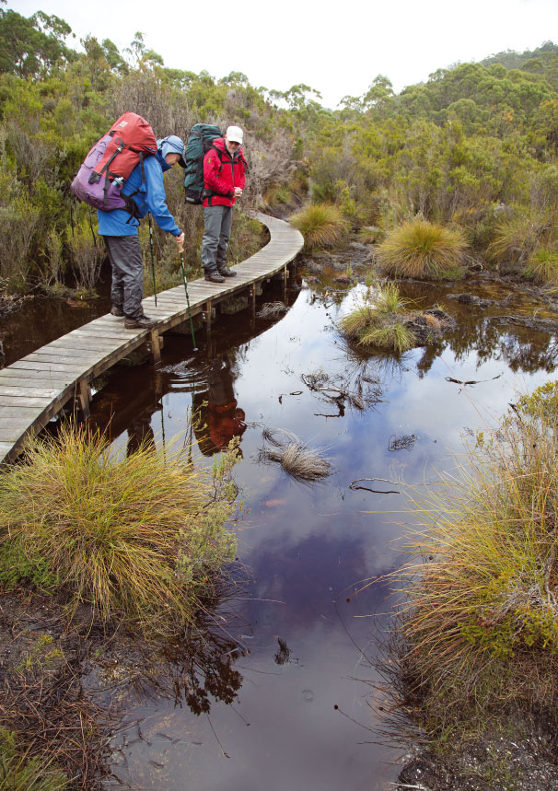

Frenchmans Cap Track - Sodden Loddons (Photo: Peter Grant)

3. POTENTIAL MAJOR RESTORATIONS, ALTERATIONS AND/OR NEW CONSTRUCTION(S) WITHIN THE PROTECTED AREA

3.1. Tourism investment opportunities in the Tasmanian Wilderness

On 21 June 2014 the Tasmanian Government commenced an Expression of Interest (EOI) process for the development of sensitive and appropriate tourism experiences and complementary infrastructure in Tasmanian national parks and reserves, including the Tasmanian Wilderness World Heritage Area. The EOI is specifically looking for developments which broaden the range of exciting and unique experiences on offer in Tasmania by improving access for tourists while maintaining the integrity of natural areas. Refer to http://dpipwe.tas.gov.au/about-the-department/tourism-opportunities for more information.

The EOI process is in two stages. Stage one was a call for proposed developments to be submitted for initial assessment by 21 November 2014. Thirty-seven expressions of interest were received. In Stage two, an Assessment Panel will provide recommendations to the Tasmanian Minister for Environment, Parks and Heritage on the proposed developments. By 13 March 2015 the Minister may then invite selected participants to provide a more detailed proposal. In considering proposed developments, a number of high-level principles will be applied. Proposed developments should:

* be compatible with and sensitive to the cultural and natural values, character and setting of the reserve   
  and should aim to enhance broader visitor enjoyment of the State’s reserve estate;
* offer unique, innovative and enhanced visitor experiences and provide a net public benefit;
* offer environmental tourism experiences that involve or benefit local communities (including the   
  Aboriginal community);
* be established and managed in an ecologically sustainable manner, and should be designed to minimise   
  the footprint on the site;
* be compatible with the statutory management objectives and purpose of the reserves in the relevant legislation; and
* take account of associated risks relating to natural events for the proposed settings, for example, bushfires   
  or flooding.

3.2 Cynthia Bay – Lake St Clair tourism developments

Lake St Clair, at the northern end of the property, is a nominated Visitor Services Zone in the property’s management plan.

New tourist cabins at Cynthia Bay are complete and luxury tourist accommodation using the former hydro-electric infrastructure at Pumphouse Point on the south-east shore of Lake St Clair is due to open in early 2015.

3.3 Walking track upgrades

Overland Track

The Overland Track is the most popular backcountry multi-day walk in the property. During 2012‑14   
$A644 000 was spent on walking track repair, hut conservation, toilet replacement and associated works.

Frenchmans Cap Track

Ongoing upgrades to this major track have been partly funded by philanthropic donations. During 2012‑14 $A305,000 was spent on completing the construction of a 4.5 kilometre reroute to avoid the infamous “Sodden Loddons” (an area dreaded by bushwalkers for its mud) on the South Loddon Plains. A Recreation Zone Plan is being prepared to guide other future management and infrastructure upgrades.

Walls of Jerusalem

In 2013 a Recreation Zone Plan[18] was completed after a period of community consultation. The plan covers an area of 3 283 hectares, being the area of greatest visitation, and details management of this popular alpine backcountry destination for the next 10 years, including recommendations for the development of significant camping, toilet and track infrastructure.

Central Plateau tracks

Works undertaken during 2014 with funds provided by the Australian Government included upgrading, clearing and improving access to Higgs Track and Warners Track. The Higgs Track upgrade included construction of a new access bridge and a section of traditional stone-pitching. The technique involves hammering wedge-shaped rocks into the soil and was developed in the Scottish highlands hundreds of years ago.

3.4 Rehabilitation of former forestry areas

A comprehensive audit of the rehabilitation requirements for the areas added in 2013 is required in order to inform a strategic approach that will prioritise management effort over time.

Within the 2013 minor boundary extension are areas impacted by forestry operations including a number of logged coupes, roads and other areas requiring rehabilitation. The Australian Government provided funds to Environment Tasmania (a peak non-government organisation) to undertake priority restoration of formerly logged areas. A joint project team involving Environment Tasmania, the Parks and Wildlife Service and Forestry Tasmania identified and assessed 18 non-regenerated logged areas (coupes) in the property, together covering approximately 652 hectares.

In autumn 2014 ecological restoration burns and reseeding were conducted in three coupes with the aim of restoring the sites to original tall eucalypt forest. The remaining coupes have been assessed and priorities for treatment determined, taking into account existing natural regeneration, other restoration methods as well as the visibility and proximity of coupes to important visitor destinations. Under the current Australian Government funded project, restoration work is scheduled to be completed in 2015. At this time, the Tasmanian Department of Primary Industries, Parks, Water and Environment will assess any remaining forest restoration requirements and work towards progressively implementing them.

The audit of the road network will also need to consider additional issues, particularly existing legal rights and access to adjacent forestry operations, as well as the costs and opportunities for presentation afforded by the access it provides.

3.5 Privately owned or managed land

Aboriginal Land

No major restorations, alterations or new constructions are planned on land owned or managed by the Aboriginal Land Council of Tasmania.

Tasmanian Land Conservancy

There are no major environmental restoration projects planned or being undertaken on Skullbone Plains Reserve. To date rehabilitation of the Old Lake Ina track has commenced and there has been the construction of five tent platforms and walkway, a small shed and installation of a water tank to facilitate camping. A small standing camp ‘RiverFly’ has been constructed under a license agreement. These developments are located in Part C [Special Management Zone] of the covenant which allows for the construction and maintenance of purpose built infrastructure.

No major restorations, alterations or new constructions are planned for Gordonvale Reserve. A small sign will be erected onsite to denote change in ownership and protection of values and any future discussions relating to protection of the homestead and existing remnant structures will be held in collaboration with Australian, State and local heritage authorities.

No major restorations, alterations or new constructions are planned for the Liffey Reserve at this time.

Bush Heritage Australia

No major restorations, alterations or new constructions are planned for the Liffey River Reserve or Coal Mine Creek Reserve.

Tas Networks

Tas Networks is planning the removal of 15km of overhead power line and the installation of a remote area power supply for existing critical communications requirements on the summit of Mt Tim Shea. The power supply system is likely to be a combination of medium sized wind turbines, solar panels and a diesel generator. The impact of this work will be largely confined to a previously disturbed area and has the benefit of allowing 15km of overhead line to be removed and allowed to naturally regenerate.

Hydro Tasmania

No major restorations, alterations or new constructions are planned on land owned or managed by Hydro Tasmania.

4. APPENDICES

4.1 World Heritage Committee Decisions

Thirty-fourth Session – Brasilia, Brazil – July 2010 Tasmanian Wilderness (Australia) (C/N 181)

Decision: 34 COM 7B.38

The World Heritage Committee;

Having examined Document WHC-10/34.COM/7B,

Recalling Decision 32 COM 7B.41, adopted at its 32nd session (Quebec City, 2008),

Recognises the efforts made by the State Party to address the actions requested in Decision 32 COM 7B.41;

Welcomes the submission of a draft Statement of Outstanding Universal Value for the property;

Thanks the State Party for proposing a minor modification to include 21 formal reserves within the property that are already covered by the Tasmanian Wilderness World Heritage Area Management Plan, also welcomes its commitment to add the Melaleuca–Cox Bight area to the property once mining licences have expired, and also recalls its request regarding the potential for further additional areas to be considered at the discretion of the State Party for eventual addition to the property;

Notes the potential for impact on the integrity of the existing World Heritage property from adjoining forestry operations, and requests the State Party to maintain rigorous assessment and management systems to ensure that no such impacts arise;

Also requests the State Party to finalize as soon as possible the creation of a mechanism involving all relevant stakeholders, to monitor, assess and manage the impact of forestry operations, road construction and regeneration on the integrity of the Tasmanian Wilderness World Heritage Area, and adjoining reserves, as previously requested by the Committee;

Further requests the State Party to submit to the World Heritage Centre, by 1 February 2012, an updated report on the state of conservation of the property, especially on the outcomes of the monitoring arrangements focusing specifically on the impact of the logging operations and road construction on the Outstanding Universal Value of the existing property, for examination by the World Heritage Committee   
at its 36th session in 2012.

Thirty-fourth Session – Brasilia, Brazil – July 2010 Tasmanian Wilderness (Australia) (C/N 181)

Decision: 34 COM 8B.46

The World Heritage Committee,

Having examined Documents WHC-10/34.COM/8B, WHC-10/34.COM/INF.8B1.Add and WHC-10/34.COM/INF.8B2,

Approves the minor modification of the boundaries of the property Tasmanian Wilderness, Australia,   
in line with the proposals of the State Party, and as previously requested by the World Heritage Committee;

Welcomes the intention of the State Party to add the Southwest Conservation Area south of Melaleuca   
to Cox Bight to the property when mining licences have expired;

Requests the State Party to ensure that the protection and management of the property within its modified boundaries takes account of past decisions of the World Heritage Committee regarding the state of conservation of the existing property, including the management of threats in the areas adjoining its boundaries;

Recommends that the State Party consider further minor modifications to the boundaries to allow for inclusion of appropriate cultural sites, related to and complementing those within the property, with appropriate protection being put in place, and considering the past decisions of the World Heritage Committee on the boundaries of the property in relation the natural and cultural values;

Also recommends that the State Party augment its staff with cultural heritage specialists in order to ensure the adequate protection and management of cultural sites both within the property and immediately outside the boundaries.

Thirty-sixth Session – Saint Petersburg, Russian Federation – June-July 2012 Tasmanian Wilderness (Australia) (C/N 181)

Decision: 36 COM 7B.36

The World Heritage Committee,

1. Having examined Document WHC-12/36.COM/7B.Add,
2. Recalling Decision 34 COM 7B.38, adopted at its 34th session (Brasilia, 2010),
3. Welcomes the State Party’s commitment under the Tasmanian Forests Intergovernmental Agreement to provide interim protection to forests adjacent to the property from logging activities while assessments are undertaken to identify the values of these area, including the Upper Florentine, and areas within the Styx, Huon, Picton and Counsel River Valleys;
4. Also welcomes the State Party’s intention to provide legislative protection to areas that are identified as being of conservation value, which may possibly include their nomination for inclusion within the property, in line with the Committee’s requests at its 32nd (Quebec City, 2008) and 34th (Brasilia, 2010) sessions that the State Party consider, at its own discretion, the potential for additional areas of Outstanding Universal Value to be added to the property;
5. Takes note however that a number of forest reserves adjoining the property appear to have been exempted from interim protection and that logging and road construction is ongoing in parts of the Styx, Huon, Picton and Counsel Areas, and requests the State Party to clarify in writing to the World Heritage Centre by 1 February 2013 that areas of potential Outstanding Universal Value are not exempted from interim protection, in order to retain their potential for possible addition to the World Heritage property;
6. Also takes note that the property’s existing monitoring structures together with the revision of the State of Tasmanian World Heritage Area Report in 2014 should provide comprehensive data on the impacts of adjacent forestry operations on the property’s integrity and values, and that this should inform the management of these impacts, and of adjoining forest reserves, within the framework of the 2015 Tasmanian Wilderness World Heritage Management Plan review;
7. Notes the continuing commitment of the State Party to resource support for Aboriginal cultural heritage, and reiterates its recommendation to increase property staff with cultural heritage specialists, in order to ensure the adequate protection and management of cultural sites both within the property and immediately outside the boundaries;
8. Welcomes the re-formed property Area Advisory Committee and recommends that it should include representatives of all stakeholders, including the Aboriginal community;
9. Also requests the State Party to submit to the World Heritage Centre, by 1 February 2015, an updated report on the state of conservation of the property, including data on the impacts of logging operations on the Outstanding Universal Value of the property and on the proposed management response, for examination by the World Heritage Committee at its 39th session in 2015.

Thirty-seventh Session – Phnom Penh and Siem Reap-Angkor, Cambodia – June 2013 Tasmanian Wilderness (Australia) (C/N 181)

Decision: 37 COM 8B.44[19]

The World Heritage Committee,

1. Having examined Documents WHC-13/37.COM/8B.Add, WHC-13/37.COM/INF.8B1.Add, WHC-13/37.COM/INF.8B2.Add and WHC-13/37.COM/INF.8B4.,
2. Recalling Decision 32 COM 7B.41, Decision 34 COM 7B.38, Decision 34 COM 8B.46 and Decision 36 COM 8B.45;
3. Notes that the proposed minor boundary modification has been submitted under natural criteria only although it appears to contain significant cultural attributes that relate to those located within the inscribed property;
4. Approves the proposed minor boundary modification of the Tasmanian Wilderness, Australia, and requests the State Party to address the following concerns regarding the cultural values of the property:
5. Undertake further study and consultation with the Tasmanian Aboriginal community in order to provide more detailed information on the cultural value of the additional areas and how these relate to the Outstanding Universal Value of the existing property;
6. Provide detailed information on the legal provisions for the protection of cultural heritage in the extended property;
7. Provide detailed information on the management arrangements for cultural heritage and in particular for the control of access to archaeological sites and sites of cultural significance.

.

Thirty-eighth Session – Doha, Qatar – June 2014 Tasmanian Wilderness (Australia) (C/N 181)

Decision: 38 COM 8B.47

The World Heritage Committee,

1. Having examined Documents WHC-14/38.COM/8B.Add, WHC-14/38.COM/INF.8B1.Add and WHC-14/38.COM/INF.8B2.Add,
2. Recalling Decisions 32 COM 7B.41, 34 COM 7B.38, 36 COM 8B.45 and 37 COM 8B.44;
3. Does not approve the proposed minor modification of the boundaries of the Tasmanian Wilderness, Australia;
4. Requests to the State Party to:
5. Undertake further study and consultation with the Tasmanian Aboriginal community in order to provide more detailed information on the cultural value of the property and how these relate to the Outstanding Universal Value;
6. Provide detailed information on the legal provisions for the protection of cultural heritage in the extended property;
7. Provide detailed information on the management arrangements for cultural heritage and in particular for the control of access to archaeological sites and sites of cultural significance.

Thirty-eighth Session – Doha, Qatar – June 2014 Tasmanian Wilderness (Australia) (C/N 181)

Decision: 38 COM 10B.1

The World Heritage Committee,

1. Having examined Document WHC-14/38.COM/10B,
2. Recalling decisions 36 COM 10A and 37 COM 10 C.1, adopted at its 36th session (Saint Petersburg, 2012) and 37th session (Phnom Penh, 2013) respectively,
3. Welcomes the progress made in the follow-up of the second cycle of Periodic Reporting in the Asia and the Pacific region;
4. Notes with appreciation the contribution of the Government of Australia to the organization of a sub-regional workshop in the Pacific for the follow-up of the second cycle of Periodic Reporting;
5. Also notes with appreciation the contribution of the World Heritage Institute of Training and Research for the Asia and the Pacific Region (WHITR-AP), a category 2 centre under the auspices of UNESCO, to the implementation of integrated capacity building activities for the follow-up to the second cycle of Periodic Reporting; and the International Centre on Space Technologies for Natural and Cultural Heritage (HIST, China) for its initiative in promoting regional cooperation on World Heritage in Asia and the Pacific;
6. Encourages the Centre for World Natural Heritage Management and Training for Asia and the Pacific Region, established as part of the Wildlife Institute of India (WII) as a category 2 centre under the auspices of UNESCO, to support capacity building and training activities for natural World Heritage in the region;
7. Calls upon Asia-Pacific States Parties to actively implement the Regional Action Plans and also encourages them to intensify their contributions to the implementation of follow-up activities while working closely with the World Heritage Centre and the Advisory Bodies;
8. Further reminds States Parties which have not already done so to submit their Retrospective Statements of Outstanding Universal Value by 1 February 2015 at the latest, as well as clarifications of boundaries by 1 December 2014 at the latest;
9. Requests the World Heritage Centre to present a progress report on the implementation of the Action Plans for Asia and the Pacific region at its 39th session in 2015.

4.2 Map of gazetted boundaries

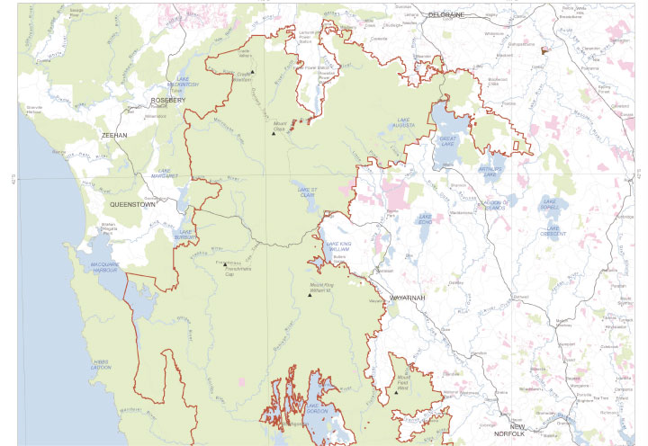

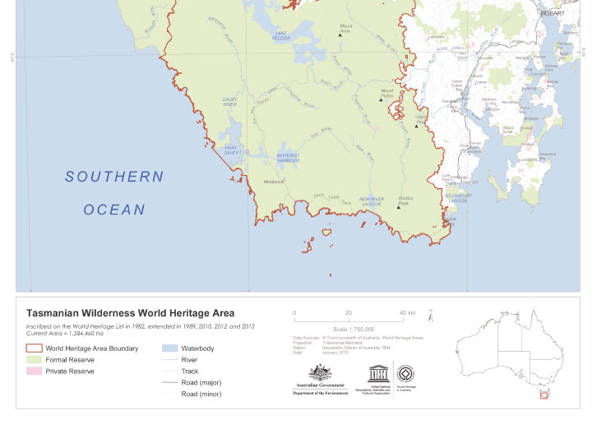

Image Credits

|  |  |
| --- | --- |
| Page no. | Image credits |
| Front cover | Mount Olympus at Dawn (Photo: Chris Anstey) |
| iv | Walls of Jerusalem (Photo: Grant Dixon) |
| vi | Falling Mountain (Photo: Chris Anstey) |
| 2 | The coastline of the Tasmanian Wilderness World Heritage Area is rich with  Aboriginal shell-middens (Photos: Tim Jones) |
| 3 | Pandani (Photo: Chris Anstey) |
| 7 | Lonely Tarns by N.Fitzgerald |
| 8 | Deep in limestone caves are many ice-age ochre hand stencils sealed behind transparent calcite (Photo: Aboriginal Heritage Tasmania) |
| 9 | Human and Wallaby tracks adorn an Aboriginal rock shelter in South West Tasmania (Photo: Aboriginal Heritage Tasmania) |
| 11 | Mushrooms (Photo: Chris Anstey) |
| 14 | Skullbone Plains (Photo: Matthew Newton) |
| 17 | Port Davey - Bathurst Harbour (Photo: Department of Primary Industries, Parks, Water and Environment) |
| 20 | The Acropolis from The Labyrinth (Photo: Chris Anstey) |
| 22 | Gordon River (Photo: Department of Primary Industries, Parks, Water and Environment) |
| 24 | Climate change photo monitoring on The Boomerang (Photo: Department of Primary Industries, Parks, Water and Environment) |
| 27 | Orange-bellied parrot (Photo: Department of Primary Industries, Parks, Water and Environment) |
| 29 | Walls of Jerusalem biosecurity measures (Photo: Peter Grant) |
| 30 | Tasmanian devil *(Sarcophilus harrisii*) (Photo: Department of Primary Industries, Parks, Water and Environment) |
| 36 | Frenchmans Cap Track - Sodden Loddons (Photo: Peter Grant) |
| Back cover | Barn Bluff (Photo: Chris Anstey) |

Pine Valley Boardwalk (Photo: Deborah Purss)


Pine Valley Boardwalk (Photo: Deborah Purss)

environment.gov.au

HER131.1114Barn Bluff (Photo: Chris Anstey)


1. http://www.stategrowth.tas.gov.au/forestry/conservation_agreement (including maps)
2. Reiterates a number of previous, similar requests to consider eventual additions at the discretion of the State Party: 32 COM 7B.41 paragraph 5 and 31 COM 7B.43 paragraph 4 (which urged the State Party to consider including critical old growth forest to the east and north of the property).
3. http://www.aboriginalheritage.tas.gov.au/
4. http://www.environment.gov.au/indigenous/workingoncountry/projects/tas/index.html
5. http://www.parks.tas.gov.au/index.aspx?id=1715
6. http://www.parks.tas.gov.au/?base=702
7. http://www.parks.tas.gov.au/indeX.aspX?base=36306
8. The new management plan addresses all cultural heritage values of property, not just the cultural heritage values that are part of the property’s Outstanding Universal Value.
9. http://www.aboriginalheritage.tas.gov.au/tasmanian-aboriginal-site-index-(tasi)
10. http://www.comlaw.gov.au/Details/C2013G01198
11. http://dpipwe.tas.gov.au/conservation/publications-forms-and-permits/publications/twwha-research-monitoring-priorities-2013-2018
12. http://dpipwe.tas.gov.au/Documents/LGR%20Monitoring-2013-14.pdf
13. http://dpipwe.tas.gov.au/conservation/climate-change/potential-impacts-of-climate-change-on-the-fauna-values-of-the-twwha.
14. Doran, N. E., et al. (2003). «Moving with the times: baseline data to gauge future shifts in vegetation and invertebrate altitudinal assemblages due to environmental change.» Organisms, Diversity and Evolution 3: 127–149.
15. Birds: MacDonald, M. (2001). “Altitudinal distribution of birds at the Warra LTER Site, southern Tasmania: a preliminary study.” Tasforests 13: 87–100.
16. http://dpipwe.tas.gov.au/Documents/Warra%20Mount%20Weld%20Invertebrates.pdf.
17. Davies, P.E., Cool, LSJ, Robinson, WR, Sloan, T (2009). Status of trout-free waters In the Tasmanian Wilderness World Heritage Area. Report to the Department of Primary Industries, Parks Water and Environment. Freshwater Systems, Sandy Bay, Tasmania.
18. http://www.parks.tas.gov.au/file.aspx?id=31600.
19. Note that paragraph 4 (a) of Decision 37 COM 8B.44 and Decision 38 COM 8B.47 are very similar and paragraphs   
    4 (b) and 4 (c) of Decision 37 COM 8B.44 and Decision 38 COM 8B.47 are identical. This report responds to paragraph 4 of Decision 38 COM 8B.47 as paragraph 4 of 37 COM 8B.44 has been superseded.