

**Tasmanian Black Gum and Brookers Gum Forests and Woodlands: A Nationally Significant Ecological Community**

A guide for farmers and other land managers

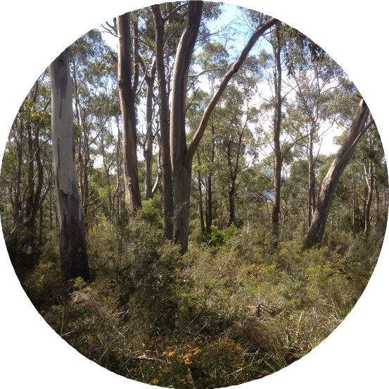

Source: John Vranjic, Department of Agriculture, Water and the Environment

© Commonwealth of Australia 2020

**Ownership of intellectual property rights**

Unless otherwise noted, copyright (and any other intellectual property rights) in this publication is owned by the Commonwealth of Australia (referred to as the Commonwealth).

**Creative Commons license**

All material in this publication is licensed under a [Creative Commons Attribution 4.0 International Licence](https://creativecommons.org/licenses/by/4.0/legalcode) except content supplied by third parties, logos and the Commonwealth Coat of Arms.

Inquiries about the licence and any use of this document should be emailed to [copyright@awe.gov.au.](mailto:copyright@awe.gov.au)



**Cataloguing data**

This publication (and any material sourced from it) should be attributed as: Tasmanian Black Gum and Brookers Gum Forests and Woodlands: A Nationally Significant Ecological Community — A guide for farmers and other land managers, Department of Agriculture, Water and the Environment, Canberra (2020). CC BY 4.0.

This publication is available at [awe.gov.au/publications.](http://awe.gov.au/publications)

Department of Agriculture, Water and the Environment GPO Box 858 Canberra ACT 2601

Telephone 1800 900 090 Web [awe.gov.au](http://awe.gov.au/publications)

This guide is a companion document to the Approved Conservation Advice for the Tasmanian Forests and Woodlands dominated by black gum or Brookers gum (*Eucalyptus ovata / E. brookeriana)*, which can be found on the Australian Government’s Species Profile and Threats (SPRAT) database at:

<http://www.environment.gov.au/cgi-bin/sprat/public/publiclookupcommunities.pl>

Click on the ‘Details’ link alongside the ecological community name to download the documents for the listed ecological community.

**Disclaimer**

The Australian Government acting through the Department of Agriculture, Water and the Environment has exercised due care and skill in preparing and compiling the information and data in this publication. Notwithstanding, the Department of Agriculture, Water and the Environment, its employees and advisers disclaim all liability, including liability for negligence and for any loss, damage, injury, expense or cost incurred by any person as a result of accessing, using or relying on any of the information or data in this publication to the maximum extent permitted by law.

# What is a nationally significant ecological community?

Australia’s national environment law provides a legal framework to list, protect and manage ‘Matters of National Environmental Significance’, which include nationally threatened ecological communities.

National environment law defines an ecological community as an assemblage of native species which inhabits a particular area in nature. In other words, ecological communities are groups of native plants, animals and other organisms that naturally live together and interact in a unique Australian

habitat or ecosystem (e.g. a wetland, forest, woodland or grassland). The native plants and animals in an ecological community have different roles and relationships that, together, contribute to a healthy functioning natural environment.

Nationally listed ecological communities are likely to become extinct, through loss of extent, loss of characteristic native species, and/or loss of natural function throughout their range, unless threats are removed or managed. Even though most areas where a threatened ecological community

remains are no longer as diverse and healthy as they once were, they retain many important natural, social and economic values. They can also provide more habitat and ecosystem services if threats are eliminated or managed to reduce impacts, and natural composition and function are restored.

Protecting threatened ecological communities safeguards ecosystem services such as clean air and water, healthy soils and pollination. These services benefit people and society both within and

beyond the local area where the ecological community occurs and are essential to the greater

productivity of our land and water. Conserving and restoring threatened ecological communities also helps shelter people, stock and property from weather extremes and climate change. Therefore, nationally significant ecological communities are an important part of our diverse natural heritage that need protection and recovery for current and future generations to enjoy and benefit from them.

**Black Gum (*Eucalyptus ovata)* open forest, Tasmania**

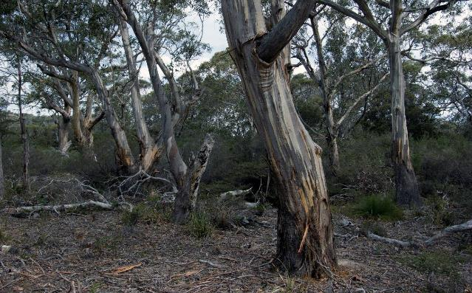

Source: © Murray Fagg, 2015

## What is the Tasmanian Black Gum / Brookers Gum ecological community?

The ecological community is found within a type of native eucalypt forest to woodland present only in Tasmania. It has a tree canopy that is mostly made up of Black Gum (Eucaly*ptus ovata*) and/or Brookers Gum (Eucal*yptus brookeriana*) trees, over an understorey of mostly native plants and also with a number of native animals, including many unique to Tasmania.

The forest and woodland ecological community now mainly occurs as scattered remnants in lowland and damp sites. Most remnants are found in the north-west, northern slopes and the eastern parts of Tasmania. It also occurs on King Island and some other Bass Strait islands. An indicative known current distribution is shown on the map below.

### Indicative distribution of the Tasmanian Black Gum / Brookers Gum Forest

The green shaded areas are where the ecological community is most likely to occur. Caveat: The map has been collated from a range of sources, with data at various resolutions. At these resolutions and scale, the data points blend together to give an artificial impression of larger intact areas than actually remain. Minimum condition thresholds help determine when a patch is too degraded to be protected as a ‘matter of national environment significance’ and are detailed in the Conservation Advice.

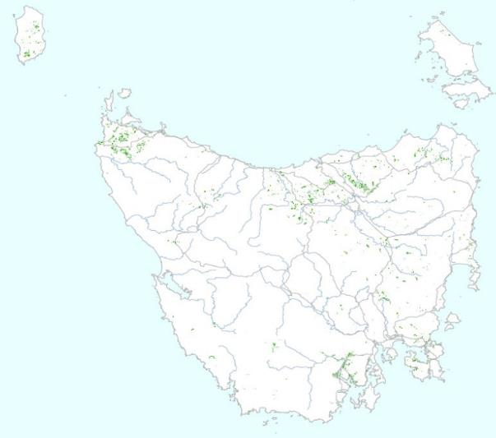

Source: Roads 1:10,000,000, © Commonwealth of Australia, Geoscience Australia, 2003. Drainage 1:5,000,000, ©

Commonwealth of Australia , Geoscience Australia, 2004. Coastline 1:250,000 © Commonwealth of Australia, Geoscience Australia, 2006. Map units 'DOV ', 'DOW ', and 'WBR' from TASVEG 3.0, Tas. DPIPWE, 2013. Produced by: Department of the Environment and Energy Australian Government, ©Commonwealth of Australia, 2017.

# Why are the Tasmanian Black Gum / Brookers Gum Forests and Woodlands nationally protected?

Listing these Tasmanian forests and woodlands as a threatened ecological community makes them a matter of national environmental significance under national environment law - the Environment

Protection and Biodiversity Conservation Act (1999).

Threatened ecological communities are listed according to the risk they could be lost in the future if nothing is done to conserve them and manage threats. The Tasmanian Black Gum / Brookers Gum Forests and Woodlands ecological community is listed as ***critically endangered***. Around 90% of this forest has been lost to historical clearing and very little of it remains in good condition. The

remaining patches are now smaller, more disconnected across the landscape, invaded by weeds and feral animals, and have lost old growth trees. As patches become smaller and disturbed, they become less suitable habitat for native plants and animals.

These forests and woodlands have a range of benefits to people and production, as well as to nature. For instance, they provide habitat for at least 51 nationally threatened species including 16 animal and 31 plant species. The ecological community also helps to maintain natural water tables and

flows, and provide amenity such as shelter to stock and people.

## Key messages about these native forests and woodlands

* The national listing protects the native wildlife (plants and animals) within a particular kind of native vegetation remnant. These remnants have Black Gum and/or Brookers Gum as the main canopy trees, plus an understorey where mostly native shrubs, herbs and grasses remain.
* Very little of the Black Gum or Brookers Gum Forests and Woodlands now remain intact.
* Black Gum and Brookers Gum are not listed as threatened species, so individual trees are not protected – you need lots of trees plus native understorey plants as well, to be considered part of the ecological community. Planting Black Gum or Brookers Gum trees, for instance, as paddock shade trees, shelter belts, for future forest harvesting or other purposes does not

mean you have the threatened ecological community.

* Minimum condition thresholds apply that guide you on when a patch of forest/woodland is too small or degraded to be considered nationally significant.
* Ecological restoration of sites degraded before listing is not required, but is encouraged. This applies to areas that retain some native vegetation but have lost key native species at the site. For instance where trees have been thinned or cleared but the understorey remains, or vice- versa. These components can be reintroduced by plantings or other works that aim to restore the threatened ecological community.
* The Australian Government offers various environmental funding programs to help

landholders look after threatened habitats and species that they may have on their properties.

* Keeping some native remnants adds value. They help protect our waterways, prevent erosion of valuable topsoil, provides shade and windbreaks for stock and crops, maintain the local microclimate, and foster useful bird and insect predators and pollinators that control vermin and assist horticulture.

# What does protection mean for my agricultural activities?

National protection does not stop farmers from continuing to do what they have been doing on their land. In many cases, supportive farming practices have helped to keep the remaining forests and woodlands in good condition and are encouraged to continue. However, some new development activities may need Australian Government approval.

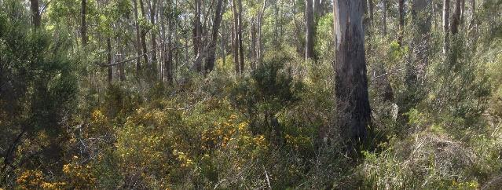

Source: John Vranjic. Department of Agriculture, Water and the Environment

## When do I need approval for my agricultural development?

You only need to seek approval for undertaking new activities that substantially change the way you use your land and that may have a significant impact on protected patches of forest or woodland.

You should consider three main questions:

1. *Is my action exempt?*
2. *Does the protected forest occur on my property?*
3. *Is my action likely to have a significant impact on the forest?*

Use the following guide to determine if you may need to seek approval under national environmental law.

|  |  |  |  |
| --- | --- | --- | --- |
|  | **Not the forest** | **Poor quality forest** | **Protected forest** |
| **Exempt activity** |  | **No approval needed** | |
| **Insignificant impact** |  | **No approval needed** | |
| **Significant impact** | **No approval needed** | | **Approval needed** |

## What activities are exempt?

You do not need to seek approval if your development is:

* A routine land management activity such as maintaining existing fence lines and fire breaks, managing weeds and pests, or undertaking your normal cropping, horticultural or grazing activities.
* An ongoing activity that you lawfully commenced prior to the forest being listed on 4 July 2019, as long as you are not considerably expanding or intensifying that activity.
* An activity that received all the required environmental authorisations prior to July 2000.

Only a new, expanded or intensified agricultural development that is likely to have a significant impact on the threatened ecological community needs approval.

In addition to these exemptions, any forestry actions that are done in accordance with an agreed Regional Forest Agreement are also exempt under the national environment law.

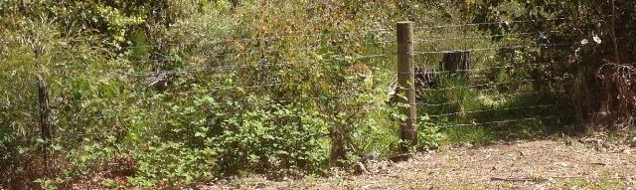

Source: John Vranjic, Department of Agriculture, Water and the Environment

## What is the protected ecological community?

### How do I identify if the ecological community is present?

The Tasmanian Black Gum / Brookers Gum Forests and Woodlands are distinguished by these key

diagnostic features:

**Vegetation structure** - A eucalypt woodland to forest with a solid crown cover of at least 5% and a minimum height of 5 metres for the tree canopy.

**Dominant trees** - Black Gum (*Eucalyptus ovata*) and/or Brookers Gum (*Eucalyptus*

*brookeriana*) are the most common species in the tree canopy. Other tree species may be present, for instance White Gum (*E. viminalis*), Black Peppermint (*E. amygdalina*) or Blue Gum (*E. globulus*). But these tree species are never as common as Black Gum and Brookers Gum.

**Understorey** - Must be mostly native plant species. The composition and structure can vary from shrubby, heathy, sedgy or grassy forms, depending on landscape position. Patches with an understorey of mostly weeds or non-native pasture grasses are too degraded or modified, and not protected.

A full description of the Tasmanian Black Gum / Brookers Gum Forests and Woodlands is given in the Conservation Advice, available online - see page 14 for a link.

# Good quality patches look like this:

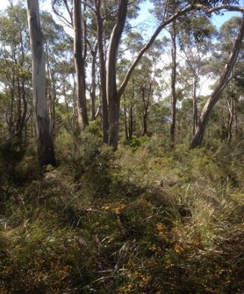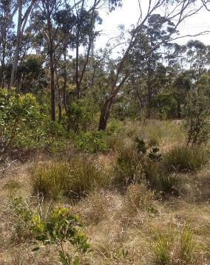

**A well-developed canopy of gum trees**

* Black Gum and/or Brookers Gum are the most common kinds of tree present.
* The canopy has a solid crown cover of 5% or more and a minimum height of 5 metres.

**A mostly intact native understorey**

* The understorey can be variable with a mix of native shrubs, grasses, sedges or other native herbs.
* The vegetation cover should be mostly native species (more than 50% perennial cover).
* The fewer weeds and more native plant species present, then the better the

condition (and value) of the patch.



**OR**

**If older, mature trees with hollows are present or the patch is connected to a larger native remnant**

These features must be present if the understorey

has a lower native vegetation cover of 30-50%. These

are important features that provide hollows for nesting and corridors for animal movement and natural dispersal of plant seeds.

**Degraded patches look like this:**

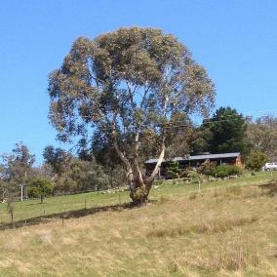

Source of photos: John Vranjic, Department of Agriculture, Water and the Environment

**Isolated paddock trees**

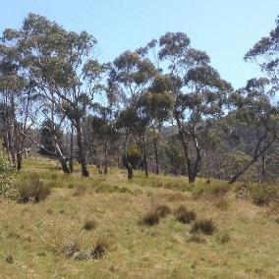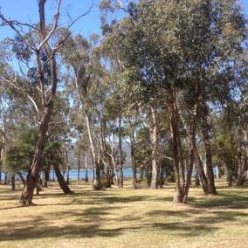

**Small stands of trees - under half a hectare (even if high quality understorey) or under 2 hectares (even if good quality understorey).**

**Gum trees with minor to no native understorey**

The ecological community is not protected within patches of forest or woodland if they are too small or too degraded, as shown in the images below. This is likely to apply to many patches that are shelterbelts and windbreaks on farms, or narrow road verges.

## What activities may have a significant impact?

Many agricultural developments will not have a significant impact and thus not require approval under the Act.

A significant impact is something that will affect the overall health and survival of the ecological community. Significance is looked at on a case-by-case basis factoring in:

* **Intensity** - clearing entire patches or otherwise permanently destroying native understorey is more likely to have a significant impact than slashing/cutting or minimal thinning of the trees or undergrowth
* **Extent** – the larger the size of the impact, the more likely it will be significant
* **Duration** – short term impacts are less likely to be significant than permanent ones.

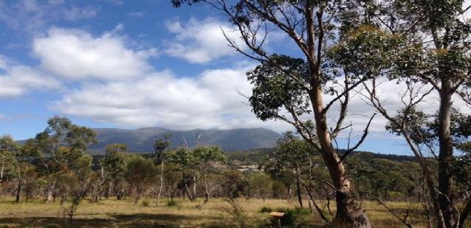

Source: Matt White, Department of Agriculture, Water and the Environment

## Agricultural developments most likely to require approval

* Clearing or significantly thinning higher quality areas of the threatened ecological community
* Introducing grazing, significantly intensifying grazing or changing from grazing to cropping within higher quality areas of the threatened ecological community
* Substantially changing or intensifying methods of weed control or fertiliser use in or next to higher quality areas of the threatened ecological community in a way that causes significant damage
* Improving pasture by introducing exotic plant species or by mechanical disturbance to higher quality areas of the threatened ecological community
* Irrigation of new high quality areas of higher quality areas of the threatened ecological community

## Activities unlikely to require approval

Farming and other activities that are ongoing and/or unlikely to have a significant impact include:

* ongoing grazing and pasture maintenance
* ongoing horticultural or cropping activities
* maintaining existing fences, access tracks and firebreaks
* maintaining existing farm gardens and orchards
* maintaining existing farm dams or water storages
* maintaining existing pumps and clearing drainage lines
* replacing and maintaining sheds, yards and other buildings
* targeted control of weeds and spraying for pests on individual properties or roadside verges with minimal disturbance to native species (e.g. selective spraying)
* moving farm vehicles and machinery (assuming there is a minimal impact on native vegetation)
* roads maintenance
* the continuation of historic controlled burning for wild fire protection
* removing or trimming individual native trees or small stands that are over an exotic or degraded understorey

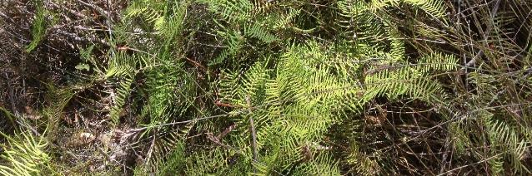

Source: John Vranjic, Department of Agriculture, Water and the Environment

## What about state regulations?

Protection under the national environment law is separate to State and local government laws, but has some similar requirements for approval.

In the event there is likely to be a significant impact on a Matter of National Environmental Signifi- cance, such as a nationally threatened species or ecological community, then similar information used for a Forest Practices Plan or a high risk farm dam application could be used in any referral under national environment law. See more details about relevant state regulations on following pages.

## What about land clearing?

The Tasmanian Government has its own laws on clearing vegetation and protecting State-listed Threatened Native Vegetation Communities. The Tasmanian Black Gum or Brookers Gum Forest is listed as two Threatened Native Vegetation Communities in Tasmania.

Land clearing in Tasmania is currently administered by the Forest Practices Authority (FPA) through a Forest Practices Code. The Code sets standards for the reasonable protection of the cultural and natural values of Tasmania’s native vegetation, and can apply to private and public land tenures.

The Code requires that a Forest Practices Plan (FPP) be developed and certified by a Forest Practices Officer before any clearing can proceed. The FPP identifies what, if any, significant areas are present at a site, for instance if State-listed vegetation communities occur. The FPP outlines the protection measures to be applied and how clearing is to be undertaken.

All FPP applications also need to consult with relevant Local Governments to ensure the work is consistent with any local council planning schemes.

There are some exemptions where the FPP is not required. Exemptions include clearing for authorised dam works, or access and easements for infrastructures such as electricity, gas pipelines and public roads.

Contact the FPA for further advice about state approvals for land clearing.

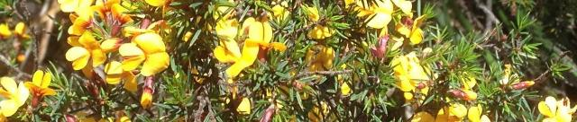

Source: John Vranjic, Department of Agriculture, Water and the Environment

## What about building farm dams?

The building of farm dams is regulated under the Tasmanian *Water Management Act 1999*. Approvals for farm dams are currently administered through the Tasmanian Department of Primary Industries, Parks, Water and Environment (DPIPWE).

Lower risk dams involve the clearing of less than one hectare of native vegetation, among other requirements. They can be constructed if a Notice of Intent is submitted.

Certain dam proposals are regarded as higher risk dam works. One of the requirements for this involves farm dam proposals that will clear more than one hectare of native vegetation. Higher risk dams must go through an application, assessment and permitting process. It could involve the

assessment and potential offsetting of impacts to State-listed Threatened Native Vegetation Communities.

It is unlikely the national environment law will require more assessment and approval conditions on farm dam projects than are already required under the state permitting process.

Contact DPIPWE for further advice about what information is required for state approval of farm dams.

# Is there funding or other assistance to help manage the Tasmanian Black Gum or Brookers Gum Forests and Woodlands on my property?

Having a threatened ecological community on your property may provide additional opportunities for funding to manage natural assets on your land. Funding is also more likely to be available for projects that help farmers and other landholders manage threats on and outside their properties that impact on both production and nature. For instance, the control of weeds, feral animals and erosion.

Current or recent Australian Government environmental and NRM funding programs include the **20 Million Trees** initiative, **Environmental Restoration Fund** and **Regional Land Partnerships Program** under **National Landcare Program**.

For example, in 2019 after the listing of the ecological community, NRM South received Landcare

funding for private land conservation activities to manage threats and restore Black Gum Forests and Woodlands.

Areas that contain the ecological community can also potentially be set by developers as an

**environmental offset**. Any payment or other benefits from such as offset is negotiated directly between landholders and the developer.

More information on past and present Australian Government natural resource management and environment programs (e.g. National Landcare and the Climate Solutions Fund) can be found at:

<http://www.environment.gov.au/about-us/grants-funding>

[www.nrm.gov.au](http://www.nrm.gov.au/)

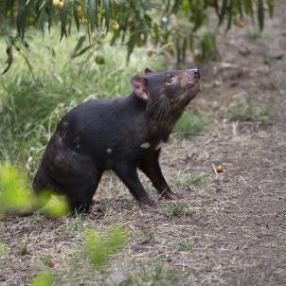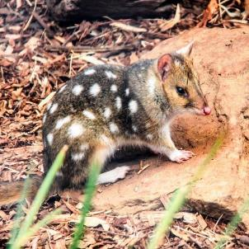

Source: Tasmanian Devil and Eastern Quoll are part of the ecological community. Leanne Chow, Department of Agriculture, Water and the Environment

# Where can I get more information?

If you need help to identify if the ecological community or another Matter of National Environmental Significance may be present in your area of interest:

Check the protected matters search tool at [www.environment.gov.au/epbc/pmst/](http://www.environment.gov.au/epbc/pmst/)

Check the species profile and threats (SPRAT) database at

[www.environment.gov.au/cgi-bin/sprat/public/sprat.pl](http://www.environment.gov.au/cgi-bin/sprat/public/sprat.pl)

Detailed information about the Tasmanian Black Gum or Brookers Gum Forests and woodlands is

available at:

[http://www.environment.gov.au/cgi-bin/sprat/public/publicshowcommunity.pl?](http://www.environment.gov.au/cgi-bin/sprat/public/publicshowcommunity.pl?id=77&amp;status=Critically%2BEndangered)

[id=77&status=Critically+Endangered](http://www.environment.gov.au/cgi-bin/sprat/public/publicshowcommunity.pl?id=77&amp;status=Critically%2BEndangered)

Further information for farmers on the national environment law and agricultural development is available at:

<http://www.environment.gov.au/land/farmers>

More information about the EPBC Act is available at:

[www.environment.gov.au/epbc](http://www.environment.gov.au/epbc)

You can also contact the Department’s Community Information Unit by:

* phone on 1800 803 772 (freecall); or
* email [ciu@environment.gov.au](mailto:ciu@environment.gov.au)

**Brookers Gum (*Eucalyptus brookeriana*) Forest**

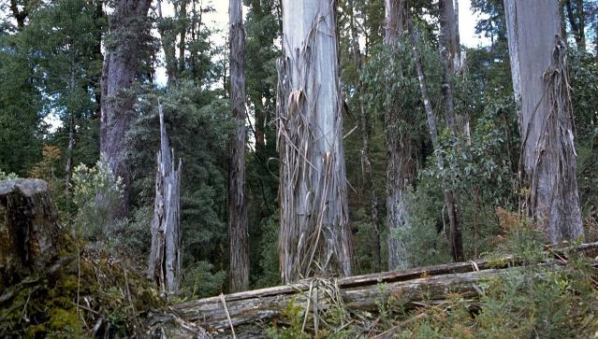

Source: Brooker and Kleinig © Australian National Botanic Gardens