|  |
| --- |
| Taro leaf blight (*Phytophthora colocasiae*) |

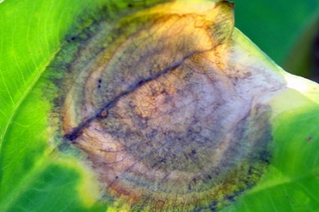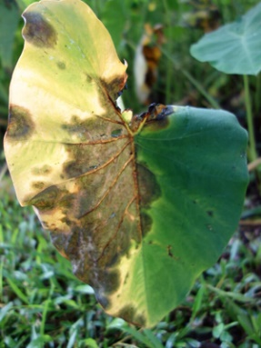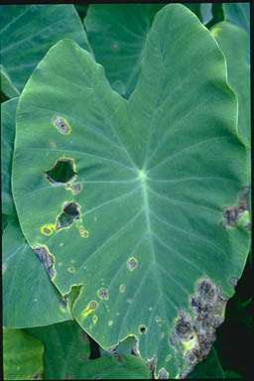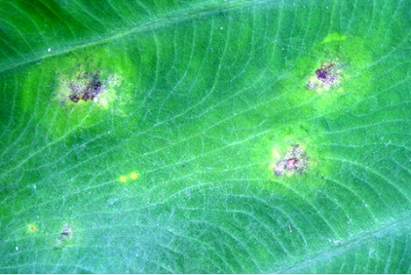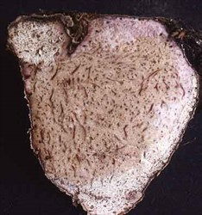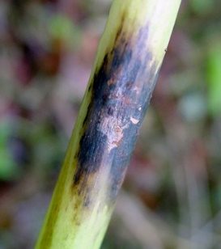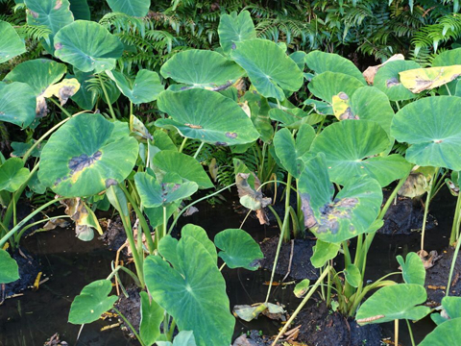

**Fig. 1** Taro crop with leaf blight symptoms including reduced numbers of mature leaves (S. Nelson, apsnet.org).

**Likely mode of entry**

This plant disease can be distributed over long distances within infected plant material, including leaves, stems, and corms of taro and some closely related plants. Soil may also contain this pathogen.

**Symptoms (Figures 1–4)**

Taro leaf blight primarily infects the leaves, but corms and petioles can also be affected. Early leaf symptoms appear as small, dark brown flecks or light brown spots on the upper leaf surface with faint, diffuse halos. The spots enlarge rapidly, becoming circular and arranged in concentric rings, and purplish brown to brown in colour. On the lower leaf surface, spots are water-soaked or dry and grey, sometimes with hard globules of plant exudate. Lesions on the petiole are grey to brownish black. As infection progresses, the spots coalesce forming a blight. The centre of lesions can become papery and fall out, producing a “shot-hole” appearance. The spots are surrounded by a powdery white ring containing masses of spores. Infected corms develop light brown firm rot becoming purplish in the advanced stages.

**Host range**

*Phytophthora colocasiae* is known to infect taro (*Colocasia esculenta*), dasheen (*Colocasia esculenta* var. *globulifera*) and some cultivars of ape or tamu (*Alocasia macrorrhiza*).

**Biology**

This pathogen is an Oomycete, a water mould that produces sporangia which release swimming spores called zoospores when water or sufficient moisture is present. Zoospores are viable for a few hours and are attracted to organic matter, and are readily distributed by splashing water, wind, and rain. Infection occurs in foliage and corms from zoospores when moisture is available. This organism is believed to survive in the corm or in soil during dry periods.

Oomycetes were formerly considered types of fungi but have recently been considered more closely related to some types of algae (kelp and diatoms).

**Distribution**

Widespread in Asia where it is probably native, and introduced to Africa, the Americas, and throughout the islands of the Pacific Ocean. Not present in Australia.

**Fig. 4** Petiole lesions may be dark with reddish brown exudates (left); corms may have light brown firm rot (right) (F. Brooks, apsnet.org; Grahame Jackson, Pacific Pests, Pathogens & Weeds app).

**Fig. 3** Taro leaf blight symptoms may include water-soaked lesions (left) or shot-holes surrounded by white powdery rings (right) (S. Nelson, apsnet.org; ©University of Hawaii at Manoa, College of Tropical Agriculture and Human Resources).

.

**Fig. 2** Early disease symptoms (left) which expand into lesions with distinct circular zones (right) (F. Brooks, apsnet.org).

**What to do if you find suspect taro leaf blight**

**Department officers:** Contain the risk, collect diseased plant samples double-bagged into zip-lock bags and deliver to a department plant pathologist immediately.

**Industry and the public:** **SEE. SECURE. REPORT.**

Secure the goods to limit movement and immediately report your detection to the Department of Agriculture, Fisheries and Forestry on **1800 798 636**.