Background Document

National Recovery Plan

for the

Swift Parrot Lathamus discolor

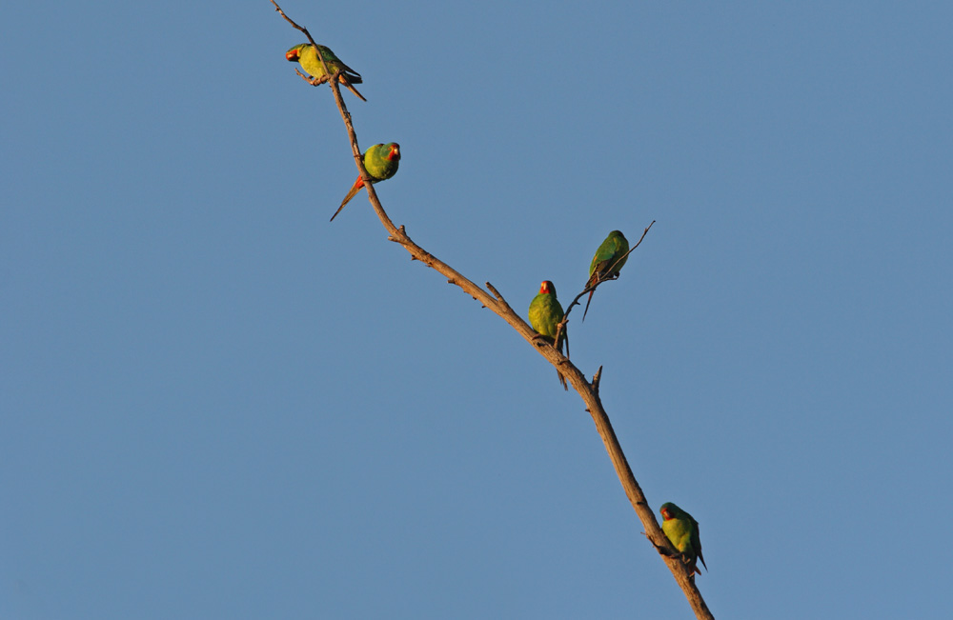

June 2010

Background Document - Swift Parrot Lathamus discolour Recovery Plan

© Swift Parrot Recovery Team 2009.

This work is copyright. However, material presented in this plan may be copied for personal use or published for educational purposes, providing that any extracts are fully acknowledged. Apart from this and any other use as permitted under the Copyright Act 1968, no part may be reproduced without prior written permission from the Department of Environment, Climate Change and Water (New South Wales) or Birds Australia.

Prepared by:
Debbie Saunders (New South Wales Department of Environment, Climate Change and Water & Australian National University), Chris Tzaros (Birds Australia), Matt Webb and Shaun Thurstans (Department of Primary Industries, Parks, Water and Environment, Tasmania.

Swift Parrot Recovery Team
C/- Birds Australia
Suite 2-05, 60 Leicester Street
Carlton Victoria 3053
Ph: +61 3 9347 0757

Disclaimer
The Australian Government, in partnership with Birds Australia, the New South Wales Department of Environment and Climate Change, the Victorian Department of Sustainability and Environment, the Queensland Department of Environment and Resource Management, the Tasmanian Department of Primary Industries, Parks, Water and the Environment, the South Australian Department for Environment and Heritage and the Australian Capital Territory Department of Parks, Conservation and Lands facilitates the publication of recovery plans to detail the actions needed for the conservation of threatened native wildlife. The attainment of objectives and the provision of funds may be subject to budgetary and other constraints affecting the parties involved, and may also be constrained by the need to address other conservation priorities. Approved recovery actions may be subject to modification due to changes in knowledge and changes in conservation status.

Publication reference
Saunders, D., Tzaros, C., Webb, M. and Thurstans, S. (2010). Background Document - Swift Parrot Recovery Plan. Department of Environment, Climate Change and Water, Queanbeyan, and Birds Australia.

Cover Photo: Swift Parrot © Chris Tzaros
Contents
Contents 3
Abbreviations 4
Introduction 5
Species Description 5
Distribution 5
Breeding 6
Dispersal 7
Migration 7
Population Monitoring 8
Nesting and Foraging Habitat 8
Mainland Volunteer Surveys 8
Published Research 12
Foraging habitat research 12
Tasmania 12
Victoria 13
New South Wales 14
Biological Research 15
Conservation Challenges 16
References 18

Abbreviations
ANU Australian National University
BA Birds Australia
CMA Catchment Management Authority
DECC Department of Environment and Climate Change and Water, New South Wales
DERM Department of Environment and Resource Management, Queensland
DEWHA Department of the Environment, Water, Heritage and the Arts, Commonwealth
DPIPWE Department of Primary Industries, Parks, Water and Environment, Tasmania
DSE Department of Sustainability and Environment, Victoria
PCL Parks, Conservation and Lands, ACT
IUCN International Union for Conservation of Nature
NRM Natural Resource Management
SADEH South Australian Department for Environment and Heritage
TBN Threatened Bird Network, Birds Australia
TSN Threatened Species Network, World Wildlife Fund (Australia)
UT University of Tasmania
WWF World Wildlife Fund (Australia)

Introduction
This document provides background information for the National Recovery Plan for the Swift Parrot in accordance with the Commonwealth Environment Protection and Biodiversity Conservation Act 1999 (EPBC Act). This includes a description of the species, distribution and lifecycle information and summaries of previous research and monitoring programs.

Species Description
The Swift Parrot Lathamus discolor (White 1790) is a small fast-flying, nectarivorous parrot which occurs in eucalypt forests in south eastern Australia. Bright green in colour, the Swift Parrot has patches of red on the throat, chin, face and forehead which are bordered by yellow. It also has red on the shoulder and under the wings and blue on the crown, cheeks and wings. A distinctive call of pip-pip-pip (usually given while flying), a streamlined body, long pointy tail and flashes of bright red under the wing enable the species to be readily identified.
The genus Lathamus is monotypic and belongs to the subfamily Platycercidae, the broad-tailed parrots which includes the genera Platycercus, Barnadius, Purpreicephalus, Northiella, Psephotus and Neophema (Christidis et al. 1991; Higgins 1999). Although the Swift Parrot superficially resembles lorikeets in habit and form (nectar feeder with brush tongue), it is generally accepted that the similarities between the Swift Parrot and the lorikeets have arisen through convergence (Smith 1975; Christidis and Boles 1994; Gartrell et al. 2000; Forshaw 2002).

Distribution
Swift Parrots breed in Tasmania and migrate to mainland Australia in autumn. During winter the parrots disperse across a broad landscape, foraging on nectar and lerps in eucalypts mainly in Victoria and New South Wales. Small numbers of Swift Parrots are also recorded in the Australian Capital Territory, south eastern South Australia and southern Queensland. A map and further details of the distribution of the species are provided in the National Recovery Plan for the Swift Parrot and a list of the Catchment Management Areas is provided in Table 1.

Table 1: Catchment Management Areas containing Swift Parrot habitat
 | State/ Territory | NRM regions
 | Tasmania | South*
 |  | North*
 |  | Cradle Coast
 | Victoria | Port Phillip Westernport*
 |  | Goulburn Broken*
 |  | East Gippsland*
 |  | West Gippsland*
 |  | North Central*
 |  | North East*
 |  | Glenelg Hopkins
 |  | Corangamite
 |  | Wimmera

 | NSW/ ACT | Southern Rivers
 |  | Northern Rivers*
 |  | Hunter - Central Rivers*
 |  | Hawkesbury - Nepean*
 |  | Sydney Metro*
 |  | Murray*
 |  | Murrumbidgee*
 |  | Lachlan*
 |  | Central West
 |  | Namoi
 |  | Border Rivers - Gwydir
 | Queensland | Burnett Mary
 |  | Condamine
 |  | South East Queensland
 |  | Border Rivers Maranoa-Balonne
 | South Australia | South East
 |  | Adelaide/Mount Lofty Ranges
 |  | Murray Darling Basin

Breeding
Swift Parrots begin to arrive in Tasmania from the mainland in early August with most of the population arriving by October. The breeding season coincides with the flowering of Tasmanian Blue Gum Eucalyptus globulus, the nectar of which is the main food source for the parrots during this time. Black Gum E. ovata is also used widely, especially as a resource for birds that have recently arrived on migration from the mainland. In Tasmania, observations and records suggest the breeding range of the Swift Parrot is largely restricted to the south and east coast within the natural range of Blue Gum. The distribution of nesting Swift Parrots each breeding season is determined largely by the distribution and intensity of Blue Gum flowering, which varies over annual cycles. There is also some breeding in the north of the state outside the natural range of Blue Gum between Launceston and Smithton. Black Gum occurs naturally throughout this region and Blue Gums have been planted widely as a street tree, in wind breaks, in gardens and plantations and are used by Swift Parrots when in flower. The size of this breeding population varies from year to year depending on the available flowering resource.
Blue Gum is a common sub-dominant and occasional dominant species in eucalypt forests of eastern Tasmania (William and Potts 1996). Any forest type containing Blue Gum (i.e. wet or dry, dominant or subdominant) can provide important foraging habitat when the Blue Gum flowers (Brereton 1997; Webb 2008). Potential nesting habitat includes any eucalypt forest that contains hollow-bearing eucalypt trees of any species. Nest trees typically contain multiple hollows, have a large trunk diameter of (mostly) > 70 cm diameter at breast height (dbh) and have signs of advanced senescence (Brereton 1997; Voogdt 2006).
The distribution and occurrence of nesting and breeding season foraging habitat can be very patchy across the landscape, with this pattern having changed over the past two centuries due to the effects of major wildfires and the extension of European land-use activities. Flowering occurs on an irregular basis with a trend for heavy flowering years to be followed by one or two poor flowering years (Tilyard and Potts 2003; Mallick et al. 2004, Webb 2008). Swift Parrots follow these annual cycles in flowering patterns of Blue Gum and birds may not return to the same breeding area until several years later when flowering conditions are again favourable. In many years this results in the majority of the breeding Swift Parrot population may be concentrated within, and dependent upon, a limited number of breeding nodes where both flowering eucalypts and nesting hollows are available (Webb 2008).
Both sexes are involved in the search for suitable nest hollows which begins soon after they arrive in Tasmania. Nesting commences in late September, however birds which are unpaired on arrival in Tasmania may not begin nesting until November after they have found mates (Brown 1989). Gregarious by nature, pairs may nest in close proximity to each other and even in the same tree. Nest sites may be re-used but not necessarily in successive years. The re-use of a nest site depends on the availability of food in that area.
The female occupies the nest chamber just before egg laying. She will not leave the nest until the chicks are hatched and sufficiently developed. The usual clutch size is four eggs but up to five may be laid (Hutchins and Lovell 1985). The eggs are white, glossy and oval, rounded at both ends. During incubation the male visits the nest site every three to five hours to feed the female. He perches near the nest and calls her out, either feeding her at the nest entrance or both will fly to a nearby perch.

Dispersal
Young birds begging for food are seen when they first leave the nest. They remain in the nesting area and gather together in flocks before dispersing. After breeding, most of the east coast population of adults and immature birds moves westwards to the Central Plateau and western Tasmania as blue gum flowering declines and other eucalypts begin to flower elsewhere, in particular Gum-topped Stringybark and White Gum. The parrots are nomadic during the post breeding period, appearing wherever there is a suitable nectar source in the west and north of the state.

Migration
Swift Parrots begin to leave Tasmania for the mainland from mid-February and most have left by the end of April. Although no Swift Parrots have ever been tracked during migration (due to current limitations on the size of satellite tracking technology), they appear to leave from the north coast between Launceston and Smithton and migrate through Bass Strait without stopping, arriving on the mainland around Port Phillip Bay including the Mornington and Bellarine Peninsulas. However, records in East Gippsland and the far south coast of NSW around this time suggest that some birds may fly direct to eastern Victoria and southern NSW.
A small number of Swift Parrots are often recorded on the mainland in March, but most of the birds are not detected until April or May when they reach their wintering habitats in central Victoria and the NSW south-western slopes and coastal regions. Once Swift Parrots arrive on the mainland, they move across the landscape in search of food, however the specific pathways used for such movements are currently unknown. Regional shifts in habitat use within and between seasons are evident from research and volunteer surveys conducted over the past 16 years (Kennedy and Overs 2001; Kennedy and Tzaros 2005; Saunders 2005; Saunders 2008; Tzaros et al. 2009). The extent of habitat use in each region varies according to food availability and competition (Kennedy and Overs 2001; Kennedy and Tzaros 2005; Saunders 2008; Saunders and Heinsohn 2008), with Swift Parrots briefly passing through some habitats feeding opportunistically, and remaining in other habitats foraging for several days, weeks or months.
There are broad temporal changes in the relative importance of various food species throughout the species’ range. For example, in central Victoria Grey box is a source generally used early in the non-breeding season. Ironbark-dominated habitats are used through much of the winter and Yellow Gum and White Box are of increasing importance towards the end of the winter. However there is considerable overlap in the flowering times of these species and local conditions play a major role in dictating the timing and extent of flowering in each region (Law et al. 2000; Keatley et al. 2002; Keatley et al. 2004; Saunders 2008; Tzaros et al. 2009). Rainfall deficiencies and subtle temperature increases throughout the inland regions of Victoria since the late 1990s have significantly affected the timing, duration, frequency and abundance of eucalypt flowering (Mac Nally et al. 2009), especially tree species known to be important for Swift Parrots, and this is influencing Swift Parrot foraging behaviour and use of resources (C. Tzaros pers. obs.).
Population Monitoring
The total Swift Parrot population is estimated to be no more than 1000 pairs and is at best stable but most likely continuing to decline, given the continued mortality of birds and the ongoing loss of habitat. There is anecdotal evidence that historically the Swift Parrot was more abundant than it current is (Hindwood and Sharland 1964; Brown 1989; Higgins 1999; Saunders 2008). A decline was first reported as early as 1917 by Mathews who summarised its status as “exceedingly rare in New South Wales and more common, though by no means now as plentiful as formerly, in Tasmania”(Brown 1989).
Therefore a monitoring program was established to determine the extent of population decline and to monitor population trends. The first season of population monitoring was conducted in the 1987/88 breeding season in Tasmania, which located an estimated 1,320 pairs (Brown 1989). Another survey was carried out during the 1995/96 breeding season, which located an estimated 940 pairs. The aim of these surveys was to attempt to locate and count a portion of all breeding birds. During 1999-2004 breeding seasons, fixed-stationary observer techniques were used at 55 sites to estimate the density of Swift Parrots across the range of dry grassy blue gum forest in eastern Tasmania. The results from these surveys suggest that the Swift Parrot population was at best stable at that time.
Breeding season surveys have been carried out in Tasmania with varying effort from 2004 to 2009 (Webb 2008; DPIPWE 2009). These surveys have focussed on the distribution of nesting and habitat use rather than population size monitoring. These surveys have recorded the annual variation in the spatial characteristics of breeding events and has documented sites being used extensively by breeding Swift Parrots, followed by several years of little or no breeding activity. The finding of a large breeding event in the wet forests of Southern Tasmania confirmed that wetter habitats provide an important alternative to areas dominated by dry forests, and may serve as an important drought refuge habitat (Webb 2008).
A project initiated in 2010, funded by the Commonwealth and Tasmanian Governments, aims to develop a statistically robust population monitoring program which addresses the difficulties associated with the unpredictable spatial and temporal variations in food abundance.

Nesting and Foraging Habitat
Details of nesting and foraging habitat types, key tree species and their distribution in relation to natural resource management areas, are available in the National Recovery Plan for the Swift Parrot. Further published information on Swift Parrot foraging ecology, biology and conservation are provided below in Published Research.

Mainland Volunteer Surveys
Given the small population size and wide distribution of the Swift Parrot in south-eastern Australia a network of volunteers was established in Victoria in 1995 to assist the location of this species throughout its over-wintering range. This network has expanded over time to around 1000 volunteers with current involvement spanning each State and Territory in which the species occurs. Swift Parrots leave the breeding grounds in Tasmania during autumn, to winter on mainland Australia before returning in spring. Therefore volunteer surveys are conducted twice a year in May and August, when most, if not all, of the population is on the mainland. Volunteers are given record sheets and relevant information before each survey and are asked to survey both known and potential areas of habitat. Information collected includes location and observer details, tree species and tree size, food availability and other bird species at each survey site. The surveys have been coordinated collaboratively with the Regent Honeyeater Recovery Team since 1997, enabling cost-savings and sharing of recovery team and volunteer resources.
There have been over 30 volunteer surveys throughout the non-breeding range of the Swift Parrot over the past 16 years (1995-2010) (). The surveys have involved hundreds of volunteers in Victoria, New South Wales, Queensland, ACT and South Australia. The aim of the winter surveys is to locate and monitor important foraging areas used by Swift Parrots and habitat resources used. A range of additional information is gleaned, stored and analysed by the Swift Parrot Recovery Team.

Figure 1 - Swift Parrot Recovery Program Volunteer Surveys 1995-2009

Swift Parrots require a combination of habitats across different regions, both within and between seasons (Mac Nally and Horrocks 2000; Kennedy and Overs 2001; Kennedy and Tzaros 2005; Saunders and Heinsohn 2008; Saunders et al. in prep).
In Victoria, the Maryborough-Dunolly area stands out as a key region having the largest average number of Swift Parrot records over the past 16 years from the volunteer survey weekends. However, the remaining regions all provide important food resources that also sustain a large proportion of the Swift Parrot population. For example habitats within north-east Victoria, Rushworth, Bendigo and St Arnaud regions are also known to regularly support large proportions of the population. Other regions, such as southern and western Victoria and Gippsland, also provide suitable resources when local conditions are favourable.
In NSW, the central and north coast regions stand out as having the largest cumulative total of Swift Parrot records over the past 11 years from the volunteer survey weekends. A large number of these records were from the 2002 season when drought conditions throughout much of their range resulted in the majority of the population concentrating in coastal regions of NSW. However, Swift Parrots require a combination of habitats from both the coast and western slopes so that food resources are available throughout the migration season each year. The south and central west slopes and south coast regions all provide such important food resources that are used regularly by Swift Parrots. Other regions, such as the north-west slopes and the tablelands are also used when local conditions are favourable.
Figure 2 shows the dynamic way that Swift Parrots use mainland wintering habitats in different regions in different years. This corresponds with the variability of food resources that occurs throughout this area during this time, which are in turn affected by rainfall. In years of low inland rainfall, there are insufficient floral resources to support large numbers of Swift Parrots and there is growing evidence (through records such as those within the Swift Parrot mainland sightings database) that the species seeks refuge habitat in coastal regions, usually on the NSW coast (e.g. central coast in 2002, south coast in 2009).
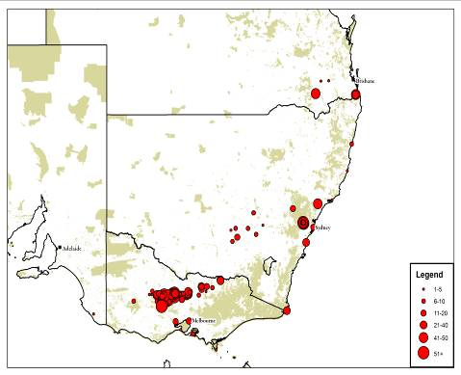 | 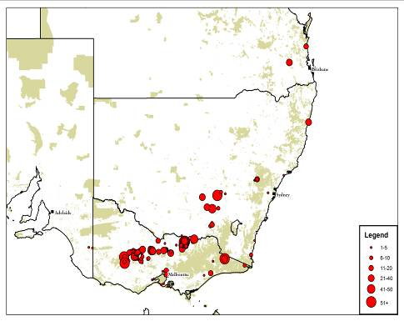  1999 | 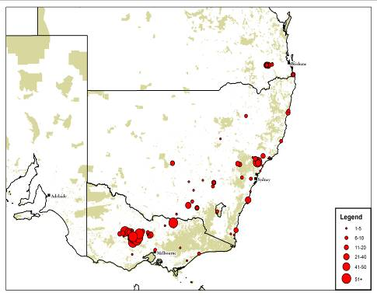  2000
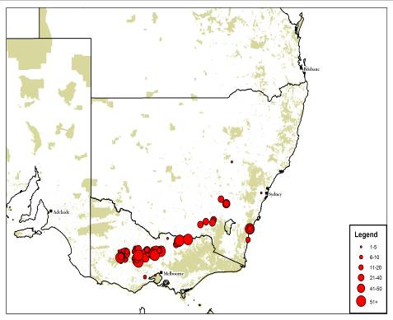  2001 | 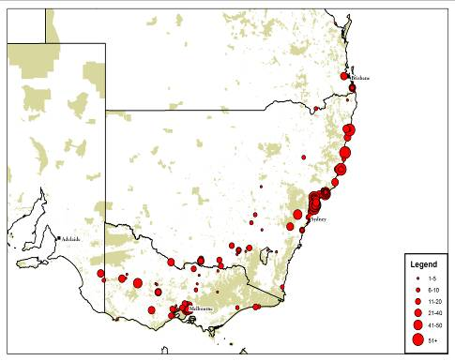  2002 | 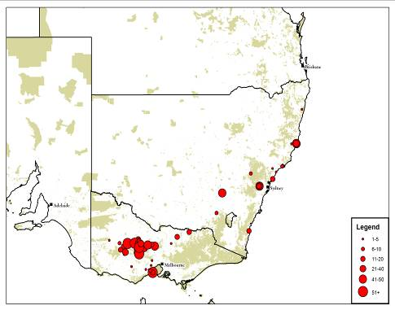  2003
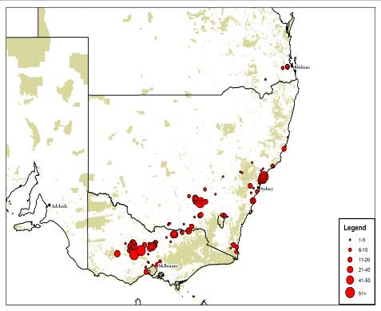  2004 | 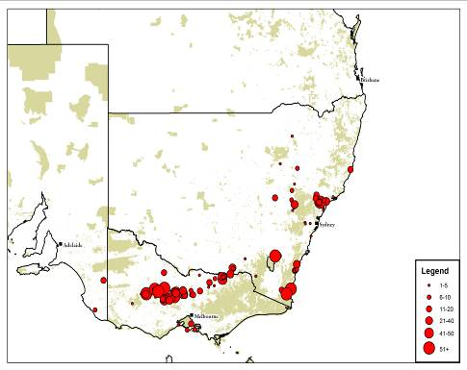  2005 | 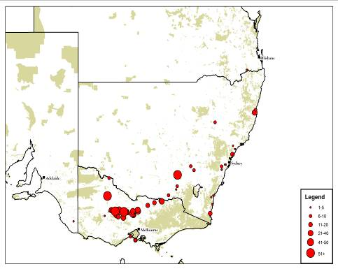  2006
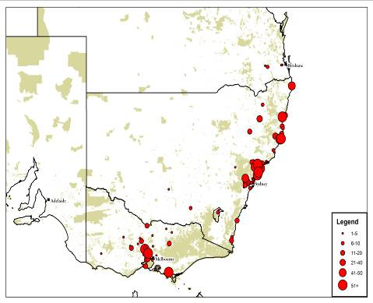  2007 | 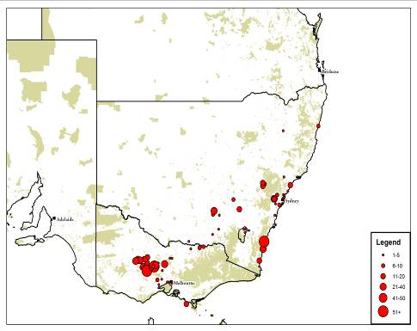  2008 | 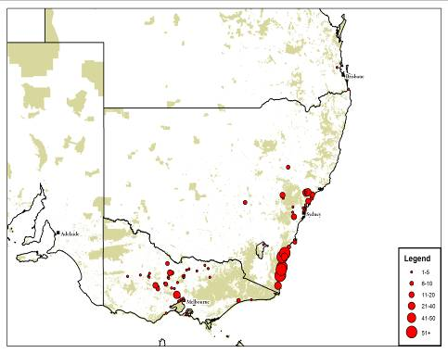  2009

Figure 2. Annual records of Swift Parrots (1998-2009) across south-eastern mainland Australia. Red circles denote Swift Parrot sightings. The larger the circle, the larger the group size of birds recorded (Source: Swift Parrot mainland sightings database).

Published Research
Abstracts of research documents on Swift Parrots in both their breeding and wintering habitats are provided below.

Foraging habitat research

Tasmania
Brereton et al. (2004) Foraging preferences of Swift Parrots on Tasmanian Blue-gum: tree size, flowering frequency and flowering intensity.
Within their breeding range, Swift Parrots prefer foraging in Tasmanian Blue-gum (Eucalyptus globulus) trees that are approximately 40% larger and have a greater flowering intensity than surrounding (non-forage) trees. The flowering frequency and intensity of Tasmanian Blue-gum increased with tree size, although there was a trend for both flowering frequency and intensity to decline in the largest tree size-classes. Past clearing has resulted in the loss of over 50% of the original (pre-European) grassy Blue-gum forest in Tasmania. Remnant grassy Blue-gum forest as well as artificially planted Blue-gum trees typically occur in small patches of <1 ha, including many solitary and scattered trees in pasture, parkland and gardens. These isolated patches of Blue-gum frequently include large, mature trees, making them an important food resource for the Swift Parrot.

DPIPWE (2010). GlobMap, The Swift Parrot foraging habitat map.
In 2009-2010 , vast areas (24 650 ha) of wet and dry Blue Gum forest and other forest types with minor proportions of Blue Gum were identified, ascribed age classes and mapped. A small area of Black Gum was also mapped. These newly mapped areas were collated with existing mapping of foraging habitat for Swift Parrots in their breeding range to form a spatial dataset dubbed ‘GlobMap’. The updated mapping of E. globulus and E. ovata dominated forest from this project will also be incorporated into future versions of TASVEG data and dramatically increase the detail and accuracy of information on the presence of E. globulus. The ability to quantify and assess the areas of subdominant E. globulus through desktop means is particularly useful for quantifying Swift Parrot foraging resources available.

Mallick et al. (2004) Blue Gums Eucalyptus globulus in north-west Tasmania: an important food resource for the endangered Swift Parrot Lathamus discolor.
Over the past 100 years, the range of the Tasmanian Blue-gum E. globulus has been extended through artificial plantings in the north-west of Tasmania. We assessed the importance of north-west Blue-gum to the Swift Parrot. Blue-gum flowering in the south-east is variable from year to year. In heavy-flowering years in the south-east, approximately 10% of the Swift Parrot population is located in the north-west. In poor-flowering years in the south-east, up to 50% of the Swift Parrot population may occur in the north-west. North-west Blue-gums include both small-scale plantings and commercial plantations. The number of potentially-flowering edge-trees in commercial Blue-gum plantations is estimated to be in the order of 1000 trees. Non-plantation Blue-gums in the north-west represent <3% of the estimated number of Blue-gums in the south-east. However these north-west trees appear to flower more consistently than trees in the south-east and may provide an important food resource for the Swift Parrot population during years of poor Blue-gum flowering in the south-east.

Webb 2008. Swift Parrot Breeding Season Survey Report – 2007/08. Threatened Species Section, Department of Primary Industries and Water.
During the 2007/08 Swift Parrot breeding season, a monitoring method was trialled to determine the distribution and relative abundance of Swift Parrots. The results suggested that the southern region and an associated flowering event were of particular importance to the species in 2007/08. Only 13 percent of 383 Swift Parrot observations were recorded elsewhere in the breeding range. Until this study the Swift Parrot was considered to be a dry forest species; however, the southern region is dominated by wet forest. To guide the development of management strategies for the region, an intensive survey regime was developed to investigate habitat use by Swift Parrots in wet forests. A preliminary analysis of these data shows a strong relationship between Swift Parrot presence and senescent eucalypt forest (potential nesting habitat), and also E. globulus and/or E. ovata flowering. During 5 minute surveys at 295 sites Swift Parrots were recorded at 52% of sites with E. globulus and/or E. ovata flowering during the first survey and 38% of sites during a second survey. Similarly, Swift Parrots were recorded at 63% and 44% of sites classified as senescent forest in the first and second survey respectively. The high proportion of sites that Swift Parrots were recorded at during short survey periods (ie. 5 min) suggests that most of the available habitat in the region was being used to some degree. Effective conservation management of Swift Parrots requires a better understanding of flowering patterns and their effects on Swift Parrot reproduction and distribution.
Annual monitoring of the distribution of Swift Parrots and the availability of floral resources is essential to provide information on the relative availability of breeding habitat each year and allow an assessment of the relative importance of particular breeding sites. Development of the methods outlined in this report to enable a reliable assessment of habitat needs and population trends is in progress.

Threatened Species Section (2009). Swift Parrot Breeding Season Survey Report 2008/09. Department of Primary Industries, Parks, Water and Environment.
The surveys carried out in the 2008/09 breeding season were focussed on the Wielangta area in the southern east coast of Tasmania. The methods used were based on those developed in the 2007/08 season by Webb (2008). The surveys confirmed the link between swift parrot presence and that of eucalypt flowering (which was more profuse towards the southern and central parts of the area) and areas mapped with forest senescence. Nests were found in aggregations with some of them in similar areas as in previous years. All nests were found in trees >80cm DBH and in close proximity to Eucalyptus globulus flowering. Intensive nest searching at selected sites indicated high densities which could potentially have been present in other areas not surveyed with the same amount of effort. As eucalyptus flowering varies spatially and temporally, these surveys are a snapshot of how swift parrots used habitats in the Wielangta area in this season alone.
The surveys and existing mapping highlight the great abundance of resources important to swift parrots in the Wielangta area. The mapping of habitat resources is useful for management of the Wielangta area that is sympathetic to the needs of breeding swift parrots. Refinement of mapping (particularly that of E.globulus distribution) will allow more accurate identification of important habitats in the area.

Victoria
Kennedy and Tzaros (2005) Foraging ecology of the Swift Parrot Lathamus discolor in the box-ironbark forests and woodlands of Victoria.
Swift Parrot foraging sites in box-ironbark forests and woodlands were found to occur most often on drainage lines. More than 90% of foraging observations were in Red Ironbark Eucalyptus tricarpa, Mugga Ironbark E. sideroxylon, Yellow Gum E. leucoxylon or Grey Box E. microcarpa. Nectar, lerp and other food from eucalypt foliage were frequent dietary items. Swift Parrots selected trees in larger size classes for foraging more often than expected given the relative abundance of such trees. Larger trees were also found to flower more reliably. Swift Parrot habitat in the study area is extensively fragmented and degraded and management to increase the density of larger trees is recommended. There was considerable between-year variation in regional distribution and relative use of principal tree species. The five regions within the study area all supported a significant percentage of the population in at least one of the three years. As a result, recovery measures will need to target important sites across the geographical extent of the study area.

Mac Nally and Horrocks (2000) Landscape-scale conservation of an endangered migrant: the Swift Parrot (Lathamus discolor) in its winter range.
The spatial distribution of Swift Parrots over two successive winters in box-ironbark habitats of central Victoria varied significantly in their regional distributions. In some years relatively small remnant patches become significant elements in the landscape for the over-wintering parrots. The Swift Parrot appeared to be dependant upon eucalypt nectar, however a possible linkage with the intensity of Golden Wattle (Acacia pycnantha) flowering was identified within the study area. Although the occurrence or density of Swift Parrots was not found to relate to eucalypt flowering, they did appear to be related to densities of other nectarivorous species. Given the regional distribution of the parrot varied significantly between seasons and this study focused on a limited number of regions, insufficient temporal and spatial data was available to detect site fidelity for this species. From a conservation standpoint, inter-annual variation in use of the major areas of the box–ironbark system by Swift Parrots is pronounced and a broad perspective needs to be maintained for their management in over-wintering regions. Remnants as small as 10 hectares are utilised in some years by Swift Parrots and therefore preservation of remnant habitats is encouraged.

New South Wales
Saunders and Heinsohn (2008) Winter habitat use by the endangered, migratory Swift Parrot (Lathamus discolor) in New South Wales.
Migratory birds are dependent on a combination of suitable wintering, migration and breeding habitats. Identification and protection of these habitats is essential for their conservation. The endangered Swift Parrot (Lathamus discolor, Psittacidae) migrates north from Tasmania in search of suitable winter food resources across south-eastern mainland Australia. This five year study examines the use of known winter foraging habitats by Swift Parrots on a state-wide scale not previously attempted. Swift Parrots used a diversity of winter foraging habitats in coastal and/or western slopes regions of New South Wales each year, including several habitats that occur in endangered ecological communities. Swift Parrot abundance fluctuated significantly between years and regions, with coastal areas providing important drought refuge habitats for a large proportion of the population. Over half of all foraging sites were used repeatedly, highlighting their likely importance for conservation. Landscapes containing winter foraging habitat included scattered trees, remnant vegetation and continuous forests, and Swift Parrots foraged extensively on lerp and nectar from a diversity of tree species within these. The occurrence of Swift Parrots at foraging sites was primarily associated with the abundance of lerp, nectar, and non-aggressive competitors.

Kennedy and Overs (2001) Foraging ecology and habitat use of the Swift Parrot on the south-western slopes of New South Wales.
Swift Parrots were located at six sites in woodlands and open forests dominated by Mugga Ironbark Eucalyptus sideroxylon and Grey Box E. microcarpa. They foraged on both of these eucalypt species, with Mugga Ironbark primarily used as a nectar source and Grey Box primarily used as a source of lerps. Previous records of Swift Parrots from White Box E. albens woodlands indicate that this habitat type may also provide important foraging resources. Swift Parrots were found to preferentially forage in the largest trees in the landscape and were able to locate small patches of suitable habitat in a highly fragmented landscape. Habitats of the south-western slopes of NSW support a significant proportion of the Swift Parrot population in years when suitable foraging resources are available. Grey Box was used widely by the Swift Parrot although it was not flowering at any site, suggesting it has food resources which Swift Parrots will use even if Mugga Ironbark nectar is also available. The site fidelity displayed at some of these patches between years also emphasises their importance.

Kennedy (2000) A winter survey of the Swift Parrot in coastal New South Wales.
In New South Wales, Box-ironbark forests and grassy woodlands in the western slopes region and Swamp Mahogany Eucalyptus robusta forests on the coast have supported large numbers of Swift Parrots. However there are also a small number of Swift Parrot records from Spotted Gum Corymbia maculata, Blackbutt Eucalyptus pilularis, Forest Red Gum E. tereticornis and Coastal Banksia communities. This survey highlighted the importance of Spotted Gum as well as Swamp Mahogany habitats to the Swift Parrot in coastal New South Wales. The Spotted Gum habitat in the Hunter Valley supported a significant percentage of the state’s Swift Parrot population in the winter of 2000. There is also evidence that the parrots preferentially select larger trees in these forests. The Hunter Valley concentration coincided with a poor year in other primary foraging habitats in NSW. Although box-ironbark and Swamp Mahogany habitats are generally considered to be the two major forest types for the Swift Parrot in NSW, it now appears that there are additional forest types, such as Spotted Gum, that may support a significant percentage of the state’s population in a given year. Despite these important vegetation types being extensively cleared in the region, remnants continue to be cleared for a range of residential and industrial developments.

Saunders et al.(in prep). Austral migration and dynamic winter habitat use in endangered swift parrots.
Migratory birds spend a large proportion of their lives within their wintering habitats. However the spatial and temporal dynamics of winter habitat use for most species are poorly understood. In this study we document patterns of winter habitat use in an endangered austral migrant, the swift parrot (Lathamus discolor, Psittacidae), a species that migrates north from its breeding range in Tasmania each year to habitats throughout south-eastern mainland Australia. Data on habitat use across a broad geographic range were collected by up to 300 volunteers in both autumn and winter for seven years (1998-2004). Despite the small population size (2500 birds), broad winter distribution (1 250 000 km²) and often cryptic nature of swift parrots, they were detected in 19% of 4140 surveys and were observed to use the same locations repeatedly. Four regions in central Victoria were used most consistently, although the birds also visited other regions each year. During drought swift parrot abundance was significantly correlated with rainfall, whereby most of the population either concentrated in a few regions or migrated longer distances (up to 1000km) to drought refuges in wetter coastal areas. However, swift parrot abundance was not associated with specific climate variables during years of average to high rainfall throughout most of their range. Instead they appeared to prefer particular regions. This study provides the first demonstration of large-scale drought related movements by a migratory population throughout their winter range. It also demonstrates the dynamic spatial and temporal patterns of winter habitat use, including repeated use of sites, by an austral migrant. Importantly it emphasises that conservation measures need to be implemented throughout the distribution of migratory species, including drought refuge habitats and areas outside conservation reserves.

Biological Research
Gartrell et al. (2000) Morphological adaptations to nectarivory of the alimentary tract of the Swift Parrot Lathamus discolor.
The morphology and microscopic architecture of the alimentary tract of the Swift Parrot was compared to that of the Green Rosella and Musk Lorikeet. Gut contents were evaluated grossly and by light microscopic examination. There were significant differences between the Swift Parrot, the Green Rosella and Musk Lorikeet. The results indicate that the Swift Parrot has retained some of the alimentary features of its granivorous ancestors, and has adapted to nectarivory, with the development of a brush tongue and changes to the crop, proventriculus and duodenum. The larger, more muscular gizzard and longer intestine may allow the Swift Parrot to use a diversity of dietary items when nectar and pollen are not readily available.

Gartrell (2002) Assessment of the reproductive state in male Swift Parrots (Lathamus discolor) by testicular aspiration and cytology.
A technique for assessing the status of reproductive activity in the Swift Parrot Lathamus discolor was developed. To validate this technique, cytology was compared with testicular histology and seasonal variations in testicular volume in both wild and captive birds. The described technique of gonad examination and testicular aspiration and cytology was effective in tracking the seasonal variation in testicular volume and spermatogenesis in Swift Parrots. But testicular histology provided more information about the cellular architecture of the testes than was evident from cytology. Testicular aspiration and cytology was a reliable and safe technique for assessing the status of reproductive activity during the breeding season in small male parrots. The normal seasonal patterns of reproductive activity of male birds need to be understood for clinical assessment of the reproductive status.

Gartrell and Jones (2001) Eucalyptus pollen grain emptying by two Australian nectarivorous psittacines.
The relative importance of pollen as a source of protein to vertebrates is controversial. In nectarivorous psittacine birds, field studies support its importance, but an experimental study in a nectarivorous parrot showed that less than 7% of pollen grains were emptied. We investigated pollen grain emptying by the Swift Parrot Lathamus discolor and the Musk Lorikeet Glossopsitta concinna. We used a controlled experiment, and examined pollen located at different levels through the alimentary tract of wild Swift Parrots. There was significant emptying of pollen grains by all birds in the experimental trials. There was also a progressive increase in the percentage of pollen grains emptied at different sites along the alimentary tract in wild birds. The percentage of pollen grains emptied by captive and wild Swift Parrots was not significantly different. Both species of nectarivorous parrot were able to rapidly ingest large quantities of eucalypt pollen and appeared to empty the pollen grains efficiently and provide an important source of protein for these birds.

Conservation Challenges
Although the Swift Parrot recovery program has achieved many positive conservation outcomes, there are still many threats to the species and its habitat that need to be addressed through a continuing and adaptive recovery effort (Saunders et al. 2007). The following two discussion papers outline some of the ongoing challenges for Swift Parrot conservation.
Munks et al. (2004) The importance of adaptive management in 'off-reserve' conservation for forest fauna: implementing, monitoring and upgrading Swift Parrot Lathamus discolor conservation measures in Tasmania.
As formal reservation targets are attained in Tasmania, a large component of habitats important for populations of threatened fauna will remain in the “off-reserve” landscape. Over 80% of Swift Parrot foraging habitat occurs on private land, potentially subject to production forestry or agriculture. As a first step in monitoring the effectiveness of management prescriptions for the conservation of Swift Parrot foraging habitat in “off-reserve” areas, an assessment was made of their implementation in between 1995 and 1998. Prescriptions recommended by specialists were generally incorporated into timber harvesting plans. However, post-harvest assessment of operations areas containing high or medium quality habitat suggested that implementation of prescriptions on the ground was not effective in protecting foraging habitat. Although prescribed clumps of trees were retained, only 16% contained the prescribed number of prime foraging trees (2-3 mature Eucalyptus globulus). In part, this may be due to the low level of detail in the plans describing how harvesting contractors should implement the prescriptions. In addition, the retention of clumps was found to be an inappropriate prescription where forage trees were sparsely distributed, and where clumps were subject to post-harvest disturbances reducing their long-term effectiveness for conservation. As a result, prescriptions were adapted to include a patch retention strategy, foresters were provided with more intense training, planning tools were developed to clarify and simply prescriptions and legislative changes were implemented to potentially achieve long-term conservation of habitat on private land.

Saunders et al. (2007) Conservation of the Swift Parrot Lathamus discolor – management lessons for a threatened migratory species.
Conserving habitat for wide-ranging fauna species provides a challenge because impacts on these species tend to be dismissed based on the assumption that there is sufficient habitat in other areas of its range. The resulting incremental loss of habitat is a serious conservation issue for a diversity of bird species. As knowledge of wide-ranging and migratory bird species increases, it often becomes evident that they select specific sites on a regular basis (i.e., the species exhibit site fidelity). Gaining a better understanding of site fidelity and selective habitat use for wide-ranging species is clearly important but also extremely challenging. Challenges associated with conservation of the migratory and wide-ranging Swift Parrot Lathamus discolor provide an example of how a recovery program has aimed to address such conservation and management challenges. Despite the small population size (less than 2 500 birds), broad distribution (1 250 000 km²) and often cryptic nature, the implementation of the national recovery program (1995-2005) for this species has been successful in the identification and protection of some important habitats. This has been made possible by involving large numbers of volunteers who collect long-term sighting and habitat data over large areas, together with more detailed research and implementation of various management practices.

References
Brereton, R. (1997). 'Management prescriptions for the Swift Parrot in production forests.' (Report to the Tasmanian Regional Forest Agreement Environment and Heritage Technical Committee.).
Brereton, R., Mallick, S. and Kennedy, S. (2004). Foraging preferences of Swift Parrots on Tasmanian Blue-gum: tree size, flowering frequency and flowering intensity. EMU 104, 377-383.
Brown, P. B. (1989). 'The Swift Parrot Lathamus discolor White: A report on its ecology, distribution and status, including management considerations. Technical Report.' (Department of Lands, Parks and Wildlife.: Hobart).
Christidis, L. and Boles, W. (1994). 'The taxonomy and species of birds of Australia and its Territories.' (Royal Australasian Ornithologists Union.).
Christidis, L., Schodde, R., Shaw, D. D. and Maynes, S. F. (1991). Relationships among the Australo-Papuan Parrots, Lorikeets, and Cockatoos (Aves, Psittaciformes) - Protein Evidence. Condor 93, 302-317.
DPIPWE (2010). GlobMap, The Swift Parrot foraging habitat map. Biodiversity Conservation Branch, Department of Primary Industries Parks, Water and Environment. Tasmanian Government. Hobart.
Forshaw, J. (2002). 'Australian Parrots.' (Lansdowne Press: Melbourne).
Gartrell, B. D. (2002). Assessment of the reproductive state in male swift parrots (Lathamus discolor) by testicular aspiration and cytology. Journal of Avian Medicine and Surgery 16(3), 211-217.
Gartrell, B. D. and Jones, S. M. (2001). Eucalyptus pollen grain emptying by two Australian nectarivorous psittacines. Journal of Avian Biology 32(3), 224-230.
Gartrell, B. D., Jones, S. M., Brereton, R. N. and Astheimer, L. B. (2000). Morphological adaptations to nectarivory of the alimentary tract of the Swift Parrot Lathamus discolor. EMU 100, 274-279.
Higgins, P. J. E. (1999). 'Handbook of Australian, New Zealand and Antarctic Birds. Parrots to Dollarbirds, Vol. 4.' (Oxford University Press: Melbourne).
Hindwood, K. A. and Sharland, M. (1964). The Swift Parrot. Emu 63, 310-326.
Keatley, M. R., Fletcher, T. D., Hudson, I. L. and Ades, P. K. (2002). Phenological studies in Australia: Potential application in historical and future climate analysis. International Journal of Climatology 22, 1769-1780.
Keatley, M. R., Hudson, I. L. and T.D., F. (2004). Long-term flowering synchrony of box-ironbark eucalypts. Australian Journal of Botany 52, 47-54.
Kennedy, S. (2000). 'A winter survey of the Swift Parrot (Lathamus discolor) in northern New South Wales'. (NSW NPWS).
Kennedy, S. and Tzaros, C. (2005). Foraging ecology of the swift parrot Lathamus discolor in the Box-Ironbark forests and woodlands of Victoria. Pacific Conservation Biology 11, 158-173.
Kennedy, S. J. and Overs, A. E. (2001). Foraging ecology and habitat use of the swift parrot on the south-western slopes of New South Wales. Corella 25, 68-74.
Law, B., Mackowski, C., Schoer, L. and Tweedie, T. (2000). Flowering phenology of myrtaceous trees and their relation to climatic, environmental and disturbance variables in northern New South Wales. Austral Ecol 25, 160-178.
Mac Nally, R. M. and Horrocks, G. (2000). Landscape-scale conservation of an endangered migrant: the Swift Parrot (Lathamus discolor) in its winter range. Biological Conservation [Biol Conserv ] no 3, 335-343.

Mac Nally, R., Bennett, A.F., Thomson, J.R., Radford, J.Q., Unmack, G., Horrocks, G. and Vesk, P. (2009). Collapse of an avifauna: climate change appears to exacerbate habitat loss and degradation. Diversity and Distributions [Diversity Distrib.] 1–11.
Mallick, S., James, D., Brereton, R. and Plowright, S. (2004). Blue Gums Eucalyptus globulus in north-west Tasmania: an important food resource for the endangered Swift Parrot Lathamus discolor. Victorian Naturalist 121, 36-46.
Munks, S., Richards, K., Meggs, J. and Brereton, R. (2004). The importance of adaptive management in 'off-reserve' conservation for forest fauna: implementing, monitoring and upgrading Swift Parrot Lathamus discolor conservation measures in Tasmania. In 'Conservation of Australia's Forest Fauna'. (Ed. D. Lunney) pp. 688-698. (Royal Zoological Society: Mosman)
Saunders, D. L. (2005). 'National Swift Parrot Recovery Program - Achievements 1995-2004'. (Commonwealth Department of Environment and Heritage: Canberra).
Saunders, D.L. (2008). Ecology and Conservation of the Swift Parrot - an endangered austral migrant. PhD Thesis, Fenner School of Environment and Society, Australian National University, Canberra.
Saunders, D. L., Brereton, R., Tzaros, C., Holdsworth, M. and Price, R. (2007). Conservation of the Swift Parrot Lathamus discolor - management lessons for a threatened migratory species. Pacific Conservation Biology 13, 111-119.
Saunders, D. L. and Heinsohn, R. (2008). Winter habitat use by the endangered, migratory Swift Parrot (Lathamus discolor) in New South Wales. Emu 108, 81-89.
Saunders, D. L., Heinsohn, R., Cunningham, R. and Wood, J. (in prep). Austral migration and dynamic winter habitat use in endangered swift parrots.
Smith, G. A. (1975). Systematics of parrots. Ibis 117, 18-68.
Threatened Species Section (2009). Swift Parrot Breeding Season Survey Report 2008/09. Department of Primary Industries, Parks, Water and Environment.
Tilyard, P., and Potts, B. (2003). Flowering phenology of Eucalyptus globulus in Swift Parrot habitat in eastern Tasmania. Cooperative Research Centre for Sustainable Production Forestry, University of Tasmania. A Report to the Nature Conservation Branch.
Tzaros, C., Saunders, D., Webb, M. and Ingwersen, D. (2009). Swift Parrots - dynamic migrants within a drought-prone environment. Wingspan 19 (3), 14-15.
Voodgt, J. (2006). Characteristics of Swift Parrot (Lathamus discolor) nesting habitat.' Honours thesis. Department of Biology, Gerof-August-University of Gottingen, Germany.
Webb, M. 2008. Swift Parrot Breeding Season Survey Report – 2007/08. Threatened Species Section, Department of Primary Industries and Water.
Williams K. J. and Potts, B. M. (1996). The natural distribution of Eucalyptus species in Tasmania. Tasforests Vol 8. Pp 39- 149.

