|  |
| --- |
| Sunflower downy mildew (*Plasmopara halstedii*) |

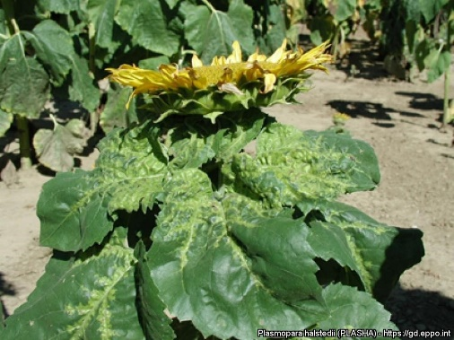

**Likely mode of entry**

All parts of living and dead infected plants can carry the long-lived spores of this fungus. Nursery stock, soil, potting mix, and particularly seeds (including weed seeds and illegal imports of sunflower seeds) are all likely modes of entry, while wind-borne spores are able to spread the disease only in local areas under wet and windy conditions.

**Symptoms (Figures 1–4)**

Infected seedlings may experience “damping off” (sudden death) or develop white fungal growth which appears downy and produces spores. Young plants show chlorotic mottling with downy fungal growth on the underside of leaves. The leaves may become thickened, curl downwards and die. Infection of older plants results in stunting, thin stems, small horizontal seed heads, and chlorotic leaf mottling. Infected plants have reduced oil and seed yield and poor seed viability. Latent infections show no obvious symptoms.

**Host range**

Hosts include sunflower (*Helianthus annuus*), other *Helianthus* species, and over 100 other species in the family Asteraceae, including many weeds.

**Biology**

Sunflower downy mildew is caused by the soil-borne fungus, *Plasmopara halstedii*. Systemic infections produce two spore types, short-lived asexual zoospores from the underside of leaves, and long-lived sexual oospores in the roots, stem, leaves and seeds. Most infections are from the long-lived soil-borne or seed-borne oospores, while some in-crop infections result from the short-lived airborne zoospores. Seed-borne infections usually result in latent infections that have no obvious symptoms but still produce spores, continuing the pathogens life cycle.

The long-lived soil-borne spores (viable for up to 10 years) and the 35 reported pathotypes of the fungus make this disease very difficult to control. Reports that this pathogen is present in Australia and New Zealand are incorrect and relate to a different disease species.

**Distribution**

Present almost worldwide where sunflower is grown, including Africa, Europe, Asia, and the Americas. Not present in Australia.

**Fig. 1** Sunflower symptoms include stunting, leaf mottling and an upturned, horizontal head (Hedvig Komjati, gd.eppo.int).

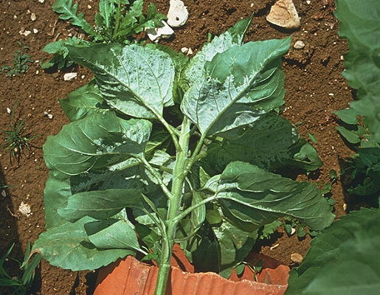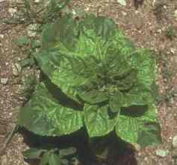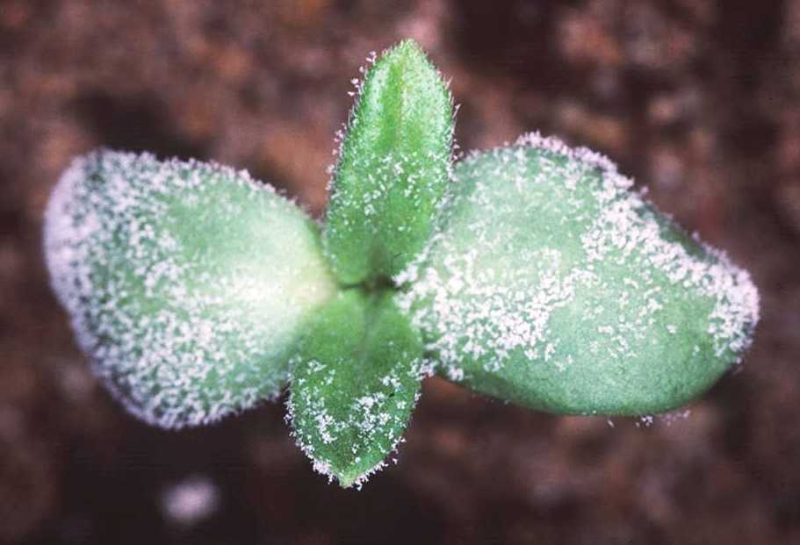

**Fig. 4** Downy mildew beneath sunflower leaves (C. Lamarque, HYPPA, inrae.fr).

**What to do if you find suspect sunflower downy mildew**

**Department officers:** Contain the risk, collect plant specimens double-bagged into zip-lock plastic bags and deliver to a department plant pathologist immediately.

**Industry and the public:** **SEE. SECURE. REPORT.**

Secure the goods to limit movement and immediately report your detection to the Department of Agriculture, Fisheries and Forestry on **1800 798 636**.

**Fig. 3** Chlorotic leaf mottling on a sunflower plant (C. Lamarque, HYPPA, inrae.fr).

**Fig. 2** Downy mildew symptoms on a sunflower seedling (Ken Goulter).