Independent Observer summary report on MV Al Messilah

Cattle and sheep exported to Kuwait and the United Arab Emirates in May 2022
December 2022

Voyage summary
Livestock: 368 cattle and 53,624 sheep.
Vessel: MV Al Messilah.
Loading location and date: Fremantle, 23 to 25 May 2022.
Vessel departure date: 25 May 2022.
Discharge location and dates:
- Shuwaikh, Kuwait: 9 to 11 June 2022.
- Jebel Ali, United Arab Emirates (UAE): 13 to 14 June 2022.
Voyage length: 23 days.
Independent Observer: Boarded at Fremantle and remained onboard until completion of discharge.
Voyage mortality rate: 0.11% (60 mortalities) for sheep. These mortalities are unlikely to be linked to any systemic failure by the exporter. There were no mortalities for cattle.
Notifiable mortality rate required to trigger an investigation: 0.5% for cattle, 1% for sheep.

Summary of observations
This report summarises key observations relating to the implementation and effectiveness of exporter arrangements to ensure the health and welfare of livestock. The report has been approved by the observer who accompanied the voyage.

Exporter documentation
Relevant exporter documentation for the voyage was made available to the observer.

Loading
The observer noted that:
- Several pens were not loaded in accordance with standard 5.5.1 of the Australian Standards for the Export of Livestock (ASEL) pen space allocation requirements. Empty pens were observed on day 1, however it is standard practice to redistribute stock following departure. The load plan provided to the observer on day 3 indicated that the vessel had been loaded to full capacity. Following receipt of the load plan, the observer advised the master on day 4 that a number of pens on Deck 10 were still empty, implying that occupied pens were overstocked. The master revised the load plan to distribute livestock more evenly among all pens and this was completed within 24 hours. Later in the voyage the observer was led to understand that a portion of Deck 10 had been kept free to allow for vessel maintenance. After redistribution of livestock, this maintenance did not take place. No significant impact on animal health and welfare was observed as a result.
- A small number of pens on Decks 6 and 7 were briefly emptied during the voyage to allow for major vessel works in the area. The animals from these pens were distributed across surrounding pens for a period no longer than 24 hours, temporarily increasing the stocking density beyond ASEL standard 5.5.1 requirements until the livestock were redistributed back to their original stocking density across the affected pens and surrounding pens of the two decks. No adverse effects on livestock health and welfare were observed as a result of temporarily removing access to pens.
- Several inter-pen gates on most decks were left open throughout the voyage to combine pens. No livestock health and welfare issues were observed as a direct result of pen gates being left open.
- One sheep was loaded with horns that were more than 1 full curl, however the exporter did not have a long-horned livestock management plan in place for the voyage as required under ASEL standard 1.7.7. No livestock health and welfare issues were observed as a direct result of this sheep’s horns.

Personnel
Based on observations made during this voyage, the exporter arrangements relating to personnel were appropriate and effective in managing livestock health and welfare.

Daily routine
The observer noted that:
- Some sheep were not able to readily access feed or water troughs due to the structure of their horns, and that two of these sheep were not identified by the Australian Accredited Veterinarian (AAV) and stockperson during daily inspections until they had lost significant body condition. These animals were later placed in a hospital pen with internal troughs provided to enable them to access feed and water (see below section on Feed and water).

Feed and water
The observer noted that:
- Feed pellets broke down into fines (fodder dust), which was observed in troughs at varying times of day throughout the voyage. ASEL standard 5.1.12 requires that livestock have access to feed of a quality to maintain good health, welfare and satisfy energy requirements. Troughs were raked through regularly to settle fines below the pellets and each day the accumulated fines were tipped out of the troughs. Fines are generally unpalatable to sheep reducing the availability of fodder to the animals, and may be associated with increased risk of bloat, respiratory and eye problems. That fines were leftover in troughs by the sheep and were emptied daily suggests fines were not palatable to the sheep. However, management practices during this voyage prevented any discernible detrimental effect on livestock health and welfare.
- ASEL standard 1.7.7 requires that sheep are not sourced for export if their horns would restrict access to feed or water during transport. Some animals were observed to have difficulty accessing feed and water troughs due to their horns being too large or awkwardly shaped to easily fit through the pen rails. With some effort, most of these horned sheep were able to access the troughs and were not negatively affected. Two sheep were observed to have greatly reduced access to feed and water and to have lost body condition prior to identification by the AAV and stockperson. These animals were later placed in a hospital pen with internal troughs provided to enable them to access feed and water.

Ventilation
The observer noted that:
- The vessel has greatly improved ventilation since their last deployment on the vessel. Areas of Decks 9, 10 and 11 have been converted from closed-deck to open-deck, which improved exhausting air from these decks. Some of the fans previously dedicated to exhaust have been rewired as intake fans, which has improved ventilation on the lower decks. Further improvements across the vessel include focusing incoming air towards livestock pens.
- 5% of sheep on Deck 11 were observed to be open mouthed panting during day 15, however when approached by the observer, the sheep ceased panting indicating they were not affected by heat stress to the extent that their cognitive abilities and reflexes were impaired. The sheep were eating well and tolerating the heat. None of the voyage’s mortalities were considered to be caused by the effects of heat.

Pen conditions
The observer noted that:
- Manure pads on all decks became tacky on days 13 and 14 of the voyage when coming into Kuwait Port, lightly soiling the sheep’s fleece. Days 13 and 14 were the hottest days of the voyage and had the highest humidity. Cattle pens were shovelled out on Day 10 in anticipation of pads softening and sawdust was added to pens once they became tacky. The pens with the lowest pen air turnover of the vessel were the first to soften, however all pads dried out as the wet bulb temperature dropped on Day 15. There was no observed negative impact on livestock health and welfare relating to pen conditions.

Health and welfare
The observer noted that:
- A total of 60 sheep mortalities occurred on this voyage. The AAV reported that 30 sheep were euthanased as a result of unresponsive infections, lameness and gut issues. Post-mortems were performed by the AAV on 9 of the mortalities, with the main causes identified as inanition, small intestine abnormalities and 1 limb injury or infection. The AAV reported that 8 mortalities could not have post-mortems due to proximity to shore or ports, 6 were autolysed and the remaining were reported by the AAV to have not required post-mortems because the cause of death was evident.
- During the voyage, the AAV reported 70 treatments of sheep and 0 treatments of cattle. The AAV treated 42 sheep for lameness, 11 for inanition, 5 for foot injury or infection, 4 for blindness in both eyes, 4 for ill-thrift, 2 for limb injury or infection, 1 for difficulty urinating, and 1 for penile infection.
- A large amount of wind-borne chaff was observed during loading of fodder. Shortly afterwards a sheep was found temporarily blinded in both eyes. The sheep was observed to be calmly eating and drinking normally in its pen. The AAV reported that another four sheep were treated for blindness during the voyage, however no other sheep were treated for blindness on the observed sheep’s deck. The observed sheep was not easily identifiable following this observation, indicating its symptoms resolved quickly so that it appeared normal by the next daily inspection.
- Sheep exported to the UAE were required to have 20mm or shorter wool or hair, and sheep exported to Kuwait were required to have 25mm or shorter wool or hair. Following a systematic review of wool and hair length across the vessel by the observer, the observer identified that up to 8,000 sheep were loaded with wool or hair over 25mm. None of the voyage’s mortalities were considered to be caused by the effects of heat, or excessive wool or hair length. Overall, the observer stated that all sheep travelled well and had good appetites during the hottest days and throughout the voyage.
  - The observer reported that sheep with wool or hair lengths over 25mm were not over-represented in mortalities. The observer did however comment that they did not appear to manage the highest temperatures (~31-32°C wet-bulb temperature) as well as those with shorter wool or hair lengths (under 25mm) with the sheep with longer wool or hair being the first observed to begin panting. The highest temperatures occurred over 3 days approaching Kuwait for discharge, with the longest continuous period above 31°C wet-bulb temperature as 1 hour and 40 minutes.
  - At the hottest times, a maximum of around 5% of sheep at a given time were observed temporarily open mouthed panting, however no sheep, including those with wool or hair lengths greater than 25mm, were observed with prolonged periods of open mouthed panting, or with their tongues out.
- On day 16, a ewe birthed two lambs. The lambs were euthanised shortly afterwards and the ewe was discharged with other sheep from its deck. No ewes were exported as part of this consignment. The department identified that the ewe was tagged in the incorrect ear, visually identifying her as a wether.

Discharge
The observer noted that:
- During the early morning on Day 17 during discharge in Kuwait, a sheep was observed recumbent in Deck 5’s mortality collection area. The sheep appeared deceased however once approached it rose and limped away from the observer with a visibly fractured foreleg. The observer was not present at the time it was placed in the collection area and was not present when the sheep was euthanased by the LiveCorp accredited stockperson shortly after the observer identified the animal. The department cannot verify the circumstances leading to this injured animal being left in the mortality collection area.
  - Vessel crew are expected to move sick or injured livestock from their pens and into hospital pens for treatment or euthanasia by the AAV or stockperson, rather than leave the livestock in the mortality collection area or an alleyway. The exporter’s documented arrangements addressed this requirement appropriately (ASEL standard 5.6.3), however the arrangements did not appear to have been implemented effectively in this instance.

Department actions
- The observer’s reporting and media evidence was assessed by the Live Animal Exports Branch (LAEB) and Animal Welfare Branch (AWB), and an independent expert was consulted to verify the reported non-compliance with wool and hair length.
  - Assessment of the observer’s reporting and media indicated that both the exporter and department’s current inspection and verification processes were inadequate to provide sufficient assurance that wool and hair length requirements are being met for all sheep, per ASEL standard 3.7.3.
  - The department developed a standardised method to verify wool and hair length and associated guidance material to ensure consistency by both department officers and industry.
  - The department has required the exporter to develop a verification plan for measuring wool and hair length, including the use of the above standardised method for future voyages.
  - The department has reviewed its current processes and developed revised inspection and verification activities for wool and hair length which will be implemented for future voyages.
- The department required the exporter to review, amend and vary as required, their processes for the management of:
    - rejection criteria relating to horned livestock
    - access to feed and water
    - pen space allocation
    - animals requiring treatment or euthanasia.

Representative photographs of voyage
Day 5 Sheep in pen — variance of wool or hair length  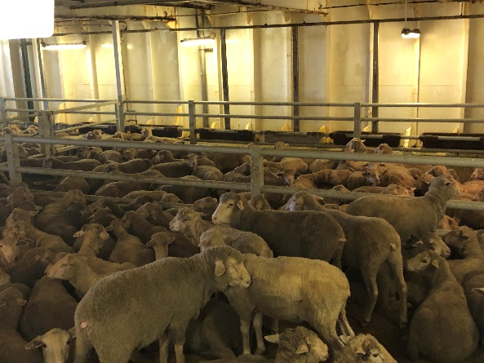 | Day 8 Cattle in pen — no issues identified  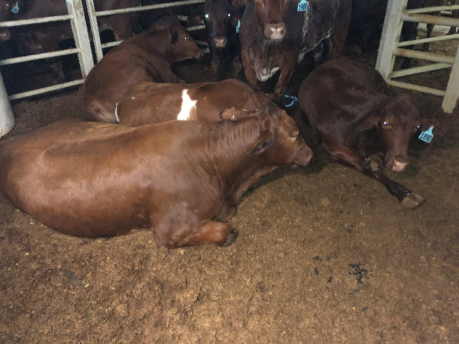
Day 12 Sheep in pen — no issues identified  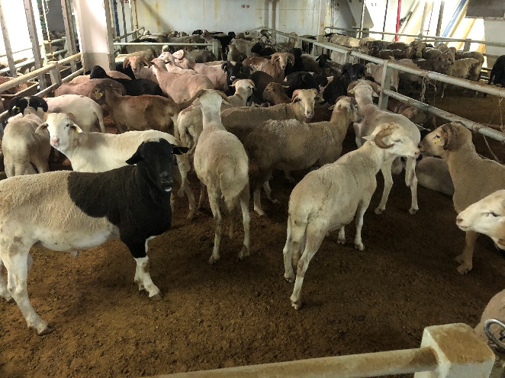 | Day 15 Sheep in pen — no issues identified  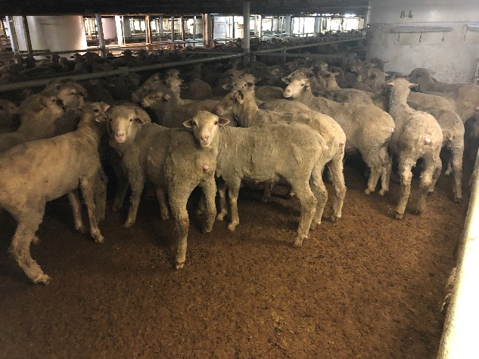
Day 19 Cattle in pen — no issues identified  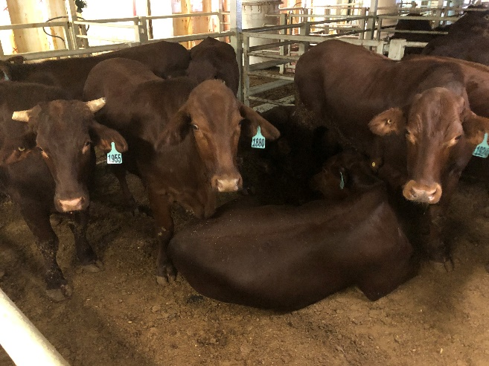 | Day 22 Sheep in pen — no issues identified  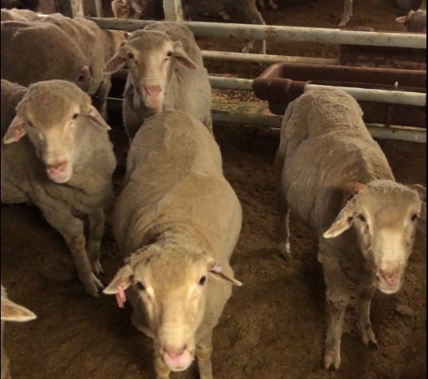
Acknowledgement of Country
We acknowledge the Traditional Custodians of Australia and their continuing connection to land and sea, waters, environment and community. We pay our respects to the Traditional Custodians of the lands we live and work on, their culture, and their Elders past and present.
© Commonwealth of Australia 2022
Unless otherwise noted, copyright (and any other intellectual property rights) in this publication is owned by the Commonwealth of Australia (referred to as the Commonwealth).
All material in this publication is licensed under a Creative Commons Attribution 4.0 International Licence except content supplied by third parties, logos and the Commonwealth Coat of Arms.
The Australian Government acting through the Department of Agriculture, Fisheries and Forestry has exercised due care and skill in preparing and compiling the information and data in this publication. Notwithstanding, the Department of Agriculture, Fisheries and Forestry, its employees and advisers disclaim all liability, including liability for negligence and for any loss, damage, injury, expense or cost incurred by any person as a result of accessing, using or relying on any of the information or data in this publication to the maximum extent permitted by law.

