Independent Observer summary report on MV Bahijah

Cattle exported to Israel in September 2023
May 2024

Voyage summary
Livestock: 5,746 cattle
Vessel: MV Bahijah
Loading location: Fremantle
Discharge location: Eilat, Israel
Voyage length: 22 days
Independent Observer: Boarded at Fremantle and remained onboard until completion of discharge.
Voyage mortality rate: 0.05% (3 mortalities) of cattle. These mortalities are unlikely to be linked to any systemic failure by the exporter.
Notifiable mortality rate: 0.5% for cattle

Summary of observations
This report summarises key observations of the implementation and effectiveness of exporter arrangements to ensure the health and welfare of livestock. The report has been approved by the observer who accompanied the voyage.

Exporter documentation
The observer reported no issues regarding exporter documentation.

Loading
Based on observations made during this voyage, the exporter arrangements relating to loading were appropriate and effective in managing livestock health and welfare.

Personnel
Based on observations made during this voyage, the exporter arrangements relating to personnel were appropriate and effective in managing livestock health and welfare.

Daily routine
Based on observations made during this voyage, the exporter arrangements relating to daily routine were appropriate and effective in managing livestock health and welfare.

Feed and water
Based on observations made during this voyage, the exporter arrangements relating to feed and water were appropriate and effective in managing livestock health and welfare.

Ventilation
Based on observations made during this voyage, the exporter arrangements relating to ventilation were appropriate and effective in managing livestock health and welfare.
On day 18, the observer recorded a temperature of 33.7°C near the engine room on Deck 6. There were no livestock observed as heat stressed during this time. There were no health or welfare impacts observed due to the temperatures on livestock decks through the voyage.

Pen conditions
The observer noted that:
- At least three temporary pens on each of Decks 5, 6 and 7 included in the stowage plan were not assembled at commencement of loading and hence were not available to receive livestock. In total 9 pens were not utilised during the voyage. This resulted in less pen space allocation than required by the Australian Standards for the Export of Livestock (ASEL). No direct effects on animal health were noted because of the failure to assemble the temporary pens and subsequent overstocking.

Health and welfare
No systemic issues observed.

Discharge
Based on observations made during this voyage, the exporter arrangements relating to discharge were appropriate and effective in managing livestock health and welfare.

Representative photographs of voyage
Day 5 Cattle in pen — no issues identified  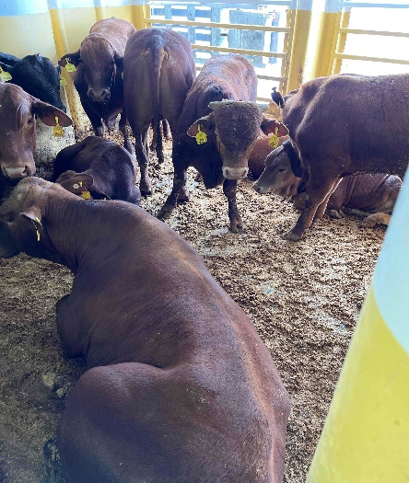 | Day 6 Cattle in pen — no issues identified  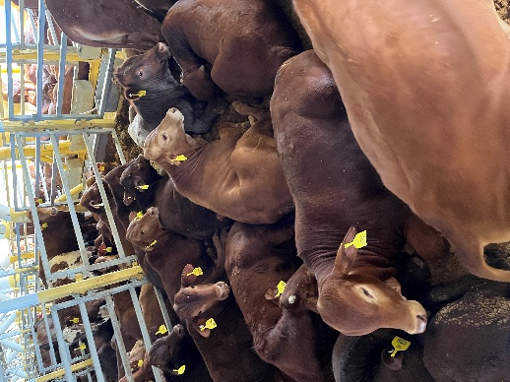
Day 9 Cattle in pen — no issues identified  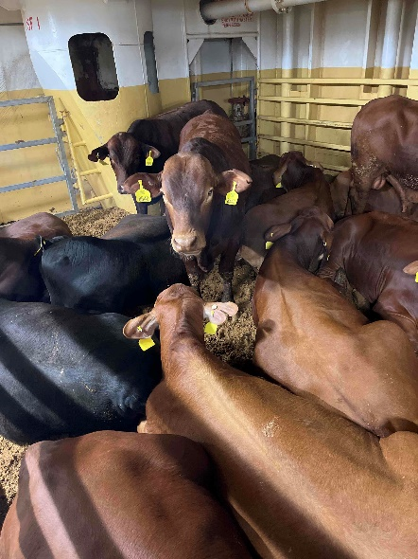 | Day 16 Cattle in pen — no issues identified  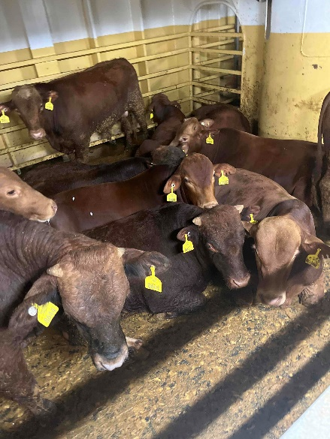
Day 19 Cattle in pen — no issues identified  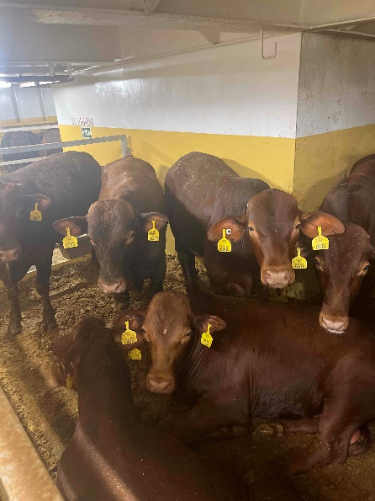 | Day 20 Cattle in pen — no issues identified  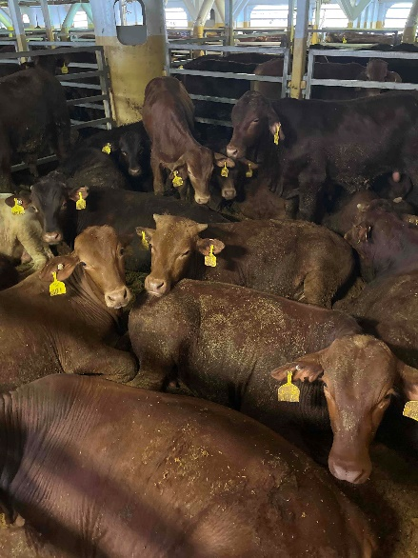
Acknowledgement of Country
We acknowledge the Traditional Custodians of Australia and their continuing connection to land and sea, waters, environment and community. We pay our respects to the Traditional Custodians of the lands we live and work on, their culture, and their Elders past and present.
© Commonwealth of Australia 2024
Unless otherwise noted, copyright (and any other intellectual property rights) in this publication is owned by the Commonwealth of Australia (referred to as the Commonwealth).
All material in this publication is licensed under a Creative Commons Attribution 4.0 International Licence except content supplied by third parties, logos and the Commonwealth Coat of Arms.
The Australian Government acting through the Department of Agriculture, Fisheries and Forestry has exercised due care and skill in preparing and compiling the information and data in this publication. Notwithstanding, the Department of Agriculture, Fisheries and Forestry, its employees and advisers disclaim all liability, including liability for negligence and for any loss, damage, injury, expense or cost incurred by any person as a result of accessing, using or relying on any of the information or data in this publication to the maximum extent permitted by law.

