Independent Observer summary report on MV Galloway Express

Cattle exported to Indonesia in July 2023
May 2024

Voyage summary
Livestock: 3,138 cattle
Vessel: MV Galloway Express
Loading location: Wyndham
Discharge location:
- Panjang, Indonesia
- Belawan, Indonesia
Voyage length: 11 days
Independent Observer (observer): Boarded at Wyndham and disembarked from the vessel at Belawan on 12 July 2023.
Voyage mortality rate: 0.1% (3 mortalities). These mortalities are unlikely to be linked to any systemic failure by the exporter.
Notifiable mortality rate: 0.5%

Summary of observations
This report summarises key observations of the implementation and effectiveness of exporter arrangements to ensure the health and welfare of livestock. The report has been approved by the observer who accompanied the voyage.

Exporter documentation
The observer reported no issues regarding exporter documentation.

Loading
The observer noted that:
- By visual appraisal, cattle in some pens appeared to vary by more than 50kg from the pen average weight, and some appeared to vary by up to 100kg from pen-mates, not in accordance with Australian Standards for the Export of Livestock (ASEL) standard 5.3.1b.
  - The stockperson re-penned livestock during the first few days of the voyage, however approximately 13 pens still contained cattle that appeared to have over 50kg variance from the pen average weight.
  - The weight differences could not be confirmed as individually weighing animals once they are on a vessel is not possible. No adverse impacts on animal health were observed as a result of this apparent size disparity.
- Cattle were loaded into overstocked pens. The stockperson and crew were observed reshuffling livestock over the first few days of the voyage to ease spacing for cattle. No adverse animal health or welfare effects were observed as a result of the overstocking.

Personnel
Based on observations made during this voyage, the exporter arrangements relating to personnel were appropriate and effective in managing livestock health and welfare.

Daily routine
Based on observations made during this voyage, the exporter arrangements relating to daily routine were appropriate and effective in managing livestock health and welfare.

Feed and water
Based on observations made during this voyage, the exporter arrangements relating to feed and water were appropriate and effective in managing livestock health and welfare.

Ventilation
The observer noted that:
- During the voyage, a known hotspot close to the engine stack bulkhead on Deck 4 aft had a slight increase in wet bulb temperature compared to surrounding pens, however there was less than 1°C difference throughout the voyage. Cattle in these pens were not observed to be open mouth panting at any point and no adverse impacts on animal health or welfare were observed.
- The hottest period of the voyage occurred on day 7, with a wet bulb temperature of 29°C. No open mouth panting was observed and there were no evident negative health effects.

Pen conditions
Based on observations made during this voyage, the exporter arrangements relating to pen conditions were appropriate and effective in managing livestock health and welfare.

Health and welfare
No systemic issues observed.

Discharge
Based on observations made during this voyage, the exporter arrangements relating to discharge were appropriate and effective in managing livestock health and welfare.

Representative photographs of voyage
Day 2 Cattle in pen — weight variance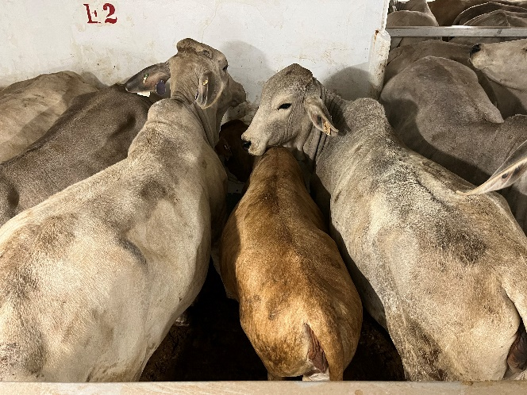 | Day 3 Cattle in pen — no issues identified  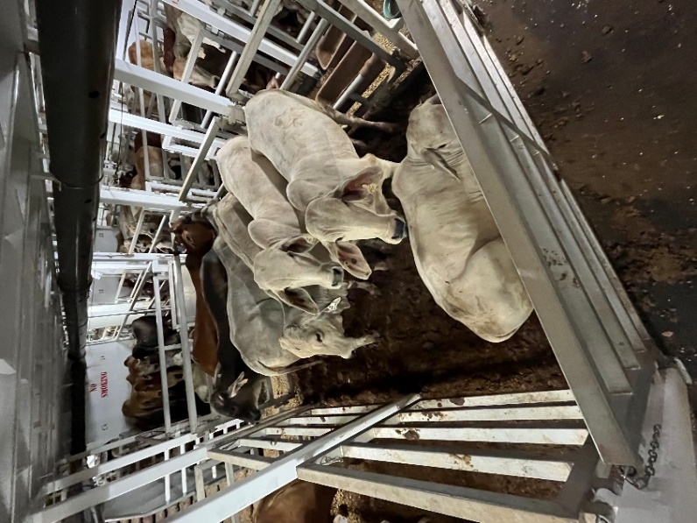
Day 4 Cattle in pen — overstocked by 1 animal  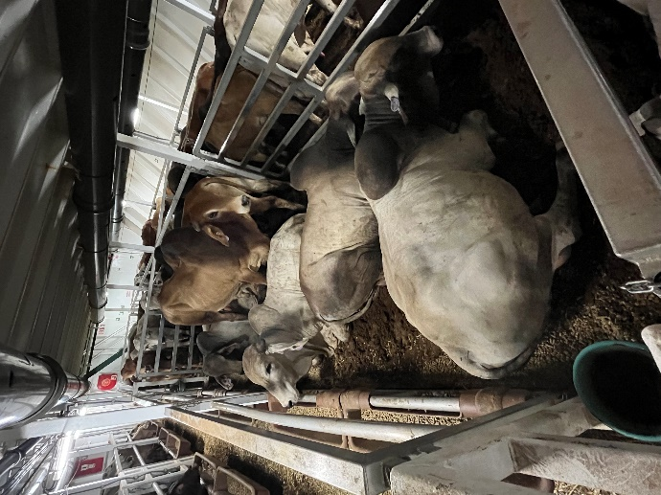 | Day 6 Cattle in pen — no issues identified  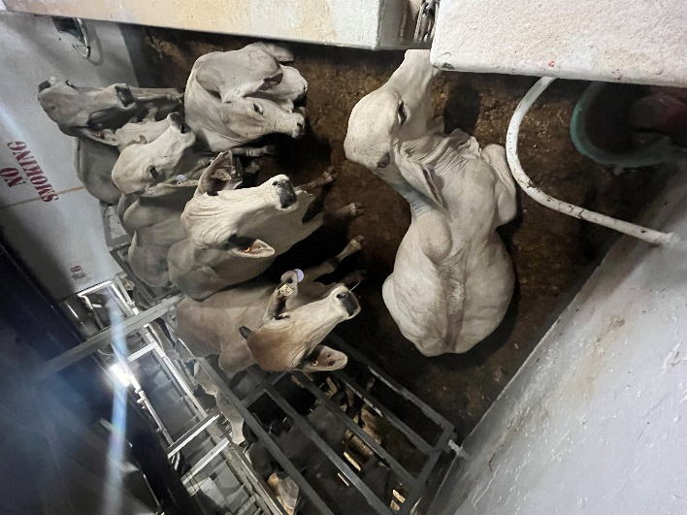
Day 8 Cattle in pen — no issues identified  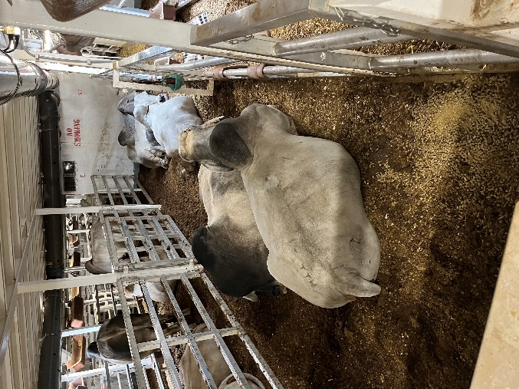 | Day 9 Cattle in pen — no issues identified  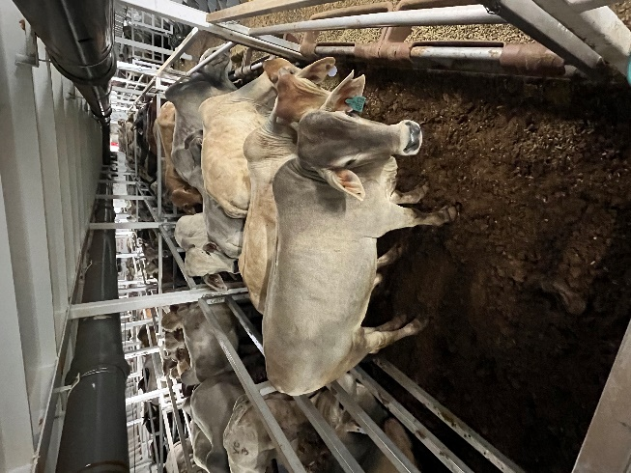
Acknowledgement of Country
We acknowledge the Traditional Custodians of Australia and their continuing connection to land and sea, waters, environment and community. We pay our respects to the Traditional Custodians of the lands we live and work on, their culture, and their Elders past and present.
© Commonwealth of Australia 2024
Unless otherwise noted, copyright (and any other intellectual property rights) in this publication is owned by the Commonwealth of Australia (referred to as the Commonwealth).
All material in this publication is licensed under a Creative Commons Attribution 4.0 International Licence except content supplied by third parties, logos and the Commonwealth Coat of Arms.
The Australian Government acting through the Department of Agriculture, Fisheries and Forestry has exercised due care and skill in preparing and compiling the information and data in this publication. Notwithstanding, the Department of Agriculture, Fisheries and Forestry, its employees and advisers disclaim all liability, including liability for negligence and for any loss, damage, injury, expense or cost incurred by any person as a result of accessing, using or relying on any of the information or data in this publication to the maximum extent permitted by law.

